U.S. Radiocommunications Sector
Fact Sheet
Working Party: ITU-R WP 5C | Document No: USWP 5C 23-21 F.1762 (R1)
Ref: Annex 10 to Document 5C/345-E | Date: 01/25/2023
Document Title: Preliminary Draft Revision to Recommendation ITU-R F.1762 “Characteristics of enhanced applications for high frequency (HF) radiocommunication systems
Author(s)/Contributors(s):  Fumie Wingo  Department of the Navy  Robert Leck  ACES in support of the Department of the Navy  Taylor King  ACES in support of the Department of the Navy | Phone: +1-703-697-0066  Email: fumie.n.wingo.civ@us.navy.mil  Phone : +1-321-332-2111  Email : robert.leck@aces-inc.com  Phone : +1- 443-966-0550  Email : taylor.king@ACES-INC.COM
Purpose/Objective: This is a Fact Sheet for the elevation of the Working Document Towards a Preliminary Draft Revision to ITU-R 1762 “Characteristics of enhanced applications for high frequency (HF) radiocommunication systems” to a Preliminary Draft Revision to Recommendation ITU-R F.1762 “Characteristics of enhanced applications for high frequency (HF) radiocommunication systems”.
Abstract: This document proposes elevating the Working Document Towards a Preliminary Draft Revision to Recommendation ITU-R F. 1762 “Characteristics of enhanced applications for high frequency (HF) radiocommunication systems” to a Preliminary Draft Revision. The update includes minor editorial corrections based upon comments that were made at the last ITU-R WP-5C meeting.

Radiocommunication Study Groups | 
United States of America
PRELIMINARY DRAFT REVISION TO RECOMMENDATION ITU-R F.1762
Characteristics of enhanced applications for high frequency (HF) radiocommunication systems
Introduction
The United States proposes that ITU-R Working Party (WP) 5C consider the proposed revisions to Recommendation ITU-R M.1762 and elevation to Preliminary Status.
The proposed edits are highlighted in yellow.
Attachment: Preliminary draft revision to Recommendation ITU-R F.1762 – Characteristics of enhanced applications for high frequency (HF) radiocommunication systems

ATTACHMENT

PRELIMINARY DRAFT
REVISION TO RECOMMENDATION ITU-R F.1762
Characteristics of enhanced applications for high frequency (HF) radiocommunication systems
(Question ITU-R 158/9)
(2006-202X)

Summary of revisions
The proposed updates include a list of additional enhanced applications as well as updated system parameters that would support the deployment of enhanced applications through high-speed digital networks within the 3 to 30 MHz frequency range. Additionally, emission masks that are appropriate for HF system operating in non-networked configurations are included, as well as descriptions of Type A and Type B transmitters in relationship to the emission masks. Finally, revisions were made to conform with the mandatory format for ITU-R Recommendations.
Scope
This Recommendation describes the technical characteristics of enhanced applications for high frequency (HF) radiocommunication systems to provide digital services.

Abbreviations/Glossary
e.i.r.p.: Effective Isotropic Radiated Power
NVIS: Near vertical incidence skywave
PSK: Phase Shift Keying
FSK: Frequency Shift Keying
HF: High Frequency
PSK: Phase Shift Keying
QAM-: Quadrature Amplitude Modulation
OFDM: Orthogonal Frequency Division Multiplexing
RF: Radio Frequency
Skywave – The propagation of radio waves reflected or refracted back toward Earth from the ionosphere.
Groundwave – Radio waves propagating parallel to and adjacent to the surface of the Earth, following the curvature of the Earth.
Related ITU Recommendations and Reports
Recommendation ITU-R BS.80-– Transmitting antennas in HF broadcasting
Recommendation ITU-R BS.705 – HF transmitting and receiving antennas characteristics and diagrams
Recommendation ITU-R F.240 – Signal-to-interference protection ratios for various classes of emission in the fixed service below about 30 MHz
Recommendation ITU-R F.1610 – Planning, design and implementation of HF fixed service radio systems
Recommendation ITU-R F.1611 – Prediction methods for adaptive HF system planning and operation
Recommendation ITU-R F.1761 – Characteristics of HF fixed radiocommunication systems
Recommendation ITU-R F.1778 – Channel access requirements for HF adaptive systems in the fixed and land mobile services
Recommendation ITU-R F.1821 – Characteristics of advanced digital high frequency (HF) radiocommunication systems
Recommendation ITU-R SM.326 - Determination and measurement of the power of amplitude-modulated radio transmitters
Recommendation ITU-R SM.339 - Bandwidths, signal-to-noise ratios and fading allowances in complete systems
Report ITU-R BS.458 – Characteristics of systems in LF, MF and HF broadcasting
Report ITU-R F.2061 – HF fixed radiocommunications systems
Report ITU-R F-2062 – Enhanced high frequency digital radiocommunication systems capable of providing enhanced applications
Report ITU-R F.2087 – Requirements for high frequency (HF) radiocommunication systems in the fixed service
Report ITU-R F.2484 – Cooperative frequency competition model and the corresponding algorithms

The ITU Radiocommunication Assembly,
considering
a) that some high frequency (HF) systems can be used to provide enhanced applications for electronic messaging systems (e-mail), digital voice and large file transfer providing a communications path to the Internet for exchanging information;
b) that the increasing use of spectrum in the HF bands for enhanced applications such as electronic messaging systems, both with and without attachments, should be taken into account;
c) that such HF systems are not standardized in use and may have different operational technical characteristics;
d) that with electronic messaging, and other enhanced applications for HF systems, equipment interoperability is an important issue,
noting
a) that such HF systems are capable of providing routine and emergency public protection and disaster relief;
b) that HF digital networks utilizing increased channel bandwidths can be used as a mechanism for providing enhanced applications;
c) that additional information on such HF systems capable of providing enhanced applications can be found in Report ITU-R F.2062,
recommends
that the technical characteristics of those HF systems providing enhanced applications, including electronic messaging and other Internet capability, described in Annex 1 should be considered representative of those systems operating in the HF frequency bands between 3 and 30 MHz.

Annex 1
Characteristics of HF radio systems
providing enhanced applications

1 Introduction
Enhanced applications that can be supported over HF include:
a) electronic mail, also known as e-mail,
b) voice over internet protocol, also known as VoIP,
c) interactive Internet applications,
d) large file transfer,
e) real-time video streams over HF.
In the event of the collapse or overload of normal telecommunication operation due to natural disasters (e.g. earthquakes) and other emergencies, applications for enhanced HF systems using fixed, transportable and mobile stations could provide emergency links during the first phase of the alarm or during the coordination of the relief operation.

2 HF Transmitter/Receiver RF Technical characteristics
Tables 1A, 1B, 2, 3A, and 3B contain technical characteristics of representative HF systems capable of providing enhanced applications. These characteristics are sufficient for general calculation to assess the compatibility between these systems and systems operating in other services.
In Table 1B, protection ratios are specified as the ratio of wanted-to-unwanted average signal powers (PY). This is in contrast to Recommendation ITU-R F.240 where the ratios are expressed in peak envelope powers (PX). Conversion from PX to PY is waveform dependent for both wanted and unwanted signals. Conversion factors can be obtained from Recommendation ITU-R SM.326.
The parameters in Table 1A apply to the Groundwave, Skywave and NVIS Systems that are listed in Table 1B.
TABLE 1A
Common Characteristics for RF traditional HF systems
Parameter | Value
Necessary bandwidth (kHz) | 3
Feeder loss (dB) | 3
Receiver IF bandwidth (kHz) | 3
Receiver RF bandwidth (kHz) | 3
Receiver noise figure (dB) | 16

TABLE 1B
Example of RF traditional HF systems
Parameter | System
Mode of operation | Groundwave | Skywave  (oblique) | NVIS  Near vertical
Frequency band (MHz) | 2-10 | 3-30 | 2-10
Transmitter power PX (dBW) | 10-30 | 0-26 | 10-26
Antenna gain (dBi) | 6 | 3 | 0
Maximum e.i.r.p. (dBW) | 33 | 26 | 23
Antenna polarization | Vertical/  horizontal | Vertical | Horizontal
Protection ratio PY (dB) | 21 | 28 | 10
Signal-to-noise ratio  (Recommendation ITU-R F.339) | 21 | 28 | 10

TABLE 2
Typical RF characteristic of enhanced HF systems for channel bandwidths of 3 to 48 kHz (transmitter)
Enhanced HF transmitter parameters | Groundwave / Skywave | NVIS / Groundwave | Skywave / NVIS / Groundwave | Skywave
Frequency band (MHz) | 3-30 | 3-30 | 3-30 | 3-30
Channel bandwidth (kHz) | Variable 3-48 | Variable 3-48 | Variable 3-48 | Variable 3-48
Transmitter power (dBW) | 36 | 26 | 36 | 27
Feeder loss (dB) | 2.2 | 1.5 | 2.6 | 1.1
Antenna gain (dBi) | 14.15 | 4.15 | 11.15 | 2.15
Antenna height (m) | 64 | 3.65 | 28.04 | 1.21
Antenna polarization | Vertical | Vertical | Vertical | Horizontal
Antenna type | Broadband Omni | Narrowband Monopole | Broadband Dual Fan-Wire | Narrowband Dipole
Maximum e.i.r.p. (dBW) | 34.2 | 24.2 | 35.7 | 26.7
Modulation | AM/FM | AM/FM | FM | FM
Typical minimum path length (km) | 161 | 48.2 | 38.6 | 19

The parameters in Table 3A apply to Groundwave, Skywave and NVIS Systems operating within the 3-30 MHz frequency band. Addition parameters are listed in Table 3B.
TABLE 3A
Common characteristic of enhanced HF systems for channel bandwidths of 3 to 48 kHz (receiver)
Enhanced HF receiver parameters | Values
Channel Bandwidth (kHz) | Variable 3-48
Variable (3 kHz to 12.0 kHz) | 12.0
Variable (3 kHz to 18.0 kHz) | 18.0
Variable (3 kHz to 24.0 kHz) | 24.0
Variable (3 kHz to 48 kHz) | 48.0
IF Filter Bandwidth (kHz) | 48
Sensitivity (dBm)
SSB for 10 dB SINAD | −113
ISB for 10 dB SINAD | −97
CW for 10 dB SINAD | −116

TABLE 3B
Typical RF characteristic of enhanced HF systems for channel bandwidths of 3 to 48 kHz (receiver)
Enhanced HF receiver parameters | Groundwave / Skywave | NVIS / Groundwave | Skywave / NVIS / Groundwave | Skywave
Signal-to-noise ratio (dB)
PSK | 5 | 12 | 8 | 14
FSK | 8 | 18 | 12 | 18
QAM | 14 | 24 | 20 | 24
OFDM | 16 | 26 | 26 | 30
Feeder loss (dB) | 2.2 | 1.5 | 2.6 | 1.1
Antenna gain (dBi) | 14.15 | 4.15 | 11.15 | 2.15
Antenna height (m) | 64 | 3.65 | 28.04 | 1.21
Antenna polarization | Vertical | Vertical | Vertical | Horizontal
Typical minimum path length (km) | 161 | 48.2 | 38.6 | 19

3 Typical HF Antenna Patterns
HF Systems utilize a variety of antenna types as a function of operational range. For short range applications conventional whip antenna are typically mounted on man-packs and vehicles. Medium range Skywave NVIS (Near Vertical Incidence Skywave) applications utilize loop, bent whips and diploes. Long range use large vertical whip antennas, yagi and log-periodic antennas. Dipoles that are higher above ground are also used for long range applications.
Antenna patterns for typical HF antenna types; Whip, Loop, Bent Whip, Dipole and Log-Periodic, can be found in Recommendation ITU-R BS.705-1 “HF transmitting and receiving antennas characteristics and diagrams”. Additional antenna patterns can be found in Appendix 1 to Annex 1 of the Recommendation and include curtain antennas with different feeding arrangements and reflector types, tropical antennas, horizontal and vertical log-periodic, rhombic, quadrant, cross dipole and vertical monopoles. Additional information and data regarding HF Broadcasting antennas can be found in Recommendation ITU-R BS.80-3 “Transmitting antennas in HF broadcasting”.

4 Emission characteristics
Figures 1 and 2 illustrates spectrum masks that can be applicable to any system utilizing the channel bandwidths that are listed in Tables 1A, 1B , 2, 3A and 3B. Where; Type A applies to fixed transmitter installations on land based sites, maritime and aircrafts (both fixed wing and rotary). The transmit power is typically greater than 150 W PEP. Type B radio systems applies to transmitters that are mounted and/or dismounted on vehicles. The transmit power is typically up to 150 W PEP. Requirements for unwanted emissions are defined to achieve reasonable non-interference conditions between receivers and distant transmitters.
FIGURE 1
Spectrum mask for system utilizing channel bandwidths of 2 to 48 kHz

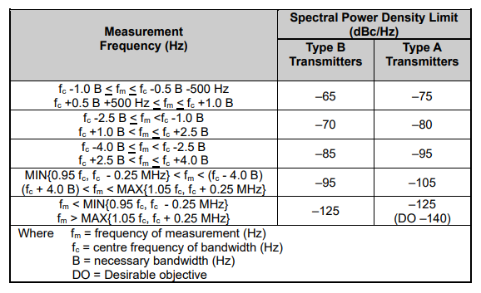
Table 4
Emission Mask for HF Systems with Channel Bandwidths of up to 48 kHz
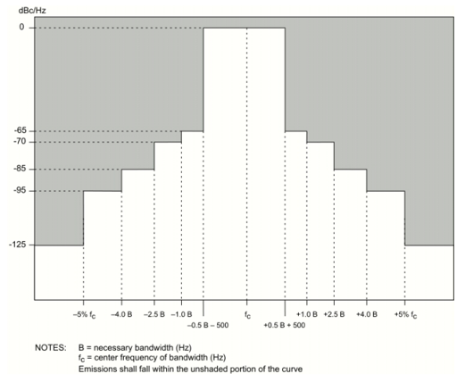
Figure 1
Type B Transmitters

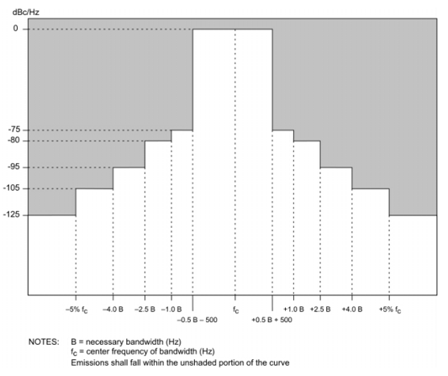
Figure 2
Type A Transmitters

The signal-to-noise ratios in Table 1B are for a traditional BPSK system with a 3 kHz channel bandwidth.
The signal-to-noise ratios in Table 1B are for a traditional BPSK system with a 3 kHz channel bandwidth.
Channel bandwidths of 24 kHz within the 3-30 MHz frequency band have been recognized and defined in Recommendation ITU-R F.339-8 “Bandwidths, signal-to-noise ratios and fading allowances in HF fixed and land mobile radiocommunication systems” (2013), Table 4a.
Channel bandwidths of 3, 6, 9, 12, 15, 18, 21, 24, 27, 30, 33, 36, 39, 42, 45 or 48 kHz can also be applicable. As a function of the application.
The signal-to-noise ratios in Table 3B are given in a waveform’s necessary bandwidth and are typical of systems that operate under the indicated propagation modes.
In conjunction with Recommendation ITU-R BS.705, the ITU has developed computer programs to calculate radiation patterns and gain for various antenna types. The output data includes the directivity gain, the relative gain for a particular azimuth and elevation angle, tables of relative gain referred to the maximum and a number of different graphic outputs.

