|  |  |
| --- | --- |
| U.S. Radiocommunications Sector  Fact Sheet | |
| **Working Party:** ITU-R WP1A | **Document No:** USWP1A-01_SD |
| **Ref:**  Report ITU-R SM.2392-1 | **Date:** 21 March 2023 |
| Document Title: Proposed revision of Report ITU-R SM.2392-1 Applications of wireless power transmission via radio frequency beam | |
| **Author(s)/Contributors(s):**  Matt Greenspan  TMG | **Email**: mgreenspan@tmgtelecom.com **Phone**: 703-472-0897 (Please email first) |
| **Purpose/Objective:** To update Report ITU-R SM.2392-1 with information accounting for new applications of WPT Beam technology. | |
| **Abstract:** This input provides new information on current uses of WPT Beam technology at higher power levels than those currently considered in the report. The input will also build on existing text to explain the current applications of WPT Beam technology for industrial, retail, and other use cases. | |

|  |  |
| --- | --- |
| **Radiocommunication Study Groups** |  |
|  |  |
|  |  |
| Received: Date 2023  Subject: Proposed revision of Report ITU-R SM.2392-1 Applications of wireless power transmission via radio frequency beam | **Document XX/-E** |
| **Date 2023** |
| **Original: English** |
| United States of America | |
| Proposed revision of Report ITU-R SM.2392-1 Applications of wireless power transmission via radio frequency beam | |
|  | |

Background

Report ITU-R SM.2392-1, *Applications of wireless power transmission via radio frequency beam,* was published in 2021. Since being published, new applications for Beam WPT have been implemented for industrial, retail, and other use cases.

Discussion

The United States of America has reviewed Report ITU-R SM.2392-1 in preparation for the May / June 2023 WP1A meeting and noted that certain sections, particularly on wireless power sensor networks, could benefit from updating with the latest information.

Proposal

The United States proposes updates to Report ITU-R SM.2392-1 to reflect new applications of beam WPT technology.

**Attachment:** Proposed Working Document towards a Preliminary Draft Revision of Recommendation ITU-R SM.2392-1

Attachment

Working document towards a Preliminary Draft Revision of report ITU-R SM.2392-1

Applications of Wireless Power Transmission via Radio Frequency Beam

…

**2.1 Wireless powered sensor network**

Recommendation ITU-T Y.222 1 [ITU 10] defines sensor network as: A network comprised of interconnected sensor nodes exchanging sensed data by wired or wireless communication. Wireless sensor networks (WSNs) are one of the most rapidly developing information technologies and promise to have a variety of applications in next generation networks (NGNs) based on ITU-T Technical Paper Y.2000 [ITU 14]. Energy efficiency is quite important. This paper states as follows:

“The WSN parts may be spatially distributed on the area of many kilometres, especially if a WSN user is managing it via the Internet. At the same time, sensor nodes can be located in the inaccessible places, or the concrete location of each sensor node can be unknown. Also, a WSN may consist of dozens, hundreds or even thousands of sensor nodes. Under these conditions charging of sensor nodes by the user is out of question. That is why a sensor node must have high energy efficiency in order to keep working on small and inexpensive battery for a few months and even years. This ultra-low-power operation can only be achieved by power hardware components.”

Wireless power enables a wide variety of applications for sensor networks that would otherwise be unfeasible. These include sensor networks to support environmental monitoring of metrics such as air quality, light, humidity, temperature, and others. Industrial applications of wireless powered sensor networks are also being implemented for physical asset management and logistics. In this regard, wireless power transmission via radio frequency beam (beam WPT) serves as an enabling factor for the deployment of internet of things (IoT) systems. These beam WPT systems operate with transmitter powers varying from 1 W to 15 W using directional antennas. An example of beam WPT charging of an IoT sensor network is illustrated in Figure [X].

FIGURE [X]

**Example of diagram of a beam WPT application for IoT sensor network**

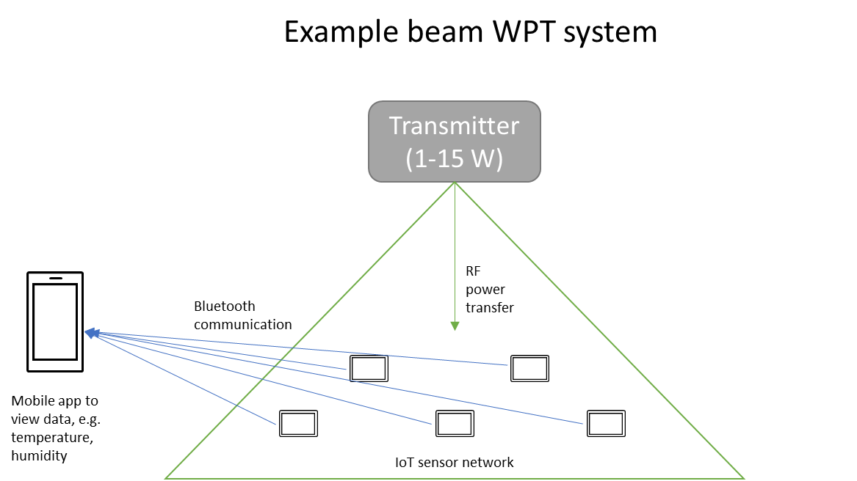

**2.1.1 Situation of Japan**

…