|  |  |
| --- | --- |
| **U.S. Radiocommunications Sector**  **Fact Sheet** | |
| **Working Party:** ITU-R WP 5B | **Document No:** USWP5B31-08_Final_UA PFD Res 155 |
| **Ref:** ITU-R 5B/355-E Annex 20 and ITU**-**R 5B/731 section 10.5.1 | **Date:** 7th April 2023 |
| **Document Title:** PRELIMINARY DRAFT NEW REPORT ITU-R M.[UA_PFD] - **Review of power flux-density limits in accordance with *resolves* 16 of Resolution 155 (WRC-15)** | |
| **Author(s)/Contributors(s):**  Name: Don Nellis  Org: Federal Aviation Administration  Name: Michael Neale  Org: ACES Corporation for the FAA | Phone: (202) 267-9779  Email: [Donald.Nellis@faa.gov](mailto:Donald.Nellis@faa.gov)  Phone: (858) 705-8978  Email: michael.neale@aces-inc.com |
| **Purpose/Objective:** The purpose of this contribution is to propose the update of the PRELIMINARY DRAFT NEW REPORT to a DRAFT NEW REPORT. Some additions are proposed in the introduction section to address questions that were raised during the last meeting of ITU-R WP 5B in November 2022. However, no changes are proposed to the technical analysis from the version that was Annexed to the Chairman’s Report from the April 2019 meeting of WP 5B and carried over without discussion during the July 2020, November 2020 and May 2021 meetings of WP 5B. Due to priority on the development of the CPM report no contribution on this topic was made to the November 2021, April 2022 and July 2022 meetings of WP5B.  This pfd mask currently exists as an example in Annex 2 to Resolution **155 (WRC-19)** so the report needs to be finalized so the example can become the normative requirement in the resolution.  This Report is required to address resolves 14, 15 and 16 in Resolution **155 (WRC-19)** in support of Agenda Item 1.8. | |
| **Abstract:** This contribution examines the pfd required to protect the FS from emissions from the CNPC link transmitter located on the UA and proposes updating the pfd mask in Annex 2 of Resolution **155 (WRC-19)** in accordance with those studies. | |

Changes from First Draft highlighted in turquoise

|  |  |
| --- | --- |
| **Radiocommunication Study Groups** |  |
|  |  |
|  |  |
| Received: XXX  Source: Document [5B/355](https://www.itu.int/md/R19-WP5B-C-0355/en), Annex 20  and ITU-R 5B/731 section 10.5.1  Subject: Resolution **155 (Rev.WRC-19)** | **Document 5B/XXX-E** |
| XXX |
| **English only** |
| United Sates of America | |
| PRELIMINARY DRAFT NEW REPORT ITU-R M.[UA_PFD] | |
| Review of power flux-density limits in accordance with *resolves* 16  of Resolution 155 (Rev.WRC-19) | |

Introduction

Resolution **155 (Rev.WRC-19)** in its *resolves* 15 identifies the need to develop power flux-density (pfd) hard limits to protect terrestrial services from emission from the Unmanned Aircraft Earth Station (UAES). Examples for such hard limits are given in Annex 2 to Resolution **155 (Rev.WRC‑19)**. *Resolves* 16 of Resolution **155 (Rev.WRC-19)** asks for a review of the pfd limits given in its Annex 2, and that WRC-23 shall review and, if necessary, revise those pfd limits.

In accordance with “invites ITU-R” of Resolution **155 (Rev.WRC-19)** studies described in this Report were performed in order to assist in determining the need to review and, if necessary, revise the pfd limits contained in Annex 2 of Resolution **155 (Rev.WRC-19)**.

Proposal

The United States of America proposes to assist in answering the above resolves with the attached contribution, which analyses the pfd required to protect the Fixed Service in frequency bands which the FS shares with the FSS.

Since this report had been develop over the last study cycle and was substantially finished in 2020 the USA is proposing to update the status of the Report to a draft new Report.

**Attachment:** 1

attachment

DRAFT NEW REPORT ITU-R M.[UA_PFD]

**Review of power flux-density limits in accordance with resolves 16   
of Resolution 155 (Rev.WRC-19)**

(202X)

[Editor’s note:

. Reply Since the above note was inserted in 2019 no MS receiver characteristics have been provided so it has not been possible to update this study. This point is already adressed at the end of the introduction.]

**Keywords**

[TBD]

**Abbreviations/Glossary**

CCDF: Complementary cumulative distribution function

CNPC: Command and non-payload communication

FDP: fractional degradation of performance

*I/N*: Interference to noise

pfd: Power flux density

UA: Unmanned aircraft

UAS: Unmanned aircraft systems

Related ITU Recommendations, Reports

*Recommendations*

ITU-R [F.758](https://www.itu.int/rec/R-REC-F.758/en) System parameters and considerations in the development of criteria for sharing or compatibility between digital fixed wireless systems in the fixed service and systems in other services and other sources of interference

ITU-R [F.1108](https://www.itu.int/rec/R-REC-F.1108/en) Determination of the criteria to protect fixed service receivers from the emissions of space stations operating in non-geostationary orbits in shared frequency bands

ITU-R [F.1245](https://www.itu.int/rec/R-REC-F.1245/en) Mathematical model of average and related radiation patterns for line-of-sight point-to-point fixed wireless system antennas for use in certain coordination studies and interference assessment in the frequency range from 1 GHz to about 70 GHz

ITU-R [M.1643](https://www.itu.int/rec/R-REC-M.1643/en) Technical and operational requirements for aircraft earth stations of aeronautical mobile-satellite service including those using fixed-satellite service network transponders in the band 14-14.5 GHz (Earth-to-space)

Introduction

Resolution **155 (Rev.WRC-19)** in its *resolves* 15 identifies that power flux-density (pfd) hard limits that need to be developed for unmanned aircraft systems (UAS) command and non-payload communication (CNPC) links; one possible example of such a provisional limit to protect the ~~f~~ixed service is provided in its Annex 2

*Resolves* 16 of Resolution **155 (Rev.WRC-19)** asks for a review of the pfd limits given in its Annex 2, and that WRC-19 shall review and, if necessary, revise those pfd limits. This *resolves* deals with the review of Annex 2 required to protect terrestrial. This implies that all current and future terrestrial service needs to be protected in all countries and thus the pfd process should not be limited to the protection of the fixed service in specific countries

[Note: Updates to Resolution **155 (Rev.WRC-19)** for WRC-23 are anticipated to address these topics.]

In accordance with “*invites ITU-R*” of Resolution **155 (Rev.WRC-19)** studies contained in this Report were performed in order to assist in determining the need to review and provide technical parameters to revise, as appropriate, the pfd limits contained in Resolution **155 (Rev.WRC-19)**.

During the development of these studies it was determined, following the methodology detailed in Annex 1, that different pfd masks were required for each of the two sub-bands within the frequency band 14-14.47 GHz to protect the terrestrial services. The following two studies were therefore undertaken:

**– Study #1**: 14-14.3 GHz – For protection of the terrestrial services in the countries listed in RR No. **5.505** (see Annex 2).

**– Study #2**: 14.25-14.47 GHz – For protection of the terrestrial services in this frequency range for relevant administrations not being subject of study #1 (see Annex 3).

These studies only consider the protection of the fixed service since the required characteristics for other terrestrial services to which this frequency band is allocated are not available, but it can be assumed, because of the operation of those services, that these other services would be appropriately protected with the technical conditions defined herein to protect the fixed service.

It is therefore considered that the pfd limits which protect the fixed service would be sufficient for all terrestrial services which have allocations in these frequency bands.

# 1 General comments

In its development and assessments of the pfd masks WP5B considered the following:

* Limiting of pfd is a well-established method to protect terrestrial services, for example, from interference caused by geostationary and non-geostationary space stations (see Article **21.16**);
* The pfd limits are defined on the earth’s surface and are exclusively dependent on the characteristics of the terrestrial service (victim) receiver and independent of altitude and relative location of the UA earth station;
* Due to the narrowband characteristics of the UAS CNPC links, no distinction of pfd masks for different UA earth station altitudes, and consequently for different reference bandwidths, is needed because the interference bandwidth is always narrower than the terrestrial service bandwidth;
* All protection criteria advised by the concerned working parties were included in the analyses.
* In particular for the fixed service:
  + Long-term protection with an I/N = -10 dB not to be exceeded for more than 20% of the time;
  + Short-term protection with I/N = +19 dB not to be exceeded for more than 2.7x10-4 % of the time;
  + Fractional Degradation of Performance less than 10% in the worst month;

*Note: Even though the long-term and short-term I/N levels (-10 dB, +19 dB, respectively) can be exceeded for specific UA earth station locations relative to the affected fixed-service station (in a static calculation case), the motion of the UA limits the amount of time for which the I/N level can be exceeded to less than that identified in the protection criteria.*

* UA earth stations flying at multiple altitudes covering all ICAO’s anticipated scenarios were analysed;
* Two sets of UA flight trajectories were analysed;
  + Scenario 1: Random entry and exit point of the UA within the field of view of the fixed-service station;
  + Scenario 2: UA entry and exit points within the field of view of the fixed service station are separated by 180 degrees, forcing all UA flights to be directly over the top of the victim fixed service station;
* Multiple fixed service stations antenna gains from 28 dBi up to 49 dBi were used to assess both the effects of the antenna beam width (relevant for interference duration and long-term protection criteria) and of the antenna gain (relevant for peak interference level and short-term protection criteria);
* That according to the advice of WP 5C, analyses were performed for two elevations for each antenna gain of the fixed service antennas: 0 degrees and 5 degrees;
* That the examination of whether a frequency assignment of an UA earth station complies with the pfd limits is out of the scope of this report but it could be similar to the methodologies used for Res. 169 (WRC-16), or other aeronautical mobile earth stations operating in the FSS.

This resulted for each of the two scenarios, for a 24 months simulation period, and all combinations of inputs parameters, in over 2 billion calculation samples.

In the following study

* Annex 1 describes the details of the methodology used including the UA earth station flight paths and study scenarios;
* Annex 2, Study #1 contains the assessment for the frequency range 14.0-14.3 GHz using the methodology described in Annex 1;
* Annex 3, Study #2 contains the assessment for the frequency range 14.25-14.47 GHz using the methodology described in Annex 1;

# 2 Summary of the Study

This report demonstrates that the fixed service (and by extension all terrestrial services as noted above) can be protected, in accordance with all three of the required protection criteria, from interference caused by UA earth stations using the following pfd masks for the following frequency ranges:

. :

1 In the frequency range 14.25-14.47 GHz used by stations (FIXED SERVICE), within line-of-sight of the territory of an administration not subject to RR No. **5.505**

* in the frequency band 14.25-14.3 GHz on the territory of countries listed in RR No. **5.508**;
* in the frequency band 14.3-14.4 GHz in Regions 1 and 3;
* in the frequency band 14.4-14.47 GHz worldwide;

where services are operating in this range, the maximum pfd produced at the surface of the Earth by emissions from a single earth station on board a UA communicating with a space station of the fixed-satellite service should not exceed:

for 0° ≤ ≤ 90°

where θ is the angle of arrival of the radio wave at the Earth’s surface.

2 In the frequency band 14-14.3 GHz used by terrestrial stations, inside and at the border of the territory of an administration where terrestrial services are operating in this band according to RR No. **5.505**, the maximum pfd produced at the surface of the Earth by emissions from a single earth station on board a UA communicating with a space station of the fixed-satellite service should not exceed:

for 0° ≤ ≤ 90°

where is the angle of arrival of the radio wave at the Earth’s surface.

A comparison of these masks with that from the “Example provided by WRC-15” in Annex 2 of Resolution **155 (Rev.WRC-19)** is shown in Figure 1.Consequently it is proposed that if exceeded these pfd masks are used as a baseline in finding agreements with affected administrations to avoid unacceptable interference into stations of the terrestrial service.

FIGURE 1

Comparison of power flux density masks

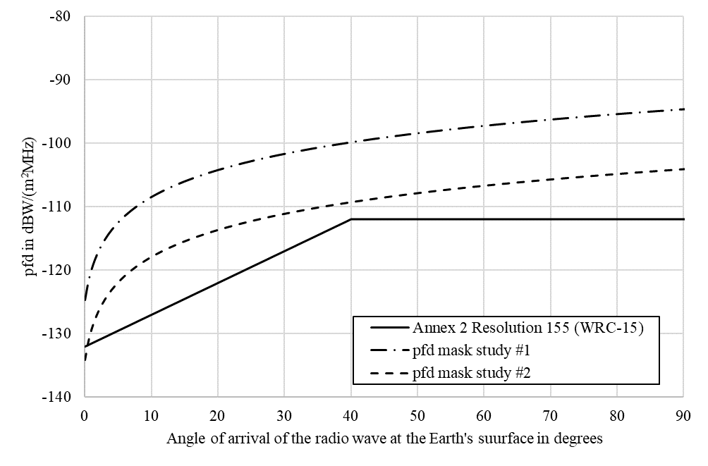

Annex 1

**Methodology**

# 1 Principle

The methodology provides a verification of whether the protection criteria for a fixed service station are respected with non-stop co-channel line-of-sight operation during a period of one month of a single unmanned aircraft (UA).

The UA flight path is defined randomly on great-circle trajectories at a constant altitude and speed.

**2 Process**

The figure below shows the stages of the methodology adopted.

Figure 2

Process of the methodology

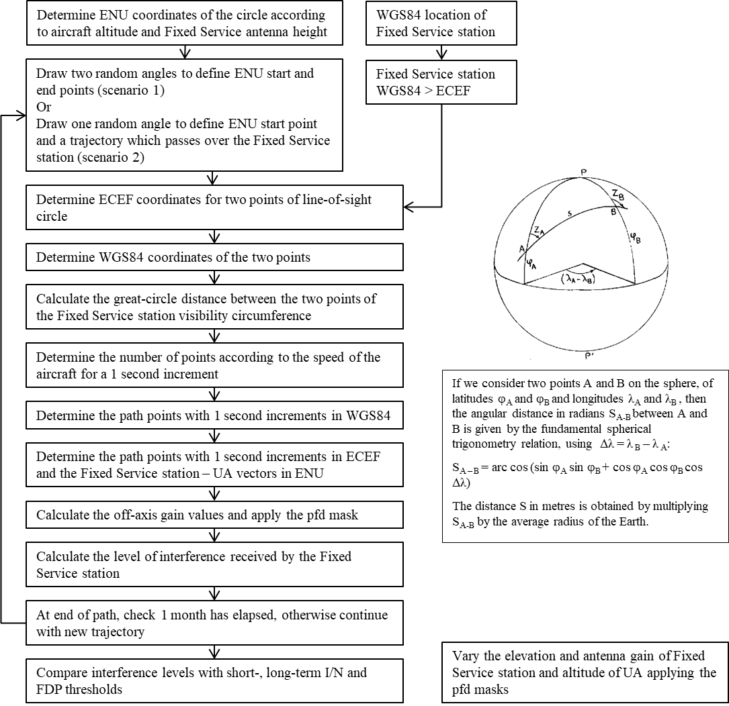

**3 Geometry**

*a) Principle*

According to WGS84 definitions:

Semi-major axis: a = 6 378 137 m

Flattening coefficient: F = 1/298.257223563

The following parameters are inferred:

Semi-minor axis: b = a(1-F) = 6 356 752.3142 m

First eccentricity: e = = 8.181919084262210-2

Second eccentricity: e’ = = 8.209443794969610-2

Mean radius of the semi-axes: R1 = 6 371 008.7714 m

The different references used are the following:

– ECEF (Earth-Centered, Earth-Fixed)

– WGS84 (World Geodetic System 84)

– ENU (East, North, Up).

They are presented in the figure below, where the angles φ and λ represent respectively the WGS84 latitude and longitude.

figure 3

Coordinate references systems

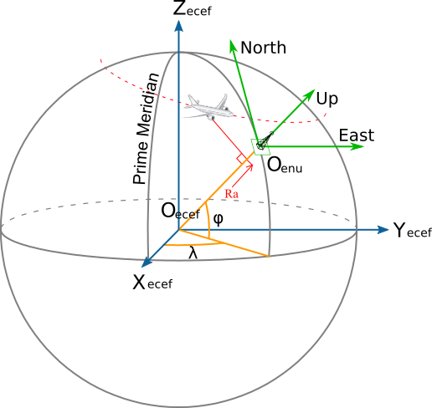

*b) Receiver: fixed service station*

Due to the applied methodology the results are independent from the location (latitude and longitude) of the fixed service.

The antenna height of the station used for the study is 30 m and is always pointing in the same direction.

*c) Transmitter: Unmanned aircraft earth station*

The UA trajectory is defined by an entry point and an exit point selected on the fixed service station’s line-of-sight circle, then by the points equally distributed on the great circle trajectory between those two points. The distance between two intermediary points on the great circle is the distance equivalent to one second trajectory at the given speed.

Two different scenarios are considered in each study:

**Scenario 1:**

In the scenario 1, the entry and exit points are both chosen randomly on the line-of-sight circle of the fixed service station.

**Scenario 2:**

In the scenario 2, the entry points are chosen randomly on the line-of-sight circle of the fixed service station but the exit points are forced to be at 180° of their corresponding entry point, so that the UA always flies over the fixed service station.

In Figures 4 and 5 example flight trajectories for scenario 1 and 2 are shown, colour-coded to show interference to noise ratio (I/N) (blue low and red high).

|  |  |
| --- | --- |
| Figure 4  Flight trajectories scenario 1 | Figure 5  Flight trajectories scenario 2 |
|  |  |

The following altitudes have been considered: 1 000 m, 4 000 m, 7 000 m, 10 000 m, 13 000 m and 16 000 m. Several aircraft speeds were used in the simulation, and it was found that the results were not dependent on this parameter. However, the results presented in this study were generated for an aircraft speed of 200 kt (370 km/h).

Figure 6 below shows the parameters used to define the line-of-sight circle:

figure 6

Parameters for line-of-sight circle

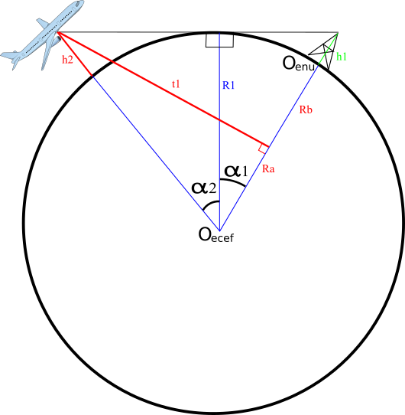

With ψ as the azimuth of the visibility circle of the Fixed service station.

**4 Characteristics of fixed service station**

**a) Interference level**

The interference level is obtained by applying the following formula:

with:

*f* in Hz;

as the speed of light in m/s;

as the receive gain of the fixed service station;

θ is the angle of arrival of the radio-frequency wave in degrees; and

ζ as the angle between the point of boresight of the fixed service station antenna as the UA as seen from the fixed service station in degrees.

**b) Noise level**

The receiver noise power density of the fixed service station considered in this study is, according to Recommendation ITU-R F.758, -136 dBW/MHz.

**5 Protection criteria**

In accordance Rec. ITU-R F.758, all of the following three protection criteria are used in the study:

– The long-term protection criterion of not exceeding an *I/N* level of -10 dB for more than 20 percent of the time.

– The short-term protection criterion of an *I/N* level of +19 dB for more than 2.710-4 percent of the time.

– A fractional degradation of performance (FDP) threshold of 10% according to the methodology set out in in Recommendation ITU-R F.1108.

ANNEX 2

**Study #1 14-14.3 GHz**

**Summary**

To ensure protection of the fixed service from emissions of a UA communicating with a satellite, the pfd mask is proposed to be applied in the identified frequency band 14-14.3 GHz which is also used by the fixed service on a co-primary basis with the fixed-satellite service in certain countries identified in RR No. **5.505**.

For verification that the pfd mask protects the fixed service in this frequency band, the methodology described in Annex 1 was applied.

**1 Fixed service receive characteristics**

**a) Antenna gain**

The antenna gain used for the studies is selected, respectively, as 37 and 28 dBi. The antenna pattern is based on Recommendation ITU-R F.1245 for point-to-point links.

**b) Antenna elevation**

For the antenna elevation, the following values were taken into account: 0° and 5°.

**c) Examples of interference to noise ratio complementary cumulative distribution function for Scenario 1**

Based on the proposed pfd mask the following two figures present the complementary cumulative distribution function (CCDF) of the *I/N* caused at the victim fixed service station having an antenna gain of 37 dBi and elevation angle of 0° and 5°, respectively. In both cases, the long-term and the short-term protection criteria are not exceeded at any time.

FIGURE 7

**Interference to noise ratio exceedance 37 dBi and 0° fixed service antenna elevation**



FIGURE 8

**Interference to noise ratio exceedance 37 dBi and 0° fixed service antenna elevation**



The two following figures demonstrate the compliance of the pfd mask with the FDP criterion, protecting a fixed service station having an antenna gain of 37 dBi and an elevation angle of 0° and 5°, respectively.

FIGURE 9

**Fractional degradation of performance 37 dBi and 0° fixed service antenna elevation**



FIGURE 10

**Fractional degradation of performance 37 dBi and 5° fixed service antenna elevation**



Using the proposed pfd mask, the following two figures show the CCDF of a fixed service station with an antenna gain of 28 dBi and an elevation angle of 0° and 5°, respectively. Both figures demonstrate that both, the long‑term and the short-term protection criteria are not exceeded at any time.

FIGURE 11

**Interference to noise ratio exceedance 28 dBi and 0° fixed service antenna elevation**



FIGURE 12

**Interference to noise exceedance 28 dBi and 5° fixed service antenna elevation**



The two following figures show the compliance of the proposed pfd mask with the FDP criterion. Both figures demonstrate that the pfd mask protects a fixed service station with an antenna gain of 28 dBi and an elevation angle of 0° and 5°, respectively.°.

FIGURE 13

**Fractional degradation of performance 28 dBi and 0° fixed service antenna elevation**



FIGURE 14

**Fractional degradation of perfromance 28 dBi and 5° fixed service antenna elevation**



The protection of fixed service stations having even smaller antenna gains becomes less critical because of the significantly lower interference level reception; hence, not further diagrams are needed.

**d) Examples of interference to noise ratio complementary cumulative distribution function for scenario 2**

Based on the proposed pfd mask the following two figures present the CCDF of the I/N caused at the victim fixed service station having an antenna gain of 37 dBi and elevation angle of 0° and 5°, respectively. In both cases, the long-term and the short-term protection criteria are not exceeded at any time.

FIGURE 15

**Interference to noise ratio exceedance 37 dBi and 0° fixed service antenna elevation**



FIGURE 16

**Interference to noise ratio exceedance 37 dBi and 5° fixed service antenna elevation**



The two following figures demonstrate the compliance of the pfd mask with the FDP criterion, protecting a fixed service station having an antenna gain of 37 dBi and an elevation angle of 0° and 5°, respectively.

FIGURE 17

**Fractional degradation of performance 37 dBi and 0° fixed service antenna elevation**



FIGURE 18

**Fractional degradation of performance 37 dBi and 5° fixed service antenna elevation**



Using the proposed pfd mask, the following two figures show the CCDF of a fixed service station with an antenna gain of 28 dBi and an elevation angle of 0° and 5°, respectively. Both figures demonstrate that both, the long‑term and the short-term protection criteria are not exceeded at any time.

FIGURE 19

**Interference to noise ratio exceedance 28 dBi and 0° fixed service antenna elevation**



FIGURE 20

**Interference to noise exceedance 28 dBi and 5° fixed service antenna elevation**



The two following figures show the compliance of the proposed pfd mask with the FDP criterion. Both figures demonstrate that the pfd mask protects a fixed service station with an antenna gain of 28 dBi and an elevation angle of 0° and 5°, respectively.

FIGURE 21

**Fractional degradation of performance 28 dBi and 0° fixed service antenna elevation**



FIGURE 22

**Fractional degradation of performance 28 dBi and 5° fixed service antenna elevation**



The protection of fixed service stations having even smaller antenna gains becomes less critical because of the significantly lower interference level reception; hence, not further diagrams are needed.

Annex 3

**Study #2 14.25-14.47 GHz**

# 1 Fixed service receive characteristics

**a) Antenna gain**

The antenna gains used in this study were 49, 45, 35, 28 or 18 dBi.

The antenna patterns shown in Figure 7 are based on Recommendation [ITU-R F.1245](https://www.itu.int/rec/R-REC-F.1245/en) for point-to-point links.

figure 23

**Antenna patterns for various fixed service antenna gains**

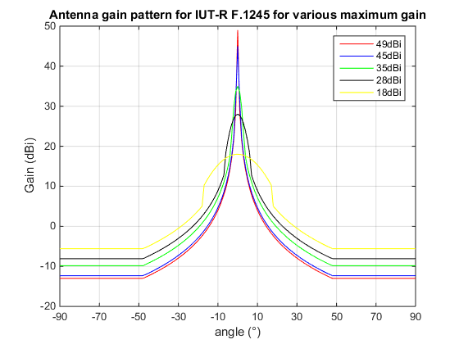

**b) Antenna elevation**

or the antenna elevation, the following values were taken into account: 0°, 1°, 2°, 3°, 4° and 5°.

**c) Examples of interference to noise ratio complementary cumulative distribution function for Scenario 1**

The variation in antenna gain, elevation angle and altitude leads to a total of 180 cases, to reduce the complexity of the report, some examples were selected.

The following two figures correspond to a fixed service station with maximum antenna gain of 49 dBi with elevation angles of 0° and 5°, respectively.

figure 24

**Interference to noise ratio exceedance 49 dBi and 0° fixed service antenna elevation**

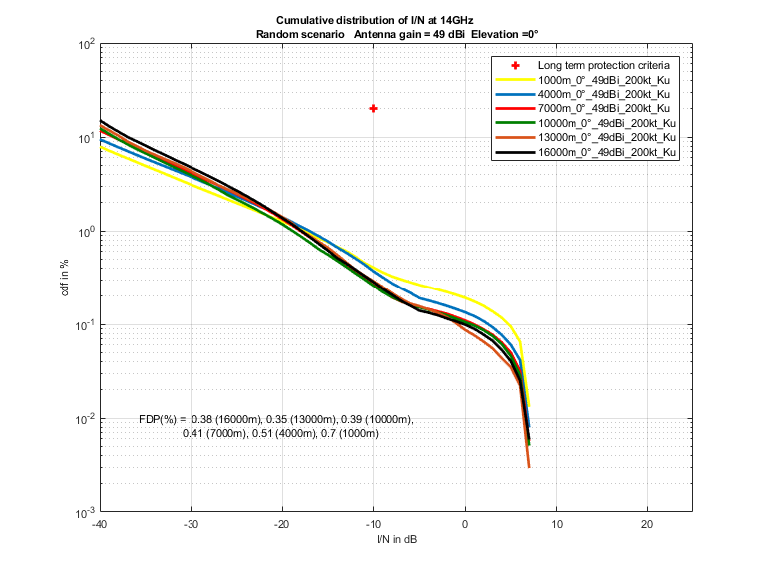

figure 25

**Interference to noise ratio exceedance 49 dBi and 5° fixed service antenna elevation**

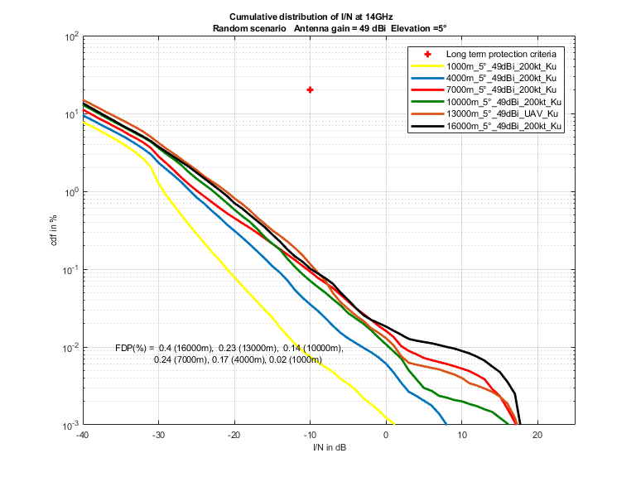

The following two figures correspond to a fixed service station with maximum antenna gain of 35 dBi with elevation angles of 0° and 5°, respectively.

figure 26

**Interference to noise ratio exceedance 35 dBi and 0° fixed service antenna elevation**

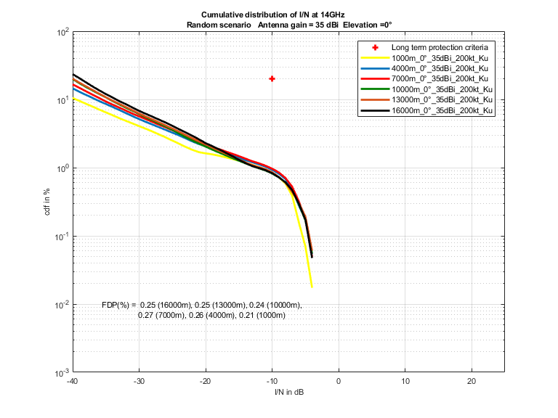

figure 27

**Interference to noise ratio exceedance 35 dBi and 5° fixed service antenna elevation**

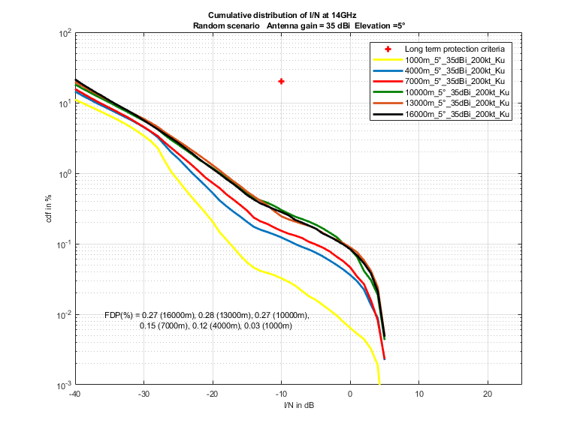

**d) Examples of interference to noise ratio complementary cumulative distribution function for scenario 2**

The variation in antenna gain, elevation angle and altitude leads to a total of 180 cases, to reduce the complexity of the report, some examples were selected.

The following two figures correspond to a fixed service station with maximum antenna gain of 49 dBi with elevation angles of 0° and 5°, respectively.

figure 28

**Interference to noise ratio exceedance 49 dBi and 0° fixed service antenna elevation**

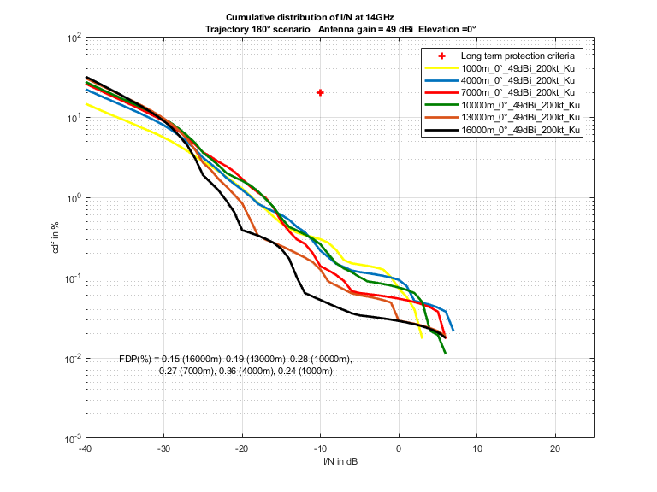

figure 29

**Interference to noise ratio exceedance 49 dBi and 5° fixed service antenna elevation**

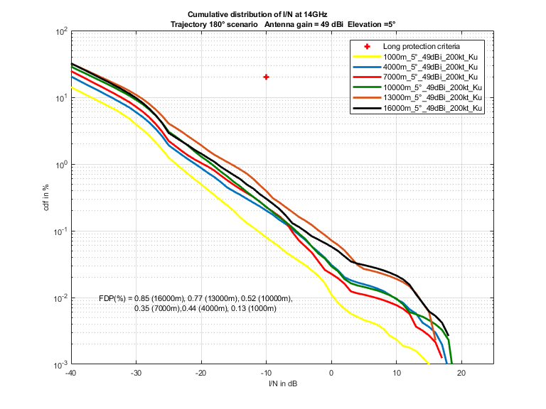

The following two figures correspond to a fixed service station with maximum antenna gain of 35 dBi with elevation angles of 0° and 5°, respectively.

figure 30

**Interference to noise ratio exceedance 35 dBi and 0° fixed service antenna elevation**

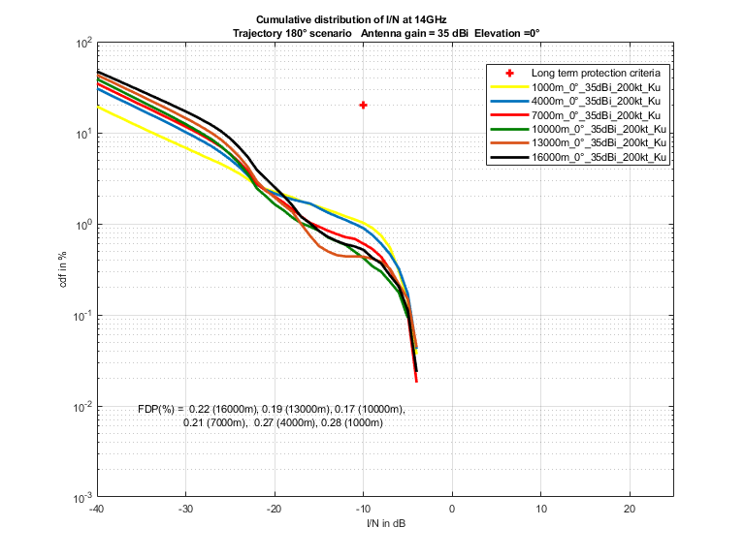

figure 31

**Interference to noise ratio exceedance 35 dBi and 5° fixed service antenna elevation**