|  |  |
| --- | --- |
| **US Radiocommunication Sector**  **FACT SHEET** | |
| **Working Party:** ITU-R WP 5B | **Document No:** USWP5B31-09 |
| **Reference:** 5B/731 Annex 15 – Annex 3 | **Date:** 11 April 2023 |
| **Document Title:** Sharing of the frequency band 15.4-15.7 GHz between RLS radars and future non-safety AM(OR)S systems | |
| **Author(s)/Contributor(s):**  Andrew Meadows  Air Force  Dominic Nguyen  eSimplicity for AFSMO | Phone: 334-467-4720  E-mail: [andrew.meadows.1@us.af.mil](mailto:andrew.meadows.1@us.af.mil)    Phone: 703-606-7394  E-mail: [dominic.nguyen@esimplicity.com](mailto:dominic.nguyen@esimplicity.com) |
| **Purpose/Objective:** The purpose of this document is to finalize the sharing studies between non-safety aeronautical mobile (off-route) service (AM(OR)S) and Radiolocation service in support of WRC-23 AI 1.10. | |
| **Abstract:** WRC-19 approved AI 1.10 for the WRC-23 study cycle to consider a possible introduction of new non-safety AMS applications in the 15.4-15.7 GHz band. During the November 2022 meeting, France/German requested US to include the Adaptive Transmit Power Control (ATPC) feature to the non-safety AM(OR)S system. This contribution includes the ATPC feature and finalizes the sharing studies between non-safety AM(OR)S and Radiolocation service. | |
| **Fact Sheet Preparer:** Dominic Nguyen | |

|  |  |
| --- | --- |
| **Radiocommunication Study Groups** |  |
|  |  |
|  |  |
| Source: Document 5B/731 Annex 15 – Annex 3  Subject: WRC-23 agenda item 1.10 | **Document 5B/XX** |
| **XX July 2023** |
| **English only** |
| |  | | --- | | United States of America | | Sharing of the frequency band 15.4-15.7 GHz between RLS radars and future non-safety AM(OR)S systems |   **1 Introduction**  The United States of America would like to finalize the sharing study between non-safety AM(OR)S and Radiolocation in the frequency band 15.4-15.7 GHz by providing some editorial and technical corrections for the multiple clusters analysis.  The United States proposals are in track changes. Attachment revisions are presented for consideration. | |

|  |
| --- |
| Attachment |
| |  | | --- | | Annex 15 to Working Party 5B Chairman's Report | | WORKING DOCUMENT TOWARDS A PRELIMINARY DRAFT NEW  REPORT ITU-R M.[NON-SAFETY AM(OR)S CHARACTERISTICS  AND SHARING STUDIES] | |  |   ANNEX 3 |
| **Sharing of the frequency band 15.4-15.7 GHz between RLS radars  and future non-safety AM(OR)S systems** |

There are no proposed changes prior to this point in the document.

…

**A3.4 Study D**

This section assesses sharing between multiple clusters of AM(OR)S stations operating in the frequency band 15.4-15.7 GHz and an RLS system operating in the band 15.4-17.3 GHz. It determines minimum separation zones around the RLS receiver to meet the protection criterion *I/N* = −6 dB.

**A3.4.1 Methodology**

The study evaluates the aggregate *I/N* variable at the RLS receiver, and determines the required separation distance to meet the protection criterion. The impact of GDTs (if some are present in a given scenario, for instance 6.2.1 and 6.2.3) is not taken into account. The simulation setup is described in Table A3-5 below. Figures A3-14 through A3-17 depicts the sharing scenarios between multiple clusters of AM(OR)S and radiolocation.

**A3.4.2 Results**

Figures A3-18 through A3-21 provide the ECDF of *I/N* measured at the RLS receiver in the four operational scenarios, in two different configurations of the AM(OR)S clusters. Figures A3-22 to A3‑25 repeat the simulation by introducing separation distances indicated in the title of each figure.

**A3.4.3 Summary**

Depending on the interference scenario under consideration and the AMS system characteristics, a separation distance is required between AM(OR)S and RLS stations.

TABLE A3-5

**Simulation setup of Study D**

|  |  | **Units** | **Scenario** | | | | | | | | |
| --- | --- | --- | --- | --- | --- | --- | --- | --- | --- | --- | --- |
|  |  |  | **6.2.1** | | **6.2.2** | | **6.2.3** | | | | **6.2.4** |
| **Clusters deployment** | | | | | | | | | | | |
| Number of clusters | | - | 5 | | | 3 | | | 4 | | 8 |
| Location | |  | All clusters randomized within 254 km from the radius of the simulations area | | | All clusters randomized within 484 km from the radius of the simulations area | | | All clusters randomized within 467 km from the radius of the simulations area | | All clusters randomized within 332 km from the radius of the simulations area |
| **AM(OR)S stations deployment within a cluster** | | | | | | | | | | | |
| Position of AM(OR)S stations inside a cluster | | - | ADTs randomized within 70 km from the GDT | | | According to Table 6-1 | | | Relay ADT randomized 300 km from the GDT; observation ADTs randomized 5 km from the relay ADT | | ADT#3 is fixed; ADT#2 and ADT#4 randomized within 500 km from ADT#3;  ADT#1 within 500 km from ADT#2; ADT#5 within 500 km from ADT#4 |
| Altitude of AM(OR)S stations AGL | | km | According to Table 6-1 | | | | | | | | |
| TPO | | dBm | Adapt the ATPC algorithm described in section A11.6.1 | | | | | | | | |
| Antennas of AM(OR)S stations | | – | According to section A1.2 | | | | | | | | |
| ADTs BW | | MHz | 10 | | 10 | | 10 | | | | 10 |
| GDTs BW | |  | 10 | | – | | 10 | | | | – |
| AM(OR)S stations centre frequency | | GHz | Randomized in 15.4-15.7 | | | | | | | | |
| **Simulation parameters** | | | | | | | | | | | |
| Simulation area radius | | km | 400 | | | 800 | | | 900 | | 1500 |
| PL ADTs – RLS | | dB | According to [Rec. ITU-R P.528-5](https://www.itu.int/dms_pubrec/itu-r/rec/p/R-REC-P.528-5-202109-I!!PDF-E.pdf) (with 5% time) | | | | | | | | |
| PL AM(OR)S Tx – AM(OR)S Rx | | dB | According to [Rec. ITU-R P.528-5](https://www.itu.int/dms_pubrec/itu-r/rec/p/R-REC-P.528-5-202109-I!!PDF-E.pdf" \o "A propagation prediction method for aeronautical mobile and radionavigation services using the VHF, UHF and SHF bands) (with 95% time) | | | | | | | | |
| Number of snapshots | | – |  | | |  | | |  | |  |
| **RLS receiver deployment** | | | | | | | | | | | |
| Location | | – | Randomized within the simulation area | | | | | | | | |
| Altitude AGL | | km | Uniformly randomized between 0.3 and 13.7, see Table A2-1 | | | | | | | | |
| Antenna pointing | | – | Uniformly randomized within ±45° in azimuth and between +5° and −45°  in elevation as per Table A2A-1 | | | | | | | | |
| Protection criterion | | – | *I/N* = −6 dB according to section A2.1.3 | | | | | | | | |
| Antenna | | – | According to section A2.1.2 and Attachment A to Annex 2 | | | | | | | | |
| Centre frequency | | GHz | Randomized in 15.4-15.7 | | | | | | | | |
| BW | | MHz | 25 | 25 | | | | 25 | | 25 | |

Figure A3-14

**Sharing studies between multiple AM(OR)S clusters and radiolocation   
based on the wildfire observation scenario**

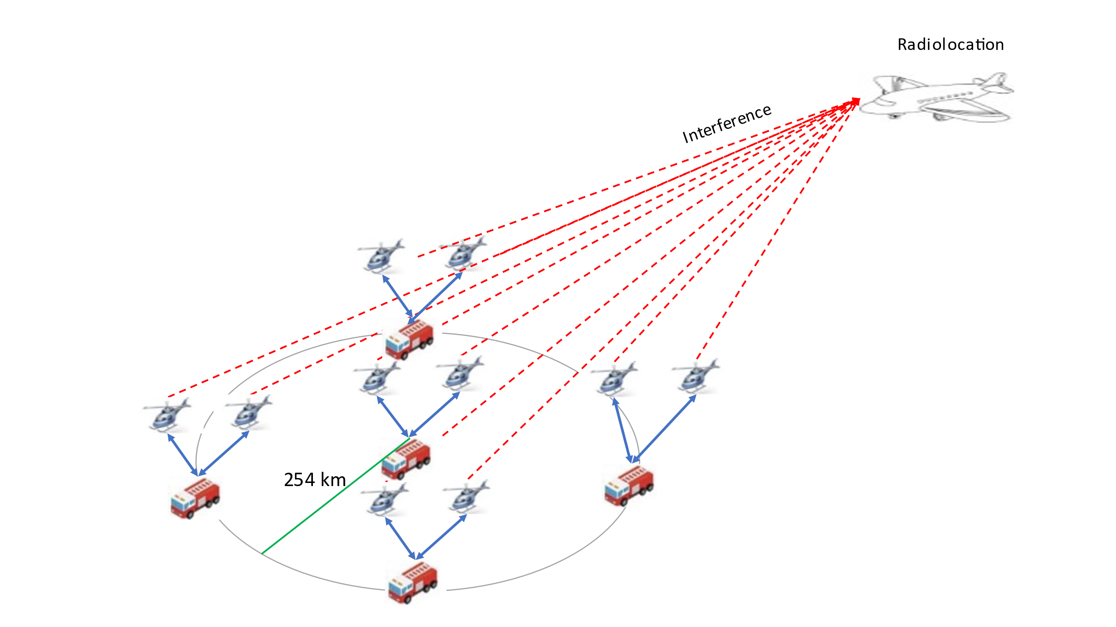

Figure A3-15

**Sharing studies between multiple AM(OR)S clusters and radiolocation based   
on the search and rescue scenario**

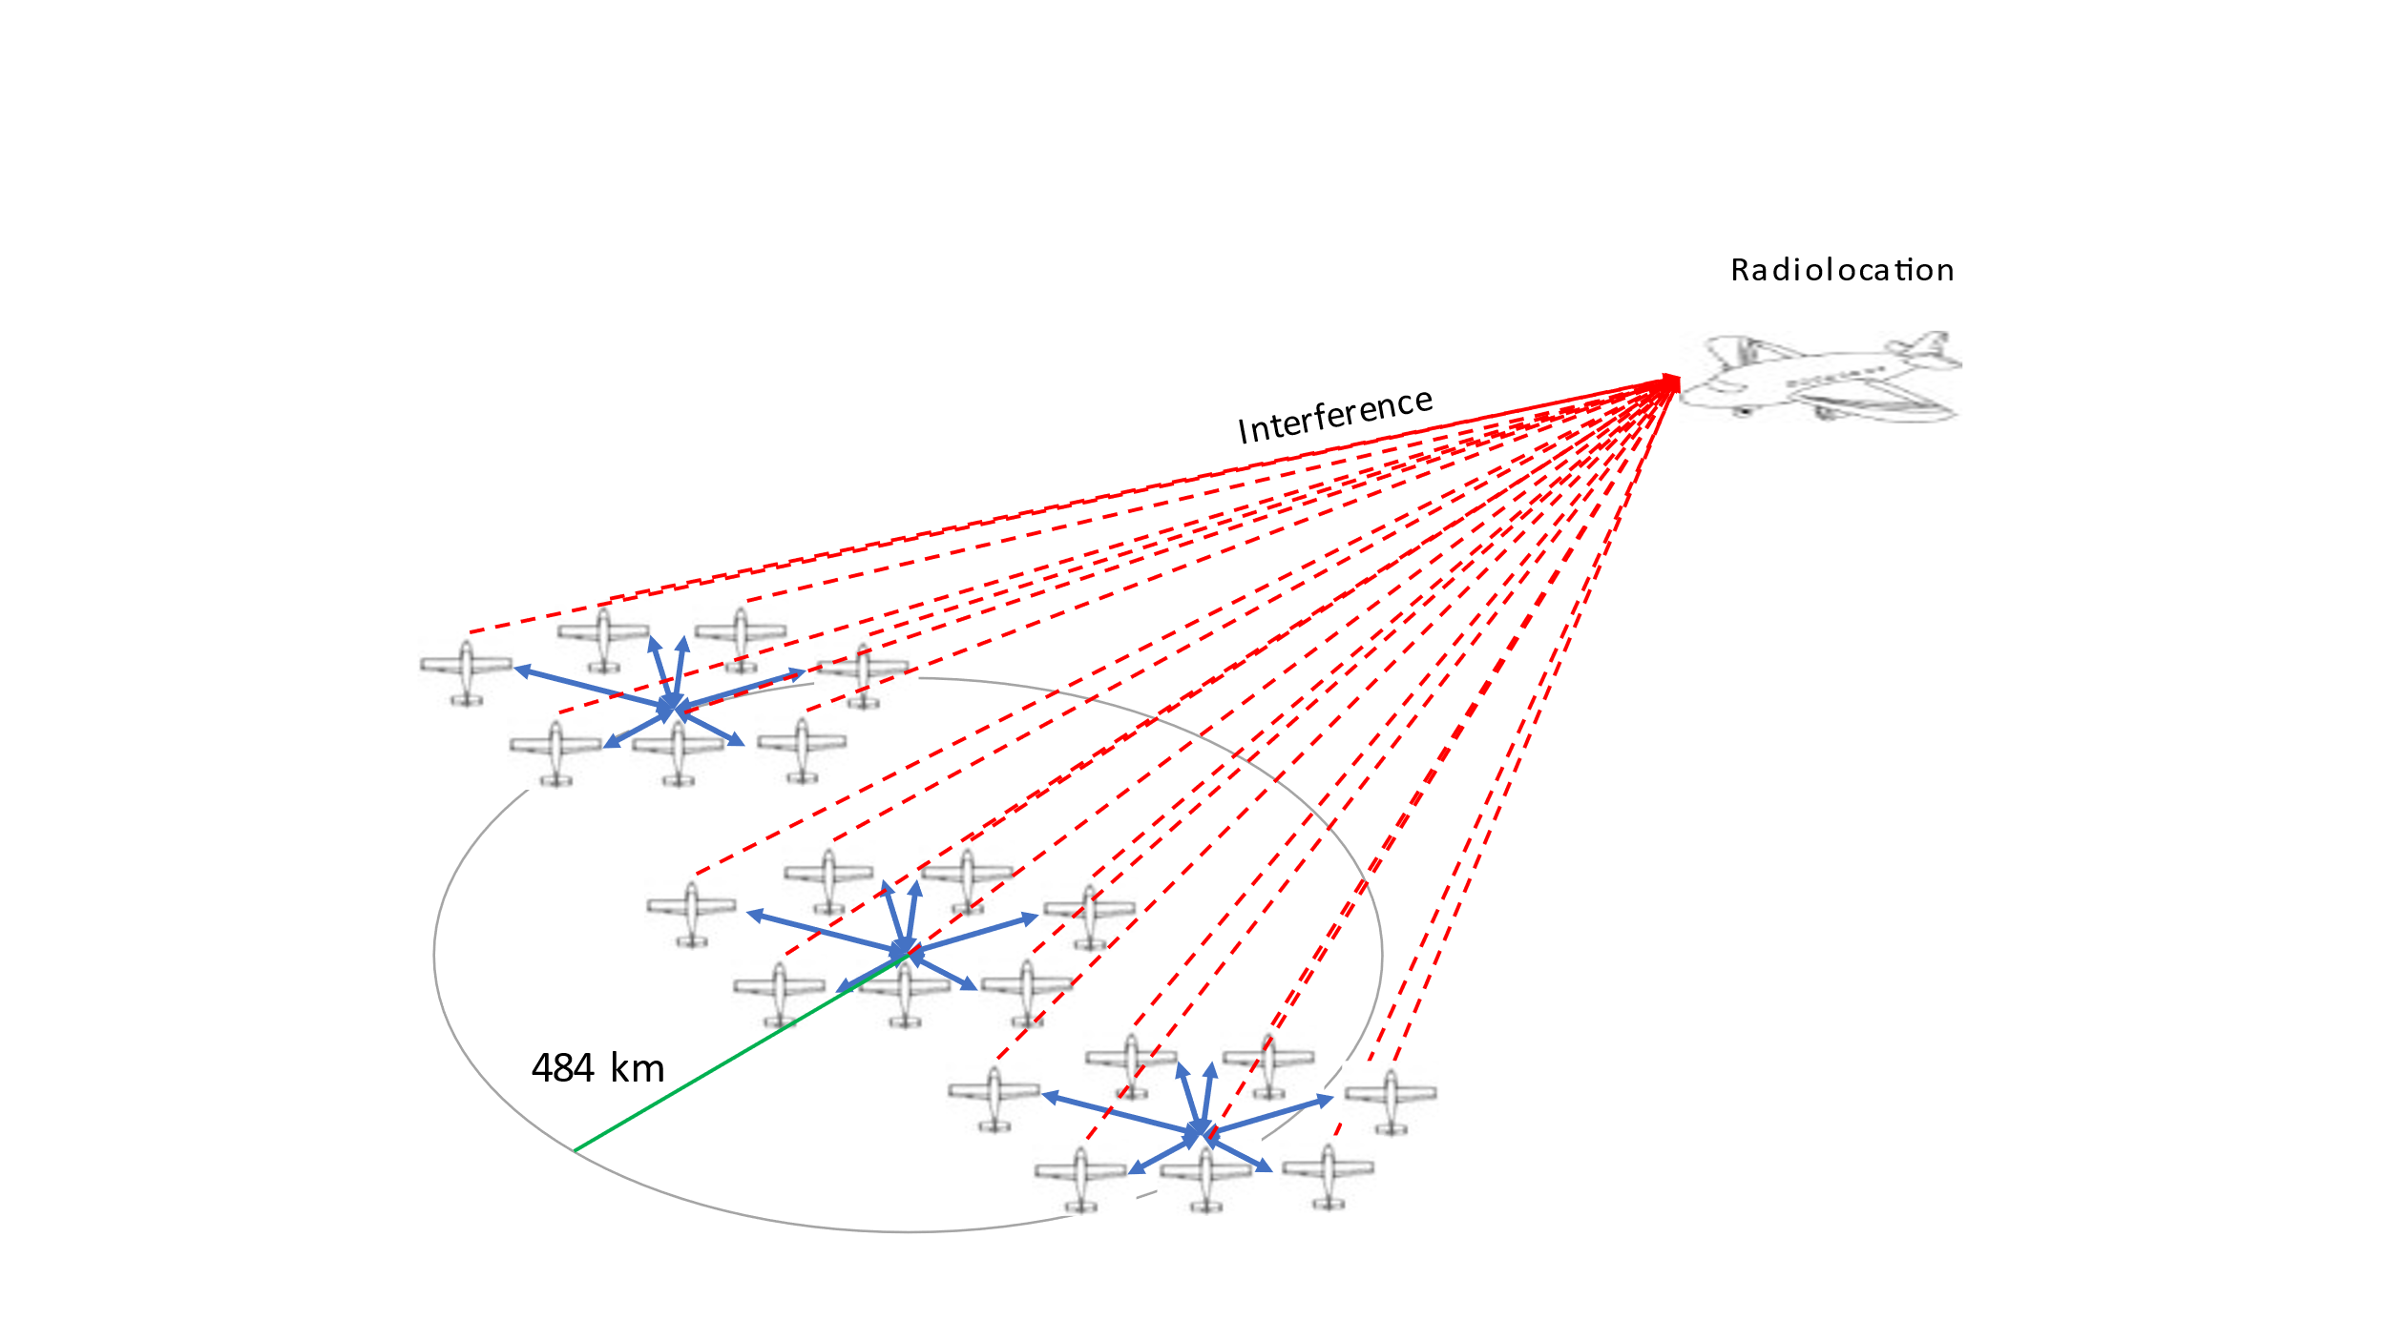

Figure A3-16

Sharing studies between multiple AM(OR)S clusters and radiolocation based   
on the surveillance mission scenario

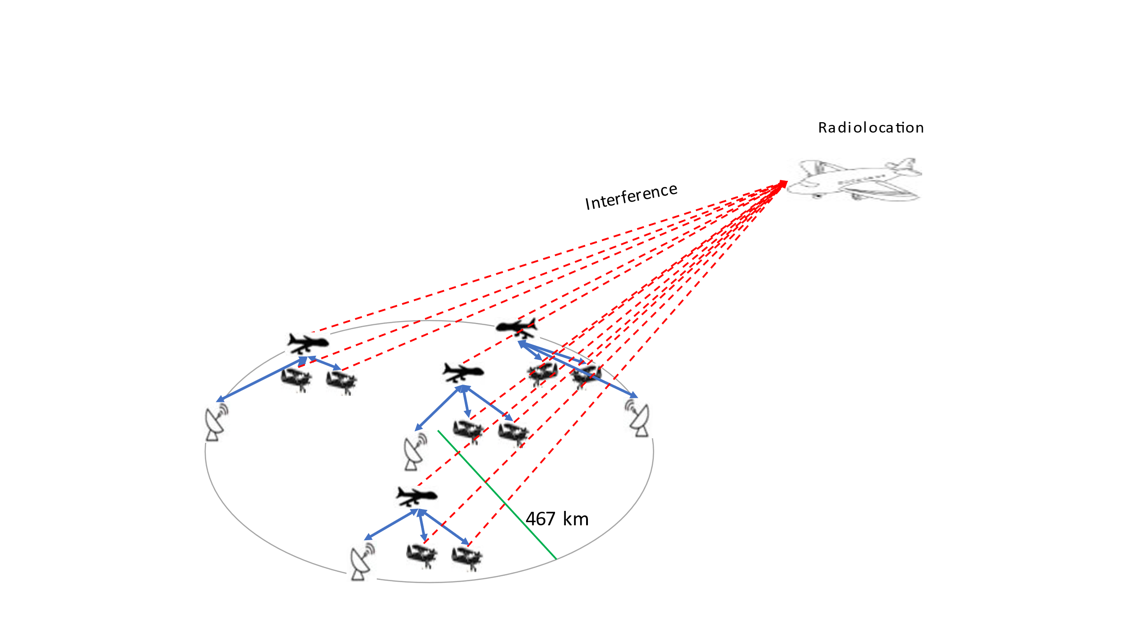

Figure A3-17

Sharing studies between multiple AM(OR)S clusters and radiolocation based   
on the Internet above the clouds scenario

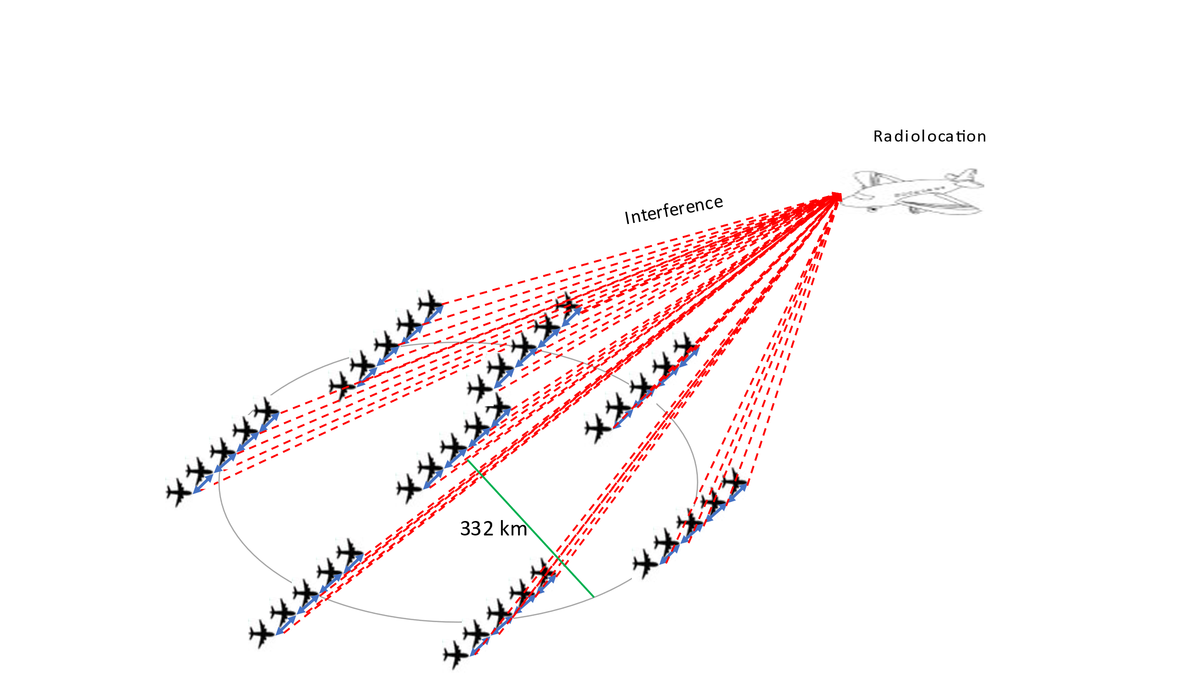

Figure A3-18

**ECDF (%) of *I/N* at the RLS receiver in scenario 6.2.1; the protection criterion of RLS (*I/N* = −6 dB)   
is indicated by a vertical red line; the left Figure is without ATPC, and the right Figure is with ATPC**

Figure A3-19

**As in Figure A3-18, in scenario 6.2.2**

Figure A3-20

**As in Figure A3-18, in scenario 6.2.3**

Figure A3-21

**As in Figure A3-18, in scenario 6.2.4**

Figure A3-22

**ECDF (%) of *I/N* at RLS receiver in scenario 6.2.1; RLS protection criterion is shown   
as a vertical red line; In the left Figure, 560 km exclusion zone in green and 565 km in blue; In the right Figure, 555 km exclusion zone in green and 560 km in blue**

Figure A3-23

**As in Figure A3-22, in scenario 6.2.2; In the left Figure, 1200 km exclusion zone in green and 1205 km in blue; In the right Figure, 1005 km exclusion zone in green and 1010 km in blue**

Figure A3-24

**As in Figure A3-22, in scenario 6.2.3; In the left Figure, 875 km exclusion zone in green and 880 km in blue; In the right Figure, 715 km exclusion zone in green and 720 km in blue**

Figure A3-25

**As in Figure A3-22, in scenario 6.2.4; In the left Figure, 1 435 km exclusion zone in green and 1 440 km in blue;** **In the right Figure, 1 330 km exclusion zone in green and 1 335 km in blue**

Table A3-6 below provides the separation distance between non-safety AM(OR)S and radiolocation.

Table A3-6

**Separation distance between systems operating in the aeronautical mobile service (off-route)   
and radiolocation service**

|  |  |  |  |  |
| --- | --- | --- | --- | --- |
|  |  |  | **Separation distance between Radiolocation and the center of non-safety AM(OR)S cluster deployment(km) without ATPC feature** | **Separation distance between Radiolocation and the center of non-safety AM(OR)S cluster deployment(km) with ATPC feature** |
| Figure 4-2 – Wildfire observation scenario |  |  | 565 | 560 |
| Figure 4-3 – Search and rescue scenario |  |  | *1205 | 1010 |
| Figure 4-4 – Surveillance mission scenario |  |  | 880 | 720 |
| Figure 4-5 – Internet above the clouds scenario |  |  | 1 440 | 1 335 |

*Editor’s note: For the Search and rescue scenario, the previous separation distance (720km) is from the edge of the AM(OR)S cluster to Radiolocation. The correct value is 1205 km for the distance between the center of the cluster to Radiolocation.

There are no proposed changes prior to this point in the document.