| **US Radiocommunication Sector**  **FACT SHEET** | | | |
| --- | --- | --- | --- |
| **Study Group:** USWP 5B | | **Document No:** USWP5B31-22 | |
| **Reference:** Document 5B/731 Annex 15-[Annex 9](https://www.itu.int/dms_ties/itu-r/md/19/wp5b/c/R19-WP5B-C-0731!N15-N09!MSW-E.docx) | | **Date:** 11 April, 2023 | |
| **Document Title:** Updates to Working document towards a preliminary draft new  report ITU-R [NON-SAFETY AMS CHARACTERISTICS AND SHARING STUDIES] | | | |
| **Authors** | **Telephone** | | **E-Mail** |
| Daniel Bishop, NASA  Ryan S. McDonough, NASA | 216-433-5220  216-433-2862 | | [daniel.w.bishop@nasa.gov](mailto:daniel.w.bishop@nasa.gov)  [Ryan.S.McDonough@nasa.gov](mailto:Ryan.S.McDonough@nasa.gov) |
| **Purpose/Objective**:  Propose minor updates to Working document towards a preliminary draft new report ITU-R [NON-SAFETY AMS CHARACTERISTICS AND SHARING STUDIES], building upon the chairman’s report from the November 2022 WP 5B meeting. | | | |
| **Abstract**:  This contribution seeks to further this work by addressing any remaining questions/comments posed in the Chairman’s Report Annex 15 regarding the studies of adjacent band compatibility between the potential new AMS allocation in 22-22.21 GHz and EESS (passive) in 22.21-22.5 GHz in A14.1 (Study B) of the working document. | | | |
| **Fact Sheet Preparer:** Ryan McDonough (NASA) | | | |

|  |  |
| --- | --- |
| **Radiocommunication Study Groups** |  |
|  |  |
|  |  |
| **Received:** XX May 2023  **Reference:** Document 5B/731 Annex 15-[Annex 9](https://www.itu.int/dms_ties/itu-r/md/19/wp5b/c/R19-WP5B-C-0731!N15-N09!MSW-E.docx) | **Document USWP 5B-XX** |
| **7 Dec 2022** |
|  |
| **United States of America** | |
| **Updates to Working document towards a preliminary draft new report ITU-R [NON-SAFETY AMS CHARACTERISTICS AND SHARING STUDIES]** | |
|  | |

**1. Introduction**

This contribution seeks to further this work by addressing any remaining questions/comments posed in the Chairman’s Report Annex 15 regarding the studies of adjacent band compatibility between the potential new AMS allocation in 22-22.21 GHz and EESS (passive) in 22.21-22.5 GHz in A14.1 (Study B) of the working document.

**2. Proposal**

Consider revisions to the Chairman’s Report for inclusion in the Working Document as appropriate.

|  |  |
| --- | --- |
| **Radiocommunication Study Groups** |  |
|  |  |
|  |  |
| Source: Document 5B/TEMP/297 | **Annex 9 to Doc. 5B/731 (Annex 15)-E** |
| **12 January 2023** |
| **English only** |
| Annex 15 to Working Party 5B Chairman's Report | |
| WORKING DOCUMENT TOWARDS A PRELIMINARY DRAFT NEW  REPORT ITU-R M.[NON-SAFETY AM(OR)S CHARACTERISTICS  AND SHARING STUDIES] | |
|  | |

ANNEX 9

Compatibility studies between future non-safety AM(OR)S systems planned to operate in 22-22.21 GHz and EESS (passive) in 22.21-22.5 GHz

Table of contents

Page

A9.1 Study A 2

A9.1.1 Methodology 2

A9.1.2 Results 8

A9.1.3 Summary 8

A9.2 Study B 9

A9.2.1 Calculation of aggregate interference 9

A9.2.2 Simulation parameters for AM(OR)S 10

A9.2.3 Simulation parameters of EESS (passive) 10

A9.2.4 Results 15

A9.2.5 Summary 18

The frequency band 22.21-22.5 GHz is globally allocated to the EESS (passive) on a primary basis. This annex contains two studies that evaluate the maximum unwanted emission limits in this band of AM(OR)S stations planned to operate in the adjacent band 22-22.21 GHz.

## A9.1 Study A

This study determines the OOB emissions limits of future AM(OR)S transmitters planned to operate in the frequency band 22-22.21 GHz to protect EESS (passive) space borne sensors operating in the adjacent band 22.21-22.5 GHz.

### A9.1.1 Methodology

#### A9.1.1.1 Introduction

The unwanted emissions characteristics of future AM(OR)S systems are provided in Table A1-1 and graphically represented in Fig. A1-1 in Annex 1. The study takes a Monte Carlo approach well explained in Annex 13 with some specificities highlighted in the following sections.

#### A9.1.1.2 EESS (passive) characteristics

A typical EESS (passive) space borne sensor operating in the frequency band 22.21-22.31 GHz i.e., at the lower edge of the EESS (passive) band is described in Table A2-10 of this Report. It is considered representative of other sensors operating under the same allocations and taken as a basis for the study.

According to Table A2-10, the trajectory of the satellite hosting this sensor is a retrograde circular orbit with 98.6° inclination and 833 km altitude AGL. The longitude of the ascending node at the beginning of the simulation has little influence on the results but for definiteness, it is chosen as 0°. The study considers a complete revolution of the satellite around the Earth i.e., which has a duration of 110 min according to the standard Keplerian model.

Figure A9-1 below shows the successive positions over the revolution in the ECDF coordinate framework. Figure A9-2 further shows the successive positions of the sub-satellite point on a projected map.

Figure A9-1

Assumed orbit in the ECDF coordinate framework of the EESS (passive) satellite hosting sensor S1 over a complete 110 min revolution; the time stamp associated to each position is read from the attached colour bar

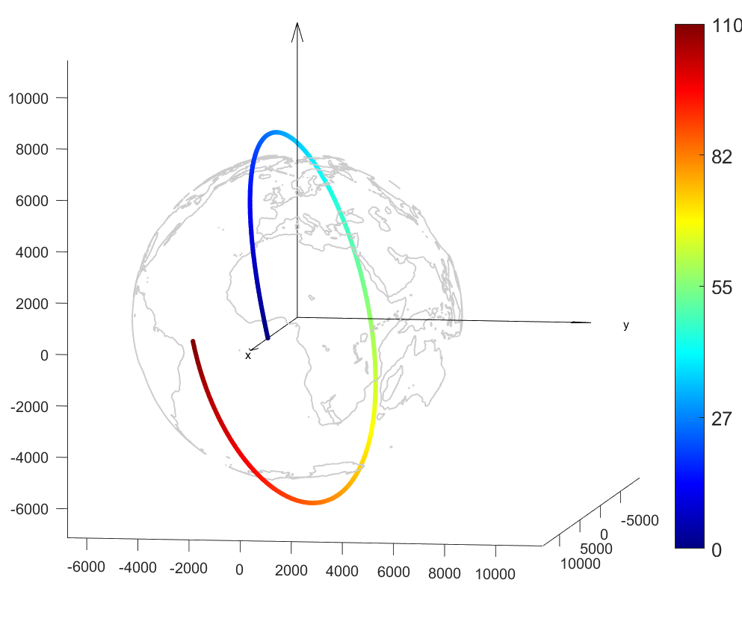

Figure A9-2

As in Figure A9-1 but showing the position of the sub-satellite point in a projected map

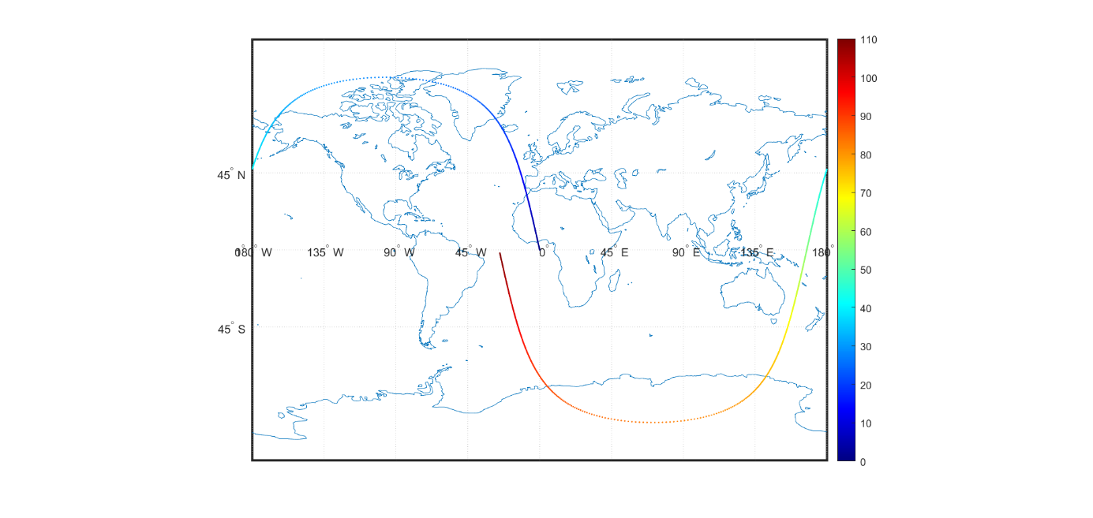

The frequency band 22.21-22.5 GHz is used for meteorological measurements related to the rain and the water vapour in the atmosphere. According to section 4.1 in Recommendation ITU-R RS.1861‑1, this kind of sensor has a fixed pointing.

According to Table A2-10, the antenna associated to the sensor S1 is offset 45° from the nadir, to the right in the direction of the movement, so that the incidence angle at the surface of the Earth is constant and equals 53.1°. Figure A9-3 shows the direction of the antenna boresight during the considered revolution of the satellite.

Figure A9-3

Successive orientation of the antenna boresight; the time associated to each position can be read   
from the attached colour bar

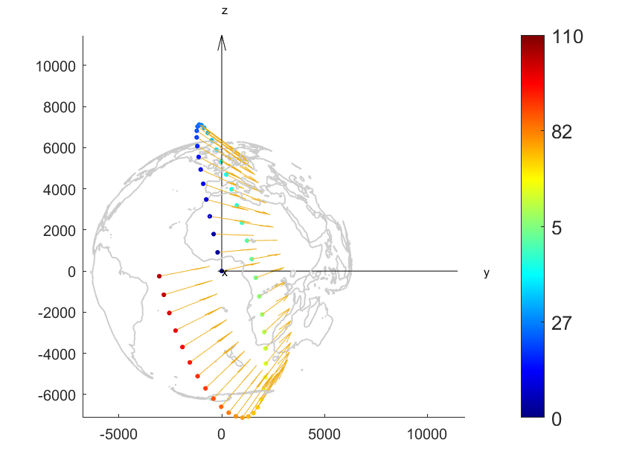

The swath of the sensor is determined from the pointing of the antenna and the beam characteristics. According to Table A2-10, the swath width is 1 707 km. Figure A9-4 shows the footprint of the sensor on the Earth ball.

Figure A9-4

Footprint of the sensor S1 over a complete revolution of the satellite; the swath has a width of 1 707 km

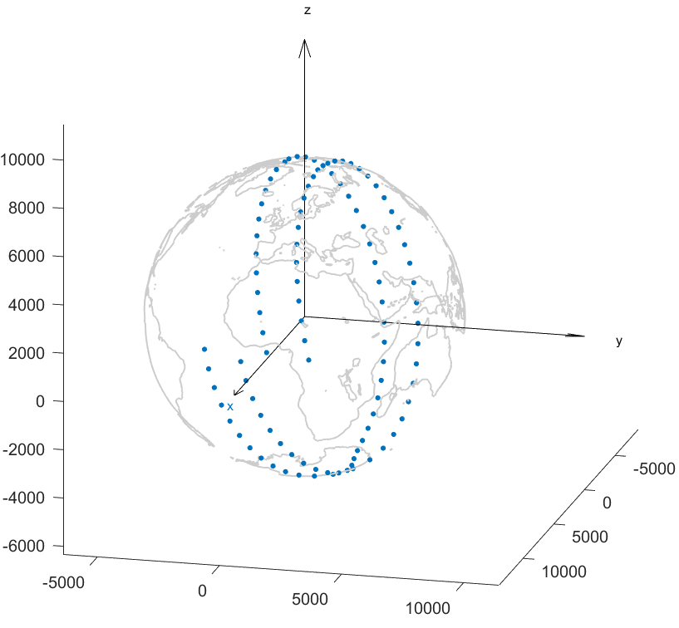

The satellite can be assumed to perform measurements over the complete surface of the Earth. However, for compatibility studies, Recommendation ITU-R RS.2017-0 prescribes to perform analysis over a 10 000 000 km2 area of interest. It is chosen arbitrarily over Europe, and considering the satellite speed on its orbit and the swath width of 1 707 km, this area of interest is observed between *t* = 9.9 min and *t* = 25.9 min.

Figure A9-5 shows this area of interest on the Earth ball.

The aggregate interference power level from AM(OR)S transmissions is calculated for all successive positions of the satellite when it flies over the area of interest. The complete satellite orbit is divided in 1 000 evenly spread sample points. The area of interest is limited by the 90th and the 235th sample points so that 146 aggregate interference values can be generated per revolution of the satellite.

In order to achieve statistical significance, the same revolution is repeated until 1 000 000 samples are obtained i.e., the revolution is repeated 6 849 times. Finally, an ECDF curve is drawn and compared against the protection criterion of EESS (passive) highlighted in section A2.5.3 of this Report, according to which at most 0.1% of the samples should be above −139 dBm measured in the band 22.21-22.31 GHz.

Figure A9-5

Successive positions of the satellite between *t* = 9.9 min and *t* = 25.9 min, and area of interest

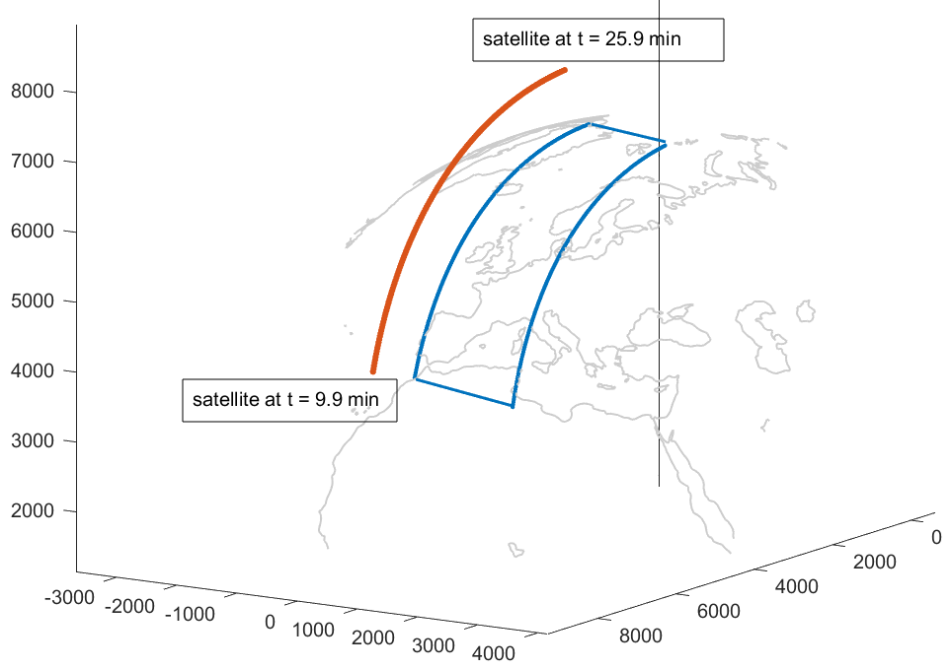

#### A9.1.1.3 AM(OR)S characteristics

While other Monte Carlo sharing and compatibility studies in this Report have considered independent snapshots, i.e. a new deployment of AM(OR)S stations from one snapshot to the other, this study has reproduced the actual cruising of aircraft over the surface of the Earth. This has been made in order to capture potential interference segments i.e., series of snapshots producing an aggregate interference level of more than −139 dBm/100 MHz due to the successive positions of aircraft.

Also, while other studies in this Report considered the four operational scenarios described in section 6.2, this study has taken a more generic approach by considering independent airborne data terminals (ADTs) flying at 900 km/h with constant bearing at an altitude of 15 km AGL (the exact altitude having little influence on the results), which is the maximum height of AM(OR)S system referenced in Table A1-1. The ADTs are equipped with AM(OR)S System 3 (see Table A1-1). The receiving station has not been simulated, but two different configurations of the antenna have been considered:

– 45° above the local horizon, i.e. an “upwards WBLOSDL” in the sense of section 5.3;

– no elevation, i.e. an “horizontal WBLOSDL”.

A number of these AM(OR)S transmitters is deployed over the area of interest. To make sure that interference from ADTs outside of the area of interest is also taken into account, the deployment zone extends over the boundaries of the footprint. Figures A9-6 and A9-7 respectively show the area of interest and deployment zone of the ADTs on a projected map.

Figure A9-6

Area of interest (approximately 10 000 000 km2)

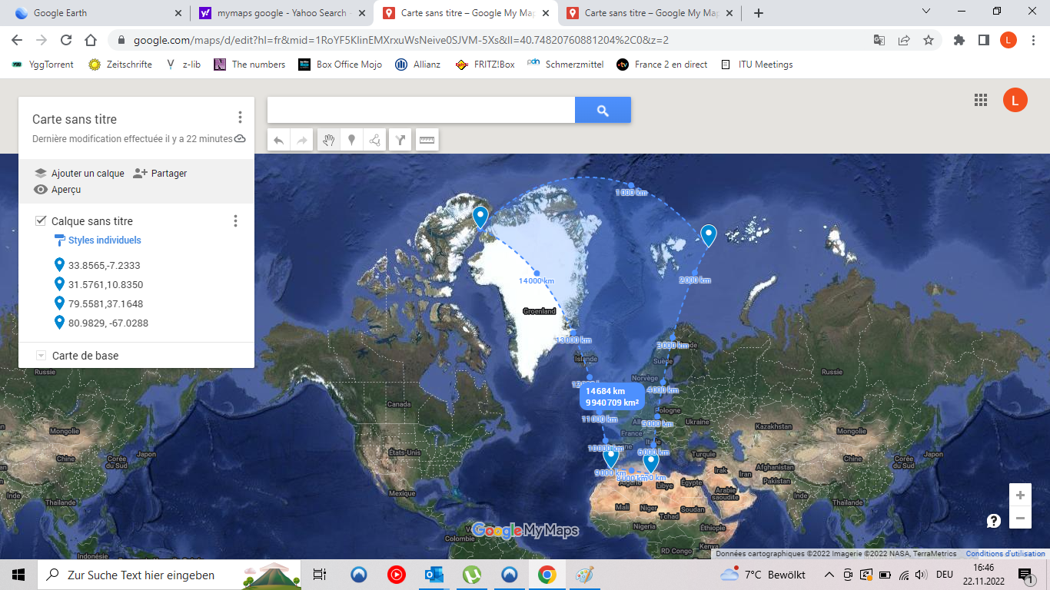

Figure A9-7

Area of interest (blue marks) and deployment zone of the ADTs (red marks)

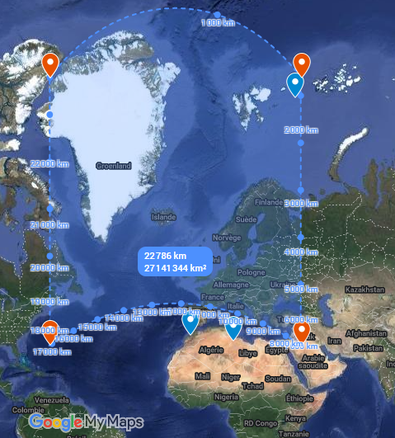

Figure A9-8 shows an exemplary run of the simulation i.e., a revolution of the EESS satellite, where 100 AM(OR)S stations are deployed at *t* = 0 s and travel for 110 minutes. One can see that some trajectories start in the area of interest and eventually get out of it, or even out of the deployment area before the end of the simulation.

Figure A9-8

Trajectories of 100 AM(OR)S transmitters over the 110 min satellite revolution

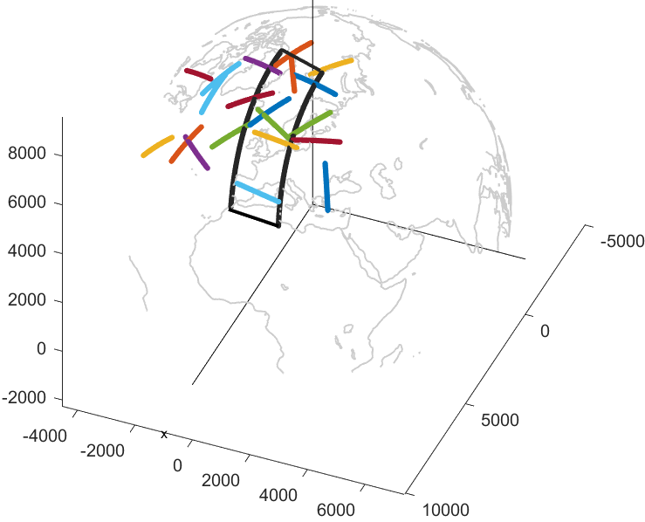

For illustration purposes, Fig. A9-9 shows the measured aggregate interference level at the EESS sensor over a complete trajectory. In this example, and in this example only, 5 000 AM(OR)S stations have been deployed over the whole globe. Other characteristics are indicated in the title of the figure. In this example, 3 samples have returned an interference level greater than −139 dBm/100 MHz but none of them were located in the area of interest.

Figure A9-9

Variation of the aggregate interference level at the EESS sensor over the whole trajectory; the passage over the area of interest is marked between green lines; density of stations is [49/10 000 000 km2]; OOB limit is 0 dB(W/100 MHz); pointing is 45° above the local horizon

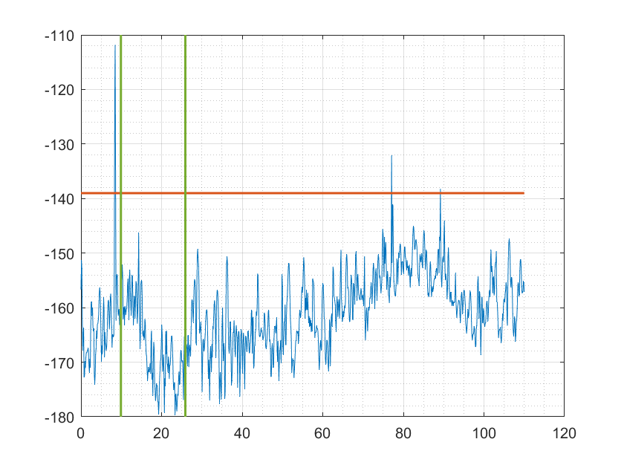

#### A9.1.1.4 Calculation principle

The goal of the analysis is to determine the unwanted emission limit in 22.21-22.31 GHz to apply to all ADTs so that the EESS (protection) criterion mentioned further above is met. In that respect, ADTs are assumed to use a channel of 100 MHz with flat PSD that completely overlaps with the measurement band 22.21-22.31 GHz of the sensor. This is relevant for the purpose of this analysis even though WRC-23 A.I. examines only the possibility to allocate the adjacent band 22-22.21 GHz to the AM(OR)S.

For a given density, this unwanted emission limit is searched by attributing a transmit power output to the ADTs, collecting 1 000 000 interference samples in the area of interest i.e., by simulating 6 849 revolutions and plotting the ECDF of these samples. If the protection criterion of EESS is not met, the power level is decreased and the whole simulation repeated. The first power level that meets the protection criteria is the actual unwanted emission limit.

### A9.1.2 Results

TABLE A9-1

Unwanted emissions limits for ADTs in dB(W/100 MHz) in 22.21-22.31 GHz

|  |  |  |
| --- | --- | --- |
|  | Number of ADTs in the MAI (10 000 000 km2) | |
| 1 | 5 |
| Upwards (+45°) | −1 | −18 |
| Horizontal (0°) | −1 | −15 |

### A9.1.3 Summary

Depending on the configuration of AM(OR)S stations and their density inside the area of interest of the EESS (satellite) hosting the S1 sensor, the average unwanted emissions in the band 22.21‑22.5 GHz should be kept below −1 and −18 dB(W/100 MHz).

## A9.2 Study B

### A9.2.1 Calculation of aggregate interference

An assessment of the aggregate RFI expected from non–safety AM(OR)S systems into EESS (passive) is achieved by a dynamic simulation. The analysis will be conducted in which the orbit of the EESS (passive) spacecraft under investigation is dynamically simulated i.e. actual flight paths as contrasted with statistical distribution “snapshots”. Calculations will be performed to determine the potential interference from the proposed non–safety AM(OR)S systems into the EESS (passive) band and will consider the aggregate effect from multiple sources. The simulation will propagate the satellite based on its orbital parameters, and the time step is selected to be an irrational number to ensure that the beam dynamics of the passive sensor do not exhibit periodic behavior. At each time step, the simulation will compute the directional vectors from each source to the EESS (passive) and then compute the gain of the transmit and receive antennas using their respective antenna patterns.

The interfering signal power level, (W), received by a spaceborne radiometer at the timestep from the active transmitter is calculated from:

(A9-1)

where:

: i-th AM(OR)S source transmitter power (W) in the EESS (passive) band, adjusted for power control as described in section A11.6.1

: i-th AM(OR)S source antenna gain towards spaceborne sensor

: spaceborne receive antenna gain towards i-th AM(OR)S source

: attenuation due to atmospheric absorption between i-th AM(OR)S source and space borne sensor

: free space path loss between i-th AM(OR)S source and space borne sensor

: losses (dB) due to polarization mismatch between i-th AM(OR)S source and spaceborne sensor.

The aggregate interference at the timestep, (W), is calculated by the summation of the received interference from active AM(OR)S stations within line of sight of EESS (passive):

(A9-2)

Thus, the aggregate interference can be represented in the logarithmic domain as:

(A9-3)

Based on time series values for the interfering signal power level, a CCDF curve will be generated in order to assess if the result exceeds the recommended performance and interference criteria that are defined in Recommendation ITU-R RS.2017-0. The criteria will be used as a metric to assess the impact that the non–safety AM(OR)S allocation would have on the EESS (passive) systems operating in the 22.21-22.5 GHz band. From Recommendation ITU-R RS.2017-0, outlined in section A4.4.3 of this Report, the following is prescribed for the frequency range 22.21-22.5 GHz:

– reference bandwidth: 100 MHz;

– maximum interference level: −169 dBW;

– percentage of area or time permissible interference level may be exceeded: 0.1%;

– the area analyzed should be 10 000 000 km2.

The selection of the simulation area will be chosen to reflect the operational area of sensors operating in the 22.21-22.5 GHz band.

**Determination of Out-of-band limit (OOBL)**

The methodology is applied for each scenario described in section 6.2 and taking into account the calculation scheme previously described in this section but also including out-of-band attenuation characteristics from section A1.1:

1. Determine the simultaneous apparent value of antenna gain coupling between one EESS (passive) system and one AM(OR)S system at 0.1% of occurrence. This value is subsequently the sum of antenna gains between a pair of active systems (EESS + AM(OR)S for a given unitary event as simulated according to A9.2.3. This value is denoted parameter α.
2. Determine the value of RF propagation loss according to section 8.2 between one EESS (passive) system and one AM(OR)S system at 0.1% of occurrence. Again as in 1), this value is taken from the simulation statistics between paired systems. This value is denoted parameter β.
3. Determine the maximum number of AM(OR)S systems that can operate under the simulation parameters described in section A9.2.3 under the condition of not exceeding the protection limit -169 dBW/100MHz at 0.1%. This value is denoted parameter γ.
4. The out-of-band limit for a single AM(O)RS system under a given scenario is computed as

(A9-X)

### A9.2.2 Simulation parameters for AM(OR)S

The AM(OR)S OOB emissions inside the target range 22.21-22.31 GHz was calculated from Fig. A1‑1 in Annex 1.

AM(OR)S system selection as well as operational altitude, and horizontal link distances for each scenario are selected from guidance by Table 6-1 as well as antenna characteristics via Table A1-2.

The 22.21-22.5 GHz EESS (passive) analysis of this study will focus on current available representative characteristics of AM(OR)S systems within this frequency range. If the deployment densities are significantly different from the values referenced in section 6.4 of this Report, the simulation will need an update to verify co-existence potential. The calculation methodology from section A9.1.1 is inherited for consideration of aggregated emission reception.

This analysis assumes the band edge reduction and incursion into the OOB region as described in section A1.1 and Fig. A1-1. This equates to −10.3 dB FDR (Channel 1, 50 MHz) and −45.83 dB FDR (Channel 2, 50 MHz) in the EESS (passive) frequency band of 22.21 to 22.31 GHz. If more than two channels are utilized by a scenario (e.g. scenario 6.5), then channels further away from the band edge than the two immediately adjacent band are subject to even more FDR and will have significantly less impact on observed interference power in-band of the EESS passive than the nearest two to the band edge. If the FDR is lower than the presumed value, the simulation and co-existence may have to be revaluated. It noted that the intended allocation of AM(OR)S frequency segments within the 22-22.21 GHz is not limited to the band edge cases. However, for this study it is the objective to determine the maximum density of AM(OR)S systems operational near the band edge (within 100 MHz of the edge), which can be supported and simultaneously protecting incumbent EESS systems in the neighboring band.

### A9.2.3 Simulation parameters of EESS (passive)

The operational altitude of the EESS (passive) sensor and antenna pattern are described in section A2.5 and are 833 km and Recommendation [ITU-R RS.1813-1](https://www.itu.int/dms_pubrec/itu-r/rec/rs/R-REC-RS.1813-1-201102-I!!PDF-E.pdf) respectively.

The analysis band for this study is 22.21-22.31 GHz centered at 22.26 GHz. An AM(OR)S emission center frequency of 22 160 MHz, 50 MHz from the band edge, with a 100 MHz bandwidth was chosen to be in line with the EESS (passive) protection criteria of −169 dB(W/100 MHz). Subsequent channels incorporate a 50 MHz offset further away from the band edge to accommodate channel assignment specific to AM(OR)S scenarios. Analysis was done along the band edge to determine the level of unwanted emissions into the EESS (passive) band. Table A9-1 below gives the rest simulation parameters that were assumed for this simulation.

Table A9-2

General simulation parameters

| Parameter | Units | Value |
| --- | --- | --- |
| Simulation frequency | MHz | 22 160 |
| Duration | days | 30 |
| Time step | sec. | 0.5 × π |
| Atmospheric losses | – | P.676-13 |
| RF prop. models  Air-space  Ground-space | Rec. ITU-R P.1409-2 Rec. ITU-R P.619-5 |
| Polarization losses | dB | 3 (C-V) |
| FDR | 10.3 (C1), 47.0 (C2) |

The simulation was run for a 30-day duration with a 0.5 × π second time step to collect an appropriate amount of sample points to achieve statistical significance of results. Atmospheric losses (*La*) were calculated using Recommendation ITU-R P.676-13. According to guidance from WPs 3K and 3M liaison statement Document 5B/369 the preferred propagation model for ground-space interference computations is Recommendation ITU-R P.619-5 and the preferred propagation model for ground‑air interference computations is Recommendation ITU-R P.1409-2. These were implemented to produce propagation losses noting that Recommendation ITU-R P.619-5 and Recommendation ITU‑R P.1409-2 internally account for atmospheric losses attributed to use of Recommendation ITU‑R P.676. The irrational time step of 0.5 × π was chosen to create a random non-uniform distribution of the EESS (passive) locations and azimuth pointing angles during satellite orbit within the simulation run time.

The RF and general parameters of the AM(OR)S system under simulation were derived from System 1 of Table A1-1 in section A1.1. In the absence of an explicit deployment, a generic one was considered and provisionally proposed to be representative. Two configurations were constructed which aim to approximate the description of “Wildfire Detection” found in section 6.2.1, “Search and Rescue” found in section 6.2.2, “Borer Surveillance Mission” found in section 6.2.3, and “Data Networks” found in section 6.2.4.

Note that for the following four configuration scenarios the operational parameters were adapted from section 6.3 “Technical setup of the scenarios”. For instance, geometric spacing and relative location are adapted from Table 6-1. Additional technical parameters implemented (which may not be explicitly stated in section 6) in order to illustrate interaction with the EESS (passive) system are taken into account individually in the following descriptions.

For the first configuration (operational scenario 6.2.1, Wildfire observation), a density of randomly deployed ground central locations was placed in a ground centred 10 million km2 EESS passive mission area of interest (MAI) centred at 68° W, 0° N, with associated ground stations taken in ratio 2 to 1 ground to air stations. See Figs A9-1 and A9-2, with associated ground stations taken in ratio 2 to 1 ground to air stations. Communication between air and ground station enforced a pointing arrangement consistent with section 6.2.1 were based on shortest distance to ground receiver. Channel assignment was allocated on a sequential basis in accordance with section 6.5 “Spectrum occupancy” Table 6-5. A single experimental simulation was performed for each transmitter density deployment and the repetition of the run may serve to establish bounds of uncertainty in a subsequent iteration of this study. The aim of this analysis was to determine what density of systems could operate a downlink main beam within the MAI without imposing harmful interference to the EESS (passive) service.

The second configuration (scenario 6.2.2, Search and Rescue), a density of randomly deployed clusters was placed in a ground centred 10 million km2 EESS passive mission area of interest (MAI) centred at 68° W, 0° N. Each cluster was defined by seven coordinated aeronautical users operating bi-directional air-air links within the specially defined region. In this scenario, altitude is varied nominally, and average relative spacing between craft remains roughly constant with cluster centre and individual craft performing exploration similar to behaviour of a random walk (for purposes here adequately approximate expected flight trajectories).

The third configuration (scenario 6.2.3, Border Surveillance Mission), a density of randomly deployed clusters was placed in a ground centred 10 million km2 EESS passive mission area of interest (MAI) centred at 52° W, 14° S. Each cluster was defined by two coordinated aeronautical observation users operating in relay (air-air bidirectional links) with an additional aircraft which communicates (return link) with a single ground station located within the specially defined region.

For the fourth configuration (operational scenario 6.2.4, Data Networks), a list of commercial air-routes was used to serve as the navigational reference basis for AM(OR)S device air platform station emissions. The density of flight paths is taken to be representative of the route traffic given by the dataset. Air-air transmissions consistent with the description in section 6.2.4 were established which enforced a pointing arrangement based on shortest distance to air-based receiver. Channel assignment was allocated on a sequential basis in accordance with section 6.5. Transmissions are assumed to be continual during nominal flight, and pointing assignment (pair-assignment) is on the basis of nearest neighbour. Operational altitude of a cluster is 10 km. A single experimental simulation was performed, and the repetition of the run may serve to establish bounds of uncertainty in a subsequent iteration of this study. The aim of this analysis was to determine the density of systems that could operate a return (air-air link) within the MAI without imposing harmful interference to the EESS passive service. Two 10 million sq. km EESS passive MAIs centred at (68° W, 0° N) and (91° W, 0° N) were considered as representatives of over ground and oversea areas, respectively. See Figs A9‑1 and A9-2.

The example R1 MAI to be used for this simulation was selected over the both Amazon River basin and oversea MAI.

When the EESS R1 sensor main beam is within the MAI, the active air-air and air-ground links with line-of-sight to the R1 were computed and aggregated receive power density computed using section A9.1.1. Interference events are considered only for that time that the EESS R1 sensor is making measurements from within the MAI. However, an extension of the MAI of 1 degree in each direction was used to determine those aeronautical systems that could additionally contribute interference.

Figure A9-10 shows the ground demark of the EESS R1 MAI utilized for all simulation runs of configurations 1 and 4 (over ground case).

Figure A9-11 shows the ground demark of the EESS R1 MAI utilized for all simulation runs of configurations 4 (oversea case).

Figure A9-12 shows the aeronautical flight paths utilized by subsequent simulation runs of configuration 4 (over ground case). The source of this data set given in public domain by [openflights.org](https://openflights.org/data.html).

Figure A9-13 shows routes in and immediately around the MAI utilized by subsequent simulation runs of configuration 4 (over ground case).

Figures A9-14 and A9-6 show routes in and immediately around the MAI utilized by subsequent simulation runs of configuration 4 (oversea case), for low and high route density, respectively.

Figure A9-15 shows the ground station segment utilized by subsequent simulation runs of configuration 1. Also plotted is the EESS R1 MAI for reference.

Figure A9-16 shows the air station segment utilized by subsequent simulation runs of configuration 1. Also plotted is the EESS R1 MAI for reference.

Figure A9-17 shows the antenna pattern for sensor R1 utilized by subsequent simulation runs. Figure A9‑18 shows the antenna pattern for AM(OR)S air-stations utilized by subsequent simulation runs.

Figure A9-19 shows the selectivity curves used by simulations including both the receiver and emission source for the case of the emission occupying the band subset immediately adjacent to the receiver allocated band. These curves are used to determine the FDR used by the simulations as described in section A9.1.2.

Figure A9-20 shows the antenna pattern for AM(OR)S Systems 1 and 3 air-stations utilized by subsequent simulation runs.

|  |  |
| --- | --- |
| FIGURE A9-10  EESS example of R1 over ground MAI for EESS (passive) observations | FIGURE A9-11  EESS R1 MAI (overseas) example of oversea MAI for EESS (passive) observations |
|  |  |

|  |  |  |  |
| --- | --- | --- | --- |
| FIGURE A9-12  Aeronautical route deployment | | FIGURE A9-13  Aeronautical route deployment | |
|  | |  | |
| FIGURE A9-14  Aeronautical route deployment (low route number) | | FIGURE A9-15  Aeronautical route deployment (high route number) | |
|  | |  | |
| FIGURE A9-16  Ground station segment deployment (low density) (one blue dot represents a ground station  in scenario 6.2) | | FIGURE A9-17  Ground station segment deployment (med. density) (one blue dot represents a ground station  in scenario 6.2) | |
|  | |  | |
| FIGURE A9-18  EESS (passive) sensor R1 gain | | FIGURE A9-19  Emission and receiver selectivity curves | |
|  | |  | |

Figure A9-20

AM(OR)S air-stations gain

### A9.2.4 Results

The following figures illustrate the findings from the study of the RF interference impact of four scenarios on EESS R1 sensors.

Figure A9-21 shows interference level CCDFs seen for operation system air-to-ground links conforming to configuration 1 (Wildfire observation, section 6.2.1), where the total number of transmitters within or immediately around the MAI are stated in the legend. FDR and RF propagation losses are included in these plots.

Figure A9-22 shows interference level CCDFs seen for operation system ground-to-air links conforming to configuration 1 (Wildfire observation, section 6.2.1), where the total number of transmitters within or immediately around the MAI are stated in the legend. FDR and RF propagation losses are included in these plots.

Figure A9-23 shows interference level CCDFs seen for operation system forward air-air links conforming to configuration 2 (Search and Rescue, section 6.2.2), where the total number of transmitters within or immediately around the MAI are stated in the legend. FDR and RF propagation losses are included in these plots.

Figure A9-24 shows interference level CCDFs seen for operation system return air-air links conforming to configuration 2 (Search and rescue, section 6.2.2), where the total number of transmitters within or immediately around the MAI are stated in the legend. FDR and RF propagation losses are included in these plots.

Figure A9-25 shows interference level CCDFs seen for operation system air-to-ground links conforming to configuration 3 (Border surveillance, section 6.2.3), where the total number of transmitters within or immediately around the MAI are stated in the legend. FDR and RF propagation losses are included in these plots.

Figure A9-26 shows interference level CCDFs seen for operation system ground-to-air links conforming to configuration 3 (Border surveillance, section 6.2.3), where the total number of transmitters within or immediately around the MAI are stated in the legend. FDR and RF propagation losses are included in these plots.

Figure A9-27 shows interference level CCDF for the air-air air-to-ground link for configuration 2 (Data networks, section 6.2.4) for aggregate representative interference sources. FDR and RF propagation losses of are included in this plot. This is the inland case.

Figure A9-28 shows interference level CCDF for the air-air forward links for configuration 2 (Data networks, section 6.2.4) for aggregate representative interference sources. FDR and RF propagation losses of are included in this plot. This is the over-sea case.

|  |  |
| --- | --- |
| FIGURE A9-21  Received interference configuration 4.2 (wildfire observation) (aggregate source System 2)  (air-to-ground links) | FIGURE A9-22  Received interference configuration 4.2 (wildfire observation) (aggregate source System 4)  (ground-to-air links) |
|  |  |
| FIGURE A9-23  Received interference configuration 4.3 (search and rescue) (aggregate source System 1) (forward) | FIGURE A9-24  Received interference configuration 4.3 (search and rescue) (aggregate source System 2) (return) |
|  |  |

|  |  |
| --- | --- |
| FIGURE A9-25  Received interference configuration 4.4 (border surveillance) (aggregate source System 1)  (observation, relay links) | FIGURE A9-26  Received interference configuration 4.4 (border surveillance) (aggregate source System 2)  (relay links) |
|  |  |
| FIGURE A9-27  Received interference configuration 4.5 (data networks above the clouds inland case)  (aggregate source System 4) (forward) | FIGURE A9-28  Received interference configuration 4.5 (data networks above the clouds oversea case)  (aggregate source System 4) (forward) |
|  |  |

A9.2.5 Summary

The following results are based on studies conducted using densities below and above the typical deployment density numbers provided in section 6.4 of this Report. The purpose of this sensitivity analysis was to assess the sensitivity of the interference predictions based on the deployment density assumptions. It is also remarked that deployment densities can vary by geographic regions, and it is useful to capture the results of a sensitivity analysis to reduce the need to re-run simulations and instead support extrapolation to different areas of the Earth.

Note that this limit is based on the nominal average operational emission and adjusted to respect OOB emission levels in the EESS (passive).

Wildfire observation (operational scenario 6.2.1)

The results of section A9.1 indicate that the first configuration (operational scenario 6.2.1, wildfire observation) can support operations in the downlink transmission direction without imposing harmful interference into the EESS (passive), according to typical deployment densities, defined by ground station platforms and their associated aeronautical users operating within the specially defined region.

The air-ground link transmission direction (utilizing System 2 as described as an option in Table 6‑1) appears to support the utilization of multiple clusters, which should be noted. Considering the return transmission direction, the interference potential is greater for the EESS passive, and a maximum number of clusters supporting operations in the ground-to-air transmission in the immediate adjacent two channels is approximately 8.

The study conducted found the majority of the contribution to this harmful interference from wildfire observation comes from non-safety-of-life AM(OR)S ground-to-air link systems operating immediately adjacent to the EESS (passive) band specifically within 50 MHz of the band edge of 22.21 GHz. The study shows it is necessary to limit the ground-to-air OOB emissions of the AM(OR)S to −17 dB(W/100 MHz) for operations within 50 MHz of the band edge in order to ensure the protection of the EESS passive service. Note that this limit is based on the nominal average operational emission and adjusted to respect OOB emission levels in the EESS (passive). It is advantageous (from a spectrum sharing perspective) to allocate ground-to-air link operations further away from the 22.21 GHz band edge as possible.

Search and rescue (operational scenario 6.2.2)

The results of section A9.1 indicate that the second configuration (operational scenario 6.2.2, search and rescue) can support without imposing harmful interference into the EESS (passive), according to typical deployment densities, each defined by seven coordinated aeronautical users operating bi-directional air-air links within the specially defined region. It is noted that this assumption is greater than the typical number of clusters defined in operational scenarios (see Table 6-4).The forward and return air-air transmission directions (utilizing Systems 1 and 2 as described as options in Table 6-1) have a noted difference in impact to EESS. Considering the forward transmission direction, the interference potential is greater for the EESS passive, and a maximum number of clusters supporting operations in the forward transmission in the immediate adjacent two channels is approximately 4. This difference appeared to be exclusively due to the system configuration differences between 1 and 2.

The majority of the contribution to this harmful interference from search and rescue operations comes from non-safety-of-life AM(OR)S air-air systems operating immediately adjacent to the EESS (passive) band specifically within 30 MHz of the band edge in order to ensure the protection of the EESS passive service. This study found it is therefore necessary to limit the OOB emissions of specifically the return links to −17 dB(W/100 MHz) in order to ensure the protection of the EESS passive service.

Border surveillance (operational scenario 6.2.3)

The results of section A9.1 indicate that the third configuration (operational scenario 6.2.3, border surveillance) can, under certain system configurations, support without imposing harmful interference into the EESS (passive), each defined by two coordinated aeronautical observation users operating in relay (air-air bidirectional links) with an additional aircraft which communicates (return link) with a single ground station located within the specially defined region. This was taking into consideration typical deployment densities (see Tables 6-5A and 6-5B).

The observation/relay and exclusive relay transmission direction (utilizing Systems 1 and 2 as described as options in Table 6-1) have a noted difference in impact to EESS. Considering the observation/relay transmission direction, the interference potential is greater for the EESS passive, and a maximum number of clusters supporting operations in the forward transmission in the immediate adjacent two channels is approximately 4. The use of system 1 for the observation/relay appeared to be primarily responsible for the greater interference levels compared to the relay exclusive transmission mode.

The majority of the contribution to this harmful interference from border surveillance operations comes from non-safety-of-life AM(OR)S air-air relay return systems operating immediately adjacent to the EESS (passive) band specifically within 20 MHz of the band edge in order to ensure the protection of the EESS passive service. This study found it is therefore necessary to limit the OOB emissions of specifically the observation/relay links to −23 dB(W/100 MHz) in order to ensure the protection of the EESS passive service.

Data networks (operational scenario 6.2.4)

The results of section A9.1 indicate that the fourth configuration (operational scenario 6.2.4, data networks above the clouds) cannot support without imposing harmful interference into the EESS (passive) more than approximately 4 aeronautical platforms operating over inland regions as well as not more than approximately 4 aeronautical platforms operating over oversea (near the shore) regions. The study found it is necessary to limit the OOB emissions of the AM(OR)S to −23 dB(W/100 MHz) immediately adjacent to the EESS (passive) band specifically within 80 MHz of the band edge of the frequency band 22.21 GHz in order to ensure the protection of the EESS passive service.

The majority of the contribution to this harmful interference from data networks above the clouds operations comes from non-safety-of-life AM(OR)S air-air relay forward systems operating immediately adjacent to the EESS (passive) band specifically within 80 MHz of the band edge in order to ensure the protection of the EESS passive service.

Summary of OOBL

Table A9-X

Determination of Out-of-band Limit (OOBL) per System (dBW/100MHz)

| Scenario | Link | α (dBi) | β (dB) | γ | OOBL |
| --- | --- | --- | --- | --- | --- |
| 6.2.1 | DL | 20 | -177 | T | T |
| 6.2.1 | UL | 34 | -177 | 8 | -17 |
| 6.2.2 | FWD | 40 | -177 | 32 | -17 |
| 6.2.2 | RET | 33 | -177 | 128 | -4 |
| 6.2.3 | OBS | 42 | -177 | 16 | -23 |
| 6.2.3 | RET | 34 | -177 | 32 | -11 |
| 6.2.4 | FWD A | 40 | -177 | 8 | -23 |
| 6.2.4 | FWD B | 38 | -177 | 16 | -18 |

Table A9-X shows the determination of the out-of-band limit per system to meet the protection criteria in the EESS (passive) band 100 MHz segment consisting of 22.21-22.31 GHz. The symbol T indicates incomplete information to compute.

General remarks

It appears that ground-air and air-air links with certain system configuration are more impactful to out-of-band interference seen by EESS passive.

As noted in section A9.2.1, the objective of this study is to determine the maximum density of AM(OR)S systems operational near the band edge (within 100 MHz of the edge), which can be supported and simultaneously protecting incumbent EESS systems in the neighbouring band. The full deployment of AM(OR)S clusters for the various scenarios would likely make use of the 22‑22.21 GHz range and some subset of systems could be assigned near the band edge. The results of this study indicate that certain AM(OR)S scenarios, link modes, or system configurations are less impactful to out-of-band interference seen in the neighbouring segment 22.21-22.31 GHz used by EESS passive service and can therefore allow greater population density of AM(OR)S near this segment and should be given preference over the other configurations. Conversely, the more impactful configurations/modes in adherence to the indicated power emission limits determined by this study will also help support protection of EESS passive service.