Radiocommunication Study Groups | 
Received : 29 June 2023  Source: Document 5B/731 – Annex 14  Subject: WRC-23 AI 1.6 Report | Document 5B/776-E
 | 30 June 2023
 | English only
United States of America
PROPOSED UPDATES TO WORKING DOCUMENT TOWARDS PRELIMINARY DRAFT NEW REPORT RELATING TO VARIOUS ASPECTS OF USE OF RADIOCOMMUNICATIONS FOR SUBORBITAL VEHICLES [suborbital vehicles studies]
Introduction
Pursuant to Resolution 772 (WRC-19), in preparation for agenda item 1.6 (WRC-23), this contribution provides further clarity to our view on the use of SOVs in section 4.3 and further updates to address bracketed texts and some of the editor’s notes in the document. It is proposed to elevate the status of this document to Preliminary Draft New Report.

Attachment: 1
ATTACHMENT
PRELIMINARY DRAFT NEW REPORT RELATING TO VARIOUS ASPECTS OF USE OF RADIOCOMMUNICATIONS FOR SUBORBITAL VEHICLES [suborbital vehicles studies]

1 Introduction
Resolution 772 (WRC-19), in preparation for WRC-23 agenda item 1.6, invites the ITU-R:
"1 to study spectrum needs for communications between stations on board sub-orbital vehicles and terrestrial/space stations providing functions such as, inter alia, voice/data communications, navigation, surveillance and TT&C;
2 to study appropriate modification, if any, to the Radio Regulations, excluding any new allocations or changes to the existing allocations in Article 5, to accommodate stations on board sub-orbital vehicles, whilst avoiding any impact on conventional space launch systems with the following objectives:
– to determine the status of stations on sub-orbital vehicles, and study corresponding regulatory provisions to determine which existing radiocommunication services can be used by stations on sub-orbital vehicles, if necessary;
– to determine the technical and regulatory conditions to allow some stations on board sub-orbital vehicles to operate under the aeronautical regulation and to be considered as earth stations or terrestrial stations even if a part of the flight occurs in space;
– to facilitate radiocommunications that support aviation to safely integrate sub-orbital vehicles into the airspace and be interoperable with international civil aviation;
– to define the relevant technical characteristics and protection criteria relevant for the studies to be undertaken in accordance with the bullet point below;
– to conduct sharing and compatibility studies with incumbent services that are allocated on a primary basis in the same and adjacent frequency bands in order to avoid harmful interference to other radiocommunication services and to existing applications of the same service in which stations on board sub-orbital vehicles operate, having regard to the sub-orbital flight application scenarios.
3 to identify, as a result of the studies above, whether there is a need for access to additional spectrum that should be addressed after WRC-23 by a future competent conference."

2 Abbreviations/Glossary
ADS-B: Automatic dependant surveillance – broadcast
ADS-C: Automatic dependant surveillance – contract
AMS(R)S: Aeronautical mobile satellite (route) service
GNSS: Global navigation satellite service
ICAO: International Civil Aviation Organization
MES: Mobile Earth station
MSS: Mobile satellite service
RNSS: Radionavigation satellite service
RR: Radio Regulations
TT&C: Telemetry, tracking & telecommand

3 Relevant ITU-R Recommendations and Reports
Recommendations
ITU-R M.1038-0 Efficient use of the geostationary-satellite orbit and spectrum in the 1-3 GHz frequency range by mobile-satellite systems
ITU-R M.1184-3 Technical characteristics of mobile satellite systems in the frequency bands below 3 GHz for use in developing criteria for sharing between the mobile-satellite service and other services
ITU-R M.1316-1 Principles and a methodology for frequency sharing in the 1 610.6-1 613.8 MHz and 1 660-1 660.5 MHz bands between the mobile-satellite service (Earth-to-space) and the radio astronomy service
ITU-R M.1471-1 Guide to the application of the methodologies to facilitate coordination and use of frequency bands shared between the mobile-satellite service and the fixed service in the frequency range 1-3 GHz
ITU-R M.1741-0 Methodology for deriving performance objectives and its optimization for IP packet applications in the mobile-satellite service
ITU-R M.1787-4 Description of systems and networks in the radionavigation-satellite service (space-to-Earth and space-to-space) and technical characteristics of transmitting space stations operating in the bands 1 164-1 215 MHz, 1 215-1 300 MHz and 1 559-1 610 MHz
ITU-R M.1901-3 Guidance on ITU-R Recommendations related to systems and networks in the radionavigation-satellite service operating in the frequency bands 1 164-1 215 MHz, 1 215-1 300 MHz, 1 559-1 610 MHz, 5 000-5 010 MHz and 5 010-5 030 MHz
ITU-R M.1903-1 Characteristics and protection criteria for receiving earth stations in the radionavigation-satellite service (space-to-Earth) and receivers in the aeronautical radionavigation service operating in the band 1 559-1 610 MHz
ITU-R M.1905-1 Characteristics and protection criteria for receiving earth stations in the radionavigation-satellite service (space-to-Earth) operating in the band 1 164-1 215 MHz
ITU-R M.1638-1 Characteristics of and protection criteria for sharing studies for radiolocation (except ground based meteorological radars) and aeronautical radionavigation radars operating in the frequency bands between 5 250 and 5 850 MHz
ITU-R RS.1260-2 Feasibility of sharing between active space-borne sensors and other services in the range 420-470 MHz
ITU-R SA.363-5 Space operation systems
Reports
ITU-R M.2413-0 Reception of automatic dependent surveillance broadcast via satellite and compatibility studies with incumbent systems in the frequency band 1 087.7-1 092.3 MHz
ITU-R M.2477-0 Radiocommunications for suborbital vehicles

4 Suborbital vehicles

4.1 Description of suborbital [flight and suborbital] vehicle
While Report ITU-R M.2477-0 includes a definition of suborbital flight, following further considerations and taking into account the diversity of applications, it may be necessary to provide more flexibility to the description of suborbital fight and suborbital vehicles.

For radiocommunication purposes a suborbital flight is described as an
intentional flight of a vehicle expected to reach the upper atmosphere without completing a full orbit around the Earth and without having the capability nor the intent to become a satellite (see RR No. 1.179) before returning back to the surface of the Earth.

Some examples of suborbital flights are shown in Annex 1.
A suborbital vehicle is a vehicle executing a suborbital flight;

4.2 Operational concepts
Currently, there are a variety of technical solutions to achieve suborbital flight. Launch modes include horizontal and vertical. Landing modes include horizontal landing and vertical landing. Recovery modes include self-controlled return and parachute recovery. Thrust modes include rocket power and combined power. Suborbital flights can be implemented by different combinations of the above modes. Annex 1 provides the corresponding use cases in European airspace which would be used for spectrum needs and functional analysis. Figures 1 and 2 show examples of the operational concepts of a suborbital flight.
Figure 1
Examples of various operational concepts of suborbital flight
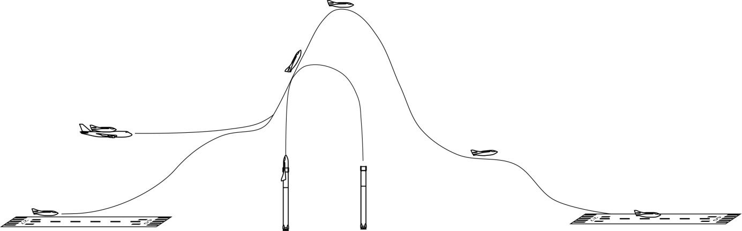
Figure 2
Examples of suborbital flights
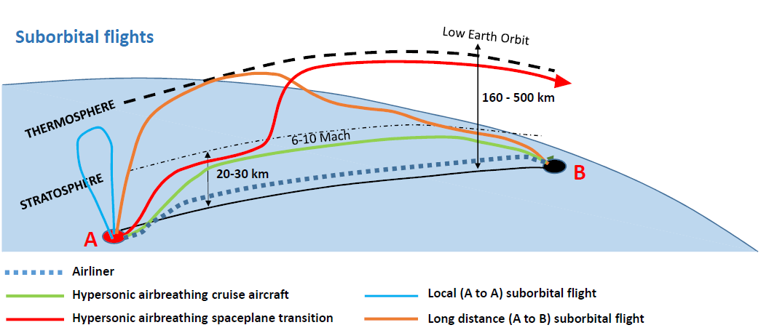
With the rapid development of the various new suborbital flight concepts in recent years, such as hypersonic flight and reusable carrier rocket technology, suborbital flight has become an operational reality, which supports a wide range of fields including transportation, tourism, and scientific research.
Suborbital vehicles may be categorised in different broad applications: Space transportation; Scientific research; Technology testing and demonstration; Deployment of satellite launcher; Remote sensing; and Astronaut training. Examples of some different applications of suborbital flight are addressed below:
1. Tourism flights consisting of a flight carrying crewmembers and passengers to beyond the Karman Line (the unofficial boundary between the Earth’s atmosphere and space), using a reusable suborbital rocket. The suborbital flight achieves Mach 3 velocity during launch and will spend a few minutes in zero gravity before deploying parachutes to return to the surface of the Earth.
2. A suborbital vehicle ferried by a special airplane and then released at a high altitude from a conventional aircraft. This suborbital vehicle, which is part airplane and part rocket, uses rocket thrust to increase altitude beyond the Karman line and then return to the surface of the Earth like a glider.
3. A conventional space launch provider using a first-stage reusable booster as part of its mission. Some components would remain in the atmosphere and other would reach space. The rocket will have its own communications requirements (e.g. for telemetry, tracking and telecommand), separate from any telemetry information of the satellite payload.
4. Related to scientific research, is the use research rockets or sounding rockets, which aim to collect scientific data and conduct engineering tests in a simple, cost-effective and time efficient way.
See also, Report ITU-R M.2477 for details and information about suborbital vehicles and associated flights

4.3 Status of stations on sub-orbital vehicles
Radio stations operating onboard sub-orbital vehicles are expected to operate in frequency bands currently allocated to certain terrestrial and space radiocommunications services, including various aeronautical related services used by conventional aircraft, while not creating new constraints on applications of the same service and on other radiocommunication services that are allocated on a primary basis in the same and adjacent frequency bands.
There is no intention to define a new category of station in the RR, and hence the station onboard a sub-orbital vehicle would have to conform to the definitions of terrestrial stations in RR No. 1.62, earth stations in RR No. 1.63, and space stations in RR No. 1.64.
The difficulty relative to the status of stations that may be applicable to suborbital vehicles is due to the lack of an agreed demarcation line between the Earth’s atmosphere and space. As the sub-orbital vehicle may be physically located within the major portion of Earth’s atmosphere and/or for a brief period of time in space, the definitions could lead to an inconsistency in the application of the regulations for the stations on the sub-orbital vehicle which intend to operate as terrestrial and/or earth stations, due to the brief period of time in space, since the terrestrial and earth stations would have to remain in the major part of the Earth’s atmosphere to comply with these definitions.
One consequence of the inconsistency could be that the definition of space station found in RR No. 1.64 should be the baseline for the classification of a station onboard sub-orbital vehicle. In such a case, in accordance with the definition of the RR. No. 1.64, the classification of the stations on-board a sub-orbital vehicle has to be “space stations” when the operation “is beyond, is intended to go beyond, or has been beyond, the major portion of Earth’s atmosphere”. These stations would therefore need to use the appropriate space service allocation. However, the relevant space service allocation or directions of the space services to be used for sub-orbital vehicles do not always exist in the current Table of Frequency Allocations. Consequently, an earth station or a terrestrial station onboard sub orbital vehicle operating in space could then only be notified under RR No. 4.4.

Another approach is to consider the classification of stations in the context of all Article 1 definitions in that terrestrial and earth stations onboard the sub-orbital vehicle retain the status of terrestrial station or earth station during the whole flight when the purpose of the radiocommunications does not change. A terrestrial station is defined as, “a station effecting terrestrial radiocommunication,” and terrestrial radiocommunication (RR No. 1.7) is defined as, “any radiocommunication other than space radiocommunication or radio astronomy”. As per RR No. 1.61, be it a terrestrial station or Earth station associated with a space service, each station shall be classified by the service in which it operates permanently or temporarily. While the sub-orbital vehicle is physically located beyond the Earth’s atmosphere for a brief period of time, the physical location of the sub-orbital vehicle on which the stations are located does not change the need for, or purpose of the use of, specific radiocommunication applications.
Report ITU-R M.2477 states that some suborbital vehicle operations may require temporarily making unavailable large areas of international and national airspace for conventional aircraft during the period of their transition to and from space. This results in airspace disruptions, extra travel time, re-routing flight paths, additional aircraft fuel consumption, etc. However, the studies in the Report also show the technical capability of some current aircraft avionics systems to be operated onboard suborbital vehicles, to facilitate the safe integration of suborbital vehicles into the same airspace as conventional aircraft during their transition to and from space which would minimize the airspace disruption.
The report also identified several existing radiocommunications services that are envisaged for use by stations onboard suborbital vehicles including, but not limited to:
a) Aeronautical radionavigation service for surveillance and navigation;
b) Aeronautical mobile service, including the aeronautical mobile (Route service), for VHF voice and data communications and automatic dependent surveillance -broadcast (ADS-B);
c) Aeronautical mobile satellite service, including the aeronautical mobile satellite (Route) service (AMS(R)S), for voice and data communications and surveillance ADS-B and automatic dependent surveillance – contract (ADS-C);
d) Mobile satellite service, including AMS(R)S, for communications and telemetry, tracking and command (TT&C) applications;
e) Aeronautical radiodetermination service (not a specifically defined service in the RR) for surveillance;
f) Radionavigation satellite service (RNSS) for navigation with global navigation satellite systems operating in the frequency bands 1 164-1 215 MHz and 1 559-1 610 MHz, and
g) Space operation service for TT&C.

5 Functional and spectrum needs for communications between stations on-board sub-orbital vehicles and terrestrial/space stations

5.1 Radiocommunication functional needs
There are functional needs for radiocommunications between stations on-board sub-orbital vehicles and terrestrial/space stations providing functions such as, inter alia, voice/data communications, navigation, surveillance, and TT&C.

5.1.1 Telemetry, tracking and command
Telemetry, radio telemetry and space telemetry are defined in Radio Regulations (RR) Nos. 1.131, 1.132, and 1.133. Radio telemetry for sub-orbital vehicles provide information about the status of vehicle and its subsystems. It is envisioned that the real-time telemetry is transmitted to ground stations, relay satellites, or space stations over radio frequency links. Additionally, some sub-orbital vehicles may require transmitting real-time high-definition digital videos from multiple feeds carrying visual information about the vehicle status to ground terminals directly or through relay satellites or space stations.
Telecommand and space telecommand are defined in RR Nos. 1.134 and 1.135. Radiocommunications for telecommand are used to initiate, modify or terminate functions of equipment on sub-orbital vehicles.
Space tracking is defined in RR No. 1.136. It is envisioned that sub-orbital vehicle will rely on dedicated radio frequency links to measure in real time the position and velocity of the vehicle by means of radiodetermination. Such tracking is expected to be performed through either ground station terminals or relay satellites or space stations.
A desired aspect of sub-orbital vehicles’ TT&C links is the ability to maintain the link throughout various phases of flight including atmospheric re-entry where radio communication with the vehicle experiences significant attenuation due to plasma effects caused by extreme heating and ionization of air around the vehicle.

5.1.2 Communications
It is expected that sub-orbital vehicles will establish and maintain communications with ground-based mission control centres during the full duration of flight through either direct communication between the various suborbital stations and ground, or through relay satellites or space stations. These communication links are like the communications commonly established by aircraft. In order to integrate into airspace used by conventional aircraft, suborbital vehicles are expected to use the same internationally or nationally standardized aviation safety systems. Passenger communications which may, for example, be for entertainment purposes are not considered safety of life.
As mentioned before, an important aspect of sub-orbital vehicle communication requirements is the desire to maintain the communication links throughout various phases of flight or have necessary mitigation and procedures in place, as required. Therefore, when designing the communication equipment to be deployed and procedures to be implemented for suborbital vehicles operation, considerations would have to be given to:
– atmospheric effects during re-entry where radio communication with the vehicle experiences significant attenuation due to plasma effects caused by extreme heating and ionization of air around the vehicle;
– additional Doppler effects caused by the increase in speed relative to conventional aircraft; and
– the vehicle’s altitude and increased separation distances from ground stations.

5.1.3 Surveillance
A surveillance service provides the identification and position of users of the airspace and obstructions. For example, the ADS-B, using the frequencies 978 MHz and 1 090 MHz, is an ICAO-standardized aeronautical surveillance system. It provides airspace navigation service providers and other users of the airspace surveillance data for high-altitude, high-velocity vehicles, including suborbital vehicles. One of the use-cases for this system includes equipping the suborbital vehicle to report ADS-B messages in all phases of flight for the purpose of aeronautical surveillance and collision avoidance from other airspace users, such as conventional aircraft operating in the airspace at lower altitudes and at much lower comparative velocities. Other surveillance technologies exist for use by conventional aircraft and suborbital vehicles, such as ADS-C. The principal surveillance application would be the same as that used for conventional aircraft.

5.1.4 Navigation
Navigation is the determination of the position and velocity of a moving vehicle. It is expected suborbital vehicles would continue to utilize the same radionavigation systems currently in use for conventional aircraft. There are several electronic aids currently available for navigation, including global navigation satellite system (GNSS), which are operated under the RNSS allocation (space-to-Earth).

5.2 Spectrum needs for sub-orbital vehicles
The expectation is that suborbital vehicles will use the space and terrestrial radiocommunications similar to systems used by conventional aircraft for the purposes of air traffic management.
Considering that suborbital vehicles are expected to consist of only a small fraction of overall aviation traffic, the spectrum requirements for the operation of suborbital vehicles are not expected to significantly impact on overall aviation spectrum requirements.
Examples of services and frequency bands identified for stations on board sub-orbital vehicles can be found in Annex 2.
Annex 1 provides the corresponding use cases in European airspace which would be used for spectrum needs and functional analysis.

6 Summary
[To be added]

[Annex 1
Use cases for sub-orbital vehicles
[Editors Note: The Figures need to be edited for the ITU audience. Also, there is a need to explain the acronyms such as “A to A]
A to A type:
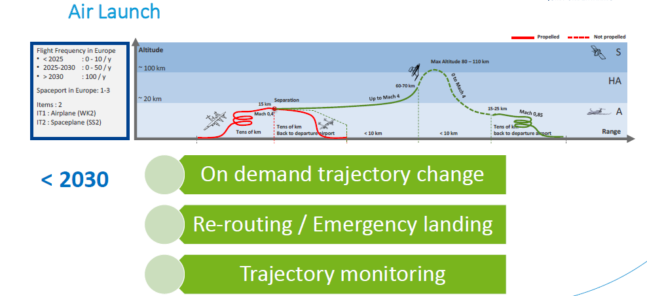

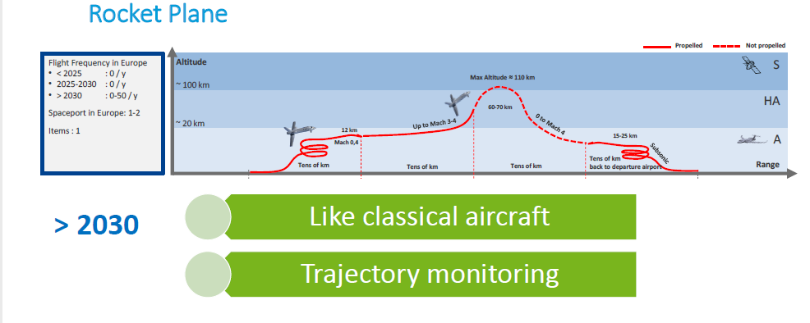

A to B type:
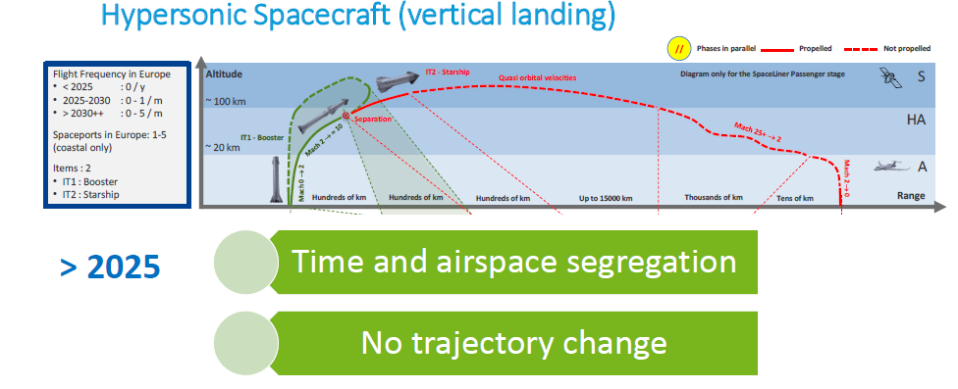
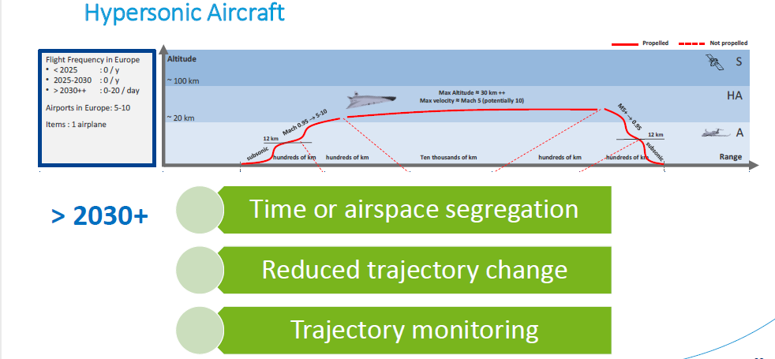
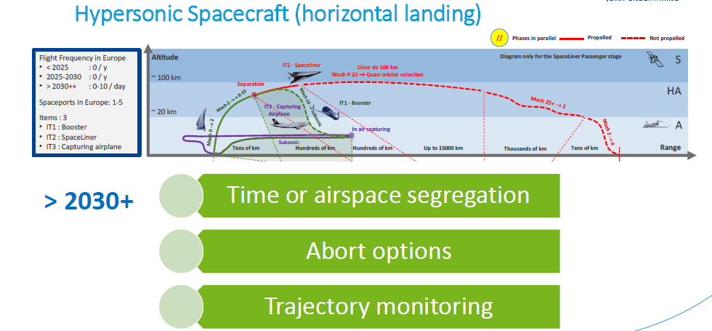
Launchers type:
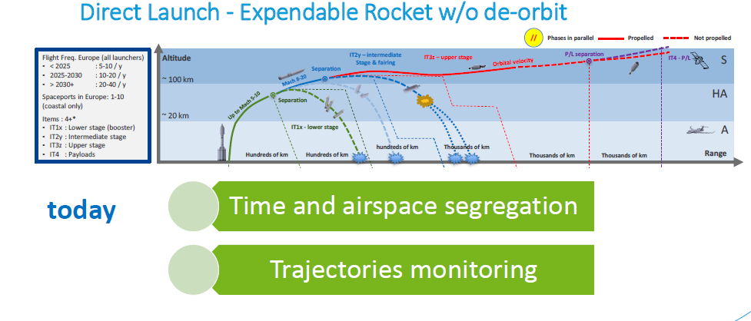
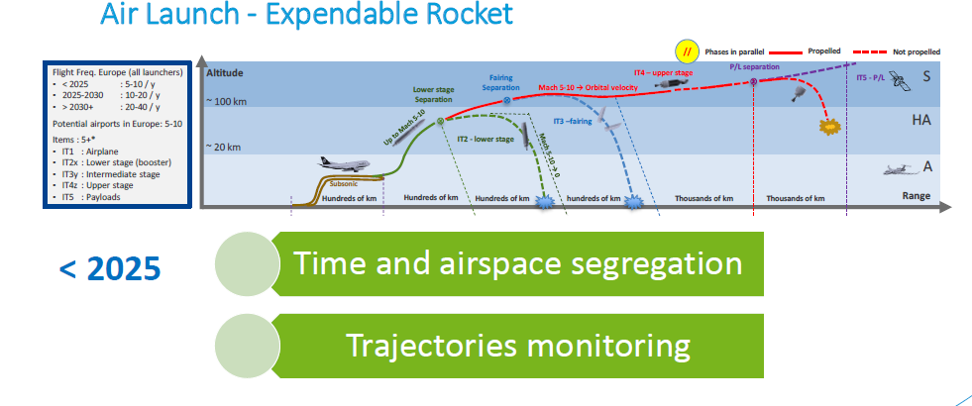
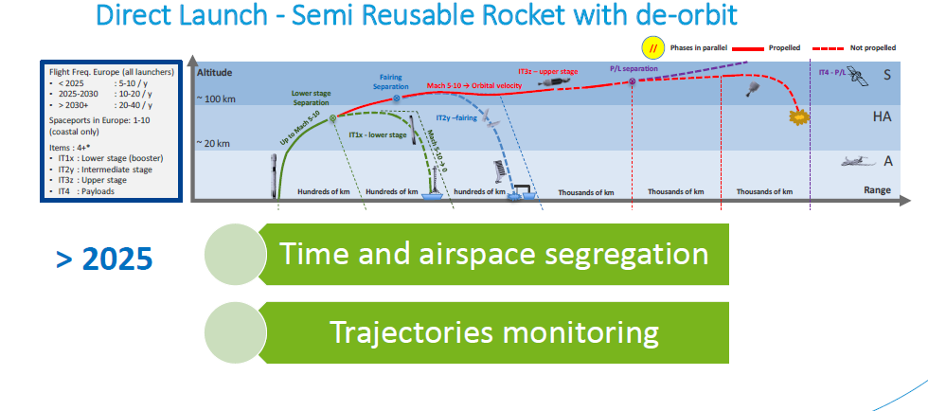
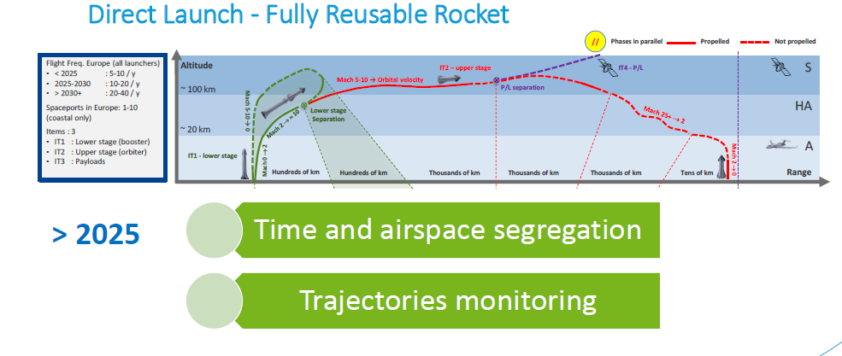
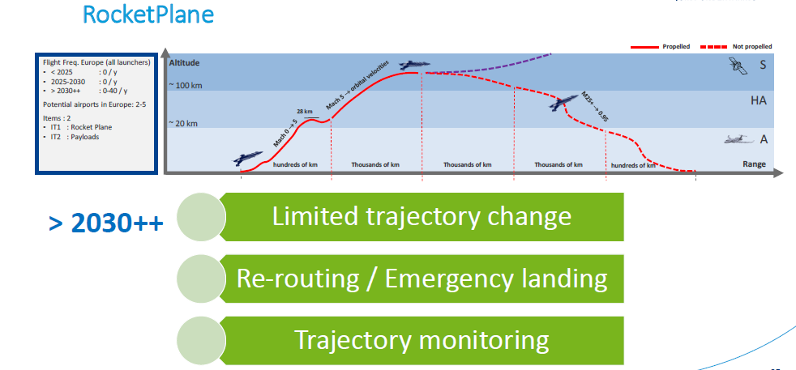
[Editors Note: The attached requires improvement]
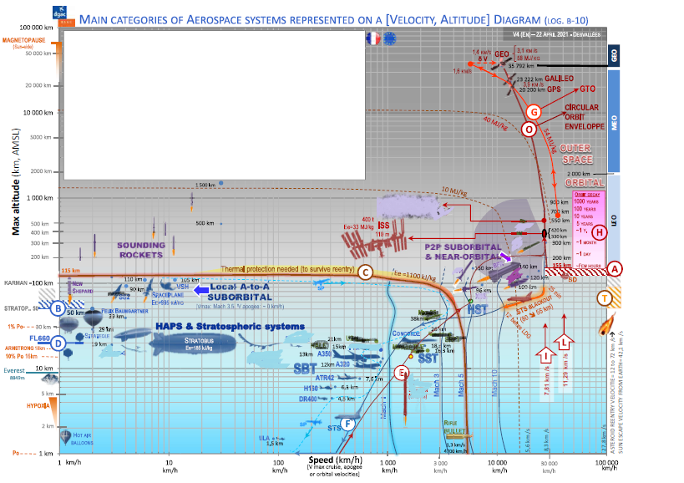
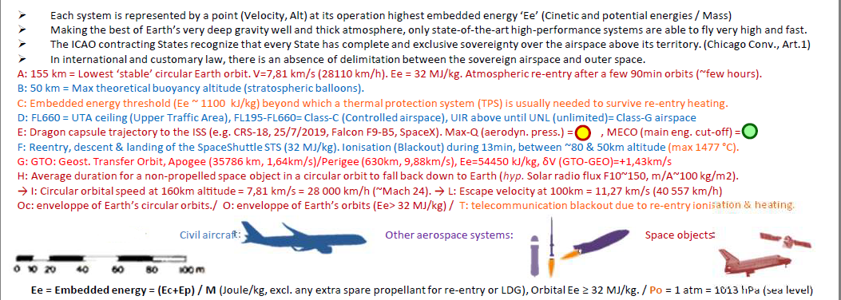
The figure represents in a single logarithmic scale graph, the main aerospace systems categories w.r.t. their altitudes and speeds, plotted at their max ‘Embedded mechanical energy’ level (kinetic + potential energies / mass) during a typical nominal operation.”
It is recognized that the frequency accommodation for suborbital vehicles should not negatively impact the current use of frequencies by any other radiocommunication services.

A3.1 Examples of radiocommunications services and frequencies

There are several existing radiocommunications services [currently or envisioned to] be used by stations on-board suborbital vehicles. These services include, but may not necessarily be limited to:
– The aeronautical mobile (route) service, e.g., VHF voice and data communications and ADS-B, in accordance with ICAO SARPs.
– AMS(R)S receive only: ADS-B, in accordance with ICAO SARPs.
– RNSS: The GNSS systems using the frequency bands 1 164-1 215 MHz and 1 559-1 610 MHz can be used for navigation.
– The mobile satellite service (MSS) in the frequency bands 1 518-1 544 & 1 545-1 559 MHz (space-to-Earth), 1 610-1 626.5 MHz, and 1 626.5-1 645.5 & 1 646.5-1 660.5 MHz (Earth-to-space), and 1 668-1 675 MHz (Earth-to-space) can be used for safety and non-safety applications.
– Mobile service: TT&C applications in the aeronautical mobile service are provided using aeronautical mobile telemetry systems in the frequency band 2 200-2 290 MHz for telemetry, and the frequency band 2 025-2 110 MHz for command and the frequency band2 360-2 395 MHz for telemetry.
According to Recommendation ITU-R RS.1260-2, launch vehicle range safety command destruct receivers operate in parts of the frequency band 420-450 MHz.
– Radiolocation Service: The radiolocation service in the frequency band 5 450-5 850 MHz can be used for SOV tracking in safety and non-safety applications.

A3.2 Application of existing mobile satellite service radio regulations

The operation of MSS systems providing aeronautical radiocommunications in the above-identified frequency bands are regulated under existing RR provisions. The application of MSS systems to support suborbital vehicles would require communications between the MSS satellite and the mobile Earth station (MES) at all stages of the flight, including when the MES is on the ground, in the atmosphere and when briefly in space. The existing RR Article 9 procedures are/would be adequate to capture any new coordination requirements in the operation of MESs onboard sub-orbital vehicles in the MSS bands that result with other MSS satellite systems and networks, and other space services operating in the MSS bands.
This approach would permit the existing frequency coordination procedures identified under Section II of RR Article 9 to remain applicable in the coordination and operation of MSS communications to sub-orbital vehicles, during the intervals of time when a sub-orbital vehicle is in space.
For coordination and protection of terrestrial services, is noted that the operation of MESs on sub-orbital vehicles in space would result in less interference to terrestrial services, relative to the comparable case of an MES operating on the Earth’s surface or within the Earth’s atmosphere on an aircraft. This reduction in the potential for interference at the Earth’s surface results from the increased separation of the MES to the Earth when operating in regions of space.
Similarly, no changes would be necessary for MSS satellite transmissions to support the operation of MESs on sub-orbital vehicles, since the required satellite transmissions powers, if anything, would be lower. When operating earth stations on sub-orbital vehicles, there would be a lower path-loss between the MES and associated MSS satellite, together with a reduction in the atmospheric impairment and multipath degradation.
The above factors would ensure the protection of terrestrial services is maintained in the use of MSS communications, and that the existing regulatory provisions and coordination requirements in the use of MSS communication in the 1.6/1.5 GHz frequency bands remain effective. Additionally, it is noted that RR Nos. 5.208B and 5.379C would continue to apply to MESs operating on sub-orbital vehicles, to maintain the protection of radioastronomy operating in the frequency bands 1 660.0-1 660.5 MHz and 1 668-1 670 MHz.
Since the definition of an MES requires it to be either on the Earth’s surface or within the major portion of the Earth’s atmosphere (see RR Nos. 1.25 and 1.63), it would be necessary to clarify the regulations to ensure that MESs may also be used on suborbital vehicles when beyond the Earth’s atmosphere.

[Annex 2]
Radiocommunication analysis for example of use cases in Europe
for sub-orbital vehicles
[Editor’s note: The table needs to be reformatted so that the text can be understood. Further discussion is needed regarding this information. Trademarks must be removed, acronyms explained, etc. Concerns with this information being used is another concern. Should this and the previous Annex be merged into ITU-R M.2477?]
A to A type:

[Editor’s note: to further consider previous example before extending to other use cases.]

______________

