U.S. Radiocommunications Sector
Fact Sheet
Working Party: ITU-R WP 1A | Document No: USWP1A-02_Rpt_SM.2451_forNC
Ref: ITU-R SM.2451 | Date: 17 April 2020

Document Title: Proposed update to Report ITU-R SM.2451, Assessment of impact of wireless power transmission for electric vehicle charging on radiocommunication services

Author(s)/Contributors(s):  Ky Sealy  WiTricity Corp.  Jon Sirota  WiTricity Corp. | Email: ky.sealy@witricity.com  Phone: +1 617-926-2700 x3002  Email: jon.sirota@witricity.com  Phone: +1 617-926-2700 x2239
Purpose/Objective: Proposal to make corrections and updates to SM.2451-0 and add a new appendix with a recent study on impact of WPT-EV on amateur radio performed on an OATS.
Abstract: Add new appendix with study performed on WPT-EV impact to amateur radio which also applies to impact of AM broadcasting. Update main body of text to remove Tables 7 & 8 which are shown to be unreasonable based on applied study. Also update text throughout the document to correct any inconsistencies.

Radiocommunication Study Groups
Received: Date 2020  Subject: Question ITU-R 210-3/1 | Document -E
Received: Date 2020  Subject: Question ITU-R 210-3/1 | XX Month 2020
Received: Date 2020  Subject: Question ITU-R 210-3/1 | English only
United States of America
Proposed Revisions To Report ITU-R SM.2451-0

Background
In preparation for consideration of the topic at the World Radiocommunication Conference (WRC-19), Study Group 1 completed, and the ITU published, Report ITU-R SM.2451, Assessment of impact of wireless transmission for electric vehicle charging on radiocommunication services, in June, 2019. Now that the pressure of a World Radiocommunication Conference has passed, it may be appropriate to thoroughly review the published Report to address any inconsistencies and editorial issues that may be in the document.

Discussion
The United States has undertaken a detailed review of the published Report and has identified what may be some inconsistencies, or points where clarifications and/or editorial corrections might be needed.
Furthermore, it was noted during the development of the Report that additional impact studies relating to WPT-EV would be helpful – especially studies utilizing WPT-EV systems adhering to the latest standards from standards development organizations, SDOs (e.g., SAE J2954, IEC 61980, ISO 19363). In order to address this open item, the U.S. has performed additional studies of the impact on amateur radio systems utilizing a WPT-EV system that meets the requirements of these standards.

Proposal
In the proposed revisions to the Report, the United States offers for the consideration of WP 1A a new annex (Annex 12) with a study performed on the impact of WPT-EV on amateur radio systems. In addition, the U.S. proposes updates to the main body of text to remove Tables 7 & 8 based on the results of the applied study. Finally, editorial corrections are made in a few places in the text to address apparent inconsistencies. Only the proposed changes are shown in the attachment.
The United States suggests that, given the substantive addition to this revision addressing the amateur service, that WP 1A consider liaising the draft revision to Working Party 5A with a copy to Working Party 1C for information.
Attachment: Proposed revisions to Report ITU-R SM.2451-0

Attachment
Proposed revisions to Report ITU-R M.2451

[U.S Note: No proposed changes prior to this point.]
Acronyms and abbreviations
…
OATS Open Area Test Site
…
SPICE Simulation Program with Integrated Circuit Emphasis
…
Related ITU Recommendations, Reports
…
Recommendation ITU-R P.372
Recommendation ITU-R SM.1753
…

4.3.5 Impact studies for the amateur service
In the studies presented in Annex 7 field measurements were conducted for the 135.7-137.8 kHz and 472-479 kHz amateur frequency bands. These frequencies allocated to the amateur service on a primary or secondary basis are unlikely to be affected by the emissions at the operating frequency of WPT-EV.
In the studies presented in Annex 12, field measurements were conducted for the 3.50-4.00 MHz, 7.00-7.30 MHz, 10.10-10.15 MHz, and 14.00-14.35 MHz bands. These frequencies, also allocated to the amateur service on a primary or secondary basis, are unlikely to be significantly impacted by the harmonic emissions of WPT-EV systems designed in accordance with the noted SDOs. The matter of harmful interference from harmonic radiated emissions are covered in § 4.5.
…

Limits of WPT-EV radiated emission for the protection of AM broadcasting
Various limits have been proposed for absolute maximum levels for the electric and magnetic field strengths for inductive applications operating over short ranges and at implied, though not specified, low power levels. There are proposals to adapt or extend these same limits to medium/high power inductive power transfer applications such as WPT-EV, which will operate at powers of the order of tens to hundreds of kW. However, it is possible based on theoretical studies in Annex 8 that adherence to existing field strength limits might not offer adequate protection to avoid interference of any type to radio services in some circumstances. It should be noted, however, that impact studies such as those in Annex 12 show that the type and effective aperture of the receiving antenna along with its distance can make a difference in the results. [USA Note: The information following is already contained in the referenced Annex 8 and is not needed here.]

4.5 Impact of spurious and harmonic radiated emissions on the amateur service and relevant protection requirements
The three frequency ranges being considered for WPT-EV do not overlap with, and have reasonable separation from, the 135.7-137.8 kHz and 472 kHz amateur frequency bands. Therefore, receiver sensitivity suppression (out-of-band) has not been considered a problem.
[USA Note: Struck wording is redundant from previous section and unnecessary]
Amateur frequency bands from 472 kHz upwards are potentially affected by harmonic radiation from WPT-EV operating at 79-90 kHz and possibly from WPT-EV operating at 20 kHz and 60 kHz.

Protection levels for the amateur service, which are set out in Recommendations ITU-R F.240 and ITU-R M.1044 and used in the studies in Annex 10, can be used to guide the development of appropriate harmonic radiation limits. Annex 12 also contains an impact study of WPT-EV harmonic emissions emanating from a system following SDO requirements in the 79-90 kHz band. Impact is dependent on distance, antenna type, and other factors. Issues of wideband noise from WPT-EV systems has not been studied, but the developed protection requirements are also applicable to such radiation, which may also be common to typical power electronics such as switch-mode power supplies, and are not harmonically related to WPT-EV specifically.
The likely separation distance from systems operating at 20 and 60 kHz is likely to provide reasonable protection from harmonic radiated emissions from the WPT-EV systems, although this remains to be validated.
The high duty cycle of 79-90 kHz WPT-EV systems, their planned location close to or inside dwellings (and therefore close to amateur service antennas), and their anticipated deployment density show that harmonic radiated emissions from WPT-EV systems in this frequency range might need to be controlled if harmful interference is to be avoided. Specifically, the adoption of radiated emission limits from inductive device limits for other applications and devices by themselves might not provide the level of protection required. See Annex 12 for further details.
The study in Annex 10 models the protection necessary for the amateur service.

However, the necessary limits for harmonic radiated emissions from WPT-EV systems can be relaxed from this level by about 20 dB if:
a) all WPT-EV systems adopt a harmonized, tightly tolerance frequency of operation; and
b) the phase noise and noise sidebands from WPT-EV are no higher than the above limit.
Limited harmonic radiated emission data has been provided for WPT-EV systems operating at 79-90 kHz. Annex 12 represents some of this data collected with a WPT-EV system that follows previously noted SDO requirements highlighted in § 3.3.1.

Harmonization and mitigation measures to minimize the impact of WPT-EV on the radiocommunication services

Global harmonization
The term harmonization in this Report encompasses two considerations:
1 The frequency ranges to be used by WPT-EV equipment.
2 The characteristics of WPT-EV equipment related to protection of other Radiocommunication services.
Both harmonization considerations above can help mass production and deployment of WPT-EV while preserving the operation of radiocommunication services from any potential interference from WPT-EV equipment.
Regarding the harmonized frequency ranges, Recommendation ITU-R SM.2110 indicates the recommended frequency bands for WPT-EV.
Regarding the characteristics of WPT-EV equipment, § 3.1 and Annex 2 to this Report provide the field strength limits that WPT-EV equipment should not exceed in different frequency bands for different concerned radiocommunication services.

Mitigation measures

Mitigation Strategies to reduce the impact on the broadcasting service
The operation of AM broadcast transmitters is covered by the Radio Regulations. In Regions 1 and 3 the relevant instrument is the Geneva 1975 Frequency Plan (GE75) and in Region 2 the Rio de Janeiro 1981 Frequency Plan (RJ81). These international agreements allocate operating frequencies to LF and MF transmitters such that they do not cause interference to each other based on factors such as geographical separation, transmitter power and antenna characteristics. The underlying basis for the plans is Recommendations ITU-R BS.703 and ITU-R BS.560. Importantly, the regional assignment plans set the transmitter operating frequencies on a grid or raster; under the GE75 Plan each (carrier) frequency is a multiple of 9 kHz and under the RJ81 Plan a multiple of 10 kHz
A significant benefit of having all the carriers on a common raster is that co-channel interference is up to 16 dB less intrusive than if the frequencies were chosen randomly. This can be seen in Fig. 1 of Recommendation ITU-R BS.560.
The same principle can be applied to a WPT-EV system if its operating frequency can be chosen and fixed to be a multiple of 9 kHz or 10 kHz. If the operating frequency is chosen in this way any harmonics will also (automatically) lie on the broadcast frequency raster. Studies to investigate the subjective effects of interference from an un-modulated carrier situated on or off the raster were carried out by the BBC in November 2017 and are described in BBC Research and Development White Paper WHP 332, November 2017 – Wireless Power Transfer: Plain Carrier Interference to AM Reception, which is reproduced as Attachment 6 to Annex 8.
[USA Note: Information removed is already contained in the referenced Annex.]

Other factors

Modulation of the charging ‘field’
As indicated by § 3.3.1, standardized WPT-EV systems are not expected to modulate the field level and do not transfer data through modulation of the charging field. Communication is typically carried out by standard and well-characterized out-of-band radio interfaces such as Wi-Fi.

[U.S. Note: No revisions proposed for the remainder of the main body of the Report.]
[USA Note: All of Annex 12 is a proposed a new addition to ITU-R Report SM.2451]
Annex 12
Impact Studies on HF Amateur Radio in United States for WPT-EV
A12.0 Abstract
The impact study reviews the current status of amateur radio regulations and selected allocated HF bands in the United States as of February, 2020. A brief review of characteristics for standardized WPT-EV systems is given, and a standard pre-production prototype ~11 kW WPT-EV system mounted on a Nissan Leaf is described. Radiated emissions testing was performed with the WPT-EV system in accordance with standardized international practices at an accredited third-party open area test site and the results compared with typical amateur radio equipment used. Calibrated data was collected by the third-party lab, and licensed amateur radio operators performed the amateur radio tests to collect data both with a calibrated spectrum analyser and off-the-shelf amateur radio equipment. The study attempts to identify interference potential caused by the harmonics of standardized WPT-EV systems in a real-world environment. Additional detailed characteristic data of the WPT-EV system is also presented including high resolution EMF measurements for human RF exposure considerations.

A12.1 Introduction to Amateur Radio in the United States
In the United States of America, the amateur service is regulated by Title 47 Part 97 of the Federal Code of Regulations. The primary purposes for amateur radio include usage for non-commercial, public, and voluntary emergency communications as well as providing opportunities for the advancement of radio art, skills in communications, and generally enhancing international goodwill. According to the American Radio Relay League (ARRL) and the FCC’s Licensing system, as of February 12, 2020, the number of active FCC amateur radio licenses held by individuals in the United States is 765006 with an average annual growth rate of about 1% over the last 5 years. The number of licensees corresponds to approximately 0.23% of the US population and an estimated density in the range from 0.2 to 2 licenses per km² in suburban areas. The United States may belong to the top 5 countries with the highest number of issued amateur radio licenses per inhabitant. The states of California and Texas rank as the top 2 states respectively for the number of amateur radio active licenses.

Amateur operators use many different types of analog and digital communication techniques such as SSB AM (single side-band amplitude modulation), CW (continuous wave), FM (frequency modulation), TV, PACTOR, PSK31, RTTY, and other modes. In the United States, a “Band Plan” is used and published by ARRL to indicate how each portion of the spectrum is to be used effectively by amateur operators. FCC regulations and amateur radio operators typically refer to their available bands of spectrum as indicated by the radio wavelength in free space. An example of the ARRL band plan for the United States is shown below and can be found on ARRL’s website [2].

Figure A12-1: ARRL Band Plan for United States of America

Some amateur operators create homemade transceivers; however, most amateur transceivers are purchased from commercial sources known for their amateur radio equipment such as ICOM, YAESU, KENWOOD, or ELECRAFT. A review of mobile and base station transceiver products from these sources indicate all the HF products (including most portable transceivers) can transmit using a number of analog and digital operating modes on bands starting with the 80 m band (3.5 MHz to 4 MHz) and going up in frequency to the 6 m (50 MHz to 54 MHz) or 2 m (144 MHz to 148 MHz) bands. Most base station transceivers also have the capability to go as low in frequency as the 160 m band (1.8 MHz to 2 MHz). The longer wavelengths of the low frequency bands also require much larger antennas for effective radio communication meaning that most portable HF antennas target the 80 m to 6 m bands for operation which isn’t fixed to a station location. Most commercial transceivers can transmit at power levels from 50 W to 200 W and require a separate linear power amplifier to operate at higher power levels. FCC’s Title 47, Part §97.313 requires the use of minimum necessary power to carry out the desired communications, but it allows operators to transmit up to 1.5 kW peak envelope power (PEP) for the 80 m, 40 m, and 20 m HF bands; and up to 200 W PEP for the 30 m HF band.

Ionospheric propagation is one of the key modes of propagation used in the HF bands enabling communication over distances of thousands of kilometres in some cases. Amateur operators utilizing the HF bands make extensive use of these “skywave” propagation modes to communicate with other licensed amateur operators in all continents around the globe. The lower frequency bands such as the 80 m and 40 m band are favoured for communication within shorter ranges (e.g., <1000 km) or even shorter (e.g., <100 km) using Near Vertical Incidence Skywave (NVIS) modes.

For the qualitative assessment of impact that is part of this impact study, the 80 m and 40 m amateur radio bands were determined to be the most feasible and likely to be impacted from harmonics originating from a WPT-EV system operating in the ITU-R recommended frequency range of 79-90 kHz (~ 85 kHz nominal). Additional data was also collected for the 30 m (10.10 MHz to 10.15 MHz) and 20 m (14 MHz to 14.35 MHz) bands as well. For practical reasons, the 160 m band was not tested, although the amateur operators doing the testing agreed that data from the 80 m band could reasonably be extrapolated to the 160 m band. The impact study was funded by a SAE J2954 Cooperative Research Program made up of many automakers and several suppliers. All testing was performed by an independent EMC lab at TDK RF Solutions in Cedar Park, Texas using an accredited Open Area Test Site (OATS). One or more licensed amateur radio operators, all of whom were also members or staff of ARRL, or officials within the International Amateur Radio Union were also involved in collecting the qualitative assessment data and selecting the appropriate amateur equipment.

A12.2 Characteristics of Standardized WPT-EV Systems
Standards for WPT-EV systems have been in development since 2010. Standards such as SAE J2954, ISO 19363, IEC 61980, and China’s GB standards have active development for WPT-EV systems and have all collaborated to ensure some degree of harmonization. Most of these standards bodies have committed to releasing a full standard in 2020; though many of them have already released publications for review such as SAE J2954’s technical information report, and two recommended practices released between 2016 and 2019. These standards are established to ensure interoperability between various manufacturers’ systems, but they also contain important information about human and cardiac implantable electronic device (CIED) EMF safety as well as recommendations for electromagnetic compatibility (EMC) and appropriate conditions for emissions testing to meet global requirements. In 2017, SAE J2954 setup a cooperative research program, which has been actively testing systems since inception and making recommendations based on that testing for harmonized standard adoption.

In 2018 and 2019, SAE J2954 sent liaison letters to ITU-R outlining EMC related requirements, indicated that emissions studies had been underway since 2010, and provided the results of those studies. Furthermore, the general characteristics of standardized WPT-EV systems were provided.

WPT-EV systems based on the aforementioned standards:
- Use near-field magnetic resonance to efficiently transfer energy wirelessly between a loosely coupled ground coil assembly and a vehicle coil assembly by means of evanescent magnetic field coupling.
- Utilize filtered sinusoidal currents in the ground assembly coil to generate a local magnetic field for transferring power.
- Have an efficiency from AC mains input to DC output greater than 80% though measured values have shown typical efficiencies at ~90%.
- Operate in the range of 79 – 90 kHz (nominally 85 kHz) but do so at a fixed frequency across the full charging cycle of a vehicle.
- Do not modulate the wireless energy between the ground and vehicle coil assemblies in any way for communication but instead utilize out-of-band wireless communications (such as Wi-Fi), which follow well-established global radio requirements.
- Meet set requirements for human and CIED EMF safety based on ICNIRP 2010 guidelines for human exposure and ISO 14117 guidelines for CIED magnetic field compatibility.
- Meet interoperability requirements for light duty vehicles and power levels starting from 3.7 kW (WPT1 power class) to 11.1 kW (WPT3 power class).
- Meet minimum alignment tolerance requirements as +/- 75 mm in the direction of vehicle travel and +/- 100 mm in the lateral direction.
- Meet requirements for foreign object detection to prevent unsafe metallic object heating.
- Meet general interoperability requirements including defined controls and communications standards.
For the purposes of this impact study, only WPT-EV systems designed to meet these standards were considered.

A12.3 Measurements Performed on an Open Area Test Site (OATS)
A12.3.1 Characteristics of the WPT-EV Equipment Under Test (EUT)
The WPT-EV system used for this impact study was a prototype pre-production system with the vehicle coil assembly mounted on a Nissan Leaf just behind its front axle at a height providing a ground clearance of 175 mm. The WPT-EV system comprised of a wall box power supply, the ground assembly, and the vehicle assembly together with the vehicle corresponding to a typical garage setting is considered the EUT. The vehicle assembly was operationally connected for charging the vehicle’s traction battery. The power input level to the WPT-EV was ~11.1 kW complying with the WPT3 power class as defined by SAE J2954. For radiated emissions testing, in order to reduce undesirable effects of the ground plane, the vehicle and the ground assembly were raised 15 cm from the OATS metal floor as recommended by several standards bodies (to better emulate real-world conditions and avoid parasitic metal ground plane interaction). The coil of the vehicle assembly was centered on the turn table and worst-case alignment offsets were set by shifting the ground assembly coil accordingly. Standard EMC practices based on international standards for radiated emissions testing were applied.
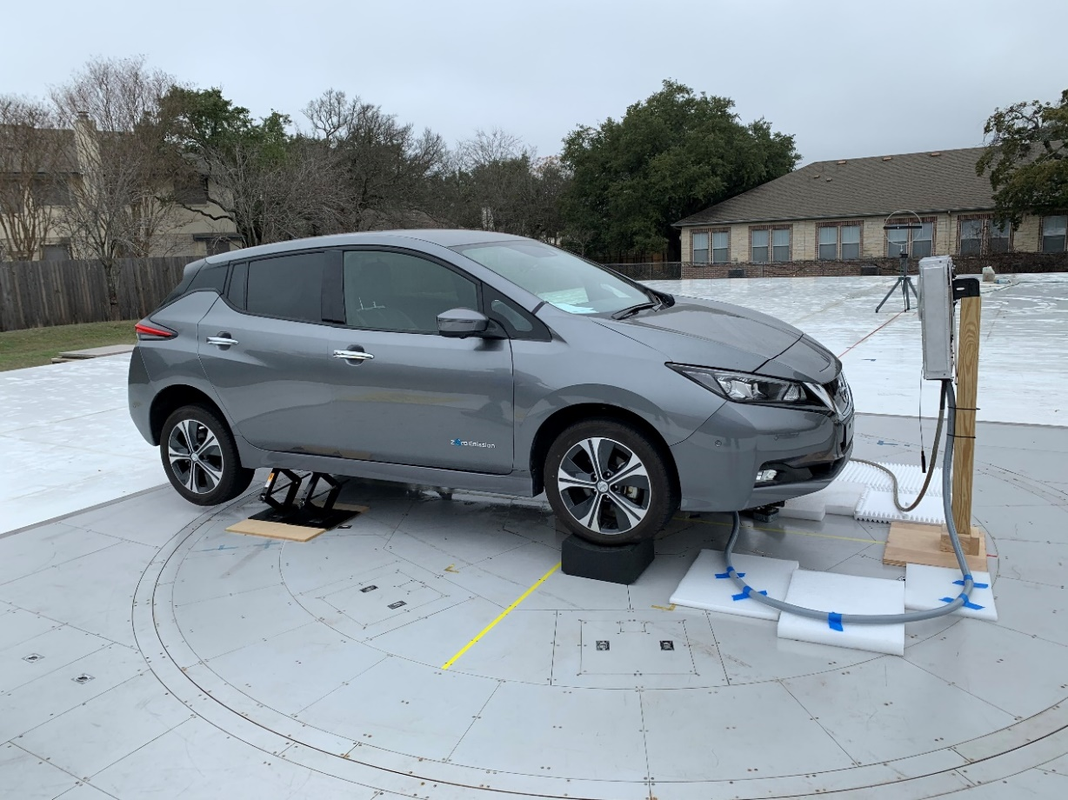
Figure A12-2: WPT-EV System Setup for Radiated Emissions Testing on an OATS (Side View)
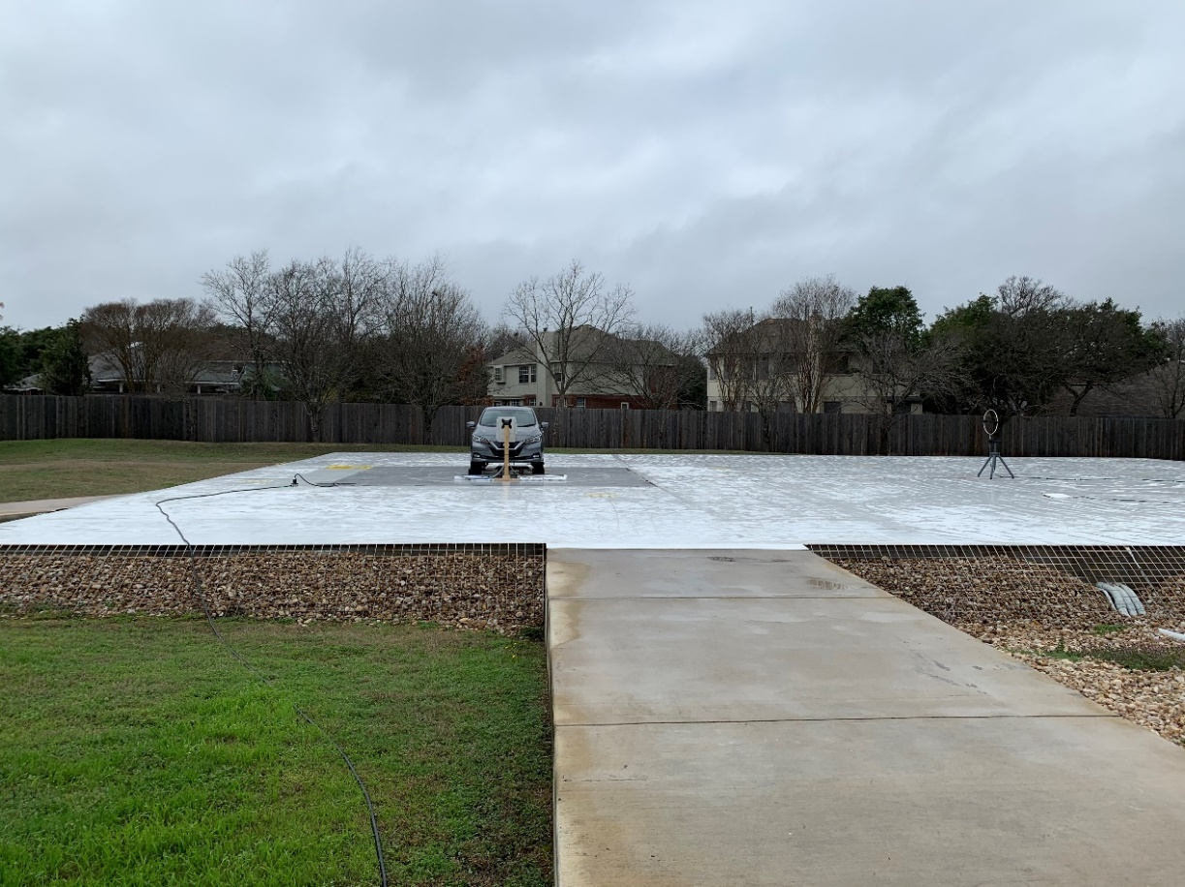
Figure A12-3: WPT-EV System Setup for Radiated Emissions Testing on an OATS (Front View)

The design of the particular WPT-EV study used is based on the criteria and details outlined in SAE J2954, ISO 19363, and IEC 61980. The system operates at a fixed frequency of 85 kHz and utilizes magnetic resonance to transfer its energy at that frequency. Although radiated emissions are not based solely on the current characteristics in the coil, it is useful to understand the expected harmonic content of the current in the ground assembly coil which transfers the power wirelessly via evanescent coupling to the vehicle assembly coil.

The image below shows calculated relative harmonic content based on Fourier Series calculations to derive the expected ground assembly coil current.
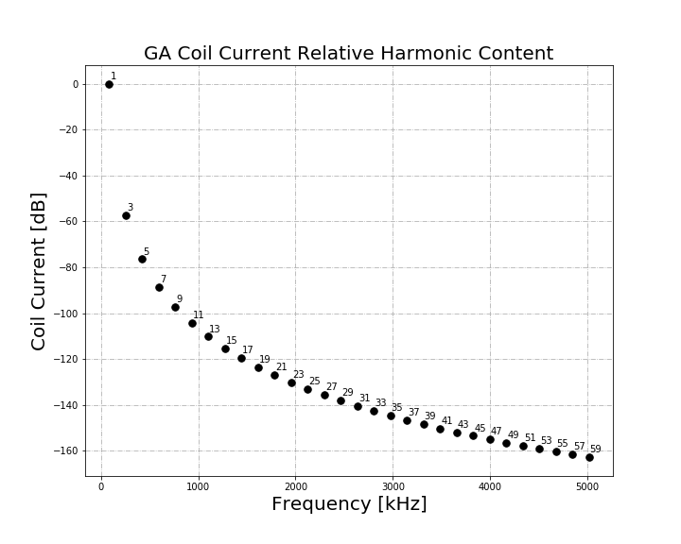
Figure A12-4: Calculated relative harmonic content of WPT-EV coil current in ground assembly

Additionally, SPICE simulations show expected time domain and frequency domain plots of the current in the ground assembly coil.
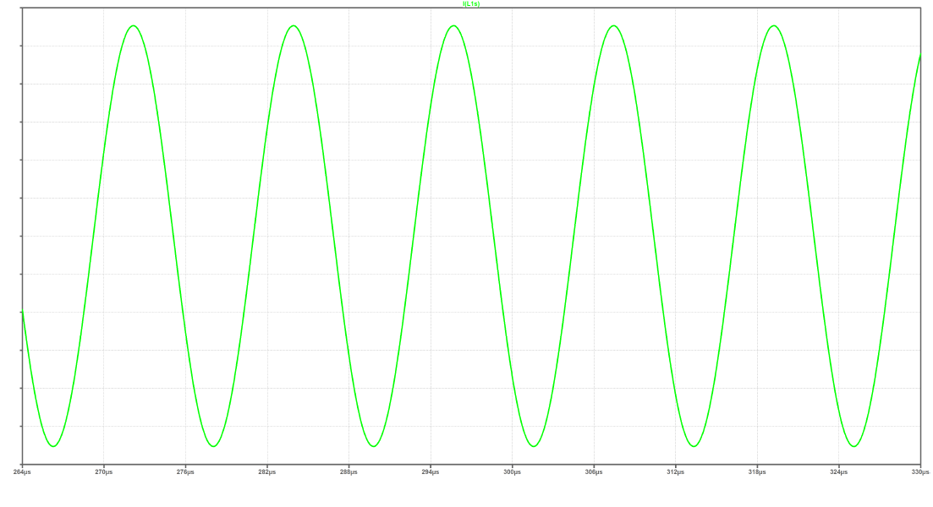
Figure A12-5: SPICE simulated time-domain current waveform of coil current in WPT-EV ground assembly
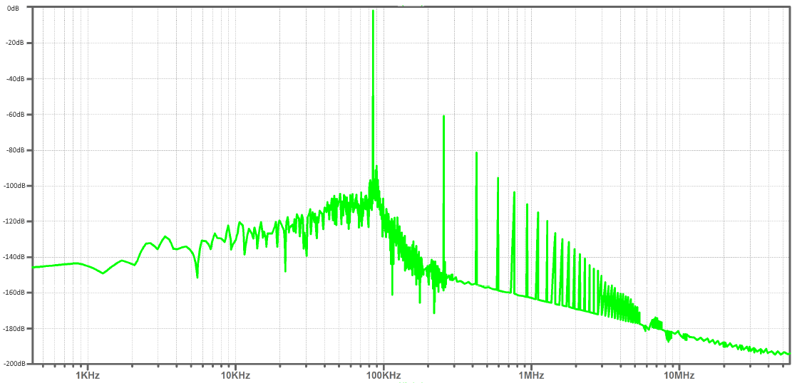
Figure A12-6: SPICE simulated relative frequency-domain spectrum of coil current in WPT-EV ground assembly

Finally, the resultant coil current was measured using a standard current probe and oscilloscope with the waveform shown below.
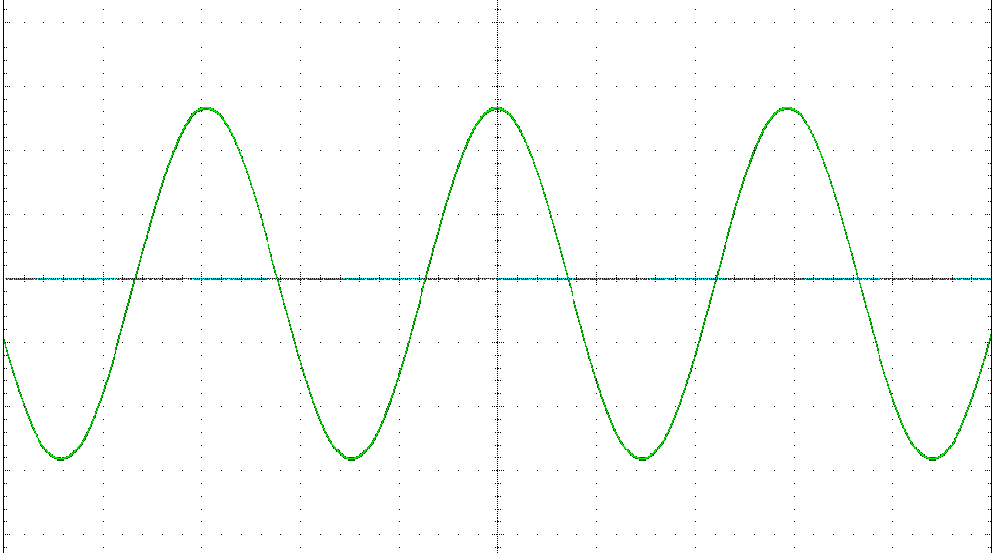
Figure A12-7: Actual coil current measured in the time-domain with oscilloscope

While the magnetic field emanating directly from ground assembly coil is not the only possible source of emissions, it is generally the source of most discussion regarding potential impact of WPT-EV on radio broadcasts and amateur radio reception. The analysis represents the best-case of emissions from differential-mode currents in the WPT-EV system since it is well-known in power electronics design that emissions from common-mode currents, which may be unrelated to an intentional emission source, can dominate far-field emissions in many cases.

A12.3.2 Characteristics of the OATS
The OATS used for testing is owned by TDK RF Solutions, Incorporated and is located in Cedar Park, Texas near Austin, Texas. All measurements were made at this A2LA accredited calibration lab. A satellite image of the OATS can be seen using Google Maps as shown below.
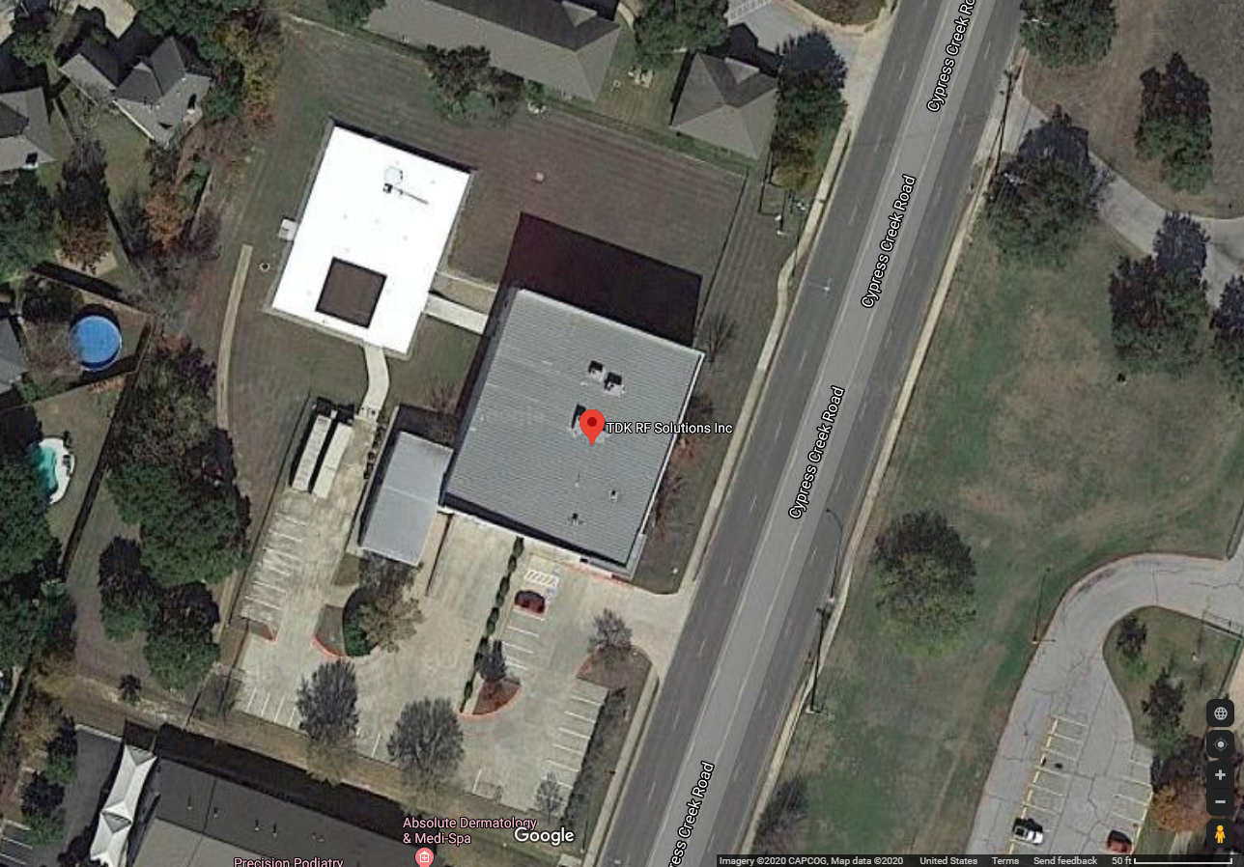
Figure A12-8: Satellite image of TDK RF Solutions OATS
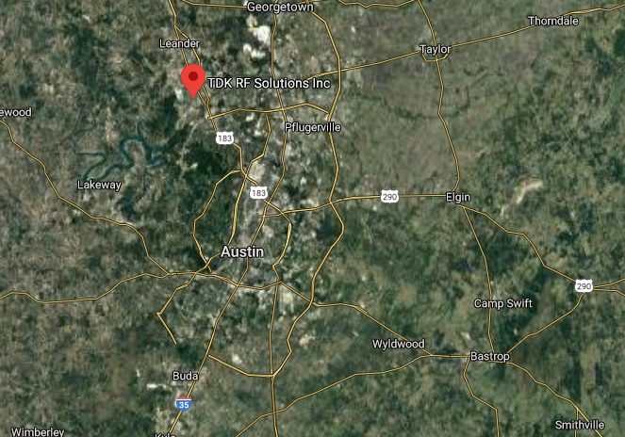
Figure A12-9: Overview map of location of TDK RF Solutions OATS

According to the United State Census Bureau, Cedar Park had an estimated population of 76,999 in July of 2018 [4]. Its population density is based on census data in 2010 and was 2,141.9 people per square mile (~5,547.5 people per square kilometre). According to the U.S. FCC’s Universal Licensing System, as of February 12, 2020 there are 342 active amateur radio licenses registered in Cedar Park corresponding to 0.44% of the estimated population.

In order to characterize the peak ambient RF conditions at the TDK RF Solution’s site, a calibrated loop, as defined in CISPR 16-1-4, was used to record radiated emissions measurements at various times of the day and with various antenna orientations. The results of the ambient emissions with this antenna is shown below combined with standardized and proposed emission limits. The FCC Part 18 limits shown in the plots are based on conversion and scaling from the 300 m limits to magnetic field limits at 10 m based on ANSI C63.30 [20] scaling as proposed by Joseph McNulty of the FCC [19]. Additional scaling has been proposed such as SAE’s J551-5 scaling procedures that result in similar scaled limits to 10 m as seen in the comparison chart below. The extrapolations are conservatively based on the principle that field strength decays at a 20 dB/decade rate in the far-field region of a radiating source and decays at a rate of 60 dB/decade within the near-field region. The current draft 3rd amendment of CISPR 11 Ed 6 limits as outlined in CIS/B/737/CDV are also shown in the charts for comparison. Standard CISPR settings utilizing a resolution bandwidth (RBW) of 200 Hz from 9 kHz to 150 k Hz, and a RBW of 9 kHz from 150 kHz to 30 MHz was used for EMC assessment and ambient peak correlation to collect the data. It should be noted that the ambient data collected represents peak data as seen at the receiver (using the CISPR peak detector) including local ambient transmission bursts and some time-varying narrow-band signals. The peak ambient data does not represent the man-made radio noise floor as outlined in Recommendation ITU-R P.372 [15], which is based on median values of man-made noise for the given environment. It has been suggested by several more recent studies e.g., carried out by the University of Twente in the Netherlands (IEEE paper [16]) and the Basque University in Spain [17], however, that the man-made noise floor in the MF and HF band has risen in recent years. For a complete comparison of measured data, EMC limits, and noise floor levels, the chart below shows a comprehensive summary including the Recommendation ITU-R P.372-14 median man-made noise factors converted to magnetic field strength (in dBµA/m) assuming a monopole antenna. It also includes the Recommendation ITU-R P.372-14 value updates as suggested in [16], peak ambient conditions, and measured peak system receiver noise.
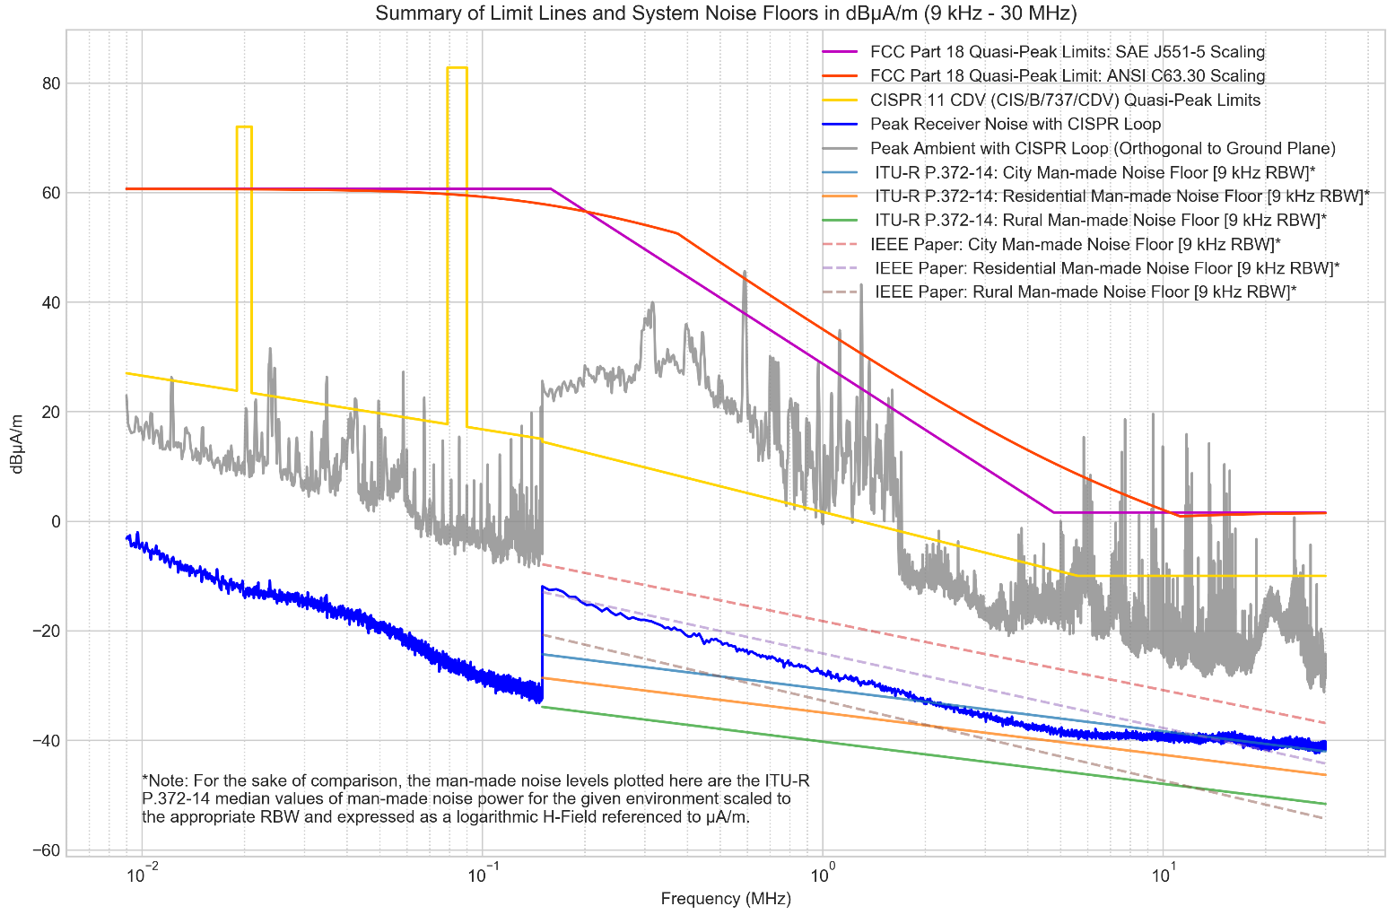
Figure A12-10: Overview of limits, peak ambient measurements, system noise with CISPR loop, as well as converted Recommendation ITU-R P.372-14 man-made noise levels and suggested IEEE paper updates based on different noise measurement procedures as outlined in Recommendation ITU-R SM.1753-2 (i.e. statistical, non-peak measurements).

Note: The Recommendation ITU-R P.372-14 and IEEE referenced levels are included for informational purposes; however, it is important to note that the measurement procedures for the peak measurements and the Recommendation ITU-R P.372 man-made noise measurements and procedures are very different as outlined in Recommendation ITU-R SM.1753.
For a direct comparison of only the system receiver noise with the TDK CISPR 60 cm loop antenna used in measurements and other commercially available antennas, the plot below is from a study conducted by CISPR B in CIS/B/736/INF [21] using the same RBW settings (200 Hz RBW from 9 kHz to 150 kHz and 9 kHz RBW from 150 kHz to 30 MHz).
Figure A12-11: System noise measurements with various system loops as performed by CISPR B and reported in CIS/B/736/INF
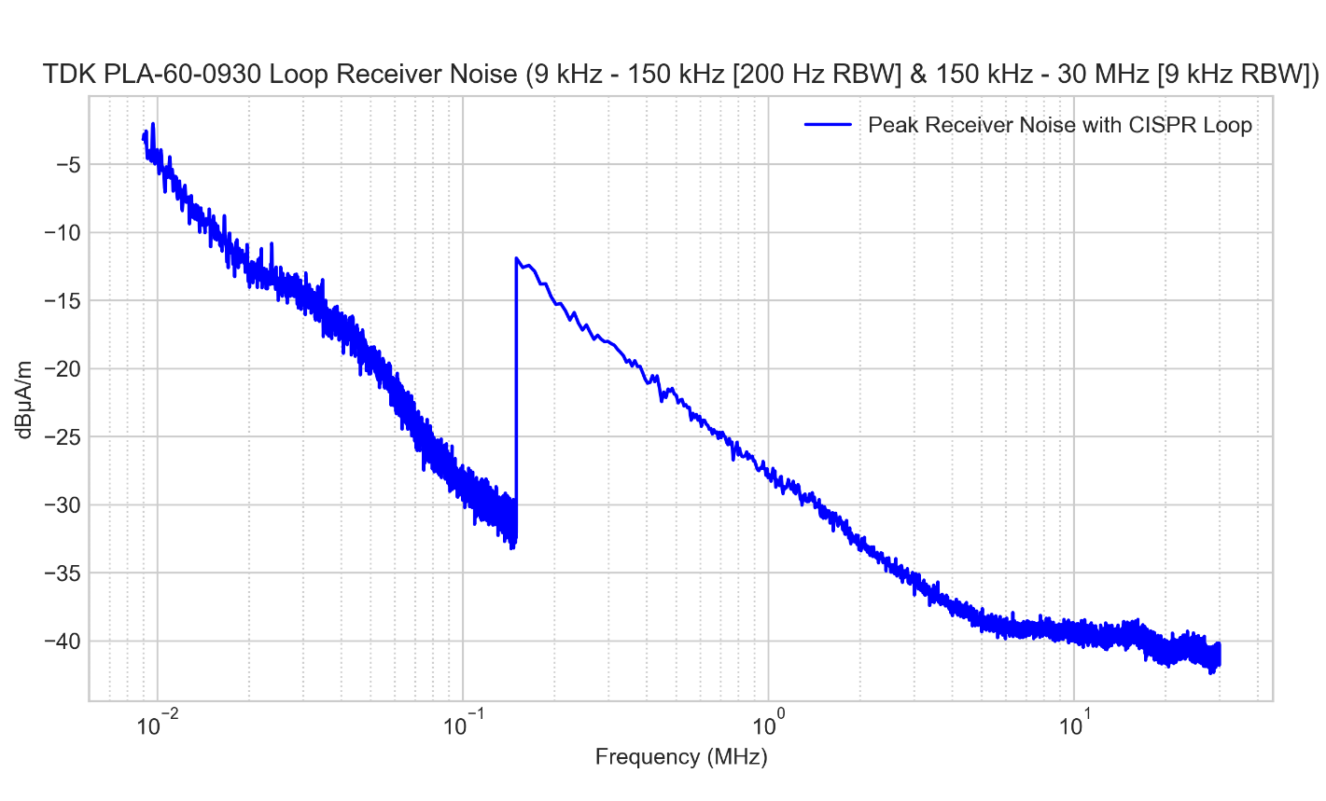
Figure A12-12: System noise measurements with the TDK PLA-60-0930 CISPR Loop used for measurements in this impact study

The following plots show peak ambient emissions at the OATS to assist in visually identifying peaks related to the WPT-EV system tested versus ambient peaks present at various times during testing. Plots are given in consideration with orientations in X & Y being coaxial and coplanar respectively to the location of the EUT (i.e., perpendicular from ground plane) as well as the Z orientation with the loop being horizontal (i.e., parallel with ground plane).
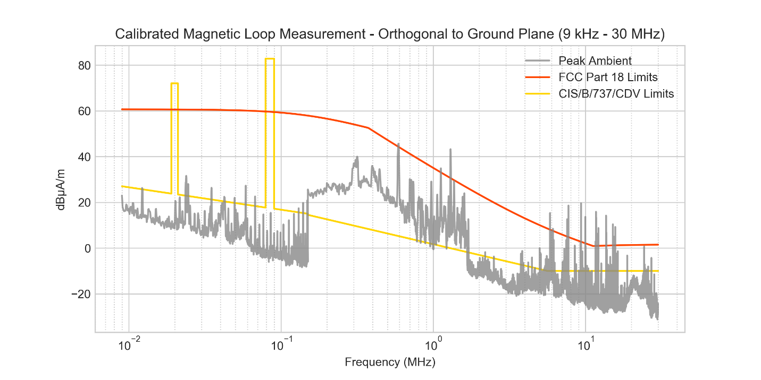
Figure A12-13: Ambient peak measurements on the OATS with calibrated magnetic loop orthogonal to the ground plane

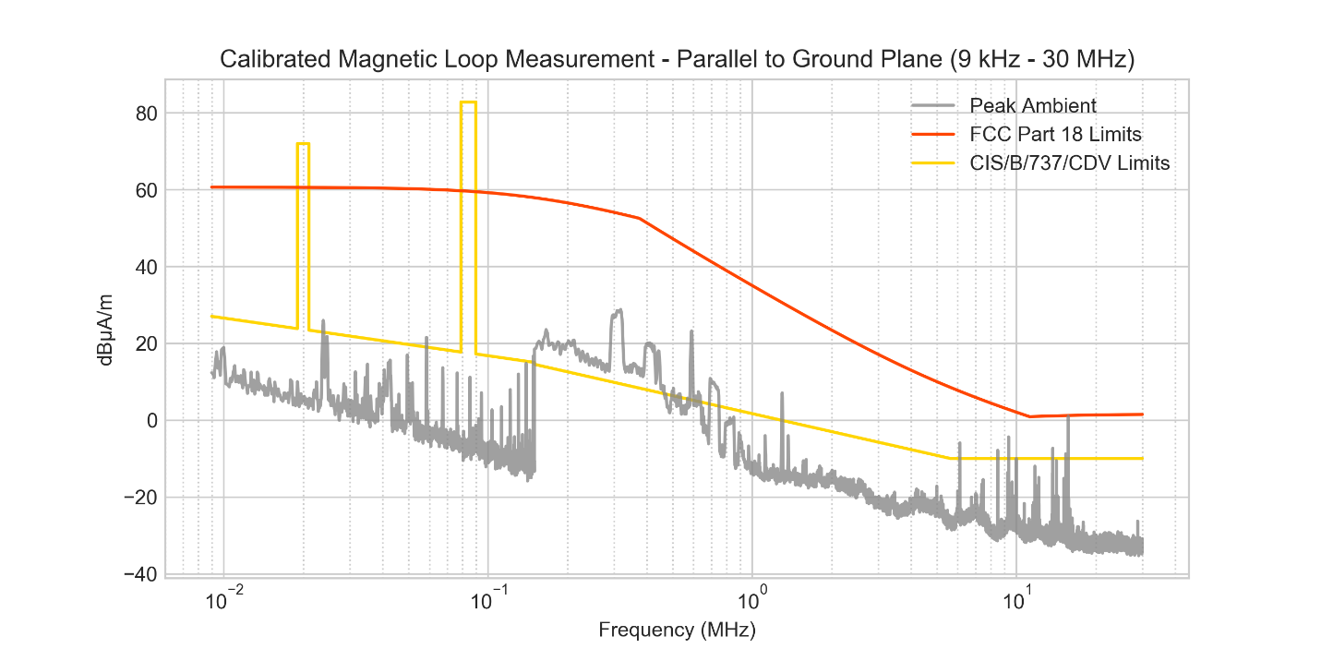Figure A12-14: Ambient peak measurements on the OATS with calibrated magnetic loop parallel to the ground plane

To assess relative ambient conditions using standard amateur radio equipment, a typical portable monopole antenna (quite a bit larger than the calibrated monopole) capable of operating from the 80 m amateur band to the 6 m amateur band was also used (see § A12.3.3 for measurement equipment list). The spectrum analyser trace was set in a max hold mode measuring from 150 kHz to 30 MHz with 9kHz RBW, 30 kHz VBW, and 40001 points. In each of the bands, a marker indicates where a projected WPT-EV harmonic could potentially occur (though the WPT-EV system was not operating during the measurements). It is noted that the measurement conditions using a CISPR peak detector for standard EMC limit evaluation are not the same as the measurement conditions used to measure man-made noise floor levels that are indicated in Recommendation ITU-R P.372 which are derived using measurement techniques outlined in ITU-R Recommendation SM.1753. The intent of the ambient measurements made with a typical amateur radio monopole are to assess the relative differences seen at the radio receiver with the WPT-EV system OFF (peak ambient emissions) and ON (peak ambient + WPT-EV system emissions) and to ensure capture of all time varying and rotationally dependent peaks emanating from the WPT-EV system in comparison with ambient emissions otherwise present. The OATS location in Cedar Park, Texas abuts a residential neighbourhood to the west and business complexes to the north and south. The location of the OATS could generally be described as a light-business area with offices and small businesses in operation during testing. The site complies with the ANSI C63.7 construction methods for EMC measurements, requiring among other criteria, that the site be located a minimum distance away from obstruction-free areas that could perturb the measurements.

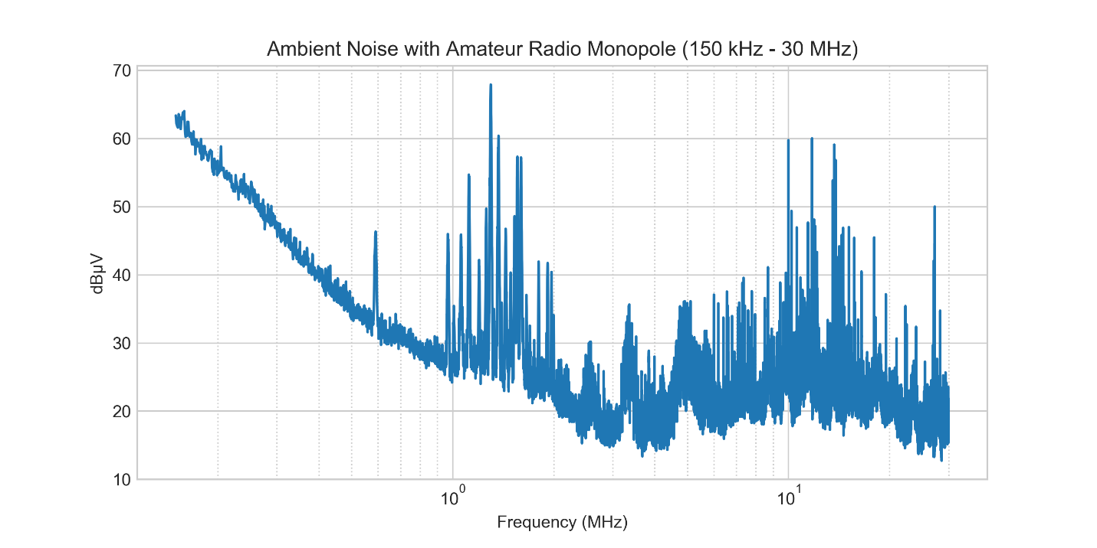
Figure A12-15: Peak ambient seen at receiver using the amateur radio monopole antenna

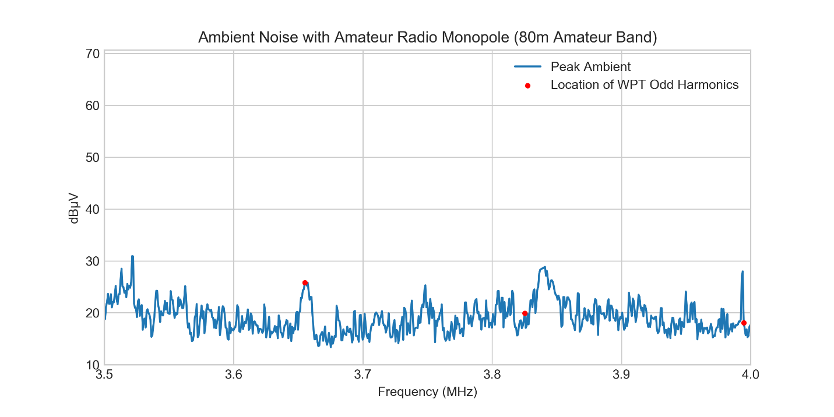
Figure A12-16: Peak ambient seen at receiver using the amateur radio monopole antenna (80 m band)

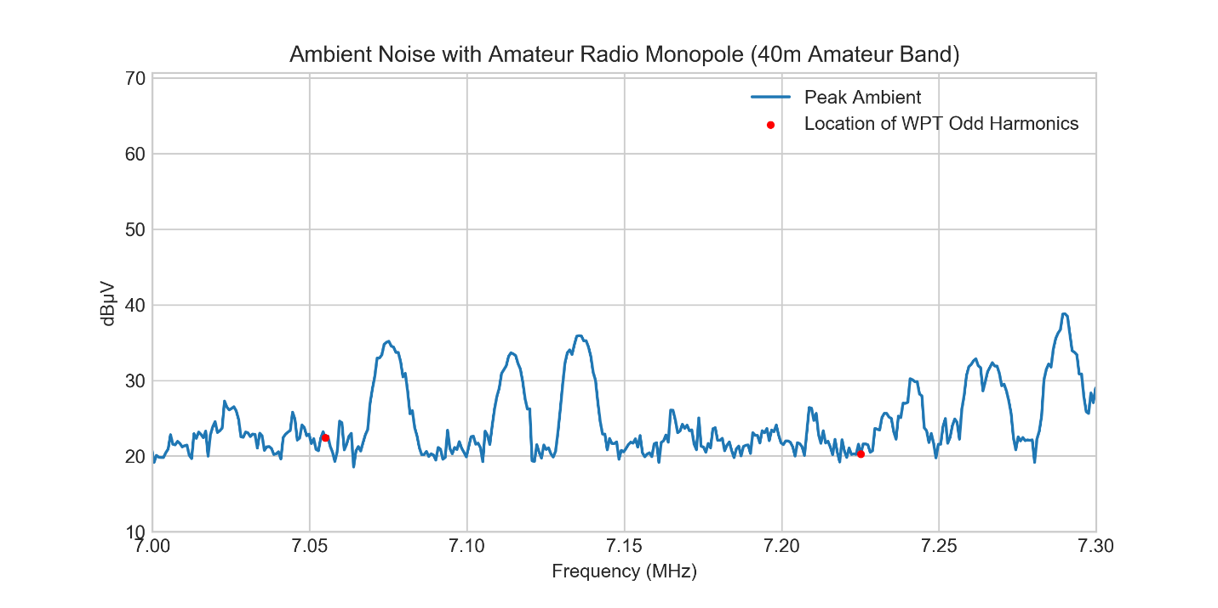
Figure A12-17: Peak ambient seen at receiver using the amateur radio monopole antenna (40 m band)

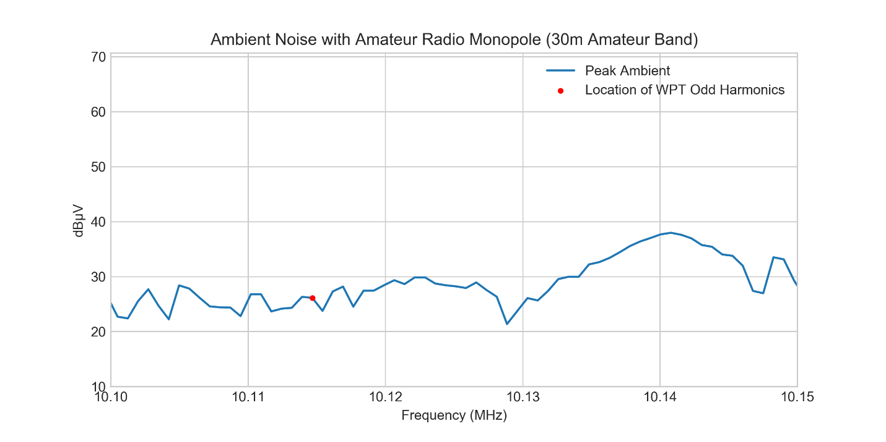
Figure A12-18: Peak ambient seen at receiver using the amateur radio monopole antenna (30 m band)

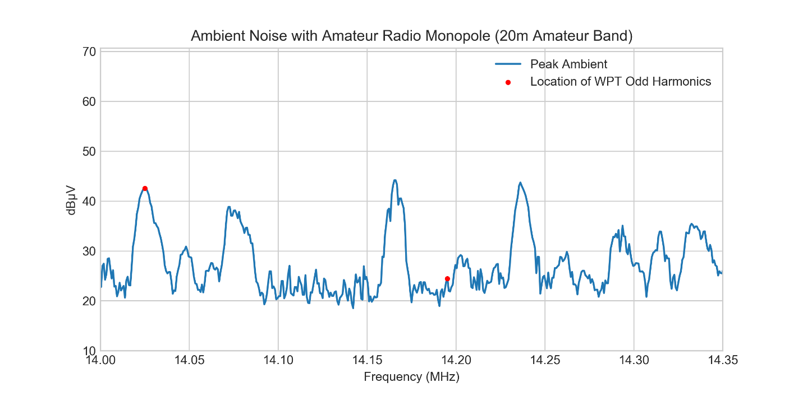
Figure A12-19: Peak ambient seen at receiver using the amateur radio monopole antenna (20 m band)

It was noted by a test observer that the ambient conditions of the test site seemed high and therefore additional ambient measurements were taken in a more rural part of the United States in Nibley, Utah to compare relative conditions that an amateur radio operator may experience. Census data from 2010 on Nibley, Utah shows its population density was 87.4 people per square mile (226.4 people per square kilometre). The FCC’s ULS database shows 44 amateur operators with active licenses registered in Nibley, Utah as of February 12, 2020. A comparison of relative peak ambient measurements as seen at the receiver (not converted to field levels) using the amateur radio monopole from 150 kHz to 30 MHz is shown below with zoomed conditions in each of the measured amateur radio bands. The duration of the peak hold measurements was in the range of 5 to 15 minutes just before midday. The location of measurement in Nibley, Utah occurred in a local residential field with a local business and school approximately 75 meters north and west of the measurement point. The measurements in Nibley, Utah were performed approximately 10 meters from the office where the measurement equipment resides. At the time of measurement for the Nibley, Utah data, the school and businesses within a 75 meter radius were not operating due to local economy shutdown. Amateur stations could be located in the residential portion of either location, so these tests are representative of what could be found in a range of amateur stations. It must be noted, however, that comparisons between EV harmonics and the two locations being measured can be applied only to the locations with similar ambient noise and signal levels.

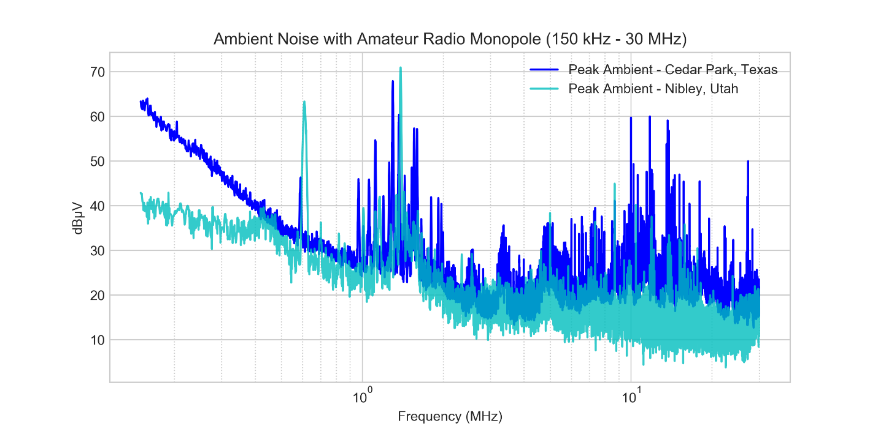
Figure A12-20: Peak ambient comparison between two locations seen at receiver using amateur radio monopole antenna

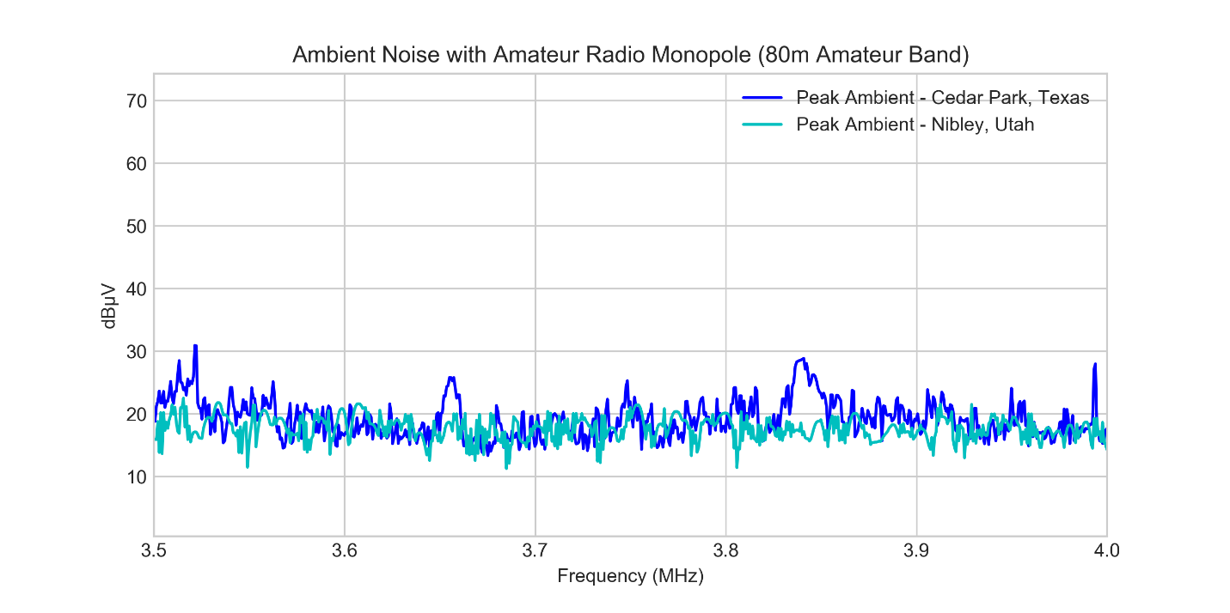
Figure A12-21: Peak ambient comparison between two locations seen at receiver using amateur radio monopole antenna (80 m band)

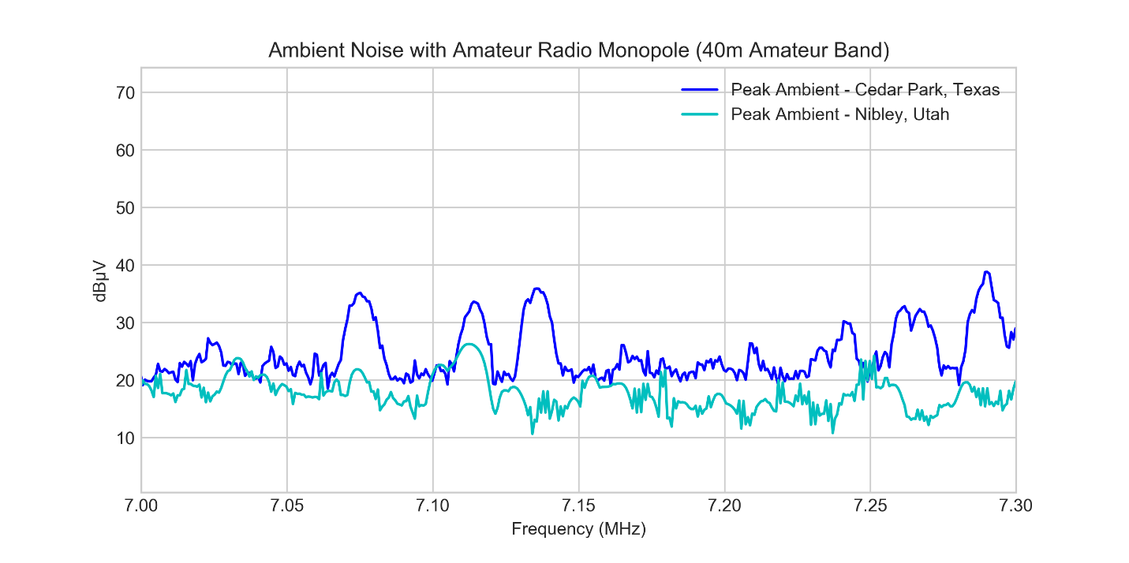
Figure A12-22: Peak ambient comparison between two locations seen at receiver using amateur radio monopole antenna (40 m band)

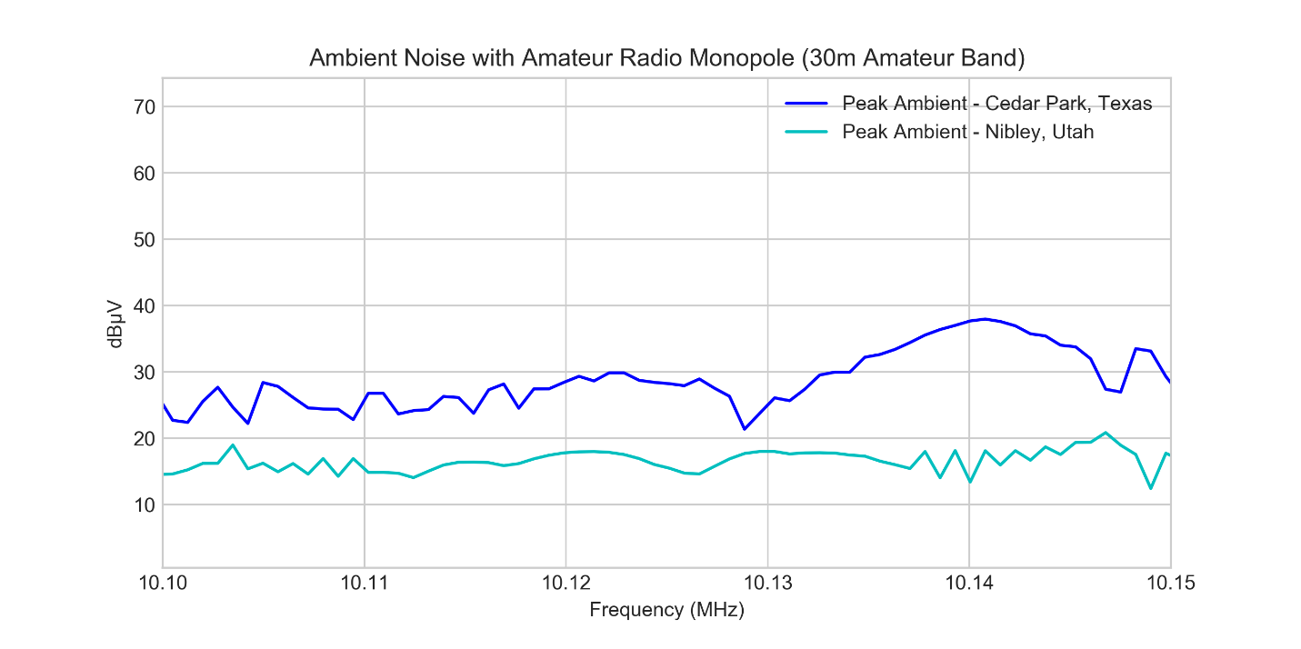
Figure A12-23: Peak ambient comparison between two locations seen at receiver using amateur radio monopole antenna (30 m band)

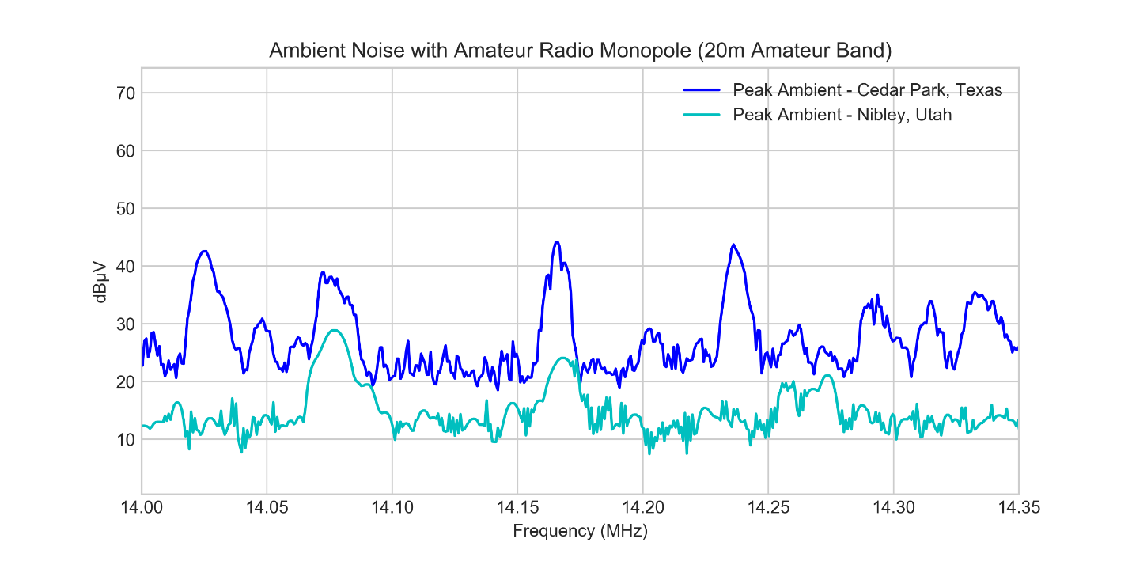
Figure A12-24: Peak ambient comparison between two locations seen at receiver using amateur radio monopole antenna (20 m band)

As can be seen, the ambient conditions between these two distant locations (separated by ~1300 miles or ~2100 km), the ambient measurements in the 80 m and 40 m bands showed similar characteristics, whereas in the 30 m and 20 m bands, the levels in Nibley, Utah were typically up to ~10 dB lower than those in Cedar Park, Texas. A satellite image of Nibley, Utah is shown below for comparison.
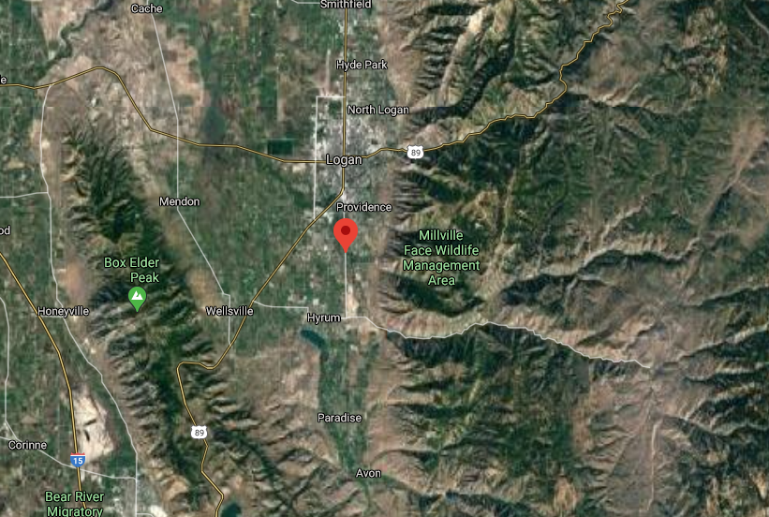
Figure A12-25: Satellite map view of Nibley, Utah

While it is generally expected that ambient conditions would be even lower in un-populated areas of the U.S. (e.g., forests, mountains, fields, etc.) where many amateur radio operators enjoy setting up portable stations for low-noise conditions, it is not expected that WPT-EV systems would be generally located nearby (e.g., much greater than 30 m) in such areas.

A12.3.3 Measurement Equipment, Measurement Standards, and Measurement Setup
TDK RF Solutions provided standard calibrated equipment for all radiated emissions and electromagnetic field (EMF) exposure measurements. Attending amateur radio operators provided additional equipment for radiated emission impact testing in the HF amateur radio bands of interest. The same calibrated spectrum analysers used for the standardized EMI testing were also used to measure the spectrum as seen using the different amateur radio antennas as well.

TDK RF Solutions Calibrated Equipment for Radiated Emissions Testing:
- Keysight Technologies (formerly Agilent Technologies) MXE Spectrum Analyzer
- Rhode and Schwarz ESCI EMI Test Receiver
- Rhode and Schwarz ZNL3 Vector Network Analyzer (VNA)
- TDK RF Solutions Magnetic Loop Antenna PLA-60-0930
- A.H. Systems Monopole Antenna SAS-551
- TDK RF Solutions Accredited Open Area Test Site
TDK RF Solutions Calibrated Equipment for EMF Testing:
- Narda ELT-400 Field Probe
- TDK RF Solutions Automated Robotic Positioning System
Amateur Radio Equipment for Radiated Emissions Interference Testing:
- Alpha Antenna HD-FMJ 6-80 Meter Portable HF Antenna (~20 feet / ~6 meters tall)
- Chameleon V1 HF 6-80 Meter Vertical Dipole Antenna raised ~20 feet (~6 meters)
- Yaesu 857D HF/VHF/UHF Transceiver
- Airspy HF+ Discovery Software Defined Radio with SDRSharp Software Interface

Below is an annotated image of the WPT-EV test setup on the OATS for calibrated radiated emissions testing.
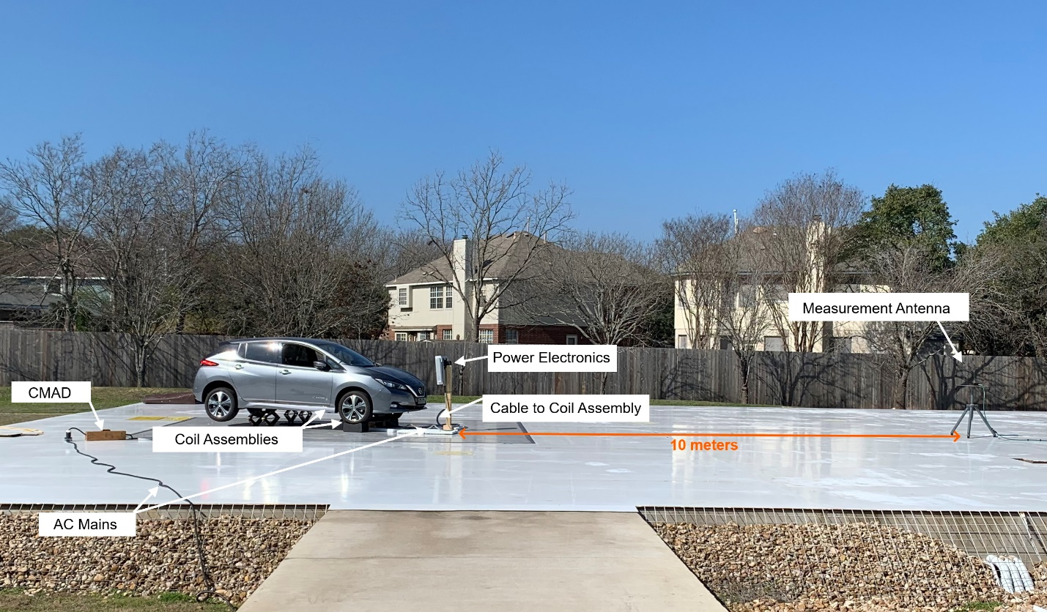
Figure A12-26: Setup on OATS for calibrated radiated emissions testing

Below is an annotated image of the WPT-EV test setup in a typical garage setting for calibrated EMF exposure testing.
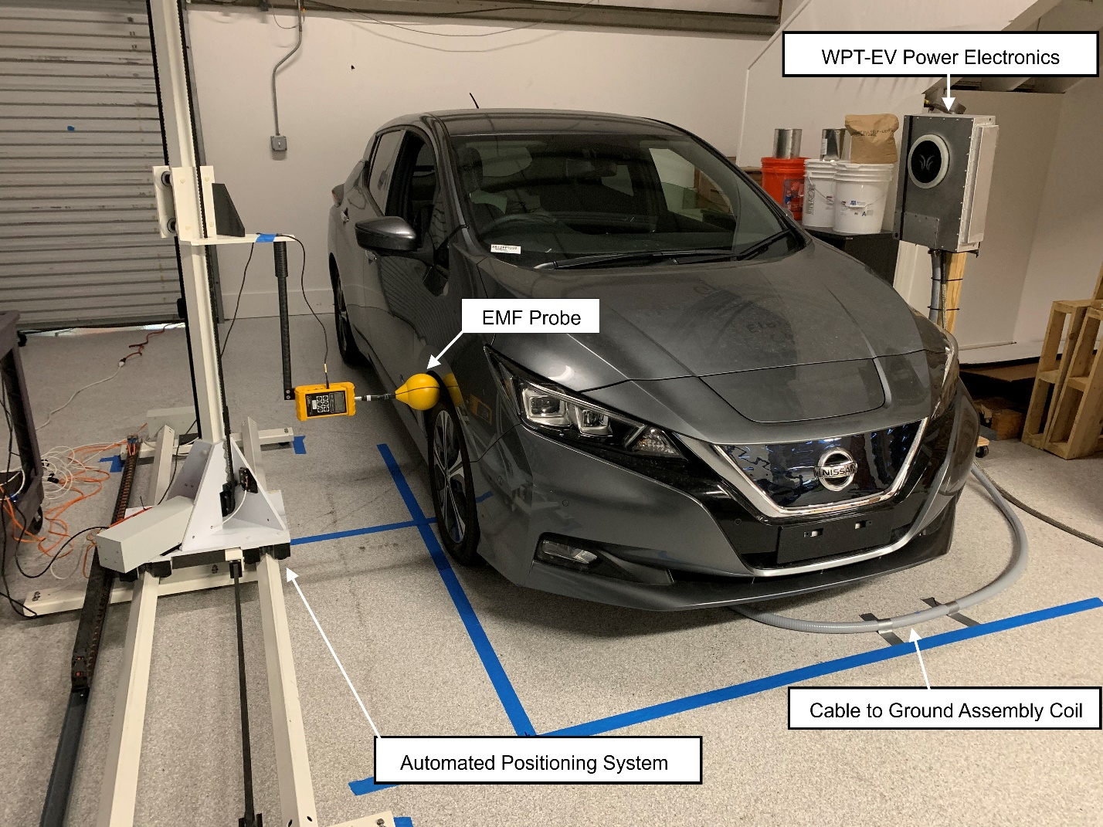
Figure A12-27: Setup over in garage with concrete floor for calibrated EMF measurement testing

The amateur radio antennas (Chameleon V1 vertical dipole and HD-FMJ monopole) were setup over real earth at 10 m, 20 m, and 30 m distances from the WPT-EV system on the OATS and turn table. The turn table was rotated to obtain worst-case conditions. While two types of antennas were initially used (both a vertical dipole and monopole), the qualitative results from the two antennas appeared similar and the vertical dipole was determined to be less sensitive so all remaining data was collected using the HD-FMJ monopole which was a much simpler setup for measurement. These two antenna types and the setup conditions for 10 m, 20 m, and 30 m distances are shown below.
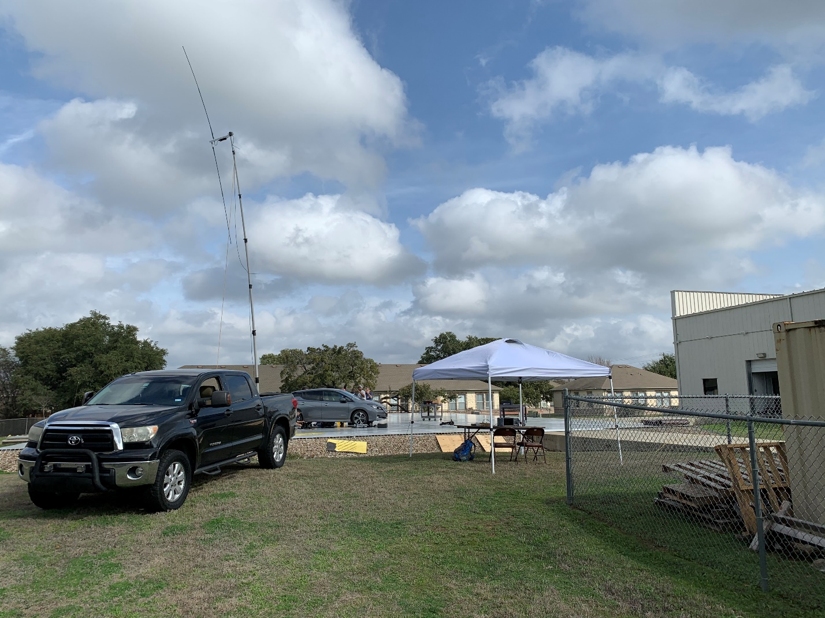
Figure A12-28: Setup of amateur radio vertical dipole antenna at a distance of 10 m from WPT-EV system

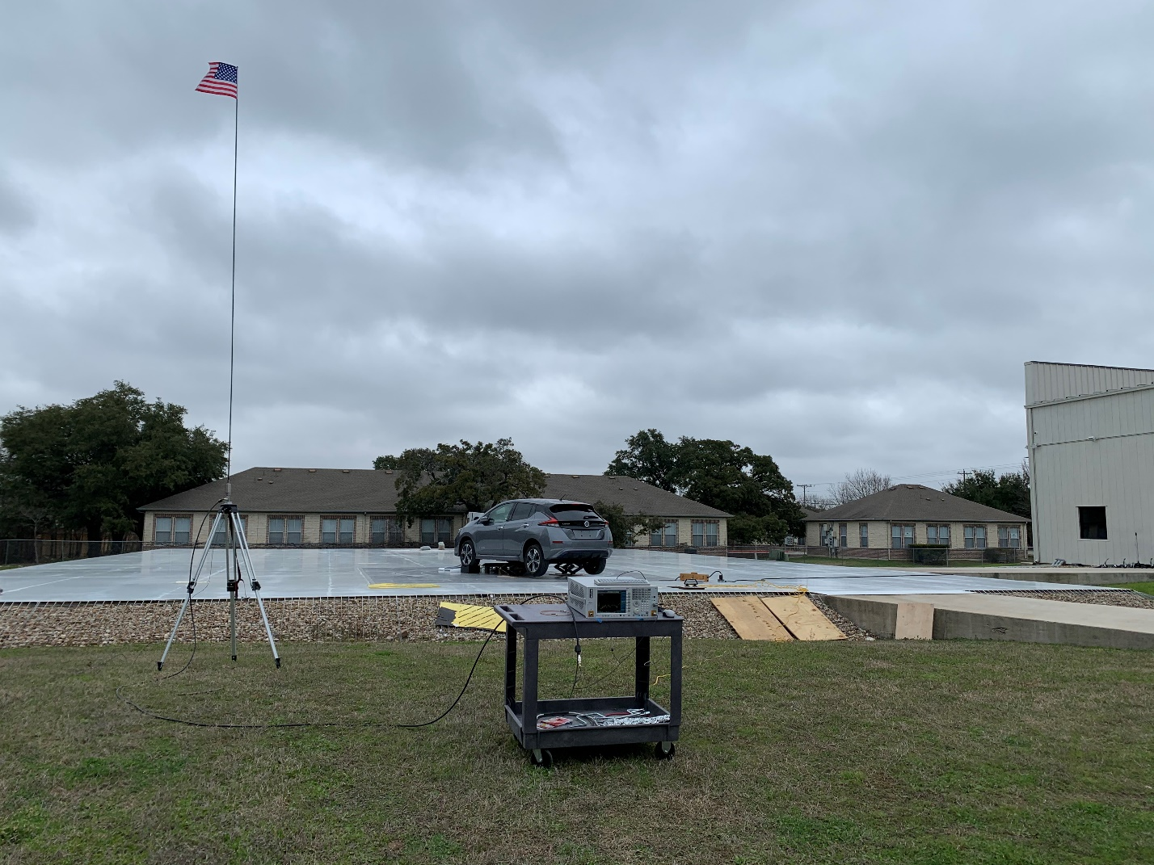
Figure A12-29: Setup of amateur radio monopole antenna at a distance of 10 m from the WPT-EV system

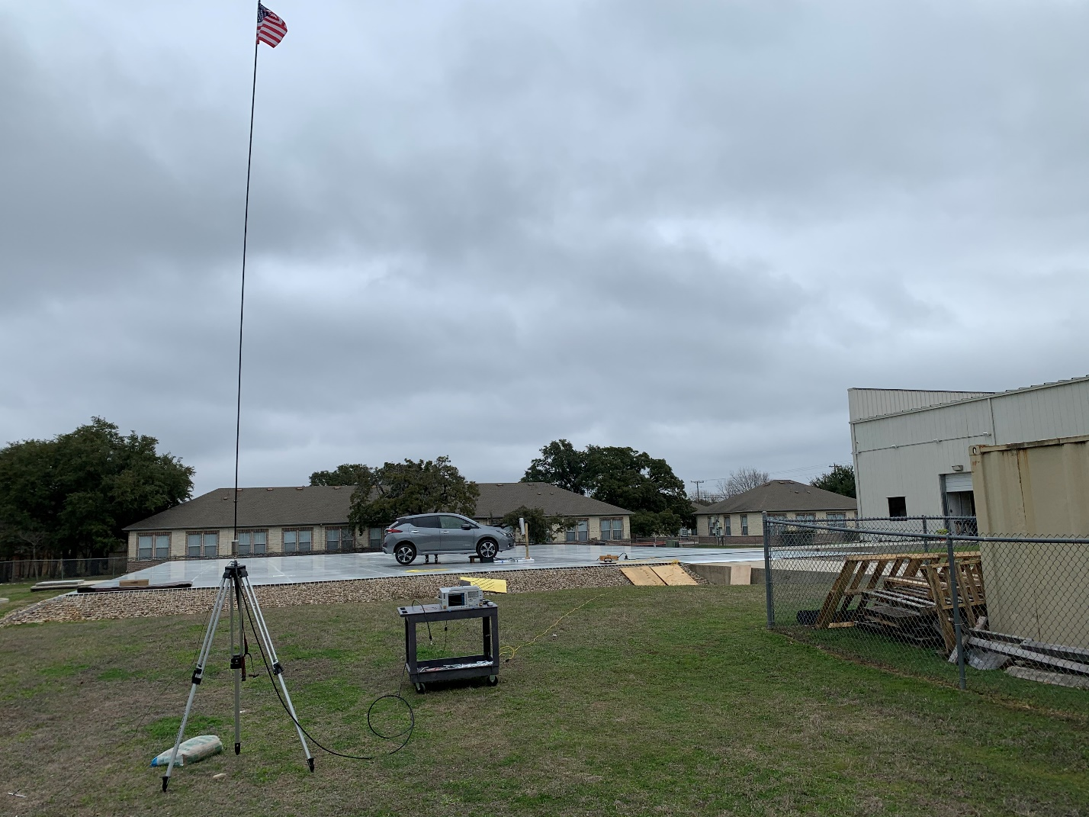
Figure A12-30: Setup of amateur radio monopole antenna at a distance of 20 m from the WPT-EV system

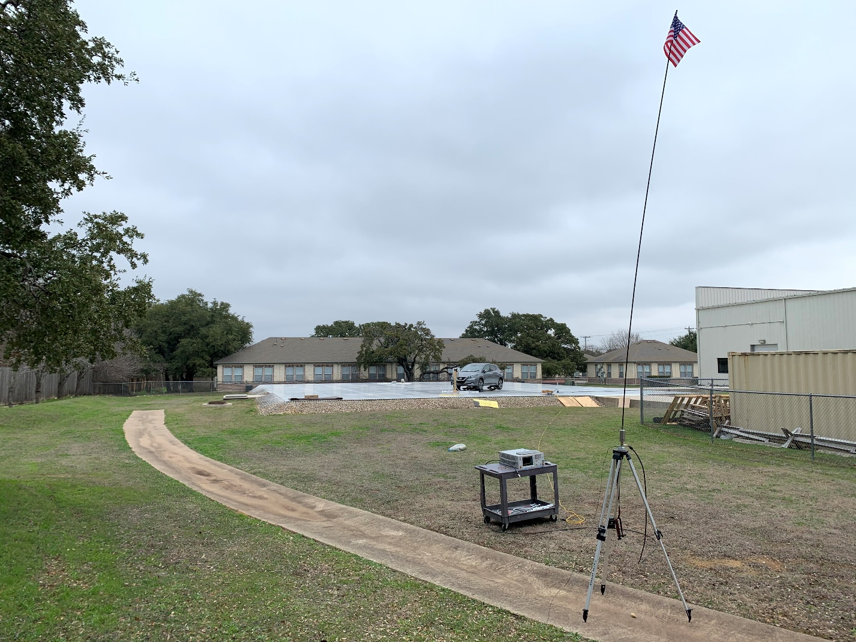
Figure A12-31: Setup of amateur radio monopole antenna at a distance of 30 m from the WPT-EV system

The amateur radio monopole antenna has multiple configurations for changing the characteristics of the antenna e.g., by adding a line for NVIS (Near Vertical Incidence Skywave) transmission and reception. Because the amateur radio antennas have not been specifically calibrated for absolute field strength measurements, all measurements shown are relative. The plots below show an S-parameter (S₁₁) characterization of the amateur radio monopole antenna with and without the NVIS line.

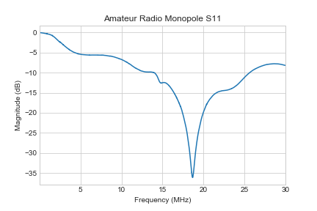
Figure A12-32: S₁₁ measurements of amateur radio monopole antenna

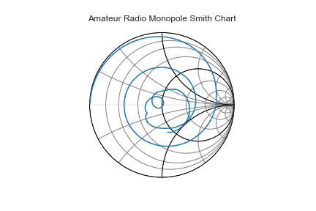
Figure A12-33: Smith chart for measurements of amateur radio monopole antenna

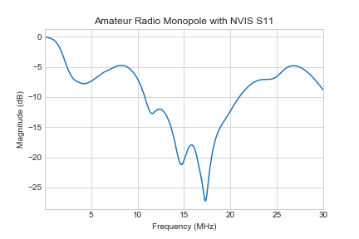
Figure A12-34: S₁₁ measurements of amateur radio monopole antenna with NVIS line

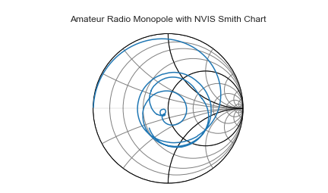
Figure A12-35: Smith chart for measurements of amateur radio monopole antenna with NVIS line

A12.3.4 Measurement Results
A12.3.4.1 EMF Measurement Results
Measurements were taken of the WPT-EV system in worst-case conditions for EMF exposure considerations including maximum offset and full power. As a reference consideration for EMF Exposure, ICNIRP 2010 guidelines set a reference level of 27 µT RMS for 85 kHz. Additionally, ISO 14117 for consideration of CIEDs (Cardiac Implantable Electronic Devices) sets induced lead-loop induced voltage requirements in a 225 cm² loop which results in a magnetic field level restriction of 15 µT RMS. The images below show the measurement planes and the resultant magnetic flux density values measured with an EMF probe containing 3 orthogonal 100 cm² loops and automatically calculating the root mean square sum of all of the axes together. A coarse scan with a resolution of 7.5 cm spacing was taken to determine the hot-spot location. Once the region of the largest field was identified, a finer resolution scan with 3.75 cm spacing was used. As a result of the fine measurements, the largest field level measured was found to be 4.226 µT RMS in the XZ plane (on the side of the vehicle). Measurements in the YZ plane (at the front of the vehicle) were approximately 4 times lower than the XZ plane and so are not shown for brevity.

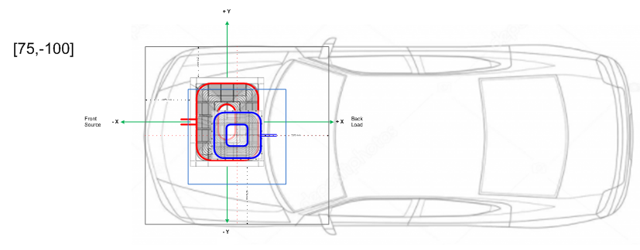
Figure A12-36: Maximum offset conditions for worst-case emission of WPT-EV system used for both EMF and radiated emissions testing
Figure A12-37: EMF measurements taken on a course grid with resolution of 7.5 cm

Figure A12-38: EMF measurements taken on a fine grid in the area of maximum EMF with resolution of 3.75 cm

A12.3.4.2 Radiated Emissions Measurement Results
A12.3.4.2.1 Calibrated Testing with Magnetic Loop Antenna and Monopole
A calibrated CISPR-16-1-4 60 cm magnetic loop from TDK RF Solutions was used to perform radiated emission measurements from 9 kHz to 30 MHz on the OATS. The WPT-EV system was turned on to charge the Nissan Leaf with ~11 kW of input power at efficiencies around 90% AC grid input to DC battery output. The state of charge of the Nissan leaf ranged from ~25% to 85% during testing to ensure that the power level was maintained constant, but the battery voltage changed overtime. Within this range, these variations in charge level and battery voltage did not significantly affect emissions for the WPT-EV system evaluated. The Nissan leaf battery capacity was specified at 62 kWh. The WPT-EV alignment between the ground coil and the vehicle coil were put in worst-case offset conditions at the specified 175mm ground height (referring to the ground-to-vehicle pad distance if the vehicle were to be on the road) to ensure the highest current and the most exposed coil conditions possible. Due to the fact that the WPT-EV system was a pre-production prototype, it was not expected to fully comply with present radiated emission regulatory requirements in all cases; however, this testing is considered generally representative for an SDO conformant WPT3 WPT-EV system.

To capture maximum emission peaks in the spectrum scans, the turn table with the WPT-EV system was rotated in 2 degree increments across the entire 360 degree rotation and for each loop orientation (e.g., x,y,z axis). From 9 kHz to 150 kHz the resolution bandwidth was set to 200 Hz, and from 150 kHz the resolution bandwidth was set to 9 kHz as defined by standardized EMI measurement procedures. To obtain more detailed results for the fundamental and harmonically related peaks in the amateur radio bands, the resolution bandwidth was set to 200 Hz and the turn table rotated in 2 degree increments to find the maximum condition to perform quasi-peak and average measurements as well as obtain a polar radiation plot.

Below are the maximum peak scans with ambient measurements collected separately (and hence not necessarily time-correlated) for relative comparison. The FCC Part 18 limits shown are based on conversion and scaling from the 300 m limits to magnetic field limits at 10 m based on ANSI C63.30 scaling procedures discussed in §A12.3.2. The current draft 3rd amendment of CISPR 11 Ed 6 limits as outlined in CIS/B/737/CDV (Committee Draft for Vote) are also shown in the charts for comparison.

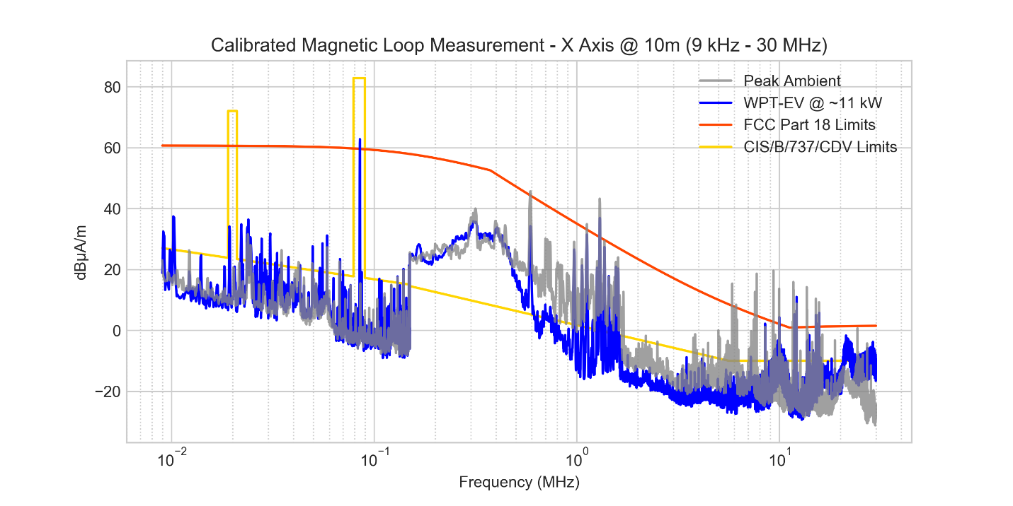
Figure A12-39: Calibrated magnetic loop measurements in X-axis (loop coaxial to EUT) with WPT-EV system on and off for comparison

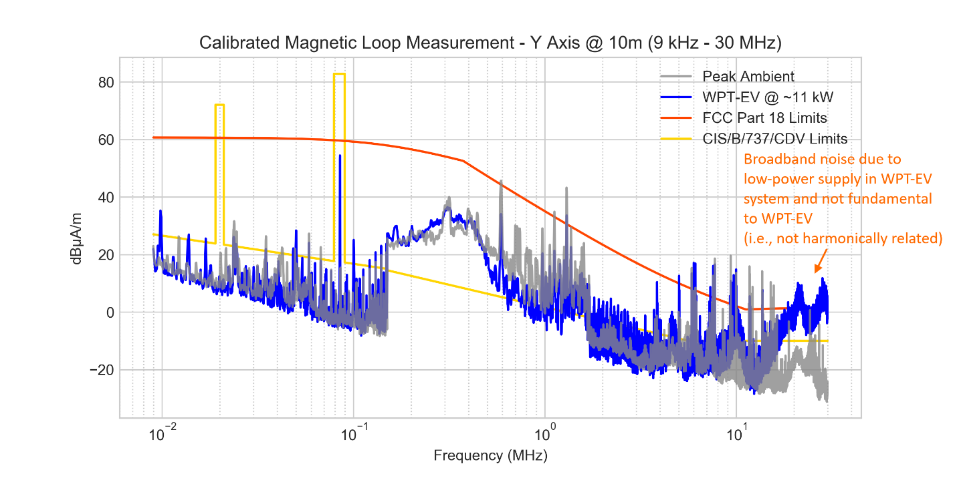
Figure A12-40: Calibrated magnetic loop measurements in Y-axis (loop coplanar to EUT) with WPT-EV system on and off for comparison

The increased broadband noise level at frequencies above 15 MHz is attributed to an auxiliary low power switched-mode power supply and is not fundamentally related to the WPT-EV core system.

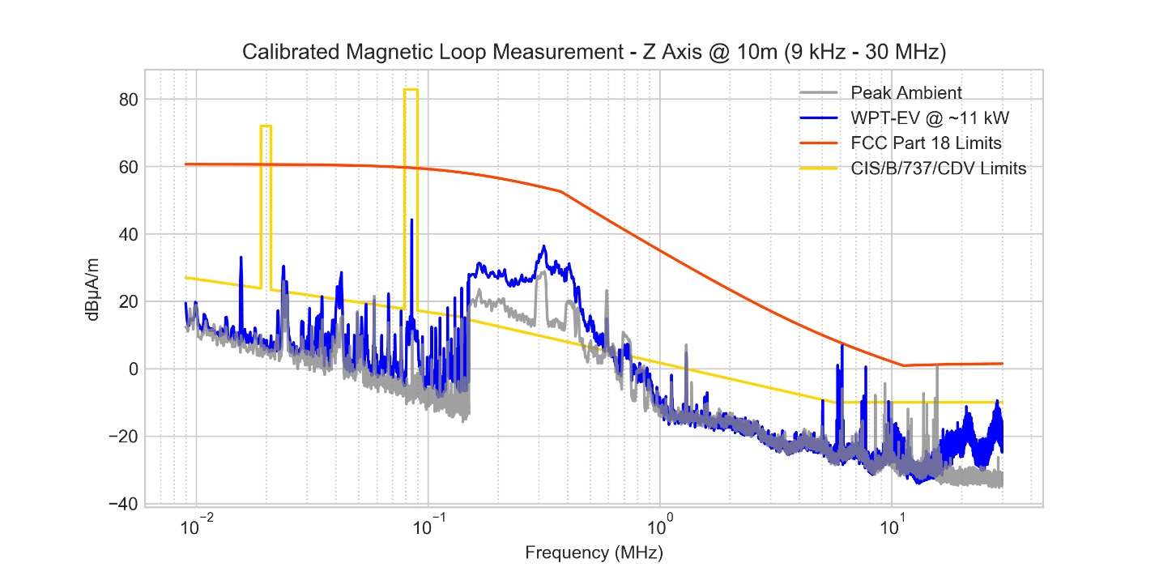
Figure A12-41: Calibrated magnetic loop measurements in Z-axis (loop parallel to ground) with WPT-EV system on and off for comparison

A zoomed in view of the 85 kHz fundamental as well as the 80 m, 40 m, 30 m, and 20 m amateur radio bands are shown below along with the measured quasi-peak and average values. It should be noted that the specifically annotated values in the plot were collected with a much lower RBW (i.e., 200 Hz) than the continuous plots which utilized a higher RBW (i.e. 9 kHz) as prescribed by CISPR. Only peaks that appeared to be somewhat discernible at a low-resolution bandwidth were collected though some of the peaks were barely above ambient conditions. Narrowband signals (with respect to the selected CISPR RBW) being essentially continuous wave (CW) signals and displaying sufficient signal to noise ratios will produce essentially the same amplitude response for peak, QP (quasi-peak), or AVG (average) detectors. It is noted that the results of these measurements show that the WPT-EV system has minimal interference potential to stations operating in the noise levels present at the OATS. For quieter locations, additional measurement would be required to ascertain interference potential (at expected distances between a WPT-EV system and receiver) in such environments.
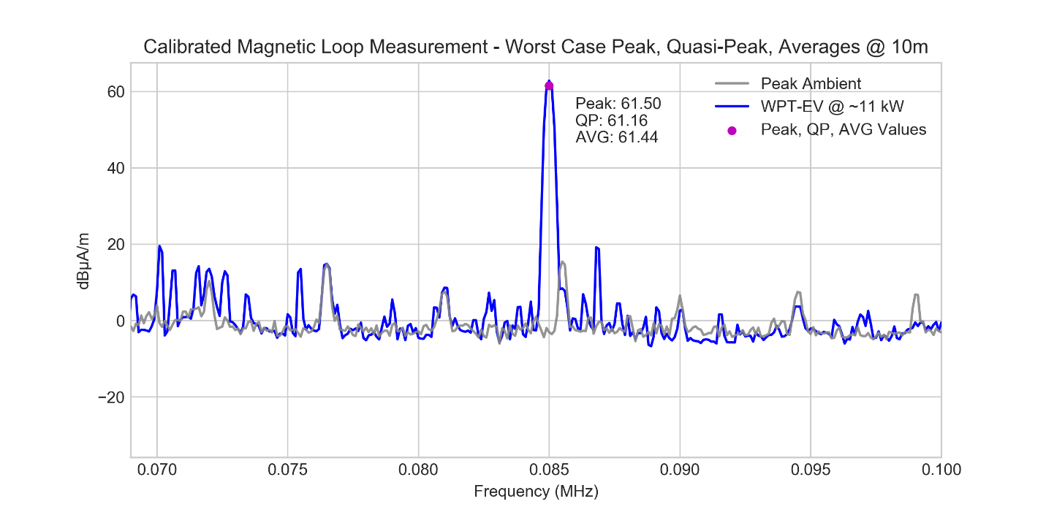
Figure A12-42: Detailed worst-case calibrated magnetic loop measurements with WPT-EV system on and off for comparison

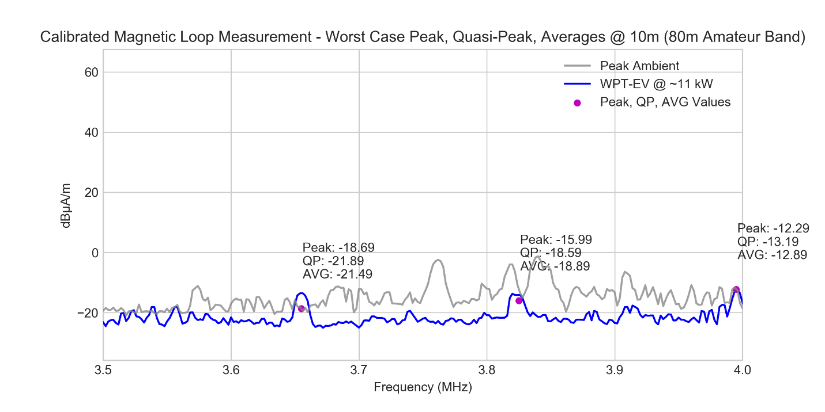
Figure A12-43: Detailed worst-case calibrated magnetic loop measurements with WPT-EV system on and off for comparison

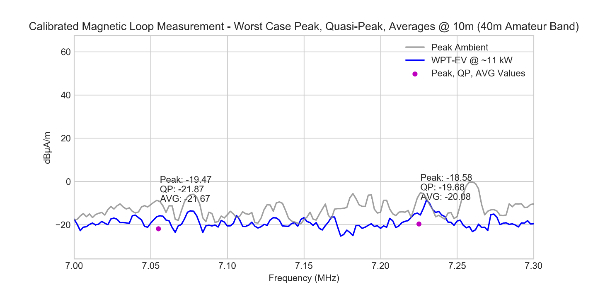
Figure A12-44: Detailed worst-case calibrated magnetic loop measurements with WPT-EV system on and off for comparison

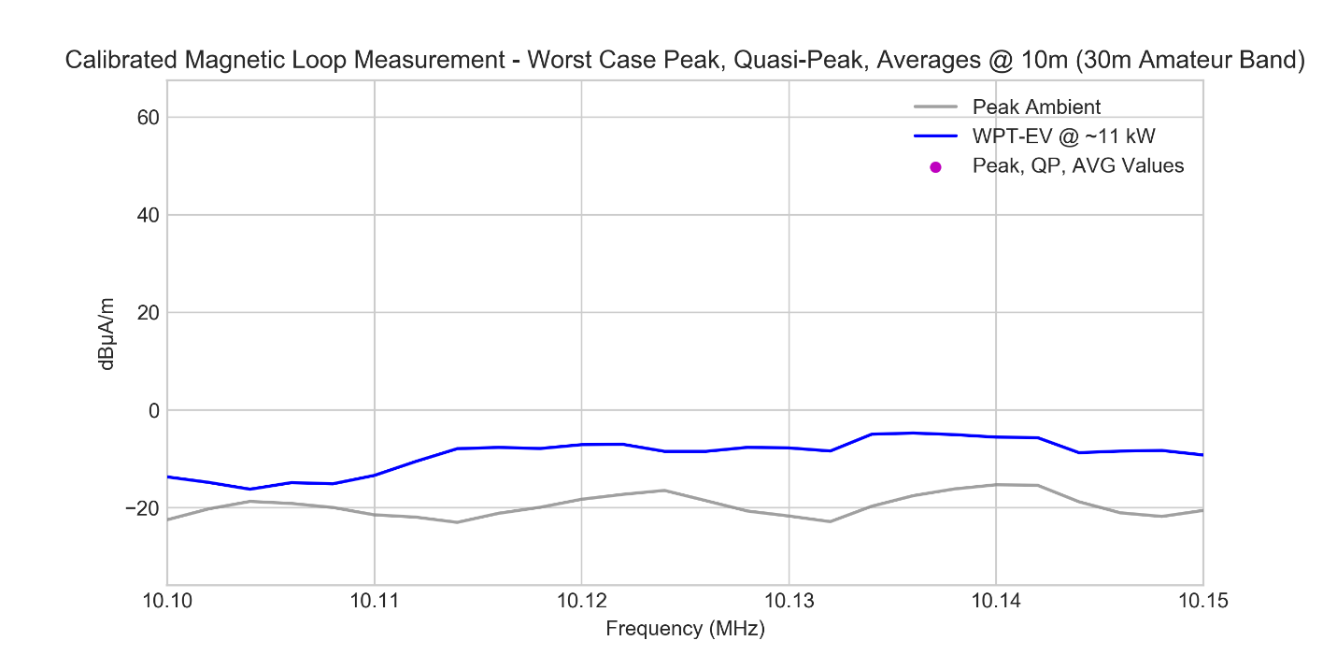
Figure A12-45: Detailed worst-case calibrated magnetic loop measurements with WPT-EV system on and off for comparison

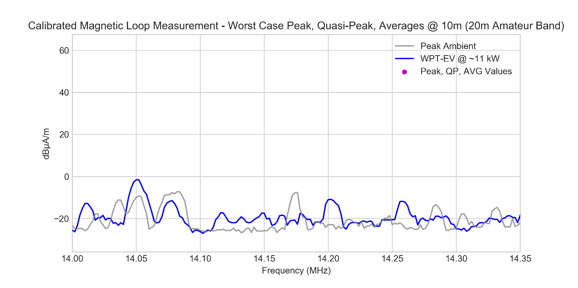
Figure A12-46: Detailed worst-case calibrated magnetic loop measurements with WPT-EV system on and off for comparison

For brevity, polar plots of the radiation pattern for several of the harmonics are shown below.

Figure A12-47: Polar radiation plot for 85 kHz fundamental of WPT-EV system

Figure A12-48: Polar radiation plot for 3.825 MHz harmonic of WPT-EV system

Figure A12-49: Polar radiation plot for 3.995 MHz harmonic of WPT-EV system

Figure A12-50: Polar radiation plot for 7.055 MHz harmonic of WPT-EV system

Additionally, to show relative fall-off correlation, several spectrum analyser measurements were collected at 10 m and 3 m distances for comparison. Since the fundamental was a large signal in comparison, attenuators were added and correlation made to ensure that no non-linear or saturation effects were observed due to high signal strength. The table below shows the results.

Frequency | 10 m | 3 m | 3 m  40 dB attenuation | 3 m  20 dB attenuation | 3 m  10 dB attenuation
85 kHz | 41.89 dBµA | 62.33 dBµA | 22.87 dBµA | 42.46 dBµA | 52.11 dBµA
1.955 MHz | 4.84 dBµA | 21.45 dBµA
3.655 MHz | 3.34 dBµA | 20.9 dBµA

In addition to the low frequency magnetic field measurements with a calibrated loop, measurements of the electric field were also collected in the same frequency range. Since calibrated EMC metrology grade electric field measurements are not traditionally considered at these lower frequencies, these additional measurements were undertaken as part of a series of anecdotal observations. The goal was to help guide future data collection by providing context and information not offered through other measurement methods typically undertaken in this frequency range for EMC applications.

The data was collected at a distance of 10 meters and was acquired with a calibrated broadband monopole with counter poise (model A.H. Systems SAS-551), matching pad and broadband pre-amplifier. The antenna’s published bandwidth covers 9 kHz to 40 MHz. The measurements targeted probable areas of emissions, specifically the WPT-EV system’s harmonics. Several phenomena were noted. The most important being the balance between the existing system’s electric field sensitivity versus the system’s saturation point with respect to the light industrial environment surrounding the OATS. Due to the combination of the broadband monopole with preamplifier, portions of the measured spectrum were affected by additional noise as a result of the system’s saturation. Because of this, the system was not readily able to view the harmonics from the WPT-EV system.

In general, a monopole is more sensitive to vertically polarized noise and responds to surface-wave noise not typically seen by horizontally polarized antennas such as half-wave dipoles commonly used by amateur radio operators [22]. The same characteristics hold true for EMC measurements. Therefore, additional precautions should be followed when utilizing monopoles on an OATS or in a shielded anechoic chamber in the presence of strong radiators that may compose part of the ambient environment. Given this, if calibrated monopole measurements are to be considered, as recommended for certain WPT-EV conditions in CIS/B/737/CDV, it is important for the EMC lab to apply appropriate metrology measures. The use of narrow-band filtering to improve selectivity, suitable pre-amplifiers for the range of measurement, and an understanding of the ambient environment will all prove useful when performing calibrated measurements using a monopole. Outside the domain of EMC regulatory measurements, radio receivers utilizing a monopole antenna typically require appropriate tuning to improve noise rejection and selectivity in the band of interest. The measurements performed with the amateur radio monopole antenna used for further qualitative testing was supplied with such a matching network for its designated amateur bands of operation (i.e., 80 m to 6 m bands).

A12.3.4.2.2 Amateur Radio Monopole Antenna Testing
A portable HF amateur radio monopole was chosen based on many qualitative reviews about the antenna from the amateur radio community. For example, eHam.net is a website for independent reviews of amateur radio products. The HD-FMJ antenna from Alpha Antennas is about ~20 feet (~6 meters) tall and has excellent reviews. As of February 12, 2020 there were 66 reviews posted resulting in a qualitative rating by amateur radio operators of 4.9 out of 5 on eHam.net [14]. Due to the large effective height (ratio of induced voltage to incident field) of this antenna compared to smaller antennas typically used for commercial radio broadcasting reception, it was expected and verified that this particular antenna was slightly more sensitive in the HF amateur radio bands. An overview of spectrum from 150 kHz to 15 MHz at 10 m, 20 m, and 30 m distances from the WPT-EV system are shown below. The results are based on a max-hold plot with the WPT-EV system rotated slowly on the turn-table to ensure maximum peaks were obtained. The resolution bandwidth was set to 9 kHz. Ambient results with the same antenna configuration were collected separately with the WPT-EV system OFF for comparison with the WPT-EV system ON.

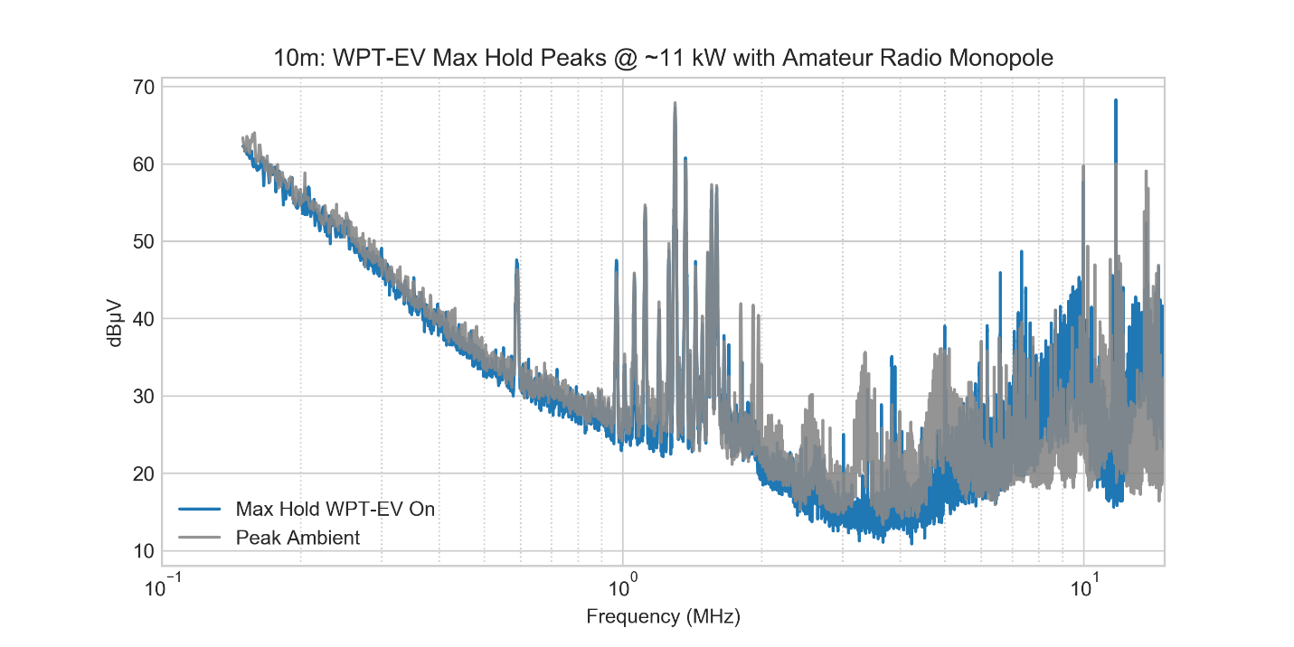
Figure A12-51: Peak measurements at a distance of 10 m using amateur radio monopole with WPT-EV system on and off for comparison

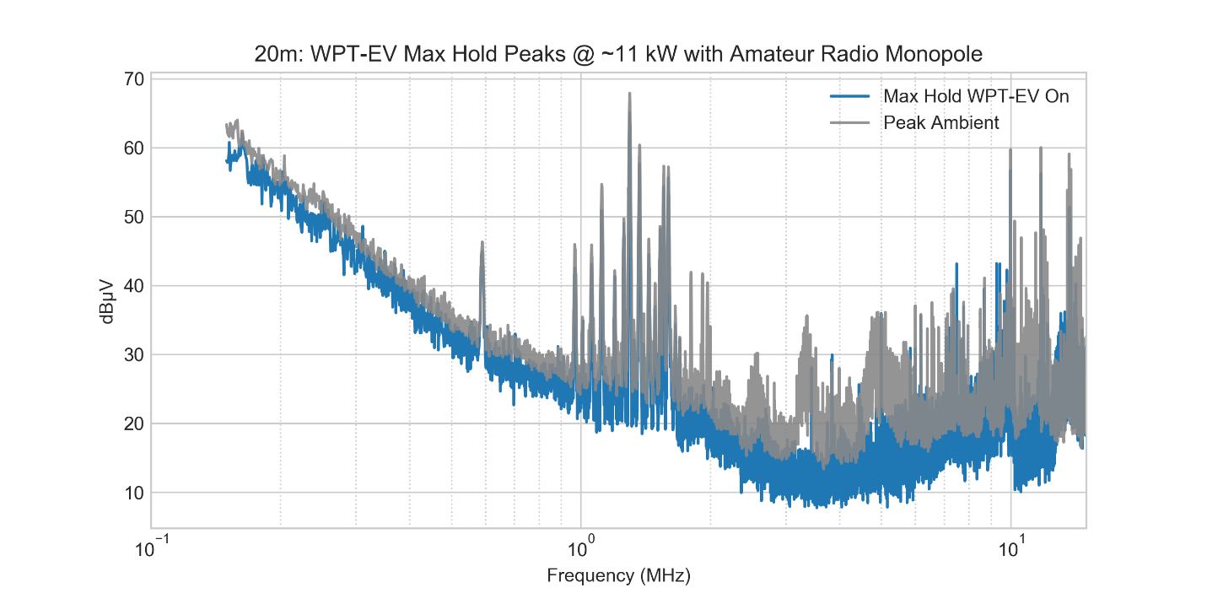
Figure A12-52: Peak measurements at a distance of 20 m using amateur radio monopole with WPT-EV system on and off for comparison

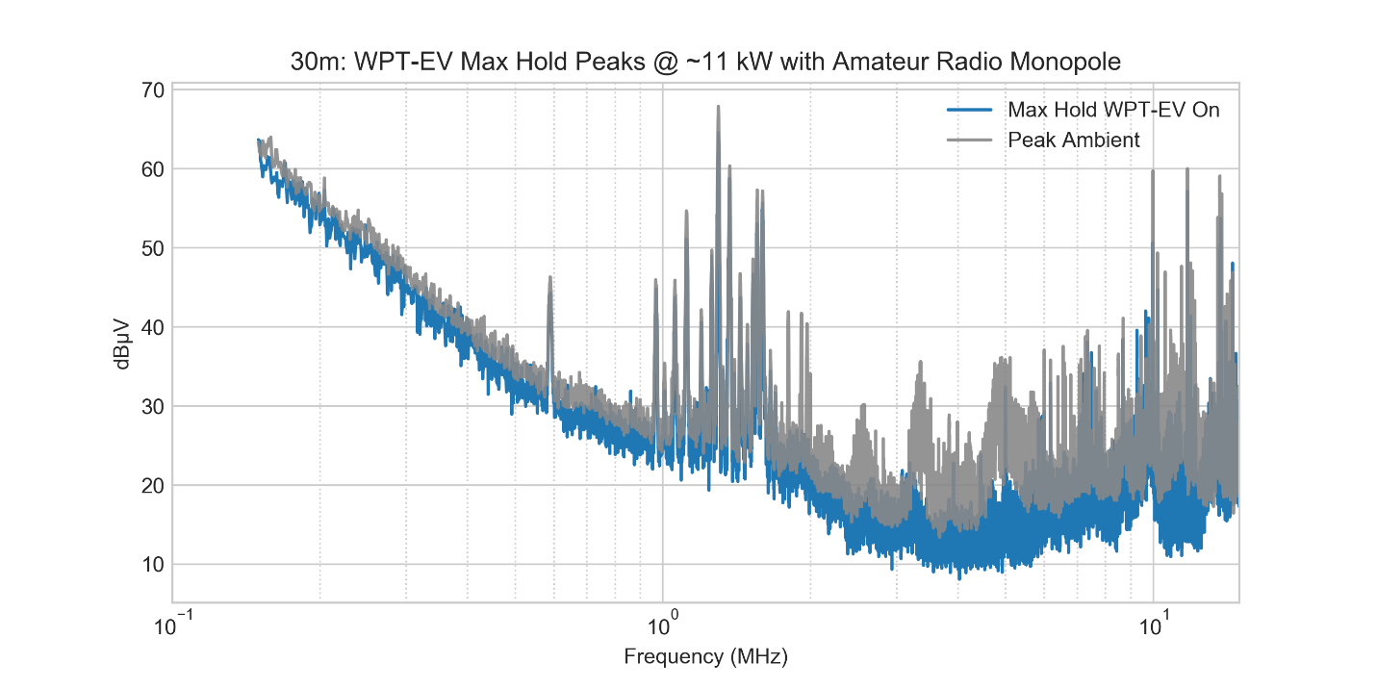
Figure A12-53: Peak measurements at a distance of 30 m using amateur radio monopole with WPT-EV system on and off for comparison

For better qualitative comparison, plots in each of the 80 m, 40 m, 30 m, and 20 m amateur radio bands are shown taken at distances of 10 m, 20 m, and 30 m from the WPT-EV system. The 80 m amateur band at the various distances is shown below along with the marked expected locations of the WPT-EV odd harmonics.

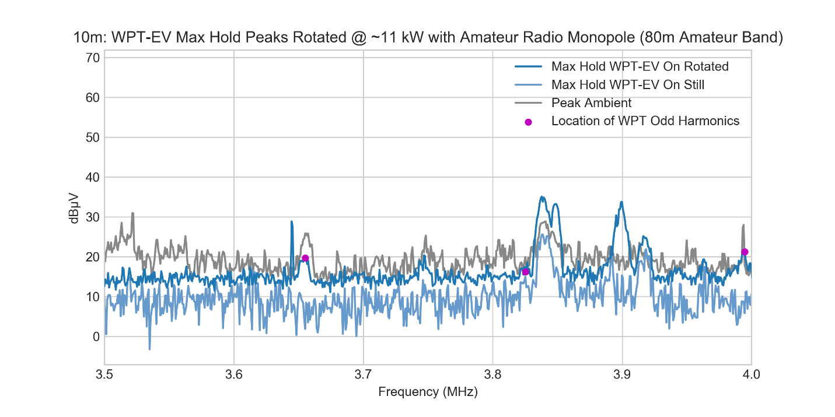
Figure A12-54: Peak measurements at a distance of 10 m using amateur radio monopole with WPT-EV system on and off for comparison

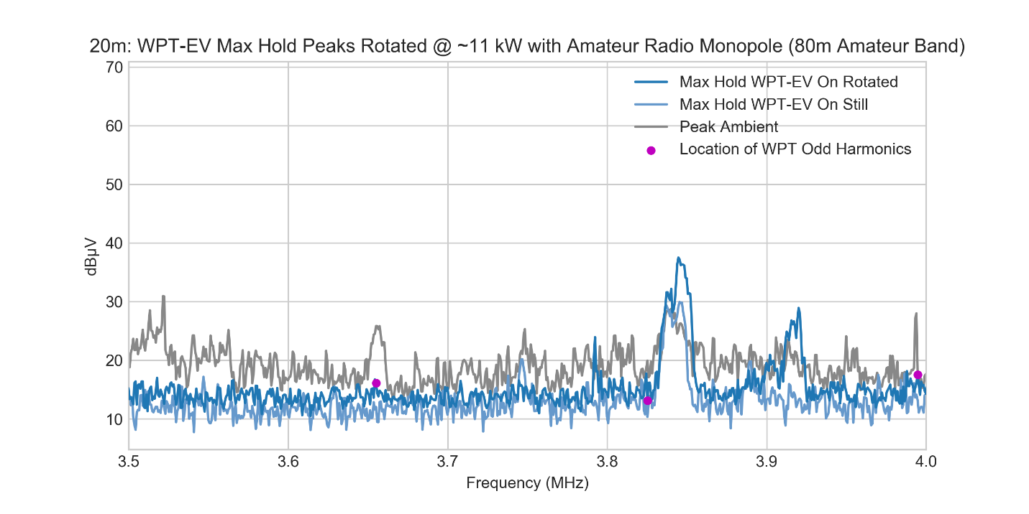
Figure A12-55: Peak measurements at a distance of 20 m using amateur radio monopole with WPT-EV system on and off for comparison

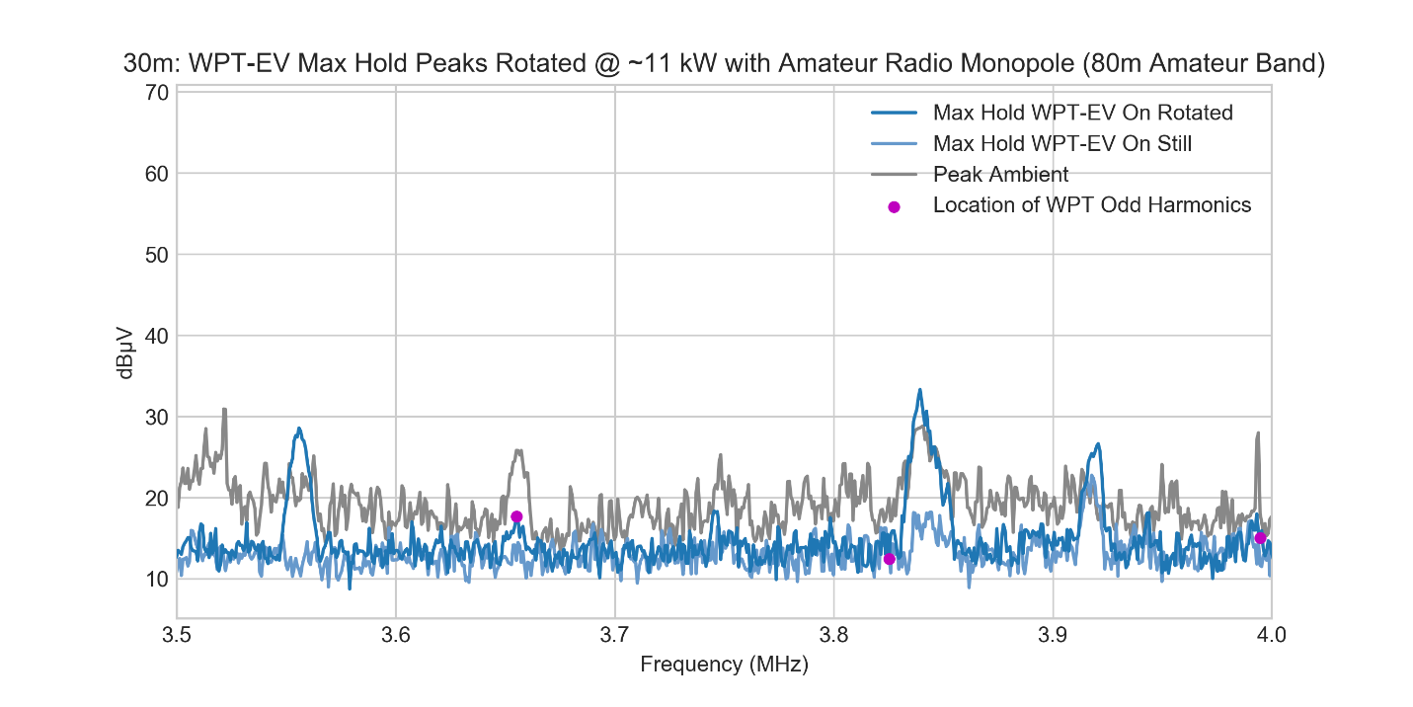
Figure A12-56: Peak measurements at a distance of 30 m using amateur radio monopole with WPT-EV system on and off for comparison

The 40 m amateur band at the various distances is shown below.

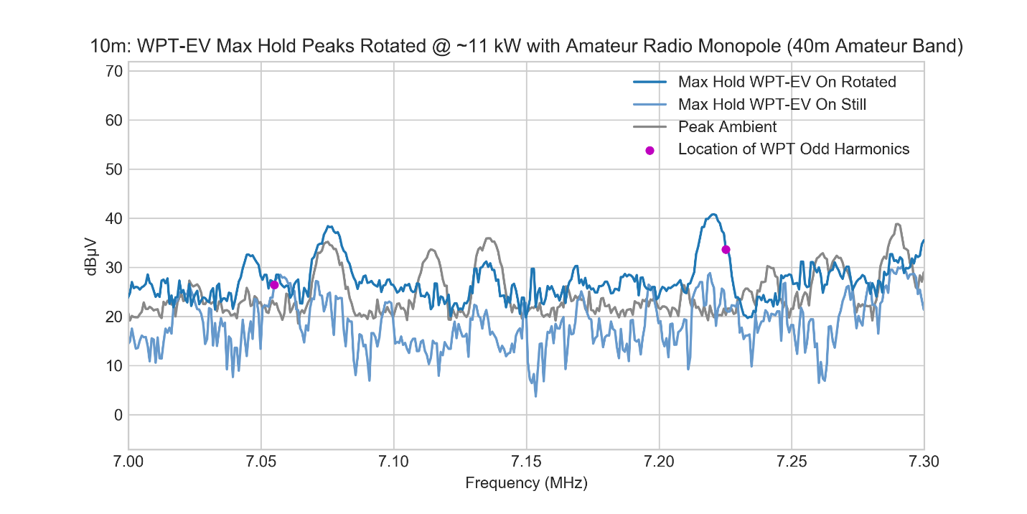
Figure A12-57: Peak measurements at a distance of 10 m using amateur radio monopole with WPT-EV system on and off for comparison

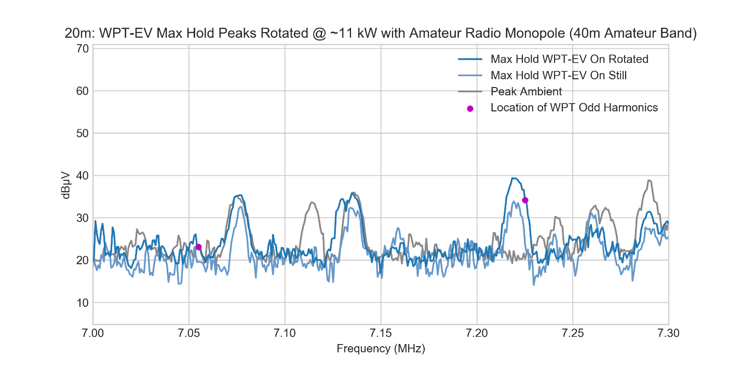
Figure A12-58: Peak measurements at a distance of 20 m using amateur radio monopole with WPT-EV system on and off for comparison

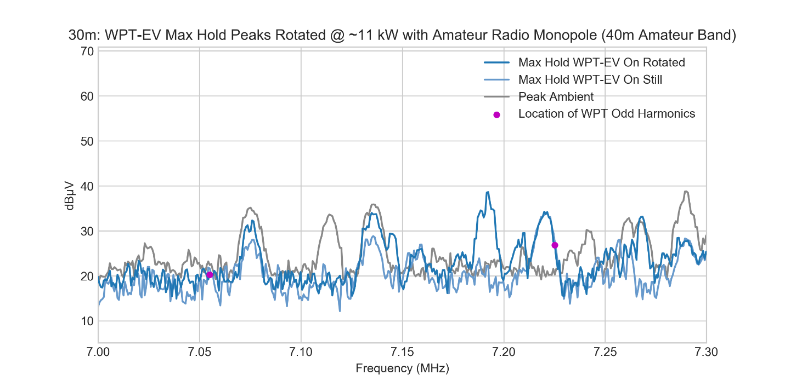
Figure A12-59: Peak measurements at a distance of 30 m using amateur radio monopole with WPT-EV system on and off for comparison

The plots for the 30 m amateur band at the various distances are shown below.

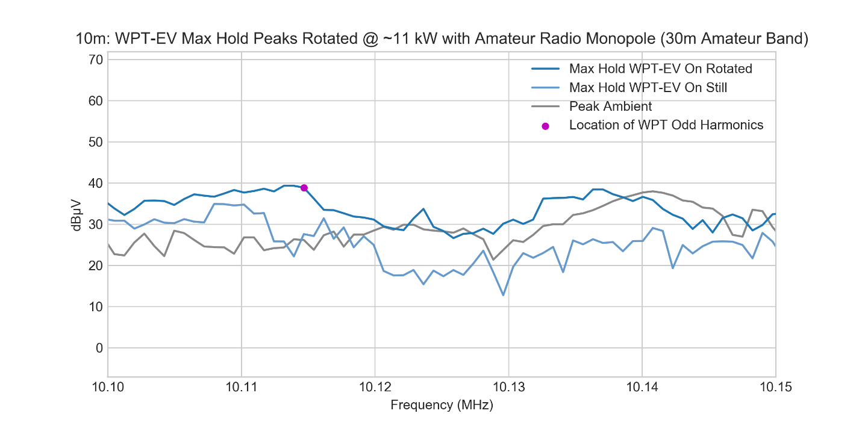
Figure A12-60: Peak measurements at a distance of 10 m using amateur radio monopole with WPT-EV system on and off for comparison

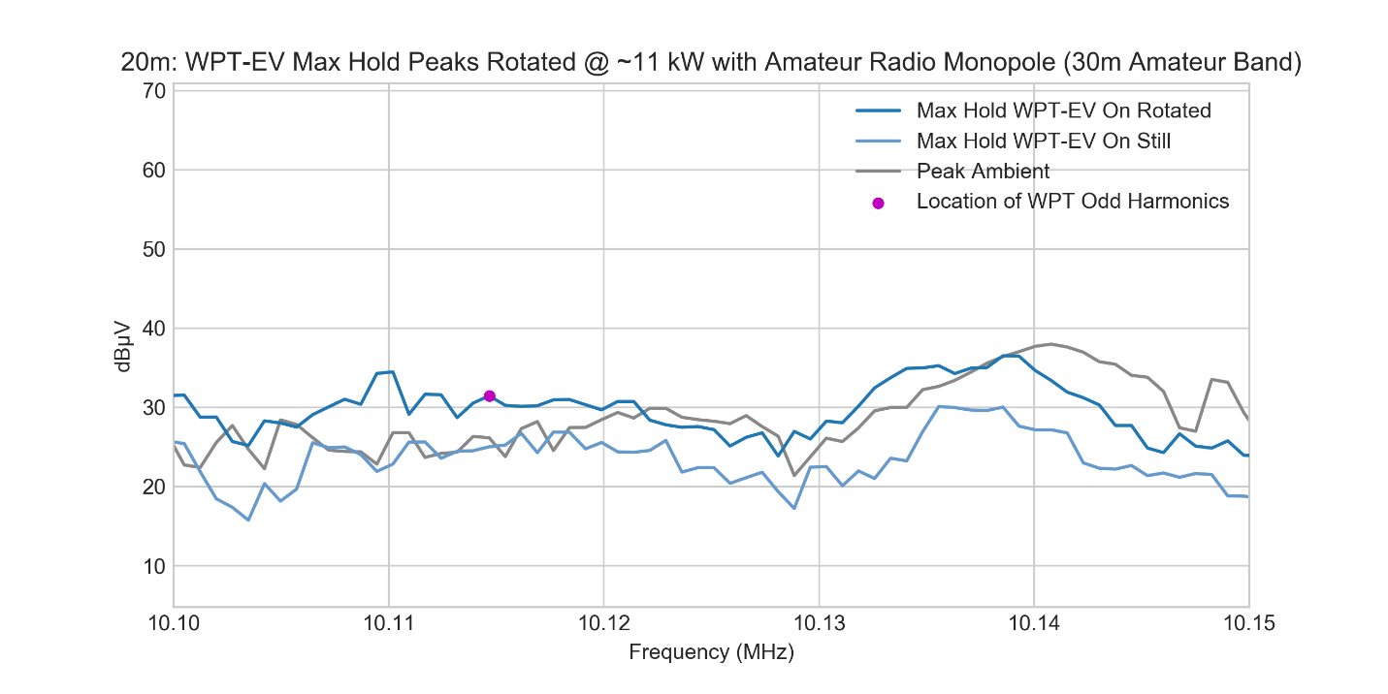
Figure A12-61: Peak measurements at a distance of 20 m using amateur radio monopole with WPT-EV system on and off for comparison

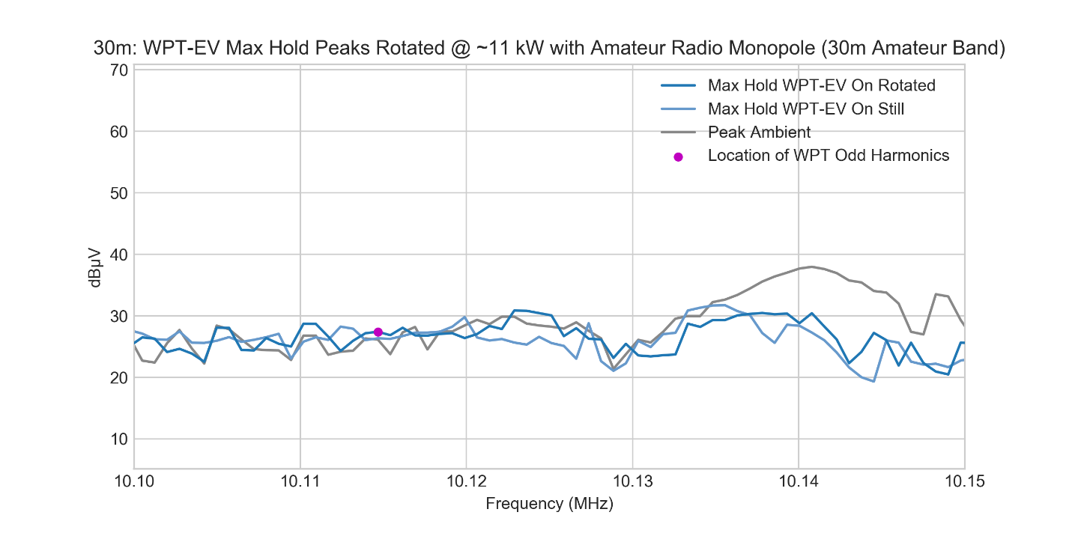
Figure A12-62: Peak measurements at a distance of 30 m using amateur radio monopole with WPT-EV system on and off for comparison

The plots for the 20 m amateur band at the various distances are shown below.

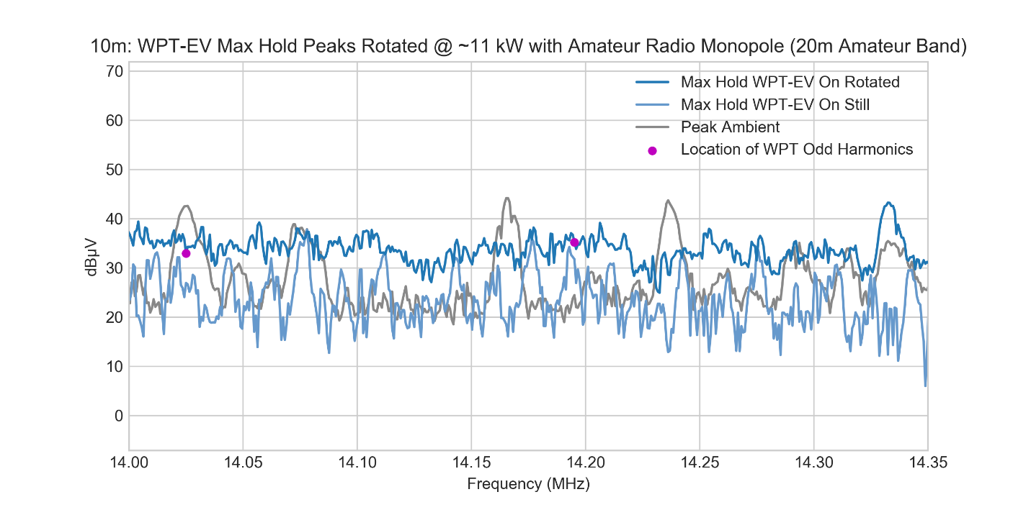
Figure A12-63: Peak measurements at a distance of 10 m using amateur radio monopole with WPT-EV system on and off for comparison

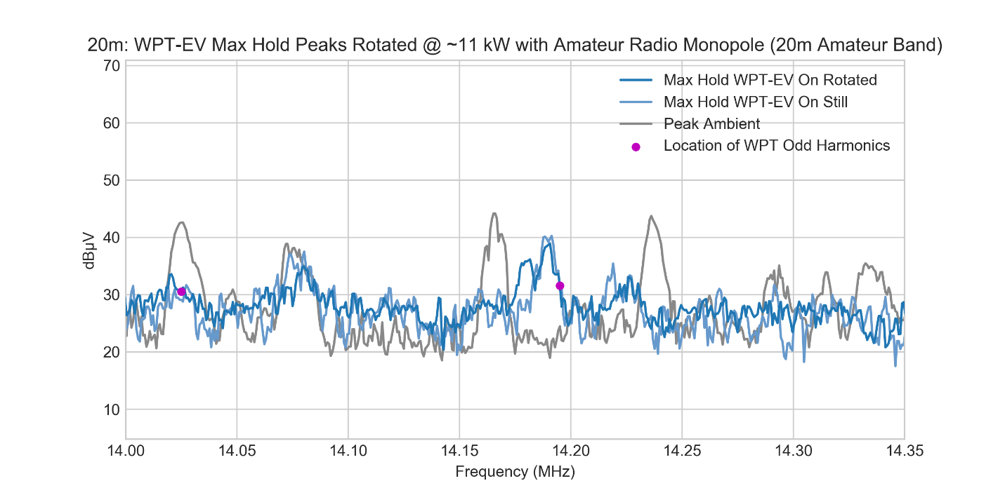
Figure A12-64: Peak measurements at a distance of 20 m using amateur radio monopole with WPT-EV system on and off for comparison

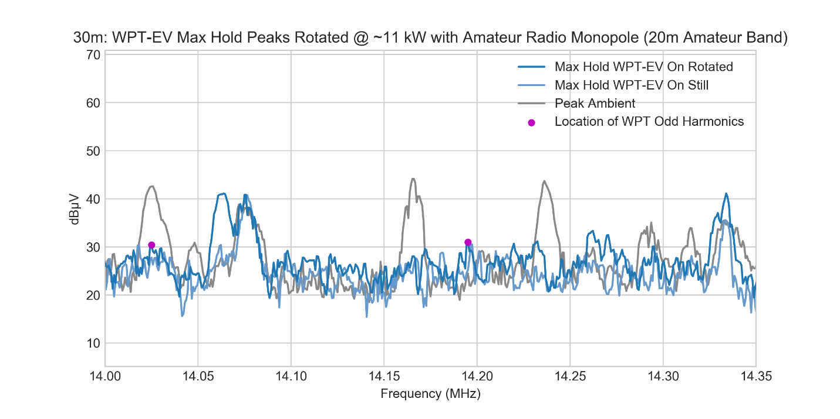
Figure A12-65: Peak measurements at a distance of 30 m using amateur radio monopole with WPT-EV system on and off for comparison

In addition to the various plots collected from the calibrated spectrum analyser, the amateur radio transceiver and receiver were used to assess qualitative audio impact of the WPT-EV system on communications. In general, at the various distances, no visual or audio impact in the tested amateur radio bands (80 m, 40 m, 30 m, 20 m) was detected above the ambient environment levels present at this site whenever the vehicle was reasonably aligned and rotated on the turn table. However, in one specific condition where the ground assembly coil and vehicle assembly coil were misaligned to maximum offset, the turn table was set to a specific angle relative to the amateur monopole antenna, and the antenna had an NVIS line attached to increase near-field sensitivity at a distance of 10 m from the WPT-EV system, audio characteristics from the WPT-EV were detectable as a faint “whistle”. In this same condition, a distant weak SSB voice transmission was also recorded directly over top of the interference signal at 3.825 MHz. Despite the faintly heard WPT-EV interference, this voice transmission was clearly audible and intelligible. A before and after image of the recorded transmission using the Airspy HF+ Discovery receiver and SDRSharp radio software are shown below along with an overlay.

The interference signal from the WPT-EV system at 3.825 MHz using the SDRSharp software is shown below.
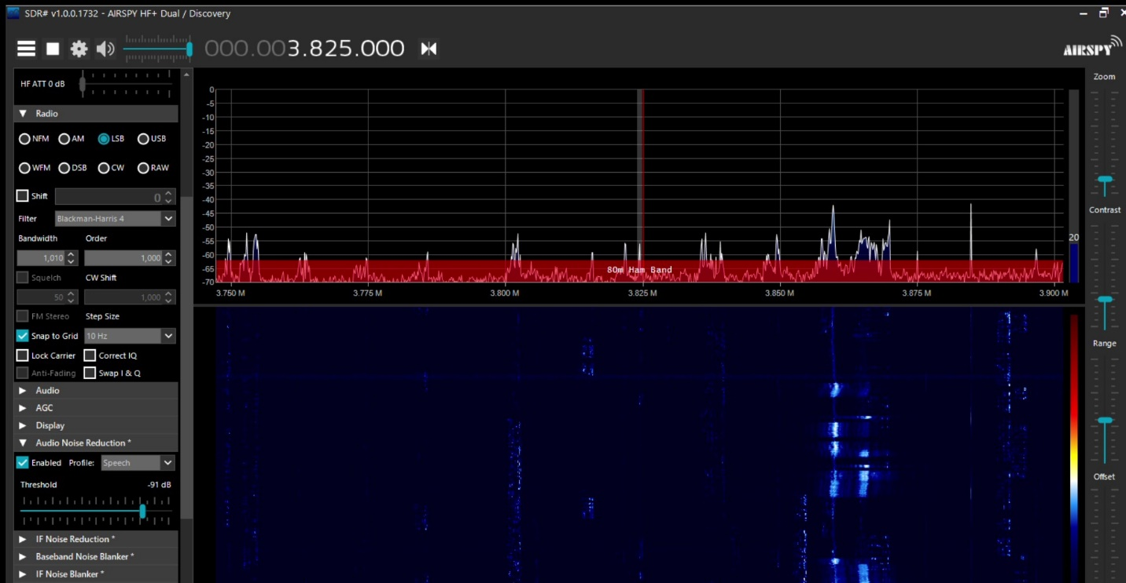
Figure A12-66: SDR# Software snapshot of WPT-EV interference signal at 3.825 MHz in worst-case condition

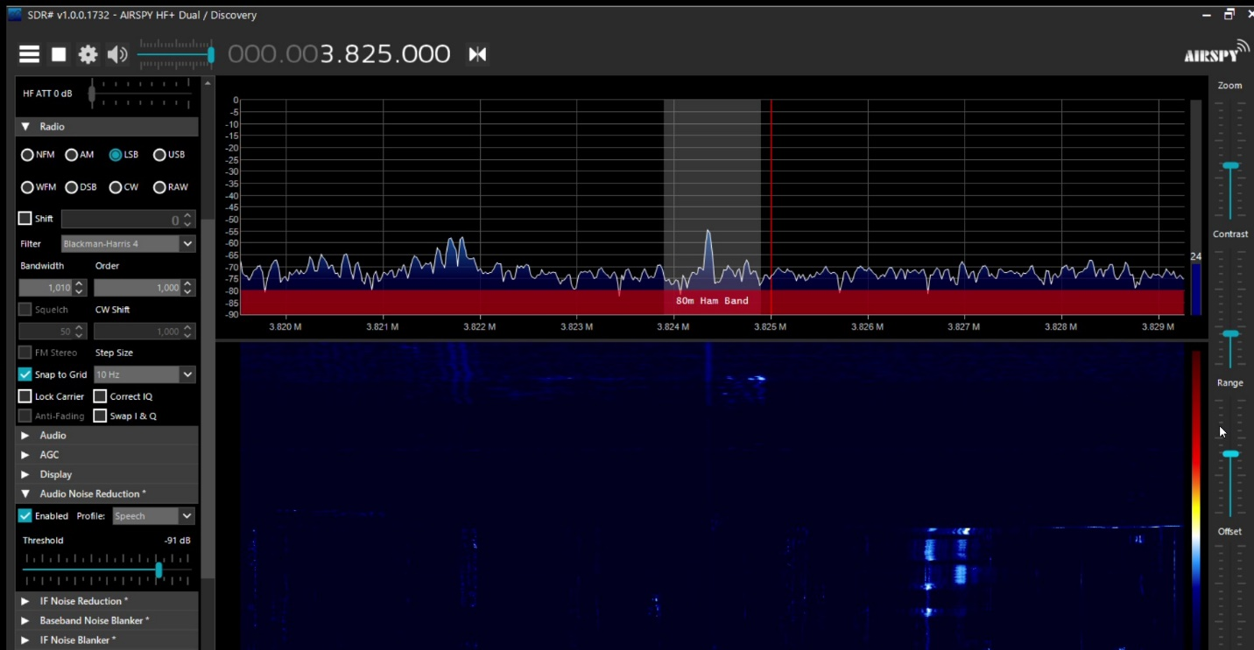
Figure A12-67: SDR# Software zoomed snapshot of WPT-EV interference signal at 3.825 MHz in worst-case condition

A distant amateur radio voice transmission occurred at the same frequency as the WPT-EV harmonic interference captured and is shown below.
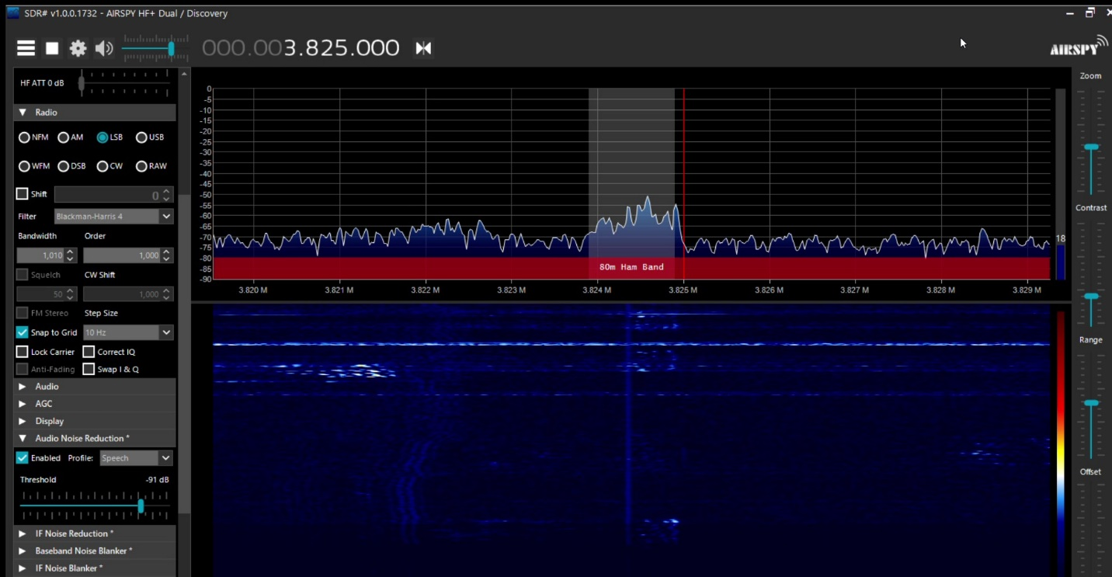
Figure A12-68: SDR# Software zoomed snapshot of distant amateur radio verbal audio broadcast at 3.825 MHz

An overlay of the interference and the SSB AM transmission together and shown below.
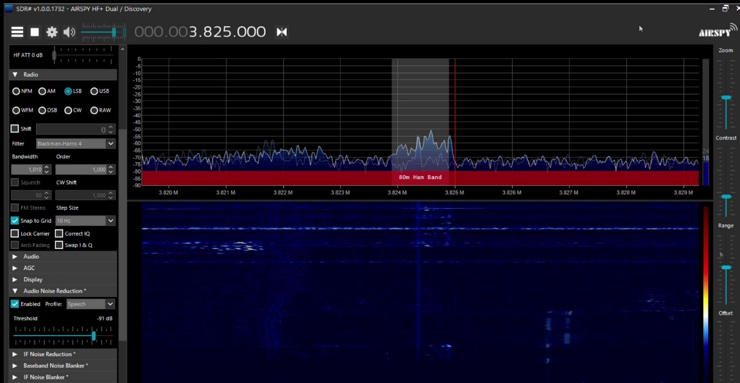
Figure A12-69: SDR# Software zoomed snapshot of distant amateur radio verbal audio broadcast at 3.825 MHz with WPT-EV interference signal underlay

A12.4 Summary of Results
A WPT-EV system as defined by the referenced SDOs operating at ~11 kW input power and ~90% efficiency AC grid input to DC battery output mounted on a Nissan Leaf with a 62 kWh battery was measured on a third-party accredited Open Area Test Site (OATS). The characteristics of the ambient environment were collected for comparison of emissions with the WPT-EV system transferring power and turned off. Ambient characteristics measured using a recommended HF amateur radio monopole antenna for the designated operating bands were collected at the OATS and compared directly with the same measurement performed in a rural area separated by ~1300 miles or ~2100 km. In the 80 m and 40 m bands, the ambient measurements showed similar characteristics, whereas in the 30 m and 20 m bands, the levels in Nibley, Utah were typically up to ~10 dB lower than those in Cedar Park, Texas. The ambient environment comparison, however, can be applied to other locations and amateur installations only if the environment and ambient conditions are similar to what they are in the specific locations measured.

EMF data was collected with the WPT-EV system in worst-case offset conditions by scanning at an initial course resolution of 7.5 cm with the probe as close the vehicle and vehicle underbody as possible and then further refined in the area of the peak at a resolution of 3.75 cm. The result of the EMF data was a maximum value of 4.226 µT RMS with the WPT-EV system at full power using a calibrated 3-axis probe and computing the magnitude across all three axes for worst-case conditions. The resultant measurement is far below the recommended ICNIRP 2010 reference level of 27 µT at 85 kHz and hence well within any ICNIRP 2010 recommended basic restrictions and also below protection levels as recommended for CIED.

The WPT-EV system was setup to operate continuously at full-power transfer and in worst-case misaligned conditions. Radiated emission data in the 9 kHz to 30 MHz range was collected by a third-part accredited lab using calibrated equipment used to perform certification measurements required by local administrations. Measurements were performed with a standard calibrated CISPR 60 cm loop antenna at a distance of 10 m. The magnetic loop antenna showed the WPT-EV operating fundamental as well as some other emissions above the ambient conditions present at the OATS. Detailed quasi-peak and average measurements were also taken with the magnetic loop antenna on discernible WPT-EV odd harmonics seen above ambient conditions in the 80 m to 20 m amateur radio bands. Radiation patterns were obtained for the fundamental as well as the measured harmonics.

For direct comparison and correlation with the calibrated measurements taken, additional data was collected by licensed amateur radio operators using a monopole antenna with a large effective antenna height. The amateur radio antenna was placed at distances of 10 m, 20 m, and 30 m over real earth from the WPT-EV system that was located on the OATS (and rotated for maximum interference potential). In several unique cases, very narrow-band harmonics were discernible with the amateur radio monopole antenna but their amplitude was no higher than the typical ambient peaks seen without the WPT-EV system operating. Qualitative audio characteristics were obtained, and a distant radio transmission was picked up operating at the identical frequency of the WPT-EV harmonic seen. The qualitative result was non-harmful interference resulting in no substantial loss of audibility and intelligibility at a close distance for the worst-case measured condition.

A12.5 References
[1] FCC Electronic Code of Federal Regulations Title 47 Part 97 - https://www.ecfr.gov/cgi-bin/text-idx?node=pt47.5.97

[2] ARRL – https://www.arrl.org

[3] ARRL Table of FCC License Counts - http://www.arrl.org/fcc-license-counts

[4] United States Census Bureau - https://www.census.gov/

[5] FCC Universal Licensing System - https://wireless2.fcc.gov/UlsApp/UlsSearch/searchLicense.jsp

[6] TDK RF Solutions, Inc., Cedar Park, Texas, U.S.A. - https://tdkrfsolutions.com/

[7] “ICNIRP Guidelines for limiting time-varying electric and magnetic fields (1 Hz – 100 kHz)”, 2010 - https://www.icnirp.org/en/frequencies/low-frequency/index.html

[8] ISO14117:2019, “Active implantable medical devices — Electromagnetic compatibility — EMC test protocols for implantable cardiac pacemakers, implantable cardioverter defibrillators and cardiac resynchronization devices” - https://www.iso.org/standard/73915.html

[9] SAE Technical Paper, “Bench Testing Validation of Wireless Power Transfer up to 7.7kW Based on SAE J2954” - https://www.sae.org/publications/technical-papers/content/07-11-02-0009/

[10] SAE Technical Paper, “Validation of Wireless Power Transfer up to 11kW Based on SAE J2954 with Bench and Vehicle Testing” - https://www.sae.org/publications/technical-papers/content/2019-01-0868/

[11] SAE J2954 Recommended Practice, “Wireless Power Transfer for Light-Duty Plug-in/Electric Vehicles and Alignment Methodology” - https://www.sae.org/standards/content/j2954_201904/

[12] ARRL, “Amateur Radio : 100 Years of Discovery” by Jim Maxwell - http://www.arrl.org/files/file/About%20ARRL/Ham_Radio_100_Years.pdf

[13] “700,000 Amateur Radio Operators in the US? Perhaps the real number is 157,000” - https://frrl.wordpress.com/2012/01/21/700000-amateur-radio-operators-in-the-us-perhaps-the-real-number-is-157000/
[14] “Reviews For: Alpha Antenna FMJ Multiband, HF directional/vertical” - https://www.eham.net/reviews/view-product?id=10357

[15] “Recommendation ITU-R P.372-14 Radio Noise” - https://www.itu.int/dms_pubrec/itu-r/rec/p/R-REC-P.372-14-201908-I!!PDF-E.pdf

[16] “Measurement Methodology and Results of Measurements of the Man-Made Noise Floor on HF in The Netherlands”, T.W.H Fockens/A.P.M. Zwamborn/F. Leferink, - https://ieeexplore.ieee.org/document/8396864

[17] “External Noise Measurements in the Medium Wave Band”, G. Prieto/M. Vélez/A. Arrinda/U. Gil/D. Guerra/D. de la Vega, University of Basque Country – UPV/EHU - http://www.ehu.eus/tsr_radio/images/International_Journals/PRIE-07-01.pdf

[18] “US Amateur Radio Population Grows Slightly in 2018” - http://www.arrl.org/news/us-amateur-radio-population-grows-slightly-in-2018

[19] “The Measurement of Radiated Emissions on Frequencies below 30 MHz – Materials for the ANSI C63 Committee”, Joseph McNulty, FCC, January 24, 1991

[20] “PC63.30 Draft American National Standard for Methods of Measurement and Radio-frequency Emissions from Wireless Power Transfer Equipment”, ANSI C63.30 - http://www.c63.org/documents/misc/matrix/c63_standards.htm

[21] “Liaison Request to CISPR/A on the development of a sensitive measurement method for magnetic fields below 30 MHz”, CISPR B Subcommittee, CIS/B/736/INF, 2019-11-22, - https://www.iec.ch/dyn/www/f?p=103:30:0::::FSP_ORG_ID,FSP_LANG_ID:1412,25

[22] “The Background Noise on the HF Amateur Bands”, Radio Society of Great Britain - http://rsgb.org/main/files/2017/12/221216-Noise-leaflet-issue-2.pdf

