U.S. Radiocommunications Sector
Fact Sheet
Working Party: ITU-R WP1A | Document No: USWP1A-06_FD_Rev. Report SM.2505_WPT_Beam
Ref: [ Ref: Report ITU-R SM.2505 – Impact studies and human hazard issues for wireless power transmission via radio frequency beam , Annex 9 to Report on the fifth 2019-2023 meeting of Working Party 1A (Thessaloniki, Greece, 29 May - 2 June 2023)  /revised | Date: 27 Mar 2024

Document Title: Working document towards a preliminary draft revision of Report ITU-R SM.2505-0

Author(s)/Contributors(s):  Michael Marcus  Marcus Spectrum Solutions, LLC  Chris Keller  GuRu Wireless | Email: marcus@marcus-spectrum.com  Phone: 301-229-7714  Email: chris@guru.inc  Phone: (626) 673-8185‬
Purpose/Objective: Submit further information impacts of using 24 GHz ISM band for WPT Beam
Abstract: New/revised material will further address protection of adjacent passive services in RAS and EESS(p)

Radiocommunication Study Groups | 
Received:  Subject: Report ITU-R SM.2505-0 | Document XX/-E
 | Date 20xx
 | Original: English
United States of America
draft revision of RecomMendation ITU-R SM.2505-0
Background
Recommendation ITU-R SM.2505-0 was approved in 2022 to provide administrations with guidelines the impact spectrum impact and human hazard issues for wireless power transmission via radio frequency beam. The United States is also developing a variant of this technology for use in the 24 GHz ISM band.

Proposal
The United States proposes that ITU-R SM.2505-0 be amended with the material in the attachment that documents the impacts of Beam WPT use in 24.1-24.15 GHz. Group 1 for further consideration and approval. The proposed changes only involve Study F (24.1-24.15 GHz). Except for adding several near 24 GHz bands of other services for consideration in the “Studies on the impact to the incumbent systems” section, other parts of the document are unchanged.

Attachment: Draft Revision to Recommendation ITU-R SM.2505-0

In order to keep the size of this document manageable, this excerpt contains only the parts of the Chairman’s Report document for which changes are proposed. These changes only concern 24 GHz Bem WPT and do not affect any other bands.

Radiocommunication Study Groups
Source: Document 1A/TEMP/93(Rev.1) (edited) | Revision 1 to  Document 1/107-E
 | English only
Working Party 1A
NEW REPORT ITU-R SM.2505-0
Impact studies and human hazard issues for wireless power transmission
via radio frequency beam

Table of Contents
Page
Document Title: Working document towards a preliminary draft revision of Report ITU-R SM.2505-0 1
Introduction 6
Radio characteristics of beam WPT 7
Studies on the impact to the incumbent systems 7
Study A (915-921 MHz) 8
Study B (915-921 MHz) 12
Study C (917-920 MHz, 2 410-2 486 MHz, and 5 738-5 766 MHz) 16
Study D (2 483.5-2 500 MHz) 27
Study E (915-921 MHz) 31
Study F (24.1-24.15 GHz) 34
Study G (61-61.5 GHz) 39
Study H (915-921 MHz, 2 410-2 486 MHz, and 5 738-5 766 MHz) 41
Human hazard issues 44
Summary 45
A1.1 Beam WPT installation environments 47
A1.1.1 WPT controlled environment 47
A1.1.2 WPT general environment 47
A1.2 Compliance with the RRPG 48
1 Introduction 51
2 Radio characteristics of beam WPT 52
3 Studies on the impact to the incumbent systems 53
3.1 Study A (915-921 MHz) 54
3.2 Study B (915-921 MHz) 58
3.3 Study C (917-920 MHz, 2 410-2 486 MHz, and 5 738-5 766 MHz) 62
3.4 Study D (2 483.5-2 500 MHz) 74
3.5 Study E (915-921 MHz) 78
3.6 Study F (24.1-24.15 GHz) 81
3.7 Study G (61-61.5 GHz) 89
3.8 Study H (915-921 MHz, 2 410-2 486 MHz and 5 738-5 766 MHz) 91
4 Human hazard issues 94
5 Summary 94
A1.1 Beam WPT installation environments 96
A1.2 Compliance with the RRPG 96
A2.1 EESS (Passive) and Beam WPT 98
A2.2 Summary of Results 103
A2.3 RAS and Beam WPT 104

…

Studies on the impact to the incumbent systems
The possible incumbent systems that may require impact studies are as follows:
– Wireless LAN (2.4 GHz, 5.6 GHz band);
– DSRC (5.8 GHz band);
– IMT (900 MHz band);
– MCA (920 MHz band);
– LPWA (920 MHz band);
– RFID (920 MHz band);
– Amateur radio (2.4 GHz band, 5.7 GHz band);
– Radar (5.6 GHz band);
– Microwave link (5.9 GHz band);
– Mobile satellite communication system (2.5 GHz band);
– Radio astronomy (1.4 GHz band, 2.7 GHz band, 4.8 GHz band);
– EESS (active) (co-frequency 5 470-5 570 MHz, 24.05-24.25 GHz, adjacent 5 250-5 470 MHz);
- Terrestrial component of IMT (Per Resolution 242 (Rev.WRC-23)) (24.25-27.5 GHz)
– Other systems operated in adjacent frequency bands and/or frequency range where harmonic emissions may occur.

…

Study F (24.1-24.15 GHz)

United States ISM regulations
In the US, the Federal Communications Commission (FCC) regulates the use of frequencies for wireless communication. The FCC rules and regulations are codified in Title 47 of the US’ Code of Federal Regulations (CFR). Part 18 deals with ISM devices. FCC has determined that in the US WPT is regulated as an ISM usage and is subject to its Part 18 rules. Part 15 of this code applies to radio frequency devices operating at unlicensed frequencies and has included use of 24 GHz for unlicensed radiodetermination applications.

24 GHz ISM BAND AND Spurious Emission Limits
FCC identifies 24-24.25 GHz band with a centre frequency of 24.125 GHz and maximum operating bandwidth of 250 MHz for ISM use consistent with the provisions of 5.150. FCC spurious emission limits of the field strength level of emissions which lie outside the 24 GHz ISM band is a field strength limit of 25 uV/m at 300m. Using the EIRP formula, we get a value EIRP of -27.27 dBm, or -57.27 dBW.
The FCC 24 GHz radio determination regulations in Part 15 have a general emission limit of -41.3 dBm in 22-29 GHz and a further restriction on EIRP at certain elevation angles in the 23.6-24.0 GHz RAS and EESS (passive) band:
“Following proper installation, vehicular radar systems shall attenuate any emissions within the 23.6-24.0 GHz band that appear 38 degrees or greater above the horizontal plane by 25 dB below the limit specified in paragraph (d) of this section. For equipment authorized, manufactured or imported on or after January 1, 2005, this level of attenuation shall be 25 dB for any emissions within the 23.6-24.0 GHz band that appear 30 degrees or greater above the horizontal plane. For equipment authorized, manufactured or imported on or after January 1, 2010, this level of attenuation shall be 30 dB for any emissions within the 23.6-24.0 GHz band that appear 30 degrees or greater above the horizontal plane. For equipment authorized, manufactured or imported on or after January 1, 2014, this level of attenuation shall be 35 dB for any emissions within the 23.6-24.0 GHz band that appear 30 degrees or greater above the horizontal plane. This level of attenuation can be achieved through the antenna directivity, through a reduction in output power or any other means.”

In 2017 FCC decided to consolidate vehicular radars and other specific types of fixed and mobile radar operations into the 76-81 GHz band. (https://docs.fcc.gov/public/attachments/DOC-345476A1.pdf) Due to new spectrum regulations by both FCC and the European Telecommunications Standards Institute (ETSI) , the 24 GHz wide bandwidth and UWB bands will not be available for new automotive radar devices after January 1, 2022 but existing units will be permitted to operate.

FCC continues to allow unlicensed field disturbance sensors, excluding perimeter protection systems, in 24.075-24.175 GHz and general unlicensed devices in 24.0-24.25 GHz with a fundamental field strength of less than 250 mv/m at 3m. For both types of unlicensed devices, the maximum emission outside the specified band, other than for harmonics, must attenuated by at least 50 dB below the level of the fundamental or 500μV/m at 3m, whichever is less.

ISM Wireless Power Transfer Parameters
This section provides examples of the characteristics of the 24 GHz beam WPT system being developed in US.

Table I below describe the characteristics used in the respective studies. Only the e.i.r.p. limit below 24.0 GHz is a present US regulatory limits. Other sets of parameters could come from other developers for alternative 24 GHz WPT systems. Under the terms of 15.13 each administration is responsible for ensuring that “radiation from such equipment is at a level that does not cause harmful interference to a radiocommunication service”.

The multielement antenna in the system being developed in US has a different far field gain for OOBE that are uncorrelated over the various antenna elements than it has for the coherent inband signals at each antenna element.
Table 15
Radio Characteristics of Example Beam WPT System within 24 GHz Band
System | System
Frequency | 24.1-24.15 GHz
Bandwidth | 10 MHz
Output Power (W) | 50
Antenna gain in ISM band (dBi) | 40
e.i.r.p. in ISM band (dBm) | 87
e.i.r.p. below 24 GHz (dBm) | -27.27
field strength limit at 300 m (uV/m) | 25

Human hazard issues for 24.1-24.15 GHz WPT
Technology being considered for these bands used phased array multiple elements beams to focus power on a small area for efficient power transfer. This creates a high-power flux density (pfd) at and near the power receiving area that could violate applicable safety standards. This situation is avoided by active measures that detect the presence of objects near the high p.f.d. volume and reduces or ceases power transmissions when such objects are detected.
The strategy is to make sure applicable safety standards are met. Systems will employ multiple, independently operating and independently testable safeguards that will ensure that exposure requirements are met. These sensors are arranged so that significant power is only transmitted if there is an authorized power destination in a position ready to receive power and without any humans or pets in a nearby position where that would be exposed to unacceptable RF power levels. Examples of these sensors are the ability to evaluate the orientation of the device being charged, including whether it is moving, fixed, or set on a stable surface; the ability to passively sense nearby movement and beam interruption; and the ability to detect Doppler signals from the device being charged or people that are moving. In this way, the distances between the beam, the charging device, and any people located in the vicinity can be calculated in milliseconds, ensuring that the power transfer will cease before a person enters the path of a beam. These independent safety features are all native to the WPT system, meaning that they are inherent in the function of the beam formation apparatus of the WPT system.
In the case of USA, Maximum Permissible Exposure (MPE) to radiofrequency electromagnetic fields have been established for both bands and are shown in Table 2. At these high frequencies RF is generally absorbed by the skin and specific absorption rate (SAR) standards are not applicable.
Table 16
USA RF Safety Standard Levels for 24GHz Bands
MPE for Occupational/Controlled Exposure (mW/cm2) | MPR for General Population/Uncontrolled Exposure (mW/cm2)
5.0 | 1.0

Experience with 24 GHz ISM bands in The United States
For ISM frequency bands, the International Telecommunications Union (ITU) allocates some frequencies for worldwide industrial, scientific and medical (ISM) purposes. ISM bands are license exempt. The most suitable ISM frequency bands for this application are 24 GHz and 61 GHz. The 24 GHz band, from 24.0 GHz to 24.25 GHz has a bandwidth of 250 MHz, is used in the US for both ISM applications and for other unlicensed uses including point-to-point data links, short-range devices and automotive radar..
Figure 2.1 shows the bands in the 24 GHz region that have been used for short range radars in various countries including the US. It can be seen that narrow band radars were previously only 50 MHz away from the 23.6-24.0 GHz EESS (passive)/RAS band and UWB(ultra wide band) radars actually overlapped the band.

FIGURE 16
Historic use of bands for short range radar in 24 GHz region
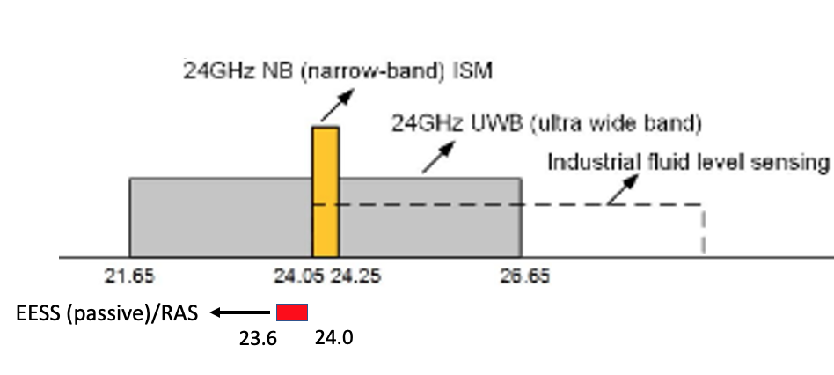

The US Administration formerly allowed the use of wideband and ultra-wideband (UWB) vehicular radar operations in the 23.12-29.0 GHz band and the 22-29 GHz band for many years. This devices had output powers in the 6-15 dBm range and were generally operated outdoors. In 2017 it decided to consolidate vehicular radars and other specific types of fixed and mobile radar operations into the 76-81 GHz band. Due to spectrum regulations by the European Telecommunications Standards Institute (ETSI) and the Federal Communications Commission (FCC), the 24 GHz wide bandwidth and UWB bandwidth will not be available for new automotive radar devices after January 1, 2022.
During the period that such radars were allowed there were no documented cases involving interference to EESS (passive) from such radar uses. In the public comments submitted to the US Administration while the change to 76-81 GHz was being considered, no party raised the issue of eliminating the potential interference to EESS (passive) or RAS was a benefit of the change. Indeed, an RAS advocate was even opposed to the change to the 76-81 GHz band but made no mention of any benefit of removing radar uses from the 22-29 GHz band.

Radio Astronomy
During an observation, a radio astronomy telescope points towards a celestial radio source at a specific right ascension and declination, corresponding with a specific azimuth and elevation at a certain moment in time. During this observation, the pointing direction of the telescope compensate for the rotation of the Earth. It can be assumed that interference from a terrestrial transmitter is received through the sidelobes of the radio astronomy antenna,
Recommendation ITU-R RA.769 assumes that the interference is received in a sidelobe of the antenna pattern, i.e., at a level of 0 dBi at 19º from boresight (see also Recommendation ITU-R SA.509). It should be noted that a radio telescope is an antenna with an extremely high gain, typically in the order of 70-80 dBi. If interference is received via the main lobe of the antenna pattern, this high gain should also be considered, and as noted in Recommendation ITU-R RA.769, damage may result to radio astronomy receivers under such scenarios. However, Recommendation ITU-R RA.769 assumes that the chance that the interference is received by the main lobe of the antenna is low, and therefore uses the level of 0 dBi in the calculation of the levels of detrimental interference given in this Recommendation.
Depending on the relative location of the interferer and the telescope, the interference occurs in the near field or the far field of the telescope. The far field area, or Fraunhofer area, lies beyond a distance of 2D2/ λ, where D is the diameter of the telescope and λ the wavelength. For the RAS frequency band in 24 GHz, this distance is of the order of 400 km for a radio telescope of 50 metre diameter. A diameter of 50 metre can be considered as representative for radio telescopes in Europe operating in the frequency range 22-24 GHz; the largest have a diameter of 100 metre.
For the assumptions considered in Recommendation ITU-R RA.769, it is irrelevant whether the interferer is in the near field or in the far field of a radio telescope. The near field/far field issue is relevant only for studies that need to consider the signal path from the interfering transmitter to the receiving antenna.
The following are the radio astronomy service (RAS) system parameters for the threshold levels of interference detrimental to radio astronomy continuum observations for 23.8 GHz band.
The interference protection criteria for RAS (Rec. ITU-R RA.769-2) is a threshold value given as -195 dBW received signal power for continuum measurements. This recommendation states “that administrations, in seeking to afford protection to particular radio astronomical observations, should take all practical steps to reduce all unwanted emissions falling within the band of the frequencies to be protected for radio astronomy to the absolute minimum.”
Table 17
RAS Protection Criteria
Parameter | Value continuum observations | spectral-line observations
Centre frequency ⁽¹⁾ f_{c} (MHz) | 23 800 | 23 700
Assumed bandwidth Δf (MHz) continuum observations  Assumed spectral line channel bandwidth Δ f (kHz) spectral-line observations | 400 | 250
Minimum antenna noise temperature T_{A} (K) | 15 | 35
Receiver noise temperature T_{R} (K) | 30 | 30
System sensitivity(2) (noise fluctuations)
Temperature ΔT (mK) | 0.05 | 2.91
Power spectral density ΔP (dB(W/Hz)) | -271 | -254
Threshold interference levels(2) (3)
Input power ΔP_{H} (dBW) | -195 | -210
pfd S_{H} Δf (dB(W/m²)) | -147 | -161
Spectral pfd S_{H} (dB(W/(m² ⋅ Hz))) | -233 | -215
Notes:
1 - Calculation of interference levels is based on the centre frequency shown in this column although not all regions have the same allocations.
2 - An integration time of 2 000 s has been assumed; if integration times of 15 min, 1 h, 2 h, 5 h or 10 h are used, the relevant values in the Table should be adjusted by +1.7, −1.3, −2.8, −4.8 or −6.3 dB respectively.
3 - The interference levels given are those which apply for measurements of the total power received by a single antenna. Less stringent levels may be appropriate for other types of measurements, as discussed in § 2.2. For transmitters in the GSO, it is desirable that the levels be adjusted by −15 dB, as explained in § 2.1.

RAS regulation

The analysis deals with use of segments of the 24.1-24.150 GHz ISM bands for Beam WPT. It estimates the number of ISM WPT devices that can be deployed while ensuring the protection of Radio Astronomy Service (RAS from out-of-band emissions (OOBE). For the 24.1-24.15 GHz, the nearby 23.6-24.0 GHz band, subject to footnote RR 5.340, with its EESS (passive) and RAS allocations are reviewed.

The 24.1-24.15 GHz ISM band that will be used for WPT Beam applications is within the 24-24.25 GHz ISM band. 5.150 states that “Radiocommunication services operating within these bands must accept harmful interference which may be caused by these applications”. 15.13 requires that “administrations shall take all practicable and necessary steps to ensure that radiation from equipment used for industrial, scientific and medical applications is minimal and that, outside the bands designated for use by this equipment, radiation from such equipment is at a level that does not cause harmful interference to a radiocommunication service and, in particular, to a radionavigation or any other safety service operating in accordance with the provisions of these Regulations”. Thus, any administrations authorizing use of WPT Beam ISM equipment must specify appropriate out-of-band emission limits for such devices that assures the protection RAS allocated in adjacent or near-adjacent frequency bands. While any physically realizable transmitter must have some level of OOBE, the key spectrum policy issue is whether the Beam WPT level is low enough to meet the requirement of 15.13.

…
Annex 2
Details of Impact Studies of Beam WPT on EESS(passive)
and RAS in Study F
[Editor’s note: This annex was not discussed during the June 2023 WP 1A meeting and will require a more thorough analysis at the next meeting, in particular considering the assumptions and scenarios used, including the 10 MHz bandwidth. It was noted that this annex is focused on a country specific regulation, so further work is need to make it more general.]

A2.1 EESS (Passive) and Beam WPT
In the United States, beam WPT has been determined to be an ISM use of spectrum subject to the national 24 GHz ISM band limit established by FCC. For the case of transmitter power less than 500 W RF power, the out-of-band limit is a field strength of 25 μV/m at a measurement distance of 300 m and a measurement bandwidth of 1 MHz. Some administrations have created national requirements that devices for indoor only use have physical characteristics limiting their potential outdoor use, including the requirement that the device must be powered from electrical mains. Administrations could also require sensors in such devices to assure they are pointed downward.

A2.1.1 Modelling impact of 24 GHz WPT beam devices on EESS (passive) sensors
In general, OOBE levels decrease as the frequency becomes separated from the carrier frequencies by multiples of the transmission half bandwidth. These transmissions are low in bandwidth compared to their separation from the nearby passive band. In this case the band separation is >100 MHz while the bandwidth of the WPT Beam emission is ≤ 10 MHz so the passive bands is more than 10 half bandwidths away. In this case ISM is only used indoor employing downward pointing antennas that transfer a large fraction of their transmitted power to the intended receiver. The antennas have multiple elements each with amplifiers and frequency synthesizers that derive the center frequency of transmissions from a reference frequency that is much lower. If the phase locked loop of the synthesizer has a bandwidth that is much smaller than the separation of the centre frequency from the nearby passive band, then the resulting emissions near centre band will have highly correlated phases over a bandwidth of less than 10 MHz over the various antenna elements and have uncorrelated phases over frequencies further from the centre frequency. This, in turn results on a highly focused beam at the centre frequency and a much more diffuse pattern with much lower gain at the frequencies more than 10 MHz from the center frequency. The resulting out of band emissions from each antenna are from the phase noise of individual local oscillators of each PLL and uncorrelated. It is noted that this is different than in the case of IMT MIMO antennas where out of band emissions are from both oscillator noise and modulation which have different correlations out-of-band. IMT emissions have much greater bandwidth because of complex information-carrying modulation which results in many correlated sidebands. In Beam WPT signal bandwidth is not an intentional design characteristic, but rather a byproduct of circuit noise in carrier frequency synthesis. .

As a result, while the centre frequencies of each element are in phase and permit antenna beam focusing by changing the amplitude and phase of transmission from each element, for frequencies more than 100 MHz away from the centre frequency the phase noise of the emissions are uncorrelated, so their OOBE do not focus, and the antenna array has little gain for such OOBE. This is illustrated below where the OOB emission pattern of a single antenna in an exemplary array is simulated using HFSS.
[Editor’s note: Views were expressed that the text “… for frequencies more than 100 MHz away from the centre frequency the phase noise of the emissions are uncorrelated, so their OOBE do not focus, and the antenna array has little gain for such OOBE …” will require technical justification. It is noted that it seems to contradict assumptions used for the same frequency range in other topic.]
Figure A2.1
In-band and out-of-band radiation patterns
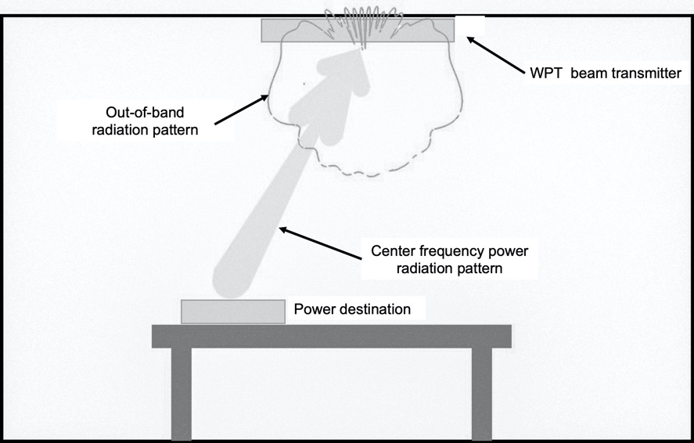
Figure A-2.2 shows the ISM device antenna gain towards selected EESS sensors for a fixed Earth to EESS elevation angle and for azimuth angles that vary between –180° to +180°.
Figure A2.2
Transmitter OOB Antenna Patterns versus Azimuth for Select Elevation Angles Matching
EESS Off-Nadir Angles

Tables A2.1 and A2.2 provide calculations to predict how much of this ISM device power reaches an EESS (passive) satellite of various types under assumption that all ISM transmitting units are indoors and are pointing downward. This is an upper-bound analysis to determine a geographic density of these devices that could be operated without adversely impacting the passive satellites. While a dynamic simulation would give a more precise result, the worst case here gives an upper bound for Beam WPT density.
The analysis provided in this document considers only direct-path propagation from the sidelobe and/or backlobe of the Beam WPT device to the main-beam of the passive remote sensor.
The calculations use the ITU-R P.2109 “Prediction of building entry loss” model that considers losses due to exterior building walls. As is shown in Figure A2.3 for high elevation angle paths to satellites the exterior wall is not the only source of structural path loss. For a ceiling mounted transmitter all emissions reaching a satellite must pass through at least one interior floor construction before they reach the exterior wall. Depending on the satellite elevation angle and the distance of the transmitter from the exterior wall, more than one through the floor transit may be involved. There is no present recommendation for such path losses through interior floors, so it is not included in the calculation presented.
Figure A2.3
Impact of ceilings on high elevation angle paths in cases where WPT device is distant from exterior wall
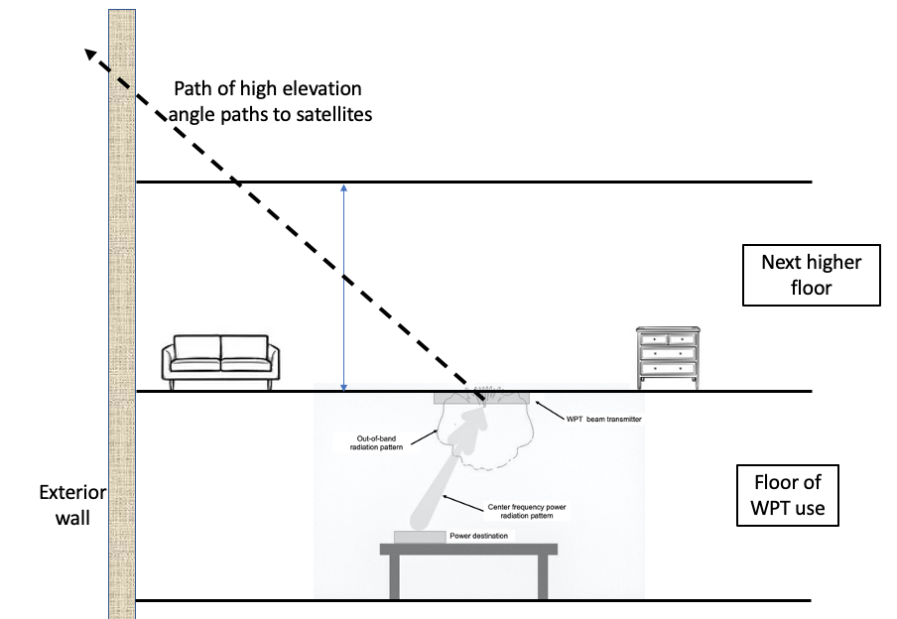
In very high population density areas with multistory buildings this model is conservative in that it does not address the vertical loss a signal would have on high elevation angle paths if an emitter was several floors down from the building roof. Nor does it account for signal blockage by nearby buildings higher than the emitter that could block paths to the satellite as some elevation angles.
[Editor’s note: Views were expressed that the indirect path including in particular the reflections of the main beam emissions in its surrounding will also have to be considered.]
In the case considered the maximum WPT beam transmitter density under the above assumptions that is consistent with the ITU-R RS.2017 protection goals are shown in the table to be in the range of >67 to several thousand units per square kilometre, depending on which sensor from ITU-R RS.1861 is considered. As mentioned above this density would be larger in the case of areas with multistory buildings due to both attenuation from multiple levels above the transmitter and partial signal blockage of power that leaves a building at low elevation angles. However, there is presently no generally accepted building attenuation model for computing the increased attenuation at high elevation angles for such areas with many multilevel, multistory buildings.
TABLE A2.1
Sample Power budget for the Aggregate Usage of Beam WPT Devices for Sensor F18
Sensor Type/Operator | Conical scan  F-18 | Comments
Sensor Orbit Altitude (km) | 665.96 | RS.1861, (term H)
Sensor Antenna Peak Gain (dBi) | 48.5 | RS.1861
Off-nadir angle (°) | 47.7 | RS.1861, (term α)
Sensor Ground Area Instantaneous Field of View (IFOV) (km²) | 263.89 | RS.1861. Horizontal resolution = Hr = 14 km  Vertical resolution = Vr = 24 km.  IFOV (km²) = π×Hr×Vr/4
Angle from ground towards Sensor (°) | 35.22 | RS.1861. Uses calculation for Incidence angle at footprint (°) = 90 - ASIN((R_{e} +H)/R_{e})*SIN(α))
ISM out of band EIRP
The field strength level, E, of emissions which lie outside the 24 GHz band. Field strength limit (µV/m) per FCC 18.305 | 25 | FCC value used in the USA
Distance of Field strength limit (m). FCC 18.305 | 300 | FCC value used in the USA
EIRP (dBm) out of band per 1 MHz where V is the unit of measurement. | –27.27 | $$10\log_{10}\left(\frac{4π×E^{2}×r^{2}}{0.377×V^{2}}\right)$$
Device EIRP (dB(W/MHz) | –57.27 | Conversion from dBm to dBW
Reduction due to out-of-band Antenna pattern shape performance (Single Element) - (dB) | Median: 11.84 dB | Azimuth dependent. Simulated antenna pattern is used in Monte-Carlo simulation. Range = 8.1 dB to 20.6 dB.
Effective Device EIRP (dB(W/MHz)) | –57.27 | Adding antenna pattern reduction
Losses
Activity factor. Number of hours during the day where all ISM devices are active (hours/day) | 8 | Hours during the day where the ISM WPT device is active
Activity factor loss in dB | 4.77 | Activity factor loss =10*log₁₀(active hours / 24) active hours is 8 hours (dB)
Percent simultaneously active ISM devices during the active time (%) | 70 | This is the percent of all ISM WPT devices that are simultaneously active with EESS being interfered
Simultaneously active ISM devices factor, dB | 1.55 | Loss due to the fact that only a percent of devices is simultaneously active = 10xlog₁₀(0.7)
Free Space Loss P.525 (dB) | 180.54 | Frees space loss at the centre of the IFOV.
Gaseous Loss P.676 (dB) | 0.71 | Gaseous loss using P.676 at the centre on the IFOV
Polarization mismatch loss (dB) | 3 | Polarization mismatch using P.619  ISM device is assumed to have horizontal linear polarization.
Total Activity Adjustments (dB) | 6.32 | Total activity adjustment from the above (4.77+1.55)
Calculations
Total Interference at EESS dB(W/MHz) | –199.79 | This is the level after all the adjustments at the EESS in MHz
Interference at EESS dB(W in 200 MHz) | –176.79 | Convert to dB(W/200 MHz)
P.2108. Prediction of clutter loss | Median: 3.08 dB | A random Percentage location is assigned to each ISM WPT device based on P.2108 CDF.
P.2109. Prediction of building entry loss | Median: 17.5 dB | A random value for probability that loss is not exceeded is assigned to each ISM WPT device. The model can be used within a Monte Carlo method, but it should be noted that the model has only been validated against empirical data over the probability range 0.01 to 0.99. The building loss is calculated for 70% traditional buildings and 30% Thermally Efficient buildings.
Results for Number of Devices that would Exceed -166 dBW/200 MHz |  | This step we aggregate the ISM WPT device signal level at the sensor until the aggregate signal level is close to the protection criteria but does not exceed it.
Worst case (Lowest) Aggregated Number of ISM WPT Devices | 18,810 | This is the total number of devices that and be added without exceeding the EESS protection threshold level.
Device Density in one km² (Device/IFOV Area) | 71 | ISM WPT device density using the IFOV
Device Density in one km² (Devices Using 200 km² Area) | 94 | ISM WPT device density using the protection threshold area of 200 km².

[Editor’s note: Views were expressed that the interference calculations being an aggregate to EESS (passive) receivers, the statistical elements (e.g. out of band antenna gain, P.2108,...) have to be taken in average and not in median. Further discussion was also invited on the WPT device deployment density, and the effects on the results.]

A2.2 Summary of Results
The tables below show the EESS (passive) sensors and of results of simulation indicating the number of ISM devices that might be allowed to operate simultaneously in the footprint of each passive sensor. The sensors in green are highlighted in this report.
Results for the number of ISM devices that can be accommodated for each EESS (passive) sensor are shown in Table A2.2.
TABLE A2.2
Summary of Results per Sensor
Sensor (RS.1861) | EESS antenna gain (dBi) | Elevation angle from ground to EESS sensor (deg) | EESS IFOV (km²) | Total ISM devices in IFOV (simulated ISM antenna gain reduction of the isotropic antenna randomized in azimuth angle) | Density using IFOV area (devices/km²) | ISM device density using 200 km² area (devices/km²)
F1 | 40 | 37.74 | 1 880.2 | 248 577 | 132 | 1 243
F4 (Outer) | 34.4 | 32.37 | 9 298.0 | 761,503 | 82 | 3 807
F4 (Nadir) | 34.4 | 90.00 | 1 847.5 | > 70 million | >37 900 | >350 000
F5 (Outer) | 30.4 | 26.02 | 35 982.7 | 2,162,096 | 60 | 10 810
F5 (Nadir) | 30.4 | 90.00 | 4 394.6 | > 60 million | >13 600 | >300 000
F6 | 40.8 | 24.93 | 3 411.0 | 211 353 | 62 | 1 057
F8 | 48.5 | 35.09 | 306.3 | 22 552 | 73 | 113
F9 (MWS) (Outer) | 37 | 31.42 | 7 153.4 | 424 454 | 59 | 2 122
F9 (MWS) (Nadir) | 37 | 90.00 | 1 288.2 | > 60 million | > 46 500 | > 300 000
F10 (MWI) | 41.5 | 36.65 | 1 801.7 | 163 443 | 91 | 817
F11 (AMR) | 42.3 | 86.79 | 855.3 | 3 170 860 | 3 707 | 15 854
F12 (MWR) | 41 | 87.86 | 490.9 | 2 801 872 | 5 708 | 14 009
F13 | 45.7 | 25.01 | 1 548.8 | 66 980 | 43 | 335
F14 | 46.5 | 37.06 | 106.0 | 13 751 | 130 | 69
F15 | 46.6 | 37.17 | 121.9 | 13 421 | 110 | 67
F16 | 45 | 36.83 | 933.1 | 98 636 | 106 | 493
F17 | 45 | 87.46 | 216.4 | 1 230 572 | 5 686 | 6 153
F18 | 48.5 | 35.22 | 263.9 | 18 810 | 71 | 94

[The ISM device density that is possible without harmful interference to the listed EESS(p) sensors ranges from >350 000 to 67 devices/km² under the conservative assumptions and the building entry loss model given in P.2109 which considered only building wall loss and does not consider additional losses for high elevation angle paths in multistory buildings.]
[Editor’s note: Views were expressed that these conclusions are based on using the full EESS (passive) protection criteria to WPT. In addition, it should be stressed that all EESS (passive) sensors need to be protected from WPT emissions, hence meaning that the worst-case calculations should be taken for any conclusions. To this respect, already showing very low WPT densities in the Table above (e.g., 69 devices / km²) may argue for saying that WPT are not compatible with EESS (passive) at 24 GHz.]

A2.3 RAS and Beam WPT

This section reviews the impact of 24 GHz Beam WPT on RAS facilities in the 23.6-24.0 GHz band that are located nearby. The Beam WPT device is indoors and downward pointing as is shown in Figure A2.1. The out-of-band power in the direction of RAS facilities is not from the main beam of the device, but from the out-of-band radiation pattern of this multielement antenna which is much less focused. Table A2.3 shows that for distances of less than 1 km one Beam WPT device could cause interference. Beam WPT devices further away have much rapidly decreasing impact on RAS use because the total propagation loss as distances increase become the sum of a variety of propagation mechanisms and decreases with distance much rapidly than the free space attenuation of P.525.

Table A2.1 shows the path losses and net power reaching eh RAS facility for the case of distances of 0.35, 5,10,25,and 50 km. Interference is possible from a single Beam WPT emitter at 0.35 km. But at a distance of 5 km. over a 1000 emitters at that distance would be necessary before interference resulted.

TABLE A2.3
Power budget for Bean WPT impact on Radio Astronomy
Atmosphere conditions | Dry | Dry | Dry | Dry | Dry
Threshold Input Power (dBW) | -195 | -195 | -195 | -195 | -195
RAS Antenna Gain at Horizontal (dBi) | 0.00 | 0.00 | 0.00 | 0.00 | 0.00
Observation Bandwidth (MHz) | 400.0 | 400.0 | 400.0 | 400.0 | 400.0
Threshold Input Spectral Power (dBW/MHz) per RECOMMENDATION ITU-R RA.769-2 | -221 | -221 | -221 | -221 | -221
Distance from RAS Antenna (Km) | 0.35 | 5.00 | 10.00 | 25.00 | 50.00
ISM out of band EIRP
The field strength levels of emissions which lie outside the 24 GHz band. Field strength limit (uV/m) FCC 18.305 Field Strength Limits | 25 | 25 | 25 | 25 | 25
Distance of Field strength limit (m) | 300 | 300 | 300 | 300 | 300
EIRP (dBm) out of band per 1 MHz = 10*log10(4*pi*E^2*distance^2 / 0.377). Also see NTIA Technical Memorandum TM-10-469 Eq-59 | -27.27 | -27.27 | -27.27 | -27.27 | -27.27
Device EIRP (dB(W/MHz) | -57.27 | -57.27 | -57.27 | -57.27 | -57.27
Losses
Normalized Antenna Gain at Horizontal (Note that the device is ceiling monted and points downward) | -4 | -4 | -4 | -4 | -4
Free Space Loss (dB) | 110.91 | 133.96 | 139.98 | 147.94 | 153.96
Gaseous Loss (dB) | 0.00 | 0.07 | 0.14 | 0.35 | 0.70
Polarization mismatch loss (dB) | 3.0 | 3.0 | 3.0 | 3.0 | 3.0
Clutter loss (P.2108 at 50%) (dB) | 26.18 | 33.00 | 33.00 | 33.00 | 33.00
Building Entry Loss P.2109 (P=50%) - Traditional Buildings (dB) | 19.8 | 19.8 | 19.8 | 19.8 | 19.8
Propagation by diffraction loss P.526-15 | 0.0 | 0.0 | 0.0 | 34.6 | 112.3
Total Losses (dB) | 163.8 | 193.8 | 199.9 | 242.6 | 326.7
Calculations

Traditional Buildings
Single Interferer level at RAS Antenna dB(W/MHz) for Traditional Buildings | -221.1 | -251.0 | -257.1 | -299.9 | -384.0
Margin for Traditional Bldgs (dB) | 0.1 | 30.0 | 36.1 | 78.9 | 163.0
Number of Devices for Traditional Bldgs (dB) BEFORE exceeding RAS protection criteria | 1 | 1,007 | 4,092 | 7.7E+07 | 2.0E+16

Due to this protentional of harmful RAS interference from Beam WPT operation close to the RAS facility, administrations that authorize the use of 24 GHz Beam WPT need to limit use of this technology near all 24 GHz RAS facilities similar to the way that they are limited in quiet zones. The exact distances of the necessary limitations depends greatly on the specific topography around the RAS facility since path loss at this frequency is depends greatly on how obstructed the path is. For distances under 10 km, the Propagation by diffraction given in P.526-15 can be ignored, but for greater distances it should be considered and has a large impact in preventing interference that might be predicted in a theoretical pure free space propagation environment.
Radio telescopes at 24 GHz are limited in number and usually in rural locations. Table A2.4 gives the estimated numbers on each continent. They are often sited in places where terrain blockage lessens their potential interference from intentional and unintentional emitters. While a few Beam WPT devices could in theory, result in interference to RAS observations within a few km in locations without terrain blockage, this can be avoided by administration that decide to permit 24 GHz Beam WPT under the provisions of 15.13 by forbidding use of the technology in area within a few km of 24 GHz radio telescopes and taking account of actual terrain.
TABLE A2.4
Summary of 24 GHz Radio Telescope Locations

Continent | Number of 24 GHz Radio Telescopes
North America | 10
South America | 0
Africa | 0
Europe | 9
Asia | 8
Australia | 1
Antarctica | 0
Total | 28

A2.4 Terrestrial Component of IMT (24.25-27.5 GHz)

The frequency band 24.25-27.5 GHz is identified by Res. 242 (REV.WRC-23) for the use of IMT worldwide and allocated to the mobile service on a primary basis. A blocking level of ‒86 dBm / 50 MHz for BS and ‒52.8 dBm / 50 MHz for UE can be used to assess the impact on IMT stations in the frequency band 24.25-27.5 GHz.

Table A2.5 shows the impact of 24.1-24.15 GHz Beam WPT on IMT UE in the 24 GHz IMT band. It can be seen that even at 10m separation with free space propagation in the same room there is no adverse out-of-band impact on the UE performance.

[An analysis is underway on BS impact and will be added here upon clarification with IMT advocates of the appropriate assumptions for the analysis.]

TABLE A2.5
Power budget for 24.25-27.5 IMT UE Impact

Protection criteria used for IMT UE
Atmosphere conditions | Dry | Dry
Threshold Input Power (dBm) | -52.8 | -52.8
IMT BS Antenna Gain at Horizontal (dBi) | 0.00 | 0.00
Observation Bandwidth (MHz) | 50.0 | 50.0
Threshold Input Spectral Power (dBW/MHz) | -100 | -100
Distance from IMT UE Antenna (m) | 10.00 | 50.00
ISM out of band EIRP
The field strength levels of emissions which lie outside the 24 GHz band. Field strength limit (uV/m) FCC 18.305 Field Strength Limits | 25 | 25
Distance of Field strength limit (m) | 300 | 300
EIRP (dBm) out of band per 1 MHz = 10*log10(4*pi*E^2*distance^2 / 0.377). Also see NTIA Technical Memorandum TM-10-469 Eq-59 | -27.27 | -27.27
Device EIRP (dB(W/MHz) | -57.27 | -57.27
Losses
Normalized Antenna Gain at Horizontal (Note that the device is ceiling monted and points downward) | -4 | -4
Free Space Loss (dB) | 79.98 | 93.96
Gaseous Loss (dB) | 0.00 | 0.00
Polarization mismatch loss (dB) | 3.0 | 3.0
Clutter loss (P.2108 at 50%) (dB) | 0.00 | 6.01
Building Entry Loss P.2109 (P=50%) - Traditional Buildings (dB) | 19.8 | 19.8
Total Losses (dB) | 106.7 | 126.7
Calculations
Single Interferer level at IMT UE Antenna dB(W/MHz) for Traditional Buildings | -164.0 | -184.0
Margin for Traditional Bldgs (dB) | 64.2 | 84.2
Number of Devices for Traditional Bldgs (dB) BEFORE exceeding IMT UE protection criteria | 3.E+06 | 3.E+08

References

[1] Recommendation ITU-R P.452-17, Prediction procedure for the evaluation of microwave interference between stations on the surface of the Earth at Frequencies above 0.7 (2021)
[2] Recommendation ITU-R P.525-4, Calculation of free-space attenuation (1978-1982-1994-2016-2019)
[3] Recommendation ITU-R P.676-12, Attenuation by atmospheric gases and related effects (Question ITU-R 201/3) (1990-1992-1995-1997-1999-2001-2005-2007-2009-2012-2013-2016-2019)
[4] Recommendation ITU-R P.2108-1, Prediction of clutter loss (2017-2021)
[5] Recommendation ITU-R P.2109-1, Prediction of building entry loss (2017-2019)
[6] Recommendation ITU-R RA.769, Protection Criteria used for Radioastronomical Measurements
[7] Recommendation ITU-R RA.1513-2, Levels of data loss to radio astronomy observations and percentage-of-time criteria resulting from degradation by interference for frequency bands allocated to the radio astronomy on a primary basis (2015)
[8] Recommendation ITU-R RS.1861-1, Typical technical and operational characteristics of Earth exploration-satellite service (passive) systems using allocations between 1.4 and 275 GHz (Question ITU-R 243/7) (2010-2021)
[9] Recommendation ITU-R RS.2017-0, Performance and interference criteria for satellite passive remote sensing (2012)
[10] Recommendation ITU-R SM.2129, Guidance on frequency ranges for operation of non-beam wireless power transmission systems for mobile and portable devices
[11] Recommendation ITU-R P.526-15, Propagation by diffraction (2019)

[12] Recommendation ITU-R P.525-4, Calculation of free-space attenuation

The FCC discussed potential rule changes in ET Docket No. 19-226 that could affect their regulation of beam or “at-a-distance” WPT, including the possibility of moving such devices out of Part 18 of FCC rules covering ISM equipment.
Calculation based on BS receiver blocking characteristics available in 3GPP TS 38.104 V18.4.0 (2023-12), “NR; Base Station (BS) radio transmission a “NR; Base Station (BS) radio transmission and reception”. See § 10.3.3 and § 10.5.2.3.
Calculation based on UE receiver blocking characteristics available in 3GPP TS 38.101-2 V18.4.0 (2023-12), “NR; User Equipment (UE) radio transmission and reception; Part 2: Range 2 Standalone”. See § 7.3.2.3 and § 7.6.2.

