U.S. Radiocommunications Sector
Fact Sheet
Working Party: ITU-R WP 4C | Document No: US4C-02(NC(R1))
Ref: Resolution 253(WRC-23), Administrative Circular CA/270 | Date: March 28th, 2024
Document Title: Guidance for Studies with regards to studies for WRC-27 Agenda item 1.13, taking into account Resolution 253(WRC-23)
Author(s)/Contributors(s):  Name: Christine Di Lapi  Org: Huntington Ingalls Industries, for DoD/CIO  Name: Andrew Feltman  Org: Huntington Ingalls Industries, for DoD/CIO | Phone: (703) 501 0831  Email: christine.dilapi@hii-tsd.com  Phone: (703) 819 7093  Email: andrew.feltman@hii-tsd.com
Purpose/Objective: According to Administrative Circular CA/270, WP 4C has the role as the responsible group for WRC-27 Agenda item 1.13 with regards to undertaking sharing/compatibility studies and developing draft text for the CPM Report to WRC-27.
Objective is to assist WP 4C in the set-up and organization of studies with regards to Agenda item 1.13, so that the resources of both ITU-R Members and the ITU-R itself can be utilized in an effective manner.

Abstract:
Contribution makes observations of several provisions of Resolution 253(WRC-23) to describe the overall regulatory landscape with regards to this Agenda item and also provides possible mitigation measures which may facilitate the introduction of a mobile-satellite allocation to provide complementary coverage to terrestrial IMT networks.

Radiocommunication Study Groups | 
Received: Xx Yyyy 2024  Subject: WRC-27 Agenda item 1.13 | Document US4C-02/xx
Received: Xx Yyyy 2024  Subject: WRC-27 Agenda item 1.13 | 28 March 2024
Received: Xx Yyyy 2024  Subject: WRC-27 Agenda item 1.13 | English only
United States of America
GUIDANCE for STUDIES with regards to WRC-27 Agenda item 1.13. Taking into account Resolution 253(WRC-23)

Introduction
As determined by the CPM27-1 meeting (18-19 December 2023, Dubai) and according to Administrative Circular CA/270, WP 4C has the role as the responsible group for WRC-27 Agenda item 1.13 with regards to undertaking sharing/compatibility studies and developing draft text for the CPM Report to WRC-27. Agenda item 1.13 is to investigate potential regulatory measures, including possible new allocations to the MSS, for direct connectivity between space stations and IMT user equipment to enhance the coverage area of terrestrial IMT networks:
to consider studies on possible new allocations to the mobile-satellite service for direct connectivity between space stations and International Mobile Telecommunications (IMT) user equipment to complement terrestrial IMT network coverage, in accordance with Resolution ​253 (WRC-23);

This contribution presents guidance which takes into account some of the regulatory factors surrounding the frequency bands under consideration for WRC-27 Agenda item 1.13, in response to WP 4C’s responsibility, given by CPM27-1, with regards to satisfying the “resolves to invite the ITU . . .”, “further resolves” and “invites administrations” provisions of Resolution 253(WRC-23).

Discussion

Taking into account considering b) of Resolution 253 (WRC-23):
that the mobile-satellite system may provide alternative network resilience and mobile connectivity to underserved communities and in rural and remote areas, in particular in the event of network failures of terrestrial IMT and natural disasters;

which indicates the benefits of enhancing the coverage of terrestrial IMT networks, WRC-27 Agenda item 1.13 is to investigate the means to satisfy this objective via regulatory measures, including possible allocations to the mobile-satellite service, to provide direct connectivity between space stations and IMT user equipment which can complement the coverage of a terrestrial IMT network.
In view of recognizing d) of this same Resolution:
that there is a need to concentrate the studies on the frequency bands allocated to the mobile service on a primary basis and used for IMT or identified for IMT by country footnotes or on a regional or multi-regional basis;

and likewise its further resolves 2):
to study possible technical and operational measures to ensure that the stations in the MSS do not cause harmful interference to, or claim protection from, stations operating in the mobile service,

a factor to consider when organizing sharing and compatibility studies for this agenda item is co-existence techniques potentially applicable to this agenda item in terms of mitigating harmful interference from transmitting space stations to receiving mobile stations.

Sharing studies previously carried out by the ITU-R in response to Resolutions of prior WRCs can provide guidance as to means or techniques which may achieve the objectives of Resolution 253 (WRC-23) while complying with further resolves 2) in terms of ensuring that any new allocation to the MSS does not adversely impact the operation of mobile service stations from a harmful interference perspective.

With regards to recognizing d) of Res. 253 (WRC-23) and for reference, the frequency bands identified via Article 5 Radio Regulation footnote for IMT in the range 694/98 MHz – 2 700 MHz, whether globally or on a per-country basis, are listed in a table in Attachment 1 at the end of this contribution. WP 5D, in Document 4C-03, has noted that “ . . . IMT frequency arrangements for the frequency range 694/698 MHz – 2.7 GHz are contained in Sections 3 to 7 of Recommendation ITU R M.1036-7”, in relation to “resolves to invite . . .” 1) of Resolution 253(WRC-23).

Summary
The purpose of this contribution was to provide a brief introduction and discussion of some of the regulatory factors as studies for WRC-27 Agenda item 1.13 are considered and organized , along with the table of IMT frequency bands in 694/98 MHz – 2 700 MHz in Attachment 1, for reference.

Attachment 1
Frequency Bands Identified for IMT in Between 694/98 MHz and 2 700 MHz

Frequency (F) and bandwidths (BWs) are in megahertz. Shading indicates portions of this frequency range which are not identified for IMT or are not described in Rec. ITU-R M.1036. These tables are not drawn to bandwidth scale. This table focuses on the IMT frequency arrangements that WP 5D has developed, it is expected that contributing groups to Agenda item 1.13 will provide information on their services impacted by this agenda item and corresponding protection criteria/conditions of usage.

AI 1.13 frequency range begins at 694/698 MHz.

F | BW | R1 | R2 | R3 | M.1036
 |  |  | MOD 5.308A | MOD 5.296A (Rev WRC-23) Micronesia, the Solomon Islands, Tuvalu, Vanuatu, Bangladesh, Lao P.D.R., Maldives, New Zealand, and Vietnam | 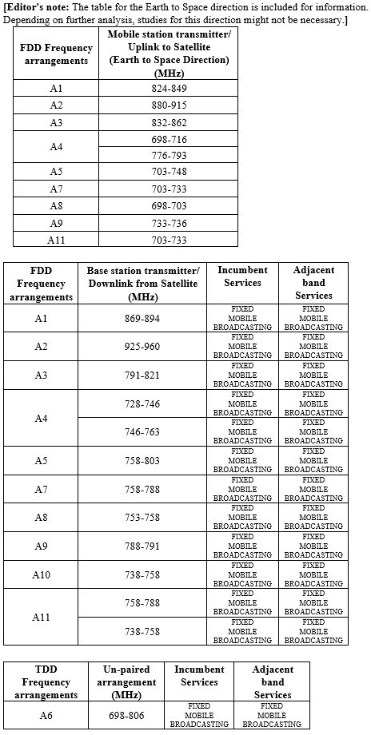
694 |  |  | (Rev WRC-23)  Bahamas, Barbados, Belize, Canada, Colombia, El Salvador, the United States, Guatemala, Jamaica and Mexico
694 | 4 | MOD 5.317A  (Rev WRC-23)  MS allocated on a primary basis entire band
698
698 | 92 |  | MOD 5.317A  (Rev WRC-23)  where MS allocated on a primary basis  (not 902-928) | 5.313A  (28 countries; Australia, Bangladesh, Brunei Darussalam, Cambodia, China, Korea (Rep. of), Fiji, India, Indonesia, Japan, Kiribati, Lao P.D.R., Malaysia, Myanmar (Union of), New Zealand, Pakistan, Papua New Guinea, the Philippines, the Dem. People’s Rep. of Korea, Solomon Islands, Samoa, Singapore, Thailand, Tonga, Tuvalu, Vanuatu and Viet Nam)
790
790 | 150 |  |  | MOD 5.317A  (Rev WRC-23)  MS allocated on a primary basis entire band
 | 150 |  | (not 902-928)
960 | 150

F | BW | R1 | R2 | R3 | M.1036
1427 | 25 | 5.341A | 5.341B | 5.341C | 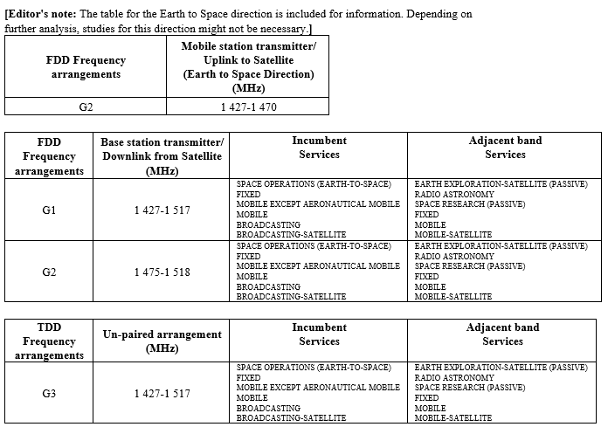
1452
1452 | 40 | MOD 5.346  (Rev WRC-23; 55 countries; Algeria, Angola, Saudi Arabia, Bahrain, Benin, Botswana, Burkina Faso, Burundi, Cameroon, Central African Republic, Congo (Rep. of the), Côte d'Ivoire, Djibouti, Egypt, United Arab Emirates, Eswatini, Gabon, Gambia, Ghana, Guinea, Iraq, Jordan, Kenya, Kuwait, Lesotho, Lebanon, Liberia, Madagascar, Malawi, Mali, Morocco, Mauritius, Mauritania, Mozambique, Namibia, Niger, Nigeria, Oman, Uganda, Palestine**, Qatar, Dem. Rep. of the Congo, Rwanda, Senegal, Seychelles, Somalia, Sudan, South Sudan, South Africa, Tanzania, Chad, Togo, Tunisia, Zambia, and Zimbabwe) | 5.341B | 5.364A
1492
1492 | 26 | 5.341A | 5.341B | 5.341C
1518

F | BW | R1 | R2 | R3 | M.1036
1710 | 175 | 5.384A |  |  | 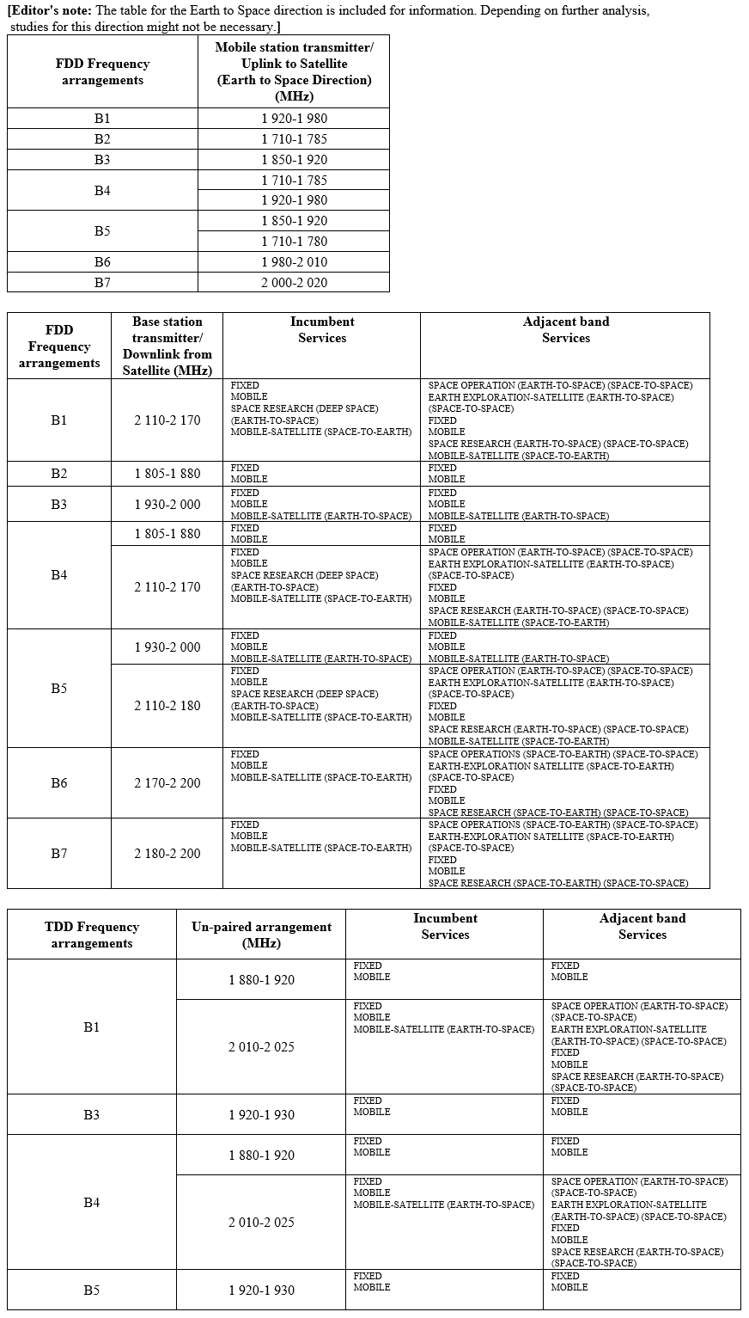
1885 | 175
1885 | 140 | MOD 5.388  (Rev WRC-23)
2025 | 140
 | 85
2110 | 90 | MOD 5.388  (Rev WRC-23)
2200 | 90

F | BW | R1 | R2 | R3 | M.1036
2300 | 100 | 5.384A |  |  | 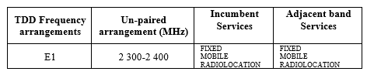
2400 | 100

F | BW | R1 | R2 | R3 | M.1036
2500 | 190 | 5.384A |  |  | 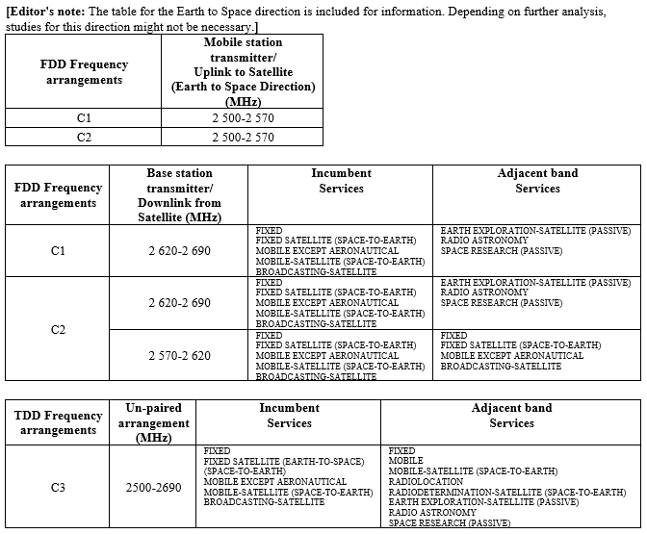
2690 | 190

