|  |  |
| --- | --- |
| U.S. Radiocommunications Sector  Fact Sheet | |
| **Working Party:** ITU-R WP 4C | **Document No:** US4C-09 |
| **Ref:** Resolution 249 (WRC-23) | **Date:** 27 March 2024 |
| Document Title: Working Document Regarding WRC-27 Agenda Item 1.11 | |
| **Author(s)/Contributors(s):**  Brennan Price  Viasat  Tatiana Lawrence  Iridium  Damon Ladson  HWG LLP for Iridium  Wayne Whyte  Teltrium for NASA | Email: [brennan.price@inmarsat.com](mailto:brennan.price@inmarsat.com) [sic] Phone: +1 703 223-3327  Email: [tatiana.lawrence@iridium.com](mailto:tatiana.lawrence@iridium.com)  Phone: +1 240 271-2751  Email: [dladson@hwglaw.com](mailto:dladson@hwglaw.com)  Phone: +1 202 730-1315  Email: [wwhyte@teltrium.com](mailto:wwhyte@teltrium.com)  Phone: +1 202 448-5040 x809 |
| **Purpose:** To initiate the studies called for under *resolves to invite the ITU Radiocommunication Sector* 1, 2, and 3 of Resolution 249 | |
| **Abstract:** The contribution will include a description of the space-to-space operations to be studied, characteristics of incumbent and space-to-space systems, and a list of relevant existing material. | |

|  |  |
| --- | --- |
| **Radiocommunication Study Groups** |  |
|  |  |
|  |  |
| Received: 27 March 2024  Subject: WRC-27 Agenda Item 1.11; Resolution 249 | **Document US4C/24/09-E** |
| **27 March 2024** |
| **Original: English** |
| **United States of America** | |
| working document regarding wrc-27 agenda item 1.11 | |
|  | |

WRC-27 Agenda Item 1.11 directs that conference to: *“to consider the technical and operational issues, and regulatory provisions, for space-to- space links among non-geostationary and geostationary satellites in the frequency bands 1 518-1 544 MHz, 1 545-1 559 MHz, 1 610-1 645.5 MHz, 1 646.5-1 660 MHz, 1 670-1 675 MHz and 2 483.5-2 500 MHz allocated to the mobile-satellite service, in accordance with Resolution* ***249 (Rev.WRC-23)****;”*

ITU-R Resolution **249 (WRC-23)** calls for ITU-R to consider the technical and operational issues, and regulatory provisions, for space-to-space links among non-geostationary and geostationary satellites in the frequency bands 1 518-1 544 MHz, 1 545-1 559 MHz, 1 610‑1 645.5 MHz, 1 646.5-1 660 MHz, 1 670-1 675 MHz and 2 483.5-2 500 MHz allocated to the mobile-satellite service.

Work on this issue has previously been conducted in Working Party 4C, most recently at the June 2019 meeting, with output in [Annex 6 to Document 4C/472 (2016-2019 cycle)](https://www.itu.int/dms_ties/itu-r/md/15/wp4c/c/R15-WP4C-C-0472!N06!MSW-E.docx). Drawing upon elements of this document, the United States herein submits the attachment as a starting point for a working document regarding WRC-27 Agenda Item 1.11 as a basis for addressing ITU-R Resolution **249 (WRC-23)**.

|  |
| --- |
| **ATTACHMENT**  working document regarding wrc-27 agenda item 1.11  **Non-geostationary satellites operating space-to-space links in mobile-satellite service (MSS) allocations in the 1-3 GHz range** |

**1 Introduction**

The landscape of satellite communications has seen a significant uptick in the deployment and operation of small non-geostationary (non-GSO) satellites, particularly those on short-duration missions. This surge is largely attributed to the advent of very small satellites, sometimes referred to as “cubesats”, along with other small Low Earth Orbit (LEO) satellite missions. These advancements have explored the potential for continuous access across their orbits, leveraging operating host non-GSO service (MSS) systems. Concurrently, geostationary (GSO) MSS operators are providing communications access to LEO satellites- via space-to-space links.

In response to this, numerous administrations worldwide have embarked on authorizing small satellites, including cubesats, on an experimental basis. This trend underscores a growing recognition of the potential these small-scale satellites hold for a myriad of applications. The number of experimental authorizations for transmissions between non-GSO space stations such as cubesats or small satellites and GSO satellite systems, as well as between non-GSO space stationsand non-GSO systems, is on the rise. These developments are pivotal, considering that many non-GSO small satellite and cubesats satellites traditionally operate with limited and non-real-time connectivity to Earth stations.

By harnessing space-to-space communication between such lower-altitude non-GSO small sat and cubesat satellites (“user space stations”)[1] and non-GSO and GSO MSS service provider space stations[2] operating at higher orbital altitudes, to relay data to or from the ground, a new realm of possibilities opens up. This approach can make data available in near-real-time, significantly enhancing the availability and value of instrument data for applications requiring low latency. The evolving regulatory landscape and the increasing experimental authorizations reflect a collective move towards maximizing the utility of satellite networks, paving the way for innovative communication solutions that transcend traditional orbital and operational boundaries.

**2 Examples of user space station missions with space-to-space links within in the frequency bands allocated to MSS**

Small satellite user space stations are planned for a number of applications, including:

* Scientific purposes
* Transmission of orbital information
* Orbital tracking
* Weather observation
* Commercial

These applications are increasingly being deployed for a wide range of applications such as scientific research, transmission of orbital information, orbital tracking, weather observation, and various commercial endeavors. These missions often involve experiments to test survivability and functionality of onboard components, such as retroreflector arrays for optical communication, GPS receivers for precise positional information, and advanced communication suites for data transmission. Additionally, they aim to develop identification and precision tracking capabilities for enhanced space situational awareness, test propulsion systems, and validate radar technologies for weather remote sensing. The use of mobile-satellite service (MSS) systems is a common thread among these missions, enabling continuous contact with ground stations, supporting command and control operations, and facilitating low-latency, low-data rate communications.

**2.2 Small LEO satellites**

In addition to cubesats, other LEO satellites make use of space-to-space links in the MSS to provide a communications link between spacecraft and ground.

As an example, this application could be of particular interest to operators of scientific, weather forecasting, earth observation and imaging missions which have a requirement to transmit the data collected by the payload sensors from space to ground. There is sometimes a requirement for the data to be transferred within minutes of acquisition which can be accomplished due to the near global coverage provided by some MSS systems. Space-to-space links could also be used to provide telemetry, tracking and command communications to and from the spacecraft.

**3 System Characteristics**

System Characteristics for studies are given below. Qualitative descriptions of service provider systems are given in Annex A.

**3.1 GSO**

**3.1.1 GSO MSS Service Provider Characteristics**

## MSS Characteristics and Protection Requirements in the frequency bands 1518-1559 MHz, 1626.5-1660.5 MHz, and 1668-1675 MHz

For any sharing and protection studies for the coexistence of existing GSO MSS services with any new MSS space links allocations, the following GSO MSS characteristics for different terminals, from ITU-R M.1184, can be used:

|  |  |  |  |  |  |  |  |
| --- | --- | --- | --- | --- | --- | --- | --- |
|  | C | Land | | Maritime | | Aeronautical | |
| High gain | Low gain | High gain | Low gain | High gain | Low gain |
| Service | MMSS | LMSS | LMSS | MMSS | MMSS | AMSS AMS(R)S | AMSS AMS(R)S |
| Typical mobile station antenna gain (dBi) | 0 | 12 | 9 | 16 | 9 | 12 | 6 |
| Antenna type (example) | Quad helix | Phased array | Phased array | Phased array | Phased array | Phased array | Phased array |
| Typical antenna size | 5 cm diameter | 50 cm diameter | 30 cm diameter | 50 cm diameter | 30 cm diameter | 2 panels 60 x 60 cm | 20 x 15 cm |
| Mobile earth station figure of merit (*G*/*T*) (dB(K–1)) | −23 | −10 | −15.5 | −7.5 | −15.5 | −13 | −20 |
| Mobile earth station e.i.r.p./channel (dBW) | 11 | 18 | 15.1 | 22 | 15.1 | 20 | 15.1 |
| User data rate | 600 bit/s | 500 kbit/s | 250 kbit/s | 500 kbit/s | 250 kbit/s | 500 kbit/s | 250 kbit/s |
| Modulation | BPSK | 16-QAM | 16-QAM | 16-QAM | 16-QAM | 16-QAM | 16-QAM |
| Typical *C*/*N*0 for communication channel (dB(Hz)) | 32 | 67 | 57 | 67 | 57 | 67 | 57 |
| Satellite e.i.r.p./channel (dBW) | 20 | 40.5 | 40.5 | 40.5 | 40.5 | 40.5 | 40.5 |
| Channel spacing (nominal) (kHz) | 5 | 200 | 200 | 200 | 200 | 200 | 200 |
| Satellite peak antenna gain (1) (dBi) | 18 | 41 | 41 | 41 | 41 | 41 | 41 |

Interference criteria for the mobile-satellite service is found in ITU-R Recommendation M.1183‑0.

The methodology for determining performance objectives for narrow-band channels in mobile satellite systems using geostationary satellites not forming part of the ISDN is contained in ITU‑R Recommendation M.1228, and other ITU-R M series recommendations may be relevant.

**3.1.2 User Space Station Characteristics for GSO MSS Service Providers**

User station characteristics to be used for studies are as follows:

|  |  |  |  |  |
| --- | --- | --- | --- | --- |
| **LEO/GEO MSS communications example characteristics** | Antenna Type | | | |
| Patch | Low Gain | Intermediate Gain | High Gain |
| Transmit Band (MHz) | 1626.5-1660.5, 1668-1675 | | | |
| Receive Band (MHz) | 1518-1559 | | | |
| Channel Bandwidth (kHz) | 200 | 10.5, 21, 42, 84, 189 | | |
| Maximum E.i.r.p. (dBW) | -1 to 10 dBW | 10 | 15.1 | 20 |
| Antenna type | patch/omni | Steerable/switched-multi | | |
| Transmit Antenna Gain (Front Lobe) (dBi) | 5 | 5 | 6 | 11 |
| Receive Antenna Gain/Noise Temperature (G/T) (dB/k) | -30 dB/k to -24 dB/k | -20 | -19 | -13 |

**3.2 Non-GSO**

**3.2.1 Non-GSO MSS Service Provider Characteristics**

**MSS Characteristics and Protection Requirements in the Frequency Bands 1610-1626.5 MHz and 2483.5-2500 MHz**

[TBD]

**3.2.2 User Space Station Characteristics for Non-GSO MSS Service Providers**

[TBD]

**4 Current use of space-to-space links in MSS allocations**

The current MSS allocations in 1 – 3 GHz do not include a space-to-space directional indicator. As a consequence, such operations may be conducted only on a non-interference basis, relying on No.**4.4** of the Radio Regulations. Given the interest in such space-to-space operations, reliance on No. **4.4** of the Radio Regulations is an unsound basis for continued development of user space station systems seeking to operate with MSS service provider space station networks and systems.. Consequently, further actions are needed to develop technical conditions and regulatory provisions for the operation of space-to-space links in these frequency bands, including MSS (space-to-space) allocations, or the addition of inter-satellite service (ISS) allocations, in all or parts of the frequency bands identified in Resolution **249 (Rev.WRC-23).**

However, No. **1.25** explicitly acknowledges the inclusion of space-to-space communications within the mobile-satellite service (MSS), stating that the service may involve communication “between space stations used by this service.” This provision indicates that space-to-space links, when operated within an MSS allocation, are permissible under the current regulatory structure, potentially without the need for additional allocations or specific regulatory provisions for space-to-space operations beyond the addition of a space-to-space direction indicator.

The absence of a transmission direction indicator in the Table of Allocations raises concerns about the operation of space-to-space links in MSS allocations, particularly in the context of maintaining compatibility with the established Earth-to-space and space-to-Earth transmission directions defined in the ITU Radio Regulations. The unique situation in the frequency band 1613.8-1626.5 MHz, which accommodates both uplink and downlink directions, underscores the need for clarity in regulatory provisions regarding the directionality of space-to-space transmissions.

While RR No. **1.25** provides a foundational basis for the development and operation of space-to-space links within MSS allocations, the practical implementation of such links may necessitate the amendment of the ITU Radio Regulations at WRC-27.

### **5 Incumbent Services Parameters for Study**

[TBD after receipt of liaison statements]

**6 Space-to-Space Link Compatibility with other services**

**6.1 Space-to-space links in the bands 1 518-1 559 MHz, 1 626.5-1 660.5 and 1 668‑1 675 MHz**

[TBD]

**6.2 Space-to-space links in the bands 1 610-1 626.5 MHz and 2 483.5-2 500 MHz**

[TBD]

**7 Summary**

[TBD]

______________

ANNEX A

SYSTEM DESCRIPTIONS

**A.1 Space-to-space links between LEO user satellites and GSO MSS service provider network satellites**

GSO MSS systems operate in the frequency bands 1 518-1 559 MHz (space-to-Earth) and 1 626.5‑1 660.5 MHz and 1 668-1 675 MHz (Earth-to-space). These bands are used for the service links to terminals on ships and aircraft and land portable terminals. The feeder links, connecting the GSO satellite with the ground network operate in other frequency bands, for example, C-band and Ku-band FSS bands. The service links at 1.5/1.6 GHz typically make use of multiple spot beams formed by the spacecraft antenna. An example of spot beam coverage from 3 GSO satellites is shown in Figure 1.

Figure 1

**Example of spot beam coverage from 3 GSO MSS satellites**

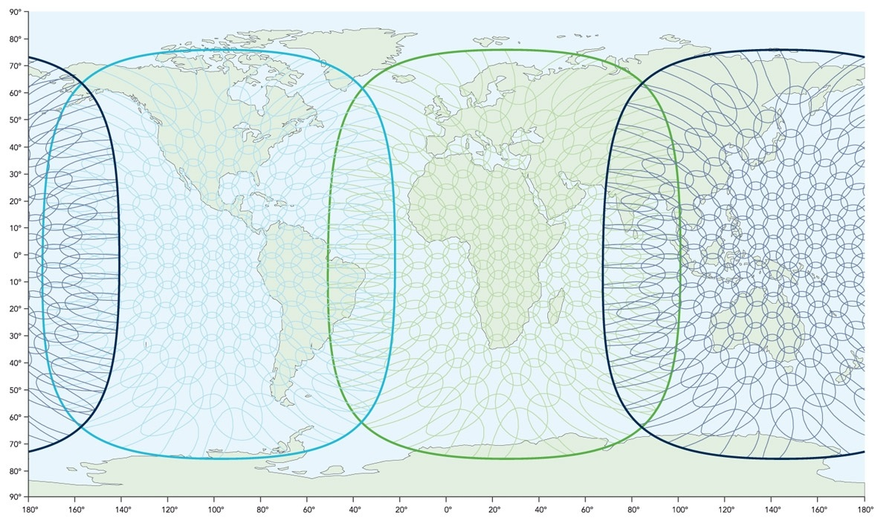

MSS operators have developed modified mobile earth stations that may be placed on a LEO spacecraft. As long as the LEO spacecraft is located within a GSO MSS satellite spot beam, it may communicate with the GSO spacecraft. Three GSO satellites equally spaced in geostationary orbit allow connectivity for almost 100% of the time, as shown in Figure 2.

Figure 2

**LEO satellite within coverage of GSO MSS satellites**



The data rates that can be provided are similar to those provided to terrestrial terminals. For this application, using a backgroundIP protocol, up to 200 kbit/s both to and from the spacecraft is provided.

**A.2 Space-to-space links between LEO user satellites and non-GSO MSS service provider system satellites**

[Note: this material will be updated in a future revision of this document.] The non-GSO HIBLEO-2 satellite system operates within the 1616-1626.5 MHz band employing 66 low earth orbit satellites that support user-to-user, user‑to-gateway, and gateway-to-gateway communications. The 66 satellites are evenly distributed in six orbital planes with an 86.4° inclination. The HIBLEO‑2 satellite constellation is depicted in Figure 1. The satellites orbit at an altitude of 780 kilometres and have an orbital period of approximately 100 minutes 28 seconds.

Figure 1

HIBLEO-2 satellite constellation

The near polar orbits of the HIBLEO-2 satellite constellation provide global coverage from pole‑to‑pole [as depicted in Figure 2].

Figure 2

HIBLEO-2 satellite coverage



All communication services are provided independent of latitude and longitude position on the globe. Ship-to-shore, shore-to-ship and ship-to-ship communications are provided by a constellation of low earth orbiting satellites with overlapping coverage areas, providing ubiquitous coverage.

The first-generation constellation was implemented in 1998. It is now being replaced even as many of the original satellites are still working. Second-generation satellites are being launched that include advance technology and functionality. The entire HIBLEO-2 satellite constellation is to be replaced before the end of 2018.

Voice, broadcast data, short burst data and “push-to-talk” services are provided globally on a 24×7 basis. Service bearing communications is networked between the satellites in the constellation over inter-satellite links operating on Ka-band frequencies. The inter-satellite links provide connectivity between satellites without going through a terrestrial earth station. Data is transferred to the ground through one of the ground stations around the globe.

As mentioned above, the near polar orbits of the HIBLEO-2 satellite constellation provide global coverage from pole to pole. Further the characteristics of this system can also be found in Report ITU‑R M.2369.]

1. A user space station is considered to be a space station transmitting in the MSS allocation (Earth-to-space) towards MSS service provider space stations at higher altitudes and receiving in the MSS allocation (space-to-Earth) from MSS service provider space stations at higher altitudes.
2. An MSS service provider space station is considered to be a space station transmitting in an MSS allocation (space-to-Earth) towards user space stations at lower altitudes and receiving in the MSS allocation (Earth-to-space) from user space stations at lower altitudes.