This document has not reached consensus in the United States preparatory process.

Viasat states that Document USWP4C-24-14 is consistent with United States regulation (47 CFR 80.377), policy at WRC-23 (to retain the GMDSS identification on the subject band, even as the position supported a method different than the outcome), and the WRC outcome (given the explicit incorporation by reference of Appendix 15 by Article 31.

Iridium opposes Document US4C-14, citing that the 1645.5-1646.5 MHz frequency band's inclusion in the GMDSS is obsolete, as the IMO no longer recognizes this band for GMDSS, and WRC-23's introduction of SAT-COM lacks corresponding IMO support. The absence of a maritime-mobile satellite service (MMSS) allocation in the frequency band 1645.5-1646.5 MHz invalidates proposed protective measures in the document, and the omission of essential information in Table 2 fails to address Resolution 252's requirements for adjacent band studies. Consequently, Iridium recommends against the submission of this document by the United States.

Viasat presents the document below the fact sheet, and Iridium attaches a more detailed argument after the document.

This document has not reached consensus in the United States preparatory process.

U.S. Radiocommunications Sector
Fact Sheet
Working Party: ITU-R WP 4C | Document No: USWP4C-24-14
Ref: Resolution 252 (WRC-23) | Date: 22 March 2024

Document Title: Characteristics of Stations in the Mobile-Satellite Service in the 1 645.5-1 646.5 MHz Frequency Band and adjacent bands 1 626.5-1 645.5 MHZ and 1 646.5-1 660.5 MHz
Author(s)/Contributors(s):  Brennan Price  Viasat | Email: brennan.price@inmarsat.com [sic]  Phone: +1 703 223-3327
Purpose: To provide characteristics necessary for sharing and compatibility studies for WRC-27 agenda item 1.12, as called for by resolves to invite the ITU Radiocommunication Sector 2 of Resolution 252.
Abstract: The contribution will provide characteristics of stations utilized for distress, urgency, and safety communications in the 1 645.5-1 646.5 MHz frequency band, as prescribed by RR No. 5.375 and Article 31. The contribution also describes characteristics of stations in adjacent frequency bands.

Radiocommunication Study Groups | 
Received: 22 March 2024  Subject: WRC-27 Agenda Item 1.12; Resolution 252 | Document US4C/24/14-E
 | 22 March 2024
 | Original: English
United States of America
Characteristics of Stations in the Mobile-Satellite Service in the 1 645.5-1 646.5 MHz Frequency Band and Adjacent Bands 1626.5-1645.5 MHz and 1646.5-1660.5 MHz
ITU-R Resolution 252 (WRC-23) calls studies to be conducted on sharing and compatibility with existing services in, among several frequency bands, the 1 645.5-1 646.5 MHz frequency band. As a result of action at WRC-23 modifying RR No. 5.375, the use of the frequency band 1 645.5-1 646.5 MHz by the mobile-satellite service (Earth-to-space) and for inter-satellite links is limited to distress, urgency and safety communications, under conditions further described in Article 31, which relates to Frequencies for the Global Maritime Distress and Safety System (GMDSS). This band is also identified in Appendix 15 (Rev.WRC-19).

Characteristics of stations used for distress, urgency, and safety communications are found in ITU-R Recommendation M.1184-3, and are excerpted in Table 1 below. The header “C” in the table describes a two-way store and forward communication system transmitting messages from ship-to-shore, shore-to-ship and ship-to-ship, including email, SMS, telex, chart and weather updates. The header “maritime” describes a higher data rate, simultaneous data and voice communication link utilizing compact terminals.

Characteristics of services in the adjacent bands, 1626.5-1645.5 MHz and 1646.5-1660.5 MHz found in ITU-R Recommendation M.1184-3 are shown in Table 2. The United States proposes that these characteristics should be taken into consideration for any protection and sharing studies to ensure no harmful interference to existing incumbent services in the adjacent frequency bands as a result of any new allocations or regulatory actions for future low-data rate non-geostationary mobile-satellite systems. The information below should considered for inclusion in any working document developed studies under WRC-23 agenda item 1.12

TABLE 1
EXCERPT OF RELEVANT CHARACTERISTICS FOR EXISTING GSO MSS SERVICES IN THE BAND 1645.5-1646.5 MHZ FROM
RECOMMENDATION ITU-R M.1184
 | C | Maritime
 |  | High gain | Low gain
Service | MMSS | MMSS | MMSS
Typical mobile station antenna gain (dBi) | 0 | 16 | 9
Antenna type (example) | Quad helix | Phased array | Phased array
Typical antenna size | 5 cm diameter | 50 cm diameter | 30 cm diameter
Mobile earth station figure of merit (G/T) (dB(K^{–1})) | −23 | −7.5 | −15.5
Mobile earth station e.i.r.p./channel (dBW) | 11 | 22 | 15.1
User data rate | 600 bit/s | 500 kbit/s | 250 kbit/s
Modulation | BPSK | 16-QAM | 16-QAM
Typical C/N₀ for communication channel (dB(Hz)) | 32 | 67 | 57
Satellite e.i.r.p./channel (dBW) | 20 | 40.5 | 40.5
Channel spacing  (nominal) (kHz) | 5 | 200 | 200
Satellite peak antenna gain ⁽¹⁾ (dBi) | 18 | 41 | 41

Interference criteria for the mobile-satellite service are found in ITU-R Recommendation M.1183-0, which provides:

that the maximum level of interference power in any such digital channel caused by the transmitters of another mobile-satellite network or fixed-satellite network, should not exceed for more than (100 – X)% of any month, 6% of the total noise power at the input to the demodulator which would give rise to the desired performance objectives[.]

The methodology for determining performance objectives for narrow-band channels in mobile satellite systems using geostationary satellites not forming part of the ISDN is contained in ITU-R Recommendation M.1228, and other ITU-R M series recommendations may be relevant.

The United States proposes that these characteristics and criteria be taken into account in studies for agenda item 1.12 required by resolves 2 of ITU-R Resolution 252

Iridium does not support Document 14 going forward.

The IMO no longer includes 1645.5-1646.5 MHz EPIRBs in the Global Maritime Distress and Safety System (GMDSS) and has not recognized other applications of GMDSS for the band. Thus, the reference to Article 31 and associated GMDSS functions for this band is obsolete.

Additionally, though WRC-23 amendments introduced SAT-COM for this band, it is necessary to clarify that for the frequency band 1645.5-1646.5 MHz, currently SAT-COM does not fall under GMDSS operations under IMO regulations. Effectively, through the application of Article 31, WRC-23 reserved the band for SAT-COM GMDSS under the maritime mobile-satellite service, for which currently there is no IMO support. A future WRC needs to address this unresolved regulatory contradiction.

Moreover, since there is no maritime-mobile satellite service (MMSS) allocation in the subject band, the protective measures for MMSS proposed in the document unwarranted. Note that in Appendix 15, Table-2, the RR definiton for Article 31 SAT-COM (see image below) provides that SAT-COM is expressly under the maritime mobile-satellite service. Characteristics applied to the band must reflect current and permissible services, not those which are unsupported or non-existent. The characteristics applied to the band in Doc. US4C-14 are for a service that is not supported in the band at this time. Consequently, protection sought for a non-existent service within this band is premature.

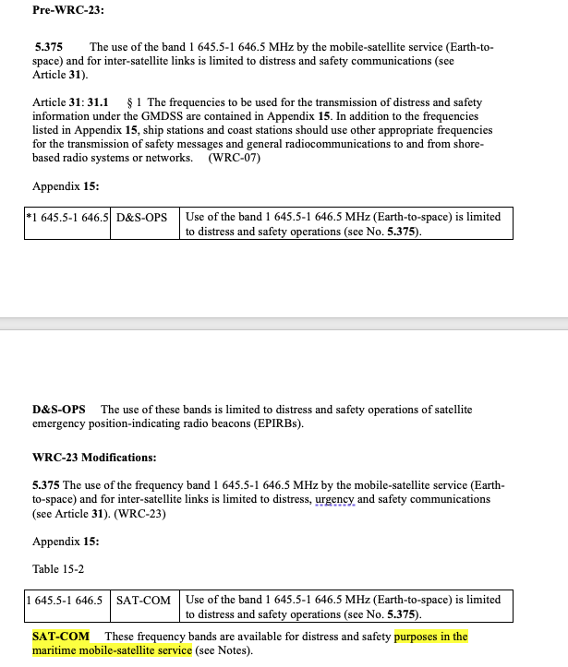
Finally, in the document, you state: "Characteristics of services in the adjacent bands, 1626.5-1645.5 MHz and 1646.5-1660.5 MHz found in ITU-R Recommendation M.1184-3 are shown in Table 2." However, Table 2 is not in the document, though adjacent band MSS characteristics would be appropriate for addressing studies under Resolution 252 (WRC-23).

In light of these considerations, we maintain that the United States should not submit the proposed document.

