U.S. Radiocommunications Sector
Fact Sheet
Working Party: ITU-R WP 4C | Document No: USWP4C-xx
Ref: N/A | Date: 12 Jul 2024
Document Title: Elements for Working Document Toward Supporting WRC27 Agenda Item 1.13
Author(s)/Contributors(s):  Jameson Dempsey  SpaceX  Zahid Islam  SpaceX  Brett Tarnutzer  SpaceX  Pascale Dumit  T-Mobile | Email: Jameson.Dempsey@spacex.com  Phone:  Email: km.islam@spacex.com  Phone:  Email: brett.tarnutzer@spacex.com  Phone:  Email: Pascale.Dumit@T-Mobile.com  Phone:
Purpose/Objective: Continue the work under WRC-27 Agenda Item 1.13 and contribute to Annex 7 of the last 4C’s chair report.

Abstract: The proposed U.S. contribution provides edits to the current 4C Working Doc on AI 1.13.

Radiocommunication Study Groups | 
Received: TBD October 2024  Source: Annex 7, WP4C/77  Subject: AI 1.13 | Document 4C/TBD-E
 | TBD October 2024
 | English only
United States of America
Elements for Working Document Toward Supporting WRC27 Agenda Item 1.13
This contribution provides edits as well as new content to the doc 4C/77 Annex 7. Moreover, the United States propose a re-structuring of the document to ensure a better flow of information.
The United States proposes to use this document as baseline for drafting at the upcoming WP 4C meeting.

- Introduction
A new agenda item 1.13 was approved at WRC-23 to study possible new allocations to the mobile-satellite service for direct connectivity between space stations and International Mobile Telecommunications (IMT) user equipment to complement terrestrial IMT network coverage in the frequency range between 694/698 MHz and 2.7 GHz, taking into account the IMT frequency arrangements addressed in the most recent version of Recommendation ITU-R M.1036, in accordance with Resolution 253 (WRC-23). The resolves 2 of this Resolution invites the ITU Radiocommunication Sector to study the spectrum requirements and technical, operational and regulatory matters related to the implementation of the mobile-satellite service (MSS) for direct connectivity to the IMT user equipment to complement the terrestrial IMT network coverage. This report aims to investigate technical and operational matters of MSS for direct connectivity to the IMT user equipment.

- Definition of Direct-to-device communications and use cases
As described in recognizing b) of Res 253, the envisaged satellite system communicating directly with IMT user equipment utilized in terrestrial IMT networks may provide complementary coverage for mobile connectivity from space as a part of IMT networks to areas such as high mountains, remote islands and deserts, where it may not be sufficient to deploy terrestrial base stations. In addition, the envisaged satellite systems may provide alternative network resilience in case of failure of terrestrial IMT base stations due to unexpected incidents, such as natural disasters and network outages. Please see the Figure 1 below.
Figure 1
The envisaged satellite system to be considered in this agenda item is characterized as:
i) the frequency bands for the satellite system are the same as those for terrestrial IMT networks; and
ii) the same user equipment as those for terrestrial IMT network is used.
It is important to clarify how AI 1.13 focuses on direct-to-unmodified IMT user equipment using IMT bands. This represents a fundamental difference with respect to traditional MSS applications as well as MSS direct-to-modified device applications treated under AI 1.14.

- Candidate Bands for Study

FDD Frequency plan
M.1036 frequency arrangement | Mobile station transmitter  (MHz) | Base station (space station) transmitter (MHz)
A1 | 824-849 | 869-894
A2 | 880-915 | 925-960
A3 | 832-862 | 791-821
A4 | 698-716  776-793 | 728-746  746-763
A5/A7/A8/A9/A11 | 698-748 | 753-803
G2 | 1427-1470 | 1475-1518
B1/B4 | 1 920-1 980 | 2 110-2 170
B2/B4 | 1 710-1 785 | 1 805-1 880
B3 | 1850-1920 | 1930-2000
C1 | 2 500-2 570 | 2 620-2 690

Complete list of sharing studies to be conducted
To be completed for the second draft

- Technical characteristics of systems and networks intended to provide direct connectivity between space stations and unmodified IMT user equipment

4.1 System A

4.1.2 Orbit and RF emission characteristics

The following two tables summarize two orbit configurations of a system for direct-to-unmodified device communications.

Table 1: 525 km orbit configuration

Altitude (km) | Inclination (deg) | # Planes | Sats per plane | RAAN spacing (deg) | Total number of sats
525 | 53 | 28 | 120 | 12.9 | 3360

Table 2: 340 km orbit configuration

Altitude (km) | Inclination (deg) | # Planes | Sats per plane | RAAN spacing (deg) | Total number of sats
340 | 53 | 48 | 110 | 7.5 | 5280

The two configurations are mutually exclusive and should be studied separately.

4.1.3 Emissions in the space-to-Earth direction

In the space-to-Earth direction it is very important to distinguish between maximum PFD on the ground per sat and average PFD when considering the full constellation in operation:
- Maximum PFD per satellite: -80 dBW/m2/MHz
- Average PFD when considering the full constellation in operation: -TBD dBW/m2/MHz

4.1.4 Antenna Pattern
To be provided for the second draft.
4.1.5 Out-of-band emissions to be used for out-of-band studies
To be provided for the second draft.

4.1.6 Emissions in the Earth-to-space direction
The intended operations foresee communications from unmodified user equipment.
Depending on further analysis, studies for this direction might not be necessary given that the characteristics of the IMT mobile stations (i.e. user equipment) are envisaged to remain unchanged.
[Feedback from WP5D is expected with respect to this section]

4.1.7 Modelling of operations
This section contains important assumptions on how to model operations of systems and networks implementing direct-to-unmodified user equipment.

4.1.7.1 Satellite selection mechanism and minimum elevation

The appropriate satellite selection mechanism for System A is random satellite selection.
The minimum elevation to be used is TBD deg.

4.1.7.2 Interference management technique implemented by System A
System A uses software-based systems to dynamically manage emissions and remain within applicable aggregate limits to protect all relevant services.

4.1.7.2.1 The “topology” function
The “topology function” enables System A operator to dynamically meet applicable cross-border limits without fixed keep-out zones away from borders.

A visual example is offered by the figure below, based on the territory of the United States. The simulated field strength shows how emissions are adapted in cells close to the border with neighbouring countries.
[Section to be expanded for the second draft]
When modelling System A the topology function should be considered.

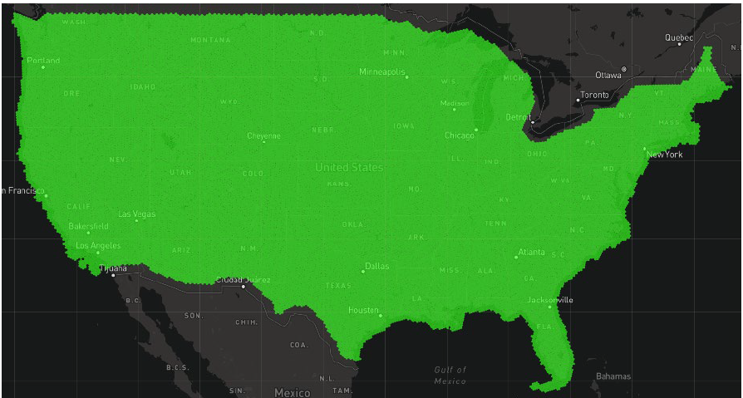
Figure 1: Simulated field strength over the territory of the United States

4.2 System B
TBD
4.3 System C
TBD

- Incumbent services system characteristics and protection criteria
5.1 Protection criterion for MSS

Table 4 contains the proposed I/N values to be used when assessing the interference impact on the incumbent MSS systems intending to provide direct-to-device communications.
TABLE 4
Protection criterion for MSS
Long-term protection criterion (I/N) | −6 dB to be exceeded for up to 20% of the time
Short-term protection criterion (I/N) | TBD dB to be exceeded for up to TBD % of the time

SINR operating range and mapping function
The following equations approximate the throughput over a channel with a given SINR (dB), when using link adaptation:
$$Throughput \left(SINR\right), bps/Hz =\left\{\begin{aligned}0 for SINR< SINR_{MIN} \\ α∙S\left(SINR\right) for SINR_{MIN}≤SINR<SINR_{MAX} \\ α∙S\left(SINR_{MAX}\right) for SINR ≥ SINR_{MAX} \end{aligned}\right.$$
where:
S(SINR) Shannon bound, S(SINR) =log₂(1 + 10^{SINR/10}) (bps/Hz)
α Attenuation factor, representing implementation losses
SINR_{MIN} Minimum SINR of the code set, dB
SINR_{MAX} Maximum SINR of the code set, dB.
The parameters α, SINR_{MIN} and SINR_{MAX} can be chosen to represent different modem implementations and link conditions. The parameters proposed in Table 5 represent a baseline case, which assumes:
– 1:1 antenna configuration;
– AWGN channel model;
– Link Adaptation (see Table 5 for details of the highest and lowest rate codes);
– No HARQ.
Table 5
Parameters describing baseline Link Level performance for 5G NR
Parameter | DL | UL | Notes
α | 0.6 | 0.4 | Represents implementation losses
SINR_{MIN}, dB | −10 | −10 | Based on QPSK, 1/8 rate (DL) & 1/5 rate (UL)
SINR_{MAX}, dB | 30 | 22 | Based on 256-QAM, 0.93 rate (DL) & 64-QAM, 0.93 rate (UL)

5.2 Terrestrial IMT characteristics and protection criteria
TBD

5.3 Passive services in adjacent bands – characteristics and protection criteria
TBD

6 High-level summary of sharing studies

7 Summary

ANNEX
Sharing and compatiblity studies
Editor’s note: Individual sharing studies will be included in this Annex.

