|  |  |
| --- | --- |
| **U.S. Radiocommunications Sector**  **Fact Sheet** | |
| **Working Party:** ITU-R WP 5C | **Document No:** USWP 5C 31-02 |
| **Ref:** Annex 10 to Document  5C/384-E - 25 May 2023 | **Date:** 07/24/20 |
| **Document Title:** Preliminary Draft Revision to Recommendation ITU-R F.1762 “Characteristics of enhanced applications for high frequency (HF) radiocommunication systems” | |
| **Author(s)/Contributors(s):**  Fumie Wingo  Department of the Navy  Robert Leck  ACES in support of the Department of the Navy  Taylor King  ACES in support of the Department of the Navy  Carmelo Rivera  ACES in support of the Department of the Navy | Phone: +1-703-697-0066  Email: [fumie.n.wingo.civ@us.navy.mil](mailto:fumie.n.wingo.civ@us.navy.mil)  Phone : +1-321-332-2111  Email : [robert.leck@aces-inc.com](mailto:robert.leck@aces-inc.com)  Phone : +1- 443-966-0550  Email : [taylor.king@ACES-INC.COM](mailto:taylor.king@ACES-INC.COM)  Phone : +1- 240-818-2766  Email : [carmelo.rivera@ACES-INC.COM](mailto:carmelo.rivera@ACES-INC.COM) |
| **Purpose/Objective:** This is a Fact Sheet for continued work on the Preliminary Draft Revision to Recommendation ITU-R F.1762 “Characteristics of enhanced applications for high frequency (HF) radiocommunication systems” the intent is to elevate the document to the next level at the Fall ITU-R meeting in Geneva | |
| **Abstract:** This work will consist of a final review and, if needed, editorial and language modifications. No substantive modifications are expected. | |

|  |  |
| --- | --- |
| **Radiocommunication Study Groups** |  |
|  |  |
|  |  |
| Received: 13 May 2022  Subject: Update to Recommendation ITU-R F.1762 | **Revision 1 to Document 5C/263-E** |
| **16 May 2022** |
| **English only** |
| **United States of America** | |
| DRAFT REVISION TO RECOMMENDATION ITU-R F.1762 | |
| **Characteristics of enhanced applications for high frequency (HF) radiocommunication systems** | |

**Introduction**

The United States proposes that ITU-R Working Party (WP) 5C consider the proposed revisions to ITU-R Recommendation **[F.1762](https://www.itu.int/rec/R-REC-F/recommendation.asp?lang=en&parent=R-REC-F.1762)** **with a view towards elevating the document to a DNR at the next ITU-R 5C Meeting.** Annex 10 to Document 5C/384-E - 25 May 2023 carries over this document from the last cycle to this current cycle despite not being considered at the last WP 5C meeting.

The proposed edits are highlighted in yellow.

**Attachment:** Draft revision to Recommendation ITU-R F.1762 – *Characteristics of enhanced applications for high frequency (HF) radiocommunication systems*

|  |
| --- |
| **ATTACHMENT**  DRAFT  REVISION TO RECOMMENDATION ITU-R F.1762 |
| Characteristics of enhanced applications for high frequency (HF) radiocommunication systems |

(Question ITU-R 158/9)

(2006-202X)

Summary of revisions

The proposed updates include a list of additional enhanced applications as well as updated system parameters that would support the deployment of enhanced applications through high-speed digital networks within the 2 [1]to 30 MHz frequency range. Additionally, emission masks that are appropriate for HF system operating in non-networked configurations are included for contiguous systems and with non contiguous systems. Finally, revisions were made to conform with the mandatory format for ITU-R Recommendations.

Scope

This Recommendation describes the typical technical characteristics of enhanced applications for high frequency (HF) radiocommunication systems to provide enhanced digital applications.

Keywords

Enhanced applications, Channel bandwidth, Video streams, File Transfer, Voice over IP

Abbreviations/Glossary

e.i.r.p.:Effective Isotropic Radiated Power

NVIS:Near vertical incidence skywave

PSK:Phase Shift Keying

FSK:Frequency Shift Keying

HF:High Frequency

PSK:Phase Shift Keying

QAM-:Quadrature Amplitude Modulation

OFDM:Orthogonal Frequency Division Multiplexing

RF:Radio Frequency

Skywave: The propagation of radio waves reflected or refracted back toward Earth from the ionosphere

Groundwave: Radio waves propagating parallel to and adjacent to the surface of the Earth, following the curvature of the Earth

Related ITU Recommendations and Reports

{*Editor’s note: There was a suggestion to check SM recommendations for out of band information for HF systems*}

Recommendation ITU-R BS.80 – *Transmitting antennas in HF broadcasting*

Recommendation ITU-R BS.705 – *HF transmitting and receiving antennas characteristics and diagrams*

Recommendation ITU-R F.240 – *Signal-to-interference protection ratios for various classes of emission in the fixed service below about 30 MHz*

Recommendation ITU-R F.1610 – *Planning, design and implementation of HF fixed service radio systems*

Recommendation ITU-R F.1611 – *Prediction methods for adaptive HF system planning and operation*

Recommendation ITU-R F.1761 – *Characteristics of HF fixed radiocommunication systems*

Recommendation ITU-R F.1778 – *Channel access requirements for HF adaptive systems in the fixed and land mobile services*

Recommendation ITU-R F.1821 – *Characteristics of advanced digital high frequency (HF) radiocommunication systems*

Recommendation ITU-R SM.326 - *Determination and measurement of the power of amplitude-modulated radio transmitters*

Recommendation ITU-R SM.339 - *Bandwidths, signal-to-noise ratios and fading allowances in complete systems*

Report ITU-R [BS.458](https://www.itu.int/pub/R-REP-BS.458) – *Characteristics of systems in LF, MF and HF broadcasting*

Report ITU-R F.2061 – *HF fixed radiocommunications systems*

Report ITU-R F-2062 – *Enhanced high frequency digital radiocommunication systems capable of providing enhanced applications*

Report ITU-R F.2087 – *Requirements for high frequency (HF) radiocommunication systems in the fixed service*

Report ITU-R F.2484 – *Cooperative frequency competition model and the corresponding algorithms*

The ITU Radiocommunication Assembly,

considering

*a)* that some high frequency (HF) systems can be used to provide enhanced applications for electronic messaging systems (e-mail), digital voice, IP services and large file transfer providing a communications path to the Internet for exchanging information;

*b)* that the increasing use of spectrum in the HF bands for enhanced applications such as electronic messaging systems, both with and without attachments, should be taken into account;

*c)* that such HF systems are not standardized in use and may have different operational technical characteristics;

*d)* that with electronic messaging, and other enhanced applications for HF systems, equipment interoperability is an important issue,

recognizing

*a)* that the frequency range 3 to 30 MHz is also allocated to several other services on a primary basis;

noting

*a)* that such HF systems are capable of providing routine and emergency public protection and disaster relief;

*b)* that HF digital networks utilizing increased contiguous channel bandwidths or non-contiguous multichannel equipment can be used as a mechanism for providing enhanced applications;

*c)* that additional information on such HF systems capable of providing enhanced applications can be found in Report ITU-R F.2062,

recommends

that the technical characteristics of those HF systems providing enhanced applications, including electronic messaging and other Internet capability, described in Annex 1 should be considered representative of those systems operating in the HF frequency bands between 2[2] and 30 MHz.

Annex 1  
  
Typical characteristics of HF radio systems   
providing enhanced applications

# 1 Introduction

Enhanced applications that can be supported over HF include:

a) electronic mail, also known as e-mail,

b) voice over internet protocol, also known as VoIP,

c) interactive Internet applications,

d) large file transfer,

e) real-time video streams over HF.

In the event of the collapse or overload of normal telecommunication operation due to natural disasters (e.g. earthquakes) and other emergencies, applications for enhanced HF systems using fixed, transportable and mobile stations could provide emergency links during the first phase of the alarm or during the coordination of the relief operation.

# 2 HF Transmitter/Receiver RF Technical characteristics

Tables 1A, 1B, 2, 3A, 3B, and 4 contain technical characteristics of representative HF systems capable of providing enhanced applications. These characteristics are sufficient for general calculation to assess the compatibility between these systems and systems operating in other services.

In Table 1B, protection ratios are specified as the ratio of wanted-to-unwanted *average* signal powers (PY). This contrasts with Recommendation ITU-R F.240 where the ratios are expressed in peak envelope powers (PX). Conversion from PX to PY is waveform dependent for both wanted and unwanted signals. Conversion factors can be obtained from Recommendation ITU-R SM.326.

The parameters in Table 1A apply to the Groundwave, Skywave and NVIS Systems that are listed in Table 1B.

Table 4 is dedicated to enhanced systems using non-contiguous multichannel equipment. These enhanced systems permit the simultaneous use of up to 16 non-contiguous traditional SSB channels arranged in an (non-overlapping) arbitrary way. The modulation of such an equipment consists in a set of elementary 3 kHz wide modulators, arranged in a frequency division multiplex. Any elementary modulation is processed and applied to a subcarrier whose frequency value is chosen according to the allocated channels. All channels shall be contained within a working bandwidth of up to a maximum of 200 kHz.

TABLE 1A

Characteristics for RF HF systems[3]

|  |  |
| --- | --- |
| Parameter | Value |
| Necessary bandwidth (kHz) | 3 |
| Feeder loss (dB) | 3 |
| Receiver IF bandwidth (kHz) | 3 |
| Receiver RF bandwidth (kHz) | 3 |
| Receiver noise figure (dB) | 16 |

TABLE 1B

Example of typical RF characteristics HF systems[4]

|  |  |  |  |
| --- | --- | --- | --- |
| Parameter | System | | |
| Mode of operation | Groundwave | Skywave (oblique) | NVIS Near vertical |
| Frequency band (MHz) range | 2-10 | 3-30 | 2-10 |
| Transmitter power PX (dBW) | 10-30 | 0-26 | 10-26 |
| Antenna gain (dBi) | 6 | 3 | 0 |
| Maximum e.i.r.p. (dBW) | 33 | 26 | 23 |
| Antenna polarization | Vertical/ horizontal | Vertical | Horizontal |
| Protection ratio PY (dB) | 21 | 28 | 10 |
| Signal-to-noise ratio (Recommendation ITU-R F.339) | 21 | 28 | 10 |

TABLE 2

Typical RF characteristic of enhanced HF systems for channel bandwidths of 3 to 48 kHz (transmitter for ISB and Contiguous channels Systems)

|  |  |  |  |  |
| --- | --- | --- | --- | --- |
| Enhanced HF transmitter parameters | Groundwave / Skywave | NVIS / Groundwave | Skywave / NVIS / Groundwave | Skywave |
| Frequency band (MHz) range | 3-30 | 3-30 | 3-30 | 3-30 |
| Channel bandwidth (kHz)[5] | Variable 3-48 | Variable 3-48 | Variable 3-48 | Variable 3-48 |
| Transmitter power (dBW) | 36 | 26 | 36 | 27 |
| Feeder loss (dB) | 2.2 | 1.5 | 2.6 | 1.1 |
| Antenna gain (dBi) | 14.15 | 4.15 | 11.15 | 2.15 |
| Antenna height (m) | 64 | 3.65 | 28.04 | 1.21 |
| Antenna polarization | Vertical | Vertical | Vertical | Horizontal |
| Antenna type | Broadband Omni | Narrowband Monopole | Broadband Dual Fan-Wire | Narrowband Dipole |
| Maximum e.i.r.p. (dBW) | 34.2 | 24.2 | 35.7 | 26.7 |
| Modulation | AM/FM | AM/FM | FM | FM |
| Typical minimum path length (km) | 161 | 48.2 | 38.6 | 19 |

The parameters in Table 3A apply to Groundwave, Skywave and NVIS Systems operating within the 3-30 MHz frequency band. Addition parameters are listed in Table 3B.

TABLE 3A

Characteristic of enhanced HF systems for channel bandwidths of 3 to 48 kHz (receiver of ISB and Contiguous channels Systems)

| Enhanced HF receiver parameters | Values |
| --- | --- |
| Channel Bandwidth (kHz)[6] | Variable 3-48 |
| Variable (3 kHz to 12.0 kHz) | 12.0 |
| Variable (3 kHz to 18.0 kHz) | 18.0 |
| Variable (3 kHz to 24.0 kHz) | 24.0 |
| Variable (3 kHz to 48 kHz) | 48.0 |
| IF Filter Bandwidth (kHz) | 48 |
| Sensitivity (dBm) |  |
| SSB for 10 dB SINAD | −113 |
| ISB for 10 dB SINAD | −97 |
| CW for 10 dB SINAD | −116 |

TABLE 3B

Typical RF characteristic of enhanced HF systems for channel bandwidths of 3 to 48 kHz (receiver of ISB and Contiguous channels Systems)

| Enhanced HF receiver parameters | Groundwave / Skywave | NVIS / Groundwave | Skywave / NVIS / Groundwave | Skywave |
| --- | --- | --- | --- | --- |
| Signal-to-noise ratio (dB)[7] | | | | |
| PSK | 5 | 12 | 8 | 14 |
| FSK | 8 | 18 | 12 | 18 |
| QAM | 14 | 24 | 20 | 24 |
| OFDM | 16 | 26 | 26 | 30 |
| Feeder loss (dB) | 2.2 | 1.5 | 2.6 | 1.1 |
| Antenna gain (dBi) | 14.15 | 4.15 | 11.15 | 2.15 |
| Antenna height (m) | 64 | 3.65 | 28.04 | 1.21 |
| Antenna polarization | Vertical | Vertical | Vertical | Horizontal |
| Typical minimum path length (km) | 161 | 48.2 | 38.6 | 19 |
|  |  |  |  |  |

TABLE 4

Characteristics of enhanced HF systems (non-contiguous multichannel Systems)

|  |  |  |  |
| --- | --- | --- | --- |
| Parameter | Propagation mode | | |
| Ground wave | Sky wave | |
| NVIS | Oblique incidence |
| Frequency band (MHz) | 2-12 (TBC) | 2-12 (TBC) | 3-30 (TBC) |
| Approximate service area | Up to 80 km (ground)  Up to 200 NM (sea) | Up to 300 km | Greater than 300 km |
| Antenna polarization | Vertical | Vertical/horizontal | Vertical/horizontal |
| Transmitting antenna gain (dBi) | 1-3 | 1-6 | 1-15 |
| Transmitter power PX (dBW) | 10-30 | 10-30 | 10-40 |
| *S*/*N* per channel (dB)1 | 17 | 25 | 25 |
| Necessary bandwidth and | SSB: 3 kHz | | |
| Type of modulation per channel2 | 3K00J2D | | |
| Sensitivity for 10 dB SINAD in 3 kHz (dBm) | –111 | | |
| Receiver IF filter bandwidth (kHz) | > 200 kHz | | |

NOTE 1 – 1 second interleaver, 16 channels.

NOTE 2 – For emission type the last letter (D) refers to data transmissions. If emission is not data (D), substitute (E) for voice, (C) for facsimile, (W) combination or (X) for cases not otherwise covered.

# 3 Typical HF Antenna Patterns

HF Systems utilize a variety of antenna types as a function of operational range. For short range applications conventional whip antenna are typically mounted on man-packs and vehicles. Medium range Skywave NVIS (Near Vertical Incidence Skywave) applications utilize loop, bent whips and diploes. Long range use large vertical whip antennas, yagi and log-periodic antennas. Dipoles that are higher above ground are also used for long range applications.

Antenna patterns for typical HF antenna types; Whip, Loop, Bent Whip, Dipole and Log-Periodic, can be found in Recommendation ITU-R BS.705-1 “HF transmitting and receiving antennas characteristics and diagrams”. Additional antenna patterns can be found in Appendix 1 to Annex 1 of the Recommendation and include curtain antennas with different feeding arrangements and reflector types, tropical antennas, horizontal and vertical log-periodic, rhombic, quadrant, cross dipole and vertical monopoles.[8] Additional information and data regarding HF Broadcasting antennas can be found in Recommendation ITU-R BS.80-3 “Transmitting antennas in HF broadcasting”.

# 4 Emission characteristics

Table 5 provides the emission masks for HF systems utilizing channel bandwidths of up to 48 kHz, w Figures 1 and 2 illustrates these spectrum masks that can be applicable to any system utilizing the channel bandwidths that are listed in Tables 1A, 1B , 2, 3A and 3B.

Table 5

Emission Mask for HF Systems with Channel Bandwidths of up to 48 kHz

Figure 1

Type B Transmitters

Figure 2

Type A Transmitters

Figures 3 and 4 illustrate spectrum mask that can be applicable to any enhanced system using non-contiguous multichannel equipment.

FIGURE 3

Spectrum mask for enhanced systems using non-contiguous multichannel equipment

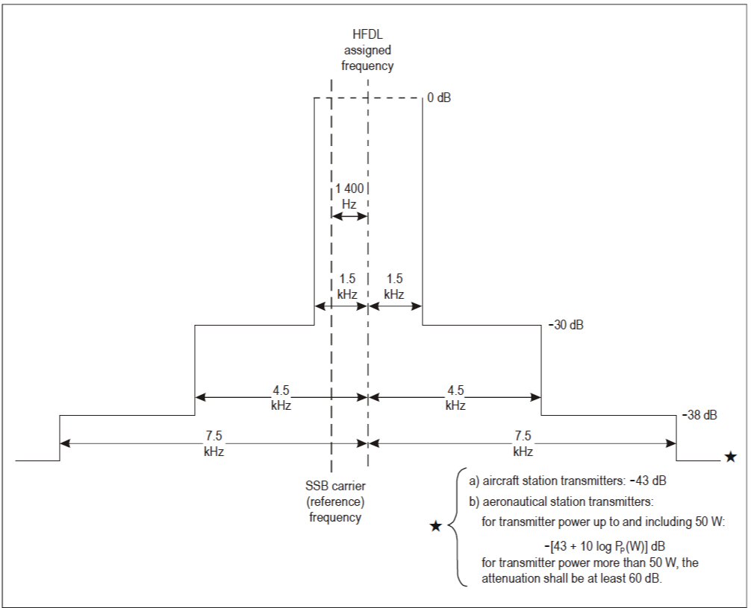

FIGURE 4

Spectrum mask for enhanced systems using non-contiguous multichannel equipment.

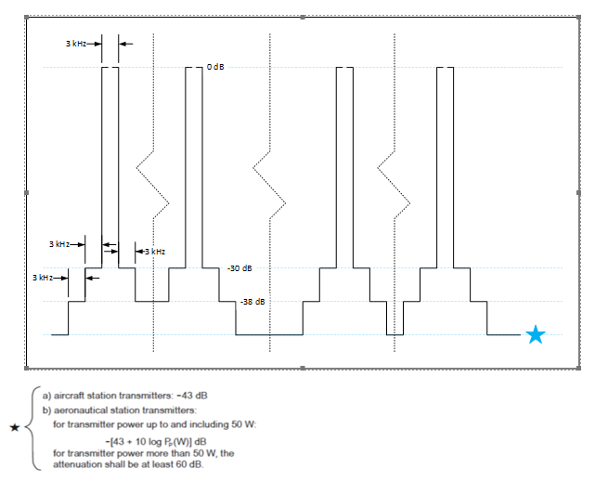

1. Some systems described in this Recommendation are operated from 2 MHz although the HF definition starts at 3 MHz.
2. Some systems described in this Recommendation are operated from 2 MHz although the HF definition starts at 3 MHz.
3. The signal-to-noise ratios in Table 1B are for a BPSK system with a 3 kHz channel bandwidth.
4. The signal-to-noise ratios in Table 1B are for a BPSK system with a 3 kHz channel bandwidth.
5. Channel bandwidths of 24 kHz within the 3-30 MHz frequency band have been recognized and defined in Recommendation ITU-R F.339-8 “Bandwidths, signal-to-noise ratios and fading allowances in HF fixed and land mobile radiocommunication systems” (2013), Table 4a.
6. Channel bandwidths of 3, 6, 9, 12, 15, 18, 21, 24, 27, 30, 33, 36, 39, 42, 45 or 48 kHz can also be applicable. As a function of the application.
7. The signal-to-noise ratios in Table 3B are given in a waveform’s necessary bandwidth and are typical of systems that operate under the indicated propagation modes.
8. In conjunction with Recommendation ITU-R BS.705, the ITU has developed computer programs to calculate radiation patterns and gain for various antenna types. The output data includes the directivity gain, the relative gain for a particular azimuth and elevation angle, tables of relative gain referred to the maximum and a number of different graphic outputs.