US Radiocommunications Sector
Fact Sheet

Working Party: WP 5B | Document No: USWP5B34-03-R1
Reference:  Document 5B/216 Annex 15 | Date: 05 February 2025
Document Title: Preliminary Draft Revision of Recommendation ITU-R M.1371-5, Technical characteristics for an automatic identification system using time division multiple access in the VHF maritime mobile frequency band
Author(s)/Contributors(s):  Pamela Murray  USCG  Jerry Ulcek  USCG  Johnny Schultz  Sev1Tech, Inc.  Ross Norsworthy  REC, Inc. | Phone : (202) 657-3081  Email: pamela.j.murray@uscg.mil  Phone : (202) 579-5924  Email: jerry.l.ulcek@uscg.mil  Phone : (727) 403-4029  Email: johnny.schultz@sev1tech.com  Phone : (727) 515-8025  Email: ross_norsworthy@msn.com
Purpose/Objective:
The purpose of this document is to provide additional information about the new AIS blocking requirements and update the blocking proposal for Recommendation ITU-R M.1371-5.
Abstract:
The USCG provided input to the November 2024 WP5B meeting, which, in part, proposed to revise the AIS receiver blocking requirement. WP5B requested additional information about this updated requirement. This contribution provides an update to the AIS blocking requirement and provides additional supporting information.

Radiocommunication Study Groups
Source: 5B/216 Annex 15  Reference: ITU-R M.1371-5  5B/151 | Document: USWP5B33-XX-R1
Source: 5B/216 Annex 15  Reference: ITU-R M.1371-5  5B/151 | 05 February 2025
Source: 5B/216 Annex 15  Reference: ITU-R M.1371-5  5B/151 | English only
United States of America

- Introduction
This document proposes updated technical content to Recommendation ITU-R M.1371-5 and supporting documentation. These changes are a result of the comments received from the last WP5B meeting.
- Summary of changes
Listed below are the proposed changes to Document 5B/216 Annex 15, which contribute to the revision of Recommendation ITU-R M.1371-5:
Revised section to Annex 2, section 2.2 to update the AIS receiver blocking details.
- Liaison to the International Maritime Organization

The Joint IMO/ITU Experts Group on Maritime Radiocommunication Matters meeting 7 – 11 October 2024 included in its report a draft liaison statement to ITU-R WP5B concerning the blockage of the reception of AIS signals by the operation of VHF radiotelephones nearby, inviting WP5B “to notify IMO on the outcome of its considerations to enable IMO to review potential consequential changes on the operational use, testing and installation of AIS equipment.” During its consideration, the Experts Group noted that “depending on the solution ITU would develop, IMO instruments containing equipment installation guidelines (e.g. COMSAR.1/Circ.32/Rev.2 and SN.1/Circ.227, as amended) might require consequential amendments.” The impact on IMO’s antenna installation guidelines in these two circulars will depend upon the decision made by WP5B regarding AIS blocking.
- Attachments
The following attachment contains the proposed changes to Annex 15 of the chairman’s report. In addition, an additional attachment is included to provide additional information to support the change proposal. All track changes from Annex 15 have been accepted; only the new proposed changes are shown in track changes. Note that only the relevant sections have been included in this proposal.
Finally, a third attachment includes a proposed liaison statement to IMO NCSR.

Radiocommunication Study Groups | 
Source: Document 5B/TEMP/60  Subject: Recommendation ITU-R M.1371-5 | Annex 15 to  Document 5B/216-E
 | 04 February 2025
 | English only
Annex 15 to Working Party 5B Chair’s Report
PRELIMINARY DRAFT REVISION OF RECOMMENDATION ITU-R M.1371-5
Technical characteristics for an automatic identification system using time division multiple access in the VHF maritime mobile frequency band

(No additional changes prior to this section)

A2-2.2 Transceiver characteristics
The transceiver should perform in accordance with the characteristics set forth herein.
TABLE A2-3
Minimum required time division multiple access transmitter characteristics
Transmitter parameters | Requirements
Carrier power error | ± 1.5 dB
Carrier frequency error | ± 500 Hz
Slotted modulation mask | ∆fc < ±10 kHz: 0 dBc  ±10 kHz < ∆fc < ±25 kHz: below the straight line between −25 dBc at ±10 kHz and –70 dBc at ±25 kHz  ±25 kHz < ∆fc < ±62.5 kHz: –70 dBc
Transmitter test sequence and modulation accuracy | < 3 400 Hz for Bit 0, 1 (normal and extreme)  2 400 Hz ± 480 Hz for Bit 2, 3 (normal and extreme)  2 400 Hz ± 240 Hz for Bit 4 … 31 (normal, 2 400 ± 480 Hz extreme)  For Bits 32 … 199  1 740 ± 175 Hz (normal, 1 740 ± 350 Hz extreme) for a bit pattern of 0101  2 400 Hz ± 240 Hz (normal, 2 400 ± 480 Hz extreme) for a bit pattern of 00001111
Transmitter output power versus time | Power within mask shown in Fig. A2-2 and timings given in Table A2-4
Spurious emissions | –36 dBm 9 kHz … 1 GHz  –30 dBm 1 GHz … 4 GHz
Intermodulation attenuation  (base station only) | ≥ 40 dB
TABLE A2-4
Definitions of timing for Figure A2-2
Reference |  |  | Bits | Time  (ms) | Definition
T₀ |  |  | 0 | 0 | Start of transmission slot. Power should NOT exceed –50 dB of P_{ss} before T₀
T_{A} |  |  | 0-6 | 0-0.625 | Power exceeds –50 dB of P_{ss}
T_{B} |  | T_{B1} | 6 | 0.625 | Power should be within +1.5 or –3 dB of P_{ss}
 |  | T_{B2} | 8 | 0.833 | Power should be within +1.5 or –1 dB of Pss (start of training sequence)
T_{E} (includes 1 stuffing bit) |  |  | 233 | 24.271 | Power should remain within +1.5 or –1 dB of P_{ss} during the period T_{B2} to T_{E}
T_{F} (includes 1 stuffing bit) |  |  | 241 | 25.104 | Power should be –50 dB of P_{ss} and stay below this
 | T_{G} |  | 256 | 26.667 | Start of next transmission time period
TABLE A2-5
Editor’s note: Table A2-5 is under discussion, needs further input
Minimum required time division multiple access receiver characteristics⁽¹⁾
Receiver parameters | Requirements
Sensitivity | 20% PER @ –107 dBm
Error behaviour at high input levels | 1% PER @ –77 dBm  1% PER @ –7 dBm
Adjacent channel selectivity | 20% PER @ 70 dB
Co-channel selectivity | 20% PER @ 10 dB
Spurious response rejection | 20% PER @ 70 dB
Intermodulation response rejection | 20% PER @ 74 dB
Spurious emissions | –57 dBm (9 kHz to 1 GHz)  –47 dBm (1 GHz to 4 GHz)
Blocking | 20% PER @ 86 dB  [Blocking signal AIS signal  ‒15 dBm ‒101 dBm  +26 dBm ‒60 dBm  These values assume antenna separations as recommended by IMO COMSAR.1/Circ.32]
⁽¹⁾ For Class B “SO”, Table 3 in Annex 6 applies.
COMSAR.1/Circ.32/Rev 2 §5.2.8 “AIS VHF antennas should be mounted directly above or below the ship's primary VHF radiotelephone antenna, with no horizontal separation and with minimum 2 metres vertical separation. If it is located on the same level as other antennas, the distance apart should be at least 5 metres.”

ATTACHMENT
Technical Analysis of the Effects of Transmissions of VHF Marine Radios on AIS (and VDES) Receivers on the Same Ship

- Introduction
The IMO has recognized the interference effects of VHF marine radios on AIS receivers co-located on the same ship. To mitigate this problem, the IMO published installation guidelines that recommended vertical and horizontal separations of the antennas. The IMO recommendation was based on a technical analysis that included legacy analog radio technology. Since then, manufacturers have implemented digital radio technology to accommodate changes in the technical equipment standards and to lower equipment costs. Consequentially, the new digital AIS (and VDES, since VDES subsumes AIS) receivers are more vulnerable to being blocked by VHF radio transmissions. To address this situation, IMO has requested ITU to propose appropriate revisions to the AIS technical standard to solve the AIS receiver blocking problem, consistent with the IMO antenna installation guidelines.

- Technical Analyses Performed by RTCM
A technical review conducted by RTCM in 2024 concluded that for all classes of shipboard AIS and of VHF radiotelephones installed in accordance with IMO and NMEA guidelines, the AIS-specified receiver blocking and desensitization requirement of -15 dBm (>5 MHz) would always be significantly exceeded. Consequently, the reception of AIS data could be blocked whenever the VHF radiotelephone was keyed. That blocking and desensitization value of -15 dBm (>5 MHz) has been specified in ITU-R M.1371 in relevant AIS IEC standards from the beginning.
Two categories of blocking protection are considered:
Category 1: Blocking of +10 dBm (>5 MHz), protecting AIS when VHF radiotelephone antennas are horizontally separated by 12 meters or more, or are vertically separated. Category 1 devices may be blocked when installed antennas are horizontally separated in accordance with COMSAR.1/Circ.32/Rev.2. Some existing Class A AIS equipment whose receivers use analog technology have been shown to meet this level of blocking.
Category 2: Blocking of +26 dBm (>5 MHz), protecting AIS when VHF radiotelephone antennas are horizontally separated by 2 meters or more, or are vertically separated. Category 2 devices should not be blocked when installed in accordance with COMSAR.1/Circ.32/Rev.2.

Technical References
The following documents contain provisions which, through direct reference in this review, constitute provisions of this review, and are indispensable for its application. For dated documents, the cited edition, version or revision, including any cited amendment(s), applies. For undated documents, the latest edition, version, or revision, including any amendments in effect when this review is published, applies.
Recommendation ITU-R M.1371-5, Technical characteristics for an automatic identification system using time division multiple access in the VHF maritime mobile frequency band
IEC 62287-1:2017 + AMD1:2022 Maritime navigation and radiocommunication equipment and systems - Class B shipborne equipment of the automatic identification system (AIS) - Part 1: Carrier-sense time division multiple access (CSTDMA) techniques.
IEC 62287-2:2017 Maritime navigation and radiocommunication equipment and systems - Class B shipborne equipment of the automatic identification system (AIS) - Part 2: Self-organising time division multiple access (SOTDMA) techniques.
COMSAR.1/Circ.32/Rev.2 Harmonization of GMDSS requirements for radio installations on board SOLAS ships

NOTE: Protection of AIS receivers from damage caused by transmissions from nearby antennas should also be considered.

Categories:
Category 1 devices should meet the blocking requirement of +10dBm (>5 MHz).
Category 2 devices should meet the blocking requirement of +26dBm (>5 MHz).

Methods of testing and required test results

Class A and B AIS receiver parameters (IEC 62287-1 7.2.4, IEC 62287-2 7.2.2)
Blocking and desensitization levels shall be as described in Table 1 (Category 1) or Table 2 (Category 2).

Table 1 – Category 1 wanted and unwanted signal levels
Unwanted (blocking) signal B  >5 MHz | Wanted (AIS) signal A
-15 dBm | -101 dBm
+10 dBm | -76 dBm

Table 2 – Category 2 wanted and unwanted signal levels
Unwanted (blocking) signal B  >5 MHz | Wanted (AIS) signal A
-15 dBm | -101 dBm
+26 dBm | -60 dBm

- AIS receiver blocking analyses
  - Category 1 - +10 dBm blocking – horizontal antenna separation

Figure 1
VHF – AIS horizontal 12.4m antenna separation with +10 dBm blocking

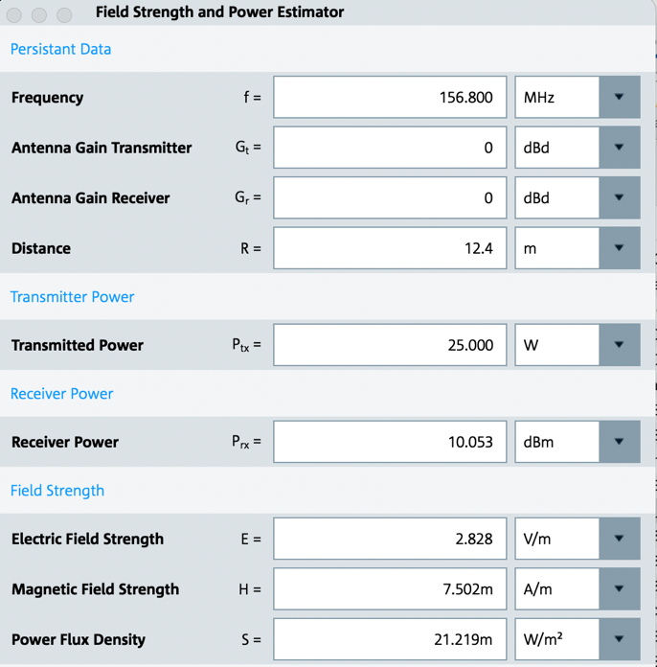

Figure 1 shows that VHF radiotelephone and AIS antennas should be horizontally separated by 12.4 meters or more to avoid AIS blocking.

  - Category 2 - +26 dBm blocking - horizontal antenna separation

Figure 2
VHF – AIS horizontal 2m antenna separation with +26 dBm blocking
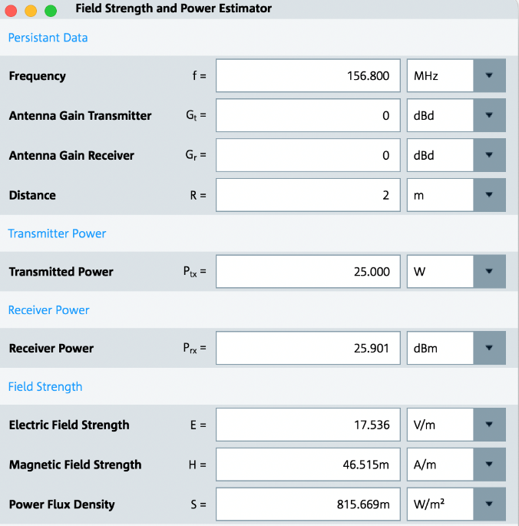

Figure 2 shows that VHF radiotelephone and AIS antennas should be horizontally separated by 2 meters or more to avoid AIS blocking.
NOTE: 0 dBd equals +2.1 dBi and is the typical gain for shipboard AIS antennas.

Vertical antenna separation
Figure 3
Characteristics for vertical whip antennas based on ITU-R F.1336
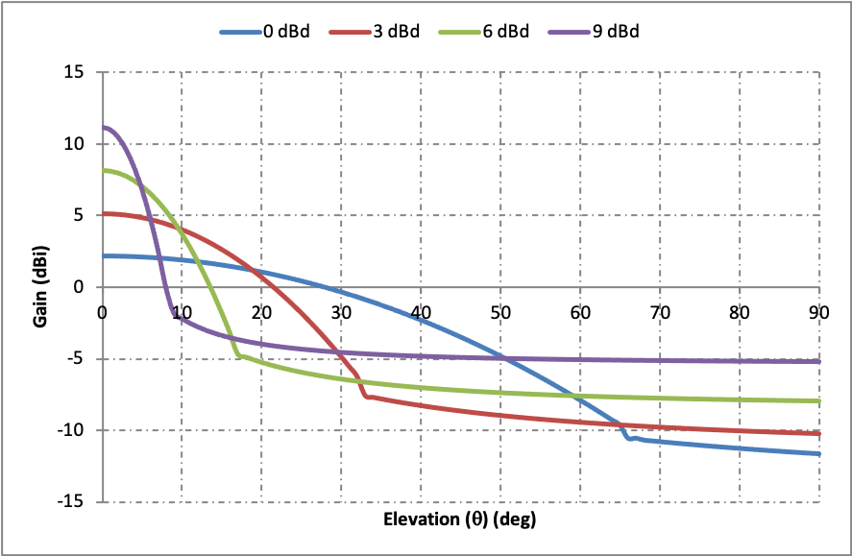

0 dBd VHF and AIS antennas vertically (90 deg elevation) separated by 2 metres in accordance with COMSAR.1/Circ.32/Rev.2 clause 5.2.8 provide 12 dBi + 12 dBi = 24 dB isolation. As shown in Figure 3, that vertical separation results in a blocking signal of -2.4 dBm, which should be sufficient to protect AIS equipment meeting either Category 1 or Category 2 from being blocked when the VHF radiotelephone is transmitting.
Figure 4
VHF – AIS 2m vertical antenna separation

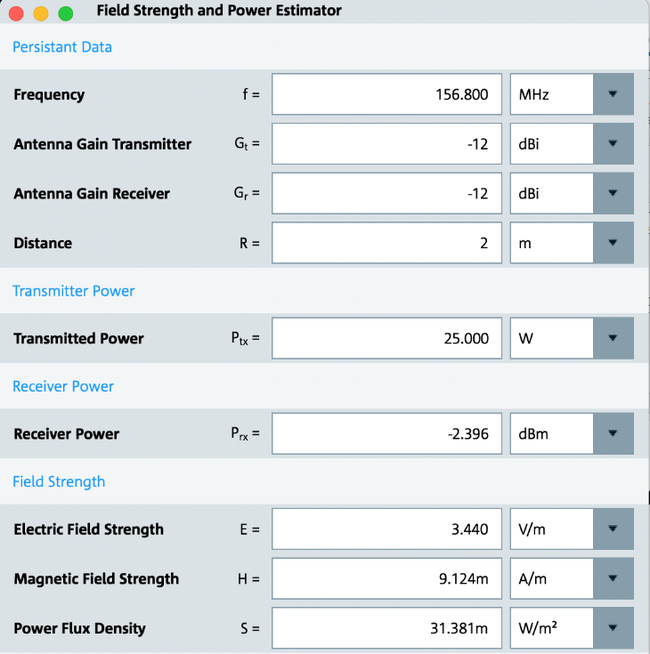
NOTE: -12 dBi terms are aligned with the units of the vertical axis of Figure 3

- Effect of desensitization on Class B AIS detection range
NOTE: Class A is expected to receive transmissions from Class B.

  - Calculating field strength necessary to receive Class B AIS based upon Recommendation ITU-R P.1546-6

Frequency = 162 MHz
Receiver sensitivity = -107 dBm
Antenna gain = 0 dBd (+2.1 dBi)
Tx antenna height = 10 m
Rx antenna height = 10 m (height assumed by ITU-R P.1546-6)
AIS power = 2 w

Category 1 maximum specified desensitization = -107 dBm – (-60 dBm) = 47 dB
Category 2 maximum specified desensitization = -107 dBm – (-76 dBm) = 31 dB

E_{dBµV/m} = AF_{dB/m} + V_{dBµV}
AF_{50Ω} = 20 log₁₀ f_{MHz} − 10 log₁₀ G − 29.7707, where
G = 1.64 for the 0 dBd AIS antenna
AF_{50Ω} = 44.19 − 0 − 29.7707 = 14.42 dB/m
V_{dBµV} = P _{dBm} + 107 = 0 dBµV
E_{dBµV/m} = AF_{dB/m} + V_{dBµV} = 14.42 + 0 = 14.42 dBµV/m
E_{dBµV/m} reference to 1KW = 10 log ($\frac{1000}{2}$) + 14.42 = 41.4 dBµV/m
E_{dBµV/m} reference to 1KW with 47 dB attenuation = 41.4 + 47 = 88.4 dB µV/m (Category 1)
E_{dBµV/m} reference to 1KW with 31 dB attenuation = 41.4 + 31 = 72.4 dB µV/m (Category 2)

  - Calculated effect of desensitization on Class B AIS detection range
Using the ITU-R P.1546-6 chart on Figure A.5:
Normal Class B AIS detection range is = 28 km = 15.1 nm
Category 1 desensitized Class B AIS detection = 6 km = 3.2 nm
Category 2 desensitized Class B AIS detection = 2 km = 1.1 nm

Figure 5
100 MHz, sea path, 50 % time (from ITU-R P.1546-6 Fig. 4)
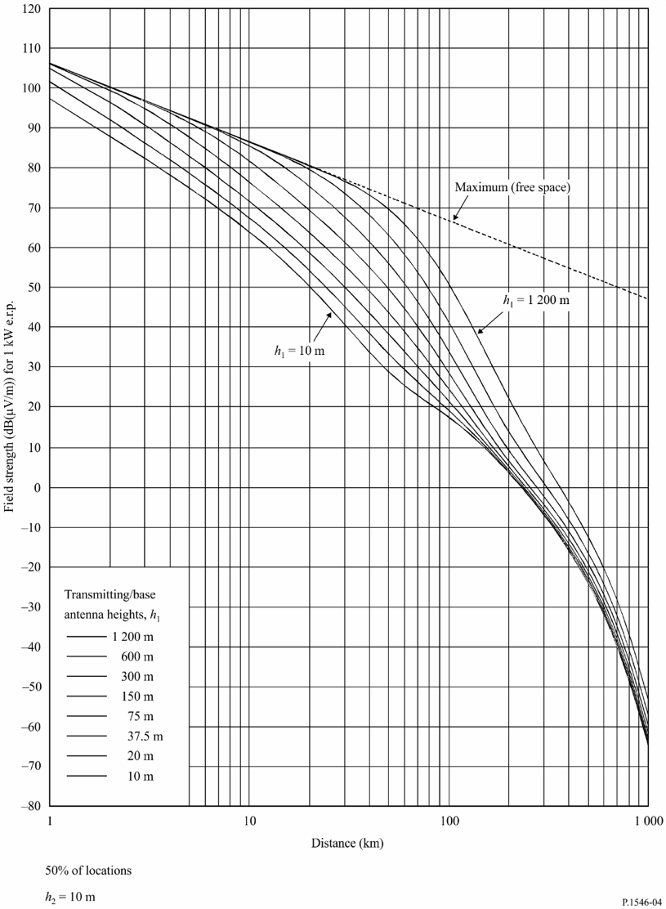
Category 1
Category 2

28 km normal range

  - Protection of receiver from damage due to transmissions from shipborne VHF radiotelephone equipment
AIS antennas can be expected to be installed within a meter of one or more VHF radiotelephone antennas. Propagation loses at these distances are within the antennas near field and are difficult to predict. Nevertheless, RTCM SC137-sponsored testing of electromagnetic interference from LED lighting to AIS and VHF radiotelephone equipment installed with four- and eight-foot antennas showed that power received by a four-foot antenna could increase by as much as 2 dB when antenna separation was reduced from one meter to one or two feet. There was no increase shown when the eight-foot antenna was used.

Figure A.6 shows that power received from a VHF radiotelephone antenna separated by 1 meter can be +32 dBm, assuming free space calculations remain valid at that distance. For four-foot VHF antennas separated by less than a meter, received power can be 2 dB higher, as high as +34 dBm or 2.5 Watts. Receivers may need protection from damage from power received at such levels.
Figure 6
+32 dBm received power – 1m horizontal antenna separation

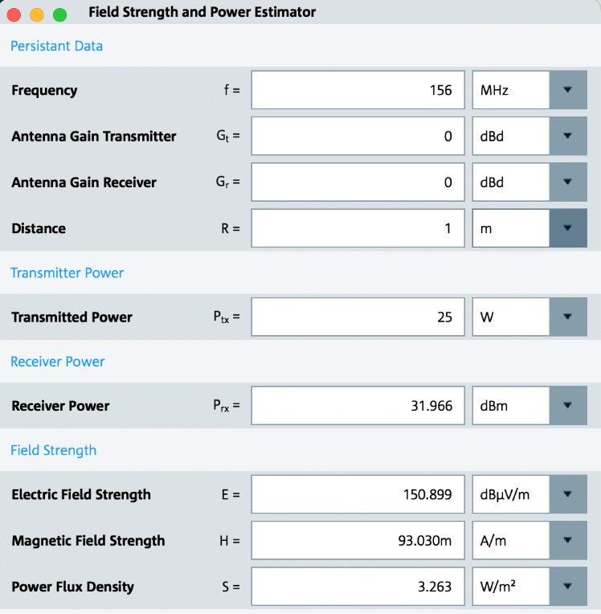

NOTE: These analyses shown above are based upon far field conditions. The near field conditions within five wavelengths (10m) have not been considered.
NOTE: Figures 1, 2, 4, and 6 are from Rohde & Schwarz Field Strength and Power Estimator application, whose calculations are based upon free space propagation. See http://www.rohde-schwarz.com/appnote/1MA85.

- Consequential effects on VDES satellite reception

Manufacturers have raised concerns about implementing Table 2 Category 2 above for AIS blocking. This would need a “local-distance switch” that could increase the AIS receiver noise figure by as much as 1.5 dB and thus degrade VDES satellite reception. However, Report ITU-R M.2435-0 Section 4.4.2 documents a typical ship’s noise floor to be approximately -116 dBm in a 25 kHz bandwidth, which equates to a ship’s noise figure of 14 dB. Section 4.2.4 provides a satellite downlink budget that takes this into account. Based on this analysis, an increase of 1.5 dB to the AIS/VDES receiver noise figure will result in negligible degradation of the VDES satellite downlink budget.

- Conclusion

Based on the technical analyses above and considering IMO installation guidelines, it is recommended that Recommendation ITU-R M.1371 be revised according to Table 2 to prevent AIS blocking on SOLAS vessels.

Proposed Liaison to IMO NCSR

DRAFT LIAISON STATEMENT TO THE INTERNATIONAL MARITIME ORGANIZATION, SUB-COMMITTEE FOR NAVIGATION, COMMUNICATIONS AND SEARCH AND RESCUE

WORKING DOCUMENT TOARDS A PRELIMINARY DRAFT REVISION OF RECOMMENDATION ITU-R M.1371-5

AIS Blocking

The Joint IMO/ITU Experts Group on Maritime Radiocommunication Matters meeting 7 – 11 October 2024 included in its report a draft liaison statement to ITU-R WP5B concerning the blockage of the reception of AIS signals by the operation of VHF radiotelephones nearby, inviting WP5B “to notify IMO on the outcome of its considerations to enable IMO to review potential consequential changes on the operational use, testing and installation of AIS equipment.”
ITU-R Working Party 5B, at its meeting of 29th April to 8th May 2025 continued working toward the revision of Recommendation ITU-R M.1371-5, has tentatively agreed
[to amend its Table A2-5 Minimum required time division multiple access receiver characteristics to require a blocking level of +26 dBm. With this amendment, no change would be needed to the operational use, testing and installation of AIS equipment, including antenna installation guidelines in COMSAR.1/Circ.32 and SN/Circ.227.]
[to amend its Table A2-5 Minimum required time division multiple access receiver characteristics to require a blocking level of +10 dBm. With this amendment, a change would be needed to the antenna installation guidelines in COMSAR.1/Circ.32 and SN/Circ.227 to eliminate horizontal separation distance option between VHF radiotelephone and AIS antenna in COMSAR.1/Circ.32 and SN/Circ.227, as horizontal separation would not be feasible. Existing antenna vertical separation requirements remain effective. Finally, AIS blocking from VHF radiotelephone transmissions of nearby vessels should no longer be a concern.]
[not to amend its Table A2-5 Minimum required time division multiple access receiver characteristics existing blocking level of -15 dBm at this time, as reports confirming this issue of AIS signal blockage as causing an immediate danger to the safety of navigation have not yet been forthcoming. VHF radiotelephone and AIS antenna installation guidelines currently in COMSAR.1/Circ.32 and SN/Circ.227 will not prevent blocking and will need to be considered for deletion or revision.]

Status: For action
Contact: Mr Johnny Schultz | E-mail: johnny.schultz@sev1tech.com

See Document 5B/151 Section 6 and Annex 4. Recognizing the IMO Subcommittee on Navigation, Communications and Search & Rescue will not have met until 13 to 22 May 2024, a formal report from them is unavailable.
COMSAR.1/Circ.32/Rev.2 Harmonization of GMDSS requirements for radio installations on board SOLAS ships

