U.S. Radiocommunications Sector
Fact Sheet
Working Party: ITU-R WP 5B | Document No: USWP5B25-22R2
Ref: 5B/93-E Annex 7 | Date: October 7, 2020
Document Title: Proposed updates to Working document towards a preliminary draft new Report, ITU-R M.[RADAR SIMULATIONS], “Simulations of performance for specific primary surveillance radars”
Author(s)/Contributors(s):  Chris Tourigny  FAA Spectrum Engineering Services  Dave Franc  Department of Commerce  Robert Leck  ACES Inc.  Michael Tran  MITRE |  | Phone: 202-267-3071  Email: chris.tourigny@faa.gov  Phone : 301-628-5647  Email: david.franc@noaa.gov  Phone : 321-246-2987  Email: robert.leck@aces-inc.com  Phone: 703-983-1295  Email: mtran@mitre.org
Purpose/Objective: This contribution provides updates to annex 1 of document 5B/93 annex 7 to include simulation results of the impact on radar due to pulsed interference.
Abstract: This contribution provides updates to annex 1 of document 5B/93 annex 7 to advance the modelling of example radar receivers to simulate the impact of pulsed interference on radar performance.

Radiocommunication Study Groups | 
Source: Document 5B/93 Annex 7  Subject: | Document 5B/
Source: Document 5B/93 Annex 7  Subject: | 9 September 2020
Source: Document 5B/93 Annex 7  Subject: | English only
United States of America
Proposed updates to WD-PDN report
itu-r M.[radar simulations]

Simulations of performance for specific primary surveillance radars

Introduction
This contribution provides updates to annex 1 of document 5B/93 annex 7 to advance the modelling of example radar receivers to simulate the impact of pulsed interference on radar performance.

Attachment: 1
ATTACHMENT
proposed updates to wd-pdn report
itu-r M.[radar simulations]
Simulations of performance for specific primary surveillance radars

Scope

Keywords
Radar, pulse compression filter, probability of detection, wideband communication signals.
Glossary / Abbreviations
A/D: Analog-to-digital converters
ATC: Air traffic control
BPF: Bandpass filter
CA-CFAR: Cell averaging CFAR
CFAR: Constant false alarm rate
CPI: Coherent processing interval
CUT: Cell under test
DFT: Discrete Fourier transform
DSP: Digital signal processing
FFT: Fast Fourier transform
IF: Intermediate frequency
I/N: Interference to noise ratio
LFM: Linear frequency modulation
LNA: Low-noise amplifier
NLFM: Non-linear frequency modulation
OFDM: Orthogonal frequency-division multiplexing
OOB: Out-of-band
PRF: Pulse repetition frequency
PRI: Pulse repetition interval
PSR: Primary surveillance radar
QPSK: Quadrature phase shift keying
RF: Radio frequency
RCS: Radar cross-section
SNR: Signal to noise ratio
WCSS: Wideband communication system signal
Related ITU Recommendations and Reports
Recommendations
ITU-R M.1463: Characteristics of and protection criteria for radars operating in the radiodetermination service in the frequency band 1 215-1 400 MHz
ITU-R M.1464: Characteristics of radiolocation radars, and characteristics and protection criteria for sharing studies for aeronautical radionavigation and meteorological radars in the radiodetermination service operating in the frequency band 2 700-2 900 MHz
ITU-R M.1465: Characteristics of and protection criteria for radars operating in the radiodetermination service in the frequency range 3 100-3 700 MHz
Introduction
Primary surveillance radars (PSR) are used in an extensive range of applications, including air traffic control, weather monitoring and emergency search and rescue operations. Many PSRs are fixed and ground based, while those that are used for search and rescue activities are typically mounted on mobile platforms such as ships and aircraft.
Although the principles of operation of all PSRs are the same, there is a high level of diversity in radio frequency (RF) pulse generation (transmit chain) and detection algorithms (receive chain). Therefore, detailed analysis of both the transmit and receive chains, including differences in signal processing algorithms is required to obtain a measure of system performance.
Modern PSRs are typically designed using software models of electronic components. Since there is a high level of diversity between PSR transmit and receive chains, radar performance under different interference scenarios can be effectively modelled in a software environment.
The software modeling approaches that are demonstrated in this report provide a way to estimate system performance with respect to a range of example interference sources and radar types. This flexibility offers the ability to change various parameters at various stages and obtain information on resultant radar performance.
This report demonstrates and provides examples for the:
a) simulation of radar transmit pulses;
b) simulation of receiver chain signal processing steps;
c) simulation of various interference sources; and
d) prediction of PSR performance when affected by a selected set of interference sources.
Given the diversity of radar types, the impact on a PSR from a given interference source is application dependent. For example, the performance criteria of interest for weather radars can be different to that of air traffic control radar. The weather radars are not modelled in this report.
Example results from software simulation are presented in one or more of the following formats:
a) probability of detection as a function of signal-to-noise ratio at various interference signal levels-expressed with respect to receiver noise floor.
b) probability of detection as a function of signal-to-interference ratio for a given radar receiver.
c) maximum range of detection as a function of interference level, expressed with respect to receiver noise floor, for a given constant radar cross section; and
d) minimum detectable (at a given probability of detection) radar cross-section at a fixed distance as a function of the level of interference.
Furthermore, simulation of transmit chain can be particularly useful for studying performance of other systems that could be impacted by radars.
This report provides examples of simulated results of select radars that are in operation in some administrations in the presence of various interference sources based on various software implementations and a range of relevant parameters (e.g. probability of detection, frequency range, radar type, etc.). This report is not intended to initiate changes to the established radar protection criteria in ITU-R Recommendations.
This Report contains two Annexes that provide example simulations performed for a given set of assumptions. The assumptions that were used and the results that were obtained are unique to the types of radars and the specific simulation tools chosen. Thus, it should not be generalized to give the impression that these simulations and their associated conditions would be applicable to all situations.
Annex 1 presents simulations of the radar performance for several air traffic control PSRs in the presence of various example interference sources (pulsed and continuous). PSRs are used worldwide to separate and control air traffic in the airport terminal areas, in en-route airspace between airports, and on the surface of airport runways. Many of the PSRs also provide weather data that can be used to assist pilots with navigating around storms; however, the weather applications are not modelled in this Annex.
Annex 2 presents a comprehensive technical investigation on the radar simulated performance degradation in the presence of high duty cycle digitally modulated signals, particularly to enhance the understanding of effects of potential interference into radars from the signal waveforms of modern wideband communication systems.
Annex 1
Example simulations of performance for particular primary surveillance radar

A1.1 Introduction
The basic principle of a PSR is to transmit high-energy electromagnetic signals of modulated or unmodulated waveforms through a directive high-gain antenna and to receive the reflections of those signals for processing to extract target information such as object range, azimuth, and velocity. A simple block diagram of a PSR is shown in Figure A1-1.
Figure A1-1
A simplified block diagram of a modern primary surveillance radar
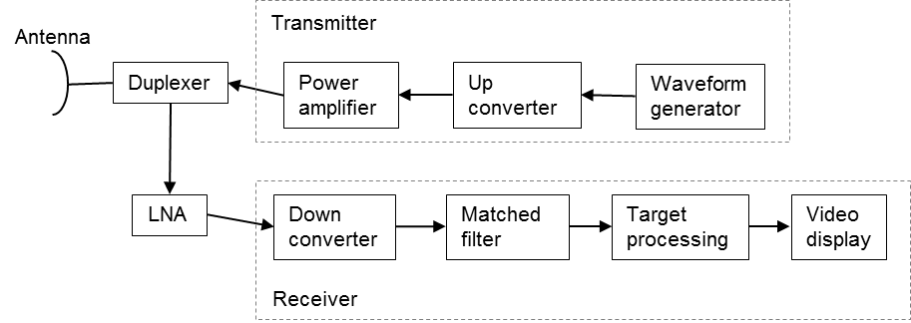
En-route air traffic control (ATC) PSRs currently use the frequency band 1 215-1 350 MHz (up to 1 370 MHz in some Countries) and the airport-area ATC PSRs use the frequency band 2 700-2 900 MHz. The system characteristics and protection criteria for the en-route ATC PSRs are found in Recommendation ITU-R M.1463 and the airport-area ATC PSRs are found in Recommendation ITU-R M.1464. PSRs may be located at other locations than at airports according to the operational requirement.

A1.2 Transmitters
ATC PSRs peak output power ranges from 25 kW solid-state transmitters to high power 5 MW klystron transmitters. They use a variety of modulations including continuous wave pulses, linear frequency modulated (chirped) pulses, and non-linear frequency modulated (chirped) pulses. PSRs utilize either a single frequency or multiple frequencies with and without sub-carrier frequencies for frequency diversity for target detection enhancement in poor weather.
A subset of the system characteristics for three sample ATC en-route PSRs operating in the frequency band 1 215-1 390 MHz, found in Recommendation ITU-R M.1463, are provided in Table A1-1:
Table A1-1
Sample of Characteristics of air traffic control, en-route primary surveillance radars
operation in the frequency band 1 215-1 390 MHz
Parameter | Units | System 2 | System 8
Peak power into antenna | dBm | 80 | 78.8
Frequency Range | MHz | 1215-1390 | 1240-1350
Pulse duration | µs | 88.8; 58.8 (Note 1) | 115.5; 17.5 (Note 2)
Pulse repetition rate | pps | 291.5 or 312.5 average | 319 average
Chirp bandwidth | MHz | 0.77 | 1.2
Compression ratio |  | 68.3:1 and 45.2:1 | 150:1; 23:1
RF emission bandwidth (3 dB) | MHz | 1.09 | 1.2
Antenna azimuthal beamwidth | degrees | 1.4 | 1.2
Antenna horizontal scan characteristics | rpm | 360º at 5 rpm | 360º at 5 rpm
Receiver IF bandwidth | kHz | 690 | 1 200
Receiver noise figure | dB | 2 | 3.2
Platform type |  | Fixed | Fixed
NOTE 1 – The radar has 44 RF channel pairs with one of 44 RF channel pairs selected in normal mode. The transmitted waveform consists of an 88.8 µs pulse at frequency f1 followed by a 58.8 µs pulse at frequency f2. Separation of f1 and f2 is 82.854 MHz.
NOTE 2 – This radar utilizes two fundamental carriers, F1 and F2, with two sub-pulses each, one for medium range detection and one for long range detection. The carriers are tunable in 0.1 MHz increments with a minimum separation of 26 MHz between F1 (below 1 300 MHz) and F2 (above 1 300 MHz). The carrier sub-pulses are separated by a fixed value of 5.18 MHz. The pulse sequence is as follows: 115.5 μs pulse at F1 + 2.59 MHz, then a 115.5 μs pulse at F2 + 2.59 MHz, then a 17.5 μs pulse at F2 – 2.59 MHz, then a 17.5 μs pulse at F1 – 2.59 MHz. All four pulses are transmitted within a single pulse repetition interval.

A subset of the system characteristics for three sample ATC airport PSRs operating in the frequency band 2 700-2 900 MHz, found in Recommendation ITU-R M.1464, are provided in Table A1-2:
Table A1-2
Sample Characteristics of air traffic control airport primary surveillance radar
operating in the frequency band 2 700 - 2 900 MHz
Parameter | Units | Radar A | Radar B | Radar C
Platform type (airborne, shipborne, ground) |  | Ground, ATC | Ground, ATC | Ground, ATC
Peak power | kW | 1 400 | 1 320 | 25
Pulse duration | µs | 0.6 | 1.03 | 1.0, 89.0; (note 1)
Pulse repetition rate | pps | 973-1 040 (selectable) | 1 059-1 172 | 722-935 (short impulse)  788-1 050 (long impulse)
Duty cycle | % | 0.07 max | 0.14 max | 9.34 max
Chirp bandwidth | MHz | N/A | N/A | 2
Compression ratio |  | N/A | N/A | 89
RF emission bandwidth (-20 dB)  (-3 dB) | MHz | 6 | 5  0.6 | 2.6 (short impulse)  5.6 (long impulse)  1.9
Antenna azimuthal beamwidth | degrees | 1.35 | 1.3 | 1.45
Antenna horizontal scan characteristics | degrees/s | 75 | 75 | 75
Receiver IF bandwidth | MHz | 13 | 0.7 | 1.1
Receiver noise figure | dB | 4 | 4 | 3.3
⁽¹⁾ This radar utilizes two fundamental carriers with a minimum separation of 30 MHz

Modelling primary surveillance radar transmitter signals
The transmitted electromagnetic signal can be expressed as:
s(t) = A(t) sin (2πf_{o}t + θ(t)) (1)
where:
f₀= radar transmit carrier frequency (Hz);
A(t)= signal amplitude (Volts);
θ(t)= signal phase (rad).
The phase of the transmitting signal, θ(t), can be modeled for unmodulated narrow pulse or linear frequency modulated (LFM) long pulse, or non-linear frequency modulated (NLFM) long pulse.
It is important that the software model of the ATC PSRs match closely to the actual systems. A comparison of modeled signal spectrum with the measured spectrum is necessary to validate the model.

A1.2.1 Modeling radar system 2
For example, the transmitted spectrum model of System 2 (Recommendation ITU-R M.1463) can be compared to the measured spectrum of this radar. The measured spectrum is shown in Figure A1-2.
Figure A1-2
Measured spectrum of air traffic control en-route surveillance radars – system 2
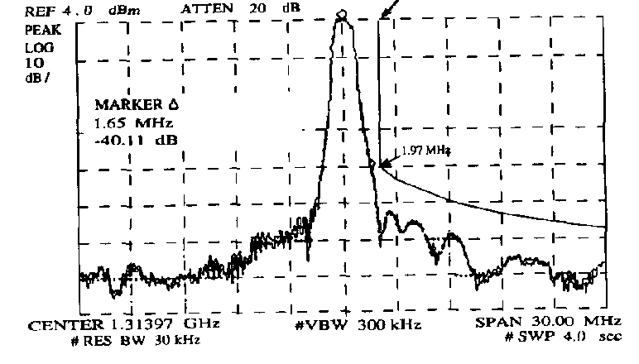
This transmitted waveform consists of an 88.8 µs pulse at frequency f1 followed by a 58.8 µs pulse at frequency f2. Separation of f1 and f2 is 82.854 MHz. Each pulse is modulated with a NLFM chirp bandwidth of 0.77 MHz. Figure A1-3 shows the modelled chirp swept frequency of System 2 using NLFM as compared LFM.
Figure A1-3
Chirp sweep frequency of air traffic control, en-route primary surveillance radar – system 2
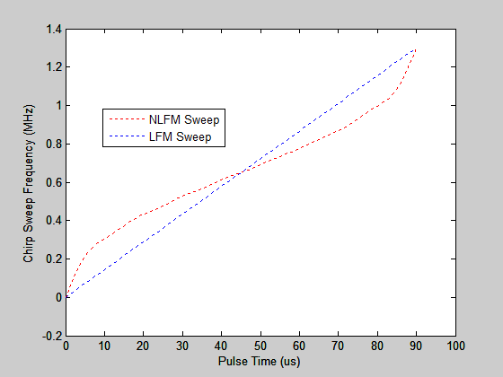
The rising edge of the pulse is modeled with a rise time of 1.2 µs (from 10% to 90% of the signal amplitude) using the cosine-square shape, as shown in Figure A1-4.
Given a pulse rise time of 1.2 µs, at around 3.4 MHz (for an 88.8 µs pulse) and around 3.5 MHz (for a 58.8 µs pulse), the modelled ATC system emission bandwidths are at a level of -40 dB.
Figure A1-4
Modelled air traffic control system 2 – pulse and emission bandwidth
The radar oscillator phase noise (ϕ(n)) is modeled as a white phase noise, a phase random walk, and a frequency random walk, as shown in Figure A1-5.
Figure A1-5
Air traffic control system 2 – modelled oscillator phase noise
Each input process (ω_{a}(n), ω_{f}(n) and ω_{ϕ}(n)) is a Gaussian white noise sequence with the following variances:
Putting all these elements together, Figure A1-6 shows the modeled System 2 normalized power spectrum (pulse spectrum at F1 and at F2, separating by 82.854 MHz, and a zoomed in view of frequency F1, which matches the spectrum in Figure A1-2.
Figure A1-6
System 2 normalized power spectrum
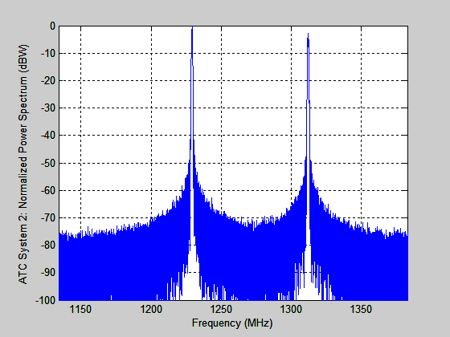 | 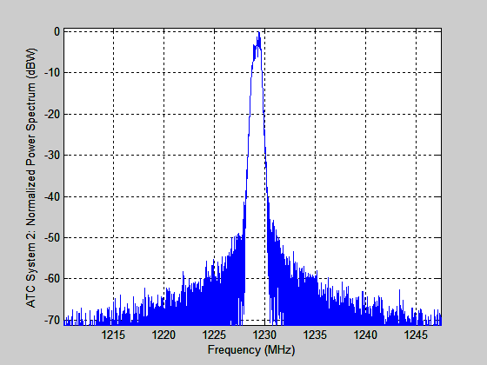

A1.2.2 Modeling radar C
This radar utilizes two fundamental carriers, F1 and F2, with a minimum separation of 30 MHz between F1 and F2. Two frequencies are provided to compensate the atmospheric fading, distortion, and other effects on any one frequency. Effects that degrade one frequency are not expected to affect the other frequency farther away. Radar C transmits on four different frequencies, F1 ± 0.5 MHz and F2 ± 0.5 MHz, as shown on Figure A1-7.
Figure A1-7
Radar C transmitting sequence
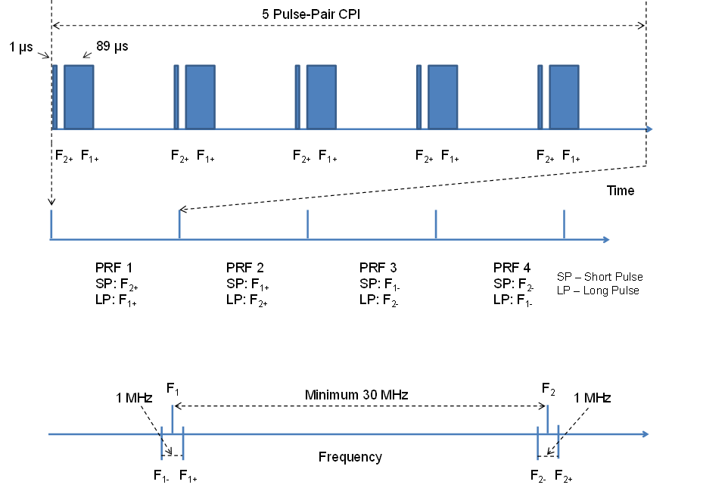
Figure A1-8 shows the modeled Radar C normalized power spectrum – pulse spectrum at F₁₊ (long pulse 89 µs with 1 MHz chirp) and at F₂₊ (short pulse 1 µs), separated by a minimum of 30 MHz.
Figure A1-8
Radar C normalized power spectrum

A1.2.3 Modeling radar system 8
Figure A1-9 shows the complex baseband chirp signal with 2 long pulses (modulated with F1 + 2.59 MHz and with F2 + 2.59 MHz, respectively) and 2 medium pulses (modulated with F2 – 2.59 MHz and with F1 – 2.59 MHz, respectively) with a gap of 4 µs between each pulse.
Figure A1-9
Radar system 8 normalized baseband chirp pulses

A1.3 General descriptions of radar receivers
In modern solid-state PSRs, reflected radar signals are received and processed through a chain of electronic components such as RF filters, low-noise amplifiers (LNA), beamformers, RF down-converters, analog-to-digital converters (A/D), matched filters, pulse compressors, Doppler filters, envelope detectors, coherent/non-coherent integrators, constant false alarm rate processors, and target detectors. Depending on the specific design and purpose of a PSR system, some signal processing methods are not used. Figure A1-10 shows a simplified block diagram of a modern PSR receiver.
Figure A1-10
Simplified block diagram of a modern primary surveillance radar receiver
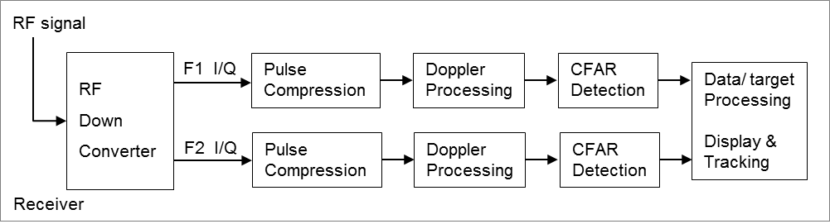
RF down converter
The RF signal received from the radar antenna goes to a RF filter and to a wideband LNA amplifier that operates over a large dynamic range (> 90 dB) and can accept signals up to –20 dBm without saturation. The noise figure of the LNA is typically less than 3 dB. This effectively establishes the system noise figure for a radar. This received RF signal is routed into the F1 bandpass-filter (BPF) and the F2 BPF before down-converting to intermediate frequencies (IF #1 and IF #2), respectively. The signals are passed through several stages of the IF processing chain (amplifier and filter) such that they fall within the dynamic range of the A/D converters. The I/Q splitter separates the digital signals into in-phase data (I) and quadrature-phase (Q), F1 I/Q signals and F2 I/Q signals, as shown in Figure A1-10.
Pulse compression
Radar range resolution depends on the bandwidth of the received signal, which is inversely proportional to the pulse duration. So, short pulses (SPs) are better for range resolution. The received signal strength is proportional to the pulse duration. Since the amplitude of the transmit pulse is limited by the maximum power of the radar, long pulses (LPs) provide higher energy and are better for signal reception. Pulse compression is employed to transmit a long pulse that has a bandwidth of a short pulse, by frequency modulating (linear FM or non-linear FM) or phase modulating (phase coded) the transmitted long pulse. The bandwidth of the linear/non-linear FM waveform is known as the chirp bandwidth. The matched filter is designed to maximize the signal-to-interference ratio in the presence of receiver noise. The pulse compression matched filter matches the received waveform with the reference waveform, through a correlation process or fast Fourier transform (FFT)-process, which provides the delays corresponding to the target ranges. Hence, each pulse is compressed down to 1 µs (the radar range resolution).
Figure A1-11 provides the details of the generation of the discrete complex signal to be input to the pulse compression block.
Figure A1-11
Simplified block diagram of a last IF stage receiver
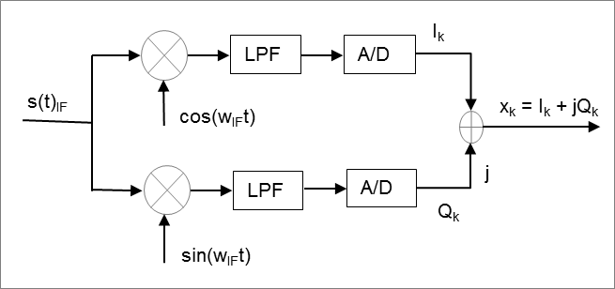
From Figure A1-11, the in-phase (I) and quadrature-phase (Q) are modelled as:
$I_{k}=\frac{\sin\left(π\tilde{f_{k}}T\right)}{π\tilde{f_{k}}T}\sqrt{\frac{2S}{N_{0}}T}R\left(\tilde{τ}\right)\cos\left(\tilde{ϕ}\right)+n_{Ik}$
$Q_{k}=\frac{\sin\left(π\tilde{f_{k}}T\right)}{π\tilde{f_{k}}T}\sqrt{\frac{2S}{N_{0}}T}R\left(\tilde{τ}\right)\sin\left(\tilde{ϕ}\right)+n_{Qk}$
where T is the pulse width (seconds), N₀ is the one-sided noise power density (Watts/Hz), $\tilde{τ}$ is the error between the true received pulse phase and the receiver’s estimate pulse phase, $\tilde{f}$ is the frequency error (Hz), $\tilde{ϕ}$ is the carrier phase error, $R(\tilde{τ})$ is the ideal auto-correlation function of the waveform and the last term of each output is the noise of unit variance.
Let x_{k} = I_{k} + jQ_{k}, the received complex samples, be the inputs to the pulse compression block and y_{k} be the replica waveform samples, then the correlation of x_{k} and y_{k} is given below:
$z\left(n\right)=\sum_{m=0}^{M-1}{x\left(m\right)y(m-n)}$
for n = 0, 1, 2, …, M-1
Figure A1-12 shows a simplified block diagram for radar pulse compression using a fast convolution technique, where the complex waveform samples, x_{k} = I_{k} + jQ_{k}, are used as the inputs.
Figure A1-12
Simplified block diagram of radar pulse compression using fast Fourier transform technique
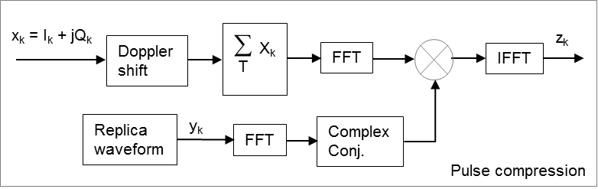
Fast convolution is used to implement the correlator. Taking the discrete Fourier transform (DFT), which can be efficiently computed using FFT algorithms, on both sides of the above equation, we have:
$Z\left(k\right)=\sum_{n=0}^{M-1}{\left\{\sum_{m=0}^{M-1}{x\left(m\right)y(m-n)}\right\}}e^{-j\left(\frac{2π}{M}\right)kn}$
$Z\left(k\right)=\sum_{m=0}^{M-1}{x(m)}\left\{\sum_{n=0}^{M-1}{y(m-n)e^{-j\left(\frac{2π}{M}\right)kn}}\right\}$
for k = 0, 1, 2, …, M-1.
Rearranging the above equation, we have:
$Z\left(k\right)=\sum_{m=0}^{M-1}{x(m)}\left\{\sum_{n=0}^{M-1}{y(-\left(n-m\right))e^{-j\left(\frac{2π}{M}\right)kn}}\right\}$
$Z\left(k\right)=\left\{\sum_{m=0}^{M-1}{x\left(m\right)e^{-j\left(\frac{2π}{M}\right)km}}\right\}Y^{*}\left(k\right)=X(k)Y^{*}(k)$
where:
$DFT\left\{v\left(n\right)=x(n-m)\right\}=V\left(k\right)=e^{-j\left(\frac{2π}{N}\right)km}X(k)$
$DFT\left\{u\left(n\right)=x^{*}(-n)\right\}=U\left(k\right)=X^{*}(k)$
Now, the time-domain correlation sequence can be computed by taking the inverse DFT of Z(k):
$z\left(n\right)={IDFT\{Z\left(k\right)\}=IDFT\{X(k)Y}^{*}(k)\}$
for n = 0, 1, 2, …, M-1.

A1.4 Example simulated performance in various noise environments

A1.4.1 Radar system 8 analysis and simulation
Figure A1-13 shows the radar medium pulse (cosine-square shape for the rising edge and falling edge) and the normalized power spectrum (shape pulse and rectangular pulse). The spectrum of the shape pulse has better emission levels outside the main lobe than the spectrum of the rectangular (rec) pulse.
Figure A1-13
Radar medium pulse and its normalized power spectrum
Figure A1-14 shows the 7 dB radar pulse compression gain for LFM medium pulses (shape pulse and rec pulse) and the 10 dB radar pulse compression gain for NLFM medium pulses (shape pulse and rec pulse). It is interesting to note that the main lobe of the NLFM pulse is wider than that of the LFM pulse, which confirmed with the tighter spectrum shape of the NLFM pulse than that of the LFM pulse as shown in Figure A1-15. Compressing in frequency results in expanding in time.
Figure A1-14
Linear frequency modulation & non-linear frequency modulation pulse compression on the radar medium pulse
Figure A1-15
Linear frequency modulation & non-linear frequency modulation normalized power spectrum
Figure A1-16 shows the 7 dB radar pulse compression gain for LFM long pulses (shape pulse and rec pulse) and the 14 dB radar pulse compression gain for NLFM long pulses (shape pulse and rec pulse). It is interesting to note that the main lobe of the NLFM pulse is wider than that of the LFM pulse.
Figure A1-16
Linear frequency modulation & non-linear frequency modulation pulse compression on the radar long pulse
The following assumptions are made for the purpose of this example: the System 8 radar is required to meet a probability of detection (P_{D}) of 80%, the target is a Swerling I with radar cross section of 2.2 m² at 200 NM, and the probability of false alarm (P_{FA}) is 1x10⁻⁶. Table A1-4 shows the derivation of the single-pulse (long pulse (LP)) received signal-to-noise from a target radar cross section of 2.2 m² at 200 NM.
[Editor’s note: add the equation or a description of the derivation for Table A1-4]
Table A1-4
Derived single-pulse received signal-to-noise for a 2.2 m² RCS target at 200 NM
Parameters | Units | LP (113 µs) | LP (115.5 µs)
P = Transmit power, (50kW LP) | dBW | 46.99 | 46.99
G = Max antenna gain | dBi | 35.00 | 35.00
Carrier frequency (1 240-1 350 MHz) | MHz | 1 350 | 1 350
Wavelength | m | 0.22 | 0.22
Target cross section area | m² | 2.20 | 2.20
Transmit pulse width (115.5+/-2.5 µs) | s | 1.130E-04 | 1.155E-04
Receiver
Thermal noise, No | dBW/Hz | -203.98 | -203.98
Rx noise figure, F | dB | 3.20 | 3.20
Rx noise, No + F | dBW/Hz | -200.78 | -200.78
Rx noise bandwidth | Hz | 8 849.56 | 8 658.01
System Loss | dB | 1.00 | 1.00
Range, 200 NM, in dB | dB | 55.69 | 55.69
Received single-pulse S/N from 200 NM | dB | 11.93 | 12.03

The received signal level from the target fluctuates due to reflections that occur due to complex formed surfaces across the target’s radar cross-section (RCS). The Swerling models (I – V), based on the Chi-square probability distribution with specific degrees of freedom, are used to describe the statistical properties of the radar cross-section of complex objects:
– Swerling I model, a Chi-square distribution with two degrees of freedom, applies to a target consisting of many independent scatterers of roughly equal areas like airplanes, where the radar cross-section is constant from pulse to pulse in a single scan, but varies independently from scan to scan. The Swerling I model is a good model to use for a surveillance radar.
– Swerling II model is similar to Swerling I model, except the RCS values are independent and vary from pulse to pulse. The Swerling II model is a good model for a target tracking radar.
– Swerling III model, a Chi-square distribution with four degrees of freedom, applies to a target consisting of one dominant reflector with many independent small scatterers, where the radar cross-section is constant from pulse to pulse in a single scan, but varies independently from scan to scan.
– Swerling IV model is like the Swerling III model, except the RCS varies from pulse to pulse, rather than from scan to scan. Examples include some helicopters and propeller driven aircraft.
– Swerling V model, also known as Swerling 0, applies to the targets (without any fluctuation) with a constant RCS.
Based on the radar scan rate and the 3-dB radar beamwidth, there are about 12 radar pulses hitting the slow-moving target per the 3-dB radar beamwidth. However, for the fast-moving targets, the number of radar pulses hitting the target per 3-dB radar beamwidth will be smaller. System 8 radar is built to provide a 5-pulse non-coherent processing technique to improve the probability of target detection. Utilizing 5-pulse non-coherent processing and assuming the probability of false alarm (P_{FA}) of 1x10⁻⁶, Figure A1-17 plots the System 8 probability of detection (P_{D}), as a function of a single-pulse signal power to noise power ratio (S/N in dB). Figure A1-17 also include the case of P_{FA} = 3.5x10⁻⁶ and the case where the number of pulses for non-coherent processing is reduced by 1, keeping P_{FA} at 1x10⁻⁶.
Figure A1-17
System 8 radar: Single-pulse signal to noise ratio as a function of P_{D} and P_{FA}
From Figure A1-17, the single pulse S/N of 11.9 dB is required to meet a Swerling-I probability of detection, P_{D} = 80% with a probability of false alarm, P_{FA} = 1x10⁻⁶. Hence, the single-pulse (long pulse) received S/N of 11.93 dB in Table A1-4 meets the required single-pulse S/N from Figure A1-18.
Cascaded integrator comb (CIC) decimation filter is a computationally efficient, linear phase, narrowband low-pass filter, which is used to filter out the signals at the 5.18 MHz offset. When the received RF signal is down-converted to IF and then from IF to baseband, the resulting signal will have a combination of long pulse (LP) and medium pulse (MP) signals at 0 Hz and at 5.18 MHz, depending on desired LP or MP processing chains. For example, the processing chains for the LP signal will have the LP signal at the baseband and the MP signal at 5.18 MHz. Similarly, the processing chains for the MP signal will have the MP signal at the baseband and the LP signal at 5.18 MHz. CIC decimation filter designed with very deep null at 5.18 MHz is used to filter out the undesired signal in each chain and has the following transfer function:
$$H\left(z\right)=\frac{1-4z^{-16}+6z^{-32}-4z^{-48}+z^{-64}}{1-4z^{-1}+6z^{-2}-4z^{-3}+z^{-4}}$$
Figure A1-18 shows the CIC filter frequency response, where the signal at the baseband will pass through and the signal with spectrum around 5.18 MHz will be filtered out.
Figure A1-18
CIC filter magnitude frequency response

Figure A1-19 shows an example of the LP radar signal processing chains from LP IF signal (after A/D converter) through IF phase rotation processing, CIC filter processing, IF gain correction, and the LP compressed signal processing: the normalized received IF long pulse (top left), the normalized compressed LP – In-phase (I) component (top right), the normalized compressed LP – Quad-phase (Q) component (bottom left), and the normalized compressed LP – I minus Q (bottom right), where the compressed signal is normalized to the maximum amplitude of (I – Q). The normalized compressed (I – Q) provides an enhanced signal detection (the presence of a peak clearly shown the presence of the LP signal from noise), as compared to the use of normalized compressed I alone or Q alone.
Figure A1-19
Example of radar processing from the received IF signal to the pulse compressed signal

Using the required probability of false alarm, P_{FA} = 1x10⁻⁶ and a required radar cross section of 2.2 m² at 200 NM, Figure A1-20 shows that the Swerling I simulated probability of detection (P_{D}) with the integration of 5 pulses, as a function of single pulse S/N (dB), closely matches the Swerling I theoretical P_{D} with the integration of 5 pulses. For each S/N value, each P_{D} in Figure A1-20 is the average of 11 P_{D} from 11 runs, each run of 50,000 long pulses (sampling at 82.88 MHz).
Figure A1-20
Swerling I – Probability of Detection (integration of 5 pulses)

Figure A1-21 shows the simulated Swerling I probability of detection as a function of I/N under pulsed interference with various pulse widths and duty cycles with no frequency offset. Each point ‘o’ is based on 8,000 scans of 5 pulses, sampling at 82.88 MHz. The simulation includes the Doppler effects of aircraft traveling either toward the radar or away from the radar, which results in pulses advancing or delaying at the radar receiver. The blue horizontal line represents the desired SNR with P_{D} = 80%. The red horizontal line is the probability of detection when the desired SNR is reduced by 1 dB from interference (see Figure A1-20).
Figure A1-21
Swerling I – Probability of detection with on-tune peak pulse interference

[Editor’s Note: The following types of interference scenarios are planned to be evaluated regarding their effects on the short pulse and the long pulse radar signals:
– Gaussian white noise;
– In-band pulse signals with varying pulse widths, pulse duty cycles, and pulse power levels;
– OOB pulse signals with varying pulse widths, pulse duty cycles, and pulse power levels
– Wideband chirp (LFM) pulse signals with varying chirp bandwidths, pulse widths, pulse duty cycles, and pulse power levels;
– Broadband communication signal.]

