|  |  |
| --- | --- |
| **US Radiocommunications Sector**  **Fact Sheet** | |
| **Working Party:** WP 5B | **Document No:** USWP5B34-## |
| **Reference:** TBD | **Date:** 10 February 2025 |
| **Document Title:** Working Document Validation of ITU-R Recommendation M.2059 with measured data | |
| **Author(s)/Contributors(s):**  Kim Kolb  Boeing  Nic Shrout  ASRI  Dave Redman  AVSI | Phone: (703) 220-2438  Email: kim.l.kolb@boeing.com  Phone:  Email: NJS@asri.aero  Phone: (979) 862-2316  Email: dredman@tamu.edu |
| **Purpose/Objective:**  This document will provide a validation of ITU-R M.2059’s radio altimeter characteristics with measured radio altimeter data | |
| **Abstract:**  Due to various national efforts over the last several years, there is a limited amount of measured radio altimeter data publicly available, and it would be useful to compare this data with the contents of ITU-R M.2059 as a validation. This effort may help in discussions in how to apply the data in ITU-R M.2059 in sharing studies. | |

|  |  |
| --- | --- |
| **Radiocommunication Study Groups** |  |
|  |  |
|  |  |
| Source:  ---  Reference**:** Recommendation ITU-R M.2059 | **Document: USWP5B34-XX** |
| **10 February 2025** |
| **English only** |
| United States of America | |
| Working Document Towards a Preliminary Draft new report iTU-R M.[ITU-R M.2059 Validation]  Validation of ITU-R M.2059 with measured radio altimeter data | |

# 1 Introduction

ITU-R Recommendation M.2059 was approved in 2015 and provides characteristics of radio altimeters, a system that operates under the aeronautical radionavigation service, including background information of how the system is used on aircraft. The characteristics include three protection criteria to ensure the operations of this system that is critical for the safe operation of aircraft. Since the publication of ITU-R Rec. M. 2059, some radio altimeter data has been published, and it is useful to validate data within ITU-R Rec. M.2059 with this data.

|  |  |
| --- | --- |
| **Radiocommunication Study Groups** |  |
|  |  |
|  |  |
| Source: --  Subject: -- | **##** |
| **## May 2025** |
| **English only** |
|  | |
| Working Document Towards a Preliminary Draft new report iTU-R M.[ITU-R M.2059 Validation] | |
| Validation of ITU-R M.2059 with measured radio altimeter data | |

1. **Introduction**

ITU-R Recommendation M.2059 (ITU-R Rec. M.2059), Operational and Technical Characteristics and Protection Criteria of Radio Altimeters (RAs) , was approved in 2015 and provides characteristics of RAs, a system that operates under the aeronautical radionavigation service, including background information of how the system is used on aircraft. The characteristics include three protection criteria to ensure the operations of this system that is critical for the safe operation of aircraft. Since the publication of ITU-R Rec. M.2059, some RA data has been published, and it is useful to validate data within ITU-R Rec. M.2059 with this data.

1. **ITU-R Recommendation M. 2059 Operational and Technical Characteristics and Protection Criteria of RAs** 
   1. **Radio Altimeter Description**

As described in ITU-R Rec. M.2059, the basic function of the RA is to provide accurate height measurements above the Earth surface with a high degree of accuracy and integrity during the approach, landing, and climb phases of aircraft operation. These operations can occur over surfaces with a wide variety of reflectivity, which may impact the RA’s performance. The distance measured by the radio altimeter is referred to as Height above Terrain (HAT), which is the distance from the terrain to the aircraft. This is a different measurement than altitude which is referenced to mean sea-level.

The information provided by the altimeter not only gives the flight crew (pilots) situational awareness, it also can be used by many other onboard safety systems. These systems can include automatic throttles (navigation), thrust reversers (used to stop the aircraft on the runway), terrain awareness warning systems (TAWS), terrain collision avoidance system (TCAS), the predictive wind shear system, as well as the autopilot, which includes numerous automatic landing systems.

Altimeters can be installed on a variety of aircraft and connect to any combination of the systems mentioned above, the aircraft types that an altimeter may be installed from range from small single pilot aircraft, small ‘business’ aircraft including jets, regional commercial airliners, and large airliners. RAs are also installed on a variety of helicopters.

Installation details vary by the aircraft types, but one, two, or three altimeters may be installed on aircraft. Typically, large airliners have two or three altimeters installed to ensure that the required precision data is available for aircraft systems.

* 1. **Radio Altimeter Characteristics**

The RA model specific parameters contained in Recommendation ITU-R M.2059 utilized in protection criteria calculations discussed in Section 2.3 are provided below in Table 2.2-1.

**Table 2.2-1: Select RA Model Specific Parameters**

| **Parameter** | **Units** | **RA Model** | | | | | | | | | |
| --- | --- | --- | --- | --- | --- | --- | --- | --- | --- | --- | --- |
| **A1** | **A2** | **A3** | **A4** | **A5** | **A6** | **D1** | **D2** | **D3** | **D4** |
| **Input Power Threshold**  **()** | **dBm** | -30 | -53 | -56 | -40 | -40 | -40 | -30 | -43 | -53 | -40 |
| **Detection Threshold**  **() (Note 1)** | **dBm / 100 Hz** | -143 | -143 | -143 |  |  |  | -143 | -143 | -143 |  |
| **IF bandwidth**  **()** | **MHz** | 2 | 0.25 | 2 | 9.2 | 6 | 16 | 0.312 | 1.95 | 2 | 30 |
| **Noise Figure**  **()** | **dB** | 10 | 6 | 6 | 10 | 10 | 10 | 8 | 9 | 8 | 10 |
| **Chirp Bandwidth**  **() (Note 1)** | **MHz** | 104 | 132.8 | 133 |  |  |  | 150 | 176.8 | 133 |  |
| Note 1: Models with a listed and are FMCW RAs, and models without are pulsed RAs | | | | | | | | | | | |

* 1. **Radio Altimeter Protection Criteria**

There are three protection criteria described in ITU-R M.2059, Receiver Desensitization, Receiver Front-end Overload, and False Altitude Generation.

* + 1. **Receiver Desensitization**

Receiver desensitization occurs when the interfering signal causes a noise floor increase within the RA receiver of 1 dB; an interference to noise ratio of -6 dB. The thermal noise power (approx. −114 dBm/MHz), noise figure at the receiver input , IF bandwidth , and chirp bandwidth must be considered to calculate the receiver desensitization at the receiver input (). The is bounded over the frequency range 4 200‑4 400 MHz, calculated using Equation 2.3-1 for frequency modulated carrier wave (FMCW) RAs, calculated using Equation 2.3‑2 for the pulsed RAs, and provided in Table 2.3-1 for each specified RA model.

For FMCW RAs:

Equation 2.3-1

For pulsed RAs:

Equation 2.3-2

**Table 2.3-1: Radio Altimeter Model Specific Receiver Desensitization**

| **Parameter** | **Units** | **RA Model** | | | | | | | | | |
| --- | --- | --- | --- | --- | --- | --- | --- | --- | --- | --- | --- |
| **A1** | **A2** | **A3** | **A4** | **A5** | **A6** | **D1** | **D2** | **D3** | **D4** |
|  | **dBm /**  **BW** | -92.8 /  104 MHz | -95.8 /  132.8 MHz | -95.8 /  133 MHz | -100.4 /  9.2 MHz | -102.2 /  6 MHz | -98.0 /  16 MHz | -93.2 /  150 MHz | -91.5 /  176.8 MHz | -93.8 /  133 MHz | -95.2 /  30 MHz |
|  | **dBm / MHz** | -113 | -117 | -117 | -110 | -110 | -110 | -115 | -114 | -115 | -110 |

* + 1. **Receiver Front-end Overload**

Receiver front-end overload occurs when sufficient power from an interfering signal saturates the front-end of a RA receiver. The input power threshold () and frequency dependent rejection factor () must be considered to calculate the receiver front-end overload at the receiver input as a function of frequency (). The is calculated using Equation 2.3-3 and plotted in Figures 2.3-1 and 2.3-2:

Equation 2.3-3

where:

: Frequency of interest in MHz.

:Frequency dependent rejection factor, in dB. This factor is modelled as an attenuation of 24 dB per octave up to a maximum of 40 dB and is defined by Equation 2.3-4

Note: The following formula assumes 24 dB per octave indicates 24 dB of attenuation is realized at 8 800 MHz (at a frequency ratio of 2:1 compared to 4 400 MHz) and 2 100 MHz (at a frequency ratio of 1:2 compared to 4 200 MHz)

*,* for ≤ 4 200

*,* for 4 200 < < 4 400

*,* for ≥ 4 400

Equation 2.3-4

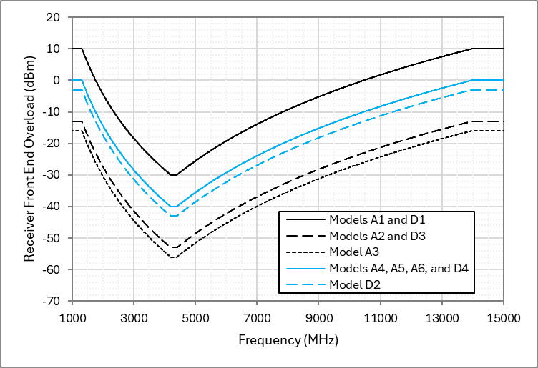

**Figure 2.3-2: Radio Altimeter Model Specific Receiver Front-end Overload Over the Frequency Range of 1 000 MHz to 15 000 MHz**

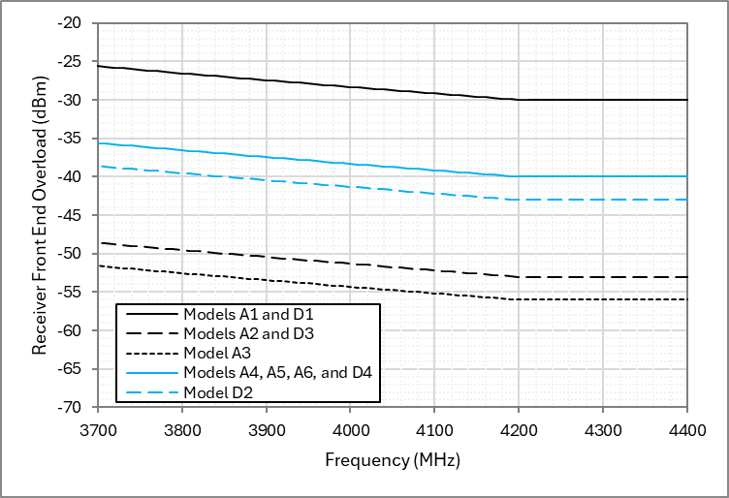

**Figure 2.3-3: Radio Altimeter Model Specific Receiver Front-end Overload Over the Frequency Range of 3 700 MHz to 4 400 MHz**

* + 1. **False Altitude Generation**

Unique to FMCW RA’s, false altitude generation occurs when interference signals are detected as frequency components during spectral frequency analysis of the overall IF bandwidth. This occurs when the received interference power at the RA detector is greater than the detection threshold () of the RA. The for all FMCW RA models is ‑143 dBm/100 Hz. The must be considered to calculate the false altitude generation at the receiver input . The is bounded over the frequency range 4 200‑4 400 MHz, calculated using Equation 2.3‑5, and provided in Table 2.3-2 for each specified RA model.

Equation 2.3-5

**Table 2.3-2: Radio Altimeter Model Specific False Altitude Generation**

| **Parameter** | **Units** | **RA Model** | | | | | |
| --- | --- | --- | --- | --- | --- | --- | --- |
| **A1** | **A2** | **A3** | **D1** | **D2** | **D3** |
|  | **dBm /**  **BW** | -85.8 /  104 MHz | -84.8 /  132.8 MHz | -84.8 /  133 MHz | -84.2 /  150 MHz | -83.5 /  176.8 MHz | -84.8 /  133 MHz |
|  | **dBm / MHz** | -106 | -106 | -106 | -106 | -106 | -106 |

* + 1. **RA Antenna**

[Insert Text Here]

1. **RA Measured Data**
   1. **RA Measured Data Background**

As a result of spectrum allocation changes in many administrations, there was a need to better understand the behaviour of RAs due to interference from adjacent and nearby frequency bands. Much of this data is considered proprietary, but some data was publicly released by the aviation industry. The data[1] is not comprehensive and only provides a snapshot to individual units that were tested. Publicly available RA test data is available in three volumes of the AVSI AFE 76s2 Report (AVSI Report), the first volume[2] specifically provides data regarding the 3 700‑3 980 MHz frequency band, the second volume provides data regarding interference into the 4 200‑4 400 MHz frequency band, and the third volume is a collection of additional test results of RAs from altimeter manufacturers.

* 1. **AVSI AFE 76s2 Report Vol I & II Data**

The AVSI Reports Vol I & II provide RA “breakpoints” which are defined based on specific criteria specified in AVSI Vol I. The criteria to determine the breakpoint include:

* Mean Error Criterion (Section 2.3.4.1): “The AUT (Altimeter Under Test) was considered to “break” (…) when the mean error exceeds 0.5%”;
* Percentile Criterion (Section 2.3.4.2): (…) “when the 1st percentile trace drops below -2% or the 99th percentile trace exceeds +2%”;
* No Computed Data (NCD) criterion (Section 2.3.4.3): (…) “the lowest 5G interference power that produces any height reading label NCD during the RF power ON period is a breakpoint”.

The breakpoints are defined for specific frequencies outside the RA frequency range of operation as well as frequencies within the RA band. The breakpoint covers in-band interference from unwanted emissions, as well as the interference caused by signals falling outside of the frequency band of RAs due to a mechanism similar to the blocking effect.

The provided breakpoints can be converted to an Interference Tolerance Threshold (ITT) which provides the closest possible comparison to the protection criteria as indicated in Recommendation M.2059. To convert the breakpoints in the AVSI Reports Equation 3.2-1 is used.

Equation 3.2-1

Where:

* : The ITT at the input to the RA transceiver receive port. The ITT is defined for a specific height and frequency offset as the highest power for which performance is still acceptable (dBm/MHz);
* : The breakpoint of the RA (dBm/MHz);
* : A -to- backoff factor that accounts for the step-size used in the AVSI testing (dB)[3];
* : An experimental error factor (dB)[4];
* : A unit-to-unit and temperature interference tolerance performance variation factor (dB)[5].

The ITT and breakpoints are derived considering an interference source bandwidth of 100 MHz in the 3 400‑4 200 MHz frequency range, and an interference source bandwidth of 160 MHz in the 4 200‑4 400 MHz frequency range. The necessary constants to convert the RA breakpoints to ITTs for the listed RA models are provided in Table 3.2-1.

**Table 3.1-1: Constants for Equation 3.2-1**

|  |  |  |
| --- | --- | --- |
| **Parameter** | **Unit** | **Value** |
|  | dB | 1 |
|  | dB | 1 |
|  | dB | 4 |

For example, the provided breakpoint of model F at 3750 MHz at 200 ft of -13 dBm/100 MHz found in Table 3‑1 of AVSI Report Vol II can be converted to an ITT resulting in a value of ‑39 dBm/MHz. Table 3.2-2 takes all the provided breakpoints provided within Table 3-1 and Table 4-2 of the AVSI Report Vol I & II and converts them into ITTs for comparative validation purposes performed in Section 4 of this Report.

**Table 3.2-2: AVSI AFE 76s2 Report Vol I & II RA Model Specific Calculated Interference Tolerance Thresholds Summarized**

| **AVSI Vol I & II RA Model Specific Calculated Interference Tolerance Thresholds Summarized (dBm/MHz)** | | | | | | | | | | | |
| --- | --- | --- | --- | --- | --- | --- | --- | --- | --- | --- | --- |
|  | | **Model** | | | | | | | | | |
| **UC 1** | | | | | **UC 2** | | | | |
| **Simulated Altitude (ft)** | **Frequency  (MHz)** | **F** | **L** | **T** | **X** | **Y** | **A** | **I** | **S** | **V** | |
| **200** | **3750** | -39 | NC | NC | NC | -35 | NC / NC* | -56 / -56* | NC / NC* | -76 / -68* | |
| **3850** | -41 | NC | NC | NC | -34 | NC / NC* | -76 / -56* | NC / NC* | -66 / -64* | |
| **3930** | -42 | NC | NC | -32 | -31 | NC / NC* | -58 / -54* | NC / NC* | -68 / -63* | |
| **4300** | -73 | -80 | -68 | -64 | -70 | -71 / -71* | -112 / -96* | -70 / -71* | -92 / -90* | |
| **1000** | **3750** | -46 | NC | NC | NC | -41 | NC | -57 | NC | -86 | |
| **3850** | -47 | NC | NC | -34 | -40 | NC | -54 | NC | -72 | |
| **3930** | -50 | NC | NC | -40 | -43 | -33 | -51 | NC | -76 | |
| **4300** | -85 | -79 | -75 | -85 | -84 | -76 | -101 | -80 | -103 | |
| **2000** | **3750** |  |  |  |  |  | -36 | -54 | NC | -94 | |
| **3850** |  |  |  |  |  | -41 | -53 | NC | -81 | |
| **3930** |  |  |  |  |  | -46 | -51 | NC | -89 | |
| **4300** |  |  |  |  |  | -89 | -97 | -92 | -119 | |
| **5000** | **3750** | -53 | -35 |  | -37 | -51 |  |  |  |  | |
| **3850** | -54 | NC |  | -52 | -51 |  |  |  |  | |
| **3930** | -56 | NC |  | -50 | -52 |  |  |  |  | |
| **4300** | -107 | -94 |  | -104 | -107 |  |  |  |  | |
| **7000** | **3750** |  |  | NC |  |  |  |  |  |  | |
| **3850** |  |  | -33 |  |  |  |  |  |  | |
| **3930** |  |  | -40 |  |  |  |  |  |  | |
| **4300** |  |  | -97 |  |  |  |  |  |  | |
| **Note 1:** An empty cell within the table indicates no data was collected for the conditions of that cell  **Note 2:** A reported value of “NC” indicates an ITT cannot be calculated because the highest testable power level was insufficient to induce a failure criterion as defined in the AVSI reports.  **Note 3:** The UC 1 and UC 2 subheadings in the table group altimeters according to their use case as defined in the AVSI Reports  **Note 4:** The AVSI report also defines a UC 3 category which uses the same radio altimeter models as in UC 2. UC 3 radio altimeters are tested at a simulated altitude of 200 ft, under a different set of test conditions. UC 3 results are included in this table denoted with an asterisk character (*). | | | | | | | | | | |

1. **Comparison of** **ITU-R Rec. M.2059 and AVSI Report Data**
   1. **Comparison over the frequency range 4 200‑4 400 MHz**

All the protection criteria provided in ITU-R Rec. M.2059 are applicable over the 4 200‑4 400 MHz frequency range and thus can be compared to the AVSI calculated ITTs over the same frequency range, i.e. the AVSI Report Vol I & II data points at 4 300 MHz. Table 4.1-1 provides statistics for the ITU-R Rec. M.2059 protection criteria and AVSI Report data over the 4 200‑4 400 MHz frequency range.

**Table 4.1-1: Statistics for the ITU-R Rec. M.2059 Protection Criteria and AVSI Reports Data Over the 4 200‑4 400 MHz Frequency Range**

|  |  |  |  |  |
| --- | --- | --- | --- | --- |
| **Data Set** | **Sample Size** | **Minimum (dBm/MHz)** | **Maximum (dBm/MHz)** | **Range (dB)** |
| **Receiver Desensitization** | 10 | -117 | -110 | 7 |
| **False Altitude Generation** | 6 | -106 | -106 | 0 |
| **Front-end Overload Note 1** | 10 | -76 | -50 | 26 |
| **UC 1 ITT at 200 ft** | 5 | -80 | -64 | 16 |
| **UC 2 ITT at 200 ft** | 4 | -112 | -70 | 42 |
| **UC 3 ITT at 200 ft** | 4 | -96 | -71 | 25 |
| **UC 1 ITT at 1000 ft** | 5 | -85 | -75 | 10 |
| **UC 2ITT at 1000 ft** | 4 | -103 | -76 | 27 |
| **UC 2 ITT at 2000 ft** | 4 | -119 | -89 | 30 |
| **UC 1 ITT at 5000 ft** | 4 | -107 | -94 | 13 |
| **UC 1 ITT at 7000 ft** | 1 | -97 | -97 | 0 |
| **Note 1:** Front-end Overload is specified in dBm in ITU-R Rec. M.2059; however, this analysis assumes that power is spread over a 100 MHz interfering signal so the data can be compared to the data collected in the AVSI Report. | | | | |

Figure 4.1-1 plots the range of performance through the minimum and maximum statistics collected in Table 4.1-1 for each data set. Several RA model specific data from ITU-R Rec. M.2059 is also overlayed on the figure to aid in any data set comparison.

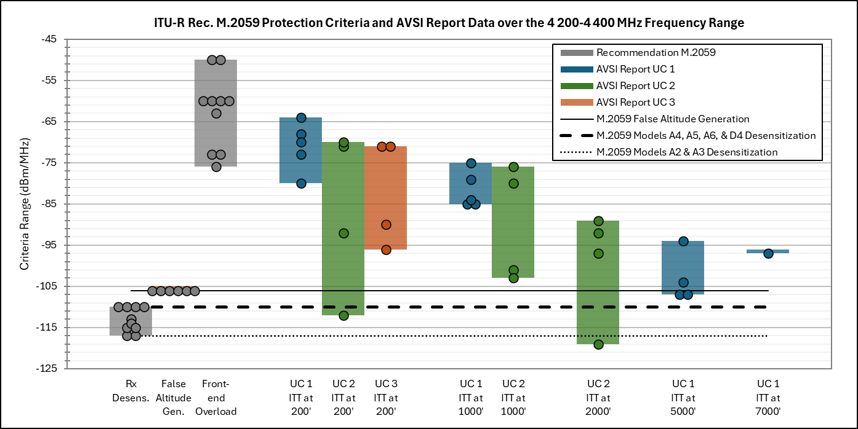

**Figure 4.1-1: ITU-R Rec. M.2059 protection criteria and AVSI Report Data over the 4 200‑4 400 MHz Frequency Range – Statistics Bar Graph**

From Figure 4.1-1, it is clear that there is a variety of performance characteristics among the tested radio altimeters, while a few are more interference tolerant than ITU-R Rec. M.2059, the performance of some radio altimeters also fall within the range of values that ITU-R Rec. M.2059, and one test data point would suggest that ITU-R Rec. M.2059 under protects an individual altimeter.

* 1. **Comparison over the frequency range 3 700‑3 980 MHz**

The front-end overload protection criteria in ITU-R Rec. M.2059 is applicable over the 3 700‑3 980 MHz frequency range and thus can be compared to the AVSI calculated ITTs over the same frequency range, i.e. the AVSI Report Vol I & II data points at 3 750, 3 850, and 3 930 MHz. Table 4.2-1 provides statistics for the ITU-R Rec. M.2059 protection criteria and AVSI Report data over the 3 700‑3 980 MHz frequency range.

**Table 4.1-1: Statistics for ITU-R Rec. M.2059 Protection Criteria and AVSI Reports for 100 MHz Interfering Signals Centered at 3 750, 3 850, and 3 930 MHz**

| **Data Set** | **Sample Size** | **Minimum (dBm/MHz)** | **Maximum (dBm/MHz)** | **Range (dB)** |
| --- | --- | --- | --- | --- |
| **Frequency: 3 750 MHz** | | | | |
| **Front-end Overload Note 1** | 10 | -72.1 | -46.1 | 26 |
| **UC 1 ITT at 200 ft** | 5 | -39 | >-35 | >4 |
| **UC 2 ITT at 200 ft** | 4 | -76 | >-56 | >20 |
| **UC 3 ITT at 200 ft** | 4 | -68 | >-56 | >12 |
| **UC 1 ITT at 1000 ft** | 5 | -46 | >-41 | >5 |
| **UC 2 ITT at 1000 ft** | 4 | -46 | >-41 | >5 |
| **UC 2 ITT at 2000 ft** | 4 | -94 | >-36 | >58 |
| **UC 1 ITT at 5000 ft** | 4 | -53 | -35 | 18 |
| **UC 1 ITT at 7000 ft** | 1 | NC | NC | NC |
| **Frequency: 3 850 MHz** | | | | |
| **Front-end Overload Note 1** | 10 | -73.0 | -47.0 | 26 |
| **UC 1 ITT at 200 ft** | 5 | -41 | >-34 | >7 |
| **UC 2 ITT at 200 ft** | 4 | -76 | >-66 | >10 |
| **UC 3 ITT at 200 ft** | 4 | -64 | >-56 | >8 |
| **UC 1 ITT at 1000 ft** | 5 | -47 | >-34 | >13 |
| **UC 2 ITT at 1000 ft** | 4 | -47 | >-34 | >13 |
| **UC 2 ITT at 2000 ft** | 4 | -81 | >-41 | >40 |
| **UC 1 ITT at 5000 ft** | 4 | -54 | >-51 | >3 |
| **UC 1 ITT at 7000 ft** | 1 | -33 | -33 | 0 |
| **Frequency: 3 930 MHz** | | | | |
| **Front-end Overload Note 1** | 10 | -73.7 | -47.7 | 26 |
| **UC 1 ITT at 200 ft** | 5 | -42 | >-31 | >11 |
| **UC 2 ITT at 200 ft** | 4 | -68 | >-58 | >10 |
| **UC 3 ITT at 200 ft** | 4 | -63 | >-54 | >9 |
| **UC 1 ITT at 1000 ft** | 5 | -50 | >-40 | >10 |
| **UC 2 ITT at 1000 ft** | 4 | -50 | >-40 | >10 |
| **UC 2 ITT at 2000 ft** | 4 | -89 | >-46 | >43 |
| **UC 1 ITT at 5000 ft** | 4 | -56 | >-50 | >6 |
| **UC 1 ITT at 7000 ft** | 1 | -40 | -40 | 0 |
| **Note 1:** Front-end Overload is specified in dBm in ITU-R Rec. M.2059; however, this analysis assumes that power is spread over a 100 MHz interfering signal so the data can be compared to the data collected in the AVSI Report.  **Note 2:** Statistics captured with a > indicate the maximum or range is greater than the amount indicated but not quantifiable because an ITT cannot be calculated because the highest testable power level was insufficient to induce a failure criterion as defined in the AVSI reports.  **Note 3:** A reported value of “NC” indicates a value cannot be calculated because the highest testable power level was insufficient to induce a failure criterion as defined in the AVSI reports. | | | | |

Figure 4.2-1 plots the range of performance through the minimum and maximum statistics collected in Table 4.1-1 for each data set for a 100 MHz interfering signal cantered at 3 750 MHz. Figure 4.2-2 plots the range of performance through the minimum and maximum statistics collected in Table 4.1-1 for each data set for a 100 MHz interfering signal cantered at 3 850 MHz. Figure 4.2-3 plots the range of performance through the minimum and maximum statistics collected in Table 4.1-1 for each data set for a 100 MHz interfering signal cantered at 3 930 MHz. Several RA model specific data from ITU-R Rec. M.2059 is also overlayed on the figures to aid in any data set comparison.

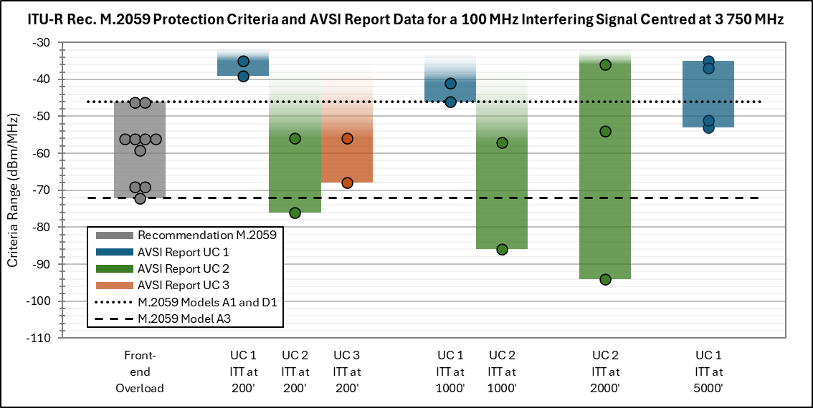

**Figure 4.2-1: ITU-R Rec. M.2059 Protection Criteria and AVSI Report Data for a 100 MHz Interfering Signal Centred at 3 750 MHz – Statistics Bar Graph**

Figure 4.2-1 shows that several of the altimeter’s breakpoints fall within the ITU-R Rec. M.2059 interference criteria, while there are altimeters that are more tolerant as well as more susceptible to interference when compared to ITU-R M.2059.

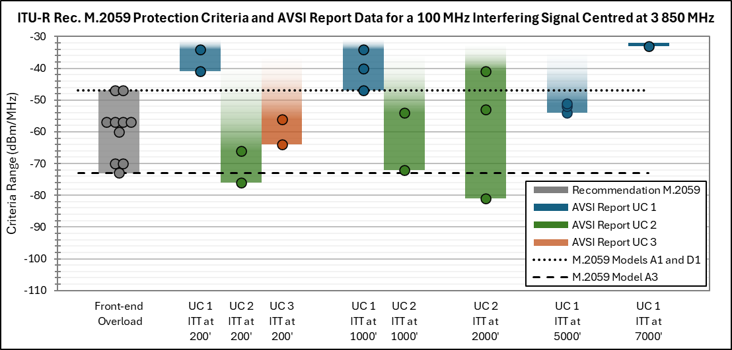

**Figure 4.2-2: ITU-R Rec. M.2059 Protection Criteria and AVSI Report Data for a 100 MHz Interfering Signal Centred at 3 850 MHz – Statistics Bar Graph**

Figure 4.2-2 shows that several of the altimeter’s breakpoints fall within the ITU-R Rec. M.2059 interference criteria, while there are altimeters that are more tolerant as well more susceptible to interference when compared to ITU-R M.2059.

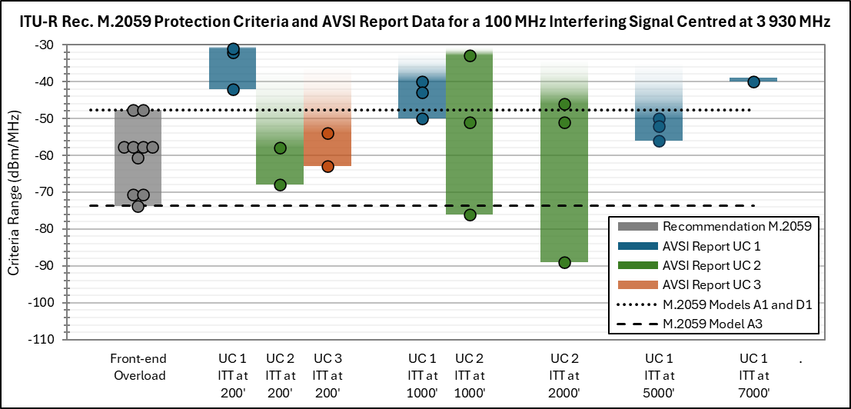

**Figure 4.2-3: ITU-R Rec. M.2059 Protection Criteria and AVSI Report Data for a 100 MHz Interfering Signal Centred at 3 930 MHz – Statistics Bar Graph**

Figure 4.2-3 shows that several of the altimeter’s breakpoints fall within the ITU-R Rec. M.2059 interference criteria, while there are altimeters that are more tolerant as well more susceptible to interference when compared to ITU-R M.2059.

1. **Observations of Section 4 Comparisons**

When comparing the AVSI tested radio altimeter data and the ITU-R Rec. M.2059 data within the 4200-4400 MHz frequency band, there is overlap between the two sets of data, but most of the test data exceeds the values from ITU-R Rec. M.2059.

Comparisons of AVSI tested radio altimeter data and ITU-R Rec. M.2059 data within the 3750 to 3930 MHz frequency ranges show a wide range of altimeter performance that falls in line with ITU-R Rec. M.2059 as well as altimeters that are more robust than the recommendation, and altimeters that are less robust than the recommendation.

1. **Conclusions**

The AVSI data is not an exact match of ITU-R Rec. M.2059 altimeters, the ITU-R Rec. M.2059 altimeters were meant to be representative of radio altimeters installed on a variety of aircraft, the information from AVSI provides more insight into the types of radio altimeters through its categorisation of the tested altimeters in “Usage Categories.” The tested altimeters for Usage Category 1 do show a trend of higher interference tolerance at lower altitudes in the 4200-4400 MHz frequency band (Fig 4.1-1), but that is not as apparent in Usage Category 2.

The AVSI testing is a very small sample of radio altimeters and limits the conclusions that may be drawn as a result. However, several general characteristics can be observed. The AVSI testing is also limited in the number of frequencies tested.

When new radio altimeter standards that are currently under development, new ITU documentation should be developed that provides a higher fidelity radio altimeter model (or models) to be used in sharing and compatibility studies.

**Annex 1**

1. **Plotted Data**

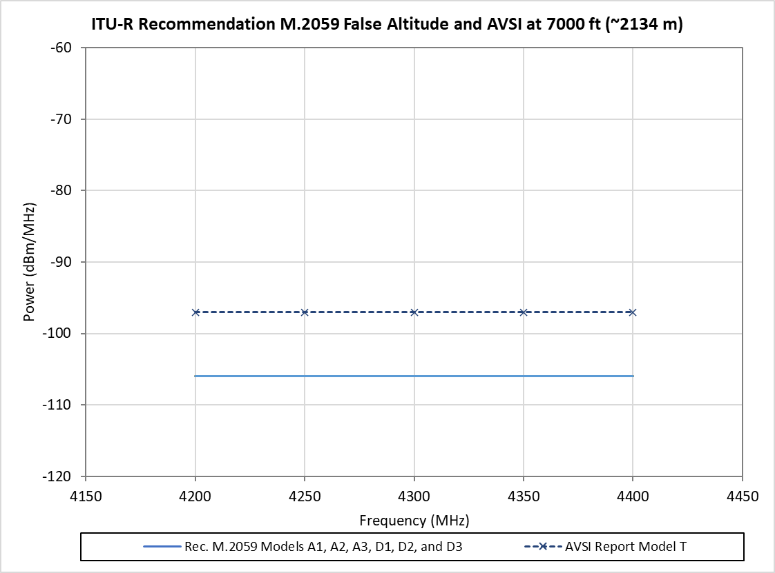

**Figure A1-1: ITU-R Rec. M.2059 False Altitude Protection Criteria and AVSI Report Data at 7000ft**

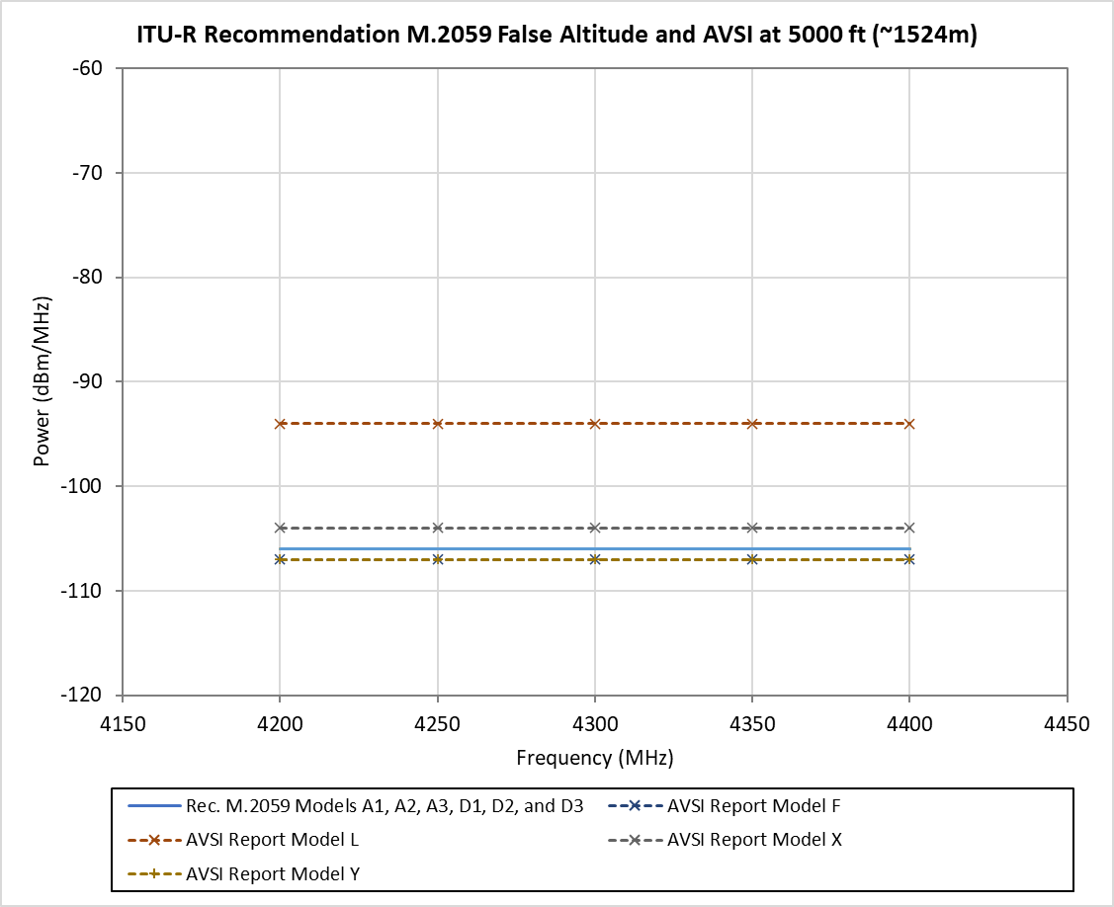

**Figure A1-2: ITU-R Rec. M.2059 False Altitude Protection Criteria and AVSI Report Data at 5000ft**

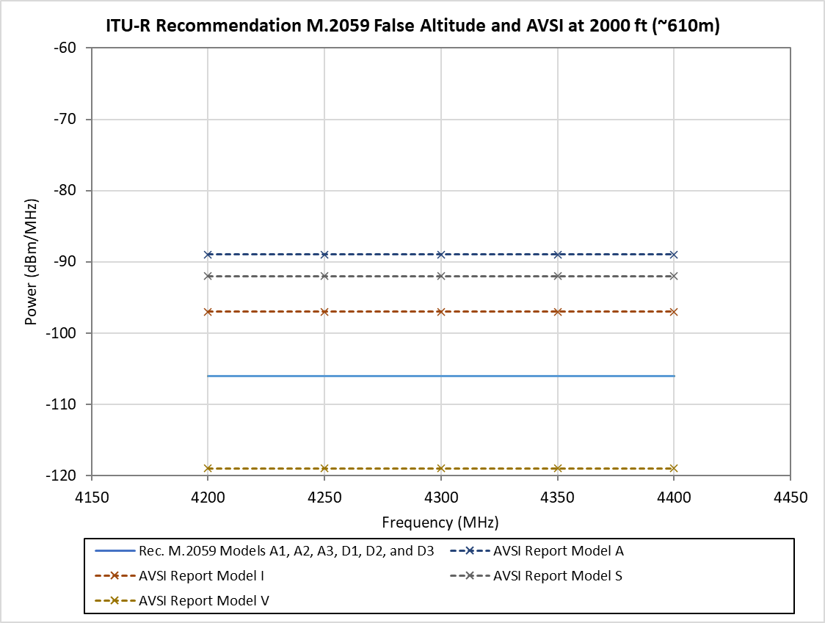

**Figure A1-3: ITU-R Rec. M.2059 False Altitude Protection Criteria and AVSI Report Data at 2000ft**

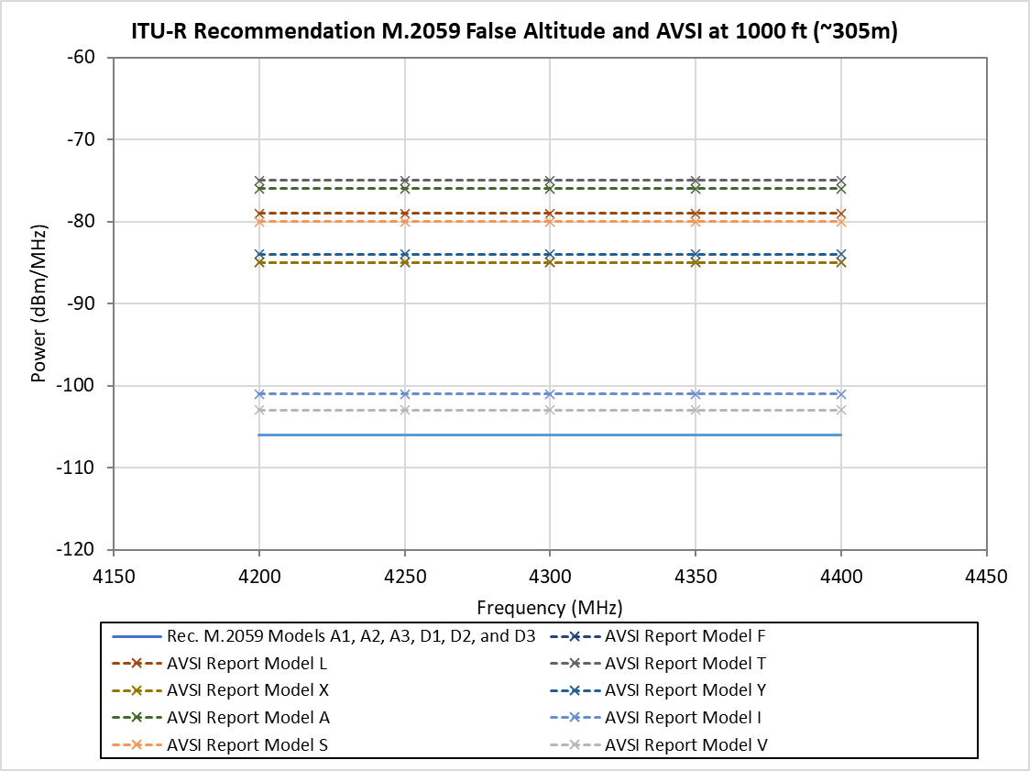

**Figure A1-4: ITU-R Rec. M.2059 False Altitude Protection Criteria and AVSI Report Data at 1000ft**

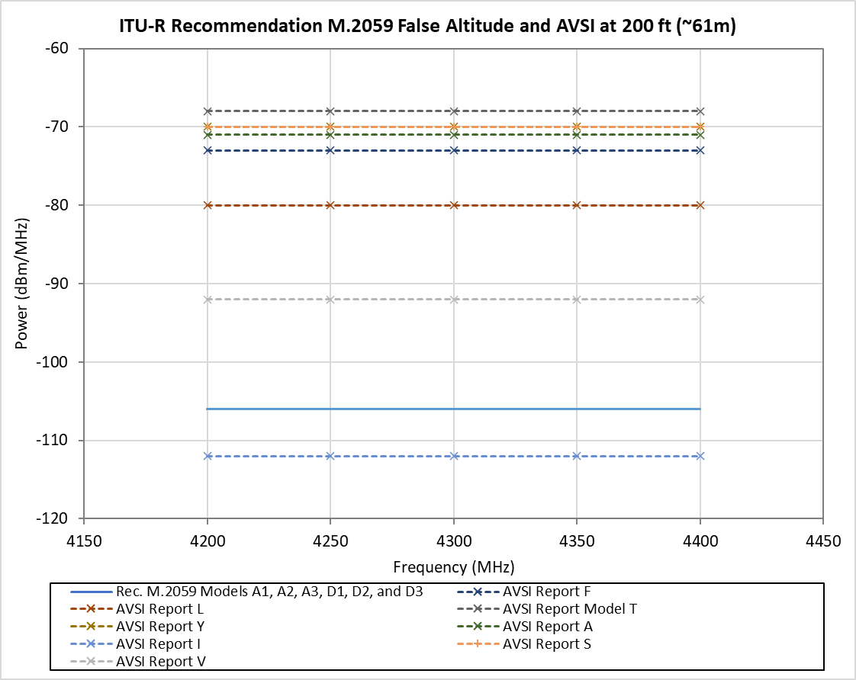

**Figure A1-5: ITU-R Rec. M.2059 False Altitude Protection Criteria and AVSI Report Data at 200ft**

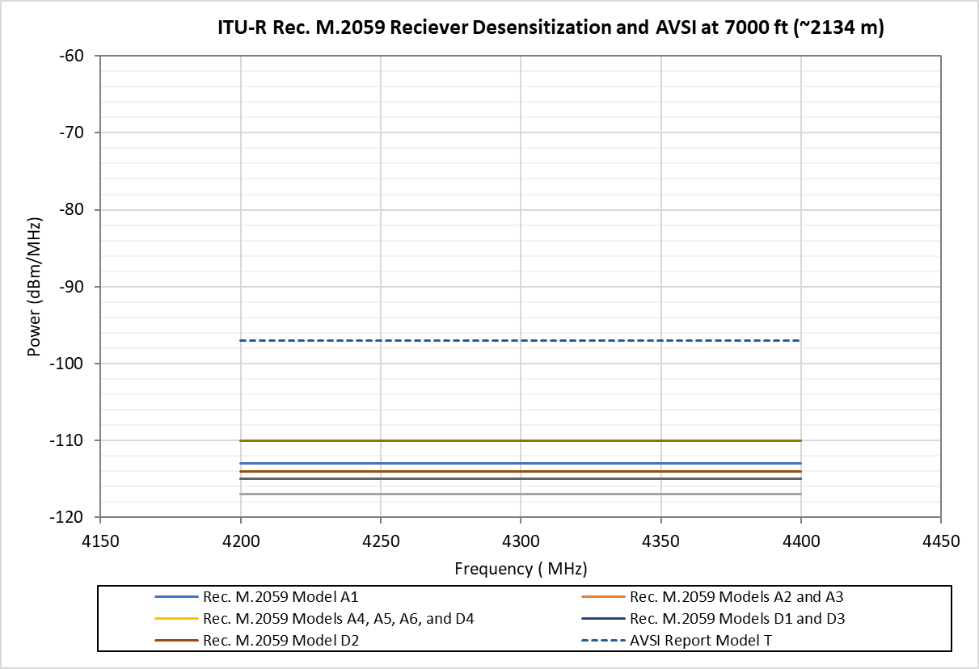

**Figure A1-6: ITU-R Rec. M.2059 Receiver Desensitization Protection Criteria and AVSI Report Data at 7000ft**

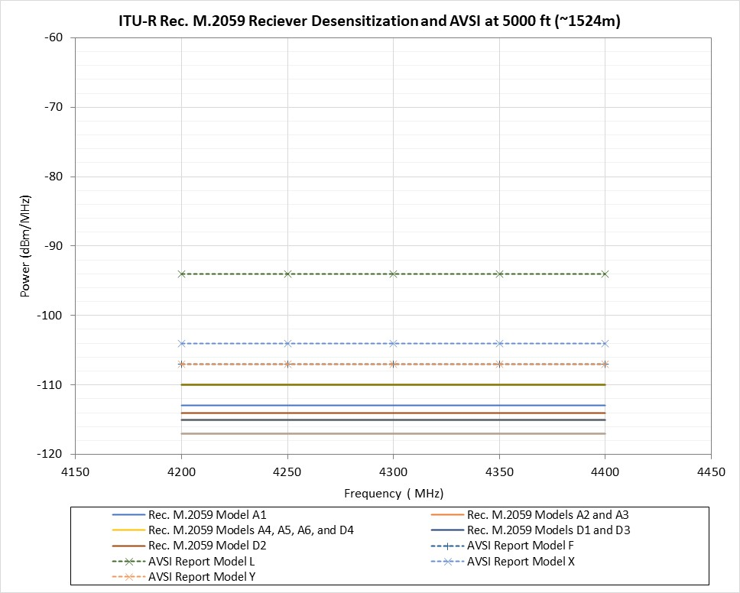

**Figure A1-7: ITU-R Rec. M.2059 Receiver Desensitization Protection Criteria and AVSI Report Data at 5000ft**

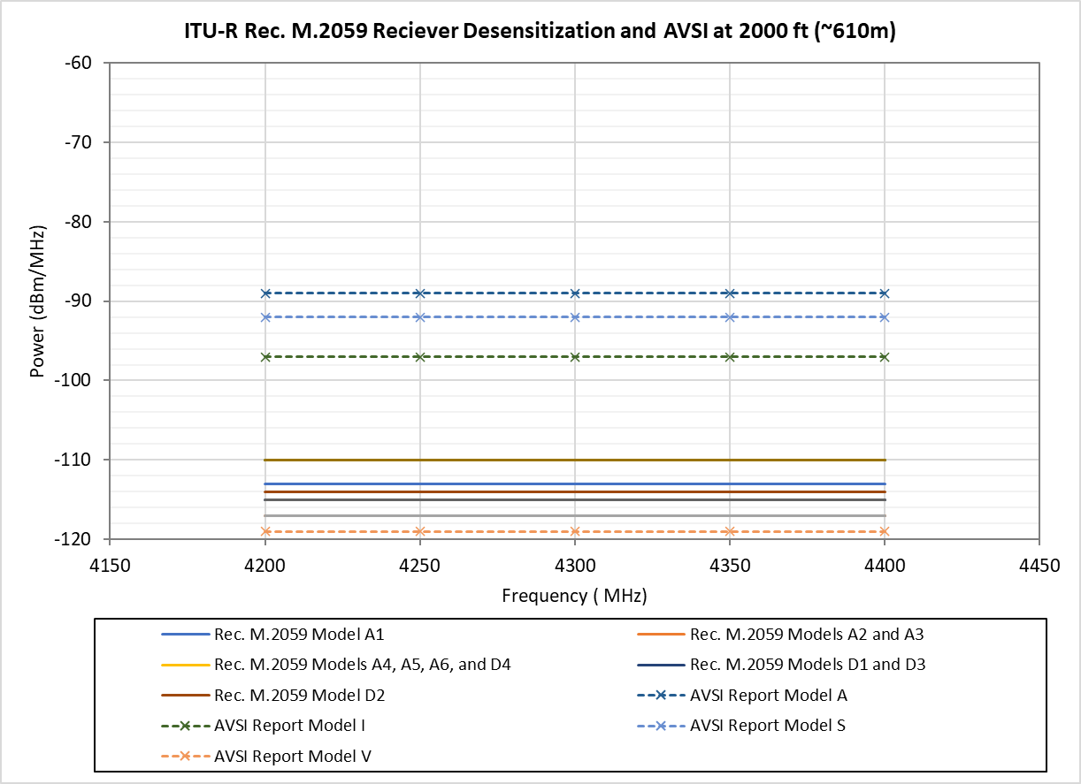

**Figure A1-8: ITU-R Rec. M.2059 Receiver Desensitization Protection Criteria and AVSI Report Data at 2000ft**

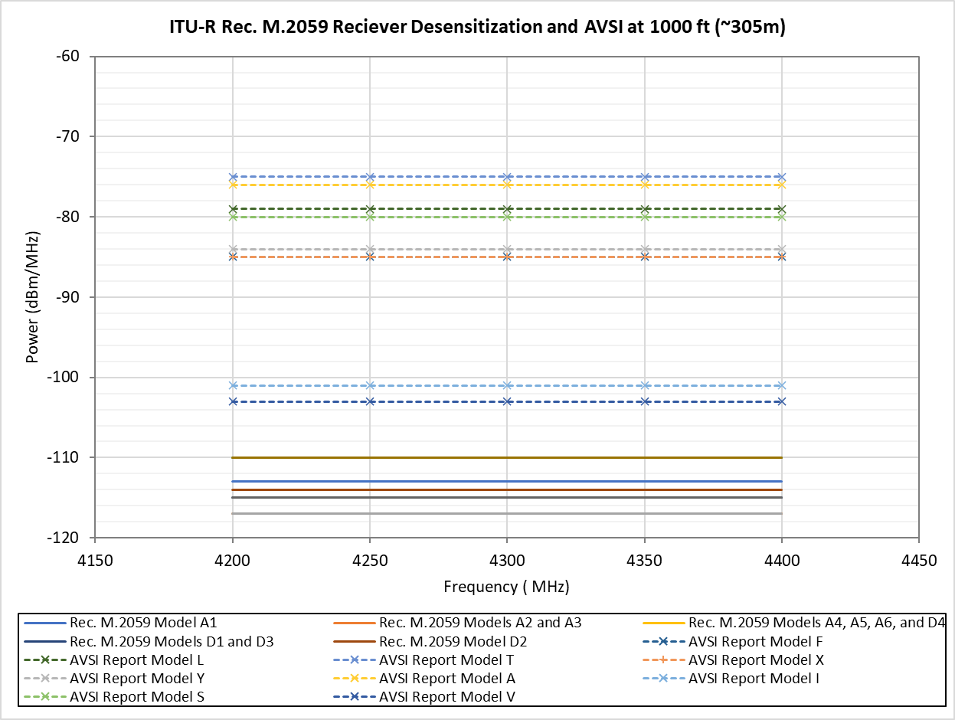

**Figure A1-9: ITU-R Rec. M.2059 Receiver Desensitization Protection Criteria and AVSI Report Data at 1000ft**

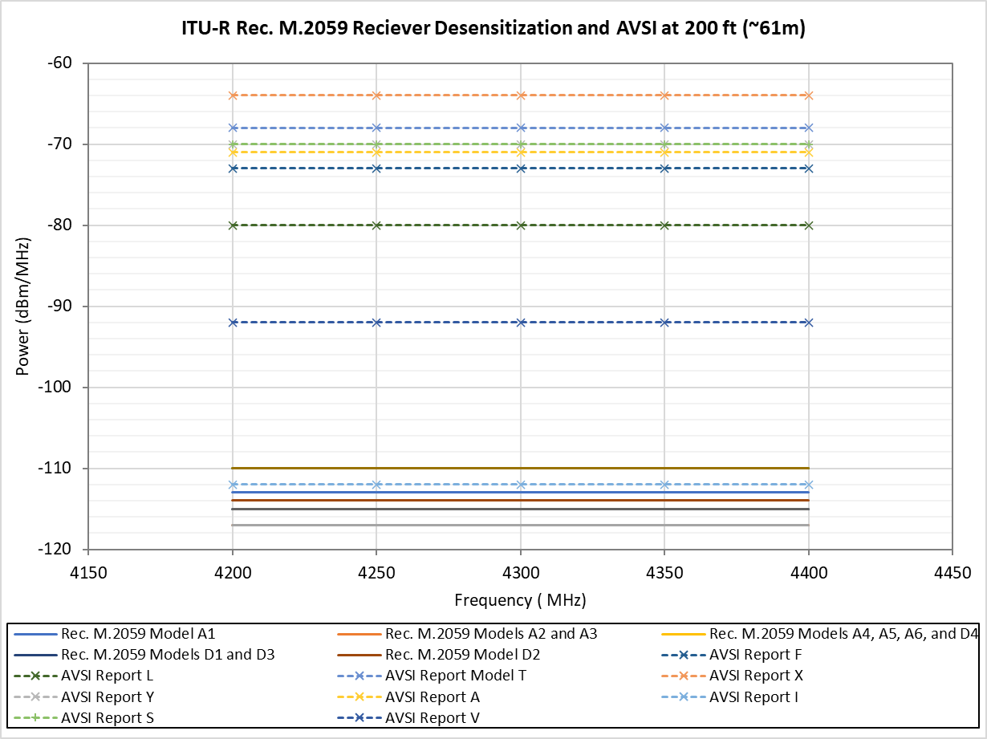

**Figure A1-10: ITU-R Rec. M.2059 Receiver Desensitization Protection Criteria and AVSI Report Data at 200ft**

1. Data is published at [https://avsi.aero/avsi-publishes-volume-iii-of-the-afe-76s2-report/](https://avsi.aero/avsi-publishes-volume-iii-of-the-afe-76s2-report/%20)
2. This volume also contains some compatibility analysis studies that will not be used in this document, only the radio altimeter data will be extracted
3. This factor accounts for the fact discrete step sizes in power are used to find a and therefore the power associated with the ITT needs to be reduced by the discrete test step sizes used in testing.
4. This factor accounts for equipment measurement error.
5. This factor accounts for two elements, one, statistical deviations in performance among the population of RAs of which the single tested model falls within, and two, statistical deviations in performance accounting for temperature impacts since the models were tested at room temperature but operate in an environment of -X°C to +Y°C.