U.S. Radiocommunications Sector
Fact Sheet
Working Party: ITU-R WP 5C | Document No: USWP5C-0C
Ref: Annex 2.2 of 5C/152 | Date: March 8, 2025
Document Title: Preliminary draft new Report ITU-R F.[EESS-PROTECTION]
Author(s)/Contributors(s):  Michael Mullinix  CTIA |  | Phone: 301-639-7159  Email: mmullinix@ctia.org
Purpose/Objective: This contribution proposes updates on the PDN Report considering studies on unwanted emission levels outside the allocated bands for FS systems operating in the frequency bands from 94.1 to 174.8 GHz for the protection of EESS (passive) operating in adjacent bands where footnote RR No. 5.340 applies.
Abstract: WP 5C has been actively studying the impact of the existing primary fixed service allocations in the 94.1 – 174.8 GHz range into adjacent EESS (passive) allocations operating under No. 5.340.

Radiocommunication Study Groups | 
Source: Annex 2.2 of 5C/152 | Document 5C/
Source: Annex 2.2 of 5C/152 | 8 May 2025
Source: Annex 2.2 of 5C/152 | English only
United States of America
Preliminary draft new Report ITU-R F.[EESS-PROTECTION]

Relevant technical information for sharing studies under WRC-27 Agenda Item 1.13
Summary
In the attached, the United States provides edits to update Working Party 5C’s efforts regarding the Preliminary Draft New Report ITU-R F.[EESS-PROTECTION].
Attachment: 1

ATTACHMENT

Annex 2.2 to Working Party 5C Chair’s Report
PRELIMINARY DRAFT NEW REPORT
ITU-R F.[EESS-PROTECTION]
Studies on unwanted emission levels outside the allocated bands for FS systems operating in frequency bands from 94.1 GHz to 174.8 GHz for the protection of EESS (passive) operating in adjacent bands where footnote RR No. 5.340 applies
(Question ITU-R 252/5)
(202X)
Introduction
This Report provides studies on emission levels outside the allocated bands for FS systems operation in the band s from 94.1 GHz to 174.8 GHz for the protection of EESS (passive) operating in adjacent bands where RR No. 5.340 applies. ITU RR No. 5.340 prohibits all emissions, inter alia, in the frequency bands 86-92 GHz, 100-102 GHz, 109.5-111.8 GHz, 114.25-116 GHz, 148.5-151.5 GHz and 164-167 GHz.

It is noted that since the frequency bands 100-102 GHz and 109.5-111.8 GHz are only used by limb sounding applications of EESS (passive) systems, and it is believed that they may coexist with adjacent frequency band FS systems operating in the frequency bands 94.1-100 GHz and 102-109.9 GHz which follow the unwanted emission levels provided in Recommendation ITU-R SM.1541. While studies on those bands are not contained in this Report, a more detailed technical study could be conducted to determine more specific unwanted emission limits needed to protect limb sounding applications in these bands.
Summary
Annex 1: Study 1 provides a comparative analysis to support the determination of relevant FS unwanted emission limits to ensure protection of EESS (passive) in the bands 114.25-116 GHz, 148.5-151.5 GHz and 164-167 GHz.
Annex 2: This analysis provides an extrapoloation of E-band FS link densities provided in Report ITU-R F.2239, so that corresponding FS link densities can be estimated in the D and W bands.

Annex 3: Study 2 (presented in Annex 5) performs Monte-Carlo studies that simulate possible deployment scenarios of fixed service and EESS (passive) parameters to determine appropriate FS unwanted emission levels that ensure protection of EESS (passive) in the frequency bands 114.25-116 GHz, 148.5-151.5 GHz and 164-167 GHz. Study 2 considers six random distributions for FS antenna elevation angles, referred to as cases 1-6. Cases 1 and 2 are considered baseline for the assumed FS parameters used in the study, while cases 3-6 examine the impact at higher elevation angles.
The density and distribution of FS antenna elevation angles has significant impact on the protection of EESS (passive) from the fixed service in an adjacent band. At high elevation, FS antenna main beam has the potential to be close or even within the EESS (passive) main lobe and, hence produces much higher level of interference.
Table 1
Summary Results for Cases 1-2 of FS Elevation Angles in Study 2
(FS Unwanted Emission Levels to Protect EESS (Passive))
FS Band | EESS band | Unwanted emission levels
111.8–114.25 GHz | 114.25–116 GHz | −30.4 − 14(f − 114.25) dBW/100 MHz for 114.3 ≤ f ≤ 115.25 GHz  −44.4 dBW/100 MHz for 115.25 ≤ f ≤ 116 GHz
141-148.5 GHz | 148.5-151.5 GHz | −22.7 − 14(f−148.5) dBW/100 MHz for 148.55 ≤ f ≤ 149.5 GHz  −36.7 dBW/100 MHz for 149.5 ≤ f ≤ 151.45 GHz
151.5-164 GHz | 148.5-151.5 GHz | −36.7 dBW/100 MHz for 148.55 ≤ f ≤ 150.5 GHz  −22.7 − 14(151.5 -f) dBW/100 MHz for 150.5 ≤ f ≤ 151.45 GHz
151.5-164 GHz | 164-167 GHz | −28.1− 14(f-164) dBW/100 MHz for 164.05 ≤ f ≤ 165 GHz  −42.1 dBW/100 MHz for 165 ≤ f ≤ 166.95 GHz
167-174.8 GHz | 164-167 GHz | −42.1dBW/100 MHz for 164.05 ≤ f ≤ 166 GHz  −28.1 − 14(167 − f) dBW/100 MHz for 166 ≤ f ≤ 166.95 GHz

Annex 4: Provides additional information on planned FS use in the D/W bands, as well as other mitigations that can be considered to protect EESS (passive).

Abbreviations/Glossary
EESS Earth Exploration Satellite service
FS Fixed Service
List of Abbreviations/Glossary (if more than 5 terms) used throughout the Recommendation should be in alphabetical order and with their description.
Related ITU Recommendations, Reports
Resolution 750 (Rev.WRC-19)
Report ITU-R F.2239 “Coexistence between fixed service operating in 71-76 GHz, 81-86 GHz and 92-94 GHz bands and passive services”.
Recommendation ITU-R RS.1861 “Typical technical and operational characteristics of Earth exploration-satellite service (passive) systems using allocations between 1.4 and 275 GHz”.
Recommendation ITU-R RS.2017 “Performance and interference criteria for satellite passive remote sensing”.
Recommendations ITU-R SM.1541 “Unwanted emissions in the out-of-band domain”.
NOTE – In every case the latest edition of the Recommendation/Reports in force should be used.

ANNEX 1
Technical analysis for FS unwanted emission limits
[No changes proposed in this Annex.]

ANNEX 2
Detailed analysis of FS links densities in the various FS bands
from 94.1 GHz to 174.8 GHz
This analysis highlights the need to validate whether the FS link density for the W/D bands differs from the one specified for the E-band in Report ITU-R F.2239, in order to estimate the FS operational parameters for FS in W/D bands.
In order to achieve the above, this analysis is proposing to reuse the approach described in Annex A2 of Report ITU-R F.2239 in order to determine an appropriate FS link density level. A new tool was developed following the methodology contained in Annex A2 (see Attachment 1 of this Annex for a detailed description of the methodology used).
Briefly, the tool simulates random possible FS deployments in urban hotspots by continuously adding new FS links within a confined region until X consecutive failures are encountered. A failure occurs when the new FS link cannot be added due to a violation of the interference criterion.
The first step to confirm the tool’s validity was to ensure it produced the same FS link density results as in Report ITU-R F.2239 for the E-band (71-76/81-86 GHz). To perform this validation, the same assumptions as in Report ITU-R F.2239 were used in Annex A2 as shown in Table 1 below:
Table 1
Assumptions from Report ITU-R F.2239
Assumption | Value
Number of consecutive failures (X) | 20
Only one direction of the link is tested | N/A
Frequency | 86 GHz
Maximum antenna gain | 55 dBi
Antenna pattern | Recommendation ITU-R F.1245-1
Noise level | −114 dBW in 250 MHz
Hop length | 50 m - 2.5 km
Minimum FS antenna height | 20 m (20 m + random value from 0 to 80 m)
Radius of the tested area ($d$) | 5 km
Pe | 9 dBm in 250 MHz
Sensitivity | −90 dBm in 250 MHz
Availability | 99.99%
Interference criterion | 3 dB i.e. I equals to N (Note 3)
NOTE 1: Pe has been assumed to be “Power emitted” and considered as transmitter output power
NOTE 2: Rain Fading and Oxygen Absorption were considered
NOTE 3: An interference criterion of 3 dB contradicts the statement that “I equals to N”. In this study, it is assumed that there was a typographic error in Report ITU-R F.2239, and that an I/N criterion of 0 dB was used in that report to calculate the FS deployment density.

The intention was to get the same results as in Report ITU-R F.2239 shown in Table 2 below:
Table 2
FS link density results from Report ITU-R F.2239
Total number of stations | Total number of stations in d + d_{max} | Total number of stations  in d | Total number of Rx at 86 GHz stations in d | Density of stations in d + d_{max} | Density of stations  in d | Density of Rx at 86 GHz stations in d
50 | 46 | 23 | 11 | 0.2603 | 0.2928 | 0.1401
104 | 97 | 45 | 23 | 0.5489 | 0.573 | 0.2928
162 | 152 | 64 | 33 | 0.8601 | 0.8149 | 0.4202
76 | 67 | 27 | 13 | 0.3791 | 0.3438 | 0.1655
84 | 77 | 36 | 19 | 0.4357 | 0.4584 | 0.2419
206 | 193 | 93 | 43 | 1.0922 | 1.1841 | 0.5475
156 | 149 | 79 | 39 | 0.8432 | 1.0059 | 0.4966
140 | 132 | 63 | 30 | 0.747 | 0.8021 | 0.382
108 | 100 | 38 | 20 | 0.5659 | 0.4838 | 0.2546
48 | 46 | 24 | 13 | 0.2603 | 0.3056 | 0.1655

In going through the validation process, it was not possible to get the same results. During investigation, two issues were uncovered.
The first issue found was that a minimum transmitter output power level was not specified. In the absence of such a minimum Tx power level, shorter FS links would have low transmit power levels which cannot be achieved by commercially available fixed service transmitters. Due to the generation of such unrealistic low power FS links, the estimated FS density can be significantly higher. Therefore, the minimum transmitter output power level is a key parameter, since it controls the effective power levels for shorter links, and thus the resulting interference levels. Based on FS system deployments in the E-band within one administration’s licensing database, it was found that the achievable transmitter output power range is 27 dB. Therefore, considering a maximum transmitter output power level of +9 dBm in 250 MHz defined in the assumptions, a minimum transmitter output power level of –18 dBm in 250 MHz was specified in the tool.
Secondly, it is worth considering that a receiver sensitivity of −90 dBm in 250 MHz is lower than the thermal noise level of −84 dBm in 250 MHz, also specified in the assumptions (−114 dBW in 250 MHz). Therefore, it would make more sense considering −84 dBm in 250 MHz as the minimal theoretical worst case receiver sensitivity (this is considered worst case because a lower sensitivity value requires a lower transmitter output power level, and thus allows a higher density of FS links).
By adding a minimum transmitter output power level of −18 dBm and correcting the receiver sensitivity to −84 dBm in 250 MHz, we were able to get the same peak FS density of 0.5 links/km². The detailed results for 10 random samples out of the 100 runs conducted with the developed tool are provided in Table 3a below. The final list of assumptions proposed to be used for estimating FS link density in the W/D bands are provided in Table 4.
Table 3a
Results (10 randomly selected sample runs out of 100)
Total number of stations | Total number of stations in d+d_{max} | Total number of stations in d | Total number of Rx at 86 GHz stations in d | Density of Rx at 86 GHz stations in d (per km²)
120 | 120 | 63 | 32 | 0.41
188 | 188 | 77 | 39 | 0.5
72 | 71 | 31 | 15 | 0.19
116 | 114 | 50 | 25 | 0.32
120 | 119 | 48 | 23 | 0.29
134 | 134 | 56 | 28 | 0.36
162 | 161 | 78 | 39 | 0.5
126 | 126 | 48 | 24 | 0.31
156 | 155 | 61 | 30 | 0.38
80 | 80 | 21 | 10 | 0.13

Table 3b below provides various statistics of the simulation results as provided in Annex A2 of Report ITU-R F.2239 and the simulation results obtained from the developed FS density tool. It should be noted that the primary interest lies in the peak FS link density. Also, note that Annex A2 of Report ITU-R F.2239 only provided the results of 10 runs while the statistics for the results of the developed FS density tool are calculated over 100 runs.
Table 3b
Comparison of results from Report ITU-R F.2239 and the developed tool
 | Average FS Link Density | Peak FS Link Density | Standard Deviation of FS Link Density
ITU-R F.2239 | 0.31/km² | 0.54/km² | 0.14/km²
Developed Tool | 0.32/km² | 0.53/km² | 0.11/km²

Table 4
Final assumptions for FS Density Estimation tool in the E-band
Assumption | Value
Number of consecutive failures (X) | 20
Only one direction of the link is tested | N/A
Frequency | 86 GHz
Maximum antenna gain | 55 dBi
Antenna pattern | Recommendation ITU-R F.1245-3 (Note 1, Note 3)
Noise level | −84 dBm in 250 MHz
Hop length ($d_{min}$ - $d_{max}$) | 50 m – 2.5 km
Minimum FS antenna height | 20-100 m (Uniform Distribution)
Radius of the tested area ($d$) | 5 km
Min. Tx Power (Pe_{min}) | −18 dBm in 250 MHz
Max. Tx Power (Pe_{max}) | 9 dBm in 250 MHz
Sensitivity | −84 dBm in 250 MHz
Availability | 99.99%
Interference criterion | 0 dB (I equals N)
Considering rain fading and oxygen absorption | ITU-R P.530, ITU-R P.676, ITU-R P.837, ITU-R P.838 (Zone “K”)
NOTE 1: It should be noted that the tool that was developed using the currently in force Recommendation ITU-R F.1245. However, it was validated that using either ITU-R F.1245-1 or ITU-R F.1245-3 had no significant impact on the FS density results.
NOTE 2: The parameters different from Table 1 are identified in bold font.
NOTE 3: Recommendation ITU-R F.1245 is the antenna radiation pattern to be used for aggregated interference cases, as noted in the working document towards a preliminary draft new Recommendation ITU-R F.[EESS-PROTECTION]. Since there is no available model beyond 86 GHz, it is currently the best available radiation pattern for such an investigation. This is also consistent with the FS density estimation in Annex 2 of Report ITU-R F.2239.

Following the validation process, the tool was used to estimate the FS link density in the various sub-bands within the frequency range 92-174.8 GHz, in which FS systems plan to operate. All the same assumptions for input technical parameters to the FS link density tool used in the 86 GHz band (reported in Table 4) were used to calculate the results within 92-174.8 GHz. This is in line with Annex 13 of the WP 5C Chairman’s Report (Annex 13 of Document 5C/248), which stated that the characteristics of the FS systems around 86 GHz and in the frequency range 94.1-174.8 GHz are similar.
Table 5
Calculated Peak FS Link Density Results in W/D bands from Use of the FS link Density Tool
 | FS Frequency (GHz)
 | 86 | 114.25 | 148.5 | 151.5 | 164 | 167 | 174.8
Peak FS Density (links/km²) | 0.5 | 0.66 | 0.71 | 0.72 | 0.75 | 0.76 | 0.79

It should be noted that in Table 5, the estimated peak FS link density increases with frequency. The frequencies used for analysis in Table 5 correspond to the edges of FS allocated bands which are adjacent to an EESS (passive) band where footnote RR No. 5.340 applies, which are:
• 114.25-116 GHz, 148.5-151.5 GHz, and 164-167 GHz;
• the frequency range 174.8-191.8 GHz has been added for completeness.
It should be noted that the EESS (passive) bands 100-102 GHz and 109.5-111.8 GHz are not considered in this study since they correspond with bands where only limb sounders operate.
Using the FS link density values from Table 5, an estimation of an FS unwanted emission level was developed for each the EESS (passive) bands within the frequency range 94.1-174.8 GHz (see Annex 2).
In Report ITU-R F.2239, the unwanted emission level for protection of EESS (passive) is determined by simulating an area of 2,000,000 km², including 20 hot spots representing urban areas where the FS link density is same as the peak determined by the FS link density tool.

ATTACHMENT 1 TO ANNEX 2
Description of Methodology used for the FS Density Estimation Tool
The following methodology was implemented for this study and is the same as the one provided in Annex A2 of Report ITU-R F.2239.
Step 1: A first station (S1) is set up in an area of a radius: d + d_{max} where d_{max} is the maximum length of the FS link. Then, another station (S2) is associated to this station. It is set up in a radius of d_{max} centred around the first station (see Fig. 1).
Figure 1
First link
The power at the receiver is assumed to be 3 dB above the sensitivity, and the power at the Tx is calculated accounting for oxygen absorption (see Recommendation ITU-R P.676) and rain fading (see Rec. ITU-R P.530). It should be mentioned that this methodology considers free-space propagation losses and does not account for topography and shielding in urban and suburban areas (which may lead to higher densities in those areas). It must be noted that the tool is based on former versions of Recommendations ITU-R P.837 and ITU-R P.838 (zone “K” is assumed in the simulations).
Step 2: Step 1 is repeated to set up new links. (See Fig. 2.)
Each time a link is set up, the tool calculates the interference from the new transmitter on all the existing receivers at the considered frequency accounting for oxygen absorption.
Figure 2
Interference from the new transmitter at each existing receiver
Then, the aggregate interference is calculated.
Step 3: Each time a link is set up, the tool calculates the interference from the existing transmitters on the new receiver at the considered frequency accounting for oxygen absorption (see Fig. 3).
Figure 3
Interference from each existing transmitter to the new receivers
Then, the aggregate interference is calculated.
Step 4: The aggregate interference at the existing and at the new receiver is compared with a threshold. If the threshold is met, the link is accepted, and the tool will try to set up an additional new link. If the threshold is not met, the new link is rejected, and the tool will test another link. If the tool is not able to set up a new link after X consecutive failures, it is considered that the maximum density is achieved.

Carrier power reduction(dB)=10×log10Symbol Frequency (Mbaud)Reference bandwidth
2n

Symbol Frequency ≥ 60 % of the ChS

PoD100
PoD100 dBW100 MHz=Pout-10×log10ChS×0.6 (Mbaud)100 (MHz)

PoD100
PoD100

ANNEX 3
Detailed Monte Carlo Study for FS Unwanted Emission Limits
The present annex presents Monte Carlo studies that simulate a large number of possible deployment scenarios based on relevant values of fixed service and EESS (passive) parameters to determine appropriate FS unwanted emission levels that ensure protection of EESS (passive) in the frequency bands 114.25-116 GHz, 148.5-151.5 GHz and 164-167 GHz.

1 Fixed service characteristics

1.1 Density of fixed service links
There are two parameters to consider on this topic: the value(s) of FS link density representative for a dense urban area and the ratio of FS links within urban areas to that outside of urban areas. First, it is proposed to use the values in Table 5 of Annex 3 for the FS links’ density in urban areas for the various EESS (passive) bands. Secondly, the density of FS links outside urban areas, following the approach developed in Report ITU-R F.2239, is determined to be 8.3 times lower than the FS link density in urban areas.
Table 1
Calculated FS Link Density in W/D Bands
FS density | FS frequency  (GHz)
FS density | 86 | 114.25 | 148.5 | 151.5 | 164 | 167 | 174.8
In urban areas (links/km²) | 0.5 | 0.66 | 0.71 | 0.72 | 0.75 | 0.76 | 0.79
Outside urban areas (links/km²) | 0.060 | 0.079 | 0.086 | 0.087 | 0.090 | 0.092 | 0.095
1.2 Elevation angle of fixed service links
Together with the density of fixed service stations found within the EESS (passive) footprint, the distribution of their elevation has also an important impact on the protection of EESS (passive) from the fixed service in an adjacent band.
Since there is no deployment data available at this time for FS antenna elevation angles within the frequency range 92-174.8 GHz, available information for FS antenna elevation angles in 71-86 GHz has been considered as a reference point to determine appropriate values for 92-174.8 GHz. As per Recommendation ITU-R F.2086, deployment information provided by administrations reflect that FS links deployed in 71-76 GHz and 81-86 GHz have an antenna elevation of no more than 2.5 degrees above the horizon in 95% of cases.
In this study, the following distributions of FS antenna elevation angles have been considered as appropriates cases to consider a reasonable representation of practical deployments with a conservative view towards ensuring protection of EESS:
– Case 1: Random uniform distribution between -10° and 10°.
– Case 2: Random gaussian distribution with a mean of 0° and standard deviation of 4.92°, with 0.39% of FS sites having a random uniform distribution of antenna elevation angles between 20° to 30°.
In both cases above, it should be noted that, assuming a bi-directional FS link, the transmitter for one direction would have the opposite elevation angle to the transmitter for the other direction.
In addition, FS elevation is one of the most important parameter for determining the compatibility with EESS (passive) operations, as shown in Report ITU-R F.2239. Indeed, at high elevation, FS antennas main beam have the potential to be close or even within the EESS (passive) main lobe and, hence producing much higher level of interference. Therefore, a sensitivity analysis has been performed by including the following additional FS deployment scenarios:
Table 2
High FS Link Elevation Scenarios for Sensitivity Analysis
 | Case 3 | Case 4 | Case 5 | Case 6
High elevation links | 0.39% of links with elevation angles between 20° and 45° | 0.39% of links with elevation angles between 20° and 90°  (see Report ITU-R F.2239) | 0.5% of links with elevation angles between 30° and 45°  (see Report ITU-R F.2239) | 2% of links with elevation angles between 20° and 65°  (see Report ITU-R F.2239)
1.3 Antenna pattern of fixed service
Recommendation ITU-R F.1245 is the antenna radiation pattern to be used for aggregated interference cases. Although this recommendation does not cover up to 174.8 GHz, the antenna pattern for the 70-86 GHz range from this recommendation currently represents the best available estimation and has been used in this study.

1.4 Other fixed service parameters
Other fixed service parameters for the study include the reference transmitter unwanted emission power level, the losses between the transmitter and the antenna (i.e. feeder losses) and the antenna gain.
Table 3
FS Parameters for Dynamic Simulation
Fixed Service Parameter | Value
Feeder losses | 0 dB
Maximum antenna gain | 55 dBi
Reference FS unwanted emission power level | −28 dBW/MHz

2 Atmospheric propagation characteristics
Considering that the path between fixed links and EESS (passive) is assumed to be unobstructed line-of-sight, the two dominant propagation mechanisms are free-space basic transmission loss and gaseous attenuation. Therefore, the method described in Recommendation ITU-R P.525 – Calculation of free-space attenuation is used to calculate the free-space basic transmission loss and the method described in Recommendation ITU-R P.676 – Attenuation by atmospheric gases and related effects is used to calculate the gaseous attenuation.

3 EESS (passive) characteristics and protection criteria
The values specified in Table 2 of Annex 2 of this document have been used as the EESS (passive) protection criteria for this study. This is also consistent with Recommendation ITU-R RS.2017-0.
Tables 4-6 describe the parameters for various EESS (passive) sensors considered in this study. The sensors selected for the study form a representative subset of the systems that use Conical and Nadir scan modes, as described in ITU-R Recommendation RS.1861-1.
Table 4
EESS (passive) Parameters for 114.25-116 GHz band
EESS system | M2 | M3 | M6 | GSO-M1
Centre frequency (GHz) | 115.55 * | 115.55 * | 115.55 * | 115.55 *
Orbit altitude (km) | 407 | 836 | 830 | 35800
Nadir angle (°) | 46.1 | 42.6 | 44.8 | 0
Slant path distance (km) | 609 | 1207 | 1257 | 35800
Free space losses (dB) | 189.4 | 195.3 | 195.7 | 224.8
Elevation at ground (°) | 40 | 40 | 37.2 | 90
Atmospheric losses (dB) | 4.6 | 4.6 | 4.89 | 2.96
Antenna gain (dBi) | 60.5 | 60.5 | 55.5 | 70.5
IFOV (km²) | 17 | 67 | 68 | 1104
* Centre of the lowest channel
Table 5
EESS (passive) Parameters for 148.5-151.5 GHz band
EESS system | N1 (nadir) | N1 (outer)
Centre frequency (GHz) | 150 | 150
Orbit altitude (km) | 705 | 705
Nadir angle (°) | 0 | 48.95
Slant path distance (km) | 705 | 1166
Free space losses (dB) | 192.9 | 197.3
Elevation at ground (°) | 90 | 33.1
Atmospheric losses (dB) | 2.1 | 3.9
Antenna gain (dBi) | 45 | 45
IFOV (km²) | 144 | 721
* Centre of the lowest channel
Table 6
EESS (passive) Parameters for 164-167 GHz band
EESS system | P3 | P4 | P10 | GSO-P1
Centre frequency (GHz) | 164.75* | 164.75 | 164.75 | 164.75
Orbit altitude (km) | 830 | 407 | 666 | 35800
Nadir angle (°) | 53.3 | 48.6 | 45.5 | 0.0
Slant path distance (km) | 1610 | 643 | 1008 | 35800
Free space losses (dB) | 200.9 | 192.9 | 196.9 | 227.9
Elevation at ground (°) | 25.0 | 37.1 | 38.0 | 90.0
Atmospheric losses (dB) | 7.9 | 5.57 | 5.46 | 3.36
Antenna gain (dBi) | 62.6 | 60.6 | 57.2 | 72.1
IFOV (km²) | 28 | 20 | 28 | 531
* Centre of the lowest channel

4 Dynamic analysis
A dynamic analysis has been conducted where the impact of an assumed distribution of FS stations over a portion of North America within a reference area of 2 000 000 km² has been considered. The EESS (passive) sensor propagates on its orbit and calculates aggregate interference at each time step of 100ms, over a total period of 10 days. Population density has been used as the trigger to distinguish urban and non-urban areas as follows:
Table 7
Criteria for Differentiation of Urban and Non-Urban Areas for Dynamic Analysis
Population Density (D) | Designation
D > 2000 inhabitants per km² | Urban
100 inhabitants per km² > D > 2000 inhabitants per km² | Other than urban
D < 100 inhabitants per km² | No FS Deployment

Once designated, FS stations are deployed in each region as per the applicable density level identified in Table 1 of this Annex. A publicly available population database was used to determine the population density over the area of study (https://earthdata.nasa.gov/data/catalog/sedac-ciesin-sedac-gpwv3-popdens-3.00). Figure 1 shows the FS deployment, consisting of more than 50,000 FS stations within the reference area.
Figure 1
Simulated FS Deployment in the Reference Area for Dynamic Analysis
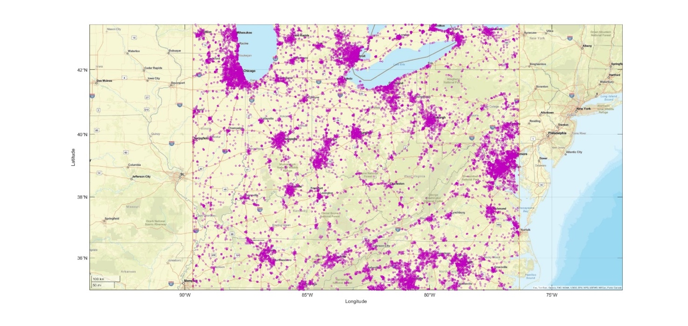

4.1 Results of dynamic analysis for 114.25-116 GHz Band
Figures 2-4 depict the aggregate interference levels obtained from the dynamic analysis for 114.25-116 GHz band for a reference FS unwanted emission power level of -28 dBW/MHz (i.e. −5 dBW/200 MHz).
Figure 2
Interference Statistics for M2 Sensor from Dynamic Analysis
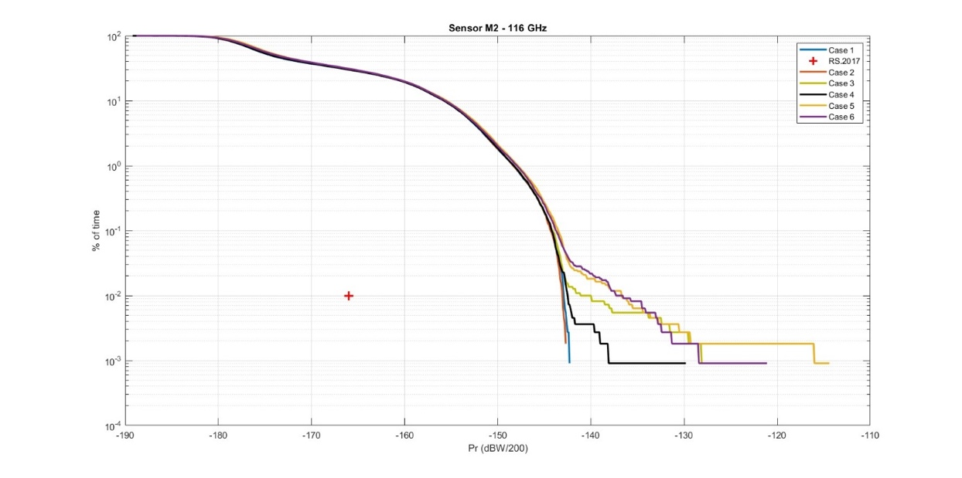
Figure 3
Interference Statistics for M3 Sensor from Dynamic Analysis
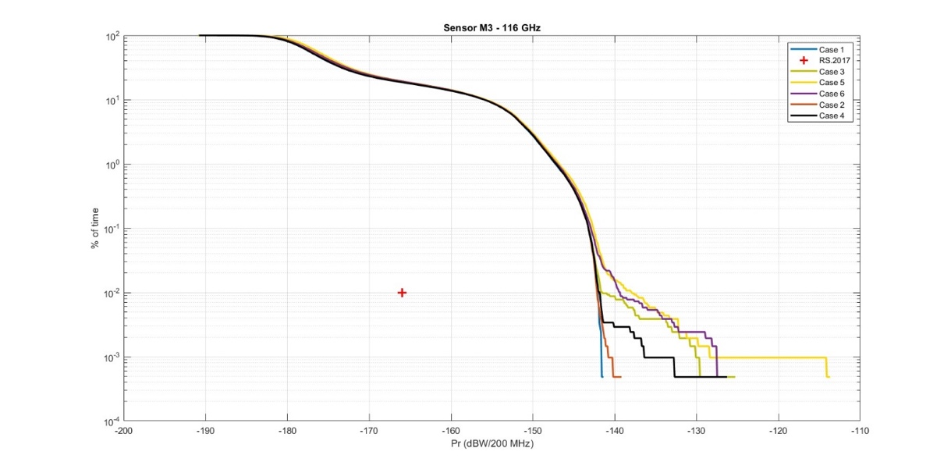
Figure 4
Interference Statistics for M6 Sensor from Dynamic Analysis
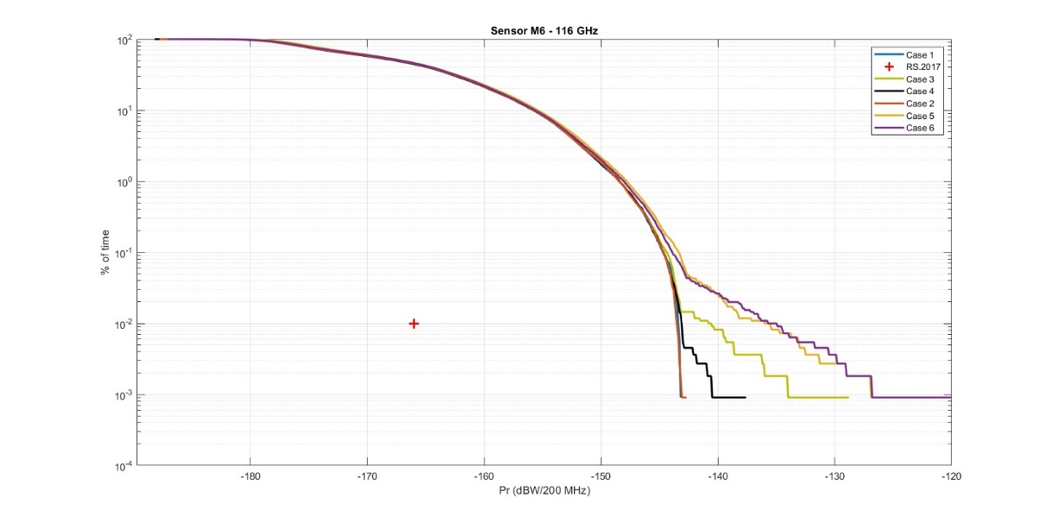
Based on these results, following FS unwanted emission levels are necessary to ensure protection of EESS (passive) sensors.
Table 8
Summary of Results of Dynamic Analysis for 114.25-116 GHz band
EESS (Passive) Sensor | Unwanted Emission Level (dBW/200 MHz)
EESS (Passive) Sensor | Case 1 | Case 2 | Case 3 | Case 4 | Case 5 | Case 6
M2 | −31.9 | −31.8 | −32.4 | −32.1 | −36 | −34.6
M3 | −31.1 | −30.9 | −34 | −31.5 | −37.3 | −37.4
M6 | −30.5 | −30.4 | −33.1 | −30.8 | −37.9 | −38.2

The results of dynamic analysis provide an unwanted emission level of −34.9 dBW/100 MHz to protect EESS (passive) for baseline cases (1-2), and a limit of −41.2 dBW/100 MHz in the sensitivity cases (3-6). in the 114.25-116 GHz band.

4.2 Results of dynamic analysis for 148.5-151.5 GHz Band
Figure 5 depicts the aggregate interference levels obtained from the dynamic analysis for 148.5-151.5 GHz band for a reference FS unwanted emission power level of −28 dBW/MHz (i.e.−1 dBW/500 MHz).
Figure 5
Interference Statistics for N1 Sensor from Dynamic Analysis
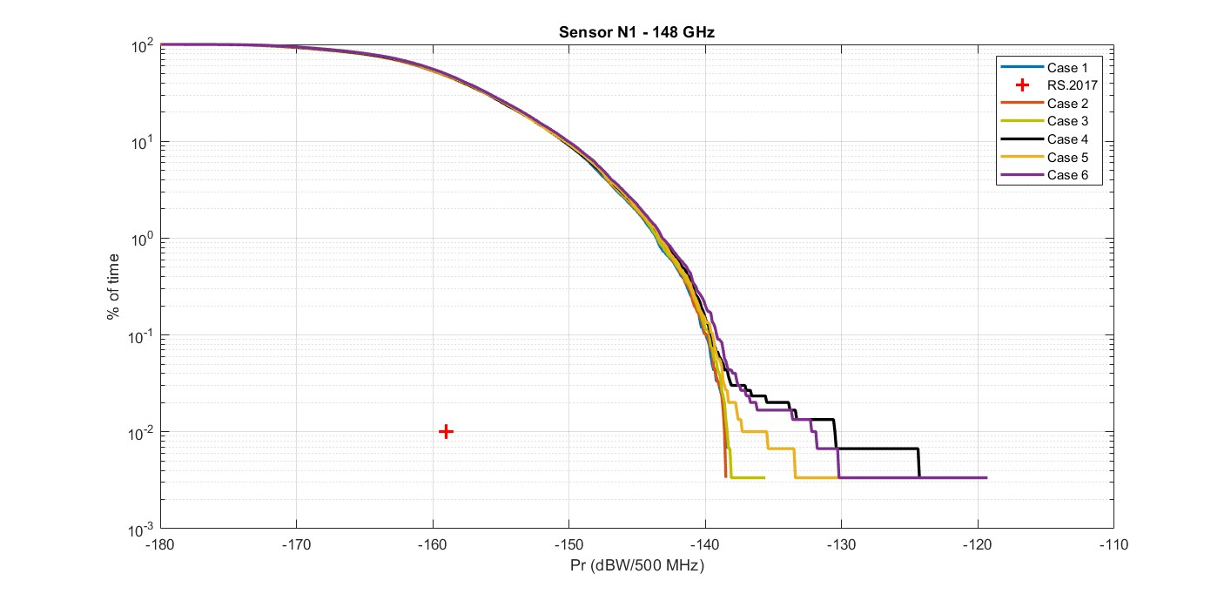
Based on these results, following FS unwanted emission levels are necessary to ensure protection of EESS (passive) sensors.
Table 9
Summary of Results of Dynamic Analysis for 148.5-151.5 GHz band
EESS (Passive) Sensor | Unwanted Emission Level (dBW/500 MHz)
EESS (Passive) Sensor | Case 1 | Case 2 | Case 3 | Case 4 | Case 5 | Case 6
N1 | −21.4 | −21.4 | −21.6 | −29.5 | −24.5 | −28.1

The results of dynamic analysis provide an unwanted emission level of −28.4 dBW/100 MHz to protect EESS (passive) for baseline cases (1-2), and a limit of −36.5 dBW/100 MHz in the sensitivity cases (3-6). in the 148.5-151.5 GHz band.

4.3 Results of dynamic analysis for 164-167 GHz Band
Figures 6-8 depict the aggregate interference levels obtained from the dynamic analysis for 164-167 GHz band for a reference FS unwanted emission power level of -28 dBW/MHz (i.e. −5 dBW/200 MHz).
Figure 6
Interference Statistics for P3 Sensor from Dynamic Analysis
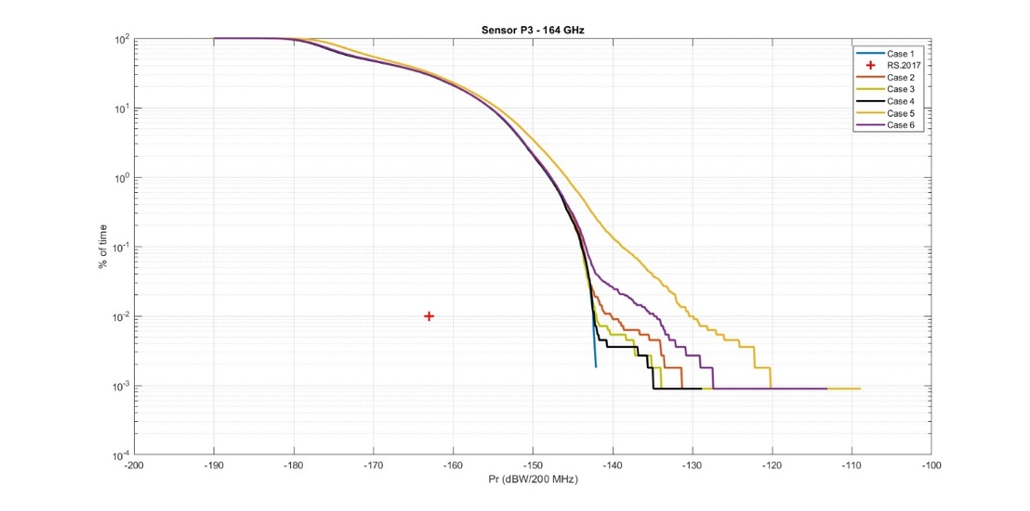
Figure 7
Interference Statistics for P4 Sensor from Dynamic Analysis
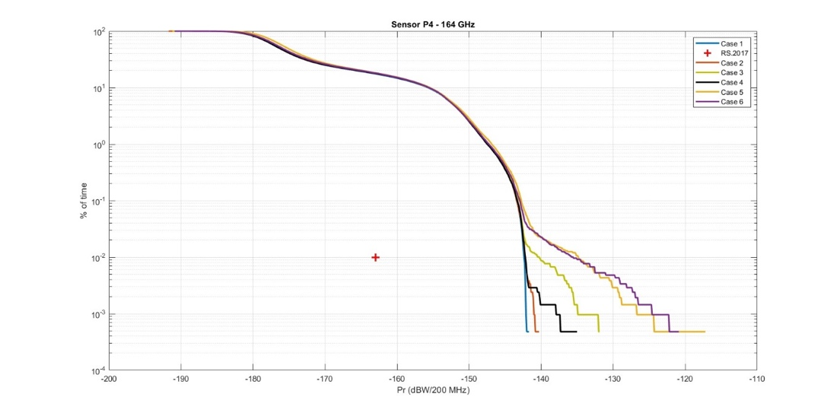
Figure 8
Interference Statistics for P10 Sensor from Dynamic Analysis
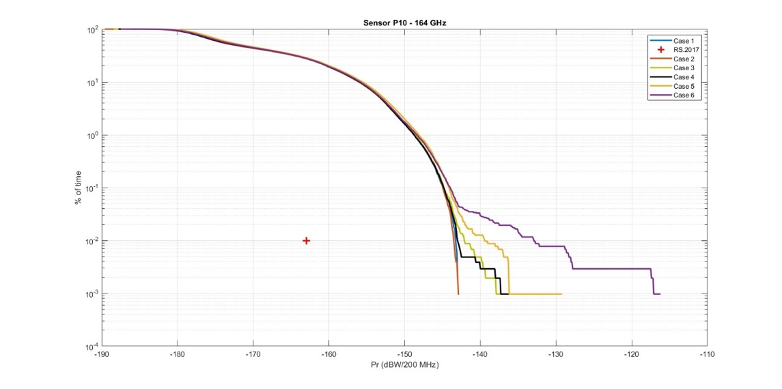
Based on these results, following FS unwanted emission levels are necessary to ensure protection of EESS (passive) sensors.
Table 10
Summary of Results of Dynamic Analysis for 164-167 GHz band
EESS (Passive) Sensor | Unwanted Emission Level (dBW/200 MHz)
EESS (Passive) Sensor | Case 1 | Case 2 | Case 3 | Case 4 | Case 5 | Case 6
P3 | −25.5 | −27.7 | −25.9 | −25.6 | −37.5 | −33.1
P4 | −25.6 | −25.8 | −27.7 | −25.7 | −33.1 | −32.4
P10 | −24.7 | −24.4 | −25.8 | −24.9 | −28.5 | −35

The results of dynamic analysis provide an unwanted emission level of −30.7 dBW/100 MHz to protect EESS (passive) for baseline cases (1-2), and a limit of −40.5 dBW/100 MHz in the sensitivity cases (3-6). in the 164-167 GHz band.

5 Static analysis
In this method, the FS links are deployed in an area corresponding to the size of the EESS (passive) IFOV (footprint), provided for the various EESS (passive) sensors in Table 4-6 of this Annex. 2000 independent Monte Carlo runs simulate different random FS deployment scenarios within this area in accordance with FS deployment characteristics described in Section 1 of this Annex. Note that the location in orbit and the pointing angle of the EESS (passive) is fixed for this analysis.
According to the EESS (passive) protection criteria, interference limits may be exceeded for 0.01% of time or area, over a measurement area of 2,000,000 km². This corresponds to a maximum area of 200 km² where unwanted emission limits may be exceeded. For the static simulation, while EESS (passive) sensor is stationary, each Monte-Carlo run represents a possible FS deployment in a measurement area (equivalent to a new EESS (passive) sensor position in the dynamic simulation) where aggregate interference is measured. To meet the EESS (passive) protection criteria, total measurement areas (Monte-Carlo runs) where aggregate interference exceeds the unwanted emission limit must not exceed 200 km².
Taking the example of the M6 EESS (passive) sensor, with an IFOV of 68 km², there may be up to 2 runs out of 2000 simulated FS deployment scenarios (equivalent to a region of 136 km²) where interference exceeds unwanted emission limits of the EESS (passive) protection criteria. A 3rd such run where interference exceeds the limits shall take the corresponding total measurement region (212 km²) beyond the EESS (passive) protection criteria. Similarly, for the M2 EESS (passive) sensor, with an IFOV of 17 km², 11 runs (187 km²) of the 2000 may exceed the unwanted emission limits.
5.1 Results of static analysis for 114.25-116 GHz Band
Figures 9-12 depict the amount by which aggregate interference levels exceed the EESS (passive) protection criteria in the static analysis for 114.25-116 GHz band for a reference FS unwanted emission power level of −28 dBW/MHz (i.e. −5 dBW/200 MHz).
Figure 9
Interference Statistics for M2 Sensor from Static Analysis

Figure 10
Interference Statistics for M3 Sensor from Static Analysis

Figure 11
Interference Statistics for M6 Sensor from Static Analysis

Figure 12
Interference Statistics for GSO-M1 Sensor from Static Analysis

Based on these results, following FS unwanted emission levels are necessary to ensure protection of EESS (passive) sensors.
Table 11
Summary of Results of Static Analysis for 114.25-116 GHz band
EESS (Passive) Sensor | Unwanted Emission Level (dBW/200 MHz)
EESS (Passive) Sensor | Case 1 | Case 2 | Case 3 | Case 4 | Case 5 | Case 6
M2 | −33.3 | −34.1 | −34.7 | −34.2 | −37.7 | −36.1
M3 | −33.5 | −34.7 | −42.3 | −36.4 | −45.6 | −45.3
M6 | −28.1 | −29.9 | −32.6 | −32.2 | −36.4 | −39.0
GSO-M1 | −27.4 | −27.4 | −27.4 | −63.7 | −27.4 | −27.5
The results of static analysis provide an unwanted emission level of −37.7 dBW/100 MHz to protect EESS (passive) for baseline cases (1-2), and a limit of −48.6 dBW/100 MHz in the sensitivity cases (3-6). in the 114.25-116 GHz band.
5.2 Results of static analysis for 148.5-151.5 GHz Band
Figures 13 and 14 depict the amount by which aggregate interference levels exceed the EESS (passive) protection criteria in the static analysis for 148.5-151.5 GHz band for a reference FS unwanted emission power level of −28 dBW/MHz (i.e. −1 dBW/500 MHz).
Figure 13
Interference Statistics for N1(Nadir) Sensor from Static Analysis
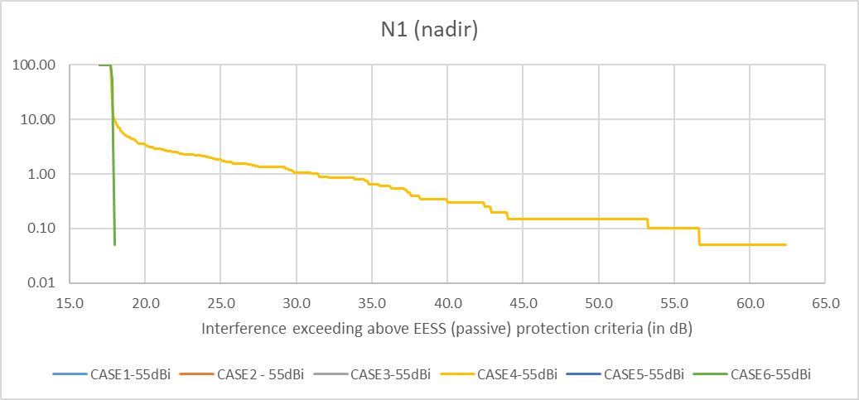
Figure 14
Interference Statistics for N1(Outer) Sensor from Static Analysis
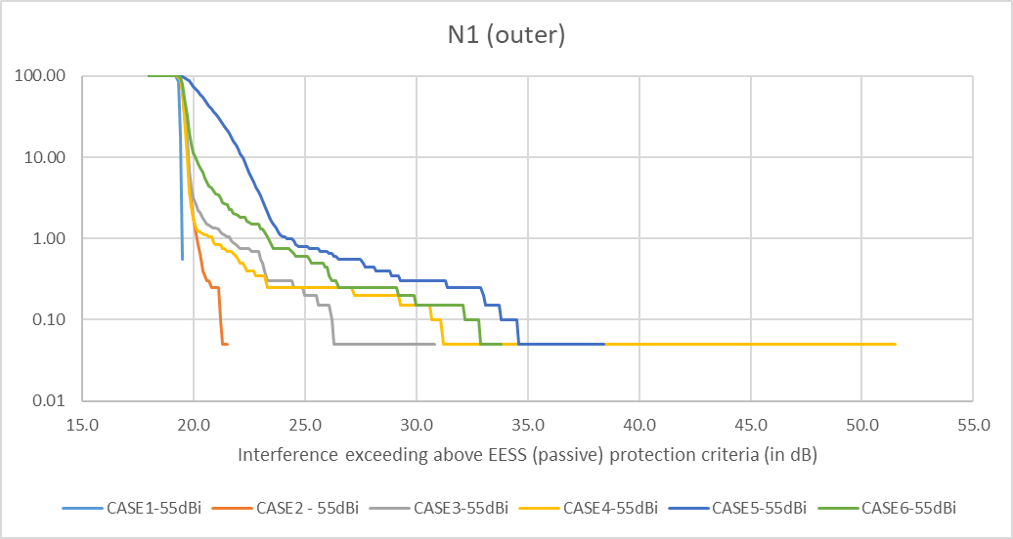

Based on these results, following FS unwanted emission levels are necessary to ensure protection of EESS (passive) sensors.
Table 12
Summary of Results of Static Analysis for 148.5-151.5 GHz band
EESS (Passive) Sensor | Unwanted Emission Level (dBW/500 MHz)
EESS (Passive) Sensor | Case 1 | Case 2 | Case 3 | Case 4 | Case 5 | Case 6
N1 (nadir) | −18.7 | −18.7 | −18.7 | −57.6 | −18.7 | −19.0
N1 (outer) | −20.5 | −22.5 | −31.8 | −52.5 | −39.4 | −34.8
. The results of static analysis provide an unwanted emission level of −29.5 dBW/100 MHz to protect EESS (passive) for baseline cases (1-2), and a limit of −64.6 dBW/100 MHz in the sensitivity cases (3-6). in the 148.5-151.5 GHz band.

5.3 Results of static analysis for 164-167 GHz Band
Figures 15-18 depict the amount by which aggregate interference levels exceed the EESS (passive) protection criteria in the static analysis for 164-167 GHz band for a reference FS unwanted emission power level of −28 dBW/MHz (i.e. −5 dBW/200 MHz).
Figure 15
Interference Statistics for P3 Sensor from Static Analysis

Figure 16
Interference Statistics for P4 Sensor from Static Analysis

Figure 17
Interference Statistics for P10 Sensor from Static Analysis

Figure 18
Interference Statistics for GSO-P1 Sensor from Static Analysis
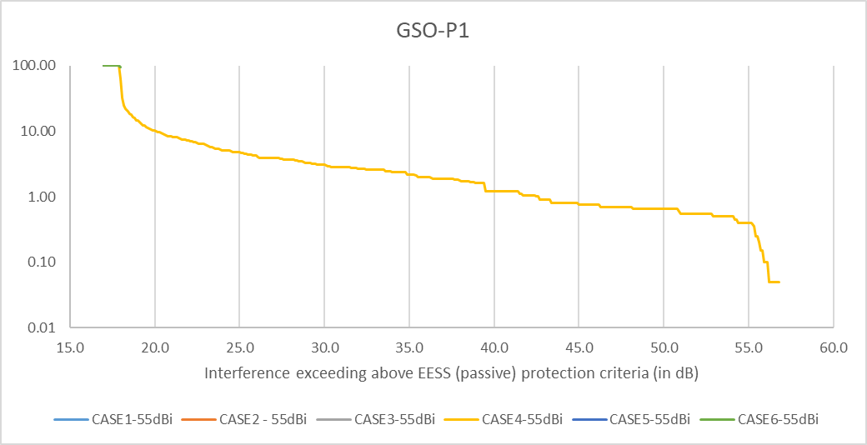
Based on these results, following FS unwanted emission levels are necessary to ensure protection of EESS (passive) sensors.
Table 13
Summary of Results of Static Analysis for 164-167 GHz band
EESS (Passive) Sensor | Unwanted Emission Level (dBW/200 MHz)
EESS (Passive) Sensor | Case 1 | Case 2 | Case 3 | Case 4 | Case 5 | Case 6
P3 | −26.1 | −31.9 | −31.2 | −31.6 | −42.4 | −31.0
P4 | −30.6 | −31.8 | −32.5 | −31.7 | −36.6 | −36.2
P10 | −24.8 | −25.8 | −27.6 | −25.6 | −31.3 | −32.0
GSO-P1 | −22.9 | −22.9 | −22.9 | −22.9 | −22.9 | −23.0

The results of static analysis provide an unwanted emission level of −34.9 dBW/100 MHz to protect EESS (passive) for baseline cases (1-2), and a limit of −45.4 dBW/100 MHz in the sensitivity cases (3-6). in the 164-167 GHz band.

6 Conclusion
The following tables summarise the results of dynamic and static studies related to the protection of EESS (passive) systems operating in the 114.25-116 GHz, 148.5-151.5 GHz and 164-167 GHz bands.
The following points should be noted:
– The worst case among the results for FS elevation cases 1 and 2 represents the baseline for a single FS unwanted emission level for the frequency band.
– The results for FS elevation cases 3-6 may be further considered if additional margin is deemed necessary to account for the impact of high elevation angles.
– Results for case 4 may include outliers (particularly for the GSO-M1 sensor) due the presence of a hypothetical FS link with 90° elevation and are hence not considered as representative.
– Results for cases 5 and 6 may include outliers due to the presence of hypothetical FS links with a higher proportion of high elevation links and are hence not considered as representative. These cases were mainly studied for the purposes of a sensitivity analysis to see the impact of higher elevation angles.
Table 14
Unwanted emission levels for the 114.25-116 GHz band (summary of results)
EESS (Passive) Sensor | Unwanted Emission Level (dBW/200 MHz)
EESS (Passive) Sensor | Case 1 | Case 2 | Case 3 | Case 4 | Case 5 | Case 6
M2 (static) | −33.3 | −34.1 | −34.7 | −34.2 | −37.7 | −36.1
M2 (dynamic) | −31.9 | −31.8 | −32.4 | −32.1 | −36 | −34.6
M3 (static) | −33.5 | −34.7 | −42.3 | −36.4 | −45.6 | −45.3
M3 (dynamic) | −31.1 | −30.9 | −34 | −31.5 | −37.3 | −37.4
M6 (static) | −28.1 | −29.9 | −32.6 | −32.2 | −36.4 | −39.0
M6 (dynamic) | −30.5 | −30.4 | −33.1 | −30.8 | −37.9 | −38.2
GSO-M1 (static) | −27.4 | −27.4 | −27.4 | −63.7 | −27.4 | −27.5

Table 15
Unwanted emission levels for the 148.5-151.5 GHz band (summary of results)
EESS (Passive) Sensor | Unwanted Emission Level (dBW/500 MHz)
EESS (Passive) Sensor | Case 1 | Case 2 | Case 3 | Case 4 | Case 5 | Case 6
N1 (nadir) | −18.7 | −18.7 | −18.7 | −57.6 | −18.7 | −19.0
N1 (outer) | −20.5 | −22.5 | −31.8 | −52.5 | −39.4 | −34.8
N1 (dynamic) | −21.4 | −21.4 | −21.6 | −29.5 | −24.5 | −28.1

Table 16
Unwanted emission levels for the 164-167 GHz band (summary of results)
EESS (Passive) Sensor | Unwanted Emission Level (dBW/200 MHz)
EESS (Passive) Sensor | Case 1 | Case 2 | Case 3 | Case 4 | Case 5 | Case 6
P3 (static) | −26.1 | −31.9 | −31.2 | −31.6 | −42.4 | −31.0
P3 (dynamic) | −25.5 | −27.7 | −25.9 | −25.6 | −37.5 | −33.1
P4 (static) | −30.6 | −31.8 | −32.5 | −31.7 | −36.6 | −36.2
P4 (dynamic) | −25.6 | −25.8 | −27.7 | −25.7 | −33.1 | −32.4
P10 (static) | −24.8 | −25.8 | −27.6 | −25.6 | −31.3 | −32.0
P10 (dynamic) | −24.7 | −24.4 | −25.8 | −24.9 | −28.5 | −35
GSO-P1 (static) | −22.9 | −22.9 | −22.9 | −22.9 | −22.9 | −23.0

ANNEX 4
Additional Information on Planned FS deployment and Mitigation Strategies

______________

This is “Table 4 Results of simulations” in Annex 2 of Report ITU-R F.2239.
The FS link densities were determined by taking into account propagation conditions associated with the frequency specified in each column.

