# 

|  |  |
| --- | --- |
| **US Radiocommunications Sector**  **Fact Sheet** | |
| **Working Party:** WP 5B | **Document No:** USWP5B34-15 |
| **Reference:** TBD | **Date:** 10 February 2025 |
| **Document Title:** Working Document Validation of ITU-R Recommendation M.2059 with measured data | |
| **Author(s)/Contributors(s):**  Kim Kolb  Boeing  Nic Shrout  ASRI  Dave Redman  AVSI | Phone: (703) 220-2438  Email: kim.l.kolb@boeing.com  Phone:  Email: NJS@asri.aero  Phone: (979) 862-2316  Email: dredman@tamu.edu |
| **Purpose/Objective:**  This document will provide a validation of ITU-R M.2059’s radio altimeter characteristics with measured radio altimeter data | |
| **Abstract:**  Due to various national efforts over the last several years, there is a limited amount of measured radio altimeter data publicly available, and it would be useful to compare this data with the contents of ITU-R M.2059 as a validation. This effort may help in discussions in how to apply the data in ITU-R M.2059 in sharing studies. | |

|  |  |
| --- | --- |
| **Radiocommunication Study Groups** |  |
|  |  |
|  |  |
| Source:  ---  Reference**:** Recommendation ITU-R M.2059 | **Document: USWP5B34-XX** |
| **10 February 2025** |
| **English only** |
| United States of America | |
| Working Document Towards a Preliminary Draft new report iTU-R M.[ITU-R M.2059 Comparison]  Comparison of ITU-R M.2059 with measured radio altimeter data | |

# 1 Introduction

Recommendation ITU-R M.2059 was approved in 2015 and provides characteristics of radio altimeters, a system that operates under the aeronautical radionavigation service, including background information of how the system is used on aircraft. The characteristics include three protection criteria to ensure the operations of this system that is critical for the safe operation of aircraft. Since the publication of Rec. ITU-R M. 2059, some radio altimeter data has been published, and it is useful to compare characteristics within Rec. ITU-R M.2059 with this data.

|  |  |
| --- | --- |
| **Radiocommunication Study Groups** |  |
|  |  |
|  |  |
| Source: --  Subject: -- | **##** |
| **## May 2025** |
| **English only** |
|  | |
| Working Document Towards a Preliminary Draft new report iTU-R M.[ITU-R M.2059 Validation] | |
| Comparison of ITU-R M.2059 with measured radio altimeter data | |

1. **Introduction**

Recommendation ITU-R M.2059 (Rec. ITU-R M.2059), Operational and Technical Characteristics and Protection Criteria of Radio Altimeters (RAs), was approved in 2015 and provides characteristics of RAs, a system that operates under the aeronautical radionavigation service, including background information of how the system is used on aircraft. The characteristics include three protection criteria to ensure the operations of this system that is critical for the safe operation of aircraft. Since the publication of Rec. ITU-R M.2059, some RA data has been published, and it is useful to compare characteristics within Rec. ITU-R M.2059 with this data.

ANNEX 1: Description [TBD]

ANNEX 2: Description [TBD]

1. **Summary**: [To be developed in future meetings.]

ANNEX 1

1. **ITU-R Recommendation M.2059 Operational and Technical Characteristics and Protection Criteria of RAs** 
   1. **Radio Altimeter Description**

As described in Rec. ITU-R M.2059, the basic function of the RA is to provide accurate height measurements over a range of reported altitudes above the Earth surface with a high degree of accuracy and integrity during the approach, landing, and climb phases of aircraft operation. These operations can occur over surfaces with a wide variety of reflectivity, which are accounted for in the RA performance requirements. The distance measured by the radio altimeter is referred to as Height above Terrain (HAT), which is the distance from the terrain to the aircraft. This is a different measurement to altitude referenced to mean sea-level.

The information provided by the altimeter not only gives the flight crew (pilots) situational awareness, it also can be used by many other onboard safety systems. These systems can include automatic throttles (navigation), thrust reversers (used to stop the aircraft on the runway), terrain awareness warning systems (TAWS), traffic alert and collision avoidance system (TCAS), the predictive wind shear system, as well as the autopilot, which includes numerous automatic landing systems.

Altimeters can be installed on a variety of aircraft and connect to any combination of the systems mentioned above, the aircraft types that an altimeter may be installed from range from small single pilot aircraft, small ‘business’ aircraft including jets, regional commercial airliners, and large airliners. RAs are also installed on a variety of helicopters.

Installation details vary by the aircraft types, but one, two, or three altimeters may be installed on aircraft. Typically, large airliners have two or three altimeters installed and operated simultaneously to ensure that the required precision data is available for aircraft systems.

* 1. **Radio Altimeter Characteristics**

The RA model specific parameters contained in Rec. ITU-R M.2059 utilized in protection criteria calculations discussed in Section 2.3 are provided below in Table A1-1.

**Table A1-1: Select RA Model Specific Parameters**

| **Parameter** | **Units** | **RA Model** | | | | | | | | | |
| --- | --- | --- | --- | --- | --- | --- | --- | --- | --- | --- | --- |
| **A1** | **A2** | **A3** | **A4** | **A5** | **A6** | **D1** | **D2** | **D3** | **D4** |
| **Input Power Threshold**  **()** | **dBm** | -30 | -53 | -56 | -40 | -40 | -40 | -30 | -43 | -53 | -40 |
| **Detection Threshold**  **() (Note 1)** | **dBm / 100 Hz** | -143 | -143 | -143 |  |  |  | -143 | -143 | -143 |  |
| **Cable Loss**  **(** | **dB** | 6 | 6 | 2 | 6 | 6 | 6 | 6 | 0 | 2 | 0 |
| **IF bandwidth**  **()** | **MHz** | 2 | 0.25 | 2 | 9.2 | 6 | 16 | 0.312 | 1.95 | 2 | 30 |
| **Noise Figure**  **()** | **dB** | 10 | 6 | 6 | 10 | 10 | 10 | 8 | 9 | 8 | 10 |
| **Chirp Bandwidth**  **() (Note 1)** | **MHz** | 104 | 132.8 | 133 |  |  |  | 150 | 176.8 | 133 |  |
| Note 1: Models with a listed and are FMCW RAs, and models without are pulsed RAs | | | | | | | | | | | |

* 1. **Radio Altimeter Protection Criteria**

There are three protection criteria described in Rec. ITU-R M.2059, Receiver Desensitization, Receiver Front-end Overload, and False Altitude Generation.

* + 1. **Receiver Desensitization**

Receiver desensitization occurs when the interfering signal causes a noise floor increase within the RA receiver of 1 dB; an interference to noise ratio of -6 dB. The thermal noise power (approx. −114 dBm/MHz), cable loss(), noise figure at the receiver input , IF bandwidth , and chirp bandwidth must be considered to calculate the receiver desensitization at the receive antenna connector port (). The is bounded over the frequency range 4 200‑4 400 MHz, calculated using Equation A1-1 for frequency modulated carrier wave (FMCW) RAs, calculated using Equation A1‑2 for the pulsed RAs, and provided in Table A1-2 for each specified RA model.

For FMCW RAs:

Equation A1-1

For pulsed RAs:

Equation A1-2

INSERTION OF NEW TABLE:



**Table A1-2: Radio Altimeter Model Specific Receiver Desensitization**

| **Parameter** | **Units** | **RA Model** | | | | | | | | | |
| --- | --- | --- | --- | --- | --- | --- | --- | --- | --- | --- | --- |
| **A1** | **A2** | **A3** | **A4** | **A5** | **A6** | **D1** | **D2** | **D3** | **D4** |
|  | **dBm /**  **BW** | -92.8 /  104 MHz | -95.8 /  132.8 MHz | -95.8 /  133 MHz | -100.4 /  9.2 MHz | -102.2 /  6 MHz | -98.0 /  16 MHz | -93.2 /  150 MHz | -91.5 /  176.8 MHz | -93.8 /  133 MHz | -95.2 /  30 MHz |
|  | **dBm / MHz** | -113 | -117 | -117 | -110 | -110 | -110 | -115 | -114 | -115 | -110 |

* + 1. **Receiver Front-end Overload**

Receiver front-end overload occurs when sufficient power from an interfering signal saturates the front-end of a RA receiver. The input power threshold () , and frequency dependent rejection factor () must be considered to calculate the receiver front-end overload at the receive antenna connector port as a function of frequency (). The is calculated using Equation A1-3:

Equation A1-3

where:

: Frequency of interest in MHz.

:Frequency dependent rejection factor, in dB. This factor is modelled as an attenuation of 24 dB per octave up to a maximum of 40 dB and is defined by Equation A1-4

Note: The following formula assumes 24 dB per octave indicates 24 dB of attenuation is realized at 8 800 MHz (at a frequency ratio of 2:1 compared to 4 400 MHz) and 2 100 MHz (at a frequency ratio of 1:2 compared to 4 200 MHz)

*,* for ≤ 4 200

*,* for 4 200 < < 4 400

*,* for ≥ 4 400

Equation A1-4

* + 1. **False Altitude Generation**

Unique to FMCW RA’s, false altitude generation occurs when interference signals are detected as frequency components during spectral frequency analysis of the overall IF bandwidth. This occurs when the received interference power at the RA detector is greater than the detection threshold () of the RA. The for all FMCW RA models is ‑143 dBm/100 Hz. The must be considered to calculate the false altitude generation at the receive antenna connector port . The is bounded over the frequency range 4 200‑4 400 MHz, calculated using Equation A1‑5, and provided in Table A1-2 for each specified RA model.

Equation A1-5

**Table A1-2: Radio Altimeter Model Specific False Altitude Generation**

| **Parameter** | **Units** | **RA Model** | | | | | |
| --- | --- | --- | --- | --- | --- | --- | --- |
| **A1** | **A2** | **A3** | **D1** | **D2** | **D3** |
|  | **dBm /**  **BW** | -79.8 /  104 MHz | -78.8 /  132.8 MHz | -82.8 /  133 MHz | -78.2 /  150 MHz | -83.5 /  176.8 MHz | -82.8 /  133 MHz |
|  | **dBm / MHz** | -100 | -100 | -104 | -100 | -106 | -106 |

1. **RA Measured Data**
   1. **RA Measured Data Background**

As a result of spectrum allocation changes in many administrations, there was a need to better understand the behaviour of RAs due to interference from adjacent and nearby frequency bands. Much of this data is considered proprietary, but some data was publicly released by the aviation industry. The data is not comprehensive and only provides a snapshot to individual units that were tested. Publicly available RA test data is available in three volumes of the AVSI AFE 76s2 Report (AVSI Report)[1], the first volume[2] specifically provides data regarding the 3 700‑3 980 MHz frequency band, the second volume provides data regarding interference into the 4 200‑4 400 MHz frequency band, and the third volume is a collection of additional test results of RAs from altimeter manufacturers.

* 1. **AVSI AFE 76s2 Report Vol I & II Data**

The AVSI Reports Vol I & II provide RA “breakpoints” which are when an RA under defined test conditions specified in AVSI Vol I. The criteria to determine the breakpoint is the lowest measured RF interference power that causes any one of the following to be true:

* [Mean Error Criterion (Section 2.3.4.1): “The AUT (Altimeter Under Test) was considered to “break” (…) when the mean error exceeds 0.5%”;]
* Percentile Criterion (Section 2.3.4.2): (…) “when the 1st percentile trace drops below -2% or the 99th percentile trace exceeds +2%”;
* No Computed Data (NCD) criterion (Section 2.3.4.3): (…) “any height reading label NCD during the RF power ON period”.

The breakpoints are defined for testing at specific frequencies outside the RA frequency range of operation as well as frequencies within the RA band. The breakpoint covers in-band interference from unwanted and/or spurious emissions, as well as the out-of-band fundamental interference caused by signals within the frequency band 3 700‑3 980 MHz.

[The provided breakpoints for each RA model can be converted to an Interference Tolerance Threshold (ITT) to provide the closest possible comparison to the , . To convert the breakpoints in the AVSI Reports Equation A1-6 is used.

Equation A1-6

Where:

* : The ITT at the input to the RA transceiver receive port. The ITT is defined for a specific height and frequency offset as the highest power for which performance is still acceptable (dBm/MHz);
* : The breakpoint of the RA (dBm/MHz);
* : A -to- backoff factor that accounts for the step-size used in the AVSI testing (dB)[3];
* : An experimental error factor (dB)[4];
* : A unit-to-unit and temperature interference tolerance performance variation factor (dB)[5].]

The [ITT and] breakpoints are derived considering an interference source bandwidth of 100 MHz in the 3 700‑3 980 MHz frequency range, and an interference source bandwidth of 160 MHz in the 4 200‑4 400 MHz frequency range. [The necessary constants to convert the RA breakpoints to ITTs for the listed RA models are provided in Table A1-3.]

**Table A1-3: Constants for Equation A1-6**

|  |  |  |
| --- | --- | --- |
| **Parameter** | **Unit** | **Value** |
|  | dB | 1 |
|  | dB | 1 |
|  | dB | 4 |
|  | dB | 3 |

For example, the provided breakpoint of model F at 3750 MHz at 200 ft of -13 dBm found in Table 3‑1 of AVSI Report Vol II can be converted to an ITT resulting in a value of ‑[-16] dBm.

Table A1-4 takes all the provided breakpoints provided within Table 3-1 and Table 4-2 of the AVSI Report Vol I & II and converts them into ITTs for comparative purposes performed in Section A1-4.

**Table A1-4: AVSI AFE 76s2 Report Vol I & II RA Model Specific Calculated Interference Tolerance Thresholds Summarized**

| **AVSI Vol I & II RA Model Specific Calculated Interference Tolerance Thresholds Summarized (dBm/MHz)** | | | | | | | | | | | |
| --- | --- | --- | --- | --- | --- | --- | --- | --- | --- | --- | --- |
|  | | **Model** | | | | | | | | | |
| **UC 1** | | | | | **UC 2** | | | | |
| **Simulated Altitude (ft)** | **Frequency  (MHz)** | **F** | **L** | **T** | **X** | **Y** | **A** | **I** | **S** | **V** | |
| **200** | **3750** | -39 | NC | NC | NC | -35 | NC / NC* | -56 / -56* | NC / NC* | -76 / -68* | |
| **3850** | -41 | NC | NC | NC | -34 | NC / NC* | -76 / -56* | NC / NC* | -66 / -64* | |
| **3930** | -42 | NC | NC | -32 | -31 | NC / NC* | -58 / -54* | NC / NC* | -68 / -63* | |
| **4300** | -73 | -80 | -68 | -64 | -70 | -71 / -71* | -112 / -96* | -70 / -71* | -92 / -90* | |
| **1000** | **3750** | -46 | NC | NC | NC | -41 | NC | -57 | NC | -86 | |
| **3850** | -47 | NC | NC | -34 | -40 | NC | -54 | NC | -72 | |
| **3930** | -50 | NC | NC | -40 | -43 | -33 | -51 | NC | -76 | |
| **4300** | -85 | -79 | -75 | -85 | -84 | -76 | -101 | -80 | -103 | |
| **2000** | **3750** |  |  |  |  |  | -36 | -54 | NC | -94 | |
| **3850** |  |  |  |  |  | -41 | -53 | NC | -81 | |
| **3930** |  |  |  |  |  | -46 | -51 | NC | -89 | |
| **4300** |  |  |  |  |  | -89 | -97 | -92 | -119 | |
| **5000** | **3750** | -53 | -35 |  | -37 | -51 |  |  |  |  | |
| **3850** | -54 | NC |  | -52 | -51 |  |  |  |  | |
| **3930** | -56 | NC |  | -50 | -52 |  |  |  |  | |
| **4300** | -107 | -94 |  | -104 | -107 |  |  |  |  | |
| **7000** | **3750** |  |  | NC |  |  |  |  |  |  | |
| **3850** |  |  | -33 |  |  |  |  |  |  | |
| **3930** |  |  | -40 |  |  |  |  |  |  | |
| **4300** |  |  | -97 |  |  |  |  |  |  | |
| **Note 1:** An empty cell within the table indicates no data was collected for the conditions of that cell  **Note 2:** A reported value of “NC” indicates an ITT cannot be calculated because the highest testable power level was insufficient to induce a failure criterion as defined in the AVSI reports.  **Note 3:** The UC 1 and UC 2 subheadings in the table group altimeters according to their use case as defined in the AVSI Reports  **Note 4:** The AVSI report also defines a UC 3 category which uses the same radio altimeter models as in UC 2. UC 3 radio altimeters are tested at a simulated altitude of 200 ft, under a different set of test conditions. UC 3 results are included in this table denoted with an asterisk character (*).  **Note 5:** The test condition for UC1 and UC2 RAs at a simulated altitude of 200 ft also considered the victim test RA to be within 350 ft of other transmitting RA sources. | | | | | | | | | | |

1. **Comparison of** **Rec. ITU-R M.2059 and AVSI Report Data**
   1. **Comparison over the frequency range 4 200‑4 400 MHz**

All the protection criteria provided in Rec. ITU-R M.2059 are applicable over the 4 200‑4 400 MHz frequency range and thus can be compared to the AVSI [calculated ITT] over the same frequency range, i.e. the AVSI Report Vol II data points at 4 300 MHz. Table A1-5 provides statistics for the Rec. ITU-R M.2059 protection criteria and AVSI Report data over the 4 200‑4 400 MHz frequency range.

**Table A1-5: Statistics for the Rec. ITU-R M.2059 Protection Criteria and AVSI Reports Data Over the 4 200‑4 400 MHz Frequency Range**

|  |  |  |  |  |
| --- | --- | --- | --- | --- |
| **Data Set** | **Sample Size** | **Minimum (dBm/MHz)** | **Maximum (dBm/MHz)** | **Range (dB)** |
| **Receiver Desensitization** | 10 | -114 | -110 | 4 |
| **False Altitude Generation** | 6 | -106 | -106 | 0 |
| **Front-end Overload Note 1** | 10 | -76 | -50 | 26 |
| **UC 1 ITT at 200 ft** | 5 | -74 | -58 | 16 |
| **UC 2 ITT at 200 ft [(WCLS)]** | 4 | -106 | -64 | 42 |
| **UC 2[/3] ITT at 200 ft** | 4 | -90 | -65 | 25 |
| **UC 1 ITT at 1000 ft** | 5 | -79 | -69 | 10 |
| **UC 2ITT at 1000 ft** | 4 | -97 | -70 | 27 |
| **UC 2 ITT at 2000 ft** | 4 | -113 | -83 | 30 |
| **UC 1 ITT at 5000 ft** | 4 | -101 | -86 | 13 |
| **UC 1 ITT at 7000 ft** | 1 | -91 | -91 | 0 |
| **Note 1:** Front-end Overload is specified in dBm in Rec. ITU-R M.2059; this is expressed as the full input power level causing overload, and can be compared to the full channel power level in the data collected in the AVSI Report. | | | | |

Figures A1-1 through A1-4 plot the range of performance collected in Table A1-5 for each data set. Several RA model specific data from Rec. ITU-R M.2059 is also overlayed on the figure to aid in any data set comparison.

**Figure A1-1: , , , and AVSI Report Data at 4 300 MHz**

**– Statistics Bar Graph**

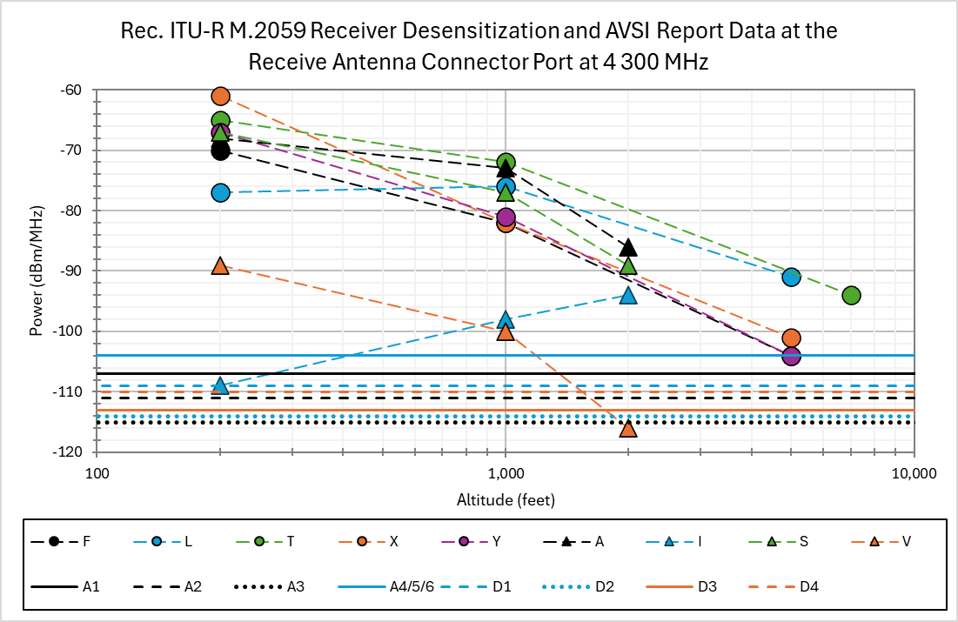

**Figure A1-2: and AVSI Report Data at 4 300 MHz**

**– Plotted as a Function of Reported Altitude**

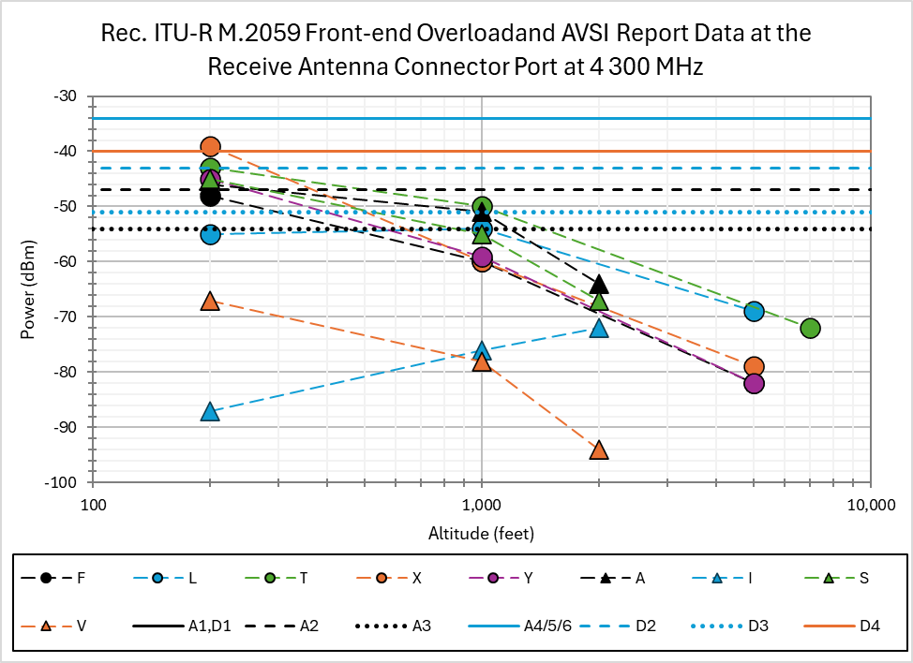

**Figure A1-3: and AVSI Report Data at 4 300 MHz**

**– Plotted as a Function of Reported Altitude**

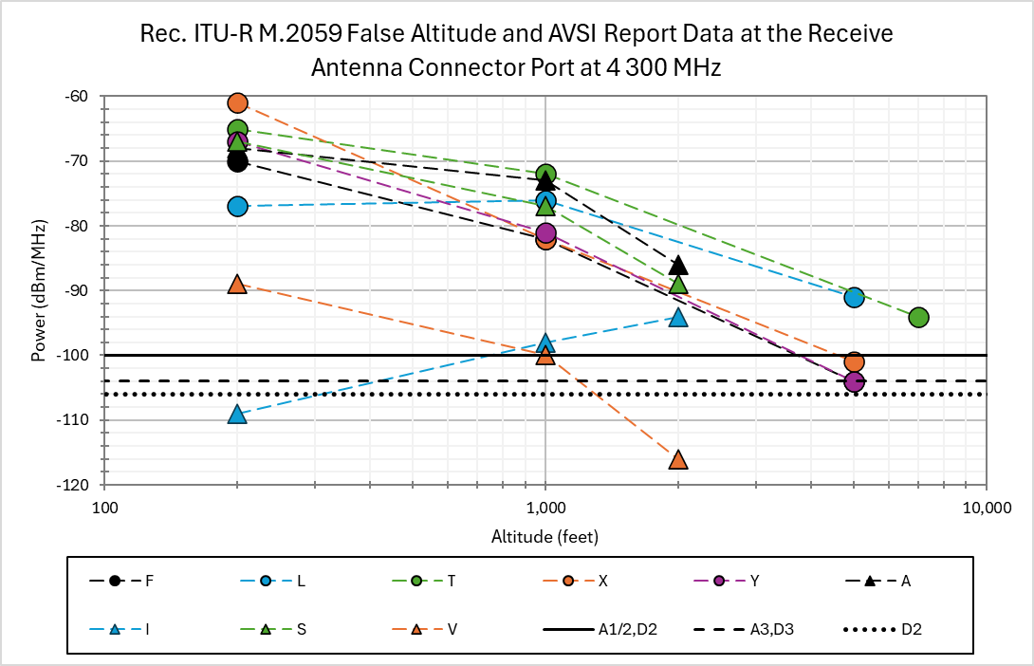

**Figure A1-4: and AVSI Report Data at 4 300 MHz**

**– Plotted as a Function of Reported Altitude**

From Figure A1-1, it is clear that there is a variety of performance characteristics among the tested radio altimeters. [TBD based on updates]

From figure A1-2, comparing to AVSI Report Data, [TBD based on updates].

From figure A1-3, comparing to AVSI Report Data, [TBD based on updates].

From figure A1-4, comparing to AVSI Report Data, [TBD based on updates].

* 1. **Comparison over the frequency range 3 700‑3 980 MHz**

The front-end overload protection criteria in Rec. ITU-R M.2059 applicable over the 3 700‑3 980 MHz frequency range can be compared to the AVSI calculated ITTs over the same frequency range, i.e. the AVSI Report Vol I data points at 3 750, 3 850, and 3 930 MHz. Table A1-6 provides comparisons for the and AVSI Report measured data over the 3 700‑3 980 MHz frequency range.

**Table A1-6: Statistics for Rec. ITU-R M.2059 Protection Criteria and AVSI Reports for 100 MHz Interfering Signals Centered at 3 750, 3 850, and 3 930 MHz**

| **Data Set** | **Sample Size** | **Minimum (dBm/MHz)** | **Maximum (dBm/MHz)** | **Range (dB)** |
| --- | --- | --- | --- | --- |
| **Frequency: 3 750 MHz** | | | | |
| **Front-end Overload Note 1** | 10 | -72.1 | -46.1 | 26 |
| **UC 1 ITT at 200 ft WCLS** | 5 | -33 | >-29 | >4 |
| **UC 2 ITT at 200 ft WCLS** | 4 | -70 | >-50 | >20 |
| **UC 2/3 ITT at 200 ft** | 4 | -62 | >-50 | >12 |
| **UC 1 ITT at 1000 ft** | 5 | -40 | >-35 | >5 |
| **UC 2/3 ITT at 1000 ft** | 4 | -40 | >-35 | >5 |
| **UC 2/3 ITT at 2000 ft** | 4 | -88 | >-30 | >58 |
| **UC 1 ITT at 5000 ft** | 4 | -47 | -29 | 18 |
| **UC 1 ITT at 7000 ft** | 1 | NC | NC | NC |
| **Frequency: 3 850 MHz** | | | | |
| **Front-end Overload Note 1** | 10 | -73.0 | -47.0 | 26 |
| **UC 1 ITT at 200 ft** | 5 | -41 | >-34 | >7 |
| **UC 2 ITT at 200 ft** | 4 | -76 | >-66 | >10 |
| **UC 3 ITT at 200 ft** | 4 | -64 | >-56 | >8 |
| **UC 1 ITT at 1000 ft** | 5 | -47 | >-34 | >13 |
| **UC 2 ITT at 1000 ft** | 4 | -47 | >-34 | >13 |
| **UC 2 ITT at 2000 ft** | 4 | -81 | >-41 | >40 |
| **UC 1 ITT at 5000 ft** | 4 | -54 | >-51 | >3 |
| **UC 1 ITT at 7000 ft** | 1 | -33 | -33 | 0 |
| **Frequency: 3 930 MHz** | | | | |
| **Front-end Overload Note 1** | 10 | -73.7 | -47.7 | 26 |
| **UC 1 ITT at 200 ft** | 5 | -42 | >-31 | >11 |
| **UC 2 ITT at 200 ft** | 4 | -68 | >-58 | >10 |
| **UC 3 ITT at 200 ft** | 4 | -63 | >-54 | >9 |
| **UC 1 ITT at 1000 ft** | 5 | -50 | >-40 | >10 |
| **UC 2 ITT at 1000 ft** | 4 | -50 | >-40 | >10 |
| **UC 2 ITT at 2000 ft** | 4 | -89 | >-46 | >43 |
| **UC 1 ITT at 5000 ft** | 4 | -56 | >-50 | >6 |
| **UC 1 ITT at 7000 ft** | 1 | -40 | -40 | 0 |
| **Note 1:** Front-end Overload is specified in dBm in Rec. ITU-R M.2059; however, this analysis assumes that power is spread over a 100 MHz interfering signal so the data can be compared to the data collected in the AVSI Report.  **Note 2:** Statistics captured with a > indicate the maximum or range is greater than the amount indicated but not quantifiable because an ITT cannot be calculated because the highest testable power level was insufficient to induce a failure criterion as defined in the AVSI reports.  **Note 3:** A reported value of “NC” indicates a value cannot be calculated because the highest testable power level was insufficient to induce a failure criterion as defined in the AVSI reports.  **Note 4:** The test condition for UC1 and UC2 RAs at a simulated altitude of 200 ft also considered the victim test RA to be within 350 ft of other transmitting RA sources. | | | | |

Figures A1-5 and A1-6 plot the range of performance for each data set detailed in Table A1-6 for a 100 MHz interfering signal centred at 3 750 MHz.

Figures A1-7 and A1-8 plot the range of performance for each data set detailed in Table A1-6 for a 100 MHz interfering signal centred at 3 850 MHz.

Figures A1-9 and A1-10 plot the range of performance for each data set detailed in Table A1-6 for a 100 MHz interfering signal centred at 3 930 MHz.

All RA model specific data from Rec. Rec. ITU-R M.2059 are overlayed on the figures to aid in any data set comparison.

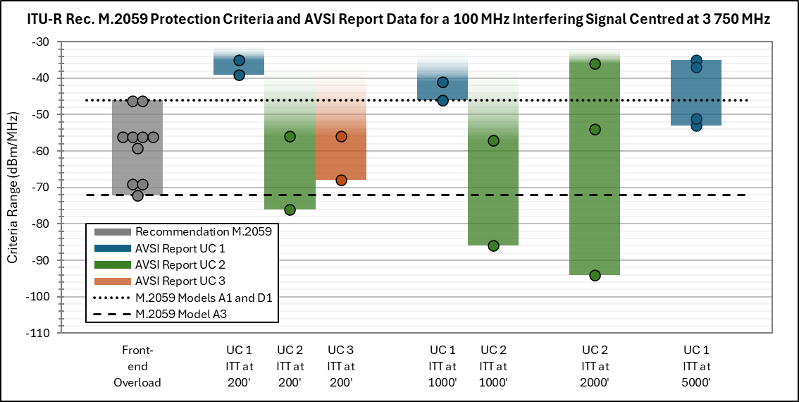

**Figure A1-5: and AVSI Report Data for a 100 MHz Interfering Signal Centred at 3 750 MHz – Statistics Bar Graph**



**Figure A1-6: and AVSI Report Data for a 100 MHz Interfering Signal Centred at 3 750 MHz – Plotted as a Function of Reported Altitude**

Figure A1-5 shows [TBD based on updates]

Figure A1-6 shows [TBD based on updates]

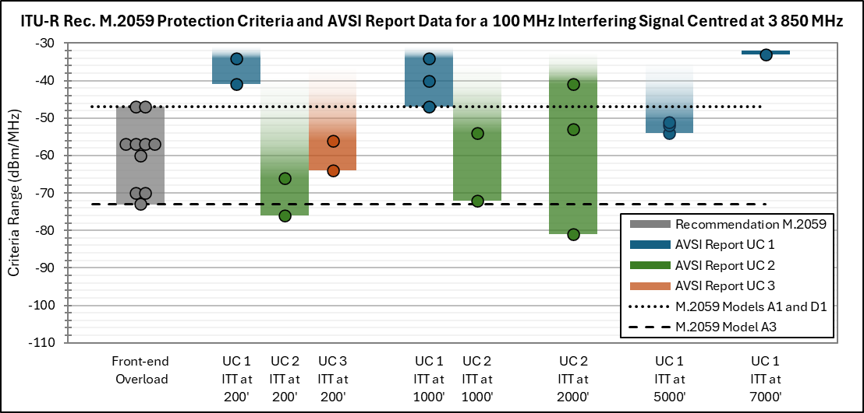

**Figure A1-7: and AVSI Report Data for a 100 MHz Interfering Signal Centred at 3 850 MHz – Statistics Bar Graph**

**[INSERT PLOT]**

**Figure A1-8: and AVSI Report Data for a 100 MHz Interfering Signal Centred at 3 850 MHz – Plotted as a Function of Reported Altitude**

Figure A1-7 shows [TBD based on updates]

Figure A1-8 shows [TBD based on updates]

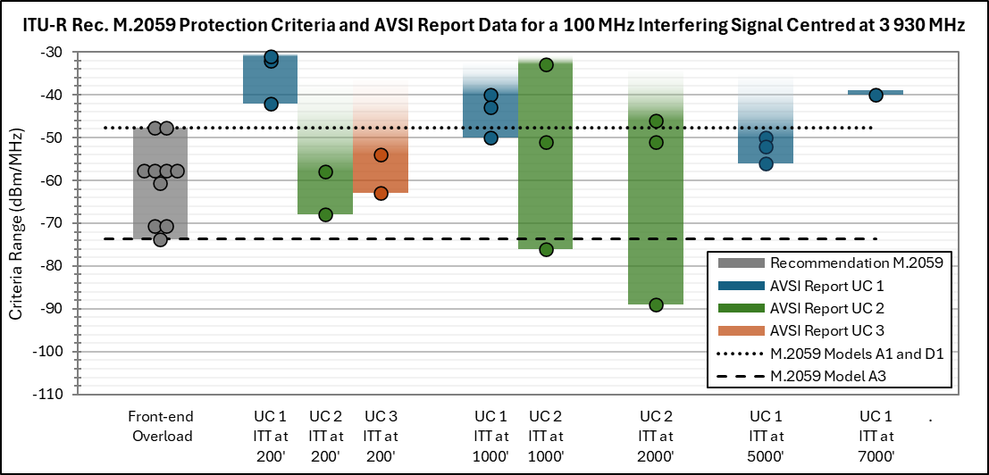

**Figure A1-7: and AVSI Report Data for a 100 MHz Interfering Signal Centred at 3 930 MHz – Statistics Bar Graph**



**Figure A1-8: and AVSI Report Data for a 100 MHz Interfering Signal Centred at 3 930 MHz – Plotted as a Function of Reported Altitude**

Figure A1-9 shows [TBD based on updates]

Figure A1-10 shows [TBD based on updates]

1. **Observations of Section 4 Comparisons**

When comparing the AVSI tested radio altimeter data and the Rec. ITU-R M.2059 *, ,*  within the 4200-4400 MHz frequency band, there is [TBD based on updates]

Comparisons of AVSI tested radio altimeter data and Rec. ITU-R M.2059 data within the 3750 to 3930 MHz frequency ranges show [TBD based on updates]

1. **Conclusions**

The AVSI data is not an exact match of Rec. ITU-R M.2059 altimeters. The Rec. ITU-R M.2059 altimeters were meant to be representative of radio altimeters installed on a variety of aircraft, the information from AVSI provides more insight into the types and performance of radio altimeters through its categorisation of the tested altimeters in “Usage Categories.” All the tested altimeters for Usage Category 1 do show [a trend] of higher interference tolerance at altitudes below 2000 ft in the 4200-4400 MHz frequency band (Figures A1-1 through A1-4), but that is not as apparent in Usage Category 2 [at or above 2000 ft. ]

The AVSI testing is a very small sample of radio altimeters and limits the conclusions that may be drawn as a result. However, several general characteristics can be observed. The AVSI testing is also limited in the number of frequencies tested.

When new radio altimeter standards that are currently under development, new ITU documentation should be developed that provides a higher fidelity radio altimeter model (or models) to be used in sharing and compatibility studies.

ANNEX 2

This Annex provides a technical analysis of recent aviation testing of Radio Altimeter (RA) performance for various altitudes.

**Radio Altimeter Performance Analysis**

Aviation industry test data assessing RA susceptibility to in-band signals within 4200-4400 MHz and signals outside of the RA band show improved tolerance at lower heights relative to the thresholds in M.2059. One example of this test data is the aviation industry measurements performed by the Aerospace Vehicle Systems Institute (AVSI), a cooperative research environment that includes major aerospace companies and government organizations. These measurement data sets are publicly available (https://avsi.aero/afe76s2-report/).

It should be noted that the performance depicted in Rec. ITU-R M.2059 was developed for a condition in which the receiver was operating in a thermal noise-limited environment. By definition, if the receiver’s desired signal level is near thermal noise such that a 1 dB noise rise over thermal may impact the receiver’s performance, then this receiver is operating near the edge of its coverage range. An RA operating at its maximum height limit above terrain would resemble this operating condition. An RA operating at a lower height above terrain receives a much stronger desired signal level than the signal at the maximum height;[6] in this operating condition, a 1 dB rise over thermal noise may not impact the receiver performance. Comparing the aviation test data at a range of heights to the characteristics in Rec. ITU-R M.2059 may help identify whether corrections to M.2059 for lower heights are warranted.

**RA Receiver Susceptibility to In-band Signals Using Publicly Available Measurement Data**

The aviation measurements of RA susceptibility to in-band signals, for the maximum test height versus performance at 200 feet, is shown in Table 1.[7] The performance at 200 ft was 14 to 40 dB better than at the maximum test height. .

**Table 1: RA Receiver Performance in the Presence of In-band Signals is Better at Low Aircraft Altitude[8]**



The Rec. ITU-R M.2059 receiver desensitization thresholds are shown in Table 2, derived from M.2059’s equation 5.

**Table 2: RA Desensitization Threshold from M.2059**



Figure 1 compares the AVSI 200 ft thresholds to the M.2059 receiver desensitization thresholds. The test data was at least 36 dB better than the M.2059 thresholds.

**Figure 1: AVSI UC1 In-band Comparison at 200 ft to M.2059 Desense Thresholds**



**RA Receiver Susceptibility to Out-of-band Signals Using Publicly Available Measurement Data**

The AVSI Volume I report provided RA susceptibility measurements to out-of-band, 100 MHz wide signals centered at 3750, 3850, and 3930 MHz. The AVSI Volume III report provided RA manufacturer-provided measurements over a broader range of center frequencies from 3000 to 5000 MHz. The worst breakpoint for the worst center frequency tested for each RA in both test reports is shown in Table 3, along with the range of center frequencies tested.

**Table 3: AVSI Volume I and III RA Susceptibility to Out-of-band Signals[9]**



Rec. ITU-R M.2059 provided a modest frequency dependent rejection factor, shown for the center frequencies above, in Table 4.

**Table 4: Rec. ITU-R M.2059 Frequency Dependent Rejection**



The M.2059 input power thresholds ranged from -55.6 to -26.1 dBm. The AVSI out-of-band susceptibility measurements of commercial/transport RAs at low height above terrain exceeded the thresholds in M.2059 by wide margins. At maximum height, the RA performance was near that of the best-performing RAs in M.2059.Based on publicly available data from aviation industry testing, more up-to-date measurements of altimeter performance are available and should be used in sharing and compatibility studies.[10] [Finally, while some administrations have been implementing RA filters/retrofits to improve their RF blocking performance on categories of airplanes, those filters cannot be assumed to be installed on all aircraft and should only be modelled as part of a sensitivity analysis.[11]]

1. Data is published at [https://avsi.aero/avsi-publishes-volume-iii-of-the-afe-76s2-report/](https://avsi.aero/avsi-publishes-volume-iii-of-the-afe-76s2-report/%20)
2. This volume also contains some compatibility analysis studies that will not be used in this document, only the radio altimeter data will be extracted
3. This factor accounts for the fact discrete step sizes in power are used to find a and therefore the power associated with the ITT needs to be reduced by the discrete test step sizes used in testing.
4. This factor accounts for equipment measurement error.
5. This factor accounts for two elements, one, statistical deviations in performance among the population of RAs of which the single tested model falls within, and two, statistical deviations in performance accounting for temperature impacts since the models were tested at room temperature but operate in an environment of -X°C to +Y°C.
6. For example, the external loop loss incurred by the RA transmission of an FMCW signal at a height of 7,000 feet is 120 dB, versus a loop loss of 89 dB at 200 feet, a difference of 31 dB. RTCA DO-155, Appendix B, Figure 4.
7. AVSI, *AFE 76s2 Report Derivation of Radar Altimeter Interference Tolerance Masks Volume II: Spurious Test Results*, Doc ID 76s2-REP-04, Dec. 2021, Tables 4-4 and 4-18. The breakpoint, recorded in dBm/160 MHz in the tables, was converted to dBm/MHz by adding 22 dB (10*log(160) = 22 dB). The factors AVSI added for backoff, temperature, unit-to-unit variation, and experimental error are not included.
8. The table presents performance of RAs installed in larger single-aisle and wide-body commercial air transport airplanes. The RAs presented were considered in the recent multi-stakeholder coexistence study conducted by CEPT culminating in ECC Report 362.
9. AVSI, *AFE 76s2 Report Derivation of Radar Altimeter Interference Tolerance Masks Volume I: Introduction, Test Procedures, and Fundamental Test Results*, Doc ID 76s2-REP-03, Dec. 2021. *AFE 76s2 Report Derivation of Radar Altimeter Interference Tolerance Masks Volume III: Manufacturer-Provided Test Results*, AVSI, Doc ID 76s2-REP-05, Apr 2022. A reported value of “NB” indicates the highest testable power level was insufficient to induce a failure criterion. The criterion of mean +/- 0.5% error was not used in the table given lack of basis in ARINC 707 or FAA TSO C87.
10. The recent multi-stakeholder coexistence study conducted by CEPT culminating in ECC Report 362, with robust aviation and wireless industry participation, relied on the publicly available AVSI data to derive the pass/fail thresholds. The report did not rely on M.2059 guidance.
11. The publicly available aviation data pre-dates all filter/retrofit programs.