|  |  |
| --- | --- |
| **U.S. Radiocommunications Sector**  **Fact Sheet** | |
| **Working Party:** ITU-R WP5B | **Document No:** USWP5B34-01 |
| **Reference:**  Document 5B/216 Annex 13  Document 5B/59  IEC 62288:2021 | **Date:** 11 March 2025 |
| **Document Title:** Working Document Towards a Preliminary Draft Revision of Recommendation ITU-R M.585-9, Assignment and use of identities in the maritime mobile service | |
| **Author(s)/Contributors(s):**  Pamela Murray  USCG  Jerry Ulcek  USCG  Johnny Schultz  Sev1tech Inc  Ross Norsworthy  REC Inc  Joe Hersey  JOECEL Engineering | Phone: (202) 657-3081  Email: [pamela.j.murray@uscg.mil](mailto:pamela.j.murray@uscg.mil)  Phone: (202) 579-5924  Email: jerry.l.ulcek@[uscg](http://jerry.l.ulcek@uscg.mil).mil    Phone: (727) 403-4029  Email: [johnnyschultz@sev1tech.com](http://johnnyschultz@sev1tech.com)  Phone: (727) 515-8025  Email: ross_norsworthy@[msn](http://ross_norsworthy@msn.com).com  Phone: (301) 512-9860  Email: joe@[joecel](http://joe@joecel.com).[com](http://joe@joecel.com) |
| **Purpose/Objective:** This document addresses MMSI impacts to AIS navigation displays and the effects of MMSI duplication which need to be considered in amending ITU-R M.585-9 | |
| **Abstract:** The continuing widespread growth in AIS applications has affected and will continue to affect MMSI assignments and allotments. IEC 62288’s necessary interpretation of ITU-R M.585 in the display of AIS symbology on ship navigation displays affects the maintenance of ITU-R M.585 and needs to be considered. | |

|  |  |
| --- | --- |
| **Radiocommunication Study Groups** |  |
|  |  |
|  |  |
| Source: Document 5B/216 Annex 13  Subject: Impacts to AIS navigation displays and effects of MMSI duplication | **Document: USWP5B34-xx** |
| **Date: 11 March 2025** |
| **English only** |
| United States of America | |
| WORKING DOCUMENT TOWARDS A PRELIMINARY DRAFT  REVISION OF RECOMMENDATION ITU-R M.585-9  **Assignment and use of identities in the maritime mobile service** | |
|  | |

# **1 Introduction**

The widespread growth in AIS applications since its introduction over twenty-five years ago has affected and will continue to affect MMSI assignments and allotments defined in Recommendation ITU-R M.585-9. MMSIs are constrained to nine numeric digits, and the way DSC, AIS, and VDES encode these nine digits makes any long-term solution difficult. CIRM, in its contribution to Document 5B/59, makes these limitations and difficulties clear.

IEC 62288:2021 *Maritime navigation and radiocommunication equipment and systems - Presentation of navigation-related information on shipborne navigational displays - General requirements, methods of testing, and required test results have* necessarily had to interpret ITU-R M.585-9 in defining AIS symbology shown on ships’ navigation displays. That necessary interpretation affects ITU-R M.585-9, effectively mandating specific MMSI formatting deemed optional in the ITU-R recommendation. The developers of both standards must understand these interpretations and their consequential effects.

This proposal has two parts.

The first part proposes changes to Recommendation ITU-R M.585-9.

The second part contains a draft liaison to IEC TC80 highlighting concerns about the portrayal of AIS symbology on ships' navigation displays in IEC 62288:2021.

**2 Summary of changes**

Remove paragraphs 4, 5, and 6 from Annex 1 section 4. These paragraphs are optional behavior and unnecessarily restrict the available MMSIs allotted for AtoNs. AIS Message 21 contains the information required to determine what type of AtoN device.

**3 Attachments 1**

The following attachment contains the proposed changes to Recommendation ITU-R M.585-9.

**ATTACHMENT**

WORKING DOCUMENT TOWARDS A PRELIMINARY DRAFT   
REVISION OF RECOMMENDATION ITU-R M.585-9[1]*

Assignment and use of identities in the maritime mobile service

(1982-1986-1990-2003-2007-2009-2012-2015-2019-2022)

(There are no changes before Section 4)

**Section 4  
  
Assignment of identification to automatic identification   
systems aids to navigation**

**1** When a means of automatic identification is required for a station aiding navigation at sea, the responsible administration should assign a 9-digit unique number in the format 9192M3I4D5X6X7X8X9 where the digits 3, 4 and 5 represent the MID and X is any figure from 0 to 9. The MID represents the administration having jurisdiction over the call identity for the navigational aid.

**2** The format shown above applies to all types of aid to navigation (AtoN) as listed in the most recent version of Recommendation ITU-R M.1371, see AIS Message 21 parameter “Type of aids to navigation” and the associated table for this parameter. This format is used for all AIS stations for the transmission of messages that relate to AtoN. In the case where an AIS base station is collocated with an AIS AtoN station the messages related to the base station operation should be assigned an identification number in the format given in Annex 2.

**3** The format scheme shown above will accommodate 10 000 AtoN per MID. If the administration concerned has more than 10 000, they may use an additional country code (MID) if it is already assigned by the ITU giving a further 10 000 identities.

**4** The details of these MMSI assignments should be made available but not limited to the International Association of Marine Aids to Navigation and Lighthouse Authorities (IALA) and appropriate national authorities.

**5** The assigned MMSI to aids of navigation should also be available from the ITU MARS database (see RR No. **20.16**).

**4 Attachments 2**

The following attachment contains the proposed Liaison to IEC TC80 and the supporting explanation.

**Proposed Liaison to IEC TC80**

DRAFT LIAISON STATEMENT TO INTERNATIONAL ELECTROTECHNICAL COMMISSION, TECHNICAL COMMITTEE 80

**WORKING DOCUMENT TOWARDS A PRELIMINARY DRAFT**

**REVISION OF RECOMMENDATION ITU-R M.585-9**

**Assignment and use of identities in the maritime mobile service**

ITU-R Working Party 5B, at its meeting of 29th April to 8th May 2025 continued working toward the revision of Recommendation ITU-R M.585-9, became aware of certain issues that affect or are affected by IEC 62288:2021 *Maritime navigation and radiocommunication equipment and systems - Presentation of navigation-related information on shipborne navigational displays - General requirements, methods of testing and required test result*. Working Party 5B respectfully requests that IEC TC80 consider these issues once IEC 62288 next enters into maintenance.

1. ITU-R M.585-9 Annex 1 Section 4 *Assignment of identification to automatic identification* notes that “The administration may use the sixth digit to differentiate between certain specific uses of the MMSI, as shown in the example applications below:

a) 99MID1XXX Physical AIS AtoN

b) 99MID6XXX Virtual AIS AtoN

c) 99MID8XXX Mobile AtoN

Recommendation ITU-R M.1371-5 AIS Message 21 and the proposed new AIS Message 28 specify means for differentiating among these types of AIS AtoNs. Since using the MMSI sixth digit is optional, it should not be relied upon for differentiating types of AtoNs. This is especially pertinent to AIS Mobile AtoNs, since the current edition of IEC 62288 Annex A Table A.2 2.10.c constrains the use of the MMSI sixth digit to 8 and 9.

ITU-R Working Party 5B proposes deleting paragraphs 4, 5, and 6 from ITU-R M.585-8 Annex 1, Section 4 to alleviate confusion.

1. IEC 62288:2021 Annex A Table A.2 2.15a and 2.15b requires the ITU-R M.1371-5 AIS AtoN Message 9 to have the MMSI seventh digit equal to 1 through 4 to enable a symbol shown on the ship’s navigation display to be of a fixed wing aircraft, and the seventh digit equal to 5 through 9 to enable a symbol of a helicopter. No symbol appears to have been designated when the MMSI seventh digit equal to 0. AIS responses from search and rescue aircraft having an MMSI between 111 MID 000 and 111 MID 099 would appear not to be shown on a ship’s navigation display.
2. Note that certain AIS transmissions, such as those using a freeform number identity from such devices as AIS search and rescue transmitters (SARTs), Man Overboard devices, and AIS Emergency Position Indicating Radio Beacons (EPIRBs), may have duplicate MMSIs. AIS transmissions from other devices, including AIS Mobile Aids to Navigation, may in the future similarly have duplicate MMSIs. WP5B recommends that when IEC 62288 is considered for maintenance, the effect of AIS responses on a ship’s navigation display having duplicate MMSIs be considered and addressed, as appropriate.

|  |  |
| --- | --- |
| **Status:** For action |  |
| **Contact:** Mr Johnny Schultz | **E-mail:** johnny.schultz@sev1tech.com |

Liaison Attachment

1. **Impacts from IEC 62288:2021**
   1. **AIS Mobile Aids to Navigation (AtoN)**

ITU-R M.585-9 Annex 1 Section 4 *Assignment of identification to automatic identification*

*systems aids to navigation* allows administrations to optionally use the sixth digit to differentiate between the following specific uses of the MMSI (current version as it stands):

99MID1XXX Physical AIS AtoN

99MID6XXX Virtual AIS AtoN

99MID8XXX Mobile AtoN

IEC 62288:2021 Annex A Table A.2 2.10.c requires the ITU-R M.1371-5 AIS AtoN Message 21 to have the MMSI sixth digit be an 8 or a 9 to enable the symbol shown on the ship’s navigation display to be of a Mobile AtoN. ITU-R M.585-9 Annex 1 Section 4 states that “administrations may use the sixth digit to differentiate between certain specific uses of the MMSI”, including the value 99MID8XXX as an example for a Mobile AtoN. Using the sixth digit to designate an AIS Mobile AtoN symbol is unnecessary since the AIS Message 21 provides the information required to determine if the device is a Physical, Virtual, or Mobile AtoN. See the extract from IEC 62288:2021 below.

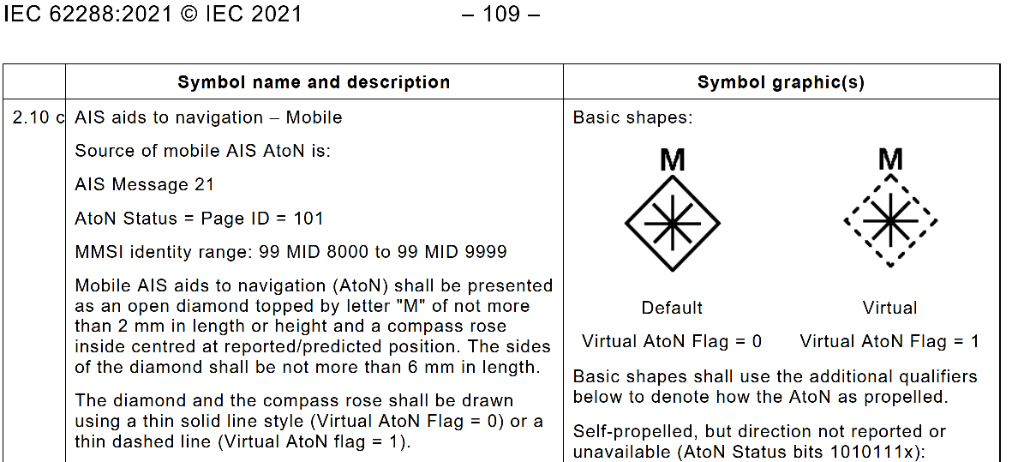

Extract from IEC 62288:2021 Table A.2 – Mobile AIS AtoN

* 1. AIS Mobile AtoN’s, defined by IALA Recommendations R1016, R0126, and Guideline G1154, are versatile devices having wide-ranging applications, e.g. as noted in RTCM 12110.0[2]. The undue constraints on the MMSI numbering imposed by IEC 62288 will inevitably lead to MMSI duplication.
  2. **Virtual AIS AtoN**

AIS Message 21 includes a one-bit Virtual AtoN field, indicating whether the message is meant to designate a physical AtoN or a virtual AtoN. The newly proposed AIS Message 28 includes a three-bit AIS AtoN Station Type field, similarly indicating whether the message is meant to designate a physical AtoN, a virtual AtoN, or some other type of AtoN.

IEC 62288:2021 Annex A Table A.2 2.10.b *AIS aids to navigation – Virtual* does not rely on the MMSI sixth digit, but instead relies on the AIS Message 21 Virtual AtoN Flag to display a virtual AtoN symbol. See the extract from Table A-2 below.

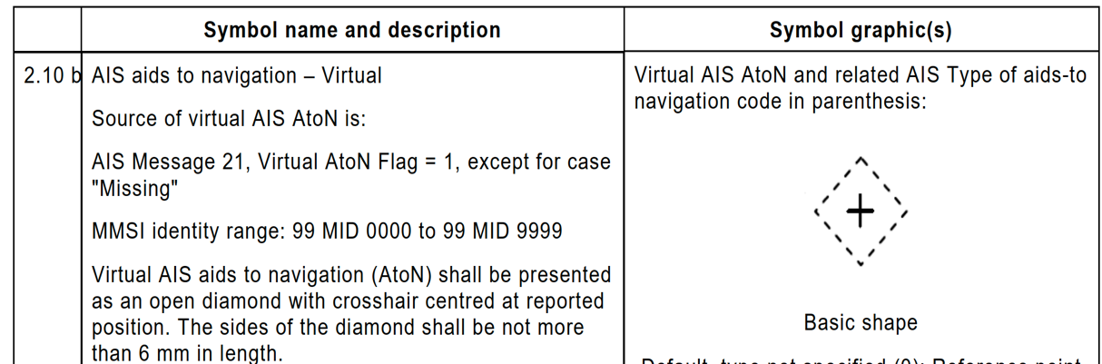

Extract from IEC 62288:2021 Table A.2 – Virtual AIS AtoN

* 1. **AIS Search and Rescue (SAR) Aircraft**

IEC 62288:2021 Annex A Table A.2 2.15a and 2.15b require the ITU-R M.1371-5 AIS AtoN Message 9 to have the MMSI seventh digit equal to 1 through 4 to enable a symbol shown on the ship’s navigation display to be of a fixed wing aircraft, and the seventh digit equal to 5 through 9 to enable a symbol of a helicopter. ITU-R M.585-9 Annex 1 Section 3 states that “administration may use the seventh digit to differentiate between certain specific uses of this class of MMSI”, giving these fixed-wing aircraft and helicopters example applications.

Unfortunately, no example application or symbol is specified when the seventh digit is equal to 0. Search and Rescue (SAR) Aircraft transmitting AIS messages having such an MMSI would apparently not be seen on a ship’s navigation display, since that MMSI is undefined by IEC 62288. Until that problem is resolved, it is recommended that administrations temporarily not assign MMSIs having a seventh digit equal to 0 to AIS transceivers used with SAR aircraft. See the extract from Table A-2 below.

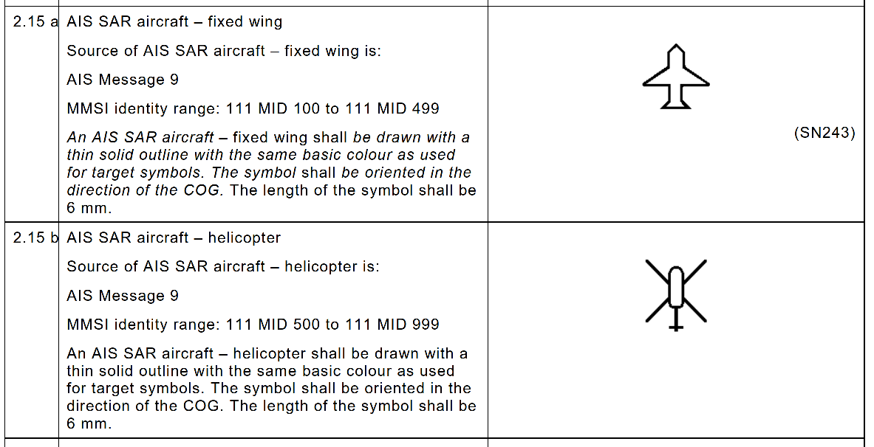

Extract from IEC 62288:2021 Table A.2 – SAR Aircraft

1. **MMSI Duplication**

As shown by CIRM regarding devices using a freeform number identity, and now likely for AIS Mobile AtoNs, MMSI duplication is a growing problem that is not easily resolved. AIS applications were never envisioned when MMSIs were developed forty-five years ago. A new more flexible MMSI scheme is of course possible, but because of the means MMSIs are encoded onto DSC and AIS, no new scheme would be interoperable with the thousands of DSC and AIS devices now in use. Because occasional MMSI duplications are inevitable, especially with AIS, AIS navigation displays should be designed with this fact in mind.

1. * This Recommendation should be brought to the attention of International Association of Marine Aids to Navigation and Lighthouse Authorities (IALA), International Civil Aviation Organization, International Hydrographic Organization, International Maritime Organization and Committee International Radio Maritime.
2. RTCM has also published RTCM 12110.0 - Standard for AUTOMATIC IDENTIFICATION SYSTEM (AIS) MOBILE AIDS TO NAVIGATION (MATON) STATIONS (AIS MATON), November 30, 2024. See [RTCM Maritime Navigation Equipment Standards](https://www.rtcm.org/publications).