|  |  |  |
| --- | --- | --- |
| U.S. Radiocommunications Sector  Fact Sheet | | |
| **Working Party:** ITU-R WP 5B | **Document No:** USWP5B34-06b | |
| Ref: Resolution 256 (WRC-23) | **Date:** 2/8/25 | |
| **Document Title:** Additional Information on WAIC | | |
| **Author(s)/Contributors(s):**  Michael Mullinix  CTIA | | Phone: 301-639-7159  Email: mmullinix@ctia.org |
| **Purpose/Objective:** This contribution presents analysis on WAIC operating in the 4.2-4.4 GHz band and a LS to ICAO. | | |
| **Abstract:** This contribution presents analysis on WAIC operating in the 4.2-4.4 GHz band and a LS to ICAO. | | |

|  |  |
| --- | --- |
| **Radiocommunication Study Groups** |  |
|  |  |
|  |  |
| Subject: WRC-27 agenda item 1.7 | Document 5B/USA-E |
| Date 2025 |
| English only |
| United States of America | |
| Additional information on WAIC | |

**Summary**

In this contribution, the United States provides a technical analysis of the ICAO proposed WAIC requirements. A draft liaison statement to ICAO on the topic is proposed.

**WAIC Technical Analysis**

The WAIC SARPS-derived in-band interference threshold of -120 dBm/MHz may contain a technical error. The SARPS assumed that external sources of interference are additive to the thermal noise level prior to accounting for the receiver’s own noise, as shown in Table 1 below.

**Table 1: WAIC SARPS Current Calculation of Permissible External Interference**

|  |  |  |  |
| --- | --- | --- | --- |
| **Parameter** | **Value** | **Units** | **Formula** |
| Thermal Noise in 1 MHz | -114 | dBm/MHz | a |
| External Interference | -120 | dBm/MHz | b |
| Total N+I | -113 | dBm/MHz | c = 10*log((10^(a/10)+(10^(b/10))) |
| Noise Figure | 10 | dB | d |
| Required SNR | 14 | dB | e |
| WAIC Rx Sensitivity | -89 | dBm/MHz | f = c + d + e |

Alternatively, an external interference level may be referenced at the detector, following the summation of the internal receiver noise, consisting of thermal noise plus the noise figure, resulting in -110 dBm/MHz as shown in Table 2.

**Table 2: Adjusted Derivation of Permissible External Interference**

|  |  |  |  |
| --- | --- | --- | --- |
| **Parameter** | **Value** | **Units** | **Formula** |
| Thermal Noise in 1 MHz | -114 | dBm/MHz | a |
| Noise Figure | 10 | dB | b |
| Total Receiver Noise | -104 | dBm/MHz | c = a + b |
| External Interference | -110 | dBm/MHz | d |
| Total N+I | -103 | dBm/MHz | e = 10*log((10^(c/10)+(10^(d/10))) |
| Required SNR | 14 | dB | f |
| WAIC Rx Sensitivity | -89 | dBm/MHz | g = e + f |

More importantly, the WAIC SARPS approach may have overlooked the environment of the 4200-4400 MHz band in which aviation systems with co-channel emissions exist and exert a distinct impact on the WAIC link budget. Several scenarios are presented below to illustrate that Table 2’s adjusted external interference threshold is below the ambient noise environment. The WAIC SARPS may need further consideration to reflect the noisier operational environment, and correspondingly higher permissible external interference threshold.

***Scenario 1: Landing Aircraft RAs Interfering with Taxiway WAIC Receiver***

The first scenario assumes the landing aircraft scenario used in aviation technical bodies for assessing interferenceshownbelow in Figure 1.

**Figure 1: Landing Scenario**

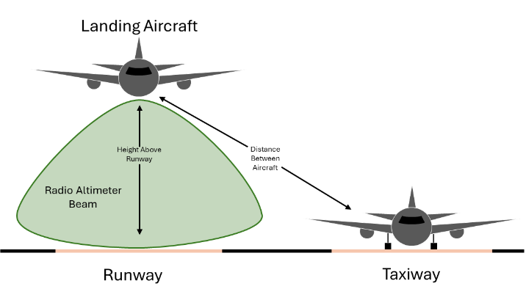

The landing aircraft’s RAs are transmitting during the landing approach. A second aircraft, on the taxiway nearby, is operating WAIC co-channel as envisioned by M.2067. The RA interference level at the WAIC receiver well exceeds the other-band interference threshold defined in the WAIC SARPS, as shown in Table 3.

**Table 3: Landing Aircraft RA and WAIC Analysis**



In this aviation scenario, the ambient RF environment exceeds the WAIC SARPS by 45 dB.

The RAs on the landing aircraft greatly increase the WAIC ambient noise level to such a degree that any WAIC receivers located outside of the aircraft will be subject to interference greater than the in-band interference threshold of -120 dBm/MHz, as shown in Table 4. The WAIC receiver requires a desired signal to be 41.6 dB stronger to be detected in this environment.

**Table 4: Landing Aircraft RA Interference and WAIC Service Outside the Aircraft Analysis**



***Scenario 2: Overflight – RA to WAIC Interference***

The second scenario assumes one aircraft with three RAs is flying 1,000 feet above a second aircraft, on a different heading, equipped with WAIC.[1] The resulting RA signal levels at the WAIC receiver are calculated in Table 5.

**Table 5: RA and WAIC In Flight Analysis: 1,000 ft**



This analysis shows an RA-equipped aircraft passing 1,000 ft above an aircraft operating WAIC would exceed the in-band interference threshold proposed in the WAIC SARPS by 44 dB.

Another example of overflight involves two aircraft traveling in the same direction, with a vertical separation of 2,000 ft. Table 6 shows that the WAIC exceedance is 38 dB.

**Table 6: RA and WAIC In Flight Analysis: 2,000 ft**



In both overflight scenario calculations, the RA interference exceeds the in-band interference threshold of -120 dBm/MHz for WAIC operation outside of the aircraft. The link budget for the 2,000 ft separation distances is shown in Table 7.

**Table 7: RA Overflight Interference and WAIC Service Outside the Aircraft Analysis**



**WAIC Conclusions**

As the new WAIC systems are being proposed to operate co-channel with radio altimeters, the WAIC SARPS external interference threshold of -120 dBm/MHz may need to be re-evaluated (or revised upward), given the high levels of interference from other co-channel aviation services.

Attachment

|  |
| --- |
| DRAFT LIAISON STATEMENT TO ICAO |
| **Additional technical information on WAIC operations** |

Working Party (WP) 5B would like to thank ICAO for its recent liaison statements containing additional technical and operational characteristics for WAIC operating in the frequency band 4200- 4400 MHz ([reference to most recent ICAO LSs]). WP 5B notes that ICAO is developing draft WAIC SARPs that “specify that WAIC receivers shall tolerate interference from sources operating outside of the frequency band 4 200-4 400 MHz whose total combined emitted power falling within the frequency band 4 200-4 400 MHz does not exceed a power spectral density of −120 dBm/MHz as measured at the receiver input port.” Based on technical analysis submitted to WP 5B ([reference, as needed)], it appears that WAIC usage outside of aircraft, especially with ICAO proposed requirements, indicates that it cannot work in the current interference environment with other operational systems that have spurious emissions falling into the 4.2 – 4.4 GHz band. However, this coexistence issue does not occur if a reasonable interference threshold is specified and the WAIC receiver is inside the fuselage.

Working Party 5B would kindly request ICAO consider this analysis as it further develops the draft ICAO SARPs and would welcome any additional information ICAO may have available on the topic.

|  |  |
| --- | --- |
| **Status:** For action |  |
| **Contact:** | **E-mail:** |

______________

1. *Instrument Procedures Handbook*, FAA-H-8083-168, Federal Aviation Administration, Department of Transportation, 2017, at 2-2. “When operating under IFR, between the surface and an altitude of Flight Level (FL) 290, no aircraft should come closer vertically than 1,000 feet.”