U.S. Radiocommunications Sector
Fact Sheet
Working Party: ITU-R WP 5B | Document No: USWP5B25-03
Ref: ITU-R 5B/712-E Annex 7 | Date: 7 October 2020
Document Title: PRELIMINARY DRAFT NEW REPORT ITU-R M.[UA_PFD] - Review of power flux-density limits in accordance with resolves 16 of Resolution 155 (WRC-15)
Author(s)/Contributors(s):  Name: Don Nellis  Org: Federal Aviation Administration  Name: Michael Neale  Org: ACES Corporation for the FAA | Phone: (202) 267-9779  Email: Donald.Nellis@faa.gov  Phone: (858) 705-8978  Email: michael.neale@aces-inc.com
Purpose/Objective: The purpose of this contribution is to propose the update of the PRELIMINARY DRAFT NEW REPORT to a DRAFT NEW REPORT. No changes, other than the status, are proposed to the version that was Annex 7 to the Chairman’s Report from the April 2019 meeting of WP 5B and carried over without discussion during the July 2020 meeting of WP 5B. This pfd mask now exists as an example in Annex 2 to Resolution 155 (WRC-19) so the report needs to be finalized so the example can become the normative requirement in the resolution.
This Report is required to address resolves 14, 15 and 16 in Resolution 155 (WRC-19) in support of Agenda Item 1.8.

Abstract: This contribution examines the pfd required to protect the FS from emissions from the CNPC link transmitter located on the UA and proposes updating the pfd mask in Annex 2 of Resolution 155 (WRC-19) in accordance with those studies.

Radiocommunication Study Groups
Source: Document 5B/712, Annex 7  Subject: Resolution 155 (Rev.WRC-19) | Document 5B/XXX
 | November 2020
 | English only
United Sates of America
PRELIMINARY DRAFT NEW REPORT ITU-R M.[UA_PFD]
Review of power flux-density limits in accordance with resolves 16 of Resolution 155 (Rev.WRC-19)

Introduction
Resolution 155 (Rev.WRC-19) in its resolves 15 identifies the need to develop power flux-density (pfd) hard limits to protect terrestrial services from emission from the Unmanned Aircraft Earth Station (UAES). Examples for such hard limits are given in Annex 2 to Resolution 155 (Rev.WRC-19). Resolves 16 of Resolution 155 (Rev.WRC-19) asks for a review of the pfd limits given in its Annex 2, and that WRC-23 shall review and, if necessary, revise those pfd limits.
In accordance with “invites ITU-R” of Resolution 155 (Rev.WRC-19) studies described in this Report were performed in order to assist in determining the need to review and, if necessary, revise the pfd limits contained in Annex 2 of Resolution 155 (Rev.WRC-19).
Proposal
The United States of America proposes to assist in answering the above resolves with the attached contribution, which analyses the pfd required to protect the Fixed Service in frequency bands which the FS shares with the FSS.
Since this report had been develop over the last study cycle and was substantially finished early last year the USA is proposing to update the status of the Report to a Draft New Report.

Attachment:

attachment
DRAFT NEW REPORTITU-R M.[UA_PFD]
Review of power flux-density limits in accordance with resolves 16
of Resolution 155 (Rev.WRC-19)
Keywords

Abbreviations/Glossary
CCDF: Complementary cumulative distribution function
CNPC: Command and non-payload communication
FDP: fractional degradation of performance
I/N: Interference to noise
LTPC: Long-term protection criterion
pfd: Power flux density
STPC: Short-term protection criterion
UA: Unmanned aircraft
UAS: Unmanned aircraft systems
Related ITU Recommendations, Reports
ITU-R F.758 System parameters and considerations in the development of criteria for sharing or compatibility between digital fixed wireless systems in the fixed service and systems in other services and other sources of interference
ITU-R F.1108 Determination of the criteria to protect fixed service receivers from the emissions of space stations operating in non-geostationary orbits in shared frequency bands

ITU-R F.1245 Mathematical model of average and related radiation patterns for line-of-sight point-to-point fixed wireless system antennas for use in certain coordination studies and interference assessment in the frequency range from 1 GHz to about 70 GHz
ITU-R M.1643 Technical and operational requirements for aircraft earth stations of aeronautical mobile-satellite service including those using fixed-satellite service network transponders in the band 14-14.5 GHz (Earth-to-space)
Introduction
Resolution 155 (Rev.WRC-19) in its resolves 15 identifies that power flux-density (pfd) hard limits that need to be developed for unmanned aircraft systems (UAS) command and non-payload communication (CNPC) links; one possible example of such a provisional limit to protect the fixed service is provided in its Annex 2
Resolves 16 of Resolution 155 (Rev.WRC-19) asks for a review of the pfd limits given in its Annex 2, and that WRC-19 shall review and, if necessary, revise those pfd limits. This resolves deals with the review of Annex 2 required to protect terrestrial. This implies that all current and future terrestrial service needs to be protected in all countries and thus the pfd process should not be limited to the protection of the fixed service in specific countries
There seems to be discrepancies between the language used in these resolves e.g. resolves 14 referred to the UAS-CNPC shall not cause harmful interference to the terrestrial service. Under RR. Nos. 5.43 and 5.43A it implies that UAS-CNPC also shall not claim protection from terrestrial. This implies that UAS CNPC will operate under non-protection, non-interference basis (e.g. secondary status) this inconsistency needs to be addressed.
In reviewing Annex 2 of Resolution 155 it was noted that while resolves 16 referred to the pfd hard limit to be reviewed which in reality merely understood to be the fixed service however resolves 14 made reference to the terrestrial services, consequently inconsistencies need to be addressed. Noting that terrestrial services are not limited to the fixed service.
In accordance with “invites ITU-R” of Resolution 155 (Rev.WRC-19) studies contained in this Report were performed in order to assist in determining the need to review and provide technical parameters to revise, as appropriate, the pfd limits contained in Resolution 155 (Rev.WRC-19).
During the development of these studies it was determined, following the methodology detailed in Annex 1, that different pfd masks were required for each of the two sub-bands within the frequency band 14-14.47 GHz to protect the terrestrial services. The following two studies were therefore undertaken:
– Study #1: 14-14.3 GHz – For protection of the terrestrial services in the countries listed in RR No. 5.505 (see Annex 2).
– Study #2: 14.25-14.47 GHz – For protection of the terrestrial services in this frequency range for relevant administrations not being subject of study #1 (see Annex 3).
These studies only consider the protection of the fixed service since characteristics for other terrestrial services to which this frequency band is allocated are not available, but it can be assumed that these other services would be appropriately protected with the technical conditions defined herein to protect the fixed service.
It is therefore considered that the pfd limits which protect the fixed service would be sufficient for all terrestrial services which have allocations in these frequency bands.
- General comments
During the development of this Report, the following concerns on the applicability of a pfd limit were raised:
The issue of how the earth station on board any aircraft would be coordinated with terrestrial systems has been the subject of intensive discussions at various WARCS and WRCs for several decades. Currently there is no agreed established methodology to perform this task. There are two reasons for this fact:
1 the aircraft earth station is considered as an aeronautical mobile satellite earth station for which there is no established procedure for coordination, and
2 the involvements of many administrations over the territories of which the aircraft flies.
This issue is currently also being discussed under WRC-19 agenda item 1.5 (ESIM aircraft station).
There was some idea that such a type of earth station could be considered as a source of interference from an altitude above the ground to the surface of the Earth on which the terrestrial service would operate. One possible way to protect the service areas of those terrestrial services on the surface of the Earth is the establishment of an appropriate pfd as a guideline to assist administration to evaluate whether or not such a CNPC/unmanned aircraft (UA) protects their terrestrial service, based on the terms and conditions described in the Resolution 155 (Rev.WRC-19) using the concept of “Not causing harmful interference Nor claiming protection”. Now the question is how such a pfd could be established for an earth station, which is in motion at different altitudes and at different directions in which the amount of received signal on the surface of the Earth is always varying. Consequently, such a course of action may be used as guidance, to the extent technically possible, for the estimation of the power produced on the surface of the Earth but it would be in fact uncertain on the exact amount of pfd produced at any moment and under all circumstances. However, such type of guidance to estimate pfd establishment merely protects the service with typical technical and operational characteristics and NOT the assignments relating to the terrestrial station for which there is another coordination procedure in Article 9 of the Radio Regulations namely RR No. 9.17 and RR No. 9.18. Since the aircraft earth station is always in motion when transmitting and receiving no coordination procedure currently addresses that situation.
This issue was also reflected in Resolution 156 (Rev.WRC-19) dealing with Earth Station On Mobile Platforms (ESOMP). The proposed pfd approach may protect to some extent and with some uncertainty in an approximate manner the” terrestrial service area”. However, whether such a course of action will sufficiently protect the assignments pertaining to terrestrial stations of other administrations has to be determined.
Moreover, the applicability of the pfd for the protection of the terrestrial service (and not the protection of the assignment) needs to be carefully examined to verify its validity for such protection due to the moving feature of the earth stations on board the aircraft. Consequently, for the protection of terrestrial stations and their assignments the non-interference conditions should be applied. The mobile service has also to be taken into account in order to ensure the protection of the terrestrial services. The current study does not provide analysis for mobile service due to lack of characteristics in any Recommendation or registered assignment in the frequency band 14-14.47 GHz, inclusion of a margin to cover the protection of all allocated terrestrial services needs to be studied and included as appropriate in the final results. A fixed margin to be studied has been proposed to be included in the pfd value to permit the administration operating allocated terrestrial services in order to take further action on licensing stage.
The following arguments provide explanation on the relevancy of pfd for station aboard aircraft in order to protect terrestrial services:
In reviewing Resolution 155 (Rev.WRC-19) Working Party 5B notes that the pfd approach contained in Article 21 of the Radio Regulations is used for the protection of terrestrial services where coordination between earth station and terrestrial station assignments is governed by Article 9 of the Radio Regulations namely RR No. 9.17 and RR No. 9.18.
Coordination for earth stations is governed by the procedures called by RR No. 9.6. Under this provision RR No. 9.17 describes the case of earth station coordination which requires coordination with administration inside the coordination area of the earth station.
The determination of the coordination area is described in RR Appendix 7. In accordance with section 1.4.7 of RR Appendix 7 the coordination area for an earth station onboard an aircraft is predetermined with a coordination distance of 1 000 km. Effectively coordination is required with all terrestrial stations inside a radius of 1 000 km around an earth station onboard an aircraft. Given that the operation of unmanned aircraft is expected to be worldwide a case by case coordination is not possible.
In order to come to a practical solution, it is necessary to define parameters which limit the emission of earth station onboard unmanned aircraft in such a way that their impact on terrestrial stations will not exceed the level of a permissible interference. This report therefore aims to define pfd limits to protect terrestrial services from emissions of earth stations onboard unmanned aircraft to avoid the coordination process. This is the same principle used in Recommendation ITU-R M.1643 and has been adopted in the technical study contained in this Report.
The appropriateness of the pfd masks is dependent on the representability of the victim parameters taken into account in the study.
For example in the case of 14.25-14.47 GHz, the Fixed service parameters were worst case parameters for configurations in Europe that are more stringent that in Recommendation ITU-R F.758. In such a situation, all Fixed service stations would be protected apart from those with exceptional characteristics.
- Summary of the Study
In accordance with resolves 16 of Resolution 155 (Rev.WRC-19) this study reviewed the pfd limits in Annex 2 of Resolution 155 (Rev.WRC-19), and concluded that they should be revised in accordance with the following:
1 In the frequency range 14.25-14.47 GHz used by stations (FIXED SDERTRVICE), within line-of-sight of the territory of an administration not subject to RR No. 5.505
- In the frequency band 14.25-14.3 GHz on the territory of countries listed in No 5.508
- In the frequency band 14.3-14.4 GHz in Regions 1 and 3
- In the frequency band 14.4-14.47 GHz worldwide
where services are operating in this range, the maximum pfd produced at the surface of the Earth by emissions from a single earth station on board a UA communicating with a space station of the fixed-satellite service should not exceed:
$pfd=15\log_{10}\left(θ+0.9\right)-133.5 dB\left(W/(m^{2}∙MHz)\right)$ for 0° ≤ $θ$ ≤ 90°
where θ is the angle of arrival of the radio wave at the Earth’s surface.
2 In the frequency band 14-14.3 GHz used by terrestrial stations, inside and at the border of the territory of an administration where terrestrial services are operating in this band according to RR No. 5.505, the maximum pfd produced at the surface of the Earth by emissions from a single earth station on board a UA communicating with a space station of the fixed-satellite service should not exceed:
$pfd=15\log_{10}\left(θ+0.9\right)-124 dB\left(W/(m^{2}∙MHz)\right)$ for 0° ≤ $θ$ ≤ 90°
where $θ$ is the angle of arrival of the radio wave at the Earth’s surface.
A comparison of these masks with that from the “Example provided by WRC-15” in Annex 2 of Resolution 155 (Rev.WRC-19) is shown in Figure 1.
The impact of multiple UAS/CNPC need to be taken into account.
The process is merely took into account specific type of fixed service and also did not take into account any Mobile service. Moreover, such course of action does not cover the full range of fixed and mobile service
FIGURE 1
Comparison of power flux density masks
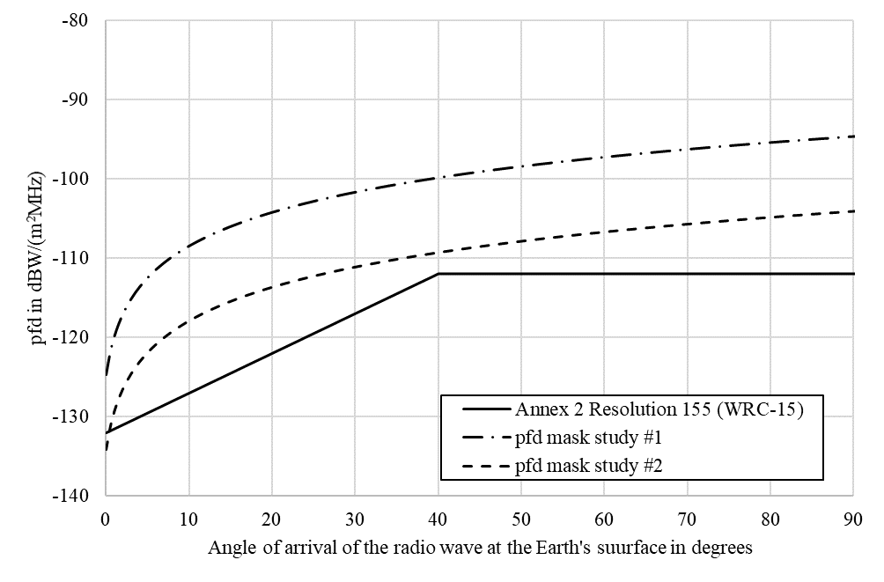

Annex 1
Methodology

1 Principle
The methodology provides a verification of whether the protection criteria for a fixed service station are respected with non-stop co-channel line-of-sight operation during a period of one month of a single unmanned aircraft (UA).
The UA flight path is defined randomly on great-circle trajectories at a constant altitude and speed.

2 Process
The figure below shows the stages of the methodology adopted.
Figure 2
Process of the methodology
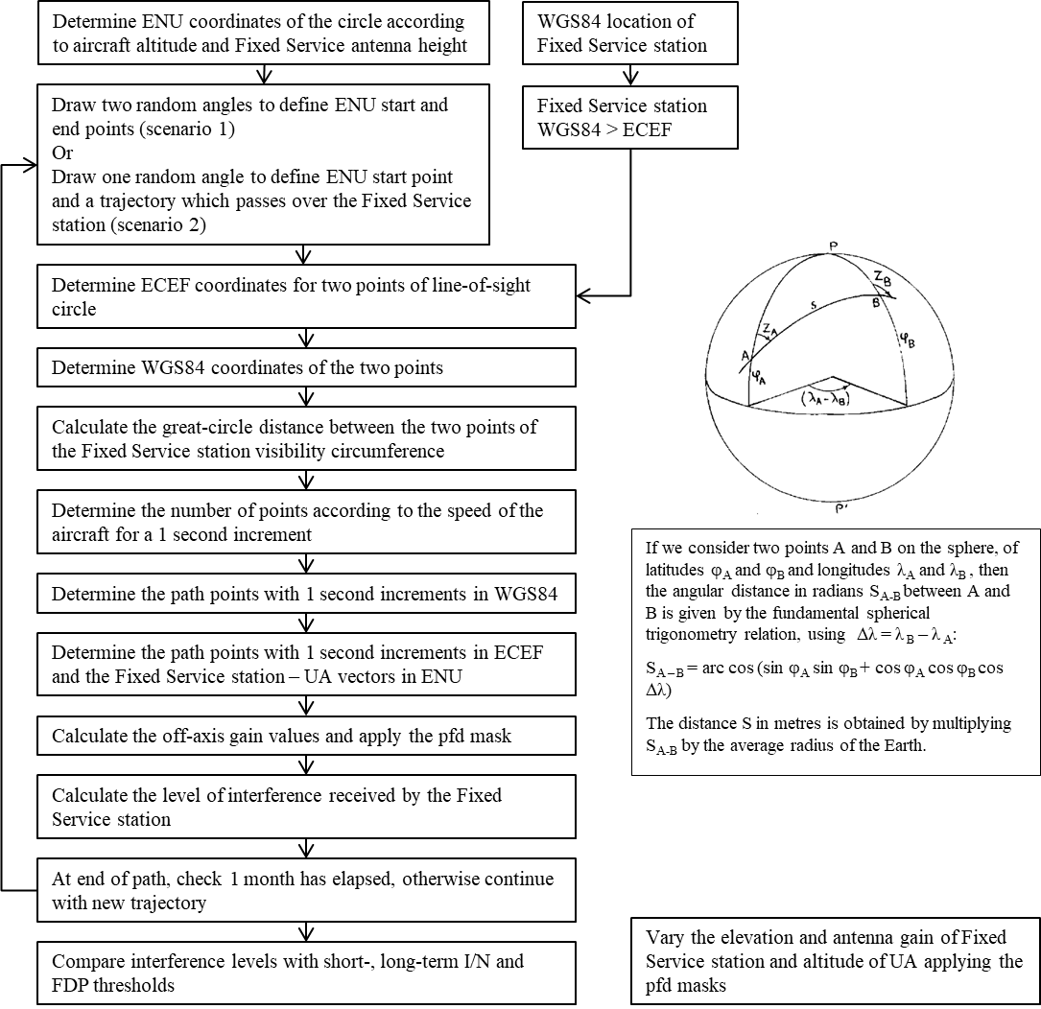

3 Geometry
a) Principle
According to WGS84 definitions:
Semi-major axis: a = 6 378 137 m
Flattening coefficient: F = 1/298.257223563
The following parameters are inferred:
Semi-minor axis: b = a(1-F) = 6 356 752.3142 m
First eccentricity: e = $\sqrt{2f-f^{2}}$$\sqrt{2F-F^{2}}$ = 8.1819190842622$∙$10⁻²
Second eccentricity: e’ = $\sqrt{f\frac{2-f}{{(1-f)}^{2}}}$$\sqrt{F\frac{2-F}{{(1-F)}^{2}}}$ = 8.2094437949696$∙$10⁻²
Mean radius of the semi-axes: R1 = 6 371 008.7714 m
The different references used are the following:
– ECEF (Earth-Centered, Earth-Fixed)
– WGS84 (World Geodetic System 84)
– ENU (East, North, Up).
They are presented in the figure below, where the angles φ and λ represent respectively the WGS84 latitude and longitude.
figure 3
Coordinate references systems
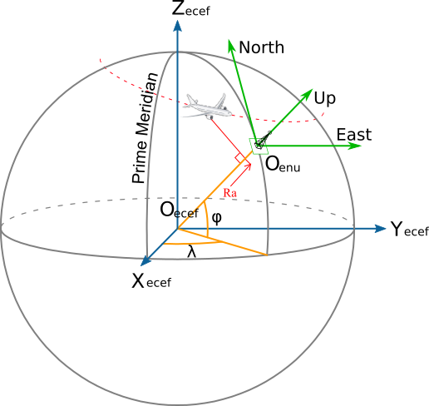
b) Receiver: fixed service station
Due to the applied methodology the results are independent from the location (latitude and longitude) of the fixed service.
The antenna height of the station used for the study is 30 m and is always pointing in the same direction.
c) Transmitter: Unmanned aircraft earth station
The UA trajectory is defined by an entry point and an exit point selected on the fixed service station’s line-of-sight circle, then by the points equally distributed on the great circle trajectory between those two points. The distance between two intermediary points on the great circle is the distance equivalent to one second trajectory at the given speed.
Two different scenarios are considered in each study:
Scenario 1:
In the scenario 1, the entry and exit points are both chosen randomly on the line of sight circle of the fixed service station.
Scenario 2:
In the scenario 2, the entry points are chosen randomly on the line of sight circle of the fixed service station but the exit points are forced to be at 180° of their corresponding entry point, so that the UA always flies over the fixed service station.
In Figures 4 and 5 example flight trajectories for scenario 1 and 2 are shown, colour-coded to show interference to noise ratio (I/N) (blue low and red high).
Figure 4  Flight trajectories scenario 1 | Figure 5  Flight trajectories scenario 2
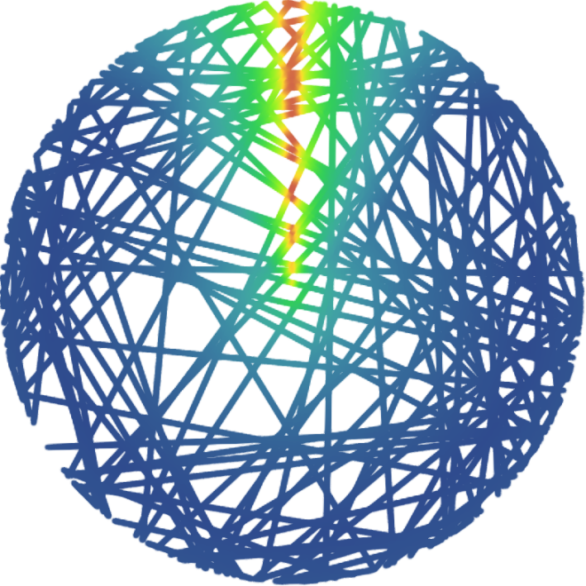 | 
The following altitudes have been considered: 1 000 m, 4 000 m, 7 000 m, 10 000 m, 13 000 m and 16 000 m. Several aircraft speeds were used in the simulation and it was found that the results were not dependent on this parameter. However, the results presented in this study were generated for an aircraft speed of 200 kt (370 km/h).
Figure 6 below shows the parameters used to define the line-of-sight circle:
figure 6
Parameters for line-of-sight circle
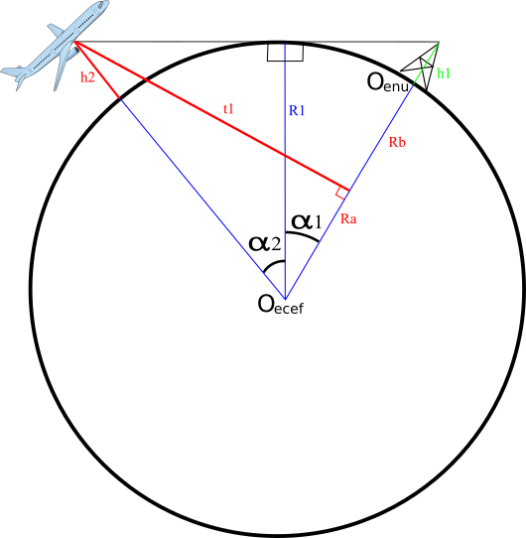
$α_{1}=\cos^{-1}\left(\frac{R1}{R1+h1}\right)$

$α_{2}=\cos^{-1}\left(\frac{R1}{R1+h2}\right)$

$PtCirconference_ENU(ψ)=\left\{\begin{aligned}\left(R1+h2\right)∙sin\left(∝_{1}+∝_{2}\right)∙cos(ψ) \\ \left(R1+h2\right)∙\sin\left(∝_{1}+∝_{2}\right)∙sin(ψ) \\ -R1-h1+\left(R1+h2\right)∙cos\left(∝_{1}+∝_{2}\right)\end{aligned}\right.$
With ψ as the azimuth of the visibility circle of the Fixed service station.

4 Characteristics of fixed service station
a) Interference level
The interference level is obtained by applying the following formula:
$$I=pfd\left(θ\right)+G_{Rec}\left(\right)-10\log_{10}\left({4π\left(\frac{f}{c_{0}}\right)}^{2}\right)$$
with:
f in Hz;
$c_{0}$ as the speed of light in m/s;
$G_{Rec}$ as the receive gain of the fixed service station;
θ is the angle of arrival of the radio-frequency wave in degrees; and
ζ as the angle between the point of boresight of the fixed service station antenna as the UA as seen from the fixed service station in degrees.
b) Noise level
The receiver noise power density of the fixed service station considered in this study is, according to Recommendation ITU-R F.758, -136 dBW/MHz.

5 Protection criteria
In accordance Rec. ITU-R F.758, all of the following three protection criteria are used in the study:
– The long-term protection criterion (LTPC) of not exceeding an I/N level of -10 dB for more than 20 percent of the time.
– The short-term protection criterion (STPC) of an I/N level of +19 dB for more than 2.7$∙$10⁻⁴ percent of the time.
– A fractional degradation of performance (FDP) threshold of 10% according to the methodology set out in in Recommendation ITU-R F.1108.

ANNEX 2
Study #1 14-14.3 GHz
Summary
To ensure protection of the fixed service from emissions of a UA communicating with a satellite, the pfd mask is proposed to be applied in the identified frequency band 14-14.3 GHz which is also used by the fixed service on a co-primary basis with the fixed-satellite service in certain countries identified in RR No. 5.505.
For verification that the pfd mask protects the fixed service in this frequency band, the methodology described in Annex 1 was applied.

1 Fixed service receive characteristics
a) Antenna gain
The antenna gain used for the studies is selected, respectively, as 37 and 28 dBi. The antenna pattern is based on Recommendation ITU-R F.1245 for point-to-point (P-P) links.
b) Antenna elevation
For the antenna elevation, the following values were taken into account: 0° and 5°.
c) Examples of interference to noise ratio complementary cumulative distribution function for Scenario 1
Based on the proposed pfd mask the following two figures present the complementary cumulative distribution function (CCDF) of the I/N caused at the victim fixed service station having an antenna gain of 37 dBi and elevation angle of 0° and 5°, respectively. In both cases, the long-term and the short-term protection criteria are not exceeded at any time.
FIGURE 7
Interference to noise ratio exceedance 37 dBi and 0° fixed service antenna elevation
FIGURE 8
Interference to noise ratio exceedance 37 dBi and 0° fixed service antenna elevation
The two following figures demonstrate the compliance of the pfd mask with the FDP criterion, protecting a fixed service station having an antenna gain of 37 dBi and an elevation angle of 0° and 5°, respectively.
FIGURE 9
Fractional degradation of performance 37 dBi and 0° fixed service antenna elevation
FIGURE 10
Fractional degradation of performance 37 dBi and 5° fixed service antenna elevation
Using the proposed pfd mask, the following two figures show the CCDF of a fixed service station with an antenna gain of 28 dBi and an elevation angle of 0° and 5°, respectively. Both figures demonstrate that both, the long-term and the short-term protection criteria are not exceeded at any time.
FIGURE 11
Interference to noise ratio exceedance 28 dBi and 0° fixed service antenna elevation
FIGURE 12
Interference to noise exceedance 28 dBi and 5° fixed service antenna elevation
The two following figures show the compliance of the proposed pfd mask with the FDP criterion. Both figures demonstrate that the pfd mask protects a fixed service station with an antenna gain of 28 dBi and an elevation angle of 0° and 5°, respectively.°.
FIGURE 13
Fractional degradation of performance 28 dBi and 0° fixed service antenna elevation
FIGURE 14
Fractional degradation of perfromance 28 dBi and 5° fixed service antenna elevation
The protection of fixed service stations having even smaller antenna gains becomes less critical because of the significantly lower interference level reception; hence, not further diagrams are needed.
d) Examples of interference to noise ratio complementary cumulative distribution function for scenario 2
Based on the proposed pfd mask the following two figures present the CCDF of the I/N caused at the victim fixed service station having an antenna gain of 37 dBi and elevation angle of 0° and 5°, respectively. In both cases, the long-term and the short-term protection criteria are not exceeded at any time.
FIGURE 15
Interference to noise ratio exceedance 37 dBi and 0° fixed service antenna elevation
FIGURE 16
Interference to noise ratio exceedance 37 dBi and 5° fixed service antenna elevation
The two following figures demonstrate the compliance of the pfd mask with the FDP criterion, protecting a fixed service station having an antenna gain of 37 dBi and an elevation angle of 0° and 5°, respectively.
FIGURE 17
Fractional degradation of performance 37 dBi and 0° fixed service antenna elevation
FIGURE 18
Fractional degradation of performance 37 dBi and 5° fixed service antenna elevation
Using the proposed pfd mask, the following two figures show the CCDF of a fixed service station with an antenna gain of 28 dBi and an elevation angle of 0° and 5°, respectively. Both figures demonstrate that both, the long-term and the short-term protection criteria are not exceeded at any time.
FIGURE 19
Interference to noise ratio exceedance 28 dBi and 0° fixed service antenna elevation
FIGURE 20
Interference to noise exceedance 28 dBi and 5° fixed service antenna elevation
The two following figures show the compliance of the proposed pfd mask with the FDP criterion. Both figures demonstrate that the pfd mask protects a fixed service station with an antenna gain of 28 dBi and an elevation angle of 0° and 5°, respectively.
FIGURE 21
Fractional degradation of performance 28 dBi and 0° fixed service antenna elevation
FIGURE 22
Fractional degradation of performance 28 dBi and 5° fixed service antenna elevation
The protection of fixed service stations having even smaller antenna gains becomes less critical because of the significantly lower interference level reception; hence, not further diagrams are needed.

Annex 3
Study #2 14.25-14.47 GHz

1 Fixed service receive characteristics
a) Antenna gain
The antenna gains used in this study were 49, 45, 35, 28 or 18 dBi.
The antenna patterns shown in Figure 7 are based on Recommendation ITU-R F.1245 for point-to-point (P-P) links.
figure 23
Antenna patterns for various fixed service antenna gains
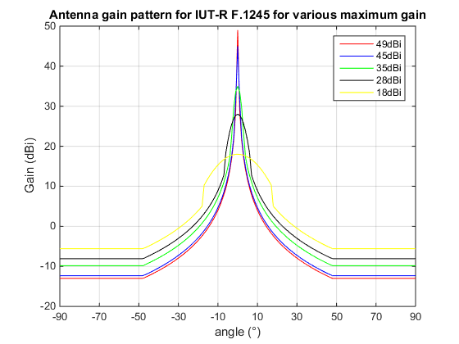
b) Antenna elevation
or the antenna elevation, the following values were taken into account: 0°, 1°, 2°, 3°, 4° and 5°.
c) Examples of interference to noise ratio complementary cumulative distribution function for Scenario 1
The variation in antenna gain, elevation angle and altitude leads to a total of 180 cases, to reduce the complexity of the report, some examples were selected.
The following two figures correspond to a fixed service station with maximum antenna gain of 49 dBi with elevation angles of 0° and 5°, respectively.
figure 24
Interference to noise ratio exceedance 49 dBi and 0° fixed service antenna elevation
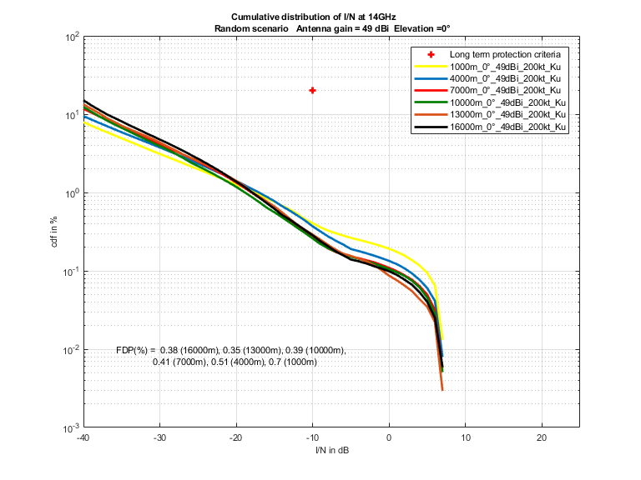
figure 25
Interference to noise ratio exceedance 49 dBi and 5° fixed service antenna elevation
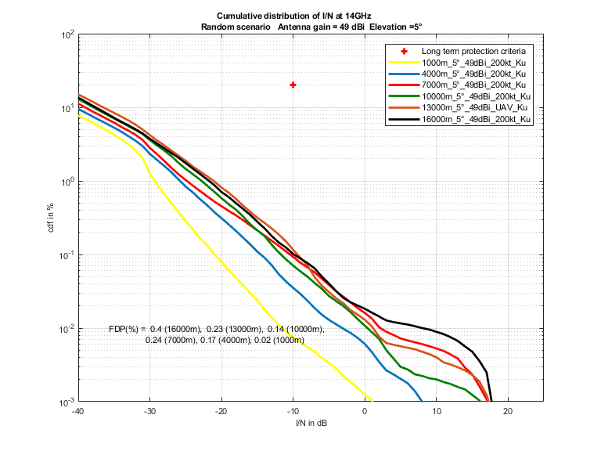
The following two figures correspond to a fixed service station with maximum antenna gain of 35 dBi with elevation angles of 0° and 5°, respectively.
figure 26
Interference to noise ratio exceedance 35 dBi and 0° fixed service antenna elevation
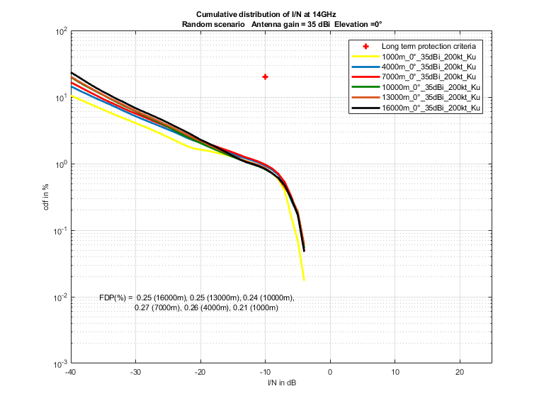
figure 27
Interference to noise ratio exceedance 35 dBi and 5° fixed service antenna elevation
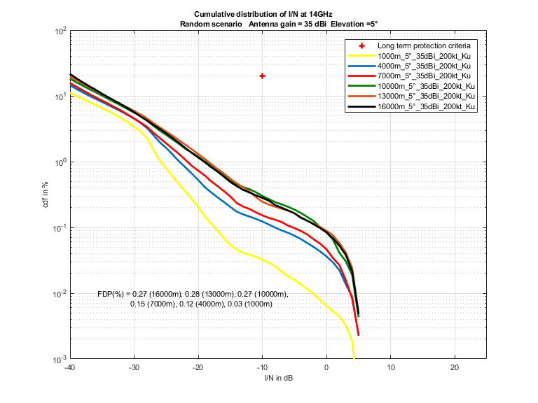
d) Examples of interference to noise ratio complementary cumulative distribution function for scenario 2
The variation in antenna gain, elevation angle and altitude leads to a total of 180 cases, to reduce the complexity of the report, some examples were selected.
The following two figures correspond to a fixed service station with maximum antenna gain of 49 dBi with elevation angles of 0° and 5°, respectively.
figure 28
Interference to noise ratio exceedance 49 dBi and 0° fixed service antenna elevation
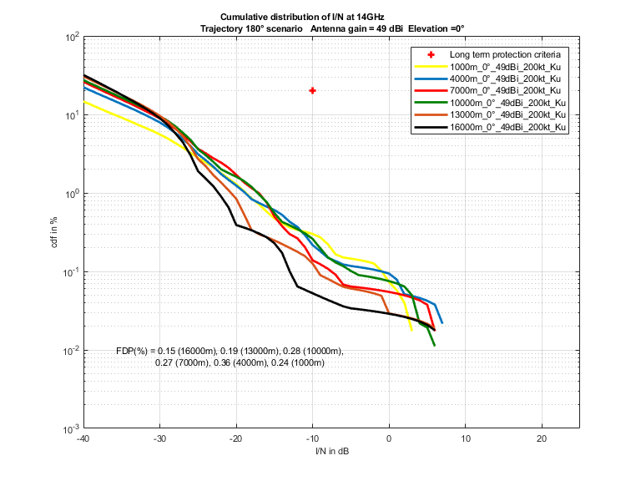
figure 29
Interference to noise ratio exceedance 49 dBi and 5° fixed service antenna elevation
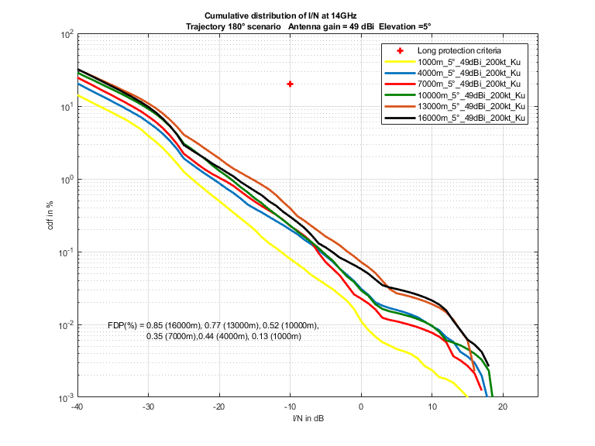
The following two figures correspond to a fixed service station with maximum antenna gain of 35 dBi with elevation angles of 0° and 5°, respectively.
figure 30
Interference to noise ratio exceedance 35 dBi and 0° fixed service antenna elevation
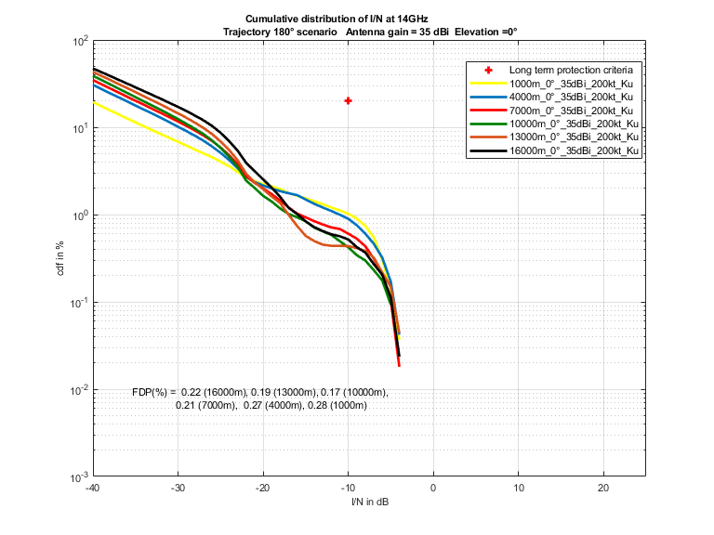
figure 31
Interference to noise ratio exceedance 35 dBi and 5° fixed service antenna elevation




