|  |  |
| --- | --- |
| U.S. Radiocommunication Sector  Fact Sheet | |
| **Working Party:** ITU-R WP-5B | **Document No:** USWP5B-34-18 |
| **Ref:** WRC-27 Agenda Item 1.8/Res. 663 (WRC-23), [5B 216](https://www.itu.int/md/R23-WP5B-C-0216/en)/Annex 6 | **Date:** 20 March 2025 |
| **Document Title:** WORKING DOCUMENT TOWARDS A PRELIMINARY DRAFT NEW REPORT ITU-R M.[RLS_231.5-700GHZ] | |
| **AuthorContributors(s):** |  |
| Ryan McDonough GRC NASA | [Ryan.S.McDonough@nasa.gov](mailto:Ryan.S.McDonough@nasa.gov) |
| Giovanni De Amici GSFC NASA | [Giovanni.DeAmici@nasa.gov](mailto:Giovanni.DeAmici@nasa.gov) |
| Elena DeJaco GRC NASA | [elena.k.dejaco@nasa.gov](mailto:elena.k.dejaco@nasa.gov) |
|  |  |
| **Purpose/Objective:** To collect relevant technical and operational characteristics to develop a framework document for compatibility and sharing studies performed under WRC-27 Agenda Item 1.8 in accordance with Resolution **663 (WRC-23).** | |
| **Abstract:** Pursuant to Resolution **663 (Rev.WRC-23)**, Working Party (WP) 5B is the responsible group for WRC-27 Agenda Item 1.8 request to consider possible additional spectrum allocations to the radiolocation service on a primary basis in the frequency range 231.5-275 GHz and possible new identifications for radiolocation service applications in frequency bands within the frequency range 275-700 GHz for millimetric and sub-millimetric wave imaging systems. This document will serve as a place to initiate sharing and compatibility studies and their associated results for section A7 on EESS. | |
| **Fact Sheet Preparer**: Ryan McDonough, NASA | |

|  |  |
| --- | --- |
| **Radiocommunication Study Groups** |  |
|  |  |
|  |  |
| Received: Date 2025  Subject: WRC-27 agenda item 1.8 | **Document XX/-E** |
| **Date 2025** |
| **Original: English** |
| United States of America | |
| WORKING DOCUMENT TOWARDS A PRELIMINARY DRAFT NEW REPORT ITU-R M.[RLS_231.5-700GHZ] | |
| Studies on possible new additional allocations to the radiolocation service on a primary basis in the frequency range 231.5-275 GHz, and possible new identifications for radiolocation service applications in frequency bands within the frequency range 275-700 GHz | |
| Pursuant to Resolution **663 (Rev.WRC-23)**, Working Party (WP) 5B is the responsible group for WRC-27 Agenda Item 1.8 request to consider possible additional spectrum allocations to the radiolocation service on a primary basis in the frequency range 231.5-275 GHz and possible new identifications for radiolocation service applications in frequency bands within the frequency range 275-700 GHz for millimetric and sub-millimetric wave imaging systems. This document will serve as a place to initiate sharing and compatibility studies and their associated results for section A7 on EESS. | |

**Attachment:** 1

|  |  |
| --- | --- |
| **Radiocommunication Study Groups** |  |
|  |  |
|  |  |
| Source: Document 5B/TEMP/47  Subject: WRC-27 agenda item 1.8 | Annex 6 to Document 5B/216-E |
| 27 November 2024 |
| English only |
| Annex 6 to Working Party 5B Chair’s Report | |
| Working document towards a preliminary draft new Report ITU-R M.[RLS_231.5-700GHz] | |
| [TBD] | |

(202X)

TABLE OF CONTENTS

1 Introduction 4

2 Provisions of the Radio Regulations 5

3 Atmospheric attenuation in the frequency bands for EESS and RAS 8

4 Characteristics of RLS systems 9

[4.1 Description and operational systems characteristics of radar systems   
to operate in the frequency band 231.5-450 GHz 10](#_Toc183599645)

4.1.1 Introduction 10

[4.1.2 Technical characteristics of radar systems operating in the   
frequency range 231.5-450 GHz or parts thereof 10](#_Toc183599647)

4.1.3 Antenna pattern 12

[4.1.4 Operational characteristics of radar systems operating in the   
frequency bands 231.5-450 GHz 14](#_Toc183599649)

[4.2 Description and operational systems characteristics of vehicular radar   
systems operating in the near ranges around vehicles to operate in the frequency  
band 231.5-450 GHz or parts thereof 14](#_Toc183599650)

4.2.1 Introduction 14

[4.2.2 Technical characteristics of vehicular radars operating   
frequency band 231.5-450 GHz or parts thereof 14](#_Toc183599652)

4.2.3 Antenna pattern 16

[4.2.4 Operational characteristics of vehicular radars operating frequency   
band 231.5-450 GHz 17](#_Toc183599654)

5 Spectrum needs of RLS systems 17

6 Propagation model 17

6.1 Recommendations applicable for all sharing geometries 18

6.1.1 ITU-R P.2108 Prediction of clutter loss 18

6.1.2 ITU-R P.2109 Prediction of building entry loss 18

[6.2 Recommendations applicable for sharing between stations   
on the surface of the Earth 19](#_Toc183599660)

[6.2.1 ITU-R P.1411 – Propagation data and prediction methods for the planning of short-range outdoor radiocommunication systems and radio local area  
 networks in the frequency range 300 MHz to 100 GHz 19](#_Toc183599661)

6.2.2 ITU-R P.1238 – Propagation data and prediction methods for the planning of indoor radiocommunication systems and radio local area networks in the frequency range 300 MHz to 450 GHz 20

6.3 Recommendations applicable for frequencies above 200 GHz 20

6.3.1 ITU-R P.525 – Calculation of free-space attenuation 20

6.3.2 ITU-R P.676 – Attenuation by atmospheric gases and related effects 20

7 Considerations relative to incumbent service systems 20

7.1 Summary related to fixed service systems 21

7.2 Summary related to fixed mobile service systems 21

7.3 Summary related to fixed mobile satellite service systems 21

7.4 Summary related to fixed amateur and amateur satellite service systems 21

7.5 Summary related to radionavigation service systems 21

7.6 Summary related to radionavigation satellite service systems 21

7.7 Summary related to earth exploration satellite service systems 21

7.8 Summary related to radioastronomy service systems 21

8 Conclusions 21

Annex 1 22

A1 Characteristics and technical analysis related to the fixed service systems 22

A1.1 Frequency bands 22

A1.2 Interference criteria 22

A1.3 Technical and operational characteristics 22

A1.4 Sharing and compatibility analysis 22

Annex 2 22

A2 Characteristics and technical analysis related to the mobile service systems 22

A2.1 Frequency bands 22

A2.2 Interference criteria 22

A2.3 Technical and operational characteristics 22

A2.4 Sharing and compatibility analysis 22

Annex 3 22

A3 Characteristics and technical analysis related to the mobile satellite service systems 22

Annex 4 23

[A4 Characteristics and technical analysis related to the fixed amateur and  
amateur satellite service systems 23](#_Toc183599691)

A4.1 Frequency bands 23

A4.2 Interference criteria 23

A4.3 Technical and operational characteristics 23

A4.4 Sharing and compatibility analysis 23

Annex 5 23

A5 Characteristics and technical analysis related to radionavigation service systems 23

A5.1 Frequency bands 23

A5.2 Interference criteria 23

A5.3 Technical and operational characteristics 23

A5.4 Sharing and compatibility analysis 23

Annex 6 24

A6 Characteristics and technical analysis related to radionavigation satellite service systems 24

A6.1 Frequency bands 24

A6.2 Interference criteria 24

A6.3 Technical and operational characteristics 24

A6.4 Sharing and compatibility analysis 24

Annex 7 24

A7 Characteristics and technical analysis related to earth exploration satellite service systems 24

A7.1 Frequency bands 24

A7.2 Interference criteria 25

A7.3 Technical and operational characteristics 26

A7.3.1 EESS (passive) below 275 GHz 26

A7.3.2 Characteristics of EESS (passive) sensors above 275 GHz. 29

A7.3.3 EESS (active) in the band 237.9-238 GHz 33

A7.4 Sharing and compatibility analysis 34

Annex 8 34

A8 Characteristics and technical analysis related to radioastronomy service systems 34

A8.1 Recommendations and Reports 35

A8.2 Representative radio astronomy sites operating in relevant frequency bands 37

A8.3 Protection criteria 41

A8.4 Graphical representations 43

A8.5 Sharing and compatibility analysis 43

Scope

TBD

Keywords

TBD

List of Abbreviations/Glossary

TBD

Related ITU-R Recommendations and Reports

TBD

# 1 Introduction

WRC-23 approved WRC-27 agenda item 1.8 ‘to consider possible additional spectrum allocations to the radiolocation service on a primary basis in the frequency range 231.5-275 GHz and possible new identifications for radiolocation service applications in frequency bands within the frequency range 275-700 GHz for millimetric and sub-millimetric wave imaging systems, in accordance with Resolution **663 (Rev.WRC-23)**’.

Resolution **663 (Rev.WRC-23)** calls to conduct the following studies:

1 the description of the technical and operational characteristics, including required protection criteria, for those receive-only and active millimetric and sub-millimetric wave RLS systems and applications in the categories listed in *recognizing a)*; [Editor’s Note: the result of discussion of 5B/180 should be reflected here]

2 studies on globally harmonized spectrum for the RLS, in particular for those millimetric and sub-millimetric wave RLS systems and applications above 231.5 GHz;

3 sharing and compatibility studies (in-band and adjacent bands) for active millimetric and sub-millimetric wave RLS systems and applications with other services in the frequency range 231.5-275 GHz, while ensuring protection for the current use and further development of the incumbent services allocated to this frequency range;

4 sharing and compatibility studies (in-band and adjacent bands) for RLS applications with EESS (passive), space research service (passive) and RAS applications in the frequency range 275-700 GHz, while maintaining protection for the passive service applications identified in No. **5.565**;

5 sharing and compatibility studies (in-band and adjacent bands) for RLS applications with fixed service and land mobile service applications in the frequency range 275-450 GHz, as identified in No. **5.564A**.

This document contains the result of the studies in response to these five bullets.

# 2 Provisions of the Radio Regulations

The extract from Article 5 of Radio Regulations, edition 2024, is presented in Table 1 for the frequency range 231.5-3000 GHz.

Table 1

Extract from Article 5 of Radio Regulations

| Allocation to services | | |
| --- | --- | --- |
| Region 1 | Region 2 | Region 3 |
| 231.5-232FIXED  MOBILE  Radiolocation | | |
| 232-235FIXED  FIXED-SATELLITE (space-to-Earth)  MOBILE  Radiolocation | | |
| 235-238 EARTH EXPLORATION-SATELLITE (passive) 5.563AA  FIXED  FIXED-SATELLITE (space-to-Earth)  MOBILE  SPACE RESEARCH (passive)  5.563A 5.563B | | |
| 238-239.2 FIXED  FIXED-SATELLITE (space-to-Earth)  MOBILE  RADIOLOCATION  RADIONAVIGATION  RADIONAVIGATION-SATELLITE | | |
| 239.2-240 EARTH EXPLORATION-SATELLITE (passive)  FIXED-SATELLITE (space-to-Earth)  RADIOLOCATION  RADIONAVIGATION  RADIONAVIGATION-SATELLITE | | |
| 240-241 EARTH EXPLORATION-SATELLITE (passive)  RADIOLOCATION | | |
| 241-242.2 EARTH EXPLORATION-SATELLITE (passive)  RADIO ASTRONOMY  RADIOLOCATION  Amateur  Amateur-satellite  5.149 | | |
| 242.2-244.2 RADIO ASTRONOMY  RADIOLOCATION  Amateur  Amateur-satellite  5.138 5.149 | | |
| 244.2-247.2 EARTH EXPLORATION-SATELLITE (passive)  RADIO ASTRONOMY  RADIOLOCATION  Amateur  Amateur-satellite  5.138 5.149 | | |
| 247.2-248 RADIO ASTRONOMY  RADIOLOCATION  Amateur  Amateur-satellite  5.149 | | |
| 248-250 AMATEUR  AMATEUR-SATELLITE  Radio astronomy  5.149 | | |
| 250-252 EARTH EXPLORATION-SATELLITE (passive)  RADIO ASTRONOMY  SPACE RESEARCH (passive)  5.340 5.563A | | |
| 252-265 FIXED  MOBILE  MOBILE-SATELLITE (Earth-to-space)  RADIO ASTRONOMY  RADIONAVIGATION  RADIONAVIGATION-SATELLITE  5.149 5.554 | | |
| 265-275 FIXED  FIXED-SATELLITE (Earth-to-space)  MOBILE  RADIO ASTRONOMY  5.149 5.563A | | |
| 275-3 000 (Not allocated) 5.564A 5.565 | | |

The allocations on the primary basis in the frequency range 231.5-275 GHz are shown schematically in Figure 1, only allocation to the radiolocation service in the frequency band 231.5-235 GHz is on the secondary basis. The identifications in the frequency range 275-700 GHz are shown in Figure 2. The use of applications of other services is not precluded in the frequency range 275-450 GHz, the frequency range 450-700 GHz can be used by active services, including fixed and mobile service applications.

FIGURE 1

Allocations in the frequency range 231.5-275 GHz

* RR 5.340 (250 – 252 GHz)

Note: No studies under WRC-23 AI 1.14 for RLS versus EESS (passive) around 240 GHz

FIGURE 2

Identifications in the frequency range 275-700 GHz

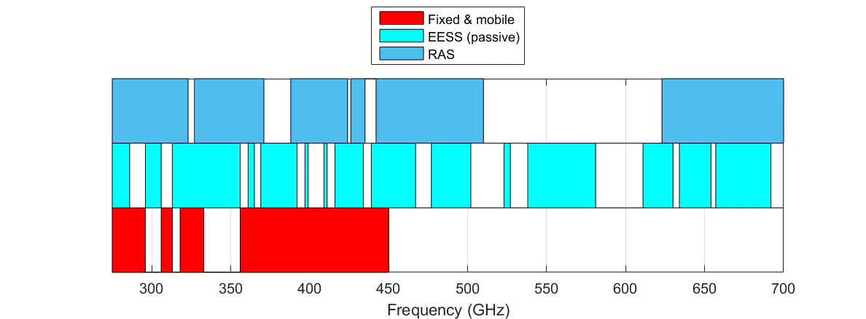

Article 1 of Radio Regulations contains the following terms and definitions in relation to radiolocation systems:

1.9 *radiodetermination:*The determination of the position, velocity and/or other characteristics of an object, or the obtaining of information relating to these parameters, by means of the propagation properties of *radio waves*.

1.11 *radiolocation:*  *Radiodetermination* used for purposes other than those of *radionavigation*.

1.40 *radiodetermination service:*  A *radiocommunication service* for the purpose of *radiodetermination*.

1.48 *radiolocation service:*  A *radiodetermination service* for the purpose of *radiolocation*.

1.100 *radar:*A *radiodetermination* system based on the comparison of reference signals with radio signals reflected, or retransmitted, from the position to be determined.

1.101 *primary radar:*A *radiodetermination* system based on the comparison of reference signals with radio signals reflected from the position to be determined.

1.102 *secondary radar:*A *radiodetermination* system based on the comparison of reference signals with radio signals retransmitted from the position to be determined.

[According to these definitions, radar may work only based on the comparison of reference signals with radio signals reflected (primary radar), or retransmitted (secondary radar), from the position to be determined. The receive-only use of systems and applications aimed to detect naturally radiated power is outside of the radiolocation service as it is defined in the Radio Regulation.]

*[Editor’s Note:*  
The status of receive only systems within the RLS may need to be addressed]

# 3 Atmospheric attenuation in the frequency bands for EESS and RAS

The frequency range 231.5-700 GHz is characterized by important atmospheric attenuation due to dry air and water vapour. The specific attenuation and attenuation for zenith path are shown in Figures 3 and 4, respectively, for ITU-R reference atmosphere (See Recommendation ITU-R P.835).

FIGURE 3

Specific attenuation by atmospheric gases for ITU-R reference atmosphere based on   
Recommendation ITU-R P.676

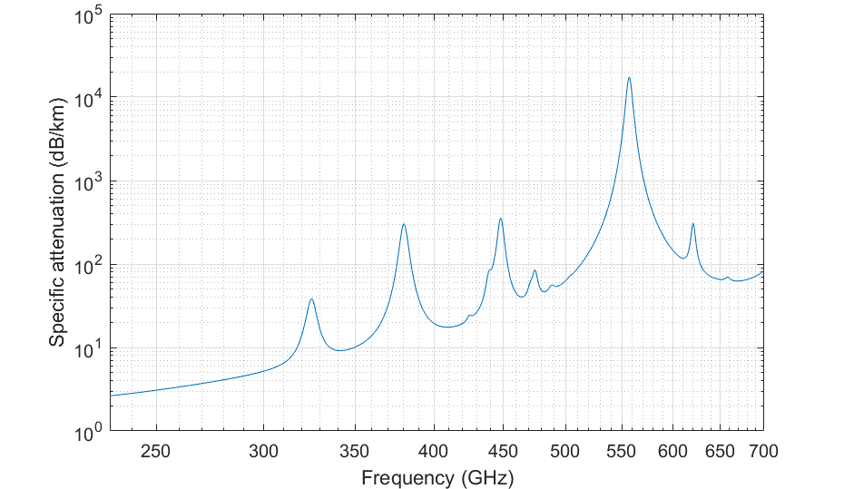

FIGURE 4

Zenith attenuation by atmospheric gases for ITU-R reference atmosphere based on  
Recommendation ITU-R P.676

Frequency bands allocated or identified for EESS (passive) and RAS were selected in the frequency ranges corresponding to spectral lines for EESS (passive) and to the ranges between spectral lines (windows) for RAS.

## General Considerations On EESS Frequency Dependent Sensitivities

The following figure demonstrates a baseline interference margin applied to the 20 proposed frequency ranges by taking into account max protection criteria (according to A7.2) and basic propagation losses: atmospheric and free-space-loss. The figure assumes a nominal EESS (passive) receiver at 800 km altitude, nadir mode, and ground reference altitude of 300 m AMSL. The margin refers to maximum EIRP (in dBW) in the relevant reference bandwidth directed back up to the orbiting sensor. Note that this scenario takes into account integrated losses through the entire atmosphere and does not take into account antenna gains of the sensor or radar systems, additional losses due to clutter, building exit losses, etc. The intention of this figure is that it should provide a rough baseline of remaining margin available to avoid exceeding protection levels for the targeted frequency ranges of study. The red shaded panels in the figure refer to RR **5.340** bands and the blue panels bound the frequency ranges of study.

figure a7.4-1

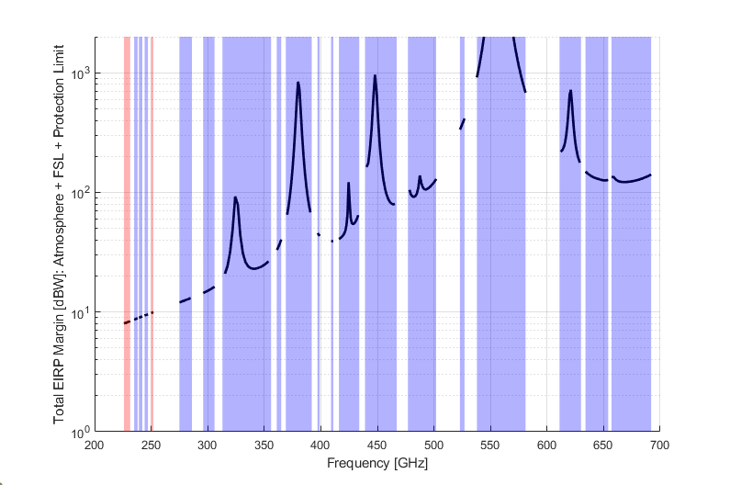

This figure demonstrates that there is a very wide range of margin values depending on the operational frequency due almost entirely to attenuation effects. It is meant to identify how much margin is available that could become closed mostly due to aggregate interference and pointing antenna alignment and its associated signal enhancements. This figure is not intended to draw conclusions about sharing and compatibility.

# 4 Characteristics of RLS systems

[Editor’s note:

The following questions were received, and contributions are invited to address those items at the next meeting:

– More information on concept and scenario of operations will be helpful for understanding how this technology is deployed. Particularly the handheld radar systems are novel and can benefit from illustrative example.

– Area of simulation versus use of e.g. population density (a model is needed in relation with the deployment)

– Unwanted Emissions, defined at which point? [likely TRP?]

– Regarding the use of necessary bandwidth *Table 1 in 4.2* says for low speed operation, the full necessary bandwidth is used for each individual radar system. Is it necessary for this radar technology to have access to the continuous segment of spectrum or can arbitrary sub-segments be excluded from operation via notch filter or other mechanisms? Also, what are spectrum utilization mechanisms intended to accommodate high number of user elements?

– Address RLS spectrum requirement i.e. how many channel/bands is needed for this RLS application? There are at least 2 different systems. Will they all use the same spectrum or need separate one?

– The protection of the potential RLS allocation needs to be addressed including protection criteria (*I/N* = −6 dB)  
]

## 4.1 Description and operational systems characteristics of radar systems to operate in the frequency band 231.5-450 GHz

### 4.1.1 Introduction

A description and operational system characteristics of radar systems to operate in parts of the frequency band 231.5-450 GHz is presented here.

Radiolocation Service (RLS) radar systems include three primary aspects: sensing, positioning, and localization where:

*– Sensing* involves the reception and processing of radio signals to gather information pertinent to a specific service. This process can utilize the geometry of the transmitter, receiver, and the environment, as typically seen in radar applications. However, some sensing tasks, like pollution monitoring, may not depend on such spatial information.

*– Positioning* determines the location coordinates of a connected device in a certain frame of reference using signal metrics, so it relies on sensing.

*– Localization* extends beyond positioning by also estimating the location coordinates of passive objects or targets in a certain frame of reference, enabling what is known as device-free localization.

The radars under considerations here are monostatic and can be hand-held/mobile and/or fixed. It is used for measuring different physical parameters like presence, distance, velocity, or material properties of a target object. The obtained information is further processed and used for example to aid automation purposes. The radar application is intended for private use. They can be operational indoor and/or outdoor with a predominant usage indoor. The sensing radar does not operate all the time and its activity, i.e. when it is transmitting, is dependent on the combination of the duty cycle (in %) of the technology and the activity factor (in %) from the user or the system.

Considering pointing direction, it is assumed random pointing for any simulation time step subject to elevation mask constraints specified.

With regard to determining the active state of a single device it modelled as a random variable with probability for any given time step a fixed value according the simple product of activity factor with duty cycle. For instance, a duty cycle of 10% combined with an activity factor of 4% indicates that the probability that a single device is actively transmitting at a given time step is 0.4%.

### 4.1.2 Technical characteristics of radar systems operating in the frequency range 231.5-450 GHz or parts thereof

The technical parameters of RLS radar systems operating in the frequency range 231.5-450 GHz or parts thereof are presented in Table 1.

[Editor’s Note: The RLS radar characteristics should be typical/representative and need to be confirmed. Some additional questions appear in the comments.]

TABLE 1

RLS radar technical parameters in the frequency range between 231.5 and 450 GHz or parts thereof

| Parameter | Units | Radar 1 Hand-held/mobile | Radar 2 Fixed |
| --- | --- | --- | --- |
| Sub-band used (Note 1) | GHz | 231.5-450 | 231.5-450 |
| Typical operating range | m | Up to 20 | Up to 20 |
| Typical emission type |  | FMCW, FMCW-variants | FMCW, FMCW-variants |
| Max occupied bandwidth | GHz | 20 | 20 |
| Chirp bandwidth (necessary bandwidth) | GHz | 18 | 18 |
| Typical sweep time | μs | 1000 (Medium Chirp) | 100 (fast chirp) |
| Maximum e.i.r.p. | dBm | 20 | 30 |
| Max power density of unwanted emission | dBm/MHz | –30 | –30 |
| Duty cycle (Note 2) | % | 10 | 10 |
| Activity factor (Note 2) | % | 4 | 16 |
| Receiver IF bandwidth | MHz | 5 | 50 |
| Receiver sensitivity | dBm | –173.9 dBm/Hz + 10*log10(5 MHz) = –106.9 dBm | –96.9 dBm |
| Receiver noise figure | dB | 10 | 10 |
| Antenna main beam gain | dBi | TX: 15  RX: 15 | TX: 18  RX: 18 |
| Antenna height | m | 1.5 | 2.5 |
| downtilt | deg | Not applicable | –25 (wall mounted)  –90 (ceiling mounted) |
| Antenna azimuth 3 dB beamwidth | degrees | ±3 | ±2 |
| Antenna elevation 3 dB beamwidth | degrees | ±10 | ±10 |
| Urban deployment density (Note 3) | devices/km2 | 1 000-2 500 | 1 000-2 500 |
| Suburban deployment density (Note 3) | devices/km2 | 100-250 | 100-250 |
| Rural deployment density (Note 3) | devices/km2 | 10-25 | 10-25 |
| Antenna polarization |  | Linear | Linear |
| Average Antenna polarization loss | dB | 3 | 3 |
| Average body loss | dB | 3 (in LoS)  20 (in NLoS) | 0 |
| Antenna efficiency loss | dB | 3 | 3 |
| Indoor deployment |  | 90% | 90% |
| Frequency reuse |  | 1 | 1 |
| Note 1: The frequency bands listed in RR No **5.340** are excluded from the studies.  Note 2: Duty cycle (in %) is technology dependent while the activity factor (in %) is user or system dependent (with reference to 1 day).  Note 3: It is expected that the RLS use case will be distributed over 3 bands: 60 GHz, 140 GHz and above 231.5 GHz. Depending on the actual implementation requirements, a different band may be chosen (power/efficiency, integration size and bandwidth/resolution). This makes it difficult to foresee a definitive deployment number. Therefore, a range is provided. | | | |

### 4.1.3 Antenna pattern

The following equations provide the antenna radiation pattern that could be used in the analysis of interference:

                       for

      for

with:

where:

*G*(ϕ,θ): gain relative to an isotropic antenna (dBi)

*G*0: Maximum gain in or near the horizontal plane (dBi)

θ: Absolute value of the elevation angle relative to the angle of maximum gain (degrees)

θ3: 3 dB beamwidth in the vertical plane (degrees)

ϕ: Azimuth angle relative to the angle of maximum gain (degrees)

ϕ3: 3 dB beamwidth in the azimuth plane (degrees).

Antenna pattern using these formulas for the sensing radar defined in Table 1 is presented in Figures 1 and 2.

Figure 1

Antenna pattern examples in transmission for hand-held/mobile sensing radar



Figure 2

Antenna pattern examples in transmission for fixed sensing radar



### 4.1.4 Operational characteristics of radar systems operating in the frequency bands 231.5-450 GHz

Sensing of passive objects will be instrumental in creating digital representations of physical entities or environments. Sensing with 20 GHz of bandwidth or more enables more accurate modelling with extreme fine ranging. In this case of monostatic sensing, the transmitter and receiver are co-located.

Examples of requirements are shown in Table 1.

Table 1

Sensing of passive objects example requirements.

|  |  |  |  |  |
| --- | --- | --- | --- | --- |
| Use case | Sensing accuracy | Sensing latency | Mobility | Sensing coverage |
| Sensing of passive objects | 1-10 cm | 1-100 ms | < 1m/s | 1-20 m |

## 4.2 Description and operational systems characteristics of vehicular radar systems operating in the near ranges around vehicles to operate in the frequency band 231.5-450 GHz or parts thereof

### 4.2.1 Introduction

The present document provides an example of an application under the Radio location service, technical and operational characteristics and deployment information for vehicular radars operating in the near ranges around vehicles operating in the frequency band 231.5-450 GHz or parts thereof.

Vehicular radars operating in this frequency range will contribute to traffic-safety (the provisions of RR No. **4.10** do not apply) for vehicle passengers and road users by realizing additional radar-based functions that require a high resolution.

Considering pointing direction, it is assumed random pointing for any simulation time step subject to elevation mask constraints specified.

With regard to determining the active state of a single device it modelled as a random variable with probability for any given time step a fixed value according the simple product of activity factor with duty cycle. For instance, a duty cycle of 10% combined with an activity factor of 4% indicates that the probability that a single device is actively transmitting at a given time step is 0.4%.

### 4.2.2 Technical characteristics of vehicular radars operating frequency band 231.5-450 GHz or parts thereof

[Editor’s Note: The RLS radar characteristics should be typical/representative and need to be confirmed. Some additional questions appear in the comments.]

TABLE 1

Technical parameters for vehicular radars in the frequency band between 231.5-450 GHz or parts thereof

| Parameter | Units | Radar X  Short Range | Radar Y  Parking (support) |
| --- | --- | --- | --- |
| Sub-band used (Note 1) | GHz | 231.5-450 GHz | 231.5-450 GHz |
| Typical operating range | m | 25 | 10 |
| Typical number of sensors per vehicle  (Note 2) |  | 6 | Radar belt > 6 |
| Range resolution | cm | 1 | 0.3 |
| Typical emission type |  | Digital Modulation –  SW defined | Digital Modulation –  SW defined |
| Max necessary bandwidth  (Note 3) | GHz | 5 | 15 |
| Chirp bandwidth | GHz | max 5 | max 15 |
| Typical sweep time | µs | 10 000-50 000 | 10 000-50 000 |
| Maximum e.i.r.p. | dBm | 70 | 55 |
| Maximum transmit power to antenna | dBm | 15 | 10 |
| Max power density of unwanted emissions | dBm/MHz | –30 | –30 |
| Duty cycle  (Note 4) | % | Less than 50 | Less than 50 |
| Activity factor  (Note 5) | % | Passenger cars 4,2  Truck 37.5-45.8 | Passenger cars 4,2  Truck 37.5-45.8 |
| Receiver IF |  | None: software defined Radar | None: software defined Radar |
| Receiver IF bandwidth  (–3 dB) | MHz | Max. 1 000-5 000 | Max 1 000-15 000 |
| Receiver IF bandwidth  (–20 dB) | MHz | 1 000-10 000 | 1 000-10 000 |
| Receiver sensitivity | dBm | –105 | –100 |
| Receiver noise figure | dB | 15 | 15 |
| Antenna main beam gain | dBi | Typical 40, Maximal 55 | Typical 30, Maximal 45 |
| Antenna height  Above the road | m | 0.2-2 for passenger car, typical 0.5  0.5-3.5 for Truck | 0.2-2 for passenger car  typical 0.5  0.5-3.5 for Truck |
| Antenna azimuth 3 dB beamwidth | degrees | +/–30° | +/–60° |
| Antenna elevation 3 dB beamwidth | degrees | +/–15° | +/–60° |
| Urban deployment  (Note 6) | devices/ km2 | 700-1 000 | 700-1 000 |
| Suburban deployment  (Note 6) | devices/ km2 | 250-500 | 250-500 |
| Rural deployment  (Note 6) | devices/ km2 | 10-100 | 10-100 |
| Note 1: The frequency bands listed in RR No 5.340 are excluded from the studies.  Note 2: The output signals of all sensors per vehicle will be arranged so that they operate in the indicated maximum necessary bandwidth.  Note 3: The maximum necessary bandwidth for the described applications depends on the intended application of the radar-based function and the speed of the vehicle. All sensors deployed at one vehicle will operate in the maximum necessary bandwidth. The indicated maximum necessary bandwidth will only be used at vehicle speeds below 50 km/h down to standstill where the full resolution of the radar sensors is needed. At vehicle speeds above 50 km/h, the necessary bandwidth will be significantly lower.  Note 4: Duty cycle (in %) is technology dependent, not all envisaged technologies will have a dedicated duty cycle, in some implementations this is related to the implemented signal processing and modulation.  Note 5: Activity factor (in %) is the typical operation time of one vehicle per day.  Note 6: Depending on the area under consideration the number of vehicles or trucks per inhabitants varies. The timeframe for the deployment of the described radar-based functions will vary depending on the area under consideration. This makes it difficult to foresee a definitive deployment number, therefore a range is provided. | | | |

### 4.2.3 Antenna pattern

The following equations provide the antenna radiation pattern that could be used in the analysis of interference:

                       for

      for

with:

where:

*G*(ϕ,θ): gain relative to an isotropic antenna (dBi)

*G*0: Maximum gain in or near the horizontal plane (dBi)

θ: Absolute value of the elevation angle relative to the angle of maximum gain (degrees)

θ3: 3 dB beamwidth in the vertical plane (degrees)

ϕ: Azimuth angle relative to the angle of maximum gain (degrees)

ϕ3: 3 dB beamwidth in the azimuth plane (degrees).

Antenna pattern using these formulas for the vehicular radars defined in Table 1 are presented in Figures 1 and 2.

Figure 1

Antenna pattern example for radar X

Figure 2

Antenna pattern example for radar Y

### 4.2.4 Operational characteristics of vehicular radars operating frequency band 231.5-450 GHz

The main use of described vehicular radar sensors is envisaged for urban scenarios. The sensors will be deployed in driver-assistance functions and higher-level automated vehicles where high resolutions are required. In urban scenarios with vehicle speeds between standstill and approx. 50 km/h high resolution is required to detect small objects and road users.

# 5 Spectrum needs of RLS systems

TBD

# 6 Propagation model

[Editor’s note: Working Parties 3J, 3K and 3M informed WP 5B that they intend to send an update.]

Working Parties 3J, 3K and 3M noted that WP 5B had been instructed to conduct studies taking into account the following propagation paths:

– terrestrial paths;

– Earth-to-space paths,

in the following frequency bands:

– 231.5-275 GHz;

– 275-700 GHz.

Working Parties 3J, 3K and 3M also noted that WP 5B expected the studies to include indoor, urban, suburban and rural deployment scenarios.

Working Parties 3J, 3K and 3M undertook a review of the ITU-R P-series recommendations in light of the scenarios required for WRC-27 agenda items and a working document was attached to the WP 3M Chair’s Report (Document [3M/106](https://www.itu.int/md/R23-WP3M-C-0106/en), Annex 1). Several areas of study were identified for further work which would be undertaken during the intersessional period.

Unless otherwise stated below, the most recently approved version of the recommendation should be used.

Information on the ITU-R P-series recommendations related to the work for WRC-27 agenda item 1.8 is provided below.

## 6.1 Recommendations applicable for all sharing geometries

### 6.1.1 ITU-R [P.2108](http://www.itu.int/rec/R-REC-P.2108/en) Prediction of clutter loss

This Recommendation provides a method for calculating additional loss due to one or both of the radio terminals being embedded in local clutter (e.g., buildings, foliage) in an urban or suburban environment.

The height gain terminal correction model, section 3.1, gives the median of losses due to different terminal surrounding environments for frequencies between 30 MHz and 3 GHz. The possible propagation mechanisms include obstruction loss and reflections due to clutter objects at representative heights, scattering and reflection from the ground and smaller clutter objects. The method used in section 3.1 distinguishes between several general cases including for woodland, open areas, suburban, and urban categories. It is assumed that the dominant mechanisms are diffraction over clutter, reflection or scattering. When using this model, the basic transmission loss should be calculated to/from the height of the representative clutter height used.

In addition, two statistical models are provided in sections 3.2 and 3.3 to estimate clutter loss in urban and suburban environments as a function of probability. The statistical output of these models includes a predicted proportion of events, based on empirical data, where there is line-of-sight and therefore negligible clutter loss:

1 one model (in section 3.2) addresses terrestrial paths for frequencies between 0.5 and 67 GHz;

2 the model in section 3.3 is for an inclined path for elevation angles in the range 0 to 90 degrees and frequencies in the range 10 to 100 GHz where the terrestrial end of the path is within the clutter.

These models have been developed using measurement results as well as analytical models over the range of frequencies, particularly in urban environments.

Report [ITU-R P.2402](https://www.itu.int/pub/R-REP-P.2402-2017) – *A method to predict the statistics of clutter loss for earth-space and aeronautical paths* describes the development of a stochastic model for the inclined path in this Recommendation based on a typical cluttered terminal height of 4 to 6 metres.

There is currently no statistical clutter loss model for a rural environment.

This Recommendation should be used in addition to one of the Recommendations for the appropriate geometry. Please refer to comments in the text for each Recommendation as to when and how this should be included.

Working Parties 3J, 3K and 3M are working on updating Recommendation ITU-R P.2108-1 (section 3.3). In the interim we would encourage Working Parties of other Study Groups to wait for the conclusion of the work, the results of which will be liaised from the next WPs 3J, 3K, and 3M meetings in February 2025.

### 6.1.2 ITU-R [P.2109](http://www.itu.int/rec/R-REC-P.2109/en) Prediction of building entry loss

This Recommendation provides a method for calculating additional loss due to one of the radio terminals being inside a building while the other is outside. Inputs to the model are frequency, probability that the loss is not exceeded, building class and elevation angle of the path at the building façade.

The current model is based on measurement data collated in Report [ITU-R P.2346](https://www.itu.int/pub/R-REP-P.2346-3-2019) in the range 80 MHz to 73 GHz and is nominally valid ‘at frequencies between about 80 MHz and 100 GHz’. Since the formulation of the present model, new data at 47 MHz and at 97, 158 and 300 GHz were submitted. Working Parties 3J, 3K and 3M anticipate that it will be possible to extend both the upper and lower frequency limits of the Recommendation, the latter to around 200 GHz, prior to July 2025. A robust extension to 700 GHz is unlikely, but it is anticipated to offer guidance for such frequencies in the same timescale. Working Parties 3J, 3K and 3M would welcome any further measurement data that may be available.

Coefficients are provided for two building types, traditional and thermally efficient; these are categorized dependent on whether thermally efficient building methods and materials are used or not.

The statistics given by the model of Recommendation ITU-R P.2109 relate to the loss exceeded at any point in any building[1] (of the ‘traditional’ or ‘thermally efficient’ types), globally.

In most cases of practical interest, it will be necessary to combine the predicted statistics of building loss with those of local environmental clutter (e.g. other buildings) or with other spatial loss distributions. It is important that this combination takes account of the entire loss distributions, rather than, for example, just considering median or other quantile values.

The statistics of building entry loss as given by Recommendation ITU-R P.2109 are currently assumed to be independent with respect to other loss distributions and should be combined accordingly. For use in Monte Carlo models, this combination reduces to the simple process of using independent draws to sample building entry loss and, e.g. clutter loss (from Recommendation ITU-R P.2108) and combining the two by addition in decibel form.

Retrieving the overall loss, for a specific probability, is less straightforward, because the model of Recommendation ITU-R P.2109 is an empirical fit with a non-analytical form. In this case, numerical convolution should be used to derive the joint distribution.

This Recommendation should be used in addition to one of the ITU-R P-series Recommendations described below for specific geometries. Please refer to comments below as to when and how this should be included.

## 6.2 Recommendations applicable for sharing between stations on the surface of the Earth

### 6.2.1 ITU-R [P.1411](http://www.itu.int/rec/R-REC-P.1411/en) – Propagation data and prediction methods for the planning of short-range outdoor radiocommunication systems and radio local area networks in the frequency range 300 MHz to 100 GHz

This Recommendation provides methods for predicting loss on outdoor short-range (typically less than 1 km) paths. The prediction includes site-specific and site-general models for line-of-sight (LOS) and non-line-of-sight (NLOS) environments, multipath models, polarization characteristics and fading conditions. The physical environments discussed in this Recommendation include urban very high rise, urban high rise, urban low-rise/suburban, residential, and rural.

The site-specific models of this recommendation require measured empirical constants to complete the calculations. Many of the prediction methods are based on measurements at specific frequencies within the range of interest. However, site-general prediction methods in the Recommendation are applicable to sharing studies using statistical methods within the frequency ranges, environments, and distances specified in the Recommendation.

It must be emphasized that the measurements and modelling in this Recommendation intrinsically include the effect of clutter over the full length of the path, so it would be inappropriate to add a calculation of clutter separately. Section 4.5.2 of the Recommendation notes the requirement to consider building entry loss separately, and this can be done by using Recommendation ITU-R P.2109 described in section 2 of the WP 3M Chair’s Report (Document 3M/106, Annex 1).

Working Party 3K is currently working to increase the frequency limit of this recommendation.

### 6.2.2 ITU-R [P.1238](http://www.itu.int/rec/R-REC-P.1238/en) – Propagation data and prediction methods for the planning of indoor radiocommunication systems and radio local area networks in the frequency range 300 MHz to 450 GHz

This Recommendation provides prediction methods for paths contained entirely within a single building, at frequencies between 300 MHz and 450 GHz. It would be of use in interference scenarios where the dominant paths between the interfering and interfered-with systems remain inside the same building. For obvious reasons, the addition of clutter loss or building entry loss would not be appropriate in this case.

## 6.3 Recommendations applicable for frequencies above 200 GHz

For frequencies above 200 GHz, for unobstructed line-of-sight paths the two dominant propagation mechanisms are free-space basic transmission loss and gaseous attenuation. For frequencies above 200 GHz where obstructions along the path lead to diffraction loss, these losses are likely very high.

### 6.3.1 ITU-R P.525 – Calculation of free-space attenuation

Recommendation ITU-R P.525 provides methods to calculate the attenuation in free space.

### 6.3.2 ITU-R [P.676](https://www.itu.int/rec/R-REC-P.676/en) – Attenuation by atmospheric gases and related effects

This recommendation provides methods in its Annex 1 to calculate the slant path gaseous attenuation, phase nonlinearity, atmospheric bending, excess atmospheric path length and downwelling and upwelling noise temperatures due to oxygen and water vapour for the frequency range from 1 to 1 000 GHz for arbitrary known pressure, temperature and water vapour height profiles. Alternatively, the approximate method in Annex 2 may be used to estimate the instantaneous slant path gaseous attenuation due to oxygen and water vapour for the frequency range from 1 to 350 GHz.

[Editors Note: Section 7, A1-A6, a8 no proposed changes.]

Annex 7

# A7 Characteristics and technical analysis related to earth exploration satellite service systems

## A7.1 Frequency bands

Considering in-band and adjacent frequency bands scenarios, the following frequency bands allocated to EESS (passive) below 275 GHz need to be included in the relevant studies under this agenda item:

‒ 226-231.5 GHz: This frequency band is subject to RR No. **5.340** (all emissions are prohibited) and is adjacent to the lower edge addressed under WRC-27 agenda item 1.8. Only adjacent frequency band compatibility studies are assumed to be performed.

‒ 250-252 GHz: This frequency band is subject to RR No. **5.340** (all emissions are prohibited). Only adjacent frequency band compatibility studies are assumed to be performed.

‒ 235-238 GHz: It is noted that this frequency band is only used by limb sounding instruments.

‒ 239.2-242.2 GHz and 244.2-247.2 GHz: these two frequency bands have been allocated to EESS (passive) by WRC-23 and sharing studies with EESS (passive) should be undertaken once RLS characteristics are known.

Above 275 GHz, there is currently no frequency allocation in the RR, but RR No. **5.565** identifies several frequency bands that are relevant and are already in use by EESS (passive). When considering sharing and compatibility studies in the range 275-700 GHz, the following EESS (passive) frequency bands are to be taken into account:

‒ 275-286 GHz, 296-306 GHz, 313-356 GHz, 361-365 GHz, 369-392 GHz, 397‑399 GHz, 409-411 GHz, 416‑434 GHz, 439-467 GHz, 477-502 GHz, 523‑527 GHz, 538-581 GHz, 611-630 GHz, 634‑654 GHz, 657-692 GHz.

Finally, the band 237.9-238 GHz is also allocated to EESS (active) through RR No. **5.563B**, and its use is limited to spaceborne cloud radars.

## A7.2 Interference criteria

For EESS (passive), the interference criteria are given in Table 2 of Recommendation [ITU-R RS.2017](https://www.itu.int/rec/R-REC-RS.2017/en), as aggregate criteria for all sources of interference.

It should also be noted that this Recommendation does not yet include the protection criteria for the newly allocated bands 239.2-242.2 GHz and 244.2-247.2 GHz but interference criteria given in Report [ITU-R RS.2535](https://www.itu.int/pub/R-REP-RS.2535) should be used (i.e. the same protection criteria as specified in Recommendation ITU-R RS.2017 for the band 226-231.5 GHz).

The following Table summarises the protection criteria to be used for EESS (passive):

TABLE yy

| Frequency bands  (GHz) | Reference bandwidth (MHz) | Maximum interference level  (dBW) | Percentage of area or time permissible interference level may be exceeded(1) (%) |
| --- | --- | --- | --- |
| 226-231.5  239.2-242.2  244.2-247.2  296-306 | 200/3(2) | −160/−194(2) | 0.01/1(2) |
| 313.5-355.6  361.2-365  369.2-391.2  397.2-399.2 | 200/3(2) | −158/−194(2) | 0.01/1(2) |
| 416-433.46  439.1-466.3 | 200/3(2) | −157/−194(2) | 0.01/1(2) |
| 523-527 | 200 | −156 | 0.01 |
| 497-502  538-581 | 200/3(2) | −156/−194(2) | 0.01/1(2) |
| 634-654  656.9-692 | 200/3(2) | −155/−194(2) | 0.01/1(2) |
| 235-238  250-252  275-285.4  409-411  477.75-496.75  611.7-629.7 | 3 | −194 | 1 |
| (1) For a 0.01% level, the measurement area is a square on the Earth of 2 000 000 km2, unless otherwise justified; for a 1% level, the measurement time is 24 h, unless otherwise justified.  (2) First number for nadir or conical scanning modes and second number for microwave limb sounding applications | | | |

The protection criteria for EESS (active) in the band 237.9-238 GHz is given in Recommendation [ITU-R RS.1166](https://www.itu.int/rec/R-REC-RS.1166/en) as follows:

TABLE zz

|  |  |  |
| --- | --- | --- |
| *I*/*N* (dB) | Data availability criteria | |
| –10 | 99 % (systematic) | 95 % (random) |

## A7.3 Technical and operational characteristics

### A7.3.1 EESS (passive) below 275 GHz

The 231-275 GHz frequency band is essential for the measurement of atmospheric trace gases using passive remote sensing satellite limb sounders. Specifically, at the 240 GHz part of the spectrum, data products include measurements of carbon monoxide, nitric acid in the upper and lower stratosphere, cloud ice water content (IWC), ice water path (IWP), ozone, volcanic sulfur dioxide, and improve the quality of upper tropospheric water vapor measurements.

The technical and operational characteristics of EESS (passive) systems in the range 231.5-275 GHz are given in section 6.20 of Recommendation [ITU-R RS.1861](https://www.itu.int/rec/R-REC-RS.1861/en), as follows:

TABLE AA

EESS (passive) sensor characteristics operating between 226 and 252 GHz

|  | Sensor T1 | Sensor T2 |
| --- | --- | --- |
| Sensor type | Conical scan | Limb sounder |
| **Orbit parameters** |  | |
| Altitude (km) | 830 | 705 |
| Inclination (degree) | 98.7 | 98.2 |
| Eccentricity | 0.001 | 0 |
| Repeat period (days) | 29 | 16 |
| **Sensor antenna parameters** |  | |
| Number of beams | 1 | 1 |
| Antenna size (m) | 0.255 | 1.6 (V) × 0.8 (H) |
| Maximum beam gain (dBi) | 52 | 67.5 |
| Polarization | V and H | H |
| −3 dB beamwidth (degree) | 0.5 | 0.060 × 0.123 |
| Instantaneous field of view (km) | 11 × 18  (155 km2) | 3.2 × 6.4 |
| Off-nadir pointing angle (degree) | 44.7 | N/A |
| Incidence angle at Earth (degree) | 52.7 | N/A |
| Swath width (km) | 1 700 | N/A |
| Antenna efficiency | 0.64 | 0.69 |
| Beam dynamics | 45 rpm (1.33 s) | Scans continuously in tangent height from the surface to ~92 km in 24.7 s, 240 scans/orbit |
| Sensor antenna pattern | Rec. ITU-R RS.1813 | Rec. ITU-R RS.1813 with minor mods (see NOTE) |
| Cold calibration ant. gain (dBi) | 47 | N/A |
| Cold calibration angle (degrees re. satellite track) | 130° to 135° | N/A |
| Cold calibration angle (degrees re. nadir direction) | 90° | N/A |
| **Sensor receiver parameters** |  | |
| Sensor integration time | 2 to 3 ms | 0.166 s |
| Channel bandwidth | See Table CC | See Table DD |
| **Measurement spatial resolution** |  | |
| Horizontal resolution (km) |  | 6.4 |
| Vertical resolution (km) |  | 3.2 |
| NOTE – The antenna model from Recommendation ITU-R RS.1813-1 can be adjusted to support elliptical reflectors with the following modifications:  • The maximum antenna gain be defined as: .  • The antenna diameter be defined as: . Therefore, the antenna diameter becomes a function of the angle (α ϵ [0°, 90°]) in the plane that is perpendicular to the antenna boresight vector and between the intended direction of emission and the antenna beam’s major axis.  • The existing functions for G(φ) and φm should be evaluated for each point in the alpha/phi space. | | |

TABLE BB

EESS (passive) sensor characteristics operating between 226 and 252 GHz

|  | Sensor T3 (MWS) |
| --- | --- |
| Sensor type | Nadir Scan |
| **Orbit parameters** | |
| Altitude (km) | 830 |
| Inclination (degree) | 98.7 |
| Eccentricity | 0.001 |
| Repeat period (days) | 29 |
| **Sensor antenna parameters** | |
| Number of beams | 1 |
| Antenna size (m) | 0.35 |
| Maximum beam gain (dBi) | 43 |
| Polarization | QV |
| −3 dB beamwidth (degree) | 1.15° |
| Instantaneous field of view (km) | Nadir FOV: 17  (218 km2) Outer FOV: 55 × 28  (1 225 km2) |
| Off-nadir pointing angle (degree) | ±49.31° cross-track |
| Incidence angle at Earth (degree) | 0 (nadir) 58.9 |
| Swath width (km) | 2 220 |
| Antenna efficiency | 0.60 |
| Beam dynamics (s) | 2.254 |
| Sensor antenna pattern | Rec. ITU-R RS.1813 |
| Cold calibration ant. gain (dBi) |  |
| Cold calibration angle (degrees re. satellite track) | 90° |
| Cold calibration angle (degrees re. nadir direction) | 78° to 83° |
|  |  |
| **Sensor receiver parameters** | |
| Sensor integration time (ms) | 13.7 |
| Channel bandwidth | 2 000 MHz centred at 229 GHz |
| **Measurement spatial resolution** | |
| Horizontal resolution | 17 km (nadir) |
| Vertical resolution | 17 km (nadir) |

TABLE CC

Sensor T1 passive sensor characteristics for channels between 239 and 248 GHz

|  |  |  |
| --- | --- | --- |
| Centre frequency  (GHz) (see NOTE below) | Frequency range (GHz) | Channel bandwidth  (MHz) |
| 243.2 ± 2.5 | 239.2-242.2 244.2-247.2 | 2 × 3 000 |
| NOTE – The T1 instrument has also multiple channels in bands above 275 GHz (three channels around 325 GHz, three channels around 448 GHz and one channel at 664 GHz). | | |

TABLE DD

Sensor T2 passive sensor characteristics for channels between 231 and 248 GHz

|  |  |
| --- | --- |
| Centre frequency  (GHz) | Channel bandwidth  (MHz) |
| 231.86 | 500 |
| 232.46 | 500 |
| 233.9515 | 1 250 |
| 234.86 | 500 |
| 235.7151 | 10 |
| 235.7151 | 1 250 |
| 236.66 | 500 |
| 242.66 | 500 |
| 244.46 | 500 |
| 246.86 | 500 |
| 247.46 | 500 |

Unless otherwise stated, antenna patterns for EESS (passive) are provided in Recommendation [ITU-R RS.1813](https://www.itu.int/rec/R-REC-RS.1813/en).

### A7.3.2 Characteristics of EESS (passive) sensors above 275 GHz.

The 275-700 GHz frequency band is essential for the measurement of atmospheric trace gases using passive remote sensing satellite limb sounders. Specifically, at the 640 GHz band data products include measurements of bromine monoxide, methyl chloride, methyl cyanide, methanol, chlorine monoxide, hydrogen chloride, hydroperoxyl, hypochlorous acid, volcanic sulfur dioxide, methyl cyanide, nitric acid, cloud ice water content (IWC), ice water path (IWP), nitrous oxide, ozone, and improve the quality of upper tropospheric water vapor measurements.

The technical and operational characteristics of EESS (passive) systems in the range 275-450 GHz are given in Report [ITU-R RS.2431](https://www.itu.int/pub/R-REP-RS.2431), as follows:

TABLE ee-1

|  |  |  |  |  |  |
| --- | --- | --- | --- | --- | --- |
| Instrument | ICI | TWICE | SMM | STEAMR | GOMAS |
| Type of Orbit | SSO LEO | SSO LEO | SSO LEO | SSO LEO | GSO |
| Altitude (km) | 817 | 400 | not available | 817 | 35 684 |
| Inclination (degrees) | 98.7 | High inclination | High inclination | 98.7 | 0 |
| Scanning mode | Conical | Conical | Conical or cross track (Fig. ee-1) | Limb  (Fig. ee-2) | Conical |
| Observation Zenith Angle (OZA) (degrees) for conical scan, or  Min. pointing altitude (km), for limb scan | Conical:  53 ± 2 | Conical:  53 | not available | Limb:  6 | not available |
| RF Centre Frequency (GHz) | 325.15  448 | 310  380.2 | 325 | 319.5  349.6 | 380.197  424.763 |
| RF Bandwidth  (GHz) | 3.2 – 6  2.4 – 6  (Table ee-3) | 10  7.2 | not available | 12  12 | 0.3 – 4  0.06 – 1  (Table ee-4) |
| Antenna type | Offset reflector, multiple feeds | Broadband multi-flare horns | not available | Reflector antenna | Filled aperture scanning |
| Antenna Peak Gain (dBi) | 55 | 46-48 (TBC) | not available | 70 | not available |
| Antenna Diameter (m) | ~ 0.5 | not available | not available | not available | 3 |
| Antenna Beamwidth (degrees) | not available | 0.64o  0.56o | not available | See Fig. ee-2 | 0.019o  0.017o |
| FOV (km)  Footprint area (km²) | 16  Area ≈ 200 km²  (Table 3) | FOV: 6.5 × 9.9  Area ≈ 50 km²  FOV: 5.8 × 8.7  Area ≈ 40 km²  (Fig. 6.2-2) | not available | N/A  (See Fig. 15) | IFOV: 12  Area ≈ 110 km²  IFOV: 10  Area ≈ 75 km² |

TABLE ee-2

| Instrument | GEM | CAMLS | MASTER | GMS |
| --- | --- | --- | --- | --- |
| Type of Orbit | GSO | LEO | SSO LEO | GSO |
| Altitude (km) | 35 684 | not available | 817 | 35 684 |
| Inclination (degrees) | 0 | not available | 98.7 | 0 |
| Scanning mode | Conical | Limb | Limb | wide strip and thin circle combined scan (Fig. ee-3) |
| Observation Zenith Angle (OZA) (degrees) for conical scan, or  Min. pointing altitude (km), for limb scan | not available | Limb:  10 | Limb:  3 | **N/A** |
| RF Centre Frequency (GHz) | 380.197  425.763 | 340 | 299.75  320.0  345.6 | 338  380.197  424.763 |
| RF Bandwidth  (GHz) | 0.05-18 (LSB) | 16 | 11.5  9.0  6.5 | 0.03-8  0.01-1 |
| Antenna type | Filled aperture scanning | not available | Elliptical Offset  reflector | Reflector Antenna |
| Antenna Peak Gain (dBi) | not available | not available | not available | **76** |
| Antenna Diameter (m) | 2 | not available | 1 × 2 | 3 |
| Antenna Beamwidth (degrees) | 0.029o  0.026o | not available | not available | 0.027° |
| FOV (km)  Footprint area (km²) | FOV: 20.5  Area ≈ 330 km²  FOV: 16.4  Area ≈ 210 km² | N/A  (See Table 13) | N/A  (See Table 17) | IFOV: 16 |

TABLE ee-3

Channel specifications for Remote Sensor-1 (ICI)

|  |  |  |  |  |
| --- | --- | --- | --- | --- |
| Channel No | Frequency *f*o±Δ*f* (GHz) (*) | Bandwidth (MHz) (**) | Polarization | Utilization |
| ICI-1 | 183.31±7.0 | 2 × 2 000 | V | Water vapour profile and snowfall |
| ICI-2 | 183.31±3.4 | 2 × 1 500 | V |
| ICI-3 | 183.31±2.0 | 2 × 1 500 | V |
| ICI-4 | 243.2±2.5 | 2 × 3 000 | V, H | Quasi-window, cloud ice retrieval, cirrus clouds |
| ICI-5 | 325.15±9.5 | 2 × 3 000 | V | Cloud ice effective radius |
| ICI-6 | 325.15±3.5 | 2 × 2 400 | V |  |
| ICI-7 | 325.15±1.5 | 2 × 1 600 | V |
| ICI-8 | 448±7.2 | 2 × 3 000 | V | Cloud ice water path and cirrus |
| ICI-9 | 448±3.0 | 2 × 2 000 | V |
| ICI-10 | 448±1.4 | 2 × 1 200 | V |
| ICI-11 | 664±4.2 | 2 × 5 000 | V, H | Quasi-window, cirrus clouds, cloud ice water path |
| (*) For each ICI channel, measurements are performed at both sides of the centre frequency (*f*o + Δ*f* and *f*o - Δ*f*)  (**) Total bandwidth per channel, considering both sides around the centre frequency *f*o. | | | | |

TABLE ee-4

Channel specifications for Remote Sensor-6 (GOMAS) within the 275‑450 GHz range

|  |  |  |  |
| --- | --- | --- | --- |
| Channel No. | Frequency  (GHz) | Bandwidth (GHz) | Utilization |
| GOMAS-1 | 380.17 ± 0.3 | 0.3 | Water |
| GOMAS-2 | 380.17 ± 0.9 | 0.5 |
| GOMAS-3 | 380.17 ± 1.65 | 0.7 |
| GOMAS-4 | 380.17 ± 3 | 1 |
| GOMAS-5 | 380.17 ± 5 | 2 |
| GOMAS-6 | 380.17 ± 7 | 2 |
| GOMAS-7 | 380.17 ± 17 | 4 |
| GOMAS-8 | 424.76 ± 0.15 | 0.06 | Oxygen |
| GOMAS-9 | 424.76 ± 0.3 | 0.1 |
| GOMAS-10 | 424.76 ± 0.6 | 0.2 |
| GOMAS-11 | 424.76 ± 1 | 0.4 |
| GOMAS-12 | 424.76 ± 1.5 | 0.6 |
| GOMAS-13 | 424.76 ± 4 | 1 |

FIGURE ee-1

Illustration of the SMM receiver array concept

FIGURE ee-2

STEAMR limb imaging principles

FIGURE ee-3

Typical wide strip and thin circle combined scanning configuration



Additional characteristics of EESS (passive) systems in the range 275-700 GHz are provided below:

TABLE gg

|  |  |  |  |  |
| --- | --- | --- | --- | --- |
| Satellite | Metop-SG-B series of 3 satellites | | | AWS-PFM (1 satellite) / EPS Sterna constellation (18 + 2 satellites) |
| Instrument | ICI | | | EPS Sterna Radiometer |
| Type of orbit | SSO | | | SSO |
| Altitude (km) | 830 | | | 595 |
| Inclination (degree) | 98.7 | | | 97.79 |
| Scanning geometry | Conical | | | Nadir (cross-track) |
| Centre frequency (GHz) | 1) 325.15 ± 9.5  2) 325.15 ± 3.5  3) 325.15 ± 1.5 | 1) 448 ± 7.2  2) 448 ± 3.0  3) 448 ± 1.4 | 664 ± 4.2 | 1) 325.15 ± 6.6  2) 325.15 ± 4.1  3) 325.15 ± 2.4  4) 325.15 ± 1.2 |
| Channel bandwidth (MHz) | 1) 2 × 3 000  2) 2 × 2 400  3) 2 × 1 600 | 1) 2 × 3 000  2) 2 × 2 400  3) 2 × 1 600 | 2 × 5 000 | 1) 2 × 2 800  2) 2 × 1 800  3) 2 × 1 200  4) 2 × 800 |
| Polarisation | H/V | H/V | H/V | QH/QV |
| Antenna Peak Gain (dBi) | 52 | | | 52 |
| Antenna 3 dB beamwidth | 0.5 | | | 0.8 |
| Footprint area / IFOV | 11 × 18 km (155 km²) | | | Nadir FOV: 8 km (54 km²)  Outer FOV: 16 × 35 km (433 km²) |
| Off-Nadir angle | 44.7° | | | 54.4° |

TABLE hh

|  |  |
| --- | --- |
| Satellite | future non-GSO |
| Instrument | ice cloud detector |
| Type of orbit | SSO |
| Altitude (km) | 836 |
| Inclination (degree) | 98.75 |
| Scanning geometry | Conical |
| Centre frequency (GHz) | 664 ± 4.2 GHz |
| Channel bandwidth (MHz) | 2 × 5 000 |
| Polarisation | V/H |
| Antenna Peak Gain (dBi) | 54 |
| Antenna 3 dB beamwidth | 0.4°/0.6° |
| Footprint area / IFOV | Nadir FOV: 18 km² |
| Off-Nadir angle | 53° |

Unless otherwise stated, antenna patterns for EESS (passive) are provided in Recommendation [ITU-R RS.1813](https://www.itu.int/rec/R-REC-RS.1813/en).

### A7.3.3 EESS (active) in the band 237.9-238 GHz

The characteristics of EESS (active) systems in the band 237.9-238 GHz are given in section 7.14 of Recommendation [ITU-R RS.2105](https://www.itu.int/rec/R-REC-RS.2105/en), as follows:

TABLE xx

Characteristics of EESS (active) missions in the 237.9-238 GHz band

| Parameter | CPR-N1 |
| --- | --- |
| Sensor type | Cloud profiling radar |
| Type of orbit | SSO |
| Altitude (km) | 705 |
| Orbital inclination (degrees) | 98.2 |
| Ascending node LST | 13:30 |
| Repeat period (days) | 16 |
| Antenna diameter (m) | 3 |
| Antenna (Transmit and Receive) peak gain (dBi) | 78 |
| Polarization | Linear |
| Azimuth scan rate (rpm) | 0 |
| Antenna beam look angle (degrees) | 0 |
| Antenna beam azimuth angle (degrees) | 0 |
| Antenna elevation beamwidth (degrees) | 0.024 |
| Antenna azimuth beamwidth (degrees) | 0.024 |
| RF centre frequency (GHz) | 237.95 |
| RF bandwidth (MHz) | 0.65 |
| Transmit Pk power (W) | 80 |
| Pulsewidth (μs) | 1.6 |
| Pulse repetition frequency (PRF) (Hz) | 4 000 |
| Range resolution (m) | 250 |
| Horizontal resolution | 0.1 × 0.7 km |
| System noise figure (dB) | 11 |

## A7.4 Sharing and compatibility analysis

### A7.4.1 Sharing and compatibility analysis of EESS (passive)

#### General Considerations

The study of sharing and compatibility of EESS (passive) sensors with regard to the proposed RLS radar systems is considered in several parts. This section covers general aspects and simulation methodology employed by A7.4. Section A7.4.1.1 describes reference Measurement Areas of Interest that the passive sensors and proposed radar system deployments for use in simulation studies. Section A7.4.2.1 covers scenarios involving frequency ranges below 275 GHz. This section includes allocated bands for EESS (passive) as well as RR **5.340** adjacency aspects. Section A7.4.2.2 covers scenarios involving frequency ranges above 275 GHz. This section includes consideration of frequency bands identified for use by EESS (passive) under RR **5.565.**

#### Simulation Methodology

Assessments of the aggregate RFI expected from the RLS radar systems (operating according to section 4.1 or 4.2) into EESS (passive) operating in the certain bands are achieved by dynamic simulations. The analysis is conducted in which the orbit of the EESS (passive) spacecraft under investigation is dynamically simulated, retaining only the data points when the EESS (passive) sensor antenna boresight points within a defined Measurement Area of Interest (MAI), as defined in section A7.2. Calculations are performed to determine the potential interference from each of the current active stations into the EESS (passive) sensors under study and will consider the aggregate effect from multiple active stations. The simulation will propagate the satellite based on its orbital parameters, and the simulation step size is selected to be an irrational number to ensure that the beam dynamics of the passive sensor are maximally representative and do not exhibit statistically reductive periodic behaviour. At each simulation step, a snapshot of the interference scenario is generated where the directional vectors from each active RLS radiative source to the EESS (passive) sensor is computed along with the apparent gain of the transmit and receive antennas using their respective antenna patterns. For the RLS systems the radiation patterns are modelled by section 4.1.3 and 4.2.3 for hand-held/fixed radars and vehicular radars, respectively.

The interfering signal power level, (W), received by a spaceborne sensor at the simulation step from the active station is calculated from:

(A3-1)

where:

: active station out of band transmitter power in the EESS (passive) band, accounting for frequency dependent rejection;

: active station antenna gain towards spaceborne sensor;

: spaceborne receive antenna gain towards terrestrial source;

 : propagation losses in accordance with section 6.1;

: Free Space Path Loss (if not already included in );

[Editor’s note: Working Parties 3J, 3K and 3M informed WP 5B that they intend to send an update regarding propagation advice. So this aspect may be refined in the methodology for EESS.]

The aggregate interference from radiolocation systems at the simulation step, (W), is calculated by the summation of the received interference from all active stations within line of sight of EESS (passive) satellite:

(A3-2)

Thus, the aggregate interference can be represented in the logarithmic domain as:

(A3-3)

Using the resulting data containing received interfering power levels, a CCDF curve is generated to assess interference received by the sensor undergoing observations over the MAI.

Since the occupied bandwidth of all radar systems is significantly larger than the reference bandwidth of the EESS(p) protection, for in-band assessments, it is assumed that emissions fully cover the reference bandwidth.

#### Measurement Area of Interest (MAI) selection and RLS radar system deployments

MAI are chosen to represent typical EESS (passive) sensor targets that may include intersection with significant density of proposed RLS radar systems. Reference MAI will include one or more urban localities to explore the impact of deployment density categorization on the predicted interference environment. MAI A/B of figure A7.4.1.1-1 are 2 million square kilometers in area. MAI A includes the west coast of the United States of America and MAI B includes the eastern coast. MAI C in figure A7.4.1.1-1 has an area of 10 million square kilometers. All regions are commonly studied by EESS (passive) sensors.

[Editor’s Note: more MAI may be included. For instance, to examine cross border scenarios. The east coastal scenario (MAI B) mainly involves a domestic scenario for the purposes of demonstrating compatibility. A more detailed cross-border scenario such as in MAI C would be added in subsequent updates to this study.]

figure a7.4.1.1-1 Reference MAI A/B

MAI A

39.0N 118W

MAI B

37.0N 79.8W

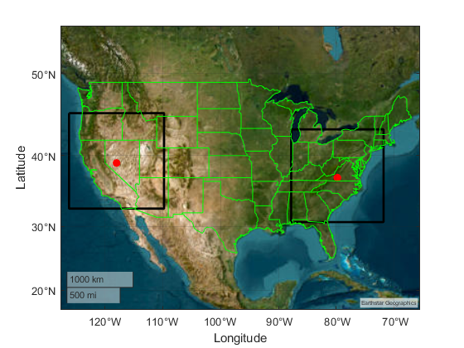

FIGURE A7.4.1.1-2 REFERENCE MAI C

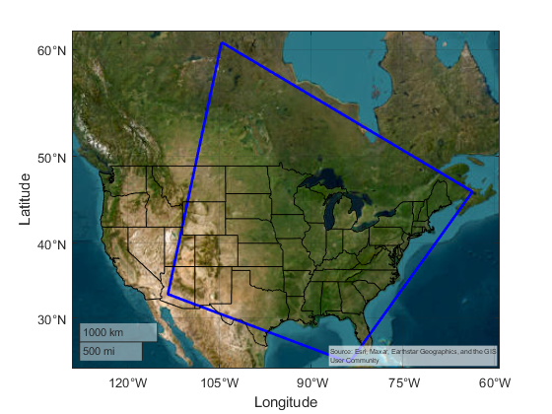

#### Deployment and characterization of RLS radar systems

Deployment and operational characteristics are informed by the tables and description contained in sections 4.1 and 4.2. The deployment density entries in the tables of these sections require that categories are assigned to locations inside the MAI region. Therefore, methodology is presented below describing how categories are determined.

##### Data sources for location based categories

All systems in these sections consider deployment density values categorized by “urban”, “suburban”, and “rural” densities as specified in sections 4.1.1 and 4.1.2 for hand-held/fixed radars and vehicular radars, respectively.

###### Land cover-based Categorization

This is an alternative methodology to population-based categorization based on satellite imagery of ground cover that could be developed further as needed.

###### Gridded Population-based Categorization

The Gridded Population of the World (GPW) dataset, developed by NASA's Socioeconomic Data and Applications Center (SEDAC), offers a globally consistent and spatially explicit representation of human population distribution. Now in its fourth version (GPWv4), this dataset provides population counts and densities at a 30 arc-second (~1 km at the equator) resolution for the years 2000, 2005, 2010, 2015, and 2020. The data are derived from approximately 13.5 million national and sub-national administrative units, ensuring high-resolution mapping of population distribution. This granularity makes GPWv4 an invaluable resource for simulations requiring detailed demographic inputs, such as urban planning, disaster response, and environmental impact assessments. By integrating GPWv4 into simulation models, researchers can accurately assess human exposure to various risks, optimize resource allocation, and inform policy decisions based on precise population metrics. See: <https://www.earthdata.nasa.gov/data/projects/gpw>

The categorization of urban/suburban/rural is computed from the density reported by GPW-4 extrapolated to 2020, and utilizing density ranges of:

Urban >1158 persons per square km

Suburban 386 < density <= 1158 persons per square km

Rural 0 < density <= 386 persons per square km.

This set of definitions derives from U.S. Department of Health and Human Services 42 CFR Parts 403 and 408, Federal Register /Vol. 68, No. 240 /Monday, December 15, 2003 /Rules and Regulations page 69851. See: <https://www.cms.gov/Regulations-and-Guidance/Regulations-and-Policies/QuarterlyProviderUpdates/downloads/cms4063ifc.pdf>

figure a7.4.1-X: Population Categories MAI East

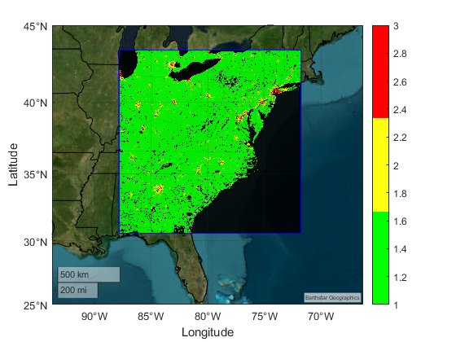

Note: State borders are drawn in black. Urban is drawn red, suburban yellow, rural green. There are also regions without data which are also drawn in black. The MAI boundary is drawn in blue.

##### RLS radar systems according to section 4.1 (handheld/mobile + fixed systems)

###### Modelling handheld/mobile radar systems

The hand-held radar systems described in section 4.1 are active inside and outside buildings with mixed use.

figure a7.4.1-X handheld radar System (Radar 1)

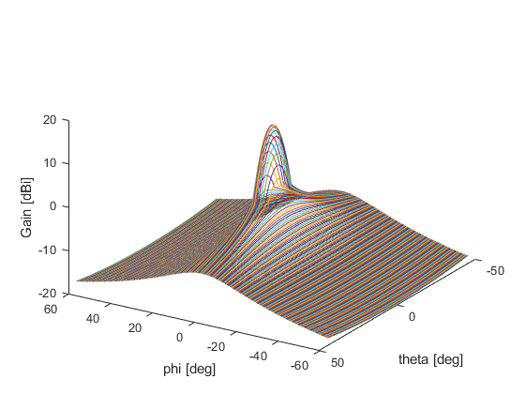

Note: This antenna pattern normalizes over all angles to average gain <=0dBi.

###### Modelling fixed radar systems

The fixed radar systems described in section 4.1 are active inside and outside buildings with mixed use. These systems are notable in that they have down tilt attitude.

##### RLS vehicular radar systems according to section 4.2 (short range + parking systems)

###### Modelling short range radar systems

The short-range vehicular radar systems described in section 4.2 have an added aspect associating their population on or near roadways and parking facilities. These systems are considered outdoor use with respect to estimating blocking losses from buildings, or other ground cover.

Short-distance systems were simulated as fixed positions with uniform spacing along roadways according to an inference between population category shared by the centre of the roadway combined with spatially nearby roadways to ensure that overall vehicle density (either car or truck) conforms with deployment density values in the tables of 4.2.

The source of the roadway spatial data was the North American Roads (NTAD) geospatial dataset. This source provides a digital single-line representation of major roads and highways for Canada, the United States, and Mexico. The North American Roads highway network has a number of intended uses including building national and regional-level maps where major highways and arterials are an important feature, national and regional transport corridor planning, national/regional traffic analyses including the routing of freight and passenger traffic flows within and between countries, and traffic simulations based on various disruption/diversion scenarios. The specific dataset used was published 27 October 2020. See: <https://geodata.bts.gov/datasets/usdot::north-american-roads/about>.

The assignment of category to roadways is complicated by the fact that some routes intersect multiple categories due to their location/length. At this time, assignment is sampled by the mean spatial location of the route. There is also a complication relating the implementation of radar deployment in adherence to the densities in the tables of 4.2. The road data include roadways with single and multi-lane routes. Moreover, the density of independent routes is highly location specific. As such, uniform spacing of vehicles on-route is selected as a simple metric for deployment. The determination of vehicle (and radar cluster) spacing is achieved by sampling 1 square kilometre area in representative land categories and adjusting the uniform spacing parameter to match the respective deployment densities per square kilometre indicated by the tables of 4.2.

Below are the representative spacing values:

Urban >1158 : 5 m,

Suburban 386 < density <= 1158 : 15 m,

Rural 0 < density <= 386 : 35 m.

For the purpose of simulation the former linear spacing between cars is used. An alternative approach is randomize allocation of systems within a spatial window and constrain deployment to roadways. So the roadways are populated with a budget of transmitters determined by the land category for the window. This procedure is repeated to cover the MAI region. The density of systems per square kilometer should be retained regardless of deployment methodology.

Time-dependent variations in spacing are expected, however, nominal values are used in simulations at this point.

figure a7.4.1-X: short-range radar (Radar X)

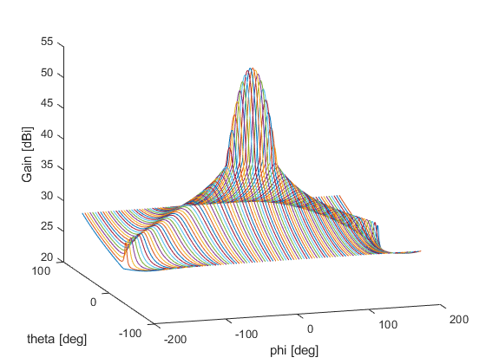

Note: This antenna pattern normalizes over all angles to average gain >0dBi.

figure a7.4.1-X

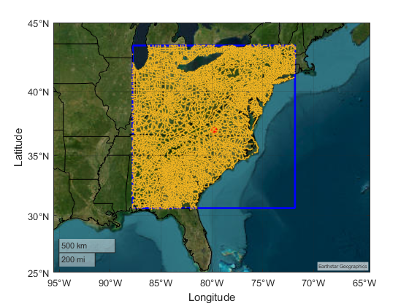

figure a7.4.1-X

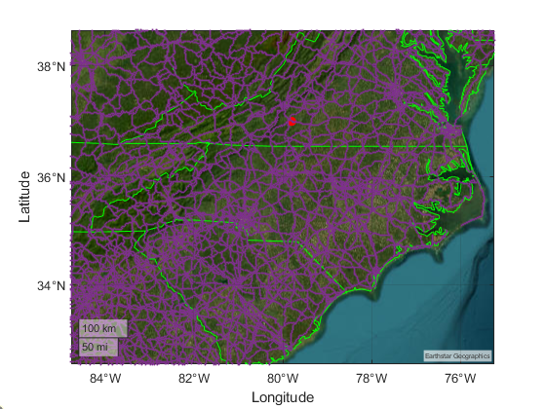

Note: All roadways are merged regardless of type (interstate, state, municipal, or local) and drawn in purple. State borders are drawn in green. The red dot is the MAI centroid.

###### Modelling parking radar systems

The hand-held radar systems described in section 4.2 are expected to be active in segregated regions of the roadways and building infrastructure.

#### Sharing and compatibility analysis EESS (passive) below 275 GHz

TBD

#### Sharing and compatibility analysis EESS (passive) above 275 GHz

TBD

### A7.4.2 Sharing and compatibility analysis of EESS (active)

#### A.7.4.2.1 Sharing and compatibility analysis of EESS (active) in the band 237.9-238 GHz

##### General Considerations

TBD

##### Simulation Methodology

Assessments of the aggregate RFI expected from the RLS radar systems (operating according to section 4.1 or 4.1) into EESS (active) operating in the certain bands are achieved by dynamic simulations. The analysis is conducted in which the orbit of the EESS (active) spacecraft under investigation is dynamically simulated, retaining only the data points when the EESS (active) sensor antenna boresight points within the intended service area. Calculations are performed to determine the potential interference from each of the current active stations into the EESS (active) sensors under study and will consider the aggregate effect from multiple active stations. The simulation will propagate the satellite based on its orbital parameters, and the simulation step size is selected to be an irrational number to ensure that the beam dynamics of the active sensor are maximally representative and do not exhibit statistically reductive periodic behaviour. At each simulation step, a snapshot of the interference scenario is generated where the directional vectors from each active RLS radiative source to the EESS (active) sensor is computed along with the apparent gain of the transmit and receive antennas using their respective antenna patterns. For the RLS systems the radiation patterns are modelled by section 4.1.3 and 4.2.3 for hand-held/fixed radars and vehicular radars, respectively.

The interfering signal power level, (W), received by a spaceborne sensor at the simulation step from the active station is calculated from:

(A3-1)

where:

: active station out of band transmitter power in the EESS (active) band, accounting for frequency dependent rejection;

: active station antenna gain towards spaceborne sensor;

: spaceborne receive antenna gain towards terrestrial source;

 : propagation losses in accordance with section 6.1;

: Free Space Path Loss (if not already included in ).

[Editor’s note: Working Parties 3J, 3K and 3M informed WP 5B that they intend to send an update regarding propagation advice. So this aspect may be refined in the methodology for EESS.]

The aggregate interference from radiolocation systems at the simulation step, (W), is calculated by the summation of the received interference from all active stations within line of sight of EESS (active) satellite:

(A3-2)

Thus, the aggregate interference can be represented in the logarithmic domain as:

(A3-3)

Using the resulting data containing received interfering power levels, a CCDF curve is generated to assess interference received by the sensor undergoing observations over the service area.

Since the occupied bandwidth of all radar systems is significantly larger than the reference bandwidth of the EESS(p) protection, for in-band assessments, it is assumed that emissions fully cover the reference bandwidth.

##### Deployment and characterization of RLS radar systems

The deployment and characterization of RLS radar system types will adopt those described in section A7.4.1.2.

1. That is, any building of the ‘traditional’ or ‘thermally efficient’ types.