Working Party: ITU-R WP 5C | Document No: USWP 5C32-04
Ref: Annex 3.2 to Document 5C/152-E | Date: 03/13/2025
Document Title: Preliminary Draft Revision to Recommendation ITU-R F.1762, “Characteristics of enhanced applications for high frequency (HF) radiocommunication systems”
Author(s)/Contributors(s):  Fumie Wingo  Department of the Navy  Andre Tarpinian  HII in support of DON CIO  Robert Leck  ACES in support of the DON CIO | Phone: +1-703-697-0066  Email: fumie.n.wingo.civ@us.navy.mil  Phone: +1-267-210-0324  Email: andre.a.tarpinian@hii.com  Phone : +1-321-332-2111  Email : robert.leck@aces-inc.com
Purpose/Objective: This is a Final Draft for continued work on the Preliminary Draft Revision to Recommendation ITU-R F.1762, “Characteristics of enhanced applications for high frequency (HF) radiocommunication systems”. The intent is to elevate the document to Draft New Report at the Spring ITU-R meeting in Geneva. First draft edits are shown in green and final draft edits are shown in turquoise.
Abstract: This work will consist of confirming table parameters and assuring consistency between the parameters in the Preliminary Draft Revision to Recommendation ITU-R F.1762 and the Preliminary Draft Revision to Recommendation ITU-R F.1821.

Radiocommunication Study Groups | 
Source: Annex 3.2 to Document 5C/152-E  Subject: Update to Recommendation ITU-R F.1762 | Annex 3.2 to  Document 5C/152-E
 | 13 December 2024
 | English only
UNITED STATES of AMERICA
PRELIMINARY DRAFT REVISION TO RECOMMENDATION ITU-R F.1762
Characteristics of enhanced applications for high frequency (HF) radiocommunication systems
Introduction
The United States proposes that ITU-R Working Party (WP) 5C consider the proposed revisions to ITU-R Recommendation F.1762 with a view towards elevating the document to a Draft New Recommendation at this ITU-R 5C Meeting. Annex 3.2 to Document 5C/152-E 13 December 2024 carries over this document to this current cycle.
Attachment: Draft revision to Recommendation ITU-R F.1762 – Characteristics of enhanced applications for high frequency (HF) radiocommunication systems

The proposed edits are highlighted in green.
Previous edits added at the December 2024 ITU-R WP5C meeting are highlighted in yellow.

Summary of revisions
The proposed updates include modifications to Tables 3, 4, and 6 to improve consistency between the Tables and update technical parameters.

Radiocommunication Study Groups
Source: Document 5C/TEMP/54  Subject: Update to Recommendation ITU-R F.1762 | Annex 3.2 to  Document 5C/152-E
 | 13 December 2024
 | English only
Annex 3.2 to Working Party 5C Chair’s Report
PRELIMINARY DRAFT REVISION TO RECOMMENDATION ITU-R F.1762
Characteristics of enhanced applications for high frequency (HF) radiocommunication systems
(Question ITU-R 158/9)
(2006-202X)
Summary of revisions
The proposed updates include a list of additional enhanced applications as well as updated system parameters that would support the deployment of enhanced applications through high-speed digital networks within the 2 to 30 MHz frequency range. Additionally, emission masks that are appropriate for HF system operating in non-networked configurations are included for contiguous systems and with non-contiguous systems. Finally, revisions were made to conform with the mandatory format for ITU-R Recommendations.

Attachment: 1

ATTACHMENT
PRELIMINARY DRAFT REVISION TO RECOMMENDATION ITU-R F.1762
Characteristics of enhanced applications for high frequency (HF) radiocommunication systems
(Question ITU-R 158/9)
(2006-202X)
Scope
This Recommendation describes the typical technical characteristics of enhanced applications for high frequency (HF) radiocommunication systems to provide enhanced digital applications.
Keywords
Enhanced applications, channel bandwidth, video streams, file transfer, voice over IP
Abbreviations/Glossary
BPSK binary phase shift keying
e.i.r.p. equivalent isotropically radiated power
FSK Frequency Shift Keying
Groundwave Groundwaves propagate parallel to and adjacent to the surface of the Earth and are capable of covering long distances
HF High Frequency
NVIS Near vertical incidence skywave
OFDM Orthogonal Frequency Division Multiplexing
PEP Peak envelope power
PSK Phase Shift Keying
QAM Quadrature Amplitude Modulation
RF Radio Frequency
Seawave Seawaves are groundwaves over water
SINAD Signal to Interference Ratio Including Noise and Distortion
Skywave The propagation of radio waves reflected or refracted back toward Earth from the ionosphere
VoIP Voice over Internet Protocol

Related ITU Recommendations and Reports
Recommendation ITU-R BS.80 – Transmitting antennas in HF broadcasting
Recommendation ITU-R BS.705 – HF transmitting and receiving antennas characteristics and diagrams
Recommendation ITU-R F.240 – Signal-to-interference protection ratios for various classes of emission in the fixed service below about 30 MHz
Recommendation ITU-R F.1610 – Planning, design and implementation of HF fixed service radio systems
Recommendation ITU-R F.1611 – Prediction methods for adaptive HF system planning and operation
Recommendation ITU-R F.1761 – Characteristics of HF fixed radiocommunication systems
Recommendation ITU-R F.1778 – Channel access requirements for HF adaptive systems in the fixed and land mobile services
Recommendation ITU-R F.1821 – Characteristics of advanced digital high frequency (HF) radiocommunication systems
Recommendation ITU-R SM.326 – Determination and measurement of the power of amplitude-modulated radio transmitters
Recommendation ITU-R F.339 – Bandwidths, signal-to-noise ratios and fading allowances in complete systems
Report ITU-R BS.458 – Characteristics of systems in LF, MF and HF broadcasting
Report ITU-R F.2061 – HF fixed radiocommunications systems
Report ITU-R F-2062 – Enhanced high frequency digital radiocommunication systems capable of providing enhanced applications
Report ITU-R F.2087 – Requirements for high frequency (HF) radiocommunication systems in the fixed service
Report ITU-R F.2484 – Cooperative frequency competition model and the corresponding algorithms
The ITU Radiocommunication Assembly,
considering
a) that some high frequency (HF) systems can be used to provide enhanced applications for electronic messaging systems (e-mail), digital voice, IP services and large file transfer providing a communications path to the Internet for exchanging information;
b) that the increasing use of spectrum in the HF bands for enhanced applications such as electronic messaging systems, both with and without attachments, should be taken into account;
c) that such HF systems are not standardized in use and may have different operational technical characteristics;
d) that with electronic messaging, and other enhanced applications for HF systems, equipment interoperability is an important issue,
recognizing
that the frequency range 2 to 30 MHz is also allocated to several other services on a primary basis,
noting
a) that such HF systems are capable of providing routine and emergency public protection and disaster relief;
b) that HF digital networks utilizing increased contiguous channel bandwidths or non-contiguous multichannel equipment can be used as a mechanism for providing enhanced applications;
c) that additional information on such HF systems capable of providing enhanced applications can be found in Report ITU-R F.2062,
recommends
that the technical characteristics of those HF systems providing enhanced applications, including electronic messaging and other Internet capability, described in Annex 1 should be considered representative of those systems operating in the HF frequency bands between 2 and 30 MHz.

Annex
Typical characteristics of HF radio systems
providing enhanced applications

1 Introduction
Enhanced applications that can be supported over HF include:
a) electronic mail, also known as e-mail,
b) voice over Internet protocol, also known as VoIP,
c) interactive Internet applications,
d) large file transfer, and
e) real-time video streams over HF.
In the event of the collapse or overload of normal telecommunication operation due to natural disasters (e.g. earthquakes) and other emergencies, applications for enhanced HF systems using fixed, transportable and mobile stations could provide emergency links during the first phase of the alarm or during the coordination of the relief operation.

2 HF Transmitter/Receiver RF technical characteristics
Tables 1, 2, 3, 4, 5 and 6 contain technical characteristics of representative HF systems capable of providing enhanced applications. Table 1 provides technical characteristics for some parameters of the representative HF systems further described in Tables 2 to 6. These characteristics are sufficient for general calculation to assess the compatibility between these systems and systems operating in other services.
In Table 2, protection ratios are specified as the ratio of wanted-to-unwanted average signal powers (PY). This contrasts with Recommendation ITU-R F.240 where the ratios are expressed in peak envelope powers (PX). Conversion from PX to PY is waveform dependent for both wanted and unwanted signals. Conversion factors can be obtained from Recommendation ITU-R SM.326.
The parameters in Table 1 apply to the Groundwave, Seawave, Skywave and NVIS Systems that are listed in Table 2.
Table 6 is dedicated to enhanced systems using non-contiguous multichannel equipment. These enhanced systems permit the simultaneous use of up to 16 non-contiguous traditional SSB channels arranged in an (non-overlapping) arbitrary way. The modulation of such an equipment consists in a set of elementary 3 kHz wide modulators, arranged in a frequency division multiplex. Any elementary modulation is processed and applied to a subcarrier whose frequency value is chosen according to the allocated channels. All channels shall be contained within a working bandwidth of up to a maximum of 200 kHz.
TABLE 1
Characteristics for RF HF systems
Parameter | Value
Necessary bandwidth (kHz) | 3
Feeder loss (dB) | 1
Receiver bandwidth (kHz) | 3
Receiver Maximum RF Bandwidth (kHz)  (Contiguous Channel Bandwidth)¹ | 3-48
Receiver Maximum RF Bandwidth (kHz)  For n-number of Non-Contiguous Channels¹ | up to 200
Typical receiver noise figure (dB) | 10-20
¹ NOTE: This parameter describes the range of RF bandwidth for the case of systems aggregating multiple channels simultaneously, either in contiguous or non-contiguous manner.

TABLE 2
Example of typical RF characteristics of HF systems
Parameter | System
Mode of operation | Groundwave/  Seawave | Skywave  (oblique) | NVIS  Near vertical
Frequency range (MHz) | Groundwave 2-15  Seawave 3-30 MHz | 3-30 | 2-15
Transmitter power PX (dBW) | 10-30 | 0-26 | 10-26
Antenna directivity gain (dBi) | 6 | 3 | 0
Maximum e.i.r.p. (dBW) | 33 | 26 | 23
Antenna polarization | Vertical/  Horizontal | Vertical/Horizontal | Vertical/Horizontal
Protection ratio PY (dB) | 21 | 28 | 10
Signal-to-noise ratio  (Recommendation ITU-R F.339) | 21 | 28 | 10

TABLE 3
Typical RF characteristic of enhanced HF systems for channel bandwidths of 3 to 48 kHz
(transmitter for ISB and Contiguous channels Systems)
Enhanced HF transmitter parameters | Groundwave / Seawave | Skywave/NVIS |  | Skywave/Oblique incidence
Frequency range (MHz) | Groundwave 2-15  Seawave 3-30 | 2-15 |  | 3-30
Channel bandwidth (kHz) | Variable 3-48 | Variable 3-48 |  | Variable 3-48
Transmitter power (dBW) | 30 | 22 |  | 40
Feeder loss (dB) | 2.2 | 1.5 |  | 1.1
Antenna directivity gain (dBi) | 0-3 | 0-6 |  | 0-15
Antenna height above ground level to the centre of the antenna (m) | 20-60 | 1-60 |  | 1-4
Antenna polarization | Horizontal/Vertical | Horizontal/Vertical |  | Horizontal/Vertical
Antenna type | Broadband Omni | Narrowband Monopole |  | Narrowband Dipole Broadband Dual Fan-Wire
Maximum e.i.r.p. (dBW) | 31 | 27 |  | 54
Modulation | AM/FM/PSK/FSK/QAM/OFDM | AM/FM/PSK/FSK/QAM/OFDM |  | FM/PSK/FSK/QAM/OFDM

The parameters in Table 4 apply to Groundwave, Skywave and NVIS Systems operating within the 3-30 MHz frequency range. Addition parameters are listed in Table 5.
TABLE 4
Receiver characteristics of enhanced HF systems for channel bandwidths of 3 to 48 kHz
(ISB and Contiguous channels Systems)
Enhanced HF receiver parameters | Values
Channel Bandwidth (kHz) | from 3 to 48  (see footnote number)
Variable (3 kHz to 12 kHz) | 12
Variable (3 kHz to 18 kHz) | 18
Variable (3 kHz to 24 kHz) | 24
Variable (3 kHz to 48 kHz) | 48
Filter Bandwidth (kHz) | 48
Sensitivity (dBm)
SSB for 10 dB SINAD | -110 to -130
ISB for 10 dB SINAD | -125 to -130
CW for 10 dB SINAD | -110 to -130

TABLE 5
Typical RF characteristic of enhanced HF systems for channel bandwidths of 3 to 48 kHz
(receiver of ISB and Contiguous channels Systems)
Enhanced HF receiver parameters | Groundwave / Seawave | Skywave/ NVIS |  | Skywave/Oblique incidence
Signal-to-noise ratio (dB)
PSK | 5 | 12 |  | 14
FSK | 8 | 18 |  | 18
QAM | 14 | 24 |  | 24
OFDM | 16 | 26 |  | 30
Feeder loss (dB) | 2.2 | 1.5 |  | 1.1
Antenna directivity gain (dBi) | 0-3 | 0-6 |  | 0-15
Antenna height above ground level to the centre of the antenna (m) | 20-60 | 1-4 |  | 1-4
Antenna polarization | Horizontal/Vertical | Horizontal/Vertical |  | Horizontal/Vertical
Antenna type | Broadband Omni | Narrowband Monopole |  | Broadband Dual Fan-Wire

TABLE 6
Characteristics of enhanced HF systems (non-contiguous multichannel Systems)
Parameter | Propagation mode
 | Groundwave/  Seawave¹ | Skywave
 |  | NVIS | Oblique incidence
Frequency band (MHz) | Groundwave 2-15  Seawave 3-30 | 2-15 | 3-30
Approximate service area | Up to 40 km (ground)  Up to 370 km (sea) | Up to 300 km | Greater than 300 km
Antenna polarization | Vertical | Vertical/horizontal | Vertical/horizontal
Transmitting antenna gain (dBi) | 0-3 | 0-6 | 0-15
Transmitter power PX (dBW) | 10-30 | 10-22 | 10-40
S/N per channel (dB)¹ | 17 | 25 | 25
Necessary bandwidth | SSB: 3 kHz
Type of emission² | 3K00J2D
Sensitivity for 10 dB SINAD in 3 kHz (dBm) | -110 to -130
Type of Modulation | AM/FM/PSK/FSK/QAM/OFDM
Receiver IF filter bandwidth (kHz) | > 200 kHz
¹ NOTE 1 – 1 second interleaver, 16 channels.
² NOTE 2 – For emission type the last letter (D) refers to data transmissions. If emission is not data (D), substitute (E) for voice, (C) for facsimile, (W) combination or (X) for cases not otherwise covered.

3 Typical HF Antenna Patterns
HF Systems utilize a variety of antenna types as a function of operational range. For short range applications conventional whip antenna are typically mounted on man-packs and vehicles. Medium range Skywave NVIS (Near Vertical Incidence Skywave) applications utilize loop, bent whips and dipoles. Long range use large vertical whip antennas, yagi and log-periodic antennas. Dipoles that are higher above ground are also used for long range applications.
Antenna patterns for typical HF antenna types; Whip, Loop, Bent Whip, Dipole and Log-Periodic, can be found in Recommendation ITU-R BS.705-1, HF transmitting and receiving antennas characteristics and diagrams. Additional antenna patterns can be found in Appendix 1 to Annex 1 of the Recommendation and include curtain antennas with different feeding arrangements and reflector types, tropical antennas, horizontal and vertical log-periodic, rhombic, quadrant, cross dipole and vertical monopoles. Additional information and data regarding HF Broadcasting antennas can be found in Recommendation ITU-R BS.80-3, Transmitting antennas in HF broadcasting.

4 Emission characteristics
Table 5 provides the emission masks for HF systems utilizing channel bandwidths of up to 48 kHz, where Type A applies to fixed transmitter installations on land-based sites, maritime and aircrafts (both fixed wing and rotary). The transmit power is typically greater than 150 W PEP. Type B radio systems apply to transmitters that are mounted and/or dismounted on vehicles. The transmit power is typically up to 150 W PEP. Requirements for unwanted emissions are defined to achieve reasonable non-interference conditions between receivers and distant transmitters. Figures 1 and 2 illustrate these spectrum masks that can be applicable to any system utilizing the channel bandwidths that are listed in Tables 1, 2, 3, 4 and 5.
Table 7
Emission Mask for HF Systems with Channel Bandwidths of up to 48 kHz
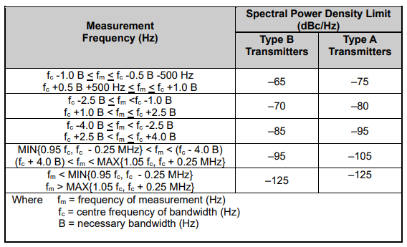

Figure 1
Type B Transmitters
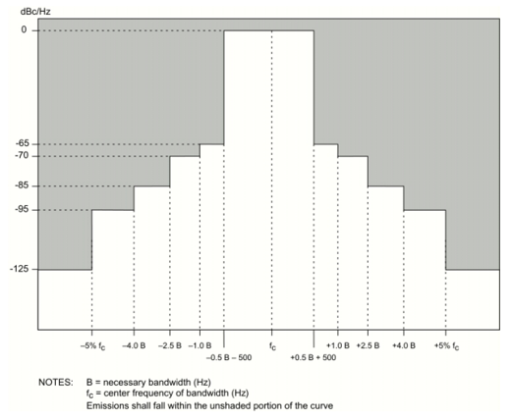
Figure 2
Type A Transmitters
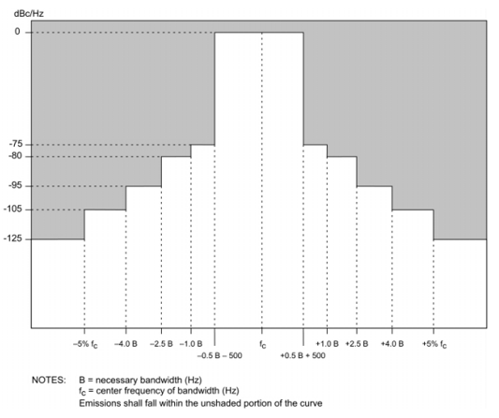
Table 8 illustrates spectrum mask that can be applicable to any enhanced system using non-contiguous multichannel equipment.
When the transmitter is driven to rated PEP with a non-contiguous multichannel transmission waveforms, the power spectral density of the transmitter broadband emission shall not exceed the levels given in the following spectrum mask table.
Spectral density is specified in dBc/Hz, with the reference representing the rated peak envelope power (PEP) of the transmission of the total waveform (including all individual 3 kHz channels).
Type A and Type B transmitter typology follows the above definition in section 4.

Table 8
Emission Mask for HF Systems using non-contiguous multichannel equipment
Measurement frequency | Spectral power density limit [dBc/Hz]
 | Type B  transmitters | Type A  transmitters
2 000 Hz ≤ f_{d} ≤ 3 000 Hz | –65 | –75
3 000 Hz < f_{d} ≤ 4 500 Hz | –70 | –80
4 500 Hz < f_{d} ≤ 12 kHz | –85 | –95
12 kHz < f_{d} < Max{250 kHz, 5% f_{c} kHz} | –95 | –105
Max {250 kHz, 5% f_{c} kHz} < f_{d} | –125 | –125
where:
f_{d} = frequency difference to the closest carrier centre frequency
f_{c} = centre frequency of bandwidth.

For Type B radio systems, the power of any discrete frequency (non-harmonic) spurious emission shall be at least 40 dB below the peak envelope power within ±12 kHz of each individual 3 kHz carrier frequency and at least 50 dB below the peak envelope power at any other frequency.
For Type A radio systems, the power of any such spurious emission shall be at least 40 dB below the peak envelope power within ±12 kHz of each individual carrier frequency, at least 60 dB below the peak envelope power between ±12 kHz and ±5% removed from each individual carrier frequency, and at least 80 dB below the peak envelope power at any other frequency. These shall be measured when the HF transmitter is transmitting modulated 3 kHz channels multicarrier signals at full rated PEP power.
Figures 3 and 4 illustrate spectrum mask that can be applicable to any enhanced system using non-contiguous multichannel equipment.
FIGURE 3
Spectrum mask for enhanced systems using contiguous multichannel equipment
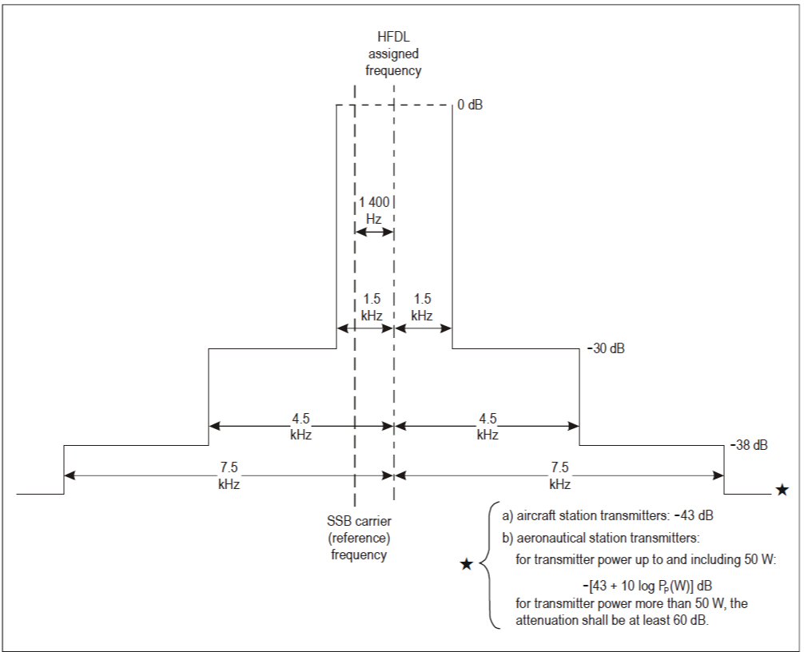
FIGURE 4
Spectrum mask for enhanced systems using non-contiguous multichannel equipment
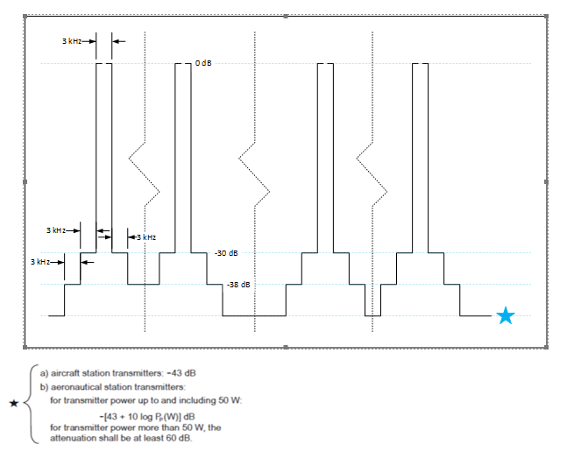

Some systems described in this Recommendation are operated from 2 MHz although the HF definition starts at 3 MHz.
Some systems described in this Recommendation are operated from 2 MHz although the HF definition starts at 3 MHz.
The signal-to-noise ratios in Table 2 are for a BPSK system with a 3 kHz channel bandwidth.
Channel bandwidths of 24 kHz within the 3-30 MHz frequency range have been recognized and defined in Recommendation ITU-R F.339-8, Bandwidths, signal-to-noise ratios and fading allowances in HF fixed and land mobile radiocommunication systems (2013), Table 4a.
Channel bandwidths of 3, 6, 9, 12, 15, 18, 21, 24, 27, 30, 33, 36, 39, 42, 45 or 48 kHz can also be applicable, as a function of the application.
The signal-to-noise ratios in Table 5 are given in a waveform’s necessary bandwidth and are typical of systems that operate under the indicated propagation modes.
In conjunction with Recommendation ITU-R BS.705, the ITU has developed computer programs to calculate radiation patterns and gain for various antenna types. The output data includes the directivity gain, the relative gain for a particular azimuth and elevation angle, tables of relative gain referred to the maximum and a number of different graphic outputs.

