Radiocommunication Study Groups |  | 
Received: Date 2025  Source: Annex 5 to Document 1A/43  Subject: Updates to the working document towards a preliminary draft revision of Report ITU-R SM.2451-1 |  | Document 1A/XX
 |  | Date 2025
 |  | English only
United States of America
working document towards a Preliminary Draft Revision of Report ITU-R SM.2451-1
US Proposal for Updates
Background
In the May-June 2023 WP1A meetings (Thessaloniki, Greece), a proposal was made to update the impact study results for SFTS protection at 60 kHz in Annex 6 of ITU-R SM.2451-1. That proposal was attached to the Chairman’s Report as Annex 6 and was carried forward to the next study period. In the May-June 2024 WP1A meetings (Geneva, Switzerland), the proposal was not progressed and was attached to the Chairman’s Report as Annex 5 and again carried forward.
This document proposes to update Annex 8 of SM.2451-1 but respects the need to include the earlier proposal to update Annex 6 that has been carried forward since 2023. This document primarily provides data on listener opinions of analogue AM reception under conditions of single carrier noise (SCN) beat-frequency interference at frequencies of 30, 50, 70, and 5,000 Hertz offset from the AM carrier. The study may be useful in assessing the impact of single-carrier noise interference due to harmonic emissions from sources such as WPT-EV that operate at 85 kHz.
Discussion
The United States of America (USA) has reviewed Annex 8 of SM.2451-1, which includes a listener opinion study based on a consumer AM receiver used in the UK where stations are assigned on a raster of 9 kHz. The USA concluded that additional data would be useful, based on a listener opinion study using a receiver typical of that used in the USA (and throughout North America) where stations are assigned on a raster of 10 kHz and receiver bandwidths are typically different.
Proposal
The USA proposes the following:
- Updates to the working document towards a preliminary draft revision of Recommendation ITU-R SM.2451-1.
Attachment: USA proposed updates to the working document toward a preliminary draft revision of Annex 8 of Recommendation ITU-R SM.2451-1

ATTACHMENT
{Editor’s note: This attachment contains the material proposed to be added in a new section A6.1.4 of Annex 6 of Report ITU-R SM.2451-1 and material proposed to be added in a new Attachment 8 of Annex 8 of Report ITU-R SM.2451-1}.
updates to the WORKING DOCUMENT TOWARDS A Preliminary Draft Revision of Report ITU-R SM.2451-1
Assessment of single carrier noise impact on radiocommunication services below 30 MHz
(2019-2022)
…
{Editor´s note: This document is not intended for elevation beyond a working document without further validated studies to address the deficiencies of real-life conditions and proper measurement.}[USA author note: the highlighted statement presumably applies only to Annex 6.]

Annex 6
Impact studies in Korea for 19-21 kHz/55-65 kHz WPT-EV
…
Annex 8
…
Attachment 8
Protection ratio tests with potential single-carrier noise to analogue and MA1 digital AM radio

Note to editor: The following text is proposed newly added text as attachment 8 to annex 8 of report SM2451-1. page, figure, and table numbers have been highlighted and may need to be aligned with the report’s scheme.

Protection ratio tests with potential single-carrier noise to analogue
and MA1 digital AM radio

Introduction
This attachment reports on listener tests with analogue AM and MA1 mode digital AM service to determine the RF protection ratios needed from single-carrier noise (SCN) sources to provide acceptable reception. While SCN can emanate from many different types of unintentional and intentional devices, non-beam wireless power transfer (WPT) is one type of device that may use near field coupling in the form of a continuous wave (CW) to transfer power and therefore could potentially have harmonic emissions in the form of SCN.
One application for WPT is wireless charging of electric vehicles. Recommendation ITU-R SM.2110 provides recommended frequency bands for wireless power transfer for electric vehicles (WPT-EV), which includes the 79 to 90 kHz band for use as a fundamental operating frequency. It is noted that switch-mode devices, including the voltage conversion electronics of WPT systems can potentially generate harmonics, which are highly dependent on the design. This report considers potential harmonics emanating as SCN from a potential switch-mode source and assumes that the SCN is introduced into the receiver by some means. This report does not consider any propagation or coupling mechanisms into the victim receiver and how that might or might not affect the results of the study.
Background and Motivation for Measurements
AM radio stations in ITU Region 2 operate in the medium wave band, with regulators assigning 117 channel frequencies between 540 and 1700 kHz on a 10 kHz channel raster: 540, 550...1690, 1700 kHz. This channel raster differs from countries outside Region 2, which mostly use carrier assignments with a 9 kHz carrier spacing.
Region 2 AM channels are 20 kHz wide, as illustrated by the lower and upper sidebands shown in light grey in Figure 1. Based on this specification, the NRSC-1 Standard allows AM stations to modulate at up to 10 kHz of audio bandwidth. AM receivers can be built to receive sidebands out to ±10 kHz, but the conditions of RF environmental noise and adjacent channel interference have resulted in the great majority of receivers having audio bandwidths that are much narrower – as suggested by the darker shading in the figure with a roll-off within 5 kHz of the carrier frequency.
Single-carrier noise, when coupled into the receiver, can produce beat frequency effects when interacting with the radio station carrier frequencies in the AM band. Figure 1 shows some potential harmonics falling in the AM band of an SCN fundamental frequency that is a multiple of 5 kHz (e.g., 85 kHz), shown as red spikes, that could approximately align with or be offset from AM radio channels and cause audible or other beat frequencies if sufficiently coupled into the receiver. Such SCN would be close to 0 Hz, ±5 kHz, or ±10 kHz from the AM carrier. This would produce beat frequencies at or near 0 Hz or audible “whistles” at 5 kHz or 10 kHz.
Figure 1
Potential harmonics of 85 kHz as SCN in relation to Region 2 AM Channel and
nominal audio response for North American receivers
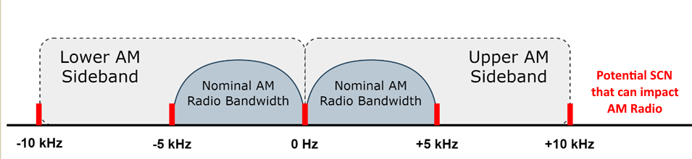
Some have estimated interference from SCN sources using the protection criteria to broadcasting services as specified in Recommendation ITU-R BS.560. However, BS.560 deals with types of station-to-station (intra-service) interference rather than single-carrier noise, such as could potentially emanate from switch-mode devices, including WPT. To evaluate the potential interference from single-carrier noise sources, one must determine how much AM receivers suppress this type of interference. A perceptual study with human listeners was conducted, since the extent of interference involves a number of factors in addition to the receiver audio roll-off, such as the audio processing characteristics and background noise heard in AM receiving environments. Audio samples were prepared in the NAB Laboratory, and listener testing was conducted at NAB Studios, both located in Washington, D.C.
Study Limitations
The study did not utilize WPT or any other switch-mode device specifically, nor were such device characteristics directly assessed other than the consideration that WPT could emit SCN as could other switch-mode devices. A CW (SCN) signal was generated by a signal generator, and AM and MA1 digital signals were produced by a commercial broadcast transmitter. These signals were combined and conducted into the receiver. The study considered only one car receiver that was determined to be typical of an AM (analogue) radio receiver in the U.S. An additional digital HD-capable receiver was tested also. The listening tests included five listeners and were performed in a quiet studio environment in order to provide a stable level of background noise and to preserve the nominal “acceptable quality” signal-to-noise ratio of the broadcast being received. The study considered only the impact of the SCN as it relates directly to a modulated AM audio input of acceptable quality without any other background noise present that may be present in a listening environment (such as road noise inside a car) or the effects of man-made or natural radio noise. An RF noise generator was used to set a local signal-to-noise ratio (SNR) of 26 dB, which is suggested in Recommendation ITU-R BS.703 as being typical for a minimum sensitivity condition. The study did not consider distortion or other effects that could be present in normal over-the-air propagation from an AM broadcast station to a receiver. The study used male and female speaking voices and selections of popular music for the audio source as those are common AM broadcast program formats.
Test Equipment to Prepare Audio Samples
MF sound broadcasting services in ITU Region 2, and particularly in the U.S. and Canada, primarily involve mobile (in-car) reception. Mobile receivers are expected to operate over a range of signal conditions and in a range of noise environments with audio frequency responses tailored for these conditions.
Figure 2
Alpine INE-667HD analogue AM frequency response
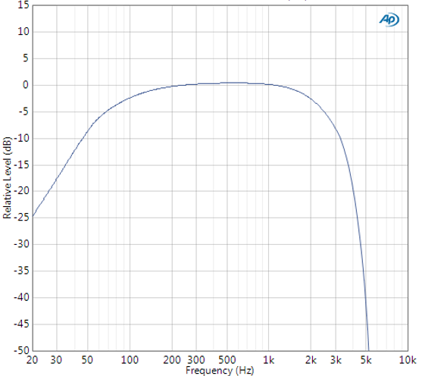
The Alpine INE-667HD receiver was selected for its frequency response, being typical of recent mobile receivers: down 8 dB at 3 kHz and 41 dB at 5 kHz. Its high frequency response is reduced more than AM receivers of the mid 2000s, but this response appears to be representative of modern automotive receivers, which take advantage of digital signal processing to further reduce high frequency noise and interference. The audibility of 5 kHz beat interference could be greater with receivers of greater audio bandwidth, but these radios are now a diminishing fraction of the automotive receiver population.
Figure 3
Experimental signal preparation
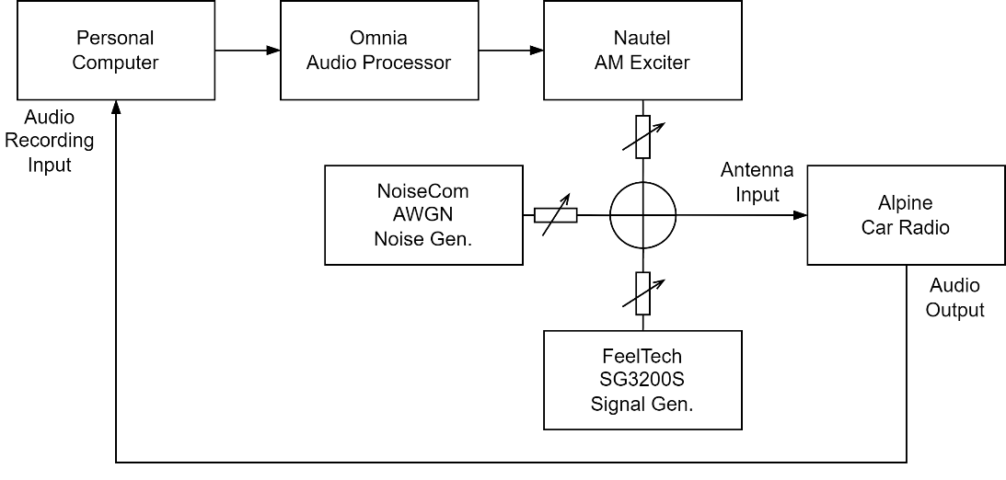
The experimental arrangement for producing the audio test samples is shown in Figure 3. Digital audio samples of male and female announcer voices and popular music were played out from a computer to an Omnia audio processor, which modulated a Nautel AM exciter. The output from the exciter was combined with the outputs of an additive white gaussian noise (AWGN) generator and RF signal generator, which produced single-carrier noise. These instruments provided composite RF signal and AWGN levels equivalent to reception at 60 dBµV/m, as defined by Recommendation ITU-R BS.703 as the minimum field-strength typically required for MF reception.
The audio output of the Alpine receiver was routed to the audio A/D sound card in the computer. All digital audio was encoded at 16-bit 44.1 kHz sampling.
All signal testing was performed on a dB ratio basis relative to the desired AM carrier. Figure 4 shows a spectrum analyser view of the unmodulated desired AM carrier at 890 kHz at –47.5 dBm (ref. to 50 ohms) in the centre with the unmodulated SCN at 895 kHz at 0 dB relative to the desired signal. The displayed generated RF noise floor represents the average condition used for all tests as assumed for a minimum service field strength of 60 dBµV/m. At an equivalent input of -47.5 dBm the receiver was fully quieted, before the addition of AWGN noise.
After allowing the equipment to settle, the RF generator frequency was adjusted by –1.0 Hz to match the AM exciter. Tests were performed with undesired carrier offsets of 5, 30, 50, 70 and 5,000 Hz, at ratios from 0 dB to –25 dB in 5 dB steps. The receiver was checked for symmetry, which was excellent, and all undesired measurements were then made on the high side of the desired carrier.
Figure 4
Spectrum display of desired unmodulated AM carrier (centre) and simulated SCN (right)
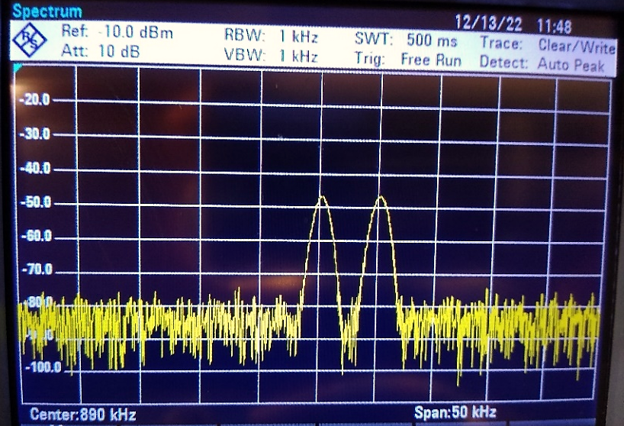
Most modern cars use roof-mounted or in-glass antennas with a preamplifier feeding a cable to the receiver. Thus, the actual RF input level for AM mobile receivers at a given field strength is not known. In the study, the addition of AWGN noise to the receiver was set as defined by ITU-R BS.703 for the minimum sensitivity of an average receiver and referenced to the desired signal level.
Preparation of Audio Samples
To minimize variations in listener performance (due to illness, for example), all testing was conducted during a single afternoon. Lengths of the audio samples and rest periods were adjusted to limit the testing time to less than 50 minutes to avoid listener fatigue. With 15-second audio samples (25 s with pauses) it was estimated that up to 120 samples could be evaluated by the listeners. With up to 5 repetitions this allowed for up to 25 signal conditions to be tested, as shown in Table 1 (a few conditions were skipped to shorten the test time as indicated by a “-“). To help average variation in responses the repeated conditions were randomized across the 50-minute test and used different clips of audio: female speech, male speech, medium-density music, and high-density music.
Table 1
Matrix of test frequencies and ratios
Hz: | 5 | 30 | 50 | 70 | 5000
0 dB | x | x | x | x | x
– 5 dB | x | x | x | x | x
–15 dB | x | x | x | x | x
–20 dB | x | x | - | - | x
–25 dB | x | - | - | - | x

The listening test was conducted on December 14, 2022, in the TV production studio of the NAB, which is quieter than a typical office and has low-reflection acoustics. The participants were three females, ages 31, 36 and 44, and two males, ages 48 and 61. All stated that they had no hearing impairment (e.g., hearing aid or head cold at the time). No high anchors were included in the test material, but all participants correctly identified the four unimpaired reception samples.
For the listening test, the participants sat in two rows, approximately 3 meters and 5 meters from the JBL LSR-2300 monitor speaker, which was elevated 1.5 meters above the floor. The chairs were positioned so that each listener had an unobstructed view of the loudspeaker. The listeners were furnished with a numbered sheet with impairment scale: Very annoying (1), Annoying (2), Slightly annoying (3), Perceptible but not annoying (4), and Imperceptible (5).
Test Results
The listener impairment ratings were grouped across each test sample heard (i.e., for each interfering frequency and RF D/U ratio) and a mean for each was determined as shown by the five “light” markers (✕, ○, □, △, ◇) in Figures 5 to 9. Then, normalized means of each listener’s score were averaged together for each condition, shown by the dark squares (■) and represent the overall mean opinion score (MOS) averaged across all listeners for a particular RF D/U ratio. The error bars shown for each MOS are ±1 standard deviation of the five data points used to compute the overall MOS. Best-fit linear trendlines of the displayed data points were added to each chart to illustrate the approximate D/U ratio required to achieve an overall MOS of 4.0.
Figure 5
Listener Mean Opinion Scores with 5 Hz Interference
Figure 6
Listener Mean Opinion Scores with 30 Hz Interference
Figure 7
Listener Mean Opinion Scores with 50 Hz Interference
Figure 8
Listener Mean Opinion Scores with 70 Hz Interference
Figure 9
Listener Mean Opinion Scores with 5000 Hz Interference
A linear trendline (curve fit) for each condition was calculated to determine the imputed D/U ratio at an impairment mean opinion score (MOS) of 4 (“Perceptible but not annoying”), which is suggested as the maximum tolerable level of interference. As noted above, the relatively small number of listeners (5) limits any robust statistical interpretation of the data, including interpolation or extrapolation. The desired to undesired ratios of the five SCN frequencies tested are summarized in Table 2, where higher D/U ratios indicate that the receiver and the listeners require more protection.
Table 2
Imputed Minimum D/U Ratios Required for MOS of 4 (Perceptible but not annoying)
Condition | D/U ratio (dB)
5 Hz | 24.5
30 Hz | 21.7
50 Hz | 14.0
70 Hz | 15.7
5,000 Hz | 27.9
For the 5,000 Hz condition the D/U ratio was extrapolated from the MOS of the five listeners as 27.9 dB and was the condition most sensitive to interference from the SCN of the tests conducted. This value is similar to the 26 dB ratio required for co-channel protection between AM stations. This rejection is due to the Alpine receiver’s large 41 dB audio frequency roll-off at 5 kHz. (If the test radio were precisely compliant with the NRSC-1-C standard, its response would be down only 7 dB at 5 kHz, resulting in a 5 kHz beat that would be 34 dB greater. While no modern AM car radios are close to precisely complying with the NRSC standard, one should consider that AM receivers could, and arguably should, have better frequency response for the sake of audio quality. Fortunately, the 5 kHz beat frequency can be easily suppressed in future receiver designs. That is, AM receivers with wider frequency response could include a 5 kHz notch filter, like the 10 kHz notch filter used in some “Hi-Fi” AM receivers to remove adjacent-channel beats. The added digital signal processing required to do this is expected to be minimal.)
Low-frequency beat interference (below 70 Hz) is technically a very different type of impairment from the 5 kHz beat and depends on a receiver’s automatic gain control (AGC) design as well as the receiver’s ability to reproduce the low-frequency noise. Most AM receivers, including DSP types, have simple first-order lowpass filters that leak low frequency beats back through the receiver’s gain control system. Thus, beat frequencies below the AGC filter cutoff, which is typically around 20 Hz, are likely to leak through the AGC and distort the audio in annoying ways.
At 5 Hz and 30 Hz the listener results with this receiver were more tolerant to this subsonic interference, at audio SNRs of 24.5 and 21.7 dB, respectively. The listeners were even less critical of interference at 50 Hz and 70 Hz even though “hum” from the beat interference could become audible. As discussed above, the resultant audio and other effects from the interference-generating mechanism is complex, and other receivers could exhibit different results.
Since beat frequencies below 20 Hz are expected to cause audible distortion effects and those above 50 Hz may become directly audible, the optimal frequency difference between the SCN and an AM station carrier appears to be 20 to 50 Hz. Thus, if the AM station operates on its exact assigned frequency, it would be best for such a potential harmonic to occur -50 to -20 Hz below, or +20 to +50 Hz above the AM carrier frequency. In the U.S., however, AM stations are permitted a carrier frequency tolerance of ±20 Hz, which effectively prevents using such a method to preplan the fundamental frequency of devices having SCN harmonics falling in the AM band. It may be prudent for the AM station to use a GPS-disciplined or other highly accurate oscillator, in combination with a temperature-compensated crystal oscillator in the SCN source to ensure that the beat frequencies due to potential harmonics stay within the optimal range.
Comparison with BBC Engineering results
Listener studies were performed in 2017 by BBC Engineering and published as its Report WHP 332. The BBC’s results were incorporated later as Attachment 7 to Annex 8 of the ITU’s Draft Revision of Report ITU-R SM.2451-0 [15] and revised for the current Report ITU-R SM.2451-1 (2022).
The BBC performed limited listener testing to determine the RF protection ratios relative to the desired AM signal. A range of beat frequencies were tested in case the eventual WPT carrier frequency is uncontrolled, relative to the U.K.’s 9 kHz channel raster. Figure 10, taken from the BBC Report, shows that unmodulated carrier interference rises to very high ratios in the upper frequency range, and then falls above 4 kHz. The BBC used an “idealised” receiver, but the de-emphasis was not described (it appears closer to the NRSC-1 characteristic below 5 kHz than the Alpine receiver). This may explain the large rise in required protection at higher beat frequencies, which are effectively removed in the Alpine receiver used for these tests. In viewing the chart, it should be noted that Recommendation ITU-R BS.560 requires a co-channel protection ratio of up to 40 dB, which, of course, is for modulated interference.
Figure 10
Unmodulated interferer protection ratio reported by the BBC for two listeners

At 5 kHz the protection ratio for one of the BBC test listeners is approximately 45 dB, while the other’s data is missing above 3 kHz, but may be similar. By comparison, the current study with the aforementioned conditions and five listeners estimates a protection ratio of 27.9 dB, or 17 dB lower. As discussed earlier, the difference is likely due to the BBC receiver’s slight roll-off up to 4.5 kHz, compared with the Alpine receiver’s heavy roll-off above 3 kHz. The audibility of a SCN at 5 kHz is thus mainly dependent on the frequency response of the AM receiver.
The other difference between the BBC’s results and the results of this study is due to the criteria by which the required protection was determined. The BBC defined a beat level at which interference was decreased until the listener decided the interference was gone. In this study listeners assigned one of five impairment scores to each sample, and a rating of 4 (“Perceptible but not annoying”) was estimated from their overall scores. This criterion is somewhat more lenient and could also account for some differences between the two studies. The resulting acceptable protection ratio at ±5 kHz ranges between 45 dB and 28 dB, depending on whether one favours a relatively “wide” receiver (used in the BBC tests) or a “narrow” receiver typical of modern car radios in the U.S.
Looking at the low-end beat effects, below 150 Hz the protection ratio drops significantly, to between 10 and 20 dB. The current tests indicate a preferred protection ratio ranging from 14 to 24.5 dB. This is only 4 dB worse than the BBC receiver tests and shows good correlation considering that entirely different receivers were used and that the assessment criteria may have been slightly tighter with the BBC listeners.
This listener study and the BBC study, while they differ on the audibility of 5 kHz interference, provide a useful comparison between a modern narrow-band car radio typical of the U.S. market and an AM receiver with greater audio fidelity. Taken together, the two studies provide a range to consider for protection from SCN generally, although as previously discussed radios could add a 5 kHz notch filter that could match the interference performance of the narrow-band radio without sacrificing audio quality. The DSP chips in modern car radios, which must handle noise reduction effects for analogue FM and other tasks, can readily support a 5 kHz AM notch filter.
The interference susceptibility at low frequencies (near zero beat) is similar in the two tests. Moreover, they provide guidance on the optimal beat frequency range and the frequency tolerance required of AM broadcast and SCN signals affecting reception.
HD Radio Interference Test
A measurement of interference susceptibility of the IBOC HD Radio™ system in MA1 (hybrid) mode with a generated SCN was included in this test program. The same RF test bed and receiver was used, including the same 890 kHz desired AM channel. The Nautel exciter was switched from analogue mode to HD Radio MA1 hybrid mode, which activated the Alpine receiver’s digital operation.
Tests were performed at beat frequencies of 1, 5, 10, 30, 70, 100 and 180 Hz (although, as discussed in the analogue section, beat frequencies of 70 Hz and higher would be undesirable). Since MA1 is a hybrid mode the measurements shown in Figure 11 are presented relative to the AM carrier level. The tested carrier levels were -87, -77, -67, -57, -47 and -37 dBm.
Figure 11
MA1 digital reception restoration with single-carrier interference

The data were collected by first raising the SCN signal until there was a failure of digital reception and then reducing the SCN until digital reception resumed. Those values were nearly coincident and are shown as dots on the chart of Figure 11. Interference susceptibility is relatively level from 5 Hz to 30 Hz, thence rising to 100 Hz and remaining approximately level to 180 Hz. (181.7 Hz is the frequency of the first OFDM subcarrier.)
MA1 susceptibility was significantly better at a beat frequency of 1 Hz, although testing with additional receivers is needed to verify that a very low frequency beat between the SCN and the AM carrier produces similar results. Nevertheless, for analogue reception, selection of the device’s fundamental frequency should ideally be chosen so that if harmonics are produced and coupled into a receiver in the relevant AM bands, they are between approximately ±20 Hz to ±50 of the AM station’s carrier frequency.
Summary
The study finds that at low frequencies, subject to the optimal beat frequency range discussed earlier, the required protection ratio for SCN coupled into a typical AM receiver is similar, or perhaps 3 dB more critical, than the BBC finding when the nominal signal-to-noise ratio (SNR) is set to 26 dB for AWGN (again, noting that other SNR values were not studied). For SCN causing beats at 5 kHz the interference protection could be up to 20 dB better (more relaxed), depending on the selectivity of the receiver. Home receivers may have somewhat wider frequency response than in-car receivers, for reasons of improved sound quality, and reductions in complexity and cost, which could increase the susceptibility to 5 kHz beat interference. Therefore, the practical protection ratio for analogue home receivers can be expected midway between the results from the BBC’s candidate receiver and the car receiver used in this study when considering impact only at the minimum SNR and sensitivity levels indicated in Recommendation ITU-R BS.703.
The protection required by MA1 mode IBOC hybrid HD Radio service is similar to the BBC and instant studies at beat frequencies of 70 to 180 Hz. At beat frequencies between approximately 5 Hz and 70 Hz the protection ratio is again covered by the analogue results. However, a beat frequency below 5 Hz may create annoying “pumping” of an analogue receiver’s AGC and confound the phase locking circuitry in a digital receiver. To the extent that harmonic emissions falling into the AM broadcast band may exist from WPT or other switch-mode equipment, in order to minimize potential interference with AM radio in Region 2, operation at a fairly well controlled fixed frequency, such as 85 kHz would respect the 10 kHz channel raster for potential harmonics and would prove advantageous to minimizing potential AM radio interference.

__________________

An earlier version of this attachment was authored by John Kean as “Protection Ratio Tests with Potential Single-Carrier Interference from Wireless Power Transfer Systems to Analog and MA1 Digital AM” (August 14, 2023, prepared for the National Association of Broadcasters and the North American Broadcasters Association).
MA1 digital AM radio is the IBOC (HD Radio) system operating in Hybrid MA1 mode as defined in Rec. ITU-R BS.1615 in the MF broadcasting band.
National Radio Systems Committee Standard NRSC-1-C, “NRSC AM Preemphasis/Deemphasis and Broadcast Audio Transmission Bandwidth Specifications,” April 2018.
National Radio Systems Committee Summary Report NRSC-R101, “Consumer Testing of AM Broadcast Transmission Bandwidth and Audio Performance Measurements of Broadcast AM Receivers,” December 2006.
A 9 kHz channel raster, unfortunately, results in beat frequencies that may occur at any 1 kHz interval, depending on an AM station’s carrier frequency.
BBC Engineering performed a listening test in 2017, but that study focused on beat interference encountered with a 9 kHz channel raster.
Background sound pressure level approximately 35-40 dBA(re 20 µPa). For comparison, an office may have a background SPL of approximately 45-50 dBA.
See, e.g., ITU-R Recommendation SM.1753-2, “Methods for measurements of radio noise,” September 2012.
ITU-R Rec. BS.703 notes that audio SNR can improve linearly to at least 40 dB with increasing AM signal level. See ITU-R BS.703, Annex 2, Section 6. However, at strong RF signal levels listener detection of and objection to interference, including SCN, will occur at lower SNR values due to the psychoacoustical effect of reduced noise masking at higher signal levels. See ITU-R BS.1387-2, Annex 1, Attachment 4. Other RF signal levels were not considered in the study but may result in lesser or greater MOS values for a given RF D/U ratio.
NPR Labs, “Consumer Testing of AM Broadcast Transmission Bandwidth and Audio Performance Measurements of Broadcast AM Receivers,” Sept. 8, 2006, prepared for the NRSC AM Study Task Group. A study of nine OEM and after-market car radios found a mean rolloff of 18 dB at 5 kHz. The audio noise level is affected by a particular receiver’s audio bandwidth. The bandwidth of the test receiver is expected to be narrower than the nominal ITU-R AM receiver, however, for the purposes of testing the signal-to-noise ratio would be similar to that heard with the ITU-R receiver.
Recommendation ITU-R BS.703 effectively specifies the total system noise level at the fringe of reception by assuming a modulation depth of 30% and a modulation to random (system) noise of 26 dB. The total system noise is, therefore 60 dBµV/m minus 10.5 dB (level of modulation below carrier) minus 26 dB (wanted signal to noise ratio).
ITU-R Rec. BS.703 notes that audio SNR can improve linearly to at least 40 dB with increasing AM signal level. See ITU-R BS.703, Annex 2, Section 6. However, at strong RF signal levels listener detection of and objection to interference, including SCN, will occur at lower SNR values due to the psychoacoustical effect of reduced noise masking at higher signal levels. See ITU-R BS.1387-2, Annex 1, Attachment 4. Other RF signal levels were not considered in the study but may result in lesser or greater MOS values for a given RF D/U ratio.
Norah Jones, “Not too late.” Medium-density music is defined here as “popular music with occasional silence or pauses.”
Jimmy Buffett, “I don’t know.” High-density music is defined here as “popular music with non-stop sound (i.e., almost no pauses).
This was a limited application of the procedures in Recommendation ITU-R BS.1116-3, “Methods for the subjective assessment of small impairments in audio systems,” as the scope did not allow for intermediate anchors or a training phase. Because high and intermediate anchors were not used, the scores were normalized per the test method described in Section 4 of Recommendation ITU-R BS.1116.
A linear regression analysis using the least squares method was used to produce the trendlines shown from the calculated mean values. The relatively small number of listeners (5) limits any robust statistical interpretation of the data, including interpolation or extrapolation.
“5 Hz Interference” means the SCN is offset from the carrier of the AM broadcast station by 5 Hz. “MOS” is mean opinion score, the standardized metric used to assess the perceived quality of audio (and sometimes other) content. See, e.g., ITU-T P.800-1, “Mean Opinion Score Terminology.” “RF D/U ratio” is the ratio of the amplitude of the unmodulated carrier of the AM broadcast station (Desired Signal) to that of the SCN (Undesired Signal) in the RF domain.
Lesser protection values, such as 26 dB, have been used by some administrations in the development of regional frequency plans. See e.g., BS.560, Annex 3.
The frequency response of the BBC’s custom test receiver is not reported but appears to be relatively close to the NRSC-1-C standard, which reduces 5 kHz energy by 7 dB in a compliant receiver, compared to 41 dB in the Alpine receiver. The BBC’s customized receiver has a 4.5 kHz lowpass filter with an unspecified suppression at 5 kHz.
A test of a 5 kHz beat was also conducted but the required undesired signal level was so high that such levels would likely not be encountered in practical situations.

