|  |  |  |
| --- | --- | --- |
| U.S. Radiocommunications Sector  Fact Sheet | | |
| **Working Party:** ITU-R WP 5D | **Document No:** USWP5D_50/01 | |
| **Ref:** Resolution **256 (WRC-23)**, **Attachment 1 of Annex 4.13 to Document 5D/792-E** | **Date:** July 15, 2025 | |
| **Document Title:** Sharing between the fixed service and IMT operating in the frequency band 7 125-8 400 MHz | | |
| **Author(s)/Contributors(s):**  Amy L. Sanders  NTIA  Raafat Nasser  ACES for NTIA  Sandra Wright  FAA  Brad Benbow  DoE  Johnnie Best  DoE  Richard Ontiveros  DHS  Dmitry V Baraban  Mitre for DHS | | Phone: +1 202 360 2677  Email: [asanders@ntia.gov](mailto:asanders@ntia.gov)  Phone: +1.571 277 4030  Email: [raafat.nasser@aces-inc.com](mailto:raafat.nasser@aces-inc.com)    Phone: +1 202 603 7094  Email: [sandra.a.wright@faa.gov](mailto:sandra.a.wright@faa.gov)  Phone: +1 202 577 3632  Email: [brad.benbow@hq.doe.gov](mailto:brad.benbow@hq.doe.gov)  Phone: +1 240 474 3501  Email: [johnnie.best@hq.doe.gov](mailto:johnnie.best@hq.doe.gov)  Phone: +1 202 924 1036  Email: [Richard.ontiveros@hq.dhs.gov](mailto:Richard.ontiveros@hq.dhs.gov)  Phone: +1 703 983 1783  Email: [dmitry.baraban@associates.hq.dhs.gov](mailto:dmitry.baraban@associates.hq.dhs.gov) |
| **Purpose/Objective:** This document proposes an updated IMT and Fixed service compatibility study in the frequency band 7 125-8 400 MHz under WRC-27 agenda item 1.7 to address comments raised and suggestions made in the June 2025 meeting of WP 5D. | | |
| **Abstract:** This study is focused on IMT compatibility with the fixed service. Attachment 1 of Annex 4.13 contains sharing between the fixed service and IMT operating in the frequency band 7 125-8 400 MHz. This input updates the previous US input (5D/757), which was incorporated as Study A. The updates are related to answering comments from 5D and adding a section on separating the time and location statistics since FS protection is assessed in the time domain. | | |

|  |  |
| --- | --- |
| **Radiocommunication Study Groups** |  |
|  |  |
|  |  |
| Source: Attachment 1 of Annex 4.13 to Document 5D/792  Subject: WRC-27 agenda item 1.7 | **Document 5D/yy** |
| **xx October, 2025** |
| **English only** |
| United States of America | |
| |  | | --- | | sharing between the fixed service and IMT operating in the frequency band 7 125-8 400 MHz | |  | | |

1 Introduction

This document contains updates to a sharing study between IMT in the frequency band 7 125-8 400 MHz and the fixed service to which the frequency band is allocated on a primary basis. The study includes additional explanations and a section to separate time and location statistics for the FS protection. The study is found in the attachment.

2 Discussion

The United States provided 5D/757 to the previous meeting of WP 5D. That study was incorporated into Annex 2 of Attachment 4.13 of 5D/792 as Study A. In that Annex, three notes were included regarding some or all of the studies included there. The following are the responses to those notes:

* The network loading factor considered in the study for representative load, when applied to a cluster of BS.
  + Results are provided for a 20% loading factor for the baseline study and then a 50% loading factor was used as sensitivity study. Utilizing Recommendation ITU-R M.2101, an IMT network was created with base station (BS) sectors arranged in a hexagonal grid of 19 tri-sectorized sites.
* Location and time variables to be considered separately, since the FS protection criteria is assessed in the time domain.
  + Two cases are shown. One where the time and location statistics are combined in one simulation and an additional set of results where time and location statistics are separated.
* Consideration of TDD network synchronization.
  + Yes, the TDD network used was synchronized.

3 Proposal

To facilitate the preparatory work for WRC-27 agenda item 1.7 within WP 5D, the United States of America proposes that the study found in the Attachment, “Sharing between the fixed service and IMT operating in the frequency band 7 125-8 400 MHz” be discussed and these updates be included in the Chair’s report.

Attachment: Sharing between the fixed service and IMT operating in the frequency band 7 125-8 400 MHz.

attachment

**Annex 4.13 to Working Party 5D Chair’s Report**

Annex 2 – Sharing and compatibility studies between services to which the band is currently allocated and IMT systems in the frequency band 7 125-8 400 MHz under WRC-27 agenda item 1.7

attachment 1

Sharing between the fixed service and IMT operating in the frequency band 7 125-8 400 MHz

# A1.1 Technical Analysis

## A1.1.1 Study A [USA – ([5D/497](https://www.itu.int/md/R23-WP5D-C-0497/en)) ([5D/757](https://www.itu.int/md/R23-WP5D-C-0757/en))]

### A1.1.1.1 Technical characteristics

The following are the answers to the questions posed in Annex 4.29 to document 5D/792:

* Which P-series Recommendations have been used and for which purposes? Has terrain data been considered?
  + M.2101 with extended AAS antenna, P.2001-4, P.2108-1, F.758-8 and 5D/583 WRC-2023 Fixed Service parameters are used. Yes. Bare Earth terrain data is also included.
* Which technical characteristics, operational parameters have been applied for the services/systems and, which of them deviate from the parameters agreed by the contributing groups and why?
  + All parameters used for the IMT setup are as prescribed in the 5D Chair’s report.
* Which methods have been used for interference calculations and simulation methodologies and are these baseline studies or sensitivity analysis?” (source: Annex 4.29 to document 5D/792)
  + MonteCarlo analysis is used with P.2101 and P.2001. Two cases are simulated. One with combined time and location statistics combined to represent the CDF results and the other with separation of time and location statistics as shown in the study description.

#### A1.1.1.1.1 Technical and operational characteristics of IMT systems operating in the frequency band 7 125-8 400 MHz

The IMT system characteristics are provided in Annex 4.1X to Document [5D/792](https://www.itu.int/md/R23-WP5D-C-0792/en). The whole list of IMT parameters will not be repeated in this section. Utilizing Recommendation ITU-R M.2101, an IMT network was created with base station (BS) sectors arranged in a hexagonal grid of 19 tri-sectorized sites. Each hexagon represents a sector with 120-degree azimuth coverage. Each BS has 3 User Equipment (UEs).

Figure A1.2.1.1.1-1

19 sites with 3 Sectors (M.2101-0)



#### A1.2.1.1.2 Technical/ operational characteristics and protection criteria of Fixed service operating in the frequency band 7 125-8 400 MHz

The assumed parameters of the FS in the frequency band 7 125-8 400 MHz (from Doc. 5D/583 WRC-23) are shown in Table A1.1-3. Recommendation ITU-R F.1245-3 is used for the fixed service (FS) antenna pattern. For each snapshot, the FS antenna points to 0 degrees in elevation and toward the centre of the IMT stations in azimuth.

Table A1.2.1.1.2-1

Assumed FS point-point system parameters that are used in the study (from 5D/583 WRC-2023)

|  |  |  |  |  |
| --- | --- | --- | --- | --- |
| System parameters | Sub-urban area | | Urban area | |
| **Modulation** | 64-QAM | | 64-QAM | |
|  | Example 1 | Example 2 | Example 3 | Example 4 |
| **Channel spacing and receiver noise bandwidth (MHz)** | 40 | 40 | 40 | 40 |
| **TX output power (dBW)** | 3 | 3 | 3 | 3 |
| **Feeder/multiplexer loss (dB)** | 1.8 | 1.8 | 1.0 | 1.8 |
| **Antenna gain (dBi)** | 38 | 39.5 | 36 | 38 |
| **Receiver noise figure (dB) (assumed in the study)** | 4.6 | 4.6 | 4.6 | 4.6 |
| **Antenna height above local terrain (m)** | 60 | 60 | 20 | 60 |
| Note 1:There is no limitation regarding FS deployment in each type of areas. Links with the receiver end in sub-urban and the transmitter end in urban can be treated as a sub-urban case, in order to better protect the FS.  Note 2: There are FS deployments with a range of values wider than those indicated in the table as shown in Recommendation ITU-R F.758-8. | | | | |

#### A1.2.1.1.3 Propagation models used in the study

Based on guidance from WP 3M in Document 5D/160, for the terrestrial path propagation loss between IMT and the fixed service, Recommendation ITU-R P.2001-4 was applied. This Recommendation has the benefit of providing a full-time percentage range of 0 to 100% and is useful where Monte Carlo analysis is needed. WP 3M in Document 5D/160 “noted that using the prediction method with a flat (smooth-Earth) profile may give a lower bound on the propagation loss for distances well beyond the horizon and for small time percentages and so may be useful in some sharing studies if a Monte Carlo simulation cannot be carried out. However, for shorter path lengths and/or higher time percentages, a smooth-Earth profile may significantly overestimate loss on real paths. In all cases, a smooth-Earth profile may also significantly underestimate loss on real land paths. This is an ongoing subject of study.”

This analysis employed Recommendation ITU-R M.2101, including the extended version of the AAS array antenna model that supports vertical sub-array geometries with fixed sub-array down-tilt, which is used as the basis for this Monte Carlo analysis. Monte Carlo analysis enables the assessment of the likelihood of interference by simultaneously simulating the inter-system interference from multiple interfering sources. In addition, GeoTiff bare Earth 1/3 Arc-Second terrain data was selected, based on the guidance from WP 3M in 5D/160.

To account for clutter losses, Recommendation ITU-R P.2108-1 was applied to all base stations. It is noted that the model in Section 3.2 of the Recommendation was developed for terminal heights up to 6 meters and is intended for use where terminal heights are well below the clutter height. Specifically, Section 3.2 states: “The model can be applied for urban and suburban clutter loss modelling provided terminal heights are well below the clutter height.”

In this study, it is assumed that base station antennas in urban and suburban environments—where 7/8 GHz deployments are most likely—are positioned below the average surrounding clutter height, thus satisfying the model's applicability conditions.

The clutter loss was applied only at the transmitter side, i.e., at the base station. Should new guidance become available from ITU-R Study Group 3 regarding applicability in these scenarios, this study will be revised accordingly.The clutter loss was randomized for all base stations. Note that in the IMT characteristics document (Annex 4.XX of Doc. 5D/792) there is a note that states “The above/below rooftop ratio in this table should not be interpreted as indicating whether or not additional clutter loss should be applied. Depending on the sharing scenarios and associated guidance from SG 3, relevant propagation models related to clutter loss should be used accordingly.”

### A1.2.1.2 Methodology

The IMT characteristics are found in Annex 4.XX to Document 5D/792. For this study, an IMT network was modelled with base stations in a hexagonal grid that included 3 base stations at each hexagonal site with 120 degrees azimuth coverage each. The grid encompassed 19 sites, or 57 base stations (BS) sectors. Three UEs per base station sector were distributed uniformly in the sector coverage area with UEs that had a maximum transmit power of 23 dBm, ‒4 dBi antenna gain and assumed a 4 dB body loss that was applied on the transmit and receive sides of the UEs. The IMT grid inter-site distances (ISD) were set to 600 m for urban with a 400 m cell size and 1200 m for sub-urban with a cell size of 800 m. The UEs had a minimum distance to the BS of 35 m. In this simulation, for any given snapshot, when a base station was active, it could serve 3 UEs simultaneously. A network loading factor was employed to determine the percentage of base stations that were active for a given snapshot. A loading factor of 20% as baseline and 50% as a sensitivity case were assumed. The TDD activity factor was set to 75% for the BSs and 25% for the UEs with all base station synchronized. The BS transmit power was 46.1 dBm/100 MHz and the BS peak antenna gain was 32.2 dBi. The BS output power per sector was 78.3 dBm. Frequency Dependent Rejection (FDR) and a 3 dB polarization mismatch were included in each snapshot. The IMT BSs heights were set to 18 m for urban and 20 m for suburban with all BSs. In this study, the clutter losses for terrestrial paths were applied only on the IMT side based on Recommendation ITU-R P.2108-1 with a uniformly distributed random percentage of locations.

With the IMT network modelled, four FS stations with the characteristics that are outlined above were randomly placed between the IMT network centre and a maximum distance as shown in Figure A.1.2.1.2-1. The I/N values were computed for all three FS antenna sizes with gains of 36 dBi, and 38 dBi for urban environment, and 38 and 39.5 dBi for sub-urban environment at all locations. For all four FS antennas, a matrix of distance-versus-I/N values was created, and the cumulative distribution function (CDF) of the aggregate I/N snapshot results plotted. Figure A.1.2.1.3-1 illustrates this approach.

The links between BS and UE used the 3GPP TR 38.901 UMa (Urban Macro) propagation model. The link between the BSs/UEs and FS was modelled using Recommendations ITU-R P.2001 and P.2108 with a uniformly random percentages of time.

An additional study was done in which the time (P.2001) and location (P.2108) statistics were separated in order to compare the resulting CDFs with the time-based FS protection criteria. In that study, the simulation was run with only P.2001-4 to collect the I/Ns as a function of time. The P.2108 clutter was added to the simulation, as a fixed value in dB versus azimuth at the base station’s sites. Required separation distances were then found for these cases where the results were only a function of time statistics.

In future studies, if below-rooftop clutter loss scenarios are to be considered, the clutter loss CDFs corresponding to 15% (suburban) and 65% (urban) cluttered environments—shown in the below-clutter loss CDF graph—may be used as a basis for further analysis. For example, if applying the 15% clutter CDF for suburban areas, all chosen percent of locations, in P.2108 section 2.2, below 85% would be assigned 0 dB clutter.

Figure A.1.2.1.3-1

CDF of Clutter Loss versus Percent of Locations. Two cases for Urban and one for Sub-Urban

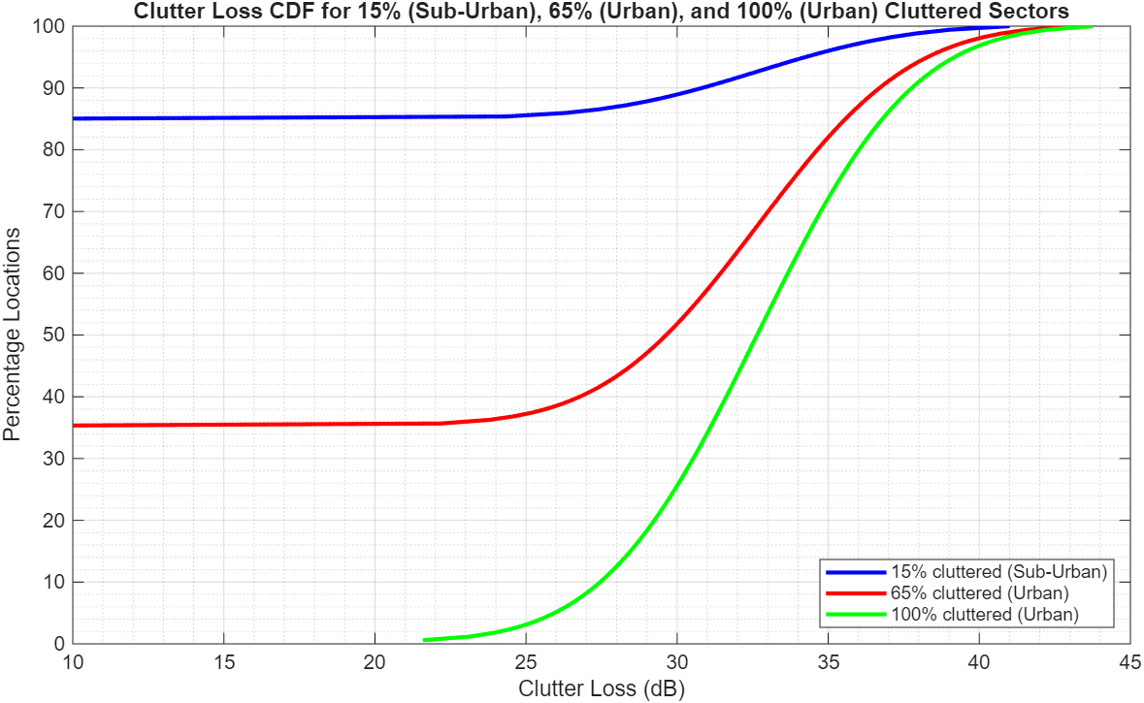

For the study aiming to separate time and location statistics, the following figure illustrates example fixed clutter loss values as a function of azimuth angle. The azimuth direction is referenced to a point located at the center of the IMT base station.

Figure A.1.2.1.3-2

**Example Base Station in Clutter  
Fixed P.2108 Clutter loss applied to all Base Stations vs Azimuth from Base Stations to FS**

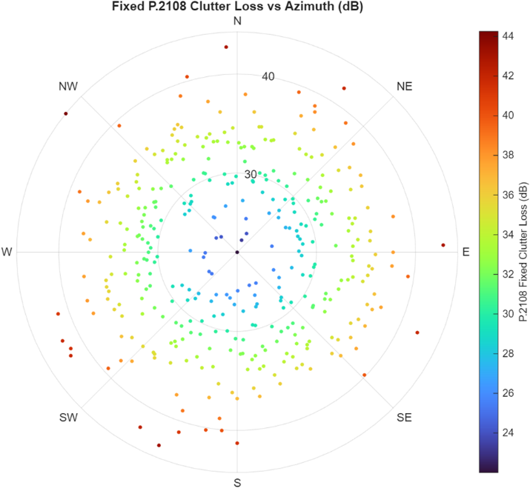

The following figure shows the scenario used in all the simulations.

Figure A.1.2.1.3-3

Sharing scenario setup and example of terrain data heights used in the simulations

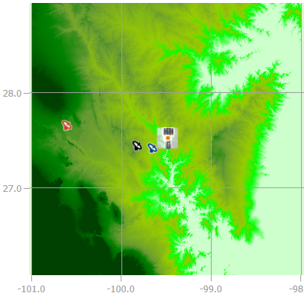 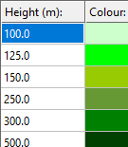

**A1.2.1.3 Study results**

This section summarizes the results of two sharing study cases and shows how the separation distances were obtained. The study was conducted with terrain profile data. The city of Laredo, Texas on the border between the United States of America and Mexico was selected. An initial latitude of +27.5256 degrees and longitude of ‒99.4896 degrees were selected. The Fixed Service station was placed randomly in the adjacent country. Simulations were conducted and CDFs were plotted for the fixed service antenna with its main-lobe, side-lobe or back lobe gain values facing the IMT deployment. The summary results are presented for two cases. One case where the time and location statistics are combined and the second where the time and location statistics are separated. For each of these cases, the baseline case is:

1) Urban base-stations deployments with terrain profile and IMT network loading factor of 20%.

And the following are sensitivity scenarios:

1) Urban base-stations deployments with terrain profile and IMT network loading factor of 50%.

2) Sub-Urban base-stations deployments with terrain profile and IMT network loading factor of 20%.

The following are the CDF results for the scenarios. The results show three CDF curves. One for the required separation distance to preclude interference and two other distances below and above the required distance. The maximum, mean, and standard deviation values for the aggregate I/N interference are provided.

After conducting the simulations for evaluating the interference from synchronized Time Division Duplex (TDD) IMT base stations to the FS victim receiver, it was observed that varying the network loading factor between 20% and 50% results in negligible changes to the required separation distances. The following are some key factors explaining the insensitivity to loading factors in this case:

* Dominance of the strongest interferer: the interference-to-noise (I/N) ratio is typically driven by the nearest or highest-EIRP base station. In dense networks, this dominant interferer outweighs the aggregate contribution from more distant sources, making the required separation largely dependent on a single transmitter.
* Fixed transmit power during downlink (DL) slots: in synchronized TDD systems, all base stations transmit during the same DL slots at maximum power, regardless of the loading factor. Loading affects the time-averaged activity, not the instantaneous transmit power. Therefore, peak interference levels remain constant across different loading scenarios.
* Increased snapshot exceedance, same separation distance: while higher loading increases the frequency of interference threshold exceedances across simulation snapshots, it does not change the peak interference level that dictates the minimum separation distance.

Table of Figures A1.2.1.3-1

CDF Results for Aggregate I/N into FS point-point system for Urban Examples 3 and 4 in 5D/583 (WRC-2023 cycle)   
with 20% Network Loading Factor  
Both time and location statistics are combined into one simulation.

| Example-3, Antenna Gain = 36 dBi | Example-4, Antenna Gain = 38 dBi |
| --- | --- |
|  |  |
|  |  |
|  |  |

Table of Figures A1.2.1.3-2

CDF Results for Aggregate I/N into FS point-point system for Urban Examples 3 and 4 in 5D/583 (WRC-2023 cycle)  
with 50% Network Loading Factor – Sensitivity Analysis  
Both time and location statistics are combined into one simulation.

| Example-3, Antenna Gain = 36 dBi | Example-4, Antenna Gain = 38 dBi |
| --- | --- |
|  |  |
|  |  |
|  |  |

Table of Figures A1.2.1.3-3

CDF Results for Aggregate I/N into FS point-point system for Sub-Urban Examples 1 and 2 in 5D/583 (WRC-2023 cycle)  
with 20% Network Loading Factor – Sensitivity Analysis  
Both time and location statistics are combined into one simulation.

| Example-1, Antenna Gain = 38 dBi | Example-2, Antenna Gain = 39.5 dBi |
| --- | --- |
|  |  |
|  |  |
|  |  |

**A1.2.1.4 Summary and analysis of the results of Study A**

This study estimated the potential aggregate interference from an IMT network into an FS station operating within a country. It considered various antenna gains and separation distances from the border of a neighbouring country that has an urban or suburban IMT network deployed at the edge of its territory. The IMT network was analysed with a 20% network loading factor and a 50% loading factor was used as a sensitivity study. The TDD network activity factor was 75% for base station downlink and 25% for user equipment (UE) uplink.

The results show that the separation distance required to prevent interference ranges from 42 km to 53 km when the fixed service main-lobe antenna is facing the IMT deployment. For the side-lobe, the required separation distance is between 14 km and 20 km, while for the back-lobe, the separation distance is negligible, ranging from 1.8 km to 2.7 km.

(I will adjust/re-write the summary section when I get the new results)

TABLE A1.2.1.4-1

Summary of separation distances for coexistence between IMT and FS Antenna   
Both time and location statistics are combined into one simulation.

|  |  |  |  |  |  |
| --- | --- | --- | --- | --- | --- |
| Deployment Type | Network Loading Factor (%) | FS Antenna Example | Distance (km) for Main-Lobe | Distance (km) for Side-Lobe | Distance (km) for Back-Lobe |
| Urban Macro | 20 (Baseline) | Ex-3 (36 dBi) | 43 | 14 | 2.6 |
| Ex-4 (38 dBi) | 53 | 16 | 1.8 |
| 50 (Sensitivity) | Ex-3 (36 dBi) | 43 | 14 | 2.6 |
| Ex-4 (38 dBi) | 53 | 16 | 1.8 |
| Sub-Urban Macro (Sensitivity) | 20 (Sensitivity) | Ex-1 (38 dBi) | 52 | 15 | 2.6 |
| Ex-2 (39.5 dBi) | 52 | 20 | 2.7 |

(Results where the time and location statistics are separated. (TBD))

TABLE A1.2.1.4-2

Summary of separation distances for coexistence between IMT and FS Antenna.  
For this case both time and location statistics are separated by fixing the clutter loss per azimuth.

|  |  |  |  |  |  |
| --- | --- | --- | --- | --- | --- |
| Deployment Type | Network Loading Factor (%) | FS Antenna Example | Distance (km) for Main-Lobe | Distance (km) for Side-Lobe | Distance (km) for Back-Lobe |
| Urban Macro | 20 (Baseline) | Ex-3 (36 dBi) |  |  |  |
| Ex-4 (38 dBi) |  |  |  |
| 50 (Sensitivity) | Ex-3 (36 dBi) |  |  |  |
| Ex-4 (38 dBi) |  |  |  |
| Sub-Urban Macro (Sensitivity) | 20 (Sensitivity) | Ex-1 (38 dBi) |  |  |  |
| Ex-2 (39.5 dBi) |  |  |  |

Table (IMT ANd Fixed Service in 7 125-8 400 MHz frequency range)

**Overview of the sharing and compatibility studies**

[*Editor’s note: Descriptive text and notes of the table. Rows to be added or deleted based on the decision of WP 5D. The table below is an example for comparison table created at the end of every Appendix.*]

|  | **Parameters from expert WPs** | **Study A** | **Study B** |  |
| --- | --- | --- | --- | --- |
| **Methodology** | | | |  |
| Single-entry or Multiple-entry (aggregated) |  | Multiple entry aggregate analysis | Multiple-entry (aggregated) |  |
| Statistical, or Statistical and Deterministic |  | Statistical (Monte-Carlo) | Statistical |  |
| **Technical and operational characteristics of IMT systems** | | | |  |
| Deployment scenario |  | Urban and Sub-Urban | Urban/suburban macro |  |
| IMT stations |  |  | BS and UE |  |
| Method to deploy multiple IMT stations for the aggregated interference analysis over a relatively large area (as applicable to scenarios for the studies) |  | Rec. ITU-R M.2101 | Rec. ITU-R M.2101 |  |
| Number of IMT base stations (BS) |  | 19 sites, 57 base stations for Urban and Sub-Urban as sensitivity. | 57 BSs (19 sites ×3 sectors) |  |
| Network loading factor for BS and UE (%) |  | 20% (50% as sensitivity) | 20, 50 |  |
| TDD activity factor (%) |  | 75% for BS and 25% for UE. | BS: 75, UE: 25 |  |
| UE power control |  | Yes. Per IMT characteristics and Rec. ITU-R M.2101 | Rec. ITU-R M.2101 |  |
| UE body loss (dB) |  | 4 dB | 4 |  |
| IMT antenna pattern |  | AAS antenna | Extended AAS model (Table 17, Annex 4.15 to Document 5D/563) |  |
|  |  |  |  |  |
| BS antenna mechanical downtilt |  | 6° | 6 degrees |  |
| UE antenna pointing (if beamforming) |  | UE used Omni antenna of -4 dBi | N/A |  |
| UE distribution |  | Random with each 120° sector | Uniform distribution |  |
| User equipment density for terminals that are transmitting simultaneously |  | Up to 3 UEs can transmit simultaneously | 3 UEs per sector |  |
| **Technical and operational characteristics (of incumbent service)** | | | |  |
| Channel spacing and receiver noise bandwidth (MHz) |  | 40 | 40 |  |
| Receiver antenna gain (dBi) |  | 36, 38, 39.5 | 36, 38, 39.5 |  |
| Receiver Noise figure (dB) |  | 4.6 | 5 |  |
| Antenna gain pattern |  | Rec. ITU-R F.1245 | Rec. ITU-R F.1245 |  |
| Station height (m) |  | 20 and 60 | 20 and 60 |  |
| Feeder/multiplexer loss (dB) |  | 1 and 1.8 | 1 and 1.8 |  |
| Tx output power (dBW) |  | N/A | N/A |  |
| Link length (km) |  | N/A | N/A |  |
| Protection criterion (Long Term, 20% of Time) I/N, (dB) |  | -10 | −10 |  |
|  |  |  |  |  |
| **Propagation model/losses** | | | |  |
| Basic transmission loss |  | Rec. ITU-R P.2001 | Rec. ITU-R P.2001 |  |
| Clutter loss |  | Rec. ITU-R P.2108.  Location variability p% random range from 0 to 100%  Clutter loss applied to all IMT Base Stations and  below rooftop Base Stations (65% for urban and 15% for suburban)  Clutter loss applied at IMT stations | Rec. ITU-R P.2108  Location variability p% random range from 0 to 100%  Clutter loss applied to all IMT Base Stations or  below rooftop Base Stations (65% for urban and 15% for suburban)  Clutter loss applied to FS 20 m height receiver |  |
| Building entry loss |  | None | Rec. ITU-R P.2109 |  |
| Cross-polarization loss (dB) |  | 3 | 3 |  |
| **Results of studies** | | | |  |
| Does the study result consider both BS and UEs? |  | Yes snapshots results are for BSs. UEs interference are much lower and not included. | Yes |  |
| Results summary |  | For combined time and location statistics: For FS main-lobe: 42 km and 53 km For Side-lobe: 14 km to 20 km. For back-lobe a negligible separation distance of 1.8 km to 2.7 km.  For separated time and location statistics: TBD | *I/N*= −10 dB not exceeded 20% of the time  Baseline *I/N* case:  Main lobe: less than 5 km to 95 km |  |

_______________