U.S. Radiocommunications Sector
Fact Sheet
Working Party: ITU-R WP 5D | Document No: USWP5D-50/02
Ref: Resolution 256 (WRC-23), Annex 4.11 to Document 5D/413-E | Date: July 17, 2025
Document Title: Studies in relation to WRC-27 agenda item 1.7 – Annex 5 and 7
Author(s)/Contributors(s):  Aspasia Paroutsas  Qualcomm Incorporated |  | Phone: (202) 277-9444  Email: aspa@qualcomm.com
Purpose/Objective: This contribution proposes updates to submitted Doc (5D/763) in last WP5D #49 meeting. This document includes sharing and compatibility studies in the frequency band 7125-8400 MHz, as part of WRC-27 agenda item 1.7 between FSS/MSS E-s and IMT.
Abstract: During the last meeting of Working Party 5D #49, the United States contributed preliminary results for a co-frequency study to assess sharing and compatibility of FSS and MSS (Earth-to-space) operating in the frequency band 7 900-8 400 MHz and in 7 900-8 025 MHz, respectively, and proposed terrestrial IMT operations in the frequency band 7 125-8 400 MHz. This contribution is an update to the Doc (5D/763) and includes updated sharing and compatibility studies that reflect updates from WP4A/4C and 3K/3M, and additional sensitivity analysis including larger contours.

Radiocommunication Study Groups | 
Received: xx 2025  Source: Annex 4.11 to Document 5D/413  Subject: WRC-27 agenda item 1.7 | Document 5D/xx-E
 | xx 2025
English only
SPECTRUM ASPECTS AND WRC PREPARATIONS
United States of America
SHARING AND COMPATIBILITY OF THE FSS/MSS (EARTH-TO-SPACE) OPERATING IN THE FREQUENCY BAND 7 900-8 400 MHz
AND IMT OPERATING IN THE FREQUENCY BAND
7 125-8 400 MHz (or parts thereof)

Introduction
Resolution 256 (WRC-23) resolves to invite the ITU Radiocommunication Sector to complete sharing and compatibility studies for WRC-27 AI1.7, and to ensure the protection of services to which the frequency band is allocated on a primary basis. This includes protection of stations operating in international waters or airspace which cannot be registered in the MIFR, without imposing additional regulatory or technical constraints on those services, as well as on services in adjacent bands. One of the bands under study for a possible terrestrial component of IMT is 7 125-8 400 MHz, or parts thereof, in Region 2 and Region 3, and 7 125-7 250 MHz and 7 750-8 400 MHz, or parts thereof, in Region 1. These ranges overlap the frequency band 7 900-8 400 MHz, allocated on a primary basis to the FSS (Earth-to-space) and 7 900-8 025 MHz allocated on a primary basis to the MSS (Earth-to-space).
This contribution proposes a methodology of a co-channel frequency study between FSS/MSS (Earth-to-space), services that are primary in 7 900-8 400 MHz and in 7 900-8 025 MHz and the terrestrial component of IMT. This study aims to assess the sharing and compatibility between the FSS and MSS (Earth-to-space) operating in the frequency band 7 900-8 400 MHz and 7 900-8 025 MHz, respectively, and the terrestrial IMT component operating in the frequency band 7 125-8 400 MHz.

2 Proposal
This contribution includes studies for a co-frequency study to assess sharing and compatibility of FSS and MSS (Earth-to-space) operating in the frequency band 7 900-8 400 MHz and in 7 900-8 025 MHz, respectively, and proposed terrestrial IMT operations in the frequency band 7 125-8 400 MHz, as described in the attachment.
It is proposed to include the attachment below in the working document on sharing and compatibility studies of IMT systems in the frequency band 7 125-8 400 MHz.
Attachment: 1

Attachment
Sharing and compatibility of the FSS and MSS (Earth-to-space) operating
in the frequency band 7 900-8 400 MHz and in 7 900-8 025 MHz respectively and IMT operating in the frequency band 7 125-8 400 MHz
[Editor’s Note: This is a preliminary study containing a methodology of a co-channel frequency study between FSS/MSS (Earth-to-space), services that are primary in 7 900-8 400 MHz and in 7 900-8 025 MHz and the terrestrial component of IMT. Further updates to this preliminary study including the FSS/MSS characteristics and protection criteria will be necessary.]

1 Technical characteristics and protection criteria

1.1 Technical and operational characteristics of IMT systems operating in the frequency band 7 125-8 400 MHz

1.1.1 Technical characteristics

1.1.1.1 IMT specification related parameters
The IMT system characteristics as described in the working document of SWG IMT Characteristics from ITU 5D #47. Table 1 summarizes the base station (BS) and user equipment (UE) characteristics in the 7 125-8 400 MHz range.
TABLE 1
IMT specification related parameters in 7 125-8 400 MHz
 |  | IMT
No. | Parameter | Base station  (non-AAS) ^{(Note 1)} | Base station  (AAS) | Mobile station
1 | Duplex Method | TDD
2 | Channel bandwidth (MHz) | 100 MHz typical ^{(Note 2)}
3 | Signal bandwidth (MHz) | Signal bandwidth = N_{RB} × SCS × 12  Will be derived from Channel Bandwidth, see [1], § 5.3.2.
4 | Transmitter characteristics
4.1 | Power dynamic range (dB) | 0 dB |  | 56 dB typical
4.2 | Spectral mask (dB) | Category A: ^{(Note 3)}  See table 1A (Wide Area BS)  (Δf_{OBUE} = 40 MHz)  Category B: ^{(Note 3)}  See [1], § 6.6.4, Tables 6.6.4.2.2.1-2a and 6.6.4.2.2.1-2b (Wide Area BS)  (Δf_{OBUE} = 40 MHz) | Category A: ^{(Note 3)}  See table 1B (Wide Area BS)  (Δf_{OBUE} = 100 MHz)  Category B: ^{(Note 3)}  See [1], § 9.7.4.2 and related Tables 6.6.4.2.2.1-2a and 6.6.4.2.2.1-2b (Wide Area BS)  (Δf_{OBUE} = 100 MHz) | See [2], § 6.5.2.2
4.3 | ACLR | 38 dB |  | 26 dB
4.4 | Spurious emissions | Category A: ^{(Note 3)}  See [1], § 6.6.5, Table 6.6.5.2.1-1.  Category B: ^{(Note 3)}  See [1], § 6.6.5, Table 6.6.5.2.1-2. |  | See [2], § 6.5.3.
4.5 | Maximum output power | See [1], § 6.2. | See Item No. 1.13 in Table 4 for typical values | 23 dBm typical ^{(Note 2)}
5 | Receiver characteristics
5.1 | Noise figure (dB) | 6 dB (Wide Area BS)  11 dB (Medium Range BS)  14 dB (Local Area BS)  For BS class definitions, see [1], § 4.4 |  | 13 dB
5.2 | Sensitivity (dBm) | - | - | -
5.3 | Blocking response | In-band blocking level: See [1], § 7.4.2, Table 7.4.2.2-1  Out-of-band blocking level: See [1], § 7.2.2, Table 7.5.2-1a (band n104)  Δf_{OOB} = 60 MHz ^{(Note 4)} | In-band blocking level: See [1], § 10.5.2.2  Out-of-band blocking level: See [1], § 10.6.2.1  Δf_{OOB} = 100 MHz ^{(Note 4)} | See [2], § 7.6 Tables 7.6.2-3 and 7.6.2-4, 7.6.3-3 and 7.6.3-4 for blocking levels and § 7.7 Tables 7.7-1a and 7.7-2 for spurious response
5.4 | ACS | 42 dB |  | 32 dB
5.5 | SINR operating range (dB) | See below “SINR operating range and mapping function”
Note 1: Non-AAS can be used for Urban small cell/Micro cell scenario and indoor scenario.
Note 2: Refer to [3] for more information on other values for channel bandwidth and maximum output power.
Note 3: Base station operating band unwanted emissions define all unwanted emissions in the supported downlink operating band plus the frequency ranges extending Δf_{OBUE} above and Δf_{OBUE} below each band. Base station unwanted emissions outside of this frequency range are limited by the spurious emissions requirement (see item 4.4. in above table).
Note 4: Base Station In-band blocking applies in the supported uplink operating band plus the frequency ranges extending Δf_{OOB} above and Δf_{OOB} below each band, excluding the downlink frequency range in case of an FDD operating band. Out-of-band blocking applies from 1 MHz to 12.75 GHz, excluding the in-band blocking frequency range, but including the downlink frequency range in case of an FDD operating band. Requirements are defined assuming a receiver desensitization of 6 dB.
Note 5: Adjacent Channel Leakage Ratio or spectrum mask can be used to define BS power in OOB domain depending on the interference scenario

AAS beamforming characteristics
Table 2 summarizes the base station (BS) AAS beamforming antenna characteristics in the 7 125-8 400 MHz range.

Table 2
Beamforming antenna characteristics for IMT in 7 125 to 8 400 MHz
 |  | Macro suburban | Macro urban | Small cell outdoor/  Micro urban | Small cell indoor/  Indoor urban
1 | Base station Antenna Characteristics
1.1 | Antenna pattern model | Table 8 (Extended AAS Model) |  | Refer to Recommendation ITU-R M.2101 | N/A
1.2 | Element gain (dBi) ^{(Note 2)} | 6.4 | 6.4 | 6.4 | N/A
1.3 | Horizontal/vertical 3 dB beam width of single element (degree) | 90º for H  65º for V | 90º for H  65º for V | 90º for H  65º for V | N/A
1.4 | Horizontal/vertical front-to-back ratio (dB) | 30 for both H/V | 30 for both H/V | 30 for both H/V | N/A
1.5 | Antenna polarization | Linear ±45º polarized sub-array | Linear ±45º polarized sub-array | Linear ±45º polarized sub-array | N/A
1.6 | Antenna array configuration (Row × Column)  ^{(Note 4)} | 8 × 16 | 8 × 16 | 8 × 8 | N/A
1.7 | Horizontal/Vertical radiating sub-array or element spacing ^{(Note 5)} | 0.5 of wavelength for H, 2.1 of wavelength for V | 0.5 of wavelength for H, 2.1 of wavelength for V | 0.5 of wavelength for H, 0.7 of wavelength for V | N/A
1.7a | Number of element rows in sub-array | 3 | 3 | N/A | N/A
1.7b | Vertical element separation in sub-array ($d_{v,sub}$) | 0.7 of wavelength for V | 0.7 of wavelength for V | N/A | N/A
1.7c | Pre-set sub-array down-tilt (degrees) ^{(Note 6)} | 3 | 3 | N/A | N/A
1.8 | Array Ohmic loss (dB) ^{(Note 2)} | 2 | 2 | 2 | N/A
1.9 | Conducted power (before Ohmic loss) per sub-array or element (dBm) ^{(Note 3)} | 22 | 22 | 16 | N/A
1.10 | Base station horizontal coverage range (degrees) | ±60 | ±60 | ±60 | N/A
1.11 | Base station vertical coverage range (degrees) ^{(Note 1)} | 90-100 | 90-100 | 90-120 | N/A
1.12 | Mechanical down-tilt (degrees) | 6 | 6 | N/A | N/A
1.13 | Base station output power/sector (e.i.r.p.) (dBm) ^{(Note 7)} | 78.3 | 78.3 | 61.5 | N/A
Note 1: The vertical coverage range is given in global coordinate system, i.e., 90° being at the horizon. This range includes the mechanical down-tilt given in row 1.12.
Note 2: The element gain in row 1.2 includes the loss given in row 1.8 and is per polarization.
Note 3: Conducted power values are per polarization. The conducted power per sub-array assumes 16 × 8 sub-arrays and 2 polarizations for the suburban and urban macro cases; the conducted power per element assumes 8 × 8 elements and 2 polarizations for the small cell outdoor/micro urban case. This power is typical power, there is no upper limit for Wide Area Base station (For BS class definitions, see 3GPP TS 38.104 [1], § 4.4).
Note 4: 16 × 8 means there are 16 rows and 8 columns of radiating sub-arrays for macro suburban and macro urban cases. 8 × 8 means there are 8 rows and 8 columns of radiating elements for the small cell outdoor/micro urban case.
Note 5: For the case of 3 elements per sub-array, d_{v} will be 2.1 wavelengths.
Note 6: The pre-set sub array down-tilt is a fixed design parameter for a base station. It is envisaged as a passive fixed (non-varying) electrical tilt within the sub-array elements.
Note 7: The base station e.i.r.p. per sector is calculated as total power (including power from two orthogonal polarizations).
Note 8: Mechanical down-tilt is handled by a coordinate system transformation described in 3GPP TR 36.814 section A.2.1.6.2.
Note 9: $θ_{etilt}$ and $φ_{escan}$ is the BS array antenna beam steering direction used in Table 3, they should be set so that the beam steering direction is within the vertical and horizontal coverage ranges in row 1.11 and row 1.10, respectively.

1.1.2 Operational characteristics

1.1.2.1 BS deployment characteristics
Table 3 provides the BS deployment-related parameters of IMT systems for the 7 125 and 8 400 MHz frequency band.
TABLE 3
Deployment-related parameters for bands between 7 125 and 8 400 MHz
 | Urban/suburban macro | Small cell (outdoor)/Micro cell | Indoor (small cell)
Deployment density (Note 1) | 10 BSs/km² urban / 2.4 BSs/km² suburban  (Note 2, 3) | 1-3 per urban macro cell  <1 per suburban macro site | Depending on indoor coverage/capacity demand
Antenna height | 18 m urban /  20 m suburban | 6 m | 3 m
Sectorization | 3 sectors | Single sector | Single sector
Frequency reuse | 1 | 1 | 1
Indoor base station deployment | n.a. | n.a. | 100%
Indoor base station penetration loss | n.a. | n.a. | Rec. ITU-R P.2109
Below rooftop base station antenna deployment (Note 4) | Urban: 65%  Suburban: 15% | 100% | n.a.
Typical channel bandwidth (Note 5) | 100 MHz | 100 MHz | 100 MHz
Network loading factor (base station load probability X%) (see section 3.5 below and Rec. ITU-R M.2101 Annex 1, section 3.4.1 and 6) | 20%, 50% | 20%, 50% | 20%, 50%
TDD / FDD | TDD | TDD | TDD
BS TDD activity factor | 75% | 75% | 75%
Note 1: These density values are for small dense areas. See section 3.3 for densities in larger areas.
Note 2: “1 BS” = 1 sector in 3-sector cell.
Note 3: This value is calculated based on use of same grid as 3-6 GHz. It is expected that the same BS infrastructure will typically be used for networks in both 3-6 GHz and 6-8 GHz. For sharing studies requiring a specific cell size, the following values should be used: 0.3 km for urban and 0.6 km for suburban.
Note 4: This “below rooftop” parameter is provided for IMT BS deployments to describe the environment surrounding the BS. The above/below rooftop ratio in this table should not be interpreted as indicating whether or not additional clutter loss should be applied. Depending on the sharing scenarios and associated guidance from SG3, relevant propagation models related to clutter loss should be used accordingly.
Note 5: Higher channel BWs compared to 100 MHz are not precluded from this frequency range. Refer to [3] for more information on other values for channel bandwidth.

1.1.2.2 UE deployment characteristics
Table 4 provides the UE deployment-related parameters of IMT systems for the 7 125- 8 400 MHz band.
TABLE 4
UE parameters for bands between 7 125 and 8 400 MHz
 | Urban/suburban macro | Small cell (outdoor)/Micro cell | Indoor (small cell)
Indoor user terminal usage | 70% | 70% | 100%
Indoor user terminal penetration loss | Rec. ITU-R P.2109 | Rec. ITU-R P.2109 | Rec. ITU-R P.2109
User equipment density for terminals that are transmitting simultaneously (Note 1) | 3 UEs per sector | 3 UEs per sector | 3 UEs per sector
UE height (Note 2) | 1.5 m | 1.5 m | 1.5 m
Average user terminal output power | Use transmit power control | Use transmit power control | Use transmit power control
Typical antenna gain for user terminals | −4 dBi | −4 dBi | −4 dBi
Body loss | 4 dB | 4 dB | 4 dB
UE TDD activity factor | 25% | 25% | 25%
Power control model | Refer to Recommendation ITU-R M.2101 Annex 1, section 4.1
Maximum user terminal output power, PCMAX | 23 dBm | 23 dBm | 23 dBm
Power (dBm) target value per RB, P0_PUSCH (Note 3) | −92.2 | −87.2 | −87.2
Path loss compensation factor, α  (same as “balancing factor” mentioned in Rec. ITU-R M.2101) | 0.8 | 0.8 | 0.8
Note 1: UEs share equally the channel bandwidth, i.e. each UE is allocated 1/3 of the channel bandwidth (see Rec. ITU-R M.2101, Section 3.4.1, item 1e-f.). In sharing studies, it is assumed that the AAS BS beamforms towards each UE using the entire array
Note 2: In principle, indoor UEs are distributed over different floors of the building. It should be noted that the number of floors of buildings vary within the environment and among the countries. Moreover, the number of floors of buildings is not related to Macro BS antenna height (parameter given in the Table). In particular in small cities, sub-urban and rural areas, many or most of antennas are installed on masts. Therefore, for outdoor BSs, indoor UEs are assumed to be modelled on the ground floor for the sharing study.
Note 3: The target power is defined per Resource Block (RB), considering 180 kHz RB bandwidth corresponding to 15 kHz subcarrier spacing.

1.1.2.2 Deployment consideration in a relatively large area
For studies involving IMT deployments over wider areas such as the entire visibility of a GSO satellite, the deployment density values for large area (Dl) to be used in a sharing study is therefore calculated according to the following formula:
Dl = Ds * Ra * Rb
where:
Ds = density value for coverage area, i.e. density of simultaneously transmitting UEs or number of BS per km²
Ra (%) = ratio of coverage areas to areas of cities/built areas/districts
Rb (%) = ratio of built areas to total area of region in study.
Table 5 shows Ra and Rb values which will be used in the study. In this contribution, we propose to use the Ra1/Rb1 values in the sharing studies as highlighted in bold considering the US area.
The following equation can be used to calculate the total number of IMT BSs $N_{BS}$ in a given area:
$$N_{BS}=N_{{BS}_{suburban}}+N_{{BS}_{urban}}=A×R_{b}×(R_{aSub}×D_{{BS}_{Sub}}+R_{aUr}×D_{{BS}_{Ur}})$$
where:
$A$: is the surface of the considered area in km²
$R_{a}$: is the ratio of coverage areas to areas of cities/built areas/districts
$R_{b}$: is the ratio built areas to total area of region
$D_{{BS}_{Sub}}$: is the BS density in suburban (2.4 km⁻²)
$D_{{BS}_{Ur}}$: is the BS densities in urban (10 km⁻²).
Table 5
Values for Ra and Rb to be used in studies involving IMT deployments for
frequency bands between 7.1 and 8.4 GHz
 | Options* | Macro | Micro
Ra | 1 | 30% Urban (area < 200 000 km²)  10% Urban (area > 200 000 km²)  10% Suburban (area < 200 000 km²)  5% Suburban (area > 200 000 km²) | 10% Urban (area < 200 000 km²)  5% Urban (area > 200 000 km²)
 | 2 | 45% Urban, 20% Suburban | 10% Urban
Rb | 1 | 5% (area < 200 000 km²)  2% (200 000 - 1 000 000 km²)  1% (area > 1 000 000 km²) | 5% (area < 200 000 km²)  2% (200 000 - 1 000 000 km²)  1% (area > 1 000 000 km²)
 | 2 | 5% (area < 3 500 000 km²)  3% (area > 3 500 000 km²) | 5% (area < 3 500 000 km²)  3% (area > 3 500 000 km²)
 | 3 | 2.5% (area < 200 000 km²) **  2% (200 000 - 1 000 000 km²)  1% (area > 1 000 000 km²) | 2.5% (area < 200 000 km²) **  2% (200 000 - 1 000 000 km²)  1% (area > 1 000 000 km²)
* The Ra and Rb values used in the sharing and compatibility studies should be provided together with the results of studies, for the purpose of comparison, as well as information on which specific geographical location the analysis is applicable to.
** The value is applicable for Region 1, for bands considered globally the value of 5% should be used.
The above options are intended to be applied to satellite footprints presenting regional or country-based coverage. To address the smaller satellite footprints, the methodology in the Annex 1 of Chair’s Report of TG 5/1
(Doc. 5-1/478) is applied.

1.1.2.3 Network loading factor and TDD factor
The study will use a network loading value of 20%, which represents a typical/average value for the loading of base stations across a network (or part thereof) and should be used for sharing and compatibility studies that are considering a relatively wide area (e.g., a large city, province, country or satellite footprint).
The study will us a TDD factor as provided in Table 3 to reflect interference from BSs and UEs to determine the total interference from IMT to FSS/MSS space station.

1.2 Technical and operational characteristics of FSS and MSS (Earth-to-space) operating in the frequency band 7 900-8 400 MHz and 7 900-8 025 MHz

1.2.1 Technical characteristics of FSS/ MSS space receiver
The required parameters for geostationary FSS/MSS space stations to carry out the compatibility studies are shown in Table 6 below.
Table 6
FSS and MSS GSO satellite characteristics
GSO | Units | System 1 | System 2 | System 3 | System 4
System |  | FSS/MSS | FSS | FSS | FSS
Uplink tuning frequency range | (MHz) | 7 900-8 400 | 7 900-8 400 | 7 900-8 400 | 7 900-8 400
Receiving antenna gain | (dBi) | 35 | 35 | 20.4 | 38
Uplink polarization (RHC, LHC, VL, HL or offset linear) |  | Circular | Circular | Circular | Circular
Receive Channel Bandwidth | (MHz) | 125 | 125 | 125 | N/A
Downlink tuning frequency range | (MHz) | 7 250-7 750 | 7 250-7 750 | 7 250-7 750 | 7 250-7 750
Downlink polarization |  | Circular | Circular | Circular | Circular
Peak transmit antenna gain | (dBi) | 35 | 35 | 20.1 | 38
Receiver noise temperature | (K) | 800 | 800 | 800 | 630
Antenna gain pattern |  | Rec. ITU-R S.672 (Ls -20 dB) | Rec. ITU-R S.672  (Ls -20dB) | Rec. ITU-R S.672 (Ls -20dB) | Rec. ITU-R S.672 (Ls -20dB)
Space Station antenna 3dB beamwidth | deg | 2.2 | 2.2 | 17.2 | 2.2

1.2.2 FSS and MSS protection criteria

The long-term protection and short term protection criteria are shown below in Table 7 based on WP4A/4C LS reply without any apportionment, similar to prior cycle studies for FSS.
Table 7
FSS protection criteria in the frequency band 7 900-8 400 MHz
Frequency ranges |  | Percentage of time for which the I/N value could be exceeded  (%) | I/N criteria  (dB)  for GSO | I/N criteria  (dB)  for NGSO
7 900-8 400 MHz (E-s) | Long term | 20% | −10.5 | −10.5
 | Short term | 0.1%  0.03% | −7  −6 | −7  −6

1.3 Propagation models for sharing and compatibility studies in the frequency band 7 125-8 400 MHz

As provided in the Liaison Statement to WP5D from WP 3K and WP 3M in Document 5D/160, Recommendation ITU-R P.619 should be considered for the evaluation of interference between stations in space and those on the surface of the Earth. Recommendation ITU-R P.619 provides methodologies to list and calculate individual propagation effects. The study takes into consideration only the basic transmission loss included in ITU-R P.619 and does not include additional losses which are included in ITU-R P.619 and can be added at later stage. A polarization loss of 3dB is used.
Recommendation ITU-R P.619 also references Recommendation ITU-R P.2108 for the use of the statistical clutter loss. The study uses the updated clutter loss model in section 3.3 of ITU-R P.2108 included in the LS reply from 3K/3M (5D/629), which includes the two-rays model for representing the ground reflections for the directional AAS antennas.
Building entry loss, if required, should be calculated using Recommendation ITU-R P.2109, depending on the environment of the terrestrial terminal. Working Party 3M is currently working on improvements for the clutter loss model ITU-R P.2108. The 3GPP Urban Macro propagation model in TR 38.901 is used to model the propagation between the BSs and the UEs to determine path loss.

2.1 Methodology
This section provides the methodology for the calculation of the aggregate interference from IMT stations to an FSS/MSS GSO space station receiver using Monte-Carlo simulations. The aggregate impact is assessed with respect to a specific orbital position of the geostationary satellite that would cover the continental US. The Monte Carlo analysis will consider initially 1 0000 snapshots and can be increased accordingly for the short-term protection criteria.
This approach can then be used for different longitudes/latitudes of a GSO satellite and multiple pointing of the FSS/MSS satellite antenna. The following steps can be used.
Step 1: A number of earth station locations in the Continental U.S. will be selected for the study. Each location will have a different elevation angle from the selected geostationary satellite under study. The study will compute the satellite antenna footprint based on the specific boresight direction corresponding to each elevation angle of the earth stations.
Step 2: The hypothetical IMT network is developed on a hexagonal grid, where each hexagonal cell will include three BS. Once the total number of BSs in each environment is calculated, a number of clusters could be spread within the area such that the total number of base stations in clusters matches the total derived from Ra/Rb. The ITU-R M.2101 methodology then can be applied for the clusters. As per ITU-R M.2101, a large number of UEs are distributed uniformly in the cluster, and at any given instant/snapshot, three UEs randomly selected from among those passing the SINR check would be serviced in each sector by a BS at the same time. Then in each cluster ITU-R M.2101 method could be implemented to arrive at BS and (and UE) transmissions and beam directions.
Step 3: The BS network load factor of 20% is considered in determining the active BSs in each snapshot.
Step 4: The BS interference to the FSS/MSS GSO space station will be calculated based on the ITU-R P.619 propagation model, considering that the BS antenna gain towards the satellite will vary every snapshot because the served UE changes location. The ITU-R P.2108 clutter loss model will be used in the calculation of the interference path from the transmitting BSs.
Step 5: In the event of considering UE uplink interference, the uplink power control has to be calculated accordingly for each UE. The uniformly distributed UEs can be located indoors or outdoors based on probability provided in Table 4. Clutter loss can be applied using ITU-R P.2108 model for the interference path from each transmitting UE. Additionally, building penetration loss is applied if the UEs are located indoors using the ITU-R P.2109 model.
Step 6: The uplink and downlink interference from IMT to the space station are weighed with the TDD activity factor to calculate the combined interference from the IMT network to the FSS/MSS space station.
Step 7: Each of the steps above will be repeated for the urban and sub-urban scenarios. Each urban and sub-urban scenario will reflect the appropriate beamforming AAS base station characteristics. The total aggregate interference from IMT into FSS/MSS space station will include the calculation under both scenarios.
Step 8: The resulting interference-to-noise ratio (I/N) CDF is calculated by dividing the total aggregate interference PSD by the noise floor PSD of the satellite space receiver. The resulting I/N CDF is compared to the protection criteria of the satellite space receiver, e.g., I/N = –10.5 dB, that cannot be exceeded by more than 20% of the time.

2.1.1 Impact of the IMT User Terminals in the sharing study
Studies in the previous WRC-23 cycle in the 6/7 GHz ranges demonstrated that UEs were not a significant source of interference with respect to the overall analysis. Consequently, aggregate interference from UEs will not be considered in this study.

2.2 Study results

System 1
For System 1, the study uses a high gain 3dB contour spot beam with 35 dBi satellite receiver antenna gain, as highlighted in Table 6 above. The GSO space station is assumed to be at 100⁰W, with a pointing direction towards the center of the continental U.S. at 100⁰W and 40⁰N. The earth station elevation angle – the elevation angle between the footprint center and the space station (E-s direction) – is 43⁰. The BS elevation angles towards the satellite are between 30⁰ to 52⁰ above the horizon. The footprint is covering only land areas (no large bodies of water), and as a result it includes a large number of BSs.
Figure 1
Footprint of System 1 with Satellite location at 100⁰W with beam oriented towards 100⁰W and 40⁰N
(3 dB contour)
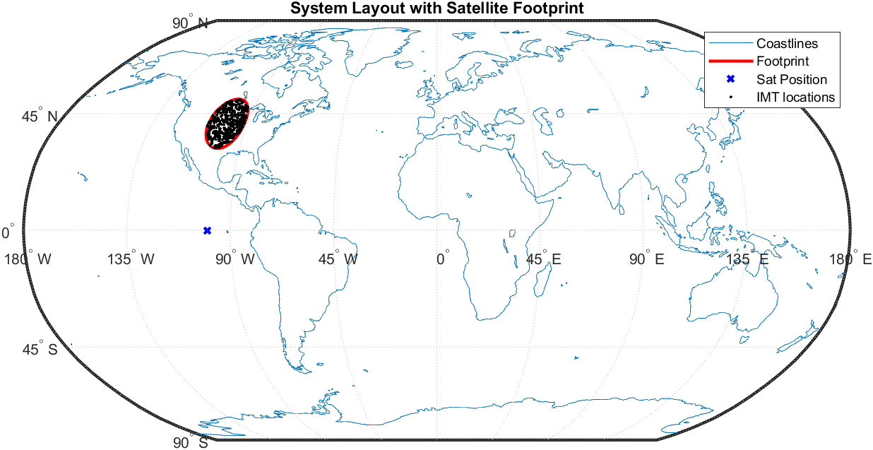
System 2
For System 2, the study uses a high gain 3dB contour spot beam with 35 dBi satellite receiver antenna gain, as highlighted in Table 6 above. The GSO space station is assumed to be at 90⁰W, with a pointing direction towards 82⁰W and 40⁰N, which is covering the East coast of the U.S. The earth station elevation angle – the elevation angle between the footprint centre and the space station (E-s direction) – is 43⁰. The BS elevation angles towards the satellite are between 30⁰ to 52⁰ above the horizon. The footprint is covering mostly land area where dense deployments of BSs can be expected.
Figure 2
Footprint of System 2 with Satellite location at 90⁰W with beam oriented towards 82⁰W and 40⁰N (3 dB contour)
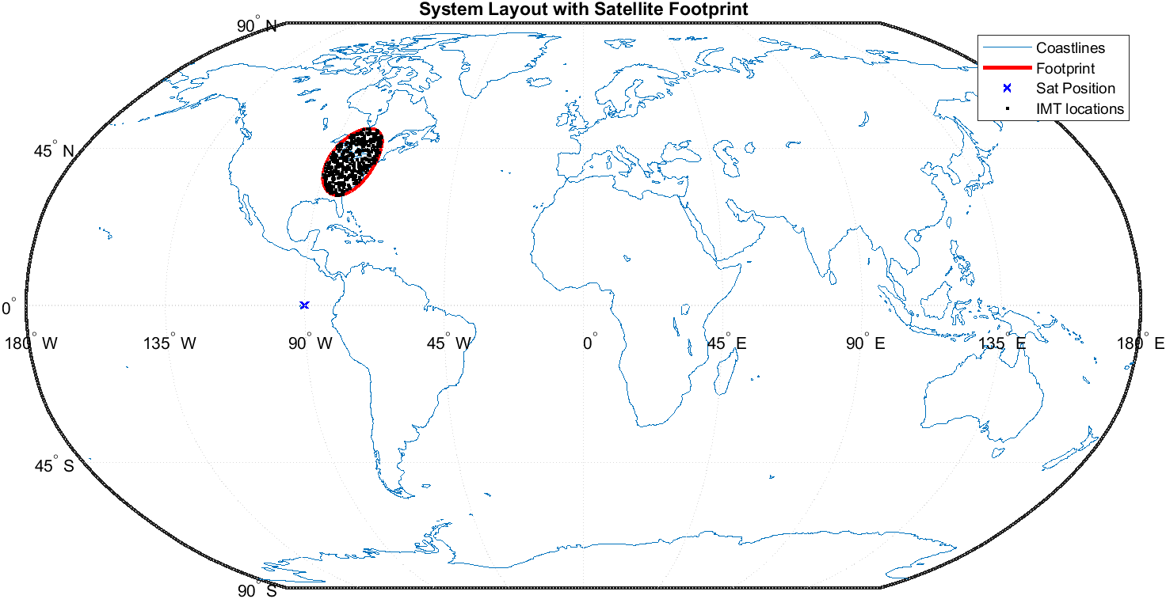
System 3
For System 3, the GSO space station is assumed to be at 100°W, covering all of Region 2 with a Global beam, and with 20.4 dBi satellite receiver antenna gain, as highlighted in Table 6 above. The footprint can cover a wide range of Earth station elevation angles above horizon. The BS elevation angles towards the satellite are between 7⁰ to 80⁰ above the horizon.

Figure 3
Footprint of System 3 with Satellite location at 100⁰W with global beam
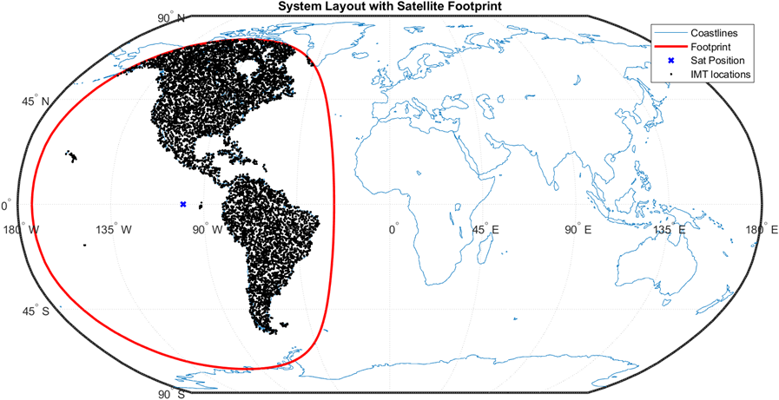
System 4
For System 4, the study uses a high gain 3dB contour spot beam with 38 dBi satellite receiver antenna gain, as highlighted in Table 6 above. The GSO space station is assumed to be at 90⁰W, with a pointing direction towards 115⁰W and 40⁰N, which is covering the West coast of the U.S. The earth station elevation angle – the elevation angle between the footprint centre and the space station (E-s direction) – is 43⁰. The BS elevation angles towards the satellite are between 30⁰ to 52⁰ above the horizon. The footprint is covering land areas in the U.S., which include larger number of BSs.
Figure 4
Footprint of System 4 with Satellite location at 112⁰W with beam oriented towards 115⁰W and 40⁰N
(3 dB contour)
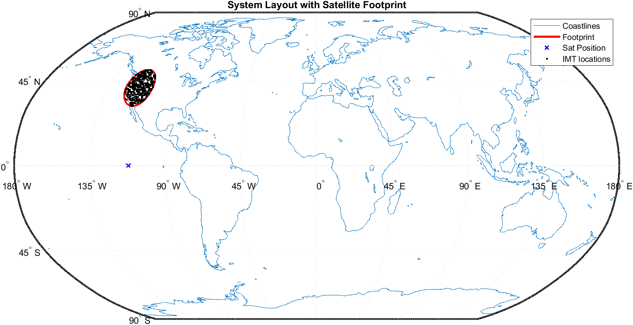
The study calculates the footprint and land areas for the respective satellite system in km² and subsequently applies the Ra/Rb method utilizing Ra1Rb1, as provided in Section 1.1.2.2 above to calculate the number of BS within that area.
Table 7 provides the footprint area and land area in km² and total number of BS sectors in urban and suburban deployments in the land area for each system.
Table 7
IMT Deployments in the Land Area
GSO Systems | Footprint area km² | Land area km² | # of BS (sectors)  Urban | # of BS (sectors)  Suburban | # Total of BS (sectors)  Urban+Suburban
System 1  (3dB contour, US Center) | 2,416,229 | 2,416,229 | 24,162 | 2,899 | 27,061
System 2  (3dB contour, US East Coast) | 2,456,866 | 2,190,501 | 21,905 | 2,628 | 24,533
System 3  (Global beam, Region 2) | 180,671,114 | 40,779,761 | 407,797 | 48,935 | 456,732
System 4  (3dB contour, US West Coast) | 2,421,686 | 2,365,369 | 23,653 | 2,838 | 26,491

In line with Step 7 of the methodology, the study calculates the resulting interference in each environment (i.e. urban and suburban) for each system.
The aggregate I/N CDF for each system is plotted as shown in Figure 5 below.
Figure 5
Simulation results for System 1, 2, 3, and 4 for Urban and Suburban deployments
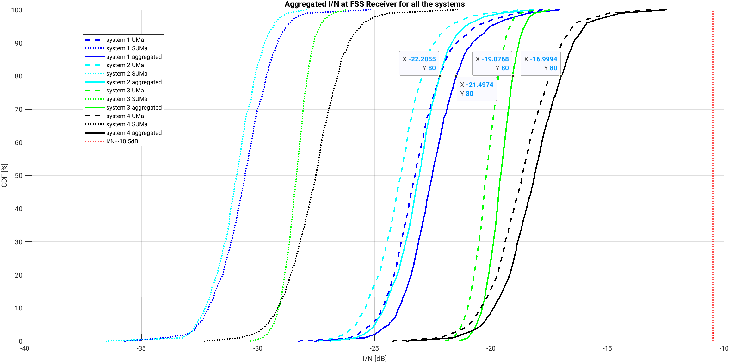
The I/N value is extracted at 80% of the CDF and compared with the long-term protection criteria of I/N = −10.5 dB as provided in Section 1.2.2. Table 8 below provides a summary of the study results for all four systems.
TABLE 8
Simulation results for FSS/MSS systems considering aggregate urban and suburban deployments
GSO systems | Aggregated I/N [dB] (Monte Carlo simulations) Exceeded for 20th percentile
System 1  (3dB contour, US Centre) | −21.5
System 2  (3dB contour, US East Coast) | −22.2
System 3  (Global beam, Region 2) | −19.07
System 4  (3dB contour, US West Coast) | −17

2.4 Summary of Results
This contribution sets forth the methodology, the analysis and preliminary results of a coexistence study between IMT and FSS/MSS in the Earth-to-space direction in the 7 900-8 400 MHz. Based on the methodology set forth above, and with the caveats provided above, the preliminary results show that for both the global beam, which covers the entire Region 2, and the three satellite spot beams, the interference level is below the long-term I/N protection criterion of −10.5 dB.
______________

2.5ANNEX 1
[TBD]
[This annex will include a sensitivity analysis using 20 dB satellite contours.]

