|  |  |  |
| --- | --- | --- |
| U.S. Radiocommunications Sector  Fact Sheet | | |
| **Working Party:** ITU-R WP 5D | **Document No:** USWP5D_50_04 | |
| **Ref:** Annex 4.xx Attachment 1 to Document 5D/xx | **Date:** July 9, 2025 | |
| **Document Title:** Sharing between fixed systems and IMT systems in the frequency band 14.8-15.35 GHz | | |
| **Author(s)/Contributors(s):**  Sandra Wright  FAA  Andrew Meadows  AFSMO  Dominic Nguyen  eSimplicity for AFSMO  Taylor King  ACES Corp. for DON CIO  Izabela Gheorghisor  MITRE for FAA  Michael Tran  MITRE for FAA | | Phone: +1-202-603-7094  Email: sandra.a.wright@faa.gov    Phone: 334-467-4720  E-mail: andrew.meadows.1@us.af.mil  Phone: 703-606-7394  E-mail: dominic.nguyen@esimplicity.com  Phone: 443-966-0550  E-mail: taylor.king@aces-inc.com  Phone : +1-703-983-5833  Email : izabela@mitre.org  Phone : +1-703-593-9969  Email : mtran@mitre.org |
| **Purpose/Objective:** This contribution proposes the sharing studies of fixed systems and IMT systems in the frequency band 14.8-15.35 GHz under WRC-27 agenda item 1.7. | | |
| **Abstract:** WRC-27 AI 1.7 considers studies on sharing and compatibility and develop technical conditions for the use of International Mobile Telecommunications (IMT) in the frequency bands 4 400-4 800 MHz, 7 125-8 400 MHz (or parts thereof), and 14.8-15.35 GHz, taking into account existing primary services operating in these, and adjacent, frequency bands, in accordance with Resolution 256 (WRC-23). The 14.8-15.35 GHz frequency band is allocated on the primary basis to fixed service (FS) and other services. There are currently many FS systems that operate in this frequency band that provide, among other applications, critical network data communications infrastructure for the safe operation of aircraft. This contribution proposes updates to Annex 3 Attachment 1, the sharing studies of fixed systems and IMT systems in the frequency band 14.8-15.35 GHz under WRC-27 agenda item 1.7. | | |

|  |  |
| --- | --- |
| **Radiocommunication Study Groups** |  |
|  |  |
|  |  |
| Source: Annex 4.12 Attachment 1 to Document 5D/-E  Subject: WRC-27 Agenda Item 1.7 | Document 5D/xxx-E |
| 7 October 2025 |
| English only |
| United States of America | |
| SHARING BETWEEN FIXED SYSTEMS AND IMT SYSTEMS OPERATING IN THE FREQUENCY BAND 14.8-15.35 GHZ | |
|  | |

**Introduction**

WRC-27 AI 1.7 considers studies on sharing and compatibility and to develop technical conditions for the use of International Mobile Telecommunications (IMT) in the frequency bands 4 400-4 800 MHz, 7 125-8 400 MHz (or parts thereof), and 14.8-15.35 GHz, taking into account existing primary services operating in these and adjacent frequency bands, in accordance with Resolution 256 (WRC-23). The 14.8-15.35 GHz frequency band is allocated on the primary basis to fixed service (FS) and other services. There are currently many FS systems that operate in this frequency band that provide, among other applications, critical network data communications infrastructure for the safe operation of aircraft.

**Summary of Proposal**

This contribution proposes a sharing study of fixed systems in the frequency band 14.8-15.35 GHz under WRC-27 agenda item 1.7. This study supersedes the one the United States submitted to the June 2025 meeting of Working Party 5D (5D/768), which was Study A in Attachment 1 of 5D/X Annex 4.12.

Attachment: 1

Attachment

**Annex 3 – Sharing and compatibility studies between services to which the band is currently allocated and IMT systems in the frequency band 14.8-15.35 GHz under WRC-27 agenda item 1.7**

attachment 1

**Sharing between the fixed service and IMT operating in the   
frequency band 14.8-15.35 GHz**

[Editor’s note: This Attachment contains sharing and compatibility studies of the fixed service and IMT operating in the frequency band 14.8-15.35 GHz. Note that the technical characteristics are provided from the inputs listed in section 2 in the main body of the document, with the relevant information summarized in Sections 3 and 4 above.]

[Editor’s note:

* At the WP5D meeting #49 in June/July 2025, the comments below were raised:
* - Studies should indicate how they account for the Loading Factor.
* - Studies should indicate how they consider TDD synchronization.
* - Studies should consider the latest version of ITU-R Recommendation F.758,[including the short-term protection criterion.]
* [- How the short-term protection for the fixed services is addressed]
* - [Whether the Clutter loss model 3.2 of Recommendation P.2108 for terrestrial path is based on measurement made with antenna height lower than 6m and “can be applied for urban and suburban clutter loss modelling provided terminal heights are well below the clutter height”. ]
* Alternatively ,how clutter losses of recommendation P.2108 should be applied to terrestrial path.
* [ - How to address time and location variability in the case when the protection criteria is specified in the time domain only.]
* - Studies should clearly indicate the assumptions made in the study, including among others: Terrain data or smooth earth profile, assumptions of the Monte Carlo analysis (whether fixed or random time percentage), network loading factors, clutter and polarization loss and the rationale for the approach taken on these. ]

# A1.1 Technical analysis

### A1.1.1 Study A

#### A1.1.1.1 Technical characteristics

##### A1.1.1.1.1 Technical and operational characteristics of IMT systems operating in the frequency band 14.8-15.35 GHz

The IMT system characteristics are provided in Annex 4.15 to Document 5D/X:

* Section 3.1.3 Table 7 provides the IMT characteristics in 14.8-15.35 GHz such as duplex method, channel bandwidth, signal bandwidth, transmitter characteristics, and receiver characteristics. AAS BS spectral mask is in Table 8. AAS BS spurious emissions are in Table 9, and OTA OOB blocking performance requirement is in Table 10.
* Section 3.2.3 Table 15 provide the IMT base station deployment in 14.8-15.35 GHz band. Table 16 provides UE parameters in 14.8-15.35 GHz band.
* Sections 3.3 and 3.3.3 provide antenna characteristics for IMT AAS base stations in 14.8-15.35 GHz.
* Section 5.1.2 provides the IMT deployment consideration in a relatively large area in 14.8-15.35 GHz band.
* Section 6 provides the IMT loading factors of 20% as the baseline case and 50% as the sensitivity case.

Recommendation [ITU-R M.2101](https://www.itu.int/rec/R-REC-M.2101/en) provides guidance for modelling and simulation of IMT networks for use in sharing and compatibility studies. Large area/nationwide sharing studies using cell radii corresponding to urban and suburban deployments should take into account those that are only deployed in limited, central areas of large cities and suburban areas. One example of a macro network topology is depicted in Figure A1.1.1-1 with a single macro cluster of 19 sites (a base station at each site) with 3 sector antennas each, for a total of 57 sector antennas. Three User Equipment (UEs), randomly distributed in each sector (not shown in the figure), are simultaneously transmitting per sector.

Figure a1.1.1-1

**Example of an IMT macro cellular layout (central cluster)**



**A1.1.1.1.2 Technical and operational characteristics of FS systems operating in the frequency band 14.8-15.35 GHz**

Recommendation ITU-R F.758-8 contains the technical characteristics of FS systems in Table 10 of Annex 2 for the frequency band 14.8-15.35 GHz, guidance on interference criteria in section 4 of Annex 1, and guidance on choosing *I/N* values for long-term sharing criteria in Table 5 of Annex 2. Section 4.2 of Annex 1 provides general information on short-term interference criteria.

Table A1.1.1-1 contains technical characteristics of FS systems in the 14.8-15.35 GHz band and notes (all from Recommendation [ITU-R F.758-8](https://www.itu.int/rec/R-REC-F.758/en) Annex 2 Table 10).

TABLE A1.1.1-1

**System parameters for PP FS systems in 14.4-15.35 GHz**

|  |  |  |
| --- | --- | --- |
| **Frequency range (GHz)** | **14.4-15.35** | |
| Reference Recommendation ITU-R | F.636 | |
| Modulation | QPSK | 128-QAM |
| Channel spacing and receiver noise bandwidth (MHz) | 2.5, **3.5**, 7, 14, 28, 40, 56, 112 | 2.5, 3.5, 7, 14, **28,** 40, 56, 112 |
| Tx output power range (dBW) | −21.0…−3.0 | −18.6…−4 |
| Tx output power density range (dBW/MHz)(1) | −26.4…−8.4 | −33.1…−18.5 |
| Feeder/multiplexer loss range (dB) | 0...10.0 | 0…10.0 |
| Antenna gain range (dBi) | 31.9…49.0 | 31.9…49.0 |
| EIRP range (dBW) | 16.9…37 | 19.9…36 |
| EIRP density range (dBW/MHz)(1) | 11.5…31.6 | 5.4…21.5 |
| Receiver noise figure typical | 5 | 5 |
| Receiver noise power density typical (=*NRX*) (dBW/MHz) | −139 | −139 |
| Normalized Rx input level for 1 × 10−6 BER (dBW/MHz) | −125.5 | −109.5 |
| Nominal long-term interference power density (dBW/MHz)(2) | −139+ *I*/*N* | −139…−136 + *I*/*N* |
| NOTE – The intended set of parameters for two reference systems for sharing/compatibility studies currently are partially or completely unavailable; on a provisional basis, the parameters reported in Annex 3 for the same bands may be used.  (1) To calculate the values for the Tx/EIRP densities, channel spacing/bandwidth needs to be identified. In these tables, the channel spacing indicated in the bold text is used. Where a modal value (Mode) is provided, it is to be taken as indicative within the range specified and further sensitivity analysis may be required on a case-by-case basis to assess a given interference potential due to the variations within the range specified.  (2) Nominal long-term interference power density is defined by “Receiver noise power density + (required *I/N*)” as described in § 4.13 in Annex 2 (see also § 4.1 in Annex 1). | | |

Recommendation [ITU-R F.699](https://www.itu.int/rec/R-REC-F.699/en) provides reference radiation patterns for, and information on, FWS antennas in the frequency range from 100 MHz to 86 GHz. This information may be used in single-entry analyses and interference assessments when information concerning the FWS antenna is not available. Recommendation [ITU-R F.1245](https://www.itu.int/rec/R-REC-F.1245/en) provides average sidelobes and related reference radiation patterns for point-to-point FWS antennas in the frequency range from 1 GHz to 86 GHz. This information may be used for aggregate coordination and interference assessments when information concerning the FWS antenna is not available.

FS Protection criteria

Based on Recommendation ITU-R F.758-8, the study considers a long-term protection criterion of *I/N* = −10 dB, not to exceed 20% of the time, for sharing studies. This represents the aggregate interference of shared primary services.

Recommendations [ITU-R F.1494](https://www.itu.int/rec/R-REC-F.1494/en), [ITU-R F.1495](https://www.itu.int/rec/R-REC-F.1495/en) and [ITU-R F.1606](https://www.itu.int/rec/R-REC-F.1606/en) provide examples of the short-term interference criteria. Short-term protection criteria could be considered in future revisions of the study.

The study will use the following FS characteristics in Table A1.1.1-1:

Modulation: QPSK

• Channel spacing and receiver noise bandwidth: 40 MHz

• Feeder/Multiplexer loss: 5 dB

• Receiver noise figure: 5 dB

• Antenna gain: 32 to 49 dBi

• Antenna height: 20 m and 60 m above local terrain height.

• Antenna pattern: Recommendation ITU-R F.1245

• Protection criteria: *I/N* = ‒10 dB, long-term protection criteria, not to exceed 20% of the time, for sharing study

• FS antenna pointing elevation angle: 0 degree toward the centre of the IMT cluster in azimuth.

**A1.1.1.2 Propagation models used in the study**

Recommendation ITU-R P.2001 provides a wide-range terrestrial propagation model to calculate the path loss between IMT (base station and UE) and the fixed service base station in the frequency range 30 MHz to 50 GHz. The propagation model considers a time percentage range of 0 to 100% and is useful for Monte Carlo analysis. Terrain data will be used in the study.

Recommendation ITU-R [P.2108](http://www.itu.int/rec/R-REC-P.2108/en)-1 – *Prediction of clutter loss* can be applied for urban and suburban clutter loss provided terminal heights are well below the clutter height (urban 15 m and suburban 10 m).

**A1.1.1.3 Methodology**

The IMT network with 19 sites (3 sector (120o) antennas per site) will be used to determine the aggregate interference and the required separation distance for each scenario. The study will consider the IMT network loading factors of 20% as the baseline and 50% as the sensitivity case. FS characteristics and antenna gain selections, and location selections are also considered.

Study assumptions:

• A macro cluster model of 19 sites (3 sector (120o) antennas per site (BS)) for a total of 57 BS sector antennas. Due to UEs with 1.5 m above ground, their aggregate interference will be insignificant at the victim FS station (tens of km away). Hence, only 57 BS sectorial antennas are used to determine the aggregate interference at the victim FS station.

• Both IMT network loading factors of 20% (baseline case) and 50% (sensitivity case) are considered. For the 20% IMT network loading factor as the baseline case, 12 random sector antennas out of 57 sector antennas will be used to determine the aggregate interference at a victim FS for each snapshot. For the 50% IMT network loading factor as the sensitivity case, 29 random sector antennas out of 57 sector antennas will be used to determine the aggregate interference at a victim FS for each snapshot. IMT BS TDD activity is 75%. A total of snapshots for the entire simulation will be several hundreds of thousands of snapshots such that around 10 000 snapshots in each 1 km wedge of the range of distances will be used in the ECDF plot as a function of *I/N* with the intersection of 80% CDF value and an *I/N* = ‒10 dB.

• All IMT base stations have the same clockwise bearings from the true North, 30o, 150o, and 270o for the 3 sector antennas of each BS. IMT mechanical downtilt is 6o.

• IMT centre of the macro cluster cell is selected in Laredo, Texas at (27.5256o,   
‒99.4896o).

• IMT BS antenna height: 18 m for urban and 20 m for suburban.

• Urban cell radius = 300 m (ISD = 450 m) and suburban cell radius = 600 m (ISD = 900 m), which are run independently to obtain results in both environments.

• Base station per sector: EIRP = 84.3 dBm and peak antenna gain = 37.97 dBi, hence transmit power = 46.33 dBm/200 MHz. Three beams per BS will be modelled, corresponding to serving 3 UEs simultaneously, and the BS power will be split among the three beams. The minimum separation distance between a BS and a UE is 35 meters.

• The analysis is for the transmit frequency at 14.9 GHz and looks at the IMT aggregate interference into both the main beam and the back-lobe of the FS antenna.

• FS antenna has its elevation angle of 0o and its peak antenna gain points at the centre of the macro cluster site. Several peak antenna gains are considered from 32-49 dBi. FS long-term protection criteria, *I/N* = ‒10 dB, not to exceed 20% of the time. FS antenna patterns are based on Recommendation ITU-R F.1245.

• 3 dB polarization mismatch loss between IMT antenna and FS antenna.

• Recommendation ITU-R [P.2108](http://www.itu.int/rec/R-REC-P.2108/en)-1 – *Prediction of clutter loss* is applied for urban and suburban clutter loss with a random p-value (0.001% to 99.999%) for each snapshot. Below rooftop BS antenna deployment is 65% for Urban and 15% for Suburban.

• A USGS terrain database of 1 arc-second resolution is used.

• FS locations across the border are selected randomly with uniformly distributed distances up to a maximum of 52 km from the IMT network centre[1]. The analysis was repeated using multiple antenna gains in the range of 31.9-49 dBi to compute the aggregate interference of IMT active sector antennas at the victim FS receivers. The climate of Laredo, Texas is hot and semiarid. Hence, a non-rain case is considered.

• Recommendation ITU-R P.2001-4 is used to determine the basic propagation path loss (with p% randomly selected between 0.001% and 99.999% for each snapshot) of each IMT active sector antenna where the aggregate interference at the FS receiver is determined and compared with the receiver noise floor. Equal propagation steps of around 30 m will be used in the analysis to determine the propagation path loss. For selected FS antennas, the aggregate *I/N* values over the snapshots are stored at each considered distance from the centre of the IMT macro cluster. Then the cumulative distribution function as a function of aggregate I*/N* was plotted and the separation distance is determined based on the intersection of 80% CDF value of 10 000 snapshots and an   
*I/N* = ‒10 dB.

**A1.1.1.4 Study A results**

Figure A1.1.1-2 shows the FS antenna patterns as function of off-axis angle for several peak antenna gains (31.9-49 dBi), using the Recommendation ITU-R F.1245.

Figure a1.1.1-2

**FS antenna patterns for several peak antenna gains (31.9-49 dBi)**

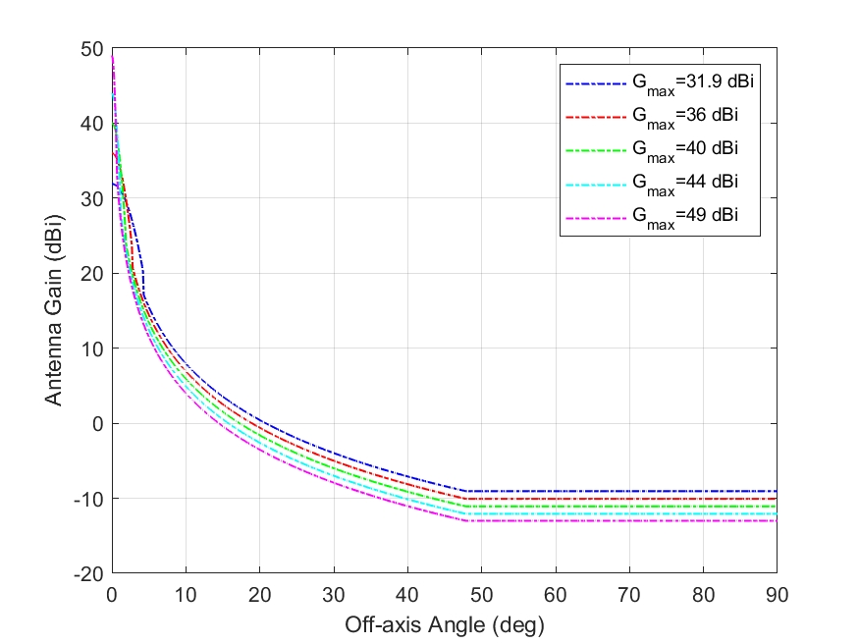

Figure A1.1.1-3 shows the IMT BS beamforming AAS antenna patterns with a mechanical tilt of 6o.

Figure a1.1.1-3

**IMT BS beamforming AAS antenna patterns**

|  |  |
| --- | --- |
|  |  |

Figure A1.1.1-4 shows the clutter losses at the frequency 14.9 GHz for 0.001 ≤ p ≤ 99.999%.

Figure a1.1.1-4

**Clutter loss for terrestrial path at the frequency 14.9 GHz**

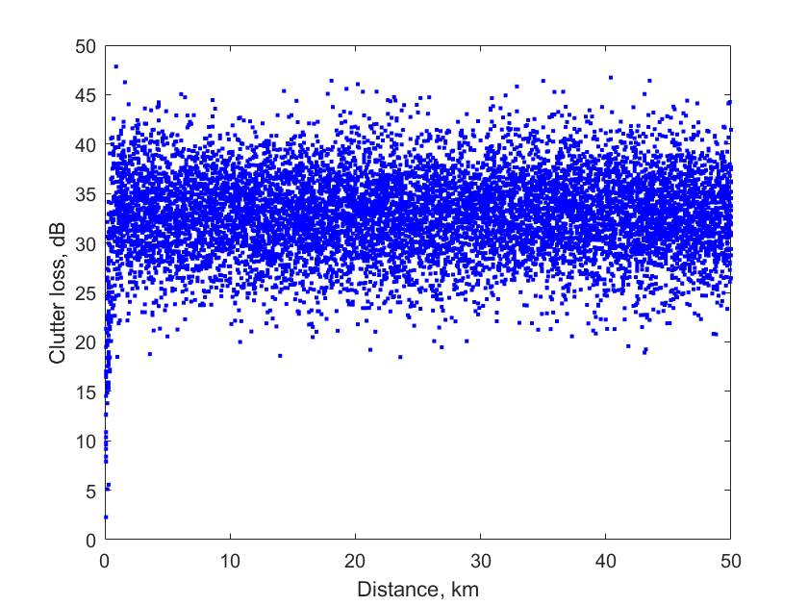

Figure A1.1.1-5 shows an example of 5000 random FS locations (resolution of 10 m) across the border from Laredo, Texas and an IMT macro cluster of 19 sites with a centre at (27.5256o,   
-99.4896o) up to a maximum distance of 50 km from the IMT network centre over the USGS 1 arc-second terrain. This example of 5000 random locations (uniformly distributed in distance and in azimuth) is to visualize the locations while showing the terrain underneath.

Figure a1.1.1-5

**Example of 5000 FS locations and an IMT macro cluster of 19 sites across Laredo, Texas**

Note that study simulations will have several hundreds of thousands of FS locations across the border from Laredo, Texas such that each 1 km wedge distance has around 10000 FS locations.

The study results and the separation distances are shown below:

1. **URBAN Baseline case**: network loading factor = 20%, FS main beam and back-lobe, **FS antenna height of 60 m** are used in the simulations to determine the separation distances based on the threshold of I/N = -10 dB and an 80% CDF value of 10 000 snapshots, as shown in Figure A1.1.1-6.

FIGURE A1.1.1-6

URBAN - **Baseline 20% network loading factor**: Separation distances with **FS height of 60 m** with FS main beam and FS back-lobe

|  |  |
| --- | --- |
|  |  |

1. **SUBURBAN Baseline case**: network loading factor = 20%, FS main beam and back-lobe, **FS antenna height of 60 m** are used in the simulations to determine the separation distances based on the threshold of I/N = -10 dB and an 80% CDF value of 10 000 snapshots, as shown in Figure A1.1.1-7.

FIGURE A1.1.1-7

SUBURBAN - **Baseline 20% network loading factor**: Separation distances with **FS height of 60 m** with FS main beam and FS back-lobe

|  |  |
| --- | --- |
|  |  |

1. **URBAN SENSITIVITY case**: **network loading factor = 50%**, FS main beam and back-lobe, **FS antenna height of 60 m** are used in the simulations to determine the separation distances based on the threshold of I/N = -10 dB and an 80% CDF value of 10 000 snapshots, as shown in Figure A1.1.1-8.

FIGURE A1.1.1-8

**URBAN SENSITIVITY** case - **Baseline 50% network loading factor**: Separation distances with **FS height of 60 m** with FS main beam and FS back-lobe

|  |  |
| --- | --- |
|  |  |

**A1.1.1.5 Summary and analysis of the results of Study A**

TBD

Table (IMT ANd FS in 14.8-15.35 MHZ frequency range)

**Overview of the sharing and compatibility studies**

*[Editor’s note: This Table should also include FS characteristics.]*

|  | Parameters from expert WPs | Study A [USA] | Study B [Japan] |
| --- | --- | --- | --- |
| **Methodology** | | | |
| Single-entry or multiple-entry (aggregated) |  | Multiple entry aggregate analysis | Multiple-entry (aggregated) |
| Statistical, or statistical and deterministic |  | Statistical (Monte-Carlo) | Statistical |
| **Technical and operational characteristics of IMT systems** | | | |
| Deployment scenario |  | Urban and Suburban | Urban/suburban micro or hotspot (outdoor) |
| **IMT stations** |  |  |  |
| Method to deploy multiple IMT stations for the aggregated interference analysis over a relatively large area (as applicable to scenarios for the studies) |  | Rec. ITU-R M.2101 | N/A |
| Number of IMT base stations (BS) |  | 19 base stations (3 sector antennas per base station), a total of 57 BS sector antennas for Urban and Suburban. | 37 BS with 1 sectors |
| Network loading factor for BS and UE (%) |  | 20% as baseline  (50% as sensitivity) | 20%, 50% |
| TDD activity factor (%) |  | 75% for BS | DL: UL = 75%:25% |
| UE power control |  | Not consider | M.2101-0 |
| UE body loss (dB) |  | Not consider | 4 |
| IMT antenna pattern |  | Extended AAS model | Annex 4.15 to Document [5D/563](https://www.itu.int/dms_ties/itu-r/md/23/wp5d/c/R23-WP5D-C-0563!H4-N4.15!MSW-E.docx) |
| BS antenna mechanical downtilt |  | 6o | 6 |
| UE antenna pointing (if beamforming) |  | Not consider | N/A |
| UE distribution |  | 3 UE per sector | 3 UE per sector |
| User equipment density for terminals that are transmitting simultaneously |  | Not consider | 1 |
| Technical and operational characteristics (of incumbent service) | | | |
| Channel spacing and receiver noise bandwidth (MHz) |  | 40 |  |
| Receiver antenna gain (dBi) |  | 32, 37, 42, 49 |  |
| Receiver noise figure (dB) |  | 5 |  |
| Antenna gain pattern |  | Rec. ITU-R F.1245 |  |
| Antenna height (m) |  | 20 and 60 |  |
| Feeder/multiplexer loss (dB) |  | 5 |  |
| Tx output power (dBW) |  | N/A |  |
| Link length (km) |  | N/A |  |
| Protection criterion (Long-term, 20% of time) I/N (dB) |  | -10 |  |
| **Propagation model/losses** | | | |
| Basic transmission loss |  | Rec. ITU-R P.2001 | P.2001-4 |
| Clutter loss |  | Rec. ITU-R P.2108  Location variability p% random range from 0 to 100%  Clutter loss applied to all IMT Base Stations and  below rooftop Base Stations (65% for urban and 15% for suburban)  Clutter loss applied at IMT stations | P.2108-1 |
| Building entry loss |  | None | N/A |
| Cross-polarization loss (dB) |  | 3 | 0 |
| **Results of studies** | | | |
| Does the study result consider both BS and UEs? |  | Study only considers interference from IMT base stations. Interference from IMT UEs is not significant, hence it is not included. | Yes |
| Results summary |  | For FS main-lobe: the separation distance is around 49.5 km.  For FS back-lobe: the separation distance is around 2.5 km. | For the smooth earth profile, the separation distance between the IMT network and the FS station, where *I/N* does not exceed –10 dB, is around 45 km. For the terrain profile, the separation distance ranges from approximately 30 km to 45 km. |

1.