U.S. Radiocommunications Sector
Fact Sheet
Working Party: ITU-R WP 5D | Document No: USWP5D_50/06 ctia02
Ref: Resolution 256 (WRC-23),  Annex 4.11 to Document 5D/792-E | Date: July 13, 2025
Document Title: Sharing between the fixed service and IMT operating in the frequency band 4 400-4 800 MHz
Author(s)/Contributors(s):  Michael Mullinix  CTIA |  | Phone: 301-639-7159  Email: mmullinix@ctia.org
Purpose/Objective: This contribution presents a study between IMT and fixed service (FS) receivers in the 4400-4800 MHz frequency band.
Abstract: This contribution presents a study between IMT and fixed service (FS) receivers in the 4400-4800 MHz frequency band.

Radiocommunication Study Groups | 
Received: [Date]  Source: Annex 4.11 (Attachment 1) to Document 5D/792  Subject: WRC-27 agenda item 1.7 | Document 5D/USA-E
 | Date 2025
English only

SPECTRUM ASPECTS AND WRC PREPARATIONS
United States of America
Sharing between the fixed service and IMT operating in the frequency band 4 400-4 800 MHz

Summary
The United States presents a study between IMT and the fixed service (FS) operating in the 4400-4800 MHz frequency band. This contribution presents the system parameters and characteristics, cross-border Monte Carlo study methodology, and simulation results.

Attachment
attachment 1
Sharing between the fixed service and IMT operating in
the frequency band 4 400-4 800 MHz

A1.1 Technical Analysis

A1.1.4 Study D [USA]

A1.1.4.1 Technical characteristics

A1.1.4.1.1 Technical and operational characteristics of IMT systems operating in the frequency band 4 400-4 800 MHz
The characteristics of IMT systems for the frequency band 4 400-4 800 MHz are provided in the working document on “Characteristics of terrestrial component of IMT for sharing and compatibility studies in preparation for WRC-27” (Annex 4.11 to Document 5D/792).
This study assumed an urban macro deployment such that the IMT BS cell radius was 400m. A network loading factor (20%) was employed to determine the percentage of BS sectors that were active for a given sample. Further, the TDD activity factor was set to 75% for the BSs and 25% for the UEs. The study assumed there were three active UEs for uplink sectors. Further, 70% of the UEs were assumed to be indoors whose uplink transmissions experienced building entry losses. The UEs used uplink power control as prescribed by equation 23 in Recommendation ITU-R M.2101. The BS output power per sector was 72.2 dBm/100 MHz. The peak BS antenna gain was calculated to be 26.2 dBi using the pattern provided for the extended version of the AAS array antenna model. The IMT BS heights were set to 20 m for a macro urban deployment and 100% of the BS experienced clutter losses.

A1.1.4.1.2 Technical/ operational characteristics and protection criteria of the fixed service operating in the frequency band 4 400-4 800 MHz
The characteristics and protection criteria of the fixed service for the frequency band 4 400-4 800 MHz are provided from WP 5C (Document 5D/129). The parameters used for this sharing study are shown in TABLE 1 below.

TABLE 1
System parameters for PP FS systems in 4 400-4 800 MHz used in the sharing study
System parameters | Values
Modulation | 256-QAM
Channel spacing and receiver noise bandwidth (MHz) | 28
Tx output power range (dBW) | -5
Feeder/multiplexer loss (dB) | 3
Antenna gain (dBi) | 22.5
Antenna pattern | Recommendation ITU-R F.1245
Antenna elevation | -0.2
Receiver noise figure (dB) | 6.5
Antenna height(m) | 39
Link length (km) | 41
Nominal long-term interference power density (dBW/MHz) | −137.5 + I/N
Long term I/N protection criteria (dB) | -10 not to be exceeded for more than 20% of the time.

A1.1.4.2 Propagation models used in the study
– ITU-R P.2001 – A general purpose wide-range terrestrial propagation model in the frequency range 30 MHz to 50 GHz
– ITU-R P.2108 – Prediction of clutter loss
– ITU-R P.2109 – Prediction of building entry loss

Recommendation ITU-R P.2001-4 was applied based on guidance from WP-3M (document 5D/160) for the terrestrial path propagation loss between IMT and the FS station. As noted by WP-3M, Recommendation ITU-R P.2001 “has the benefit of providing a full-time percentage range of 0 to 100% and is useful where Monte Carlo analysis is to be used.”
Recommendation ITU-R P.2108-1 was used to determine clutter loss as an end point correction model. It was assumed that using a uniformly distributed random percentage between 0% and 100% of locations. The base station and UE are assumed to be in clutter in all cases. The FS station is assumed to not experience clutter losses.
Recommendation ITU-R P.2109-2 was used to determine the building entry losses for the UE uplink path (70% traditional, 30% thermally efficient building). It was assumed that using a uniform random distribution of percentages between 0% and 100%. The elevation angle of the link is calculated for each UE and BS combination.

A1.1.4.3 Methodology
Using the IMT parameters outlined above, the IMT network consisting of 19 cell sites was created with BSs and UEs, operating at the border, in Country A. For downlink interference, the active sectors are randomly selected. In each sector, there were 100 UEs placed randomly with a minimum distance of 35 meters from the base station. At each sample, three randomly selected UEs were chosen from the 100 to orient the base station beam pointing. For uplink interference, three UEs are randomly selected from the within randomly selected sectors based on the activity factors defined above.
An FS station is operating in Country B, with antenna characteristics outlined above was configured to consider two different antenna beam coupling toward the IMT network, mainlobe and backlobe. The configurations are visualized in Figure 1 where $d_{back}$ and $d_{front}$ are the calculated distances necessary to meet the FS station protection criteria list in Table 1 above.
Figure 1
Topology relation between the IMT network and the FS station

The equation for interference power density $I$ (dBW/MHz) from each IMT BS sector or UE is as follows:
$$I=P_{IMT}+G_{IMT}-L_{pr}-L_{cl}+G_{FS}-L_{fl}$$
where:
$P_{IMT}$: transmit power of an IMT BS sector or UE (dBW/MHz)
$G_{IMT}$: IMT BS sector or UE antenna gain towards the FS station (dBi)
$L_{pr}$: propagation loss calculated from Recommendation ITU-R P.2001-4 (dB)
$L_{cl}$: clutter loss calculated from Recommendation ITU-R P.2108-1 (dB)
$G_{FS}$: antenna gain of the FS station towards the IMT network (dBi)
$L_{fl}$: feeder loss (dB)

The interference to noise, $I/N$, ratio is calculated by aggregating the interference power density from all active IMT stations in a Monte Carlo sample and subtracting the noise power density with units dBW/MHz.
In this study, terrain data from the U.S. Geological Survey (USGS), without clutter along the path, was used to model different terrain profiles between the IMT network and the FS station. Specifically, each Monte Carlo sample of the simulation randomly selected a terrain profile of the appropriate length, determined by calculating the distance between the IMT network stations and the FS earth station, from a raster file of terrain data bounded by latitudes 29°N and 32°N and longitudes 97°W and 94°W. The USGS terrain tiles are downloadable as 1x1-degree tiles meaning nine tiles were used as the sample space for the terrain profiles. The purpose of randomly sampling terrain profiles is to obtain location-independent statistics for the path loss along different terrain profiles.
The victim link between the BSs/UEs and FS station uses Recommendations ITU-R P.2001 and P.2108 with uniformly random percentages of time. The simulation considers 10,000 samples for each FS station configuration.

A1.1.4.4 Intermediate results
The study calculated the transmit antenna gain of the IMT BS in the direction of the FS station as well as the off-axis gain of the FS station antenna in the direction of the IMT network. As an example, a CDF of these gain values is shown in the following figure for the mainlobe coupling configuration. Note that each configuration recalculates the antenna gain information since the elevation and distance values were varied.
Figure 2
IMT BS antenna gain towards the FS station (left) and FS station off-axis antenna gain towards the IMT network (right) with mainlobe coupling
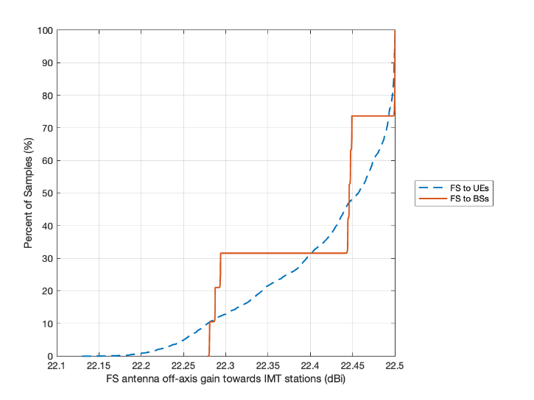 | 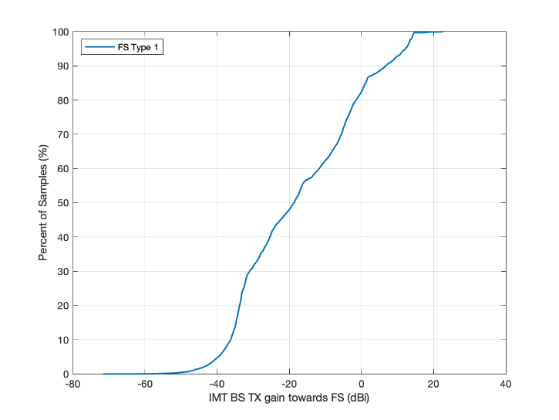

A1.1.4.5 Study results
The distances were varied until the FS station protection criteria was met. For the mainlobe configuration, the FS station needed to be 38 km from the edge of the IMT deployment to meet the FS station protection criteria. For the backlobe, the FS station needed to be 1.5 km from the edge of the IMT deployment.
In the following figures, the FS station I/N is plotted as a cumulative distribution function (CDF) for each configuration. A red line shows the I/N of -10 dB which intersects a dashed black line representing the 20% of the time threshold.
Figure 3
FS station I/N CDF plots
Configuration | CDF plot
Mainlobe  $$d_{front}=38km$$ | 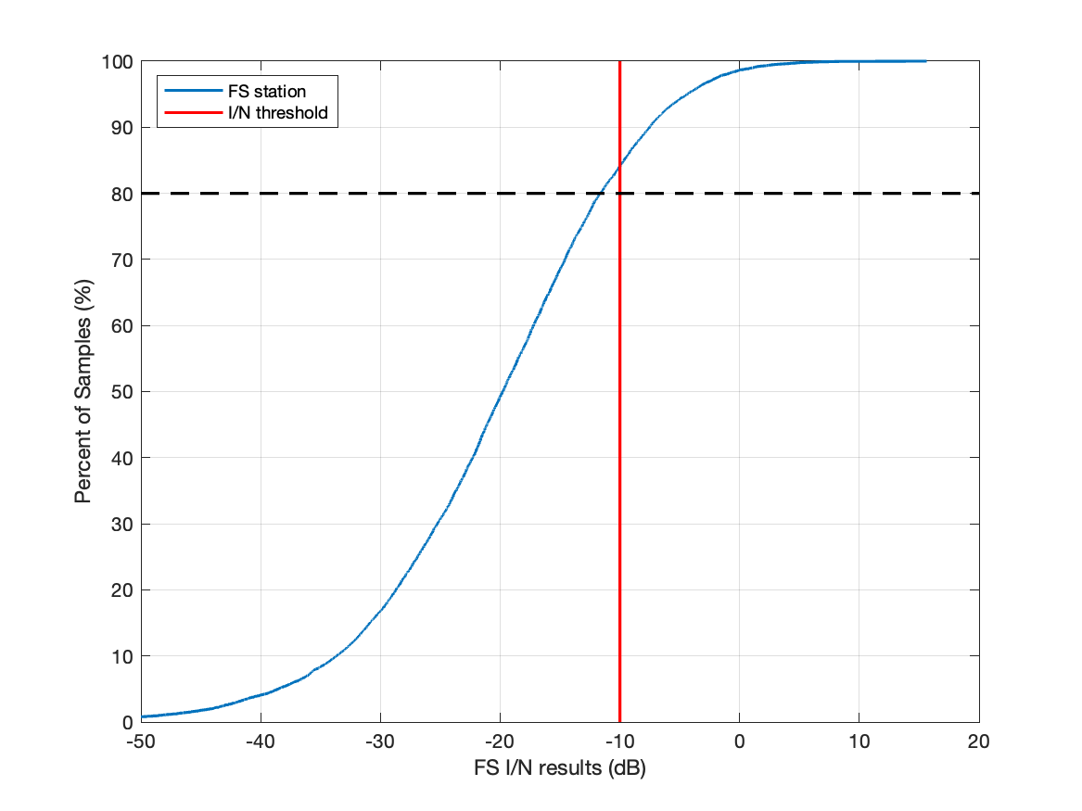
Backlobe  $$d_{back}=1.5km$$ | 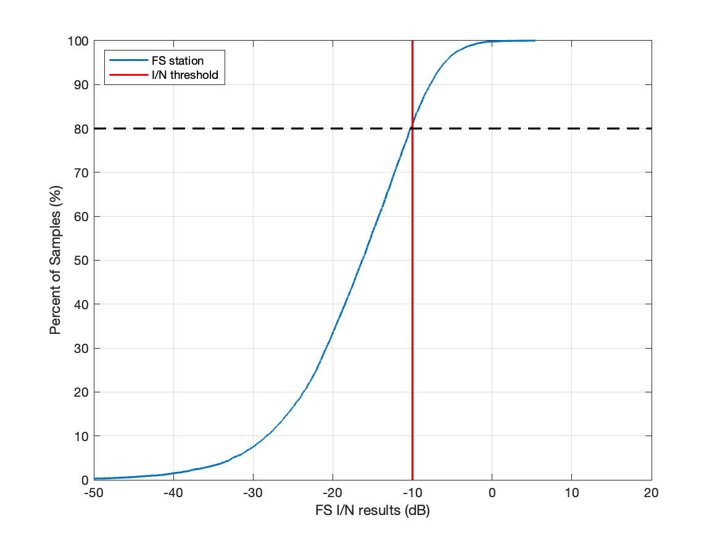

A1.1.4.6 Summary and analysis of the results of Study D
This study considered potential cross-border interference from an urban IMT deployment into an FS station at various antenna coupling configurations and distances from the border of a neighbouring country. The urban IMT network deployment was at the edge of its territory. The IMT network had a 20% network loading factor, a 75/25% BS downlink to uplink ratio, 100% of the base stations experienced clutter loss, and a 70% indoor deployment of the UEs. Based on the assumptions used in the study, a separation distance 38 km would meet the long-term (80% of the time) threshold at an I/N of −10 dB. For back lobe coupling of the FS station with the IMT network, a separation distance of 1.5 km protects the FS station at this long-term protection objective.
Table (IMT AND THE FIXED SERVICE IN 4 400-4 800 MHZ FREQUENCY RANGE)
Overview of the sharing and compatibility studies
[Editor’s note: Descriptive text and notes of the table. Rows to be added or deleted based on the decision of WP 5D.]
 | Parameters from expert WPs | Study D | Study …
Methodology
Single-entry or Multiple-entry (aggregated) |  | Aggregate
Statistical, or Statistical and Deterministic |  | Statistical (Monte-Carlo)
Technical and operational characteristics of IMT systems
Deployment scenario |  | Macro Urban
IMT stations
Method to deploy multiple IMT stations for the aggregated interference analysis over a relatively large area (as applicable to scenarios for the studies) |  | M.2101
Number of IMT base stations (BS) |  | 19 (57 sectors)
Network loading factor for BS and UE (%) |  | 20%
TDD activity factor (%) |  | 75% for BS and 25% for UE.
UE power control |  | Yes. Per IMT characteristics and M.2101
UE body loss (dB) |  | 4 dB
IMT antenna pattern |  | Extended AAS model (Table 8 of Annex 4.2 of 5D/413)
BS antenna mechanical downtilt |  | -6°
UE antenna pointing (if beamforming) |  | N/A
UE distribution |  | Uniform
User equipment density for terminals that are transmitting simultaneously |  | 3
Technical and operational characteristics (of incumbent service)
Feeder/Multiplexer loss (dB) |  | 3
Antenna gain (dBi) |  | 22.5
Antenna pattern |  | Recommendation ITU-R F.1245
Antenna elevation |  | 0
Receiver noise figure (dB) |  | 6.5
Antenna height (m) |  | 39
I/N protection criteria (dB) |  | -10 not to be exceeded for more than 20% of the time
Propagation model/losses
Basic transmission loss |  | P.2001
Clutter loss |  | P.2108
Building entry loss |  | P.2109
Cross-polarization loss (dB) |  | N/A
Results of studies
Does the study result consider both BS and UEs? |  | Yes
Results summary
_______________

