U.S. Radiocommunications Sector
Fact Sheet
Working Party: ITU-R WP 5D | Document No: USWP5D_50_07
Ref: Resolution 256 (WRC-23), Chapter 4 - Annex 4.XX to Document 5D/792 | Date: July 18, 2025
Document Title: Sharing between the aeronautical mobile service and IMT operating
in the frequency band 14.8-15.35 GHz
Author(s)/Contributors(s):  Thu Luu  USAF  Dominic Nguyen  eSimplicity for USAF  Taylor King  ACES for DON CIO |  | Phone: 703-203-7344  Email: thu.luu@us.af.mil  Phone: 703-606-7394  Email: dominic.nguyen@esimplicity.com  Phone: 443-966-0550  Email: taylor.king@aces-inc.com
Purpose/Objective: This contribution proposes updates to the sharing between the aeronautical mobile service and IMT operating in the frequency band 14.8-15.35 GHz under WRC-27 agenda item 1.7.
Abstract: WRC-27 AI 1.7 considers studies on sharing and compatibility and develops technical conditions for the use of International Mobile Telecommunications (IMT) in the frequency bands 4 400-4 800 MHz, 7 125-8 400 MHz (or parts thereof), and 14.8-15.35 GHz, taking into account existing primary services operating in these, and adjacent, frequency bands, in accordance with Resolution 256 (WRC-23). This contribution presents an initial study between aeronautical mobile service and IMT in the 14.8-15.35 GHz band.

Radiocommunication Study Groups | 
Source: Chapter 4 Annex 4.XX to Document 5D/792-E  Subject: WRC-27 agenda item 1.7 | Document 5D/xxx-E
 | XX October 2025
 | English only
United States of America
SHARING BETWEEN THE AERONAUTICAL MOBILE SERVICE AND IMT OPERATING IN THE FREQUENCY BAND 14.8-15.35 GHZ
Summary
In the attached, the United States presents update to the study between aeronautical mobile service and IMT operating in the 14.8-15.35 GHz band.

Attachment: 1
attachment 2
Sharing between the aeronautical mobile service and IMT operating
in the frequency band 14.8-15.35 GHz
[Editor’s note: This Attachment contains sharing and compatibility studies of the aeronautical mobile service and IMT operating in the frequency band 14.8-15.35 GHz. Note that the technical characteristics are provided from the inputs listed in section 2 in the main body of the document, with the relevant information summarized in Sections 3 and 4 above.]
[Editor’s note: The studies in this attachment need to be updated at the 50th WP5D meeting and further clarifications are required.]

A2.1 Technical analysis

A2.1.1 Study A (Single IMT network) [USA, 5D/769, 5D/XXX]

A2.1.1.1 Technical characteristics

A2.1.1.1.1 Technical and operational characteristics of IMT systems operating in the frequency band 14.8-15.35 GHz
For this study, an IMT network was modelled with base stations in a hexagonal grid that included 3 base stations at each hexagonal site with 120 degrees azimuth coverage each. The grid encompassed 19 sites, or 57 base station (BS) sectors. Three UEs per base station sector were distributed randomly in the sector coverage area with UEs that had maximum transmit power of 23 dBm, -4 dBi antenna gain and assumed a 4 dB body loss that was applied on the transmit and receive sides of the UEs. The IMT grid inter-site distances (ISD) were set to 450m for urban with 300m cell size. The UEs had a minimum distance to the BS of 35 m. At any given snapshot when a base station was active, it could serve up to 3 UEs simultaneously. A network loading factor was employed to determine the percentage of base stations that were active for a given snapshot. A loading factor of 20% was assumed. The TDD activity factor was set to 75% for the BSs and 25% for the UEs. The BS transmit power was 46.3 dBm/200MHz and the BS peak antenna gain was 38 dBi. The BS output power per sector was 84.3 dBm/200 MHz. The AAS antenna was modelled with 6-degree mechanical downtilt. The noise figures for the IMT were set to 8 dB for BSs and 13 dB for the UEs. The IMT BSs heights were set to 18 m for urban and 20 m for suburban for all BSs. In this study, the clutter losses for terrestrial paths were applied on the IMT side only based on Recommendation ITU-R P.2108-1 with a uniformly distributed random percentage of locations.

A2.1.1.1.2 Technical/ operational characteristics and protection criteria of aeronautical mobile service operating in the frequency band 14.8-15.35 GHz

TABLE 1
Representative technical characteristics of the aeronautical mobile service systems in the frequency range 14.5-15.35 GHz
Parameter |  | Units | System 1  Airborne | System 1  Ground and shipborne | System 2  Airborne | System 2  Ground and shipborne
Receiver
Tuning range |  | GHz | 14.50-14.83 | 15.15-15.35 | 15.15-15.35 | 14.50-14.93
IF selectivity | 3 dB | MHz | 36 / 140 | 27 / 150 | 27 / 150 | 12 / 36 / 140
 | 20 dB | MHz | 67 / 400 | 46 / 210 | 46 / 210 | 40 / 67 / 400
 | 60 dB | MHz | 173 / 850 | 113 / 600 | 113 / 600 | 60 / 173 / 850
NF |  | dB | 4 | 5 | 3 | 4

TABLE 1 (continued)
Parameter | Units | System 1  Airborne |  | System 1  Ground and shipborne | System 2  Airborne |  | System 2  Ground
Antenna
Antenna gain | dBi | 4 | 24 | 40 | 27 | 7.2 | 44 | 3
1st sidelobe | dBi | N/A² | 5.5 @ 21° | 20 @ 2.5° | 9.7 @ 12° | N/A² | 21 @ 2.3° | N/A²
Polarization |  | V | RHCP³ | V / RHCP³ & LHCP⁴ | RHCP³ & LHCP⁴ | Not available | RHCP³ | Vertical
Antenna pattern/type |  | Dipole | RF lens | Parabolic reflector | Parabolic reflector | Biconical dipole | Parabolic reflector | Dipole
Horizontal BW | degrees | 360 | 12 | 1.5 | 8 | 360 | 1.7 | 360
Vertical BW | degrees | 40 | 12 | 1.5 | 8 | 16 | 1.7 | 42
Antenna model |  | Omnidi-rectional | Recommendation  ITU-R M.1851⁵  (Uniform distribution) | Recommendation  ITU-R M.1851⁵  (Cosine distribution) | Recommendation  ITU-R M.1851⁵  (Uniform distribution) | Omnidirectional | Recommendation  ITU-R M.1851⁵  (Cosine distribution) | Omnidirectional
Notes:
⁽¹⁾ In the frequency band 14.5-14.8 GHz, RR Article 21 (Nos. 21.2, 21.3 and 21.5) apply.
⁽²⁾ N/A – Not applicable.
⁽³⁾ RHCP – Right Hand Circularly Polarized.
⁽⁴⁾ LHCP – Left Hand Circularly Polarized.
⁽⁵⁾ Recommendation ITU-R M.1851 provides several patterns based on the field distribution across the aperture of the antenna. The suggested distribution for modelling the antennas is shown in the parenthetical text based on guidance in Recommendation ITU-R M.1851.

TABLE 1 (continued)
Parameter |  | Units | System 3  Airborne | System 3  Ground | System 4  Airborne | System 4  Ground
Receiver
Tuning range |  | GHz | 14.83-15.35 | 14.50-15.35 | 15.15-15.35 | 14.50-14.83
IF selectivity | 3 dB | MHz | 50 | 50 | 130 | 36.5
 | 20 dB | MHz | 85 | 70 | 400 | 59.1
 | 60 dB | MHz | 135 | 120 | 1 200 | 103.7
NF |  | dB | 5 | 4 | 4.5 | 4 to 6

TABLE 1 (continued)
Parameter | Units | System 3  Airborne | System 3  Ground | System 4  Airborne |  | System 4  Ground
Antenna
Antenna gain | dBi | 24 | 45 | 3.7 | 19.5 | 3 | 40 | 45
1st sidelobe | dBi | 5.5 @ 21° | 20 | N/A² | 3.5 @ 20° (azimuth)  4.0 @ 23° (elevation) | N/A¹ | 22 | 20
Polarization |  | RHCP³ | RHCP³ | RHCP³ | RHCP³ | RHCP³ | RHCP³ | V / RHCP
Antenna pattern/type |  | RF lens | Parabolic reflector | Biconical dipole | RF lens | Biconical dipole | Parabolic reflector | Parabolic reflector
Horizontal BW | degrees | 12 | 1.11 | 360 | 12 | 360 | 3.8 | 1
Vertical BW | degrees | 12 | 1.11 | 40 | 12 | 42 | 3.8 | 1
Antenna model |  | Recommendation ITU-R M.1851⁵  (Uniform distribution) | Recommendation ITU-R M.1851⁵  (Cosine distribution) | Omnidirectional | Recommendation ITU-R M.1851⁵  (Uniform distribution) | Omnidirectional | Recommendation ITU-R M.1851⁵  (Uniform distribution) | Recommendation ITU-R M.1851⁵  (Uniform distribution)
Notes:
⁽¹⁾ In the frequency band 14.5-14.8 GHz, RR Article 21 (Nos. 21.2, 21.3 and 21.5) apply.
⁽²⁾ N/A – Not applicable.
⁽³⁾ RHCP – Right Hand Circularly Polarized.
⁽⁴⁾ LHCP – Left Hand Circularly Polarized.
⁽⁵⁾ Recommendation ITU-R M.1851 provides several patterns based on the field distribution across the aperture of the antenna. The suggested distribution for modelling the antennas is shown in the parenthetical text based on guidance in Recommendation ITU-R M.1851.

TABLE 1 (continued)
Parameter |  | Units | System 5  Airborne | System 5  Ground | System 6  Airborne / Ground / Shipboard terminals
Receiver
Tuning range |  | GHz | N/A² | 14.5-15.35 | 14.5-15.35
IF selectivity | 3 dB | MHz | N/A² | 0.85 / 8.8 / 11.7 / 40.7 / 43.7 | 0.85 to 120
 | 20 dB | MHz | N/A² | 1.3 / 18 / 23 / 90 / 90 | 1.3 to 120
 | 60 dB | MHz | N/A² | 3.2 / 61 / 81 / 320 / 320 | 3.2 to 160
NF |  | dB | N/A² | 3.5 | 3.5

TABLE 1 (continued)
Parameter | Units |  |  | System 5  Airborne | System 5  Ground |  | System 6  Airborne / Ground / Shipboard terminals
Antenna
Antenna gain |  | dBi | −3 to 27.5 |  | 7 | 42.5 | 0 to 12
1st sidelobe |  | dBi | N/A² |  | N/A | 22.5 | N/A²
Polarization |  |  | RHCP³ |  | RHCP³ | RHCP³ | Vertical / RHCP³
Antenna pattern/type |  |  | Dipole / Parabolic reflector |  | Parabolic reflector | Parabolic reflector | Dipole / Phase array
Horizontal BW |  | degrees | 360 to 7 |  | 40 | 1 | 360 to 45
Vertical BW |  | degrees | 90 to 7 |  | 40 | 1 | 90 to 45
Antenna model |  |  | Omnidirectional or Recommendation ITU-R M.1851⁵  (Uniform distribution) |  | Recommendation ITU-R M.1851⁵  (Cosine distribution) | Recommendation ITU-R M.1851⁵  (Cosine distribution) | Not available
Notes:
⁽¹⁾ In the frequency band 14.5-14.8 GHz, RR Article 21 (Nos. 21.2, 21.3 and 21.5) apply.
⁽²⁾ N/A – Not applicable.
⁽³⁾ RHCP – Right Hand Circularly Polarized.
⁽⁴⁾ LHCP – Left Hand Circularly Polarized.
⁽⁵⁾ Recommendation ITU-R M.1851 provides several patterns based on the field distribution across the aperture of the antenna. The suggested distribution for modelling the antennas is shown in the parenthetical text based on guidance in Recommendation ITU-R M.1851.
⁽⁶⁾ System 9 has no link from ground / shipborne stations to an airborne station on the helicopters in the frequency band 14.5-15.35 GHz.

table 1 (end)
Parameter |  |  | Units | System 7  Airborne | System 7  Ground | System 8  Airborne/Ground/Shipboard
Receiver
Tuning range |  |  | GHz | 14.5-15.35 | 14.5-15.35 | 14.5-15.35
IF selectivity | 3 dB |  | MHz | 32 | 12 | 30
 | 20 dB |  | MHz | N/A² | N/A² | 44
 | 60 dB |  | MHz | N/A² | N/A² | 92
NF |  |  | dB | 3 | 3 | 10
Antenna
Antenna gain |  | dBi |  | −3 to 6 | 44 | 36
1st sidelobe |  | dBi |  | N/A² | N/A² | 15
Polarization |  |  |  | V | V | RHCP
Antenna pattern/type |  |  |  | Dipole | Parabolic reflector | Phased Array
Horizontal BW |  | Degrees |  | 360 | 1 | 3.10
Vertical BW |  | Degrees |  | 90 | 1 | 3.10
Antenna model |  |  |  | Omnidirectional | Recommendation ITU-R M.1851⁵  (Uniform distribution) | M.1851  (cosine distribution)

Parameter |  |  | Units | System 9  Airborne⁶ | System 9  Ground / Shipborne⁶
Receiver
Tuning range |  |  | GHz | N/A^{2, 6} | 14.5-15.35
IF selectivity | 3 dB |  | MHz | N/A² | 22
 | 20 dB |  | MHz | N/A² | 23.6
 | 60 dB |  | MHz | N/A² | N/A²
NF |  |  | dB | N/A² | 5
Sensitivity |  |  | dBm | N/A² | −90
Image rejection |  |  | (dB) | N/A² | 80
Spurious rejection |  |  | (dB) | N/A² | 60
Antenna
Antenna gain |  | dBi |  | 4 to 14 | 5
1st sidelobe |  | dBi |  | N/A² | −90
Polarization |  |  |  | V & H | 80
Antenna pattern/type |  |  |  | Horn / Collinear / Planar-array / Parabolic reflector | 60
Horizontal BW |  | Degrees |  | 360 to 40 | 5
Vertical BW |  | Degrees |  | 60 to 1 | −90
Antenna model |  |  |  | Omnidirectional / Recommendation ITU-R M.1851⁵  (Cosine distribution)/  Recommendation ITU-R M.1851⁵  (Uniform distribution) | Recommendation  ITU-R F.699-8
Notes:
⁽¹⁾ In the frequency band 14.5-14.8 GHz, RR Article 21 (Nos. 21.2, 21.3 and 21.5) apply.
⁽²⁾ N/A – Not applicable.
⁽³⁾ RHCP – Right Hand Circularly Polarized.
⁽⁴⁾ LHCP – Left Hand Circularly Polarized.
⁽⁵⁾ Recommendation ITU-R M.1851 provides several patterns based on the field distribution across the aperture of the antenna. The suggested distribution for modelling the antennas is shown in the parenthetical text based on guidance in Recommendation ITU-R M.1851.
⁽⁶⁾ System 9 has no link from ground / shipborne stations to an airborne station on the helicopters in the frequency band 14.5-15.35 GHz.]

A2.1.1.1.3 Propagation models used in the study

[Editor’s note: This study used the current in-force version of ITU-R Recommendation P.2108-1 (09/2019). The study will be updated when we have the approved version of P.2108.]
– ITU-R P.528 – A propagation prediction method for aeronautical mobile and radionavigation services using the VHF, UHF and SHF bands;
– ITU-R P.2001 – A general purpose wide-range terrestrial propagation model in the frequency range 30 MHz to 50 GHz;
– ITU-R P.2108 – Prediction of clutter loss;
– ITU-R P.2109 – Prediction of building entry loss.
Recommendation ITU-R P.528-5 was applied based on guidance from WP-3M (document 5D/160) for ground-to-air paths between IMT and aeronautical mobile service (airborne systems). It was assumed that a uniform random distribution of percentages between 1% and 99% was used over time.
Recommendation ITU-R P.2001-4 was applied based on guidance from WP-3M (document 5D/160) for the terrestrial path propagation loss between IMT and aeronautical mobile service (ground systems). As noted by WP-3M, Recommendation ITU-R P.2001 “has the benefit of providing a full-time percentage range of 0 to 100% and is useful where Monte Carlo analysis is to be used.”
Recommendation ITU-R P.2108-1 was used to determine clutter loss along the path with clutter losses varying randomly between the 0 and 100th percentile. Clutter losses were applied to all UEs and only those base stations below rooftop heights. Section 3.2 of P.2108, which outlines the statistical clutter loss model for terrestrial paths, was applied to the sharing study between IMT and AMS ground, while Section 3.3 of P.2108, detailing the Earth-space and Aeronautical statistical clutter loss model, was applied to the sharing study between IMT and AMS airborne.
Recommendation ITU-R P.2109-2 was used to determine the building entry losses for the UE uplink path. A uniform distribution between 0 and 100% for the building entry loss probability of non-exceedance was assumed.” The elevation angle of the link was calculated for each UE and BS combination.
In addition, Shuttle Radar Topography Mission (SRTM) 3 Arc-Second Global terrain data was selected, based on the guidance from WP 3M.

A2.1.1.2 Methodology
Using the IMT parameters outlined in A1.2.1.1.1, the IMT network was modelled. The location of the central IMT is in El Paso, Texas (31.754898° N, 106.489754° W). For downlink interference, three UEs were placed randomly, ensuring a minimum distance of 35 meters from the base station. For uplink interference, up to three UEs per sector were chosen based on the activity factors defined earlier.
The AMS receivers’ locations were randomly chosen such that the distance between the AMS receiver and the IMT network centre was fixed at 50, 150, 250, 350, and 450 km for the airborne systems, and 10, 20, 30, and 40 km for the ground-based systems. The AMS airborne height was randomized between 300 m and 13.7 km, while the AMS ground height was fixed at 10 m. The AMS airborne antenna pointed downward with a random elevation angle ranging from 0 to -90 degrees, whereas the AMS ground antenna pointed upward with an elevation angle between 0 and 90 degrees. The azimuth of antennas pointed at the centre of the IMT network.
Propagation losses between the BSs/UEs and the AMS ground receiver were calculated using ITU-R P.2001 recommendations, while the AMS airborne receiver utilized P.528 recommendations. The clutter loss from P.2108 was applied only to the IMT side. Building entry loss was considered for the interference link between the UE and AMS. The simulation included 100 000 samples for each AMS system. The I/N distribution for all AMS systems was computed, as shown in Table 2.

A2.1.1.3 Study A results

A2.1.1.3.1 Intermediate results
Figures 1, 2, and 3 present the intermediate results for Study A, showing the cumulative distribution functions (CDFs) of IMT antenna gain towards AMS receivers, AMS antenna gain towards IMT systems, clutter loss and path losses at 50 km for AMS airborne and 10 km for AMS ground based.
FIGURE 1
IMT (BS and UE) antenna gain towards AMS receivers, AMS antenna gain towards IMT systems

 | CDF plot
IMT (BS and UE) antenna gain towards AMS receivers | 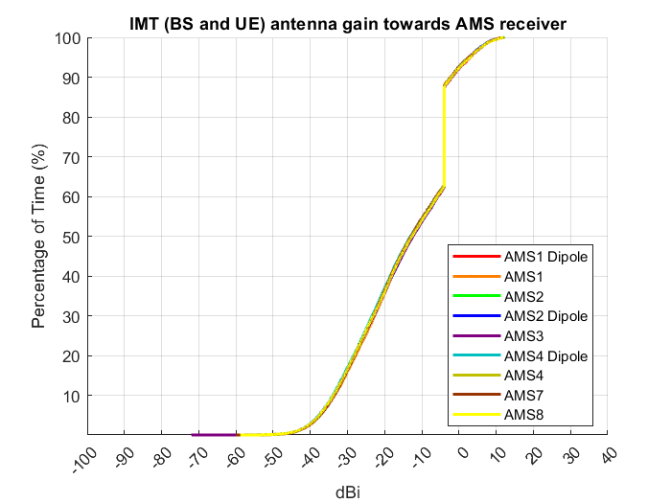
AMS airborne antenna gain towards IMT systems | 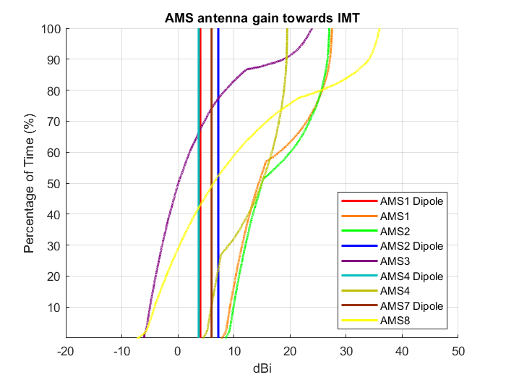
AMS ground-based antenna gain towards IMT systems | 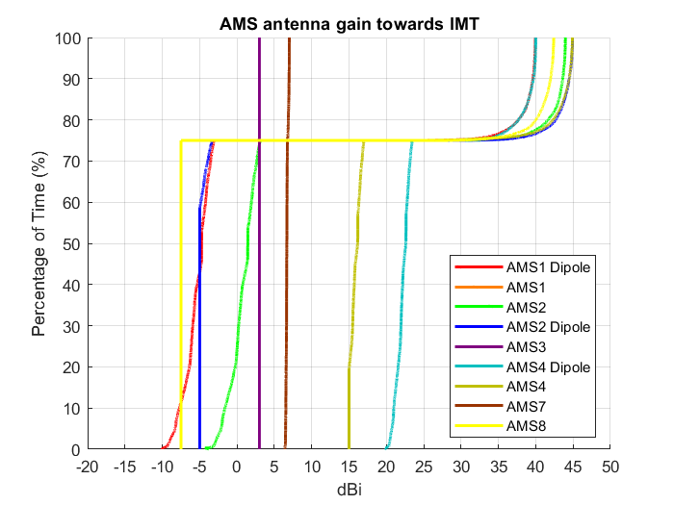
FIGURE 2
Path loss and clutter loss at 50 km for AMS airborne
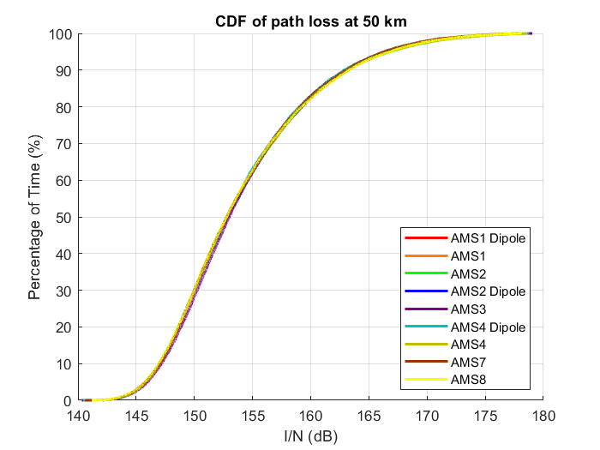
FIGURE 3
Path loss and clutter loss at 10km for AMS ground based
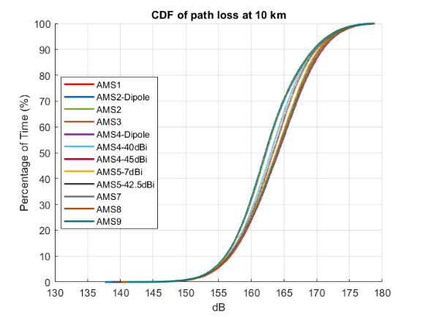

A2.1.1.3.2 I/N plots for Study A
Figure 4 illustrates the interference from IMT to AMS airborne receivers. The figure depicts the AMS I/N as a CDF at different distances.
FIGURE 4
AMS airborne I/N CDF plot at different distances
Distance | CDF
50 km | 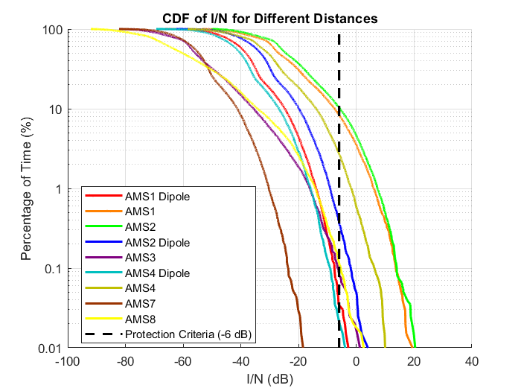
150 km | 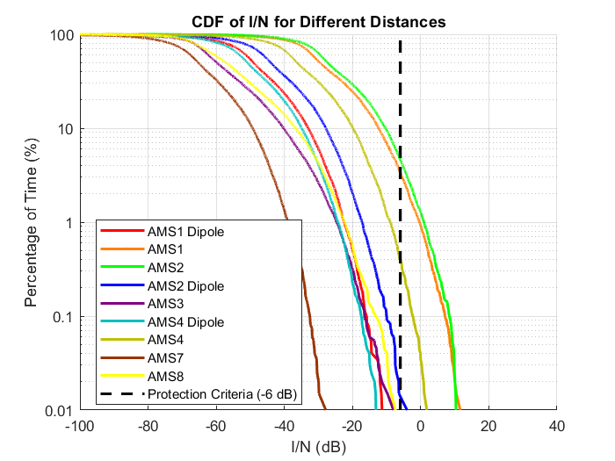
250 km | 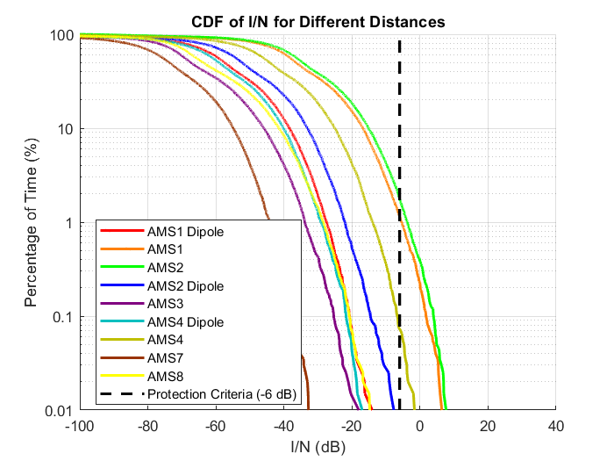
350 km | 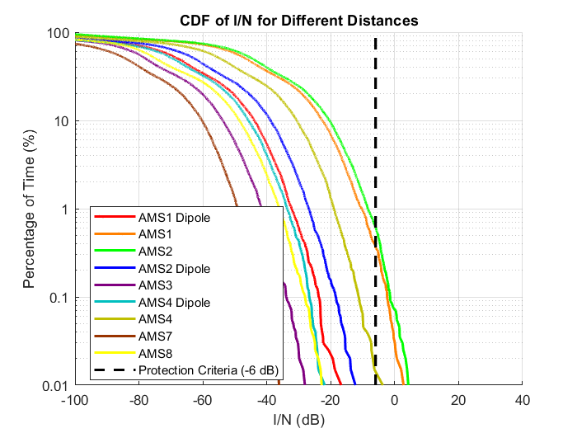
450 km | 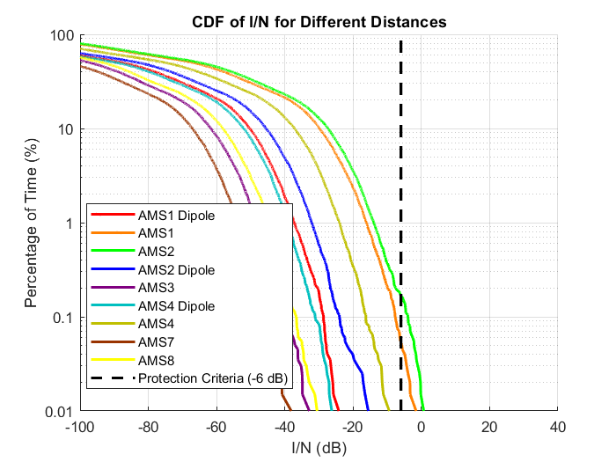
From the CDF plot above, the percentage of I/N samples exceeding the threshold at I/N = -6 dB is calculated for each AMS airborne receiver and presented in Table 2.
Table 2
Percent of I/N samples that exceed the protection threshold
Distance | AMS1-Dipole | AMS1 | AMS2 | AMS2-Dipole | AMS3 | AMS4-Dipole | AMS4 | AMS7 | AMS8
50 km | 0.0300 | 8.3000 | 10.3250 | 0.3650 | 0.0800 | 0.0200 | 2.6800 | 0.0000 | 0.1150
150 km | 0.0000 | 3.3450 | 4.5750 | 0.0100 | 0.0000 | 0.0000 | 0.3950 | 0.0000 | 0.0050
250 km | 0.0000 | 1.1600 | 1.7600 | 0.0000 | 0.0000 | 0.0000 | 0.0700 | 0.0000 | 0.0000
350 km | 0.0000 | 0.3750 | 0.6200 | 0.0000 | 0.0000 | 0.0000 | 0.0100 | 0.0000 | 0.0000
450 km | 0.0000 | 0.0500 | 0.1650 | 0.0000 | 0.0000 | 0.0000 | 0.0050 | 0.0000 | 0.0000
Figure 5 illustrates the interference from IMT to AMS ground-based receivers. The figure depicts the AMS I/N as a cumulative distribution function (CDF) at different distances.
FIGURE 5
AMS ground based I/N cdf plot at different distances
Distance | CDF
10 km | 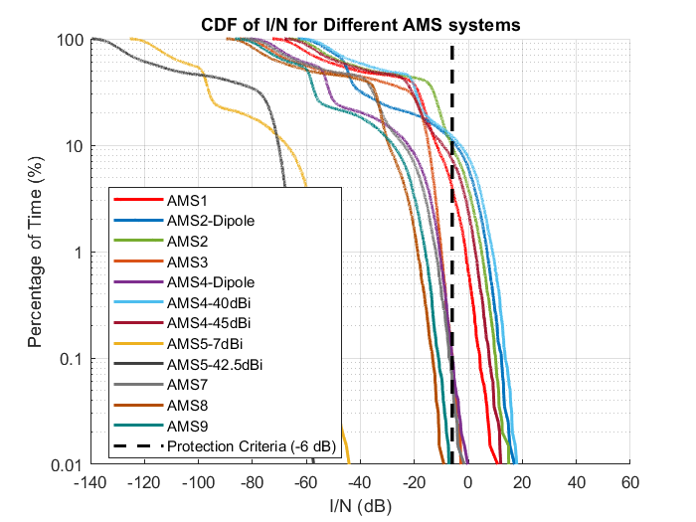
20 km | 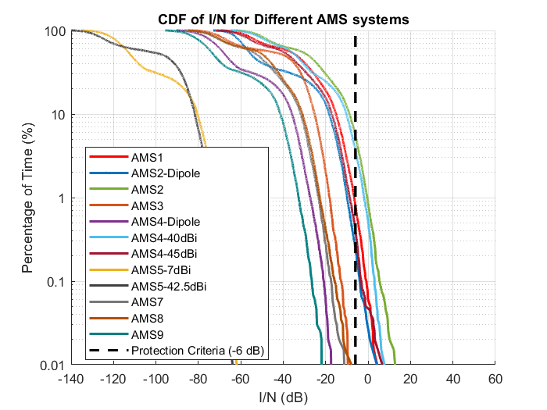
30 km | 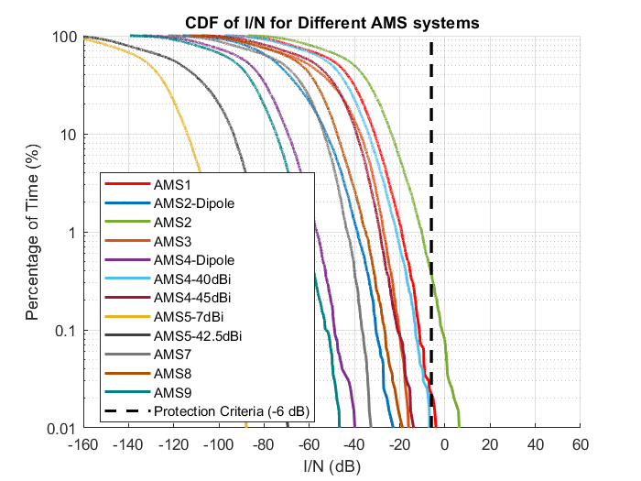
40 km | 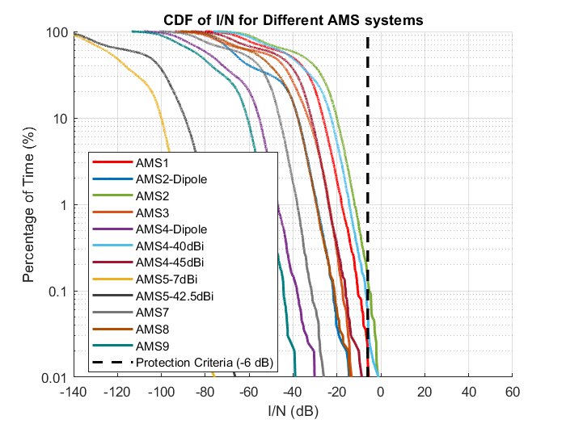
From the cdf plot above, the percentage of I/N samples exceeding the threshold at I/N = -6 dB is calculated for each AMS ground-based receiver and presented in Table 3.
TABLE 3
Percent of I/N samples that exceed the protection threshold
Distance | AMS1 | AMS2 -Dipole | AMS2 | AMS3 | AMS4 Dipole | AMS4 -40dBi | AMS4 -45dBi | AMS5 -7dBi | AMS5 -42.5dBi | AMS7 | AMS8 | AMS9
10 km | 3.955 | 11.065 | 9.635 | 0.105 | 0.100 | 12.115 | 7.295 | 0.000 | 0.000 | 0.050 | 0.000 | 0.000
20 km | 0.810 | 0.245 | 5.460 | 0.000 | 0.000 | 3.685 | 0.390 | 0.000 | 0.000 | 0.000 | 0.000 | 0.000
30 km | 0.015 | 0.000 | 0.135 | 0.000 | 0.000 | 0.055 | 0.005 | 0.000 | 0.000 | 0.000 | 0.000 | 0.000
40 km | 0.010 | 0.000 | 0.137 | 0.000 | 0.000 | 0.005 | 0.000 | 0.000 | 0.000 | 0.000 | 0.000 | 0.000

A2.1.1.4 Summary and analysis of the results of Study A
Based on the stated assumptions and methodology, a separation distance of 40 km is required to protect the AMS ground-based systems, while 450 km is necessary to protect the AMS airborne systems.

A2.1.2 Study B (multiple IMT networks) [USA, 5D/769, 5D/XXX]

A2.1.2.1 Technical characteristics

A2.1.2.1.1 Technical and operational characteristics of IMT systems operating in the frequency band 14.8-15.35 GHz
See Section A2.1.1.1.1 above.

A2.1.2.1.2 Technical/operational characteristics and protection criteria of [service type z] operating in the frequency band 14.8-15.35 GHz
See Section A2.1.1.1.2 above.

A2.1.2.1.3 Propagation models used in the study
See Section A2.1.1.1.3 above.

A2.1.2.2 Methodology

The calculation for the total number of IMT base stations deployed within the visible earth surface is given by the following equation:
NBS=Nurban+ Nsuburban=A∙Rb∙Ra, urban∙durban+A∙Rb∙Ra, suburban∙dsuburban Equation 1
where:
A: Visible land area [See Table 4]
durban: BS deployment density in urban areas [10 BS / km²]
dsuburban: BS deployment density in suburban areas [2.4 BS / km²]
Ra, urban: Ratio of urban coverage areas to areas of cities/built areas/districts [10%]
Ra, suburban: Ratio of suburban coverage areas to areas of cities/built areas/districts [5%]
Rb: Ratio of built areas to total area of region in study [2%].
The visible land area of the airborne, and the total number of IMT BS were calculated in Table 4 below.
Table 4: Visible land area at various altitudes and the total number of IMT BS
Altitude (km) | Horizon Distance (km) | Visible Area (km²) | Reference | NBS
15 | 437 | 601 112 | A≈2πRh | 13465
10 | 357 | 400 742 | A≈2πRh | 8977
5 | 253 | 200 371 | A≈2πRh | 4488

This is an interference analysis from IMT BS to AMS airborne only.
Using the IMT parameters outlined in A1.2.1.1.1, the IMT network was modelled. For downlink interference, three UEs were placed randomly, ensuring a minimum distance of 35 meters from the base station. For uplink interference, up to three UEs per sector were chosen based on the activity factors defined earlier.
The AMS receivers’ locations were randomly chosen such that the distance between the AMS receiver and the IMT network centre was fixed at 150, 250, 350, and 450 km for the airborne systems. The AMS airborne height was fixed at 5, 10, and 15 km. The AMS airborne antenna pointed downward with a random elevation angle ranging from 0 to -90 degrees. The azimuth of antennas pointed at the centre of the IMT network.
Propagation loss of Rec. P.528 was used. The clutter loss from P.2108 was applied only to the IMT side. Building entry loss was considered for the interference link between the UE and AMS. The simulation included 100 000 samples for each AMS system. The I/N distribution for all AMS systems was computed, as shown in Table 5.

A2.1.2.3 Study B results
[TBD]

A2.1.2.4 Summary and analysis of the results of Study B
[TBD]

A2.2 Summary and analysis of the results of studies
[Editor’s note: This section provides the summary and analysis of the results of studies. The text here can be used in the section 1/1.7/3 “Summary and analysis of the results of ITU-R studies” of draft CPM text.]
[Editor’s note: This section should include concise text with summary and analysis of the results of studies. It may contain a summary table listing possible distance and/or frequency separation, or any other mitigation techniques, needed to protect, without imposing additional regulatory or technical constraints on existing service/application(s) operating in the band 14.8-15.35 GHz, or in adjacent band as appropriate, from IMT systems.]
Table 4 (IMT and AMS in the frequency band 14.8-15.35 Ghz)
Overview of the sharing and compatibility studies
 | Parameters from expert WPs | Study A [USA] | Study B [USA]
Methodology
Single-entry or Multiple-entry (aggregated) |  | Aggregate | Aggregate
Statistical, or Statistical and Deterministic |  | Statistical (Monte-Carlo) | Statistical (Monte-Carlo)
Number of snapshots |  | 100 000 | 100 000
Technical and operational characteristics of IMT systems
Deployment scenario |  | Macro Urban | Macro Urban + Suburban
Method to deploy multiple IMT stations for the aggregated interference analysis over a relatively large area (as applicable to scenarios for the studies) |  | M.2101 | M.2101
Number of IMT base stations (BS) |  | 19 (57 sectors) | See Tabe 4
Cell size and inter site distance |  | 300 and 450 m | 300 and 450 m
Network loading factor for BS and UE (%) |  | 20% | 20%
TDD activity factor (%) |  | 75% for BS and 25% for UE. | 75% for BS and 25% for UE.
UE power control |  | Yes. Per IMT characteristics and M.2101 | Yes. Per IMT characteristics and M.2101
UE body loss (dB) |  | 4 dB | 4 dB
Channel bandwidth (MHz) |  | 200 | 200
BS transmit power |  | 46.3 dBm/200MHz | 46.3 dBm/200MHz
BS output power per sector |  | 84.3 dBm | 84.3 dBm
BS peak antenna gain |  | 38 dBi | 38 dBi
IMT antenna pattern |  | Extended AAS model (Table 8 of Annex 4.2 of 5D/413) | Extended AAS model (Table 8 of Annex 4.2 of 5D/413)
BS antenna mechanical downtilt |  | -6° | -6°
UE antenna pointing (if beamforming) |  | N/A | N/A
UE transmit power |  | 23 dBm | 23 dBm
UE antenna gain |  | Omni antenna of -4 dBi | Omni antenna of -4 dBi
UE distribution |  | Uniform with 35 m minimum distance from IMT | Uniform with 35 m minimum distance from IMT
User equipment density for terminals that are transmitting simultaneously |  | 3 | 3
Technical and operational characteristics (of incumbent service)
System number |  | AMS1-5, and 7-9 | AMS1, and AMS2
Antenna height |  | For airborne: Vary between 0.3-13.7 km  For ground: Fixed at 10m | For airborne: Fixed at 5, 10, and 15 km
Rx antenna gain |  | See Table 1 above | See Table 1 above
Receive antenna –3 dB beamwidth |  | See Table 1 above | See Table 1 above
Receiver noise figure |  | See Table 1 above | See Table 1 above
Receive antenna pattern |  | See Table 1 above | See Table 1 above
Receiver channel bandwidth |  | See Table 1 above | See Table 1 above
Antenna azimuth pointing |  | At the centre of IMT network | At the centre of IMT network
Antenna elevation pointing |  | For airborne: between 0 to -90 degrees  For ground based: between 0 to 90 degrees | For airborne: between 0 to -90 degrees
Long term protection criterion of I/N |  | -6 dB | -6 dB
Propagation model/losses
Basic transmission loss |  | P.528 for AMS air  P.2001 for AMS ground | P.528 for AMS air
Clutter loss |  | P.2108 for IMT side only | P.2108 for IMT side only
Building entry loss |  | P.2109 | N/A
Cross-polarization loss (dB) |  | 0 | 0
On Turn Rejection (OTR) (dB) |  | 10log(TxBW/RxBW) | 10log(TxBW/RxBW)
Results of studies
Does the study result consider both BS and UEs? |  | Yes | No
Results summary

