U.S. Radiocommunication Sector
Fact Sheet
Working Party: USWP 5D | Document No: USWP5D-50-08
Ref: Attachment 11 in Annex 4.12 to Document 5D/792-E, Attachment 11 in Annex 4.12 to Document 5D/563-E | Date: July 18, 2025
Document Title: Compatibility of the Space Research Service (space-to-Earth) operating in the frequency band 8 400 – 8 500 MHz and IMT operating in the frequency band 8 215 – 8400 MHz.
Author(s)/Contributors(s):
Elena DeJaco  NASA  Luciano Alexandre  NASA JPL | Email: elena.k.dejaco@nasa.gov  Email: luciano.c.alexandre@jpl.nasa.gov
Dennis Lee  NASA JPL | Email: dennis.k.lee@jpl.nasa.gov
Purpose/Objective: To update attachment 11 of the Annex to the Chair’s report for WRC-27 Agenda Item 1.7 sharing and compatibility studies in the frequency range 7125-8400 MHz

Abstract: Pursuant to Resolution 256 (WRC-23), Working Party (WP) 5D is the responsible group for WRC-27 agenda item 1.7 and for the consideration of studies on technical, operational and regulatory issues pertaining to the possible use of the terrestrial component of IMT in the frequency bands 4 400-4 800 MHz, 7 125-8 400 MHz, and 14.8-15.3 GHz. Attachment 11 of Annex 4.12 to Document 5D/792 contains compatibility studies between IMT systems in the frequency band 7125-8400 MHz and the incumbent SRS in 8 400 – 8 500 MHz. Our proposed submission offers revisions to this document including methodologies and/or studies to address compatibility between potential IMT systems and the existing SRS (space-Earth) service.

Fact Sheet Preparer: Dennis Lee, NASA JPL

Radiocommunication Study Groups | 
Received: xx October 2025  Source: Annex 4.11 to Document 5D/563  Subject: WRC-27 agenda item 1.7 | Document 5D/xxx-E
 | xx October 2025
English only

SPECTRUM ASPECTS AND WRC PREPARATIONS
United States of America
COMPATIBILITY OF THE SPACE RESEARCH SERVICE (space-to-Earth) operating in the frequency band 8 400 – 8 500 MHz and IMT operating in the frequency band 8 215 – 8400 MHz

This input contribution includes proposed revisions to Attachment 11 of the working document towards the document on sharing and compatibility studies in relation to WRC-27 agenda item 1.7, as contained in Annex 4.12 of the Working Party 5D Chair’s Report (Document 5D/792). The proposed revisions contain initial results for Study A, interference received by an SRS earth station from transmitting IMT base stations.

Attachment: 1

attachment 11
Compatibility of the space research service (space-to-Earth) operating
in the frequency band 8 400-8 500 MHz and IMT operating
in the frequency band 8 215-8 400 MHz
[Editor’s note: The studies provided have not been discussed and will need to be carefully examined and updated once service parameters are finalized.]
This Attachment contains compatibility studies of the space research service (deep space)(space-to-Earth) in the frequency band 8 400 – 8 450 MHz and IMT operating in the adjacent frequency band 8 215 – 8 400 MHz

A11.1 Technical/operational characteristics and protection criteria of space research service (space-to-Earth) operating in the frequency band 8 400-8 500 MHz
[Editor’s note: This section provides the technical characteristics for sharing and compatibility studies from WP 7B.]
Detailed information on technical and operational characteristics of SRS (deep space) in the frequency band 8 400 – 8 450 MHz has been provided by Working Party 7B in Documents 5D/92 and 5D/403. Contents are referenced by section and title in Table A11-1 below.
Table A11-1
Document reference listing for characteristics of SRS (deep space) operating in 8 400-8 450 MHz
Document number | Document section | Location | Parameter description
5D/403 | Annex 2, Section 4 | Table 13 | Additional representative SRS (deep space) Earth station characteristics
5D/92 | Annex 1,  Section 1.2 |  | Listing of in-force ITU-R documentations on SRS

For deep space SRS earth stations, this study considers a minimum elevation of 10 degrees. The SRS antenna gain towards the horizon is determined using the minimum pointing elevation angle for the azimuth considered and the relevant antenna pattern. The reference antenna gain pattern for deep space SRS earth stations is given in Recommendation ITU-R SA.509 (see Figure A11-4).
The parameters for the SRS (deep space) Earth stations are based on ITU-R Recommendation SA.1014-4, as presented in Table A11-2.
TABLE A11-2
Parameters for SRS (deep space) Earth station
Parameter | Value
Frequency band | 8 400 - 8450 MHz
Antenna diameter | 70 m
Antenna height (above ground) | 39 m
Antenna gain | 74 dBi
Antenna pattern | Rec. ITU-R SA. 509
Antenna polarization | Circular

FIGURE A11-1
SRS (deep space) Earth Station Antenna Pattern
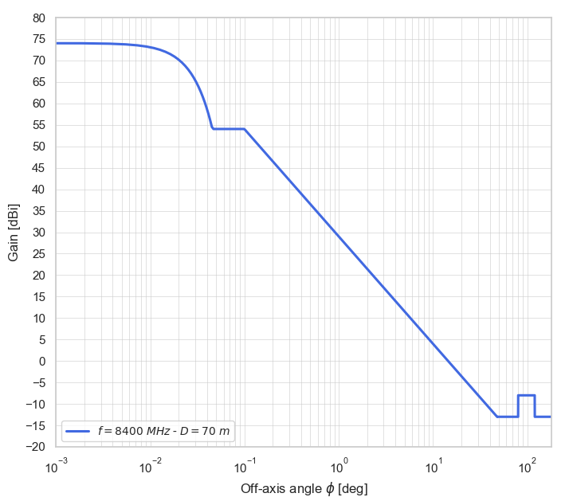

SRS (deep space) protection criteria
For SRS (deep space) systems operating in the 8 400-8 450 MHz band, Recommendation ITU-R SA.1157 gives the protection level (I₀) as −221 dBW in a reference bandwidth of 1 Hz. Per Recommendation ITU-R SA.1157, the calculation of interference to SRS (deep space) earth stations that may result from atmospheric and precipitation effects should be based on weather statistics that apply for 0.001% of the time.
For the protection of the SRS (deep space) space-to-Earth link in the adjacent band 8 400-8 450 MHz, degradation by all out-of-band emissions should not be more than 1% of the total allowable degradation, following Recommendation ITU-R SA.1743. Applying the 1% allowable degradation to the power level of the protection criteria results in a level of -241 dBW/Hz for IMT adjacent band interference into the SRS (deep space) receiver.

A11.2 Technical Analysis

A11.2.1 Study A [USA]
[Editor’s note: The chapter structure of each study depends on the input contribution of the ITU members. The following chapter structure in each study can be used as a reference.]
Earth stations of the space research service (deep space) in the 8 400-8 450 MHz band operate with extremely sensitive receivers needed to communicate with spacecraft at very large distances. These sensitive receivers have the potential to receive interference from IMT base stations operating in the 7 125-8 400 MHz adjacent band. Figure A11-2 below shows a diagram of the interference scenario between a receiving SRS earth station and a transmitting IMT base station considered in this study.

FIGURE A11-2
Interference scenario between receiving SRS earth stations
and transmitting IMT base stations

A11.2.1.1 Technical characteristics

A11.2.1.1.1 Technical and operational characteristics of IMT systems operating in the frequency band 7 125-8 400 MHz
[Editor’s note: This section provides specific characteristics of IMT systems provided by WP 5D for sharing/interference analyses used in the study.]
Technical parameters referenced in this sub-section and used in this study can be found in Annex 4.15 to Document 5D/563, the Working Document on characteristics of terrestrial component of IMT for sharing and compatibility studies in preparation for WRC-27. For brevity, the locations to reference are included in Table A11-3 below.
Table A11-3
Document reference listing for operational characteristics of IMT systems in 7 125-8 400 MHz
Document number | Document section | Location | Parameter description
Annex 4.15 to  Document 5D/563 | 3.1.2 | Table 4 | IMT technology related parameters in 7 125-8 400
Annex 4.15 to  Document 5D/563 | 3.2.2 | Table 6-1 | Deployment-related parameters for bands between 7.125 and 8.4 GHz
Annex 4.15 to  Document 5D/563 | 3.2.2 | Table 6-2 | UE parameters for bands between 7.125 and 8.4 GHz
Annex 4.15 to  Document 5D/563 | 3.3 | Table 8 | Extended AAS model
Annex 4.15 to  Document 5D/563 | 3.3.2 | Table 10 | Beamforming antenna characteristics for IMT in 7 125 to 8 400 MHz

For this study, the IMT deployment considered is a suburban macro, with parameters indicated in Tables A11-4 and A11-5.
TABLE A11-4
IMT Base Station (BS) characteristics and deployment-related parameters
No. | Parameter | Macro Suburban
 | Frequency band | 7 125 – 8 400 MHz
1 | Transmitter characteristics
1.1 | Duplex method | TDD
1.2 | Typical channel bandwidth | 100 MHz
1.3 | Signal bandwidth | N_{rb} * SCS * 12
1.4 | Antenna pattern | Extended AAS
1.5 | Antenna array configuration (Row x Column) | 8 x 16
1.6 | Horizontal/Vertical radiating sub-array or element spacing | 0.5λ for H, 2.1λ for V
1.7 | Number of element rows in sub-array | 3
1.8 | Vertical element separation in sub-array | 0.7λ
1.9 | Pre-set sub array down-tilt | 3⁰
1.10 | Element gain | 6.4 dBi
1.11 | Horizontal/Vertical 3 dB beam width of single element (degree) | 90⁰ for H / 65⁰ for V
1.12 | Mechanical downtilt | 6⁰
1.13 | Base station horizontal coverage range | +/- 60⁰
1.14 | Base Station maximum coverage angle in the vertical plane | 90 to 100⁰
1.15 | Conducted power per sub-array or element (dBm) | 22 dBm
1.16 | Base station spectral mask | Table 6 of Annex 4.15 to Doc. 5D/563
1.17 | TDD activity factor | 75%
2 | Deployment-related parameters
2.1 | Frequency reuse | 1
2.2 | Sectors | 3
2.3 | Antenna height | 20 m
2.4 | Base station density | Typical cell radius of 0.8 km (2.4 BS/km²)
2.5 | Below rooftop base station antenna deployment | 15%
2.6 | Network loading factor | 20%, 50%

TABLE A11-5
IMT User equipment (UE) characteristics
No. | Parameter | Suburban macro
1.1 | Indoor terminal usage | 70 %
1.2 | Indoor user terminal penetration loss | Rec. ITU-R P.2109
1.3 | User equipment density for terminals that are transmitting simultaneously | 3 UEs per sector
1.4 | UE Height | 1.5 m
1.5 | Average user terminal output power | Use transmit power control
1.6 | Typical antenna gain for user terminal | - 4 dBi
1.7 | Body loss | 4 dB
1.8 | TDD Activity factor | 25 %
1.9 | Power control model | Rec. ITU-R M.2101
1.10 | Maximum user terminal output power, PCMAX | 23 dBm
1.11 | Power (dBm) target value per RB, P0_PUSCH | -92.2 dBm
1.12 | Path loss compensation factor, α (same as “balancing factor” mentioned in Rec. ITU-R M.2101) | 0.8

It is important to emphasize that the vertical and horizontal spacing between the elements/sub-arrays of the IMT Extended AAS antenna pattern was adjusted by a frequency factor of fc/8350 to calculate the base station antenna gain pattern at the SRS channel center frequency (fc) in MHz. The adjusted antenna pattern is presented in the example in Figure A11-3 for the center frequency of 8404 MHz. It incorporates a mechanical downtilt of 6° and a pre-set sub-array downtilt of 3°. The maximum antenna gain is achieved at 9°.
Figure A11-4 presents an example of the IMT base station antenna pattern when the BS is beamsteering toward a UE at the cell edge, 800 meters away from the BS, at φ = 0°. The reference antenna angles for the antenna model geometry, as denoted in Figure A11-3 and A11-4, follow the references presented in Section 5 of Recommendation ITU-R M.2101.
FIGURE A11-3
IMT base station antenna pattern; (a) horizontal; (b) vertical
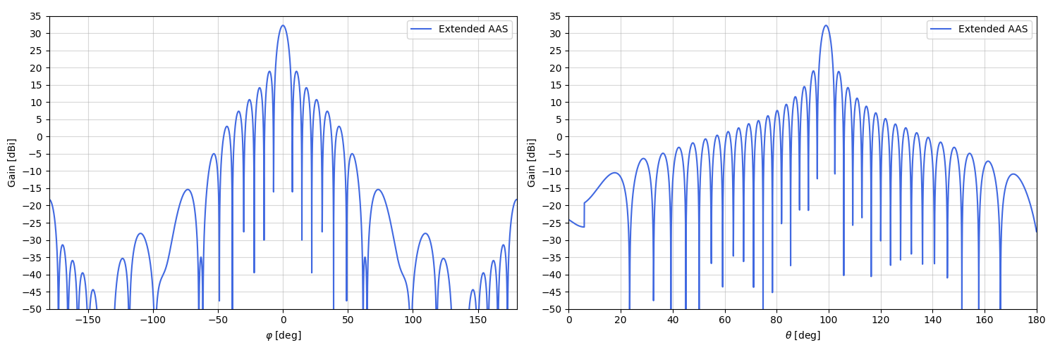
(a) | (b)
FIGURE A11-4
IMT base station antenna pattern (beamsteered towards UE at cell edge); (a) horizontal; (b) vertical
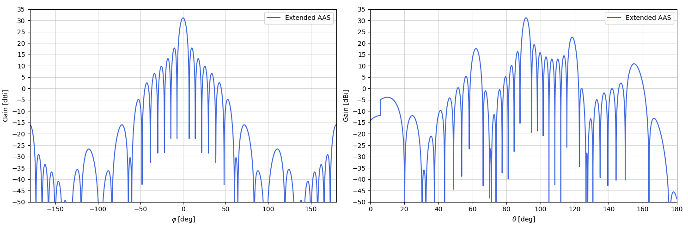
(a) | (b)

A11.2.1.1.2 Technical/operational characteristics and protection criteria of SRS (deep space) operating in the frequency band 8 400-8 450 MHz
For deep space SRS earth stations, this study considers a minimum elevation of 10 degrees.

The antenna pattern given in Rec. ITU-R SA.509 can be used to determine the SRS receiver antenna gain.

A11.2.1.1.2.1 Protection criteria
For SRS (deep space) systems operating in the 8 400-8 450 MHz band, Recommendation ITU-R SA.1157 gives the protection level (I₀) as −221 dBW in a reference bandwidth of 1 Hz. The calculation of interference that may result from atmospheric and precipitation effects should be based on weather statistics that apply for 0.001% of the time.

A11.2.1.1.3 Propagation models used in the study
Working Parties 3K and 3M provided a reply liaison statement to WP 5D (Doc. 5D/160, Doc. 7B/57) with guidance on the propagation models to be used for sharing between stations on the surface of the Earth. This study uses the propagation model in Recommendation ITU-R P.2001. Table A11-6 presents the propagation models used, along with their respective characteristics.

TABLE A11-6
Propagation models used for compatibility study
Propagation Model | System/Path | Characteristics
3GPP Urban Macro (UMa) | IMT System | -
Rec. ITU-R P.2001 | IMT-to-SRS terrestrial path | p is randomly selected between [0,1] for each snapshot. A 3 dB polarization discrimination loss was taken into account.
Rec. ITU-R P.2108 | IMT-to-SRS terrestrial path | For every link, the p-parameter is calculated using a uniform distribution between [0,1], to calculate the clutter loss, following the Rec. ITU-R P.2108.

A11.2.1.2 Study Methodology

The received interference power due to the aggregated IMT downlink interference contribution is calculated as follows, where n is the number of activated base stations at each snapshot, considering network loading factors of 20% and 50%, including the TDD factor:

Ird,p=inEIRPiθ, φθt+ GrxSRS θ, φθr-Lx - Ldi,p
Ird,p= Pt+Gtθt+ Grθr-Lx - Ld,p
where:
d : separation distance (km) between the transmitter and the receiver;
p: exceedance time probability to be used in propagation loss calculation;
I_{r} : interference power (dBW) received in the SRS reference bandwidth at the input of the SRS earth station antenna;
EIRPiθ, φ(θt):: unwanted emissions equivalent isotropic radiated power of each activated base station, considering the respective azimuth and elevation relative to the physical horizon for a given azimuth;

GrxSRS θ, φθr: victim receiver antenna gain towards the physical horizon for a specific azimuth, determined by the difference between the minimum elevation angle and the physical horizon angle;

L_{x}: coupling losses (dB) between the IMT transmit spectrum in the IMT reference bandwidth and SRS receiver in the SRS reference bandwidth due to polarization loss, frequency separation, interference spectrum overlaps, and spectrum roll-offs;
L: propagation loss (dB) calculated for a time probability of 𝑝 when the separation distance between the transmitter and the receiver is d km.
For SRS missions, the Earth station main beam pointing rates are dependent upon target spacecraft orbits and trajectories. Thus separation distances around SRS earth stations are necessary to ensure scientific mission needs to mitigate interference geometry involving the SRS earth station antenna pointing towards the azimuth of the IMT station at its minimum elevation angle.
The distance (d_{max}) required to ensure adequate separation between the terrestrial service transmitters and the SRS earth station receivers can be determined by the following:
$d_{max}=max\left\{d :I_{r}\left(d,p\right)≥I_{0}\right\}$
where I0 is the protection level of the SRS earth station, p is the exceedance time percentage used in calculating the propagation losses, and d (in km) is the separation distance between the transmitter and the receiver. With this definition, the interference received from an IMT base station would satisfy the protection level of the SRS earth station for all separation distances d ≥ dmax along the given azimuth.

A11.2.1.2.1 IMT Deployment Methodology
This study considers an IMT deployment based on a 19-site cluster as depicted in Figure 3 of Recommendation ITU-R M.2101.
The suburban macro cell deployment, with 3 UEs per cell, at one snapshot, is presented in Figure A11-5.
FIGURE A11-5
Suburban macro-cell topology
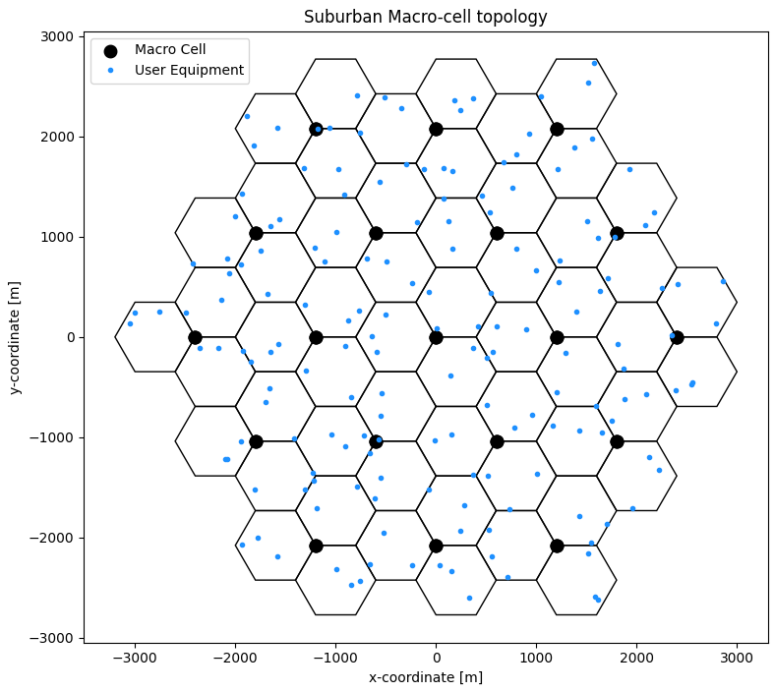
For this study, BS sites are evaluated using a single cluster and an assigned network loading factor of either 20% and 50% and a BS TDD factor of 75%. The UEs in each cell are randomly oriented with the BS-UE radial distance uniformly distributed in the cell grid area. The simulation performs beamsteering, resource scheduling, power control, and the calculation of coupling loss between each UE and its BS, enabling interference calculations between the systems. Interference from all sources are then aggregated. Finally, interference results and system performance indicators are collected, and this process is repeated for 10000 snapshots.

A11.2.1.3 Study results
[Editor’s note: This section provides the sharing and compatibility study results of this study.]
In this study, a suburban deployment is considered where, based on IMT characteristics, the cell radius is 800 m. As a result, beam steering, which depends on both the IMT antenna and user heights, as well as the user's distance from the base station, enables the AAS to steer the beam 1.32° below the horizon to support a user at the cell edge while staying within the maximum beam steering limit.
To illustrate vertical beam steering, an example is provided at a frequency of 8404 MHz with a user located at φ = 0°. Figure A11-6 presents 10 samples, considering users at varying distances from the base station (BS), with beam steering for the user at the cell edge (1.32° below the horizon), and beam steering angles ranging from 2° to 10° with a step size of 1°, taking into account the mechanical downtilt of 6°. It is important to note that sidelobe levels above the horizon may reach their maximum values at different beam steering angles. In the simulation, the beam steering angles were determined based on the user distribution within the BS cell radius, with both horizontal and vertical steering angles constrained according to the IMT characteristics for each plane.
FIGURE A11-6
IMT Vertical antenna pattern (Example: 10 beamsteering samples, φ=0⁰)
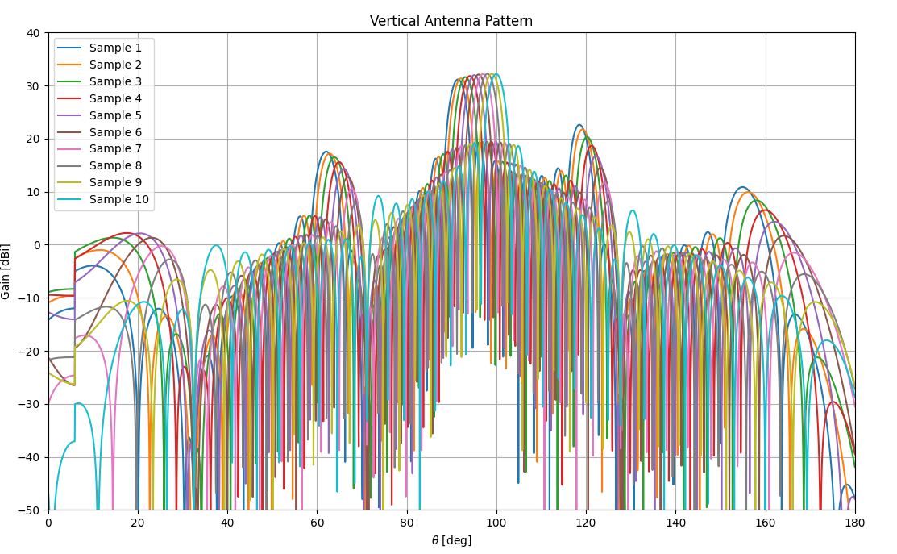
The IMT user distribution follows a uniform distribution within each serving cell area, with 3 users per cell, as described earlier, using a 19-cluster macro-cell topology. Figure A11-7 shows the user distribution after 300 snapshots to assess the uniformity of the deployment and the user area within the cell, with each blue point representing a user location recorded after 300 snapshots. In the simulation, a total of 10,000 snapshots were used.
FIGURE A11-7
IMT User equipment distribution after 300 snapshots
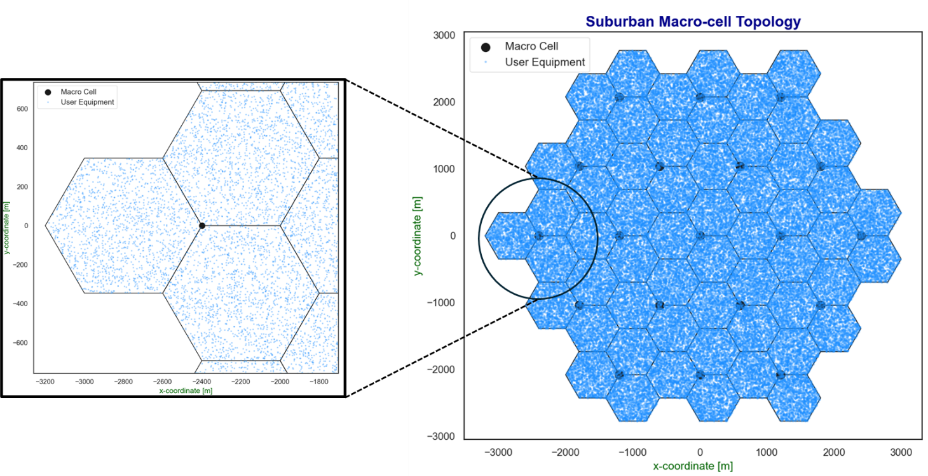
According to the IMT characteristics, 15% of suburban base stations may be deployed below the rooftop, where clutter applies, while the remaining base stations are deployed above the rooftop, where no clutter is expected to affect the propagation. It is noted that the “below rooftop” parameter in the IMT characteristics document (Annex 4.15 of Document 5D/563) is provided for IMT BS deployments to describe the environment surrounding the BS, and should not be interpreted as indicating whether or not additional clutter loss should be applied. Further guidance from Study Group 3 (SG3) relevant to the clutter loss model will be incorporated as it becomes available.
In this study, due to the lack of clear guidance on how to apply clutter for stations located above and below rooftop, all deployed base stations are randomly selected at each snapshot, with the clutter p-value varying uniformly between 0 and 100% (0 < p < 1), as specified by Recommendation ITU-R P.2108. The clutter loss is applied at only one end of the path, specifically on the IMT side.
Terrain data between the IMT topology and the SRS (deep space) Earth station are considered for the SRS (deep space) earth station location using Shuttle Radar Topography Mission (SRTM) 1-arc-second global data.
For this study, the IMT user equipment (UE) height is set to 1.5 m, ensuring that 100% of the users are within the clutter area, with both the UE conducted power and antenna gain significantly lower than those of the IMT base station. Additionally, 70% of the users are indoors, where building entry loss applies, resulting in a minimal impact of the total aggregate contribution on the final results in the suburban scenario. Therefore, this study focuses on the IMT downlink, with the total suburban deployment area of 23.7 km². Simulations using network loading factors of 20% and 50% were applied.
The IMT unwanted emissions level in the adjacent SRS band was averaged over 8 MHz, based on the IMT AAS BS spectral mask and the representative SRS channel bandwidth in Table 13 of Document 5D/403. For the SRS frequency range of 8 400 – 8 408 MHz closest to the IMT downlink, the calculated average IMT unwanted emissions level is 1.46 dBm/100 kHz. For SRS frequency channels farther away from the IMT band edge, the unwanted emissions levels will be lower. For example, a mid-band SRS frequency range of 8 421 – 8429 MHz would see an average IMT unwanted emissions level that is 2.94 dB lower. And for the SRS frequency range 8 442 – 8 450 MHz farthest from the IMT downlink, the average IMT unwanted emissions level is 5.88 dB lower compared to 8 400 – 8408 MHz.
For the SRS earth station, a minimum elevation angle of 10° was considered, along with the terrain surrounding each site. The computed SRS antenna gain accounts for the off-boresight angle between the radio horizon and the SRS antenna boresight. The same approach was applied to the IMT side.
At each snapshot, the aggregated interference generated by all activated IMT base stations (BS) was calculated, considering off-axis angles for both IMT and SRS in relation to the terrain radio horizon. The received interference level was computed and compared with the SRS protection criteria to determine the required separation distance between stations. A 3 dB depolarization loss is considered due to the different antenna polarizations between the systems.
The diagram representing the separation distance is illustrated in Figure A11-8.
FIGURE A11-8
IMT network deployment (23.7 km²) simulation scenario and separation distance details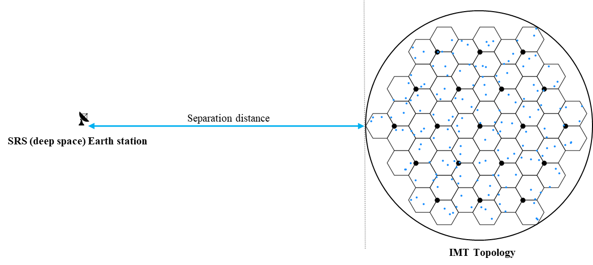

A11.2.1.4 Summary and analysis of the results of Study A
[Editor’s note: This section provides the summary and analysis of the results of this study.]

A11.2.2 Study B

A11.2.2.1 Technical characteristics

A11.2.2.1.1 Technical and operational characteristics of IMT systems operating in the frequency band 7 125-8 400 MHz

A11.2.2.1.2 Technical/operational characteristics and protection criteria of [service type z] operating in the frequency band 7 125-8 400 MHz

A11.2.2.1.3 Propagation models in the studies

A11.2.2.2 Methodology

A11.2.2.3 Study results

A11.2.2.4 Summary and analysis of the results of Study B

A11.3 Summary and analysis of the results of studies
[Editor’s note: This section provides the summary and analysis of the results of studies. The text here can be used in the Section 1/1.7/3 “Summary and analysis of the results of ITU-R studies” of draft CPM text.]
[Editor’s note: This section should include concise text with summary and analysis of the results of studies. It may contain a summary table listing possible distance and/or frequency separation, or any other mitigation techniques, needed to protect, without imposing additional regulatory or technical constraints on existing service/application(s) operating in the band 7 125-8 400 MHz, or in adjacent band as appropriate, from IMT systems.]

Table (IMT ANd Service SRS (deep space) in 8 400-8 450 MHz frequency range)
Overview of the sharing and compatibility studies
[Editor’s note: Descriptive text and notes of the table. Rows to be added or deleted based on the decision of WP 5D.]
 | Parameters from expert WPs | Study A | Study …
Methodology
Single-entry or Multiple-entry (aggregated) |  | Multiple-entry (aggregated)
Statistical, or Statistical and Deterministic |  | Statistical
Technical and operational characteristics of IMT systems
Deployment scenario |  | Macro Surburban
IMT stations |  | 57 Base Stations / 171 User Equipment
Method to deploy multiple IMT stations for the aggregated interference analysis over a relatively large area (as applicable to scenarios for the studies) |  | Rec. ITU-R M.2101
Number of IMT base stations (BS) |  | 57
Network loading factor for BS and UE (%) |  | 20% and 50%
TDD activity factor (%) |  | 75% for BS
UE power control |  | Rec. ITU-R M.2101
UE body loss (dB) |  | 4 dB
IMT antenna pattern |  | Extended AAS
BS antenna mechanical downtilt |  | -6⁰
UE antenna pointing (if beamforming) |  | N/A
UE distribution |  | Uniform
User equipment density for terminals that are transmitting simultaneously |  | 3 per cell
Technical and operational characteristics (of incumbent service)
SRS Antenna Gain |  | 74 dBi
SRS Antenna elevation |  | 10°
SRS Antenna Pattern |  | Rec. ITU-R SA.509
Propagation model/losses
Basic transmission loss |  | Rec. ITU-R P.2001
Clutter loss |  | Rec. ITU-R P.2108
Building entry loss |  | Rec. ITU-R P.2109
Cross-polarization loss (dB) |  | 3 dB
Results of studies
Does the study result consider both BS and UEs? |  | BS only
Results summary
_______________

