U.S. Radiocommunication Sector
Fact Sheet
Working Party: USWP 5D | Document No: US5D-50/09
Ref: Revision 1 to  Document 5D/TEMP/342-E | Date: 18 July 2025
Document Title: Sharing between the Earth exploration satellite service (space-to-Earth) in the frequency band 8 025-8 400 MHz and IMT operating in the frequency band 7 125-8 400 MHz
Author(s)/Contributors(s):
Elena DeJaco  NASA | Email: elena.k.dejaco@nasa.gov
Kenneth George  ADS for NASA | Email: kgeorge@asrcfederal.com
Jason Szklany  ADS for NASA | Email: jszklany@asrcfederal.com
James Brase  Peraton for NASA | Email: jbrase@peraton.com
Purpose/Objective: To update attachment 10 of the Annex to the Chair’s report for WRC-27 Agenda Item 1.7 sharing and compatibility studies in the frequency range 7125-8400 MHz
Abstract: Working Party (WP) 5D is the responsible group for WRC-27 agenda item 1.7 and for the consideration of studies on technical, operational and regulatory issues pertaining to the possible use of the terrestrial component of IMT in the frequency bands 4 400-4 800 MHz, 7 125-8 400 MHz, and 14.8-15.3 GHz. Annex 4.22 to Document 5D/792-E contains sharing studies between IMT systems in the frequency band 7125-8400 MHz and EESS (space-Earth) in 8 025 - 8 400 MHz. Our proposed submission offers revisions to Study B in this document including methodologies and/or studies to address sharing between potential IMT systems and the existing EESS (space-Earth) service.
Fact Sheet Preparer: Kenneth George, ADS for NASA

Radiocommunication Study Groups | 
Source: Revision 1 to  Document 5D/TEMP/342-E | Document 5D/xxx-E
 | YY June 2025
English only

SPECTRUM ASPECTS AND WRC PREPARATIONS
United States of America
Sharing between the Earth exploration satellite service (space-to-Earth) in the frequency band 8 025-8 400 MHz and IMT operating in the frequency band 7 125-8 400 MHz
Introduction
This input contribution includes proposed revisions to Study B of attachment 10 of the working document towards the document on sharing and compatibility studies in relation to WRC-27 agenda item 1.7, as contained in Annex 4.11 of the Working Party (WP) 5D Chair’s Report (Document 5D/792). The proposed revisions contain additional refinements to the methodology of and preliminary results for study B, a sharing study between EESS (s-E) and IMT.
Attachment: 1

Radiocommunication Study Groups | 
Meetings of Working Party 5D
Kobe, Japan, 24 June – 3 July 2025
Subject: WRC-27 agenda item 1.7 | Revision 1 to  Document 5D/TEMP/342-E
 | 3 July 2025
 | English only
SWG WRC-27 agenda item 1.7
ANNEX 2 – SHARING AND COMPATIBILITY STUDIES BETWEEN
SERVICES TO WHICH THE BAND IS CURRENTLY ALLOCATED AND IMT SYSTEMS IN THE FREQUENCY BAND 7 125-8 400 MHz
UNDER WRC-27 AGENDA ITEM 1.7
attachment 10
Sharing between the Earth exploration satellite service (space-to-Earth)
in the frequency band 8 025-8 400 MHz and IMT operating
in the frequency band 7 125-8 400 MHz
[Editor’s note: The studies provided have not been discussed in detail and will need to be carefully examined and updated once service parameters are finalized.]
[Editor’s Note: The following remarks were made for many studies in this attachment:
1. The consideration of cross-border scenario for studies, when placing IMT cluster near Earth Stations.
2. On the modelling of interfering IMT cluster for the Earth Station that is expected to track an NGSO satellite.
3. Applicability of clutter on both, single, none of the sides of Tx and Rx and considerations on polarization losses.
4. Utilizing latest parameters as per LS from 7B.
5. It was suggested that the ES azimuth should be aligned to the IMT cluster. If varying the ES azimuth and only using one IMT cluster, the study is only applicable where 1 IMT cluster is near the ES.
6. Application of P.452 and extended version of P.2001 should be according to the LS from 3K/3M, with explanation on their usage.
7. Assessment of the exceedance of protection criteria expressed in percentages of time should not be based in CDF expressed in percentages of cases, mixing time and geographical dependent variables
8. Several studies indicated that the revised results will be provided, incorporating the applicable remarks]

A10.1 Technical Analysis
[Editor’s Note: Only the relevant portions to Study B are included in this document. This contribution does not propose any changes to Study A.]

A10.1.2 Study B [USA (5D/500, 5D/761)]
The sharing scenario between IMT and EESS (space-to-Earth) in the 8 025-8 400 MHz band is illustrated in Figure A10-1.
FIGURE A10-1
Sharing study scenario between IMT and EESS (space-to-Earth)
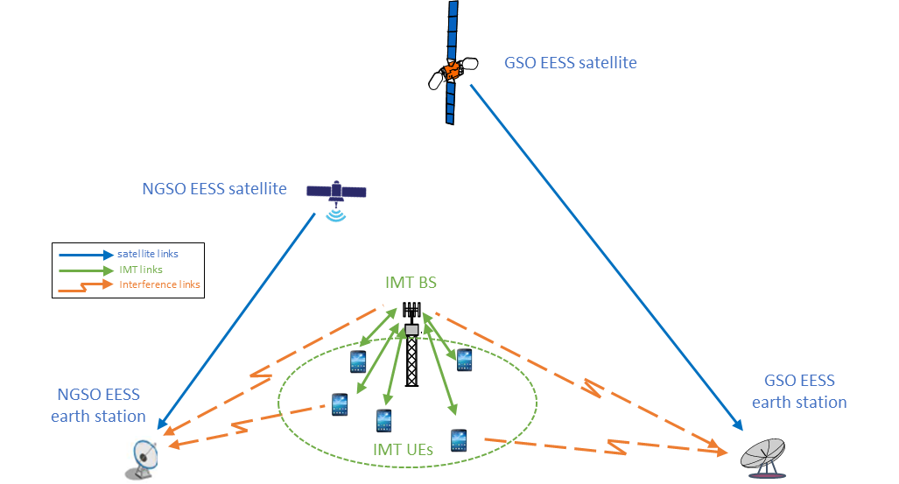

A10.1.2.1 Technical Characteristics

A10.1.2.1.1 Technical and operational characteristics of IMT systems operating in the frequency band 8 025-8 400 MHz
Technical parameters referenced in this sub-section can be found in Annex 4.15 to Document 5D/563, the working document on characteristics of terrestrial component of IMT for sharing and compatibility studies in preparation for WRC-27. For brevity, the locations to reference are included in Table A10.2.1.1.1.1 below.
Table A10.2.1.1.1.1
Document reference listing for operational characteristics of IMT systems in 7 125-8 400 MHz
Document  number | Document section | Location | Parameter description
Annex 4.15 to Document 5D/563 | 3.1.2 | Table 4 | IMT technology related parameters in 7 125-8 400 MHz
Annex 4.15 to Document 5D/563 | 3.2.2 | Table 13 | Deployment-related parameters for bands between 7.125 and 8.4 GHz
Annex 4.15 to Document 5D/563 | 3.2.2 | Table 14 | UE parameters for bands between 7.125 and 8.4 GHz
Annex 4.15 to Document 5D/563 | 3.3 | Table 17 | Extended AAS model
Annex 4.15 to Document 5D/563 | 3.3.2 | Table 19 | Beamforming antenna characteristics for IMT in 7 125 to 8 400 MHz

The Extended Advanced/Active Antenna System (AAS) model is used to create the IMT base station (BS) gain pattern which is provided below in Figure A10.2.1.1.1.1 when electrically steered to -9° elevation at both 0° and 60° azimuth. Note this assumes the 3° subarray downtilt and 6° mechanical downtilt are always applied, such that no additional electrical steering is required to achieve a beam at -9° elevation. The peak gain achieved in the pattern steered to 0° azimuth is 32.1 dBi. The BS output power per sector used for these simulations follow the IMT characteristics provided by WP5D, with total EIRP of 78.3 dBm/100 MHz. Considering this simulation will select three user equipment (UEs) per base station, the power per sector must be split among the three links, resulting in lower output power per link. The power per sector will be evenly distributed to the three BS-UE links following M.2101 by evenly allocating the available resource blocks to the three chosen UEs per snapshot.
Figure A10.2.1.1.1.1
IMT Extended AAS Model at -9° Elevation
[Figure TBD]
The IMT BS deployment parameters for the 7 125-8 400 band are specified in Table 13 of Annex 4.15 to Document 5D/563, provided below as Table A10.2.1.1.1.2 for reference.
Table A10.2.1.1.1.2
Deployment-related parameters for bands between 7.125 and 8.4 GHz
 | Urban/suburban macro | Small cell (outdoor)/Micro cell | Indoor (small cell)
Cell Radius / Deployment density (Note 1) | Typical cell radius 0.4 km urban / 0.8 km suburban  (10 BSs/km² urban / 2.4 BSs/km² suburban  (Note 2, 3)) | 1-3 per urban macro cell  <1 per suburban macro site | Depending on indoor coverage/capacity demand
Antenna height | 18 m urban /  20 m suburban | 6 m | 3 m
Sectorization | 3 sectors | Single sector | Single sector
Frequency reuse | 1 | 1 | 1
Indoor base station deployment | N/A | N/A | 100%
Indoor base station penetration loss | N/A | N/A | Rec. ITU-R P.2109
Below rooftop base station antenna deployment (Note 4) | Urban: 65%  Suburban: 15% | 100% | N/A
Typical channel bandwidth (Note 5) | 100 MHz | 100 MHz | 100 MHz
Network loading factor (base station load probability X%) (see section 6 below and Rec. ITU-R M.2101 Annex 1, section 3.4.1 and 6) | 20%, 50% | 20%, 50% | 20%, 50%
TDD / FDD | TDD | TDD | TDD
BS TDD activity factor | 75% | 75% | 75%
Note 1: These density values are for small dense areas. See section 3.3 for densities in larger areas.
Note 2: “1 BS” = 1 sector in 3-sector cell.
Note 3: This value is calculated based on use of same grid as 3-6 GHz. It is expected that the same BS infrastructure will typically be used for networks in both 3-6 GHz and 6-8 GHz. To that effect, it can be noted that the e.i.r.p is higher in this frequency band (see Tables 18 and 19).
Note 4: This “below rooftop” parameter is provided for IMT BS deployments to describe the environment surrounding the BS. The above/below rooftop ratio in this table should not be interpreted as indicating whether or not additional clutter loss should be applied. Depending on the sharing scenarios and associated guidance from SG3, relevant propagation models related to clutter loss should be used accordingly.
Note 5: Higher channel BWs compared to 100MHz are not precluded from this frequency range. Refer to [3] for more information on other values for channel bandwidth.

The corresponding IMT user equipment (UE) deployment parameters for the 7 125-8400 band are specified in Table 14 of Annex 15 to Document 5D/563, provided below as Table A10.2.1.1.1.3 for reference.
Table A10.2.1.1.1.3
UE parameters for bands between 7.125 and 8.4 GHz
 | Urban/suburban macro | Small cell (outdoor)/Micro cell | Indoor (small cell)
Indoor user terminal usage | 70% | 70% | 100%
Indoor user terminal penetration loss | Rec. ITU-R P.2109 | Rec. ITU-R P.2109 | Rec. ITU-R P.2109
User equipment density for terminals that are transmitting simultaneously (Note 1) | 3 UEs per sector | 3 UEs per sector | 3 UEs per sector
UE height (Note 2) | 1.5 m | 1.5 m | 1.5 m
Average user terminal output power | Use transmit power control | Use transmit power control | Use transmit power control
Typical antenna gain for user terminals | −4 dBi | −4 dBi | −4 dBi
Body loss | 4 dB | 4 dB | 4 dB
UE TDD activity factor | 25% | 25% | 25%
Power control model | Refer to Recommendation ITU-R M.2101 Annex 1, section 4.1
Maximum user terminal output power, PCMAX | 23 dBm | 23 dBm | 23 dBm
Power (dBm) target value per RB, P0_PUSCH (Note 3) | −92.2 | −87.2 | −87.2
Path loss compensation factor, α  (same as “balancing factor” mentioned in Rec. ITU-R M.2101) | 0.8 | 0.8 | 0.8
Note 1: UEs share equally the channel bandwidth, i.e. each UE is allocated 1/3 of the channel bandwidth (see Rec. ITU-R M.2101, Section 3.4.1, item 1e-f.). In sharing studies, it is assumed that the AAS BS beamforms towards each UE using the entire array
Note 2: In principle, indoor UEs are distributed over different floors of the building. It should be noted that the number of floors of buildings vary within the environment and among the countries. Moreover, the number of floors of buildings is not related to Macro BS antenna height (parameter given in the Table). In particular in small cities, sub-urban and rural areas, many or most of antennas are installed on masts. Therefore, for outdoor BSs, indoor UEs are assumed to be modelled on the ground floor for the sharing study.
Note 3: The target power is defined per Resource Block (RB), considering 180 kHz RB bandwidth corresponding to 15 kHz subcarrier spacing.

A10.1.2.1.2 Technical/operational characteristics and protection criteria of EESS (space-to-Earth) in the frequency band 8 025-8 400 MHz

Detailed information on technical and operational characteristics have been provided by WP 7B in Documents 5D/92 and 5D/403.
The study methodology will be repeated for each of the EESS earth stations operating in 8025-8400 MHz specified in Document 5D/403 Table 2 and Table 7. Table 2 has been condensed below as Table A10.2.1.1.2.1 to only display characteristics for the relevant band.
Table A10.2.1.1.2.1
Additional representative EESS Earth station characteristics
Parameter | Unit | Station 1 | Station 2 | Station 3 | Station 4 | Station 5 | Station 6
Antenna size | meters | 0.6**** | 1.25 | 3 | 5.4 | 11.3 | 13.0
Height above ground*** | meters | 1 | 1 | 2 | 3 | 6 | 7
Receiving characteristics in the band 8 025-8 400 MHz
Antenna gain | dBi | 31.0 | 38.0 | 45.0 | 51.0 | 57.5 | 59.0
Antenna pattern | – | Recommendation ITU-R S.465-6/ RR Appendix 8, Annex 3**
Min. elevation angle | degrees | 5* (according to Recommendation ITU-R SA.1159 and Report ITU-R SA.2488)
Polarization | – |  | Circular polarized
* Per RR Article 21.14, the minimum elevation angle of the earth station is 3 deg. Sensitivity analyses may also be performed using this elevation angle
** The antenna gain towards the local horizon shall be computed considering the angular difference between the minimum elevation angle and the local horizon as seen from the earth station. Should the local horizon be higher than the minimum elevation angle, a separation angle as low as 0 deg should be considered in reception scenarios.
*** “Height above ground” is understood as the height of the antenna radiation center above ground. Please note that earth stations 1-3 might also be deployed on rooftops, such that the height above ground might increase to values e.g. between 10-25 m.
**** Station 1 can also benefit from development from active phased array antennas, with lower antenna gains and smaller sizes (e.g. 8x8 elements with an antenna gain of ~23 dBi).
[Editor’s Note: The above table does not provide details of the corresponding satellite links. The characteristics for simulated satellite links from SA.2488 will be included in this section in a future update to this study.]
The characteristics in Table 7 from Document 5D/403 have been copied below as Table A10.2.1.1.2.2, providing additional characteristics of EESS earth stations and details of the corresponding satellite links.
Table A10.2.1.1.2.2
Additional Representative Space-to-Earth EESS Systems in the Frequency Band 8 025-8 400 MHz
Parameter | Unit | System 1 | System 2
Satellites | N/A | 200 | 18
Highest circular orbital altitude | km | 580 | 630
Lowest circular orbital altitude | km | 450 | 400
Representative inclination angle | deg | 97.41 | 502  97.453
Center frequencies | MHz | 8072.25 to 8352.75 | 8025.128 to 8399.872  8055 to 8370
Necessary bandwidth(s)4 | MHz | 94.5 (EESS data) | 60 (EESS data)
Satellite transmit power | dBW | 18 | 22
Satellite antenna maximum gain | dBi | 16 | 27
Satellite antenna pattern | N/A | Rec ITU-R S.1528 | Rec ITU-R S.1528
Satellite antenna polarization(s) | N/A | RHCP  LHCP | RHCP
Ground station maximum antenna gain | dBi | 42.8 (2.7-meter dish)  49.8 (6-meter dish) | 42.8 (2.7-meter dish)  49.8 (6-meter dish)
Ground station  antenna (3 dB full) beamwidth | deg | 1.3 (2.7-meter dish)  0.6 (6-meter dish) | 1.3 (2.7-meter dish)  0.6 (6-meter dish)
Ground station antenna pattern | N/A | Rec. ITU-R S.465-5 | Rec. ITU-R S.465-5
Ground station antenna polarization(s) | N/A | RHCP  LHCP | RHCP
Ground station minimum elevation | deg | 5 | 5
Ground station typical height | m | 2.7 to 60 | 2.7 to 60
Ground station receiver noise temperature | K | 80 | 80
Ground station tracking | N/A | Yes | Yes
NOTE 1: This inclination will have one plane with 200 satellites. All satellites have the same right ascension of ascending node (RAAN) at 0 deg.
NOTE 2: This inclination will have one plane with three satellites (225 deg RAAN) and one plane with two satellites (315 deg RAAN).
NOTE 3: This inclination will have one plane with seven satellites (135 deg RAAN) and one plane with six satellites (195 deg RAAN).
NOTE 4: For the high bandwidth data download channels, the systems use adaptive and coding and modulation. As a result, degradation of the overall C/(N+I) will reduce the data rate on the link and, therefore, the overall link efficiency and the effectiveness of a given ground station deployment. The low bandwidth telemetry downlinks operate with fixed data rates, and a degradation of the overall C/(N+I) can cause the link to fail.The criteria for sharing between a terrestrial signal path and EESS earth stations using spacecraft in low-Earth orbit are defined in Recommendation ITU-R SA.1027-6 for a minimum elevation angle of 5º, as summarized in Table A10.2.1.1.2.3. Additionally, the protection criteria for EESS earth stations using spacecraft in geostationary orbit is defined in Recommendation ITU-R SA.514-3 and is described in Table A10.2.1.1.2.4.
TABLE A10.2.1.1.2.3
Sharing criteria for Earth exploration-satellite earth stations using spacecraft in low-Earth orbit
(see Notes 1, 2, 3 and 4)
Frequency band  (MHz) | Interfering signal power (dBW)  in the reference bandwidth  to be exceeded no more  than 20% of the time | Interfering signal power (dBW)  in the reference bandwidth  to be exceeded no more  than p% of the time
 | Interfering signal path | Interfering signal path
 | Terrestrial | Terrestrial
8 025-8 400 | –150 dBW per 10 MHz | –133 dBW per 10 MHz  p = 0.0050
NOTE 1 – The single entry interfering signal power thresholds in the above table are the permissible levels of interfering signal power that fall within the specified reference bandwidth. Accordingly, the total power in interfering signals that are narrower than the reference bandwidth should be considered in frequency sharing analyses. In cases where the interfering signal bandwidth exceeds the reference bandwidth or does not fully overlap the passband of a specific receiver under study, the available frequency dependent rejection should be applied in conjunction with the specified permissible interference levels.
NOTE 2 – In deriving the above sharing criteria from permissible total levels of interfering signal power, no allowance has been made for interference from spurious emissions.
NOTE 3 – Both the long-term (20% of the time) and short-term (< p% of the time) sharing criteria must be met in order for interference to be at or below permissible levels.
NOTE 4 – Sharing criteria specified for terrestrial signal paths are applicable to transmitting stations in terrestrial services and transmitting earth stations.
TABLE A10.2.1.1.2.4
Protection criteria for Earth exploration-satellite earth stations
using spacecraft in geostationary orbit
Frequency Band (GHz) | Link Type | Protection Criteria
1-10 | space-to-Earth | The power spectral density of noise-like interference or the total power of CW-type interference in any single band or in all sets of bands shall not exceed –154 dB(W/MHz) at the receiver input for more than 1% of the time.

A10.1.2.1.3 Propagation models used in the study
Working Parties 3K and 3M provided the guidance to either use Recommendation ITU-R P.452-18 or Recommendation ITU-R P.2001 for evaluation of interference between stations on the surface of the Earth, which includes mechanisms for calculating free space loss, diffraction and troposcatter. WP 3K and 3M specify that both models could be used in Monte-Carlo simulations.
[Editor’s Note: The propagation model to be used in this study, and the relevant percentage of time input to the propagation model, will be detailed in a future revision of this document.]
As the simulations cover generalized deployment regions, terrain data will be applied per the guidance of WPs 3K and 3M. This guidance states that P.452-18 “requires a specific terrain profile but may be suitable for Monte Carlo simulations by running the model repeatedly on real (but random) paths of a fixed length. Such paths should be chosen by using a terrain database for a region representative of the environment of interest.” The representative region selected for this study is described in more detail in section A10.2.1.2 Methodology below. To accomplish this, real (but random) paths of a fixed length will be chosen from a representative region to reference the corresponding bare-earth terrain height from the United States Geological Survey (USGS). For each Monte Carlo simulation, a random starting point and azimuth will be selected within the representative region. Using these, a real and representative terrain path-profile can be selected and sourced from the mentioned datasets. The terrain profile and clutter heights of this region will then be used for that Monte Carlo simulation.
Additionally, Working Parties 3K and 3M provided guidance to use Recommendation ITU-R P.2108 to provide additional loss due to one or both of the radio terminals being embedded in local clutter. The applications of P.2108 is dependent on deployment methodology and propagation model, so P.2108 usage will be explained in more detail in the deployment methodology sections of this document.

A10.1.2.2 Methodology

A10.1.2.2.1 Simulation methodology
An assessment of the aggregate RFI expected from the proposed IMT identification, into EESS receiving earth stations, operating in the band 8 025-8 400 MHz is achieved by dynamic simulations. The simulations will model cross-border studies, with the EESS earth station in Country A and the IMT cluster in Country B, using terrain representative of the southern US border.
To model interference of IMT services into the receiving station, the EESS ES azimuthal steer will maintain a fixed pointing towards the centre of the IMT cluster. The steering elevation will be randomized with a minimum elevation angle of 5 degrees as specified in Tables A10.2.1.1.2.1 and A10.2.1.1.2.2, which corresponds to the minimum EESS satellite elevation relative to its Earth station. The EESS earth station’s elevation will be randomly selected in each Monte-Carlo snapshot weighted by an elevation probability density function (PDF) shown in Figure A10.2.1.2.1.1. This figure was generated by tracking the elevation steer of the EESS earth stations across a 1-year, 1.9 million steps simulation tracking ITUR-R Report SA.2488 EESS satellites. The individual satellite lines illustrate the elevation track if the EESS earth station were only tracking satellites with those characteristics.
[Editor’s Note: Additional detail about the process used to calculate the elevation steer PDF for each EESS earth station will be included here.]
Figure A10.2.1.2.1.1
Probability Density Function (PDF) of EESS Earth Station tracking EESS Satellites
[FIGURE TBD]
Document 5D/403, Table 2, note 3 specifies that EESS earth stations 1, 2, and 3 may be installed on rooftops and therefore have heights from 10-25m. Document 5D/403 Table 7 stations 1 and 2 additionally have varying heights, from 2.7m to 60m. For these simulations, these EESS earth stations are assumed to be installed on rooftops, and their height will be uniformly randomly selected from 10-25m in each simulation.
[Editor’s Note: P.2108 end-point clutter correction will be applied following WP 3K/3M guidance and assumptions detailed in this document.]
In this Monte Carlo analysis, many IMT deployment schemes will be simulated to assess the probability of potential interference from each active IMT station into the receiving EESS Earth station under study. At each simulation step, a snapshot of the interference scenario will be generated where directional vectors from each IMT source to the EESS earth station will be computed along with the gain of the transmit and receive antennas using their respective antenna patterns. The total interference will be calculated by aggregating the interference from each IMT base station and user equipment. This total interference will be compared to the protection criteria for the EESS earth station, provided in Recommendation ITU-R SA.1027-6 as noted by WP 7B in Document 5D/403.
The terrain profile will be randomized for each Monte Carlo trial, using real terrain data sourced from a representative region of the southern US, bounded by latitudes 30°N and 32°N and longitudes 96°W and 94°W. This terrain data is referenced from the USGS dataset. The first position will be identified as the EESS earth station position, while the other position will be designated as the centre of the IMT cluster. A check will then be performed to verify the IMT cluster is fully within the boundaries of the representative region.
[Editor’s Note: If P.452-18 propagation model is used for analysis, the clutter heights will be included over the same path profile.]
The study methodology will be repeated for each of the six EESS earth stations specified in Table A10.2.1.1.2.1 and two EESS earth stations in Table A10.2.1.1.2.2. These eight EESS earth stations have differing sizes and heights which should provide a representative sample of the broad range of EESS ES sizes and deployments. For this study, EESS earth stations 1, 2, and 3 will be deployed on rooftops as mentioned in the third note of Table A10.2.1.1.2.1. Since the note specifies this height varies between 10 and 25 meters, the height of these three earth stations will be uniformly randomized between these provided heights for each snapshot of the Monte-Carlo analysis. The remaining earth stations 4, 5, and 6 have a fixed height and thus will always remain at the height specified in the table.
The interfering signal power level,$I_(i,n)$ (W), received by the receiving earth station at the $n^th$ simulation step from the $i^th$ active IMT station is calculated from:
$I_{i,n}=\frac{{ P}_{TX i,n}G_{TX i,n}{ G}_{RX i,n}}{{ L}_{PL i,n} L_{pol i,n}L_{\text{clutter} i, n}L_{\text{body} i, n}}$ (A1-1)
where:
${ P}_{TX i,n}$: active IMT station transmitter power in the band of study
$G_{TX i,n}$: active IMT station antenna gain towards ES receive antenna
$G_{RX i,n}$: ES receive antenna gain towards terrestrial source
$L_{PL i,n}$: path loss using Recommendation ITU-R P.452-18 or ITU-R P.2001
$L_{pol i,n}$: losses due to polarization mismatch
$L_{clutter i,n}$: losses due to clutter (Rec. ITU-R P.2108), as appropriate
$L_{body i,n}$: losses due to human body attenuation; this factor is 1 (0 dB) for base stations and 2.51 (4 dB) for user equipment.
The aggregate interference at the $n^{th}$ simulation step,${ AggI}_{n}$ (W), is calculated by the summation of the received interference from all active IMT stations or UEs within line of sight of the receiving EESS earth station.
${AggI}_{n}=\sum_{i}{I_{i,n}}=\sum_{i}{\frac{{P_{TX i,n} G}_{TX i,n}{ G}_{RX i,n}}{{ L}_{PL i,n} L_{pol i,n}L_{\text{clutter} i, n}L_{\text{body} i, n}}}$ (A1-2)
Thus, the aggregate interference can be represented in the logarithmic domain as:
${AggI}_{n|dB}=10 {\log_{10}\left(\sum_{i}{\frac{{ P}_{TX i,n}{ G}_{TX i,n}{ G}_{RX i,n}}{{ L}_{PL i,n} L_{pol i,n}L_{\text{clutter} i, n}L_{\text{body} i, n}}}\right) }_{|dB}$ (A1-3)
Using the resulting data containing received interfering power levels, a CCDF curve will be generated to assess interference observed at the EESS earth station.
An example laydown containing the IMT base stations, the linked user equipment (3 per base station), the EESS earth station and its steer direction towards the centre of the IMT cluster are provided in Figure A10.2.1.2.1.2. Note that the cluster has a random orientation resulting in it appearing tilted.
Figure A10.2.1.2.1.2
Example Laydown of EESS Earth Station (Green), IMT Base Stations (Red), and Linked User Equipment (Blue)
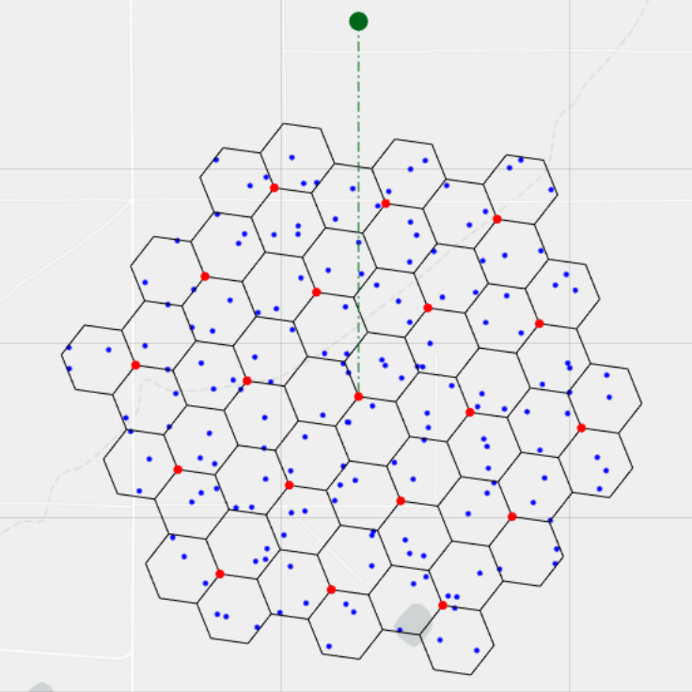

A10.1.2.2.2 IMT deployment assumptions
The deployment of IMT in this band is assumed to focus primarily on urban and suburban areas, with limited presence in rural locations.
Base stations are placed in 19 site hexagonal grid cluster, with 3 IMT base stations per site, totalling 57 IMT base stations, per Recommendation ITU-R M.2101. Additionally, Recommendation ITU-R M.2101 Section 3 states “For modelling and simulation of IMT networks for use in co-existence studies, it is essential to select appropriate deployment conditions. The assumed deployment conditions are critical aspects that will directly impact the results of any sharing study… density and distribution of stations and EIRP may be considered depending on factors such as the size of the area over which interference is aggregated.” To model deployments larger than a 19-site cluster, studies with larger deployments will be considered by increasing the cluster size to a 7 x 19 site cluster, referencing the wrap-around example provided in M.2101. These clusters are formed from cells measuring 0.4 km and 0.8 km representing urban and suburban areas respectively. Example clusters, which use the hexagonal grid structure shown in Figure 2 of Recommendation ITU-R M.2101, are shown in figures below, and each base station antenna aperture azimuth within the baseline cluster is offset by 120°.
Figure A10.2.1.2.2.1
Urban 19 site cluster with cell size of 400 m
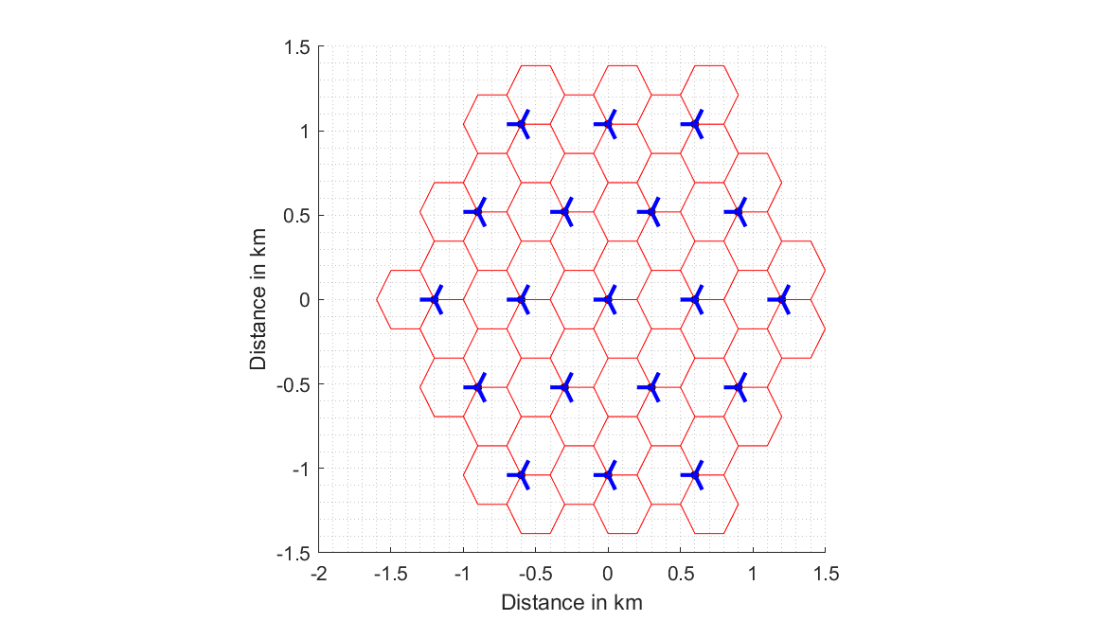

Figure A10.2.1.2.2.2
Suburban 19 site cluster with cell size of 800 m
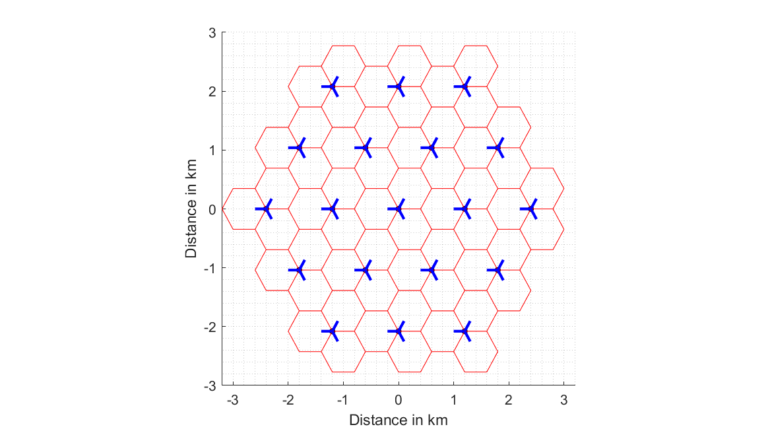

Figure A10.2.1.2.2.3
Urban 7 × 19 site cluster with cell size of 400 m
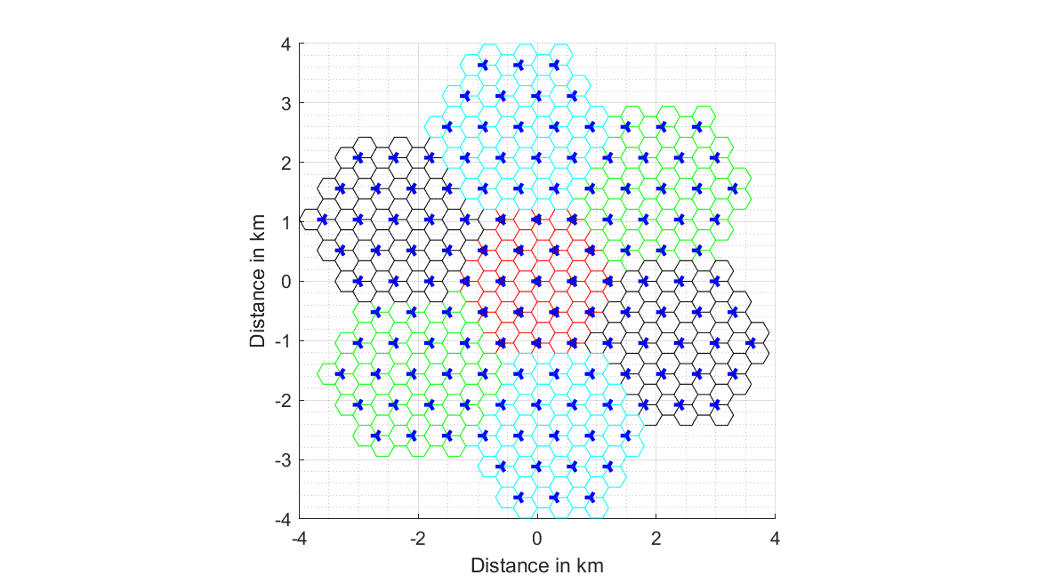
In simulations, clusters will be deployed at designated distance from the EESS for each study. The orientation of the clusters will be randomized from (0° ≤ θ < 360°) such that physical aperture of each cluster of the antenna points in various directions throughout the simulated area.
In Table A10.2.1.1.1.2 Note 4, it is specified that the below-rooftop parameter does not indicate whether a base station will experience clutter. However, a parameter is needed to identify the percentage of base stations that would experience clutter loss. For the purposes of this study, it is assumed that the below-rooftop percentage is a sufficient estimate for clutter in urban and suburban deployments. This clutter assumption and study methodology will be updated following any updated guidance from SG3 relating to clutter. Table A10.2.1.1.1.2 provided the below-rooftop characteristic of 65% for IMT urban deployments and 15% for IMT suburban deployments. For each Monte-Carlo snapshot, 65% of urban base stations and 15% of suburban base stations will be selected as experiencing clutter corresponding to the number of IMT base stations below-rooftop. Additionally, the IMT BS antenna height will be 18m for urban deployments and 20m for suburban deployments.

A10.1,2.2.3 Application of TDD activity factor and network loading factor
The network loading factor utilized by this simulation will be explored using two studies, the first, a 20% network loading factor, the second will utilize 50% network loading factor. Noting that a 50% network loading factor will be studied with no more than a single cluster to be representative of a small area.
When applying the TDD activity factor of 75% to IMT BS and 25% to UEs, active base stations will be designated as either transmitting or receiving within each time snapshot.

A10.1.2.2.4 Calculation and placement of IMT user equipment
In accordance with the IMT characteristics for this frequency band, three UEs transmit per active BS receiving sector and three UE receive per active BS transmitting sector. Therefore, during each snapshot of a simulation with a 19-site IMT cluster, there are exactly 171 receiving or 171 transmitting UEs.
As an initial step, the BS-UE radial distance is uniformly distributed in the cell grid area, such that 100 UEs will be uniformly randomly distributed within each hexagonal sector of the IMT cluster. Of these UEs, 70% will be randomly selected to be indoors. In accordance with the methodology given in Rec. ITU-R M.2101, the BS-UE path coupling loss is calculated and compared against a threshold (determined by the minimum allowable link SINR), while a check is made to verify each UE is at minimum 35 meters from the assigned BS, identify the UEs with placements that are valid for an IMT BS-UE link. An illustration of the resulting 100 UEs per base station sector is provided in Figure A10.2.1.2.4.1, where each blue dot represents a valid UE.
Figure A10.2.1.2.4.1
Example Deployment of IMT User Equipment
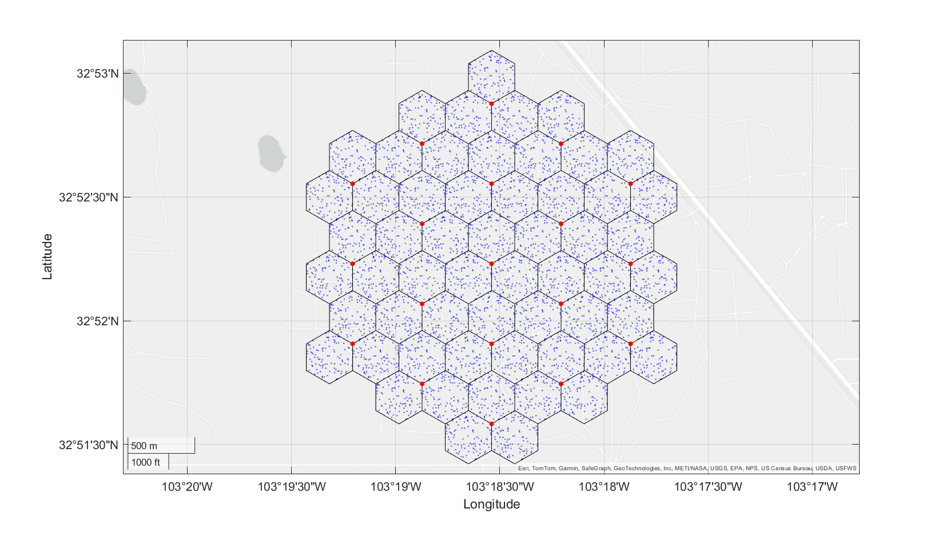
During each snapshot, three UEs with valid links will be selected for each IMT BS. Dependent on the TDD activity factor for a snapshot, these three UEs will either transmit or receive. If they are transmitting, then the UE transmit power will vary dependent on the power required to link with its base station, utilizing the power control specified in the IMT characteristics and M.2101. If the UEs are receiving, then their location will be used to select the BS beam steering angles.
Indoor UEs experience building entry losses per Recommendation ITU-R P.2109-2, with 30% of buildings designated as thermally efficient buildings. In both loss models, a randomly distributed percentage between 0% and 100% will be applied.

A10.1.2.3 Study results
[Editor’s Note: Future updates to this study will provide results and summarize how they relate to the EESS earth station sharing criteria.]
In the following figures, the distance parameter denotes the minimum distance (in kilometres) from the EESS earth station from any base station or user equipment in the IMT cluster.
Figure A10.2.1.3.1
[Figures and Results TBD]

A10.1.2.4 Summary and analysis of the results of Study A
This study analysed the potential interference of an IMT cluster in one country with an EESS earth station in another, during conditions where less than average propagation losses make the EESS earth station more vulnerable to interference. An overview of the study and its assumptions are provided below in Table A10.2.1.4.1.
Table A10.2.1.4.1
Overview of the sharing and compatibility studies
[Editor’s note: Descriptive text and notes of the table. Rows to be added or deleted based on the decision of WP 5D.]
 | Parameters from expert WPs | Study A | Study …
Methodology
Single-entry or Multiple-entry (aggregated) |  | Aggregate
Statistical, or Statistical and Deterministic |  | Statistical (Monte-Carlo)
Technical and operational characteristics of IMT systems
Deployment scenario |  | Macro Urban
IMT stations
Method to deploy multiple IMT stations for the aggregated interference analysis over a relatively large area (as applicable to scenarios for the studies) |  | M.2101
Number of IMT base stations (BS) |  | 19 (57 sectors)
Network loading factor for BS and UE (%) |  | 20%
TDD activity factor (%) |  | 75% for BS and 25% for UE.
UE power control |  | Yes. Per IMT characteristics and M.2101
UE body loss (dB) |  | 4 dB
IMT antenna pattern |  | Extended AAS model (Table 17 of Annex 4.15 of 5D/563)
BS antenna mechanical downtilt |  | -6°
UE antenna pointing (if beamforming) |  | N/A
UE distribution |  | Uniform
User equipment density for terminals that are transmitting simultaneously |  | 3
Technical and operational characteristics (of incumbent service)
EESS earth station characteristics (gain, antenna size, height) |  | 8 earth stations (Document 5D/403 Table 2 and Table 7)
EESS earth station elevation (steer) static or dynamic |  | Dynamic (tracking EESS satellites per 5D/403 and SA.2488)
Propagation model/losses
Basic transmission loss |  | [TBD]
Clutter loss |  | [TBD]
Building entry loss |  | P.2109
Cross-polarization loss (dB) |  | 3
Results of studies
Does the study result consider both BS and UEs? |  | Yes
Results summary |  | [TBD]
[Editor’s Note: Only the relevant portions to Study B are included in this document. This contribution does not propose any changes to Studies C-F.]

