|  |  |
| --- | --- |
| U.S. Radiocommunication Sector  Fact Sheet | |
| **Working Party:** USWP 5D | **Document No:** USWP5D-50/10 |
| **Ref:** Annex 4.XX to Document 5D/792-E | **Date:** 17 July 2025 |
| **Document Title:** Sharing between the space research service (see No. 5.510A) and IMT operating in the frequency band 14.8-15.35 GHz | |
| **Author(s)/Contributors(s):** |  |
| Bashaer Zaki NASA GSFC | Email: [Bashaer.E.Zaki@nasa.gov](mailto:Bashaer.E.Zaki@nasa.gov) |
| Ted Berman Peraton for NASA GSFC | Email: [Theodore.E.Berman@nasa.gov](mailto:theodore.e.berman@nasa.gov) |
| James Brase Peraton for NASA GSFC | Email: [James.M.Brase@nasa.gov](mailto:james.m.brase@nasa.gov) |
| Giadira V. León  Peraton for NASA GSFC  Elena DeJaco  NASA | Email: [Giadira.V.Leon@nasa.gov](mailto:Giadira.V.Leon@nasa.gov)  Email: [elena.k.dejaco@nasa.gov](mailto:elena.k.dejaco@nasa.gov) |
| **Purpose/Objective:** To update Attachment 3 of Annex 4.XX of the WP 5D Chair’s report for WRC-27 Agenda Item 1.7 containing sharing and compatibility studies in the frequency range 14.8-15.35 GHz | |
| **Abstract:** Pursuant to Resolution **256 (WRC-23)**, Working Party (WP) 5D is the responsible group for WRC-27 agenda item 1.7 and for the consideration of studies on technical, operational and regulatory issues pertaining to the possible use of the terrestrial component of IMT in the frequency bands 4 400-4 800 MHz, 7 125-8 400 MHz, and 14.8-15.35 GHz. Annex 4.XX to Document 5D/792-E contains sharing studies between IMT systems in the frequency band 14.8 – 15.35 GHz and incumbent services, including the space research service. Attachment 3 of this Annex contains studies of sharing between IMT systems and the SRS. This contribution offers proposed revisions to Annex 4.12 including methodologies and/or studies to address sharing between potential IMT systems and the existing SRS (space-to-space) service. | |
| **Fact Sheet Preparer**: Giadira V. León, Peraton for NASA | |

|  |  |
| --- | --- |
| **Radiocommunication Study Groups** |  |
|  |  |
|  |  |
| Source: Annex 4.XX to Document 5D/792-E  Subject: WRC-27 agenda item 1.7 | **Document 5D/XX** |
| **XX 2025** |
| **English only** |

**United States of America**

SHARING BETWEEN THE SPACE RESEARCH SERVICE (see No. 5.510A) AND IMT OPERATING IN THE FREQUENCY BAND 14.8-15.35 GHz

**Introduction**

This input contribution includes proposed revisions to Attachment 3 to Annex 4.12 of the working document on sharing and compatibility studies in the 14.8 - 15.35 GHz band in relation to WRC-27 agenda item 1.7, as contained in Chapter 4 of the Working Party 5D Chair’s Report (Document 5D/792-E). This proposed revision contains information relating to a proposed study of interference from IMT systems into space research service (Earth-to-space) (Study A) and (space-to-space) links (Study B).

attachment 3

Sharing between the space research service (see No. 5.510A) and IMT   
operating in the frequency band 14.8-15.35 GHz

[Editor’s note: The studies provided have not been discussed and will need to be carefully examined and updated once service parameters are finalized.]

# A3.1 Technical analysis

## A3.1.1 Study A (SRS (Earth-space)) [USA, 5D/767]

Assessment of potential interference from IMT systems operating in the 14.8-15.35 GHz band into data relay satellite systems operating (Earth-to-space) links in the space research service

The purpose of this study is to assess the potential for interference from IMT systems in the 14.8‑15.35 GHz band to data relay satellite (DRS) systems operating (Earth-to-space) links in the SRS. As the potentially interfered-with link under study in this analysis is an Earth-to-space link, studies will explore the case in which multiple terrestrial stations located in the satellite antenna footprint are transmitting simultaneously. This scenario is depicted in the illustration of Figure A12-1 below.

FIGURE A12-1

Sharing study scenario between IMT and SRS (Earth-to-space)

### A3.1.1.1 Technical characteristics

#### A3.1.1.1.1 Technical and operational characteristics of IMT systems operating in the frequency band 14.8-15.35 GHz

Technical parameters referenced in this sub-section can be found in [Annex 4.15 to Document 5D/563](https://www.itu.int/dms_ties/itu-r/md/23/wp5d/c/R23-WP5D-C-0413!H4-N4.02!MSW-E.docx), the working document on characteristics of terrestrial component of IMT for sharing and compatibility studies in preparation for WRC-27. For brevity, the locations to reference are included in Table A12-1 below.

Table A12-1

Document reference listing for operational characteristics of IMT systems in 14.8-15.35 GHz

|  |  |  |  |
| --- | --- | --- | --- |
| Document number | Document section | Location | Parameter description |
| [Annex 4.15 to  Document 5D/563](https://www.itu.int/dms_ties/itu-r/md/23/wp5d/c/R23-WP5D-C-0413!H4-N4.02!MSW-E.docx) | 3.1.3 | Table 7 | IMT technology related parameters in 14.8-15.35 GHz |
| [Annex 4.15 to  Document 5D/563](https://www.itu.int/dms_ties/itu-r/md/23/wp5d/c/R23-WP5D-C-0413!H4-N4.02!MSW-E.docx) | 3.2.3 | Table 15 | Deployment-related parameters for bands between 14.8 and 15.35 GHz |
| [Annex 4.15 to  Document 5D/563](https://www.itu.int/dms_ties/itu-r/md/23/wp5d/c/R23-WP5D-C-0413!H4-N4.02!MSW-E.docx) | 3.2.3 | Table 16 | UE parameters for bands between 14.8 and 15.35 GHz |
| [Annex 4.15 to  Document 5D/563](https://www.itu.int/dms_ties/itu-r/md/23/wp5d/c/R23-WP5D-C-0413!H4-N4.02!MSW-E.docx) | 3.3 | Table 17 | Extended AAS model |
| [Annex 4.15 to  Document 5D/563](https://www.itu.int/dms_ties/itu-r/md/23/wp5d/c/R23-WP5D-C-0413!H4-N4.02!MSW-E.docx) | 3.3.3 | Table 20 | Beamforming antenna characteristics for IMT in 14 800 to 15 350 MHz |

#### [US Note: The above table will be updated once the working document on IMT characteristics can be found under the official Chairman’s Report document 5D/792]

#### A3.1.1.1.2 Technical/operational characteristics and protection criteria of SRS (Earth-to-space) links operating in the frequency band 14.8-15.35 GHz

These links support SRS spacecraft deployed in various orbits, including low-Earth orbit (both polar and equatorial inclinations), geostationary altitudes, high Earth orbits (HEO), and at the L1 and L2 Lagrange points.

The protection criteria for data relay satellite systems in this frequency range are identified in Recommendation [ITU-R SA.1155-2](https://www.itu.int/rec/R-REC-SA.1155-2-201707-I/en). This recommends that the protection criteria, specified in maximum aggregate interference power spectral density to system noise power density ratio from all sources should not be exceeded for more than 0.1% of the time for the various links of data relay satellite systems as indicated in Table A1-1.

TABLE A1-1

Protection criteria in 14.8-15.35 GHz band

|  |  |  |
| --- | --- | --- |
| Data relay satellite link | Receiver location | *I*0/*N*0  (dB) |
| Forward feeder link | GSO Data relay satellite | –6 |

Further detailed information on technical and operational characteristics can be found in Recommendation ITU-R SA.2141 *“Characteristics of space research service systems in the frequency range 14.8-15.35 GHz”* and Recommendation ITU-R SA.509-3 *“Space research earth station and radio astronomy reference antenna radiation pattern for use in interference calculations, including coordination procedures, for frequencies less than 30 GHz”*.

#### A3.1.1.1.3 Propagation models used in the study

[Editor’s note: This section provides specific propagation models for sharing/interference analyses used in the study in accordance with guidance from Study Group (SG) 3 and its WPs (Documents [5D/160](https://www.itu.int/md/R23-WP5D-C-0160/en) and 5D/[TBD]). For each model, values used for model parameters are to be clearly stated.]

Working Parties 3M and 3K provided guidance for the use of Recommendation [ITU-R P.619](https://www.itu.int/rec/R-REC-P.619/en) relating to the calculation of individual propagation effects (including tropospheric refraction or beam spreading loss). Such propagation effects should apply to the calculation of the received interfering signal’s power.

### A3.1.1.2 Methodology

[Editor’s note: This section provides the methodology used in this study.]

##### **A3.1.1.2.1 IMT Deployment assumptions**

The deployment of IMT in this band is assumed to focus primarily on urban and suburban areas, with limited presence in indoor locations.

[The IMT deployment methodology and assumptions will be included here.]

###### **A3.1.1.2.1.1 Area of Interest Evaluation with Publicly Available Land Cover Data**

This interference scenario considers deployments over the Earth surface visible from a geosynchronous satellite location. These deployments will be estimated based on publicly available land cover data. One such available [data set produced by the Moderate Resolution Imaging Spectroradiometer (MODIS)](https://lpdaac.usgs.gov/products/mcd12q1v061/) provides global land cover types at yearly intervals with a spatial resolution of 500 metres. The currently available set is based on imagery taken in 2023, representing the most up-to-date information for this combination of area and resolution. The data provides a total of 16 different land cover classifications, including “Urban and Built-up”.

###### A3.1.1.2.1.2 Calculation of Total Number of IMT Base Stations within MAI

The macro cell deployment model is selected as the worst case for emissions towards a satellite receiver in this band. The calculation for the total number of IMT base stations deployed within the visible earth surface is given by the following equation:

where:

: Visible land area [61,882,811.740 km2 (calculated)]

: BS deployment density in urban areas [10 BS / km2]

: BS deployment density in suburban areas [2.4 BS / km2]

: Ratio of urban coverage areas to areas of cities/built areas/districts [10%]

: Ratio of suburban coverage areas to areas of cities/built areas/districts [5%]

: Ratio of built areas to total area of region in study [1%].

When evaluating Equation A3-1, the land masses of Antarctica and Greenland are excluded from the land area calculation. The resulting total number of IMT base stations within the visible area is 693,088, where 618,828 are attributed to urban environments and 74,260 are attributed to suburban environments.

It should be noted that the number of base stations calculated within Equation A3-1 does not represent the number of simultaneously transmitting base stations during any given simulation step; a subset of the total number of base stations is selected after appropriate application of the TDD activity and network loading factors.

Base station clusters shown in the figures below use the hexagonal grid structure from Figure 2 of Recommendation ITU-R M.2101. Illustrated are urban and suburban 19 site clusters and an urban 7 × 19 site cluster. For each site, the BS antenna aperture azimuths within the cluster are offset by 120°.

Figure a12-2

Urban Cluster with cell size of 300 m

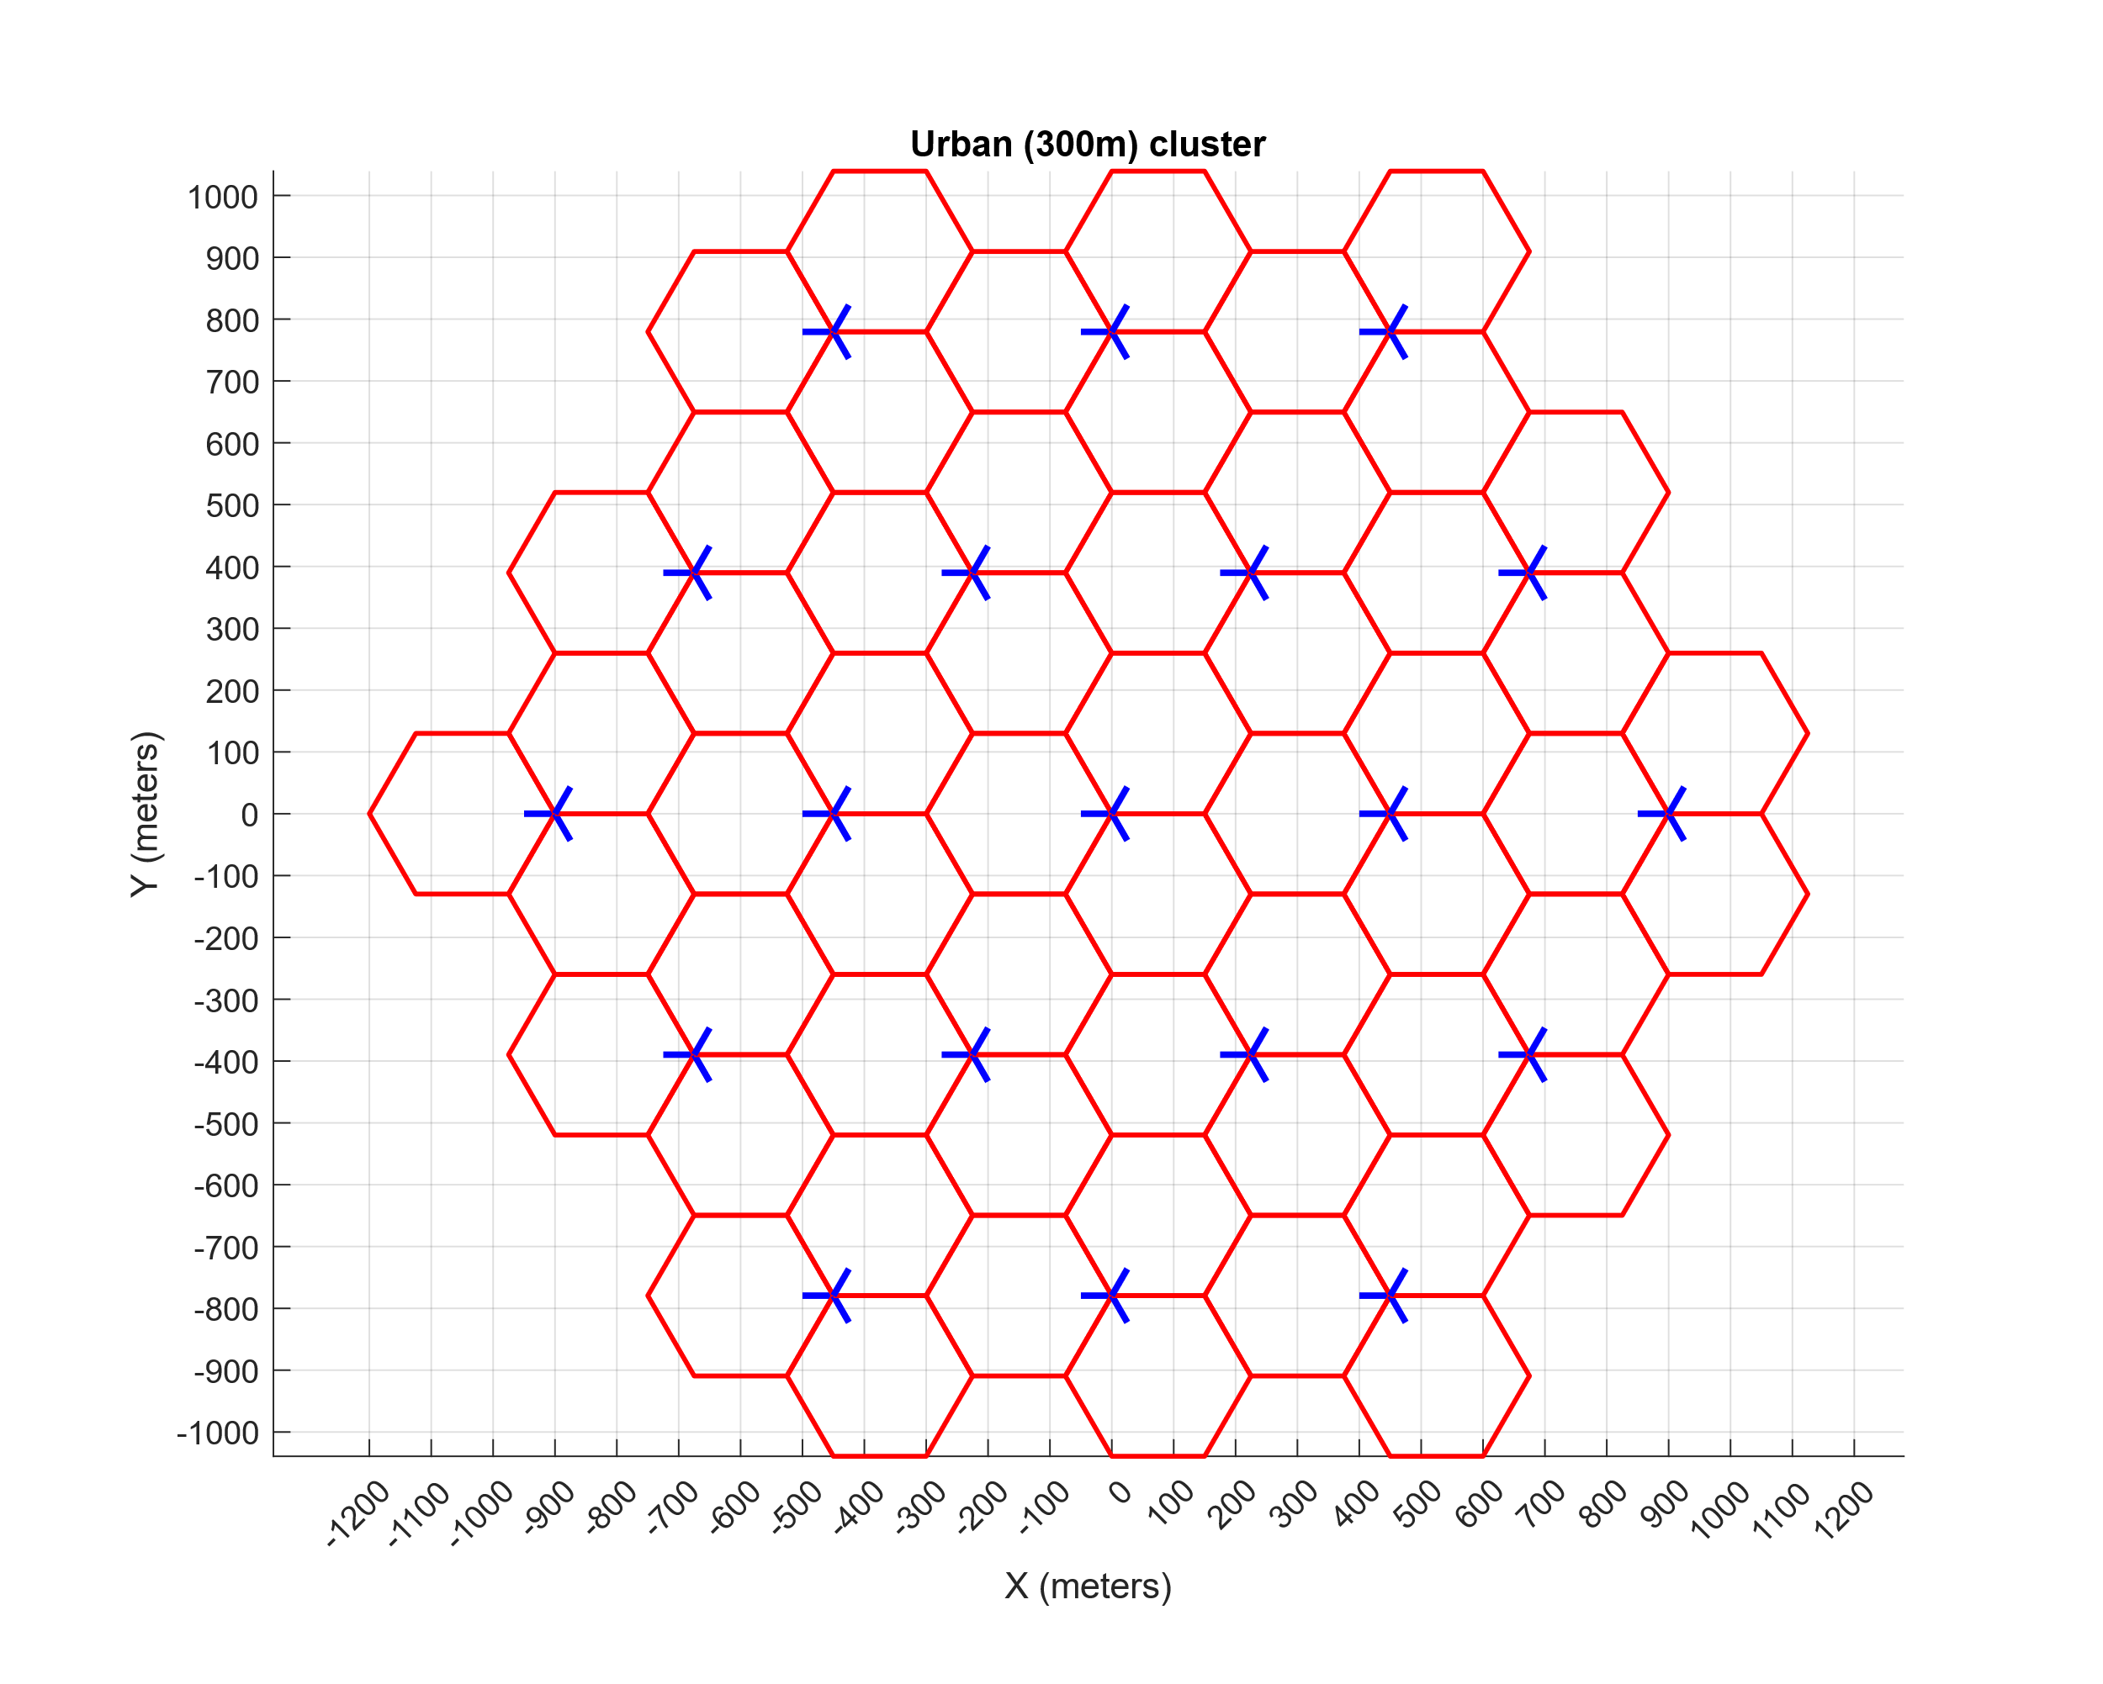

Figure A12-3

Suburban 19 site cluster with cell size of 600 m

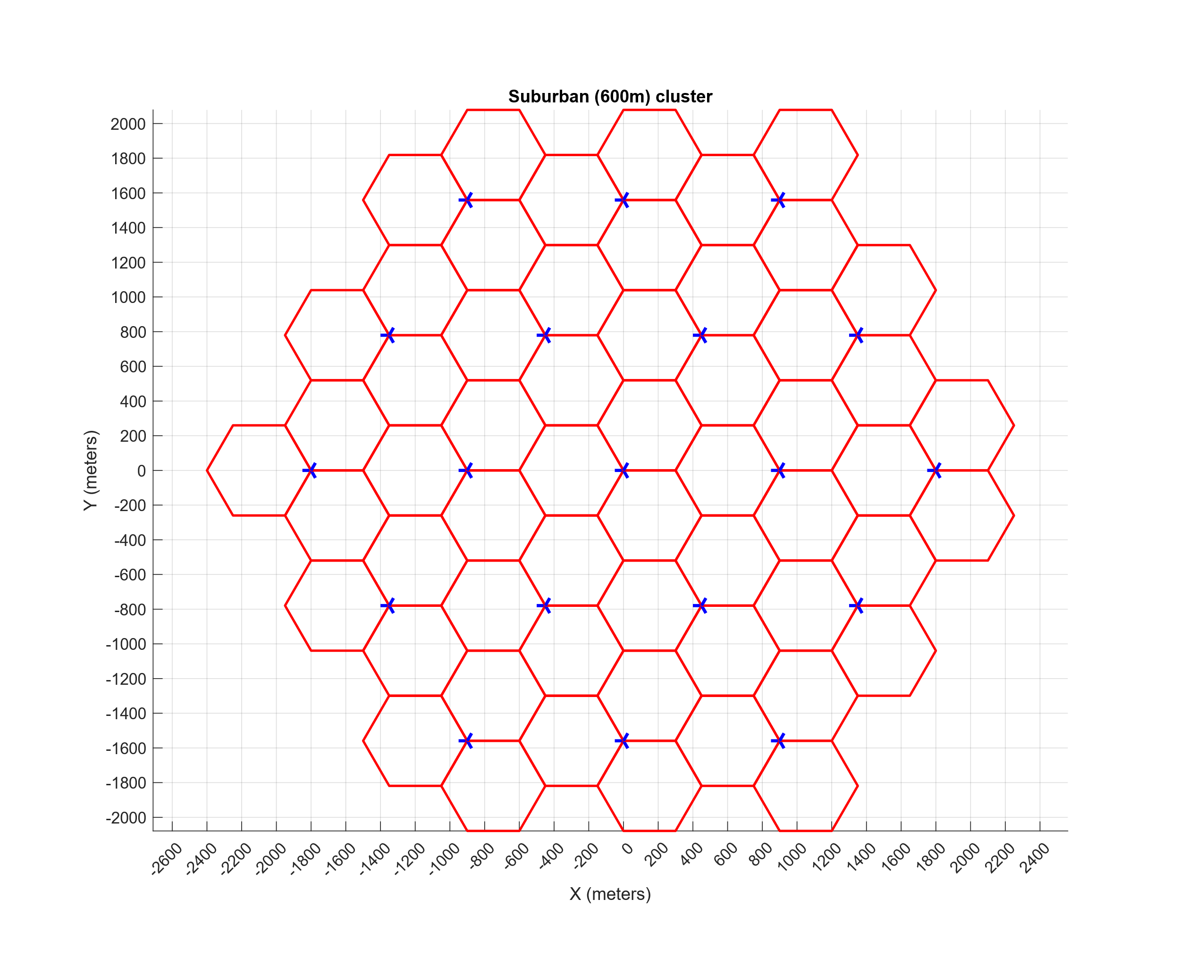

Figure A12-4

Urban 7 × 19 site Wraparound cluster with cell size of 300 m

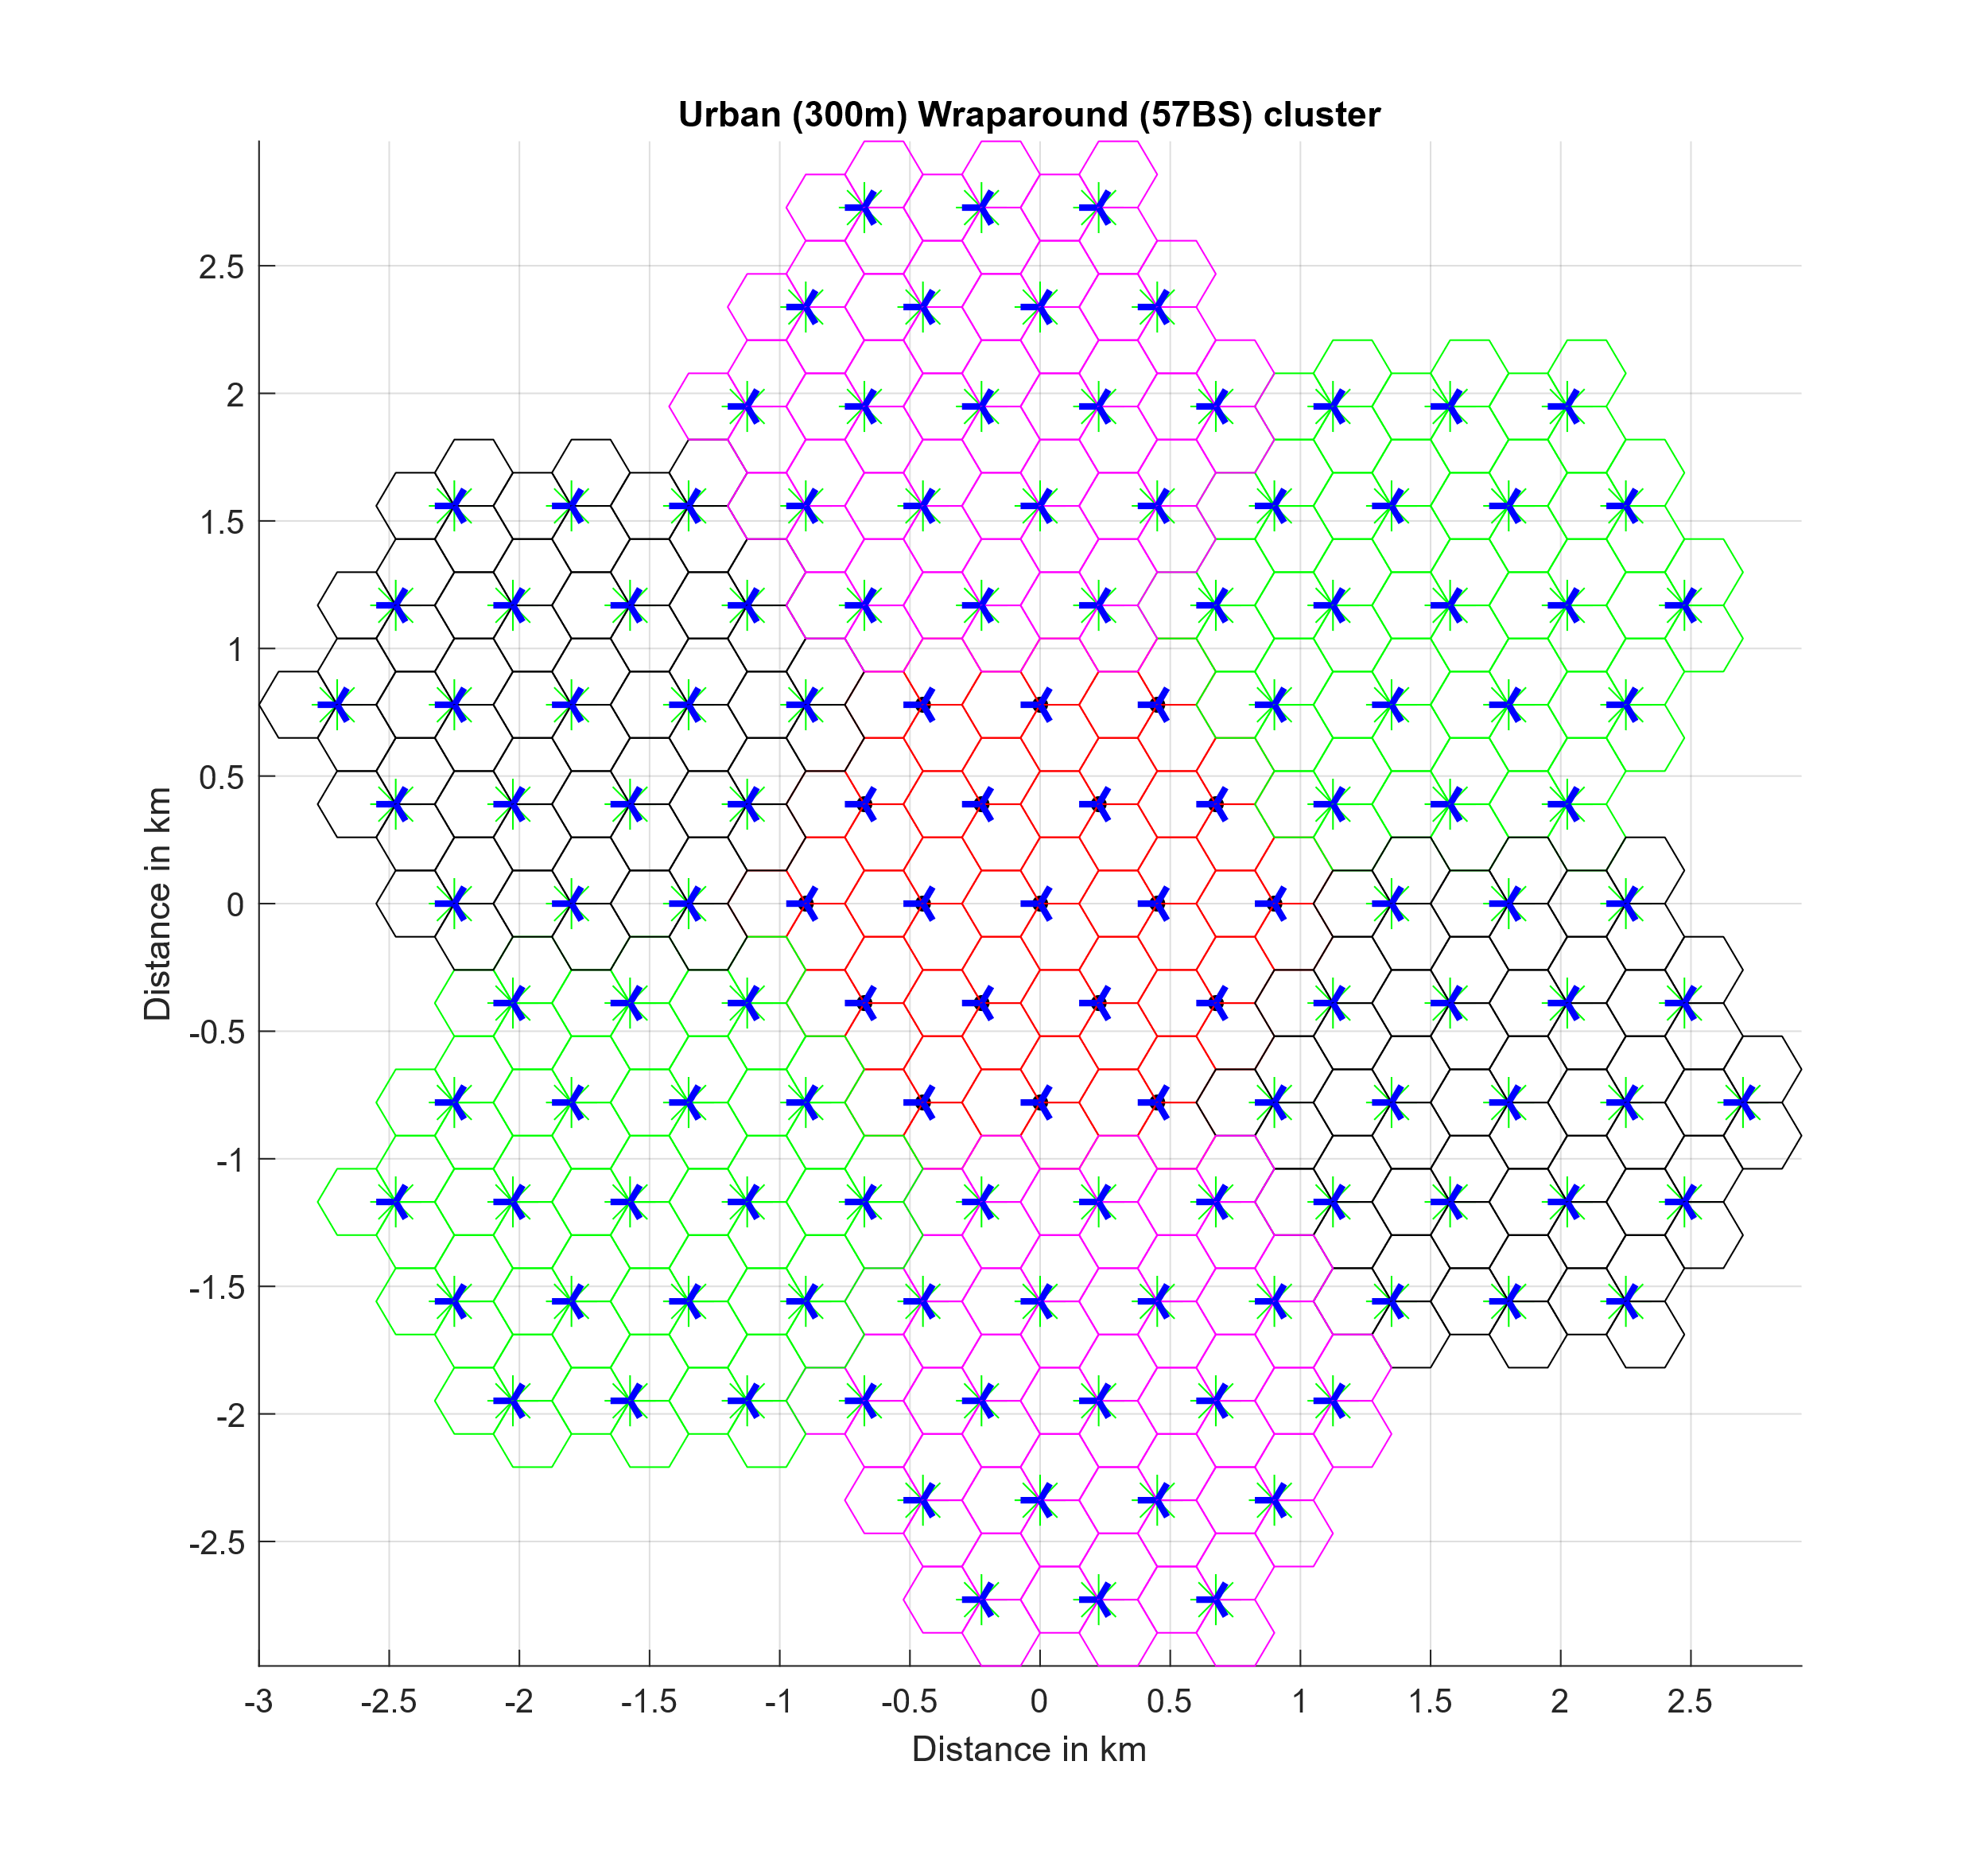

The process for placing IMT base stations within the visible Earth is described below:

1 Without replacement, randomly select one of the pixels within the visible Earth area that is designated as an “Urban and built-up” area. The latitude and longitude of this pixel will serve as the centre point of a base station cluster.

2 Ensure that the resulting cluster centred around the selected pixel does not overlap with previous clusters, which guarantees that the maximum base station density is not exceeded.

3 Place 19 base stations at a time with 3 BS/site (using the pattern in Figure A12-2 or A12-3 as appropriate).

4 Reiterate until all urban and suburban base stations have been placed within the visible Earth area.

The superset of base station locations, consisting of all possible 693,088 stations from evaluating Equation A3-1, is shown in Figure A12-5. It is worth noting that each single point on Figure A12-5 represents three distinct base stations, as the corresponding antenna aperture azimuths are not simultaneously plotted.

Figure A12-5

Complete Base Station Placement within Visible Area

##### A3.1.1.2.2 Application of TDD Activity Factor and Network Loading Factor

This study will use a network loading factor of 20%, as appropriate for a wide area analysis. Therefore, within a given snapshot, exactly 138,618 of the possible 693,088 base stations are randomly designated as either actively transmitting or receiving. Furthermore, when applying the TDD activity factor of 75%, 103 232 base stations are designated as transmitting and 36 411 base stations are designated as receiving within each snapshot, and stations are randomly chosen during each snapshot.

Additionally, within the simulation, all IMT operations are synchronized on a per-cluster basis. Therefore, active base stations within any individual cluster are either all transmitting or all receiving, i.e., there is no combination of transmitting and receiving base stations within a single cluster for a given snapshot.

#### A3.1.1.2.3 Calculation and Placement of IMT User Equipment

In accordance with the IMT characteristics for this frequency band, three UEs transmit per active BS receiving sector and three UEs receive per active BS transmitting sector. Therefore, during each snapshot, there are exactly 311,890 receiving and 103,963 transmitting UEs, forming a total of 415,853 stations.

The following assumptions are used:

– The maximum BS-UE radial distance considered is the cell radius, which is 150 metres for urban and 280 metres for suburban clusters.

– As an initial step, the BS-UE radial distance is uniformly distributed in the cell grid area. In accordance with the methodology given in Recommendation ITU-R M.2101, the BS-UE path coupling loss is calculated and compared against a threshold (determined by the minimum allowable link SINR) to ensure that the placement is valid. If the path coupling loss is determined to be too high, the BS-UE radial distance is randomly chosen again, and the process is repeated.

##### A3.1.1.2.4 Simulation methodology

An assessment of the aggregate RFI expected from the proposed IMT identification, into SRS receiving space stations, operating in the 14.8-15.35 GHz band is achieved with a Monte Carlo style static analysis.

In this Monte Carlo style analysis, many simulated deployment trials will be conducted to assess the probability of potential interference from each active IMT station into the receiving station under study, taking into account the aggregate effect of multiple IMT stations. Those deployment trials will represent a uniform distribution of elevation angles from the IMT interferers towards the geostationary satellite will be considered. At each Monte Carlo iteration, a snapshot of the interference scenario will be generated where the gain of the transmit and receive antennas using their respective antenna patterns will be computed.

The interfering signal power level, (W), received by a non-GSO SRS space station at the simulation step from the active IMT station is calculated from:

(A1-1)

where:

: active IMT station transmitter power in the band of study

: active IMT station antenna gain towards SRS space station

: SRS space station receive antenna gain towards terrestrial source

: free space path loss

: attenuation due to atmospheric gasses (Rec. ITU-R P.619 Attachment C)

: losses due to polarization mismatch

: losses due to clutter (Rec. [ITU-R P.2108](https://www.itu.int/md/meetingdoc.asp?lang=en&parent=R23-SG03-C-0041))

: losses due to human body attenuation; this factor is 1 (0 dB) for base stations and 2.51 (4 dB) for user equipment.

The aggregate interference at the simulation step, (W), is calculated by the summation of the received interference from all active IMT stations within line of sight of the receiving SRS space station.

(A1-2)

Thus, the aggregate interference can be represented in the logarithmic domain as:

(A1-3)

Using the resulting data containing received interfering power levels, a CCDF curve will be generated to assess interference observed at the SRS space station.

### A3.1.1.3 Study A results

[Editor’s note: This section provides the sharing and compatibility study results of this study.]

### A3.1.1.4 Summary and analysis of the results of Study A

[Editor’s note: This section provides the summary and analysis of the results of this study for both the protection of incumbent services (in band and adjacent bands) and without imposing additional regulatory or technical constraints on those incumbent services.]

## A3.1.2 Study B (SRS (space-space)) [USA. 5D/767]

Assessment of potential interference from IMT systems operating in the 14.8-15.35 GHz band into data relay satellite systems operating (space-to-space) links in the space research service

The purpose of this study is to assess the potential for interference from IMT systems in the 14.8‑15.35 GHz band to data relay satellite (DRS) systems operating (space-to-space) links in the SRS. DRS systems operate inter-satellite links in this band in the NGSO-to-GSO direction. As the potentially interfered-with link under study in this analysis is a space-to-space link, studies will explore the case in which multiple terrestrial stations located in the satellite antenna footprint are transmitting simultaneously.

FIGURE A12-2

Sharing study scenario between IMT and SRS (space-to-space)

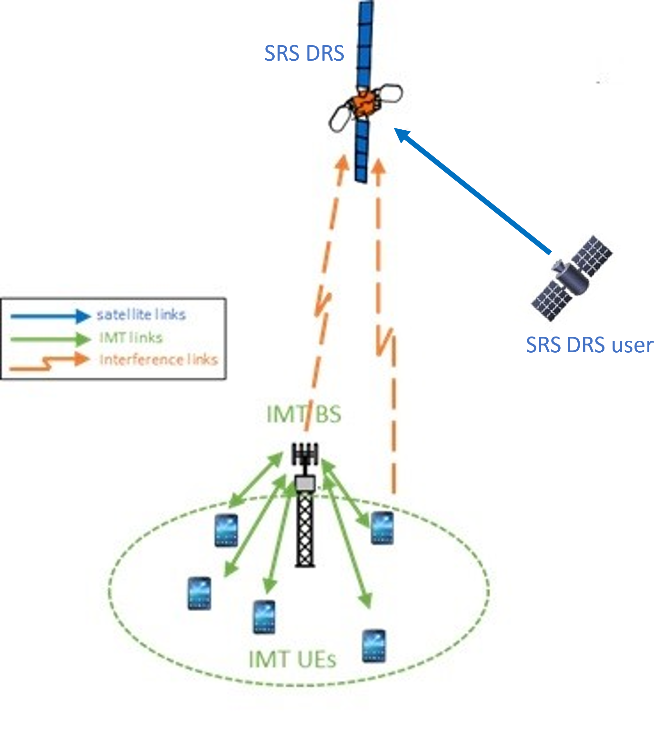

### A3.1.2.1 SRS Technical characteristics

These will generally be links between data relay satellites in GSO orbit and DRS user satellites deployed in low-Earth orbit, with either polar or equatorial inclination.

#### A3.1.2.1.1 Technical and operational characteristics of IMT systems operating in the frequency band 14.8-15.35 GHz

Technical parameters referenced in this sub-section can be found in [Annex 4.15 to Document 5D/563](https://www.itu.int/dms_ties/itu-r/md/23/wp5d/c/R23-WP5D-C-0413!H4-N4.02!MSW-E.docx), the working document on characteristics of terrestrial component of IMT for sharing and compatibility studies in preparation for WRC-27. For brevity, the locations to reference are included in Table A12-1.

#### A3.1.2.1.2 Technical/operational characteristics and protection criteria of SRS operating (space-to-space) links in the frequency band 14.8-15.35 GHz

The protection criteria for data relay satellite systems operating in the SRS in this frequency range is identified in Recommendation ITU-R SA.1155-2. This specifies that a maximum aggregate interference power spectral density to system noise power density ratio (Io/No), from all sources as in Table A1-2 below should not be exceeded for more than 0.1% of the time.

TABLE A1-2

SRS Protection criteria in 14.8-15.35 GHz band

|  |  |  |
| --- | --- | --- |
| Data relay satellite link | Receiver location | *I*0/*N*0 (dB) |
| Return inter-orbit link | Data relay satellite | –10 |

Further detailed information on technical and operational characteristics can be found in Recommendation ITU-R SA.2141 *“Characteristics of space research service systems in the frequency range 14.8-15.35 GHz”* and Recommendation ITU-R SA.509-3 *“Space research earth station and radio astronomy reference antenna radiation pattern for use in interference calculations, including coordination procedures, for frequencies less than 30 GHz”*.

#### A3.1.2.1.3 Propagation models used in the study

Working Parties 3M and 3K provided guidance for the use of Recommendation ITU-R [P.619](http://www.itu.int/rec/R-REC-P.619/en) relating to the calculation of individual propagation effects (including tropospheric refraction or beam spreading loss). Such propagation effects should apply to the calculation of the received interfering signal’s power.

### A3.1.2.2 Methodology

The general simulation methodology will be as described is section A.3.1.1.2.4.

#### **A3.1.2.2.1 IMT Deployment assumptions**

The deployment of IMT characteristics are as described in section A3.1.1.2.1.

#### A3**.1.2.2**.2 Application of TDD Activity Factor and Network Loading Factor

The activity and network loading factors will be as detailed in section A3.1.1.2.2.

#### A3.1.2.2.3 Calculation and Placement of IMT User Equipment

IMT user equipment deployment will be modeled as in A3.1.1.2.3.

#### **A3.1.2.2.2.2 Simulation process**

**Start time loop**

The time loop is run for a number of iterations equal to 100 divided by the interference / sharing criteria exceedance percentage. For the Recommendation [ITU-R SA.1155-2](https://www.itu.int/rec/R-REC-SA.1155-2-201707-I/en) protection criteria, the loop is run for 100/.001 which is 100 000 iterations.

Generate IMT deployment scenario

This was described in sections A.3.1.2.2.1 through A.3.1.2.2.3.Locate user spacecraft and point space station antennas

At each snapshot, the SRS space station antenna is pointed in a random direction within its service area, representing pointing towards a potential user satellite. The random pointing directions are generated according to a normal distribution in antenna azimuth and a Poisson distribution in elevation. The antenna elevation profile is bounded by 10° from Nadir. This is representative of the relative frequencies of user satellites positions with respect to a DRS satellite.

*[Editor’s note: It is suggested to provide justification for the chosen statistical distributions of antenna pointing angles taking into account orbital parameters of operational user satellites.]*

Calculate aggregate interference

At each time instant, the interference from each IMT source within the area of visibility of the SRS DRS satellite is determined by calculating the effective antenna gains, and applicable losses between each interference source and the victim satellite. Aggregate interference is calculated by summing the interference contribution from each of the transmitting BS and UEs.

Compare to protection criteria

At the conclusion of the time loop, the aggregate interference result from each time step is compared to the applicable protection / sharing criteria to determine whether the interference received form the particular IMT deployment in this snapshot exceeds the criteria. The percentage of exceedances for all iterations will then determine if the protection criteria is satisfied.

### A3.1.2.3 Study B results

[TBD]

### A3.1.2.4 Summary and analysis of the results of Study B

[TBD]

[No changes to section A3.1.3]

# A3.2 Summary and analysis of the results of studies

[Editor’s note: This section provides the summary and analysis of the results of studies. The text here can be used in the Section 1/1.7/3 “Summary and analysis of the results of ITU-R studies” of draft CPM text.]

[Editor’s note: This section should include concise text with summary and analysis of the results of studies. It may contain a summary table listing possible distance and/or frequency separation, or any other mitigation techniques, needed to protect existing service/application(s) operating in the band 14.8-15.35 GHz, or in adjacent band as appropriate, from IMT systems.]

Table (IMT ANd SRS in 14.8-15.35 gHz frequency range)

Overview of the sharing and compatibility studies

|  | Parameters from expert WPs | Study A | Study B |
| --- | --- | --- | --- |
| **Methodology** | | | |
| Single-entry or Multiple-entry (aggregated) |  | Multiple Entry (Aggregated) | Multiple Entry (Aggregated) |
| Statistical, or Statistical and Deterministic |  | Statistical | Statistical |
| **Technical and operational characteristics of IMT systems** | | | |
| Deployment scenario |  | Macro Urban and Suburban | Macro Urban and Suburban |
| IMT stations |  |  |  |
| Method to deploy multiple IMT stations for the aggregated interference analysis over a relatively large area (as applicable to scenarios for the studies) |  | M.2101 and [Working doc on characteristics] | M.2101 and [Working doc on characteristics] |
| Number of IMT base stations (BS) |  | 693,088 | 693,088 |
| Network loading factor for BS and UE (%) |  | 20% | 20% |
| TDD activity factor (%) |  | 75% | 75% |
| UE power control |  | N/A | N/A |
| UE body loss (dB) |  | N/A | N/A |
| IMT antenna pattern |  | Extended AAS model (Section 3.3 Table 17 of characteristics doc) | Extended AAS model (Section 3.3 Table 17 of characteristics doc) |
|  |  |  |  |
| BS antenna mechanical downtilt |  | 6° | 6° |
| UE antenna pointing (if beamforming) |  | N/A | N/A |
| UE distribution |  | N/A | N/A |
| [User equipment density for terminals that are transmitting simultaneously](" \l "RANGE!_ftn1) |  | N/A | N/A |
| **Technical and operational characteristics DRS satellite** | | | |
| Orbital Location |  | 314° | 314° |
| Antenna Size |  | 1.8 m | 4.9 m |
| Rx antenna gain |  | 47.0 dBi | 52.6 dBi |
| Rx antenna radiation pattern |  | Rec. ITU-R .672 | Rec. ITU-R .672 |
| Protection Criteria (I/N) |  | -6 dB | -10 dB |
| **Propagation model/losses** | | | |
| Basic transmission loss |  | P.619 | P.619 |
| Clutter loss |  | P.2108 Section 3.3 | P.2108 Section 3.3 |
| Building entry loss |  | N/A | N/A |
| Cross-polarization loss (dB) |  | 3 dB | 3 dB |
| **Results of studies** | | | |
| Does the study result consider both BS and UE transmissions? |  | No | No |
| Results summary |  |  |  |

\_\_\_\_\_\_\_\_\_\_\_\_\_\_