U.S. Radiocommunication Sector
Fact Sheet
Working Party: USWP 5D | Document No: USWP5D-50/11
Ref: Annex 4.14 to Document 5D/792-E | Date: 18 July 2025
Document Title: Sharing between the space research service (Earth-to-space) in the frequency band 7 145-7 235 MHz and IMT
Author(s)/Contributors(s):
Bashaer Zaki  NASA GSFC | Email: Bashaer.E.Zaki@nasa.gov
Ted Berman  Peraton for NASA GSFC | Email: Theodore.E.Berman@nasa.gov
Giadira V. León  Peraton for NASA GSFC | Email: Giadira.V.Leon@nasa.gov
James Brase  Peraton for NASA GSFC | Email: James.M.Brase@nasa.gov
Dennis Lee  NASA JPL | Email: Dennis.K.Lee@jpl.nasa.gov
Luciano Alexandre  NASA JPL  Elena DeJaco  NASA | Email: Luciano.C.Alexandre@jpl.nasa.gov  Email: elena.k.dejaco@nasa.gov
Purpose/Objective: To update Annex 4.14 of the WP 5D Chair’s report for WRC-27 Agenda Item 1.7 containing sharing and compatibility studies between IMT and SRS in the frequency range 7 145 -7 235 MHz
Abstract: Pursuant to Resolution 256 (WRC-23), Working Party (WP) 5D is the responsible group for WRC-27 agenda item 1.7 and for the consideration of studies on technical, operational and regulatory issues pertaining to the possible use of the terrestrial component of IMT in the frequency bands 4 400-4 800 MHz, 7 125-8 400 MHz, and 14.8-15.35 GHz. Annex 4.14 to Document 5D/792-E contains sharing studies between IMT systems in the frequency band 7125 – 8 400 MHz and incumbent services. This document specifically addresses sharing with the space research service in the band 7 145 – 7 235 MHz. This contribution proposes revisions to the Annex to incorporate sharing studies between IMT systems and the existing SRS (Earth-to-space) service.
Fact Sheet Preparer: James Brase, Peraton for NASA

Radiocommunication Study Groups | 
Source: Annex 4.14 to Document 5D/792-E  Subject: WRC-27 agenda item 1.7 | Document 5D/XXY-E
 | XX October 2025
 | English only

United States of America
SHARING BETWEEN THE SPACE RESEARCH SERVICE (EARTH-TO-SPACE) IN THE FREQUENCY BAND 7 145 – 7 235 MHZ AND IMT

Introduction
This contribution includes proposed revisions to Annex 4.14 of the working document on sharing and compatibility studies between IMT systems and SRS uplinks in the 7145 – 7 235 MHz band in relation to WRC-27 agenda item 1.7, as contained in Chapter 4 of the Working Party 5D Chair’s Report (Document 5D/792-E). This proposed revision contains information relating to a proposed studies of interference from IMT systems into space research service systems in GSO and NGSO orbits.

attachment 2
Sharing between the space research service (Earth-to-space) in the frequency band 7 145-7 235 MHz and IMT operating in the frequency
[Editor’s note: This Attachment contains sharing and compatibility studies of the space research service (Earth-to-space) in the frequency band 7 145-7 235 MHz and IMT operating in the frequency band 7 125-8 400 MHz. The studies in this Attachment are divided into two sections. section A2.1 contains sharing studies involving SRS (near-Earth)(Earth-to-space) in GSO and non-GSO orbits in the frequency band 7 190-7 235 MHz. Section A2.2 contains sharing studies involving SRS (deep space)(Earth-to-space) in the frequency band 7 145-7 190 MHz Section A2.3 contains sharing studies involving SRS (deep space)(Earth-to-space) in the frequency band 7 145-7 190 MHz. Note that the technical characteristics are provided from the inputs listed section 2 in the main body of the document, with the relevant information summarized in sections 3 and 4 above.]
[Editor’s note: The studies provided have not been discussed in detail and will need to be carefully examined and updated once service parameters are finalized.]
[Editor’s Note: The following remarks were made for many studies in this attachment:
1. The studies to utilization of latest Protection Criteria in the LS from 7B, (I/N instead of C/I and C/N).
2. Several studies indicated that the revised results will be provided, incorporating the applicable remarks.]

A2.1 Technical Analysis - SRS (near-Earth) (Earth-to-space)

A2.1.1 Study A [USA (5D/502, 5D/762)]
The purpose of this study is to assess the potential for interference from IMT systems in the 7 125-8 400 MHz band to space stations operating in the SRS (near-Earth) in the 7 190-7 235 MHz band. As the potentially interfered-with link under study in this analysis is an Earth-to-space link, studies will explore the case in which multiple terrestrial stations located in the satellite antenna footprint are transmitting simultaneously.
This scenario is depicted in Figure A2-1 below.
FIGURE A2-1
Sharing study scenario between IMT and SRS (near-Earth) (Earth-to-space)
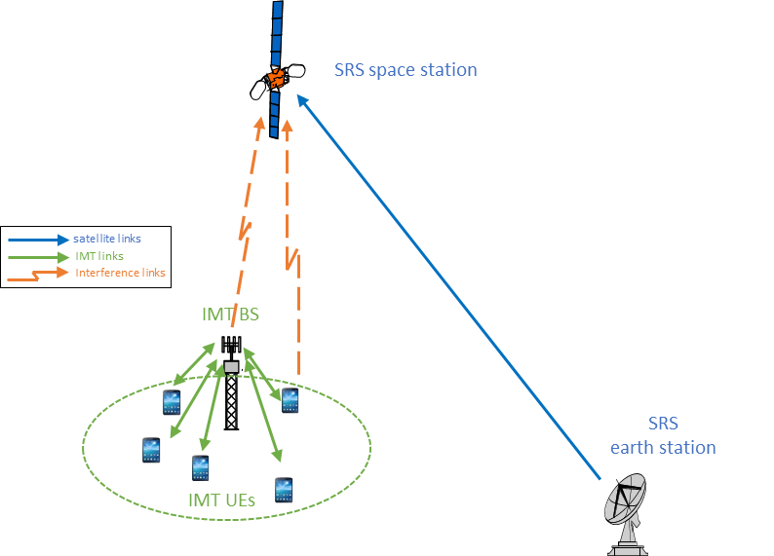

A2.1.1.1 Technical characteristics

A2.1.1.1.1 Technical and operational characteristics of IMT systems operating in the frequency band 7 125-8 400 MHz
The characteristics and technical parameters referenced in this sub-section and used in this study can be found in Annex 4.15 to Document 5D/563, which is the working document on characteristics of terrestrial component of IMT for sharing and compatibility studies in preparation for WRC-27.
For brevity, the locations to reference are included in Table A2-1 below.
Table A2-1
Document reference listing for operational characteristics of IMT systems in 7 125-8 400 MHz
Document number | Document section | Location | Parameter description
Annex 4.15 to  Document 5D/563 | 3.1.2 | Table 4 | IMT technology related parameters in 7 125-8 400
Annex 4.15 to  Document 5D/563 | 3.2.2 | Table 13 | Deployment-related parameters for bands between 7.125 and 8.4 GHz
Annex 4.15 to  Document 5D/563 | 3.2.2 | Table 14 | UE parameters for bands between 7.125 and 8.4 GHz
Annex 4.15 to  Document 5D/563 | 3.3 | Table 17 | Extended AAS model
Annex 4.15 to  Document 5D/563 | 3.3.2 | Table 19 | Beamforming antenna characteristics for IMT in 7 125 to 8 400 MHz

[US Note: The above table will be updated once the working document on IMT characteristics can be found under the official Chair’s Report document 5D/792]

A2.2.1.1.2 Technical/ operational characteristics and protection criteria of space research service (near-Earth) (Earth-to-space) operating in the frequency band 7 190-7 235 MHz
Information on technical and operational characteristics and protection criteria of SRS (near-Earth) systems in the 7 190-7 235 MHz band has been provided to WP 5D in liaison statements from Working Party 7B (Documents 5D/92 and 5D/403). Document 5D/403 indicates that example characteristics for near-Earth SRS networks are included in Report ITU-R SA.2309-0, section 3.
A listing of this information referenced by section and title is given in Table A2-2 below.
Table A2-2
Document reference listing for characteristics of SRS (near-Earth) earth stations
and spacecraft in 7 190-7 235 MHz
Document number | Document section | Location | Parameter description
5D/403 | Annex 1,  Section 3.4 |  | Protection Criterion
5D/403 | Annex 2, Section 3 | Table 11 | Additional representative SRS (near-Earth) Earth station characteristics in the frequency band 7 190-7 235 MHz
5D/403 | Annex 2, Section 3 | Table 12 | Additional representative SRS (near-Earth) spacecraft receiving characteristics for Earth-to-space links in the frequency band 7 190-7 235 MHz
5D/92 | Annex 1, Section 1.2 |  | Listing of in-force ITU-R documentations on SRS
Document 5D/403 informs that SRS (near-Earth) systems perform a wide variety of scientific missions associated with a range of orbit types which include Earth-sun Lagrangian point (L1/L2) orbits, lunar orbits, highly elliptical orbits, geosynchronous orbits and low-Earth orbits. The technical and operational characteristics of the SRS spacecraft vary from one mission type to another. For this Study, SRS (near-Earth) systems using [low-Earth and geosynchronous] orbits are examined
[Editor’s note: future studies will consider potential interference to SRS systems with other orbit types as appropriate.]
Specific characteristics of SRS systems considered in Study A are summarized in Table A2-3.
Table A2-3
Characteristics of SRS (near-Earth) systems considered in this study
Parameter | System 1 | System 2
Transmitting SRS Earth Station Parameters
Tx Earth station lat. (deg) | 32.38 | 37.95
Tx Earth station long. (deg) | ‒106.49 | ‒75.46
Tx Earth station representative parameters | (Table 11 of 5D/403)  (Table 2 of ITU-R Report SA.2309)
Tx Earth station antenna minimum elevation angle (deg) | 5 | N/A (fixed at 46.0 deg)
Receiving SRS Spacecraft Parameters
Rx spacecraft altitude (km) | 550 | 35 786
Rx spacecraft longitude (deg) | N/A | ‒75.2
Rx spacecraft orbit inclination (deg) | 85.5 | N/A
Rx spacecraft orbit eccentricity | 0 | N/A
Rx spacecraft receive antenna gain (dBi) | 2 | 35.3
Rx spacecraft antenna pattern | Omni | Rec ITU-R S.672 (Ls = -25)
Rx spacecraft antenna beamwidth (deg) | N/A | 2.91
Rx spacecraft noise temperature (deg K) | 450 | 500
Figure A2-2 shows the SRS spacecraft receive antenna gain patterns used in this analysis.
FIGURE A2-2
SRS Spacecraft Receive Antenna Gain Patterns
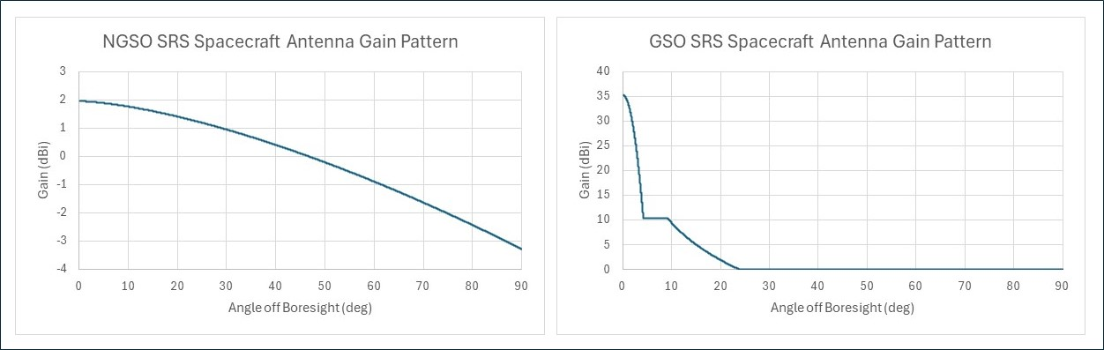

The specific SRS system characteristics to be used in sharing and compatibility studies will be refined as necessary as studies are further developed.
Document 5D/403 from WP 7B, provides a pointer to Recommendation ITU-R SA.609-2 containing applicable protection criteria for near-Earth networks in the SRS in the 7 190-7 235 MHz frequency band. For SRS (near-Earth) satellites, the criteria specifies that an interference density of −177 dB(W/kHz) at the input terminal of the receiver should be exceeded for no more than 0.1% of the time for both manned and unmanned spacecrafts.

A2.1.1.1.3 Propagation models used in the study
In Document 5D/160, WPs 3K and 3M provided guidance on modelling propagation losses applicable to various sharing scenarios including those involving IMT base stations. This guidance calls for use of Recommendation ITU-R P.619 for losses along the Earth-to-space path as well as Recommendation ITU-R P.2108 for statistical clutter loss, as appropriate.

A2.1.1.1.4 Study Methodology

A2.1.1.1.4.1 IMT deployment assumptions
The deployment of IMT in this band is assumed to focus primarily on urban and suburban areas, with limited presence in rural locations.
[Note: The IMT deployment methodology and assumptions will be included here.]

A.2.1.1.4.1.1.1 Calculation of the Number of IMT Systems Visible to the SRS Satellite Based on Publicly Available Land Cover Data
This study considers IMT deployments over the Earth’s surface, calculating the total number of stations visible from an SRS satellite. Separate calculations are performed for SRS satellites in different orbits (including LEO and GSO) as identified in Table A2-3 above.
These deployments are estimated using publicly available land cover data to identify urban and suburban areas. In particular, the global land cover dataset data set produced by the Moderate Resolution Imaging Spectroradiometer (MODIS) sensor provides global land cover types at yearly intervals with a spatial resolution of 500 metres. The currently available set is based on imagery taken in 2023, representing the most up-to-date information for this combination of area and resolution. The data provides a total of 16 different land cover classifications, including “Urban and Built-up”.
The calculation for the total number of IMT base stations deployed within the visible earth surface (based on the Urban and Suburban Macro model) is given by the following equation:
$$\begin{aligned}N_{\text{BS}}=N_{\text{urban}}+ N_{\text{suburban}}=A∙R_{\text{b}}∙R_{\text{a, urban}}∙d_{\text{urban}}+{A∙R_{\text{b}}∙R}_{\text{a, suburban}}∙d_{\text{suburban}} \left(A2-1\right)\end{aligned}$$
where:
$A$: Visible land area (excluding Greenland and Antarctica);
$d_{\text{urban}}$: BS deployment density in urban areas;
$d_{\text{suburban}}$: BS deployment density in suburban areas;
$R_{\text{a, urban}}$: Ratio of urban coverage areas to areas of cities/built areas/districts;
$R_{\text{a, suburban}}$: Ratio of suburban coverage areas to areas of cities/built areas/districts;
$R_{\text{b}}$: Ratio of built areas to total area of region in study.
The results of this calculation are shown in Table A2-4.
TABLE A2-4
Calculation of the total number of BSs
 | Non-GSO LEO | GSO
A (km²) | [10 174 839] | 44 199 000
d_{urban} (BS/km²) | 10
d_{suburban} (BS/km²): | 2.4
R_{a, urban}: | 10%
R_{a, suburban}: | 5%
R_{b} | 1%
Total Number of BS | [113 958] | 495 029
Total Urban BS | [101 748] | 441 990
Total Suburban BS | [12 210] | 53 039

It should be noted that the number of base stations calculated within Equation A2-1 does not represent the number of simultaneously transmitting base stations during any given simulation step; a subset of the total number of base stations is selected after appropriate application of the TDD activity and network loading factors.
Base station clusters shown in the figures below use the hexagonal grid structure from Figure 2 of Recommendation ITU-R M.2101. Illustrated are urban and suburban 19 site clusters and an urban 7 × 19 site cluster.
Figure A2-3
Urban cluster with cell size of 400 m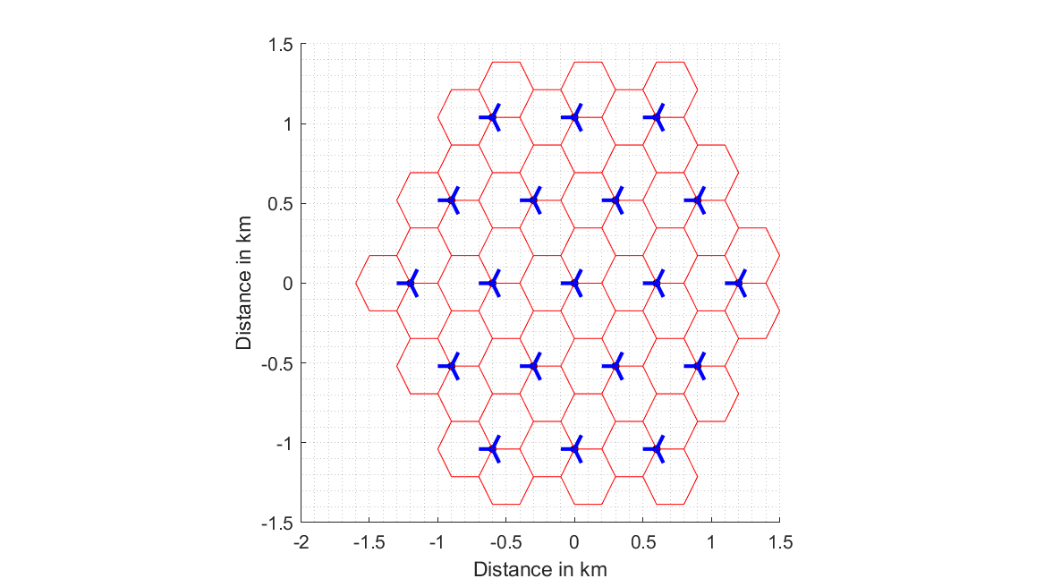
Figure A2-4
Suburban 19 site cluster with cell size of 800 m
z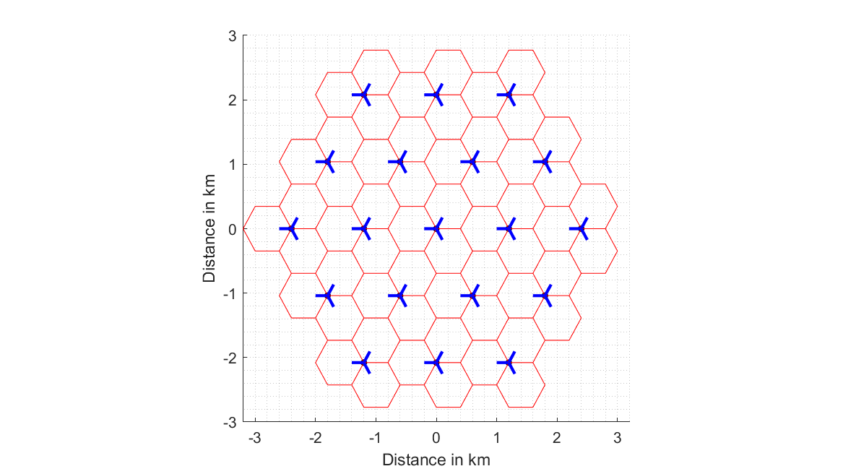

Figure A2-5
Urban 7 × 19 site wraparound cluster with cell size of 400 m
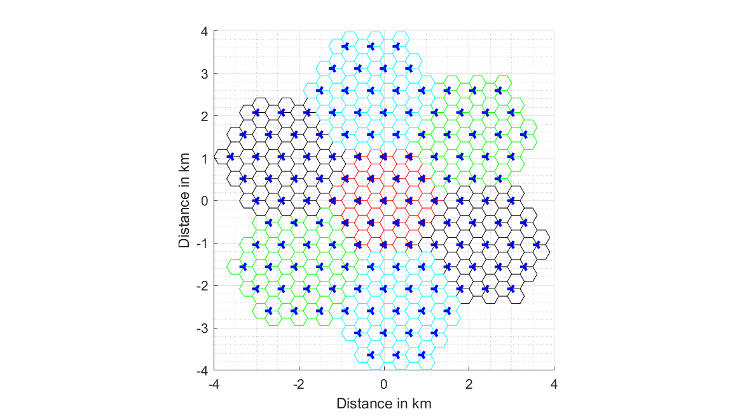

The process for placing IMT base stations within the visible Earth area is described below:
1 Without replacement, randomly select one of the pixels within the visible Earth area that is designated as an “Urban and built-up” area. The latitude and longitude of this pixel will serve as the centre point of a base station cluster.
2 Ensure that the resulting cluster centred around the selected pixel does not overlap with previous clusters, which guarantees that the maximum base station density is not exceeded.
3 Place 19 base stations at a time with 3 BS/site (using the pattern in Figure A2-2 or A2-3 above as appropriate).
4 Reiterate until all urban and suburban base stations have been placed within the visible Earth area.
For the non-GSO SRS case, the superset of base station locations, consisting of all possible [113 958] stations (as per Table A2-5) is shown in Figure A2-6. Similarly, for the GSO SRS case, Figure A2-7 shows the superset of base station locations, consisting of all possible 425 029 possible base stations (as per Table A2-5).
It is worth noting that a single point on these Figures represents three distinct base stations, as the corresponding antenna aperture azimuths are not simultaneously plotted.
Figure A2-6
Complete Base Station Placement within non-GSO LEO SRS Visible Area
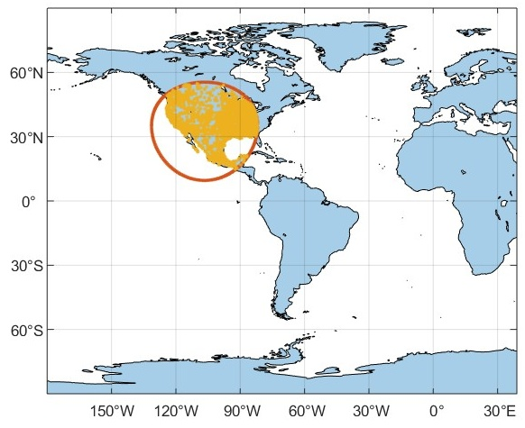

Figure A2-7
Complete Base Station Placement within GSO SRS Visible Area
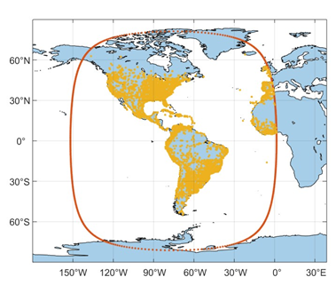

A2.1.1.1.4.2 Application of TDD Activity Factor and Network Loading Factor
For this study, simulations will be performed using a network loading factor of 20%.
Additionally, within the simulation, all IMT operations are synchronized on a per-cluster basis. Therefore, active base stations within any individual cluster are either all transmitting or all receiving, i.e., there is no combination of transmitting and receiving base stations within a single cluster for a given snapshot.
When applying the TDD activity factor of 75%, active base stations will be designated as either transmitting or receiving within each time snapshot.

A2.1.1.1.4.3 Calculation and Placement of IMT User Equipment
In accordance with the IMT characteristics for this frequency band, three UEs transmit per active BS receiving sector and three UEs receive per active BS transmitting sector. Therefore, in the NGSO SRS case, during each snapshot there are exactly [51 281] receiving and [17 094] transmitting UEs forming a total of [68 375]. Similarly, for the GSO SRS case, during each snapshot there are exactly 222 763 receiving and 74 254 transmitting UEs for a total of 297 017.
The following assumptions are used:
– The maximum BS-UE radial distance considered is the cell radius, which is 400 metres for urban and 800 metres for suburban clusters.
– As an initial step, the BS-UE radial distance is uniformly distributed in the cell grid area. In accordance with the methodology given in Recommendation ITU-R M.2101, the BS-UE path coupling loss is calculated and compared against a threshold (determined by the minimum allowable link SINR) to ensure that the placement is valid. If the path coupling loss is determined to be too high, the BS-UE radial distance is randomly chosen again, and the process is repeated.
[Note: Further explanation of the approach to be used to model UE distribution will be provided in future drafts ]

A2.1.1.2 Simulation Methodology
An assessment of the aggregate RFI expected from the proposed IMT identification into SRS receiving space stations operating in the 7 190-7 235 MHz band is achieved with a Monte Carlo style analyses (utilizing dynamic simulation) for each of the SRS (near-Earth) mission types considered.
The analysis includes propagation of the SRS space station in its orbit while its receive antenna tracks the assigned transmitting SRS Earth station. As per 21.15, the link from the Earth station is active during periods of time when the elevation angle to the satellite is greater than or equal to 5 degrees.
In this Monte Carlo style analysis, many simulated deployment trials will be conducted to assess the probability of potential interference from the aggregate transmissions of each active IMT station into the receiving station under study
Additionally, the simulation time step size used will be an irrational number to ensure that the data points do not exhibit periodic behavior. At each simulation step, a snapshot of the interference scenario will be generated where directional vectors from each IMT source to the SRS space station will be computed along with the relative gains of the transmit and receive antennas using their respective antenna patterns.
The interfering signal power level, $I_(i,n)$ (W), received by a non-GSO SRS space station at the $n^th$ simulation step from the $i^th$ active IMT station is calculated from:
$I_{i,n}=\frac{{ P}_{TX i,n}G_{TX i,n}{ G}_{RX i,n}}{L_{a i,n}{ L}_{FSPL i,n} L_{pol i,n}L_{\text{clutter} i, n}L_{\text{body} i, n}}$ (A2-2)
where:
${ P}_{TX i,n}$: active IMT station transmitter power in the band of study;
$G_{TX i,n}$: active IMT station antenna gain towards SRS space station;
$G_{RX i,n}$: SRS space station receive antenna gain towards terrestrial source;
Lagas i,n : attenuation due to atmospheric gasses (Rec. ITU-R P.619 Attachment C);
$L_{FSPL i,n}$: free space path loss; (Rec. ITU-R P.619);
$L_{pol i,n}$: losses due to polarization mismatch; (Rec. ITU-R P.619);
$L_{clutter i,n}$: losses due to clutter
$L_{body i,n}$: losses due to human body attenuation; this factor is 1 (0 dB) for base stations and 2.51 (4 dB) for user equipment.
The aggregate interference at the $n^{th}$ simulation step,${ AggI}_{n}$ (W), is calculated by the summation of the received interference from all active IMT stations within line of sight of the receiving SRS space station.
${AggI}_{n}=\sum_{i}{I_{i,n}}=\sum_{i}{\frac{{P_{TX i,n} G}_{TX i,n}{ G}_{RX i,n}}{L_{a i,n}{ L}_{FSPL i,n} L_{pol i,n}L_{\text{clutter} i, n}L_{\text{body} i, n}}}$ (A2-3)
Thus, the aggregate interference can be represented in the logarithmic domain as:
${AggI}_{n|dB}=10 {\log_{10}\left(\sum_{i}{\frac{{ P}_{TX i,n}{ G}_{TX i,n}{ G}_{RX i,n}}{L_{a i,n}{ L}_{FSPL i,n} L_{pol i,n}L_{\text{clutter} i, n}L_{\text{body} i, n}}}\right) }_{|dB}$ (A2-4)
Using the resulting data containing received interfering power levels, a CCDF curve will be generated to assess interference observed at the SRS space station and determine compliance with the applicable protection criteria.

A2.1.1.3 Study results
[Editor’s note: This section provides the sharing and compatibility study results of this study.]

A2.1.1.4 Summary and analysis of the results of Study A
[Editor’s note: This section provides the summary and analysis of the results of this study for both the protection of incumbent services (in band and adjacent bands) and without imposing additional regulatory or technical constraints on those incumbent services.]

Table (IMT ANd SRS in 7 145 – 7 235 MHz frequency range)
Overview of the sharing and compatibility studies

 | Parameters from expert WPs | Study A  LEO UL | Study A  GSO UL
Methodology
Single-entry or Multiple-entry (aggregated) |  | Multiple Entry (Aggregated) | Multiple Entry (Aggregated)
Statistical, or Statistical and Deterministic |  | Statistical | Statistical
Technical and operational characteristics of IMT systems
Deployment scenario |  | Macro Urban and Suburban | Macro Urban and Suburban
IMT stations
Method to deploy multiple IMT stations for the aggregated interference analysis over a relatively large area (as applicable to scenarios for the studies) |  | M.2101 and [Working doc on characteristics] | M.2101 and [Working doc on characteristics]
Number of IMT base stations (BS) |  | [113 958] | 495 029
Network loading factor for BS and UE (%) |  | 20% | 20%
TDD activity factor (%) |  | 75% | 75%
UE power control |  | N/A | N/A
UE body loss (dB) |  | N/A | N/A
IMT antenna pattern |  | Extended AAS model (Section 3.3 Table 17 of characteristics doc) | Extended AAS model (Section 3.3 Table 17 of characteristics doc)
BS antenna mechanical downtilt |  | 6° | 6°
UE antenna pointing (if beamforming) |  | N/A | N/A
UE distribution |  | N/A | N/A
User equipment density for terminals that are transmitting simultaneously |  | N/A | N/A
Technical and operational characteristics of SRS satellite
Altitude (km) |  | 550 | 35 786
Orbital Location |  | N/A | -75.2°
Antenna Size
Rx antenna gain |  | 2.0 dBi | 35.3 dBi
Rx antenna radiation pattern |  | Omni | Rec. ITU-R .672
Long Term Protection Criteria (I/N) |  | -6 dB | -6 dB
Propagation model/losses
Basic transmission loss |  | P.619 | P.619
Clutter loss |  | P.2108 Section 3.3 | P.2108 Section 3.3
Building entry loss |  | N/A | N/A
Cross-polarization loss (dB) |  | 3 dB | 3 dB
Results of studieA
Does the study result consider both BS and UE transmissions? |  | No | No
Results summary
______________

A2.3 Technical analysis - SRS (deep space)

A2.3.3 Study C [USA (5D/502, 5D/762)]
The purpose of this study is to assess the potential for interference from IMT systems in the 7 125-8 400 MHz band to space stations operating in the SRS (deep space) in the 7 145-7 190 MHz band.
This study is concerned with potential interference from IMT systems into SRS (deep space) spacecraft receivers during critical mission phases (launch, Earth fly-bys, and return-to-Earth) in which the SRS spacecraft distance to Earth is small relative to other mission phases. Per RR No. 4.24, space research systems intended to operate in deep space may also use the space research service (deep space) allocations, with the same status as those allocations, when the spacecraft is near the Earth, such as during launch, early orbit, flying by the Earth and returning to the Earth.

A2.3.3.1 Technical characteristics

A2.3.3.1.1 Technical and operational characteristics of IMT systems operating in the frequency band 7 125-8 400 MHz
The technical and operational characteristics of the terrestrial component of IMT are based on Annex 4.15 of Document 5D/563 are provided in section A2.1.1.1.

A2.3.3.1.2 Technical/ operational characteristics and protection criteria of space research service (deep space) operating in the frequency band 7 145-7 190 MHz
The technical and operational characteristics of SRS deep space satellites are based on Documents 5D/92 and 5D/403. These characteristics are outlined in Table A2-12.
TABLE A2-12
SRS (deep space) space station characteristics
Parameter | LEOP/swing-by | Deep space
Frequency band | 7 145-7 190 MHz
Antenna diameter | N/A | 3.7 m
Antenna gain | 0 dBi | 48 dBi
Noise temperature | 330 K | 170 K
Antenna pattern | Non-directional | Appendix 8 – Annex 3 (Radio Regulations)
Antenna polarization | Circular

The protection criteria for SRS (deep space) is provided in Recommendation ITU-R SA.1157. For SRS space station receivers, the protection criterion specifies a maximum interference density of −190 dB(W/20 Hz) at the input terminal of the receiver. In Document 5D/403, WP 7B notes that the Earth vicinity operations of SRS (deep space) systems in the 7 145-7 190 MHz band can occur at perigee altitudes as low as 200 km. Additionally Document 5D/403 notes that Recommendation ITU-R SA.1743 allows for guidance to identify the apportionment of allowable interference by IMT for the protection of SRS.
A listing of this information referenced in this section for SRS (deep space) characteristics in 7 145-7 190 MHz is given in Table A2-13 below.
Table A2-13
Document reference listing for characteristics of SRS (deep space) earth stations
and spacecraft in 7 145-7 190 MHz
Document number | Document section | Location | Parameter description
5D/403 | Annex 1,  Section 4.4 |  | Protection criterion
5D/403 | Annex 2, Section 4 | Table 13 | Additional representative SRS (deep space) Earth station characteristics in the frequency band 7 145-7 190 MHz
5D/403 | Annex 2,  Section 4 |  | SRS (deep space) spacecraft receiving characteristics during near-Earth operation phase
5D/92 | Annex 1, Section 1.2 |  | Listing of in-force ITU-R documentations on SRS

A2.3.3.1.3 Propagation models used in the study
According to Document 5D/160, for the possible study scenarios relating to stations in space and stations on the Earth’s surface applicable to WRC-27 agenda item 1.7, WPs 3K and 3M advise the use of Recommendation ITU-R P.619, including Recommendation ITU-R P.2108 for the use of statistical clutter loss. Building loss, when applicable, should be calculated using Recommendation ITU-R P.2109. Table A2-14 presents each model used in this study and its characteristics.
TABLE A2-14
Propagation models used for sharing and compatibility studies
Propagation model | System/Path | Characteristics
3GPP Urban Macro (UMa) | IMT System | Used for urban/suburban macro scenarios.
Rec. ITU-R P.2108 | Earth-to-space path | For every link, it is calculated the p-parameter, with a uniform distribution between [0,1], to calculate the clutter loss, following the Rec. ITU-R P.2108
Rec. ITU-R P.2109 | Earth-to-space path | For each link, the p-parameter is calculated using a uniform distribution between [0,1] to determine the building entry loss, considering the classification of “traditional” building type, as specified in Rec. ITU-R P.2109
Rec. ITU-R P.619 | Earth-to-space path | A 3 dB polarization discrimination loss was taken into account following Item 2.2 of Rec. ITU-R P.619

A2.3.3.2 Methodology
The methodology applied in this study follows the framework proposed by Recommendation ITU-R M.2101, where, at each snapshot, IMT user equipment (UE) are randomly generated and placed within a cell. The IMT base stations are uniformly deployed across the landmass, taking into account the full satellite visibility area. The coupling loss between each UE and its nearest IMT base station (BS) is calculated using the Urban Macro (UMa) propagation model. The simulation then performs beamsteering, resource scheduling, and power control, enabling the calculation of interference among the systems. Finally, system performance indicators are collected, and this process is repeated for a fixed number of snapshots.
This sharing study considers an SRS (deep space) satellite in LEOP/swing-by as a victim receiver from IMT base station (BS) and user equipment (UE) transmitters. Figure A2-13 presents a pictorial diagram of the study scenario.
FIGURE A2-13
Simulation scenario – LEOP/Swing-by
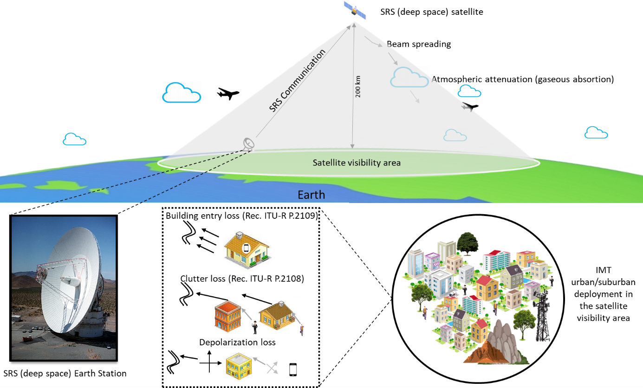
This study considers the whole SRS (deep space) satellite visibility area at 200 km altitude, calculated from Attachment A and B of Recommendation ITU-R P.619. The maximum line-of-sight (LOS) was calculated by assessing the apparent elevation angle of the Earth-to-space path. Based on a minimum elevation angle of 0°, the satellite's visible area covers approximately 8 408 988 km². Figure A2-14 shows an example of the satellite visibility area over North America (highlighted in the red circle).
FIGURE A2-14
Representation of the SRS (deep space) satellite visibility area over North America
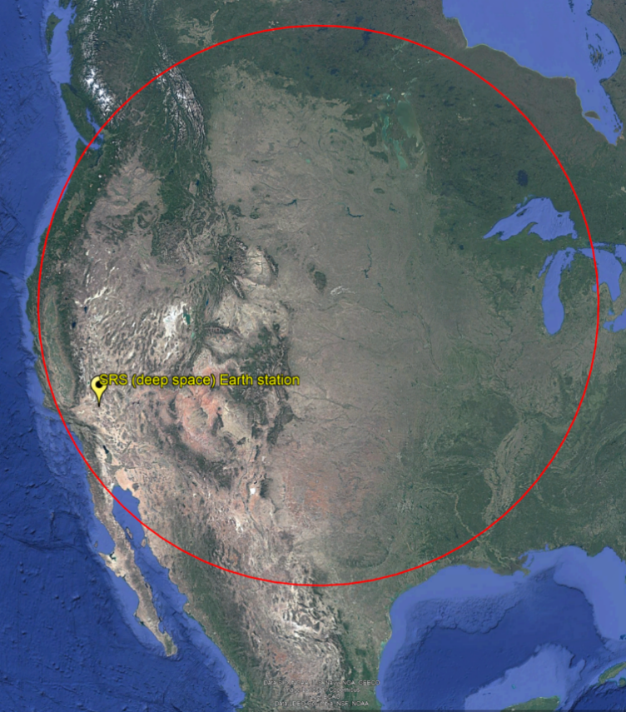
The sharing study scenario includes both urban and suburban IMT deployments, considering specific deployment-related characteristics. The number of base stations is determined based on the Ra and Rb density factors for the coverage area, as described below. User equipment are uniformly distributed within the BS coverage area. For the values of Ra and Rb, Option 1 from Table 22 of Doc. 5D/563 Annex 4.15 was selected.
For the calculation of the number of base stations in the entire satellite visibility area (S_{area}), we followed the urban (Ds_{(urban)}) and suburban (Ds_{(suburban)}) densities of 10 BS/km² and 2.4 BS/km², respectively. The Ra and Rb factors were applied as follows.
Ds = density value for coverage area, i.e. density of simultaneously transmitting UEs or number of BS per km²
Ra (%) = ratio of coverage areas to areas of cities/built areas/districts
Rb (%) = ratio of built areas to total area of region in study.
$${Dl}_{urban}={Ds}_{urban}* Ra*Rb$$ | $${Dl}_{suburban}={Ds}_{suburban}*Ra*Rb$$
$${Dl}_{urban}=10 BS/km² 10\%*1\%$$ | $${Dl}_{suburban}=2.4 BS/km²*5\%*1\%$$
$${Dl}_{urban}=0.01 BS/{km}^{2}$$ | $${Dl}_{suburban}=0.0012 BS/{km}^{2}$$
For the total satellite visibility area (S_{area}) in this study, the number of base stations (N_{BS}) to be deployed for urban and suburban is calculated as follows:
$$N_{BS (Urban)}=S_{area}*{Dl}_{Urban}=8,408,988 {km}^{2}*0.01BS/{km}^{2}$$
$$N_{BS (Urban)}=84,099$$
$$N_{BS (Suburban)}=S_{area}*{Dl}_{Suburban}=8,408,988 {km}^{2}*0.0012BS/{km}^{2}$$
$$N_{BS (Suburban)}=10,090$$
$$N_{Base Stations (total)}=N_{BS (Urban)}+N_{BS (Suburban)}=84,099+10,090$$
$$N_{Base Stations (total)}=94,189$$
In the simulation, at each snapshot, the BS and UE are randomly generated and uniformly distributed within the simulation scenario, in accordance with Recommendation ITU-R M.2101. The coupling loss between the UE and BS is calculated, taking into account the beamsteering limit angles of the serving BS. Additionally, the simulation performs resource scheduling and power control, enabling the calculation of interference between the IMT system and the SRS (deep space) satellite. The simulations were conducted with 10 000 snapshots.
Figure A2-15 shows the impact of aggregated IMT UE interference from urban deployments on the SRS (deep space) satellite. Urban deployments are identified as the dominant source of interference due to the high density of base stations, which can potentially affect the SRS (deep space) satellite receiver. The results show that the UE interference is 28 dB lower compared to the IMT downlink (BS to UE) contribution. This is because the height of the UE is well below the rooftop, resulting in clutter loss being applied in 100% of the cases. Additionally, 70% of UEs are indoors, and the building entry loss, as specified in Recommendation ITU-R P.2109, provides additional attenuation. Furthermore, body loss is considered for UEs, and the conducted output power and antenna gain of the UEs are lower compared to those of the base stations. Therefore, this study will focus on IMT downlink simulations to avoid the complexity and duration of simulations that would not meaningfully contribute to the total interference results.
FIGURE A2-15
IMT uplink (Urban) – SRS (deep space) (Earth-to-space) co-channel simulation results
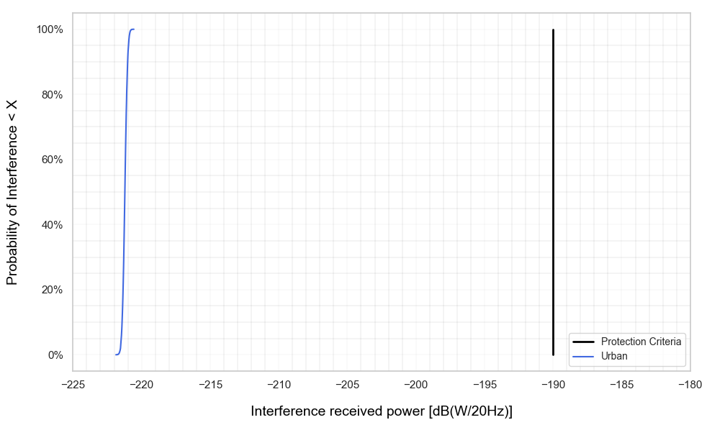
[Editor’s note: This figure to be updated using the revised clutter loss model for the Earth-to space path per WP 3K/3M guidance in Doc 5D/629]
The interference received power due to the aggregated IMT downlink interference contribution is calculated as follows, where n is the number of activated base stations at each snapshot, considering a loading factor of 20% due to the large area, including the TDD factor:
$$I= \sum_{i=1}^{n}{\left({EIRP}_{i_{\left(θ, φ\right)}}-{Path loss}_{i}+ G_{{rx}_{SRS \left(θ, φ\right)}}\right)}$$
where:
${EIRP}_{i_{\left(θ, φ\right)}}$= Equivalent isotropic radiated power of each activated base station considering the respective azimuth and elevation towards the interfered system
${Path loss}_{i}$= Propagation loss from the i^{th} base station based on Table A2-8
$G_{{rx}_{SRS \left(θ, φ\right)}}$= SRS (deep space) satellite antenna gain, considering the gain in azimuth and elevation towards the IMT topology
For the transmission loss for multiple entry interference, this study used the Recommendation ITU-R P.619 (Section 3.2) to compute the total loss in the path (L_{b}) considering the following:
$$L_{b}=L_{bfs}+A_{xp}+A_{g}+A_{bs}+L_{c}+L_{be}$$
where:
$L_{bfs}$= Free space basic transmission loss
$A_{xp}$= Attenuation due to polarization mismatch (3 dB)
$A_{g}$= Attenuation due to atmospheric gases
$A_{bs}$= Attenuation due to beam-spreading
$L_{c}$= Clutter loss, based on Recommendation ITU-R P.2108, is applied randomly at each snapshot using a uniform distribution to represent the percentage of deployed base stations below the rooftop level: 65% for urban and 15% for suburban base stations. [Note that the “below rooftop” parameter in the IMT characteristics document (Annex 4.15 of Document 5D/563) is provided for IMT BS deployments to describe the environment surrounding the BS, and should not be interpreted as indicating whether or not additional clutter loss should be applied. Further guidance from SG 3 relevant to the clutter loss model will be used accordingly.]
$L_{be}$= Building entry loss, based on Recommendation ITU-R P.2109, is applied randomly at each snapshot using a uniform distribution to 70% of UEs randomly deployed indoors, with 0 dB for BS and UEs that are outdoors.
For atmospheric gases attenuation, Figure A2-16 presents the loss as a function of elevation angles, where the loss is considered significant for elevation angles less than 5° due to the slant path crossing the atmosphere. In the simulation, a water vapor density of 7.5 g/m³, representing the global mean reference value, was used. The simulation was conducted in accordance with Recommendation ITU-R P.619 (Section 2.3).
FIGURE A2-16
Atmospheric gases attenuation
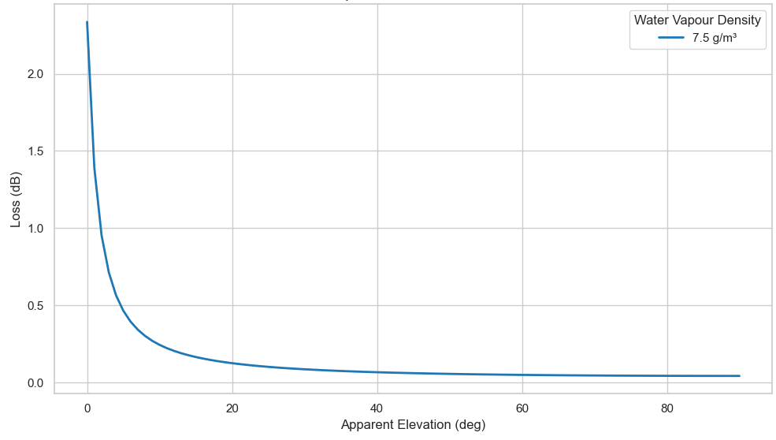
For beam spreading attenuation, the effect is small above approximately 5 degrees of elevation but can be significant at lower elevations. Figure A2-17 presents the attenuation as a function of the altitude of the lowest point above sea level on Earth and the elevation angle. The simulation was conducted in accordance with Recommendation ITU-R P.619 (Section 2.4.2).
FIGURE A2-17
Beam spreading loss
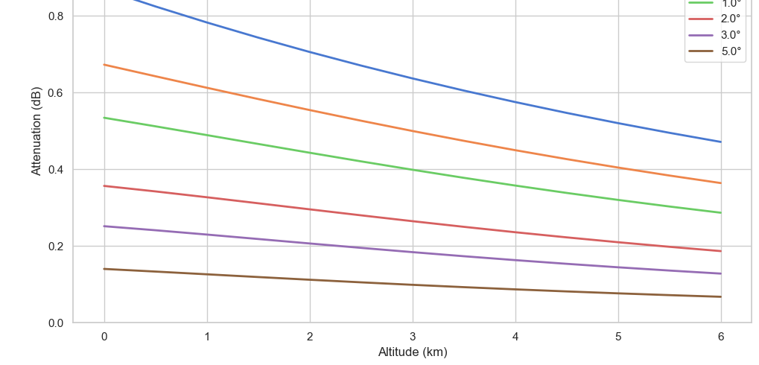
The results for the total aggregated interference received by the SRS (deep space) satellite are presented in Figure A2-18. These results indicate that the total aggregated interference received from urban and suburban IMT base stations within the satellite’s visibility area is ‒191.7 dB(W/20 Hz), which is 1.7 dB below the SRS (deep space) protection criteria.
FIGURE A2-18
IMT-downlink – SRS (deep space) (Earth-to-space) co-channel simulation results
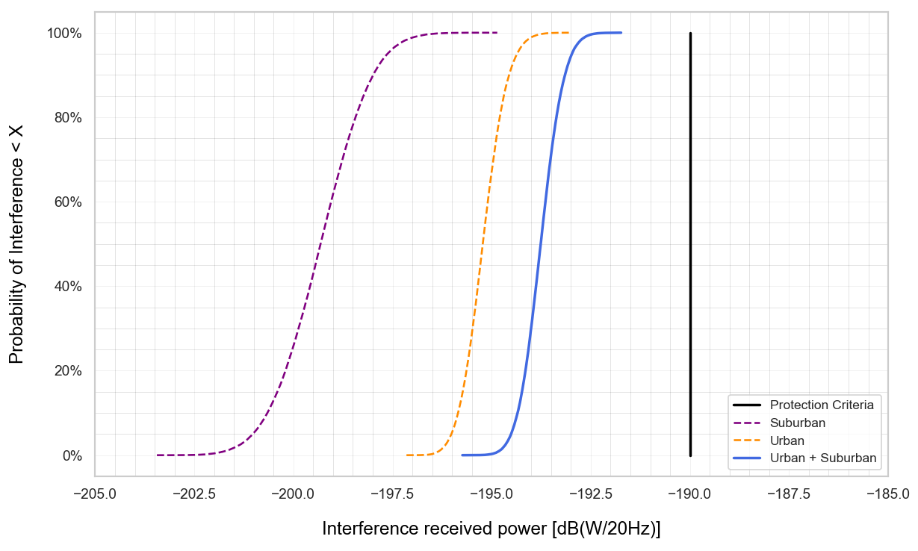
[Editor’s note: This figure to be updated using the revised clutter loss model for the Earth-to space path per WP 3K/3M guidance in Doc 5D/629]

A2.3.3.3 Study C results
[Editor’s note: This section provides the sharing and compatibility study results of this study.]
[TBD]

A2.3.3.4 Summary and analysis of the results of Study C
[Editor’s note: This section provides the summary and analysis of the results of this study for both the protection of incumbent services (in band and adjacent bands) and without imposing additional regulatory or technical constraints on those incumbent services.]

Table A2-15 (IMT ANd SRS (deep space) in 7 145 – 7 190 MHz frequency range)
Overview of the sharing and compatibility studies
[Editor’s note: Descriptive text and notes of the table. Rows to be added or deleted based on the decision of WP 5D. The table below is an example for comparison table created at the end of every Appendix.]
 | Parameters from expert WPs | Study C | Study …
Methodology
Single-entry or multiple-entry (aggregated) |  | Multiple-entry (aggregated)
Statistical, or statistical and deterministic |  | Statistical
Technical and operational characteristics of IMT systems
Deployment scenario |  | Macro Urban and Suburban
IMT stations
Method to deploy multiple IMT stations for the aggregated interference analysis over a relatively large area (as applicable to scenarios for the studies) |  | Rec. ITU-R M.2101
Number of IMT base stations (BS) |  | 98 189
Network loading factor for BS and UE (%) |  | 20%
TDD activity factor (%) |  | 75% for BS
UE power control |  | Rec. ITU-R M.2101
UE body loss (dB) |  | 4 dB
IMT antenna pattern |  | Extended AAS
BS antenna mechanical downtilt |  | 6°
UE antenna pointing (if beamforming) |  | N/A
UE distribution |  | Uniform
User equipment density for terminals that are transmitting simultaneously |  | 3 per cell
Technical and operational characteristics (of incumbent SRS (deep space) service)
Orbit Altitude (km) |  | 200
Space station receive antenna gain (dBi) |  | 0
Space station receive antenna pattern |  | ND
Space station receiver protection criterion |  | -190 dB(W/20 Hz)
Propagation model/losses
Basic transmission loss |  | Rec. ITU-R P.619
Clutter loss |  | Rec. ITU-R P.2108
Building entry loss |  | Rec. ITU-R P.2109
Cross-polarization loss (dB) |  | 3 dB
Results of studies
Does the study result consider both BS and UEs? |  | Yes
Results summary

