U.S. Radiocommunication Sector
Fact Sheet
Working Party: USWP 5D | Document No: USWP5D-50-12
Ref: Annex 4.2 of Document 5D/792-E | Date: 18 July 2025
Document Title:
Proposed revision of Preliminary Draft New Report ITU-R M.[SRS-IMT]
Author(s)/Contributors(s): | E-mail
Elena DeJaco (NASA) | Elena.k.dejaco@nasa.gov
Dennis Lee (NASA JPL)  Luciano Alexandre (NASA JPL) | dennis.k.lee@jpl.nasa.gov  luciano.c.alexandre@jpl.nasa.gov
Purpose/Objective:
To update Annex 4.2 to the WP5D Chairman’s Report (Doc. 5D/792) on possible coordination between space research service (deep space) stations operating in the band 7 145-7 190 MHz and IMT stations operating in the band 6 425-7 125 MHz.

Abstract:
Resolution 220 (WRC-23) invites the ITU Radiocommunication Sector 7 to update existing ITU-R Recommendations/Reports or develop new ITU-R Recommendations/Reports, as appropriate, to provide information and assistance to the administrations concerned on possible coordination of SRS earth stations operating in 7 145-7 190 MHz with IMT stations operating in the 6 425-7 125 MHz. Doc. 5D/792 (Annex 4.2) contains a Preliminary Draft New Report ITU-R M.[SRS-IMT] which provides the generic methodology and specific examples for calculating the coordination area between SRS earth station in 7 145 – 7 190 MHz and IMT stations in 6 425 – 7 125 MHz. This document proposes some edits to remove some repetitive material in Annex D and to align it with the generic methodology described in the main body of the PDN Report.

Fact Sheet Preparer: Dennis Lee (NASA/JPL)

Radiocommunication Study Groups | 
Source: Doc. 5D/792-E (Annex 4.2)  Subject: WRC-23 Res. 220 | Document 5D/XX
Source: Doc. 5D/792-E (Annex 4.2)  Subject: WRC-23 Res. 220 | October 2025
Source: Doc. 5D/792-E (Annex 4.2)  Subject: WRC-23 Res. 220 | English only
United States of America
Under Resolution 220 (WRC-23) Working Party 5D has developed a Preliminary Draft New Report ITU-R M.[SRS-IMT] to provide information and assistance to the concerned administrations on possible coordination between the SRS earth stations operating in the 7 145-7 190 MHz band and the IMT stations operating in the 6 425-7 125 MHz band.
This document proposes some revisions to the PDN Report contained in Annex 4.2 of Document 5D/792, in order to remove some repetitive material in Annex D and align it with the generic methodology described in the main body of the text.

Attachment: 1

Radiocommunication Study Groups
Source: Document 5D/TEMP/281(Rev.1) | Annex 4.2 to  Document 5D/792-E
Source: Document 5D/TEMP/281(Rev.1) | 15 July 2025
Source: Document 5D/TEMP/281(Rev.1) | English only
Annex 4.2 to Working Party 5D Chair’s Report
PRELIMINARY DRAFT NEW REPORT ITU-R M.[SRS-IMT]
Coordination between space research service (deep space) stations operating in the band 7 145-7 190 MHz and IMT stations
operating in the band 6 425-7 125 MHz
(20xx)
TABLE OF CONTENTS
Page
1 Introduction 3
2 Generic methodology 3
3 Determination of the parameters 4
3.1 Parameters of SRS earth station 4
3.2 Parameters of IMT base station 4
3.3 Propagation loss 5
3.3.1 Basic propagation loss for terrestrial paths 5
3.3.2 Clutter loss 6
3.3.3 Polarization loss 6
4 Interference calculation 6
5 Maximum interference level acceptable for an IMT base station 6
6 Summary 7
Annex A - Example of calculated coordination areas 8
Annex B - Example of calculated coordination areas 9
B.1 Parameters of the interfering SRS 9
B.2 Parameters of IMT base stations 10
B.3 Assumptions and propagation models used in the study 10
B.4 Results 12
Annex C - Example of calculated coordination area 16
C.1 Parameters of SRS earth station 16
C.2 Parameters of IMT base stations 17
C.3 Propagation model 18
C.3.1 Basic propagation loss for terrestrial paths 18
C.3.2 Clutter loss 18
C.3.3 Polarization loss 19
C.4 Interference calculation 20
C.5 Coordination area around SRS earth station 20
Annex D - Example of calculated coordination area 23
D.1 Introduction 23
D.2 SRS (deep space) earth station transmitter parameters 23
D.3 IMT base station receiver parameters 24
D.4 Terrestrial propagation model 25
D.5 Clutter loss 26
D.6 Polarization loss 26
D.7 Interference calculation 26
D.8 Coordination areas around SRS (deep space) earth stations 27
D.9 Summary 28

Related ITU-R Recommendations, Reports and Handbooks
Recommendation ITU-R M.2101 – Modelling and simulation of IMT networks and systems for use in sharing and compatibility studies
Recommendation ITU-R P.452 – Prediction procedure for the evaluation of interference between stations on the surface of the Earth at frequencies above about 100 MHz
Recommendation ITU-R P.2001 – A general purpose wide-range terrestrial propagation model in the frequency range 30 MHz to 50 GHz
Recommendation ITU-R P.2108 – Prediction of clutter loss
Recommendation ITU-R SA.509 – Space research earth station and radio astronomy reference antenna radiation pattern for use in interference calculations, including coordination procedures, for frequencies less than 30 GHz
Recommendation ITU-R SA.1014 – Radiocommunication requirements for manned and unmanned deep space research
List of acronyms and abbreviations
BS Base Station
IMT International Mobile Telecommunications systems
MCL Minimum Coupling Loss
SRS Space Research Service
UE User Equipment
WRC World Radiocommunication Conference

1 Introduction
The World Radiocommunication Conference 2023 (WRC-23), held on 20 November – 15 December 2023, identified IMT in the frequency ranges of 6 425-7 125 MHz in accordance with Resolution 220 (WRC-23).
Space research service (SRS) earth stations may operate with high power transmissions to track a non-GSO spacecraft in deep space and SRS earth stations operating in the 7 145-7 190 MHz have the potential to cause interference to IMT receivers operating in the 6 425-7 125 MHz.
Resolution 220 (WRC-23) invites the ITU Radiocommunication Sector 7 to update existing ITU-R Recommendations/Reports or develop new ITU-R Recommendations/Reports, as appropriate, to provide information and assistance to the administrations concerned on possible coordination of SRS earth stations operating in 7 145-7 190 MHz with IMT stations operating in the 6 425-7 125 MHz.
The purpose of this Report is to provide a generic methodology that may be used for calculating coordination areas. As the coordination areas will differ for the specific SRS site analysed (due to the specificity of SRS characteristics and the surrounding terrain), additional annexes to the Report provide example implementations of the generic methodology for calculations of the coordination areas for specific sites. It is noted that, where appropriate, alternative methodology may be used to calculate coordination areas on a case-by-case basis, taking into account all relevant information available.

2 Generic methodology
The generic methodology for calculating a coordination area is set out in the following steps:
Step 1: Determine the parameters for both the IMT base station and the SRS earth station and propagation loss for terrestrial paths, as shown in section 3. This is on a site-specific case by case basis where the specific details of the SRS earth station should be used.
Step 2: Calculate the interference, I, (from the parameters determined in Step 1) for each pixel on a grid (i.e., interference to be determined for each pixel in the grid). The area of the grid for the calculation should be set large enough to cover the entire coordination area. The interference I of a transmitting SRS earth station to a receiving IMT base station is calculated by evaluating the out-of-band transmit power and antenna gain of an SRS transmit earth station towards an IMT base station as shown in section 4.
Step 3: Compare the calculated interference for each pixel with the maximum interference level acceptable for an IMT base station as shown in section 5.
Step 4: Determine and draw the coordination area based on the comparison of maximum interference level acceptable for an IMT base station for each pixel.

3 Determination of the parameters

3.1 Parameters of SRS earth station
Example of SRS transmitter characteristics can be found in Recommendation ITU-R SA.1014, which can be seen in Table 1. The studies for specific SRS earth stations will most likely use their corresponding antenna diameter and its height above ground.

TABLE 1
SRS (deep space) earth station transmitter characteristics
Parameter | Value
Transmit frequency | 7 145-7 190 MHz
Transmitter power (dBW) | 43 | 49
Attenuation for unwanted emissions (dBc) | 60  (in 4 kHz reference bandwidth, see RR Appendix 3)
Unwanted power spectral density at 7 125 MHz (dB(W/Hz)) | −53 | –47
Antenna diameter | 70 m
Peak transmit antenna gain | 72 dBi
Antenna gain pattern | Recommendation ITU-R SA.509
Antenna height (above ground level) | 39 m
Minimum elevation angle of transmit earth station | 10 degrees

3.2 Parameters of IMT base station
The technical characteristics of IMT systems for operation in the 6 425-7 125 MHz band are in Annex 4.4 to Document 5D/716. The base station (BS) deployment parameters are captured in the table below.

TABLE 2
Parameters of IMT base stations
Parameter | Unit | Macro suburban | Macro urban
Antenna array configuration N_{H}×N_{V} | N/A | 8×16 | 8×16
Maximum element gain | dBi | 6.4 | 5.5
Maximum composite antenna gain | dBi | 27.5 | 26.6
H/V radiating element spacing | N/A | 0.5 of wavelength or H,  0.7 of wavelength for V | 0.5 of wavelength for H,  0.5 of wavelength for V
Antenna height (above ground level) | m | 20 | 18
H/V 3 dB beamwidth | degrees | 90º for H  65º for V | 90º for H  90º for V
H/V front to back ration | dB | 30 for both | 30 for both
Mechanical down tilt | degrees | 6 | 10
Thermal noise | dBW/Hz | −204 | −204
Noise figure | dB | 6 | 6
Antenna polarization | ° | Linear ±45 | Linear ±45
Sectorization |  | 3 sectors | 3 sectors
Protection criterion | dB | I/N = –6 dB | I/N = –6 dB

The IMT base station antenna gain is described in Recommendation ITU-R M.2101, § 5. Antenna height information is required as well, including the mechanical pointing of the antenna in elevation and azimuth. Furthermore, the information on UE location is required to determine the IMT base station antenna gain.

3.3 Propagation loss
The signal propagating from the SRS earth station to the IMT base station is subject to the following propagation losses/attenuations:
– Free space loss
– Diffraction loss due to the surrounding terrain
– Clutter loss
– Polarization loss.

3.3.1 Basic propagation loss for terrestrial paths
For each pixel on a grid, the propagation loss should be determined using an appropriate propagation model such as the one contained in Recommendation ITU-R P.452 or Recommendation ITU-R P.2001. Recommendations ITU-R P.452 and ITU-R P.2001 are basic models for terrestrial paths, including free space loss and diffraction loss.
It is well known that the topography around a SRS site has a significant impact on the general interference situation. Diffraction by terrain is one of the most effective mitigation measures. So, the terrain should be incorporated in any coordination efforts, as it usually makes the required coordination area much smaller. Recommendations ITU-R P.452 and ITU-R P.2001 provide information and procedures to account for multiple aspects of terrain loss, including knife-edge diffraction effects and spherical-Earth impacts. In addition, the terrain profiles can be sampled with an azimuth step of 1 degree and a distance of 25 m around the SRS earth station of interest.
Some SRS gateway earth stations may have natural or artificial site shielding, where the SRS earth station is located behind a building. This needs to be considered on a case-by-case basis and the appropriate loss compensation figure needs to be determined.

3.3.2 Clutter loss
For the prediction of clutter loss, § 3.2 of Recommendation ITU-R P.2108 should be employed if the IMT is deployed in suburban or urban areas. This model depends only on frequency, distance, and the location percentage, p_{L}. The random variable p_{L} corresponds to the percentage of urban or suburban cases in which the clutter loss will be below the value calculated. It can be noted that Recommendation ITU-R P.452-18 includes a methodology to account for clutter, and care should be taken in this case to avoid double counting the clutter loss in the interference calculation.

3.3.3 Polarization loss
The polarization loss will be specific to the loss caused by the polarization mismatch. Because the base station has linear polarization and the SRS earth station has circular polarization, polarization loss should be considered.

4 Interference calculation
To determine if an existing or planned SRS earth station could interfere with an IMT base station, a methodology can be used to calculate if the interference criteria of the IMT base station is exceeded. A coordination area should be calculated around the SRS earth, and if the station IMT base station would fall within such a coordination area, potential further mitigations need to be assessed.
The interference level at the IMT base station from SRS is calculated, using the following equation:
$I_{IMT}={EIRP}_{SRS}\left(θ_{SRS}\right)-L_{basic}{-L_{clutter}-L_{PL}+G}_{IMT}\left(θ_{IMT}\right)$ (dB)
where:
$I_{IMT}$: interference level at IMT base station
${EIRP}_{SRS}\left(θ_{SRS}\right)$: SRS transmit earth station off-axis e.i.r.p. density at the radio horizon elevation angle θSRS and in the azimuth direction of the receive IMT base station in dBW/Hz in the IMT receiving band
$L_{basic}$: basic propagation loss in dB including losses due to terrain and site shielding
$L_{clutter}$: clutter loss in dB
$L_{PL}$: polarization losses in dB
$G_{IMT}\left(θ_{IMT}\right)$: IMT base station receive antenna gain at the radio horizon elevation angle θIMT in the azimuth direction of the SRS transmit earth station in dBi.

5 Maximum interference level acceptable for an IMT base station
Assuming the protection criterion for IMT BS is I/N = −6 dB, the maximum interference level can be evaluated as follows:
Maximum interference level = IMT receiver noise floor −6 dB
= Thermal noise + Noise figure −6 dB
= −204 dB(W/Hz) + 6 dB −6 dB
= −204 dB(W/Hz)
NOTE – This is based on a noise temperature of 290 K and a noise figure of 6 dB.

6 Summary
This Report provides a possible methodology that may be used for calculating coordination areas between space research service (deep space) stations operating in the band 7 145-7 190 MHz and IMT stations operating in the band 6 425-7 125 MHz. It is noted that, where appropriate, alternative methodologies may be used to calculate coordination areas on a case-by-case basis, taking into account all relevant information available. Annexes to this Report provide example implementations of the calculation methodology in the Report for some SRS stations.
[Editor’s note WP 5D, June/July 2025: proponents of the example studies are encouraged to review the contents of the studies and remove information that is repetitive with the main body while not losing any important information toward next WP 5D meeting.]

[Note: No revisions suggested for Annexes A-C]
Annex D
Example of calculated coordination area

D.1 Introduction
Earth stations of the space research service (SRS) operate in the 7 145-7 190 MHz band with high power uplink transmissions to communicate with spacecraft, which have the potential to cause interference to IMT receivers operating in the 6 425-7 125 MHz band. Figure D-1 below shows the interference scenario between transmitting SRS earth stations and receiving IMT base stations.
FIGURE D-1
Interference scenario between SRS earth stion and IMT base station
This Annex provides the coordination distances required between IMT base stations and two deep space stations, one in Canberra (Australia) and the other in Madrid (Spain).

D.2 SRS (deep space) earth station transmitter parameters
The transmitter parameters for the SRS (deep space) earth stations are given Table 1. The SRS antenna polarization is circular.

The SRS transmit e.i.r.p. towards the IMT base station will depend on the transmitter PSD, the elevation angle of the physical horizon around the SRS earth station, and the SRS antenna gain pattern. The gain pattern for the 70-m diameter SRS antenna is given below in Figure D-2 as specified in Recommendation ITU-R SA.509.
FIGURE D-2
Gain pattern for the 70-m SRS antenna at 7 125 MHz
Note that the SRS antenna gain varies from 7 dB to 39.5 dB as the off-boresight angle decreases from 10 deg to 0.5 deg.

D.3 IMT base station receiver parameters
This study assumes that the IMT base stations are located in suburban areas. The technical parameters for the IMT base stations used in this study are given in Table 2 (see column labelled “Macro suburban”).

The IMT base station vertical antenna pattern for Advanced Antenna System (AAS) is presented in the Figure D-3 below using the model from Recommendation ITU-R M.2101. In this study, it is assumed that the IMT base station antenna has a vertical beam electronically steered towards a UE at the edge of the cell in the azimuthal direction of the SRS earth station.
FIGURE D-3
IMT AAS vertical antenna pattern at 7 125 MHz
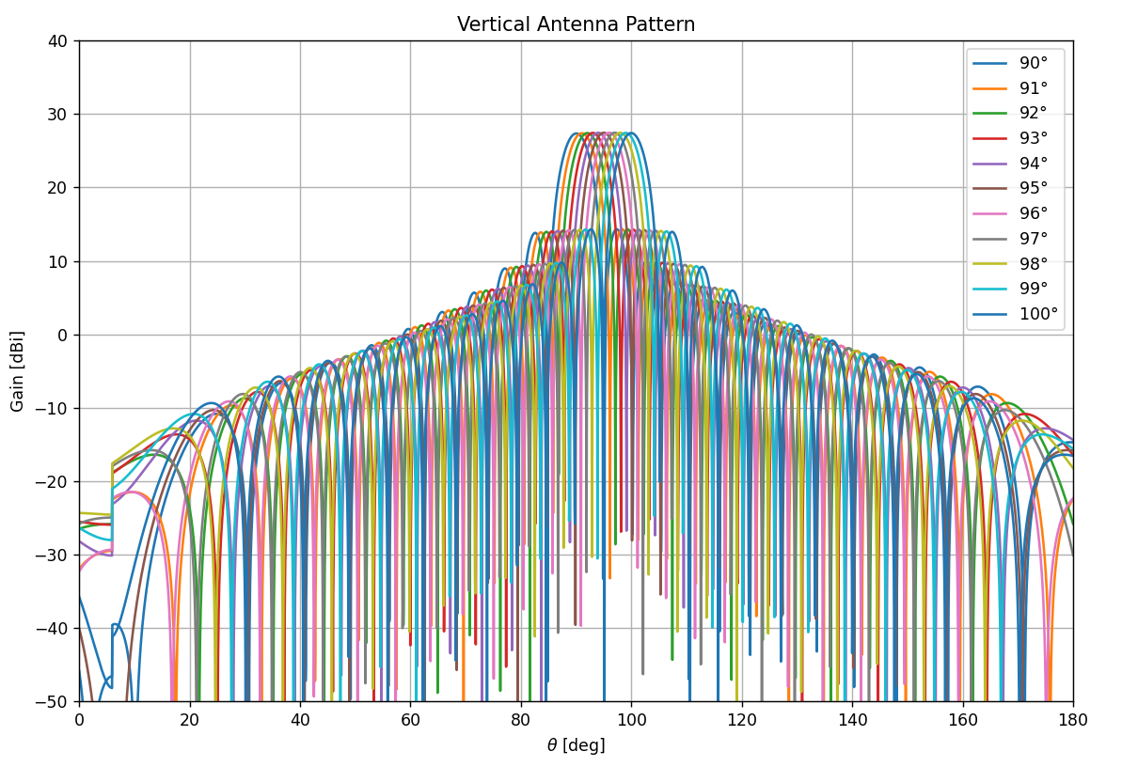

D.4 Terrestrial propagation model
The propagation losses are determined using the propagation model given in Recommendation ITU-R P.452 as recommended by the WPs 3M/3K. This model includes losses due to several propagation mechanisms such as free-space, atmosphere, tropospheric scatter, diffraction, ducting, site shielding, and clutter.
This loss model requires an input probability parameter, p, and calculates a predicted propagation loss value, L, such that the Prob{ loss <= L } = p. Thus, the calculated interference power received by the IMT receiver will exceed the protection criteria with probability p. A value of p = 20% was considered in this study, similar to the percentage used for the long-term protection criterion for some other terrestrial services (e.g., Recommendation ITU-R F.758). Other values, such as p = 50%, can also be used.
The terrain height profiles around the SRS earth stations are generated using the SRTM database.

D.5 Clutter loss
The clutter losses are included in the terrestrial propagation model in Recommendation ITU-R P.452-18, with representative clutter heights for the suburban category provided in Table 3 (copied below) of the Recommendation ITU-R P.452-18. These heights are added to the terrain profile within the IMT cell radius area.
TABLE D-3
Default representative clutter height values (from Recommendation ITU-R P.452-18)
Clutter category | Representative clutter height (m)
Clutter category | Add to profile of equation (6e)  for i = 1 to n − 1
Water/sea | 0
Open/rural | 0
Suburban | 10
Urban/trees/forest | 15
Dense urban | 20

In this example calculation, the suburban category was chosen for the Madrid deep space earth station because the Madrid deep space earth station is actually located about 60 km distance from the city of Madrid.

D.6 Polarization loss
A linearly polarized antenna will receive half of the power of a circularly polarized signal, i.e., the polarization loss factor will be 3 dB. Thus, the study assumes a polarization loss factor of 3 dB.

D.7 Interference calculation
The interference-to-noise (I/N) ratio of the IMT receiver is calculated as given below:
${\frac{I}{N}(dB)=P}_{t}+G_{t}\left(θ\right)+G_{r}\left(θ\right)-L\left(d,p\right)-N_{rcv}$
which needs to be less than the IMT receiver protection level of −6 dB. G_{t}(θ) is the SRS earth station antenna gain in dB towards the physical horizon, with θ representing the off-boresight angle, G_{r} (θ) is the IMT antenna gain in dB towards the physical horizon, with θ also representing the off-boresight angle, and N_{rcv} is the IMT receiver thermal noise.

D.8 Coordination areas around SRS (deep space) earth stations
FIGURE D-4
Canberra (Recommendation ITU-R P.452-18 (p = 20%))
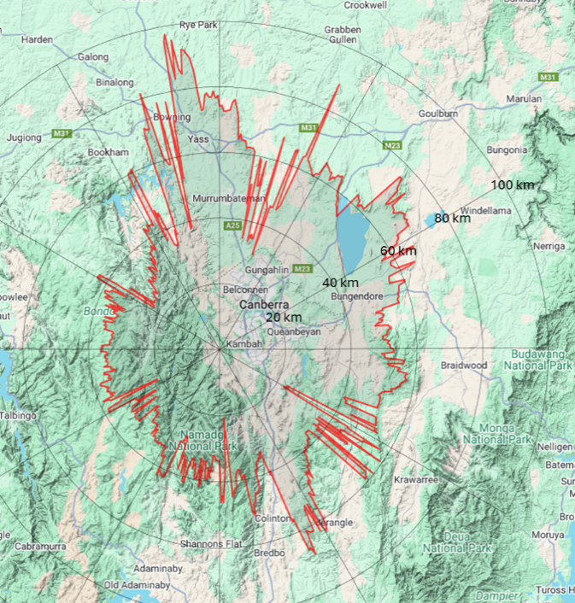
FIGURE D-5
Madrid (Recommendation ITU-R P.452-18 (p = 20%))
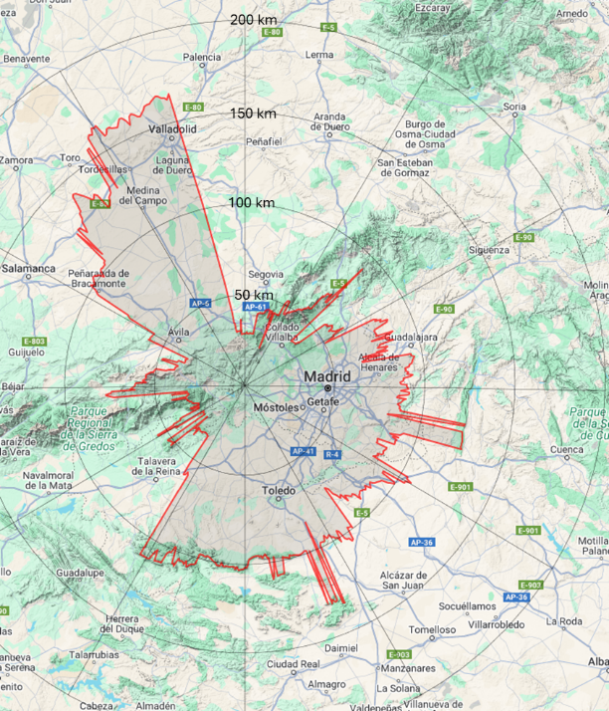
[Editor’s note: Figures D-4 and D-5 to be updated, along with results in Table D-4]
Table D-4 presents the minimum and maximum coordination distances, which are azimuth-dependent, between the IMT Base station and SRS (deep space) earth stations in Canberra and Madrid for potential coordination.
TABLE D-4
Coordination distances
SRS (deep space) earth station | Recommendation ITU-R P.452-18 (p = 20%)
Canberra | From 20.6 to 97.4 km
Madrid | From 28.3 to 166 km

[Editor’s Note, WP 5D June/July 2025: There is disagreement between some members on the results using the same terrain profile and the same time percentage 20% in Recommendation ITU-R P.452 shown in Figure D-5 and Table D-4. Further comparison of results will be performed towards the next WP 5D meeting.]

D.9 Summary
This study addresses the identification of coordination distances between IMT base stations operating in the 6 425-7 125 MHz frequency range and SRS (deep space) earth stations in the 7 145-7 190 MHz frequency range in Canberra and Madrid, for potential coordination. The required distances between the systems, which are azimuth-dependent, range from 20.6 km to 97.4 km for Canberra and from 28.3 km to 166 km for Madrid. These distance ranges correspond to time percentage (p) of 20% in Recommendation ITU-R P.452-18.

