US Radiocommunication Sector
FACT SHEET
Study Group: USWP 5D |  |  | Document No: USWP5D-50-16 R0
Reference: Document 5D/792 Annex 4.20 |  |  | Date: 18 July 2025
Document Title: Updates to the working document on sharing and compatibility studies regarding WRC-27 AI 1.7.
Authors  Tomasz Wojtaszek  NOAA  Vassilios Tsiglifis  NOAA  Botan Karim  (for NOAA)  Travis Inghram  (for NOAA) | Telephone | E-Mail  tomasz.wojtaszek@noaa.gov  vassilios.tsiglifis@noaa.gov  botan.karim@noaa.gov  travis.inghram@noaa.gov
Purpose: To provide a summary for Study A of Attachment 8 (WRC-27 AI 1.7 sharing and compatibility studies, Document 5D/792 Annex 4.20).
Abstract: In accordance with Resolution 256 (WRC-23), WP 5D is the responsible group for WRC-27 agenda item 1.7 and will conduct sharing and compatibility studies, as well as develop technical conditions pertaining to the use of the terrestrial component of IMT, while ensuring the protection of services in which the following bands are allocated on a primary basis: 4 400 – 4 800 MHz, 7 125 – 8 400 MHz, and 14.8 – 15.35 GHz. This contribution provides a summary for an existing sharing study in the WP 5D Chair’s Report.
Fact Sheet Preparer: Botan Karim, NOAA

Radiocommunication Study Groups | 
Source: Annex 4.20 to Document 5D/792-E  Subject: WRC-27 agenda item 1.7 | Document 5D/XX
 | Day Month Year
 | English only
United States of America
SHARING AND COMPATIBILITY STUDIES BETWEEN SERVICES TO WHICH THE BAND IS CURRENTLY ALLOCATED AND IMT
SYSTEMS IN THE FREQUENCY BAND 7 125-8 400 MHZ
UNDER WRC-27 AGENDA ITEM 1.7

Introduction
This contribution includes a study summary for Study A in Attachment 8 of Annex 2 of the working document on sharing and compatibility studies related to WRC-27 agenda item 1.7, as contained in the Working Party 5D Chair’s Report (Document 5D/792). Minor revisions have also been made to the text; however, the study methodologies and results remain unchanged from those introduced during the Working Party 5D meeting held from 24 June – 3 July 2025.

Attachments: 1

attachment 8
Sharing between the meteorological satellite service (space-to-Earth) in the frequency bands 7 450-7 550 MHz and 7 750-7 900 MHz and IMT
operating in the frequency band 7 125-8 400 MHz
[Editor’s note: The studies provided have not been discussed in detail and will need to be carefully examined and updated once service parameters are finalized.]
[Editor’s Note: The following remarks were made for many studies in this attachment:
1. The network loading factor considered in the study for representative load, when applied to a cluster of BS.
2. On the modelling of interfering IMT cluster for the Earth Station that is expected to track an NGSO satellite.
3. The consideration of cross-border scenario for studies, when placing IMT cluster near Earth Stations.
5. Applicability of clutter on both, single, none of the sides of Tx and Rx and considerations on polarization losses.
6. Utilizing latest parameters as per LS from 7B.
7. Application of P.452 and extended version of P.2001 should be according to the LS from 3K/3M, with explanation on their usage.
8. Assessment of the exceedance of protection criteria expressed in percentages of time should not be based in CDF expressed in percentages of cases, mixing time and geographical dependent variables
9. Several studies indicated that the revised results will be provided, incorporating the applicable remarks]

A8.1 Technical Analysis
[
NOTE: General for all studies:

“each study submitted to Working Party (WP) 5D should have an introductory paragraph or clear explanation to clearly indicate the following:
‒ Which P-series Recommendations have been used and for which purposes? Has terrain data been considered?
‒ Which technical characteristics, operational parameters have been applied for the services/systems and, which of them deviate from the parameters agreed by the contributing groups and why?
‒ Which methods have been used for interference calculations and simulation methodologies and are these baseline studies or sensitivity analysis?” (source: TEMP/347rev)
]

A8.1.1 Study A [USA (5D/295, 5D/494, 5D/765)]
The sharing scenario between IMT and MetSat (space-to-Earth) in the 7 750-7 900 MHz band is depicted in Figure A8-1.
FIGURE A8-1
Sharing study scenario between IMT and non-GSO MetSat (space-to-Earth)
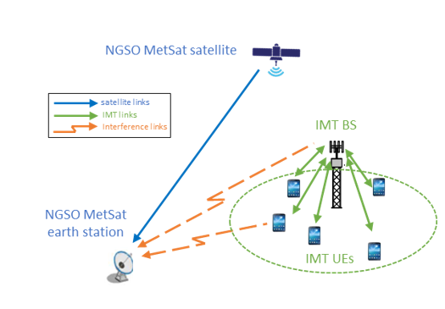

A8.1.1.1 Technical characteristics

A8.1.1.1.1 Technical and operational characteristics of IMT systems operating in the frequency band 7 125-8 400 MHz
The technical and operational characteristics of the IMT systems in the 7 125-8 400 MHz band for use in sharing studies between MetSat and IMT are contained in Annex 4.XX to Document 5D/792. The specific references to the parameters are included in Table A8-1.
TABLE A8-1
Technical and operational characteristics of IMT systems in the 7 125-8 400 MHz band
Document number | Document section | Location | Parameter description
Annex 4.XX to Document 5D/792 | 3.1.2 | Table 4 | IMT technology related parameters in 7 125-8 400 MHz
Annex 4.XX to Document 5D/792 | 3.2.2 | Table 13 | Deployment-related parameters for bands between 7.125 and 8.4 GHz
Annex 4.XX to Document 5D/792 | 3.2.2 | Table 14 | UE parameters for bands between 7.125 and 8.4 GHz
Annex 4.XX to Document 5D/792 | 3.3 | Table 17 | Extended AAS Model
Annex 4.XX to Document 5D/792 | 3.3.2 | Table 19 | Beamforming antenna characteristics for IMT in 7 125 to 8 400 MHz

A8.1.1.1.2 Technical / operational characteristics and protection criteria of MetSat (space-to-Earth) in the frequency band 7 750-7 900 MHz
The technical/operational characteristics and protection criteria for MetSat (space-to-Earth) systems, as described Tables A8-2 – A8-3, are parameters provided by WP 7B to WP 5D for non-GSO systems. Table A8-2 lists parameters for two non-GSO MetSat systems that are analysed in Study A.
TABLE A8-2
Non-GSO MetSat systems, space-to-Earth link, high-rate data
Parameter | Value and unit
Satellite(s) | JPSS-1 (Note 1) | JPSS-2 (and 3, 4)
Orbital altitude | 824 km | 824 km
Inclination angle | 98.7 degrees | 98.7 degrees
Orbit type | Sun-synchronous | Sun-synchronous
Local time of ascending node (LTAN) | 13:25:00 | 13:25:00
Center frequency | 7 812 MHz | 7 812 MHz
Necessary bandwidth | 30 MHz | 50 MHz
Satellite transmit power | 9.6 dBW | 11.7 dBW
Satellite antenna maximum gain | 9.4 dBi | 6 dBi
Satellite antenna pattern | Isoflux | Isoflux
Satellite antenna polarization | RHCP | RHCP
Ground station maximum antenna gain | 44.9 dBi | 44.9 dBi
Ground station antenna beamwidth | 0.8 degrees | 0.8 degrees
Ground station antenna pattern | Rec. ITU-R S.465-6 | Rec. ITU-R S.465-6
Ground station antenna polarization | RHCP | RHCP
Ground station minimum elevation | 5 degrees | 5 degrees
Ground station receiver noise temperature | 343 K | 343 K
Ground station height above ground (Note 2) | 25 m | 25 m
Note 1: This satellite is also represented as “Satellite C” in Report ITU-R SA.2488-0. However, the parameters in this table provide refined characteristics.
Note 2: The ground station “height above ground” represents the antenna feed height above ground. The height of 25 m is assumed in this study and represents a rooftop deployment for this ground station.

The sharing criteria for the 7 750-7 900 MHz band between IMT and MetSat earth stations using spacecraft in low-Earth orbit is defined in Recommendation ITU-R SA.1027-6 for a minimum elevation angle of 5° and is summarized in Table A8-3.
TABLE A8-3
Sharing criteria for Meteorological-satellite earth stations using spacecraft in low-Earth orbit
(see Notes 1, 2, 3 and 4)
Frequency band  (MHz) | Interfering signal power (dBW)  in the reference bandwidth  to be exceeded no more  than 20% of the time | Interfering signal power (dBW)  in the reference bandwidth  to be exceeded no more  than p% of the time
Frequency band  (MHz) | Interfering signal path | Interfering signal path
Frequency band  (MHz) | Terrestrial | Terrestrial
7 750-7 900 | –148 dBW per 10 MHz | –127 dBW per 10 MHz  p = 0.0016
NOTE 1 – The single entry interfering signal power thresholds in the above table are the permissible levels of interfering signal power that fall within the specified reference bandwidth. Accordingly, the total power in interfering signals that are narrower than the reference bandwidth should be considered in frequency sharing analyses. In cases where the interfering signal bandwidth exceeds the reference bandwidth or does not fully overlap the passband of a specific receiver under study, the available frequency dependent rejection should be applied in conjunction with the specified permissible interference levels.
NOTE 2 – In deriving the above sharing criteria from permissible total levels of interfering signal power, no allowance has been made for interference from spurious emissions.
NOTE 3 – Both the long-term (20% of the time) and short-term (< p% of the time) sharing criteria must be met in order for interference to be at or below permissible levels.
NOTE 4 – Sharing criteria specified for terrestrial signal paths are applicable to transmitting stations in terrestrial services and transmitting earth stations.

A8.1.1.1.3 Propagation models used in the study
Recommendation ITU-R P.2001, which provides a wide-range terrestrial propagation model in the frequency range 30 MHz to 50 GHz, was applied to calculate the basic transmission loss between the MetSat ground station and the IMT base stations/UEs. The propagation model considers a time percentage range of 0 – 100% that is uniformly randomized in a Monte Carlo analysis. Table A8-4 provides the assumptions used to apply the propagation model described by Recommendation ITU-R P.2001. Additionally, the propagation losses between the IMT UEs and IMT base stations are computed to apply the IMT UE power control algorithm as defined in Recommendation ITU-R M.2101.
Path profile information from the U.S. Geological Survey (USGS) is used to model varying path profiles between the IMT stations and the MetSat Earth station. The model is applied to real, but randomly selected paths of a fixed length, based on representative areas (i.e., urban locations).

TABLE A8-4
Recommendation ITU-R P.2001 parameters and assumptions
Parameter | Value | Discussion
Frequency | 7.825 GHz | -
Polarization | H-pol | -
Transmitter/Receiver Heights | - | Antenna heights are as described in the IMT and MetSat ground station technical assumptions from the tables above.
Percentage | Random | The percentage of the average year for which the predicted basic transmission loss is not exceeded is uniformly randomized per path between the IMT base station / UE to the MetSat ground station in a Monte Carlo analysis.
Zone Code | Inland | A generic inland scenario is modeled in the study.
Path Profile | - | Terrain data from the U.S. Geological Survey (USGS) was used. The terrain tiles bounded by the following latitudes and longitudes were considered:  1) 29°N - 31°N, 96°W - 95°W  2) 32°N - 33°N, 98°W - 96°W  3) 35°N - 37°N, 98°W - 97°W

65% and 15% of urban and suburban IMT base station antennas are assumed to be located below rooftops, respectively, and the MetSat ground station is assumed to be located on a rooftop. The clutter model described by section 3.2 of Recommendation ITU-R P.2108 is considered, and the correction is applied to both ends of the path only if both terminals are well below the clutter in urban or suburban environments. Clutter losses are always computed for the IMT UEs and are calculated for the IMT base stations when there is no line-of-sight with the MetSat ground station. Table A8-5 provides the assumptions for applying Recommendation ITU-R P.2108 (section 3.2).
TABLE A8-5
Recommendation ITU-R P.2108, section 3.2 parameters and assumptions
Parameter | Value | Discussion
Frequency | 7.825 GHz | -
Percentage of locations | Random | The probability in which the clutter loss is not exceeded for p% of locations is uniformly randomized per terminal.
Distance | Minimum path length: 0.25 km / 1 km | Path length between the MetSat ground station and the below rooftop IMT base station antenna / IMT UE.

[Editor’s note: Application of Recommendation ITU-R P.2108 will be evaluated/updated based on further guidance from SG 3]
Recommendation ITU-R P.2109 is applied to predict the building entry loss between the indoor UEs and both the MetSat earth station and the IMT base station (to apply the power control algorithm). Table A8-6 provides the assumptions used to apply the propagation model described by Recommendation ITU-R P.2109.
TABLE A8-6
Recommendation ITU-R P.2109 parameters and assumptions
Parameter | Value | Discussion
Frequency | 7.825 GHz | -
Percentage | Random | The probability in which the building entry loss is not exceeded is uniformly randomized per path between the indoor UE to the MetSat ground station in a Monte Carlo analysis.
Building Class | Traditional/Thermally Efficient | 70% (thermally efficient), 30% (traditional)
Degrees above the horizontal | - | Represents the elevation angle of the path at the building façade and is computed per path between the indoor UE to the MetSat ground station.

A8.1.1.2 Methodology
The aggregate RFI experienced by a MetSat ground station due to potential IMT deployments operating in the 7 750-7 900 MHz band can be assessed through dynamic simulations. The analysis is conducted by simulating the dynamic nature of the MetSat satellite and implementing a satellite tracking strategy at the ground station. The simulation only retains the data points in which the ground station establishes contact with the satellite, as determined by the minimum elevation angle of the ground station antenna. Calculations are performed to determine the potential RFI from each IMT station (i.e., IMT base station or IMT UE) and to ultimately calculate its aggregate effects.
The study applies a Monte Carlo analysis, where the simulated satellite orbit remains consistent across each trial, but varies the IMT deployment per trial. The satellite position is based on its orbital characteristics and the duration and resolution of the simulation is dictated such that a comprehensive scenario depicting all potential pointing angles of the ground station antenna is observed. At each time step, the transmit (i.e., IMT BS or UE) and the receive (i.e., MetSat ground station) gains are calculated in the direction of each other using their respective antenna patterns.
The RFI received by a MetSat ground station, at the n^{th} time step, from the i^{th} active IMT station (i.e., IMT BS or UE), and at a separation distance of d is calculated as follows:
$I_{r},_{n,i}\left(d,p\right)=P_{t}+G_{t}+G_{r}-L_{l}\left(p_{2001}\right)-L_{clutter}\left(p_{2108}\right)-L_{body}-L_{pol}-L_{building}(p_{2109})$ (A8-1)
where:
$I_{r},_{n,i}(p)$: Interference power received in the MetSat reference bandwidth at the input of the MetSat ground station antenna to not be exceeded for a percentage of time (dBW)
$P_{t}$: Transmit power of the active IMT station (i.e., IMT BS or UE) in the MetSat reference bandwidth (dBW)
$G_{t}$: Gain of the active IMT station antenna towards the MetSat ground station (dBi)
$G_{r}$: Gain of the MetSat ground station antenna towards the active IMT station (dBi)
$L_{l}(p_{2001})$: Basic transmission loss that is not exceeded for a given percentage (p₂₀₀₁%) of an average year (Recommendation ITU-R P.2001) (dB)
$L_{clutter}(p_{2108})$: Clutter loss not exceeded for p₂₁₀₈% of locations (dB)
$L_{body}$: Losses due to human body attenuation (dB). This is equal to 0 dB for IMT base stations and 4 dB for IMT UEs
$L_{pol}$: Polarization mismatch loss (dB). A loss of 3 dB is assumed
$L_{building}(p_{2109})$: Probability (p₂₁₀₉%) that the building entry loss is not exceeded (dB). This is only calculated for indoor UEs.
The aggregate interference of all active IMT stations at each time step can be computed as the sum of all potential RFI sources in the linear domain. The data on interfering power levels can be used to generate statistical distributions of separation distances and aggregate RFI, which can then be compared to the required MetSat protection criteria.

A8.1.1.2.1 IMT modeling approach
This study analyses a cross-border scenario where the MetSat ground station is in Country A, while an IMT network is deployed in Country B. To model the IMT deployment, the wrap-around technique described in Attachment 2 to Annex 1 of Recommendation ITU-R M.2101 is utilized. IMT deployments in medium-to-large sized urban areas are modeled by creating an IMT network consisting of either 7 clusters of 19 base station sites or 19 clusters of 19 base station sites. Each scenario is illustrated in Figure A8-2. The IMT network is deployed at a specific distance, which is defined as a distance between the edge of the IMT network and the MetSat earth station.
figure A8-2
IMT wrap-around models:
7 clusters of 19 base station sites (left plot) and 19 clusters of 19 base station sites (right plot)
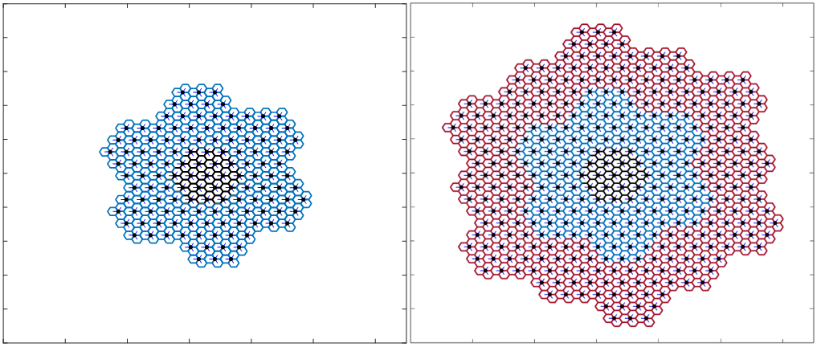
Three sectors (i.e., base stations) are modeled per site. A synchronized IMT network is modelled, maintaining a 120-degree separation in sector pointing. Furthermore, the study considers an IMT TDD deployment, where the TDD activity factor is 75% for the IMT BSs and 25% for the IMT UEs (where three UEs are simultaneously transmitting per sector). The average IMT base station activity is modeled as described in Recommendation ITU-R M.2101, where the IMT sectors are active or are silent (i.e., implementation of network load probability). The network loading factor is assumed to be 20%. Lastly, the UEs are uniformly distributed within each cell, maintaining a minimum distance of 35 meters from the base station. This distribution is in accordance with the methodology in Recommendation ITU-R M.2101 where the UE-BS coupling loss is calculated and compared to the minimum allowable link SINR. Uplink power control is also implemented on the UEs based on the power control algorithm defined in Section 4.1 of Recommendation ITU-R M.2101, where the maximum UE transmit power is 23 dBm and each UE in each sector equally share the available bandwidth.

A8.1.1.2.2 MetSat ground station modeling approach
To perform the dynamic simulations, each Monte Carlo trial simulates the MetSat satellite over a 5-day period with a resolution of 6 seconds. These time parameters provide a comprehensive set of potential ground station antenna pointing angles to fully analyse the IMT and MetSat sharing scenario. Data points in the analysis are retained only when the MetSat satellite is above the minimum 5-degree elevation with respect to the MetSat earth station. For example, Figure A8-3 represents the pdf of the local elevation angle for an arbitrarily placed MetSat ground station when it is in contact with the MetSat satellite. Additionally, the antenna pattern as shown in Figure A8-4, and as computed from Recommendation ITU-R S.465, is used to determine the MetSat receiver antenna gain towards the active IMT stations for each time step.
figure A8-3
pdf of MetSat ground station elevation angle to the MetSat satellite

figure A8-4
Antenna pattern of the MetSat ground station

A8.1.1.3 Study results
Using the system parameters and modeling methodologies described in the previous sections, the following results are obtained. Each curve is an output of 10,000 Monte Carlo snapshots and represents a distance between the far edge of the IMT network and the MetSat ground station. The aggregate RFI from the IMT base stations or UEs are calculated for each time step across the entire simulation period for each Monte Carlo snapshot to capture the ground station’s tracking strategy.
figure A8-5
MetSat and IMT 7x19 Network Scenario
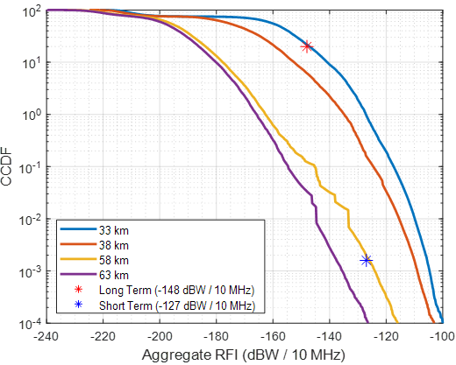

figure A8-6
MetSat and IMT 19x19 Network Scenario
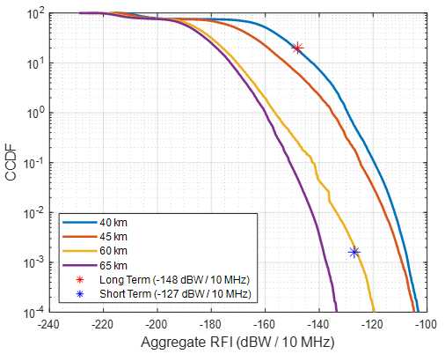

A8.1.1.4 Summary and analysis of the results of Study A
This study analysed the potential interference from varying sized IMT networks operating in one country into a MetSat ground station located in a neighbouring country using a dynamic analysis. Only NGSO MetSat scenarios were analysed in the 7 750 – 7 900 MHz band, where a tracking strategy was employed at the ground station. The analysis results indicate that a separation distance of approximately 60 km protects the studied MetSat ground station based on its required protection criteria. This distance is derived such that both the long-term and short-term interference criteria of Recommendation ITU-R SA.1027 are met.

A8.2 Summary and analysis of the results of studies
[Editor’s note: This section provides the summary and analysis of the results of studies. The text here can be used in the Section 1/1.7/3 “Summary and analysis of the results of ITU-R studies” of draft CPM text.]
[Editor’s note: This section should include concise text with summary and analysis of the results of studies. It may contain a summary table listing possible distance and/or frequency separation, or any other mitigation techniques, needed to protect, without imposing additional regulatory or technical constraints on existing service/application(s) operating in the band 7 125-8 400 MHz, or in adjacent band as appropriate, from IMT systems.]
Table A8.2-1
Overview of the sharing studies between the meteorological-satellite service (space-to-Earth) in the frequency bands 7 450-7 550 MHz and 7 750-7 900 MHz and IMT operating in the frequency band 7 125-8 400 MHz
[Editor’s note: Descriptive text and notes of the table. Rows to be added or deleted based on the decision of WP 5D. The table below is an example for comparison table created at the end of every Appendix.]
 | Parameters from expert WPs | Study A (USA) | Study …
Methodology
Single-entry or Multiple-entry (aggregated) |  | Aggregate
Statistical, or Statistical and Deterministic |  | Statistical (Monte Carlo)
Technical and operational characteristics of IMT systems
Deployment scenario |  | Macro urban
IMT stations
Method to deploy multiple IMT stations for the aggregated interference analysis over a relatively large area (as applicable to scenarios for the studies) |  | Rec. ITU-R M.2101 (Attachment 2 to Annex 1) Wrap-around technique  7 clusters of 19 base station sites, or 19 clusters of 19 base station sites, per cluster
Number of IMT base stations (BS) |  | 7 clusters * 19 sites * 3 sectors = 399 sectors  19 clusters * 19 sites * 3 sectors = 1083 sectors
Network loading factor for BS and UE (%) |  | 20%
TDD activity factor (%) |  | 75% BS  25% UE
UE power control |  | Yes (combination of IMT characteristics and Rec. ITU-R M.2101 (Section 4.1)
UE body loss (dB) |  | 4 dB
IMT antenna pattern |  | Extended AAS model (Table 17 of Annex XX to Doc 5D/792)
BS antenna mechanical downtilt |  | 6°
UE antenna pointing (if beamforming) |  | N/A
UE distribution |  | Uniform (minimum 35 m from the BS)
User equipment density for terminals that are transmitting simultaneously |  | 3
Technical and operational characteristics (of incumbent service)
NGSO or GSO? |  | NGSO
Ground Station Tracking Strategy and Minimum Elevation Angle |  | Yes, dynamic NGSO tracking strategy. Full dynamic strategy per snapshot. 5° minimum elevation angle.
Ground station height above ground |  | 25m
Ground station antenna pattern |  | Rec. ITU-R S.465-6
Propagation model/losses
Basic transmission loss |  | Rec. ITU-R P.2001 (percentage of time is uniformly randomized)
Terrain profile |  | Yes
Clutter loss |  | Rec. ITU-R P.2108 Section 3.2 (percentage of location is uniformly randomized). Only applied to IMT terminal.
Building entry loss |  | Rec. ITU-R P.2109 (for indoor UEs, 70% (thermally efficient), 30% (traditional)).
Cross-polarization loss (dB) |  | 3-dB polarization mismatch
Results of studies
Does the study result consider both BS and UEs? |  | Yes
Results summary |  | Separation distance of approximately 60 km to protect NGOS MetSat in the 7 750 – 7 900 MHz band.

________________

https://apps.nationalmap.gov/downloader/
Per WP7B (Document 5D/403), “…it needs to be noted that the percentage of time in Recommendations ITU-R SA.514-3 and ITU-R SA.1027-6 relates to the contact time between the satellite and its ground station. The contact time is understood to be the time during which the spacecraft is visible from the ground station, including time periods associated with initial signal acquisition, receiver synchronization of the data, and synchronized reception of data.”

