U.S. Radiocommunications Sector
Fact Sheet
Working Party: ITU-R WP 5D | Document No: WP5D-50/17
Ref: WP5D/792 Chapter 4 – Annex 4.6 | Date: 17 July 2025
Document Title: Placeholder document for proposed edits to the Working document on studies for the regulatory considerations to protect terrestrial IMT systems under WRC-27 agenda item 1.13

Author(s)/Contributors(s):  Pascale Dumit  T-Mobile | Email: Pascale.Dumit@T-Mobile.com
Purpose/Objective: .
This contribution is a placeholder for proposed edits to the Working document on studies for the regulatory considerations to protect terrestrial IMT systems under WRC-27 agenda item 1.13
Abstract: This contribution is a placeholder for proposed edits to the Working document on studies for the regulatory considerations to protect terrestrial IMT systems under WRC-27 agenda item 1.13

Radiocommunication Study Groups | 
Source: Document 5D/TEMP/358 | Annex 4.6 to  Document 5D/792-E
Source: Document 5D/TEMP/358 | 15 July 2025
Source: Document 5D/TEMP/358 | English only
Annex 4.6 to Working Party 5D Chair’s Report
WORKING DOCUMENT ON STUDIES FOR THE REGULATORY CONSIDERATIONS TO PROTECT TERRESTRIAL IMT SYSTEMS
UNDER WRC-27 AGENDA ITEM 1.13
Note: This working document contains a compilation of contributions on received at the February and June 2025 WP 5D meetings containing studies on the regulatory examples to address the protection of terrestrial IMT systems relevant to WRC-27 studies. These studies have not been fully reviewed and are considered as preliminary and not agreed by WP 5D. It is expected that once completed, WP 5D will provide the final results of these studies and any regulatory considerations to WP 4C to be included directly into the draft CPM text for agenda item 1.13. Therefore, it is attached to the Chair’s Report for information.
Note: This Document is capturing the text from documents Annex 4.6 to WP 5D Chair’s Report, 5D/633 (D), 5D/639 (D, G), 5D/652 (RUS), 5D/696 (IND), 5D/712 (CHN), 5D/713 (CHN), 5D/715 (CHN), 5D/739 (Ericsson), 5D/754 (F), 5D/775 (Orange)

1 Introduction
…

2 Technical and operational aspects

2.1 ITU-R Relevant materials
…

2.2 Technical and operational characteristics
WP 5D/ | Source | Services/Applications/Models
77 (Annex 4.8) | WP 5D | International Mobile Telecommunications (IMT)
TBD | WP 4C | DC-MSS-IMT
Note: Working Party 4C is expected to provide the DC-MSS-IMT technical and operational parameters to WP 5D by its next meeting in October 2025. Studies should be updated to reflect this DC-MSS-IMT information.

2.3 IMT bands to be protected
[All IMT bands to be considered for sharing studies to be protected from DC-MSS-IMT]

3 Potential interference scenarios
[Doc 5D/520 (J)]
The interference scenarios applicable to WRC-27 agenda item 1.13 shown in the table below.
TABLE 1
Interference scenarios between DC-MSS and terrestrial components of IMT
Scenario | From | To
A1 | Terrestrial IMT base station or mobile station | DC-MSS-IMT space station
A2 | Terrestrial IMT base station or mobile station | DC-MSS-IMT user equipment
B1 | DC-MSS-IMT user equipment | Terrestrial IMT base station or user equipment
B2 | DC-MSS-IMT space station | Terrestrial IMT user equipment or base station

FIGURE 1
Concept of interference scenarios for WRC-27 agenda item 1.13
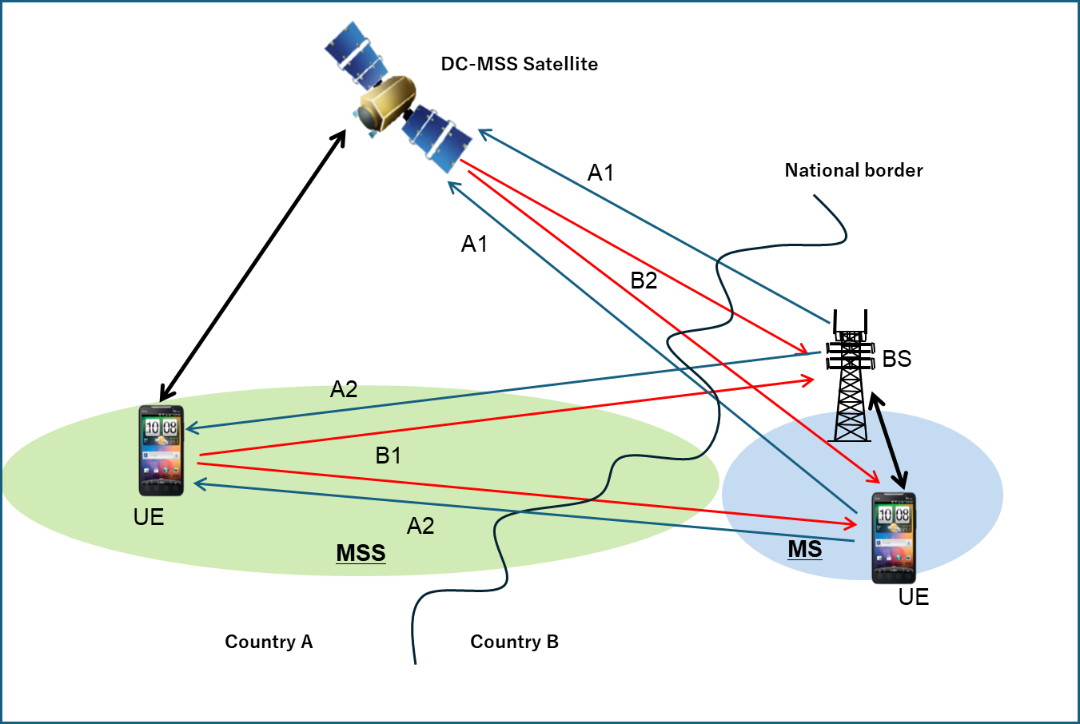
Figure 1 describes four scenarios, which are categorized as A1, A2, B1 and B2. The first two scenarios consider interference to the satellite system from the terrestrial system. Scenario A1 investigates the uplink interference issue from UE and BS to the satellite, and Scenario A2 investigates the downlink interference issue from terrestrial BS to satellite UE. Scenarios B1 and B2 consider interference to the terrestrial system from the satellite system. Scenario B1 investigates the uplink interference issue from satellite UE to terrestrial BS or UE, and Scenario B2 investigates the downlink interference issue from the satellite to terrestrial UE or BS.
Studies in WP 5D for WRC-27 agenda item 1.13, it is considered that scenarios for sharing between terrestrial component of IMT and DC-MSS-IMT using the same frequency bands are as follows:
A1) Since DC-MSS-IMT stations do not cause harmful interference to, or claim protection from, stations operating in the mobile service, so no study is needed.
A2) Since DC-MSS-IMT stations do not cause harmful interference to, or claim protection from, stations operating in the mobile service, so no study is needed.
B1) UEs used for DC-MSS-IMT and UEs used for terrestrial IMT are identical, so no study is needed since the interference situation is the same as that between existing terrestrial IMT networks in neighbouring countries.
In scenario B2, there are two patterns depending on whether the frequency arrangement (FDD) of the terrestrial IMT in the neighbouring country is the same as the DC-MSS-IMT.
B2-1) Study is needed to protect UE receivers in neighbouring countries
(The case that satellite transmission frequency of DC-MSS overlaps with the base station transmission frequency of the terrestrial IMT frequency arrangement in the neighbouring country.)
B2-2) Study is needed to protect BS receivers in neighbouring countries
(The case that satellite transmission frequency of DC-MSS-IMT overlaps with the user equipment frequency of the terrestrial IMT frequency arrangement in the neighbouring country.)
As mentioned above, it is clear that B2-1) and B2-2) should be considered in the sharing study between terrestrial component of IMT and DC-MSS-IMT.

4 Methodologies to determine protection threshold for terrestrial IMT networks
[Editor’s Note: Several proposed methodologies are presented in this section. Further discussions are needed to reduce/consolidate these methods.]
[Annex 4.15 to WP 5D Chair’s Report]

4.1 Possible Approaches
Note: Any action relating to implementation of further resolves of the Resolution 253 (WRC-23) is pending until the time that necessary information on the functionality of DC-MSS-IMT is formally provided by WP 4C. That also requires to have clear indication of modelling and potential interference management techniques of DC-MSS-IMT systems that will be provided by WP4C.
There are multiple options to define the pfd limit which need further consideration:
[1) Pfd per satellite
Editor’s note: Concerns were raised by a number of administrations regarding the applicability of PFD per satellite to define the possible measures for protection of terrestrial IMT systems. However, there was no agreement on the deletion of this option. Therefore, it will be retained in square brackets until information on the technical characteristics of DC-MSS-IMT systems/networks will be provided by WP 4C.
Defining pfd per satellite requires to assess the aggregation factor, based on typical MSS/D2D deployment. [It has to be noted that for MSS/D2D, a given area can only be covered by one spot in a given block of spectrum, thus making easier to assess the aggregation factor in particular for high arrival angles.]
Defining pfd per satellite will make easier for the BR and the administrations to check/control the conformity. In addition, it avoids having to make assumptions on the number of systems which could be actively transmitting in visibility of the border (i.e. avoiding to assume the aggregation factor over different systems).
However, the pfd per satellite limits is not suitable for the DC-MSS-IMT system application requirement related to the DC-MSS-IMT satellite station unwanted emissions need further consideration]
2a) Aggregate pfd per system
From a technical point of view, potential BS and UE victims can potentially receive interference from multiple satellites within one DC-MSS-IMT system. Consequently, starting from an agreed IMT protection criterion, it is possible to define an aggregate pfd mask that each potential DC-MSS-IMT system will have to respect. The aggregate pfd level is then correlated to the way that the considered DC-MSS-IMT systems are operated. Consequently, when conducting sharing studies, it is essential to take into account accurate modelling of DC-MSS-IMT operations, as well as studying options of potential interference management techniques (pending conclusions of the sharing studies) that may be used in operations. Finally, with respect to the way to model aggregate pfd, in the case of the UEs, the pfd equation is equivalent to the linearly adding pfd contributions, i.e. aggregate pfd.

3a) Aggregate pfd for multiple systems when protecting UEs
UE victims can potentially receive interference from multiple DC-MSS-IMT systems operating in the same frequency bands. An aggregate mask could then take into account the presence of multiple systems and apportion accordingly.
3b) Aggregate epfd for multiple systems when protecting base stations
Epfd was used in RR to protect GSO satellite systems and Radio Astronomy receivers from the aggregate interference due to non-GSO satellite constellations when victims have directional antennas.
Aggregate epfd could be used to protect IMT base stations in case of potential aggregate interference from multiple DC-MSS-IMT systems.
Epfd and aggregate epfd are metrics to protect IMT from satellite networks considering the aggregate interference from various satellites within a satellite system/constellation and potential aggregate interference from multiple DC-MSS-IMT systems.
These limits are defined only based on IMT protection criteria and IMT characteristics and different DC-MSS-IMT systems need to make sure the limits are met however their systems are or whatever interference mitigation techniques they use.
Further notes:
Views expressed about the potential aggregate interference from multiple DC-MSS-IMT systems:
– It has to be validated in terms of its applicability and likelihood. Working Party 5D welcomes studies at upcoming meetings.
– Is not of global nature depending on the BS location and orbital parameters of the constellation, the number of visible satellites contributing to the interference will vary, and also potentially corresponds to niche cases, e.g. small landlocked countries.

4.1.1 Issue of limits compliance verification
Currently, there are two options with respect to ensuring compliance with applicable aggregate limits:
- No ITU verification methodology is needed in order to verify compliance of a system with aggregate limits. Administrations who submit the envisaged new DC-MSS-IMT filings will commit to respect the limits and that will suffice
- A methodology is needed

4.2 Factors impacting the aggregate interference from DC-MSS-IMT to terrestrial IMT
[Editor’s note: The content of this section will be provided by the Offline on the Aggregation factor]

4.2.1 Aggregate interference from multiple satellites of one DC-MSS-IMT system

4.2.2 Aggregate interference from multiple DC-MSS-IMT systems
See Annex 2 for studies

4.3 Compilations of sharing and compatibility studies between terrestrial IMT and DC-MSS-IMT
See Annex 1 for studies

5 Regulatory limits for the frequency bands within the range 694-2700 MHz

5.1 Below 1 GHz

5.2 1.5 GHz

5.3 Above 2 GHz

6 Regulatory measures considerations
[Editor’s Note: Feasibility analyses of technical and operational measures to ensure protection of IMT and additional regulatory considerations could be included in this section.]

7 Summary of Results
…
TBD

ANNEX 1
Calculation of limits for protection of terrestrial IMT

Study A (Doc. 5D/550 (Nokia))
Document 5D/322 has proposed a methodology to calculate the maximum pfd levels on the ground to protect IMT receivers, based on the following equation in dB (W/(m² · MHz)):
$PFD\left(θ\right)=10\log_{10}\left(kTB\right)+NF+\frac{I}{N}-G_{r}\left(θ\right)+L-10\log_{10}\left(\frac{{}^{2}}{4π}\right)$ (1)
where:
k: Boltzmann’s constant ($1.380649 × {10}^{-23} J/K$)
$T$: receiver noise temperature in K
B: reference bandwidth (1 MHz)
NF: receiver noise figure in dB
I/N: protection criteria in dB
$G_{r}\left(θ\right)$: antenna gain in dBi of the receiver antenna in the direction of the interferer
$θ$: the elevation angle
$L$: Losses.
The resulting PFD from the above equation is dependent on the angle of the IMT receiver gain $G_{r}\left(θ\right)$. This implies that the equation produces the maximum aggregate PFD for the protection of IMT receivers from all possible interfering sources at a specific angle θ.
Suitability considerations of Equation 1 for the protection of IMT BS
IMT BS have directional non-AAS or AAS antennas. Therefore, if this angle dependent equation is considered as the basis of the methodology to derive the maximum aggregate pfd limits to protect IMT uplinks (i.e. IMT BSs), the derived result will be the maximum aggregate pfd limit from all possible interfering sources at a specific angle θ. When more than one non-GSO satellite of one or more satellite constellations are visible from different angles at an IMT BS, this equation produces the maximum aggregate pfd limits at each of those different visible angles. As it is shown in the analysis below, the presence of two or more satellites visible from different angles at the IMT BS, may result in exceeding the maximum aggregate pfd limits produced by Equation 1 at each angle θ, pfd(θ), even if individually, each satellite complies with the respective pfd(θ) limits of Equation 1 at their visible angles to the IMT BS.
To further demonstrate the issue, we assume that two satellites are visible by the IMT BS at two different angles θ₁ and θ₂ and we use Equation 1 to derive the maximum aggregate pfd limits at each of those θ₁ and θ₂ angles. These resulting maximum aggregate pfd limits at each angle are pfd(θ₁) and pfd(θ₂) as seen in Figure 1.
Figure A1-1
pfd limits and pfd levels for two satellites at visible angles θ1 and θ2 at the IMT BS
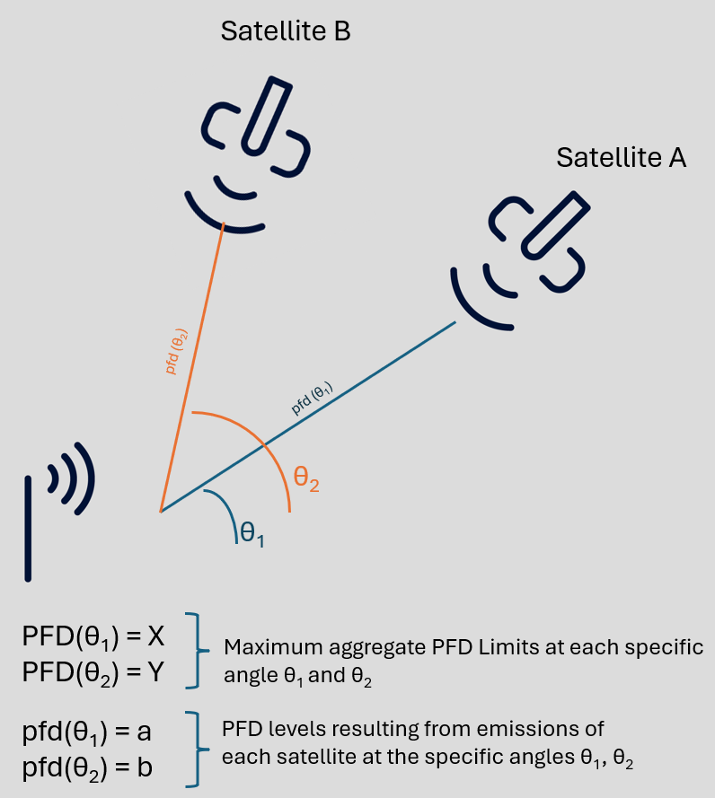
The individual pfd levels caused by Satellite A and Satellite B at the visible angles θ₁ and θ₂ at the IMT BS receiver are pfd(θ₁) = a and pfd(θ₂) = b.
For simplicity, assuming that the individual pfd levels caused by each satellite are equal to the maximum aggregate pfd limit at each visible angle at the IMT BS, we have that:
pfd(θ₁) = a = PFD(θ₁) = X
and
pfd(θ₂) = b = PFD(θ₂) = Y
While the above pfd levels at each angle θ are compliant with the maximum aggregate pfd limits at each respective angle, the effect of their aggregate emissions generates total aggregate pfd levels which are higher than each of the maximum aggregate pfd limits at each angle.
This is further demonstrated in the equations below:
$$total aggregate pfd at the IMT BS = pfd\left(θ1\right)+pfd\left(θ2\right)$$
$$= PFD\left(θ1\right)+PFD\left(θ2\right)$$
$$= Χ+Υ$$
$$which is higher than X=PFD\left(θ1\right)$$
$$and also higher than Υ=PFD\left(θ2\right)$$
As it can be seen from the above, although the emissions of each satellite are compliant with the maximum aggregate pfd limits visible at each angle θ₁ and θ₂ at the IMT BS, their total aggregate effect causes higher pfd levels than the maximum aggregate pfd limits at each specific angle, risking interference at the IMT BS receiver.
Suitability considerations of Equation 1 for the protection of IMT UEs
In contrast to the IMT BSs, IMT UEs are expected to be assumed to have an omnidirectional antenna pattern. In such cases where $G_{r}\left(θ\right)$ refers to the gain of an omnidirectional pattern, the consideration of angle θ becomes obsolete since the IMT UE receiver gain could be considered the same in all directions. In such case, the Equation 1 takes the format shown below:
$PFD=10\log_{10}\left(kTB\right)+NF+\frac{I}{N}-G_{r}+L-10\log_{10}\left(\frac{{}^{2}}{4π}\right)$ (2)
where:
$G_{r}$: omnidirectional antenna gain in dBi of the IMT UE.
The resulting pfd limit would be independent of the angle of arrival at the IMT UE and it would be a single value representing the maximum aggregate pfd limit from all possible sources from all visible angles.
A recreation of the scenario of Figure 1, but now for the case of protecting the IMT UE, is demonstrated in Figure 2.
Figure A1-2
pfd limit and pfd levels for two satellites at visible angles θ1 and θ2 at the IMT UE
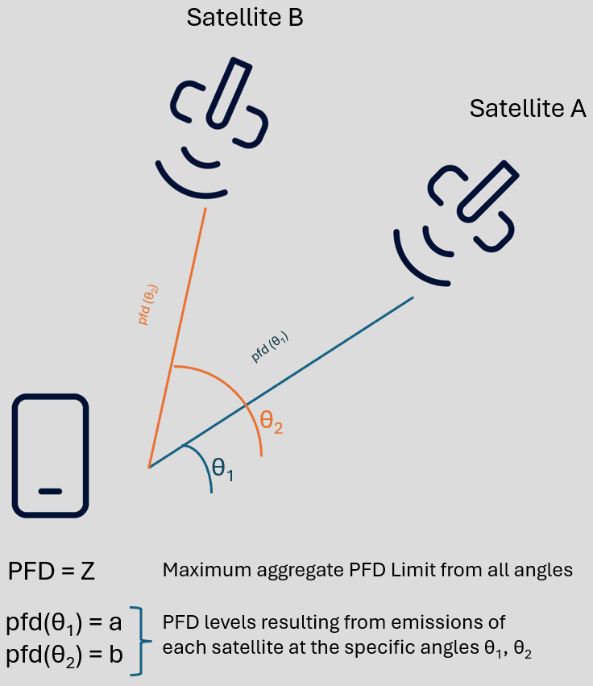
In the case of using the above Equation 2 as a methodology to derive a pfd limit to protect IMT UEs, the technical regulatory requirement for the maximum aggregate pfd limit produced by Equation 2 would be that:
$$pfd\left(θ1\right)+pfd\left(θ2\right) ≤ PFD$$
and the resulting pfd levels from all possible interfering sources from all visible angles would be compliant with both the pfd regulatory limit and the total maximum aggregate pfd level that can be handled at the IMT UE.
Conclusion - Proposal
From the above analysis it can be seen that the angle dependent pfd(θ) equation, in combination with the fact that IMT BSs have directional antenna patterns, as well as with the fact that the effect of aggregate emissions from multiple satellites of one or more satellite constellations needs to be considered, render Equation 1, in the format presented in Document 5D/322, not to be a suitable methodology to derive confident pfd limits for the protection of IMT uplinks (i.e. IMT BS). Therefore, we invite the group to consider the above analysis in the discussions for defining a methodology suitable for deriving the maximum aggregate pfd limit to protect IMT BS from all possible interfering sources from all possible angles.

Study B (Doc. 5D/533 (Multi MNOs), Doc 5D/775 (Orange))

1 Introduction
WRC-27 agenda item 1.13 deals with direct connectivity between space stations and International Mobile Telecommunications (IMT) user equipment to complement terrestrial IMT network coverage using the IMT frequency bands between 694/698 MHz and 2.7 GHz.
This document discusses the protection of the terrestrial IMT networks from potential interferences from DC-MSS-IMT satellite stations.

2 Protection of Terrestrial IMT Networks
2.1 Frequency bands consideration
It is assumed DC-MSS-IMT will be operated in FDD bands. Terrestrial IMT networks operating in both TDD and FDD frequency bands need to be protected.
It is proposed to group the frequency bands into three frequency ranges in the calculation of pfd limits for the protection of the terrestrial IMT networks:
1) Band Group_1: 694/698 MHz ~ 1 GHz.
2) Band Group_2: 1 ~ 2.2 GHz.
3) Band Group_3: 2.2 ~ 2.7 GHz.
For all of the three Band Groups, both non-AAS and AAS BS antennas should be considered.
2.2 Protection of terrestrial IMT networks
The protection of the terrestrial IMT networks need to take into account all interfering sources. There are many satellite stations per satellite system, and there are also multiple satellite systems using IMT frequency bands.
The aggregation effects of interferences from multiple satellites per system and the interference apportionment between multiple DC-MSS-IMT systems need to be taken into account in the study of protection of the terrestrial IMT networks.
2.2.1 Relation between pfd value and victim receiver parameters
The pfd value in dB(W/(m² · MHz)) can be calculated with the receiver characteristics of the IMT base station and IMT UE using the equation (1) below:
$pfd\left(θ\right)=10\log_{10}\left(kTB\right)+NF+\frac{I}{N}-G_{r}\left(θ\right)+L_{feeder}-10\log_{10}\left(\frac{{}^{2}}{4π}\right)$ (1)
where:
k: Boltzmann’s constant (-228.6 dB(W/(K ⋅ Hz)))
$T$: receiver noise temperature (300 K)
B: reference bandwidth (1 MHz)
NF: receiver noise figure in dB
I/N: protection criteria in dB
$G_{r}\left(θ\right)$: effective antenna gain in dBi of the receiver antenna in the direction of the interfering satellite
$θ$: the elevation angle direction towards the satellite
$L_{feeder}$: receiver antenna feeder loss.
2.2.2 Protection of terrestrial IMT network downlink
As illustrated in Figure 1, an UE antenna is modelled as omni-directional, all of the interferences from multiple satellites above the horizontal plan are received by the UE. Some may come from the satellite station main-beams, some others from satellite stations side-lobes.
If the interference from a satellite k is denoted as I_{k}, the total interference I__{system} from a DC-MSS-IMT system at the UE is
I__{system} $=\sum_{k=1}^{n}{I\text{k}}$ (2)
where n is the total number of satellites seen by an UE from a given DC-MSS-IMT system using IMT frequency band.
Figure A1-3
Illustration of multiple interferences from multiple satellites to an UE

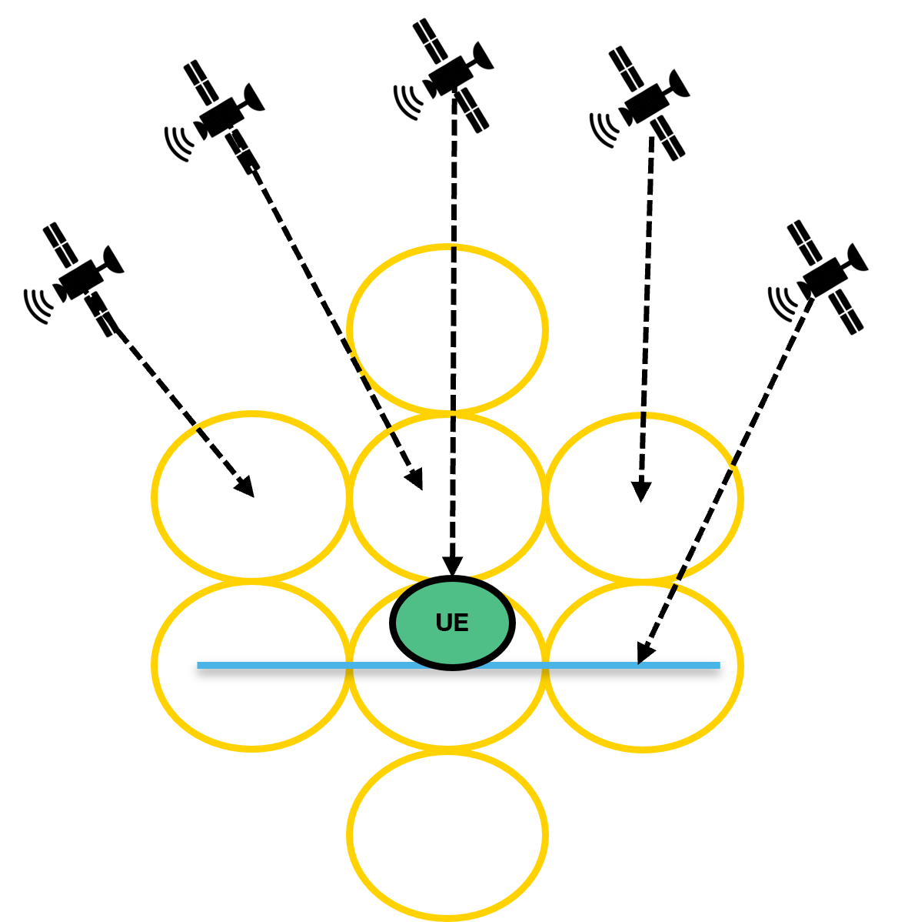

As shown in Figure 1, for an omni-directional antenna, gain G(θ) is not elevation angle dependant. If I__{system} /N is used in the equation (1), the calculated pfd value is aggregated pfd value. If I_{k} /N is used in the equation (1), the calculated pfd value is a single entry pfd value. Without a detail knowledge on number of satellites nor the satellites space distribution, a simple solution is to calculate the total interference level with an assumed aggregation factor α, where I_{k} is the k^{th} interferer in dB, β is the apportionment factor for DC-MSS-IMT multiple systems.
I__{total} = I_{_system} + β =I_{k +} α+β (3)
IMT UE parameters and calculated pfd values for protecting IMT downlinks are given in Table 3.

Table A1-1
IMT UE parameters and calculated pfd values for the protection of the IMT network downlink
MSS IMT Frequency range | 694/698- 1 GHz | 1 ~ 2.2 GHz | 2.2 ~ 2.7 GHz
UE antenna gain (dBi) | 0 dBi | 0 dBi | 0 dBi
Body loss (dB): | 0 dB | 0 dB | 0 dB
Noise figure (dB) | 9 | 9 | 9 | ITU-R M.2039, M.2292  Many UEs have typical Noise figure of 7 dB  9 dB is used in the pfd calculation
I/N (dB) | ‒6 | ‒6 | ‒6 | ITU-R M.2039, M.2292
Multi-beam/satellite aggregation. factor α (dB) | [tbd] | [11.6] | [tbd] | The simulation method and results are described in Annex 1
Multi-system apportionment factor β (dB) | β =10 log (2)=3 dB | β =10 log (2) = 3 dB | β =10 log (2)=3 dB | This proposed factor would be applicable at the border area with three neighbouring countries.  This factor will be updated following the outcome of ITU-R WP 5D discussions
Frequency (MHz) for calculating pfd value | 738 | 1475 | 2620 | Lowest DL frequency from each band group
Aggregated pfd dB(W/(m² · MHz)) | −125 | −119 | −114 | With β = 3 dB
Single entry pfd with α dB(W/(m² · MHz)) | −125 - α | [−130.6] | −114-α | With β = 3 dB

2.2.3 Protection of terrestrial IMT network uplink
As illustrated in Figure 2, a BS antenna (non-AAS and/or AAS) has a directional antenna pattern, the BS antenna gain G(q) is function of the elevation angle. The interference contributions from different satellites at different elevation angles are not the same, it is elevation angle dependent, and in consequence BS antenna gain dependent. The equation (1) can not be used directly to calculate the UL pfd levels, since the uplink protection criterion I_total/N=−6 dB (or −10 dB) where I_total is the total interference received by the BS from all angles.
Figure A1-4
Illustration of multiple interferences from multiple satellites to a BS
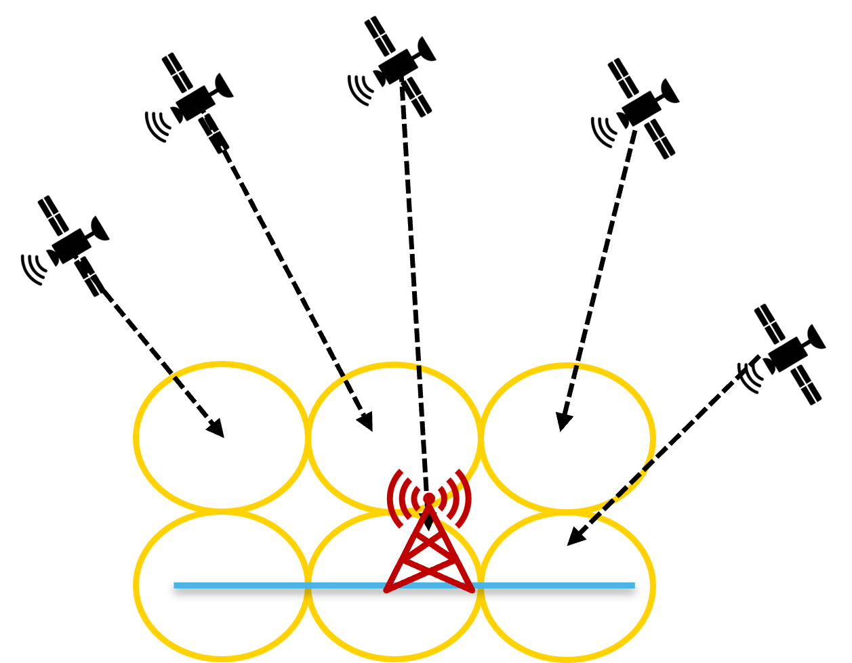
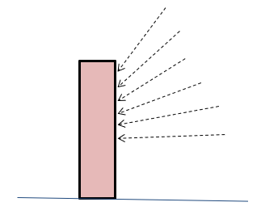
The interference from DC-MSS-IMT satellite stations to the terrestrial IMT network uplink can happen at three situations:
1) Co-frequency interference in case of the band plan incompatibility between regions, some regional band plan uplink is within the downlink block of another region.
2) Adjacent band case due to out of band emissions from satellite stations.
3) Inter-band case related to the unwanted emissions from satellite stations.
IMT networks are deployed with typical antenna downtilts of 0°, ‒3°, ‒6°, ‒10°. Annex 2 provides the distribution of a French Mobile network BS donwtilts over an area of 20 km from the north-east borderline. It shows that downtilts >=-3° represent 60% to 80% depending on the frequency band, downtilts <=0° and >-3° represent 20% to 40% depending on the frequency band.
In order to cover all of the cases, in the calculation/simulation of the pfd values for IMT network uplink protection, 0° downtilt should be considered for the most adequate protection levels.
There are two possible solutions on IMT TN uplink protection:
1) Epfd
Or
2) UL Pfd mask by considering the aggregation of interferences from multiple satellites within each elevation angle class under the condition that the I_total/N=−6 dB (or −10 dB) where I_total is the total interference received by the BS from all angles.
IMT uplink parameters for simulating pfd mask on IMT network uplink protection are summarized in Table 4. It should be pointed out that all of the IMT base stations deployed in the field have noise figure < 3 dB.

Table A1-2
IMT uplink parameters for simulaing pfd values for the protection of the IMT network uplink
MSS IMT Frequency range | 694/698 ~ 1 GHz | 1 ~ 2.2 GHz | 2.2 ~ 2.7 GHz
Uplink frequency (MHz) for calculating pfd value | 703 | 1710 | 2500
BS antenna type | Non-AAS  ITU-R F.1336 (recommends 3.1 & 3.2) with ka = 0.7, kp = 0.7, kh = 0.7, and kv = 0.3 | Non-AAS  ITU-R F.1336 (recommends 3.1 & 3.2) with ka = 0.7, kp = 0.7, kh = 0.7, and kv = 0.3 | Non-AAS  ITU-R F.1336 (recommends 3.1 & 3.2) with ka = 0.7, kp = 0.7, kh = 0.7, and kv = 0.3
IMT BS non-AAS maximum antenna gain (dBi) | 15 | 18 | 18 | ITU-R M.2039, ITU-R M.2292
BS non-AAS antenna feeder loss (dB) | 1 | 1 | 1 | For RRH (Remote Radio Head)
BS AAS antenna | Element gain: 6.4 dB  Element beam width:  90º for H  65º for V  config: 4x8  sub-array, M_{sub} =3  d_{v,sub}=0.7l  d_{h,sub}=0.5l | Element gain: 6.4 dB  Element beam width:  90º for H  65º for V  config: 4x8  sub-array, M_{sub} =3  d_{v,sub}=0.7l  d_{h,sub}=0.5l | Element gain: 6.4 dB  Element beam width:  90º for H  65º for V  config: 4x8  sub-array, M_{sub} =3  d_{v,sub}=0.7l  d_{h,sub}=0.5l | Table 9 of Annex 4.4 to the WP 5D Chair's Report Doc. 5D/716
IMT BS noise figure (dB) | 3 | 3 | 3 | IMT BS in the field has typical noise figure < 3 dB
I/N (dB) | ‒6 [‒10] | ‒6 [‒10] | ‒6 [‒10] | The UL protection threshold will be further revised based on the out of 5D IMT protection threshold
3 Summary and way-forward
This document discusses the terrestrial IMT network downlink and uplink protection from potential interferences due to DC-MSS-IMT satellite stations operating in IMT frequency bands.
It is proposed to consider three band groups in the definition of pfd limits for the protection of terrestrial IMT networks:
1) Band Group_1: 694/698 MHz ~ 1 GHz.
2) Band Group_2: 1 ~ 2.2 GHz.
3) Band Group_3: 2.2 ~ 2.7 GHz.
Based on the principle that the protection of the terrestrial IMT networks need to take into account all interfering sources, single entry pfd or aggregated pfd can be defined for protecting the terrestrial IMT networks downlink.
The calculated aggregated pfd limits for protecting the terrestrial IMT network downlink are summarised in Table 3 above. In order to define the single entry DL pfd, the interference aggregation factor was simulated for the frequency band 1800 MHz with the very preliminary assumptions, the preliminary simulation result for the 1800 MHz band is a= 11.6 dB at 99% of probability. The interference aggregation factor simulation will be updated with the progress on the discussions on the assumptions for DC-MSS-IMT satellite stations such as number of satellites per constellation, altitude of satellite stations, satellite antenna patterns, etc.
There are two possible solutions on the IMT TN uplink protection:
1) Epfd
Or
2) UL pfd mask by considering the aggregation of interferences from multiple satellites within each elevation angle class under the condition that the I_total/N= ‒6 dB (or ‒10 dB) where I_total is the total interference received by the BS from all angles.

Terrestrial IMT network BS antenna downtilt
The distribution of a French IMT network in the north-east country border area over 20 km from the borderline is given in Figure A2-1, it shows that downtilts >=-3° represent 60% to 80% depending on the frequency band, downtilts <=0° and >-3° represent 20% to 40% depending on the frequency band.
Figure A1-5
Distribution of IMT TN BS antenna downtilt in France country border Area
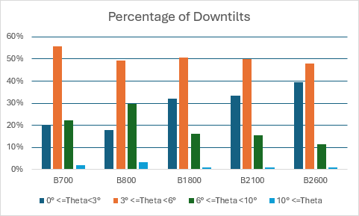

Study C (Doc 5D/483(RUS))
When implementing MSS within the frequency bands identified for terrestrial segment of IMT, it is crucial to ensure the protection of IMT stations. This protection is particularly important in cross-border scenarios, where Country A deploys MSS, and Country B uses the same frequency bands solely for terrestrial IMT stations. It also taken into account that the level of interference largely depends on the separation distances between the IMT stations and the coverage area of MSS in adjacent countries.
Figure 1 illustrates a potential scenario, highlighting that the separation distances between IMT stations and MSS can vary depending on the latitude. This variability underscores the need for careful coordination to minimize interference while enabling effective MSS deployment.
Figure A1-6
One of the possible configurations of IMT and MSS when MSS will interfere IMT
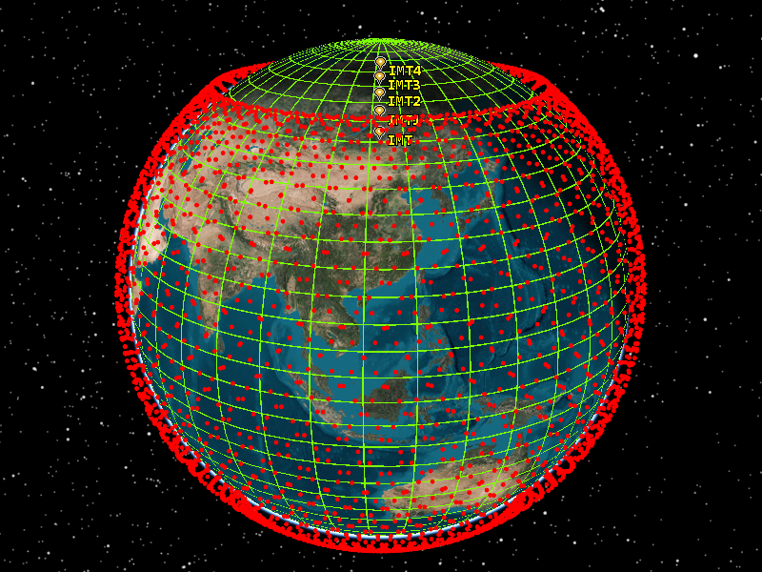
Typically, an acceptable threshold for throughput loss in IMT networks is 5%. The following equations approximate the throughput over a channel based on the signal-to-interference-plus-noise ratio (SINR, measured in dB) when employing link adaptation:
$$SE \left(SINR\right), bps/Hz =\left\{\begin{aligned}0 for SINR< SINR_{MIN} \\ α∙S\left(SINR\right) for SINR_{MIN}≤SINR<SINR_{MAX} \\ α∙S\left(SINR_{MAX}\right) for SINR ≥ SINR_{MAX} \end{aligned}\right.$$
where:
S(SINR) Shannon bound, S(SINR) =log₂(1 + 10^{SINR/10}) (bps/Hz)
α Attenuation factor, representing implementation losses
SINR_{MIN} Minimum SINR of the code set, dB
SINR_{MAX} Maximum SINR of the code set, dB.
Table A1-3
Parameters describing baseline Link Level performance for 5G NR
Parameter | DL | UL | Notes
α | 0.6 | 0.4 | Represents implementation losses
SINR_{MIN}, dB | −10 | −10 | Based on QPSK, 1/8 rate (DL) & 1/5 rate (UL)
SINR_{MAX}, dB | 30 | 22 | Based on 256-QAM, 0.93 rate (DL) & 64-QAM, 0.93 rate (UL)

Figure A1-7
Spectral efficiency of UL and DL depending on the SINR levels
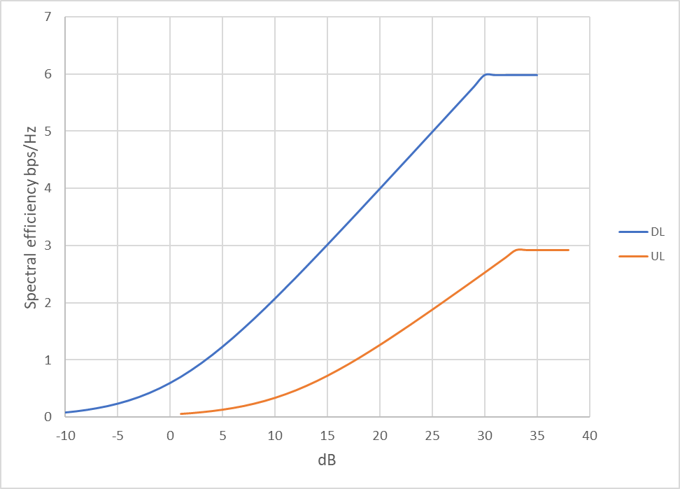

Table A1-4
Downlink spectral efficiency values for each SNR and when 5% throughput losses occur
SNR (dB) | SE (bps/Hz) | SE with 5% reduction (bps/Hz)
‒10 | 0.082502 | 0.078377009
‒9 | 0.102641 | 0.097509409
‒8 | 0.127347 | 0.120979504
‒7 | 0.157479 | 0.149604883
‒6 | 0.19398 | 0.184280614
‒5 | 0.237845 | 0.225953222
‒4 | 0.290085 | 0.275580723
‒3 | 0.351662 | 0.334079238
‒2 | 0.423431 | 0.402259859
‒1 | 0.506066 | 0.48076298
0 | 0.6 | 0.57
1 | 0.705382 | 0.670112882
2 | 0.822063 | 0.780959662
3 | 0.949609 | 0.902128942
4 | 1.087348 | 1.032980329
5 | 1.234424 | 1.172702729
6 | 1.389874 | 1.320380022
7 | 1.552689 | 1.475054193
8 | 1.721872 | 1.635778715
9 | 1.896483 | 1.801658522
10 | 2.075659 | 1.971876023
11 | 2.258637 | 2.145704789
12 | 2.444751 | 2.322513584
13 | 2.633435 | 2.501763611
14 | 2.824212 | 2.68300155
15 | 3.016685 | 2.865850374
16 | 3.210526 | 3.049999408
17 | 3.405468 | 3.235194544
18 | 3.601294 | 3.421229173
19 | 3.797827 | 3.607936102
20 | 3.994927 | 3.795180545
21 | 4.192478 | 3.982854172
22 | 4.39039 | 4.170870121
23 | 4.588588 | 4.359158883
24 | 4.787016 | 4.547664914
25 | 4.985625 | 4.736343887
26 | 5.184379 | 4.925160462
27 | 5.383249 | 5.11408648
28 | 5.58221 | 5.303099523
29 | 5.781244 | 5.49218175
30 | 5.980336 | 5.681318968
Table A1-5
Downlink spectral efficiency values for each SNR and when 5% throughput losses occur
SNR (dB) | SE (bps/Hz) | SE with 5% reduction (bps/Hz)
‒10 | 0.055001 | 0.052251339
‒9 | 0.068428 | 0.065006273
‒8 | 0.084898 | 0.080653002
‒7 | 0.104986 | 0.099736589
‒6 | 0.12932 | 0.122853743
‒5 | 0.158564 | 0.150635481
‒4 | 0.19339 | 0.183720482
‒3 | 0.234442 | 0.222719492
‒2 | 0.282288 | 0.268173239
‒1 | 0.337378 | 0.320508654
0 | 0.4 | 0.38
1 | 0.470255 | 0.446741921
2 | 0.548042 | 0.520639775
3 | 0.633073 | 0.601419295
4 | 0.724898 | 0.688653553
5 | 0.822949 | 0.781801819
6 | 0.926582 | 0.880253348
7 | 1.035126 | 0.983369462
8 | 1.147915 | 1.090519143
9 | 1.264322 | 1.201105681
10 | 1.383773 | 1.314584015
11 | 1.505758 | 1.430469859
12 | 1.629834 | 1.548342389
13 | 1.755624 | 1.667842408
14 | 1.882808 | 1.7886677
15 | 2.011123 | 1.910566916
16 | 2.14035 | 2.033332939
17 | 2.270312 | 2.156796363
18 | 2.400863 | 2.280819449
19 | 2.531885 | 2.405290735
20 | 2.663285 | 2.530120363
21 | 2.794985 | 2.655236114
22 | 2.926926 | 2.780580081

Knowing the values of spectral efficiency when 5% throughput reduction occurs and using base Shannon expression taking into account implementation losses:
$$SE\left(SINR\right)=\log_{2}\left(1+{10}^{SINR/10)}\right)∙α$$
It is possible to derive SINR from that expression. First it is needed to rearrange the formula to isolate $\log_{2}$:
$$\frac{SE(SINR)}{α}=\log_{2}\left(1+{10}^{SINR/10}\right)$$
Convert base-2 logarithm to base-10 logarithm:
$$\log_{2}\left(y\right)=\frac{\log_{10}(y)}{\log_{10}(2)}$$
So:
$$\frac{SE(SINR)}{α}=\frac{\log_{2}\left(1+{10}^{SINR/10}\right)}{\log_{10}(2)}$$
Simplify to $\log_{10}:$
$$\log_{10}\left(1+{10}^{SINR/10}\right)=\frac{SE(SINR)}{α}∙\log_{10}(2)$$
Exponentiate to solve for ${10}^{SINR/10}$:
$$C=\frac{SE(SINR)}{α}∙\log_{10}(2)$$
Then, SINR can be calculated using the following expression:
$$SINR=10∙\log_{10}\left({10}^{C}-1\right)$$
After SINR values that correspond to the 5% throughput losses are calculated, it is possible to calculate I/N for each case of baseline SNR when 5% throughput losses occur using the following expression:
$$I/N=10\log_{10}⁡\left(\frac{{10}^{SNR/10}+{10}^{SINR/10}}{{10}^{SINR/10}}\right)$$
Table A1-6
Dependence of SNR and I/N for 5% throughput lossSNR (dB) | DL  I/N for 5% throughput loss (dB) | UL  I/N for 5% throughput loss (dB)
‒10 | ‒12.58205191 | ‒12.58205191
‒9 | ‒12.53234092 | ‒12.53234092
‒8 | ‒12.47160011 | ‒12.47160011
‒7 | ‒12.39787616 | ‒12.39787616
‒6 | ‒12.30909749 | ‒12.30909749
‒5 | ‒12.20316949 | ‒12.20316949
‒4 | ‒12.07810826 | ‒12.07810826
‒3 | ‒11.93220748 | ‒11.93220748
‒2 | ‒11.76422289 | ‒11.76422289
‒1 | ‒11.57354833 | ‒11.57354833
0 | ‒11.36035123 | ‒11.36035123
1 | ‒11.12563661 | ‒11.12563661
2 | ‒10.87122046 | ‒10.87122046
3 | ‒10.5996119 | ‒10.5996119
4 | ‒10.31382384 | ‒10.31382384
5 | ‒10.01714594 | ‒10.01714594
6 | ‒9.71291723 | ‒9.71291723
7 | ‒9.40432991 | ‒9.40432991
8 | ‒9.094282982 | ‒9.094282982
9 | ‒8.785291541 | ‒8.785291541
10 | ‒8.479446934 | ‒8.479446934
11 | ‒8.17841717 | ‒8.17841717
12 | ‒7.883475126 | ‒7.883475126
13 | ‒7.595543031 | ‒7.595543031
14 | ‒7.315244103 | ‒7.315244103
15 | ‒7.042954889 | ‒7.042954889
16 | ‒6.778854261 | ‒6.778854261
17 | ‒6.522966945 | ‒6.522966945
18 | ‒6.275200709 | ‒6.275200709
19 | ‒6.035377251 | ‒6.035377251
20 | ‒5.803257224 | ‒5.803257224
21 | ‒5.578560131 | ‒5.578560131
22 | ‒5.360979847 | ‒5.360979847
23 | ‒5.150196527 | -
24 | ‒4.945885576 | -
25 | ‒4.747724264 | -
26 | ‒4.555396504 | -
27 | ‒4.368596178 | -
28 | ‒4.187029354 | -
29 | ‒4.010415661 | -
30 | ‒3.838489027 | -

To protect IMT user equipment and base stations pfd limits may be used and knowing I/N values that are linked to the 5% throughput loss of DL and UL it is possible to derive necessary pfd limits by:
$$PFD=10\log_{10}\left(kTB\right)+NF+\frac{I}{N}-10\log_{10}\left[G_{receiver}\right]+L_{feeder}-10\log_{10}\left(\frac{λ^{2}}{4π}\right)$$
Alternatively, the 5% throughput losses may be linked to the epfd limits.

Determining epfd/pfd limits for the frequency bands within the range 694-2700 MHz
To determine the appropriate level of I/N for pfd calculations, it is necessary to simulate the SINR of IMT DL and UL channels for each frequency band. This involves considering deployment-related IMT parameters and analyzing the average SINR. The corresponding I/N value for the calculated SINR will then be used to establish pfd limits for each frequency band.
This contribution provides a simulation example for the 2–3 GHz frequency band. In this scenario, IMT DL and UL channels are subject to interference from non-GSO in a rural deployment case, which represents the worst-case scenario. For urban and suburban deployments, the likelihood of interference is significantly lower due to clutter shielding and the fact that a large portion of user UEs (up to 70%) will be indoors. Consequently, the rural case, where less Ues are indoors, and no clutter shielding has been simulated.
TABLE A1-7
BS parameters for bands between 2 and 3 GHz
 | Rural macro
Cell radius / Deployment density (for bands between 2 and 3 GHz) | 4 km
Antenna height | 30 m
Sectorization | 3 sectors
Typical channel bandwidth | 10 or 20 MHz
Element gain (dBi) | 6.4
Horizontal/vertical 3 dB beam width of single element (degree) | 90º for H  65º for V
Horizontal/vertical front-to-back ratio (dB) | 30 for both H/V
Antenna polarization | Linear ±45º
Antenna array configuration (Row × Column) | 4 × 8 elements
Horizontal/Vertical radiating element/sub-array spacing, d_{h} /d_{v} | 0.5 of wavelength for H, 2.1 of wavelength for V
Number of element rows in sub-array, M_{sub} | 3
Vertical radiating element spacing in sub-array, d_{v,sub} | 0.7 of wavelength of V
Pre-set sub-array down-tilt, θ_{subtilt} (degrees) | 3
Array Ohmic loss (dB) | 2
Conducted power (before Ohmic loss) per antenna element/sub-array (dBm) | 28
Base station horizontal coverage range (degrees) | ±60
Base station vertical coverage range (degrees) | 90-100
Mechanical downtilt (degrees) | 3
Maximum base station output power/sector (e.i.r.p.) (dBm) | 72.28

TABLE A1-8
UE parameters for bands between 2 and 3 GHz
 | Rural macro
User terminal characteristics
User equipment density for terminals that are transmitting simultaneously (Note 1) | 3 Ues per sector
UE height (Note 2) | 1.5 m
Average user terminal output power | Use transmit power control
Typical antenna gain for user terminals | −3 dBi
Body loss | 4 dB
UE TDD activity factor | 25%
Transmit power control
Power control model | Refer to Recommendation ITU-R M.2101 Annex 1, section 4.1
Maximum user terminal output power, PCMAX | 23 dBm
Power (dBm) target value per RB, P0_PUSCH (Note 3) | −92.2
Path loss compensation factor, α  (same as “balancing factor” mentioned in Rec. ITU-R M.2101) | 0.8

Figure A1-8
SINR CDF and PDF for DL in 2-3 GHz
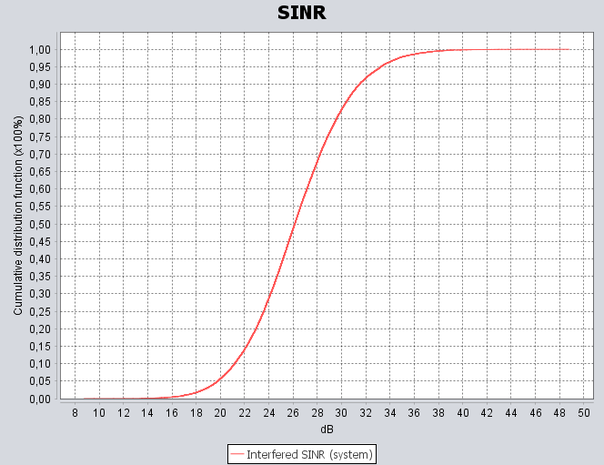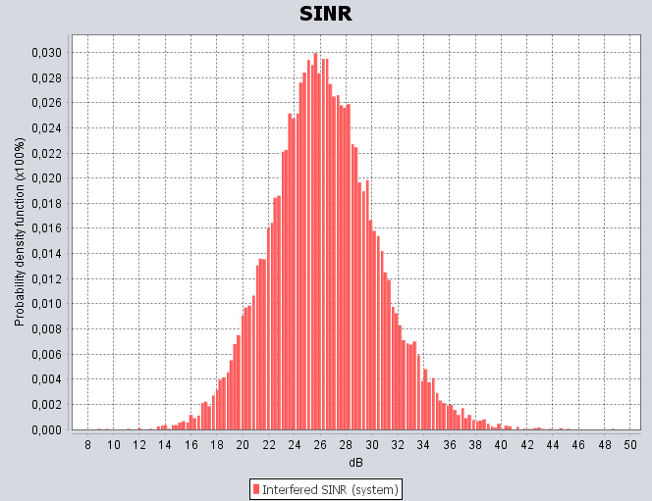
Figure A1-9
SINR CDF and PDF for UL in 2-3 GHz
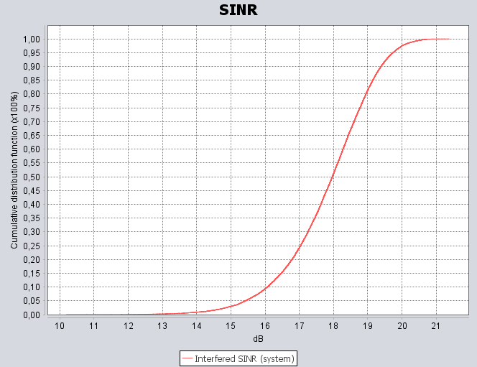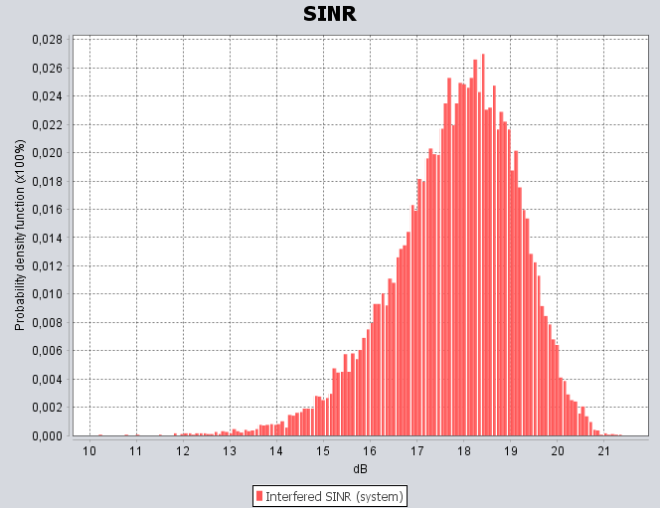
The results indicate that for LoS conditions with Rural deployment in 2-3 GHz, the average SINR for DL is 26 dB whereas for the UL is 18 dB.
Based on the above, it is possible to derive the average epfd/pfd limits to protect IMT BS and UE in the frequency bands within the range 694-2 690 MHz, knowing that based on the Table 4 I/N values for the downlink case the average I/N = ‒4.55 dB and for the uplink case the average I/N would be I/N = ‒6.2 dB.
As can be noted, for the UL case pdf/epfd values should be based on the I/N = ‒6 dB criterion, whereas for the DL it is possible to mitigate the pfd/epfd levels using the I/N = ‒4.5 dB.

Study D (Doc 5D/525 (Ericsson))
PFD limits for Protection of terrestrial IMT
PFD levels for protection of terrestrial IMT (IMT UE and IMT BS) are defined based on the IMT protection criterion and the characteristics of IMT receivers. The regulatory measures (PFD limits) need to be defined based on these PFD levels taking into account the functionality and characteristics of the aggressor (DC-MSS-IMT).
DC-MSS-IMT systems contain of hundreds or thousands of satellites in low-Earth orbit. Thus, the terrestrial IMT receives interference from multiple satellites, either in one constellation or in multiple constellations. This aggregate interference must be considered when defining regulatory measures for protection of terrestrial IMT from DC-MSS-IMT.
Multiple options to define the PFD limits are identified for further consideration in the last WP 5D meeting in October 2024 (Annex 4.15 to WP 5D Chair’s Report):
• PFD per satellite (PFD produced by each satellite of DC-MSS-IMT system)
• Aggregate PFD per system (summation of PFDs produced by all satellites in an DC-MSS-IMT system)
• EPFD per system and aggregate EPFD for multiple systems (EPFD as defined in Article No. 22.5C.1 of RR)
Defining PFD per satellite would require prior assessment of two factors:
1. One factor based on DC-MSS-IMT deployment to consider the aggregate interference from multiple satellites in one system (multi-satellite aggregation factor), noting that this aggregation factor needs to take into account future development of the DC-MSS-IMT system.
2. Another factor to consider is the aggregate interference from different DC-MSS-IMT systems which could be actively transmitting in visibility of the border (multi-system aggregation factor).
To estimate these factors, information on the functionality and characteristics of the DC-MSS-IMT system is required.
In the following the options to define PFD limits for protection of IMT UE and IMT BS starting from the maximum tolerable interference obtained from IMT protection criterion and the characteristics of IMT UE and IMT BS are discussed.
Protection of IMT UE from DC-MSS-IMT
PFD levels to protect IMT UE can be derived based on the IMT UE characteristics and IMT protection criterion:
$PFD level to protect IMT UE=10\log_{10}\left(kTB\right)+NF+\frac{I}{N}-10\log_{10}\left[G_{UE}\right]-10\log_{10}\left(\frac{{}^{2}}{4π}\right)$ (1)
where:
$k$: Boltzmann’s constant (-228.6 dB(W/(K ⋅ Hz)))
$T$: receiver noise temperature (300 K)
$B$: reference bandwidth (1 MHz)
$NF$: receiver noise figure in dB
$I/N$: protection criterion in dB
$G_{UE}$: antenna gain of IMT UE in in linear scale.
To protect IMT UE from harmful interference due to DC-MSS-IMT, the aggregate interference due to all visible satellites operating co-frequency (either in one constellation or in multiple constellations) should not exceed the value obtained by equation (1). This value can be seen as an interference budget to protect IMT UE from harmful interference and can be used as the aggregate EPFD limit for protection of IMT UE.
The value obtained by equation (1) is the aggregate PFD limit or EPFD limit per system if only one DC-MSS-IMT system causes interference. In case of having potential interference from multiple systems, the interference budget must be partitioned between different systems, meaning that a multi-system aggregation factor must be estimated and subtracted from the value obtained by equation (1) to achieve the aggregate PFD limit or EPFD limit per system.
$$Aggregate PFD limit per system=PFD level to protect IMT UE-multi system aggregation factor$$
$$EPFD limit per system=PFD level to protect IMT UE-multi system aggregation factor$$
To define the PFD limit per satellite, an aggregation factor to consider the aggregate interference from multiple satellites in one MSS-SC system must be estimated and subtracted from the aggregate PFD limit per system.
$$PFD limit per satellite=PFD level to protect IMT UE-multi system aggregation factor-multi satelite aggregation factor$$
Protection of IMT BS from DC-MSS-IMT
To protect IMT BS from harmful interference due to DC-MSS-IMT, the aggregate interference received by IMT BS due to all visible satellites operating co-frequency (either in one constellation or in multiple constellations) should not exceed
$I_{max}=10\log_{10}\left(kTB\right)+NF+\frac{I}{N}$.
If only one satellite caused interference, PFD mask to protect IMT BS could be derived as:
$PFD\left(φ\right)=10\log_{10}\left(kTB\right)+NF+\frac{I}{N}-10\log_{10}\left[G_{BS}\left(φ\right)\right]+L_{f}-10\log_{10}\left(\frac{{}^{2}}{4π}\right)$ (2)
where:
$φ$ is the elevation angle toward the interfering satellite
$G_{BS}\left(φ\right)$ is the antenna gain of BS in the direction of the interfering satellite (in linear scale), and
$L_{f}$ is the BS antenna feeder loss (in dB).
However, in case of DC-MSS-IMT, the interfering signal comes from multiple satellites and since the IMT BS has a directional antenna, the impact of PFDs from different satellites on its performance depends upon the relative gain towards these interfering satellites. This means the total interference received by the IMT BS is (see Figure 1 for a case with 3 interfering satellites)
$I_{total}=10\log_{10}{\sum_{i}{I_{i}}}-L_{f}=10\log_{10}{\sum_{i}{\left(\frac{{10}^{\frac{P_{i}}{10}} G_{Sat}\left(θ_{i}\right)}{4πd_{i}^{2}}G_{BS}(φ_{i})\frac{λ^{2}}{4π}\right)}}-L_{f}$ (3)
where:
$P_{i}$: transmit power of the $i$-th interfering satellite in dBW
$G_{Sat}(θ_{i})$: the gain of the $i$-th interfering satellite toward the victim receiver
$G_{BS}\left(φ_{i}\right)$: antenna gain of the victim receiver antenna in the direction of the $i$-th interfering satellite
$θ_{i}$ and $φ_{i}$: angles to specify the direction between the victim receiver and the $i$-th interfering satellite
$d_{i}$: the distance between the victim receiver and the $i$-th interfering satellite.
This total interference received by the BS should be equal to the maximum tolerable interference ($I_{max}$). Therefore,
$10\log_{10}{\sum_{i}{\left(\frac{{10}^{\frac{P_{i}}{10}} G_{Sat}\left(θ_{i}\right)}{4πd_{i}^{2}}G_{BS}(φ_{i})\right)}}=10\log_{10}\left(kTB\right)+NF+\frac{I}{N}+L_{f}-10\log_{10}\left(\frac{{}^{2}}{4π}\right)$ (4)
The left-hand side of equation (4) looks like the EPFD (equivalent power flux density) equation in Article No. 22.5C.1 of ITU-R Radio Regulations. Therefore, EPFD which considers the aggregate interference due to all transmitting stations within a satellite constellation taking into account the directional antenna gain of the victim receiver towards interfering satellites is a proper metric to protect IMT BS. Further consideration is needed on the BS antenna gain when deriving the regulatory limits for protection of AAS base stations as the antenna pattern of AAS BSs vary.
Figure A1-10
An IMT BS receiving interference from three satellites
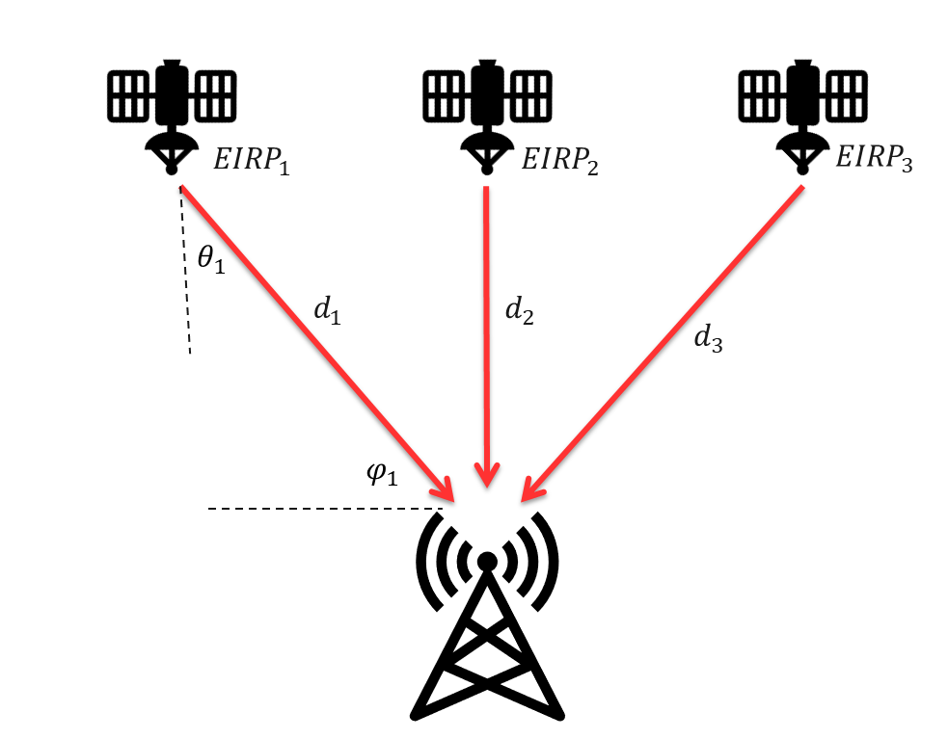
The aggregate PFD from a constellation at the location of IMT BS is (see Figure 1 for a case with 3 interfering satellites)
$Aggregate PFD=10\log_{10}{\sum_{i}{\frac{EIRP_{i}(θ_{i})}{4πd_{i}^{2}}}}=10\log_{10}{\sum_{i}{\left(\frac{{10}^{\frac{P_{i}}{10}} G_{Sat}\left(θ_{i}\right)}{4πd_{i}^{2}}\right)}}$ (5)
It is unclear how this aggregate PFD can be related to the characteristics of IMT BS to ensure protection. Further consideration is needed in this regard.
The EPFD level which can be obtained using equation (4) is the “EPFD limit per system” if only one DC-MSS-IMT system causes interference. In case of having potential interference from multiple DC-MSS-IMT systems, either the EPFD level obtained using equation (4) should be defined as “Aggregate EPFD limit”, or the interference budget should be partitioned between the systems, meaning that a multi-system aggregation factor must be estimated and applied as following:
$$EPFD limit per system=Aggregate EPFD limit to protect IMT BS-multi system sgregation factor$$
Conclusion and summary of the three options
A comparison of all the options are summarized in the table below. It show that a multi-system aggregation factor should be estimated and used when defining “Aggregate PFD limit per system” or “EPFD limit per system” to consider the aggregate interference due to multiple DC-MSS-IMT systems.
“PFD limit per satellite” does not seem suitable for protection of IMT BS as there are multiple interfering satellites that their impact on IMT BS depends on the gain of BS antenna in the direction of interfering satellites. In case of defining “PFD limit per satellite” for protection of IMT UE, in addition to the multi-system aggregation factor, the multi-satellite aggregation factor to model the aggregate interference from multiple satellites in one MSS-SC system must be applied. To estimate these aggregation factors, the information on the functionality and characteristics of DC-MSS-IMT systems is needed.
While EPFD limit seems a proper metric for protection of IMT BS which has directional antennas, it is unclear how “Aggregate PFD limit” can be defined for protection of IMT BS. Further study and consideration are needed in this regard.
Since the aggregate EPFD limit considers the aggregate interference from multiple DC-MSS-IMT systems as well as all the satellites in each system, there is no need to apply any aggregation factor when using aggregate EPFD limit as the regulatory measure.
TABLE A1-9

 | Protection of IMT UE | Protection of IMT BS
PFD levels/masks based on total amount of tolerable interference | $$10\log_{10}\left(kTB\right)+NF+\frac{I}{N}-10\log_{10}\left[G_{UE}\right]-10\log_{10}\left(\frac{{}^{2}}{4π}\right)$$ | $10\log_{10}\left(kTB\right)+NF+\frac{I}{N}-10\log_{10}\left[G_{BS}\left(φ\right)\right]+L_{feeder}-10\log_{10}\left(\frac{{}^{2}}{4π}\right)$  If there is only one interfering satellite
PFD limit per satellite | $$PFD levels-multi system aggregation factor-multi satellite aggregation factor$$ | Not suitable when we have multiple interfering satellites
Aggregate PFD limit per system | $$PFD levels-multi system aggregation factor$$ | Needs further consideration
EPFD limit per system | $$PFD levels-multi system aggregation factor$$ | $$Aggregate EPFD limit-multi system aggregation factor$$
Aggregate EPFD limit | $$PFD levels$$ | Can be calculated using equation (4)

Study E (Document 5D/477 (CHN), 5D/715 (CHN))
1 Introduction
This attachment provides a deterministic calculation-based methodology and a dynamic simulation-based methodology for deriving the aggregate PFD value per system to protect IMT system at the border between neighboring countries from DC-MSS-IMT space stations for possible new MSS allocation on a primary or secondary basis. Based on technical characteristics of DC-MSS-IMT and IMT system, the preliminary results of PFD values for protecting IMT UE are provided.
2 Technical characteristics
2.1 Technical characteristics of DC-MSS-IMT
Annex to the Chair’s Report of WP 4C (See Annex 7 to Doc. 4C/356) provides the technical characteristics of DC-MSS-IMT towards WRC-27 agenda item 1.13 which could be used as the basis of the study. Detailed technical characteristics are summarized in Table 1 and Table 2.
Table A1-10
Parameters of orbital configuration
Altitude  (km) | Inclination  (deg) | Planes | Sats per plane | RAAN spacing  (deg) | Total number of sats
500 | 55 | 60 | 60 | 6 | 3 600

Table A1-11
Parameters of DC-MSS-IMT
 | Parameter | Unit | Frequency
Downlink (Space-to-Earth) | Frequency band | MHz | 694/698-960 | 1 427-1 518 | 1 805-1 880  /2 110-2 170  /1 880-1 920 |  | 2 300-2 400 | 2 500-2 690
Downlink (Space-to-Earth) | Typical Emission Bandwidth | MHz | 5 | 5 | 5 |  | 5 | 5
Downlink (Space-to-Earth) | S/S Transmitter power per beam | dBW | 9 | 13 | 13 |  | 13 | 13
Downlink (Space-to-Earth) | S/S EIRP per beam | dBW | 39.9 | 46.2 | 48.2 |  | 50.4 | 51.1
Downlink (Space-to-Earth) | EIRP spectral density per beam | dBW/  Hz | -27.1 | -20.8 | -18.8 |  | -16.6 | -15.9
Downlink (Space-to-Earth) | S/S Antenna pattern | n/a | M.2101 | M.2101 | M.2101 |  | M.2101 | M.2101
Downlink (Space-to-Earth) | Single element antenna gain | dBi | 2 | 3.92 | 4.11 |  | 4.15 | 4.15
Downlink (Space-to-Earth) | Antenna array configuration  (Row×Column) |  | 28×28 | 29×29 | 36×36 |  | 46×46 | 50×50
Downlink (Space-to-Earth) | Horizontal 3dB beamwidth of single element | ° | 120 | 118 | 118 |  | 110 | 110
Downlink (Space-to-Earth) | Vertical 3dB beamwidth of single element | ° | 120 | 118 | 112 |  | 110 | 110
Downlink (Space-to-Earth) | Horizontal radiating element spacing | dH/λ | 0.5 | 0.5 | 0.5 |  | 0.5 | 0.5
Downlink (Space-to-Earth) | Vertical radiating element spacing | dV /λ | 0.5 | 0.5 | 0.5 |  | 0.5 | 0.5
Downlink (Space-to-Earth) | Horizontal Front-to-back ratio | dB | 30 | 30 | 30 |  | 30 | 30
Downlink (Space-to-Earth) | Vertical Front-to-back ratio | dB | 30 | 30 | 30 |  | 30 | 30
Downlink (Space-to-Earth) | ACLR | dB | 25 | 25 | 25 |  | 25 | 25
Uplink (Earth-to-space) | Frequency band | MHz | 694/698-960 | 1 427-1 518 | 1 710-1 785  /1 920-1 980  /2 010-2 025 |  | 2 300-2 400 | 2 500-2 690
Uplink (Earth-to-space) | Emission Bandwidth (s) | MHz | 1.4 | 1.4 | 1.4 |  | 1.4 | 1.4
Uplink (Earth-to-space) | Polarization | n/a | Linear polarization | Linear polarization | Linear polarization |  | Linear polarization | Linear polarization
Uplink (Earth-to-space) | E/S Transmitter power | dBW | −7 | −7 | −7 |  | −7 | −7
Uplink (Earth-to-space) | Antenna gain | dBi | −3 | −3 | −3 |  | −3 | −3
Uplink (Earth-to-space) | E/S EIRP | dBW | −10 | −10 | −10 |  | −10 | −10
Uplink (Earth-to-space) | Antenna Pattern |  | Omni direction | Omni direction | Omni direction |  | Omni direction | Omni direction
Uplink (Earth-to-space) | Spectral mask | n/a | See 3GPP TS 38.101-1 v16.6.0 (2020-12), § 6.5.2.2, Table 6.5.2.2-1.
Uplink (Earth-to-space) | ACLR | n/a | See 3GPP TS 38.101-1 v16.6.0 (2020-12), § 6.5.2.4.1.
Uplink (Earth-to-space) | Out of band emissions | n/a | See 3GPP TS 38.101-1 v16.6.0 (2020-12), § 6.5.3.1.
Uplink (Earth-to-space) | Min Elevation | ° | 35 | 35 | 35 |  | 35 | 35
*Note: There is currently no available ITU-R recommendation in force to simulate satellite phased array antenna for DC-MSS-IMT system sharing and compatibility studies. The satellite engineering design and antenna gain simulation is based on Recommendation ITU-R M.2101 complimented with antenna orientation parameter.

2.2 Technical characteristics of IMT
Technical characteristics of IMT systems operating in the frequency bands below 1GHz and 1-3GHz can be found in Section 4 of the working document on characteristics of terrestrial component of IMT for sharing and compatibility studies in preparation for WRC-27 (Annex 4.2 to Doc. 5D/413).

2.2.1 Deployment-related parameters of IMT
Detailed deployment-related parameters of IMT systems are summarized as follows:

TABLE A1-12
Deployment-related parameters for bands between 1 and 3 GHz
 | Rural macro | Urban/suburban macro | Small cell (outdoor)/Micro cell | Indoor  (small cell)
Base station characteristics/Cell structure
Cell radius / Deployment density (for bands between 1 and 2 GHz)  (Report ITU-R M.2292) | > 3 km  (typical value to be used in sharing studies 5 km) | 0.25-1 km urban /  0.5-3 km suburban  (typical value to be used in sharing studies for urban macro 0.5 km and for suburban macro 1 km) | 1-3 per urban macro cell  <1 per suburban macro site | Depending on indoor coverage/ capacity demand
Cell radius / Deployment density (for bands between 2 and 3 GHz)  (Report ITU-R M.2292) | > 2 km  (typical value to be used in sharing studies 4 km) | 0.2-0.8 km urban / 0.4-2.5 km suburban (typical value to be used in sharing studies for urban macro 0.4 km and for suburban macro 0.8 km) | 1-3 per urban macro cell  <1 per suburban macro site | Depending on indoor coverage/ capacity demand
Antenna height  (Report ITU-R M.2292) | 30 m | 25 m urban / 30 m suburban (1-2 GHz)  20 m urban / 25 m suburban (2-3 GHz) | 6 m | 3 m
Sectorization | 3 sectors | 3 sectors | Single sector | Single sector
Indoor base station deployment | n.a. | n.a. | n.a. | 100%
Indoor base station penetration loss | n.a. | n.a. | n.a. | Rec. ITU-R P.2109
Below rooftop base station antenna deployment (Report ITU-R M.2292) | 0% | Urban: 30% (1-2 GHz),  50% (2-3 GHz)  Suburban: 0% | 100% | n.a.
Typical channel bandwidth | 10 or 20 MHz | 10 or 20 MHz | 10 or 20 MHz | 10 or 20 MHz
Network loading factor (base station load probability X%) (see section 3.4 below and Rec. ITU-R M.2101 Annex 1, section 3.4.1 and 6) | 20%, 50% | 20%, 50% | 20%, 50% | 20%, 50%
TDD / FDD | Depending on band | Depending on band | Depending on band | Depending on band
BS TDD activity factor | 75% | 75% | 75% | 75%
TABLE A1-13
UE parameters for bands between 1 and 3 GHz
 | Rural macro | Urban/suburban macro | Small cell (outdoor)/Micro cell | Indoor (small cell)
User terminal characteristics
Indoor user terminal usage (Report ITU-R M.2292) | 50% | 70% | 70% |  | 100%
Indoor user terminal penetration loss | Rec. ITU-R P.2109 | Rec. ITU-R P.2109 | Rec. ITU-R P.2109 |  | Rec. ITU-R P.2109
User equipment density for terminals that are transmitting simultaneously (Note 1) | 3 UEs per sector | 3 UEs per sector | 3 UEs per sector |  | 3 UEs per sector
UE height (Note 2) | 1.5 m | 1.5 m | 1.5 m |  | 1.5 m
Average user terminal output power | Use transmit power control | Use transmit power control | Use transmit power control |  | Use transmit power control
Typical antenna gain for user terminals | −3 dBi | −3 dBi | −3 dBi |  | −3 dBi
Body loss | 4 dB | 4 dB | 4 dB |  | 4 dB
UE TDD activity factor | 25% | 25% | 25% |  | 25%
Transmit power control
Power control model | Refer to Recommendation ITU-R M.2101 Annex 1, section 4.1
Maximum user terminal output power, PCMAX | 23 dBm | 23 dBm | 23 dBm |  | 23 dBm
Power (dBm) target value per RB, P0_PUSCH (Note 3) | −92.2 | −92.2 | −87.2 |  | −87.2
Path loss compensation factor, α  (same as “balancing factor” mentioned in Rec. ITU-R M.2101) | 0.8 | 0.8 | 0.8 |  | 0.8

2.2.2 Beamforming antenna characteristics of IMT
Detailed beamforming antenna characteristics of IMT systems are provided as follows. IMT AAS BSs are considered in this study.
TABLE A1-14
Beamforming antenna characteristics for IMT in 1 710-4 990 MHz
 |  | Rural macro | Suburban macro | Urban macro | Urban small cell (outdoor)/Micro cell | Indoor  (small cell)
1 | Base station antenna characteristics
1.1 | Antenna pattern | Refer to the extended AAS model in Table A of Annex 3 |  |  | Refer to section 5 of Rec. ITU-R M.2101 | N/A
1.2 | Element gain (dBi) (Note 1) | 6.4 | 6.4 | 6.4 | 6.4 | N/A
1.3 | Horizontal/vertical 3 dB beam width of single element (degree) | 90º for H  65º for V | 90º for H  65º for V | 90º for H  65º for V | 90º for H  65º for V | N/A
1.4 | Horizontal/vertical front-to-back ratio (dB) | 30 for both H/V | 30 for both H/V | 30 for both H/V | 30 for both H/V | N/A
1.5 | Antenna polarization | Linear ±45º | Linear ±45º | Linear ±45º | Linear ±45º | N/A
1.6 | Antenna array configuration (Row × Column) (Note 2) | 4 × 8 elements | 4 × 8 elements | 4 × 8 elements | 8 × 8 elements | N/A
1.7 | Horizontal/Vertical radiating element/sub-array spacing, d_{h} /d_{v} | 0.5 of wavelength for H, 2.1 of wavelength for V | 0.5 of wavelength for H, 2.1 of wavelength for V | 0.5 of wavelength for H, 2.1 of wavelength for V | 0.5 of wavelength for H, 0.7 of wavelength for V | N/A
1.7a | Number of element rows in sub-array, M_{sub} | 3 | 3 | 3 | N/A | N/A
1.7b | Vertical radiating element spacing in sub-array, d_{v,sub} | 0.7 of wavelength of V | 0.7 of wavelength of V | 0.7 of wavelength of V | N/A | N/A
1.7c | Pre-set sub-array down-tilt, θ_{subtilt} (degrees) | 3 | 3 | 3 | N/A | N/A
1.8 | Array Ohmic loss (dB) (Note 1) | 2 | 2 | 2 | 2 | N/A
1.9 | Conducted power (before Ohmic loss) per antenna element/sub-array (dBm) (Note 5, 6) | 28 | 28 | 28 | 16 | N/A
1.10 | Base station horizontal coverage range (degrees) | ±60 | ±60 | ±60 | ±60 | N/A
1.11 | Base station vertical coverage range (degrees) (Notes 3, 4, 7) | 90-100 | 90-100 | 90-100 | 90-120 | N/A
1.12 | Mechanical downtilt (degrees) (Note 4) | 3 | 6 | 6 | 10 | N/A
1.13 | Maximum base station output power/sector (e.i.r.p.) (dBm) | 72.28 | 72.28 | 72.28 | 61.53 | N/A

2.3 Propagation models
Based on the liaison statement from WPs 3L/3M to WP5D (Doc. 5D/167), Recommendation ITU-R P.619-5 is used to calculate the propagation loss between stations in space and those on the surface of the Earth.

2.4 Protection criteria
When considering DC-MSS-IMT as the interfering system with the possible new MSS allocation on a primary or secondary basis, the IMT protection criterion I/N =−6dB without any probability (which means the non-exceedance probability of I/N =−6dB is 100%) is used for the deterministic calculation-based method and the IMT protection criterion with specific non-exceedance probability of I/N =−6dB is used for dynamic simulation-based method.

3 Methodology

3.1 Scenario
The scenario of the sharing study to evaluate the aggregate PFD value per system from DC-MSS-IMT space stations to protect IMT system at border between neighboring countries is shown in Figure 1.
Figure A1-11
Sharing scenario between DC-MSS-IMT space stations interfere with IMT stations at border
between neighboring countries
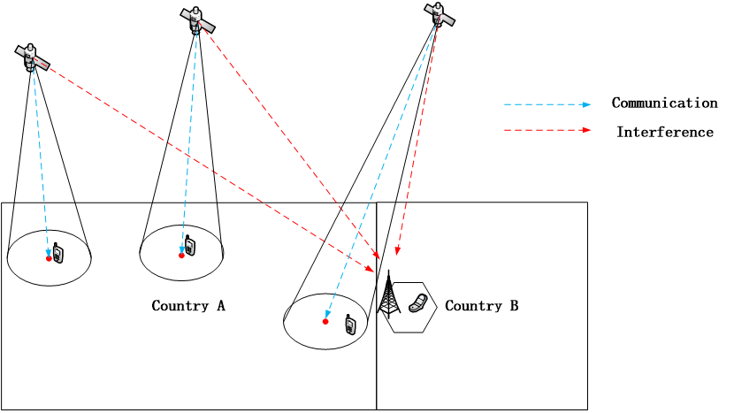
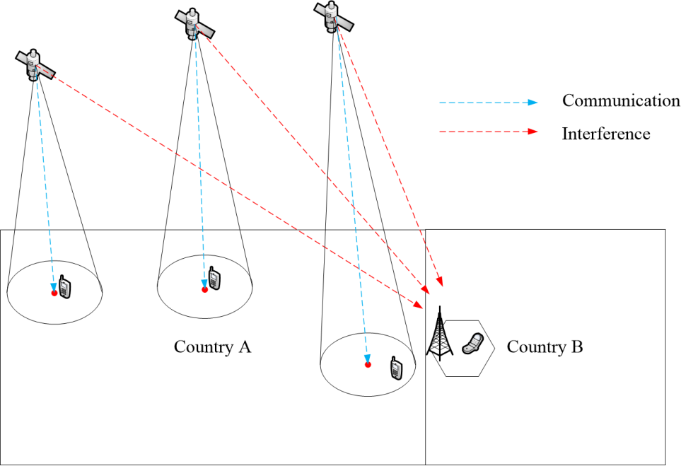

3.2 Methodology

3.2.1 Deterministic calculation-based method
Deterministic calculation-based method is used to evaluate the aggregate PFD value per system from DC-MSS-IMT space stations to protect IMT system consideration the IMT protection criterion I/N =−6dB without any probability (which means the non-exceedance probability of I/N =−6dB is 100%). Deterministic calculation is derived using the following formula:
$PFD=10 \log\left(KTB\right)+\frac{I}{N}+NF-10 \log{\frac{λ^{2}}{4π}-G_{rx}\left(θ_{rx}\right)+OtherLoss}$
where:
$PFD$: Aggregate PFD from DC-MSS-IMT space stations, dB(W/m²·MHz)
$K$: Boltzmann constant, $1.38×{10}^{-23}J/K$
T: Equivalent noise temperature, 290K
B: System bandwidth, MHz
$\frac{I}{N}$: IMT system protection criteria, dB
NF: Receive station noise figure, dBW/MHz
$λ$: Wavelength, m
$G_{rx}\left(θ_{rx}\right)$: IMT receiver station antenna gain in the direction of DC-MSS-IMT space station, dBi
$OtherLoss$: Feeder loss for IMT BS, Body Loss for IMT UE, dB.

3.2.2 Dynamic simulation-based method
Dynamic simulation-based method is used to evaluate the aggregate PFD value per system from DC-MSS-IMT space stations to protect IMT system at the border between neighboring countries with additional isolation required to satisfy the IMT protection criterion with specific non-exceedance probability of I/N =−6dB. Main steps of the simulation are listed as follows.
Step1: Determine the range of simulation area
In this study, DC-MSS-IMT space stations serve DC-MSS-IMT UEs in Country A which shares a border with Country B.
The size of Country A is set to 2442 km in length and 2442 km in width, with the center located at 109°E, 30°N.
Step2: Generate DC-MSS-IMT space stations/DC-MSS-IMT UEs and IMT BSs/UEs
The spatial topology of DC-MSS-IMT space stations is generated at time T based on the parameters of orbital configuration.
DC-MSS-IMT UEs are generated within Country A randomly, and adopts highest elevation satellite selection and pointing strategy to connect to DC-MSS-IMT space stations. The center of space station beam can only point within the territory of Country A.
IMT BSs/UEs are generated along the border of Country B. Based on the deployment-related parameters of IMT system, the inter-site distance is 600m. IMT UEs are generated within IMT base station sectors randomly.
Step3: Simulate the positions of satellite constellation over a period of time and calculate aggregate interference from DC-MSS-IMT space stations to IMT system at each time step
The aggregate interference level is determined by all visible space stations serving DC-MSS-IMT UEs in Country A.
$I_{total}=10 log\left(\sum_{n}^{N}{\sum_{j}^{J}{{10}^{{I_{n,j}}/{10}}}}\right)$
$I_{n,j}=P_{tx}+{G_{tx}(θ_{tx})}_{n,j}-{PL}_{n}+{G_{rx}(θ_{rx})}_{n,j}-L_{other}$
where:
$I_{total}$: Aggregate interference power density from DC-MSS-IMT space stations, dBW/MHz
$I_{n,j}$: Interference power density from j-th beam of n-th space station, dBW/MHz
$P_{tx}$: DC-MSS-IMT space station transmit power density, dBW/MHz
${G_{tx}(θ_{tx})}_{n,j}$: n-th DC-MSS-IMT space station antenna gain in the direction of IMT receiver stations taking into account the j-th main beam of MSS space station is pointing to its serving DC-MSS-IMT UE, dBi
${G_{rx}(θ_{tx})}_{n,j}$: IMT station antenna gain in the direction of MSS space station, dBi
${PL}_{n}$: Propagation loss, dB
$L_{other}$: Feeder loss for IMT BS, Body Loss for IMT UE dB
$N$: The number of DC-MSS-IMT space stations in the interference calculation
$J$: The number of beams of one DC-MSS-IMT space station.
Furthermore, the required additional isolation could be derived based on the received aggregate interference and maximum allowed interference level based on protection criteria I/N=−6dB at different probabilities(X%) of CDF.
$ISO=I_{total}-I_{max}$
$ISO$: The required additional isolation that may be needed to protect IMT system to satisfy the protection criteria I/N=−6dB at different probabilities(X%) of CDF.
$I_{max}$: The acceptable maximum interference power derived based on the protection criteria and receiver noise, dBW/MHz
Step4: Calculate required PFD values from DC-MSS-IMT constellation at the border between neighboring countries
Aggregate PFD is calculated by simulation using the following formulas:
$PFD=10 log\left(\sum_{n}^{N}{\sum_{j}^{J}{{10}^{{{PFD}_{n,j}}/{10}}}}\right)$
${PFD}_{n,j}= P_{tx}+{G_{tx}(θ_{tx})}_{n,j}-10\log_{10}(4πd_{n}^{2})$
where:
$PFD$: Aggregate PFD from DC-MSS-IMTspace stations, dB(W/m²·MHz)
${PFD}_{n,j}$: PFD from j-th beam of n-th space station, dB(W/(m²·MHz))
$P_{tx}$: DC-MSS-IMT space station transmit power density${G_{tx}(θ_{tx})}_{n,j}$: n-th DC-MSS-IMT space station antenna gain in the direction of IMT receiver stations taking into account the j-th main beam of DC-MSS-IMT space station is pointing to its serving DC-MSS-IMT UE, dBi
$d_{n}$: Distance between n-th transmit DC-MSS-IMT space station and IMT receiver station, m.
Based on the additional isolation obtained in Step 3, the required PFD values are derived using the following formula:
${PFD}_{value}=PFD-ISO$
where:
${PFD}_{value}$: Required PFD values of DC-MSS-IMT constellation to protect IMT system at the border between neighbouring countries, dB(W/(m²·MHz)).
Step5: Analyse the study results
4 Study results
This section provides the preliminary aggregate PFD value per system for protecting IMT UE from MSS space station based on the methodologies described in Section 3 above.
4.1 PFD values using deterministic calculation-based method for protecting IMT UE
The aggregate PFD values per system using deterministic method mentioned in section 3.2.1 for protecting IMT UE are as follows:
TABLE A1-15
Aggregate PFD values per system using deterministic method for protecting IMT UE
Frequency band  (MHz) | 800 | 1450 | 1 800 | 2 155 | 2 350 | 2 600
λ(m) | 0.375 | 0.2069 | 0.16667 | 0.13921 | 0.12766 | 0.11538
I/N (dB) | −6 | −6 | −6 | −6 | −6 | −6
G (dBi) | −3 | −3 | −3 | −3 | −3 | −3
BodyLoss (dB) | 4 | 4 | 4 | 4 | 4 | 4
K | 1.38E-23 | 1.38E-23 | 1.38E-23 | 1.38E-23 | 1.38E-23 | 1.38E-23
T (K) | 290 | 290 | 290 | 290 | 290 | 290
B (MHz) | 1 | 1 | 1 | 1 | 1 | 1
NF (dB) | 9 | 9 | 9 | 9 | 9 | 9
N(dBW/MHz) | −143.98 | −143.98 | −143.98 | −143.98 | −143.98 | −143.98
PFD(dBW/m²/MHz) | −114.47 | −109.30 | −107.42 | −105.86 | −105.11 | −104.23
4.2 PFD values using dynamic simulation–based method for protecting IMT UE
Based on the parameters of DC-MSS-IMT in Section 2.1 of Attachment, this section provides the preliminary simulation results of the aggregate interference contributed by DC-MSS-IMT space stations to different IMT UEs that are located at the border between neighbouring countries in the frequency band 2 110-2 200 MHz. According to the simulation results, the aggregate PFD values per system of DC-MSS-IMT space stations at border between neighbouring countries to protect IMT UE are provided.
Figure A1-12
(a) I/N CDF of DC-MSS-IMT to protect IMT UE in the frequency band 2110-2200MHz | (b) Aggregate PFD CDF of DC-MSS-IMT constellation in the frequency band 2110-2200MHz
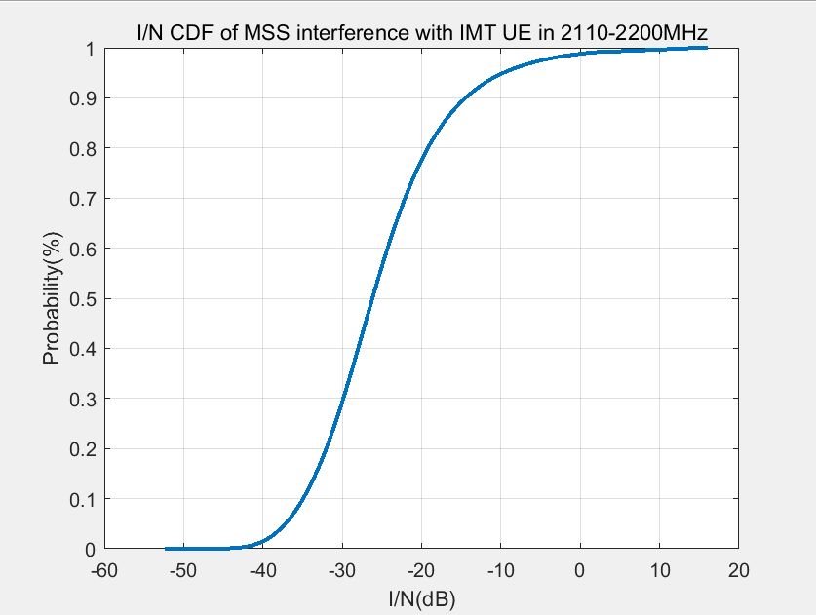 | 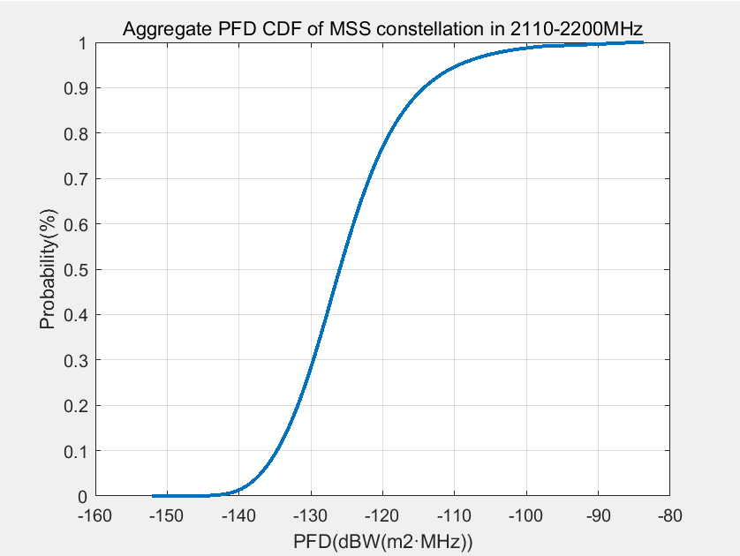
TABLE A1-16
Simulation results for protecting IMT UE
Frequency band (MHz) | X% of I/N CDF (%) | I/N  (dB) | Additional isolation  (dB) | PFD value (dBW(m²·MHz))
2110-2200 | 100 | 16.0935 | 22.0935 | -105.86
2110-2200 | 99.99 | 15.3296 | 21.3296 | -105.0961
2110-2200 | 99.9 | 13.5102 | 19.5102 | -103.2767
2110-2200 | 99.5 | 7.9780 | 13.9780 | -97.7445
5 Summary
This study results based on deterministic calculation method and dynamic simulation method for deriving the aggregate PFD value per system to protect IMT UEs from DC-MSS-IMT space stations at the border between neighboring countries in the frequency band 2110-2200MHz are as follows:
The results of aggregate PFD value per system based on deterministic calculation using IMT protection criterion of I/N =−6dB without any probability to protect IMT UE is −105.86 dB(W/m2·MHz) as the worst case.
The results of aggregated PFD value per system based on dynamic simulation using IMT protection criterion with specific non-exceedance probability of I/N =−6dB are observed as the following:
– considering satisfying the IMT protection criteria I/N=−6dB with 99.99% of probability not to be exceeded, the required aggregated PFD value per system is −105.0961 dB(W/m2·MHz)
– considering satisfying the IMT protection criteria I/N=−6dB with 99.9% of probability not to be exceeded, the required aggregated PFD value per system is −103.2767 dB(W/m2·MHz)
– considering satisfying the IMT protection criteria I/N=−6dB with 99.5% of probability not to be exceeded, the required aggregated PFD value per system is −97.7445 dB(W/m2·MHz).
Other methodologies and associated non-exceedance probability, as appropriate, could also be further discussed and considered in the future.
It should be noted that Working Parties (WPs) 3J,3K and 3M are working on updating Recommendation ITU-R P.2108-1 (Section 3.3) for the frequency band below 10GHz based on the liaison statement from WP 3L and 3M (see Doc. 5D/167). If the study on the clutter loss model is concluded by WPs 3J,3K and 3M, the simulation results could be further updated accordingly.

Study F (Document 5D/633 (D))
1 Introduction
This contribution provides the maximum pfd levels on the ground required for protection of IMT BS in the context of WRC-27 agenda item 1.13 taking into account the IMT BS receiver characteristics respectively. The pfd masks for protection of IMT stations were calculated and plotted for each scenario (i.e. urban, sub-urban and rural) for the frequency bands preliminarily considered under WRC-27 agenda item 1.13. The technical characteristics of IMT were extracted from Annex 4.4 to Document 5D/716 which was developed based on Report ITU-R M.2292 and contains the characteristics of terrestrial component of IMT for sharing and compatibility studies in preparation of WRC-23. Once IMT characteristics for sharing and compatibility studies in preparation of WRC-27 are finalized in Working Party (WP) 5D, the pfd masks contained herein could be updated, if necessary.
2 Technical characteristics of IMT BS
2.1 Frequency ranges
The frequency bands considered under WRC-27 agenda item 1.13 have been grouped into four frequency ranges as seen in Table 2 below to reduce the number of pfd plots and formulas. The lower end of the band is used to plot the pfd masks for protection of IMT BS and UE, i.e. the worst case pfd is calculated for each range.
Table A1-17
Frequency ranges used for calculation of pfd levels
Frequency ranges | Lower end (MHz) | Upper end (MHz) | Frequency bands covered
Below 1 GHz | 698 | 960 | 698-960 MHz
1-2.2 GHz | 1427 | 2 200 | 1 427-1 518 MHz  1 710-1 785 MHz  1 805-2 025 MHz  2 110-2 200 MHz
2.3-2.4 GHz | 2300 | 2 400 | 2 300-2 400 MHz
2.5-2.69 GHz | 2500 | 2 690 | 2 500-2 690 MHz

2.2 Technical characteristics of IMT BS using Non-AAS antenna pattern
The technical characteristics of IMT non-AAS BS (urban, suburban and rural) extracted from Annex 4.4 to Document 5D/716 which was developed based on Report ITU-R M.2292 are provided in Table 2 below. For IMT BS using frequency range below 1 GHz only the non-AAS antenna pattern in used.
Table A1-18
Technical characteristics of IMT non-AAS BS used for calculating the pfd levels
Parameter | Value
Parameter | Rural macro | suburban macro | urban macro
Noise spectral density in dBW/MHz | −143.8
Noise figure in dB | 5
Noise temperature in K | 300
Protection criterion (I/N) in dB | −6
Peak Non-AAS BS antenna gain ($G_{0}$) in dBi | 18 | 16 | 16
Non-AAS BS antenna pattern | Recommendation ITU-R F.1336 (recommends 3.1)  ka = 0.7  kp = 0.7  kh = 0.7  kv = 0.3  Horizontal 3 dB beamwidth ($φ_{3}$): 65 degrees  Vertical 3 dB beamwidth ($θ_{3}$): determined from the horizontal beamwidth by equations in Recommendation ITU-R F.1336.  $$θ_{3}=\frac{31000×{10}^{-0.1G_{0}}}{φ_{3}}$$
Feeder loss in dB | 3
Downtilt | 3° | 6° | 10°

2.3 Technical characteristics of IMT BS using extended AAS antenna model
Antenna characteristics for IMT-2020 AAS base stations in 1 710-4 990 MHz were taken from section 3.2.1.6 of Annex 4.4 to Document 5D/716 and summarised in Tables 3 and 4. Both non-AAS and AAS antenna patterns are used for developing the pfd mask for protection of IMT BS using frequency range above 1 GHz. IMT AAS BS using 1427-1518 MHz band are assumed to use the same characteristics provided in Tables 3 and 4.
Table A1-19
Beamforming antenna characteristics for IMT AAS BS in 1 710-4 990 MHz
Parameter | Value
Parameter | Rural macro | Suburban macro | Urban macro
Antenna pattern | Refer to the extended AAS model in Table 4
Element gain (dBi) (Note 1) | 6.4
Horizontal/vertical 3 dB beam width of single element (degree) | 90º for H  65º for V
Horizontal/vertical front-to-back ratio (dB) | 30 for both H/V
Antenna polarization | Linear ±45º
Antenna array configuration (Row × Column) (Note 2) | 4 × 8 elements
Horizontal/Vertical radiating element/sub-array spacing, dh /dv | 0.5 of wavelength for H, 2.1 of wavelength for V
Number of element rows in sub-array, M_{sub} | 3
Vertical radiating element spacing in sub-array, d_{v,sub} | 0.7 of wavelength of V
Pre-set sub-array down-tilt, θ_{subtilt} (degrees) | 3
Array Ohmic loss (dB) (Note 1) | 2
Base station horizontal coverage range (degrees) | ±60
Base station vertical coverage range (degrees) (Notes 3, 4, 5) | 90-100
Mechanical downtilt (degrees) (Note 4) | 3 | 6 | 6
Note 1: The element gain includes the array ohmic loss and is per polarization. This means that array ohmic loss is not needed for the calculation of the BS composite antenna gain.
Note 2: For the extended AAS model case, 4 × 8 means there are 4 vertical and 8 horizontal radiating sub-arrays.
Note 3: The vertical coverage range is given in global coordinate system, i.e. 90° being at the horizon.
Note 4: The vertical coverage range includes the mechanical downtilt.
Note 5: In sharing studies, the UEs that are below the base station vertical coverage range can be considered to be served by the “lower” bound of the electrical beam, i.e. beam steered towards the max. coverage angle. A minimum BS-UE distance along the ground of 35 m should be used for urban/suburban and rural macro environments.

Table A1-20
Extended AAS model
Description | Equation
Peak normalized element radiation pattern | $$A\left(θ,φ\right)=-min\left[-\left(-min\left[12{\left(\frac{φ}{φ_{3dB}}\right)}^{2},A_{m}\right]-min\left[12{\left(\frac{θ-90}{θ_{3dB}}\right)}^{2},{SLA}_{v}\right] \right),A_{m}\right]$$
Peak gain normalized element radiation pattern | $$A_{E}\left(θ,φ\right)=G_{E,max}+A\left(θ,φ\right)$$
Sub-array excitation | $$w_{m}=\frac{1}{\sqrt{M_{sub}}}exp\left(j2π\left(m-1\right)\frac{d_{v,sub}}{λ}sin\left(θ_{subtilt}\right)\right)$$
Sub-array radiation pattern | $$A_{sub}\left(θ,φ\right)=A_{E}\left(θ,φ\right)+10\log_{10}\left({\left|\sum_{m=1}^{M_{sub}}{w_{m}v_{m}}\right|}^{2}\right)$$  , where  $$v_{m}=exp\left(j2π\left(m-1\right)\frac{d_{v,sub}}{λ}cos\left(θ\right)\right)$$
Array excitation | $$w_{m,n}=\frac{1}{\sqrt{MN}}exp\left(j2π\left(\left(m-1\right)\frac{d_{v}}{λ}sin\left(θ_{etilt}\right)-\left(n-1\right)\frac{d_{h}}{λ}cos\left(θ_{etilt}\right)sin\left(φ_{escan}\right)\right)\right)$$  Where M and N is corresponding to (Row × Column) provided in Table 3
Composite array radiation pattern | $$A_{A}\left(θ,φ\right)=A_{sub}\left(θ,φ\right)+10\log_{10}\left({\left|\sum_{m=1}^{M}{\sum_{n=1}^{N}{w_{m,n}v_{m,n}}}\right|}^{2}\right)$$  , where  $$v_{m,n}=exp\left(j2π\left(\left(m-1\right)\frac{d_{v}}{λ}cos\left(θ\right)+\left(n-1\right)\frac{d_{h}}{λ}sin\left(θ\right)sin\left(φ\right)\right)\right)$$  Where M and N is corresponding to (Row × Column) provided in Table 3

3 Antenna patterns
3.1 IMT BS antenna patterns
Based on the receiver characteristic values of IMT base station provided in Annex 4.4 to Document 5D/716, the non-AAS base station antenna pattern was calculated by applying Recommendation ITU-R F.1336.
The gain versus elevation angle for IMT non-AAS BS deployed in urban, sub-urban and rural macro scenarios are provided in Figure 1 below based on Recommendation ITU-R F.1336 using recommends 3.1.1 which represents the peak side-lobe pattern. The gain versus elevation angle for IMT AAS BS deployed in urban, sub-urban and rural macro scenarios are provided in Figure 2 below based on Extended ASS model.
Figure A1-13
IMT non-AAS BS gain versus elevation angle for urban, sub-urban
and rural macro scenarios based on Recommendation ITU-R F.1336 (recommends 3.1.1)
Figure A1-14
IMT AAS BS gain versus elevation angle for urban, sub-urban
and rural macro scenarios based on Extended AAS model
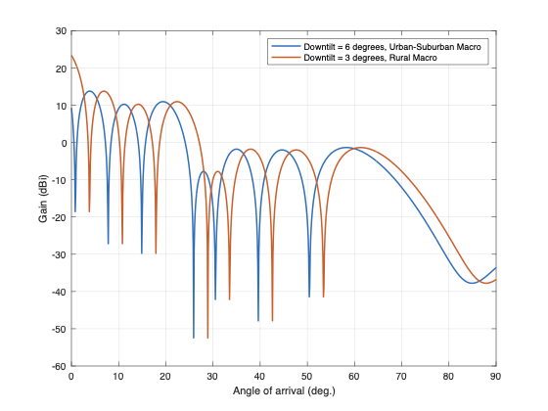

4 Methodology
The maximum pfd levels on the ground that protect IMT receivers are calculated at various frequencies preliminarily considered for WRC-27 agenda item (AI) 1.13, based on IMT BS receiver characteristics extracted from Annex 4.4 to Document 5D/617 which was developed based on Report ITU-R M.2292.
The following formula was used to calculate the pfd levels in dB (W/ (m² · MHz)):
$pfd\left(θ\right)=10\log_{10}\left(kTB\right)+NF+\frac{I}{N}-G_{r}\left(θ\right)+L-10\log_{10}\left(\frac{{}^{2}}{4π}\right)$
where:
k: Boltzmann’s constant ($1.380649 × {10}^{-23} J/K$)
$T$: receiver noise temperature in K
B: reference bandwidth (1 MHz)
NF: receiver noise figure in dB
I/N: protection criteria in dB
$G_{r}\left(θ\right)$: effective antenna gain in dBi of the receiver antenna in the direction of the interferer
$θ$: the elevation angle in degree
$:$ wavelength in m
$L$: Receiver antenna feeder/cable loss for IMT BS using non-AAS/AAS antenna and body loss for IMT UE in dB.
Other losses such as polarization isolation, ionospheric scintillation losses and atmospheric losses, and MSS system characteristics that impact sharing conditions between interfering and victim systems are to be considered during sharing and compatibility studies.
This equation allows the computation of the maximum allowable pfd value in a single direction above the horizon ($θ$). However, if this maximum allowed pfd value is reached in a single direction, the whole margin for I/N is consumed. For interfering sources coming from different directions and contributing to the overall interference perceived by the IMT receiver, further investigations are needed to establish a model to calculate the total amount of pfd allowed over all elevations. WP 4C needs to clarify NGSO systems characteristics, sharing scenarios, as well as whether more than one satellite system would operate co-channel with an IMT terrestrial service in the same geographical area and if any aggregation factor is needed due to multiple satellites in visibility of the terrestrial IMT receiver from multiple elevation angles.
5 PFD masks
5.1 The pfd masks for protection of IMT BS
PFD masks that protect IMT BS are calculated and plotted for the following scenarios:
1 pfd masks for protection of IMT non-AAS BS in rural macro scenario (see Figure 4 below)
2 pfd masks for protection of IMT non-AAS BS in suburban macro scenario (see Figure 5 below)
3 pfd masks for protection of IMT non-AAS BS in urban macro scenario (see Figure 6 below)
4 pfd masks for protection of IMT AAS BS operating in frequency bands above 1 GHz assuming urban/suburban macro scenario (see Figure 7 below)
5 pfd masks for protection of IMT AAS BS operating in frequency bands above 1 GHz assuming rural macro scenario (see Figure 8 below)
Figure A1-15
pfd masks for protection of IMT non-AAS BS in rural scenario
Figure A1-16
pfd masks for protection of IMT non-AAS BS in suburban scenario
Figure A1-17
pfd masks for protection of IMT non-AAS BS in urban scenario
Figure A1-18
pfd masks for protection of IMT AAS BS operating in frequency bands
above 1 GHz assuming urban/suburban scenario
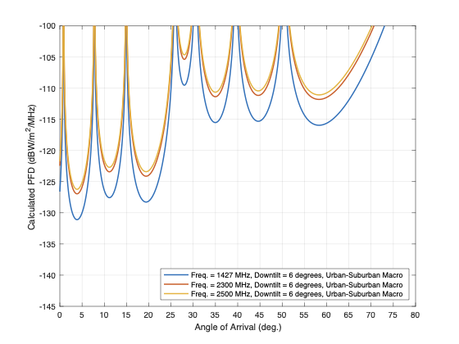
Figure A1-19
pfd masks for protection of IMT AAS BS in frequency bands > 1 GHz assuming rural scenario
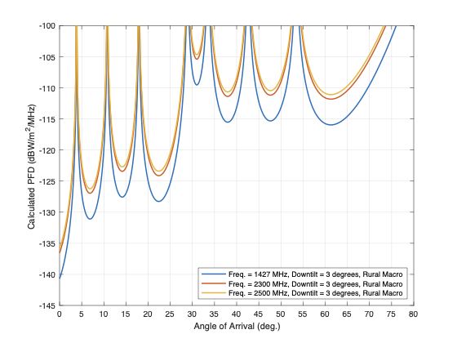
As evident from figures above, the most stringent pfd masks are the ones calculated based on rural macro IMT BS scenarios.
5.2 The envelope PFD mask to protect IMT BS
As seen from the pfd plots above, the most stringent pfd masks are the ones calculated based on rural macro IMT BS scenarios. As such, to develop an envelope pfd mask, 10 000 IMT UEs are randomly located within a single 500-meter IMT macro-BS cell using extended AAS antenna model in rural scenario (see Figure 9 below). The altitude of IMT BS is assumed to be 20 meters, and all the IMT UEs assumed to be at an altitude of 1.5 meters.
Figure A1-20
A single sector with 10 000 IMT UЕs
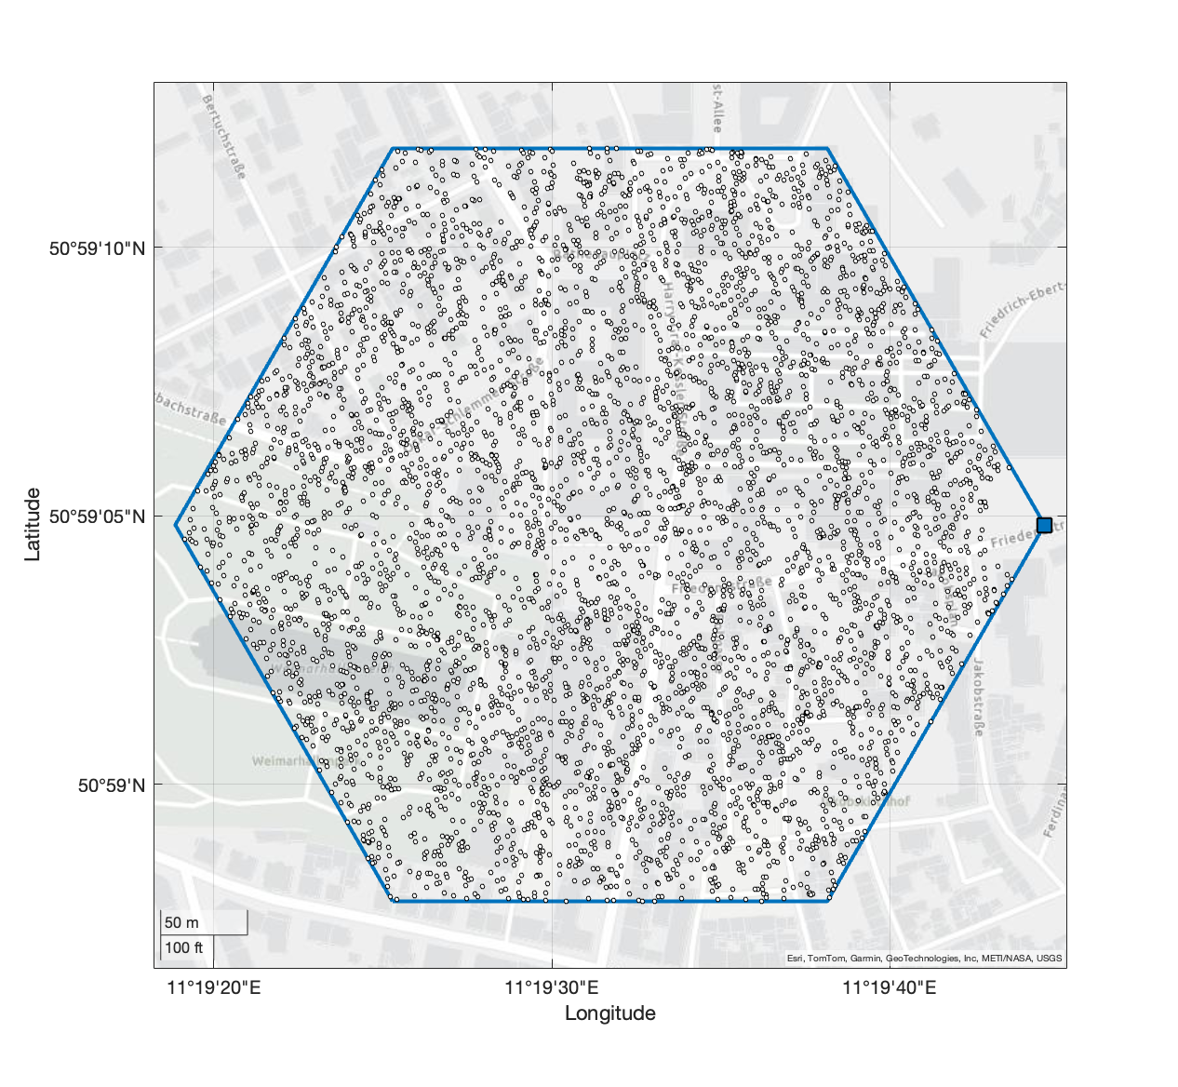
The AAS antenna beam is steered towards 10 000 UE positions within this sector, and the resulting pfd is calculated for each UE position using the same methodology as before. Out of this 10 000 pfd snapshots, the most stringent one is selected as the worst-case pfd needed to protect the IMT BS using the extended AAS antenna pattern.
Figure 10 summarizes the following scenarios in one plot:
1 Sub-GHz range: Single pfd mask for protection of IMT BS using non-AAS antenna pattern
2 1 GHz to 2.2 GHz: the worst-case pfd masks for protection of IMT BS using extended AAS and non-AAS antenna patterns
3 2.3-2.4 GHz: the worst-case pfd masks for protection of IMT BS using extended AAS and non-AAS antenna patterns
4 2.5-2.69 GHz: the worst-case pfd masks for protection of IMT BS using extended AAS and non-AAS antenna patterns.
Figure A1-21
pfd masks for protection of AAS and non-AAS IMT BS in rural macro scenario

Considering the pfd masks provided in Figure 10 are the most stringent pfd (i.e. rural scenario), an envelope pfd mask can be calculated per frequency range to protect IMT BS, irrespective of the type of antenna used. The envelope pfd mask should describe the worst-case pfd per frequency range, merging the curves calculated using the AAS and non-AAS antenna patterns (see Figures 11 and 12 below).
Figure A1-22
Envelop pfd for protection of IMT BS (<1 GHz)
Figure A1-23
Envelop pfd for protection of IMT BS (>1 GHz)

The equations describing the envelop pfd masks in Figures 11 and 12 are provided in Table 6 below.

Table A1-21
Envelope pfd mask equations for protection of IMT BS in rural macro scenario
Frequency range | Pfd equation per frequency range (dB(W/(m² · MHz)))
Below 1 GHz | $$pfd_{mask}\left(θ\right)=\left\{\begin{aligned}-0.21*θ^{2}+1.26*θ-139.6 for θ ≤ 4 \\ 5.017{*e}^{-4}*θ^{3}-0.03379*θ^{2}+0.8451*θ-133.8 for 4 <θ ≤ 27.5 \\ -3.740{*e}^{-7}*θ^{4}+9.845{*e}^{-5}*θ^{3}-0.01053*θ^{2}+0.6512*θ-137.5 for 27.5 <θ ≤ 90\end{aligned}\right.$$
1 GHz to 2.2 GHz | $$fd_{mask}\left(θ\right)=\left\{\begin{aligned}1.106*e^{-4}*θ^{4}-4.47*e^{-3}*θ^{3}+0.08494*θ^{2}-0.353*θ-142.8 for θ ≤ 26.7 \\ 3.896*e^{-3}*θ^{2}+1.585*e^{-2}*θ-122.9 for 26.7 <θ ≤ 31.25 \\ -1.6055*e^{-6}*θ^{5}+4.338*e^{-4}*θ^{4}-4.6637*e^{-2}*θ^{3}+2.5139*θ^{2}-67.94*θ+606.49 for 31.25 <θ ≤ 67.2 \\ -1.396*e^{-3}*θ^{2}+0.3137*θ-127.6 for 67.2 <θ ≤ 90\end{aligned}\right.$$
2.3-2.4 GHz | $$fd_{mask}\left(θ\right)=\left\{\begin{aligned}1.106*e^{-4}*θ^{4}-4.47*e^{-3}*θ^{3}+0.08494*θ^{2}-0.353*θ-138.6 for θ ≤ 26.7 \\ 3.896*e^{-3}*θ^{2}+1.585*e^{-2}*θ-118.7 for 26.7 <θ ≤ 31.25 \\ -1.6055*e^{-6}*θ^{5}+4.338*e^{-4}*θ^{4}-4.6637*e^{-2}*θ^{3}+2.5139*θ^{2}-67.94*θ+610.64 for 31.25 <θ ≤ 67.2 \\ -1.396*e^{-3}*θ^{2}+0.3137*θ-123.5 for 67.2 <θ ≤ 90\end{aligned}\right.$$
2.5-2.69 GHz | $$fd_{mask}\left(θ\right)=\left\{\begin{aligned}1.106*e^{-4}*θ^{4}-4.47*e^{-3}*θ^{3}+0.08494*θ^{2}-0.353*θ-137.9 for θ ≤ 26.7 \\ 3.896*e^{-3}*θ^{2}+1.585*e^{-2}*θ-118 for 26.7 <θ ≤ 31.25 \\ -1.6055*e^{-6}*θ^{5}+4.338*e^{-4}*θ^{4}-4.6637*e^{-2}*θ^{3}+2.5139*θ^{2}-67.94*θ+611.36 for 31.25 <θ ≤ 67.2 \\ -1.396*e^{-3}*θ^{2}+0.3137*θ-122.8 for 67.2 <θ ≤ 90\end{aligned}\right.$$

6 Conclusion
This contribution proposes maximum pfd levels on the Earth’s surface, as a function of angle of arrival, required to protect IMT BS. Germany proposes that WP 5D considers the pfd masks provided in this contribution for protection of IMT under WRC-27 agenda item 1.13.
Note that the IMT parameters outlined in this document may need to be revised if WP 5D agrees different IMT characteristics under AI 1.13.
It should be noted that the pfd calculation formula proposed in this document allows the computation of the maximum allowable pfd value in a single direction above the horizon ($θ$). However, if this maximum allowed pfd value is reached in a single direction, the whole margin for I/N is consumed. For interfering sources coming from different directions and contributing to the overall interference perceived by the IMT receiver, further investigations are needed to establish a model to calculate the total amount of pfd allowed over all elevations. WP 4C needs to clarify NGSO systems characteristics, sharing scenarios, as well as whether more than one satellite system would operate co-channel with an IMT terrestrial service in areas adjacent to the IMT coverage area and if any aggregation factor is needed due to multiple satellites in visibility of the terrestrial IMT receiver from multiple elevation angles.
Once WP 4C responds to the liaison statement from WP 5D (Document 5D/231), additional measures may need to be adopted to account for aggregation factors.

Study G (Doc. 5D/639 (D, G))
1 Introduction
WRC-27 AI 1.13 is intended to study possible new allocations to the mobile-satellite service for direct connectivity between space stations and unmodified IMT UEs. WP 5D is responsible for developing regulatory measures to protect terrestrial IMT systems for inclusion in the draft CPM text for WRC-27 AI 1.13.
2 Method
The method proposed in this contribution is used to determine required pfd limits for ensuring protection of terrestrial IMT networks from DC-MSS-IMT (s-E) transmission.
$PFD\left(θ\right)=10\log_{10}\left(kTB\right)+NF+ \frac{I}{N}-G_{r}\left(θ\right)+L-10 \log_{10}\left(\frac{λ^{2}}{4π}\right)$ (1)
where:
$k$ is Boltzmann’s constant ($1.380649 × {10}^{-23} J/K$)
𝑇 is the receiver noise temperature (Kelvin)
$B$ is the reference bandwidth (1 MHz)
$NF$ is the receiver noise figure (dB)
$\frac{I}{N}$ is the receiver interference to noise ratio limit (dB)
$G_{r}\left(θ\right)$ is the effective antenna gain (dBi) of the receiver antenna towards the direction of the interferer
$θ$ is the elevation angle (°) towards the direction of the interferer
$L$ is the receiver antenna feeder loss for IMT BS (dB)
$10 \log_{10}\left(\frac{λ^{2}}{4π}\right)$ is the antenna aperture (dB.m²) at the wavelength, λ (m).
We note that the method presented in Equation 1 is based on the victim’s perspective w. r. t. the incoming interference power corresponding to the given I/N ratio for a single-entry interferer. However, in case of interference from DC-MSS-IMT (s-E) transmissions, terrestrial IMT stations could receive interferences from multiple satellites (multiple interferers) of the same constellation and/or different constellations.
For the terrestrial IMT UE, the pfd limits obtained using Equation 1 has been adopted as the total pfd from all DC-MSS-IMT satellite emissions from all visible angles measured in a 1 MHz bandwidth at the ground level because $G_{r}(θ)$ will not vary for different satellites. This total pfd can be apportioned between different operators depending on how many satellite operators are in a mobile band serving the same point on earth in the same frequency. The apportioned levels must then be met considering the total emissions from all the satellites of an operator for any area that requires protection.
With respect to the terrestrial IMT BS, Equation 1 can be used to investigate how the pfd limits vary with the victim terrestrial BS antenna pattern for a single satellite interferer. Unlike the UE, the BS antenna gain varies with elevation and so there is an off-axis angle dependency in the BS pfd equation. Therefore the locations of the satellites in the sky need to be known in order to calculate the total interference from multiple visible satellites. As a result, the calculation of the uplink pfd limits for protection of the terrestrial IMT BS is more complex and needs further consideration.
We note that aggregation and apportionment is being discussed at ITU WP 4C. When aggregation and apportionment factors have been agreed by ITU WP 4C, the aggregate pfd limits proposed in this contribution can be calculated on a per satellite basis.
3 Technical Characteristics
In this section, the technical characteristics for the terrestrial IMT UE are presented.
3.1 Terrestrial IMT UE
In Table 1, the values and parameters used to determine the pfd limits using Equation 1 for coexistence with a terrestrial IMT UE operating at the centre of the 900 MHz mobile downlink band, 942.5 MHz are provided.
In determining appropriate parameters for terrestrial IMT user equipment (UE), Working Document 5D/563 is used, which outlines the characteristics of IMT for sharing and compatibility studies in preparation for WRC-27. It should be noted that the current Working Document 5D/563, related to IMT bands under Agenda Item 1.13 for WRC-27, is based on Document 5D/716, which was originally developed for IMT bands under Agenda Item 1.4 for WRC-23.
Our modelling considers that the UE antenna gain is uniform in all directions and so the pfd limits ($PFD(θ))$ obtained using Equation 1 is the same for all angle of arrivals, hence it is not elevation dependent. For the terrestrial IMT UE, we have adopted:
–3 dBi for the IMT UE antenna gain,
0 and 4 dB for IMT UE body loss.
[Editor’s Note: according to Documents 5D/563 and 5D/716, the IMT UE body loss is 4 dB. However, for this contribution, both 0 dB and 4 dB loss values were considered until WP5D makes a final decision on the body loss parameter.]
Table A1-22
Determining pfd limits for coexistence with Terrestrial IMT UE (900 MHz band)
Terrestrial mobile (UE)
Parameter | Value | Comment
Freq (MHz) | 942.5 | Centre of the 900 MHz mobile downlink band
$10\log_{10}\left(kTB\right)$ (dBW/MHz) | -144 | Thermal noise density
$NF$ (dB) | 9 | This is adopted from 5D/7162, Table 1, page 3
$10\log_{10}\left(kTB\right)+NF$ (dBW/MHz) | -135 | UE noise floor density
$\frac{I}{N}$(dB) | -6 | This is adopted from 5D/7162, Table 13, page 26
$G_{r}$ (dBi) | -3 | This is adopted from 5D/7162, Table 5-2, page 12 and represents a typical UE
$10\log_{10}{\frac{λ^{2}}{4π}}$(dB.m²) | -21 | Antenna aperture
Body loss (dB) | 4 & 0 | 4 dB is based on 5D/7162
Note that the IMT UE parameters outlined in Table 1 are for a typical device and may need to be revised if WP5D agrees different IMT characteristics under AI 1.13.

3.2 Terrestrial IMT BS
[TBD]
[Editor’s Note: This section will be further developed and finalized once Working Party 5D has completed its work on defining the IMT base station characteristics. The content will reflect the finalized parameters and specifications as determined by WP5D.]
4 Pfd limits for Terrestrial IMT
In this section, the pfd limits for protecting terrestrial IMT Ues are provided.

4.1 Pfd limits for protecting Terrestrial IMT UE
The pfd limits presented in Table 2 have been calculated using the parameters in Table 1. For the band groups shown in Table 2, the same parameters have been used to calculate the pfd limits for all the bands considered for DC-MSS-IMT. The only exception to this is the antenna aperture term (10∙log10(λ²/4π) which is frequency dependent and so varies between IMT bands.
In order to minimise the number of different pfd limits satellite network operators (SNO) need to comply with, the pfd limits in Table 2 have been grouped such that the spread in the pfd limits calculated is around a few dBs.
Table A1-23
Aggregate pfd for protecting terrestrial IMT UE
Mobile Band | Pfd limits in mobile downlink spectrum  (0 dB body loss) | Pfd limits in mobile downlink spectrum  (4 dB body loss)
MHz | dBW / MHz / m² | dBW / MHz / m²
700, 800, 900 | ‒119 | ‒115
1400 | ‒113 | ‒109
1800, 1900, 2100 | ‒111 | ‒107
2300, 2600 | ‒108 | ‒104
[Editor’s Note: once WP5D agrees on the various IMT characteristics under AI 1.13—particularly regarding IMT UE body loss—the appropriate option listed in the table shall be used to ensure the protection of IMT UE.]

4.2 Equivalent RSRP
We note that administrations do not normally use pfd limits when describing coverage in terrestrial IMT mobile networks. A more common terminology is Reference Signal Received Power (“RSRP”), so we have translated our pfd limits into the equivalent RSRP limit to allow for comparison. We note that this equivalent RSRP limit conversion assumes a noise-limited environment rather than interference-limited environment.
We calculated the equivalent RSRP limit as follows:
$P_{R}=10\log_{10}\left(kTB\right)+NF+ \frac{I}{N}-G_{r}\left(θ\right)+L$ (2)
where:
P_{R} is the power limit at the UE antenna connector, equivalent to the pfd limit at the UE antenna (dBW / MHz).
other terms have the same meaning as in equation 1.
And
$P_{RSRP}=P_{R}+10∙\log_{10}\left(1000\right)+10∙\log_{10}{(15/1000)}$ (3)
where:
P_{RSRP} is the equivalent RSRP limit assuming a noise limited environment (dBm)
P_{R} is the power limit at the UE antenna connector, equivalent to the pfd limit at the UE antenna (dBW / MHz).
$10∙\log_{10}\left(1000\right)$ is the unit magnitude adjustment factor going from dBW to dBm (dB)
$10∙\log_{10}{(15/1000)}$ is the bandwidth adjustment factor going from 1 MHz to the bandwidth of a single resource element, 15 kHz (dB)
We note that using the values from Table 1, we get an equivalent RSRP limit of ‒126 dBm for all mobile bands (because RSRP, unlike pfd, does not have a frequency dependency). This is 6 dB below the minimum useable sensitivity commonly cited for mobile user equipment (-120 dBm RSRP).

4.3 Protecting the Terrestrial IMT BS
[TBD]
[Editor’s Note: When aggregation and apportionment factors have been agreed by ITU WP 4C, aggregate or per satellite pfd limits can be proposed for protecting the terrestrial IMT BS]

5 Aggregation And Apportionment
The proposed pfd limits in this contribution are maximum aggregate power pfd limits from multiple satellites and multiple constellations for protection of terrestrial IMT downlink. We also consider that a “per satellite” transmission pfd limit could also be appropriate in order to provide measurable limits. However, a per satellite pfd limit requires knowledge of the aggregation effect.
Furthermore, DC-MSS-IMT is still a relatively new technology, and it is uncertain how many SNOs will provide DC-MSS-IMT services in each mobile band as the market matures, hence further analysis is required to determine whether an apportionment factor is needed.
WP 4C needs to clarify NGSO systems characteristics, sharing scenarios, as well as whether more than one satellite system would operate co-channel with an IMT terrestrial service in the same geographical area and if any aggregation factor is needed due to multiple satellites in visibility of the terrestrial IMT receiver from multiple elevation angles.
Consequently, further work is needed to derive the pfd limits for the protection of the terrestrial IMT BS including determining a per satellite pfd value as it is possible that there are multiple active satellites/beams in view of a terrestrial IMT BS.

6 Conclusion
Based on the analysis presented in this contribution, the aggregate pfd limits below are proposed for protecting terrestrial IMT Ues from DC-MSS-IMT s-E transmissions.
Table A1-24
Aggregate pfd limits from multiple satellites and multiple constellations
Mobile Band | Pfd Limit in mobile downlink spectrum  (0 dB body loss) | Pfd Limit in mobile downlink spectrum  (4 dB body loss)
MHz | dBW / MHz / m² | dBW / MHz / m²
700, 800, 900 | ‒119 | ‒115
1400 | ‒113 | ‒109
1800, 1900, 2100 | ‒111 | ‒107
2300, 2600 | ‒108 | ‒104
[Editor’s Note: once WP5D agrees on the various IMT characteristics under AI 1.13—particularly regarding IMT UE body loss—the appropriate option listed in the table shall be used to ensure the protection of IMT UE.]

Study H (Doc. 5D/712 (CHN))
1 Introduction
For IMT UE, due to the use of omnidirectional antennas, the interference from satellites to IMT UEs varies synchronously with the generated pfd. This enables the calculation of aggregated pfd limit through the difference between the aggregated interference generated by the satellites and the interference criteria, as well as the aggregated pfd values generated by the satellites.
For IMT BS, due to the use of directional antennas, the interference of satellites to IMT BSs and the pfd generated at IMT BSs will not change synchronously. The methods used for IMT UEs are no longer applicable to IMT BSs. This attachment provides consideration on the method to calculate the aggregated pfd limit for protecting IMT BS.
2 Consideration on the method to calculate the aggregated pfd limit for the protection of IMT BS
Step 1: Generate the interference scenario
Two options can be considered as the interference scenarios.
① Considering the scenario that DC-MSS-IMT is only deployed in a specific area, calculate the aggregated PFD limit based on the interference situation of satellites in this area to the IMT BSs in adjacent areas.
② Considering the scenario that DC-MSS-IMT is only prohibited from operating in a specific area, calculate the aggregated pfd limit based on the interference of all the visible satellites outside this area to the IMT BSs within that area.
The size and location of the deployment area and the prohibited deployment area in the above scenarios, as well as the location of the IMT BS, can be specifically set according to the simulation scenarios.
Step 2: For a specific scenario, generate all the satellites according to the orbital parameters, and determine the satellites that are visible to the IMT BS and in operation.
Step 3: For a specific time T_{i}, calculate the aggregated interference to the IMT BS
$$I_{total, Ti}=10 log\left(\sum_{n}^{N}{\sum_{j}^{J}{{10}^{{I_{n,j}}/{10}}}}\right)$$
$$I_{n,j}=P_{tx}+G_{tx}(θ_{tx})-PL+G_{rx}(θ_{rx})-L_{other}$$
where:
$I_{total, T1}$: Aggregate interference power density from satellites, dBW/MHz
$I_{n,j}$: Interference power density from j-th beam of n-th satellite, dBW/MHz
$P_{tx}$: Satellite transmit power density, dBW/MHz
$G_{tx}(θ_{tx})$: Satellite antenna gain in the direction of IMT BS taking into account the main beam of satellite is pointing to its serving UE, dBi
$G_{rx}(θ_{tx})$: IMT BS antenna gain in the direction of satellite, dBi
$PL$: Propagation loss, dB
$L_{other}$: other losses, such as feeder loss
$N$: The number of visible satellite from the view of IMT station
$J$: The number of beams of one satellite.
Step 4: Calculate the difference between the aggregated interference and the protection criteria.
$${ISO}_{Ti}=I_{total, T1}-I_{th}$$
${ISO}_{Ti}$: The difference between the aggregated interference and the protection criteria, which is also the required additional isolation that is needed to protect IMT BSs.
Step 5: Calculate the aggregated pfd value produced at the IMT BS
$${PFD}_{Ti}=10 log\left(\sum_{n}^{N}{\sum_{j}^{J}{{10}^{{{PFD}_{n,j}}/{10}}}}\right)$$
$${PFD}_{n,j}= P_{tx}+G_{tx}(θ_{tx})-10\log_{10}(4πd_{n}^{2})$$
where:
${PFD}_{Ti}$: Aggregated PFD from satellites, dB(W/m²·MHz)
${PFD}_{n,j}$: PFD from j-th beam of n-th satellite, dB(W/(m²·MHz))
$P_{tx}$: Satellite transmit power density, dBW/MHz
$G_{tx}(θ_{tx})$: Satellite antenna gain in direction of IMT BS, dBi
$d_{n}$: Distance between n-th satellite and IMT BS, m.
Step 6: Calculate the PDF limit derived according to the specific scenario at the time T_{i}
$${PFD}_{limit, Ti}={PFD}_{Ti}-{ISO}_{Ti}$$
where:
${PFD}_{limit, Ti}$: Required PFD limit to protect IMT BSs at the time T_{i}, dB(W/(m²·MHz)).
Step 7: Set the simulation step size of the time as t, advance the time by one step size, regenerate the position of satellites, and repeat Steps 2-6.
Step 8: Simulate M simulation step sizes to ensure that the total simulation duration covers at least one cycle of the constellation’s operation.
Step 9: Analyse the study results. According to the M PFD limits that obtained through the above steps, a CDF curve of pfd limits can be obtained. If the non-exceedance probability in the IMT criteria is X%, the pfd limit required should take the point of (100-X)% on the CDF curve.

Study I (Doc. 5D/739 (Ericsson))
Introduction
Different regulatory measures (PFD per satellite, aggregate PFD, EPFD and aggregate EPFD) are under discussion for protection of IMT from harmful interference due to DC-MSS-IMT in studies under WRC-27 agenda item 1.13.
In this contribution, we provide some comments on proposed regulatory measures for protection of IMT UE and IMT BS and propose values for PFD/EPFD limits.
Discussion
When defining PFD/EPFD limits for protection of terrestrial IMT from DC-MSS-IMT, the interference budget must be partitioned among all potential interfering satellites (all visible DC-MSS-IMT satellites either in one constellation or in multiple constellations). A simplified approach to partition the interference budget among multiple systems is to define multi-system aggregation factor. Both “maximum aggregate PFD/ EPFD limits” and “PFD /EPFD limits per system (single entry limit)” need to be defined to ensure protection of terrestrial IMT UE and IMT BSs from DC-MSS-IMT systems,
In addition, to ensure protection of terrestrial IMT, verification procedures to examine the compliance of DC-MSS-IMT systems with PFD/EPFD limits must be defined. There is a procedure available in ITU to verify the compliance of non-GSO systems with EPFD limits derived for protection of GSO earth stations. That procedure could potentially be modified to be used for verifying the compliance of DC-MSS-IMT systems with EPFD limits defined for protection of IMT UE and BSs.
Protection of terrestrial IMT from multiple DC-MSS-IMT systems
As discussed in Document 4C/336, there is the potential of receiving interference from at least two DC-MSS-IMT systems at the border of many countries. Therefore, when defining PFD/EPFD limits per system, a procedure to ensure protection of terrestrial IMT from potential interference from multiple DC-MSS-IMT systems must be identified.
A simplified approach could be considering a multi-system aggregation factor, for example 3 dB to reflect the possibility of interference due to two MSS-DC-IMT systems which could be actively transmitting co-frequency in visibility of the border. We have used this approach in this contribution.
Protection of IMT UE from DC-MSS-IMT
Since IMT UE has an isotropic antenna, the values for aggregate PFD and EPFD limits derived from the IMT UE receiver characteristics are equal. While the compliance of MSS systems with aggregate PFD limits are not examined by ITU, there is an ITU procedure to verify the compliance with EPFD limits. Therefore, in case of aggregate PFD limits, a procedure to examine the compliance of DC-MSS-IMT systems with those limits must be defined.
To protect IMT UE from harmful interference due to MSS-DC-IMT, the maximum aggregate PFD/EPFD due to all visible satellites operating co-frequency (either in one constellation or in multiple constellations) should not exceed the value obtained by equation (1).
$Maximum aggregate PFD/EPFD=10\log_{10}\left(kTB\right)+NF+\frac{I}{N}-G_{UE}-10\log_{10}\left(\frac{{}^{2}}{4π}\right)$ (1)
where:
$k$: Boltzmann’s constant (-228.6 dB(W/(K ⋅ Hz)))
$T$: receiver noise temperature (300 K)
$B$: reference bandwidth (1 MHz)
$NF$: receiver noise figure in dB
$I/N$: protection criterion in dB
$G_{UE}$: antenna gain of IMT UE in dB.
Considering 3 dB multi-system aggregation factor, aggregate PFD/EPFD limit per system (single entry PFD limit) can be obtained using equation (2)
$Aggregate PFD/EPFD per system=Maximum aggregate PFD/EPFD-3$ (2)
In Table 1, we propose maximum aggregate PFD and EPFD limits (considering interference from multiple DC-MSS-IMT systems) and aggregate PFD and EPFD limits per system for protection of UE. The proposed values are obtained using equation (1) and (2), assuming the lowest frequency in each frequency range and the protection criterion of I/N = ‒20 dB. We note that the protection criterion is still under discussion in WP 5D and the proposed values might need to be updated later.
Table A1-25
Aggregate PFD/ EPFD limits in dB(W/(m² . MHz)) for protection of IMT UE
Frequency range | < 1 GHz | 1.5 GHz | > 2 GHz
UE antenna gain (dBi) | ‒3 dBi | ‒3 dBi | ‒3 dBi
Noise figure (dB) | 9 | 9 | 9
I/N (dB) | ‒20 | ‒20 | ‒20
Frequency (MHz) for calculating PFD values | 700 | 1500 | 2000
Maximum aggregate PFD/ EPFD limit | ‒134 | ‒127 | ‒124
Aggregate PFD/ EPFD limit per system | ‒137 | ‒130 | ‒127

Protection of IMT BS from DC-MSS-IMT
To ensure protection of BSs from DC-MSS-IMT, the total interference received by the BS from all interfering satellites, either belong to one system or multiple systems, should be equal to the BS maximum tolerable interference. The interference received by BS from multiple interfering satellites depends on the gain of the BS towards the satellites. Therefore, to derive the limits for protection of BSs, one has to take into account the effect of the antenna gain correctly (see Doc. 5D/525 for more details and explanation).
As discussed in Document 5D/525, compared to aggregate PFD limits, EPFD limits take into account the aggregate interference due to all transmitting stations within a satellite constellation considering the directional antenna gain of the victim receiver towards interfering satellites. In addition, the ITU procedure to verify the compliance of non-GSO systems with EPFD limits derived for protection of GSO earth stations could potentially be modified to be used for ensuring protection of IMT BSs.
However, when defining aggregate PFD limits for protection of BSs, two issues must be addressed:
1) How to take into account the antenna gain of the BS towards different interfering satellites?
2) How can ITU verify the compliance of a MSS system with aggregate PFD limits?
EPFD limits for protection of BSs
Defining EPFD like the definition of EPFD in Article 22.5C.1, using gain of BS toward horizon ($G_{BS}\left(φ=0\right)$) as the maximum gain of the BS toward interfering satellites, we have
$EPFD=10\log_{10}{\sum_{i}{\left(\frac{{10}^{\frac{P_{i}}{10}} G_{Sat}\left(θ_{i}\right)}{4πd_{i}^{2}}\frac{G_{BS}\left(φ_{i}\right)}{G_{BS}\left(φ=0\right)}\right)}}$ (3)
The maximum aggregate EPFD limit for protection of BSs can be obtained from the BS receiver characteristics as:
$Aggregate EPFD =10\log_{10}\left(kTB\right)+NF+\frac{I}{N}+L_{f}-10\log_{10}\left[G_{BS}\left(φ=0\right)\right]-10\log_{10}\left(\frac{{}^{2}}{4π}\right)$ (4)
Considering 3 dB multi-system aggregation factor, EPFD limit per system (single entry EPFD limit) can be obtained as
$EPFD per system=Aggregate EPFD -3$ (5)
Maximum aggregate EPFD and EPFD per system for non-AAS BSs in rural deployment are obtained and summarized in Table 2.
Table A1-26
EPFD limits in dB(W/(m² . MHz)) for protection of non-AAS IMT BS
Frequency range | < 1 GHz | 1.5 GHz | > 2 GHz
Peak of antenna gain (dBi) | 18 | 18 | 18
Downtilt (degree) | 3 | 3 | 3
$G_{BS}\left(φ=0\right)$ (dBi) | 16 | 16 | 16
Noise figure (dB) | 5 | 5 | 5
Feeder loss (dB) | 3 | 3 | 3
I/N (dB) | ‒20 | ‒20 | ‒20
Frequency (MHz) for calculating PFD values | 700 | 1500 | 2000
Maximum aggregate EPFD | ‒154 | ‒147 | ‒144
EPFD per system | ‒157 | ‒150 | ‒147

Aggregate PFD limits for protection of BSs
The aggregate PFD from a constellation at the location of IMT BS is
$Aggregate PFD per system=10\log_{10}{\sum_{i}{\frac{EIRP_{i}(θ_{i})}{4πd_{i}^{2}}}}=10\log_{10}{\sum_{i}{\left(\frac{{10}^{\frac{P_{i}}{10}} G_{Sat}\left(θ_{i}\right)}{4πd_{i}^{2}}\right)}}$ (6)
To be able to define aggregate PFD limit for protection of BS, one idea is to model the BS as a receiver with an isotropic antenna with the equivalent gain of $α*G_{BS}\left(φ=0\right)$, where $0<α<1$ needs to be estimated after doing sharing studies. Note that the value of $α$ depends on the satellite constellation parameters, particularly the number of satellites in the constellation.
With this modeling, the maximum aggregate PFD for protection of BSs can be obtained in a way similar to IMT UE. Therefore,
$$Maximum aggregate PFD for protection of BS=$$
$10\log_{10}\left(kTB\right)+NF+\frac{I}{N}+L_{f}-10\log_{10}(α)-10\log_{10}\left[G_{BS}\left(φ=0\right)\right]-10\log_{10}\left(\frac{{}^{2}}{4π}\right)$ (7)
Considering 3 dB multi-system aggregation factor, aggregate PFD limit per system (single entry limit) can be obtained as
$Aggregate PFD per system =Maximum aggregate PFD for protection of BS-3$ (8)
Maximum aggregate PFD and aggregate PFD per system for non-AAS BSs in rural deployment are obtained and summarized in Table 3.
Table A1-27
Aggregate PFD limits in dB(W/(m² . MHz)) for protection of non-AAS IMT BS
Frequency range | < 1 GHz | 1.5 GHz | > 2 GHz
Peak of antenna gain (dBi) | 18 | 18 | 18
Downtilt (degree) | 3 | 3 | 3
$G_{BS}\left(φ=0\right)$ (dBi) | 16 | 16 | 16
$$α$$ | TBD | TBD | TBD
Noise figure (dB) | 5 | 5 | 5
Feeder loss (dB) | 3 | 3 | 3
I/N (dB) | ‒6 | ‒6 | ‒6
Frequency (MHz) for calculating PFD values | 700 | 1500 | 2000
Maximum aggregate PFD | $$-154-10\log_{10}\left[α\right]$$ | $$-147-10\log_{10}\left[α\right]$$ | $$-144-10\log_{10}\left[α\right]$$
Aggregate PFD per system | $$-157-10\log_{10}\left[α\right]$$ | $$-150-10\log_{10}\left[α\right]$$ | $$-147-10\log_{10}\left[α\right]$$

Proposal
Based on the discussion and analysis presented in this contribution, it is proposed to:
• consider including both “maximum aggregate PFD/ EPFD limits” and “PFD /EPFD limits per system (single entry limit)” for protecting terrestrial IMT UE and IMT BSs from DC-MSS-IMT systems;
• consider 3 dB multi-system aggregation factor when defining PFD/ EPFD limits per system (this value might need to be updated);
• update working document on studies for the regulatory considerations to protect terrestrial IMT systems under WRC-27 agenda item 1.13 (Annex 4.6 to Document 5D/563) as proposed in the attachment. Note that the attachment shows only section 5 “Regulatory limits for the frequency bands within the range 694-2700 MHz” of the of the working document with track changes activated as no changes proposed to the other sections.

ANNEX 2
Factors impacting the aggregate interference from
DC-MSS-IMT TO terrestrial IMT
Study A (Doc 5D/543 (F))
The factors impacting the aggregated interference from MSS for the Protection of IMT TN under WRC-27 agenda item 1.13
Protection of International Mobile Telecommunication (IMT) terrestrial networks is achieved by considering the number of satellites visible from a given location on Earth, its variation over time due to the constellation satellite motions, and as a function of the minimum elevation angle.
Constellation characteristics
The constellation characteristics are based on [Document 4C/156] and shown in Table 1.
Table A2-1
Parameters of orbital configuration
Altitude (km) | Inclination (deg) | Planes | Sats per plane | RAAN spacing (deg) | Total number of sats
500 | 55 | 60 | 60 | 6 | 3600

Methodology and results
Simulation of the satellite constellation at 5 different epochs (starting from epoch t0 = 2019/08/12 12:00:00), regularly spaced between time t = t0 and t = t0 + 7T, with T being the orbital period (T = 5677s / 94.6 minutes).
Considering an Earth Station at a given location on Earth, e.g., at the French border, given by:
lat = 46.250°, lon = 6.217°, alt = 0 Km
The number of satellites visible from an Earth Station is determined based on the elevation angle relative to the Station’s ground location. This can be evaluated for different thresholds of the elevation angle, such as theta>20°, theta>10°, or theta>0°. The results are shown in Table 2.
Table A2-2
Number of satellites visible from a given location on Earth [lat = 46.250°, lon = 6.217°, alt = 0 Km],
according to the elevation angle w.r.t. the ground location
Time | 0 | 1.75T | 3.5T | 5.25T | 7T
Nb of visible satellites with theta > 0° | 188 | 189 | 191 | 186 | 193
Nb of visible satellites with theta > 10° | 96 | 95 | 100 | 95 | 100
Nb of visible satellites with theta > 20° | 51 | 52 | 53 | 47 | 51
Max theta [°] | 64.4 | 63.5 | 72.3 | 68.5 | 83
The number of visible satellites is almost constant over the time, since the considered constellation is very dense with 60 orbital planes of 60 satellites each. For a visibility defined by theta > 20°, almost 50 satellites are visible from the Earth Station at the given location. For a visibility higher than the horizon (theta > 0°), the number of visible satellites are much higher, almost 188 visible satellites.
Figure A2-1
CDF of the elevation angles of satellites which are visible for a given location on Earth
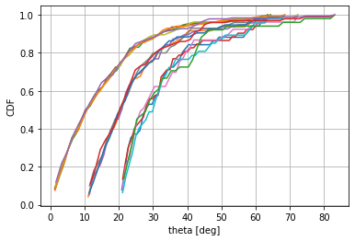
Theta >0°
theta>10°
Theta >20°
Figure A2-2
CDF of the distance distribution of satellites which are visible for a given location on Earth
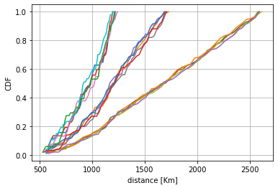
Theta >20°
Theta >10°
Theta >0°
Figures 1 and 2 show the statistical distribution (CDF) of the elevation angles (theta) and the distances between the Earth station’s location at the ground and each visible satellite. The probability of high elevation angles, corresponding to small separation distances, is low.
Figure A2-3
Number of visible satellites as a function of the latitude of the Earth Station
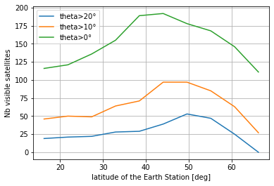
Figure 3 shows that the number of visible satellites varies with the latitude of the Earth Station.
Analysis
The aggregation factor depends on the number of visible satellites. From an UE perspective, all visibility directions are equivalent. However from a BS perspective, it depends on the beam orientation of the BS, which amplifies some directions while attenuating others. In other words, the pfd will be more constraining for low elevation angles than for high elevation angles.
The aggregation factor could be based on the assumption that all satellites in visibility are strictly complying with the pfd mask. However, it may be useful to include consideration of how such a dense satellite constellation manage the communications towards the UE when several satellites have good visibility. In addition, the aggregation factor may be distributed over various elevation angles in a differentiated mode (e.g. more for low elevation angles and less for high elevation angles) in order to have a pfd mask fitting better the satellite antenna performance.

Study B (Doc 5D/652 (RUS))
Analysis of interference from DC-MSS-IMT multiple satellite systems
In the below analysis, the mutual interference from three DC-MSS-IMT satellite systems operating in the same frequency band in three different neighbouring countries is considered.
Annex 7 to Document 4C/356 provides the preliminary proposed technical characteristics of DC-MSS-IMT systems towards technical studies under WRC-27 agenda item 1.13 which could be used as the basis of the study. Detailed technical characteristics are summarized in Tables 1 and 2.
TABLE A2-3
Parameters of orbital configuration
System ID | Altitude (km) | Inclination  (deg) | # Planes | Sats per plane | RAAN spacing  (deg) | Total number of sats
System 1  (non-GSO) | 680 | 97 | 12 | 60 | 6 | 720
System 2  (non-GSO) | 500 | 55 | 60 | 60 | 6 | 3 600
System 3  (non-GSO) | 525 | 53 | 28 | 120 | 12.9 | 3 360
System 3  (non-GSO) | 340 | 53 | 48 | 110 | 7.5 | 5 280
Table A2-4
Parameters of DC-MSS-IMT satellite systems
 | Parameter | Unit | System 1 | System 2 | System 3
Downlink (Space-to-Earth) | Frequency band | MHz | 2 620-2 690 | 2 620-2 690 | 2 620-2 690
Downlink (Space-to-Earth) | Emission bandwidth | MHz | 5 | 5 | 5
Downlink (Space-to-Earth) | S/S Transmitter power | dBW | ‒10...16  (min, max) | 13 | -
Downlink (Space-to-Earth) | S/S EIRP | dBW | 26 … 52  (min, max) | 51.1 | -
Downlink (Space-to-Earth) | EIRP spectral density | dBW/Hz | ‒41 … ‒15  (min, max) | ‒15.9 | ‒18.1 dBW/Hz @EL 90°⁽¹⁾
Downlink (Space-to-Earth) | S/S antenna pattern | n/a | S.1528 | M.2101 | S.1528
Downlink (Space-to-Earth) | S/S peak antenna gain | dBi | 38 | 47.5 | 34.1
Downlink (Space-to-Earth) | Single element antenna gain | dBi | - | 4.15 | -
Downlink (Space-to-Earth) | Antenna array configuration  (Row × Column) | - | - | 50×50 | -
Notes to the Table:
⁽¹⁾ In terms of modelling the variation of PFD with slant path, several options can be considered, and correspond to several ways operators manager real-world operations:
• Keep PFD constant on the ground, i.e. adjust EIRP at the satellite to ensure a constant PFD on the ground regardless of the slant path / arrival angle.
• Keep EIRP constant at the satellite: this implies that the PFD value contained in Table 1 is only ensured at Nadir, while it will be lower at lower elevation, i.e. as the slant path increases.
• Hybrid mode: some systems adjust the EIRP to ensure constant PFD on the ground only up to a certain elevation angle, after which the EIRP is not increased more, thus the PFD decreases as the elevation angle decreases.
figure A2-4
Modelling of the System 1
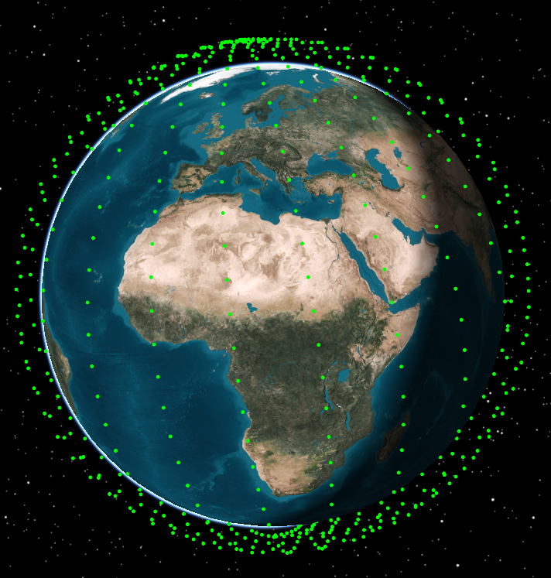
figure A2-5
Modelling of the System 2
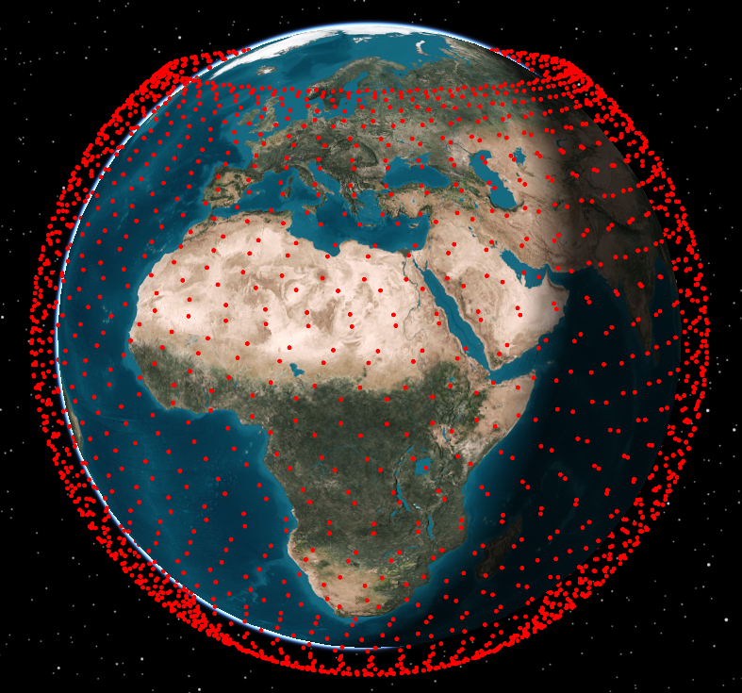
figure A2-6
Modelling of the System 3
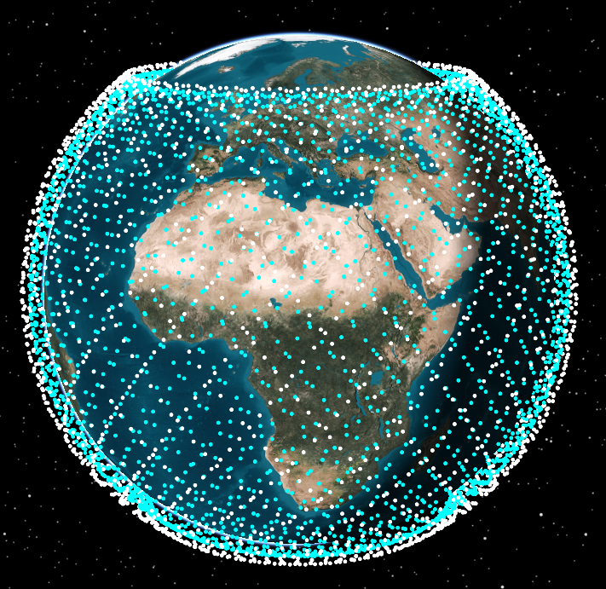
Methodology of simulation
Interference from the i^{th} active satellite station was calculated using the following expression:
$$I_{iRSS}=\frac{P_{iRSS}∙G_{Tx}{∙G}_{Rx}∙c^{2}}{{(4πdf)}^{2}}$$
where:
P_{iRSS} – power of the i^{th} satellite (in Watts);
G_{Tx} – gain of the transmitting satellite (in absolute);
G_{Rx} – gain of the interference receiving station (in absolute);
d – Distance between transmitter and receiver (in meters)
λ – Wavelength of the signal (in meters);
c – Speed of light;
f – Frequency of the signal (in Hz).
The total interference-to-noise ratio from all interfering satellites is calculated using:
$$\frac{I}{N}\left[\text{dB}\right]=10{log}\left(\sum_{i}{10^{\frac{I_{iRSS}\left(i\right)}{10}}}\right)-10 log\left(kTB\right),$$
where:
I_{iRSS} – interfernence power from each i^{th} interfereing satellites (in Watts);
B – bandwidth of the victim receiver (in Hz);
T – noise temperature of the victim receivier (in Kelvin);
k – Bolzmann’s constant.
To calculate the statistical distribution of interference levels, the following algorithm was applied:
Step 1: For each time step during the simulation period, the following are computed:
‒ The position of each interfering station (DC-MSS-IMT).
‒ The location of the victim receiving station (DC-MSS-IMT).
‒ The angle between:
• the direction from the interfering station to the victim receiver, and
• the main axis of the antenna of each interfering space or ground station.
‒ The gain of the transmit antenna of each interfering space/ground station in the direction of the victim receiver.
‒ The distance between each interfering space station and the victim receiving station.
‒ The gain of the victim receiver’s antenna in the direction of each interfering station.
‒ The resulting interference power at the input of the victim receiver from each interfering station.
Step 2: These calculations are repeated for all time steps within the simulation interval, using a fixed time resolution. This process produces a dataset of I/N values over time.
Step 3: Based on the dataset generated in Step 2, the cumulative distribution function (CDF) of the I/N for the space-to-Earth link is generated.
To estimate possibility of aggregation of interference from multiple satellite systems it was assumed that those systems will operate in the same frequency band and the territory of three neighbouring countries. Each system was operating within the borders of the respective country. Figure 4 illustrates the scenario where two systems operate on the adjacent territories of two countries.
FIGURE A2-7
Scenario of operation of two DC-MSS-IMT systems
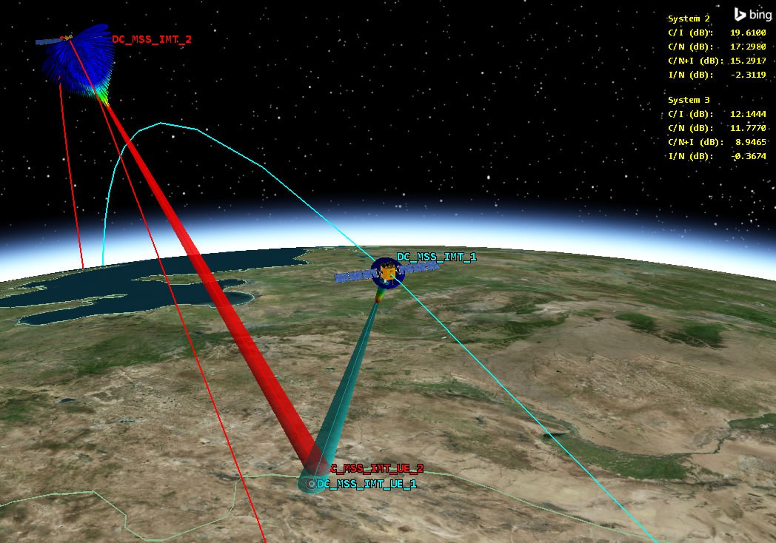
It was also taken into account that the level of interference largely depends on the separation distances between the DC-MSS-IMT user equipment (UE) and the coverage area of interfering space system in the adjacent countries.
For each system the interference was calculated for different separation distances from border: 10 km, 20 km, 30 km, 40 km and 50 km.
Figure 5 illustrates distribution of user terminals at different distances from the border.
figure A2-8
Distribution of DC-MSS-IMT UEs
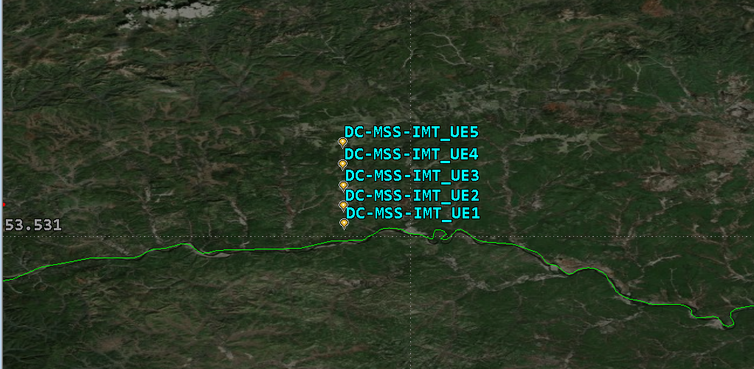
The analysis was based on modelling and simulation of interface from DC-MSS-IMT satellite system operating on the territory of a neighbouring country without implementation of any possible mitigation techniques.
Figures 6-11 show the I/N levels cumulative distribution functions obtained for each system simulations for different separation distances.
FIGURE A2-9
I/N levels from System 1 towards DC-MSS-IMT UE of System 2
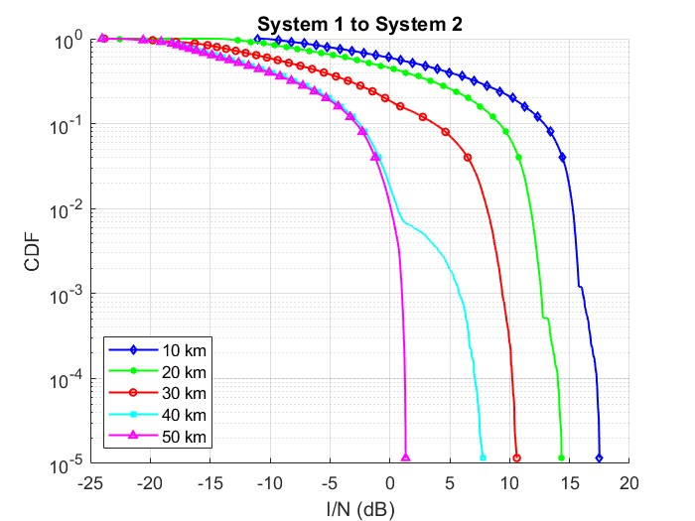
FIGURE A2-10
I/N levels from System 1 towards DC-MSS-IMT UE of System 3
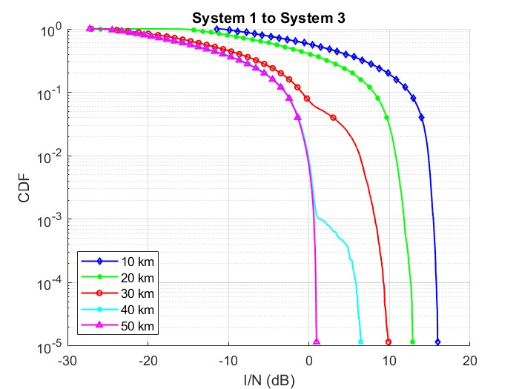
FIGURE A2-11
I/N levels from System 2 towards DC-MSS-IMT UE of System 1
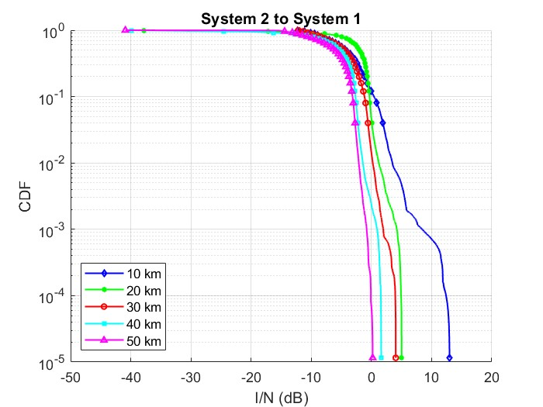
FIGURE A2-12
I/N levels from System 2 towards DC-MSS-IMT UE of System 3
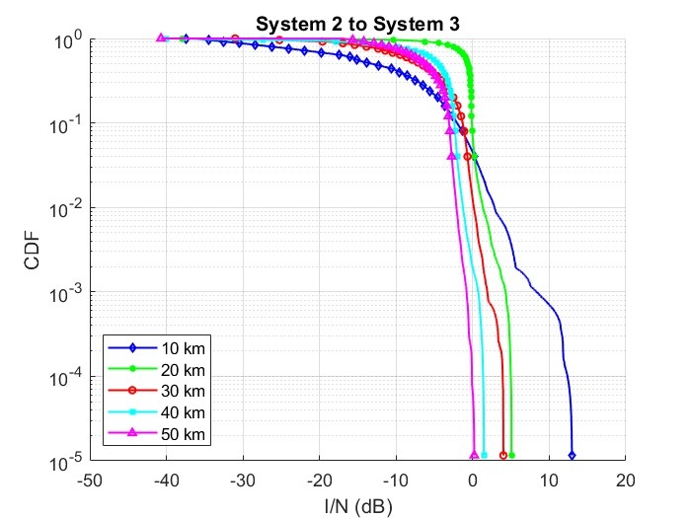
FIGURE A2-13
I/N levels from System 3 towards DC-MSS-IMT UE of System 2
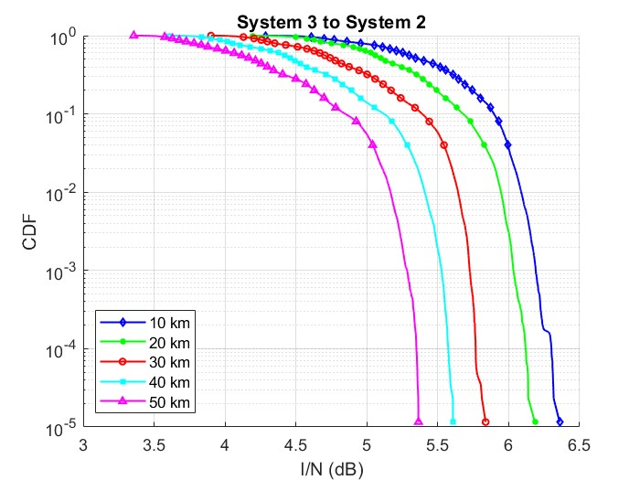
FIGURE A2-14
I/N levels from System 3 towards DC-MSS-IMT UE of System 1
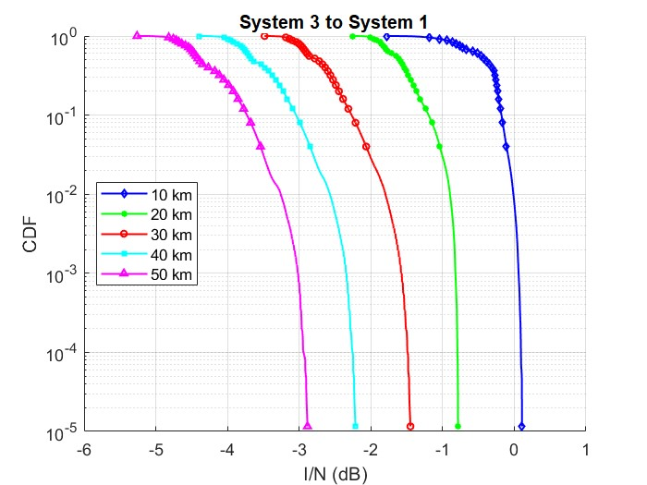
The results of the simulations showed significant interference levels between different DC-MSS-IMT systems. Such interference levels are due to the dynamic behavior of MSS systems and the use of omnidirectional antennas in user terminals. The use of certain mitigation techniques will ensure the coexistence of such systems. Thus, it can be concluded that for a number of the cases multiple systems will not be able to operate on the same or immediately adjacent territory in the same frequency band without any mitigation techniques.
Analysis of a specific geographical case
The analysis presented above illustrates a generic scenario; however, due to the geographical diversity in certain regions, alternative configurations may arise. One such case is shown in Figure 12, where a portion of the Russian Federation lies geographically between Kazakhstan and Mongolia.
FIGURE A2-15
Type of configuration where aggregate interference factor may be required
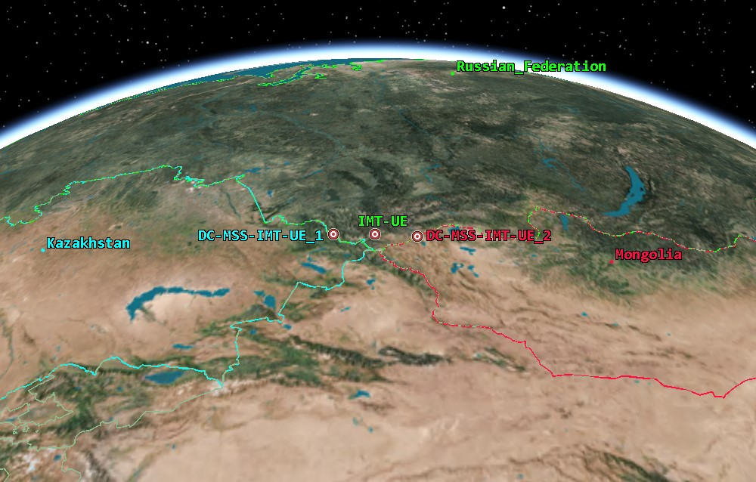
As illustrated in Figure 13, the distance between the DC-MSS-IMT UE of different systems is substantial. This spatial separation facilitates effective coexistence between the two DC-MSS-IMT systems. Nonetheless, interference experienced by terrestrial IMT systems can vary considerably, particularly when comparing aggregate interference from multiple systems to that generated by a single system. Such a situation is plausible in practice—for instance, if Kazakhstan is served by System 3 and Mongolia by System 2.
FIGURE A2-16
Distances between protected terrestrial IMT station from DC-MSS-IMT UEs for this example
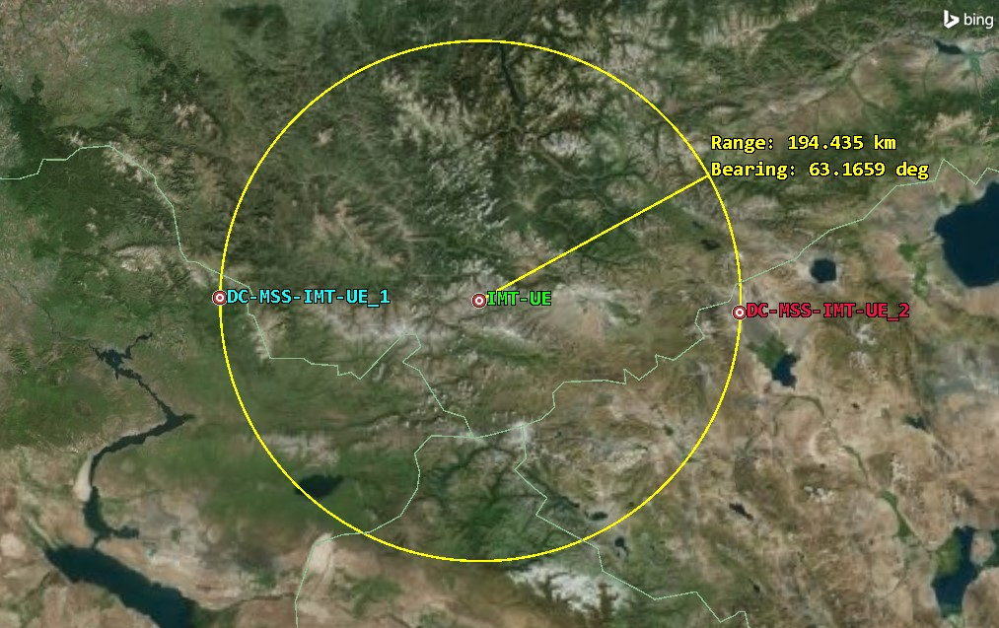
Figure 14 illustrates the mutual interference between System 2 and System 3. The results indicate that in this configuration, both DC-MSS-IMT systems demonstrate compatibility, maintaining sufficient interference margins no matter what protection criterion would be considered.
FIGURE A2-17
Interference between System 2 and System 3
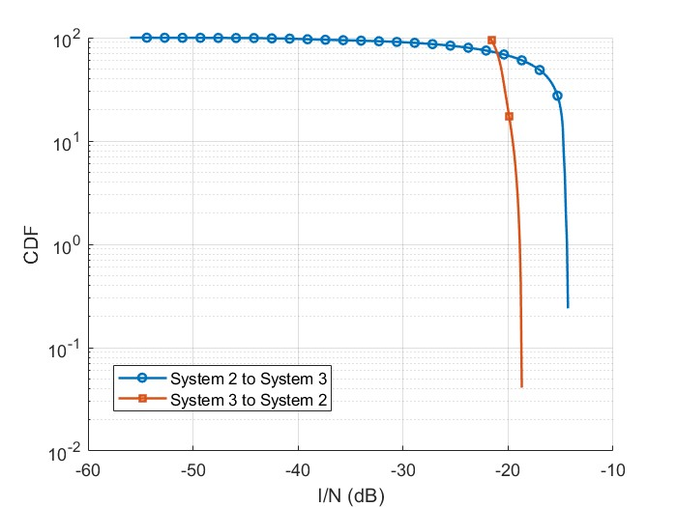
However, in scenarios involving the concurrent operation of multiple DC-MSS-IMT systems, there exists a potential for aggregate interference impacting terrestrial IMT systems. Figure 15 quantifies this interference at a terrestrial UE situated equidistantly between the DC-MSS-IMT user terminals. The results highlight the disparity between interference from a single DC-MSS-IMT system and the cumulative effect of both systems operating simultaneously. The results show that aggregate interference difference from single system interference from 3 to 5 dB, which means that aggregate factor may be needed for some cases.
FIGURE A2-18
Interference from System 2, System 3 and aggregate from both systems to terrestrial IMT UE
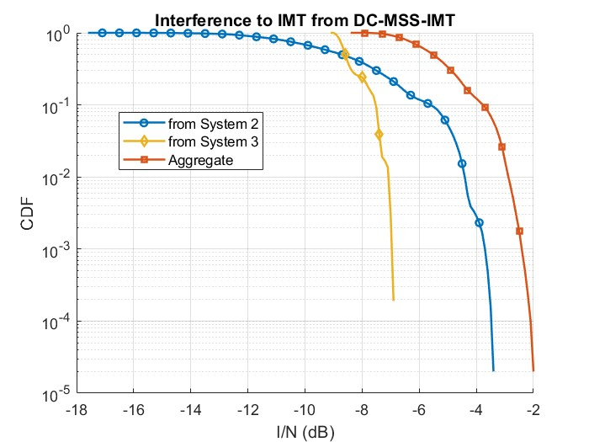
The results presented above indicate that aggregate interference can be significantly higher than individual contributions. In some cases, interference from a single system may remain below the trigger level for protection for terrestrial IMT systems (I/N = –6 dB). However, when aggregated with interference from other sources, this threshold can be exceeded. This demonstrates that evaluating systems in isolation—without considering the cumulative impact — may lead to the incorrect conclusion that DC-MSS-IMT is compatible with terrestrial IMT services. At the same time, it should be taken into account that such cases might be rare in practice, therefore further studies are needed to determine whether aggregation factor is required.
Conclusion
The analysis demonstrates that in a number of cases multiple DC-MSS-IMT satellite systems will not be able to operate on the same or immediately adjacent territory in the same frequency band without causing interference to each other. In order for such systems to co-exist it is necessary to use certain mitigation techniques such as separation distances or operation in the different blocks of spectrum.
Nevertheless, certain configurations demonstrate the potential for compatibility between DC-MSS-IMT systems, albeit with an increased likelihood of aggregate interference to terrestrial IMT networks. Preliminary assessments suggest that in these scenarios, an aggregate factor – ranging from 3 to 5 dB may be required to maintain acceptable performance. Further studies are necessary to refine this estimate, and more comprehensive results will be presented at the next meeting.
Study C (Doc 5D/713 (CHN))

1 Introduction
To analyse the aggregate interference from the envisaged MSS systems (designated as “DC-MSS-IMT”) to IMT user equipment (UE), Working Party (WP) 5D asked WP 4C to provide additional information “that might help in the estimation of the aggregate interference to IMT receivers from different MSS satellites or systems”.
With respect to aggregate interference from space stations of single and/or multiple DC-MSS-IMT systems into incumbent services, WP 4C has not concluded its assessment as indicated in the initial reply liaison statement to WP 5D from WP4C (Doc. 5D/597). Based on the DC-MSS-IMT technical and operational characteristics as stated in the WP4C reply liaison statement, WP 4C will continue to work toward modelling DC-MSS-IMT systems and to investigate the issue of aggregate interference from single and/or multiple DC-MSS-IMT systems.
In this document, this administration would like to provide its considerations and analysis of the aggregate interference from DC-MSS-IMT systems to terrestrial IMT UE in the border area for consideration and discussion in the WP 5D meeting.

2 Discussion

2.1 Consideration on the modelling of DC-MSS-IMT satellite beams
A) Operational management:
It is noted that a DC-MSS-IMT system will manage and control its beam pointing of the satellites through its operation control centre. The satellite downlink beams will direct to specific areas under authorization based on the access requirements of IMT UE, while meeting the regulatory requirements to protect the incumbent services, including terrestrial IMT networks. Therefore, only sidelobe of the satellite beams may contribute to the potential interference to an IMT receiver that is within a neighbouring unauthorized administration’s territory.
B) Intra-system interference avoidance
For a DC-MSS-IMT system, to avoid its intra-system interference adequate distance must be maintained between the co-frequency beams, either from the same satellite or different satellites. This distance can be determined through the intra-system C/I (Carrier-to-Interference) ratio, where “I” represents the aggregate sidelobe interference from co-frequency beams within the same system. To ensure the C/I ratio meets system requirements, an appropriate isolation distance must be maintained between co-frequency beams, which is primarily determined by the sidelobe degradation or suppression characteristics of the satellite antennas.
C) Sharing and compatibility between DC-MSS-IMT systems
For the sharing and compatibility between different DC-MSS-IMT systems, they need to implement interference mitigation techniques, such as service area isolation, frequency segmentation and/or other methods, based on their negotiation under coordination procedure of the RR, to meet their sharing and compatibility. Based on our system simulation, different DC-MSS-IMT systems cannot use the same frequency channel to cover the same area simultaneously and they have to set up enough geographical isolation to ensure the required frequency sharing and compatibility between their systems.

2.2 Study on the protection of IMT UE from potential interference of DC-MSS- IMT systems

2.2.1 Technical characteristics

2.2.1.1 Technical characteristics of DC-MSS-IMT systems
The Technical characteristics of DC-MSS-IMT systems are summarized in Tables 1, 2 and 3.
Table A2-5
Parameters of orbital configuration
System | Altitude (km) | Inclination (deg) | Planes | Sats per plane | RAAN spacing (deg) | Total number of sats
A | 525 | 53 | 28 | 120 | 12.9 | 3360
B | 500 | 55 | 60 | 60 | 6 | 3600
Table A2-6
Parameters of carriers of dc-MSS-imt systems
Downlink (Space-to-Earth) | Parameter | Unit | System A | System B
Downlink (Space-to-Earth) | Frequency band | MHz | 2155 | 2155
Downlink (Space-to-Earth) | Emission Bandwidth | MHz | 5 | 5
Downlink (Space-to-Earth) | S/S Transmitter power | dBW | 12.79 | 13
Downlink (Space-to-Earth) | S/S Maximum EIRP | dBW | 46.89 | 48.2
Downlink (Space-to-Earth) | S/S Maximum EIRP density | dBW/Hz | -20.1 | -18.8
Downlink (Space-to-Earth) | S/S Antenna pattern | n/a | Recommends 1.4 of  ITU-R S.1528 | M.2101
Downlink (Space-to-Earth) | Min Elevation | ° | 20 | 35
Table A2-7
Parameters of antenna pattern of dc-mss-imt
Antenna Model |  | Parameters | Unit | Value
System A | Recommends 1.4 of  ITU-R S.1528 | S/S Peak antenna gain | dBi | 34.1
System A | Recommends 1.4 of  ITU-R S.1528 | radial and transverse sizes of the effective radiating  area of the satellite transmit antenna | m | 1.6
System A | Recommends 1.4 of  ITU-R S.1528 | side-lobe ratio | dB | 20
System A | Recommends 1.4 of  ITU-R S.1528 | number of secondary lobes | / | 2
System B | ITU-R M.2101* | Single element antenna gain | dBi | 4.11
System B | ITU-R M.2101* | Antenna array configuration(Row×Column) | / | 36×36
System B | ITU-R M.2101* | Horizontal 3dB beamwidth of single element | ° | 118
System B | ITU-R M.2101* | Vertical 3dB beamwidth of single element | ° | 112
System B | ITU-R M.2101* | Horizontal radiating element spacing | dH/λ | 0.5
System B | ITU-R M.2101* | Vertical radiating element spacing | dV/λ | 0.5
System B | ITU-R M.2101* | Horizontal Front-to-back ratio | dB | 30
System B | ITU-R M.2101* | Vertical Front-to-back ratio | dB | 30
*Note: There is currently no available ITU-R recommendation in force to simulate satellite phased array antenna for DC-MSS-IMT system sharing and compatibility studies. The satellite engineering design and antenna gain simulation is based on Recommendation ITU-R M.2101 complimented with antenna orientation parameter.

2.2.1.2 Technical characteristics of IMT network
The technical characteristics of IMT networks operating in the frequency bands between 1 and 2.7 GHz are outlined in Section 4 of the Working document (Annex 4.2 to Document 5D/413) on the characteristics of the terrestrial component of IMT for sharing and compatibility studies in preparation for WRC-27.
Detailed parameters of IMT networks are as follows.
TABLE A2-8
IMT Network Deployment-related parameters
Parameters
BS cell radius / deployment density | 0.2-0.8 km
BS sector number | 3 sectors
TABLE A2-9
IMT UE parameters
Parameters
UE number per BS sector | 3
UE height | 1.5 m
Typical antenna gain for UE | −3 dBi
Body loss | 4 dB

2.2.1.3 Radiowave propagation models
In accordance with the liaison statement from WPs 3L/3M to WP5D (Document 5D/167), Recommendation ITU-R P.619-5 is utilized to assess interference between stations in space and those on the surface of the Earth.

2.2.2 Methodology

2.2.2.1 Scenarios
This contribution presents two simulation scenarios for analyzing the potential aggregate interference from DC-MSS-IMT systems to IMT network, considering interference from a single DC-MSS-IMT system and multiple DC-MSS-IMT systems respectively.

2.2.2.1.1 Scenario 1 of IMT UEs interfered by a single DC-MSS-IMT system
In Scenario 1, IMT UEs experience interference from a single DC-MSS-IMT system, as illustrated in Figure 1. In this scenario, a DC-MSS-IMT system provides service in country A and country B simultaneously. A terrestrial IMT network of Country C is deployed at the cross-border area of Countries A, B and C, where Country C shares borders with both Country A and Country B. By comparation, the final result needs to choose the severe one in the interference potential to the terrestrial IMT network in Country C.
For the DC-MSS-IMT system, in order to prevent intra-interference, it is necessary to establish an isolation distance between co-frequency beams. The isolation distance is depicted in Figure 1, represented by the radius of the dashed circle to indicate that other co-frequency UE could not be set within the circle.
Figure A2-19
Scenario 1 with IMT UE interfered by a single DC-MSS-IMT system
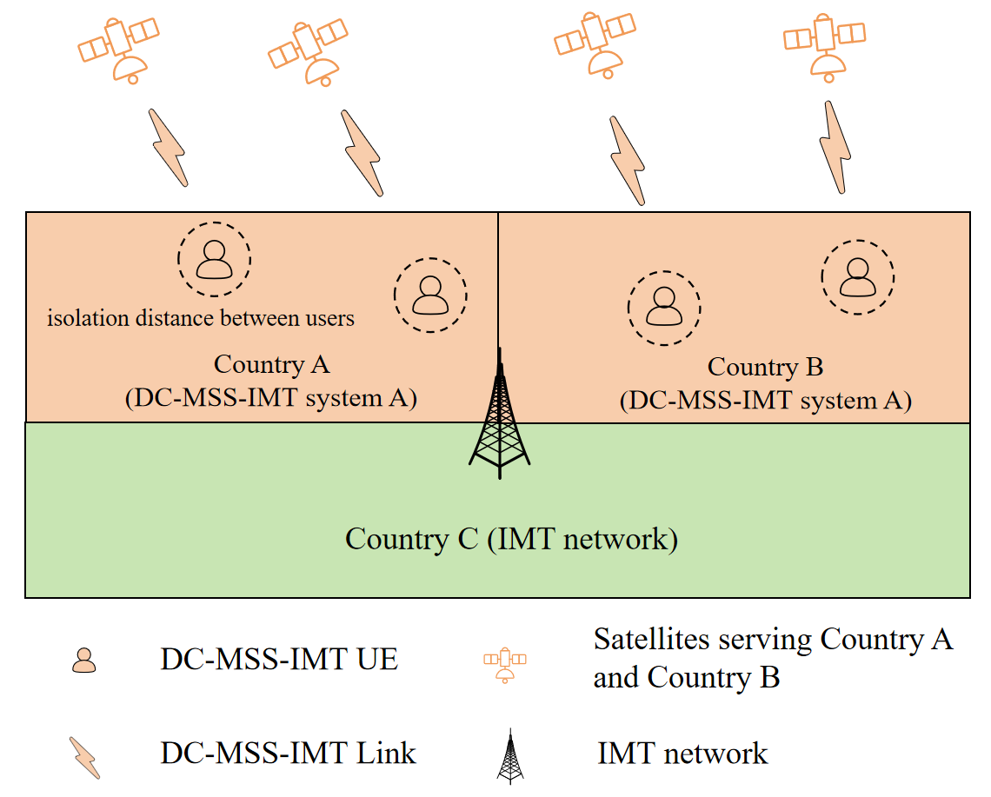

2.2.2.1.2 Scenario 2 of IMT UEs interfered by multiple DC-MSS-IMT systems
In Scenario 2, IMT UEs experience interference from multiple DC-MSS-IMT systems, as illustrated in Figure 2. In this scenario, DC-MSS-IMT system A provides service in Country A and DC-MSS-IMT system B provides service in Country B. IMT network of Country C is also deployed at the cross-border area of Countries A, B and C.
Figure A2-20
Scenario 2 with IMT UEs interfered by multiple DC-MSS-IMT systems
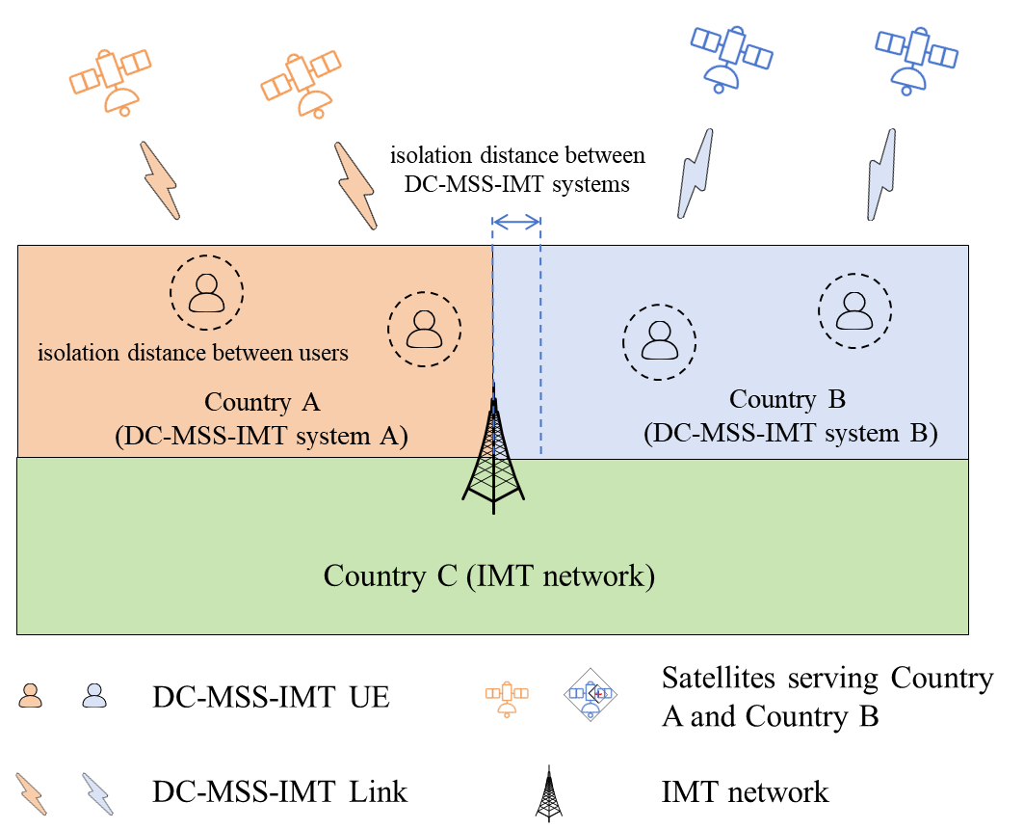
Similar to the isolation distance in section 2.2.2.1.1, due to the utilization of the co-frequency beams, different DC-MSS-IMT systems cannot operate simultaneously in the same area. Therefore, an additional isolation distance is required between DC-MSS-IMT systems to ensure compatibility and spectrum sharing, as indicated by the width between the blue dotted lines shown in Figure 2.

2.2.2.2 Methodology
A simulation method is used to evaluate the interference from DC-MSS-IMT systems to the IMT network. Main steps of the simulation are listed as follows.
Step 1：Determine the range of simulation area
In the single DC-MSS-IMT system scenario described in section 2.2.2.1.1, a DC-MSS-IMT system serves UEs in Country A and Country B simultaneously. In the multiple DC-MSS-IMT systems scenario described in section 2.2.2.1.2, two DC-MSS-IMT systems serve UEs in Country A and Country B respectively. To comprehensively estimate the potential interference to the IMT network, the aggregate interference from all visible satellites of IMT UE is considered. The size of service area in Country A and Country B is set at 2500 km in length and 2500 km in width.
Step 2：Generate DC-MSS-IMT satellites/UEs and IMT BSs/UEs
The spatial topology location of DC-MSS-IMT satellites is generated at time T. The DC-MSS-IMT UEs directly connected with DC-MSS-IMT space stations are randomly deployed within the countries A and B served by the DC-MSS-IMT systems, and may choose and access the satellite having highest elevation angle based on satellite selection strategy. To avoid the intra-system interference from other user links within the DC-MSS-IMT system, we set the required isolation among UEs as mentioned above, the specific value of isolation distance is given in section 3.1.
The IMT BS is deployed at the cross-border interconnected area of Countries A, B, and C, and IMT UEs are randomly generated within the BS sectors.
Step 3：For the multiple DC-MSS-IMT systems scenario mentioned in section 2.2.2.1.2, simulate the isolation distance between DC-MSS-IMT systems
The simulation process of isolation distance between DC-MSS-IMT systems is shown in Figure 3.
In Figure 3, DC-MSS-IMT UEs colored in orange are deployed along the border between Country A and Country B to directly connect to space stations of DC-MSS-IMT system A. It should be noted that, in real application, whether UEs of System A can deploy to the border of Country B depends on relevant agreement of Country B. Meanwhile, DC-MSS-IMT UEs colored in blue are randomly deployed in Country B, which are served by DC-MSS-IMT system B.
In order to protect DC-MSS-IMT system A from the potential interference of DC-MSS-IMT system B, the geofencing should be configured starting from the border of these two countries, and extending into Country B’s territory. In this process, the isolation distance (representing the geofencing width) gradually increases from zero to $d_{1}$, $d_{2},...$, until the requirement of spectrum sharing and compatibility is satisfied.
And in the opposite direction, to protect System B from System A, the above process is also applicable.
The required isolation distance corresponds to the minimum geofencing extension width at which the maximum interference-to-noise (I/N) ratio meets the -6 dB protection threshold.
Figure A2-21
Simulation process of isolation distance between DC-MSS-IMT systems
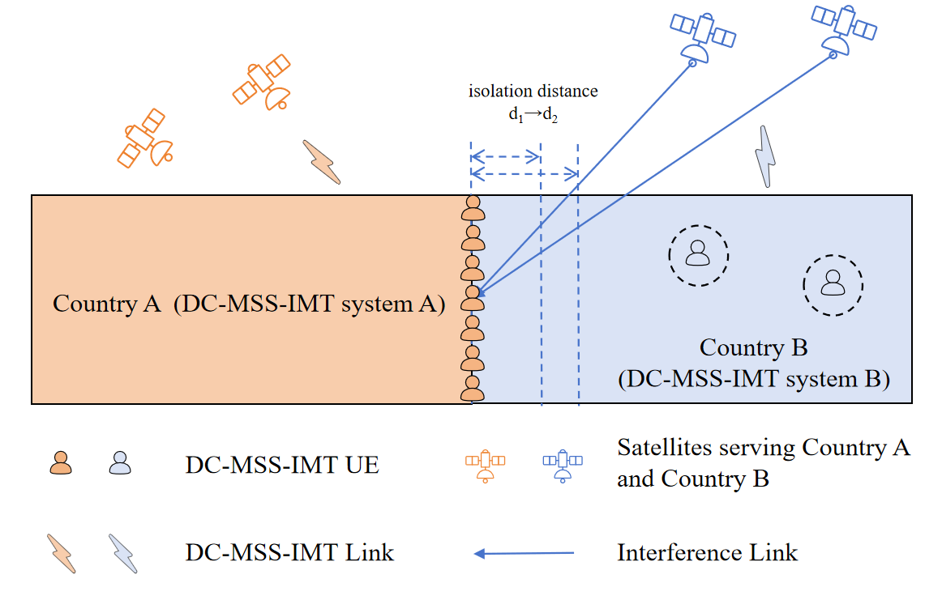

Step 4：Simulate the positions of satellite constellation over a period of time and calculate the aggregate interference from DC-MSS-IMT satellites to IMT network at each time step.
The aggregate interference level is determined by all active satellites in the considered DC-MSS-IMT systems within the visible range of IMT UEs.
$I_{total}=10 log\left(\sum_{m}^{M}{\sum_{n}^{N}{{\sum_{j}^{J}{10}}^{{I_{m,n,j}}/{10}}}}\right)$ (1)
$I_{m,n,j}=P_{tx}+G_{tx}(θ_{tx})-PL+G_{rx}(θ_{rx})-L_{other}$ (2)
where:
$I_{total}$: Aggregate interference power from DC-MSS-IMT satellites, dBW
$I_{m,n,j}$: Interference power from j-th beam of n-th space station of m-th DC-MSS-IMT system, dBW
$P_{tx}$: DC-MSS-IMT satellite transmit power, dBW
$G_{tx}(θ_{tx})$: DC-MSS-IMT satellite antenna gain in the direction of IMT UE taking into account the main beam of DC-MSS-IMT satellite is pointing to its serving DC-MSS-IMT UE, dBi
$G_{rx}(θ_{tx})$: IMT UE antenna gain in the direction of DC-MSS-IMT space station, dBi
$PL$: Propagation loss, dB
$L_{other}$: Body Loss for IMT UE, dB
$M$: The number of DC-MSS-IMT systems involved in the calculation
$N$: The number of visible active space stations from the view of IMT UE
$J$: The number of beams of one satellite.

3 Results
This section provides the simulation results and analysis of interference from DC-MSS-IMT systems into IMT UEs in the above two scenarios, based on the methodology mentioned in Section 2.2.2.

3.1 Intra-system isolation distance
For the evaluation of intra-system interference, C/N-C/(I+N) < 2 dB was set as the accepted threshold of a DC-MSS-IMT system. The isolation distance for two beams of DC-MSS-IMT systems are given in Figure 4 and Figure 5. According to the simulation results, the intra-system isolation distance was set at 120 km for DC-MSS-IMT System A and 100 km for System B.
Figure A2-22
Intra-system isolation distance (System A)
Figure A2-23
Intra-system isolation distance (System B)

3.2 Isolation distance between DC-MSS-IMT systems
With an I/N < -6 dB as protection threshold between different DC-MSS-IMT systems, the compatible isolation distances between system A and system B are 160 km and 130 km (shown as Figures 6 and 7), respectively. To ensure the coexistence under mutual interference, the isolation distance between DC-MSS-IMT systems is set at 160km.
Figure A2-24
Isolation distance between DC-MSS-IMT systems (Distance of System A)
Figure A2-25
Isolation distance between DC-MSS-IMT systems (Distance of System B)

3.3 Results of aggregate Interference in different scenarios
Based on the aforementioned steps, this section presents interference simulation results. For Scenario 1, referring to the scenarios described in Section 2.2.2.1.1 and the comparation of the interference potential to the terrestrial IMT network in Country C from system A and B, we consider DC-MSS-IMT system A serves both Country A and Country B that has equivalent number of space stations, and calculate their interference to IMT UEs in Country C. For Scenario 2, similarly, we consider DC-MSS-IMT system A and B serves Country A and Country B respectively, and calculate the aggregate interference to IMT UEs in Country C.
According to the simulation result, it shows that the aggregate interference in Scenario 2 from multiple DC-MSS-IMT systems A and B is not greater than the aggregate interference from the space stations coming from a signal DC-MSS-IMT system.
Figure A2-26
Aggregated Interference of different scenarios

4 Proposal
From a technical point of view, we agree that terrestrial IMT networks can potentially receive interference from multiple satellites within one DC-MSS-IMT system. We also agree that the pfd value for the protection of terrestrial IMT network is defined only based on terrestrial IMT protection criteria and its characteristics.
Based on the above analysis and the simulation result, it shows that the potential aggregate interference from multiple DC-MSS-IMT systems is smaller than the aggregate interference coming from the space stations of a signal DC-MSS-IMT system. Therefore, based on a single DC-MSS-IMT system to model and conduct sharing and compatibility study to protect IMT receiver is appropriate where the pfd level, if any, should also be applied to a single DC-MSS-IMT system. Accordingly, no aggregation factor needs to be considered for the protection of IMT network.

Study D (Doc. 5D/754 (F))

1 Introduction
For the protection of IMT terrestrial network from the envisaged direct communication between MSS and IMT, it is required to decide which approach is the most suitable for this purpose, whether pfd per satellite, epfd, or aggregated pfd. In this context, this contribution aims to:
‒ Analyse and evaluate the aggregation factor from different satellites within the same constellation system;
‒ Analyse and evaluate the aggregation factor of interferences from multiple systems at the boundary of at least three countries;
‒ Propose a regulatory approach to protect the terrestrial IMT networks.
The current study concerns the protection of IMT user equipment (UE).

2 Scenario
Consider the border line shared by three different countries, countries A, B, and C, such as the tri-border area between France, Germany, and Switzerland. The scenario is depicted in Figure 1.
Suppose that countries B and C (such as Germany and Switzerland) each authorizes the direct communication between the MSS and the IMT TN. The MSS operates over the same frequency band in both countries, but each terrestrial cell is covered by a single satellite, single system, at a given frequency band.
The objective of this contribution is to evaluate the aggregated interference, in particular from different systems authorized in neighboring countries. As a starting point, we consider the same constellation characteristics for coverage in both countries (These characteristics are shown in Table I of the Annex 1, referring to System 2 in the Document 4C/356 (Annex 7)). We aim to evaluate the interference at several points distributed along the border region of country A (such as France), as shown in Figure 1. The measurement point P0 corresponds to the border tri-point where the three countries meet. The remaining points are positioned around P0, spaced 5 km apart.
Figure 27
Cross-border interference scenario to protect IMT TN in country A
from two MSS systems covering neighboring countries

P4 P1
P3 P0
P5 P2

System 1covering country B
System 2 covering country C
Country A:
No MSS coverage

3 Methodology and statistical analysis
At each measurement point along the border region, the interference from each constellation system $I_{system i}$ results from the integration of the received powers $I_{l}$ from all visible satellites ($N_{visible}$) covering a neighboring country. The interference is calculated as:
$$I_{system i}=\sum_{l=1}^{N_{visible}}{I_{l} }$$
We note that the calculation considers the coverage of all the satellites that are visible from the measurement point.
At each cross-border measurement point, the total interference from both systems can be assessed as follows:
$$I_{total}=I_{system 1}+I_{system 2}$$
The protection criteria to protect the IMT TN is expressed in terms of interference to noise ratio I/N with a value of ‒6 dB.
The protection of IMT TN in a country A relies on whether each MSS system needs to respect the I/N limit independently or jointly. To help in this matter, we propose to evaluate the apportionment/aggregation factor β, as follows:
$$β=10*\log_{10}\left(\frac{I_{total}}{\max\left(I_{system 1}, I_{system 2}\right)}\right)$$
Similarly, but at the level of a single MSS system, the evaluation of the aggregation factor α from interference powers received from different satellites of the same MSS system could help to understand how the interference power is distributed and whether there is a dominant interference direction. The aggregation factor α is assessed as, where $I_{max}=\max\left(I_{l}\right)$ is the highest interference received from a visible satellite:
$$α = 10*log\left(\frac{I_{system}}{I_{max}}\right).$$

4 Scenario settings and parameters
Regarding the functionality of the MSS systems, we consider the following:
‒ Beam placement: fixed beam cells on ground, of a size of 30 km.
‒ Satellite selection strategy: At a given time t, the selected satellite may be at any elevation angle, provided it is higher than a minimum threshold (25° in this study). Consequently, a satellite is randomly selected per grid cell.
‒ Satellite Tx power control: Satellite Tx power is set to maintain a constant pfd at ground level, regardless of the elevation angle and the corresponding slant distance.
‒ Satellite antenna model: ITU-R M.2101, with a single beam per satellite
‒ Mitigation technique: No mitigation techniques or isolation distances are considered in this analysis.
We consider the satellite constellation described in Table I of the Annex 1. The orbital period of this constellation is T = 5677 s / 94.6 minutes. The satellite constellation is simulated at different epochs, regularly spaced at 20 s intervals, starting from time t=0 (12/08/2019 12:00:00) until (12/08/2019 18:18:20), covering a period of nearly 6 hours.
The measurement point P0 corresponds to the cross-border tri-point France-Germany-Switzerland, given by:
lat = 47.590°, lon = 7.589°, alt = 0 km
The operating frequency is 2 600 MHz.

5 Results
Figure 2 shows the CDF of the interference to noise ratio I/N from each system, as well as the total interference observed at all measurement points. If each system respects an I/N limit of ‒6 dB at the cross-border area, the aggregated interference may still exceed the protection criteria of the IMT TN UE. Therefore, an aggregation (or apportionment) should be defined to manage interference from multiple systems. This apportionment factor is statistically represented in Figure 3, both per measurement point and across all points combined. The highest apportionment factor of 3 dB should be considered when no percentage for the exceedance of the I/N protection criteria is allowed. However, if a certain percentage is allowed for exceedance, a lower apportionment factor may be considered, for example β= 2.6 dB for 20%- exceedance.
Figure A2-28
Cdf of I/N ratio of each system and the total I/N from both systems
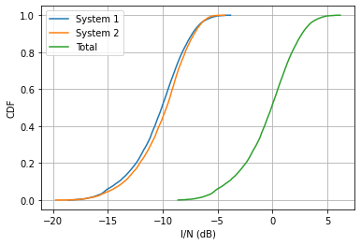
Figure A2-29
Cdf of the apportionment factor β at each measurement point and all combined
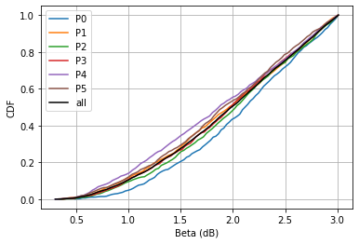
Figure A2-30
Cdf of the aggregation factor α at each measurement point and all combined
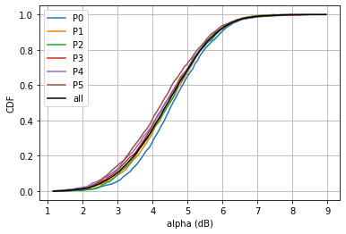
Figure 4 shows the CDF of the aggregation factor α, which is equal to 5.4 dB at 80 %.

6 Conclusion
The results show that an apportionment factor of at least β=2.6 dB is required to protect the terrestrial IMT network with 20% of exceedance of the protection criteria.

Study E (Doc 5D/713 (CHN))
Preliminary DL interference aggregation factor simulations

A1 Simulation assumptions
The assumptions used in this preliminary DL interference aggregation factor simulations are summarized in Table A1-1.
Table A2-10
Preliminary assumptions
Number of satellites | 600
Average satellite station altitude | 360 km
Satellite station antenna patterns | Multi-beams (256 per satellite station)  Configuration: 30x30  Antenna beam gain: 26 dBi
Frequency | 1800 MHz
Minimum elevation angle | 25°

A2 Simulation method
The simulation scenario is illustrated in Figure A1-1, the north east borderline between France and Germany was chosen in the simulations. Country A is Germany, and Country B is France.
Figure A2-31
Simulation scenario
borderline

In this preliminary simulation, the link from satellite to ground based UE is considered as Line Of Sight, the clutters around the ground UE was not used.
1) The first step is to simulate the CDF of I__{system} $=\sum_{k=1}^{n}{I\text{k}}$
2) Select the simulation I_{_max} among the I_{_k} which meet the condition of 99% of I_ _{system} /N <= −6 dB.
3) Simulate the CDF of α = 10*log10(I_{_system} / I_{_max} )

A3 Preliminary simulation result
The preliminary simulation result is plotted in Figure A1-1.
Figure A2-32
Interference aggregation factor
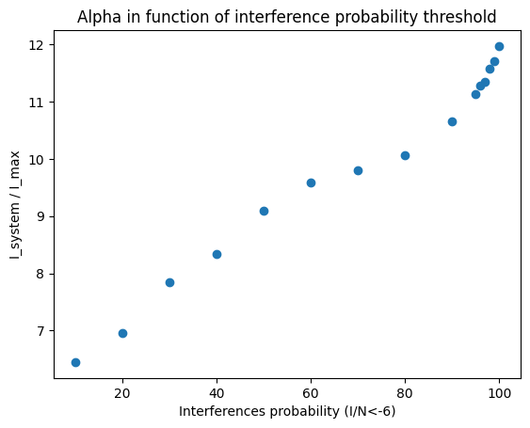
The preliminary simulation results in Figure A1-2 indicate at 99%, the α = 10*log10(I_{_system} / I_{_max} ) ≈ 11.6 dB.

ANNEX 3
Considerations on the regulatory measures
[Document 5D/478 (CHN)]
The possible new allocations to the mobile-satellite service (MSS) for direct connectivity between space stations and IMT user equipment (UE) is to complement terrestrial IMT network coverage and may provide direct connectivity to underserved communities in rural and remote areas, in particular in the event of network failures of terrestrial IMT and natural disasters, where the same IMT UE is used.
The possible frequency usage of the new MSS allocation under the above scenario and the management of the MSS network is similar to terrestrial IMT network for which it could be achieved through the cooperation between satellite operator and local terrestrial network operator and then be authorized or directly authorized by the administration within its territory. The application of this kind of MSS system within a country can be implemented according to its own usage requirements and conditions while not causing interference to other administrations.
Therefore, it is necessary to consider the issue of potential harmful interference to terrestrial IMT networks of neighbouring countries from a country where the new MSS application has been authorized (Figure1). The possible regulatory measures for this kind of potential harmful interference could comprehensively refer to the existing bilateral coordination and/or protection requirement of terrestrial IMT networks between neighbouring countries.
Figure A3-1
Diagram of the interference scenario of MSS systems to the IMT system between neighbouring countries
It is impossible to allow different MSS systems or different beams of the same MSS system to be used in the same frequency and in the same area because of the non-directionality of IMT terminals’ antenna. Therefore, in the process of potential harmful interference assessment to protect a neighbouring countries’ terrestrial IMT network, it is proposed to set up a PFD value by considering the potential aggregate interference from one MSS system.
And two methods on how to use the calculated PFD value in regulatory measures are under consideration,
Alternative 1: to set up a PFD value as a coordination trigger to initiate the bi-lateral coordination between concerned administrations.
Alternative 2: to set up a PFD limit for protection of the concerned administrations’ territorial IMT network.
Additionally, it should be also noted that the 2 GHz band usage is shared between existing MSS and IMT systems and the required compatibility is reached through interference mitigation techniques pursuant to Resolution 212 (Rev.WRC-23). Refer to No. 389F too.

Chapter 4 - Annex 4.15 - Working document on characteristics of terrestrial component of IMT for sharing and compatibility studies in preparation for WRC-27
Annex 4.4 to Working Party 5D Chairman’s Report- Characteristics of terrestrial component of IMT for sharing and compatibility studies in preparation for WRC-23

