US Radiocommunications Sector
Fact Sheet

Working Party: WP 5B | Document No: USWP5B35-05
Reference: Document 5B/315 Annex 4.7 Recommendation ITU-R M.2092-1 | Date: 24 July 2025
Document Title: Preliminary Draft Revision of Recommendation ITU-R M.2092-1, Technical characteristics for a VHF data exchange system in the VHF maritime mobile band
Author(s)/Contributors(s):  Pamela Murray  USCG  Jerry Ulcek  USCG  Johnny Schultz  Sev1Tech, Inc.  Ross Norsworthy  REC, Inc | Phone: (202) 657-3081  Email: pamela.j.murray@uscg.mil  Phone: (202) 579-5924  Email: jerry.l.ulcek@uscg.mil  Phone: (727) 403-4029  Email: johnny.schultz@sev1tech.com  Phone: (727) 515-8025  Email: ross_norsworthy@msn.com
Purpose/Objective:
The purpose of this document is to update the receiver blocking requirement and to update the section, figures, and tables to the current ITU format. Requesting to update the document status and send it to SG5.
Abstract:
ITU WP5B has opened Recommendation ITU-R M.2092-1 for revision. The USCG has identified the need to update the receiver blocking requirement and provide a summary of the changes. Additionally, the section, figure, and table references need to be updated to the current ITU format requirements.

Radiocommunication Study Groups
Source: Document 5B/315 Annex 4.7  Reference: Recommendation ITU-R M.2092-1 | Document: USWP5B35-XX
 | 24 July 2025
 | English only
United States of America
PRELIMINARY Draft Revision of Recommendation ITU-R M.2092-1
Technical characteristics for a VHF data exchange system
in the VHF maritime mobile band

1 Introduction
Working Party 5B has opened Recommendation ITU-R M.2092-1 for revisions. The USCG has identified the need to update the receiver blocking requirement to protect it from the vessel’s own VHF communications. The section, figures, and tables references also need to be updated to the current ITU format requirements. This contribution proposes some revisions to Document 5B/315 Annex 4.7.

2 Summary of changes
To be added before final draft.

3 Attachments
The following attachment contains the proposed changes to Annex 4.7 of the chairman’s report and are highlighted in blue.

Radiocommunication Study Groups | 
Source: Document 5B/TEMP/100 | Annex 4.7 to  Document 5B/315-E
Source: Document 5B/TEMP/100 | 15 May 2025
Source: Document 5B/TEMP/100 | English only
Annex 4.7 to Working Party 5B Chair’s Report
[] DRAFT REVISION OF RECOMMENDATION ITU-R M.2092-1
Technical characteristics for a VHF data exchange system
in the VHF maritime mobile band
(2015-2022-202X)
Summary of revisions
TBD
Scope
This Recommendation provides the technical characteristics of a VHF data exchange system (VDES) which integrates the functions of VHF data exchange (VDE) comprising both terrestrial and satellite components, application specific messages (ASM) and the automatic identification system (AIS) operating in the frequency bands listed in Appendix 18 of the Radio Regulations (RR).
Keywords
Maritime, VHF, VDES, ASM, data exchange.
Abbreviations/Glossary
ACK Acknowledgement
ACM Adaptive coding and modulation
AIS Automatic identification system
ARQ Automatic repeat request
ASC Announcement signalling channel
ASM Application-specific messages
AWGN Additive white Gaussian noise
BB Bulletin board
BBSC Bulletin board signalling channel
BER Bit error rate
BPSK Binary phase shift keying
BW Bandwidth
CA Certificate authority
CDMA Code division multiple access
CPM Continuous phase modulation
CQI Channel quality indicator
CRC Cyclic redundancy check
DAC Designated area code
DC Data channel
DLS Data link service
DSCH Data signalling channel
EDN End delivery notification
e.i.r.p. Equivalent isotropic radiated power
ETSI European Technical Standards Institute
FATDMA Fixed access time-division multiple access
FEC Forward error correction
GNSS Global navigation satellite system
IALA International Association of Marine Aids to Navigation and Lighthouse Authorities
ID Identification
IEC International Electrotechnical Commission
IMO International Maritime Organization
IP Internet protocol
ITU International Telecommunication Union
LC Logical channel
LCID Link config ID
LEO Low-earth orbiting
LME Link management entity
LNA Low noise amplifier
LSB Least significant bit
MAC Media access control
MCS Modulation and coding scheme
MITDMA Multiple incremental time division multiple access
MMSI Maritime mobile service identity
MSB Most significant bit
NM Nautical mile
OSI Open systems interconnection
PAPR Peak to average power ratio
PC Physical channels
PCN Physical channel number
pfd Power flux-density
PKI Public key infrastructure
PI Presentation interface
PL Physical layer
ppm parts per million
PSK Phase shift keying
QAM Quadrature amplitude modulation
QPSK Quadrature phase shift keying
RA Random access
RAC Random access channel
RATDMA Random access time-division multiple access
RC Ranging channel
RF Radio frequency
RMS Root mean square
RR Radio Regulations
RSC Recursive systematic convolutional
SI Selection interval
SINR signal to interference-plus-noise ratio
SYNC Synchronization
TBB Terrestrial bulletin board
TDMA Time division multiple access
UTC Coordinated universal time
VDE VHF data exchange
VDES VHF data exchange system
VDE-SAT VHF data exchange-satellite
VDE-TER VHF data exchange-terrestrial
VDL VHF data link
VHF Very high frequency
Related ITU Recommendations, Reports
Recommendations
ITU-R M.585 – Assignment and use of identities in the maritime mobile service
ITU-R M.1084 – Interim solutions for improved efficiency in the use of the band 156-174 MHz by stations in the maritime mobile service
ITU-R M.1371 – Technical characteristics for an automatic identification system using time division multiple access in the VHF maritime mobile frequency band
Report
ITU-R M.2435 – Technical studies on the satellite component of the VHF data exchange system
ITU-R M.2317 – VHF data exchange system channel sounding campaign
The ITU Radiocommunication Assembly,
considering
a) that the International Maritime Organization (IMO) has a continuing requirement for a universal shipborne automatic identification system (AIS);
b) that the use of a universal shipborne AIS allows efficient exchange of navigational data between ships and between ships and shore stations, thereby improving safety of navigation;
c) that the VHF data exchange system (VDES) should use appropriate access schemes that ensure the protection of AIS while making efficient use of the spectrum and accommodate all users;
d) that while AIS is used primarily for surveillance and safety of navigation purposes in ship-to-ship use, ship reporting and vessel traffic services applications, a growing need for other maritime safety related communications has developed;
e) that the VDES gives priority to AIS, and also accommodate future expansion in the number of users and diversification of data communications applications, including vessels which are not subject to IMO AIS carriage requirements, aids to navigation and search and rescue;
f) that the VDES has data communications capacity and technical characteristics that support the harmonized collection, integration, exchange, presentation and analysis of marine information on board and ashore by electronic means to enhance berth to berth navigation and related services for safety and security at sea and protection of the marine environment;
g) that IMO considered measures to improve the security and integrity aspects of AIS, including possible future utilization of VDES for authentication and encryption of AIS transmissions (NCSR 11/19, paragraph 14.5.4),
recognizing
that the implementation of VDES ensures that the functions of digital selective calling, AIS and voice distress, safety and calling communication (Channel 16), are not impaired,
recommends
1 that general elements of VDES should be designed in accordance with Annex 1;
2 that technical elements common to VHF data exchange (VDE) and application specific messages (ASM) should be designed in accordance with Annex 2;
3 that technical characteristics of the ASM channel should be designed in accordance with Annex 3;
4 that technical characteristics of the VDE-terrestrial (VDE-TER) channel should be designed in accordance with Annex 4;
5 that technical characteristics of the satellite component of VDE-satellite (VDE-SAT) should be designed in accordance with Annex 5;
6 that characteristics necessary for each component of VDES to share the available spectrum such that impact between applications is minimized and AIS is respected should be designed in accordance with Annex 6;
7 that applications of the VDES which make use of ASM designed for AIS, as defined in Recommendation ITU-R M.1371 should also take into account the international application identifier branch, as specified in IMO SN.1/Circ. 289, maintained and published by IMO;
8 that the design and installation of VDES should also consider relevant technical requirements, recommendations and guidelines published by IMO, IEC and IALA;
9 that VDES should give its highest priority to the AIS position reporting and safety related information;
10 that VDES should be capable of transmitting additional safety information on request;
11 that VDES installation should be able to operate continuously while under way, moored or at anchor;
12 that VDES should be capable of various modes of operation, including the autonomous, assigned and polled modes;
13 that VDES should provide flexibility for the users in order to prioritize some applications and, consequently, adapt some parameters of the transmission (robustness or capacity) while minimizing system complexity;
14 that VDES shipborne stations should have one multi-function transmitter and a multi-channel and multi-function receiver capable of simultaneously supporting the functions AIS, ASM, VDE-TER and VDE-SAT; and
15 that VDES should facilitate authentication of AIS messages.

Annex 1
General description of the VHF data exchange system operating system
TABLE OF CONTENTS
Page
1 General description of VHF data exchange system 8
2 Key technical characteristics 9
2.1 Satellite downlink 9
2.2 VHF data exchange-terrestrial may operate in either duplex
or simplex mode 9
2.3 VHF data exchange system channel usage in accordance with
Appendix 18 of the Radio Regulations 10
2.4 Station identification 10
2.5 Presentation interface protocol 11
2.6 VHF data exchange system communications prioritization 11

A1-1 General description of VHF data exchange system
In essence, the VDES provides a variety of means for the exchange of data between maritime stations, ship-to-ship, ship-to-shore, shore-to ship, ship-to-satellite and satellite-to-ship. The VDES is a multi-component system comprising of VDE, ASM and the AIS in the VHF maritime mobile band (156.025-162.025 MHz). The VDES has a terrestrial component VDE-TER and a satellite component VDE-SAT. The VDES functions are illustrated pictorially in Figure A1-1.
Figure A1-1
VHF data exchange system functions illustrated
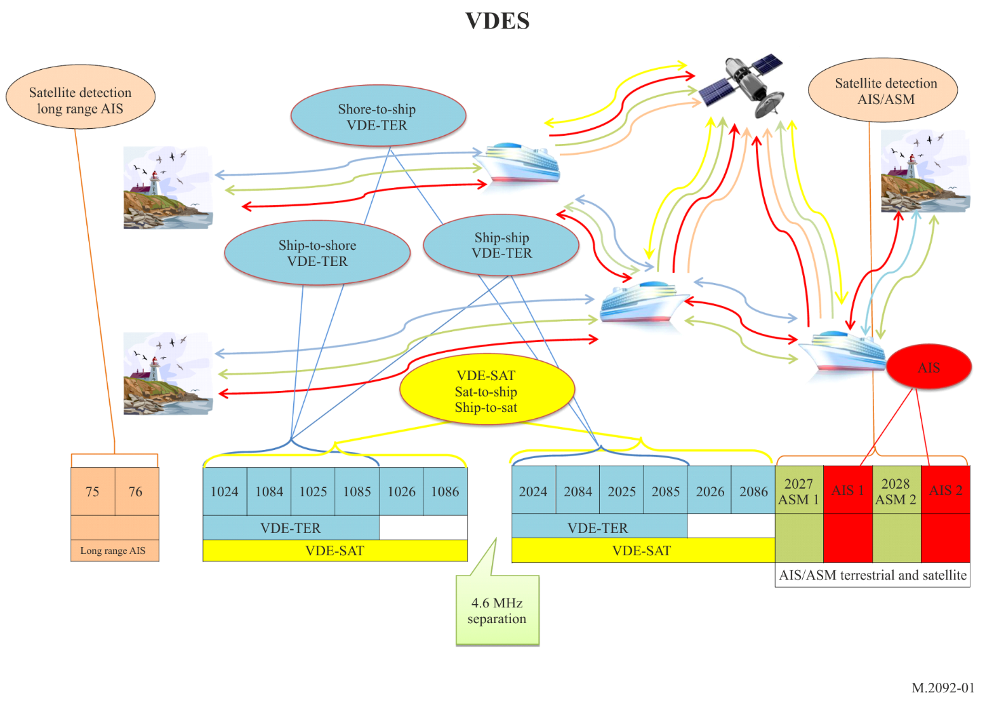

A1-2 Key technical characteristics

A1-2.1 Satellite downlink
To ensure interoperability and compatibility between VDE-TER and VDE-SAT, a pfd-mask is described by the following formula, where $θ°$ is the angle between the direction of the earth’s horizon and the direction of the satellite.
$θ°=earth to satellite elevation angle$
${PFD\left(θ°\right) }_{(dBW/(m^{2}*4 kHz))}=\left\{\begin{aligned}-149+0.16*θ° 0°≤θ<45°; \\ -142+0.53*\left(θ°-45°\right) 45°≤θ<60°; \\ -134+0.1*\left(θ°-60°\right) 60°≤θ≤90°.\end{aligned}\right.$
The values shown above are intended to be what is received by a vertically polarised dipole antenna on ships.

A1-2.2 VHF data exchange-terrestrial may operate in either duplex or simplex mode
VDE-TER may operate in duplex mode by using the lower leg channels for ship-to-shore and the upper leg channels for shore-to-ship and ship-to-ship digital messaging.
VDE-TER may operate in simplex mode by using the lower leg channels for ship-to-shore, shore-to-ship and ship-to-ship digital messaging.

A1-2.3 VHF data exchange system channel usage in accordance with Appendix 18 of the Radio Regulations
This section provides information on channel usage between terrestrial stations and between satellite and terrestrial stations. The VDES frequency usage is illustrated in Figure A1-2.
Figure A1-2
VHF data exchange system frequency usage
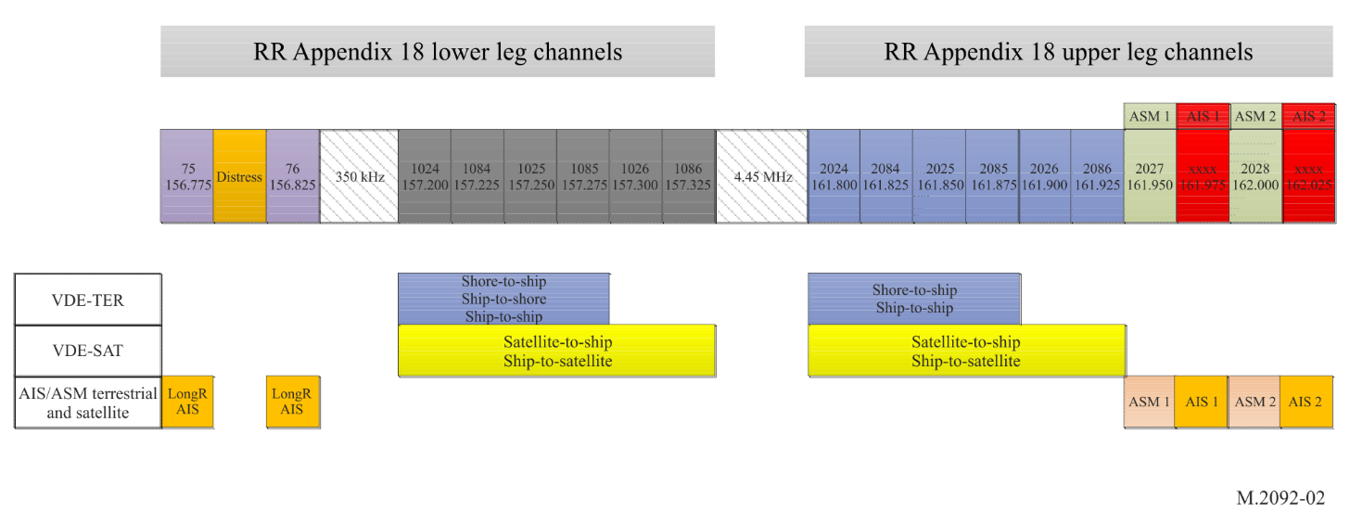
AIS 1 and AIS 2, which are AIS channels, are used in accordance with Recommendation ITU-R M.1371, and are also used for receiving AIS messages by satellite.
Long Range AIS using channel 75 and channel 76 are used in accordance with Recommendation ITU-R M.1371 for receiving AIS messages by satellite.
ASM 1 and ASM 2 are ASM channels used in accordance with this recommendation for ASM, and are also used for receiving ASM by satellite.
Channels 1024, 1084, 1025 and 1085 are the VDE channels used in accordance with this Recommendation and identified for ship-to-shore, shore-to-ship and ship-to-ship VDE, but may be used for VDE-SAT without imposing constraints on VDE-TER.
Channels 2024, 2084, 2025 and 2085 are the VDE channels used in accordance with this Recommendation and are identified for shore-to-ship and ship-to-ship VDE, but may be used for VDE-SAT without imposing constraints on VDE-TER.
Channels 1026, 1086, 2026 and 2086 are VDE channels used in accordance with this Recommendation and are identified for ship-to-satellite and satellite-to-ship VDE and are not used by the terrestrial component of VDE.

A1-2.4 Identification

A1-2.4.1 Station identification
All VDES stations should be uniquely identified with a maritime mobile service identity (MMSI) according to Recommendation ITU-R M.585, except satellite VDES stations, which should refer to § A5-3.1.9.

A1-2.4.2 Source and destination identification
When the source or destination is a VDES station, an MMSI should be used. For other purposes, numerical identifiers greater than 999999999, but less than 2³², may be used for additional source or destination identifiers.

A1-2.5 Presentation interface protocol
For VDES transceivers:
– data may be input via the presentation interface to be transmitted by the VDES station;
– data received by the VDES station should be output through the presentation interface.

A1-2.6 VHF data exchange system communications prioritization
Since transmissions by own equipment may impair reception by own equipment on own ship, the priority and timing of ship station transmissions shall be in accordance with the following service priorities:
Highest Priority 1: AIS transmissions
Priority 2: ASM transmissions – see § A3-4.5.3
Priority 3: VDE transmissions – see § A4-4.19
The references given above are specifically addressing how priority is given to AIS by each VDES function.
The ship station VDES receivers should always be active.

A1-2.7 Simplified VHF data exchange system
Simplified VHF data exchange system (simplified VDES) means a VDES for mobile station which output average power is up to 5 W.
NOTE – The simplified VDES should include the Class B AIS.

Annex 2
Common technical elements of VHF data exchange system
TABLE OF CONTENTS
Page
1 Protocol layer 8
1.1 Protocol layer overview 12
1.2 Physical layer 12
1.3 Link layer 35

This Annex describes those elements of VDES that may be common across the ASM and VDE Channels.

A2-1 Protocol layer

A2-1.1 Protocol layer overview
The VDES architecture should utilize the open systems interconnection layers 1 to 4 (physical layer (PL), link layer, network layer, transport layer) as illustrated in Figure A2-1.
Figure A2-1
Seven-layer open systems interconnection model
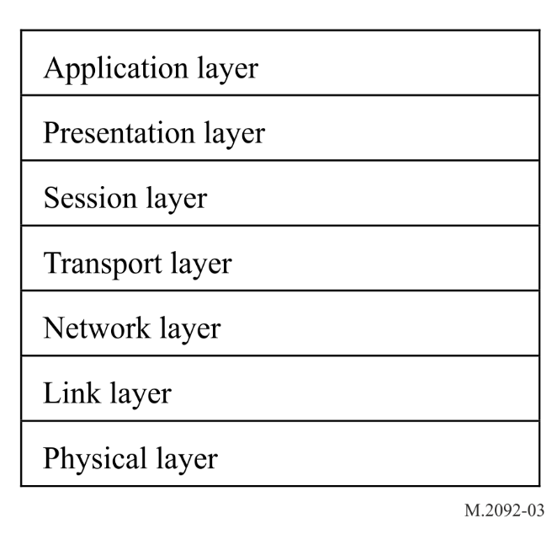

A2-1.2 Physical layer
This layer provides transmission and reception of raw bit streams over a physical medium including signal modulation, filtering/shaping upon transmission, and amplification, filtering, time and frequency synchronization, demodulation, and decoding upon reception.

A2-1.2.1 Transmission accuracy figures

A2-1.2.1.1 Symbol timing accuracy (at the output)
The timing accuracy of the transmit signal should be better than 5 ppm.

A2-1.2.1.2 Transmitter timing jitter
The timing jitter should be better than 5% of the symbol interval (peak value).

A2-1.2.1.3 Slot transmission accuracy at the output
The slot transmission accuracy should be better than 100 µs peak relative to coordinated universal time (UTC) reference for ship stations.

A2-1.2.2 Frame structure
The system uses the Recommendation ITU-R M.1371 concept of a frame. A frame equals one (1) minute and is divided into 2 250 slots. The slot is a time interval of approximately 26.667 ms (60 000 / 2 250 ≈ 26.667). Access to the data link is, by default, given at the start of a slot. The VDES frame structure is identical and synchronized in time to UTC (as in AIS). The general slot formats are shown in Figures A2-2 and A2-3.
Figure A2-2
Application specific message – terrestrial and VHF data exchange-terrestrial general slot format
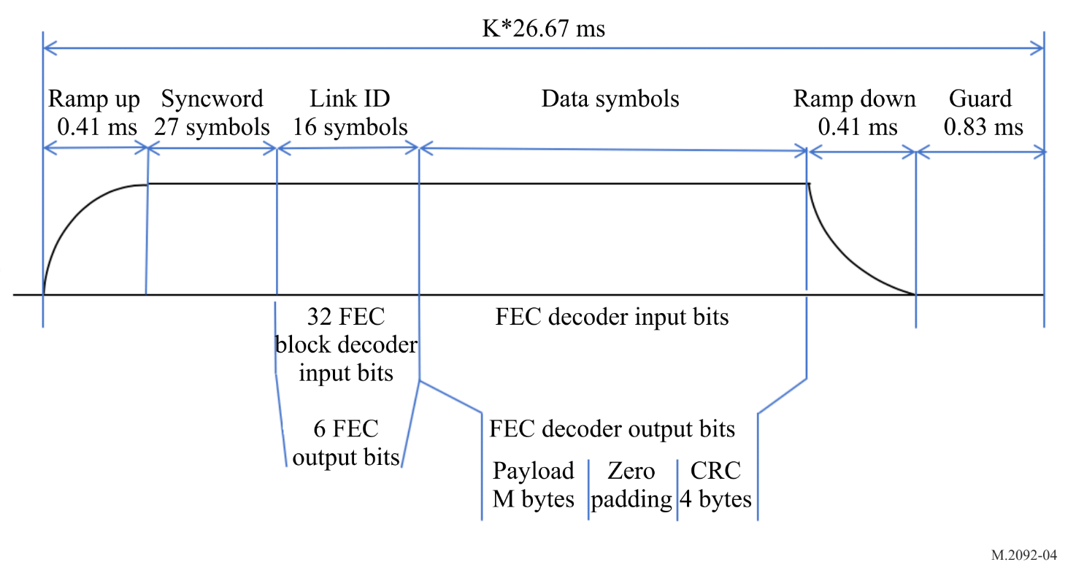
Figure A2-3
Application specific message – satellite and VHF data exchange-satellite general slot format
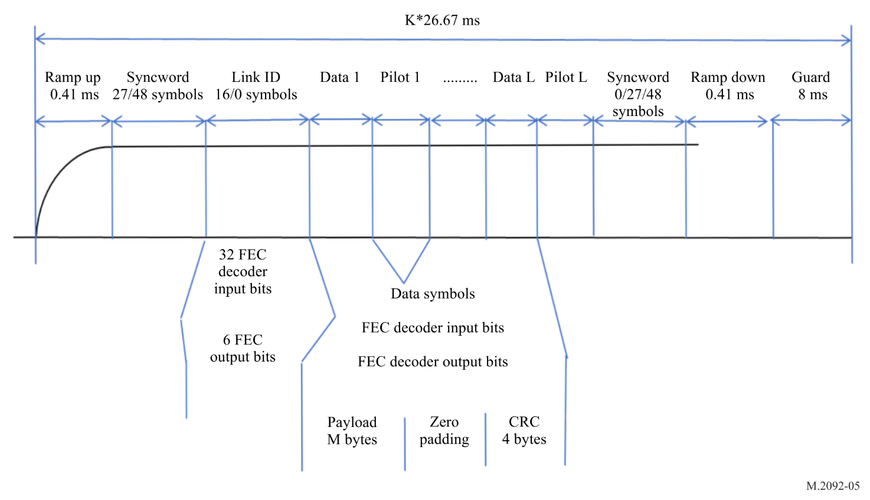

A2-1.2.3 Burst transmission structure

A2-1.2.3.1 Ramp up
The ramp up from −50 dBc to −1.5 dBc of the power shall have a controlled rise time and occur in approximately 417 µs. A gradual ramp-up period provides important spectral shaping to reduce energy spread outside the desired signal modulation bandwidth and reduces interference to other users of the current and adjacent channel. The modulation during ramp up is not specified.

A2-1.2.3.2 Training sequence
Table A2-1 shows the syncwords used for VDES.
TABLE A2-1
Syncwords for VHF data exchange system
Usage | Symbol size | Sequence | Type
ASM-TER | 27 | 1 1111100110101 0000011001010 | 1+ Barker13+ inverted Barker13
VDE-TER | 27 | 1 1111100110101 0000011001010 | 1+ Barker13+ inverted Barker13
ASM-SAT | 27 | 010001010010010000000110011 | Best autocorrelation for differential detection
VDE-SAT | 27 | 010001010010010000000110011 | Best autocorrelation for differential detection
VDE-SAT | 48 | 000100011110011011000001010111011010110111101000 | Best autocorrelation for differential detection

The Double Barker sequence used for ASM-TER and VDE-TER allows for detection of the two correlation peaks and the 13-bit known noise in-between. Furthermore, the correlation peak size indicates frequency offset.

1.2.3.3 Bit mapping for training sequence
For training the following mapping applies:
– 1 maps to π/4 quadrature phase shift keying (QPSK) (1 1) (see Figure A2-9)
– 0 maps to π/4 QPSK (0 0).
For π/4 QPSK bit mapping, see § A2-1.2.9.

1.2.3.4 Link identification
The Link ID defines the channel configurations. The Link ID is used to index the table of channel configurations (see Tables A2-7, A2-8, A2-9, A2-10 and A2-11).
The Link ID follows the training sequence for transmissions (see Figures A2-2 and A2-3), and uses π/4 QPSK bit mapping (see § A2-1.2.9). Note that not all burst transmission structures utilize the Link ID (refer to Tables A2-7, A2-8, A2-9, A2-10 and A2-11).
The Link ID consists of 6 bits (D0, D1, D2, D3, D4, D5) encoded into a sequence of 32 bits using (32,6) biorthogonal code . The code is a first order Reed-Muller code with generator matrix:
Table A2-2
Reed-Muller generator matrix
Generator matrix
10 00 00 10 11 10 10 01 11 10 10 01 10 01 01 10
01 00 00 01 11 01 01 01 11 01 01 01 01 01 01 01
00 10 00 11 10 11 00 11 00 11 00 11 00 11 00 11
00 01 00 11 00 00 11 11 10 00 11 11 00 00 11 11
00 00 10 00 01 11 11 11 00 00 00 00 11 11 11 11
00 00 01 00 00 00 00 00 01 11 11 11 11 11 11 11

The code shall be bit scrambled using the scrambling word 11000010111000101000111001001111. This results in the Link ID coding of Table A2-3.

Table A2-3
Link identification code words for VHF data exchange system
Link ID | Bit-scrambled code word | Link ID | Bit-scrambled code word
0 | 11 00 00 10 11 10 00 10 10 00 11 10 01 00 11 11 | 32 | 01 00 00 00 00 00 10 11 01 10 01 11 11 01 10 01
1 | 11 00 01 10 11 10 00 10 11 11 00 01 10 11 00 00 | 33 | 01 00 01 00 00 00 10 11 00 01 10 00 00 10 01 10
2 | 11 00 10 10 10 01 11 01 10 00 11 10 10 11 00 00 | 34 | 01 00 10 00 01 11 01 00 01 10 01 11 00 10 01 10
3 | 11 00 11 10 10 01 11 01 11 11 00 01 01 00 11 11 | 35 | 01 00 11 00 01 11 01 00 00 01 10 00 11 01 10 01
4 | 11 01 00 01 11 10 11 01 00 00 00 01 01 00 00 00 | 36 | 01 01 00 11 00 00 01 00 11 10 10 00 11 01 01 10
5 | 11 01 01 01 11 10 11 01 01 11 11 10 10 11 11 11 | 37 | 01 01 01 11 00 00 01 00 10 01 01 11 00 10 10 01
6 | 11 01 10 01 10 01 00 10 00 00 00 01 10 11 11 11 | 38 | 01 01 10 11 01 11 10 11 11 10 10 00 00 10 10 01
7 | 11 01 11 01 10 01 00 10 01 11 11 10 01 00 00 00 | 39 | 01 01 11 11 01 11 10 11 10 01 01 11 11 01 01 10
8 | 11 10 00 01 01 01 00 01 10 11 11 01 01 11 11 00 | 40 | 01 10 00 11 10 11 10 00 01 01 01 00 11 10 10 10
9 | 11 10 01 01 01 01 00 01 11 00 00 10 10 00 00 11 | 41 | 01 10 01 11 10 11 10 00 00 10 10 11 00 01 01 01
10 | 11 10 10 01 00 10 11 10 10 11 11 01 10 00 00 11 | 42 | 01 10 10 11 11 00 01 11 01 01 01 00 00 01 01 01
11 | 11 10 11 01 00 10 11 10 11 00 00 10 01 11 11 00 | 43 | 01 10 11 11 11 00 01 11 00 10 10 11 11 10 10 10
12 | 11 11 00 10 01 01 11 10 00 11 00 10 01 11 00 11 | 44 | 01 11 00 00 10 11 01 11 11 01 10 11 11 10 01 01
13 | 11 11 01 10 01 01 11 10 01 00 11 01 10 00 11 00 | 45 | 01 11 01 00 10 11 01 11 10 10 01 00 00 01 10 10
14 | 11 11 10 10 00 10 00 01 00 11 00 10 10 00 11 00 | 46 | 01 11 10 00 11 00 10 00 11 01 10 11 00 01 10 10
15 | 11 11 11 10 00 10 00 01 01 00 11 01 01 11 00 11 | 47 | 01 11 11 00 11 00 10 00 10 10 01 00 11 10 01 01
16 | 10 00 00 11 00 11 01 11 01 01 10 11 00 01 10 10 | 48 | 00 00 00 01 11 01 11 10 10 11 00 10 10 00 11 00
17 | 10 00 01 11 00 11 01 11 00 10 01 00 11 10 01 01 | 49 | 00 00 01 01 11 01 11 10 11 00 11 01 01 11 00 11
18 | 10 00 10 11 01 00 10 00 01 01 10 11 11 10 01 01 | 50 | 00 00 10 01 10 10 00 01 10 11 00 10 01 11 00 11
19 | 10 00 11 11 01 00 10 00 00 10 01 00 00 01 10 10 | 51 | 00 00 11 01 10 10 00 01 11 00 11 01 10 00 11 00
20 | 10 01 00 00 00 11 10 00 11 01 01 00 00 01 01 01 | 52 | 00 01 00 10 11 01 00 01 00 11 11 01 10 00 00 11
21 | 10 01 01 00 00 11 10 00 10 10 10 11 11 10 10 10 | 53 | 00 01 01 10 11 01 00 01 01 00 00 10 01 11 11 00
22 | 10 01 10 00 01 00 01 11 11 01 01 00 11 10 10 10 | 54 | 00 01 10 10 10 10 11 10 00 11 11 01 01 11 11 00
23 | 10 01 11 00 01 00 01 11 10 10 10 11 00 01 01 01 | 55 | 00 01 11 10 10 10 11 10 01 00 00 10 10 00 00 11
24 | 10 10 00 00 10 00 01 00 01 10 10 00 00 10 10 01 | 56 | 00 10 00 10 01 10 11 01 10 00 00 01 10 11 11 11
25 | 10 10 01 00 10 00 01 00 00 01 01 11 11 01 01 10 | 57 | 00 10 01 10 01 10 11 01 11 11 11 10 01 00 00 00
26 | 10 10 10 00 11 11 10 11 01 10 10 00 11 01 01 10 | 58 | 00 10 10 10 00 01 00 10 10 00 00 01 01 00 00 00
27 | 10 10 11 00 11 11 10 11 00 01 01 11 00 10 10 01 | 59 | 00 10 11 10 00 01 00 10 11 11 11 10 10 11 11 11
28 | 10 11 00 11 10 00 10 11 11 10 01 11 00 10 01 10 | 60 | 00 11 00 01 01 10 00 10 00 00 11 10 10 11 00 00
29 | 10 11 01 11 10 00 10 11 10 01 10 00 11 01 10 01 | 61 | 00 11 01 01 01 10 00 10 01 11 00 01 01 00 11 11
30 | 10 11 10 11 11 11 01 00 11 10 01 11 11 01 10 01 | 62 | 00 11 10 01 00 01 11 01 00 00 11 10 01 00 11 11
31 | 10 11 11 11 11 11 01 00 10 01 10 00 00 10 01 10 | 63 | 00 11 11 01 00 01 11 01 01 11 00 01 10 11 00 00

The Link ID is not used by the satellite link.

A2-1.2.3.5 Data payload with cyclic redundancy check
Input data is processed most significant bit (MSB) first.
The data payload with its appended cyclic redundancy check (CRC) (refer to § A2-1.2.5) is interleaved (refer to Table A2-4) encoded (refer to § A2-1.2.4.1), scrambled (refer to § A2-1.2.6) and bit mapped (refer to § A2-1.2.9).
Unused payload data is padded as specified in the appropriate section.
Figure A2-4
Typical order of operations for symbol data; if cyclic redundancy = 1 and forward error correction is not applied
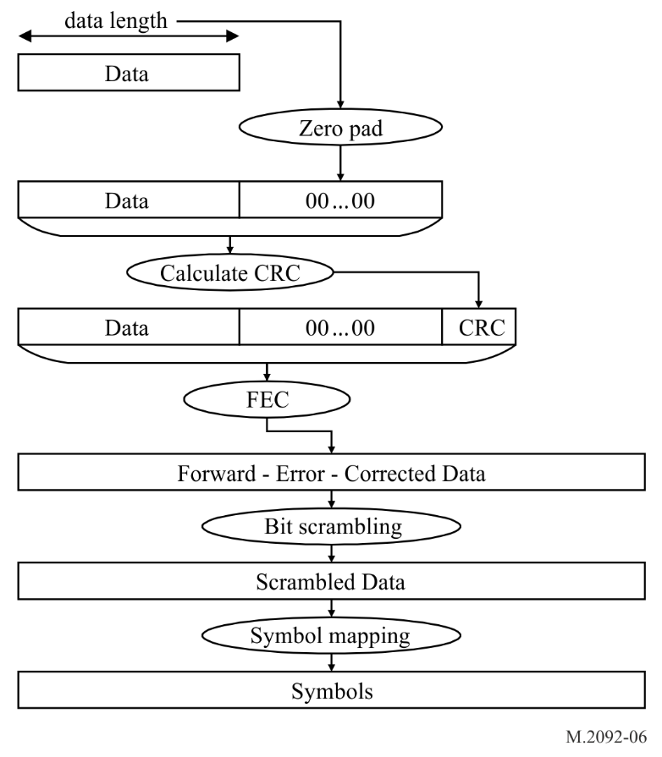

A2-1.2.3.6 Bit scrambling
Scrambling of the user data is required to avoid the power spectral density to be concentrated in the narrow band. Refer to § A2-1.2.6 for the detailed definition of the scrambler sequence.

A2-1.2.3.7 Guard time
The guard time consists of the ramp down time from full power to −50 dBc of less than or equal to 417 µs. The remaining time is for delay and jitter.

A2-1.2.4 Forward error correction

A2-1.2.4.1 Encoder structure
This paragraph defines the general structure of the forward error correction encoder to be used on the satellite and the terrestrial component of the VDES. The overall structure follows the specification in the European Technical Standards Institute standard (ETSI) EN 302 583.
The general encoder structure is depicted in Figure A2-5. The encoder consists of two recursive systematic convolutional (RSC) encoders concatenated in parallel. Each encoder produces three output bits per input bit. The first RSC encoder produces the bits X, Y₀ and Y₁, while the second encoder produces the bits X’, Y’₀ and Y’₁. The <pi> block in Figure A2-5 represents the interleaving function as described in § A2-1.2.4.3.
The first encoder gets as input a word u of k bits, with k, as specified in § A2-1.2.4.3. The second encoder input is denoted by u’ and it is a permuted version of the vector u. The input u is the data (including padding and CRC), with MSB of each byte first. For example, if the data is 0x7F, 0xA5, … u will be 01111111 10100101…
Figure A2-5
Turbo encoder structure (high-level)
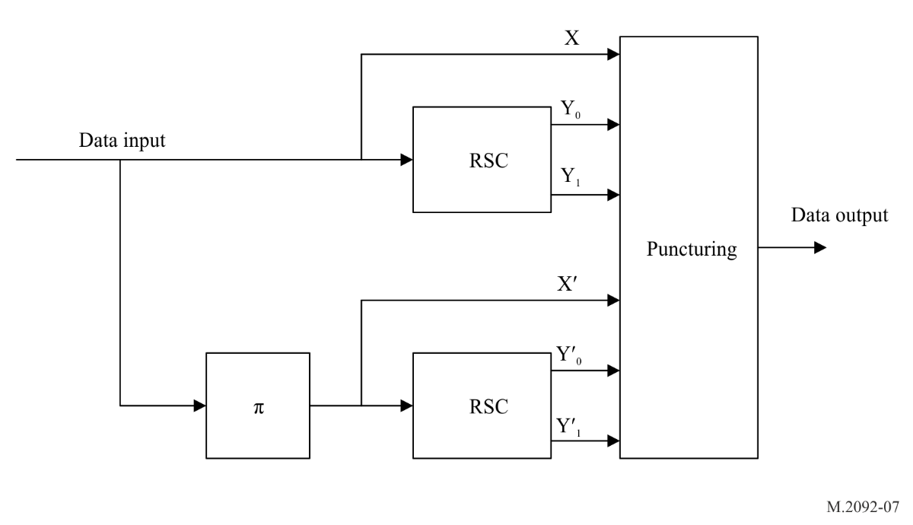

A2-1.2.4.2 Constituent codes
The constituent codes are specified by the transfer function:
$G\left(D\right)=\left[\begin{matrix}1 & \frac{n_{0}(D)}{d(D)} & \frac{n_{1}(D)}{d(D)}\end{matrix}\right]$
where:
$n_{0}\left(D\right)=1+D+D^{3}$
$n_{1}\left(D\right)=1+D+D^{2}+D^{3}$
$d\left(D\right)=1+D^{2}+D^{3}.$
The constituted encoder definition is provided in Figure A2-6. For the first k clocks the switch is in position (a), i.e. information is fed into the encoder. For the subsequent six clocks, the switch is moved to position (b) to handle the RSC trellis termination. In the first three termination clocks, only the RSC 1 (upper branch) is output, while in the subsequent three termination clocks, only the output of RSC 2 (lower branch) is provided. The termination is thus given by the sequence of six termination bits (X, Y₀, Y₁, X’, Y’₀, Y’₁) with X output first.
Figure A2-6
Recursive systematic convolutional code encoder
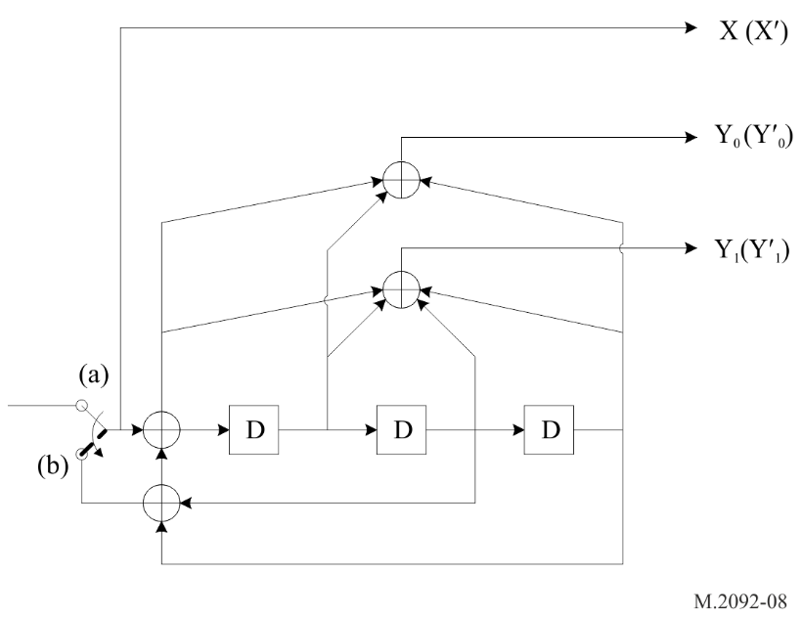

A2-1.2.4.3 Interleaver definition
The interleaver specification follows that prescribed in the Consultative Committee for Space Data systems, Recommendation for Space Data System Standards, “TM Synchronization and Channel Coding”. CCSDS 131.0-B-2. Blue Book. Issue 2. Washington, D.C.: August 2011.
First factorize k = k₁ k₂, where the parameters k₁ and k₂ depend on the choice of the respective code, where k is the information block length. Then select prime numbers and puncturing parameters values as given in Table A2-4.
Table A2-4
Interleaver and puncturing parameters for different information lengths / code rates
LinkID | Nominal code rate | Information length | k1|k2 | p1|p2|p3| p4| p5| p6| p7| p8 | Puncturing  ID | Tail  ID
4 | 3/4 | 952 | 4|238 | 113|31|59|163|29|181|101|11 | 8 | 8a
5 | 3/4 | 288 | 2|144 | 47|17|233|127|239|139|199|163 | 8 | 8b
6 | 3/4 | 672 | 2|336 | 37|101|191|149|79|131|229|31 | 8 | 8b
7 | 3/4 | 1056 | 4|264 | 23|31|167|223|59|113|47|211 | 8 | 8b
8⁽¹⁾ | 1/2 | 192 | 2|96 | 31|37|43|47|53|59|61|67 | 6 | 6
9⁽¹⁾ | 1/2 | 448 | 2|224 | 31|37|43|47|53|59|61|67 | 6 | 6
10⁽¹⁾ | 1/2 | 704 | 2|352 | 31|37|43|47|53|59|61|67 | 6 | 6
11 | 1/2 | 432 | 2|216 | 127|191|241|5|83|109|107|179 | 6 | 6a
12 | 3/4 | 972 | 2|486 | 31|37|43|47|53|59|61|67 | 8 | 8
13 | 3/4 | 1296 | 2|648 | 31|37|43|47|53|59|61|67 | 8 | 8
14 | 1/2 | 896 | 2|448 | 31|37|43|47|53|59|61|67 | 6 | 6
15 | 3/4 | 2016 | 4|504 | 31|37|43|47|53|59|61|67 | 8 | 8
16 | 3/4 | 2688 | 4|672 | 31|37|43|47|53|59|61|67 | 8 | 8
17 | 1/2 | 1872 | 6|312 | 211|61|227|239|181|79|73|193 | 6 | 6a
18 | 3/4 | 4032 | 4|1008 | 31|37|43|47|53|59|61|67 | 8 | 8
19 | 3/4 | 5616 | 16|351 | 137|101|223|41|67|131|61|47 | 8 | 8
20 | 1/4 | 96 | 2|48 | 37|83|211|61|107|101|149|167 | 2 | 2a
21 | 2/3 | 736 | 2|368 | 139|17|241| 47|109|11|29|163 | 7a | 7a
22 | 2/3 | 3120 | 16|195 | 89|47|239|17|127|59|43|31 | 7a | 7b
23 | 2/3 | 4544 | 4|1136 | 31|37|43|47|53|59|61|67 | 7b | 7b
24 | 5/6 | 3788*2 | 4|947 | 127|251|227|173|139|149|101|7 | 9 | 9
25 | 1/2 | 4776 | 12|398 | 31|37|43|47|53|59|61|67 | 6 | 6a
26 | 1/4 | 5456*7 | 16|341 | 37|41|43|47|53|59|61|67 | 2 | 2a
27 | 1/2 | 6032*19 | 16|377 | 31|37|43|47|53|59|61|67 | 6 | 6b
28 | 1/4 | 5280*4 | 16|330 | 31|37|43|47|53|59|61|67 | 2 | 2b
29 | 1/4 | 5552*6 | 16|347 | 31|37|43|47|53|59|61|67 | 2 | 2c
30 | 1/4 | 5320*13 | 14|380 | 31|37|43|47|53|59|61|67 | 2 | 2c
31 | 1/4 | 5328*22 | 16|333 | 31|41|43|47|53|59|61|67 | 2 | 2d
32 | 1/4 | 312 | 2|156 | 37|79|29|139|151|97|181|157 | 2 | 2e
33 | 1/3 | 4280 | 8|535 | 59|37|157|167|239|83|163|29 | 4 | 4a
34 | 1/3 | 4160*2 | 16|260 | 163|157|149|137|197|47|241|251 | 4 | ⁽²⁾
⁽¹⁾ No previous definitions or simulations results available, but a default configuration suggested.
⁽²⁾ No tail bits.

Table A2-4 will be extended as different information block lengths are defined.
This forward error correction (FEC) will be calculated by first choosing prime numbers p_{q}, q ∈ (1, ..., 8) as given in Table A2-4.
The following operations shall be performed for s ∈ (1, ..., k) to obtain the permutation numbers π(s):
$$m=\left(s-1\right) mod 2$$
$$i=floor (\left(s-1\right) /(2k_{2}))$$
$$j=floor (\left(s-1\right) /2))-ik_{2}$$
$$t=\left(19i+1\right) mod (k_{1}/2)$$
$$q=t mod 8+1$$
$$c=\left(p_{q}j+21m\right) mod k_{2}$$
$$π\left(s\right)=2\left(t+ck_{1}/2+1\right)-m$$
The permutation numbers shall be interpreted such that the s^{th} bit read out after interleaving is the π(s)^{th} bit of the input information block.

A2-1.2.4.4 Rate adaptation
Rate adaptation is obtained by puncturing the encoder output as in § 5.3.1 of ETSI EN 302 583, as recalled in Table A2-5 for the first k clocks, and as in ETSI EN 302 583².
The puncturing table for the termination part is given in Table A2-6. The last two rows of Table A2-6 are not part of ETSI EN 302 583².
Table A2-5
Puncturing patterns for data bit periods
Punc. pattern ID | Code rate | Punc. patern (X; Y0; Y1; X’; Y’0; Y’1 | X; Y0; Y1; X’; Y’0; Y’1 | …)
0 | 1/5 | 1;1;1;0;1;1
1 | 2/9 | 1;0;1;0;1;1 | 1;1;1;0;1;1 | 1;1;1;0;0;1 | 1;1;1;0;1;1
2 | 1/4 | 1;1;1;0;0;1 | 1;1;0;0;1;1
3 | 2/7 | 1;0;1;0;0;1 | 1;0;1;0;1;1 | 1;0;1;0;0;1 | 1;1;1;0;0;1
4 | 1/3 | 1;1;0;0;1;0
5 | 2/5 | 1;0;0;0;0;0 | 1;0;1;0;0;1 | 0;0;1;0;0;1 | 1;0;1;0;0;1 | 1;0;1;0;0;1 | 0;0;1;0;0;1 | 1;0;1;0;0;1 | 1;0;1;0;0;1 | 0;0;1;0;0;1 | 1;0;1;0;0;1 | 1;0;1;0;0;1 | 0;0;1;0;0;1
6 | 1/2 | 1;1;0;0;0;0 | 1;0;0;0;1;0
7 | 2/3 | 1;0;0;0;0;0 | 1;0;0;0;0;0 | 1;0;0;0;0;0 | 1;0;1;0;0;1
7a | 2/3 | 1;0;0;0;0;0 | 1;0;0;0;0;0 | 1;0;0;0;0;0 | 1;1;0;0;1;0
7b | 2/3 | 1;0;0;0;0;0 | 1;1;0;0;0;0 | 1;0;0;0;0;0 | 1;0;0;0;1;0
8 | 3/4 | 1;0;1;0;0;0 | 1;0;0;0;0;0 | 1;0;0;0;0;0 | 1;0;0;0;0;0 | 1;0;0;0;0;0 | 1;0;0;0;0;1
9 | 5/6 | 1;0;0;0;0;0 | 1;1;0;0;0;0 | 1;0;0;0;1;0 | 1;0;0;0;0;0 | 1;0;0;0;0;0 |  1;0;0;0;0;0 | 1;0;0;0;0;0 | 1;0;0;0;0;0 | 1;0;0;0;0;0 | 1;0;0;0;0;0
Note: For each rate, the puncturing table shall be read first from left to right and then from top to bottom.

Within a puncturing pattern, a “0” means that the symbol shall be deleted and a “1” means that a symbol shall be passed. A “2” or a “3” means that two or three copies of the symbol shall be passed. This is relevant for the termination periods. In particular:
– For the rate 1/5 turbo code (Punct_Pat_ID=0), the tail output symbols for each of the first three tail bit periods shall be XXXY₀Y₁, and the tail output symbols for each of the last three tail bit periods shall be X’X’X’Y’₀Y’₁.
– For the rate 2/9 turbo code (Punct_Pat_ID=1), the tail output symbols for the first and the second output period shall be XXXY₀Y₁, for the third output period XXY₀Y₁, for the fourth and fifth output period X’X’Y’₀Y’₁, and for the sixth (last) output period X’X’X’Y’₀Y’₁.
– For the rate 1/4 turbo code (Punct_Pat_ID=2), the tail output symbols for each of the first three tail bit periods shall be XXY₀Y₁, and the tail output symbols for each of the last three tail bit periods shall be X’X’ Y’₀Y’₁.
All other code rates shall be processed similar to the given examples above with the exact puncturing patterns to be derived from ETSI EN 302 583.
The puncturing table for the termination part is given in Table A2-6. The last rows of the Table are introduced in this Recommendation to obtain higher rates, and are not part of ETSI EN 302 583³.
Table A2-6
Puncturing and repetition patterns for tail bit periods (last 6 clocks)
Punct. pattern ID | Code rate | Punct. / Rep. pattern (X; Y0; Y1; X’; Y’0; Y’1 | X; Y0; Y1; X’; Y’0; Y’1 | …)
0 | 1/5 | 3;1;1;0;0;0 | 3;1;1;0;0;0 | 3;1;1;0;0;0 | 0;0;0;3;1;1 | 0;0;0;3;1;1 | 0;0;0;3;1;1
1 | 2/9 | 3;1;1;0;0;0 | 3;1;1;0;0;0 | 2;1;1;0;0;0 | 0;0;0;2;1;1 | 0;0;0;2;1;1 | 0;0;0;3;1;1
2 | 1/4 | 2;1;1;0;0;0 | 2;1;1;0;0;0 | 2;1;1;0;0;0 | 0;0;0;2;1;1 | 0;0;0;2;1;1 | 0;0;0;2;1;1
2a | 1/4 | 1;1;1;0;0;0 | 1;1;1;0;0;0 | 1;1;1;0;0;0 | 0;0;0;1;1;1 | 0;0;0;1;1;1 | 0;0;0;1;1;1
2b | 1/4 | 1;1;1;0;0;0 | 1;1;1;0;0;0 | 1;1;0;0;0;0 | 0;0;0;1;1;1 | 0;0;0;1;1;1 | 0;0;0;1;1;0
2c | 1/4 | 1;1;0;0;0;0 | 1;1;0;0;0;0 | 1;1;0;0;0;0 | 0;0;0;1;1;0 | 0;0;0;1;1;0 | 0;0;0;1;1;0
2d | 1/4 | 1;1;0;0;0;0 | 1;0;0;0;0;0 | 1;0;0;0;0;0 | 0;0;0;1;1;0 | 0;0;0;1;0;0 | 0;0;0;1;0;0
2e | 1/4 | 2;1;1;0;0;0 | 2;1;1;0;0;0 | 2;1;0;0;0;0 | 0;0;0;2;1;1 | 0;0;0;2;1;1 | 0;0;0;2;0;0
3 | 2/7 | 1;1;1;0;0;0 | 2;1;1;0;0;0 | 2;1;1;0;0;0 | 0;0;0;2;1;1 | 0;0;0;1;1;1 | 0;0;0;1;1;1
4 | 1/3 | 2;1;0;0;0;0 | 2;1;0;0;0;0 | 2;1;0;0;0;0 | 0;0;0;2;1;0 | 0;0;0;2;1;0 | 0;0;0;2;1;0
4a | 1/3 | 2;1;0;0;0;0 | 2;1;0;0;0;0 | 2;0;0;0;0;0 | 0;0;0;2;1;0 | 0;0;0;2;1;0 | 0;0;0;0;1;0
5 | 2/5 | 1;1;1;0;0;0 | 1;1;1;0;0;0 | 1;0;1;0;0;0 | 0;0;0;1;1;1 | 0;0;0;1;1;1 | 0;0;0;1;0;1
6 | 1/2 | 1;1;0;0;0;0 | 1;1;0;0;0;0 | 1;1;0;0;0;0 | 0;0;0;1;1;0 | 0;0;0;1;1;0 | 0;0;0;1;1;0
6a | 1/2 | 1;1;0;0;0;0 | 1;1;0;0;0;0 | 1;0;0;0;0;0 | 0;0;0;1;1;0 | 0;0;0;1;1;0 | 0;0;0;1;0;0
6b | 1/2 | 1;1;0;0;0;0 | 1;0;0;0;0;0 | 1;0;0;0;0;0 | 0;0;0;1;1;0 | 0;0;0;1;0;0 | 0;0;0;1;0;0
7 | 2/3 | 1;0;0;0;0;0 | 1;0;1;0;0;0 | 1;0;1;0;0;0 | 0;0;0;1;0;0 | 0;0;0;1;0;1 | 0;0;0;1;0;0
7a | 2/3 | 1;1;0;0;0;0 | 1;0;0;0;0;0 | 1;0;0;0;0;0 | 0;0;0;1;1;0 | 0;0;0;1;0;0 | 0;0;0;1;0;0
7b | 2/3 | 1;1;0;0;0;0 | 1;1;0;0;0;0 | 1;1;0;0;0;0 | 0;0;0;1;1;0 | 0;0;0;1;1;0 | 0;0;0;1;1;0
8 | 3/4 | 1;0;1;0;0;0 | 1;0;1;0;0;0 | 1;0;1;0;0;0 | 0;0;0;1;0;1 | 0;0;0;1;0;1 | 0;0;0;1;0;1
8a | 3/4 | 1;0;1;0;0;0 | 1;0;1;0;0;0 | 1;0;1;0;0;0 | 0;0;0;1;0;1 | 0;0;0;1;0;1 | 0;0;0;1;0;0
8b | 3/4 | 1;0;1;0;0;0 | 1;0;1;0;0;0 | 1;0;0;0;0;0 | 0;0;0;1;0;1 | 0;0;0;1;0;1 | 0;0;0;1;0;0
9 | 5/6 | 1;1;0;0;0;0 | 1;0;0;0;0;0 | 1;0;0;0;0;0 | 0;0;0;1;1;0 | 0;0;0;1;0;0 | 0;0;0;1;0;0

For each rate, the puncturing table shall be read first from left to right and then from top to bottom.

A2-1.2.4.5 Determine the number of forward error correction decoder input bits
Typically, the number of FEC decoder input bits is equal to the FEC decoder output bits divided by the FEC rate. However, one or more of the last bits as given by the puncturing pattern in Table A2-4 is not received when the number of FEC decoder output bits divided by the puncturing length is not an integer number. In the following, the number of FEC decoder input and output bits are denoted N and K respectively, and the FEC rate is denoted r.
At the transmitter side, the Turbo encoder typically encodes a block of K bits into a codeword of N bits, given by N = (1/r)∙K. Since the output of the Turbo code is punctured, this equality is however only valid when the block length K is a multiple of the puncturing length Lp.
In the case when K is not a multiple of Lp one should determine the actual number of output bits by examining the puncturing table P since the exact number of output bits then depends on how the puncturing table is defined.
The Turbo code puncturing table P has size 6∙Lp as defined in Table A2-4 and the number of 1’s in the Table is exactly Lp/r.
The number of output bits from the Turbo encoder, excluding tail bits, is then given as:
$\begin{matrix}I = \left\lfloor K/L_{p}\right\rfloor \\ R=K mod L_{p} \\ N=I\left(L_{p}/r\right)+\sum_{j=1}^{R}{\sum_{i=1}^{6}{P\left(i,j\right)}}\end{matrix}$

A2-1.2.5 Cyclic redundancy check
A generated CRC check sequence is appended to the last segment of the datagram. A 32-bit CRC-32 check sequence is applied for all waveforms except for the satellite waveform SAT-MCS-1.50-2 (Link ID 20) which applies a 16 bits CRC-16 check sequence. The CRC-32 is calculated with the generator polynomial
x³² + x²⁶ + x²³ + x²² + x¹⁶ + x¹² + x¹¹ + x¹⁰ + x⁸ + x⁷ + x⁵ + x⁴ + x² + x + 1
and the CRC-16 with the generator polynomial x¹⁶ + x¹⁵ + x² + 1. CRC check sequence generation shall be equivalent to that defined in ITU-T H.222.0, Annex A of Recommendation ITU-T V.42 for CRC-32 and ETSI EN 301 545 for CRC-16. The CRC check sequence is the remainder of the division of the initial value + datagram by the generator polynomial and can be effectively calculated by applying a linear feedback shift register. The 32 bits shift register for generating CRC-32 should be set to the initial value 0xFFFF FFFF, and the 16 bits shift register for generating CRC-16 to the initial value 0x0000 (all zero).
The CRC check sequence is calculated over all fragments of the datagram (including any zero padding) with MSB of each byte processed first, and the resulting CRC check sequence is appended MSB first. In the receiver, the CRC check sequence can be verified by obtaining an all zero result in the linear feedback shift register after processing over the entire data+padding+CRC datagram.

A2-1.2.6 Bit scrambling
The bit scrambler shown in Figure A2-7 uses the polynomial:
F(x)=1 + x⁻¹⁴ + x⁻¹⁵
and the initialization sequence as indicated in the top of Figure A2-7. For each transmitted packet, the bit scrambler is re-initialized. The MSB shall be the first output bit.
Figure A2-7
Bit scrambling
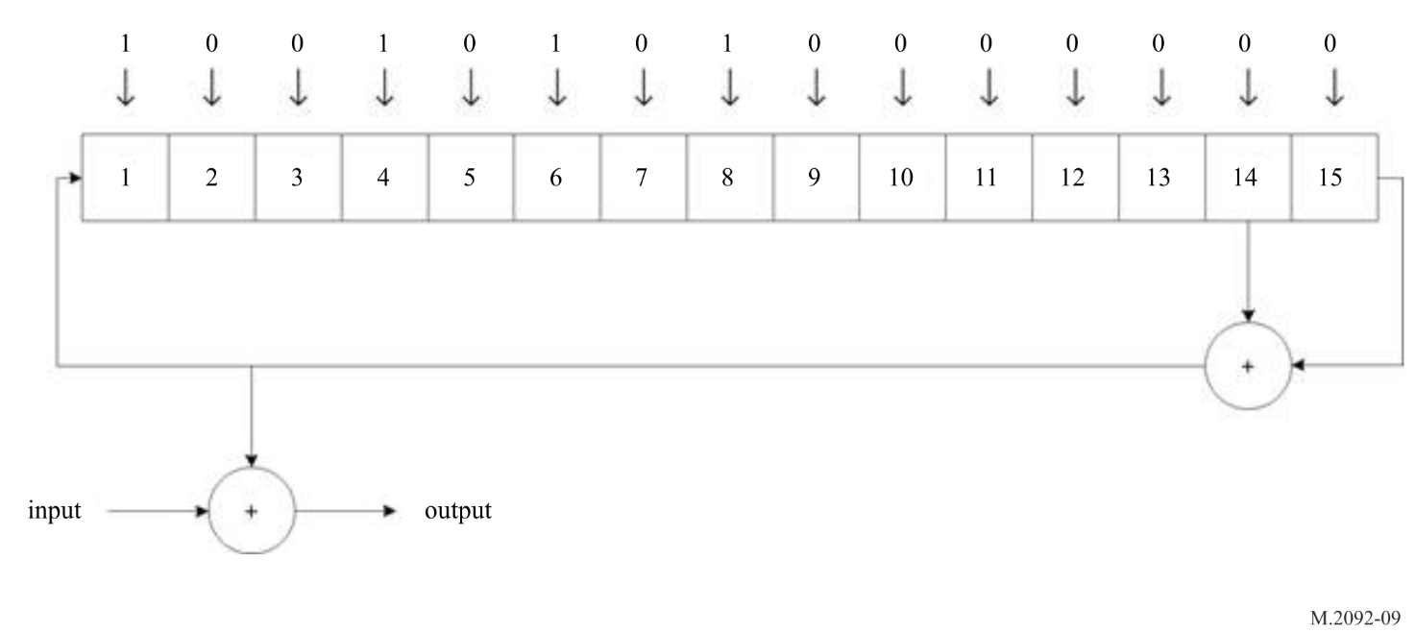

A2-1.2.7 Modulation coding schemes
All modulation coding scheme (MCS) formats are defined in the Link ID in Tables A2-7, A2-8, A2-9, A2-10 and A2-11 (refer to Figures A2-2 and A2-3). The channel quality indicator (CQI) value is used by the adaptive coding and modulation (ACM) mechanism.

Table A2-7
Application specific message link identification parameters
PL format # | ASM-MCS-1.16-1 | ASM-MCS-1.16-2 | ASM-MCS-1.16-3 | ASM-MCS-1.16-4 | ASM-MCS-1.16-5 |  | ASM-MCS-1.16-6 | ASM-MCS-1.16-7
Link ID | 1 | 2 | 3 | 4 (SAT) | 5 | 48⁽¹⁾ | 6 | 7 | 8⁽¹⁾ | 9⁽¹⁾ | 10⁽¹⁾
Channel BW (kHz) | 16
Roll off filtering⁽²⁾ | 0.35
Signal BW (kHz) | 13.0
Symbol rate (ksps) | 9.6
PAPR (example) (dB) | 3.35
Output average power (W) | 12.5
Burst size (slots) | 1 | 2 | 3 | 3 | 1 |  | 2 | 3
Guard time (ms) | 0.83 |  |  | 8 | 0.83
Burst duration (ms) | 25.8 | 52.5 | 79.2 | 72.0 | 25.8 |  | 52.5 | 79.2
Symbols/ burst (symbols) | 248 | 504 | 760 | 691 | 248 |  | 504 | 760
Ramp-up/down (symbols) | 4/4
Ramp-up/down (ms) | 0.41/0.41
Syncword size (symbols) | 27
Syncword modul. (symbols) | π/4-QPSK (00/11 only)
Link ID symbols | 16
Link ID modulation | π/4-QPSK
Net symbols/burst (symbols) | 197 | 453 | 709 | 640 | 197 |  | 453 | 709
Channel bits (bits) | 394 | 906 | 1418 | 1280 | 394 |  | 906 | 1418
Padding+FEC tail ⁽³⁾ (bits) | 10+0 |  |  | 0+11 | 0+10
FEC decoder input symbols (symbols) | 192 | 448 | 704 | 634.5⁽⁴⁾ | 192 |  | 448 | 704
FEC decoder input bits (bits) | 384 | 896 | 1408 | 1269 | 384 |  | 896 | 1408
FEC output bits | 384 | 896 | 1408 | 952 | 288 |  | 672 | 1056
FEC output (bytes) | 48 | 112 | 176 | 119 | 36 |  | 84 | 132
Modul. | π/4-QPSK
Bits / symbol | 2
FEC rate | 1 |  |  | 3/4
E_{s}/N₀ on AWGN (dB) | 11.0 | 11.0 | 11.0 | 4.5 | 5.3 |  | 5 | 4.8
C/(N₀ + I₀) threshold (dB/Hz) | 50.8 | 50.8 | 50.8 | 44.3 | 45.1 |  | 44.8 | 44.6
⁽¹⁾ This link configuration is defined for future use. It is optional and not subject to testing.
⁽²⁾ The baseband shall employ a root raised cosine filter.
⁽³⁾ Given as padding + FEC tail bits, where the tail bits are according to Table A2-6, refer to § A4-4.6 Data Structures.
⁽⁴⁾ Note that the FEC tail plus FEC decoder input results in an integer number of symbols.

Table A2-8
VHF data exchange-terrestrial link identification parameters
PL format  # | TER-MCS-1.25 |  | TER-MCS-3.25 |  | TER-MCS-5.25 | TER-MCS-1.50 | TER-MCS-3.50 | TER-MCS-5.50 |  |  | TER-MCS-1.100 |  | TER-MCS-3.100 |  | TER-MCS-5.100
Link ID | 11 | 35 ⁽⁴⁾ | 12 ⁽¹⁾ | 36 ⁽⁴⁾ | 13 ⁽¹⁾ | 14 ⁽¹⁾ | 15 ⁽¹⁾ | 16 ⁽¹⁾ |  |  | 17 | 37 ⁽⁴⁾ | 18 ⁽¹⁾ | 38 ⁽⁴⁾ | 19
Channel BW (kHz) | 25 |  |  |  |  | 50 |  |  |  |  | 100⁽⁵⁾
Roll off filtering ⁽²⁾ | 0.3
Signal BW (kHz) | 25.0 |  |  |  |  | 49.9 |  |  |  |  | 99.8
Symbol rate (ksps) | 19.2 |  |  |  |  | 38.4 |  |  |  |  | 76.8
Modulation | π/4-QPSK |  | 8-PSK |  | 16-QAM | π/4-QPSK | 8-PSK | 16-QAM |  |  | π/4-QPSK |  | 8-PSK |  | 16-QAM
PAPR (example) (dB) | 3.82 |  | 4.4 |  | 6.7 | 3.82 | 4.4 | 6.7 |  |  | 3.82 |  | 4.4 |  | 6.7
Output average power (W) | 12.5 |  | 11 |  | 6.5 | 12.5 | 11 | 6.5 |  |  | 12.5 |  | 11 |  | 6.5
Burst size (slots) | 1
Guard time (ms) | 0.83
Burst duration (ms) | 25.8
Symbols/burst (symbols) | 496 |  |  |  |  | 992 |  |  |  |  | 1984
Ramp-up/down (symbols) | 8/8 |  |  |  |  | 16/16 |  |  |  |  | 32/32
Ramp-up/down (ms) | 0.41/0.41
Syncword size (symbols) | 27
Syncword modulation | π/4-QPSK (00/11 only)
Link ID size (symbols) | 16 (32,6 block code)
Link ID modulation | π/4-QPSK
Net symbols/burst (symbols) | 437 |  |  |  |  | 917 |  |  |  |  | 1877
Channel bits | 874 |  | 1311 |  | 1748 | 1834 | 2751 | 3668 |  |  | 3754 |  | 5631 |  | 7508
Padding + FEC tail ⁽³⁾ (bits) | 0+10 | N/A | 3+12 | N/A | 8+12 | 30+12 | 51+12 | 72+12 |  |  | 0+10 | N/A | 243+12 | N/A | 8+12
FEC decoder input symbols (symbols) | 432 | N/A | 432 | N/A | 432 | 896 |  |  |  |  | 1872 | N/A | 1792 | N/A | 1872
FEC decoder input bits | 864 | N/A | 1296 | N/A | 1728 | 1792 | 2688 | 3584 |  |  | 3744 | N/A | 5376 | N/A | 7488
FEC output bits | 432 | N/A | 972 | N/A | 1296 | 896 | 2016 | 2688 |  |  | 1872 | N/A | 4032 | N/A | 5616
FEC output bytes | 54 | N/A | 121 | N/A | 162 | 112 | 252 | 336 |  |  | 234 | N/A | 504 | N/A | 702
FEC rate | 1/2 | N/A | 3/4 | N/A | 3/4 | 1/2 | 3/4 | 3/4 |  |  | 1/2 | N/A | 3/4 | N/A | 3/4
E_{s}/N₀ on AWGN (dB) | 1.0 | N/A | 7.9 | N/A | 10.2 | 1.0 | 7.9 | 10.2 |  |  | 1.0 | N/A | 7.9 | N/A | 10.2
C/(N₀+I₀) threshold (dB/Hz) | 43.8 | N/A | 50.7 | N/A | 53.0 | 46.8 | 53.7 | 56.0 |  |  | 49.9 | N/A | 56.8 | N/A | 59.1
⁽¹⁾ This link configuration is defined for future use. It is optional and not subject to testing.
⁽²⁾ The baseband shall employ a root raised cosine filter.
⁽³⁾ Given as padding + FEC tail bits, where the tail bits are according to Table A2-6, refer to § A4-4.6 Data Structures.
⁽⁴⁾ Not for communications, reserved for future radio navigation.
⁽⁵⁾

Equipment should operate in the channel conditions reported in Report ITU-R M.2317-0 VHF data exchange system channel sounding campaign.

Table A2-9
VHF data exchange-satellite uplink identification parameters
PL format | SAT-MCS-1.50-2 | SAT-MCS-1.50-3 | SAT-MCS-1.50-4 | SAT-MCS-3.50-2 | SAT-MCS-5.50
Link ID | 20 | 21 | 22 | 23⁽¹⁾ | 24⁽³⁾
Channel bandwidth (kHz) | 50
Roll off filtering ⁽²⁾ | 0.25
Signal bandwidth (kHz) | 42.0
CDMA chip rate (kcps) | 33.6 | N/A
Spreading factor (chips) | 16
Symbol rate (ksps) | 2.1 | 33.6
PAPR (example) (dB) | 0 | 4.35 |  | 4.9 | 7.1
Output average power (W) | 12.5 | 11 |  | 10 | 6
Burst size (slots) | 5 | 1 | 3
Guard time (ms) | 8
Burst duration (ms) | 125.3 | 18.7 | 72.0
Symbols/burst (symbols) | 263 | 627 | 2419
Ramp-up/down (symbols) | 14/14 ⁽⁴⁾
Ramp-up/down (ms) | 0.41/0.41
Syncword size (symbols) | 48 | 27
Syncword modulation | QPSK/CDMA (00/11)⁽⁶⁾ | π/4-QPSK (00/11)
Link ID size (symbols) | 0 | 16 (32,6 block code)
Link ID modulation | NA | π/4-QPSK
Pilot symbol distance (symbols) | 17 | N/A |  | 33
Total pilot symbols (symbols) | 12 | 0 |  | 71
Net symbols/burst (symbols) | 201 | 556 | 2348 | 2277 | 2277
Channel bits | 402 | 1112 | 4696 | 6831 | 9108
Padding + FEC tail ⁽⁵⁾ (bits) | 0+18 | 0+8 | 4+12 | 3+12 | 2*(0+8)
FEC decoder input symbols (symbols) | 192 | 552 | 2340 | 2272 | 2273
FEC decoder input bits | 384 | 1104 | 4680 | 6816 | 4546*2
FEC output bits | 96 | 736 | 3120 | 4544 | 3788*2
FEC output bytes | 12 | 92 | 390 | 568 | 947⁽⁷⁾
FEC sub-block | 1 | 1 |  | 1 | 2
Modulation | QPSK / CDMA⁽⁶⁾ | π/4-QPSK |  | 8-PSK | 16-QAM
FEC rate | 1/4 | 2/3 |  |  | 5/6
E_{s}/N₀ on AWGN (dB) | -0.9 | 3.9 | 3.9 | 8.0 | 12.2
C/(N₀+I₀) threshold (dB/Hz) | 32.3 | 49.2 | 49.2 | 53.3 | 57.5
⁽¹⁾ This link configuration is defined for future use. It is optional and not subject to testing.
⁽²⁾ The baseband shall employ a root raised cosine filter.
⁽³ FEC block is split into two sub-blocks in order to avoid very long FEC block.
⁽⁴⁾ For spread sequence it is 14/14 chips.
⁽⁵⁾ Given as padding + FEC tail bits, where the tail bits are according to Table A2-6, refer to § A4-4.6 Data Structures.
⁽⁶⁾ The spreading sequence shall be in accordance with § A5-2.5.1.
⁽⁷⁾ The two FEC blocks contain a non-integer number of bytes (3788 bits per FEC block).

Table A2-10
VHF data exchange-satellite downlink identification parameters
PL format | SAT-MCS-0.50-1 | SAT-MCS-1.50-1 | SAT-MCS-3.50-1 | SAT-MCS-0.100 |  | SAT-MCS-0.150
Link ID | 25 | 26 | 27 | 28 | 41⁽³⁾ | 29 | 42⁽³⁾
Channel BW (kHz) | 50 |  |  | 100 |  | 150
Roll off filtering⁽¹⁾ | 0.25
Signal BW (kHz) | 42.0 |  |  | 90.0 |  | 141.0
CDMA chip rate (kcps) | 33.6 | N/A |  | 72.0 |  | 112.8
Spreading factor (chips) | 8 |  |  | 2
Symbol rate (ksps) | 4.2 | 33.6 |  | 36.0 |  | 56.4
Burst size (slots) | 90
Guard time (ms) | 8
Burst duration (ms) | 2392.0
Symbols/burst (symbols) | 10046 | 80371 |  | 86112 |  | 134908
Ramp-up/down (symbols / chips) | 14/14 |  |  | 30/30 |  | 47/47
Ramp-up/down (ms) | 0.41/0.41
Syncword size (symbols) | 48 | 27 |  | 48
Number of syncwords | 10 | 35 |  | 32
Total syncword symbols (symbols) | 480 | 945 |  | 1536
Syncword distance (symbols) | 1004 | 2268 |  | 2690 |  | 4214
Syncword modulation | BPSK/  CDMA | π/4-QPSK  (00 /11) |  | BPSK/CDMA
Link ID size (symbols) | 0 (N/A)
Link ID modulation | N/A | N/A |  | N/A
Pilot distance (symbols) | N/A | 27 |  | N/A
Total pilots symbols (symbols) | N/A | 2940 |  | N/A
Net symbols/burst (symbols) | 9562 | 76458 | 76458 | 84546 |  | 133325
Burst stuffing bits | 0 | 1 | 6 | 2 |  | 5
Channel bits | 9562 | 152915 | 229368 | 84544 |  | 133320
Padding + FEC tail⁽²⁾ (bits) | 0+10 | 7*(3+18) | (0+8)*19 | 4*(0+16) | N /A | 6*(0+12) | N/A
FEC decoder input symbols (symbols) | 9552 | 76384 | 76406 | 84480 | N /A | 133248 | N/A
FEC decoder input bits | 9552 | 152768 | 229216 | 84480 | N /A | 133248 | N/A
FEC output bits | 4776 | 7*5456 | 19*6032 | 4*5280 | N /A | 6*5552 | N/A
FEC output bytes | 597 | 7*682 | 19*754 | 4*660 | N /A | 6*694 | N/A
FEC sub-blocks | 1 | 7 | 19 | 4 |  | 6
Modulation | BPSK/  CDMA | π/4-QPSK | 8-PSK | BPSK/CDMA
FEC rate | 1/2 | 1/4 | 1/2 | 1/4 | N/A |  | N/A
E_{s}/N₀ on AWGN (dB) | −2.0 | −2.4 | 5.0 | −2.0 | N/A |  | N/A
C/(N₀+I₀) threshold (dB/Hz) | 34.2 | 42.9 | 50.3 | 40.6 | N/A | 42.5 | N/A
⁽¹⁾ The baseband shall employ a root raised cosine filter.
⁽²⁾ Given as padding + FEC tail bits, where the tail bits are according to Table A2-6, refer to § A4-4.6 Data Structures.
⁽³⁾ This link configuration is defined for future use. It is optional and not subject to testing.

Table A2-11
VHF data exchange-satellite downlink identification parameters (continued)
PL format | SAT-MCS-0.50-2 | SAT-MCS-0.50-3 | SAT-MCS-1.50-2
Link ID | 32 | 33 | 34
Channel BW (kHz) | 50
Roll off filtering⁽¹⁾ | 0.25
Signal BW (kHz) | 42.0
CDMA chip rate (kcps) | 33.6 | N/A
Spreading factor (chips) | 8
Symbol rate (ksps) | 4.2 | 33.6
Burst size (slots) | 15
Guard time (ms) | 8.238 | 8 | 8.625
Burst duration (ms) | 392.0
Symbols/burst (symbols) | 1645 | 13171 | 13150
Ramp-up/down (symbols/chips) | 14/14
Ramp-up/down (ms) | 0.41/0.41
Syncword size (symbols) | 48 | 48 | 27
Number of syncwords (symbols) | 4 | 6 | 6
Total syncword symbols (symbols) | 192 | 288 | 162
Syncword distance (symbols) | 531 | 2619 | 2619
Syncword modulation | BPSK / CDMA | BPSK | π/4-QPSK  (00/11)
Pilot distance (symbols) | 8 | N/A | 27
Total pilots symbols (symbols) | 180 | N/A | 480
Burst symbol duration⁽²⁾ (symbols) | 1641 | 13143 | 13122
Net symbols/burst (symbols) | 1269 | 12855 | 12480
Channel bits | 1269 | 12855 | 24960
Padding + FEC tail⁽³⁾ (bits) | 0+21 | 0+15 | 0+0
FEC decoder input symbols (symbols) | 1248 | 12840 | 12480
FEC decoder input bits | 1248 | 12840 | 2*12480
FEC output bits | 312 | 4280 | 2*4160
FEC output bytes | 39 | 535 | 1040
FEC sub-blocks | 1 | 1 | 2
Modulation | BPSK/CDMA | BPSK | π/4-QPSK
FEC rate | 1/4 | 1/3 | 1/3
E_{s}/N₀ on AWGN (dB) | −4.5 | −3.6 | −0.6
C/(N₀+I₀) threshold (dB/Hz) | 31.6 | 41.7 | 44.7
⁽¹⁾ The baseband shall employ a root raised cosine filter.
⁽²⁾ Burst symbol duration is the number of net symbols/burst plus pilot and syncword symbols.
⁽³⁾ Given as padding + FEC tail bits, where the tail bits are according to Table A2-6, refer to § A4-4.6.

A2-1.2.8 Channel quality indicator
A receiving station will report a CQI in the relevant response messages to provide feedback on the quality of received transmissions. The receiving station shall estimate the CQI parameters based on a signal to noise plus interference ratio estimate, signal to interference-plus-noise ratio (SINR), given in dB. The SINR is equivalent to E_{s}/N₀ on AWGN, when no interference. The CQI parameter is a positive integer value that occupies one byte, ranging from 0 to 255. The relationship between the estimated SINR and the CQI is given by:
CQI = 4·(10 + SINR) = 40 + 4·SINR
The SINR estimate and hence the CQI parameter is independent of the channel BW, and the carrier to noise plus interference ratio estimate, C/(N₀ + I₀), as given in Annex 2, is related to SINR by:
C/(N₀ + I₀) = SINR + 10log₁₀(R_{s})
where R_{s} denotes the symbol rate. An estimated SINR value less than −10.0 dB shall result in a minimum CQI value of 0, and a SINR larger 53.75 dB shall result in CQI = 255. The precision of the CQI parameter is 0.25 dB, but the actual accuracy is also dependent on the variance of the SINR estimate. The CQI accuracy will thus depend on the SINR working point, the length of the burst waveform, type of modulation and estimation method.
The SINR can be estimated based on averaging the noise power of demodulated symbol, found by squaring the deviating distance from nominal symbol locations. The signal power is known in advance, provided that an automatic gain control loop is implemented. Such an estimation approach can be performed on known symbols (syncwords and pilot symbols), but also on unknown symbols based on symbol location decision. Another possible method for estimating the SINR can be based on bit error rate (BER), counting the error corrected by the FEC Turbo coder.
When a response message relates to multiple received transmissions, the average CQI will be calculated and reported.

A2-1.2.9 Bit mapping
The bit mappings used throughout the Annexes are shown in Figures A2-8, A2-9, A2-10 and A2-11.
The first output from the bit scrambler is mapped to the MSB of the first symbol, the second bit to the next bit in the symbol, and so on until the least significant bit (LSB) of the symbol has been filled, then mapping continues in the next symbol. If more bits are needed to complete the last symbol, 0 shall be used. The initial state of the alternating π/4-QPSK bit mapping is defined such that the first symbol of the training sequence is mapped to the constellation defined by points $\{\left(1+j\right)/\sqrt{2}$, $\left(-1+j\right)/\sqrt{2}$, $\left(-1-j\right)/\sqrt{2}$, $\left(1-j\right)/\sqrt{2}\}$ (shown in green in Figure A2-9); the next symbol is mapped to the constellation defined by points $\{1+0j, 0+j$, $-1+0j, 0-j\}$(shown in purple in Figure A2-9); the third symbol is mapped to the same constellation as the first symbol; and so on. If the modulation of the following transmission is also π/4-QPSK, then the first symbol should be mapped to the constellation defined by points $\{1+0j, 0+j$, $-1+0j, 0-j\}$ (shown in purple in Figure A2-9).
The modulation accuracy requirements for binary phase shift keying (BPSK) are:
1 The root mean square (RMS) error vector in any burst shall be less than 0.15.
2 The peak error vector magnitude shall be less than 0.45 for any symbol.
Figure A2-8
Bit mapping for binary phase shift keying
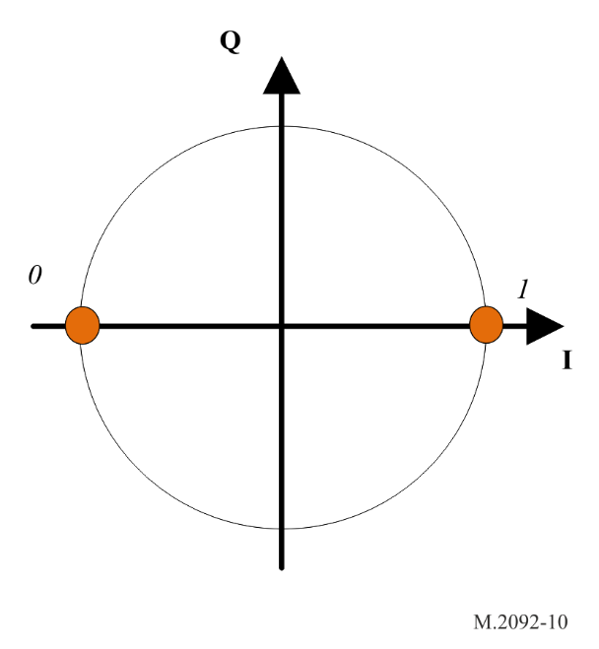
The modulation accuracy requirements for π/4-QPSK are:
1 The RMS error vector in any burst shall be less than 0.1.
2 The peak error vector magnitude shall be less than 0.3 for any symbol.
Figure A2-9
Bit mapping for π/4 quadrature phase shift keying
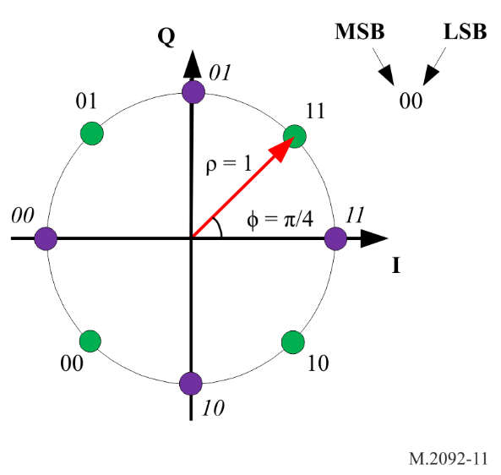
The modulation accuracy requirements for 8-PSK are:
1 The RMS error vector in any burst shall be less than 0.07.
2 The peak error vector magnitude shall be less than 0.22 for any symbol.
Figure A2-10
8 phase shift keying symbol to bit mapping
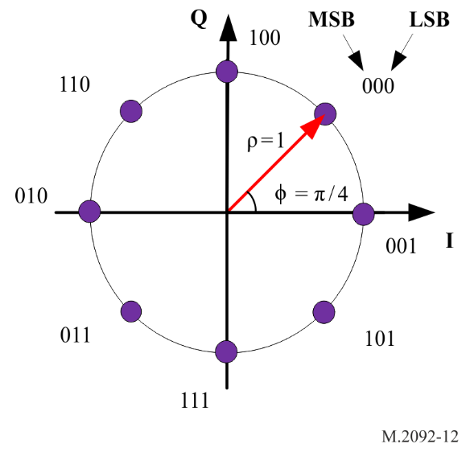
The modulation accuracy requirements for 16-QAM are:
1 The RMS error vector in any burst shall be less than 0.04.
2 The peak error vector magnitude shall be less than 0.1 for any symbol.
Figure A2-11
Bit mapping for 16 quadrature amplitude modulation
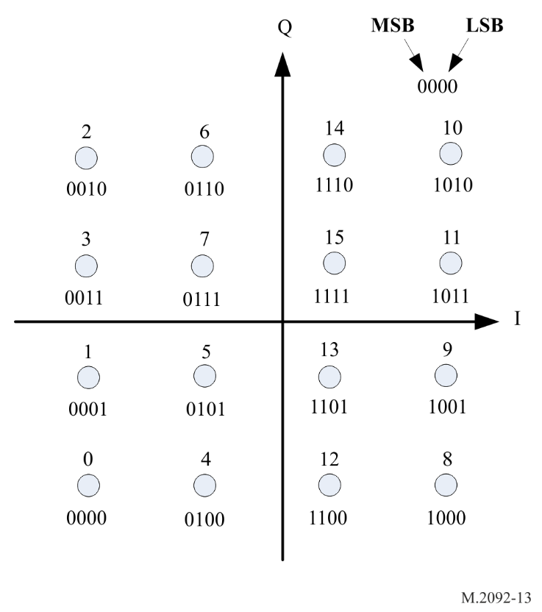

A2-1.2.10 Antenna gain for VHF data exchange system ship stations
Existing ship AIS antennas may be used for VDES. An antenna with a gain of 2 dBi at zero degrees elevation is assumed.

A2-1.2.11 Noise and interference level
The noise floor is a function of many sources such as vessel electronics, other radio equipment, power supplies, etc., and sensitivity is also reduced by RF cabling losses and the low noise amplifier (LNA) noise figure. Table A2-12 presents assumed representative values for the receiver noise figure.
Table A2-12
Ship receiver noise figure calculations
Antenna noise temperature⁽¹⁾ | 245.0 | K
LNA noise figure | 6.0 | dB
LNA noise temperature | 813.8 | K
Feed loss noise temp at LNA | 0.0 | K
Antenna noise temp at LNA | 245.0 | K
System noise temp at LNA | 1058.8 | K
System noise temp at LNA | 30.2 | dBK
⁽¹⁾ The galactic background antenna noise temperature is 245 K at 160 MHz {RD-4}.

A2-1.2.12 Transmitter requirements for VHF data exchange system

A2-1.2.12.1 Ship Stations transmitter power
Except for Annex 3, Table A2-13 defines the requirements for VDES ship station transmitters, for the transmit spectrum mask (see Figure A2-12). The resolution bandwidth for the mask measurement is 300 Hz.
Table A2-13
Transmitter parameters
Transmitter parameters | Requirements | Condition
Frequency error | 1.5 ppm | Normal
Frequency error | 3 ppm | Extreme
Average transmit power capability | The minimum average power should be according to Table A2-8,  Table A2-9.  The power tolerance is ±1.5 dB in normal, +2/−6 dB in extreme conditions. | Conducted
Maximum adjacent power levels for 25 kHz channel | ∆fc < ±12.5 kHz: 0 dBc  ±12.5 kHz < ∆fc < ±25 kHz: below the straight line between  −25 dBc at ±12.5 kHz and –70 dBc at ±25 kHz  ±25 kHz < ∆fc < ±62.5 kHz: −70 dBc

Table A2-13 (end)
Transmitter parameters | Requirements | Condition
Maximum adjacent power levels for 50 kHz channel | ∆fc < ±25 kHz: 0 dBc  ±25 kHz < ∆fc < ±37.5 kHz: below the straight line between  −25 dBc at ±25 kHz and –70 dBc at ±37.5 kHz  ±37.5 kHz < ∆fc < ±125 kHz: −70 dBc
Maximum adjacent power levels for 100 kHz channel | ∆fc < ±50 kHz: 0 dB.  ±50 kHz < ∆fc < ±62.5 kHz: below the straight line between  −25 dBc at ±50 kHz and –70 dBc at ±62.5 kHz  ±62.5 kHz < ∆fc < ±250 kHz: −70 dBc
Spurious emissions | −36 dBm  −30 dBm | 9 kHz to 1 GHz  1 GHz to 4 GHz

Figure A2-12
Slotted transmission mask (VHF data exchange)
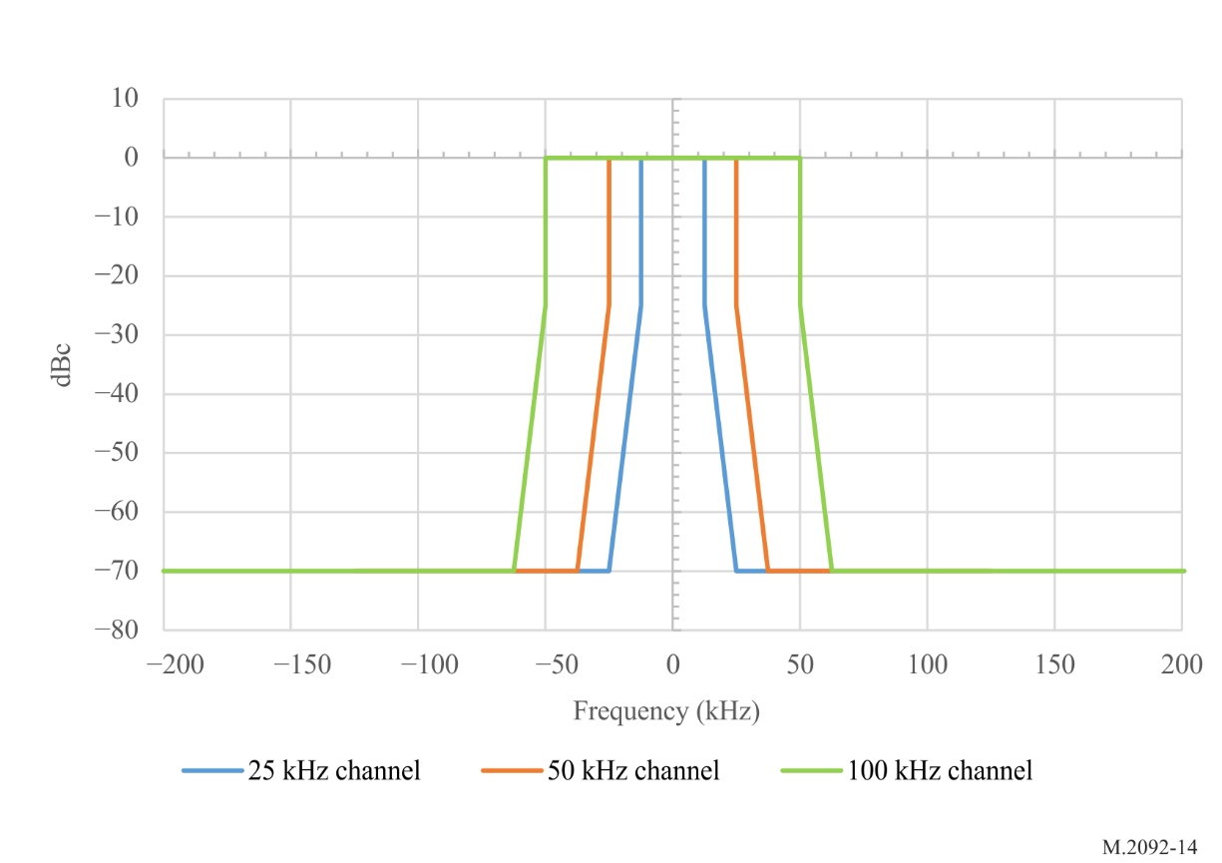

A2-1.2.12.2 Ship effective isotropic radiated power vs. elevation angle
The minimum ship effective isotropic radiated power (e.i.r.p.), vs elevation angle is shown in Table A2-14. There are no minimum e.i.r.p. requirements above 80 degrees elevation. Table A2-14 is based on a linear transmitter meeting the maximum Adjacent Channel Interference levels defined in Table A2-13. For saturated operation, the e.i.r.p. shall be 3 dB higher.
Table A2-14
Minimum ship e.i.r.p. vs elevation angle
Ship elevation angle  (degrees) | Ship antenna gain  (dBi) | Minimum ship e.i.r.p. with 6 W transmitter  (dBW)
0 | 3 | 10.8
10 | 3 | 10.8
20 | 2.5 | 10.3
30 | 1 | 8.8
40 | 0 | 7.8
50 | −1.5 | 6.3
60 | −3 | 4.8
70 | −4 | 3.8
80 | −10 | −2.2
90 | −20 | −12.2

A2-1.2.12.3 Shutdown procedure
An automatic transmitter hardware shutdown procedure and indication should be provided in case a transmitter continues to transmit for more than 2 s. This shutdown procedure should be independent of software control.

A2-1.2.12.4 Safety precautions
The VDES installation, when operating, should not be damaged by the effects of open circuited or short-circuited antenna terminals.

A2-1.2.13 Requirements for protecting the VDES receiver front end
The VDES receiver front end should be protected from saturation by high-level signals from transmissions by the ship’s VHF radio or from transmissions by VHF radios on nearby ships that could block the reception of VDES signals. To prevent saturation of the VDES receiver front end, the receiver blocking requirement should be as follows:

20% PER @ 86 dB
Blocking signal | Desired signal
‒15 dBm | ‒101 dBm
+10 dBm | ‒76 dBm
These values assume a 2-meter vertical antenna separation as recommended by IMO COMSAR.1/Circ.32]

A2-1.3 Link layer
This layer ensures reliable transmission of data between ships, ship and shore, and ship and satellite. This layer will further be responsible for packing data into messages and providing access to the data transfer medium using time division multiple access (TDMA) techniques.

A2-1.3.1 Time division multiple access synchronization
TDMA synchronization is achieved using an algorithm as described below.
The TDMA receiving process should not depend on slot boundaries.
Synchronization other than UTC direct may be provided by the AIS system.

A2-1.3.2 Coordinated universal time direct
A station, which may acquire timing directly from UTC source having the required accuracy.

A2-1.3.3 Coordinated universal time indirect
A station, which is unable to get direct access to UTC, but has access to the AIS system timing, should get its synchronization from the AIS system.

Annex 3
Technical characteristics of the application specific message
channels for the VHF data exchange system in the VHF maritime band
TABLE OF CONTENTS
Page
1 Introduction 37
2 Open systems interconnection layers 37
2.1 Physical layer 37
2.2 Link layer 37
2.3 Network layer 38
2.4 Transport layer 38
3 Physical layer 38
3.1 Parameters 38
3.2 Transceiver characteristics 39
3.3 Modulation scheme 40
3.4 Data transmission bit rate 40
3.5 Frame structure 41
3.6 Signal information 41
3.7 Forward error correction and bit scrambling 41
3.8 Transmitter transient response 41
3.9 Transmitter power 41
4 Link layer 41
4.1 Sub-layer 1 – medium access control 41
4.2 TDMA synchronization 41
4.3 Time division 41
4.4 Sub layer 2 – data link service 43
4.5 Sub layer 3 – link management entity 44
5 Network layer 52
5.1 Multi-channel operations 52
5.2 Management of priority assignment for messages 52
5.3 Data link congestion resolution 52
6 Transport layer 53
6.1 Definition of transmission packet 53
6.2 Application specific message identifier 53
6.3 Transmission packets 54
6.4 Multiple incremental time division multiple access 54
7 Packet structure 56
7.1 slot transmission structure 58
7.2 Message summary 59
7.3 Message 0: broadcast automatic identification system
application specific message 59
7.4 Message 1: Scheduled broadcast message 60
7.5 Message 2: Broadcast message 61
7.6 Message 3: Scheduled addressed message 61
7.7 Message 4: Addressed message 62
7.8 Message 5: Acknowledgment message 63
7.9 Message 6: Geographical multicast message 64
8 Example of application specific message burst symbol generation 67

A3-1 Introduction
This section describes those elements of the ASM that are unique to ASM operation. It contains a description of the different protocols according to the open systems interconnection (OSI) layer model and recommends implementation details for each layer. For those elements that are common, the cross reference into Annex 2 is provided.
The system should use TDMA techniques in a synchronized manner.
This Annex describes the characteristics of the TDMA access schemes which include random access TDMA (RATDMA), Multiple Incremental TDMA (MITDMA), fixed access TDMA (FATDMA), techniques. Slot carrier sense TDMA may be implemented as an option. The behaviour should be in accordance with Recommendation ITU-R M.1371-5, Annex 7.

A3-2 Open systems interconnection layers
Refer to Annex 2.

A3-2.1 Physical layer
Convert digital transmission packet to π/4-QPSK signal to modulate transmitter.

A3-2.2 Link layer
The link layer is divided into three sub-layers with the following tasks.

A3-2.2.1 Link management entity
This sub layer has the following functions:
– Assemble ASM message bits
– Order the ASM message bits into 8-bit byte for assembly of transmission packet.

A3-2.2.2 Data link services
This sub layer has the following functions:
– Calculate CRC of the ASM message bits (see § A2-1.2.5)
– Append CRC to ASM message to complete creation of transmission packet contents.
– Complete assembly of transmission packet.

A3-2.2.3 Media access control
Media access control provides a method for granting access to the data transfer to the VHF data link (VDL). The method used is a TDMA scheme using a common time reference.

A3-2.3 Network layer
The network layer is responsible for the management of priority assignments of messages, distribution of transmission packets between channels, and data link congestion resolution.

A3-2.4 Transport layer
The transport layer is responsible for converting data into transmission packets of correct size and sequencing of data packets.

A3-3 Physical layer

A3-3.1 Parameters

A3-3.1.1 General
The PL is responsible for the transfer of a bit-stream from an originator, out on to the data link. The performance requirements for the PL are summarized in Tables A3-1, A3-2 and A3-3.
The low setting and the high setting for each parameter is independent of the other parameters.
Table A3-1
Minimum required time division multiple access transmitter characteristics
Parameter name | Low setting | High setting
Channel spacing (encoded according to RR Appendix 18 with footnotes)⁽¹⁾ (kHz) | 25 | 25
ASM 1⁽¹⁾ (MHz) | 161.950 | 161.950
ASM 2⁽¹⁾ (MHz) | 162.000 | 162.000
Average transmit output power (W) | 1 | 12.5
⁽¹⁾ See Recommendation ITU-R M.1084, Annex 4.

A3-3.1.2 Transmission media
Data transmissions are made in the VHF maritime mobile band. Data transmissions should use ASM 1 and/or ASM 2 channels.

A3-3.1.3 Multi-channel operation
The ASM station should be capable of receiving on two parallel channels and transmitting on two independent channels. Two separate TDMA receiving processes should be used to simultaneously receive on two independent frequency channels. One TDMA transmitter may be used to enable TDMA transmissions on one or two independent frequency channels.
ASM transmission should alternate between the two ASM channels.
MITDMA linked transmissions should be on the same channel.

A3-3.2 Transceiver characteristics
The transceiver should perform in accordance with the characteristics set forth herein, see Table A3-2 and Figure A3-1. The resolution bandwidth for the mask measurement is 300 Hz.
Table A3-2
Minimum required time division multiple access transmitter characteristics
 | Requirements
Carrier power error | ±1.5 dB
Carrier frequency error (normal) | 1.5 ppm
Carrier frequency error (extreme) | 3.0 ppm
Slotted modulation mask | ∆fc < ±8 kHz: 0 dBc  ±8 kHz < ∆fc < ±16 kHz: below the straight line between  −25 dBc at ±8 kHz and –60 dBc at ±16 kHz  ±16 kHz < ∆fc < ±25 kHz: below the straight line between  −60 dBc at ±16 kHz and –70 dBc at ±25 kHz  ±25 kHz < ∆fc < ±62.5 kHz: −70 dBc
Spurious emissions | −36 dBm: 9 kHz ... 1 GHz  −30 dBm: 1 GHz ... 4 GHz
Figure A3-1
Application specific message slotted modulation mask
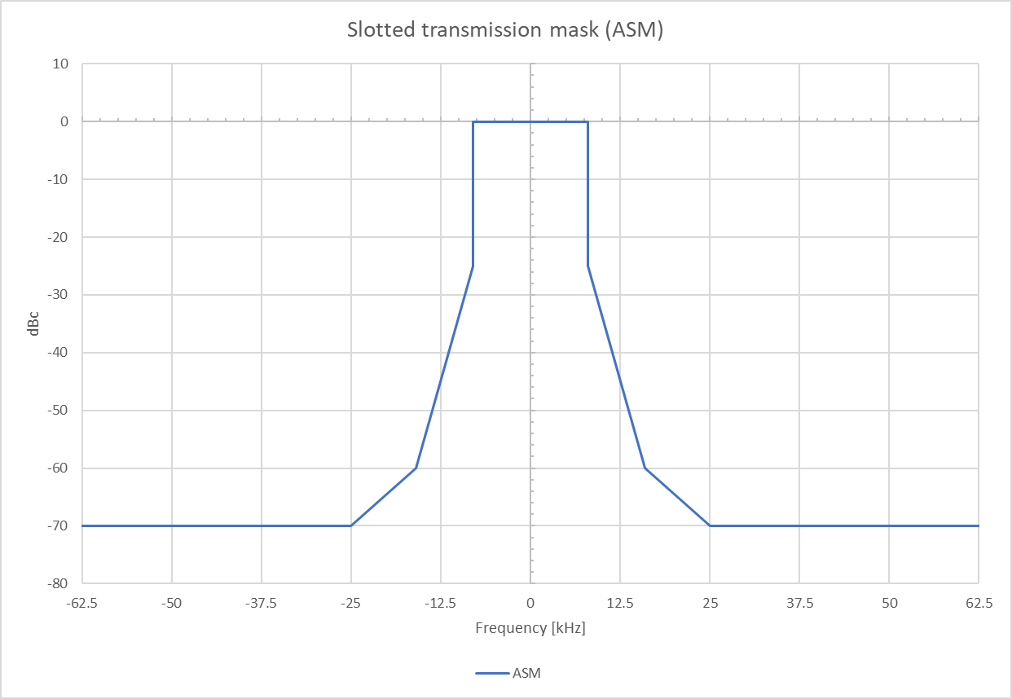
Table A3-3
Minimum required time division multiple access receiver characteristics without forward error correction
Receiver parameters | Requirements
Sensitivity | 20% PER @ −107 dBm
Error behaviour at high input levels | 1% PER @ −77 dBm  1% PER @ −7 dBm
Adjacent channel selectivity | 20% PER @ 70 dB
Spurious response rejection | 20% PER @ 70 dB
Intermodulation response rejection | 20% PER @ 71 dB
Spurious emissions | −57 dBm (9 kHz to 1 GHz)  −47 dBm (1 GHz to 4 GHz)
Blocking | 20% PER @ 86 dB

A3-3.3 Modulation scheme
The base modulation is defined by the Link ID, see Table A2-7.
For the modulation bit mapping, see Annex 2.

A3-3.4 Data transmission bit rate
The transmission bit rate should be 19.2 kbit/s ±10 ppm for π/4-QPSK.

A3-3.5 Frame structure
For the generic definition of the frame structure, see Annex 2.

A3-3.6 Signal information
Signal information selects the modulation scheme and coding according to the Link ID defined in Table A2-7.

A3-3.7 Forward error correction and bit scrambling
When forward error correction is used, it will be used as defined in Annex 2. Interleaving and bit scrambling are used, as defined by the FEC designated in the signal information. In the event of no FEC, bit scrambling according to Annex 2 shall be implemented.

A3-3.8 Transmitter transient response
The time taken to switch from transmit to receive conditions, and receive to transmit conditions, should not exceed the transmit ramp up and ramp down (see § A2-1.2.3.1). It should be possible to receive a message from the slot directly after or before own transmission.
The equipment should not be able to transmit during channel switching operation.

A3-3.9 Transmitter power
The power level is determined by the link management entity (LME) of the link layer.
Provision should be made for two levels of nominal power (high power, low power) as required by some applications. The default operation of the ASM station should be on the high nominal power level.
The nominal levels for the two power settings should be 1 W (average power) and 12.5 W (average power); tolerance should be within ±1.5 dB.

A3-4 Link layer
The link layer specifies how data is packaged in order to apply error detection and correction to the data transfer. The link layer is divided into three sub-layers.

A3-4.1 Sub-layer 1 – medium access control
The medium access control (MAC) sub layer provides a method for granting access to the data transfer medium, i.e. the VHF data link. The access scheme is TDMA using a common time reference.

A3-4.2 TDMA synchronization
TDMA synchronization is achieved using an algorithm as described in § A2-1.3.1.

A3-4.3 Time division
The slot and frame are as defined in Annex 2. Access to the data link is, by default, given at the start of a slot. The frame start and stop coincide with the UTC minute, when UTC is unavailable the AIS system may provide the frame synchronization.

A3-4.3.1 Slot phase and frame synchronization
Slot phase synchronization and frame synchronization is done by using information from UTC or from the AIS system.

A3-4.3.2 Slot phase synchronization
Slot phase synchronization is the method whereby the slot boundary is synchronized with a high level of synchronization stability, thereby ensuring no message boundary overlapping or corruption of messages.

A3-4.3.3 Frame synchronization
Frame synchronization is the method whereby the current slot number for the frame is known.

A3-4.3.4 Slot identification
Each slot is identified by its index (0-2249). Slot zero (0) should be defined as the start of the frame.

4.3.5 Slot access
The transmitter should begin transmission by turning on the RF power at slot start.
The transmitter should be turned off after the last bit of the transmission packet has left the transmitting unit. This event should occur within the slots allocated for own transmission. The slot access is performed as described in § A2-1.2.2.

A3-4.3.6 Slot state
Each slot on an ASM or VDE channel can be in one of the following states:
Unavailable:
If any of the conditions below are met, the corresponding slot should be considered as unavailable on all VDE and ASM channels:
(1) slot is internally allocated by own station for the purpose of own transmission on any channel;
(2) when the same slot on an AIS channel is externally allocated by an AIS station and meets the following conditions (*):
(2.1) SOTDMA slot timeout = 0;
(2.2) the slot is an FATDMA allocated slot to an AIS station within 120 NM;
(3) slot is allocated for addressed message to own station on any channel;
(4) slot is allocated for own station VDE reception; or
(5) slot is reserved for VDE-TER or VDE-SAT bulletin board reception.
(*) only when co-locating with AIS.
Allocated:
A slot that is not Unavailable, and externally allocated by an ASM station or VDE station on the channel is considered Allocated.
Free:
A slot that is not Unavailable or Allocated is considered Free on the channel.
NOTE: For AIS channels, slots are considered “allocated” when matching the requirements defined for “available” in Recommendation ITU-R M.1371 section on “Intentional slot reuse by the own station”.

A3-4.4 Sub-layer 2 – data link service
The data link service (DLS) sub layer provides methods for:
data link activation and release;
data transfer; or
error detection, correction and control.

A3-4.4.1 Data link activation and release
Based on the MAC sub layer the DLS will listen, activate or release the data link. A slot, marked as free or externally allocated, indicates that own equipment should be in receive mode and listen for other data link users.

A3-4.4.2 Data transfer
Data transfer should use a bit-oriented protocol and should be in accordance with this standard.

A3-4.4.3 Packet format
Data is transferred using the generic transmission packet as defined in Figures A2-2 and A2-3.
The packet should be sent from left to right. The training sequence is being used to synchronize the VDES receiver.

A3-4.4.3.1 Summary of the transmission packet
The data packet is defined in Table A3-4.
The ASM channel configurations are defined by Link ID table, Table A2-7.
Table A3-4
Packet symbol structure for π/4 quadrature phase shift keying modulation scheme
 | Symbols | Description
Ramp up | 4
Training sequence | 27 | Necessary for synchronization.
Link ID | 16 | Decoded from (32,6) biorthogonal code;  ASM channel configurations as defined in Link ID table;  Note that the Link ID will identify how many slots make up the message.
Data | 1 slot: 176  2 slot: 432  3 slot: 688  SAT: 618.5 | The symbol count and the information bits varies according to coding rate as defined by the Link ID field.
CRC | 16 | The CRC only includes the data field.
FEC termination bits | TER : 5  SAT 5.5 | Set to zero when not used.
Ramp Down | 4 | Distance delay and jitter.
Guard Time | TER: 8  SAT: 77 | Distance delay and jitter.
Total | 1 slot: 256  2 slot: 512  3 slot: 768
Note that the data, CRC and FEC termination bits combined results in an integer number of symbols.

A3-4.4.3.2 Transmission timing
The modulation may be applied during the ramp up period, but it shall not be considered as part of the training sequence.

A3-4.4.3.3 Long transmission packets
A station may occupy a maximum of three consecutive slots, as defined by the Link ID, for one (1) continuous transmission. Only a single application of the overhead (ramp up, training sequence, CRC, guard time) is required for a long transmission packet.

A3-4.4.4 Error detection and control
Error detection is accomplished using a CRC polynomial as described in Annex 2.

A3-4.4.5 Forward error correction
Forward error correction should be handled as described in § A2-1.2.4, and specified by the Link ID see Table A2-7.

A3-4.5 Sub layer 3 – link management entity
The LME controls the operation of the DLS, MAC and the PL.

A3-4.5.1 Access to the data link
There should be different access schemes for controlling access to the data transfer medium. The application and mode of operation determine the access scheme to be used.
The access schemes are MITDMA, RATDMA, and FATDMA.

A3-4.5.2 Cooperation on the data link
The access schemes operate continuously, and in parallel, on the same physical data link. They all conform to the rules set up by the TDMA. The ASM system should give priority to the AIS system when accessing the physical data link.

A3-4.5.3 Candidate slots
For ASM shore stations, a shore authority may decide to make FATDMA reservations on the AIS channels to account for ASM transmissions in FATDMA mode ensuring that no AIS data is lost to the shore station when sending ASM data. All shore stations should also be capable of using the rules below for candidate slot selection if FATDMA is not configured in the station.
The definitions of slot states applied in the selection rules below are defined in § A3-4.3.6.
Slots, used for transmission, are selected from candidate slots in the selection interval (SI) which is defined as 235 slots. The ASM transmit channel should be selected before initiating the slot selection process.
The selection process uses received data from AIS, ASM and VDE channels where these functions are co-located. Functions not part of a co-located station, or not in use by the station, are not considered by the candidate slot selection process of the station.
There should be, at minimum, a set of eight candidate slots to choose from.
Only candidate slots that are free on the transmit ASM channel shall be considered using the rule set below in consecutive order.
Rule 1: The candidate slots are initially selected from slots that are Free on all VDES channels.
If the candidate slot set contains less than eight slots, additional candidate slots can be obtained by using the following rules and order (rule 2 followed by rule 3 and then rule 4 and then rule 5):
Rule 2: Free on AIS and ASM channels, Free or Allocated on VDE channel(s).
Rule 3: Free on AIS channels, Free or Allocated on the other ASM channel or the VDE channel(s).
Rule 4: Free on one AIS channel and Available on the other, Free or Allocated on the other ASM channel or the VDE channel(s).
Rule 5: Available on both AIS channels, Free or Allocated on the other ASM channel or the VDE channel(s).
When selecting candidates for messages longer than one (1) slot, i.e. a multi-slot message, a candidate slot should be the first slot in a consecutive block of slots that conform to the selection criteria stated above, i.e. all slots selected for the multi-slot message should meet one of the rules above.
If the station cannot find a sufficient number of candidate slots, the station should not transmit and should re-schedule the transmission.
The candidate slot selection process also has to consider time periods reserved for the reception of the VDE-TER and VDE-SAT bulletin board.
The purpose of maintaining a minimum of eight candidate slots within the same probability of being used for transmission is to provide high probability of access to the link.
Note that individual VDES services need only to be considered in the candidate slot selection process when they are in use and there is not sufficient isolation ensure that the individual services will meet its receiver performance requirements.
Figure A3-2 shows a flowchart representation of the selection algorithm.
Figure A3-2
Application specific message candidate slot selection algorithm
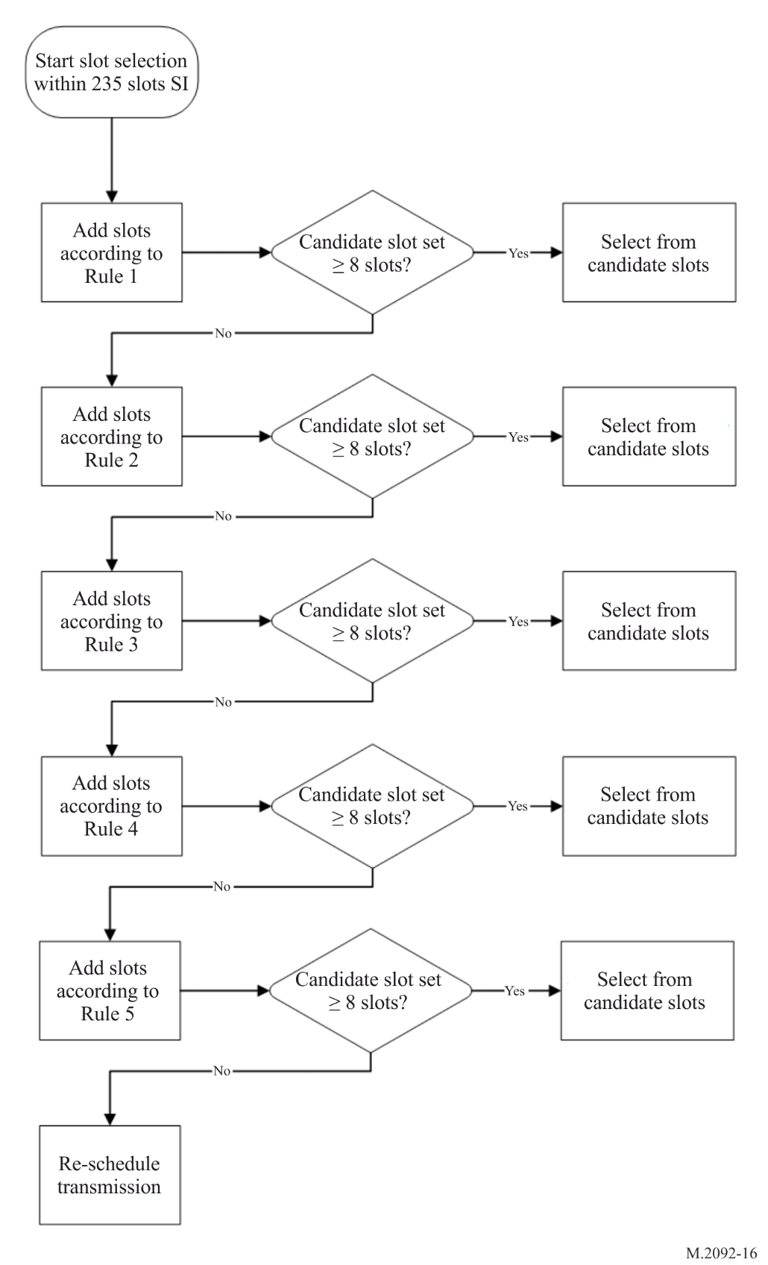

A3-4.5.4 Modes of operation
There should be two modes of operation, autonomous and designated. The default mode should be autonomous.

A3-4.5.5 Autonomous
A station operating autonomously should determine its own schedule for transmission. The station should automatically resolve scheduling conflicts with other stations.

A3-4.5.6 Designated
A station operating in the designated mode takes into account the transmission schedule of the designating message when determining when it should transmit.

A3-4.5.7 Channel access schemes
The access schemes, as defined below, should coexist and operate simultaneously on the TDMA channel. The access scheme FATDMA is as defined in Recommendation ITU-R M.1371.

A3-4.5.7.1 Multiple incremental time division multiple access
The MITDMA access schemes allows a station to pre-announce transmission slots that the station will use in the future. A single MITDMA transmission may be used to schedule up to three future transmissions with each transmission occupying up to three slots.

A3-4.5.7.2 Multiple incremental time division multiple access algorithm
MITDMA is a method of chaining slot allocations together for the purpose of transmitting messages. The first transmission within a MITDMA chain will be a single slot transmission using RATDMA access. Further transmissions will be allocated by the MITDMA communication state.
Receiving stations should mark these slot allocations as unavailable.
MITDMA may chain up to 15 transmissions together in a single frame. See § A3-6.4.

A3-4.5.7.3 Random access time division multiple access
RATDMA is used when a station needs to allocate a slot, which has not been pre-announced. This is generally done for the first transmission slot during MITDMA chain, or for messages of a non-repeatable character.

A3-4.5.7.4 Random access time division multiple access algorithm
The RATDMA access scheme should use a probability persistent (p-persistent) algorithm as described in this paragraph (see Table A3-5).
When a candidate slot is selected, the station randomly selects a probability value (LME.RTP1) between 0 and 100. This value should be compared with the current probability for transmission (LME.RTP2). If LME.RTP1 is equal to, or less than LME.RTP2, transmission should occur in the candidate slot. If not, LME.RTP2 should be incremented with a probability increment (LME.RTPI) and the station should wait for the next candidate slot in the frame.
The SI for RATDMA should be 235 time slots, which is equivalent to 6.3 s. The candidate slot set should be chosen within the SI, so that the transmission occurs within 6.3 s.
Each time that a candidate slot is entered, the p-persistent algorithm is applied. If the algorithm determines that a transmission shall be inhibited, then the parameter LME.RTCSC is decremented by one and LME.RTA is incremented by one.
LME.RTCSC can also be decremented as a result of another station allocating a slot in the candidate set. If LME.RTCSC + LME.RTA < 8 then the candidate set shall be complemented with a new slot within the range of the current slot and LME.RTES following the slot selection criteria.
Figure A3-3
RATDMA p-persistent algorithm
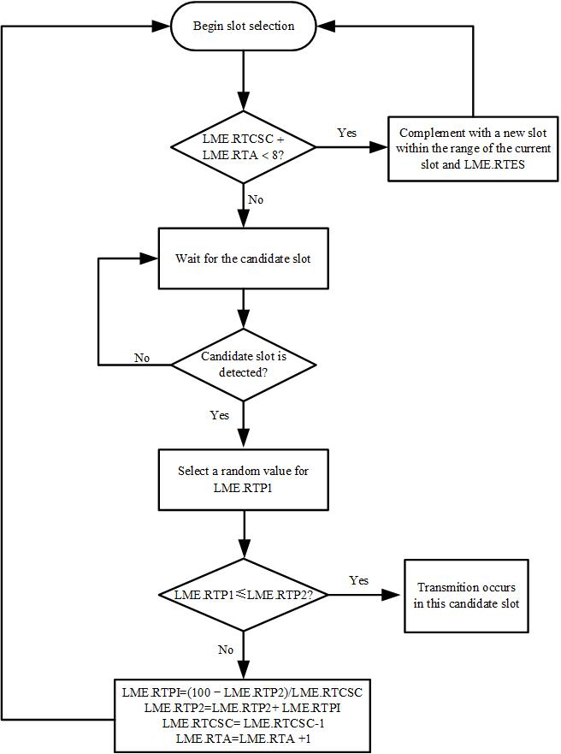

4.5.7.5 Random access time division multiple access parameters
The following parameters (Table A3-5) are used to control the RATDMA scheduling:
Table A3-5
Random access time division multiple access parameters
Symbol | Name | Description | Minimum | Maximum
RTCSC | Candidate slot counter | The number of slots currently available in the candidate set. NOTE 1 – The initial value is always 8 or more (see § A3-4.5.3). However, during the cycle of the p-persistent algorithm the value may be reduced below 8. | 1 | 235
RTES | End Slot | Defined as the slot number of the last slot in the initial SI, which is 235 slots ahead. | 0 | 2249
RTPS | Start probability | Each time a new message is due for transmission, LME.RTP2 should be set equal to LME.RTPS. LME.RTPS shall be equal to 100/LME.RTCSC.  NOTE 2 – LME.RTCSC is set to 6 or more initially. Therefore LME.RTPS has a maximum value of −12 (100/8). | 0 | 12
RTP1 | Derived probability | Calculated probability for transmission in the next candidate slot. It should be less than or equal to LME.RTP2 for transmission to occur, and it should be randomly selected for each transmission attempt. | 0 | 100
RTP2 | Current probability | The current probability that a transmission will occur in the next candidate slot. | RTPS | 100
RTA | Number of attempts | Initial value set to 0. This value is incremented by one each time the p-persistent algorithm determines that a transmission shall not occur. | 0 | 234
RTPI | Probability Increment | Each time the algorithm determines that transmission should not occur, LME.RTP2 should be incremented with LME.RTPI. LME.RTPI shall be equal to(100 − LME.RTP2)/LME.RTCSC. | 1 | 12

A3-4.5.7.6 Network access and entry of a new data stream
At power on, a station should monitor the TDMA channels for one (1) minute to determine channel activity, other participating member IDs, current slot assignments and reported positions of other users, and possible existence of base stations, as shown in Figure A3-4. During this time, a dynamic directory of all members operating in the system should be established. A frame map should be constructed, which reflects TDMA channel activity. After one (1) minute has elapsed, the station may be available to transmit ASM messages according to its own schedule.
Figure A3-4
Network access for multiple incremental time division multiple access
and random access time division multiple access
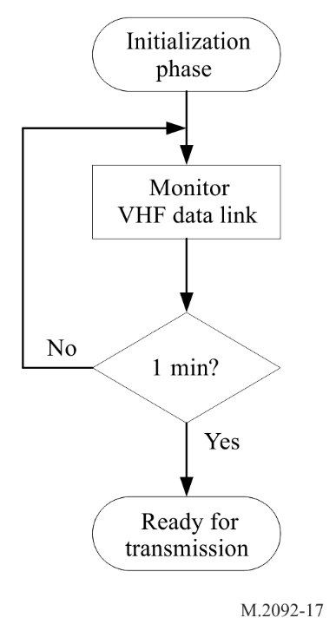

A3-4.5.7.7 Random access time division multiple access channel access
When the ASM station needs to transmit a single ASM message which is not repeated periodically, it should use RATDMA access.

A3-4.5.7.8 Multiple incremental time division multiple access channel access
When the ASM station needs to transmit a block of ASM messages, or if it needs to transmit ASM message periodically, it should use MITDMA access.

A3-4.5.8 Message structure
The messages should have the following structure shown in Figure A3-5 inside the data portion of a data packet.
Figure A3-5
Message structure
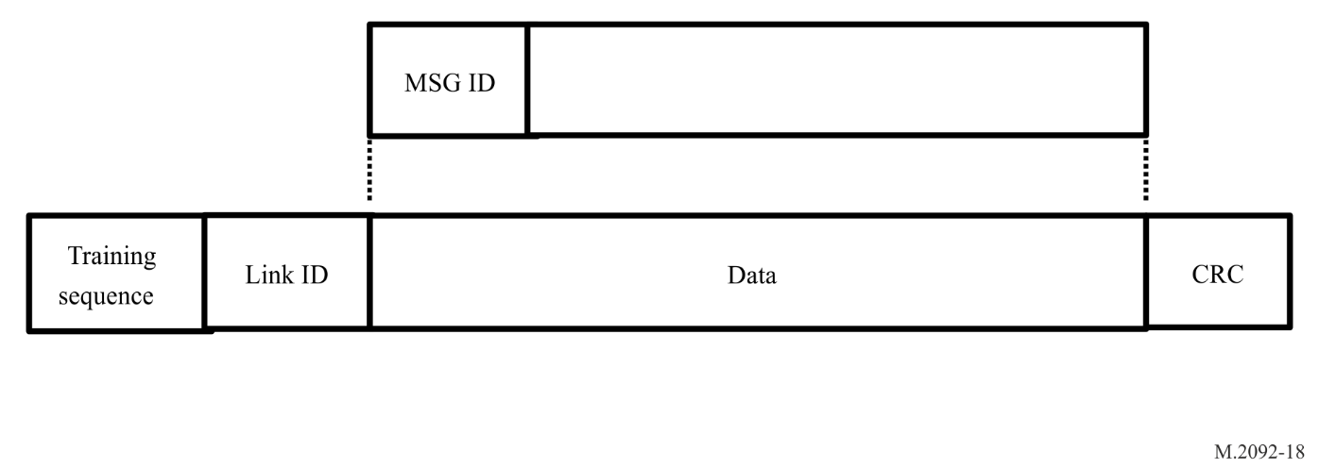
Each message is described using a table with parameter fields listed from top to bottom. Each parameter field is defined with the most significant bit first.
Parameter fields containing sub-fields (e.g. communication state) are defined in separate tables with sub-fields listed top to bottom, with the most significant bit first within each sub-field.

A3-4.5.8.1 Message identification
The message ID should be 4 bits long and should have a range of 0-15. The message ID should identify the message type.

A3-4.5.8.2 User identification
The user ID should be a unique identifier and is 32 bits long. All ASM messages will contain the user identifier to identify the source of the transmission.

A3-4.5.8.3 Multiple incremental time division multiple access message structure
The MITDMA message structure is shown in Figure A3-6.
Figure A3-6
MITDMA message structure
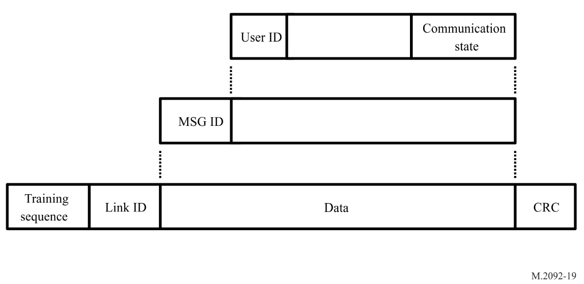

A3-4.5.8.4 Multiple incremental time division multiple access communication state
The communication state provides the information used by the slot allocation algorithm in the MITDMA concept.
The MITDMA communication state is structured as shown in Table A3-6.
Table A3-6
Multiple incremental time division multiple access communication state parameters
Parameter | Number of bits | Description | Minimum | Maximum
Transmit block counter | 4 | A decrementing counter used to indicate how many transmissions are left to transmit within the chain.  A value of 1 indicates this is the last transmission within the chain.  A value of 0 indicates a recurring transmission. | 0 | 15
Block Identifier | 4 | An increasing counter used to identify the block of data within the transmit chain uniquely. This identifier also maps to the acknowledgment for addressed messages.  A value of 0 indicates this is the first transmission within the chain and corresponds to the bit 0 of the ACK mask. | 0 | 14
Slot Increment 1 | 8 | Offset to the next slot to be used, referenced to the current transmission start slot.  A value of 0 indicates no additional slot reservations. | 20 | 255
Number of Slots 1 | 2 | Indicates the number of consecutive slots, which are allocated, starting at the slot increment  A value of 0 indicates the 8 bits from Slot Increment 1 become the MSB for the Slot Increment 2. | 0 | 3
Slot Increment 2 | 8 | Offset to the next slot to be used, referenced to the slot specified by slot increment 1 (or current transmission slot if the number of slots 1 is set to 0).  A value of 0 indicates no additional slot reservations. | 20 | 255  13500⁽¹⁾
Number of Slots 2 | 2 | Indicates the number of consecutive slots, which are allocated, starting at the slot increment.  A value of 0 indicates no slot reservations. | 1 | 3
Slot Increment 3 | 8 | Offset to the next slot to be used, referenced to the slot specified by Slot Increment 2.  A value of 0 indicates no additional slot reservations. | 20 | 255
Number of Slots 3 | 2 | Indicates the number of consecutive slots, which are allocated, starting at the slot increment.  A value of 0 indicates no additional slot reservations. | 1 | 3
Total bits | 38
⁽¹⁾ When combining Slot Increment 1 and Slot Increment 2 as a 16-bit field. This value should not exceed 6 frames. The combining of these values should only be done for recurring period broadcast transmissions.

A3-5 Network layer
The network layer should be used for:
– Establishing and maintaining channel connections.
– Management and priority assignments of messages.
– Distribution of transmission packets between channels.
– Data link congestion resolution.

A3-5.1 Multi-channel operations
Two frequencies have been designated in RR Appendix 18 for ASM transmissions. These frequencies are:
– ASM1 (161.950 MHz).
– ASM2 (162.000 MHz).
Channel access is performed independently on each of the two channels. Generally, ASM transmission should alternate between the two channels when available.
Terrestrial transmissions of acknowledgements to addressed messages should be done on the channel as the initial message was received.
Chained transmissions using MITDMA shall all be done on the same channel.

A3-5.2 Management of priority assignment for messages
ASM messages support message priority. The priority of the message is determined by the PI interface. The messages are serviced in order of priority. Messages with the same priority are dealt with in a first in first out order.

A3-5.3 Data link congestion prevention
As the data link becomes loaded, the availability of transmission slots will reduce. When the data link is loaded to such a level as reception of ASM messages is jeopardized, measures should be taken to reduce the loading.
ASM channel loading shall be measured independently per channel over a window of the past 2 250 slots (1 Minute).
The percentage of slots in which an ASM transmission is detected by a station on a specific channel shall be adopted by the station as the channel loading on that channel.
Regardless of the channel load, the maximum number of slots used by a mobile station for transmission on one channel shall not exceed 50 slots over a period of one minute (2.2% duty cycle), excluding up to 22 slots available for use for retransmission of addressed data. No more than three re-transmission attempts of the same data shall be made.

A3-5.3.1 Mandatory quiet times
After the completion of a singular Non-MITDMA ASM channel transmission or a complete MITDMA transmission block chain, the ASM station shall wait for a specific time before additional transmission can be scheduled. This time is referred to as quiet time. The selection interval for finding candidate transmission slots starts after the quiet time.
For a singular transmission, quiet time shall per default be one second per timeslot.
For an MITDMA linked transmission chain, the quiet time is a function of the number of transmission slots within that chain. The quiet time shall be increased by one second per time slot used in the transmission chain.
The quiet time shall be increased with a multiplier, depending on channel load (Table A3-7).
Table A3-7
Quiet time multiplier
Channel load | <10% | 10%-30% | 30%<
Multiplier | 1 | 2 | 3
Quiet Time [seconds] = Transmission slots * Multiplier

A3-6 Transport layer
The transport layer is responsible for:
– converting data into transmission packets of correct size;
– sequencing of data packets;
– interfacing protocol to upper layers.

A3-6.1 Definition of transmission packet
A transmission packet is an internal representation of some information which can ultimately be communicated to external systems. The transmission packet is dimensioned so that it conforms to the rules of data transfer. Transmission packets are fixed block sizes on slot boundaries with a maximum of 3 consecutive slots. When data does not completely fill the block, then padding bits with the value of 0 should be added to complete the required block size.

A3-6.2 Application specific message identifier
Addressed and broadcast binary messages should contain a 16-bit application identifier (Table A3-8).
Table A3-8
Application specific message identifier parameters
Bit | Description
15-6 | Designated area code (DAC). This code is based on the maritime identification digits (MID). Exceptions are 0 (test) and 1 (international). Although the length is 10 bits, the DAC codes equal to or above 1 000 are reserved for future use.
5-0 | Function identifier. The meaning should be determined by the authority which is responsible for the area given in the designated area code.

Whereas the application identifier allows for regional applications, the application identifier should have the special values for international compatibility, as defined in Recommendation ITU-R M.1371 annex Application specific messages.

A3-6.3 Transmission packets

A3-6.3.1 Addressed messages
Addressed messages are point to point communications between VDES stations. Addressed messages may require an acknowledgment. When an acknowledgement is required and not received, the VDES stations may retransmit the message up to three times.

A3-6.3.2 Broadcast messages
A broadcast message lacks a destination identifier ID. Therefore, receiving stations should not acknowledge a broadcast message.

A3-6.3.3 Conversion to presentation interface messages
Each received transmission packet should be converted to a corresponding presentation interface message and presented in the order they were received regardless of message category. Applications utilizing the presentation interface should be responsible for their own sequencing numbering scheme, as required. For a mobile station, addressed messages should not be output to the presentation interface, if Destination ID (unique identifier) is different to the ID of own station (own unique identifier).

A3-6.3.4 Conversion of data into transmission packets
The transport layer should convert data, received from the presentation interface into transmission packets. If the data exceeds the maximum limit, then a negative acknowledgement should be returned on the PI.

A3-6.4 Multiple incremental time division multiple access
When the length of the data requires more than three consecutive slots, then the data should be divided up into sub-groups of three slot packets and MITDMA should be used to chain the transmissions together. A total of 15 MITDMA transmissions may be chained together. If the data provided by the PI exceeds this limit, a negative acknowledgment should be provided on the PI.
If data transmissions are repetitive in nature, and have a transmit interval less than two frames (4 500 slots), then MITDMA should be used to maintain the link.
If multiple messages are queued for transmission, then MITDMA should be used to allocate slots for the additional messages.
When using MITDMA for addressed messages, the MITDMA will provide the return slot for the message acknowledgment in the last three transmissions as specified in example in § A3-6.4.1.

A3-6.4.1 Multiple incremental time division multiple access example
An MITDMA access example is shown in Figure A3-7. The first transmission (Tx 1) of a MITDMA chain is always a single slot transmission.
Determine the candidate slots for the Tx 1. Apply the RATDMA algorithm until the transmit criteria is meet.
Before transmitting at Tx 1, determine the candidate slots for up to three additional transmissions. Randomly select the transmit slots from the candidate slot lists. Calculate the offsets for these future transmissions. This information is provided in the MITDMA communication state. Slot Increment 1 reserves Tx 2, Slot Increment 2 reserves Tx 3, and Slot Increment 3 reserves Tx 4.
Before transmitting at Tx 2, determine the candidate slots for the next transmission, e.g. Tx 5. Randomly select a transmit slot from the candidate slot list. This information is provided in the MITDMA communication state. Slot Increment 1 reserves Tx 3, Slot Increment 2 reserves Tx 4, and Slot Increment 3 reserves Tx 5.
If this is a broadcast message, then starting at Tx n-2, the unused Slot Increments are set to 0. If this is an addressed message, then the following process happens.
At Tx n-2, determine the candidate slots for the acknowledgment message. Randomly select the acknowledgment slot from the candidate slot list. Calculate the offset for the acknowledgement (ACK) slot. This information is provided in the MITDMA communication state. Slot Increment 1 reserves the Tx n-1, Slot Increment 2 reserves the Tx n, and Slot Increment 3 reserves the ACK slot.
At Tx n-1 a new offset is calculated for the ACK slot. This information is provided in the MITDMA communication state. Slot Increment 1 reserves the Tx n, Slot Increment 2 reserves the ACK slot, and Slot Increment 3 is set to 0.
At Tx n a new offset is calculated for the ACK slot. This information is provided in the MITDMA communication state. Slot Increment 1 reserves the ACK slot, Slot Increment 2 and 3 are set to 0.
At the ACK slot, the receiving station transmits the acknowledgment message with the ACK/NACK Mask field set to indicate the success or failure of the MITDMA transmission chain. If one or more of the blocks failed during the transmission of the chain, then the transmitting station should re-transmit the failed block(s). When starting the re-transmission of the failed MITDMA block(s), Block 1 (the single slot RATDMA transmission) is always sent first.
Figure A3-7
Multiple incremental time division multiple access example
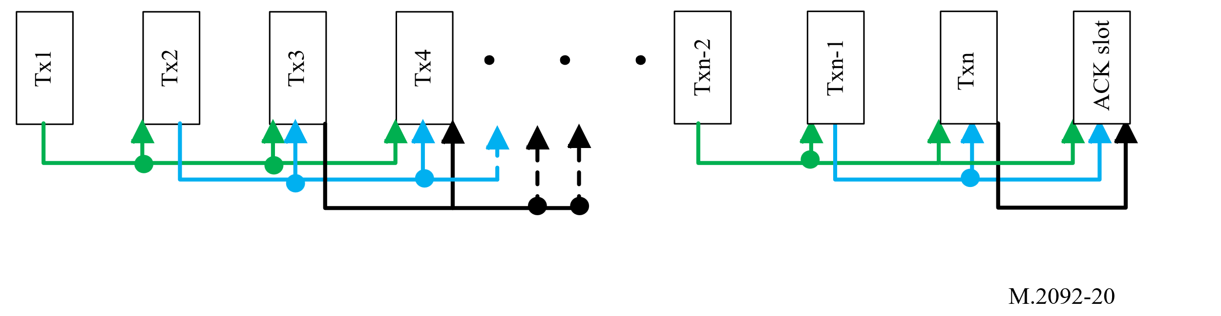
To use MITDMA to transmit a periodic broadcast, the “Transmit Block Counter” field of the MITDMA communication state is set to 0. The “Number Slot 1” field of the MITDMA communication state is set to 0 to allow “Slot Increment 1” and “Slot Increment 2” fields to be combined into a 16-bit value. A slot increment can now be set to a value which has a maximum range of 360 seconds (6 minutes).

A3-6.5 Message Retransmission
In the ASM message, scheduled broadcast message and scheduled addressed message are transmitted via Multiple incremental time division multiple access (MITDMA), enabling a chain up to 15 data block transmissions together. These two types of messages utilize data retransmission mechanisms to achieve efficient data transmission.

A3-6.5.1 Scheduled broadcast message retransmission
Scheduled broadcast messages can be transmitted multiple times. Retransmission should be initiated within 3 minutes after the first transmission. For scheduled broadcast messages that are expected to be retransmitted, the Retransmit flag should be set to 1 during the initial transmission, indicating that retransmitted messages may follow. In subsequent retransmissions, the Retransmit flag should remain set to 1, and the Session ID should be kept consistent throughout. Based on the Block Identifier, the receiving station should ascertain whether any previously not received or failed verification blocks are correctly received this time. If so, they should be integrated into the message. If all blocks in the MITDMA chain are complete, they should be output through the PI. After the PI outputs the data, the device should ignore subsequent retransmitted data with the same Session ID. Scheduled broadcast message retransmission should be completed within 20 minutes referenced from the start of the first block.

A3-6.5.2 Scheduled addressed message retransmission
When the source device receives an Acknowledgment Message indicating one or more blocks are not successfully received and need to be retransmitted, it may initiate another MITDMA block chain. The first transmission uses RATDMA and then uses MITDMA to reserve slots for subsequent retransmissions and ACK. In the retransmitted blocks, the Retransmit flag should be set to 1, the Session ID should remain consistent with that in the first transmission, the Block Identifier should match the block number of the MITDMA chain in the first transmission, and the Transmit block counter should only count the number of retransmitted blocks. The schedule mechanism for ACK slots is the same as in the first transmission, as shown in Table A3-9. Within the ACK message, the bits corresponding to the Block Identifier of the retransmitted blocks should indicate whether the blocks were successfully transmitted, while all other bits should be set to 0.
Table A3-9
Criteria for retransmission
Parameter | Description
Retransmit flag | Set to 1.
Session ID | Maintain consistency with that in the first transmission.
Transmit block counter | Only count the number of retransmitted messages.
Block Identifier | Maintain consistency with the blocks in the first transmission of the MITDMA chain.
Slot Increment | Reserve slots for subsequent retransmissions or ACK.
Number of Slots | Reserve slots for subsequent retransmissions or ACK.

During retransmission, the first block (Block 0) of the message should be transmitted regardless of whether it has been successfully transmitted before.
If the total time slots occupied by the blocks in the current retransmission exceed 22, or if adding the blocks from the current retransmission will result in the total time slots of all retransmitted blocks within one minute time span exceeding 22, the retransmission operation shall not be initiated. Instead, the whole message can be retransmitted in subsequent transmissions with a new session ID.
Figure A3-8
Multiple incremental time division multiple access example in retransmission
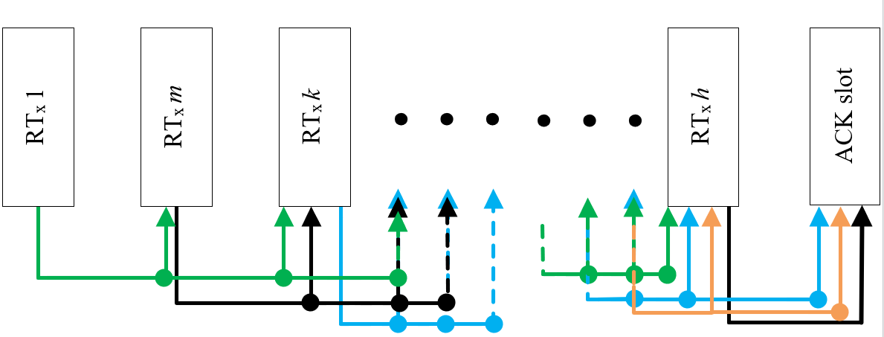

A3-7 Packet structure
The ASM transmission packets are used to transport data from one ASM station to another. There are multiple types of packet definitions which use different address modes and channel access schemes. The packet structures are defined by the message identifier.

A3-7.1 Slot transmission structure
The generic slot transmission structure is defined in Table A3-10.
Table A3-10
Slot transmission structure
Parameter | Number of bits | Descriptions
Ramp up | 8 | 417 μs.
Training sequence | 54 | Necessary for synchronization.
Link ID | 32 | Six information bits decoded from (32,6) biorthogonal code  ASM channel configurations as defined in Link ID, see Table A2-7  Note that the Link ID will identify how many slots make up the message.
Data payload including padding (no FEC / FEC) | 1 slot: 352 / 256  2 slot: 864 / 640  3 slot: 1376 / 1024  SAT: N/A / 920 | The symbol count and the information bits vary according to coding rate as defined by the Link ID field.
CRC | 32 | The CRC is calculated over the data payload including padding.
FEC | TER: 10  SAT: 11 | Set to zero when not used.

Table A3-10 (end)
Parameter | Number of bits | Descriptions
Ramp down | 8 | 417 μs.
Guard time | TER: 16  SAT: 154 | Distance delay TER .083 ms.  Distance delay SAT 8.02 ms.
Total | 1 slot: 512  2 slot: 1024  3 slot: 1536

A3-7.2 Message summary
The defined message types are summarized in Table A3-11.
Table A3-11
Message summary
Message ID | Name | Description | Access scheme | Communication state
0 | Broadcast AIS ASM Message | Encapsulated AIS ASM messages. | RATDMA | None
1 | Scheduled Broadcast Message | Broadcast data using communication state. | FATDMA  RATDMA MITDMA | MITDMA
2 | Broadcast Message | Broadcast data with no communication state. | FATDMA  RATDMA | None
3 | Scheduled Individual Addressed Message | Individual addressed data with communication state. Requires acknowledgement. | FATDMA  RATDMA MITDMA | MITDMA
4 | Individual Addressed Message | Individual addressed data with no communication state. Requires acknowledgement. | FATDMA  RATDMA | None
5 | Acknowledgment Message | This message is used to provide and acknowledgment for one or more addressed messages. | FATMDA  RATDMA  MITDMA | None
6 | Geographical Multicast Message | Addressed to a group of stations defined by their geographical location with no communication state. No acknowledgment required. | FATDMA  RATDMA | None
7 | ASM Data link management message | This message is used to broadcast FATDMA reservations for ASM. | RATDMA  FATMDA | None

7.3 Message 0: broadcast automatic identification system application specific message
ASM Message 0 may contain encapsulated AIS Messages 6, 8, 12, 14, 21, 25 or 26. Acknowledgement is not supported for addressed messages. This message type is for terrestrial use only.
The encapsulated message may or may not be transmitted on AIS1 or AIS2 channels.
If the encapsulation repeats a Message that was transmitted on AIS1 or AIS2 channel, the encapsulation and transmission of messages shall be performed as soon as possible, according to configuration, after receiving the relevant messages which are required to be retransmitted.
The communication state of the encapsulated message shall always be set to zero at encapsulation.
The receiving station shall output all received encapsulated AIS Messages at the PI immediately after reception. Scheduled broadcast message is defined in Table A3-12.
Table A3-12
Broadcast automatic identification system application specific message
Parameter | Number of bits | Description
Message ID | 4 | 0 – Selected AIS messages that are output at receiving mobile station PI by using VDM sentence with no communication state.
Retransmit flag | 1 | 0 (reserved for future use).
Repeat indicator | 2 | Used by the repeater to indicate how many times a message has been repeated.  0 – 3; 0 = default; 3 = do not repeat any more.
Session ID | 6 | The Session ID associates the VDL transmission with a specific PI transaction.
Source ID | 32 | The Unique Identifier of the transmitting station as described in § A1-2.4.
Data count | 11 | Size of actual data in Application Data field in bits, excluding padding bits range: from 1 to maximum data count.
Application data  (no FEC / FEC) | 1 slot: 296 / 200  2 slot: 808 / 584  3 slot: 1320 / 968 | Content is encapsulated AIS Messages that are channeled through ASM Channels. Receiver is expected to be ASM-capable mobile station where the ASM-box would relay the encapsulated AIS messages to local presentation interface. The encapsulated AIS Messages would then be output at the PI using VDM sentence. The arrangement would thus be compliant with existing nav presentations.  Application data as specified by the ASM Identifier.  The available length of the binary data is specified by the Link Id.

A3-7.4 Message 1: Scheduled broadcast message
This ASM message is used to broadcast data to all stations, and utilizes MITDMA communication state. Multiple messages, or periodically broadcasted messages may be chained together using the MITDMA communication state as described in § A3-4.5.7.2. Scheduled broadcast message is defined in Table A3-13.
Table A3-13
Scheduled broadcast message
Parameter | Number of bits | Description
Message ID | 4 | 1 – Broadcast message with MITDMA communication state.
Retransmit flag | 1 | 0 – Indicates there will be no retransmission of data.  1 – Indicates there will be retransmission of data.
Repeat indicator | 2 | Used by the repeater to indicate how many times a message has been repeated.  0 – 3; 0 = default; 3 = do not repeat any more.
Session ID | 6 | The Session ID associates the VDL transmission with a specific PI transaction.
Source ID | 32 | The Unique Identifier of the transmitting station as described in § A1-2.4.
Data count | 11 | Size of actual data in Application Data field in bits, excluding padding bits. range: from 1 – Max data count.
Application data  (no FEC / FEC) | 1 slot: 256 / 160  2 slot: 768 / 544  3 slot: 1280 / 928 | ASM Identifier | The first 16 bits of the Application data are the ASM Identifier, which is described in § A3-6.2. When chaining multiple blocks using MITDMA, the ASM Identifier is only contained in the first transmission.
Application data  (no FEC / FEC) | 1 slot: 256 / 160  2 slot: 768 / 544  3 slot: 1280 / 928 | Application data as specified by the ASM Identifier. | The available length of the binary data is specified by the Link ID. Unused payload data is zero-filled.
Communication state | 38 | MITDMA communication state as described in § A3-6.4.
Spare bits | 2 | Spare bits – reserved for the future.

A3-7.5 Message 2: Broadcast message
This ASM message is used to broadcast data to all stations and does not contain a communication state. These broadcast messages are used for non-periodic transmission of data, and access the link using RATDMA. Broadcast message is defined in Table A3-14.
Table A3-14
Broadcast message
Parameter | Number of bits | Description
Message ID | 4 | 2 – Broadcast message with no communication state.
Retransmit flag | 1 | 0 (reserved for future use).
Repeat indicator | 2 | Used by the repeater to indicate how many times a message has been repeated.  0 – 3; 0 = default; 3 = do not repeat any more.
Session ID | 6 | The Session ID associates the VDL transmission with a specific PI transaction.
Source ID | 32 | The Unique Identifier of the transmitting station as described in § A1-2.4.
Data count | 11 | Size of actual data in Application Data field in bits, excluding padding bits. range: from 1 – Max data count.
Application data  (no FEC / FEC) | 1 slot: 296 / 200  2 slot: 808 / 584  3 slot: 1320 / 968  SAT: N/A / 864 | ASM Identifier | The first 16 bits of the Application data are the ASM Identifier, which is described in § A3-6.2.
Application data  (no FEC / FEC) |  | Application data as specified by the ASM Identifier. | The available length of the binary data is specified by the Link ID.

A3-7.6 Message 3: Scheduled individual addressed message
This ASM message is used to send data to an individual station, and utilizes MITDMA communication state. Multiple transmission of messages, or periodically transmissions of messages may be chained together using the MITDMA communication state as described in § A3-4.5.7.2.
These transmissions require the destination station to return a message acknowledgment (Message 5). This addressed message supplies the return slot for the message acknowledgment. Scheduled addressed message is defined in Table A3-15.
Table A3-15
Scheduled individual addressed message
Parameter | Number of bits | Description
Message ID | 4 | 3 – Individually addressed message with MITDMA communication state.
Retransmit flag | 1 | Indicates that this is a retransmission of data.
Repeat indicator | 2 | Used by the repeater to indicate how many times a message has been repeated.  0 – 3; 0 = default; 3 = do not repeat any more.
Session ID | 6 | The Session ID associates the VDL transmission with a specific PI transaction.
Source ID | 32 | The Unique Identifier of the transmitting station, as described in § A1-2.4.
Destination ID | 32 | The Unique Identifier of the receiving station, as described in § A1-2.4.
Data count | 11 | Size of actual data in Application Data field in bits, excluding padding bits. range: from 1 – Max data count.
Application data  (no FEC / FEC) | 1 slot: 224 / 128  2 slot: 736 / 512  3 slot: 1248 / 896 | ASM Identifier | The first 16 bits of the Application data are the ASM Identifier, which is described in § A3-6.2. When chaining multiple blocks using MITDMA, the ASM Identifier is only contained in the first transmission.
Application data  (no FEC / FEC) | 1 slot: 224 / 128  2 slot: 736 / 512  3 slot: 1248 / 896 | Application data as specified by the ASM Identifier. | The available length of the binary data is specified by the Link ID.
Communication state | 38 | MITDMA communication state as described in § A3-6.4.
Spare bits | 2 | Spare Bits – reserved for the future.

A3-7.7 Message 4: Individual addressed message
This ASM message is used to send data to an individual station and does not contain a communication state. This message is used for non-periodic transmission of data, and access the link using RATDMA.
These transmissions require the destination station to return a message acknowledgment (Message 5). The destination station will use RATDMA to send the message acknowledgment. Addressed message is defined in Table A3-16.
Table A3-16
Individual addressed message
Parameter | Number of bits | Description
Message ID | 4 | 4 – Individually addressed message with no communication state.
Retransmit flag | 1 | Indicates that this is a retransmission of data.
Repeat indicator | 2 | Used by the repeater to indicate how many times a message has been repeated.  0 – 3; 0 = default; 3 = do not repeat any more.
Session ID | 6 | The Session ID associates the VDL transmission with a specific PI transaction.
Source ID | 32 | The Unique Identifier of the transmitting station as described in § A1-2.4.
Destination ID | 32 | The Unique Identifier of the receiving station as described in § A1-2.4.
Data count | 11 | Size of actual data in Application Data field in bits, excluding padding bits. range: from 1 – Max: data count.
Application data  (no FEC / FEC) | 1 slot: 264 / 168  2 slot: 776 / 552  3 slot: 1288 / 936  SAT: N/A / 832 | ASM Identifier | The first 16 bits of the Application data are the ASM Identifier, which is described in § A3-6.2.
Application data  (no FEC / FEC) |  | Application data as specified by the ASM Identifier. | The available length of the binary data is specified by the Link ID.

A3-7.8 Message 5: Acknowledgment message
This ASM message is used to return message acknowledgments to one or more addressed messages. Note that this message should always use Link ID of 5 (3/4 coding rate). Acknowledgement message is defined in Table A3-17.
Table A3-17
Acknowledgment message
Parameter | Number of bits | Description
Message ID | 4 | 5 – Multiple acknowledgment message with no communication state.
Retransmit flag | 1 | 0 (reserved for future use).
Repeat indicator | 2 | Used by the repeater to indicate how many times a message has been repeated.  0 – 3; 0 = default; 3 = do not repeat any more.
Session ID | 6 | The Session ID associates the VDL transmission with a specific PI transaction.
Source ID | 32 | The Unique Identifier of the transmitting station as described in § A1-2.4.
Destination ID | 32 | The Unique Identifier of the receiving station as described in § A1-2.4.
ACK/NACK mask | 16 | Specifies which MITDMA block identifiers failed. Bit map field with the LSB representing Block identifier 0, up to the 15th bit representing Block identifier 14.  “1” indicates a packet failed.  “0” indicates the packet was received ok.  The MSB (16th bit) is not used and should be set to “0”.
Table A3-17 (end)
Parameter | Number of bits | Description
Coding rate adaption request | 2 | 0 (reserved for future use).
Channel quality indicator | 8 | Signal quality.
Zero padding  (no FEC / FEC) | 1 slot: N/A / 153 | Padding bits are added as required to complete the block size. These bits are not available for future use.

A3-7.9 Message 6: Geographical multicast message
This ASM message is used to broadcast data to a group of stations as defined by the specified geographical area. The broadcast message does not contain a communication state. These broadcast messages are used for non-periodic transmission of data, and access the link using RATDMA. Geographical multicast message is defined in Table A3-18.
TableA3-18
Geographical multicast message
Parameter | Number of bits | Description
Message ID | 4 | 6 – Geographical addressed message with no communication state.
Retransmit flag | 1 | Indicates that this is a retransmission of data.
Repeat Indicator | 2 | Used by the repeater to indicate how many times a message has been repeated.  0 – 3; 0 = default; 3 = do not repeat any more.
Session ID | 6 | The Session ID associates the VDL transmission with a specific PI transaction.
Source ID | 32 | The Unique Identifier of the transmitting station as described in § A1-2.4.
Longitude 1 | 18 | Longitude of area to which the group assignment applies; upper right corner (north-east); in 1/10 min  (±180°, East = positive, West = negative).
Latitude 1 | 17 | Latitude of area to which the group assignment applies; upper right corner (north-east); in 1/10 min  (±90°, North = positive, South = negative).
Longitude 2 | 18 | Longitude of area to which the group assignment applies; lower left corner (south-west); in 1/10 min  (±180°, East = positive, West = negative).
Latitude 2 | 17 | Latitude of area to which the group assignment applies; lower left corner (south-west); in 1/10 min  (±90°, North = positive, South = negative).
Data Count | 11 | Size of actual data in Application Data field in bits, excluding padding bits. range: from 1 – Max data count.
Spare bits | 2 | Spare bits – reserved for the future.
Application data  (no FEC / FEC) | 1 slot: 224 / 128  2 slot: 736 / 512  3 slot: 1248 / 896 | ASM Identifier | The first 16 bits of the Application data are the ASM Identifier, which is described in § A3-6.2.
Application data  (no FEC / FEC) | 1 slot: 224 / 128  2 slot: 736 / 512  3 slot: 1248 / 896 | Application data as specified by the ASM Identifier. | The available length of the binary data is specified by the Link ID.

A3-7.10 Message 7: ASM data link management message
This ASM message is used by the ASM shore station to broadcast FATDMA reservations. It should be repeated as often as required. Link ID 5 should always be used.
The mobile station, within 120 nautical miles should then reserve the slots as unavailable for its own transmission until time-out occurs. The base station should refresh the time-out value with each transmission of Message 7 in order to allow mobile stations to terminate their reservation for the use of the slots.
The parameters: offset number, number of slots, time-out, and increment should be treated as a unit, meaning that if one parameter is defined all other parameters should be defined within that unit. The parameter offset number should denote the offset from the slot in which Message 7 was received to the first slot to be reserved. The parameter number of slots should denote the number of consecutive slots to be reserved starting with the first reserved slot. This defines a reservation block.
This reservation block should not exceed 15 slots. The parameter increment should denote the number of slots between the starting slot of each reservation block. An increment of zero indicates one reservation block per frame. The following values for increment are allowed: 30, 45, 50, 75, 90, 125, 150, 225, 250, 375, 450, 750, or 1125. Use of one of these values guarantees symmetric slot reservations throughout each frame. ASM data link management message is described in Table A3-19.
Table A3-19
ASM data link management message
Reservation Block | Parameter | Number of bits | Description
 | Message ID | 4 | 7 – ASM Data link management.
 | Retransmit flag | 1 | 0 (reserved for future use).
 | Repeat indicator | 2 | Used by the repeater to indicate how many times a message has been repeated.  0 – 3; 0 = default; 3 = do not repeat any more.
 | Session ID | 6 | The Session ID associates the VDL transmission with a specific PI transaction.
 | Source ID | 32 | The Unique Identifier of the transmitting station as described in § A1-2.4.
Reservation Block 1 | Channel selection | 2 | 0 = ASM1; 1 = ASM2; 2 = ASM1 and ASM2; 3 = no reservation.
Reservation Block 1 | Offset number | 12 | Reserved offset number.
Reservation Block 1 | Number of slots | 4 | Number of reserved consecutive slots: 1-15.
Reservation Block 1 | Time-out | 4 | Time-out value in minutes.
Reservation Block 1 | Increment | 4 | Increment to repeat reservation block 1.  0 = one reservation block per frame.  1 = 30, 2 = 45, 3 = 50, 4 = 75, 5 = 90, 6 = 125, 7 = 150, 8 = 225, 9 = 250, 10 = 375, 11 = 450, 12 = 750, 13 = 1125, 14-15 not used.
Reservation Block 2 | Channel selection | 2 | 0 = ASM1; 1 = ASM2; 2 = ASM1 and ASM2; 3 = no reservation.
Reservation Block 2 | Offset number | 12 | Reserved offset number.
Reservation Block 2 | Number of slots | 4 | Number of reserved consecutive slots: 1-15.
Reservation Block 2 | Time-out | 4 | Time-out value in minutes.
Reservation Block 2 | Increment | 4 | Increment to repeat reservation block 2.  0 = one reservation block per frame.  1 = 30, 2 = 45, 3 = 50, 4 = 75, 5 = 90, 6 = 125, 7 = 150, 8 = 225, 9 = 250, 10 = 375, 11 = 450, 12 = 750, 13 = 1125, 14-15 not used.
Reservation Block 3 | Channel selection | 2 | 0 = ASM1; 1 = ASM2; 2 = ASM1 and ASM2; 3 = no reservation.
Reservation Block 3 | Offset number | 12 | Reserved offset number.
Reservation Block 3 | Number of slots | 4 | Number of reserved consecutive slots: 1-15.
Reservation Block 3 | Time-out | 4 | Time-out value in minutes.
Reservation Block 3 | Increment | 4 | Increment to repeat reservation block 3.  0 = one reservation block per frame.  1 = 30, 2 = 45, 3 = 50, 4 = 75, 5 = 90, 6 = 125, 7 = 150, 8 = 225, 9 = 250, 10 = 375, 11 = 450, 12 = 750, 13 = 1125, 14-15 not used.
Reservation Block 4 | Channel selection | 2 | 0 = ASM1; 1 = ASM2; 2 = ASM1 and ASM2; 3 = no reservation.
Reservation Block 4 | Offset number | 12 | Reserved offset number.
Reservation Block 4 | Number of slots | 4 | Number of reserved consecutive slots: 1-15.
Reservation Block 4 | Time-out | 4 | Time-out value in minutes.
Reservation Block 4 | Increment | 4 | Increment to repeat reservation block 4.  0 = one reservation block per frame.  1 = 30, 2 = 45, 3 = 50, 4 = 75, 5 = 90, 6 = 125, 7 = 150, 8 = 225, 9 = 250, 10 = 375, 11 = 450, 12 = 750, 13 = 1125, 14-15 not used.
Reservation Block 5 | Channel selection | 2 | 0 = ASM1; 1 = ASM2; 2 = ASM1 and ASM2; 3 = no reservation.
Reservation Block 5 | Offset number | 12 | Reserved offset number.
Reservation Block 5 | Number of slots | 4 | Number of reserved consecutive slots: 1-15.
Reservation Block 5 | Time-out | 4 | Time-out value in minutes.
Reservation Block 5 | Increment | 4 | Increment to repeat reservation block 5.  0 = one reservation block per frame.  1 = 30, 2 = 45, 3 = 50, 4 = 75, 5 = 90, 6 = 125, 7 = 150, 8 = 225, 9 = 250, 10 = 375, 11 = 450, 12 = 750, 13 = 1125, 14-15 not used.
Reservation Block 6 | Channel selection | 2 | 0 = ASM1; 1 = ASM2; 2 = ASM1 and ASM2; 3 = no reservation.
Reservation Block 6 | Offset number | 12 | Reserved offset number.
Reservation Block 6 | Number of slots | 4 | Number of reserved consecutive slots: 1-15.
Reservation Block 6 | Time-out | 4 | Time-out value in minutes.
Reservation Block 6 | Increment | 4 | Increment to repeat reservation block 6.  0 = one reservation block per frame.  1 = 30, 2 = 45, 3 = 50, 4 = 75, 5 = 90, 6 = 125, 7 = 150, 8 = 225, 9 = 250, 10 = 375, 11 = 450, 12 = 750, 13 = 1125, 14-15 not used.
Reservation Block 7 | Channel selection | 2 | 0 = ASM1; 1 = ASM2; 2 = ASM1 and ASM2; 3 = no reservation.
Reservation Block 7 | Offset number | 12 | Reserved offset number.
Reservation Block 7 | Number of slots | 4 | Number of reserved consecutive slots: 1-15.
Reservation Block 7 | Time-out | 4 | Time-out value in minutes.
Reservation Block 7 | Increment | 4 | Increment to repeat reservation block 5.  0 = one reservation block per frame.  1 = 30, 2 = 45, 3 = 50, 4 = 75, 5 = 90, 6 = 125, 7 = 150, 8 = 225, 9 = 250, 10 = 375, 11 = 450, 12 = 750, 13 = 1125, 14-15 not used.
Reservation Block 8 | Channel selection | 2 | 0 = ASM1; 1 = ASM2; 2 = ASM1 and ASM2; 3 = no reservation.
Reservation Block 8 | Offset number | 12 | Reserved offset number.
Reservation Block 8 | Number of slots | 4 | Number of reserved consecutive slots: 1-15.
Reservation Block 8 | Time-out | 4 | Time-out value in minutes.
Reservation Block 8 | Increment | 4 | Increment to repeat reservation block 6.  0 = one reservation block per frame.  1 = 30, 2 = 45, 3 = 50, 4 = 75, 5 = 90, 6 = 125, 7 = 150, 8 = 225, 9 = 250, 10 = 375, 11 = 450, 12 = 750, 13 = 1125, 14-15 not used.
 | Spare | 3 | Spare bits – reserved for the future.

A3-8 Example of application specific message burst symbol generation
The following shows an example of generating one VDES burst, using Link Config ID #5. An ASM acknowledgement message is used as a simple example.
This is done by (a) Generating the ASM message structure (b) bit packing the message, (b) appending CRC32, (c) performing FEC encoding with flushing bits, (d) bit-scrambling and (e) adding Syncword and Link ID + symbol-mapping:
(a) Input message structure (using ASM acknowledgement message as an example) – See § A3-7.8
Parameter | Number of bits | Value | Bits
Message ID | 4 | 5 | 0 1 0 1
Retransmit flag | 1 | 0 | 0
Repeat indicator | 2 | 0 | 0 0
Session ID | 6 | 56 | 1 1 1 0 0 0
Source ID | 32 | 123456789 | 0 0 0 0 0 1 1 1 0 1 0 1 1 0 1 1 1 1 0 0 1 1 0 1 0 0 0 1 0 1 0 1
Destination ID | 32 | 987654321 | 0 0 1 1 1 0 1 0 1 1 0 1 1 1 1 0 0 1 1 0 1 0 0 0 1 0 1 1 0 0 0 1
ACK/NACK mask | 16 | 0 | 0 0 0 0 0 0 0 0 0 0 0 0 0 0 0 0
Coding rate adaption request | 2 | 0 | 0 0
Signal quality indicator | 8 | 100 | 0 1 1 0 0 1 0 0
Total bits above | 103
Zero padding | 153  (256 – 103) | 0 | 0 0 0 0 0 0 0 0 0 0 0 0 0 0 0 0 0 0 0 0 0 0 0 0 0 0 0 0 0 0 0 0 0 0 0 0 0 0 0 0 0 0 0 0 0 0 0 0 0 0 0 0 0 0 0 0  0 0 0 0 0 0 0 0 0 0 0 0 0 0 0 0 0 0 0 0 0 0 0 0 0 0 0 0 0 0 0 0 0 0 0 0 0 0 0 0 0 0 0 0 0 0 0 0 0 0 0 0 0 0 0 0  0 0 0 0 0 0 0 0 0 0 0 0 0 0 0 0 0 0 0 0 0 0 0 0 0 0 0 0 0 0 0 0 0 0 0 0 0 0 0 0 0

(b) Bit packed ASM acknowledgement message, using LinkID#5 (256 bits)
0 1 0 1 0 0 0 1 1 1 0 0 0 0 0 0 0 0 1 1 1 0 1 0 1 1 0 1 1 1 1 0 0 1 1 0 1 0 0 0 1 0 1 0 1 0 0 1 1 1 0 1 0 1 1 0 1 1 1 1 0 0 1 1 0 1 0 0 0 1 0 1 1 0 0 0 1 0 0 0 0 0 0 0 0 0 0 0 0 0 0 0 0 0 0 0 1 1 0 0 1 0 0 0 0 0 0 0 0 0 0 0 0 0 0 0 0 0 0 0 0 0 0 0 0 0 0 0 0 0 0 0 0 0 0 0 0 0 0 0 0 0 0 0 0 0 0 0 0 0 0 0 0 0 0 0 0 0 0 0 0 0 0 0 0 0 0 0 0 0 0 0 0 0 0 0 0 0 0 0 0 0 0 0 0 0 0 0 0 0 0 0 0 0 0 0 0 0 0 0 0 0 0 0 0 0 0 0 0 0 0 0 0 0 0 0 0 0 0 0 0 0 0 0 0 0 0 0 0 0 0 0 0 0 0 0 0 0 0 0 0 0 0 0 0 0 0 0 0 0 0 0 0 0 0 0

(c) Input for turbo encoder (256 bits payload + 32 bits CRC = 288 bits)
0 1 0 1 0 0 0 1 1 1 0 0 0 0 0 0 0 0 1 1 1 0 1 0 1 1 0 1 1 1 1 0 0 1 1 0 1 0 0 0 1 0 1 0 1 0 0 1 1 1 0 1 0 1 1 0 1 1 1 1 0 0 1 1 0 1 0 0 0 1 0 1 1 0 0 0 1 0 0 0 0 0 0 0 0 0 0 0 0 0 0 0 0 0 0 0 1 1 0 0 1 0 0 0 0 0 0 0 0 0 0 0 0 0 0 0 0 0 0 0 0 0 0 0 0 0 0 0 0 0 0 0 0 0 0 0 0 0 0 0 0 0 0 0 0 0 0 0 0 0 0 0 0 0 0 0 0 0 0 0 0 0 0 0 0 0 0 0 0 0 0 0 0 0 0 0 0 0 0 0 0 0 0 0 0 0 0 0 0 0 0 0 0 0 0 0 0 0 0 0 0 0 0 0 0 0 0 0 0 0 0 0 0 0 0 0 0 0 0 0 0 0 0 0 0 0 0 0 0 0 0 0 0 0 0 0 0 0 0 0 0 0 0 0 0 0 0 0 0 0 0 0 0 0 0 0 0 1 0 1 1 0 1 0 1 1 1 1 0 0 1 0 1 0 0 1 0 1 0 0 0 1 1 1 1 1 0 0

(d) Turbo encoded data with flushing (288 bits / ¾ FEC rate + 10 FEC tail bits = 394 bits)
0 0 1 0 1 0 0 0 0 0 1 1 1 0 0 0 0 0 0 0 0 0 0 1 1 1 1 1 0 1 0 1 1 1 1 0 1 1 1 1 1 0 0 0 1 1 0 0 1 1 0 0 0 1 0 1 1 0 0 1 0 0 1 0 1 1 1 0 1 0 1 1 1 1 0 1 1 1 1 0 0 0 0 1 1 0 1 1 0 0 0 0 1 0 1 1 1 0 0 0 0 1 0 0 0 1 0 0 0 0 0 1 0 0 0 0 0 0 0 1 0 0 0 0 0 0 0 0 1 0 1 0 0 1 0 1 0 0 0 0 0 0 0 0 0 0 0 0 0 0 0 0 0 0 0 0 0 0 0 1 0 0 0 0 0 0 0 1 0 0 0 0 0 0 0 1 0 0 0 0 0 0 0 1 0 0 0 0 0 0 0 1 0 0 0 0 0 0 0 1 0 0 0 0 0 0 0 0 0 0 0 0 0 0 0 0 0 0 0 0 0 0 0 1 0 0 0 0 0 0 0 0 0 0 0 0 0 0 0 1 0 0 0 0 0 0 0 1 0 0 0 0 0 0 0 0 0 0 0 0 0 0 0 0 0 0 0 0 0 0 0 1 0 0 0 0 0 0 0 0 0 0 0 0 0 0 0 0 0 0 0 0 0 0 0 1 0 0 0 0 0 0 0 1 0 0 0 0 0 0 0 1 0 0 0 0 0 0 0 1 0 0 0 0 0 0 0 1 0 0 0 0 0 0 0 1 0 0 0 0 0 0 1 1 0 1 1 1 0 1 0 0 1 1 1 1 1 0 0 1 1 1 0 1 0 0 1 0 0 1 1 0 0 0 1 0 1 0 1 1 1 0 0 1 1 1 1 1 0 1 0 0 0 1

(e) Scrambled data (394 bits)
0 0 1 0 1 0 1 1 1 1 0 0 1 1 1 0 0 0 0 0 1 0 0 1 1 1 0 0 0 0 0 1 1 1 0 1 1 1 1 1 0 0 1 1 0 1 0 0 0 1 1 0 0 1 1 0 0 0 0 0 0 0 0 1 0 0 1 0 0 0 1 0 1 0 1 1 0 1 1 0 1 0 1 0 1 1 0 0 0 1 1 1 1 0 0 0 0 0 1 1 0 1 1 1 0 1 1 0 1 0 0 0 1 0 1 0 1 0 1 1 1 1 1 1 0 1 0 1 0 1 0 1 1 0 1 1 0 0 1 1 1 1 0 0 0 0 0 0 0 1 0 0 1 0 0 0 1 0 0 1 0 0 0 1 1 0 1 0 0 0 1 1 0 0 0 1 0 1 0 1 1 0 1 1 1 0 1 0 0 0 0 0 1 1 0 1 1 1 1 0 1 1 0 0 0 1 0 0 1 1 0 0 0 0 0 0 1 0 0 1 1 0 1 1 1 0 0 0 0 0 1 1 0 1 0 1 1 1 1 0 0 0 0 0 1 0 1 0 1 1 0 0 0 0 1 0 0 0 1 1 1 0 0 0 1 0 0 0 1 1 0 1 1 0 0 1 0 0 1 1 0 0 1 0 1 0 1 1 0 1 1 0 1 0 1 1 1 1 1 1 1 0 1 0 0 1 1 1 1 1 1 1 0 0 0 1 1 0 1 0 0 0 0 0 0 1 0 1 0 1 0 1 1 0 1 1 0 0 0 1 1 0 1 0 1 0 1 0 1 0 0 0 1 0 1 0 1 1 0 1 0 0 0 1 1 0 1 1 1 0 0 1 1 0 0 0 0 0 0 0 1 1 0 1 1 1 1 0 1 0 1 1 1 1

(f) Symbol mapped with QPSK (27 symbols syncword + 16 symbols Link ID + 197 symbols data = 240 symbols total)
-- Syncword symbols:
(+0.7,+0.7),(+1.0,+0.0),(+0.7,+0.7),(+1.0,+0.0),(+0.7,+0.7),(+1.0,+0.0),(-0.7,-0.7),(-1.0,+0.0),(+0.7,+0.7),(+1.0,+0.0),(-0.7,-0.7),(+1.0,+0.0),(-0.7,-0.7),(+1.0,+0.0),
(-0.7,-0.7),(-1.0,+0.0),(-0.7,-0.7),(-1.0,+0.0),(-0.7,-0.7),(+1.0,+0.0),(+0.7,+0.7),(-1.0,+0.0),(-0.7,-0.7),(+1.0,+0.0),(-0.7,-0.7),(+1.0,+0.0),(-0.7,-0.7),
-- Link ID symbols:
(+1.0,+0.0),(-0.7,+0.7),(+0.0,+1.0),(-0.7,+0.7),(+1.0,+0.0),(+0.7,-0.7),(+1.0,+0.0),(-0.7,+0.7),(+0.0,+1.0),(+0.7,+0.7),(+1.0,+0.0),(+0.7,-0.7),(+0.0,-1.0),
(+0.7,+0.7),(+1.0,+0.0),(+0.7,+0.7),
-- Data symbols:
(-1.0,+0.0), (+0.7,-0.7), (+0.0,-1.0), (+0.7,+0.7), (+1.0,+0.0), (-0.7,-0.7), (+1.0,+0.0), (+0.7,-0.7), (-1.0,+0.0), (-0.7,-0.7), (+0.0,-1.0), (-0.7,+0.7), (+1.0,+0.0), (-0.7,-0.7), (-1.0,+0.0), (-0.7,+0.7),(+1.0,+0.0), (-0.7,+0.7), (+1.0,+0.0), (+0.7,+0.7), (-1.0,+0.0), (+0.7,+0.7), (+0.0,+1.0), (-0.7,-0.7), (+0.0,+1.0), (+0.7,-0.7), (+0.0,+1.0), (+0.7,-0.7), (-1.0,+0.0), (-0.7,-0.7), (-1.0,+0.0), (-0.7,+0.7), (-1.0,+0.0), (+0.7,-0.7), (-1.0,+0.0), (+0.7,-0.7), (+0.0,-1.0), (+0.7,+0.7), (+0.0,+1.0), (+0.7,-0.7), (+0.0,-1.0), (+0.7,-0.7), (+1.0,+0.0), (-0.7,-0.7), (+0.0,+1.0), (+0.7,+0.7), (+0.0,-1.0), (-0.7,-0.7), (-1.0,+0.0), (+0.7,+0.7), (+0.0,+1.0), (+0.7,+0.7), (+0.0,+1.0), (+0.7,-0.7), (+0.0,-1.0), (-0.7,-0.7), (+0.0,-1.0), (+0.7,-0.7), (+0.0,-1.0), (+0.7,+0.7), (+1.0,+0.0), (+0.7,+0.7), (+0.0,+1.0), (-0.7,+0.7), (+0.0,+1.0), (-0.7,+0.7), (+0.0,-1.0), (+0.7,+0.7), (-1.0,+0.0), (+0.7,+0.7), (+1.0,+0.0), (-0.7,-0.7), (-1.0,+0.0), (-0.7,-0.7), (+0.0,+1.0), (-0.7,-0.7), (+0.0,-1.0), (-0.7,-0.7), (+0.0,-1.0), (-0.7,+0.7), (-1.0,+0.0), (-0.7,+0.7), (+0.0,-1.0), (+0.7,-0.7), (-1.0,+0.0), (+0.7,+0.7), (-1.0,+0.0), (-0.7,+0.7), (+0.0,+1.0), (-0.7,+0.7), (+0.0,-1.0), (+0.7,+0.7), (+0.0,-1.0), (+0.7,-0.7), (-1.0,+0.0), (-0.7,-0.7), (+1.0,+0.0), (-0.7,+0.7), (+1.0,+0.0), (+0.7,-0.7), (+1.0,+0.0), (-0.7,-0.7), (+0.0,+1.0), (-0.7,-0.7), (+1.0,+0.0), (-0.7,-0.7), (-1.0,+0.0), (-0.7,-0.7), (+0.0,-1.0), (-0.7,+0.7), (+0.0,-1.0), (+0.7,+0.7), (+0.0,-1.0), (-0.7,-0.7), (-1.0,+0.0), (+0.7,+0.7), (+0.0,+1.0), (-0.7,+0.7), (+1.0,+0.0), (+0.7,-0.7), (-1.0,+0.0), (-0.7,-0.7), (+0.0,-1.0), (+0.7,-0.7), (+1.0,+0.0), (-0.7,-0.7), (-1.0,+0.0), (+0.7,-0.7), (-1.0,+0.0), (+0.7,+0.7), (+0.0,-1.0), (-0.7,-0.7), (+0.0,-1.0), (-0.7,-0.7), (+1.0,+0.0), (-0.7,+0.7), (+0.0,-1.0), (-0.7,+0.7), (-1.0,+0.0), (+0.7,+0.7), (-1.0,+0.0), (+0.7,-0.7), (+0.0,-1.0), (+0.7,+0.7), (+0.0,+1.0), (+0.7,-0.7), (+0.0,-1.0), (+0.7,+0.7), (+1.0,+0.0), (+0.7,+0.7), (+0.0,-1.0), (+0.7,-0.7), (+0.0,+1.0), (+0.7,+0.7), (+1.0,+0.0), (+0.7,+0.7), (-1.0,+0.0), (-0.7,+0.7), (+0.0,-1.0), (+0.7,-0.7), (-1.0,+0.0), (-0.7,-0.7), (+0.0,+1.0), (-0.7,+0.7), (+0.0,+1.0), (-0.7,+0.7), (+0.0,-1.0), (+0.7,+0.7), (-1.0,+0.0), (-0.7,+0.7), (+0.0,-1.0), (+0.7,-0.7), (+0.0,-1.0), (+0.7,-0.7), (+0.0,-1.0), (-0.7,-0.7), (+0.0,-1.0), (+0.7,-0.7), (+1.0,+0.0), (-0.7,+0.7), (-1.0,+0.0), (-0.7,+0.7), (+0.0,-1.0), (+0.7,+0.7), (+0.0,-1.0), (-0.7,+0.7), (+0.0,-1.0), (-0.7,-0.7), (-1.0,+0.0), (-0.7,-0.7), (+1.0,+0.0), (-0.7,+0.7), (+1.0,+0.0), (+0.7,-0.7), (+0.0,-1.0), (+0.7,+0.7), (+1.0,+0.0)

Annex 4
Technical characteristics of VHF data exchange-terrestrial
in the maritime mobile band
TABLE OF CONTENTS
Page
1 Introduction 72
2 Open systems interconnection layer 72
3 Physical layer 72
3.1 Range 72
3.2 Transmitter parameter settings 72
3.3 Antenna 72
3.4 Modulation 72
3.5 Sensitivity 72
3.6 Symbol timing accuracy 73
3.7 Transmitter timing jitter 73
3.8 Slot transmission accuracy at the output 73
3.9 Frame structure 73
4 Link layer 73
4.1 Time division multiple access hierarchy 73
4.2 Link layer definitions 74
4.3 Control station service area 74
4.4 Resource management 75
4.5 Endianness 75
4.6 Data structures 75
4.7 Adaptive coding and modulation/rate adaption 76
4.8 Slot functions 76
4.9 VHF data exchange-terrestrial messages 78
4.10 Cyclic redundancy check 91
4.11 Acknowledgement 91
4.12 Logical channels 92
4.13 Terrestrial bulletin board 92
4.14 VHF data exchange-terrestrial default physical channel and slotmap 92
4.15 Digital signature of bulletin board 93
4.16 Data transfer protocols 94
4.17 Data session transmission and continuation 94
4.18 Data frame retry 96
4.19 Giving priority to automatic identification system 96
4.20 Short data message 98
4.21 Random access channel scheme 98
4.22 Announcement channel access scheme 99
4.23 Logical channel access 99
4.24 Logical channel use map 99
4.25 Unused logical channel slots as random access channel slots 100
4.26 Logical channel assignment 100
4.27 Retry mechanism 100
4.28 Data transfer protocol detail 100
4.29 Data transfer protocol state diagrams 111
4.30 Segmentation of VHF data exchange payload 114
5 Network layer 115
6 Transport layer 115
7 Presentation interface layer 115

A4-1 Introduction
This section describes those elements of the VDE-TER that are unique to VDE-TER operation. For those elements that are common, the cross reference into Annex 2 is provided. It contains a description of the different protocols according to the OSI layer model and recommends implementation details for each layer.
Data transmission is made in the VHF maritime mobile band within the spectrum identified in § A1-2.3. The spectrum may be used as 25 kHz, 50 kHz or 100 kHz channels.
The system should use TDMA techniques in a synchronized manner.

A4-2 Open systems interconnection layer
Refer to Annex 2.

A4-3 Physical layer

A4-3.1 Range
The communication range of terrestrial VDE is typically 20−50 NM.

A4-3.2 Transmitter parameter settings
Refer to Annex 2 for transmitter parameter settings for mobile stations.

A4-3.3 Antenna
Refer to Annex 2.

A4-3.4 Modulation

A4-3.4.1 Waveforms
The waveforms are defined in Annex 2.

A4-3.4.2 Bit mapping
For bit mappings, see Annex 2.

A4-3.5 Sensitivity
VDE uses adaptive modulation and coding to maximise spectral efficiency and throughput. Sensitivity for the supported modulation methods are given in Table A4-1.
Table A4-1
Sensitivity
Receiver parameters | Requirements
Receiver parameters | LinkID 11 | LinkID 13 | LinkID 14 | LinkID 16 | LinkID 17 | LinkID 19
Sensitivity | 1% PER @ −111 dBm | 1% PER @ −108 dBm | 1% PER @ −108 dBm | 1% PER @ −105 dBm | 1% PER @ −105 dBm | 1% PER @ −102 dBm

A4-3.6 Symbol timing accuracy
Refer to Annex 2.

A4-3.7 Transmitter timing jitter
Refer to Annex 2.

A4-3.8 Slot transmission accuracy at the output
Refer to Annex 2.

A4-3.9 Frame structure
Refer to Annex 2.

A4-4 Link layer

A4-4.1 Time division multiple access hierarchy
TDMA hierarchy describes the use of slots in a time interleaved pattern, thus non-continuous in time. Figure A4-1 details the TDMA layout. Note that the numbers inside each block indicate the slot number. Time runs from top to bottom from left to right.
Figure A4-1
Time division multiple access hierarchy
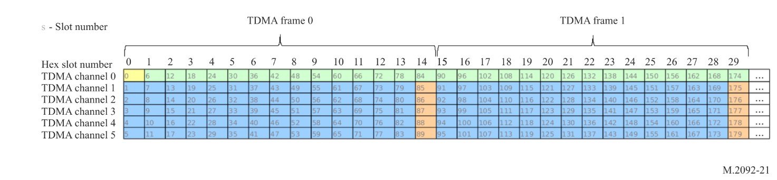

A4-4.1.1 Hexslot
Six slots numbered from 0 to 5 form a hexslot. The hexslot has duration of 160 ms with each slot having a duration of 26.7 ms. The hexslot should be incremented after every 6 slots.

A4-4.1.2 Time division multiple access channel
A TDMA channel refers to all the slots with the same offset in the hexslot. Every 6th slot is part of the same TDMA channel. Six TDMA channels are defined. Figure A4-1 shows each TDMA channel as a horizontal line of slots.

A4-4.1.3 Time division multiple access frame
A TDMA channel is divided into TDMA frames. The default total time duration of a TDMA frame is defined as 15 hexslots within a TDMA channel. TDMA frames are numbered from 0 to 24.
The functionality to configure a TDMA frame length by a shore station exists, but is reserved for future use. The frame length would be changed by increasing or decreasing the number of hexslots in a frame.

A4-4.1.4 Time division multiple access slot
A TDMA slot defines the slot number within a TDMA frame. With the TDMA frame length of 15 slots, the TDMA slots will be cyclically numbered from 0 to 14.

A4-4.2 Link layer definitions

A4-4.2.1 Logical channel
Logical channels (LC) define functions for a set of continuous slots within a TDMA channel and may repeat in a TDMA channel. See § A4-4.12.

A4-4.2.2 Physical channel
A Physical Channel is defined by a frequency and bandwidth.

A4-4.2.3 VHF data exchange slotmap
Each physical channel is associated with one VDE slotmap to map LC to slots for one frame.

A4-4.2.4 Bulletin board
The bulletin board message is sent by a control station to define the physical channels with their VDE slotmap for a control station service area. See § A4-4.13.

A4-4.2.5 Short data message
The short data message refers to the data transfer protocol used for transmission of payload in one slot only.

A4-4.2.6 Data session
A data session refers to the period of data transfer, starting with the first fragment, and ending with a fragment that indicates “End data session”. A data session may span multiple TDMA frames. See § A4-4.17.

A4-4.2.7 Data fragment
During a data session, the data may be broken into multiple data fragments to be transmitted in separate slots. The data fragments refer to the start fragment, continuation fragment and end fragment VDE messages. See § A4-4.17.

A4-4.3 Control station service area
Control stations may transmit a bulletin board message with its control station service area on logical channel 0. The bulletin board content only applies to vessels inside the control station service area. While vessels are inside a control station service area, all data session transmissions between ships should take place via the control station.
Ships outside the control station service area may communicate directly. In this case AIS receptions may be used to determine if a ship is within range.
Coordination is required between control stations to establish mutually exclusive service areas and to ensure that LC are shared appropriately between them, in particular the timing of the broadcast of the bulletin board on logical channel 0.
If a VDE vessel unit detects that it is not within any controlling station service area, it should start using the default bulletin board to communicate, as defined in § 4.14 unless instructed otherwise.

A4-4.4 Resource management
The connection between ship and shore is session oriented with a logical channel being reserved, upon request, for a particular ship for a given time by the control station.
Ship originated short data messages can be sent on the random access channels without resource allocation.
During heavy network loading, the network control may introduce time dispersion for resource requests, modify the maximum allowed number of ship originated short data messages or only allow traffic with high priority levels.

A4-4.5 Endianness
The order of bytes within a binary representation of a number is referred to as the endianness.
With regards to the message structure, the same endianness is used as in AIS. See Recommendation ITU-R M.1371-5, § 3.3.7, Annex 1.
When a message is constructed it should be grouped in bytes of 8 bits from top to bottom of the table associated with each message. Multi-byte words are packed most significant byte first in the message.

A4-4.6 Data structures
VDE packet transmissions shall always fit into one slot. The number of bits transmitted per VDE packet shall be fixed, depending on the Link ID used. A packet shall consist of one or multiple VDE messages, zero padding and a CRC.
An example is shown in Figure A4-2.
Figure A4-2
Single/multiple message, zero padding and cyclic redundancy check-32 structure
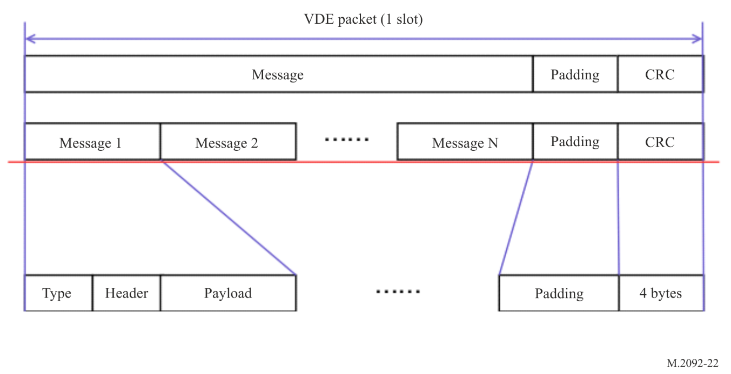
Note that the padding is defined as a separate message. The CRC is always at the end of the packet. Preamble and FEC tail bits are not shown.

A4-4.7 Adaptive coding and modulation/rate adaption
The signal and interference environment are expected to change with time and location. The control station may use the reported CQI as well as measure the channel quality of the received ship signal and request the ship to adjust the Link ID to maximize throughput. The Physical Channel may not be changed dynamically according to the environment, thus the physical channel in use determines the Link ID’s available for selection as determined by the physical channel bandwidth.
Should the Link ID be changed then re-fragmentation of the data payload is required. Re-fragmentation should start at the first fragment that has not been successfully transmitted. This is because the overall data payload is fragmented based on the Link ID used during a data transfer and the fragmentation cannot be re-adjusted for individual fragments in a data transfer.
During ship-to-ship communication outside of control station service area, the Link ID can be controlled by the resource allocating ship. The details for rate adaptation are not defined in this document.
The link adaption mechanism is intentionally undefined.

A4-4.8 Slot functions

A4-4.8.1 Bulletin board signalling channel
Bulletin board signalling channel (BBSC) slots are reserved for bulletin board message transmissions. All transactions in the BBSC shall use Link ID 11.

A4-4.8.2 Random access channel
Random access channel (RAC) slots are reserved for requests, resource allocations or short data message transmissions by mobile stations.

A4-4.8.3 Announcement signalling channel
Announcement signalling channel (ASC) slots are reserved for requests, assignments or ad-hoc one-slot data transmissions by the control station.

A4-4.8.4 Data channel
Data channel (DC) slots are reserved for data transmission messages. The Link ID used in the DC is defined by message 4, Resource allocation and may be changed with message 13, ACK/NACK.

A4-4.8.5 Data signalling channel
Data signalling channel (DSCH) slots are reserved for acknowledgements, resource allocation and resource de-allocations for the DC within the same TDMA channel. The link ID used in the DSCH is defined by message 4, Resource allocation and may be changed with message 13, ACK/NACK.

A4-4.8.6 Ranging channel
The ranging channel (RC) is reserved for future radio navigation applications.

A4-4.8.7 VHF data exchange-terrestrial default slot functions
The default slot functions are defined in Figures A4-3 and A4-4.
Figure A4-3
VHF data exchange-terrestrial ship to shore default slot functions (lower leg)
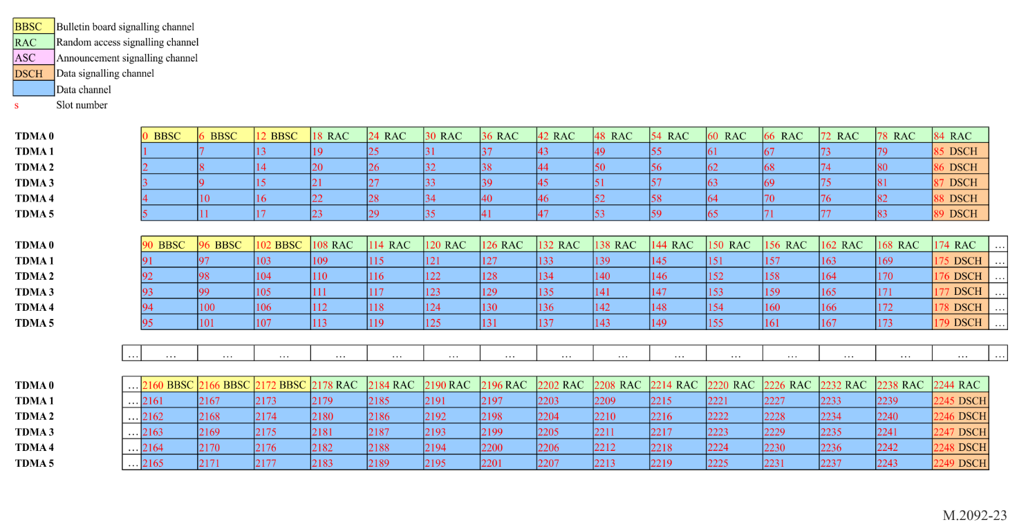
Figure A4-4
VHF data exchange-terrestrial ship to ship and shore to ship default slot functions (upper leg)
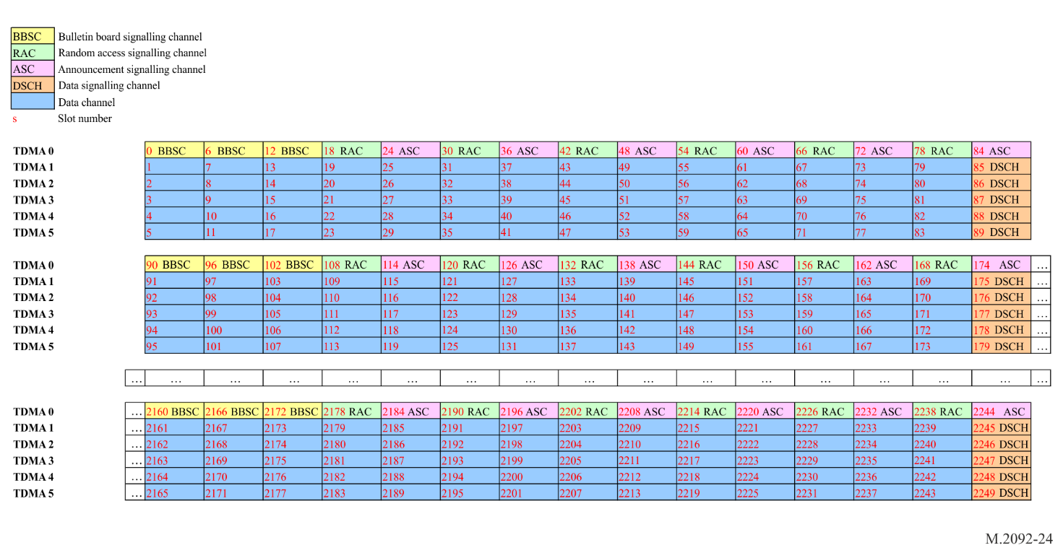

A4-4.9 VHF data exchange-terrestrial messages
Table A4-2
VHF data exchange message summary
Type | Name | Description | Slot function
0 | Media access control | Changes random access selection interval. | BB, ASC
4 | Resource allocation | Allocated LC resource to data session. | ASC, RAC, DSCH
13 | ACK/NACK | Acknowledgement or negative-acknowledgement. | ASC, RAC, DSCH
20 | Bulletin board message start fragment | Start fragment of bulletin board message used for control station service area configuration. | BB
21 | Bulletin board message continuation fragment | Middle fragment of bulletin board message used for control station service area configuration. | BB
22 | Bulletin board message end fragment | Last fragment of bulletin board message used for control station service area configuration. | BB
74 | Start fragment | Start data fragment of the TDMA frame. | DC
75 | Continuation fragment | Middle data fragment of the TDMA frame. | DC
76 | End fragment | Last data fragment of the TDMA frame . | DC
81 | Padding byte | Byte used for padding. | BB, ASC, RAC, DSCH
90 | Resource request / Transmission announcement | Request resource from station or announce transmission to follow. | ASC, RAC
92 | Short data message  (with ACK) | Short data message. ACK is required. | ASC, RAC
93 | Short data message  (no ACK) | Short data message that does not require an ACK. May be used for broadcasting. | ASC, RAC

4.9.1 Media access control
Table A4-3
Media access control
Media access control
Field No. | Value (dec) | Size  (bytes) | Function | Content
1 | 000 | 1 | Type
2 | 0 to  2¹⁶-1 | 2 | Length | 12: Total size in bytes, fixed at 12 bytes.
3 | 0 to  2³²-1 | 4 | Source ID | The unique identifier of the transmitting station as described in § A1-2.4.
4 | 0-255 | 1 | Media Access priority level | Reserved for future use. Always 0.
5 | 0-511 | 2 | Random access selection interval | The random access scheme selection interval in hexslots.  0 – Default selection interval applies.
6 | 0-127 | 1 | Short data message limit | Maximum allowed number of short data message transmissions on the RAC during a frame.
7 | 0-255 | 1 | System status | 0: Normal.  10: Busy.  20: Temporarily out of service.  30: Scheduled out of service.

Note:
Provides methods for granting data transfer access.
When a mobile station receives a MAC message, this message takes preference over the BB message parameters and the mobile station should apply the random access selection interval for a duration selected randomly between 4 and 8 minutes. After the expiry of the duration, the random access selection interval should revert back to the parameters specified by the BB.
If the random access selection interval is set to 0, then the BB random access selection interval applies.

A4-4.9.2 Resource allocation
Table A4-4
Resource allocation
Field No. | Value (dec) | Size (bytes) | Function | Content
1 | 004 | 1 | Type
2 | 0 to  2¹⁶-1 | 2 | Length | Total size in bytes, variable.
3 | 0 to  2³²-1 | 4 | Source ID | The unique identifier of the transmitting station as described in § A1-2.4.
4 | 0 to  2³²-1 | 4 | Destination ID | The unique identifier of the station being assigned a logical channel as described in § A1-2.4.  Set to 0 for shore-originated broadcast.
5 | 0-255 | 1 | Logical Channel Tx | Logical channel assigned to the session for transmission. Transmission only applies to data slots.(1) LC of 255 indicates no resource.
6 | 0-255 | 1 | Logical Channel Rx | Logical channel assigned to the session for reception. Reception only applies to data signalling slots.(1) LC of 255 indicates no resource.
7 | 0-255 | 1 | Link ID | The link ID that should be used in the TDMA channel. This will apply to Messages 74, 75, 76 and 13.
8 | 1-255 | 1 | TDMA frame delay | The number of TDMA frames to delay before the resource may be used. Resource may only be assigned from the start of the next TDMA frame. Default 1 (2) (3).
9 (4) | 0 | 1 | Session ID | Session ID.
10 | 0-255 | 1 | CQI | Received channel quality indicator as defined in § A2-1.2.8.
⁽¹⁾ The resource allocation message will always be sent on the signalling channel when being sent in response to a resource request (#90) message and will always be sent in the assigned TDMA channel when sent in response to an end fragment (#76). When the resource allocation message is being sent in the assigned TDMA channel, then the message should be transmitted in the same VDE packet as the ACK (#13) message. See fragment continuation for more details.
⁽²⁾ When assigning a logical channel, then both the logical channel Tx and the logical channel Rx should have identical TDMA channel numbers. The assigned LCs may have the same physical channels for simplex communication and different physical channels for duplex communication.
⁽³⁾ The TDMA frame delay allows for the efficient transferal of LC from one vessel to another with as little as possible wasting of slots.
⁽⁴⁾ The session ID is reserved for future use.

A4-4.9.3 Acknowledge/NACK
Table A4-5
Acknowledge/NACK
Field No. | Value  (dec) | Size  (bytes) | Function | Content
1 | 013 | 1 | Type
2 | 0 to 2¹⁶-1 | 2 | Length | Total size in bytes.
3 | 0 to 2³²-1 | 4 | Source ID | The unique identifier of the transmitting station, as described in § A1-2.4.
4 | 0 to 2³²-1 | 4 | Destination ID | The unique identifier of the receiving station, as described in § A1-2.4.
5⁽¹⁾ | 0 | 1 | Session ID | Session ID of data session.
6 | 0 to 2¹⁶-1 | 2 | ACK/NACK mask 0 | When a packet was not received, then its corresponding bit should be set to one to not acknowledge the packet.  Each ACK/NACK mask corresponds to a data transfer session that started with a Start Fragment and ended with an end fragment. If the start fragment is not received, then the least significant bit is set.  The first continuation fragment corresponds with the next bit, and so on, with the end fragment being represented by the last bit. If there were 10 fragments and the end fragment was not received, then the ACK/NACK mask should be logically or-ed with 0x0200.  ACK/NACK mask 2 represents the latest TDMA frame received directly before this message response.  ACK/NACK mask 1 represents the second to last TDMA frame received.  ACK/NACK mask 0 represents the third to last TDMA frame received.
7 | 0 to 2¹⁶-1 | 2 | ACK/NACK mask 1
8 | 0 to 2¹⁶-1 | 2 | ACK/NACK mask 2
9 | 0-255 | 1 | CQI | Received channel quality indicator averaged over the last TDMA frame received as defined in § A2-1.2.8.
10 | 0-255 | 1 | ACM or EDN | 0: Maintain link ID.  1: Increment link ID (higher rate)  2: Decrease link ID.  3: End delivery notification.  The link ID may only be changed if all the fragments have been successfully received and the ACK/NACK mask is set to 0. Changing the link ID should not change the channel bandwidth.
11 | 0-255 | 1 | Power setting | 0: Maintain power level  1: Increase power level (reserved for future use).  2: Decrease power level (reserved for future use).
Notes:
The ACK/NACK message will be transmitted in the data signalling channels on the same logical channel as defined by the “logical channel Rx” assigned by the resource allocation (#4).
During short addressed message transmissions, the ACK/NACK message will be transmitted on the RAC.
⁽¹⁾ Session ID is reserved for future use.

A4-4.9.4 Resource request/transmission announcement
Table A4-6
Resource request / transmission announcement
Field No. | Value  (dec) | Size  (bytes) | Function | Content
1 | 90 | 1 | Type
2 | 0 to 2¹⁶-1 | 2 | Length | Total packet size in bytes.
3 | 0 to 2³²-1 | 4 | Original source ID | The unique identifier of the transmitting station, as described in § A1-2.4.
4 | 0 to 2³²-1 | 4 | Node source ID | Unique identifier of the current node transmitting the message, as described in § A1-2.4.
5 | 0 to 2³²-1 | 4 | Node destination ID | Unique identifier of the current node receiving the message, as described in § A1-2.4.  Set to 0 for shore-originated broadcast.
6 | 0 to 2³²-1 | 4 | Original destination ID | The unique identifier of the receiving station, as described in § A1-2.4.  Set to 0 for shore-originated broadcast.
7 | 0-255 | 1 | Priority | Set to 0. Reserved for future use.
8 | 0 to 2³²-1 | 4 | Terminal capabilities | This field is a 32-bit bitmask with each bit set to indicate capabilities/restrictions of a unit:  Bit 0: All bandwidths and modulation schemes as per VDE v1.0 supported.  Bit 1: Unit has only 1 VDE receiver.  Bit 2: Set to 1 for the simplified VDES (refer to § A1-2.7).  Bits 3 to 31: Reserved for future use. Should be set to zero.
Note: The Resource request message will be transmitted on the RAC by ships and ASC by shore stations.
The four maritime mobile service identity (MMSI) numbers could allow for multiple hops of data messages between many stations. This functionality is reserved for future use. The original source and original destination IDs are the end points of the communication while the node source and node destination IDs are the immediate stations communicating with each other during the current hop.

A4-4.9.5 Short data message (with acknowledgement)
Table A4-7
Short data message (with acknowledgement)
Field  No. | Value  (dec) | Size  (bytes) | Function | Content
1 | 92 | 1 | Type
2 | 0 to 2¹⁶-1 | 2 | Length | Total size in bytes, variable.
3 | 0 to 2³²-1 | 4 | Source ID | The unique identifier of the transmitting station, as described in § A1-2.4.
4⁽¹⁾ | 0 | 1 | Session ID | Session ID of data session.
5 | 0 to 2³²-1 | 4 | Destination ID | Destination MMSI may not be set to zero (broadcast address).
6 | 0 to 255 | 1 | Retransmission no | Starts with value 0 and increments with every retransmission. Handles lost ACKs.  Value of 255 indicates no ACK is requested.
7 |  | Variable | Payload
Notes:
Should always be transmitted on the RAC by ship and ASC by shore station. The short data message ACK message should be transmitted on the RAC by ship and ASC by shore.
⁽¹⁾ Session ID is reserved for future use.

A4-4.9.6 Short data message (no acknowledgement)
Table A4-8
Short data message (no acknowledgement)
Field No. | Value  (dec) | Size  (bytes) | Function | Content
1 | 93 | 1 | Type
2 | 0 to 2¹⁶-1 | 2 | Length | Total size in bytes, variable.
3 | 0 to 2³²-1 | 4 | Source ID | The unique identifier of the transmitting station, as described in § A1-2.4.
4⁽¹⁾ | 0 | 1 | Session ID | Session ID.
5 | 0 to 2³²-1 | 4 | Destination ID | The unique identifier of the receiving station, as described in § A1-2.4.  Set to 0 for broadcast.
6 |  | Variable | Payload
Notes:
May be used on the RC in conjunction with link IDs 35, 36, 37 and 38 in order to enable future radio navigation applications.
⁽¹⁾ Session ID is reserved for future use.

A4-4.9.7 Bulletin board start fragment message
Table A4-9
Bulletin board start fragment message
Field No. | Value  (dec) | Size  (bytes) | Function | Content
1 | 020 | 1 | Type
2 | 0 to 2¹⁶-1 | 2 | Length | Total size in bytes, variable.
3 | 0 to 2³²-1 | 4 | Source ID | The unique identifier of the transmitting station, as described in § A1-2.4.
4 | 0 to 255 | 1 | Control station ID
5 | 0 to 2¹⁶-1 | 2 | Bulletin board version | Version number of this bulletin board.  All valid versions are stored in the ship terminal (includes configuration message).
6 | 0 to 255 | 1 | Number of fragments | Should be a value from 1 to 6 (TBC).
7 |  | Variable | Bulletin board payload | See bulletin board payload definition in Table A4-10.

Table A4-10
Bulletin board payload
Field No. | Value  (dec) | Size  (bytes) | Function | Content
1 | 0 to 2³²-1 | 4 | Start time for this version | UTC start time for this version of the bulletin board in number of seconds since 1 January 2000 00:00:00 UTC.
2 | 0 to 2¹⁶-1 | 2 | Validity of this version | Lifetime of this version in number of 1 minute frames.  Up to 45 days.
3 | 0 to 255 | 1 | TDMA frame size | The size of TDMA frames in hexslots.  May have the following values: 3, 5, 15 (default).  Only 15 have to be supported.
4 |  | Variable | Physical channel definitions | See physical channel definition in Table A4-14.
5 | 0 to 255 | 1 | Modulation, coding and protocol versions supported | Set to zero.  May be used to in the future to define a mandatory base set and optional more capable versions. Network ID segmentation could be used to distinguish different network types.  ASM reception flag one of the parameters for satellite.

Table A4-10 (end)
Field No. | Value  (dec) | Size  (bytes) | Function | Content
6 |  | 9 | Control station service area | Parameter (longitude and latitude) defining the control station service area.  See Table A4-11 – control station service area.
7 |  | 64 | Authentication and integrity sequence | See § A4-4.15

Table A4-11
Control station service area
Name | Field size  (bits) | Content
Longitude of point 1 | 18 | Longitude of area to which the assignment applies; upper right corner (North-East); in 1/10 min (±180°, East = positive, West = negative).
Latitude of point 1 | 17 | Latitude of area to which the assignment applies; upper right corner (North-East); in 1/10 min  (±90°, North = positive, South = negative).
Longitude of point 2 | 18 | Longitude of area to which the assignment applies; lower left corner (South-West); in 1/10 min (±180°, East = positive, West = negative).
Latitude of point 2 | 17 | Latitude of area to which the assignment applies; lower left corner (South-West); in 1/10 min (±90°, North = positive, South = negative).
Padding | 2 | Padding bits for byte alignment. Set to zero.

A4-4.9.8 Bulletin board continuation fragment message
Table A4-12
Bulletin board continuation fragment message
Field No. | Value  (dec) | Size  (bytes) | Function | Content
1 | 021 | 1 | Type
2 | 0 to 2¹⁶-1 | 2 | Length | Total size in byte, variable.
3 | 0 to 2³²-1 | 4 | Source ID | The unique identifier of the transmitting station, as described in § V1-2.4.
4 | 0 to 255 | 1 | Control station ID
5 | 0 to 2¹⁶-1 | 2 | Bulletin board version | Version number of this bulletin board.  All valid versions are stored in the ship terminal (includes configuration message).
6 | 0 to 255 | 1 | Fragment number
7 |  | Variable | Bulletin board payload | See bulletin board payload definition, Table A4-10.

A4-4.9.9 Bulletin board end fragment message
Table A4-13
Bulletin board end fragment message
Field No. | Value  (dec) | Size  (bytes) | Function | Content
1 | 022 | 1 | Type
2 | 0 to 2¹⁶-1 | 2 | Length | Total size in bytes, variable.
3 | 0 to 2³²-1 | 4 | Source ID | The unique identifier of the transmitting station, as described in § A4-1-2.4.
4 | 0 to 255 | 1 | Control station ID
5 | 0 to 2¹⁶-1 | 2 | Bulletin board version | Version number of this Bulletin Board.  All valid versions are stored in the ship terminal (includes configuration message).
6 | 0 to 255 | 1 | Fragment number
7 |  | Variable | Bulletin board payload | See bulletin board payload definition, Table A4-10.
Table A4-14
Physical channel definition
Name | Value | Field size  (bits) | Content
Number of physical channels N | 0-255 | 8 | Number of physical channels defined in control station service area.
Physical channel 0 (PC0) number | 0-255 | 8 | Defines the first physical channel number.
PC0 channel frequency | As defined in Recommendation ITU-R M.1084 | 12 | Identification of centre frequency use channel numbering scheme defined in Recommendation ITU-R M.1084. Channel bandwidth is not according to Recommendation ITU-R M.1084 and is defined in PC0 bandwidth field below.  Default: 1284: 157.2375 MHz.
Reserved |  | 1 | Reserved for future use.
PC0 bandwidth | 0-2 | 2 | 0 – 25 kHz.  1 – 50 kHz (reserved for future use).  2 – 100 kHz (default).
PC0 Tx flag | 0 or 1 | 1 | 0 – mobile may not transmit on this PC.  1 – mobile may transmit on this PC.
PC0 RA selection interval | 0-511 | 9 | The Random Access scheme selection interval in hexslots. 0 for default.
PC0 short data message limit | 0-127 | 7 | Maximum allowed number of short data message transmissions on the RAC during a frame.
PC0 logical channel definition | See logical channel definition, Table A4-15. | Variable | Defines the logical channel definition of physical channel 0.
… | … | … | ...
Physical channel N (PCN) number | 0-255 | 8 | Defines the last physical channel number.
PCN channel frequency | As defined in ITU-R M.1084 | 12 | Identification of centre frequency use channel numbering scheme defined in Recommendation ITU-R M.1084. Channel bandwidth is not according to Recommendation ITU-R M.1084 and is defined in PCN bandwidth field below. Default: 2284: 161.8375 MHz.
Reserved |  | 1 | Reserved for future use.
PCN bandwidth | 0-2 | 2 | 0 – 25 kHz.  1 – 50 kHz (reserved for future use).  2 – 100 kHz (default).
PCN Tx flag | 0 or 1 | 1 | 0 – mobile may not transmit on this PC.  1 – mobile may transmit on this PC.
PCN RA selection interval | 0-511 | 9 | The random access scheme selection interval in hexslots. 0 for default.
PCN short data message limit | 0-127 | 7 | Maximum allowed number of short data message transmissions on the RAC during a frame.
PCN logical channel definition | See logical channel definition, Table A4-15 | Variable | Defines the logical channel definition of physical channel N.

Table A4-15
Logical channel definition terrestrial
Name | Value | Field size  (bits) | Content
TDMA 0 LC count | 0-63 | 6 | Number of LCs defined inside TDMA channel 0.
TDMA 1 LC count | 0-63 | 6 | Number of LCs defined inside TDMA channel 1.
TDMA 2 LC count | 0-63 | 6 | Number of LCs defined inside TDMA channel 2.
TDMA 3 LC count | 0-63 | 6 | Number of LCs defined inside TDMA channel 3.
TDMA 4 LC count | 0-63 | 6 | Number of LCs defined inside TDMA channel 4.
TDMA 5 LC count | 0-63 | 6 | Number of LCs defined inside TDMA channel 5.
LC 0 function | 0-5 | 3 | Slot function..  0 – Bulletin board  1 – Random access.  2 – Announcement signalling.  3 – Data.  4 – Data signalling.  5 – Ranging.
LC 0 repeat | 0-1 | 1 | 0 – This LC does not repeat in the TDMA channel.  1 – This LC does repeat in the TDMA channel.
LC 0 duration | 0-255 | 8 | The duration in slots of this LC in each TDMA frame .
… | … | … | ...
LC N function | 0-5 | 3 | Slot function.  0 – Bulletin board.  1 – Random access.  2 – Announcement signalling.  3 – Data.  4 – Data signalling.  5 – Ranging.
LC N repeat | 0-1 | 1 | 0 – This LC does not repeat in the TDMA channel.  1 – This LC does repeat in the TDMA channel.
LC N duration | 0-255 | 8 | The duration in slots of this LC in each TDMA frame .
Padding | 0 | 4 if total number of LC definition pairs are even.  0 if total number of LC definition pairs are odd. | Padded with 0 valued bits to ensure byte alignment of logical channel definition.
Note: See § A4-4.13 for explanation.

4.9.10 Start fragment
Table A4-16
Start fragment
Field  No. | Value  (dec) | Size  (bytes) | Function | Content
1 | 074 | 1 | Type
2 | 0 to 2¹⁶-1 | 2 | Length | Total size in bytes, variable.
3 | 0 to 2³²-1 | 4 | Source ID | The unique identifier of the current node transmitting this message, as described in § A1-2.4.
4⁽¹⁾ | 0 | 1 | Session ID | Session ID.
5⁾ | 0 to 2³²-1 | 4 | Destination ID | The unique identifier of the current node receiving this message, as described in § A1-2.4.  Set to 0 for broadcast.
6 | 0-255 | 1 | Number of fragments | Number of fragments in this TDMA frame.  Should be a value from 1 to 14.
7 | 0-255 | 1 | Fragment number | Fragment number of the payload in this message. First fragment should start at 0, increment with any additional fragment and wrap at 255.
8 | 0-255 | 1 | Continue resource usage | 0 – Ends data session.  1 – Continue resource usage.
9 |  | Variable | Payload
Notes:
Should always be transmitted on the TDMA channel (derived from the logical channel) as assigned by a resource allocation.
Will always be transmitted to carry payload of first data fragment.
⁽¹⁾ Session ID is reserved for future use.

A4-4.9.11 Continuation fragment
Table A4-17
Continuation fragment
Field No. | Value  (dec) | Size  (bytes) | Function | Content
1 | 075 | 1 | Type
2 | 0 to 2¹⁶-1 | 2 | Length | Total size in bytes, variable.
3 | 0 to 2³²-1 | 4 | Source ID | The unique identifier of the transmitting station, as described in § A1-2.4.
4⁽¹⁾ | 0 | 1 | Session ID | Session ID.
5 | 0 to 2³²-1 | 4 | Destination ID | The unique identifier of the current node receiving this message, as described in § A1-2.4.  Set to 0 for broadcast.
6 | 0-255 | 1 | Number of fragments | Total number of fragments in this TDMA frame.  Should be a value from 1 to 14.
7 | 0-255 | 1 | Fragment number in this TDMA frame | Fragment number in this TDMA frame.  Should be a value from 2 to 13.
8 | 0-255 | 1 | Fragment number | Fragment number of the payload in this message. First fragment should start at 0, increment with any additional fragment and wrap at 255.
9 |  | Variable | Payload
Note: Should always be transmitted on the data channel (derived from the logical channel) as assigned by a resource allocation.
⁽¹⁾ Session ID is reserved for future use.

A4-4.9.12 End fragment
Table A4-18
End fragment
Field No. | Value  (dec) | Size  (bytes) | Function | Content
1 | 076 | 1 | Type
2 | 0 to 2¹⁶-1 | 2 | Length | Total size in bytes, variable.
3 | 0 to 2³²-1 | 4 | Source ID | The unique identifier of the transmitting station, as described in § A1-2.4.
4⁽¹⁾ | 0 | 1 | Session ID | Session ID.
5 | 0 to 2³²-1 | 4 | Destination ID | The unique identifier of the current node receiving this message, as described in § A1-2.4.  Set to 0 for broadcast.
6 | 0-255 | 1 | Number of fragments | Total number of fragments in this TDMA frame.  Should be a value from 1 to 14.
7 | 0-255 | 1 | Fragment number | Fragment number of the payload in this message. First fragment should start at 0, increment with any additional fragment and wrap at 255.
8 | 0-255 | 1 | Continue resource usage | 0 – Ends data session.  1 – Continues resource usage.
9 |  | Variable | Payload
Note:
Should always be transmitted on the data channel (derived from the Logical Channel) as assigned by a resource allocation.
Will always be transmitted on last fragment signalling the end of Logical Channel use, unless only one fragment will be transmitted. When only one fragment will be transmitted, then only a Start Fragment will be transmitted.
⁽¹⁾ Session ID is reserved for future use.

A4-4.9.13 Padding single byte
Table A4-19
Padding single byte
Field  No. | Value  (dec) | Size  (bytes) | Function | Content
1 | 081 | 1 | Type | 1 byte padding.

A4-4.10 Cyclic redundancy check
Refer to § A2-1.2.5.

A4-4.11 Acknowledgement
Acknowledgement behaviour for the terrestrial link is described in § A4-4.17.

A4-4.12 Logical channels
A LC defines a grouping of slots that can be uniquely identified and assigned for a specific use.
LC map slots to slot functions. LC numbers are used to assign resources to data sessions.

A4-4.13 Terrestrial bulletin board
The terrestrial bulletin board (TBB) message defines the slot map for each physical channel (PC). The TBB content is defined in § A4-4.9.7, § A4-4.9.8 and § A4-4.9.9. A TBB message defines a list of PC. For VDE-TER each PC definition contains six TDMA Channels. Each TDMA channel can contain one or more LCs that repeat as multiple TDMA frames. See Figure A4-1.
A LC definition starts by announcing the number of LC definitions per TDMA channel. Each TDMA Channel, in turn, gets its number of LCs defined by function, repeat and duration. The slotmap of each TDMA frame is identical as defined by Table A4-15. The LCs should be sized to ensure the repeating pattern aligns with a full frame.
The relationship between LC and PL for ship to shore, shore to ship and ship to ship mappings are shown in § A4-4.14.
A VDES station shall always use the latest valid TBB that is received. The TBB shall be used in the frame immediately following the frame in which it is valid. The validity is found by use of the TBB start time and Lifetime fields in the TBB payload (Table A4-10).
The TBB may be transmitted in either the upper or the lower leg in channels 1024 or 2024 respectively. The mobile station should therefore always listen for the bulletin board announcement in both upper leg (channel 2024) and lower leg (channel 1024).
Coast stations should coordinate the timing of the transmissions where multiple station coverage is the case.

A4-4.14 VHF data exchange-terrestrial default physical channel and slotmap
A slotmap defines the LC of all the slots in a frame. Each physical channel in a VDES system will have a valid slotmap defined. By monitoring the terrestrial bulletin board, ships will determine if they are within a control station service area and adopt the physical channel and slotmap from the bulletin board. In the absence of a bulletin board, the default physical channel and slotmap will be applied.
The default physical channel centre frequency is located in the middle of each VDE1 upper (161.837 5 MHz) and lower VDE leg (157.237 5 MHz) and the default bandwidth is set to 100 kHz.
Default LC for VDE lower and upper legs are defined as shown in Figures A4-5 and A4-6.
Signalling only takes place in RA, ASC and DSCH slots. For VDE-TER, the default slot map keeps all signalling in TDMA 0 channel and at the DSCH slot at the end of every TDMA frame.
TDMA 1-5 channels are broken into TDMA frames of 15 slots where data transfer can take place on the first 14 (DC) slots while the 15th slot (DSCH) is used for ACK/NACK and resource allocation signalling.
Figure A4-5
VHF data exchange-terrestrial ship to shore default slot to LC mapping (lower leg)
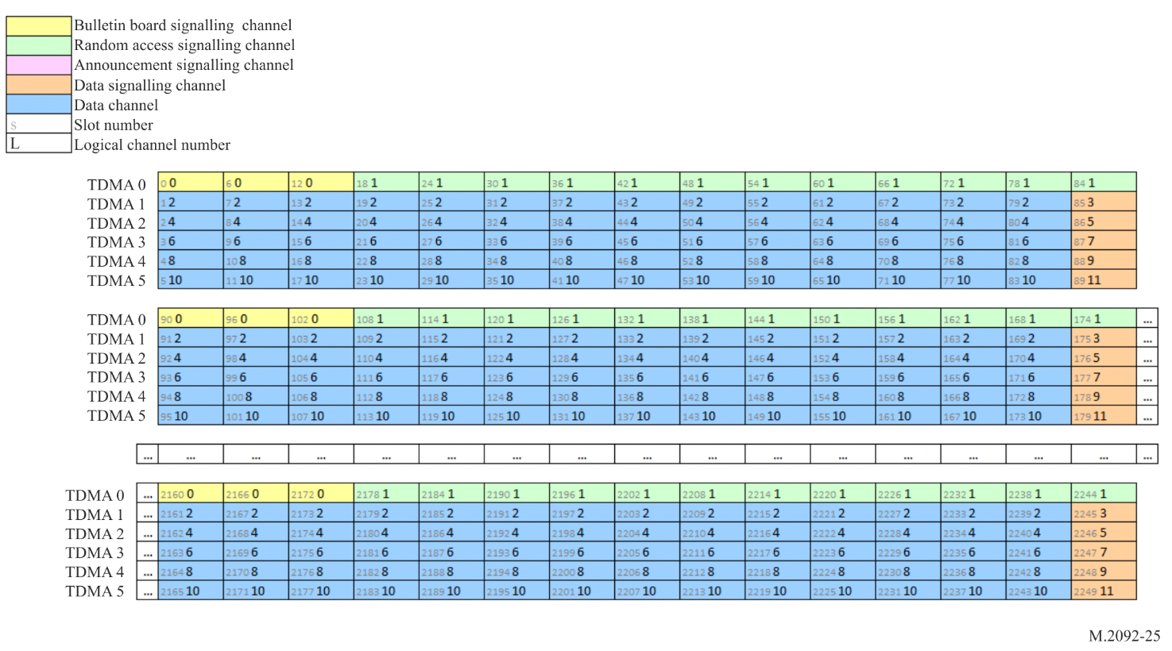
Figure A4-6
VHF data exchange-terrestrial ship to ship default slot to logical channel mapping (upper leg)
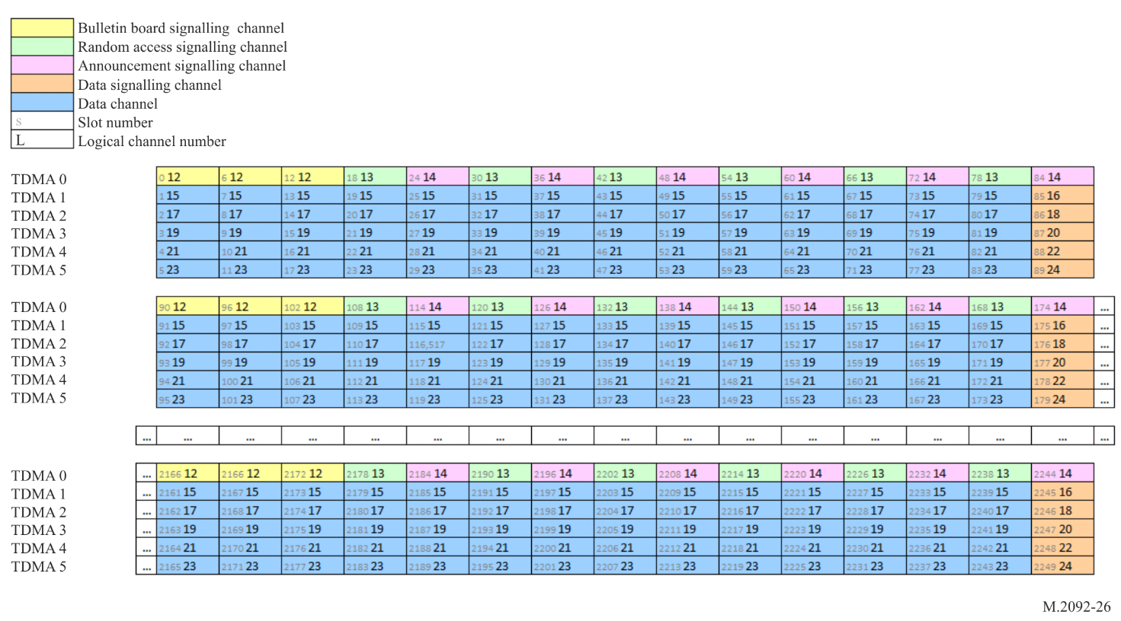

A4-4.15 Digital signature of bulletin board
It is assumed that a public key infrastructure (PKI) is established with an international organization capable of acting as certificate authority (CA), and that Recommendation ITU-T X.509 (10/2016) is used for public key certificates and the PKI implementation. The PKI will serve several systems and among these VDES. For VDES the primary purpose is to attach a digital signature to the bulletin board (BB) issued by a VDES control station to authenticate the control station transmitting the BB.
It should be possible to store certificate validation data in the VDES unit to refer to when a network connection is not available to the CA. Both certificate validation data storage and real-time network access to the CA are done by using the VDES unit PI. In case the verification of the signature fails on the VDES mobile station this shall be flagged to the user. The system shall continue its operation as if the signature was verified.
Cryptographic algorithm for the end-entities digital signatures is the elliptic curve digital signature algorithm. The elliptic curve cryptography public key shall therefore be 256 bits. With this key size, the recommendations from Internet Engineering Task Force (IETF) Document RFC 5480 states that the minimum bits of security should be 128, the message digest algorithm Secure Hash Algorithm (SHA)-256, and the curve secp256r1. The lifetime of the selected key material is three years.

A4-4.16 Data transfer protocols
The following protocols shall be supported:
– Shore originated broadcast.
– Ship originated broadcast inside/outside control station service area.
– Shore to ship addressed message.
– Ship to shore addressed message.
– Ship to ship addressed message inside/outside control station service area.
– Shore to ship short data message.
– Ship to shore short data message.
– Ship to ship short data message.

A4-4.17 Data session transmission and continuation
For each data session between two stations, each station will be assigned one LC for data transmission and one LC for acknowledgement reception. The two logical channels should have identical TDMA channel numbers but do not have to be on the same PC. This ensures adequate processing time between message transmissions. When both LCs are on the same PC, the session is considered simplex (Figure A4-7). When the two LCs are on different PCs, the session is considered duplex (Figure A4-8).
LCs assigned for data transmission sessions should have a DC slot function, while LCs assigned for acknowledgement reception, should have DSCH slot function. See § A4-4.8.
Figures A4-4 and A4-5 show examples of the required slot use during simplex and duplex data session transmissions when 14 fragments are transmitted during each TDMA frame. Two TDMA channels are shown from different physical channels.
Figure A4-7
Simplex data session
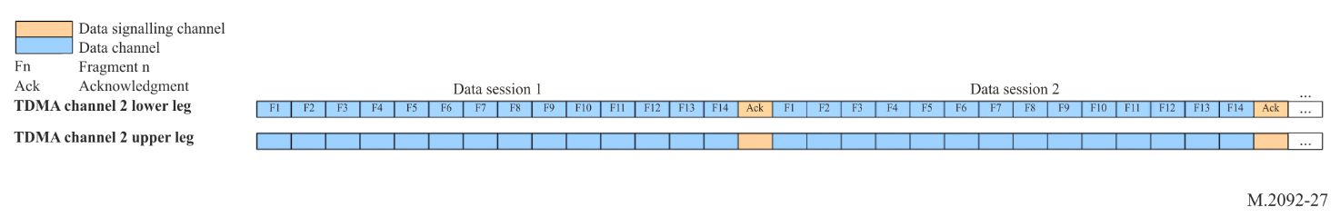
Figure A4-8
Duplex data session
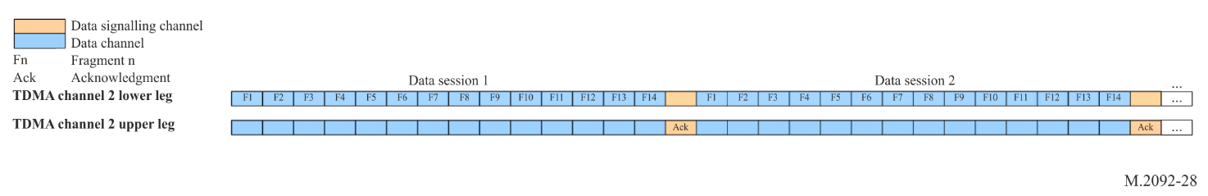
All data fragments will be transmitted on DC slots on the assigned LC only. ACK/NACK messages will be transmitted on the DSCH slots as assigned.
When data exceeds the data packet payload capacity, then data should be broken up and transmitted in fragments.
The first data fragment starts with a start fragment (#74) message, continues with continuation fragment (#75) messages onwards and ends with an end fragment (#76) message.
When only one fragment is transmitted, the one fragment should be a start fragment (#74).
When two fragments are transmitted, then transmission order will be:
1 Start fragment (#74).
2 End fragment (#76).
When three fragments are transmitted, then transmission order will be:
1 Start fragment (#74).
2 Continuation fragment (#75).
3 End fragment (#76), etc.
If the maximum number of fragments (14) are being used and there are data left for transmission, then the data transmission can be continued by setting the “continue resource usage” parameter in the end fragment (#76) message to 1. On successful transmission, the fragments will be acknowledged with an ACK/NACK (#13) message and a logical channel will be immediately assigned by means of a Resource Allocation (#4) message. Both messages ACK/NACK (#13) and resource allocation (#4) will be transmitted in the same data signalling slot. If no more LC resources are available, then an ACK/NACK (#13) message may be transmitted with the ACM or end delivery notification (EDN) parameter set to 3.
To continue the data transmission over multiple TDMA frames during a shore to ship data session, the shore station should transmit a Resource Allocation (#4) message in the ASC before the start of the next TDMA frame.

A4-4.18 Data frame retry
During data frame transmission, it is expected that data fragments can be lost occasionally. When some data fragments are not received, the receiving station shall transmit a NACK message (#13) and flag the lost fragments in the ACK/NACK mask parameter.
The transmitting station shall retry transmission of each individual fragment for a maximum of three times before giving up.
The receiving station shall request retransmission of data fragments for a maximum of three attempts.
It is also possible that the NACK message (#13) is not received by the transmitting station. It is for this reason that the NACK message (#13) contains redundancy with three ACK/NACK masks, referencing the previous three TDMA frames.
When the transmitting station does not receive an ACK/NACK, it shall continue as if all the fragments has been acknowledged. If there were any errors, then the transmitting station will see this when it receives the next ACK/NACK message. If no ACK is received within three TDMA frames, then the transmitter shall stop transmitting immediately.
An example of this process is shown in Figure A4-9.
Figure A4-9
Simplex data session retry
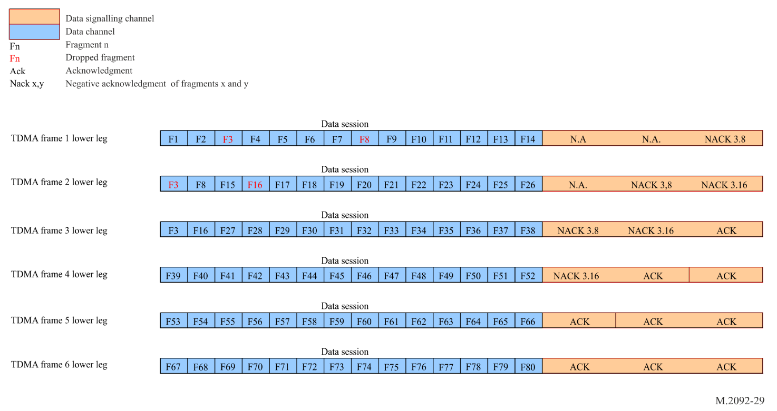

A4-4.19 Giving priority to automatic identification system
VDE transmissions should always give preference to AIS transmissions.

A4-4.19.1 Ship side
Because of the limited physical antenna separation available on a ship, and the possibility that ships use integrated VDES units (containing VDE-TER, VDE-SAT, ASM and AIS), it is best to assume that whatever VDE-TER configuration is used (simplex or duplex), any VDE-TER or ASM transmission will interfere with AIS and vice versa.
It is not required to implement any measure to prevent an own ship AIS transmission from interfering with an ASM or VDE (terrestrial or satellite) reception. The VDE data session acknowledgment and retry mechanism should be able to handle the short interference in this case.
For the more problematic case of VDE or ASM transmission interfering with AIS reception, the first mitigation measure is that a single VDE ship transceiver should not use more than one logical channel simultaneously. This measure in itself will limit VDE interference on AIS channels to a very worst case of 1/6 duty-cycle during the VDE transmission, if the AIS channels are loaded to 100%, which is considered impossible. This measure is not an absolute requirement, but it is a ship-side responsibility to ensure that own VDE transmissions do not overly affect the AIS function primary purpose of collision avoidance. For example, in areas where it is detected that there is no or few AIS stations within close proximity of own ship, a ship may use more than one VDE logical channels simultaneously to transfer larger amounts of data for short periods of time.
A VDES unit may greatly decrease the amount of AIS message transmission conflicts by monitoring the future slots in the current TDMA frame for own AIS transmissions. During the transmission of the Start Fragment (#74) message, the number of fragments used (up to 14) will be announced. The announced number of fragments can be decremented by one for every own AIS message transmission conflict.
For example, if the transmitting station wants to transmit start fragment (#74) with an announcement of 14 fragments but detects one own AIS message transmission conflict with one of the VDE data fragments, then the transmitting station may transmit start fragment (#74) with an announcement of 13 fragments. This way the transmitting station will avoid the data session retry from happening and slowing down the data transfer.
In addition to the general limits explained above, access to VDE RAC is subject to rules for slot selection that have been designed to protect the AIS function. Please see § A4-4.21.1.

A4-4.19.2 Shore side
Shore-side interference mitigation is a complex matter that can be solved in a number of different ways by subject matter experts. This section aims to highlight the intent of this standard to protect the AIS function from interference. The discussion below should not be interpreted as a specification per se but rather as a reference for achieving acceptable protection of the AIS function within VDES.

A4-4.19.2.1 Duplex configuration
On the shore side, unless sufficient isolation can be achieved, VDE should not be co-located with AIS to prevent wideband noise desensitization of the AIS receiver and loss of situational awareness.
Unless AIS coverage is available from other base stations, providing the desired situational awareness to the shore authority, the recommended isolation between VDE transceiver and AIS receiver is 82 dB as per Table A4-20.

Table A4-20
Base station co-site performance
AIS base station sensitivity as per Recommendation ITU-R M.1371⁽¹⁾ | 20% PER @ −107 dBm
Required margin | −10 dBm
VDE transceiver power | 41 dBm rms
Mask sideband noise of VDE @ AIS1 | −70 dBc (−29 dBm)
Required isolation | 82 dB
⁽¹⁾ Different AIS deployments may have different sensitivity requirements.

For co-location of VDE and AIS without the recommended isolation, shore authorities should be aware that the local AIS reception will be degraded whenever the VDE control station transmits. Trying to synchronise VDE transmissions with AIS and ASM services so as to minimize the interference runs the risk of greatly reducing the throughput of VDE and should be carefully considered. Increasing the number of AIS receivers in the area to offer coverage redundancy would be preferable if feasible.
This is why sufficient isolation is recommended when operating VDES in duplex mode co-located with AIS.

A4-4.19.2.2 Simplex configuration
The simplex configuration simplifies the isolation between co-located VDE transceiver and AIS receiver to a point where co-location using an affordable duplexer is possible without any interference on AIS. That being said, the simplex configuration reduces the global capacity of VDE-TER, especially in very busy areas where lots of transmissions are expected simultaneously.

A4-4.20 Short data message
Vessels may transmit short data messages in RAC slots as long as the vessel adheres to the selection interval and short data message transmission limits while inside the control station service area. When vessels are not inside a control station service area, then the default selection interval and short data message transmission limits apply.

A4-4.21 Random access channel scheme
When a message is scheduled for immediate RAC transmission, then all transmission candidate slots should be gathered over the selection interval. The default selection interval is 235 slots, but may be set via a control station. Only slots with slot function set as RAC may be considered as candidate slots. As AIS and ASM functions form part of the VDES system, their transmission schedules should also be considered. AIS and ASM will always have priority over VDE transmissions.
The candidate slot selection process for RAC on VDE follows the rules explained in § A4-4.21.1 below. One candidate slot will be randomly selected from all the available candidate slots. If no candidate slot is available or if for some reason, the VDE message could not be transmitted (AIS messages could be scheduled after the VDE schedule), then the VDE transmission will fail and the normal retry mechanism will follow. The retry mechanism will allow up to 3 retries of the RAC transmission.

A4-4.21.1 Slot selection algorithm for the VHF data exchange random access channel
The definitions of free, allocated and unavailable slots are the same as with ASM function and defined in § A3-4.3.6.
Slots, used for transmission, are selected from candidate slots in the selection interval (SI) which is defined as 235 slots.
The selection process uses received data from AIS, ASM and VDE channels where these functions are co-located. Functions not part of a co-located station, or not in use by the station, are not considered by the candidate slot selection process of the station.
There should be, at minimum, a set of eight candidate slots to choose from.
The conditions for slot state (see § A3-4.3.6) will determine if the slot is unavailable for VDE RAC.
Rule 1: The candidate slots are initially selected from slots that are free on all VDES channels.
If the candidate slot set contains less than eight slots, additional candidate slots can be obtained by using the following rules and order (rule 2 followed by rule 3 and then rule 4 and then rule 5):
Rule 2: Free on all AIS and VDE channels, allocated on one ASM channel and free on the other.
Rule 3: Free slot on all AIS and VDE channels, allocated on both ASM channels.
Rule 4: Free on one AIS channel and available on the other, free or allocated on both ASM channels[].
Rule 5: Available on both AIS channel, free or allocated on both ASM channels[].
If the station cannot find a sufficient number of candidate slots, the station should not transmit and should re-schedule the transmission.
The purpose of maintaining a minimum of eight candidate slots within the same probability of being used for transmission is to provide high probability of access to the link.
Note that individual VDES functions need only to be considered in the candidate slot selection process when they are in use and there is not sufficient isolation ensure that the AIS station will meet its receiver performance requirements.
Figure A3-2 shows a flowchart representation of the selection algorithm.

A4-4.22 Announcement channel access scheme
Ad hoc messages (messages 4, 90 and 92) shall be transmitted on ASC by the control station and transmitted on RAC by a mobile station to avoid any conflicts between control station and mobile stations.
When scheduling a message for ASC transmission, then the first available announcement slot may be selected for transmission. A control station may choose to use RAC slots for the transmission of ad hoc messages during high congestion but should always use the RAC scheme when accessing the RAC.

A4-4.23 Logical channel access
A resource assignment message assigns two LCs. One LC for data transmission and one LC for receiving signalling information. In addition, the LC pair is assigned with a TDMA frame delay. As the frame delay has a minimum value of 1, transmission cannot start in the current TDMA frame at the time of assignment. The LC assignment goes into effect at the beginning of the next frame, after the TDMA frame delay expires.
Only DC slots may be used for transmission and only DSCH slot may be used for the reception of ACK/NACK and resource re-assignment or de-assignment messages.

A4-4.24 Logical channel use map
Each station should continuously monitor all ASC and DSCH slots for LC resource assignment messages. A station should keep a map of all LCs and mark if they are reserved or free. When an LC remains in use, it will be assigned again at every DSCH slot. If no LC assignment has been received for three consecutive TDMA frames, the LC can be marked as free. Whenever a LC is used for own station transmission or reception, then a LC should be marked as internally assigned for the current TDMA frame and for the following three TDMA frames.

A4-4.25 Unused logical channel slots as random access channel slots
As an LC can only be assigned from the start of the next TDMA frame, an LC that is marked as free in the current TDMA frame shall remain free for the remainder of the current TDMA frame. As these slots will remain unutilised in the current frame, they may be used as RAC slots. These slots may form part of the random access candidate slots, if they also comply with the rules in § A4-4.21.1. Free slots from the next TDMA frame may not be added to the list of candidate slots, until such time that the TDMA frame has arrived and the slots are still free.

A4-4.26 Logical channel assignment
When a ship is outside of the control station service area, the receiving ship should be capable of assigning a LC to another ship after reception of a resource request message. The LC assignment should be made by randomly selecting a free LC from the logical channel use map.

A4-4.27 Retry mechanism
All individual message transmissions and receptions will in general be retried three times before the session will fail and be removed. Because of different selection intervals of different access schemes, the rules for the general retry mechanism will not hold for all the situations and all the special rules and cases will be shown in the state diagrams.
The retry timeouts will also be modified as the selection interval gets changed via the control station.

A4-4.28 Data transfer protocol detail

A4-4.28.1 Shore originated broadcast
The sequence diagram for shore originated broadcast without ACK is shown in Figure A4-10. The transfer starts with a resource allocation. The diagram shows a large multi-fragmented data session.
Figure A4-10
Shore originated broadcast sequence diagram
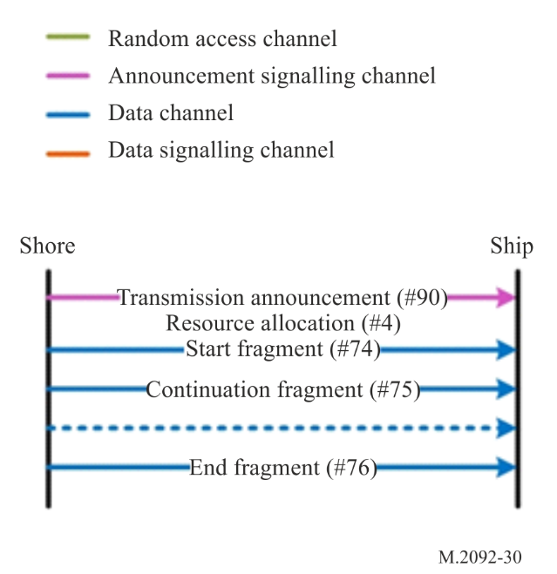

A4-4.28.2 Ship originated broadcast outside control station service area
The sequence diagram for ship originated broadcast outside of control station service area is shown in Figure A4-11.
Figure A4-11
Ship originated broadcast outside control station service area sequence diagram
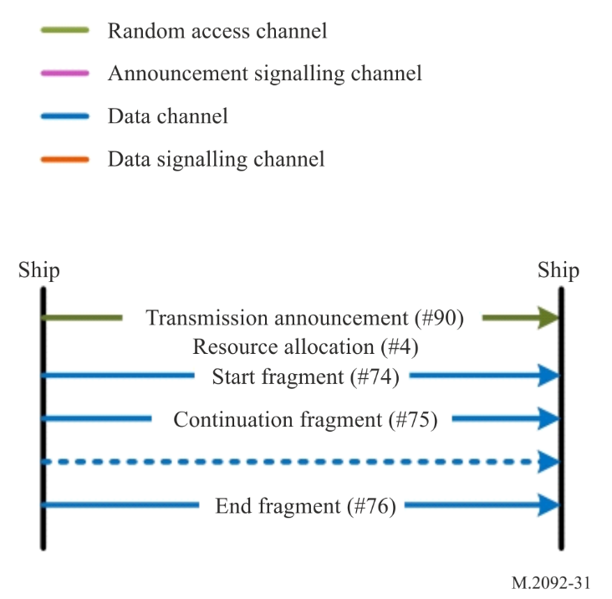

A4-4.28.3 Ship originated broadcast inside control station service area
The sequence diagram for ship originated broadcast inside of control station service area is shown in Figure A4-12.
Figure A4-12
Ship originated broadcast inside control station service area sequence diagram
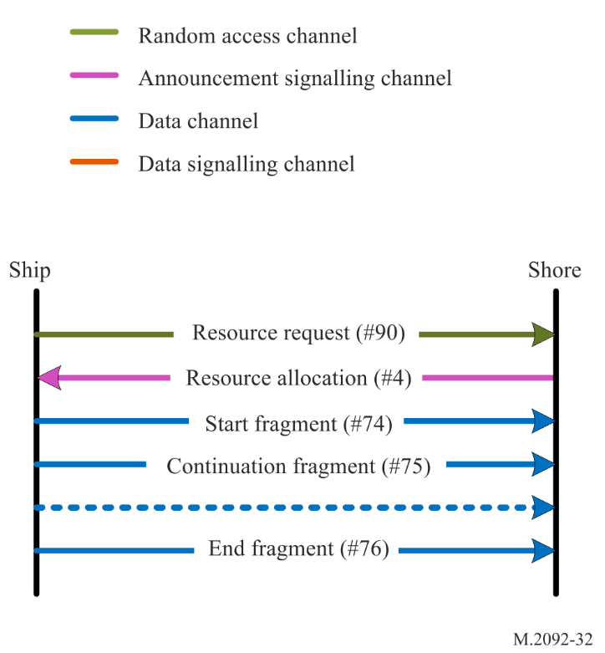

A4-4.28.4 Shore to ship addressed message
The sequence diagram for shore to ship addressed message is shown in Figure A4-13. The transfer starts with a resource request/transmission announcement message to announce the source and destinations of the data session. In the same slot, a resource allocation message is transmitted to assign a LC to the data session. The diagram shows a large multi-fragmented data session. Up to 14 fragments are sent before the ship sends a selective NACK indicating which fragments have to be resent. The LC is kept allocated until all fragments have been received by the ship and an ACK has been received or a retry limit has been exceeded.
The datagram payload has source, destination and format encapsulated for routing and presentation purposes.
Figure A4-13
Shore to ship addressed message sequence diagram
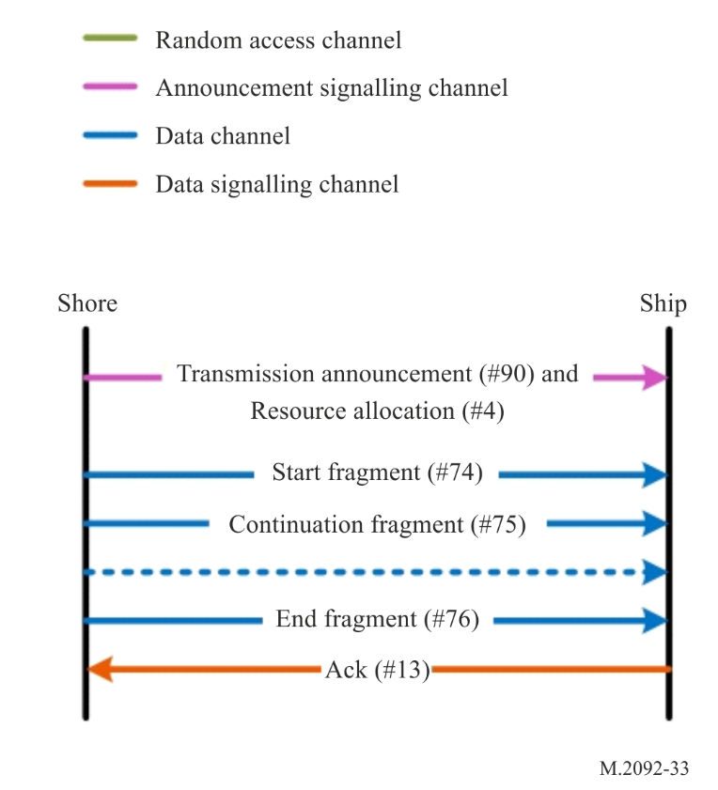

A4-4.28.5 Ship to shore addressed message
The sequence diagram for ship to shore addressed message is shown in Figure A4-14. The transfer starts with a resource request message to request a LC for the data session. The following resource allocation message is transmitted to assign a LC to the data session. The diagram shows a large multi-fragmented data session.
The datagram payload has source, destination and format encapsulated for routing and presentation purposes.
Figure A4-14
Ship to shore addressed message sequence diagram
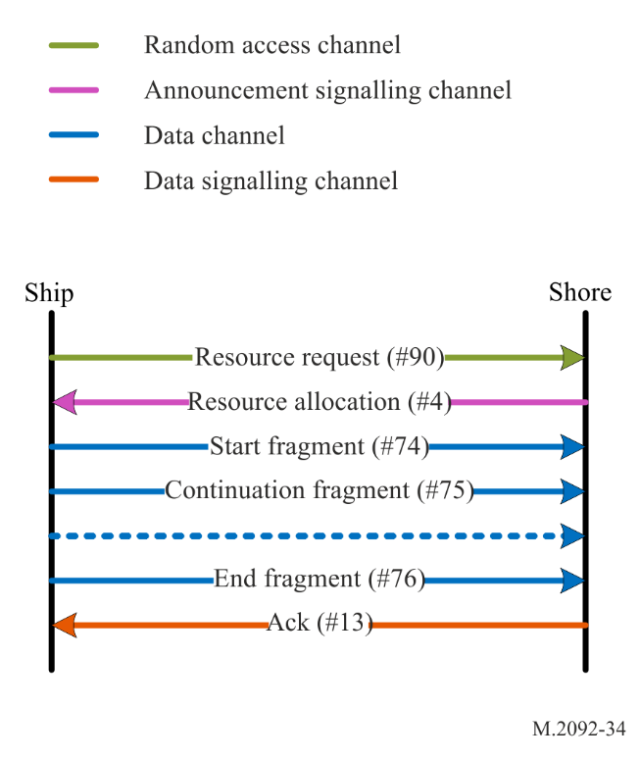

A4-4.28.6 Ship to ship addressed message outside control station service area
The sequence diagram for ship to ship addressed message outside of control station service area is shown in Figure A4-15. The transfer starts with a resource request message to request a LC for the data session. The following resource allocation message is transmitted to assign a LC to the data session. The diagram shows a large multi-fragmented data session.
The datagram payload has source, destination and format encapsulated for routing and presentation purposes.
Figure A4-15
Ship to ship addressed message outside control station service area sequence diagram
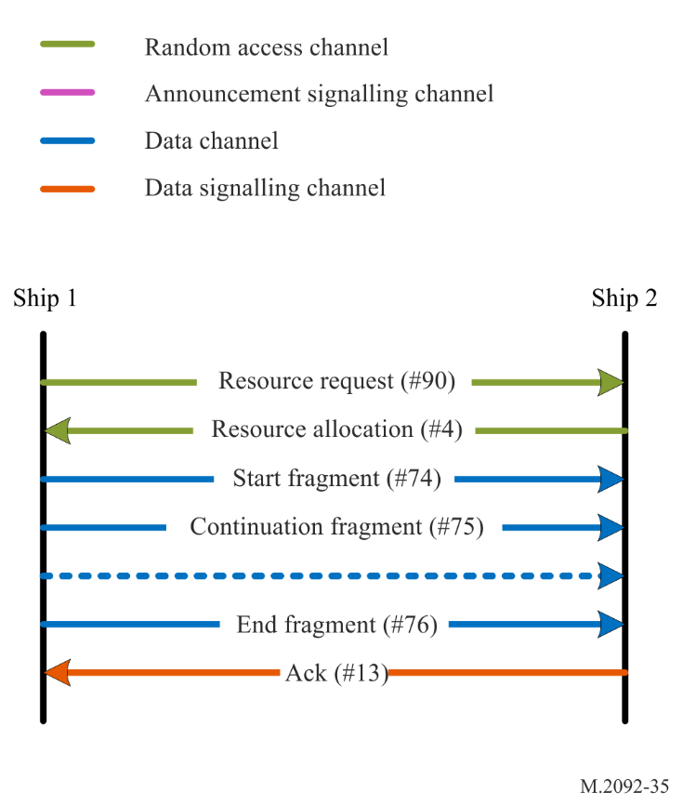

A4-4.28.7 Ship to ship addressed message inside control station service area
The sequence diagram for ship to ship addressed message inside of control station service area is shown in Figure A4-16. The transfer starts with a resource request message to request a LC for the data session. The following resource allocation message is transmitted to assign a LC to the data session. The diagram shows a large multi-fragmented data session.
The datagram payload has source, destination and format encapsulated for routing and presentation purposes.
Figure A4-16
Ship to ship addressed message inside control station service area sequence diagram
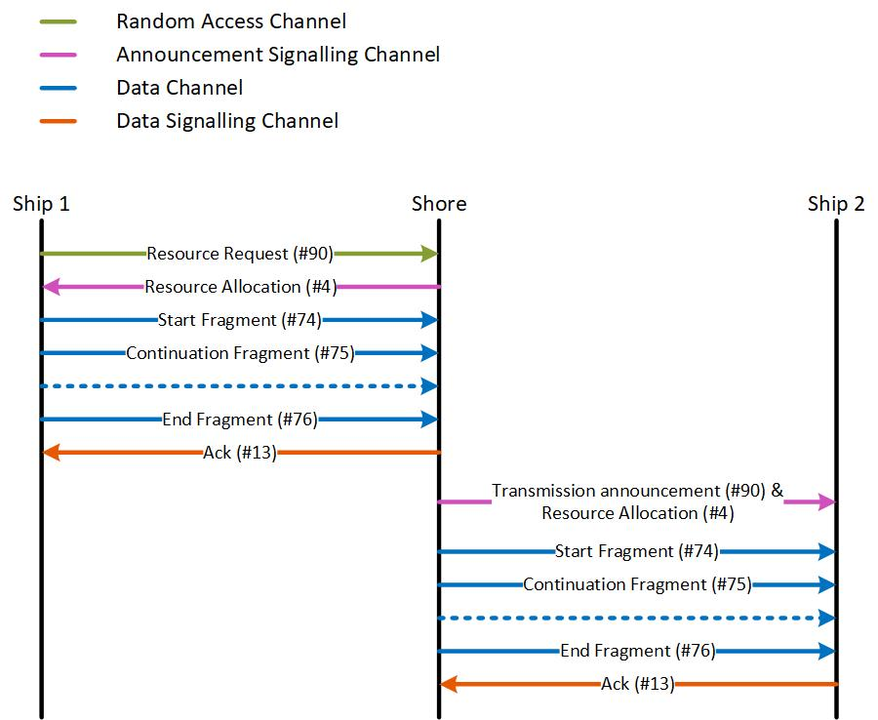

A4-4.28.8 Shore to ship short data message
The sequence diagram for shore to ship short data message with ACK is shown in Figure A4-17. This protocol is used for short data messages that fit within a single transmission burst.
The ship sends an ACK when the message is received correctly, otherwise the shore may automatically retry until the retry limit is reached.
Figure A4-17
Shore to ship short data message sequence diagram with ACK
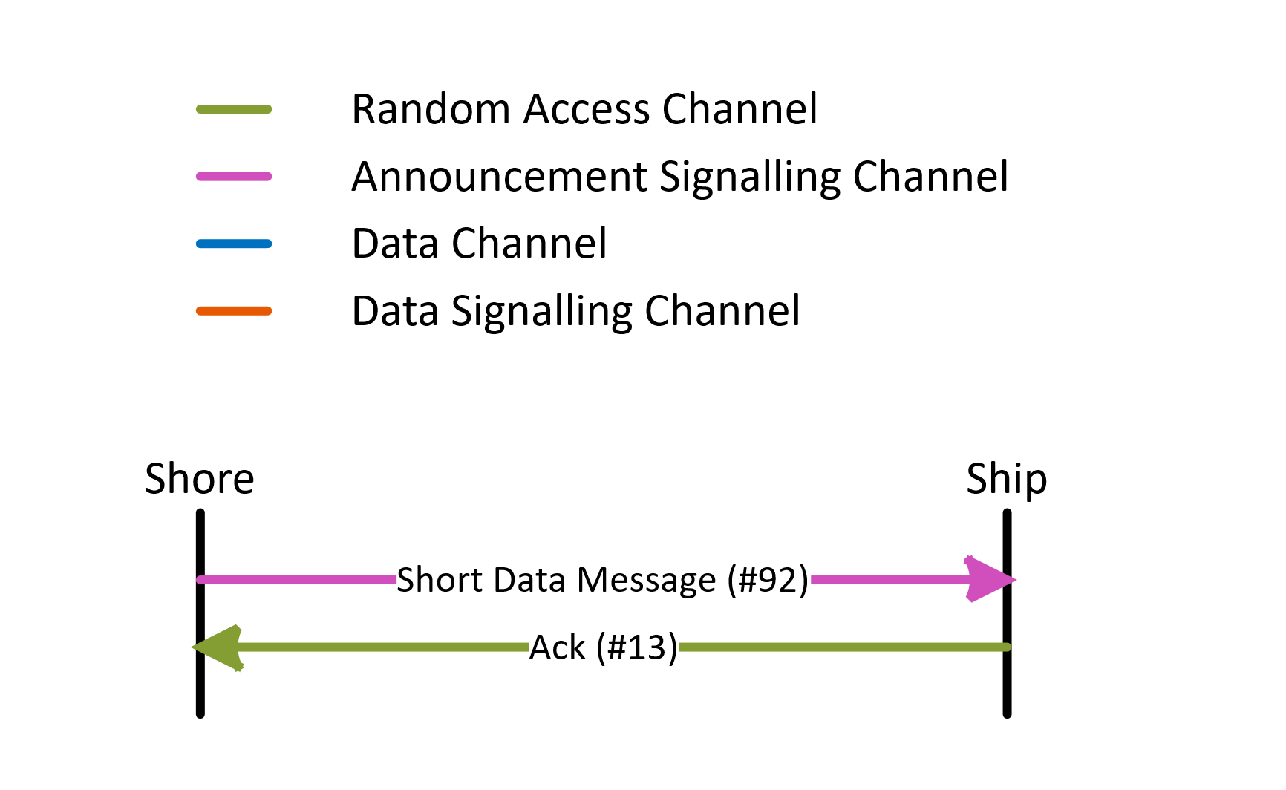
The sequence diagram for shore to ship short data message without ACK is shown in Figure A4-18. This protocol is used for short data messages that fit within a single transmission burst.
The destination ID of this message may be set to zero to use it as a short, efficient broadcast message.
Figure A4-18
Shore to ship short data message sequence diagram without ACK
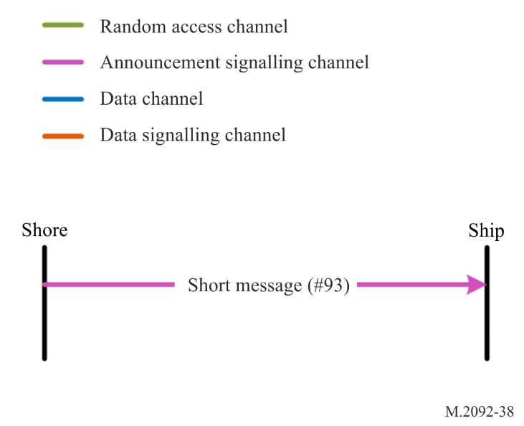

A4-4.28.9 Ship to shore short data message
The sequence diagram for ship to shore short data message is shown in Figure A4-19. This protocol is used for short data messages that fit within a single transmission burst. A random slot in the randomizing interval given in the MAC signalling is used for the transmission.
The shore sends an ACK when the message is received correctly, otherwise the ship may automatically retry until the retry limit is reached.

Figure A4-19
Ship to shore short data message sequence diagram
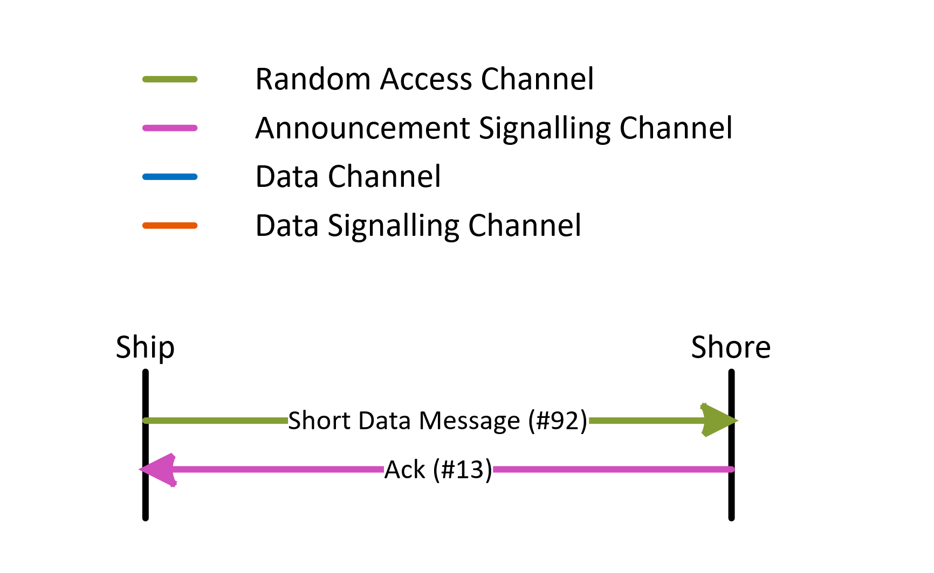

A4-4.28.10 Ship to ship short data message
The sequence diagram for ship-to-ship short data message is shown in Figure A4-20. This protocol is used for short data messages that fit within a single transmission burst. A random slot in the randomizing interval given in the MAC signalling is used for the transmission.
The receiving ship sends an ACK when the message is received correctly, otherwise the transmitting ship may automatically retry until the retry limit is reached.
Figure A4-20
Ship to ship short data message sequence diagram
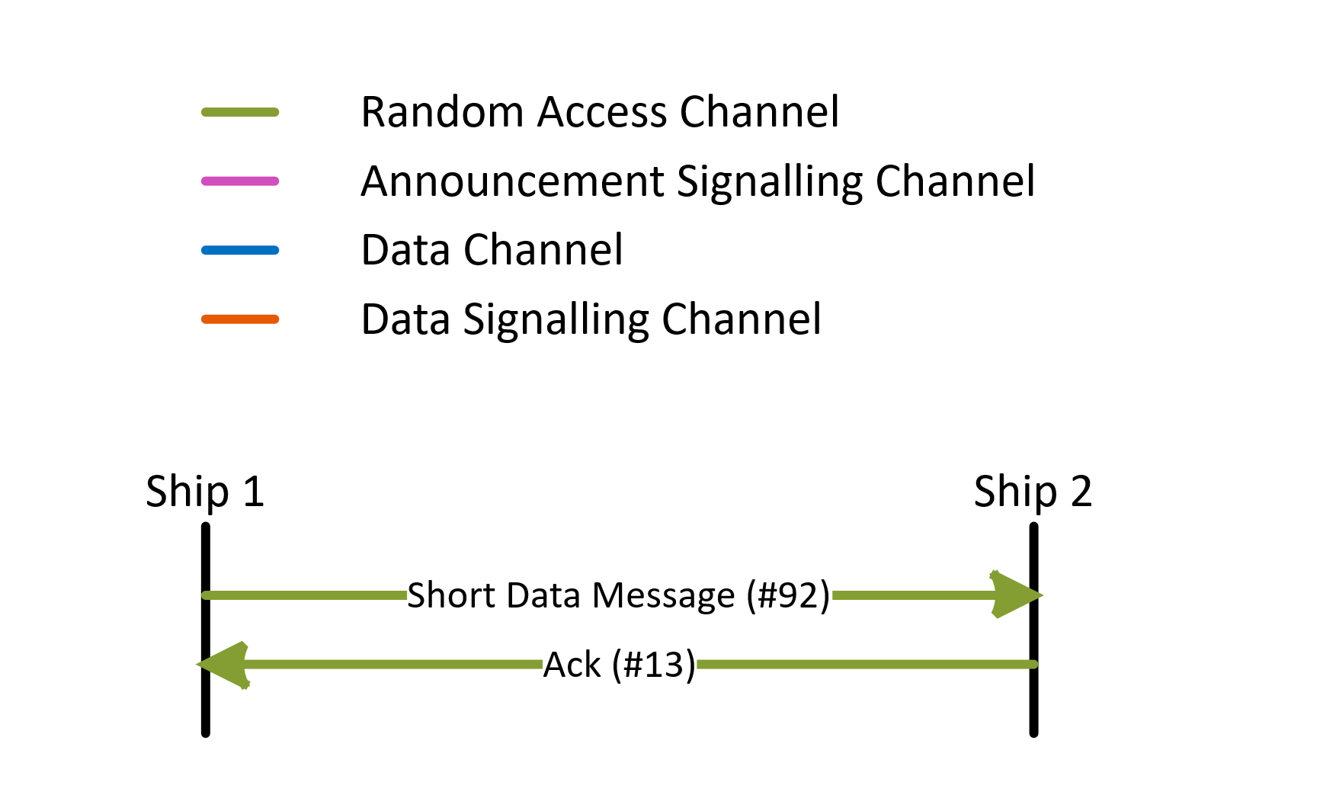

A4-4.29 Segmentation of VHF data exchange payload
Data to be transmitted over VDE payload should be input to equipment via the PI by using applicable international standards. If the PI input results in need of executing multiple simultaneous transactions over VDL, the equipment should process them as described in this section.
VDE payload segments get packed inside the fragment as shown in Figure A4-21. Each segment denotes a part of data within a transaction. Transactions under simultaneous processing are identified by different sequential IDs included in the segment header.
Figure A4-21
Segmentation of VHF data exchange payload
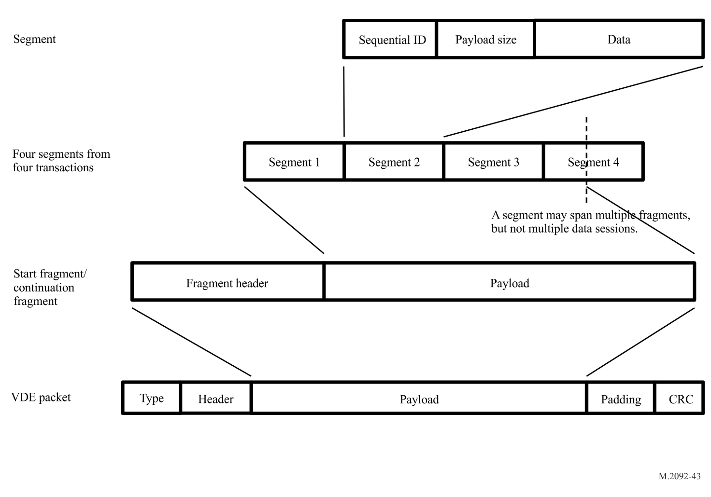
Segments may span multiple fragments, but not multiple data sessions.

A4-4.29.1 Segment description
Table A4-21
Segment description
Field  No. | Value  (Dec) | Size  (Bits) | Function | Content
1 | 0 to 2¹⁶-1 | 16 | Sequential ID | Sequential ID of matching data transaction.
2 | 0 to 2¹⁶-1 | 16 | Payload size | Size of the segment payload data only (bytes).
3 |  | Variable | Payload data | Payload data.

A4-5 Network layer
The priority assignment, distribution of transmission packets and data link congestion resolution requires close integration with the link layer. The responsibility of the network layer was therefore moved to the link layer.

A4-6 Transport layer
The reliable transmission of data segments, segmentation, acknowledgement and multiplexing requires close integration with the link layer. The responsibility of the transport layer was therefore moved to the link layer.

A4-7 Presentation interface layer
VDES supports a presentation interface to be specified in detail by the applicable international standards.

Annex 5
Technical characteristics of VHF data exchange-satellite operating
in the VHF maritime mobile satellite band
TABLE OF CONTENTS
Page
1 Introduction 117
2 Physical layer 117
2.1 VHF data exchange-satellite component key parameters 117
2.2 Technical characteristics of the VHF data exchange-satellite
component downlink 121
2.3 Technical characteristics of the VHF data exchange-satellite
component uplink 123
2.4 Bit mapping 124
2.5 Spreading 124
2.6 Baseband shaping and quadrature modulation 128
2.7 Transmission timing accuracy 128
2.8 Half duplex and full duplex satellites 128
2.9 Frame structure 129
2.10 Pilots and syncword symbol location and modulation 129
2.11 Forward error correction and interleaving 130
2.12 VHF data exchange-satellite link configuration formats 130
2.13 VHF data exchange-satellite downlink block channel interleaver 130
3 Link layer 131
3.1 Link layer definitions 131
3.2 Resource management 132
3.3 Endianness 133
3.4 Data structures 133
3.5 Slot functions 133
3.6 Guard slot 133
3.7 VHF data exchange-satellite default bulletin board 134
3.8 Use of the data acknowledgement signalling channel 136
3.9 VHF data exchange-satellite message summary 137
3.10 VHF data exchange-satellite message descriptions 138
3.11 Downlink retry mechanism 155
3.12 Uplink retry mechanism 155
3.13 Data transfer protocol details 156
3.14 Random access 165
3.15 Logical channel assignment 166
3.16 Adaptive coding and modulation/rate adaptation 166
4 Segmentation of VHF data exchange-satellite payload 166
5 Network layer 166
6 Transport layer 166
7 Presentation layer 166

A5-1 Introduction
This Annex describes those elements of the VDE-SAT that are unique to VDE-SAT operation. For those elements that are common, the cross reference into Annex 2 is provided. In this context, the following types of functionality are envisaged:
– Paging.
– Satellite to ship broadcast multi-packet data transfer.
– Satellite to ship addressed multi-packet data transfer.
– Ship to satellite addressed multi-packet data transfer.
– Satellite to ship short data message.
– Ship to satellite short data message.
In this Annex, low earth orbit (LEO) satellites with 600 km altitude are considered to present typical examples of VDE satellite solutions. It should be noted that other orbital selections are also possible according to the overall system design consideration.
The focus of this Annex is to describe the PL of the OSI model as defined in Annex 2. The overall description of the link, network and the transport layers is provided in Annex 2.

A5-2 Physical layer

A5-2.1 VHF data exchange-satellite component key parameters
This section outlines key parameters regarding the VDE-SAT system that are common to for the uplink and downlink.

A5-2.1.1 Satellite to surface distance range
The orbit height determines the satellite range variations. For example, for a 600 km LEO the maximum range is 2 830 km. For timing purposes, a maximum range of 3 000 km will be used.
The minimum range is equal to the orbit height. For a LEO satellite at 600 km altitude the minimum range will be 600 km. This value is used to determine the minimum propagation delay time. Considering these exemplary values for the minimum and maximum ranges, the path delay will vary from 2 ms to 10 ms, a variation of 8 ms as shown in Figures A5-1 and A5-2.
For the VDE-SAT downlink, in addition to the relative delays between signal receptions at a vessel from different satellites, there could be absolute delay due to other sources such as signal processing delay. The satellite service provider should pre-compensate for absolute delay, by transmitting packets 2 ms before UTC epoch and receive packets 2 to 8 ms after UTC epoch. This will cause half-duplex satellites to lose one slot when switching from receive to transmit.
Figure A5-1
VHF data exchange-satellite downlink timing
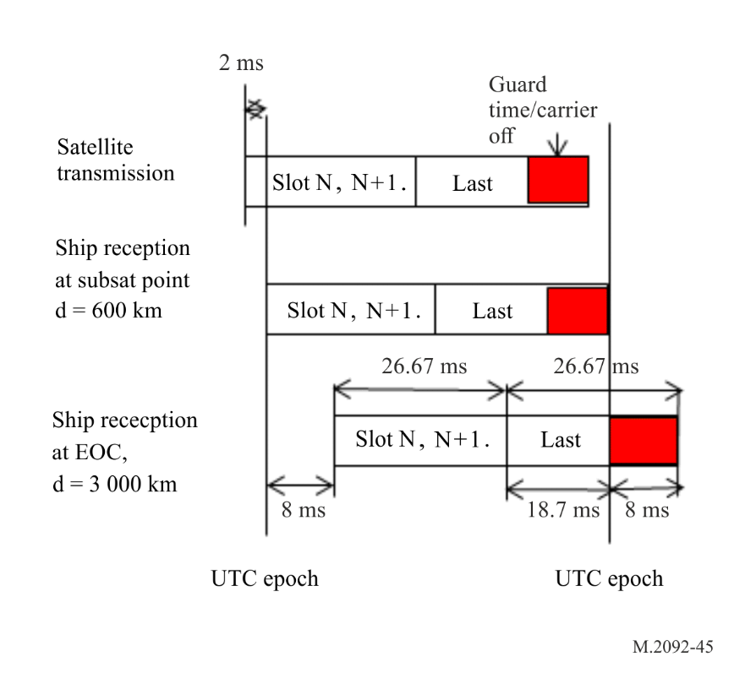
Figure A5-2
VHF data exchange-satellite uplink timing
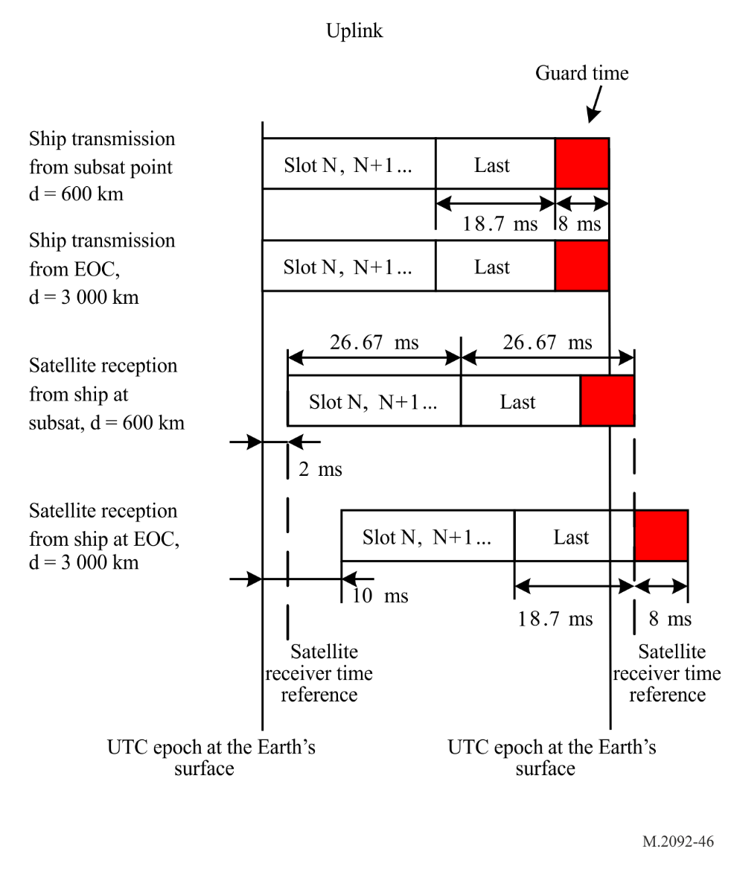

A5-2.1.2 Satellite transmission carrier frequency error
The transmit carrier frequency error at the satellite shall be less than 1 ppm, i.e. ±160 Hz.
A LEO satellite will move at a speed of about 8 km/s and this will cause a maximum Doppler of ±4 kHz at VHF.

A5-2.1.3 Ship station transmitter requirements
For ship station transmitter requirements, see Annex 2.

A5-2.1.4 Ship station antenna gain
For ship station antenna gain, see Annex 2.

A5-2.1.5 Ship station noise plus interference level
For noise plus interference level of ship station, see Annex 2.

A5-2.1.6 Satellite antenna characteristics
A circularly polarized Yagi antenna, comprised of three elements, is used as an example for the satellite antenna. Figure A5-3 shows how the main lobe of Yagi antenna is pointed towards the horizon of the earth. The thin solid line indicates the field of view from the satellite, but the communications coverage area will be limited to the area within the main lobe of the Yagi antenna. Most of the satellite coverage area and visibility time will be at low elevation angles, and high elevation angle coverage may be sacrificed without significant system capacity loss. Assuming a peak antenna gain of 8 dBi, satellite antenna gain versus ship elevation angle and nadir offset angle are shown in Table A5-1. It is the responsibility of the VDE-SAT satellite operator to ensure that the pointing of the antenna and the e.i.r.p. are set in a manner which keeps the VDE-SAT downlink emissions within the pfd-mask limit specified in § A1-2.1 when above areas with VDE-TER coverage.
Figure A5-3
Illustration showing how the Yagi antenna and its main lobe is pointed towards the horizon of the earth
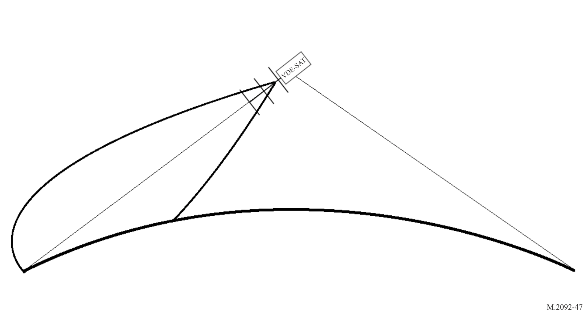
Table A5-1
Satellite antenna gain versus ship elevation angle, nadir offset angle and boresight offset angle
Ship elevation angle  (degree) | Nadir offset angle  (degree) | Boresight offset angle  (degree) | Satellite antenna gain  (dBi)
0 | 66.1 | 0 | 8
10 | 64.2 | 1.9 | 8
20 | 59.2 | 6.9 | 8
30 | 52.3 | 13.8 | 7.8
40 | 44.4 | 21.7 | 6.9
50 | 36 | 30.1 | 5.5
60 | 27.2 | 38.9 | 3.6
70 | 18.2 | 47.9 | 0.7
80 | 9.1 | 57 | −2.2
90 | 0 | 66.1 | −5.5

A5-2.2 Technical characteristics of the VHF data exchange-satellite component downlink
This section outlines the technical characteristics, key parameters and typical link budgets for the VDE-SAT downlink.

A5-2.2.1 Satellite downlink equivalent isotropic radiated power
A pfd-mask to ensure interoperability and compatibility between VDE-TER and VDE-SAT is specified in § A1-2.1.
Table A5-2 shows the theoretical maximum satellite e.i.r.p. as a function of elevation angles for this mask.
Table A5-2
Maximum satellite maximum effective isotropic radiated power as
a function of elevation angle
Ship elevation angle θ  (degrees) | pfd-mask on ground  (dB(W/(m²· 4 kHz))) | Satellite range  (km) | Inverse squared distance  (dB) | pfd-mask at satellite antenna  (dB(W/(m²· 4 kHz))) | Maximum satellite e.i.r.p.
 |  |  |  |  | dBW/4 kHz | dBW/50 kHz | dBW/100 kHz | dBW/150 kHz
0 | −149.0 | 2 829 | −129.0 | −20.0 | −9.0 | 2.0 | 5.0 | 6.8
10 | −147.4 | 1 932 | −125.7 | −21.7 | −10.7 | 0.3 | 3.3 | 5.1
20 | −145.8 | 1 392 | −122.9 | −22.9 | −11.9 | −1.0 | 2.0 | 3.8
30 | −144.2 | 1 075 | −120.6 | −23.6 | −12.6 | −1.6 | 1.4 | 3.2
40 | −142.6 | 882 | −118.9 | −23.7 | −12.7 | −1.7 | 1.3 | 3.0
50 | −139.4 | 761 | −117.6 | −21.7 | −10.7 | 0.2 | 3.2 | 5.0
60 | −134.0 | 683 | −116.7 | −17.3 | −6.3 | 4.7 | 7.7 | 9.4
70 | −133.0 | 635 | −116.1 | −16.9 | −6.0 | 5.0 | 8.0 | 9.8
80 | −132.0 | 608 | −115.7 | −16.3 | −5.3 | 5.6 | 8.7 | 10.4
90 | −131.0 | 600 | −115.6 | −15.4 | −4.4 | 6.5 | 9.5 | 11.3

The maximum achievable satellite e.i.r.p. depends on the antenna on-board the satellite, and how well the antenna pattern can be made to fit the theoretical maximum satellite e.i.r.p. mask.
With the satellite antenna described in § A5-2.1.6, which has a peak antenna gain of 8 dBi, a transmit RF power of −9.4 dBW in 50 kHz will ensure compliance with the pfd-mask in defined in § 2.1, Annex 1. Satellite e.i.r.p. and resulting margin to the pfd-mask as a function of ship elevation is shown in Table A5-3.
Table A5-3
Satellite effective isotropic radiated power and margin to the power flux-density mask
as a function of vs elevation angle
Ship elevation angle  (degrees) | Satellite antenna gain  (dBi) | Satellite e.i.r.p. in circular polarization  (dBW/50 kHz) | Margin to maximum satellite e.i.r.p. i.e. margin to the pfd mask (dB)
0 | 8 | −1.4 | 3.4
10 | 8 | −1.4 | 1.7
20 | 8 | −1.4 | 0.4
30 | 7.8 | −1.6 | 0.0
40 | 6.9 | −2.5 | 0.8
50 | 5.5 | −3.9 | 4.1
60 | 3.6 | −5.8 | 10.5
70 | 0.7 | −8.7 | 13.7
80 | −2.2 | −11.6 | 17.2
90 | −5.5 | −14.9 | 21.4

A5-2.2.2 VHF data exchange-satellite component downlink receiver thresholds
The VDES maximizes frequency efficiency by using adaptive coding and modulation based on the actual link quality. Initial system access is done using a combination of spread spectrum, low bit rate and powerful FEC. The VDE-SAT uses the waveforms defined in Annex 2. The thresholds C/N₀ on a Gaussian channel have been estimated.

A5-2.2.3 VHF data exchange-satellite component downlink link budget
The nominal signal level C/N₀ and C/(N₀ + I₀) for the VDE-SAT downlink as a function of elevation angle for a 50 kHz channel are provided in Table A5-4 for the satellite antenna described in § A5-2.1.6. In a 50 kHz channel a signal bandwidth of 42 kHz can be used, which allow a satellite transmitter RF output power of −10.2 dBW. A transmission frequency of 161.912 5 MHz is used in the calculation of path loss. The ship antenna maximum gain is 3 dBi and the system noise temperature is 30.2 dBK as shown in Annex 2. The noise density level (N₀) will then be −168.4 dBm/Hz. On board ships there can be additional noise and interference sources which can raise the noise plus interference level (N+I) up to −114.0 dBm in a 50 kHz channel, as documented in IEC 61993. This corresponds to a noise plus interference density level (N₀+I₀) of −161 dBm/Hz.
The link budget shown in Table A5-4 is theoretical and does not take into account propagation effects such as multi-path which is documented in § 3.1 of Report ITU-R M.2435-0.
Table A5-4
VHF data exchange-satellite component downlink budget as function of elevation angle
Ship elevation angle  (degrees) | Satellite e.i.r.p. in circular polarization  (dBW) | Satellite range  (km) | Path loss  (dB) | Polarization loss  (dB) | Ship antenna gain  (dBi) | Carrier level at LNA  (dBm in 50 kHz) | C/N₀  (dBHz) | C/(N₀+I₀)  (dBHz)
0 | −2.2 | 2 829 | 145.7 | 3 | 3 | −117.8 | 50.5 | 43.2
10 | −2.2 | 1 932 | 142.4 | 3 | 3 | −114.5 | 53.8 | 46.5
20 | −2.2 | 1 392 | 139.5 | 3 | 2.5 | −112.2 | 56.2 | 48.8
30 | −2.4 | 1 075 | 137.3 | 3 | 1 | −111.6 | 56.7 | 49.4
40 | −3.3 | 882 | 135.5 | 3 | 0 | −111.8 | 56.5 | 49.2
50 | −4.7 | 761 | 134.3 | 3 | −1.5 | −113.4 | 54.9 | 47.6
60 | −6.6 | 683 | 133.3 | 3 | −3 | −115.9 | 52.5 | 45.1
70 | −9.5 | 635 | 132.7 | 3 | −4 | −119.1 | 49.2 | 41.8
80 | −12.4 | 608 | 132.3 | 3 | −10 | −127.7 | 40.7 | 33.3
90 | −15.7 | 600 | 132.2 | 3 | −20 | −140.9 | 27.5 | 20.1

A5-2.3 Technical characteristics of the VHF data exchange-satellite component uplink
This section outlines the technical characteristics, key parameters and typical link budgets for the VDE-SAT uplink.

A5-2.3.1 VHF data exchange-satellite component uplink receiver thresholds
The VDES maximizes frequency efficiency by using adaptive coding and modulation based on the actual link quality. Initial system access is done using a combination of spread spectrum, low bitrate and powerful FEC. The VDE-SAT uses the waveforms defined in Annex 2. The thresholds C/N₀ and C/(N+I) on a Gaussian channel have been estimated.

A5-2.3.1.1 Satellite system noise temperature
The satellite receiver noise temperature is shown in Table A5-5. The system noise temperature is 25.7 dBK, assuming no external interference.
Table A5-5
Satellite receiver system noise temperature
Antenna noise temperature | 200.0 | K
Feed losses | 1.0 | dB
LNA noise figure | 2.0 | dB
LNA noise temperature | 159.7 | K
Feedloss noise temp. at LNA | 56.1 | K
Antenna noise temp. at LNA | 158.9 | K
System noise temp. at LNA | 374.7 | K
System noise temp. at LNA | 25.7 | dBK
Intrinsic noise power density | −202.9 | dBW/Hz

A5-2.3.1.2 VHF data exchange-satellite component uplink link budget
Table A5-6 provide a link budget for the VDE-SAT uplink as a function of elevation angle for a 50 kHz channel with the satellite antenna described in § A5-2.1.6. In a 50 kHz channel a signal bandwidth of 42 kHz can be used. The ship antenna maximum gain is 3 dBi and the ship terminal output power is 6 W, as provided in Annex 2. Note that the different link configurations available for the VDE-SAT uplink have an average ship terminal output power levels ranging from 6 W to 12.5 W. A transmission frequency of 161.9125 MHz is used in the calculation of path loss. The satellite receiver noise level is −202.9 dBW/Hz as provided in § A5-2.3.2. The link budget in Table A5-6 is theoretical and does not take into account propagation effects such as multi-path, which is documented in § 2.1, Annex 1 of Report ITU-R M.2435-0, or interference from other services operating in the same frequency band.
Table A5-6
VHF data exchange-satellite component uplink link budget
Ship elevation angle  (degree) | Ship antenna gain  (dBi) | Ship e.i.r.p.  (dBW) | Polariza-tion loss  (dB) | Path length  (km) | Path loss  (dB) | Satellite antenna gain  (dBi) | Carrier level at LNA, including feed loss  (dBW) | C/N₀  (dBHz)
0.0 | 3.0 | 10.8 | 3.0 | 2 829 | 145.7 | 8.0 | –130.9 | 72.0
10.0 | 3.0 | 10.8 | 3.0 | 1 932 | 142.4 | 8.0 | –127.6 | 75.3
20.0 | 2.5 | 10.3 | 3.0 | 1 392 | 139.5 | 8.0 | –125.2 | 77.6
30.0 | 1.0 | 8.8 | 3.0 | 1 075 | 137.3 | 7.8 | –124.7 | 78.2
40.0 | 0.0 | 7.8 | 3.0 | 882 | 135.5 | 6.9 | –124.9 | 78.0
50.0 | –1.5 | 6.3 | 3.0 | 761 | 134.3 | 5.5 | –126.5 | 76.4
60.0 | –3.0 | 4.8 | 3.0 | 683 | 133.3 | 3.6 | –128.9 | 73.9
70.0 | –4.0 | 3.8 | 3.0 | 635 | 132.7 | 0.7 | –132.2 | 70.7
80.0 | –10.0 | –2.2 | 3.0 | 608 | 132.3 | –2.2 | –140.7 | 62.1
90.0 | –20.0 | –12.2 | 3.0 | 600 | 132.2 | –5.5 | –153.9 | 48.9

A5-2.4 Bit mapping
For bit mappings, see Annex 2.

A5-2.5 Spreading
Direct sequence spreading with constant envelope is applied for the PL burst format SAT-MCS-1.50-2, identified by Link ID 20. Spreading for the downlink burst waveforms carrying bulletin boards, Link ID 25 and Link ID 32 are achieved by utilising gold sequences of length 2047. A short direct spreading sequence of length four is applied for the downlink burst waveforms defined by Link ID 28 and 29.

A5-2.5.1 Spread spectrum with constant envelope
Direct sequence spreading with constant envelope can be implemented according to the spreading strategy contained in R. Mueller, On Random CDMA with Constant Envelope, IS IT 2011. This provides a way to generate constant envelope signals whilst allowing the use of linear modulations (i.e. BPSK, or QPSK for data modulation). In this approach, the continuous phase modulation (CPM) spreading sequences are selected such that the spread symbols maintain quasi continuous phase even at the transition from one symbol to the next. The CPM spreading principle is provided in Figure A5-4.
Figure A5-4
Continuous phase modulation spreading principle
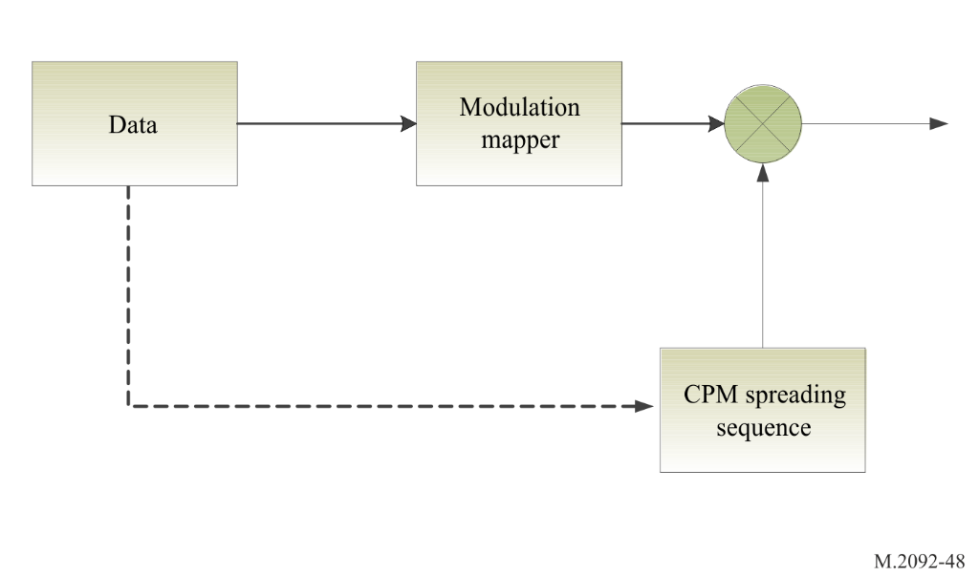
In order to avoid phase discontinuity at the data symbol transitions, the proposed solution is to adapt the spreading sequence according to the modulating data. In other words, the CPM spreading sequence at the edge of each symbol is adapted according to the new input modulating symbol value to avoid, or minimize any phase discontinuity. Such a solution produces a small loss at the receiver as the receiver does not know the edge symbol part of the used CPM spreading sequence. For a spreading factor (SF) of 16 or higher, the resulting correlation loss experienced by the receiver due to this issue is less than 0.25 dB. Performance losses with respect to conventional spreading is thus quite negligible provided that SF = 16 or larger is used.
The CPM spreading sequences are computed and optimized off-line and then stored in the memory of the terminals and receivers. A single spreading code is sufficient for all the users in the system. There is thus no need for storing multiple spreading sequences but just a single spreading sequence.
The stored spreading sequence is then applied starting from the first preamble syncword symbol and continuing in the data part (as shown in Figure A5-5). The generated constant envelope spreading output sequence $y\left(k\right)$ is given by:
$y\left(k\right)=\left\{\begin{matrix}x\left(n\right)∙{cp}_{a}\left(l_{a},p_{a}\left(n\right)\right), \text{for }m<{SL}/2 \\ x\left(n\right)∙{cp}_{e}\left(l_{e},p_{e}\left(n\right)\right), \text{otherwise }\end{matrix}\right.$
where $x\left(n\right)$ represents the QPSK modulated input signal of length $BL$ symbols. Thus, $n∈\left[0,B\left.L-1\right]\right.$. Bit mapping for QPSK modulation is defined by the green points that appear in Figure A2-9 showing the π/4-QPSK constellation. It should be noted that the generated spreading sequence $y\left(k\right)$ is actually partly dependent on the modulation symbols in order to ensure continuity of the signal phase when the modulation symbol changes (Figure A5-4). The spreading sequence to be generated is oversampled by a factor $NS$ relative to the chip rate. The total number of constant envelope output samples then becomes $BS=BL∙SF∙NS$, where one single input QPSK symbol is spread to
$SL=SF∙NS$ output samples. The output sample index $k$ is ranging from $0$ to $BS-1$, and the input symbol index $n$ as function of the output sample index $k$ is related by $n=\left\lfloor k/{SL}\right\rfloor$. Here the floor operator $\left\lfloor u\right\rfloor$ rounds $u$ down to the nearest integer towards minus infinity. Furthermore, two predefined two-dimensional complex valued tables, ${cp}_{a}$ and ${cp}_{e}$, containing optimised constant envelope spreading signature sequences are utilised in the constant envelope spreading process. The table ${cp}_{a}$ is applied for generating the spreading sequence for the first half of an input symbol, while ${cp}_{e}$ is used for the second half, where a half symbol period consists of ${SL}/2$ output samples. The present table to use, either ${cp}_{a}$ or ${cp}_{e}$, is decided by the modulus index value given by
$m=k \% SL=k-SL∙\left\lfloor k/{SL}\right\rfloor =k-SL∙n$, where % defines a modulus operator. The first dimensional, representing sample time, table indexes $l_{a}$ and $l_{e}$ are given by $l_{a}=\left(m+n∙{SL}/2\right) \% TL=\left(k-n∙{SL}/2\right) \% TL$ and $l_{e}=\left(m+\left(n-1\right)∙{SL}/2\right) \% TL=\left(k-\left(n+1\right)∙{SL}/2\right) \% TL$, where $TL$ is the first dimensional size of the ${cp}_{a}$ and ${cp}_{e}$ tables. In this case, the spreading sequence is designed as maximum length, i.e. ${TL=BS}/2$, $l_{a}∈\left[0,\left. {BS}/{2-1}\right]\right.$ and $l_{e}∈\left[0,\left. {BS}/{2-1}\right]\right.$. The modulus $TL$ in the timing index expressions is not needed. The second dimensional table indexes, $p_{a}\left(n\right)$ and $p_{e}\left(n\right)$, depend on $x\left(n\right)$ and are based on differential QPSK symbol quadrant computation. Given the applied Gray-coded QPSK bits-to-symbol mapping definition, the belonging quadrant is given by:
$\text{q=}\left\{\begin{matrix}\begin{matrix}\text{0, for QPSK input bits equal to 11} \\ \text{1, for QPSK input bits equal to 01}\end{matrix} \\ \begin{matrix}\text{2, for QPSK input bits equal to 00} \\ \text{3, for QPSK input bits equal to 10}\end{matrix}\end{matrix}\right.$
and the second dimensional table indexes
$p_{a}\left(n\right)=\left\{\begin{matrix}0, \text{ for }n=0 \\ \left(q\left(n\right)-q\left(n-1\right)\right) \% 4,\text{ for }n>0\end{matrix}\right.$
and
$p_{e}\left(n\right)=\left\{\begin{matrix}\left(q\left(n+1\right)-q\left(n\right)\right) \% 4, \text{for }n<BL-1 \\ 0,\text{ for }n=BL-1\end{matrix}\right.$
As the differential phase table indexes $p_{a}\left(n\right)$ and $p_{e}\left(n\right)∈\left[0,\left.3\right]\right.$, the overall size of the ${cp}_{a}$ and the ${cp}_{e}$ tables becomes ${BS}/{2×4}$, thus containing $2∙BS$ complex valued constant envelope values.
The specified constant envelope spreading scheme is at present only applicable for the SAT-MCS-1.50-2 PL burst format, with Link ID equal to 20, for which $BL=261$ and $SF=16$. The signature spreading sequences are optimised for an oversampling factor $NS$=16, and the ${cp}_{a}$ signature table is stored in the ASCII file “cpa_SF16_NS16_BL261_r1.txt”, and the ${cp}_{e}$ table is stored in the file “cpe_SF16_NS16_BL261_r1.txt” . The table entities within the files are oriented in ${BS}/2$ rows and 4 columns. The row number thus directly related to the first dimensional table indexes, $l_{a}$ and $l_{e}$. Each of the complex values cp() can be represented as a phasor with amplitude and angle. The ASCII file contains the angle values (as radian) of the phasor with unity amplitude. The full relationship between a loaded ASCII file table, T[ ], and a signature table cp ( ) becomes:
cpl,p=cos (Tl+1, 2p+1)+j∙sin (Tl+1, 2p+21)
where $j=\sqrt{-1}$ and the row and column of T[ ] are assumed counted from one.
Even if the signature sequences are optimised for $NS$=16, appropriate constant envelope spreading sequences for $NS$=8 and $NS$=4 can be generated by decimating the signature spreading tables in time, i.e. along the first dimensional table index, by a decimation factor equal to 2 or 4 correspondingly.
Figure A5-5
Proposed spreading in the continuous phase modulation
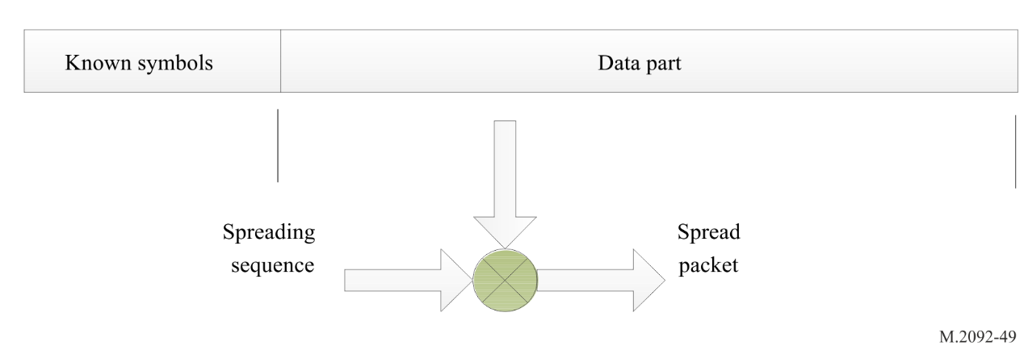

A5-2.5.2 Direct sequence spreading for downlink waveforms
The waveform used for the bulletin board should allow for detection of overlapping signals received from two satellites. Two Gold spreading code sequences named SS0 and SS1 are selected to reduce the cross-correlation between delayed and frequency shifted versions of the overlapping waveforms. SS0 and SS1 is shown as byte oriented hexadecimal text strings in Table A5-7. The first byte, bit sequence “00000100” for spreading sequence SS0, is used to spread the very first syncword bit of the burst into 8 chips. The MSB of the bit sequence is to be transmitted first. The next byte, bit sequence “01100001” for SS0, is then used to spread the second bit of the burst. The spreading process making the chip sequence to transmit is further achieved by XORing between each burst bit and the 8 by 8 spreading sequence bits. As the length of the Gold spreading sequences is limited to 2047, only the 7 MSBs of the last Gold spreading sequence byte is utilised, i.e. “0101101” for byte 0x5A and “0001111” for byte 0x1E. Furthermore, spreading is based on periodic repetition of the spreading sequence, such that when reaching the end of the actual Gold sequence, the 8 bits sequence to utilise for spreading will consist of the 7 MSBs of the last Gold sequence byte appending the MSB of the first byte. Due to this bit shift, the 8 by 8 bits spreading sequences obtained after repetition will not be equal to the original 8 by 8 spreading sequences.
The chip bit sequence is mapped into values by ordinary BPSK bit to symbol mapping.
Table A5-7
Gold spreading sequences
Name | Spreading sequence
SS0 | 04-61-4F-29-8E-A3-63-13-B4-81-44-3D-35-C9-BC-DF-06-05-D3-3E-A3-13-DE-DA-C9-37-F6-C0-2D-5A-81-B7-ED-4B-43-77-31-0D-DF-99-1C-49-E1-71-31-C1-12-30-58-9E-80-9E-AC-E7-83-AB-D8-9A-AD-24-56-89-BB-C2-37-EA-DB-49-F8-4D-80-B9-2C-E3-F1-98-1C-86-06-45-4C-31-25-68-6A-3F-1F-9B-62-CC-2D-42-4B-E1-9F-2C-0F-F0-84-4F-31-3C-B4-40-05-B6-FD-D2-D4-E8-63-A9-56-62-B6-08-80-DA-DD-07-AA-37-76-C7-8A-81-81-BD-95-31-79-E4-0D-EB-92-8C-A4-D1-A6-FF-45-47-C7-F9-09-D1-D2-2C-46-02-B1-B5-B2-83-6B-57-D0-BF-C3-4C-D6-2A-26-0A-EB-C1-D8-58-49-0A-FB-CF-DA-62-FD-41-60-FD-F7-0F-A2-8E-A4-90-B0-AD-37-FD-2E-E4-2B-75-E6-46-63-AB-FA-55-24-3D-93-CF-4E-72-CE-02-38-B7-77-95-97-30-86-7E-24-2E-80-81-C2-97-26-32-2A-71-90-CB-36-79-17-A5-D4-49-36-04-21-5F-1E-54-A2-88-D6-62-AD-E0-47-61-A7-89-ED-81-34-88-1A-D0-BE-5A
SS1 | 41-0B-57-66-A0-D1-94-36-C2-94-8C-60-10-FF-81-06-51-84-E3-80-EB-FE-B5-C2-26-5D-AE-A7-12-22-D2-94-18-CF-31-C0-3C-6A-C0-F5-47-EF-46-F6-02-BE-C2-22-53-DA-4A-62-8D-73-7B-48-B5-41-FB-E5-EE-62-D3-1B-40-7F-E3-72-E2-A3-AA-69-1E-FC-BD-D7-B2-A4-D3-75-72-29-EA-16-3A-DD-72-E0-70-27-05-B3-2D-7E-03-11-96-8F-14-75-2B-72-DA-BA-A7-B3-BF-DB-91-62-17-DD-E2-AE-49-E8-8C-DD-5E-36-54-F7-CE-8C-A6-72-66-32-A3-4C-88-A2-86-7F-2A-47-D8-00-54-38-7E-3D-15-CA-56-15-C8-A2-50-CB-0C-5C-FB-0E-9C-12-9A-B3-84-E7-F6-DE-42-B4-23-7C-91-55-EE-6D-A4-8B-90-CE-FE-C0-D0-13-9D-F7-81-9B-4C-D9-9D-1E-58-27-38-AD-C6-BE-BA-83-99-E9-93-2C-B7-C6-11-7E-40-D4-49-91-03-4D-F5-84-DD-BC-91-F7-11-92-E9-38-29-5F-BB-6F-2F-53-A5-97-33-FB-66-D3-41-D1-49-34-5F-6F-C0-20-56-6C-38-88-05-E1-47-C1-E3-A3-7D-9B-3A-CE-F1-78-1F-1E

The direct spreading sequence “0010” is applied for the downlink burst waveforms identified by link ID 28 and 29. This sequence has excellent auto-correlation property. The first bit of the burst is spread by “00”, the second by “10”, and then the third again by “00” as the spreading sequence are periodically repeated. XORing is performed between burst bits and 2 by 2 spreading sequence bits, and the resulting chip sequence is mapped into values by ordinary BPSK bit to symbol mapping.

A5-2.6 Baseband shaping and quadrature modulation
For baseband shaping of symbols, see Annex 2.

A5-2.7 Transmission timing accuracy
For transmission accuracy figures, see Annex 2.

A5-2.8 Half duplex and full duplex satellites
The system can be configured for both half and full duplex satellites as shown in Figure A5-6.
Figure A5-6
Half-duplex and full duplex satellite operation
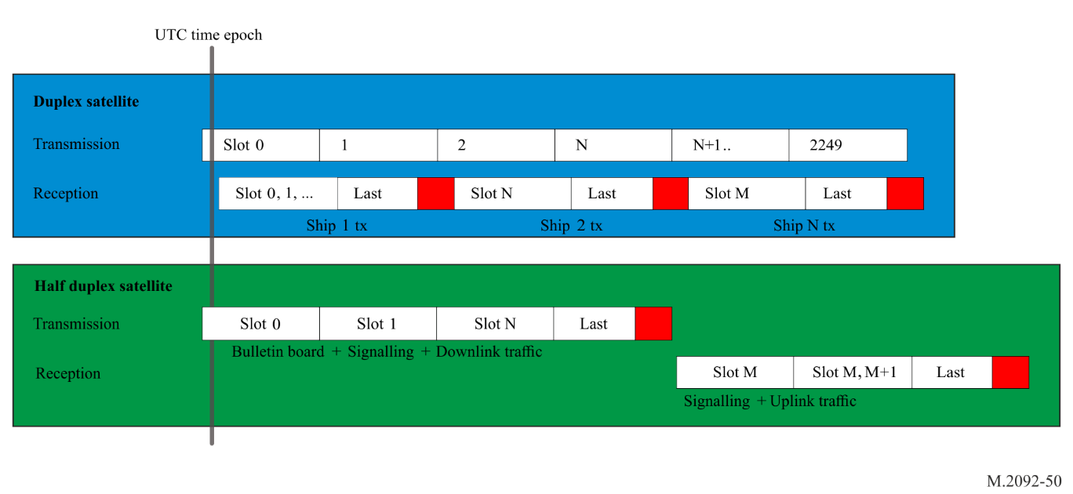

A5-2.9 Frame structure
For frame and transmission burst structure, see Annex 2.

A5-2.10 Pilots and syncword symbol location and modulation
Pilot symbols are utilised for some of the VDE-SAT uplink and downlink PL burst waveforms. A pilot symbol is a single symbol with unity power mapped to the constellation point $\frac{\left(1+j\right)}{\sqrt{2}}$. For waveforms utilising direct sequence spreading, the pilot symbols shall have a bit value of “1” before spreading. After spreading, the pilot symbols will utilise the same modulation as the rest of the waveform. A generalized burst structure containing both uniformly repetitive syncword and regularly distributed single pilot symbols is visualised in Figure A5-7.
Figure A5-7
General PL burst structure with repetitive sync word and distributed single pilot symbols
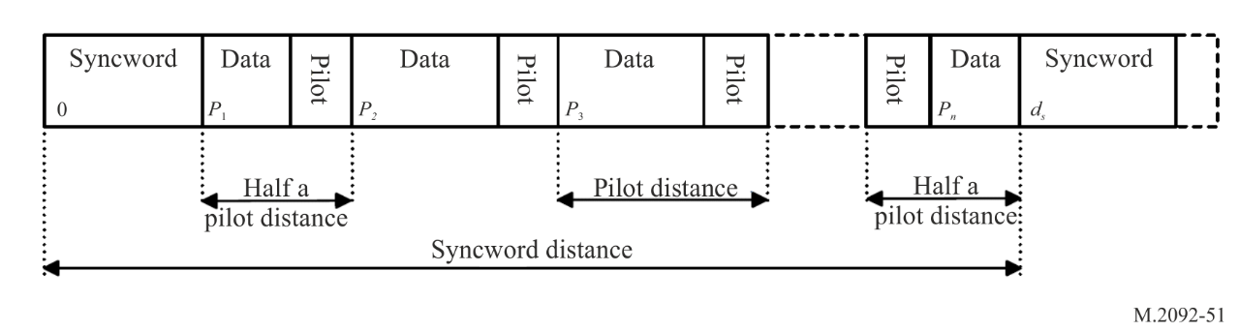
Single pilot symbols are regularly distributed over the burst, and the position of each pilot symbol is defined by the pilot distance, denoted by $d_{p}.$ When $d_{p}$ is an even number, ${\left(1+d_{p}\right)}/2$ is rounded down to the nearest integer, towards minus infinity. The very first pilot symbol in the burst is located (1 + 𝑑_{𝑝})⁄2 symbols after the last symbol of the preceding training sequence (syncword). P1 in Figure A5-7 is the first symbol position of data following a preamble syncword, which equals the syncword size denoted by 𝑆𝑠. The first pilot symbol is located at (P₂ − 1), which equals (𝑆_{𝑠} +(𝑑_{𝑝} − 1)⁄2). And the next pilot symbol at position (P₃ − 1), which equals (𝑆_{𝑠} +(3𝑑_{𝑝} − 1)⁄2). For VDE-SAT downlink, uniformly repeated syncwords are utilised for synchronisation purpose as shown in Figure A5-7. The bit pattern sequence of a repeated syncword is equal to the preamble training sequence, as defined for VDE-SAT in Table A2-1. The location of the uniformly repeated syncwords are given by the syncword distance, defined as the distance between the first symbol of two subsequently syncwords, denoted by 𝑑𝑠. Counting from zero, the first symbol of the preamble syncword and the first repeated syncword in such a burst waveform is thus located at position 0 and 𝑑𝑠, correspondingly. The last pilot symbol preceding the first repeated syncword is located at (P_{n} − 1), which equals (𝑑_{𝑠} − (1 + 𝑑_{𝑝})⁄2). Varying number of symbols are following the last syncword and the last single pilot symbol for different PL formats. Some PL burst waveform formats have no symbols after the last syncword.
For the VDE-SAT downlink PL format SAT-MCS-1.50-1 and SAT-MCS-3.50-1, both the syncword size and the pilot distance is 27 symbols, and the syncword distance is 2268 symbols. The last preamble syncword symbol is thus located at position 26, the first pilot symbol at position 40, and the next pilot symbol at position 67. The location of the last pilot symbol preceding the first repeated syncword becomes 2254, and the first repeated syncword symbol is located at position 2268. For both these PL burst waveform formats, the last syncword is followed by 3204 symbols, including single pilot symbols. The last single pilot symbol is followed by 31 symbols.
For PL burst waveform applying π/4-QPSK, 8-PSK and 16-QAM modulation, the syncword is π/4 QPSK modulated. Odd symbol position indexes are then mapped to symbol constellation points that are phase offset by +45 degree from the nominal QPSK symbol constellation points used for even symbol position indexes. This even and odd position indexes toggling rule, as described in § A2-1.2.9, and visualised in Figure A2-9, shall also be applied for the uniformly repeated syncword. This rule results in two different syncword modulation signal patterns for these particular PL burst waveforms when the syncword distance is an even number of symbols.
For π/4 QPSK modulated PL burst waveforms, single pilot symbols located at odd symbol position indexes are phase offset by π/4 from the nominal QPSK symbol constellation points as all other odd symbol positioned symbols in the actual burst.

A5-2.11 Forward error correction and interleaving
For forward error correction and interleaving, see Annex 2.

A5-2.12 VHF data exchange-satellite link configuration formats
For link configurations available for the VDE-SAT uplink and downlink, see Annex 2.

A5-2.13 VHF data exchange-satellite downlink block channel interleaver
A block channel interleaver is required on the VDE-SAT downlink to reduce the impact of short blockage on the channel (for example due to the AIS transmission from the vessel or fast fading events). The channel interleaver at the transmitter side is applied to the coded and scrambled data bits at the output of the bit scrambler, before possible adding of burst stuffing bits.
The channel interleaver is essentially randomly rearranging the scrambled bits. At the receiver side, the channel de-interleaver is performing the reverse operation. In the following, the channel interleaver is specified.
Blocks of scrambled data bits of length L are written by row into a M × N matrix and read out by column after accomplished first row and then column permutations. The row and column permutations are given by:
p_{r}(m) = 1 + (A_{r}·m + C_{r}(n)) mod M, for m = 1 to M, where C_{r}(n) = (B_{r}·n – 1) mod M, for n = 1 to N
p_{c}(n) = 1 + (A_{c}·n + C_{c}(m)) mod N, for n = 1 to N, where C_{c}(m) = (B_{c}·m – 1) mod N, for m = 1 to M.
The interleaver is relocating the bit appearing at row p_{r}(m) to row m, and a bit appearing at column p_{c}(n) is relocated to column n.
As the burst length and the total number of bits to interleave are large for the burst waveforms identified by link config ID (LCID) 26-29, interleaving for these waveforms is split in either four or five smaller interleaver blocks, IB. The interleaver length L times the number of interleaver blocks IB match the number of “channel bits” as given in Table A2-9 and Table A2-10 (located in {RD2}).
The permutation parameters A_{r}, B_{r}, A_{c} and B_{c} and other interleaver parameters for the VDE-SAT downlink burst waveforms are specified in Table A5-8.
Table A5-8
Channel interleaver parameters for VHF data exchange-satellite downlink burst waveforms
PL format | SAT-MCS-0.50-1 | SAT-MCS-1.50-1 | SAT-MCS-3.50-1 | SAT-MCS-0.100 | SAT-MCS-0.150 | SAT-MCS-0.50-2 | SAT-MCS-0.50-3 | SAT-MCS-1.50-2
LCID | 25 | 26 | 27 | 28 | 29 | 32 | 33 | 34
M | 14 | 257 | 503 | 16 | 132 | 27 | 857 | 128
N | 683 | 119 | 114 | 1321 | 202 | 47 | 15 | 195
L | 9562 | 30583 | 57342 | 21136 | 26664 | 1269 | 12855 | 24960
IB | 1 | 5 | 4 | 4 | 5 | 1 | 1 | 1
A_{r} | 5 | 127 | 251 | 7 | 61 | 13 | 421 | 51
B_{r} | 3 | 107 | 223 | 13 | 31 | 17 | 367 | 89
A_{c} | 337 | 59 | 53 | 659 | 97 | 23 | 7 | 97
B_{c} | 71 | 41 | 11 | 59 | 59 | 13 | 3 | 19

A5-3 Link layer

A5-3.1 Link layer definitions

A5-3.1.1 Physical channel
A physical channel is defined by a frequency and bandwidth.

A5-3.1.2 Channel pair
A channel pair is a combination of two physical channels that are used together.

A5-3.1.3 Logical channel
Logical channels define functions for a set of continuous slots.

A5-3.1.4 VHF data exchange slotmap
A VDE slotmap is defined for each channel pair, defining the logical channel configuration over a 2250 slot frame.
A VDE-SAT sub-frame is defined as one set of logical channels, see Figure A5-9.

A5-3.1.5 Bulletin board
The bulletin board message is sent by the satellite to define six channels pairs, each with its associated VDE slotmap.

A5-3.1.6 Short data message
The short data message refers to the data transfer protocol used for transmission of the payload in a single burst on RAC or ASC channel.

A5-3.1.7 Data session
A VDE-SAT data session is a managed data transfer using assigned resources. A data session is uniquely identified by a source, destination MMSI combination and Session ID.
A VDE-SAT data session starts with a start fragment and ends with the last transmitted fragment; the last fragment normally is the end fragment; however, retransmissions and applicable timeouts can make any retransmitted fragment the last fragment; a session can span over multiple, and changing DC assignments, and over multiple VDE-SAT sub-frames.

A5-3.1.8 Data fragment
During a data session, the data may be broken into multiple data fragments to be transmitted in separate bursts. The data fragments refer to the start fragment, continuation fragment and end fragment VDE messages. See § A5-3.10.7 to § A5-3.10.9.

A5-3.1.9 Satellite identification and network identifications
Each satellite has a unique satellite ID.
Multiple satellites can be associated as a network of satellites. Each VDE-SAT network, associated with an operator, is assigned a primary network ID (see § A5-3.10.2).
NOTE – This allows VDE-SAT terminals to choose using satellites from one or multiple specific primary network IDs.
Multiple satellite networks can be combined to represent a roaming network. Each roaming network is assigned a roaming network ID (see § A5-3.10.2).
NOTE – This allows VDE-SAT terminals to choose using satellites from one or multiple specific roaming network IDs.

A5-3.1.10 Paging
The satellite may utilise paging to query if a ship station is in range and what its terminal capabilities are.

A5-3.1.11 End delivery notification
End delivery notification is an optional message utilised by the application layer to indicate that data was delivered to the end destination on the application level.

A5-3.2 Resource management
The downlink data session connection between ship and satellite is session oriented with one or multiple a data LCs and the corresponding DSCH LC being assigned to a station in the ASC resource allocation message at the beginning of each VDE-SAT sub-frame.
To request an uplink data session, a ship station sends a resource request message to the satellite on the RAC, which is answered by the satellite with a resource allocation message on the ASC, giving the ship station permission to transmit uplink fragments for that session in one or multiple uplink LCs. This resource allocation to a ship station is valid for the current VDE-SAT sub-frame. The satellite indicates the ongoing reservation of subsequent uplink resources to the ship by using the resource reallocation field of the uplink ACK message, or a new resource allocation for this session. The ship shall stop transmission if the resource reallocation is zero, or the LC resources are allocated to another session and/or ship.
Ship originated short data messages can be sent on the RAC without resource allocation.
Satellite originated short data messages can be sent on the ASC without resource allocations.
During heavy network loading, the satellite may increase the selection interval for random access or modify the maximum allowed number of ships originated short data messages. This is done using the MAC message.

A5-3.3 Endianness
See § A4-4.5.

A5-3.4 Data structures
See § A4-4.6.

A5-3.5 Slot functions

A5-3.5.1 Satellite bulletin board signalling channel
The downlink satellite BBSC is used for resource configuration of satellite information, frequencies, timeslots and logical channels. All ships should always listen to all BBSC channels. Link ID 32 should always be used.

A5-3.5.2 Announcement signalling channel
The downlink ASC is used for media access control, paging, resource allocation, data broadcast. All ships should listen to all ASC channels. Link ID 32 should always be used.

A5-3.5.3 Data acknowledgement signalling channel
The DSCH is used for acknowledgments of downlink data. Link ID 20 should always be used on this uplink channel.

A5-3.5.4 Random access channel
The uplink RAC is used for resource request, paging response and short data messages. Link ID 20 should always be used by default. If the satellite also supports additional Link IDs (as indicated in the Media Access Control message), short data messages may be transmitted with the additional Link IDs.

A5-3.5.5 Data up or down channel
The DC is used for data uplink or downlink. The Link ID is assigned by the resource allocation message.

A5-3.5.6 Empty channel
As overlapping bandwidths are feasible, by assigning a channel as not used, it can indicate when a channel should not interfere with other channels.

A5-3.6 Guard slot
When the satellite switches from uplink to downlink (see § A5-2.1.1), one slot is lost before the change-over. During the bulletin board logical channel slot size assignment, one additional guard slot should automatically be added to the Slotmap by each ship under any of the following conditions, as illustrated in Figure A5-8:
1 When a slot function change from uplink to downlink.
2 When a slot function changes from uplink to a slot function that can be used for both uplink or downlink.
3 When a slot function changes from a slot function that can be used for both uplink or downlink to downlink.
Figure A5-8
Use of guard slot
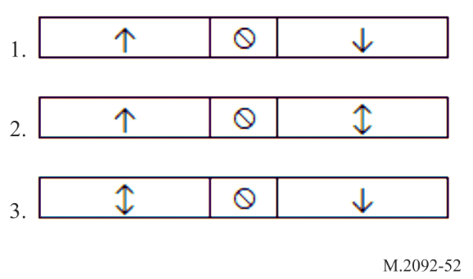
If any of the above conditions are met, one guard slot should be added to the logical channel slot size before the change-over condition. For each guard slot added, a slot should be removed from another logical channel to allow all the slots to fit into a frame of 2 250 slots. Remove slots as follows:
– If the slot function before the change-over event is RAC, remove the last slot from that RAC logical channel.
– Otherwise remove the slot from the next RAC logical channel.
To minimise the required amount of guard slots, any slot functions used for both uplink and downlink should always be used for downlink first, before switching over to uplink. This rule will ensure that if a slot is lost due to the Satellite switching from uplink to downlink, then the lost slot will always fall inside a guard slot and not inside the logical channel.

A5-3.7 VHF data exchange-satellite default bulletin board
The default VDE-SAT bulletin board defines six channel pairs, labelled A to F, each with an associated VDE slotmap. The default channel pairs have been defined to support the frequencies and bandwidths allocated for VDE-SAT services, as detailed in Table A5-9.
Table A5-9
Default VHF data exchange-satellite channel pairs
Channel pair | Uplink |  |  |  |  |  |  | Downlink
Channel pair | Channel |  |  | Frequency  (MHz) |  | Bandwidth  (kHz) |  | Channel |  |  |  | Frequency  (MHz) |  | Bandwidth  (kHz)
A | 1226: (1026 + 1086) |  |  | 157.3125 |  | 50 |  | 2226: (2026 + 2086) |  |  |  | 161.9125 |  | 50
B | 2226: (2026 + 2086) |  |  | 161.9125 |  | 50 |  | 1226: (1026 + 1086) |  |  |  | 157.3125 |  | 50
C | 1225: (1025 + 1085) |  |  | 157.2625 |  | 50 |  | 2284: (2024 + 2084 + 2025 + 2085) |  |  |  | 161.8375 |  | 100
D | 2225: (2025 + 2085) |  |  | 161.8625 |  | 50 |  | 1284: (1024 + 1084 + 1025 + 1085) |  |  |  | 157.2375 |  | 100
E | 1224: (1024 + 1084) |  |  | 157.2125 |  | 50 |  | 2225: (2024 + 2084 + 2025 + 2085 + 2026 + 2086) |  |  |  | 161.8625 |  | 150
F | 2224: (2024 + 2084) |  |  | 161.8125 |  | 50 |  | 1225: (1024 + 1084 + 1025 + 1085 + 1026 + 1086) |  |  |  | 157.2625 |  | 150
 | Lower band |  |  |  |  |  |  | Upper band
Channel No. | 1024 | 1084 | 1025 | 1085 | 1026 |  | 1086 |  | 2024 | 2084 | 2025 | 2085 | 2026 |  | 2086
Uplink | E |  | C |  | A |  |  |  | F |  | D |  | B
Downlink | D |  |  |  | B |  |  |  | C |  |  |  | A
Downlink | F |  |  |  |  |  |  |  | E

The VDE slotmap for channel pairs A and B are illustrated in Figure A5-9. These slot maps contain the BBSC and ASC channels, as the channel pair is assigned to the 50 kHz physical channels, 2026 / 2086 or 1026 / 1086.
Figure A5-9
VHF data exchange-satellite slotmap for channel pair A and B
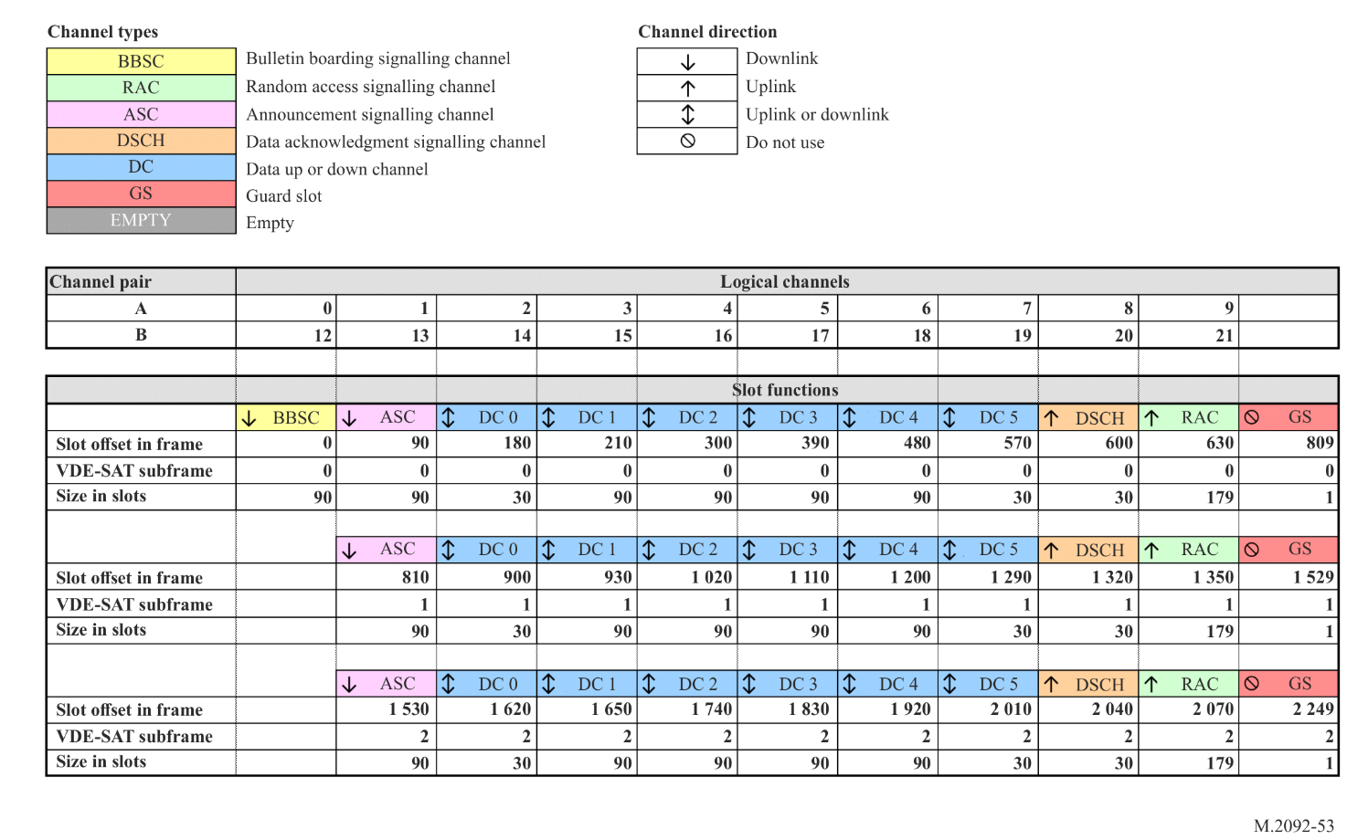
The slotmap for the remaining channel pairs C to F are illustrated in Figure A5-10. Note that the first two logical channels are marked as not used, as these would overlap with SBB and resource allocation messages.
Figure A5-10
VHF data exchange-satellite slotmap for channel pair C to F
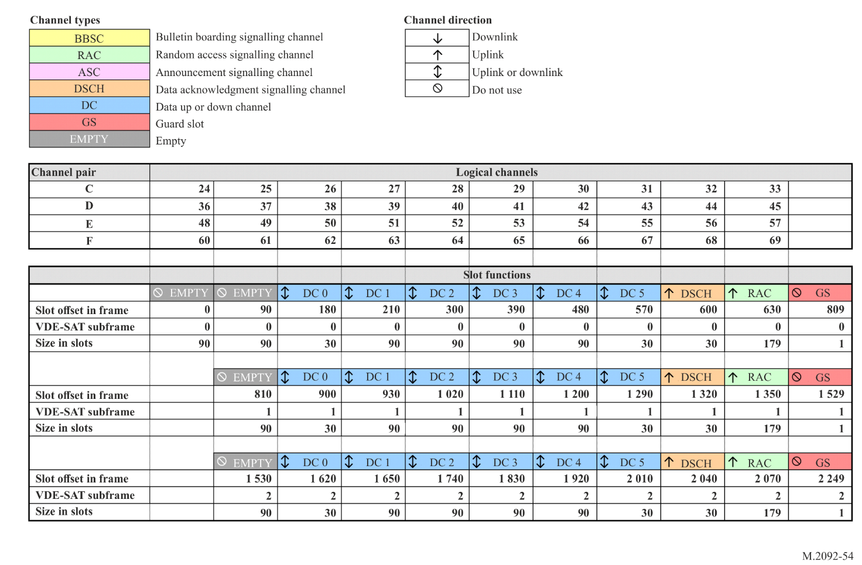

A5-3.8 Use of the data acknowledgement signalling channel
The DSCH is divided into sub-channels, where each sub-channel supports the acknowledgement of a specific DC (see Figure A5-11). When the satellite transmits large data messages to a ship on an assigned DC, these are divided into fragments that are selectively acknowledged on a dedicated uplink DSCH sub-channel. There is one DSCH sub-channel for each downlink DC. For the default SBB, 30 slots are allocated to this every 20 s. The ACK for DC 0 is transmitted in the first five slots (starting at slot 600 using the 5 slot link ID 20), the ACK for DC 1 to 5 are transmitted in the consecutive DSCH sub-channels.
Note that the number of available DSCH sub-channel should always match the number of DC. DC direction is given in the assignment message, uplink data transfers use the upper DC (e.g. DC 5) to group downlink and uplink DCs to minimise the number of guard slots.
Figure A5-11
Mapping of DSCH sub-channels
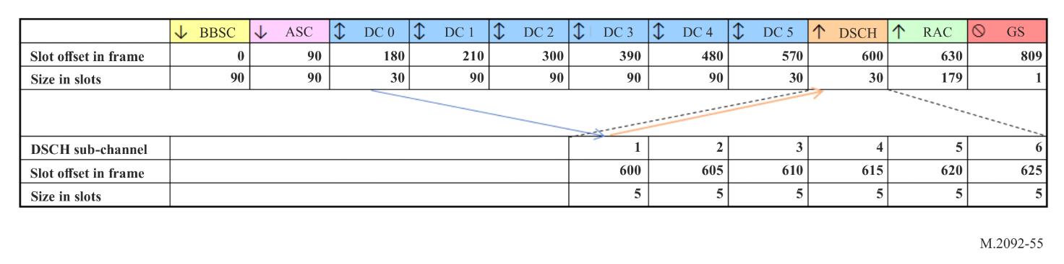

A5-3.9 VHF data exchange-satellite message summary
Table A5-10
VHF data exchange-satellite message summary
Type | Name | Description | Slot function
1 | Satellite Bulletin Board 1 | Satellite bulletin board fragment 1. | BBSC
2 | Satellite Bulletin Board 2 | Satellite bulletin board fragment 2. | BBSC
3 | Satellite Bulletin Board 3 | Satellite bulletin board fragment 3. | BBSC
4 | Satellite Bulletin Board 4 | Satellite bulletin board fragment 4. | BBSC
5 | Satellite Bulletin Board 5 | Satellite bulletin board fragment 5. | BBSC
6 | Satellite Bulletin Board 6 | Satellite bulletin board fragment 6. | BBSC
10 | Media access control | Changes random access selection interval, max ARQ retries. | BBSC, ASC
11 | Paging | Pages a ship. | ASC
12 | Resource allocation | Allocated LC resource to data session. | ASC
13 | Uplink addressed message acknowledgement | Acknowledgement or negative-acknowledgement of uplink data fragments for addressed messages. | ASC
14 | Downlink short data message (with ACK) | Short data message to ship that requires acknowledgement. | ASC
16 | Downlink short data message (without ACK) | Short data message to ship with no acknowledgement. | ASC
18 | End delivery notification to ship | Message from the application layer to acknowledge that the data was delivered to the end destination on the application layer. | ASC
20 | Resource request | Request resource from ship. | RAC
21 | Paging response | Paging response. | RAC
22 | End Delivery Notification from ship | Message from the application layer to acknowledge that the data was delivered to the end destination on the application layer. | RAC
33 | Uplink short data message (with ACK) | Short data message from ship with acknowledgement. | RAC
23 | Uplink short data message (without ACK) | Short data message from ship with no acknowledgement. | RAC
24, 25, 26, 27, 28 | Uplink short data message (without ACK) | 5 bytes of data to satellite pre-configured destinations. | RAC
29 | Downlink addressed message acknowledgement | Selective acknowledgement of downlink data fragments. | DSCH
30 | Start fragment | Start data fragment of data session. | DC
31 | Continuation fragment | Middle data fragment of data session. | DC
32 | End fragment | Last data fragment of data session. | DC
34 | Uplink short data message Acknowledgement | Acknowledgement of uplink short data messages. | ASC
35 | Padding byte | Byte used for padding. | BBSC, ASC, RAC, DSCH, DC
36 | Downlink short data message Acknowledgement | Acknowledgement of downlink short data messages. | RAC
37 | Variable length uplink short data message (with ACK) | Short data message from ship with acknowledgement with a variable length payload. | RAC
38 | Variable length uplink short data message (without ACK) | Short data message from ship with no acknowledgement with a variable length payload. | RAC

A5-3.10 VHF data exchange-satellite message descriptions

A5-3.10.1 Satellite bulletin board
Table A5-11
Satellite bulletin board (Fragment 1)
Field  No. | Size  (bytes) | Function | Content
1 | 1 | Type | Bulletin Board start fragment 1, network info.  Type = 1.
2 | 1 | Satellite ID | 0-255.
3 | 1 | Primary Network ID | 0-255.
4 | 1 | Roaming Network ID | 0-255.
5 | 2 | SBB Version | Version number of this Bulletin Board.  All valid versions are stored in the ship terminal.
6 | 4 | Start time | UTC start time for this version of the Bulletin Board in number of seconds since 1 January 2000, 00:00:00 UTC.
7 | 2 | Validity duration | Lifetime of this version in number of 1-minute frames.  Up to 45 days.
8 | 1 | Service capabilities | 4 MSB Bitmap.  Recommendation ITU-R M.2092 version compatibility;  1 = M.2092-1;  2 = M.2092-2.  4 LSB service capabilities bitmap.  Bit3: Reserved for future use. Default = 0.  Bit2: Reserved for future use. Default = 0.  Bit1: Reserved for future use. Default = 0.  Bit0: Reserved for future use. Default = 0.
9 | 2 | SBB backup frequency | As defined in Recommendation ITU-R M.1084.
10 | 2 | Max uplink msg size | Maximum message uplink size allowed in kilo Bytes [kB].
11 | 1 | Reserved for future use | Default 0.
12 | 2 | Total message size of all fragments including overflow | SBB total size in bytes.

Table A5-12
Satellite bulletin board (Fragment 2)
Field  No. | Size (bytes) | Function | Content
1 | 1 | Type | Logical Channels 0-23 definition, frequency pairs A and B.  Type = 2.
2 | 2 | Downlink centre frequency A | Identification of centre frequency use channel numbering scheme defined in Recommendation ITU-R M.1084. Channel bandwidth is not according to Recommendation ITU-R M.1084 and is defined in Field No. 4.  Default: 2226: 161.9125 MHz.
3 | 2 | Uplink centre frequency A | Identification of centre frequency use channel numbering scheme defined in Recommendation ITU-R M.1084. Channel bandwidth is not according to Recommendation ITU-R M.1084 and is defined in Field No. 4.  Default: 1226: 157.3125 MHz.
4 | 1 | Downlink and uplink bandwidth A | First 4 bits defines downlink bandwidth.  1: 50 kHz (default).  2: 100 kHz.  3: 150 kHz.  Last 4 bits define uplink bandwidth.  1: 50 kHz (default).  2: 100 kHz.  3: 150 kHz.
5 | 6 | Logical channel slot sizes A | Up to 12 LCs on a frequency pair 1, multiple of 15 slots, 4 bits per LC (max size 15 × 15=225 slots).  Default SBB slot sizes. 90, 90, 30, 90, 90, 90, 90, 30, 30, 180, 0, 0. The slot sizes except SBB are repeated until frame is full (2250 slots).
6 | 6 | Logical channel function A | 4 bits per LCs.  0: BBSC.  1: ASC.  2: DSCH.  3: RAC.  4: DC, Data up or down (Dynamic, given in Resource Allocation message).  5: Empty.  Default: 0, 1, 4, 4, 4, 4, 4, 4, 2, 3, 5, 5.
7 | 2 | Downlink centre  frequency B | Identification of centre frequency use channel numbering scheme defined in Recommendation ITU-R M.1084. Channel bandwidth is not according to Recommendation ITU-R M.1084 and is defined in Field No. 9.  Default: 1226: 157.3125 MHz.
Table A5-12 (end)
Field  No. | Size (bytes) | Function | Content
8 | 2 | Uplink centre frequency B | Identification of centre frequency use channel numbering scheme defined in Recommendation ITU-R M.1084. Channel bandwidth is not according to Recommendation ITU-R M.1084 and is defined in Field No. 9.  Default: 2226: 161.9125 MHz.
9 | 1 | Downlink and uplink bandwidth B | First 4 bits defines downlink bandwidth.  1: 50 kHz (default).  2: 100 kHz.  3: 150 kHz.  Last 4 bits define uplink bandwidth.  1: 50 kHz (default).  2: 100 kHz.  3: 150 kHz.
10 | 6 | Logical channel slot sizes B | Up to 12 LCs on a frequency pair 1, multiple of 15 slots, 4 bits per LC (max size 15 × 15 = 225 slots).  Default SBB slot sizes. 90, 90, 30, 90, 90, 90, 90, 30, 30, 180, 0, 0. The slot sizes except SBB are repeated until frame is full (2250 slots).
11 | 6 | Logical channel function B | 4 bits per LCs.  Default: 0, 1, 4, 4, 4, 4, 4, 4, 2, 3, 5, 5.  See “SBB Fragment 2” for more details.
Table A5-13
Satellite bulletin board (Fragment 3)
Field  No. | Size  (bytes) | Function | Content
1 | 1 | Type | Logical Channels 24-47 definition, frequency pairs C and D.  Type = 3.
2 | 2 | Downlink centre frequency C | Identification of centre frequency use channel numbering scheme defined in Recommendation ITU-R M.1084. Channel bandwidth is not according to Recommendation ITU-R M.1084 and is defined in Field No. 4.  Default: 2284: 161.8375 MHz.
3 | 2 | Uplink centre frequency C | Identification of centre frequency use channel numbering scheme defined in Recommendation ITU-R M.1084. Channel bandwidth is not according to Recommendation ITU-R M.1084 and is defined in Field No. 4.  Default: 1225: 157.2625 MHz.
4 | 1 | Downlink and uplink bandwidth C | First 4 bits defines downlink bandwidth.  2: 100 kHz (default).  Last 4 bits define uplink bandwidth.  1: 50 kHz (default).  See “SBB Fragment 2” for more details.
Table A5-13 (end)
Field  No. | Size  (bytes) | Function | Content
5 | 6 | Logical channel slot  sizes C | Up to 12 LCs on a frequency pair 1, multiple of 15 slots, 4 bits per LC (max size 15 × 15 = 225 slots).  Default SBB slot sizes. 90, 90, 30, 90, 90, 90, 90, 30, 30, 180, 0, 0. The slot sizes except SBB are repeated until frame is full (2250 slots).
6 | 6 | Logical Channel  function C | 4 bits per LCs.  Default: 5, 5, 4, 4, 4, 4, 4, 4, 2, 3, 5, 5.  See “SBB Fragment 2” for more details.
7 | 2 | Downlink centre frequency D | Identification of centre frequency use channel numbering scheme defined in Recommendation ITU-R M.1084. Channel bandwidth is not according to Recommendation ITU-R M.1084 and is defined in Field No. 9.  Default: 1284: 157.2375 MHz.
8 | 2 | Uplink centre frequency D | Identification of centre frequency use channel numbering scheme defined in Recommendation ITU-R M.1084. Channel bandwidth is not according to Recommendation ITU-R M.1084 and is defined in Field No. 9.  Default: 2225: 161.8625 MHz.
9 | 1 | Downlink and uplink bandwidth D | First 4 bits defines downlink bandwidth.  2: 100 kHz (default).  Last 4 bits define uplink bandwidth.  1: 50 kHz (default).
10 | 6 | Logical channel slot  sizes D | Up to 12 LCs on a frequency pair 1, multiple of 15 slots, 4 bits per LC (max size 15 × 15 =225 slots).  Default SBB slot sizes. 90, 90, 30, 90, 90, 90, 90, 30, 30, 180, 0, 0. The slot sizes except SBB are repeated until frame is full (2250 slots).
11 | 6 | Logical Channel  function D | 4 bits per LCs.  Default: 5, 5, 4, 4, 4, 4, 4, 4, 2, 3, 5, 5.  See “SBB Fragment 2” for more details.

Table A5-14
Satellite bulletin board (Fragment 4)
Field  No. | Size  (bytes) | Function | Content
1 | 1 | Type | Logical Channels 48-71 definition, frequency pairs E and F.  Type = 4.
2 | 2 | Downlink centre frequency E | Identification of centre frequency use channel numbering scheme defined in Recommendation ITU-R M.1084. Channel bandwidth is not according to Recommendation ITU-R M.1084 and is defined in Field No. 4.  Default: 2225: 161.8625 MHz.

Table A5-14 (end)
Satellite bulletin board (Fragment 4)
Field  No. | Size  (bytes) | Function | Content
3 | 2 | Uplink centre  frequency E | Identification of centre frequency use channel numbering scheme defined in Recommendation ITU-R M.1084. Channel bandwidth is not according to Recommendation ITU-R M.1084 and is defined in Field No. 4.  Default: 1224: 157.2625 MHz.
4 | 1 | Downlink and uplink bandwidth E | First 4 bits defines downlink bandwidth.  3: 150 kHz (default).  Last 4 bits define uplink bandwidth.  1: 50 kHz (default).  See “SBB Fragment 2” for more details.
5 | 6 | Logical channel slot  sizes E | Up to 12 LCs on a frequency pair 1, multiple of 15 slots, 4 bits per LC (max size 15 × 15 = 225 slots).  Default SBB slot sizes. 90, 90, 30, 90, 90, 90, 90, 30, 30, 180, 0, 0.  The slot sizes except SBB are repeated until frame is full (2250 slots).
6 | 6 | Logical Channel  function E | 4 bits per LCs.  Default: 5, 5, 4, 4, 4, 4, 4, 4, 2, 3, 5, 5.  See “SBB Fragment 2” for more details.
7 | 2 | Downlink centre frequency F | Identification of centre frequency use channel numbering scheme defined in Recommendation ITU-R M.1084. Channel bandwidth is not according to Recommendation ITU-R M.1084 and is defined in Field No. 9.  Default: 1225: 157.2625 MHz.
8 | 2 | Uplink centre  frequency F | Identification of centre frequency use channel numbering scheme defined in Recommendation ITU-R M.1084. Channel bandwidth is not according to Recommendation ITU-R M.1084 and is defined in Field No. 9.  Default: 2224: 161.8125 MHz.
9 | 1 | Downlink and uplink bandwidth F | First 4 bits defines downlink bandwidth.  3: 150 kHz (default).  Last 4 bits define uplink bandwidth.  1: 50 kHz (default).  See “SBB Fragment 2” for more details.
10 | 6 | Logical Channel slot sizes F | Up to 12 LCs on a frequency pair 1, multiple of 15 slots, 4 bits per LC (max size 15 × 15 = 225 slots).  Default SBB slot sizes. 90, 90, 30, 90, 90, 90, 90, 30, 30,  180, 0, 0.  The slot sizes except SBB are repeated until frame is full (2250 slots).
11 | 6 | Logical Channel  function F | 4 bits per LC.  Default: 5, 5, 4, 4, 4, 4, 4, 4, 2, 3, 5, 5.  See “SBB Fragment 2” for more details.
Table A5-15
Satellite bulletin board (Fragment 5)
Field  No. | Size  (bytes) | Function | Content
1 | 1 | Type | SBB digital signature part 1.  Type = 5.
2 | 32 | Digital signature part 1 | Refer § 4.15, Annex 4.

Table A5-16
Satellite bulletin board (Fragment 6)
Field  No. | Size  (bytes) | Function | Content
1 | 1 | Type | SBB digital signature part 2.  Type = 6.
2 | 32 | Digital signature part 2 | Refer § 4.15, Annex 4.

A5-3.10.2 Media access control
Table A5-17
Media access control
Field  No. | Size  (bytes) | Function | Content
1 | 1 | Type | Type = 10.
2 | 2 | Payload size | Fixed of fields 3 to 12.  Payload size = 11.
3 | 1 | Satellite ID | 0-255.
4 | 1 | Primary Network ID | 0-255.
5 | 1 | Roaming Network ID | 0-255.
6 | 1 | Media Access Priority | 0: All accesses allowed.  1: All accesses except short data message allowed.  2: Only short data messages allowed.  255: No accesses allowed; system busy.
Table A5-17 (end)
Field  No. | Size  (bytes) | Function | Content
7 | 1 | Random selection interval | In multiple of 15 slots.  e.g. = 12 (12 × 15 = 180 slots).  For transmitting a message on the RAC, the ship terminal determines a transmission start slot offset relative to the next RAC slot in time by calculating a uniformly distributed random number from the discrete set 0, …, random selection interval × 15 (Default 0, 5, 10, …, 180). The transmission shall start in the RAC slot defined by that random number.  Note: the transmission needs to stay entirely inside the reserved slots for RAC, therefore, the random transmission start slot offset may map the start of transmission to RAC slots beyond the current VDE-SAT sub-frame’s RAC interval into future VDE-SAT sub-frame’s RAC intervals.
8 | 1 | RAC Message access limit | Maximum number of allowed messages sent by a ship terminal on the Random Access Channel during a 15-minute interval.  Default: 3.
9 | 1 | Network status | 0: Operational.  1: Reduced availability.  2: Network down.
10 | 1 | ARQ/timeout limits | 4 MSB Number of fragment retries.  Default: 3 retries for a fragment.  4 LSB: Timeout timer setting.  Reserved for future use. Default = 0.
11 | 2 | Bulletin Version number | Maps to SBB version number.
12 | 1 | Additional Link ID on RAC | Additional Link IDs supported by the satellite on RAC, in addition to Link ID 20. Bits are set to enable a Link ID.  Bit 0: Link ID 21  Bit 1: Link ID 22  Bit 2: Link ID 23  Bit 3: Link ID 24  Bit 4 to 7: Reserved for future use.  Default: 0 (No additional Link ID supported by the satellite)

A5-3.10.3 Paging
Table A5-18
Paging
Field  No. | Size  (bytes) | Function | Content
1 | 1 | Type | Type = 11.
2 | 2 | Payload size | Size of fields 3 to 10.  Payload size = 32.
3 | 4 | Ship 1 Station ID | The Unique Identifier of the receiving station, as described in § A1-2.4.
4 | 4 | Ship 2 Station ID | The Unique Identifier of the receiving station, as described in §A1-2.4.  Set to 0 when empty.
5 | 4 | Ship 3 Station ID | The Unique Identifier of the receiving station, as described in § A1-2.4.  Set to 0 when empty.
Table A5-18 (end)
Field  No. | Size  (bytes) | Function | Content
6 | 4 | Ship 4 Station ID | The Unique Identifier of the receiving station, as described in § A1-2.4.  Set to 0 when empty.
7 | 4 | Ship 5 Station ID | The Unique Identifier of the receiving station, as described in § A1-2.4.  Set to 0 when empty.
8 | 4 | Ship 6 Station ID | The Unique Identifier of the receiving station, as described in § A1-2.4.  Set to 0 when empty.
9 | 4 | Ship 7 Station ID | The Unique Identifier of the receiving station, as described in § A1-2.4.  Set to 0 when empty.
10 | 4 | Ship 8 Station ID | The Unique Identifier of the receiving station, as described in § A1-2.4.  Set to 0 when empty.

A5-3.10.4 Paging response
Table A5-19
Paging response
Field  No. | Size (bytes) | Function | Content
1 | 1 | Type | Type = 21.
2 | 4 | Ship Station ID | The Unique Identifier of station where the message originated from, as described in § A1-2.4.
3 | 1 | Terminal capabilities | Bitmask:  4 MSB: Set for versions of 2092.  4 LSB:  Bit 3: Reserved for future use. Default = 0.  Bit 2: Reserved for future use. Default = 0.  Bit 1: Reserved for future use. Default = 0.  Bit 0: Set to 1 for the simplified VDES (refer to § A1-2.7).
4 | 1 | Downlink ASC CQI | Received channel quality indicator averaged over the last VDE-SAT sub-frame received as defined in § A2-1.2.8.

A5-3.10.5 Resource request
Table A5-20
Resource request
Field  No. | Size (bytes) | Function | Content
1 | 1 | Type | Type = 20.
2 | 4 | Ship Station ID | The Unique Identifier of station where the message originated from, as described in § A1-2.4.
3 | 1 | Satellite ID | Destination satellite ID.  0-255.
4 | 1 | Priority and message size | Bits 7-4, Priority.  0: Normal.  15: Highest.  Bits 3-0, Message size.  Message size = size of message transmitted/maximum uplink message size (in SBB fragment 1)*15.
5 | 1 | Terminal capabilities | See field 3 in Paging Response Message.
6 | 1 | Downlink ASC CQI | Received Channel Quality Indicator averaged over the last VDE-SAT sub-frame received as defined in § A2-1.2.8.
7 | 1 | TBD | Set to 0. Reserved for future use.
Note: The message will be transmitted on the RAC by ships during a resource request.

A5-3.10.6 Resource allocation
Table A5-21
Resource allocation
Field  no | Size (bytes) | Function | Content
1 | 1 | Type | Type = 12.
2 | 2 | Payload size | Size of fields 3 to 22.  Payload size = 32.
3 | 4 | Ship Station ID 1 | The Unique Identifier of the ship station, as described in § A1-2.4.  0 for broadcast.
4 | 1 | Logical Channel 1 | Logical Channel assigned for data transmission. Only applies to data slots. LC of 255 indicates no resource.
5 | 1 | Link ID 1 | Link ID that should be used in Logical Channel 1. Transmission direction can be inferred from link ID.
6 | 1 | Session ID 1 | Assigned session ID.
7 | 1 | Uplink link CQI 1 | Received Channel Quality Indicator as defined in § A2-1.2.8,  .
Table A5-21 (end)
Field  no | Size (bytes) | Function | Content
8 | 4 | Ship Station ID 2 | The Unique Identifier of the ship station, as described in §A1- 2.4, .  0 for broadcast.
9 | 1 | Logical Channel 2 | Logical Channel assigned for data transmission. Only applies to data slots. LC of 255 indicates no resource.
10 | 1 | Link ID 2 | Link ID that should be used in Logical Channel 2. Transmission direction can be inferred from link ID.
11 | 1 | Session ID 2 | Assigned session ID.
12 | 1 | Uplink link CQI 2 | Received Channel Quality Indicator as defined in § A2-1.2.8.
13 | 4 | Ship Station ID 3 | The Unique Identifier of the ship station, as described in § A1-2.4, .  0 for broadcast.
14 | 1 | Logical Channel 3 | Logical Channel assigned for data transmission. Only applies to data slots. LC of 255 indicates no resource.
15 | 1 | Link ID 3 | Link ID that should be used in Logical Channel 3. Transmission direction can be inferred from link ID.
16 | 1 | Session ID 3 | Assigned session ID.
17 | 1 | Uplink link CQI 3 | Received Channel Quality Indicator as defined in § A2-1.2.8.
18 | 4 | Ship Station ID 4 | The Unique Identifier of the ship station, as described in § A1-2.4, .  0 for broadcast.
19 | 1 | Logical Channel 4 | Logical Channel assigned for data transmission. Only applies to data slots. LC of 255 indicates no resource.
20 | 1 | Link ID 4 | Link ID that should be used in Logical Channel 4. Transmission direction can be inferred from link ID.
21 | 1 | Session ID 4 | Assigned session ID.
22 | 1 | Uplink link CQI 4 | Received Channel Quality Indicator as defined in § A2-1.2.8

A5-3.10.7 Start fragment

Data transfers which are not short data messages, use start, continuation and end fragment messages as described in § A5-3.10.7, § A5-3.10.8 and § A5-3.10.9. A start fragment is always sent in a VDE-SAT data session. Several cases apply:
a) In case the complete payload of a session transfer fits into the start fragment, only a start fragment is sent.
b) In case the complete payload does fit into a start and end fragment, no continuation fragment is sent.
c) In case the complete payload does not fit into a start, or start and end fragment alone, continuation fragments are used to carry payload as well.
Table A5-22
Start fragment
Field  No. | Size  (bytes) | Function | Content
1 | 1 | Type | Type = 30.
2 | 2 | Payload size | Size of fields 3 to 8.
3 | 4 | Source ID | The Unique Identifier of the source station, as described in § A1-2.4, and § A5-3.13.
4 | 1 | Satellite ID | Satellite ID.  0-255.
5 | 1 | Session ID | 1-255.
6 | 4 | Destination ID | The Unique Identifier of the destination station, as described in § A1-2.4, and § A5-3.13.  Set to 0 for broadcast.
7 | 2 | Remaining Fragments | The number of remaining fragments in this VDE-SAT data session. Valid range 0-65535.
8 | Variable | Payload

Note: Used for uplink and downlink data. The data transfer direction can be inferred from the used link ID. For uplink data, the source station is the ship station; for downlink data, the destination station is the ship station.

A5-3.10.8 Continuation fragment
Table A5-23
Continuation fragment
Field  No. | Size (bytes) | Function | Content
1 | 1 | Type | Type = 31.
2 | 2 | Payload size | Size of fields 3 to 8.
3 | 4 | Source ID | The Unique Identifier of the source station, as described in § A1-2.4, and § A5-3.13.
4 | 1 | Satellite ID | Satellite ID.  0-255.
5 | 1 | Session ID | 1-255
6 | 4 | Destination ID | The Unique Identifier of the destination station, as described in § A1-2.4, and § A5-3.13.  Set to 0 for broadcast.
7 | 2 | Fragment number | Fragment number in this VDE-SAT data session. First continuation fragment should start at 1, increment with any additional fragment. Valid range 1-65534.
8 | Variable | Payload

A5-3.10.9 End fragment
Table A5-24
End fragment
Field  No. | Size (bytes) | Function | Content
1 | 1 | Type | Type = 32.
2 | 2 | Payload size | Size of fields 3 to 8.
3 | 4 | Source ID | The Unique Identifier of the source station, as described in § A1-2.4, and § A5-3.13.
4 | 1 | Satellite ID | Satellite ID.  0-255.
5 | 1 | Session ID | 1-255
6 | 4 | Destination ID | The Unique Identifier of the destination station, as described in § A1-2.4, and § A5-3.13.  Set to 0 for broadcast.
7 | 2 | Fragment number | The last fragment number in this VDE-SAT data session. Valid range 1-65535.
8 | Variable | Payload

A5-3.10.10 End delivery notification to ship
Table A5-25
End delivery notification to ship
Field  No. | Size (bytes) | Function | Content
1 | 1 | Type | Type = 18.
2 | 2 | Payload size | Size of fields 3 to 14.  Payload size = 5-30.
3 | 1 | Satellite ID | 0-255.
4 | 4 | Ship 1 Station ID | The Unique Identifier of the ship station, as described in § A1-2.4.
5 | 1 | Session ID ship 1 | Set to 0 for uplink short data message EDN.
6 | 4 | Ship 2 Station ID | The Unique Identifier of the ship station, as described in § A1-2.4.  Set to 0 when empty.
7 | 1 | Session ID ship 2 | Set to 0 for uplink short data message EDN.
8 | 4 | Ship 3 Station ID | The Unique Identifier of the ship station, as described in § A1-2.4.  Set to 0 when empty.
9 | 1 | Session ID ship 3 | Set to 0 for uplink short data message EDN.
10 | 4 | Ship 4 Station ID | The Unique Identifier of the ship station, as described in § A1-2.4.  Set to 0 when empty.

Table A5-25 (end)
Field  No. | Size (bytes) | Function | Content
11 | 1 | Session ID ship 4 | Set to 0 for uplink short data message EDN.
12 | 4 | Ship 5 Station ID | The Unique Identifier of the ship station, as described in § A1-2.4.  Set to 0 when empty.
13 | 1 | Session ID ship 5 | Set to 0 for uplink short data message EDN.
14 | 4 | Ship 6 Station ID | The Unique Identifier of the ship station, as described in § A1-2.4.  Set to 0 when empty.
15 | 1 | Session ID ship 6 | Set to 0 for uplink short data message EDN.

A5-3.10.11 End delivery notification from ship
Table A5-26
End delivery notification from ship
Field  No. | Size  (bytes) | Function | Content
1 | 1 | Type | Type = 22.
2 | 4 | Ship Station ID | The Unique Identifier of the ship station, as described in § A1-2.4.
3 | 1 | Satellite ID | 0-255.
4 | 4 | Destination ID | The Unique Identifier of the destination station, as described in § A1-2.4.
5 | 1 | Session ID | Set to 0 for short data message EDN.

A5-3.10.12 Downlink acknowledgement
Table A5-27
Downlink acknowledgement for addressed messages
Field  No. | Size  (bytes) | Function | Content
1 | 1 | Type | Type = 29.
2 | 1 | Satellite ID | Satellite ID.  0-255.
3 | 4 | Ship station ID | The Unique Identifier of the ship station, as described in § A1-2.4.
4 | 1 | Downlink CQI | Received Channel Quality Indicator averaged over the last VDE-SAT sub-frame received as defined in § A2-1.2.8.
Table A5-27 (end)
Field  No. | Size  (bytes) | Function | Content
5 | 1 | ACK/NACK mask 0 | When a burst was not received, then its corresponding bit should be set to one to Not Acknowledge the packet.  Each ACK/NACK mask corresponds to one VDE-SAT sub-frame. If the first fragment of a VDE-SAT sub-frame is not received, then the least significant bit is set.  The second fragment corresponds with the next bit, and so on. E.g. if there were five fragments and the last fragment was not received, then the ACK/NACK mask should be logically or-ed with 0×10.  NACK mask 2 represents the latest VDE-SAT sub-frame received directly before this message response.  NACK mask 1 represents the second to last VDE-SAT sub-frame received. NACK mask 0 represents the third to last VDE-SAT sub-frame received.
6 | 1 | ACK/NACK mask 1
7 | 1 | ACK/NACK mask 2
Note: Used for the ACK of downlink addressed messages.
TABLE A5-28
Downlink acknowledgement for short data messages
Field  No. | Size  (bytes) | Function | Content
1 | 1 | Type | Type = 36.
2 | 1 | Satellite ID | Satellite ID.  0-255.
3 | 4 | Ship station ID | The Unique Identifier of the ship station, as described in § A1-2.4.
4 | 1 | Ship NACK flag | Received short data message sets to 0.

A5-3.10.13 Uplink acknowledgement
Table A5-29
Uplink acknowledgement for addressed messages
Field  No. | Size  (bytes) | Function | Content
1 | 1 | Type | Type = 13.
2 | 1 | Satellite ID | 0-255.
3 | 4 | Ship Station ID | The Unique Identifier of the ship station, as described in § A1-2.4.
4 | 1 | Session ID | 1-255.
5 | 1 | Resource re-allocation | Number of subsequently allocated VDE-SAT sub-frames of the logical channel this acknowledgment message refers to.  If the transmitting station is provided with a new resource allocation for this session, or in order to cancel the current allocation, this field is set to 0.
6 | 1 | Uplink CQI | Received Channel Quality Indicator averaged over the last TDMA frame received as defined in § A2-1.2.8.
7 | 1 | Adaptive coding and modulation control | 4 MSB.  0: Maintain Link ID.  1: Select Link ID with next higher CQI.  2: Select Link ID with next lower CQI.  4 LSB.  0: Use default power level for current Link ID.  1: Reduce Power level 10 dB.  2: Reduce power level 3 dB.  3: Increase power level 3 dB.

Table A5-29 (end)
Field  No. | Size  (bytes) | Function | Content
8 | 25 | ACK/NACK mask | When a burst was not received, then its corresponding bit should be set to one to Not Acknowledge the packet.  The mask indicates ACK/NACK for the previous 200 bursts as historically allocated for this uplink session in the previous VDE-SAT sub-frames.  The mask works like a 200 bits long shift register, with the most significant bit of the first byte representing the oldest allocated burst, and the least significant bit of the last byte the most recent allocated burst. Bits representing bursts before allocation started shall be set to one.  If the uplink Link ID changes, the mask is reset and the ship station retransmits all non-acknowledged data.
Note: Used for the ACK of uplink addressed messages.

Table A5-30
Uplink acknowledgement for short data messages
Field  No. | Size (bytes) | Function | Content
1 | 1 | Type | Type = 34.
2 | 2 | Payload Size | Size of fields 3 to 15.
3 | 1 | Satellite ID | 0-255.
4 | 4 | Ship 1 Station ID | Set to 0 when empty.
5 | 1 | Ship 1 NACK flag | Received short data message sets to 0.
6 | 4 | Ship 2 Station ID | Set to 0 when empty.
7 | 1 | Ship 2 NACK flag | Received short data message sets to 0.
8 | 4 | Ship 3 Station ID | Set to 0 when empty.
9 | 1 | Ship 3 NACK flag | Received short data message sets to 0.
10 | 4 | Ship 4 Station ID | Set to 0 when empty.
11 | 1 | Ship 4 NACK flag | Received short data message sets to 0.
12 | 4 | Ship 5 Station ID | Set to 0 when empty.
13 | 1 | Ship 5 NACK flag | Received short data message sets to 0.
14 | 4 | Ship 6 Station ID | Set to 0 when empty.
15 | 1 | Ship 6 NACK flag | Received short data message sets to 0.
Note: Used for the ACK of uplink short data messages.

A5-3.10.14 Downlink short data message (with acknowledgement)
Table A5-31
Downlink short data message (with acknowledgement)
Field  No. | Size (bytes) | Function | Content
1 | 1 | Type | Type = 14.
2 | 2 | Payload size | Size of fields 3 to 6.
3 | 1 | Satellite ID | 0-255.
4 | 4 | Source ID
5 | 4 | Ship Station ID | The Unique Identifier of the destination station, as described in § A1-2.4.
6 | Variable | Payload | Binary data.

A5-3.10.15 Downlink short data message (without acknowledgement)
Table A5-32
Downlink short data message (without acknowledgement)
Field  No. | Size  (bytes) | Function | Content
1 | 1 | Type | Type = 16.
2 | 2 | Payload size | Size of fields 3 to 6.
3 | 1 | Satellite ID | 0-255.
4 | 4 | Source ID
5 | 4 | Ship Station ID | The Unique Identifier of the destination station, as described in § A1-2.4.
6 | Variable | Payload | Binary data.

A5-3.10.16 Uplink short data message (with acknowledgement)
Table A5-33
Uplink short data message (with acknowledgement)
Field  No. | Size  (bytes) | Function | Content
1 | 1 | Type | Type = 33.
2 | 4 | Ship Station ID | The Unique Identifier of the source station, as described in § A1-2.4.
3 | 4 | Destination ID | The Unique Identifier of the destination station, as described in § A1-2.4.
4 | 1 | Data | Binary data.

A5-3.10.17 Uplink short data message (without acknowledgement)
Table A5-34
Uplink short data message (without acknowledgement)
Field  No. | Size  (bytes) | Function | Content
1 | 1 | Type | Type = 23.
2 | 4 | Ship Station ID | The Unique Identifier of the source station, as described in § A1-2.4.
3 | 4 | Destination ID | The Unique Identifier of the destination station, as described in § A1-2.4.
4 | 1 | Data | Binary data.

A5-3.10.18 Uplink short data message (without acknowledgement and destination identification)
Table A5-35
Uplink short data message (without acknowledgement and destination identification)
Field  No. | Size  (bytes) | Function | Content
1 | 1 | Type | Type = 24 – 28.
2 | 4 | Ship Station ID | The Unique Identifier of the source station, as described in § A1-2.4.
3 | 5 | Data | Binary data.

A5-3.10.19 Padding byte
Table A5-36
Padding byte
Field  No. | Size  (bytes) | Function | Content
1 | 1 | Type | Type = 35.
Padding byte used to fill the fragment to the required size.

A5-3.10.20 Variable length uplink short data message (with acknowledgement)
Table A5-37
Variable length uplink short data message (with acknowledgement)
Field  No. | Size  (bytes) | Function | Content
1 | 1 | Type | Type = 37
2 | 4 | Ship Station ID | The Unique Identifier of the source station, as described in § A1-2.4.
3 | 4 | Destination Station ID | The Unique Identifier of the destination station, as described in § A1-2.4.
4 | 2 | Length | Total size in bytes, variable.
5 | Variable | Payload

Note: Only to be used when the satellite supports an additional Link ID on RAC.

A5-3.10.21 Variable length uplink short data message (without acknowledgement)
Table A5-38
Variable length uplink short data message (without acknowledgement)
Field  No. | Size  (bytes) | Function | Content
1 | 1 | Type | Type = 38
2 | 4 | Ship Station ID | The Unique Identifier of the source station, as described in § A1-2.4.
3 | 4 | Destination Station ID | The Unique Identifier of the destination station, as described in § A1-2.4.
4 | 2 | Length | Total size in bytes, variable.
5 | Variable | Payload

Note: Only to be used when the satellite supports an additional Link ID on RAC.

A5-3.11 Downlink retry mechanism
During data transmission, it is expected that data fragments can be lost occasionally. The ship station shall flag the received and lost fragments in the ACK/NACK masks of the downlink acknowledgment message (#29), sent by the ship station to the satellite for each VDE-SAT sub-frame and assigned DC.
The satellite shall retry transmission of each individual fragment for a maximum of N consecutive VDE-SAT sub-frames before giving up, excluding the original fragment transmission in a data channel.
The ship station shall request retransmission of data fragments for a maximum of N attempts. N is given in the MAC message field 10.
It is also possible that the ACK/NACK message (#29) is not received by the satellite. It is for this reason that the ACK/NACK message (#29) contains redundancy for three ACK/NACK masks, referencing the fragments transmitted during the previous three VDE-SAT sub-frames.
When the satellite does not receive an ACK/NACK message, it shall continue as if all the fragments have been acknowledged. If there were any errors, then the satellite will see this when it receives the next ACK/NACK message in the following VDE-SAT sub-frame. If no ACK/NACK message is received within N consecutive VDE-SAT sub-frames, then the transmitter shall stop that session immediately.

A5-3.12 Uplink retry mechanism
During uplink data transmission, it is expected that data fragments can be lost occasionally. The satellite shall flag the received and lost fragments in the ACK/NACK masks of the uplink acknowledgment message (#13), sent by the satellite to the ship station for each uplink session and VDE-SAT sub-frame.
The ship station shall retransmit each individual lost fragment for a maximum of N consecutive VDE-SAT sub-frames before giving up, excluding the original fragment transmission in a data channel.
The satellite shall request retransmission of data fragments for a maximum of N attempts. N is given in the MAC message field 10.
It is also possible that the uplink acknowledgment message (#13) is not received by the ship station. It is for this reason that the uplink acknowledgment message (#13) contains ACK/NACK bits for 200bursts, referencing the fragments transmitted during the previous VDE-SAT sub-frames.
Each ACK/NACK bit represents an allocated burst, regardless if a fragment is transmitted or not. It is the responsibility of the ship station to keep track of what fragment was transmitted in each burst position. The size of each burst depends on the link ID used, so the number of ACK/NACK mask bits per VDE-SAT sub-frame depends on the DC size and link ID used.
When the ship station does not receive uplink acknowledgment messages, it shall continue as if all the fragments have been acknowledged, up to 200 fragments from the last allocated burst, given that the ship station still has an uplink resource allocation. If there were any lost fragments, then the ship station will see this when it receives the next uplink acknowledgment message (#13). If no uplink acknowledgment message (#13) is received for 200 allocated bursts, the ship station shall retransmit all not-acknowledged fragments as long as uplink resources are allocated to it.

A5-3.13 Data transfer protocol details
Detailed protocol diagrams for VDE-SAT are provided in § A5-3.13.1 through § A5-3.13.10.
Addressed data transfers are from a source ID to a destination ID, where it is the VDE-SAT networks responsibility to route transfer data from start to end between the two stations.
The source station identifies the station that is originally transmitting the data, to be identified by the receiving destination ID. The source ID is also used for sending an answer back to it.
Transfers using resource request and Allocation mechanism, the source and destination IDs are identified as follows:
For an uplink addressed transfer from a ship to a destination station, the ship station ID is part of the resource request (see § A5-3.10.5), and the destination ID is given as the destination ID in the start, continuation and end fragments.
For a downlink addressed transfer that passes through the satellite to a ship station, the ship station ID is part of the resource allocation, whereas the source ID is given as the source ID in the start, continuation and end fragments.
Two examples of a data transfer process are illustrated in Figures A5-12 and A5-13. Additional considerations on the two examples are provided in the enumerated list below the two Figures.
Figure A5-12
Example of a short data messages transfer process in VHF data exchange system-satellite
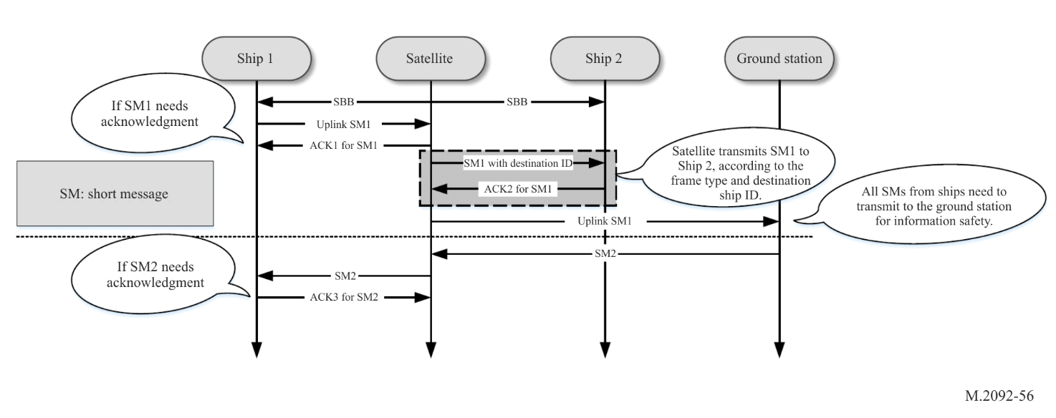
Figure A5-13
Example of an addressed messages transfer process in VHF data exchange system-satellite
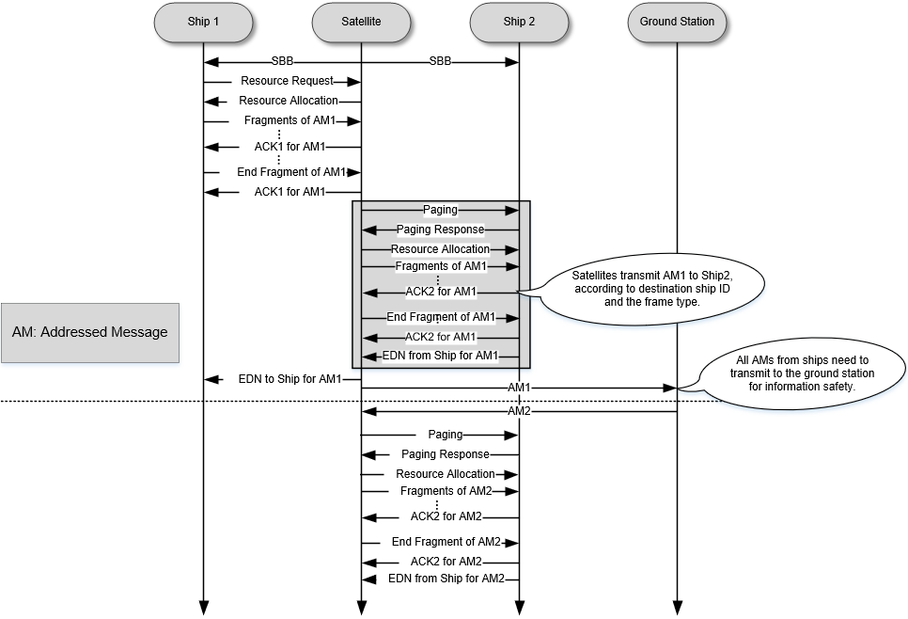
1) Short data messages can need ACK and none ACK, while addressed message should need ACK.
2) Short/addressed data messages support the service from one ship to another via satellite.
3) Short/addressed data messages can be from ground station.
4) All short/addressed data messages from ships should be transmitted to ground stations for information safety.
5) For the service (short and addressed messages) from one ship to another, the process should be separated to two transfer processes, ship to satellite and satellite to ship.
6) For addressed messages, there is only one ship and one satellite in every data session.
7) The EDN message is an optional message that may be used by the application layer to indicate delivery of the message to the end destination on the application layer.

3.13.1 A5-Paging
Figure A5-14
Paging

A5-3.13.2 Satellite originated broadcast
Figure A5-15
Satellite originated broadcast
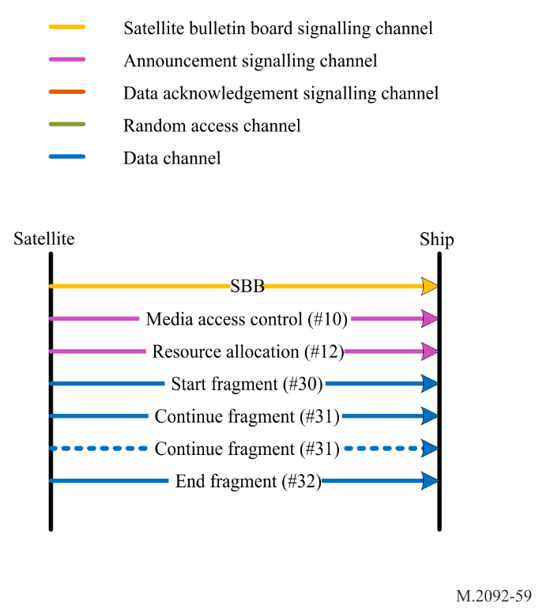

A5-3.13.4 Satellite to ship addressed message
Figure A5-16

Satellite to ship addressed message
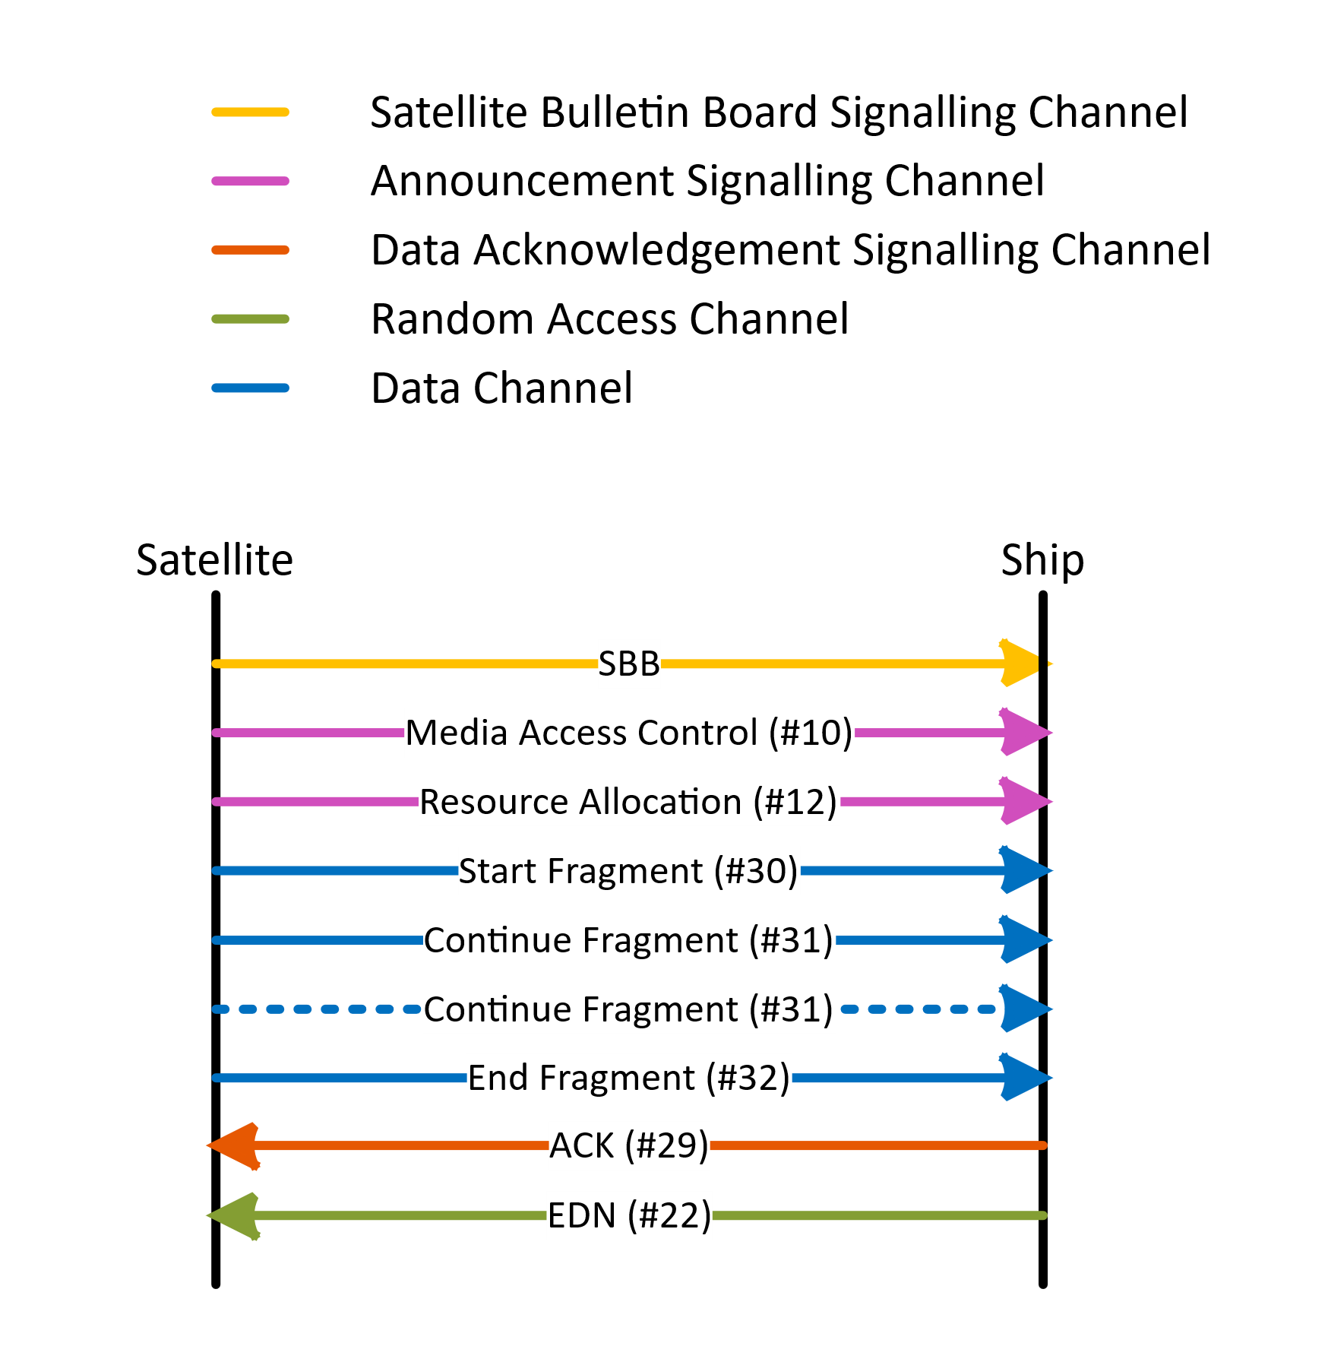

Note: End delivery notification (#22) in the figure A5-16 is optional, and is only initiated by the application layer.

A5-3.13.5 Ship to satellite addressed message
Figure A5-17
Ship to satellite addressed message

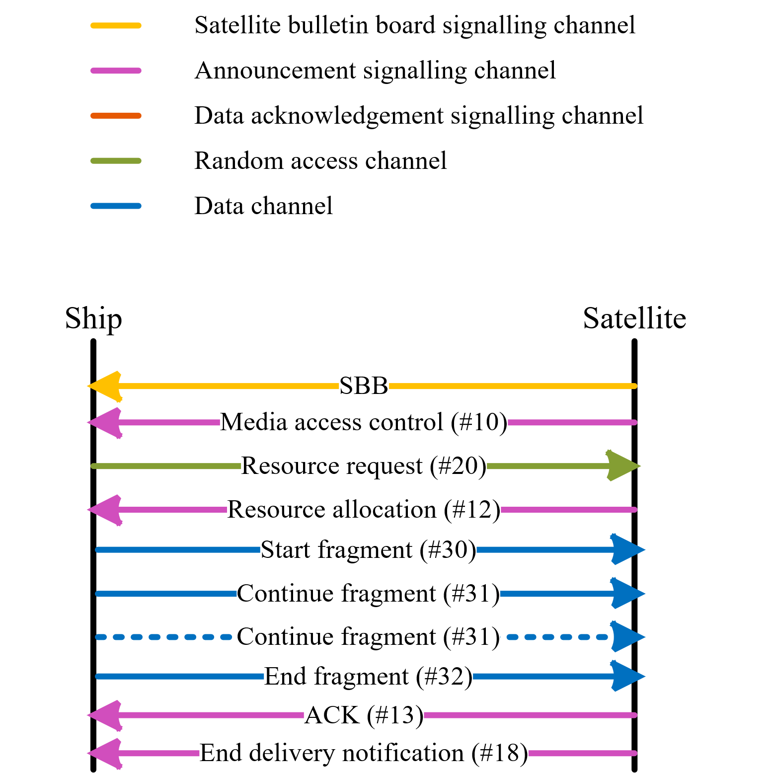
Note: End delivery notification (#18) in the figure A5-17 is optional, and is only initiated by the application layer.

A5-3.13.6 Satellite to ship short data message (with acknowledgement)
Figure A5-18
Satellite to ship short data message (with acknowledgement)
Note: End delivery notification (#22) in the figure A5-18 is optional, and is only initiated by the application layer.

A5-3.13.7 Ship to satellite short data message (with acknowledgement)
Figure A5-19
Ship to satellite short data message (with acknowledgement)
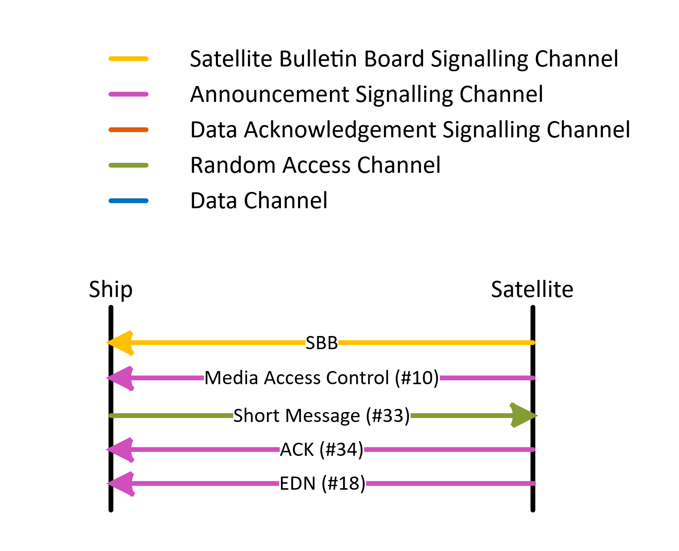
Note: End delivery notification (#18) in the figure A5-19 is optional, and is only initiated by the application layer.

A5-3.13.8 Satellite to ship short data message (no acknowledgement)
Figure A5-20
Satellite to ship short data message (no acknowledgement)
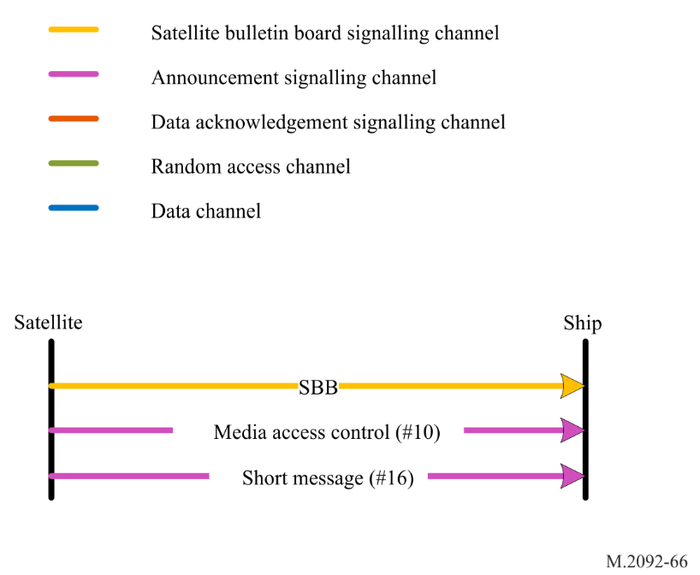

A5-3.13.9 Ship to satellite short data message (no acknowledgement)
Figure A5-21
Ship to satellite short data message (no acknowledgement)

A5-3.14 Random access
A ship accesses the system by requesting a resource or sending a short data message on the random access channel.
When a message is scheduled for immediate RAC transmission, then all transmission candidate slots should be gathered over the selection interval. The default selection interval is 180 slots (minus 1 last guard slot), but may be set via a Media Access Control message, received from a Satellite. Only slots with slot function set as RAC may be considered as candidate slots. As an AIS transceiver forms part of the VDES system, the AIS transmission schedules should also be considered. AIS will always have priority over VDE-SAT transmissions.
One candidate slot will be randomly selected from all the available candidate slots. If no candidate slot is available or if for some reason, the VDE message could not be transmitted (AIS messages could be scheduled after the VDE-SAT schedule), then the VDE transmission will fail and the normal retry mechanism will follow. The retry mechanism will allow up to three retries of the RAC transmission.

A5-3.15 Logical channel assignment
For data transfers two logical DC are assigned until the transfer is complete, has timed out (fragment loss) or is terminated by the satellite for other reasons (e.g. priority or capacity limits).

A5-3.16 Adaptive coding and modulation/rate adaptation
See § A4-5.

A5-4 Segmentation of VHF data exchange-satellite payload
See § A4-4.30.

A5-5 Network layer
See § A4-5.

A5-6 Transport layer
See § A4-6.

A5-7 Presentation Layer
See § A4-7.

Annex 6
Resource sharing method for VHF data exchange system
terrestrial and satellite services
TABLE OF CONTENTS
Page
1 Introduction 167
2 VHF data exchange system resource sharing principles 167
2.1 Automatic identification system priority 167
2.2 Coordination between application specific message and
VHF data exchange 168
2.3 Shore station VHF data exchange system control area 168
3 VHF data exchange-terrestrial resource sharing between multiple
controlling shore stations 168
4 VHF data exchange-terrestrial and VHF data exchange-satellite
resource sharing 169
5 Sharing between different VHF data exchange-satellite systems 169

A6-1 Introduction
This annex describes how resource sharing (i.e. in time and frequency) for utilizing the VHF spectrum available between different VDES services and stations should be accomplished.
A ship may be within range of multiple controlling shore stations. This annex describes a method for coordinating time and frequency resources between multiple controlling shore stations, particularly the use of bulletin boards and announcement signalling channels, as defined in Annexes 4 and 5.
The VDE-SAT is an effective means to extend the VDES to areas outside of coastal VHF coverage. However, due to the large footprint of satellite, the VDE-SAT downlink signal may interfere with VDE-TER in the coastal areas when satellite is in visibility. Similarly, the terrestrial ship-to-shore VDE signals can interfere with the satellite reception of VDE-SAT uplink when a VDE Satellite is in the field of view. The method described in this annex for resource sharing is derived based on the characteristics of VDE-TER and VDE-SAT, particularly the use of bulletin board and announcement signalling channels, as defined in Annexes 4 and 5.

A6-2 VHF data exchange system resource sharing principles

A6-2.1 Automatic identification system priority
Care should be taken to respect the AIS transmission and reception as the highest priority.

A6-2.2 Coordination between application specific message and VHF data exchange
VDE ship transmissions should be coordinated with transmissions on the ASM channels to ensure that ASM messages with new safety and navigational related information can be received.

A6-2.3 Shore station VHF data exchange system control area
The VDES resource assignments in the proximity of a shore station is monitored and controlled by a shore station. Shore stations utilize TBB to coordinate the resource assignment within the control area.
There are dedicated slots and frequency bands for TBB that are reserved to communicate the required information to each vessel in the control area of a shore station.

A6-3 VHF data exchange-terrestrial resource sharing between multiple controlling shore stations
The allocation of frequency and time slots used for the bulletin board announcement should be coordinated between controlling stations. Other resource assignments are managed based on the content of the bulletin board and announcement signalling channels. The assignment may change dynamically (according to temporal demands).
There are dedicated resources that are assigned to the terrestrial bulletin board and announcement signalling channels, as described in Annexes 4 and 5.
Channels 2024, 2084, 2025 and 2085 are shared between multiple controlling stations. The resource sharing should be coordinated between shore station operators. This coordination can be done either directly between the operators or rely on the bulletin board and announcement signalling channels of the shore stations, depending on the shore control areas, the resource assignment may vary. As an initial configuration for resource sharing, the controlling shore stations should adopt a static assignment in time and frequency.
A VDES unit receiving conflicting bulletin boards for the same service area should maintain the bulletin board it was already using until it exits the conflicting service area. Upon exiting the conflicting service are, it can start using the different bulletin board received for the remainder of the area. An example of the desired behaviour is given in Figure A6-1.
Figure A6-1
Expected behaviour of VHF data exchange system units in conflicting service areas
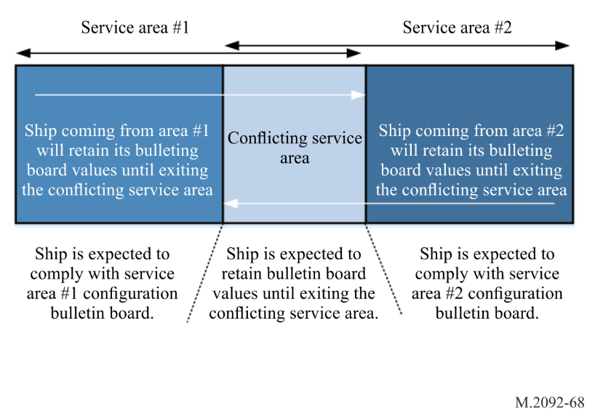

A6-4 VHF data exchange-terrestrial and VHF data exchange-satellite resource sharing
Shore stations utilize the TBB, as described in Annex 4, to coordinate the resource assignment within the control area. There are dedicated time slots and frequency bands for TBB that are reserved to communicate the required information to each vessel in the control area of a shore station. The frequency bands and time slots that are assigned to the TBB should not be used for VDE-SAT communications.
Each satellite shall use satellite bulletin board SBB, as defined in Annex 5, to communicate the VDE-SAT resource assignments, both for downlink and uplink, to vessels in the coverage area. There are dedicated slots and frequency bands for the SBB that are reserved to communicate the required information to each vessel in the field of view of a satellite.
Within the service area of a VDE-TER shore station the resource assignments provided in the TBB from that VDE-TER shore station shall be respected and given priority over the resource assignments provided in the SBB from a VDE-SAT satellite. When VDE-SAT uplink transmissions occur, care should be taken to respect the VDE-TER transmission and reception as the higher priority.
Channels 1026, 1086, 2026 and 2086 are identified to VDE-SAT communications, and are managed by the SBB. These channels are not used for VDE-TER communications. Therefore, on these channels no resources are shared between VDE-TER and VDE-SAT and no sharing scheme is required.
Channels 1024, 1084, 1025, 1085, 2024, 2084, 2025 and 2085 are identified for VDE-TER and VDE-SAT communications. With respect to ship stations within VDE-TER shore station coverage, the use of these channels should not cause harmful interference to VDE-TER operation, as described in § 2.1, Annex 1.
For areas not controlled by a VDE-TER shore station, VDE-TER ship-to-ship communications should be according to the default TBB. VDE-SAT communications on channels 1024, 1084, 1025, 1085, 2024, 2084, 2025 and 2085 is managed by the SBB, and should not cause harmful interference to VDE-TER operation, as described in § A1-2.1.

A6-5 Sharing between different VHF data exchange-satellite systems
The sharing between two or more satellite systems is co-operated between the satellite operators and organized through the bulletin board, delivered by satellites in VDE-SAT downlink bands, as described in Annexes 2 and 5. Ships use the satellite bulletin boards for channel and resource configuration.
The waveform used for the bulletin board should allow for detection of overlapping signals received from multiple satellites. The use of direct sequence spreading as defined in Annex 5, allows for detection of up to four overlapping satellite signals, depending on SAT-MCS.

ETSI EN 302 583 (V1.2.1) – Digital Video Broadcasting (DVB); Framing Structure, channel coding and modulation for Satellite Services to Handheld devices (SH) below 3 GHz.
Digital Video Broadcasting (DVB); Framing Structure, channel coding and modulation for Satellite Services to Handheld devices (SH) below 3 GHz.
Digital Video Broadcasting (DVB); Framing Structure, channel coding and modulation for Satellite Services to Handheld devices (SH) below 3 GHz.
Series V: Data Communication over the Telephone Network – Error control – Error-correcting procedures for DCEs using asynchronous-synchronous conversions.
Digital Video Broadcasting (DVB); Second Generation DVB – Interactive Satellite System (DVB-RCS2); Part 2: Lower Layers for Satellite standard.
Where 0 dBc is average.
Where 0 dBc is 12.5 W average power for higher power and 1W average power for low power.
A base station report (AIS Message 4) in conjunction with a data link management message (ASM Message 7) with the same base station ID (MMSI) must be received by the mobile station so that it can determine its distance from the transmitting base station.
IETF Document RFC 5480: Elliptic Curve Cryptography Subject Public Key Information.
Signature spreading sequences are utilised such that quasi continuous phase is obtained for the generated direct sequence spreading signal. These signature spreading sequences, referred to as the ${cp}_{a}$ and ${cp}_{e}$ in § A5-2.5, are found in the ASCII text files “cpa_SF16_NS16_BL261_r1.txt” and cpe_SF16_NS16_BL261_r1.txt” respectively. These embedded files are not subject to IP restrictions.

