U.S. Radiocommunications Sector
Fact Sheet
Working Party: ITU-R WP 5B | Document No: USWP5B35-09
Ref: New | Date: 11th August 2025
Document Title: WORKING DOCUMENT TOWARDS A PRELIMINARY DRAFT NEW REPORT ITU-R M.[RNSS_AM(R)S_5GHZ_SHARING] – Sharing and compatibility study between RNSS and AM(R)S systems operating in the 5 000 to 5 150MHz Frequency Band

Author(s)/Contributors(s):  Name: Don Nellis  Org: Federal Aviation Administration  Name: Michael Neale  Org: ACES Corporation for the FAA  Name: Martin San Juan  Org: ACES Corporation for the FAA | Phone: (202) 267-9779  Email: Donald.Nellis@faa.gov  Phone: (858) 705-8978  Email: michael.neale@aces-inc.com  Phone: (202) 267-5976  Email: martin.sanjuan@aces-inc.com
Purpose/Objective: The purpose of this contribution is a sharing and compatibility study between the RNSS operating in the 5 010 – 5 030 MHz frequency band and the AM(R)S service supporting Unmanned Aircraft Systems operating in the 5 030 to 5 091 MHz frequency band. This study is aimed at finalizing the e.i.r.p. density limit that is currently provisional in RR No. 5.443C
Abstract: This initial contribution provides an outline for the study and the characteristics of the two systems.

Radiocommunication Study Groups | 
Received : XXX  Source: New  Subject: New Report  ITU-R M.[RNSS_AM(R)S_5GHZ_SHARING] | Document 5B/XXX-E
 | XXX
 | English only
United Sates of America
WORKING DOCUMENT TOWARDS A preliminary draft new RePORT Itu-r m.[RNSS_AM(R)S_5GHz_SHARING]
Sharing and compatibility study between RNSS and AM(R)S systems operating in the 5 010 to 5 091 MHz Frequency Band
Introduction
At WRC-2012 it was agreed, under No. 5.443C, that the frequency band 5 030-5 091MHz could be used by the aeronautical mobile (R) service limited to internationally standardized aeronautical systems. Industry, international standards development organizations and ICAO have been working since then to develop the technology and standards necessary to use that allocation. Consequently, it is now possible to provide characteristics and protection criteria for such systems for use in any future sharing studies within ITU-R.
Proposal
The United States of America proposes to assist in answering the above need by providing characteristics as Attachment 1 for such Control and Non-Payload Communications (CNPC) links operating in the AM(R)S allocation under No. 5443C and used in air-ground applications between Unmanned Aircraft (UA) and their Control Station (CS) where the Remote Pilot (RP) is located.
Attachment 2 provides the characteristics of the Galileo Positioning System, and the Global Positioning System, the two most widely used GNSS constellation in Region 2 of the RNSS services operating in the 5 010 – 5 030 MHz frequency band as found in ITU-R M.2031-1.
Attachment 3 provides an outline for conducting the sharing and compatibility study of the two systems detailing the various cases and the processes.

Attachments: 3

ATTACHMENT 1

UAS CNPC Characteristics

UAS CNPC Characteristics are taken from PDNR ITU-R M.[AM(R)S_AMS(R)S_CHAR_5GHZ] - Characteristics and Protection Criteria of Terrestrial and Satellite Unmanned Aircraft System Control and Non-Payload Communications Links operating in the Aeronautical Mobile (R) Service and Aeronautical Mobile Satellite (R) Service in the band 5 030-5 091 MHz.

ATTACHMENT 2

RNSS Characteristics

As recommended by WP 4C (5B/312) RNSS characteristics and protection criteria are taken from Recommendation ITU-R M.2031-1 - Characteristics and protection criteria of receiving earth stations and characteristics of transmitting space stations in the radionavigation-satellite service (space-to-Earth) operating in the band 5 010-5 030 MHz.

ATTACHMENT 3

Outline for conducting the sharing and compatibility study of the two systems

1 Introduction and scope
At WRC-2012 it was agreed, under No. 5.443C, that the frequency band 5 030-5 091MHz could be used by the aeronautical mobile (R) service limited to internationally standardized aeronautical systems.
No. 5.443C states that “Unwanted emissions from the aeronautical mobile (R) service in the frequency band 5030-5091 MHz shall be limited to protect RNSS system downlinks in the adjacent 5010-5030 MHz band. Until such time that an appropriate value is established in a relevant ITU-R Recommendation, the e.i.r.p. density limit of −75 dBW/MHz in the frequency band 5010-5030 MHz for any AM(R)S station unwanted emission should be used. (WRC-12)”
It is the intention of this study to investigate the e.i.r.p. density limit that needs to be applied to the emissions of UAS CNPC (whose characteristics are provided in Attachment 1) in order to protect the RNSS whose characteristics and protection criteria are provided in Attachment 2 and in so doing enable the provisional nature of the current e.i.r.p. density limit to be resolved.

1.1 RNSS amd UAS CNPC Frequency Allocation
The frequency arrangement is shown below. The target systems were RNSS systems operating in the 5 010-5 030 MHz frequency band, which is adjacent to the CNPC frequency band.
Figure 1
Frequency Placement of RNSS, CNPC and AM(R)S operating in the 5 000-5 150 MHz frequency band

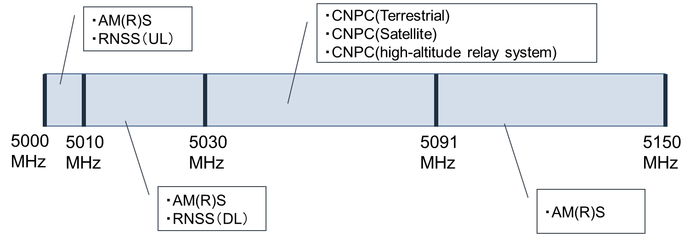

NOTE 1: Compatibility studies among UAS CNPC systems are currently being conducted mainly by aeronautical standardization bodies and are outside the scope of this shared-use study.
NOTE 2: RNSS (UL) in the 5 000-5 010 MHz frequency range is out of scope as there is sufficient frequency separation.
[Editor's Note: There is an AM(R)S system operating at 5 010-5 030 MHz and 5 091-5 150 MHz called AeroMACS. However, its operational status is still under investigation and will be addressed in a future WP 5B meeting.]

2 Compatibility studies

____________

