|  |  |  |
| --- | --- | --- |
| U.S. Radiocommunications Sector  Fact Sheet | | |
| **Working Party:** ITU-R WP 5B | **Document No:** USWP5B35-22 | |
| Ref: Resolution 256 (WRC-23) | **Date:** 8/11/25 | |
| **Document Title:** Additional technical information for sharing studies  under WRC-27 agenda item 1.7 | | |
| **Author(s)/Contributors(s):**  Nicholas Shrout  ASRI  Kim Kolb  Boeing | | Email: [njs@asri.aero](mailto:njs@asri.aero)    Email: [kim.l.kolb@boeing.com](mailto:kim.l.kolb@boeing.com) |
| **Purpose/Objective:** This contribution presents additional information on radio altimeters operating in the 4.2-4.4 GHz band. | | |
| **Abstract:** This contribution presents additional information for WP 5B’s consideration when developing their response liaison station to WP 5D concerning WRC-27 agenda item 1.7. | | |

|  |  |
| --- | --- |
| **Radiocommunication Study Groups** |  |
|  |  |
|  |  |
| Subject: WRC-27 agenda item 1.7 | Document 5B/USA-E |
| Date 2025 |
| English only |
| United States of America | |
| Additional technical information for sharing studies under WRC-27 agenda item 1.7 | |

1. **Introduction**

At the last meeting (April to May 2025), Working Party (WP) 5B, as a contributing group for WRC-27 agenda item 1.7, informed WP 5D that further information on radio altimeter performance in the frequency band 4 200-4 400 MHz and updates to considerations of WAIC may be provided.

1. **Proposal**

The United States provides WP 5B a draft reply liaison for consideration to liaise to WP 5D with further information on radio altimeter performance.

______________

**ATTACHMENT**

|  |
| --- |
| REPLY LIAISON STATEMENT TO WORKING PARTY 5D  (COPY FOR INFORMATION TO WORKING PARTIES 1B, 3K, 3M,  4A, 4C, 5A, 5C, 7B, 7C, 7D AND ICAO) |
| **Additional technical information for sharing studies  under WRC-27 agenda item 1.7** |

Working Party (WP) 5B would like to thank WP 5D for its liaison statements (Document [5B/147](https://www.itu.int/md/R23-WP5B-C-0147/en)) requesting additional information on radio altimeter performance in the frequency band 4200- 4400 MHz. WP 5B provides to WP 5D the following technical information regarding radio altimeters to consider when conducting sharing and compatibility studies.

**Radio Altimeters**

Recommendation[**ITU-R M.2059-0**](https://www.itu.int/rec/R-REC-M.2059/en)provides the technical and operational characteristics, and protection criteria of radio altimeters, which operate during all phases of flight. Representative radio altimeter operational and technical characteristics are contained in Annex 1 and Annex 2; and radio altimeter protection criteria are contained in Annex 3.

It should be noted that the evaluation of potential interferers should consider all altitudes each radio altimeter model operates from 0 m to the “operational altitude” in Tables 1 and 2.

For each radio altimeter model, the protection criteria contained in Annex 3 should be applied as provided from the upper limit of the “Range of reported altitude” () to the “Operational Altitude” () stipulated in Tables 1 and 2 of the Recommendation. For altitudes less than the , an altitude adjustment factor () should be considered.

**Altitude Adjustment Factor**

The is used to approximate the radio altimeters improved resilience to interfering signals at lower altitudes. This assumption is supported by publicly available test data, including radio altimeter breakpoints and interference tolerance thresholds from Annex 3.6 of the Report on the 34th meeting of Working Party 5B (5B/315), which show that radio altimeters are typically more resilient to interference at lower altitudes. This increased resilience is assumed to occur primarily due to two mechanisms: (1) the received signal is typically stronger at lower altitudes due to a reduction in signal loop loss, and (2) the receiver may implement automatic gain control, which reduces sensitivity to undesired signals as the desired signal strength increases.

For all altimeter models and all three failure modes the is assumed to follow the following equation.

for, 0

for, 10

, for,

where:

: Altitude of the altimeter in meters

: Approximated interference resilience improvement per decade decreases in altitude

0 ≤ ≤ 20

**Applied Example**

Considering the receiver desensitization protection criteria at the radio altimeter receive port as a function of altitude () as an example, the following shows how to apply the .

For FMCW radio altimeters:

For pulsed radio altimeters:

where:

: IF bandwidth of the altimeter in MHz

: Chirp bandwidth of the altimeter in MHz

: Noise figure at the receiver input in dB

Recommendation ITU-R M.2059 Radio Altimeter Model Specific Parameters

| Parameter | Units | Radio Altimeter Model | | | | | | | | | |
| --- | --- | --- | --- | --- | --- | --- | --- | --- | --- | --- | --- |
| A1 | A2 | A3 | A4 | A5 | A6 | D1 | D2 | D3 | D4 |
|  | **m** | 2500 | 2438 | 6000 | 1524 | 1524 | 457 | 1676 | 1737 | 6000 | 2424 |
|  | **km** | 12 | 12 | 20 | 12 | 12 | 12 | 12 | 12 | 20 | 12 |
|  | **MHz** | 2 | 0.25 | 2 | 9.2 | 6 | 16 | 0.312 | 1.95 | 2 | 30 |
|  | **dB** | 10 | 6 | 6 | 10 | 10 | 10 | 8 | 9 | 8 | 10 |
| **(Note 1)** | **MHz** | 104 | 132.8 | 133 |  |  |  | 150 | 176.8 | 133 |  |
| Note 1: Models with a listed are FMCW radio altimeters, and models without are pulsed radio altimeters | | | | | | | | | | | |

The following figure plots the assuming an of 20.

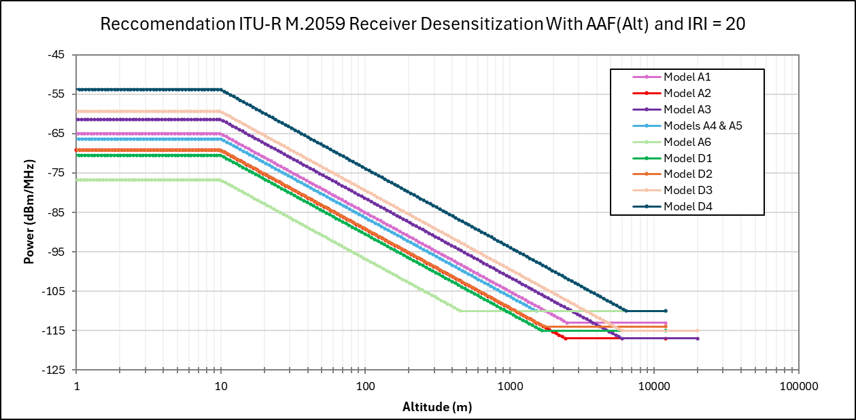

Finally, WP 5B requests to be kept informed on the progress of the studies under WRC-27 agenda item 1.7.

|  |  |
| --- | --- |
| **Status:** For action |  |
| **Contact:** | **E-mail:** |

______________