U.S. Radiocommunications Sector
Fact Sheet
Working Party: ITU-R WP 5B | Document No: USWP5B_xyz
Ref: 5B/315 Annex 3.6 | Date: 8/11/25
Document Title: Additional technical information for sharing studies
under WRC-27 agenda item 1.7
Author(s)/Contributors(s):  Nicholas Shrout  ASRI  Kim Kolb  Boeing |  | Email: njs@asri.aero  Email: kim.l.kolb@boeing.com
Purpose/Objective: This contribution provides updates for WP 5B’s consideration to Annex 3.6 of the Chair’s Report of the 34th Working Party 5B Meeting.
Abstract: This contribution provides updates for WP 5B’s consideration to Annex 3.6 of the Chair’s Report of the 34th Working Party 5B Meeting. Titled, WORKING DOCUMENT TOWARDS A [PRELIMINARY DRAFT NEW REPORT ITU-R M.[ITU-R M.2059 COMPARISON]] / WORKING DOCUMENT WITH ELEMENTS [IN VIEW OF A POSSIBLE NEW REPORT] ON RADIO ALTIMETER MEASUREMENTS COMPARED TO ITU-R DOCUMENTATION

Radiocommunication Study Groups | 
Subject: WRC-27 agenda item 1.7 | Document 5B/USA-E
Subject: WRC-27 agenda item 1.7 | Date 2025
Subject: WRC-27 agenda item 1.7 | English only
United States of America
Additional technical information for sharing studies under WRC-27 agenda item 1.7

- Introduction
At the last meeting (April to May 2025), Working Party (WP) 5B, started developing a working document comparing Recommendation ITU-R M.2059 with publicly available test data.
- Proposal
The United States provides WP 5B proposed edits to the working document. The edits include consolidating the first two Annexes and adding an additional annex discussing the concept of an altitude adjustment factor to be applied to Recommendation ITU-R M.2059 protection criteria.

______________

Radiocommunication Study Groups
Source: Document 5B/TEMP/116 | Annex 3.6 to  Document 5B/315-E
Source: Document 5B/TEMP/116 | 15 May 2025
Source: Document 5B/TEMP/116 | English only
Annex 3.6 to Working Party 5B Chair’s Report
Working Document Towards a [Preliminary Draft new report iTU-R M.[ITU-R M.2059 COMPARISON]] / WORKING DOCUMENT WITH ELEMENTS [IN VIEW OF A POSSIBLE NEW REPORT] ON RADIO ALTIMETER MEASUREMENTS COMPARED TO ITU-R DOCUMENTATION
Comparison of ITU-R M.2059 with measured radio altimeter data
Editor’s Note: This document was not fully discussed within WP 5B nor agreed. Further discussion will take place at next WP 5B.
Editor’s note: Views were expressed that measurements mentioned in this document derived from three volumes of public available data were made on limited number of radio altimeters from only four manufacturers below 4.2 GHz and only two manufacturers above 4.4 GHz.
It should be noted that,
– Only radio altimeter units manufactured after 2012 were considered except for one radio altimeter in the volume III (Model RA-F), which was manufactured after 2007. Radio altimeters still in use onboard aircraft but manufactured before these dates were not measured. Furthermore, it is recognised that an aircraft's lifecycle may last over 50 years,
– In this document, when extracting information from Volume III, only UC1 radio altimeters have been considered, excluding the measurements of the RA-W and RA-Z models (UC2 and UC3 equipped on helicopters, regional aircraft (up to 100 seats), general aviation aircraft (up to 19 seats) and business jets, and
– There are inconsistencies in testing procedures between Vol I and II with Vol III leading to as much as 20 dB difference in the result (eg RA-V 200ft 3930MHz).
Consequently, the radio altimeters tested and measured cannot be considered exhaustive and representative of all radio altimeters in use, and cannot be considered as conclusive.

1 Introduction
Recommendation ITU-R M.2059 (Rec. ITU-R M.2059), Operational and Technical Characteristics and Protection Criteria of Radio Altimeters (RAs), was approved in 2015 and provides characteristics of RAs, a system that operates under the aeronautical radionavigation service, including background information of how the system is used on aircraft. The characteristics include three protection criteria to ensure the operations of this system that is critical for safety and regularity of flight. Since the publication of Recommendation ITU-R M.2059, some RA data has been published, and it is useful to compare characteristics within Recommendation ITU-R M.2059 with this data.
ANNEX 1: Description [TBD]
ANNEX 2: Description [TBD]

2 Summary
[To be developed in future meetings.]
Attachment: 1

ANNEX 1
Editor’s Note: The intent for the second draft is to merge Annex 1 and 2 where it fits best. There currently is duplication of some material. This exercise would be to improve readability and flow.

A1-1 Recommendation ITU-R M.2059 Operational and Technical Characteristics and Protection Criteria of RAs

A1-1.1 Radio Altimeter Description
As described in Recommendation ITU-R M.2059, the basic function of the RA is to provide accurate height measurements over a range of reported altitudes above the Earth surface with a high degree of accuracy and integrity during the approach, landing, and climb phases of aircraft operation. These operations can occur over surfaces with a wide variety of reflectivity. The distance measured by the radio altimeter is referred to as Height above Terrain (HAT), which is the distance from the terrain to the aircraft. This is a different measurement to altitude referenced to mean sea-level.
The information provided by the altimeter not only gives the flight crew (pilots) situational awareness, it also can be used by many other onboard safety systems. These systems can include automatic throttles (navigation), thrust reversers (used to stop the aircraft on the runway), terrain awareness warning systems (TAWS), traffic alert and collision avoidance system (TCAS), the predictive wind shear system, as well as the autopilot, which includes numerous automatic landing systems.
Altimeters can be installed on a variety of aircraft and connect to any combination of the systems mentioned above, the aircraft types that an altimeter may be installed from range from small single pilot aircraft, small ‘business’ aircraft including jets, regional commercial airliners, and large airliners. RAs are also installed on a variety of helicopters.
Installation details vary by the aircraft types, but one, two, or three altimeters may be installed on aircraft. Typically, large airliners have two or three altimeters installed and operated simultaneously to ensure that the required precision data is available for aircraft systems.

A1-1.2 Radio Altimeter Characteristics
The RA model specific parameters contained in Rec. ITU-R M.2059 that are utilized in protection criteria calculations discussed in Section A1-1.3 are provided in Table A1-1.
Table A1-1
Select RA Model Specific Parameters
Parameter | Units | RA Model
Parameter | Units | A1 | A2 | A3 | A4 | A5 | A6 | D1 | D2 | D3 | D4
Input Power Threshold | dBm | -30 | -53 | -56 | -40 | -40 | -40 | -30 | -43 | -53 | -40
Detection Threshold  (Note 1) | dBm / 100 Hz | -143 | -143 | -143 |  |  |  | -143 | -143 | -143
IF bandwidth | MHz | 2 | 0.25 | 2 | 9.2 | 6 | 16 | 0.312 | 1.95 | 2 | 30
Noise Figure | dB | 10 | 6 | 6 | 10 | 10 | 10 | 8 | 9 | 8 | 10
Chirp Bandwidth  (Note 1) | MHz | 104 | 132.8 | 133 |  |  |  | 150 | 176.8 | 133
Note 1: Models with a listed Detection Threshold and Chirp Bandwidth are FMCW RAs, and models without are pulsed RAs

A1-1.3 Radio Altimeter Protection Criteria
There are three protection criteria described in Rec. ITU-R M.2059, Receiver Desensitization, Receiver Front-end Overload, and False Altitude Generation.

A1-1.3.1 Receiver Desensitization
Receiver desensitization occurs when the interfering signal causes a noise floor increase within the RA receiver of 1 dB; an interference to noise ratio of -6 dB. The receiver thermal noise power (approx. −114 dBm/MHz), noise figure $\left(N_{F}\right)$, IF bandwidth $\left({BW}_{IF}\right)$, and chirp bandwidth $\left({BW}_{C}\right)$ must be considered to calculate the receiver desensitization threshold at the receiver input (${RD}_{Rx}$). The ${RD}_{Rx}$ is bounded over the frequency range 4 200‑4 400 MHz, is calculated using Equation A1-1 for frequency modulated carrier wave (FMCW) RAs, is calculated using Equation A1-2 for the pulsed RAs, and is provided in Table A1-2 for each specified RA model.
For FMCW RAs:
${RD}_{Rx}=$ $-114+10*\left(\log_{10}\left({BW}_{IF}\right)-\log_{10}\left({{2BW}_{IF}}/{{BW}_{C}}\right)\right)+N_{F}-6$
$-114+10*\log_{10}\left({BW}_{C}\right)+N_{F}-9$
Equation A1-1
For pulsed RAs:
${RD}_{Rx}=-114+10*\log_{10}\left({BW}_{IF}\right)+N_{F}-6$ Equation A1-2
Table A1-2
Radio Altimeter Model Specific Receiver Desensitization
Parameter | Units | RA Model
Parameter | Units | A1 | A2 | A3 | A4 | A5 | A6 | D1 | D2 | D3 | D4
$${RD}_{Rx}$$ | dBm /  BW | -92.8 /  104 MHz | -95.8 /  132.8 MHz | -95.8 /  133 MHz | -100.4 /  9.2 MHz | -102.2 /  6 MHz | -98.0 /  16 MHz | -93.2 /  150 MHz | -91.5 /  176.8 MHz | -93.8 /  133 MHz | -95.2 /  30 MHz
$${RD}_{Rx}$$ | dBm / MHz | -113 | -117 | -117 | -110 | -110 | -110 | -115 | -114 | -115 | -110
Note 1: The chirp bandwidth approach for FMCW RAs is for fixed frequency interferers in the RA operating bandwidth; this analysis assumes that a wideband noise rise over thermal in the 4200-4400 MHz band has the same receiver desense impact as a fixed frequency interferer present in the chirp bandwidth (i.e., a further 3 dB reduction).

A1-1.3.2 Receiver Front-end Overload
Receiver front-end overload occurs when sufficient power from an interfering signal saturates the front-end of a RA receiver. The input power threshold ($P_{T,RF}$) and frequency dependent rejection factor (${FDR}_{f}$) must be considered to calculate the receiver front-end overload threshold at the receiver input as a function of frequency (${RFO}_{Rx}(f_{0})$). The ${RFO}_{Rx}(f_{0})$ is calculated using Equation A1-3:
${RFO}_{Rx}(f_{0})= P_{T,RF}+{FDR}_{f}\left(f_{0}\right)$ Equation A1-3
where:
$f_{0}$: Frequency of interest in MHz.
${FDR}_{f}\left(f_{0}\right)$: Frequency dependent rejection factor, in dB. This factor is modelled as an attenuation of 24 dB per octave up to a maximum of 40 dB and is defined by Equation A1-4.
Note: The following formula assumes 24 dB per octave indicates 24 dB of attenuation is realized at 8 800 MHz (at a frequency ratio of 2:1 compared to 4 400 MHz) and 2 100 MHz (at a frequency ratio of 1:2 compared to 4 200 MHz)
${FDR}_{f}\left(f_{0}\right)=$ $Min\left(40 , 24*\log_{2}\left({4200}/{f_{0}}\right)\right)$, for $f_{0}$≤ 4 200
$0$, for 4 200 < $f_{0}$< 4 400
$Min\left(40 , 24*\log_{2}\left({f_{0}}/{4400}\right)\right)$, for $f_{0}$≥ 4 400
Equation A1-4

A1-1.3.3 False Altitude Generation
Unique to FMCW RA’s, false altitude generation occurs when interference signals are detected as frequency components during spectral frequency analysis of the overall IF bandwidth. This occurs when the received interference power at the RA detector is greater than the detection threshold ($DT$) of the RA. The $DT$ for all FMCW RA models is -143 dBm/100 Hz. The ${BW}_{C}$ must be considered to calculate the false altitude generation at the receiver input $({FA}_{Rx})$. The ${FA}_{Rx}$ is bounded over the frequency range 4 200‑4 400 MHz, calculated using Equation A1-5, and provided in Table A1-2 for each specified RA model.
${FA}_{Rx}=$ $DT-10*\log_{10}\left({2*100}/{{BW}_{C}*{10}^{6}}\right)$
$DT+10*\log_{10}\left({BW}_{C}\right)+37$
Equation A1-5
Table A1-2
Radio Altimeter Model Specific False Altitude Generation
Parameter | Units | RA Model
Parameter | Units | A1 | A2 | A3 | D1 | D2 | D3
$${FA}_{Rx}$$ | dBm /  BW | -85.8 /  104 MHz | -84.8 /  132.8 MHz | -84.8 /  133 MHz | -84.2 /  150 MHz | -83.5 /  176.8 MHz | -84.8 /  133 MHz
$${FA}_{Rx}$$ | dBm / MHz | -106 | -106 | -106 | -106 | -106 | -106

A1-2 RA Measured Data

A1-2.1 RA Measured Data Background
As a result of spectrum allocation changes in many administrations, there was a need to better understand the behaviour of RAs exposed to interference from adjacent and nearby frequency bands. The Aerospace Vehicle Systems Institute (AVSI) studied the effects of RF interference on a set of commercial RAs and published the results in a three-volume report (AVSI Report). The first volume (Vol I) specifically provides data regarding the 3 700-3 980 MHz frequency band, the second volume (Vol II) provides data regarding interference into the 4 200-4 400 MHz frequency band, and the third volume (Vol III) is a collection of additional test results of RAs from altimeter manufacturers.

A1-2.2 AVSI Report Vol I & II Data
The AVSI Report Vol I & II provide RA breakpoints (BPs) which occur when an RA under defined test conditions reports a height or condition that exceeds criteria specified in AVSI Report Vol I. The criteria to determine the BP is the lowest measured RF interference power that causes any one of the following to be true:
a) Mean Error Criterion (Vol I, Section 2.3.4.1): “(…) when the mean error exceeds 0.5%”;
b) Percentile Criterion (Vol I, Section 2.3.4.2): “(…) when the 1st percentile trace drops below -2% or the 99th percentile trace exceeds +2%”;
c) No Computed Data (NCD) criterion (Vol I, Section 2.3.4.3): (…) “any height reading label NCD during the RF power ON period”.
The BPs are defined for testing conducted at specific frequencies outside the RA frequency range of operation as well as frequencies within the RA band. The BP covers in-band interference from unwanted and/or spurious emissions, as well as the out-of-band fundamental interference caused by signals within the frequency band 3 700-3 980 MHz. Table A1-3 presents all the BPs summarized within Table 3-1 and Table 4-2 of the AVSI Report Vol I & II
Table A1-3
AVSI Report Vol I & II RA Model Specific BPs Summarized
AVSI Report Vol I & II RA Model Specific BPs Summarized (dBm)
 |  | Model (Note 1)
 |  | UC 1 |  |  |  |  | UC 2 / 3 (Note 2)
Simulated Altitude (ft) | Frequency  (MHz) | F | L | T | X | Y | A | I | S | V
200  (Note 3) | 3750 | -13 | NB (-1) | NB (-1) | NB (-1) | -9 | NB / NB* (-1) | -30 / -30* | NB / NB* (-1) | -50 / -42*
200  (Note 3) | 3850 | -15 | NB (-2) | NB (-2) | NB (-2) | -8 | NB / NB* (-2) | -50 / -30* | NB / NB* (-2) | -40 / -38*
200  (Note 3) | 3930 | -16 | NB (-5) | NB (-5) | -6 | -5 | NB / NB* (-5) | -32 / -28* | NB / NB* (-5) | -42 / -37*
200  (Note 3) | 4300 | -45 | -52 | -40 | -36 | -42 | -43 / -43* | -84 / -68* | -42 / -43* | -64 / -62*
1000 | 3750 | -20 | NB (-1) | NB (-1) | NB (-1) | -15 | NB (-1) | -31 | NB (-1) | -60
1000 | 3850 | -21 | NB (-2) | NB (-2) | -8 | -14 | NB (-2) | -28 | NB (-2) | -46
1000 | 3930 | -24 | NB (-5) | NB (-5) | -14 | -17 | -7 | -25 | NB (-5) | -50
1000 | 4300 | -57 | -51 | -47 | -57 | -56 | -48 | -73 | -52 | -75
2000 | 3750 |  |  |  |  |  | -10 | -28 | NB (-1) | -68
2000 | 3850 |  |  |  |  |  | -15 | -27 | NB (-2) | -55
2000 | 3930 |  |  |  |  |  | -20 | -25 | NB (-5) | -63
2000 | 4300 |  |  |  |  |  | -61 | -69 | -64 | -91
5000 | 3750 | -27 | -9 |  | -11 | -25
5000 | 3850 | -28 | NB (-2) |  | -26 | -25
5000 | 3930 | -30 | NB (-5) |  | -24 | -26
5000 | 4300 | -79 | -66 |  | -76 | -79
7000 | 3750 |  |  | NB (-1)
7000 | 3850 |  |  | -7
7000 | 3930 |  |  | -14
7000 | 4300 |  |  | -69
Note 1: The UC 1 and UC 2 / 3 subheadings in the table group RAs according to their Usage Categories (UCs) as defined in the AVSI Report.
Note 2: The AVSI Report defines a UC 3 category which uses the same radio altimeter models as in UC 2. UC 3 radio altimeters are tested at a simulated altitude of 200 ft without including the worst-case landing scenario (WCLS) (See: Note 3). UC 3 results at 200 ft. are denoted with an asterisk character (*). UC 3 Results at all other altitudes are equivalent to UC 2 results.
Note 3: The WCLS (i.e. the worst-case test condition) for UC1 and UC2 RAs simulated the victim test RA to be 200 ft above the runway and within 350 ft of the nearest aggressor aircraft with transmitting RAs. (See AVSI Report Vol I Fig 2-4 and section 2.1.3.1 description of the WCLS).
Note 4: A reported value of NB indicates no BP was observed because the highest testable power level was insufficient to induce a failure criterion as defined in the AVSI Report. NB values will also include the highest tested power level in parenthesis.
Note 5: An empty cell within the table indicates no data was collected for the conditions of that cell.

The BPs measured for each individual tested RA unit can be converted to an Interference Tolerance Threshold (ITT) representative of the performance of all the fielded units of the same model. Converting every BP to an ITT would account for the performance of over 66,000 fielded operational RAs. The BPs contained within Table A1-3 can be substituted into Equation A1-6 to calculate ITTs.
$$ITT=BP-{BTI}_{f}-{EE}_{f}-{U\&T}_{f}$$
$$ITT=BP-6$$
Equation A1-6
where:
$ITT$: ITT at the input to the RA receive port (dBm)
$BP$: The BP of the RA (dBm)
${BTI}_{f}$: A $BP$ -to- $ITT$ backoff factor of 1 dB
${EE}_{f}$: An experimental error factor of 1 dB
${U\&T}_{f}$: A unit-to-unit and temperature performance variation factor of 4 dB.
For the ITTs at 3750, 3850, and 3930 MHz an interference source bandwidth of 100 MHz was used. For ITTs at 4300 MHz, it is useful to convert the BP threshold to a power spectral density; an interference source bandwidth of 160 MHz was used in testing which results in a 22 dB reduction to convert from dBm to dBm/MHz.

A1-3 Comparison of Rec. ITU-R M.2059 and AVSI Report Data

A1-3.1 Comparison over the frequency range 4 200‑4 400 MHz
The three protection criteria provided in Rec. ITU-R M.2059 are applicable over the 4 200‑4 400 MHz frequency range; however, only the receiver desensitization and false altitude generation in this section are compared to the calculated ITTs and measured BPs over the same frequency range, i.e. the AVSI Report Vol II calculated ITTs and BPs at 4 300 MHz. Figure A1-1 plots the Rec. ITU-R M.2059 protection criteria performance ranges and AVSI Report Vol II Calculated ITTs at 4 300 MHz derived using the BPs in Table A1-3. Figure A1-2 plots the Rec. ITU-R M.2059 protection criteria performance ranges and AVSI Report Vol II measured BPs in Table A1-3.
Figure A1-1
Recommendation ITU-R M.2059 Receiver Desensitization and False Altitude Generation Range
and AVSI Report Vol II Calculated ITTs at 4 300
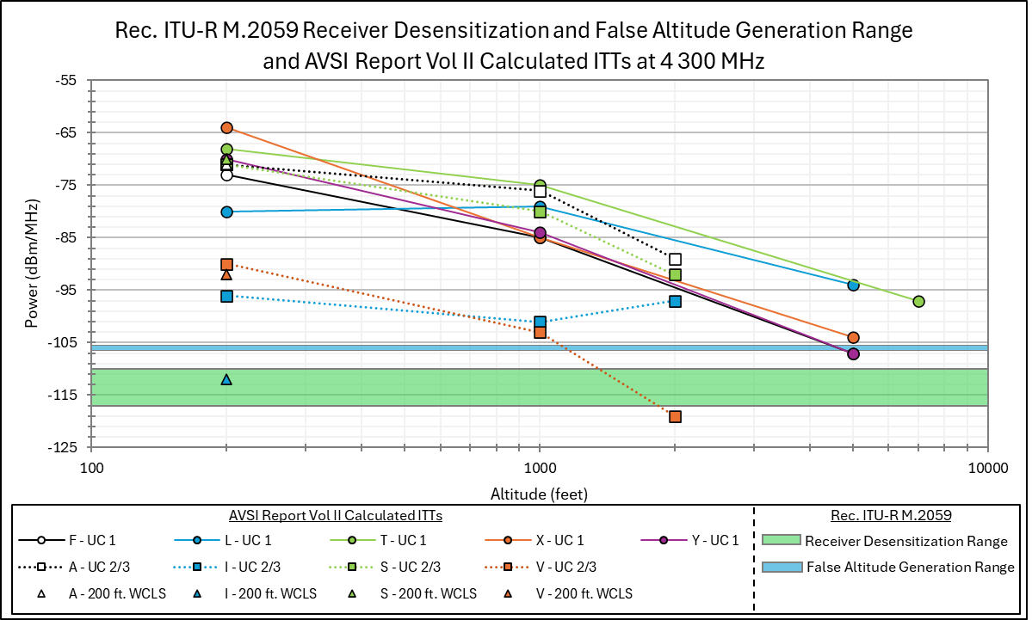
Figure A1-2
Recommendation ITU-R M.2059 Receiver Desensitization and False Altitude Generation Range and
AVSI Report Vol II BPs at 4 300
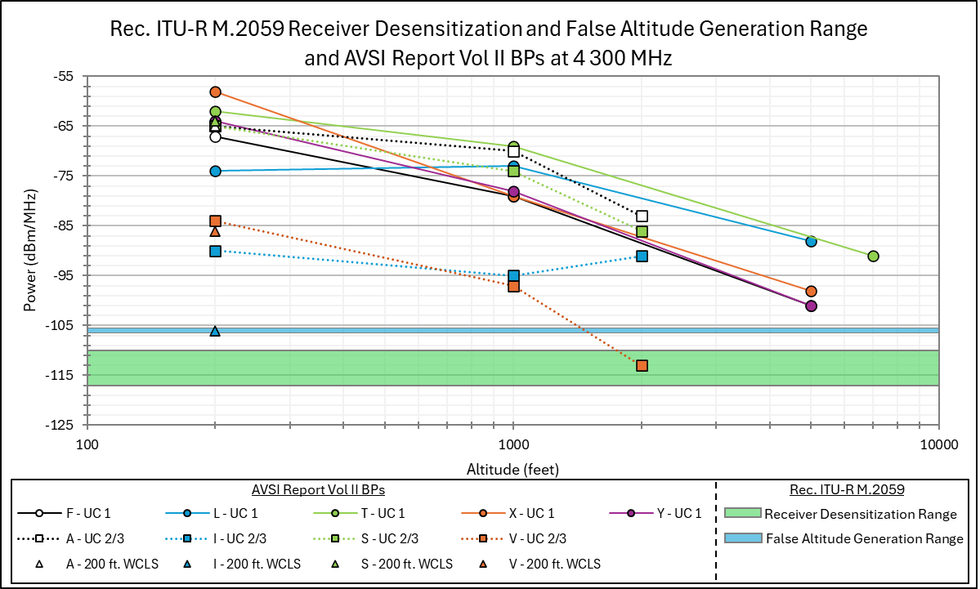

A1-3.2 Comparison over the frequency range 3 700‑3 980 MHz
The front-end overload protection criteria in Rec. ITU-R M.2059 applicable over the 3 700‑3 980 MHz frequency range can be compared to the AVSI Report calculated ITTs and measured BPs over the same frequency range, i.e. the AVSI Report Vol I calculated ITTs and BPs at 3 750, 3 850, and 3 930 MHz. Figures A1-3, A1-4, and A1-5 plot the front-end overload performance range based on Rec. ITU-R M.2059 and AVSI Report Calculated ITTs at 3 750, 3 850, and 3 930 MHz respectively derived using the BPs in Table A1-3. Figures A1-6, A1-7, and A1-8 plot the front-end overload performance range based on Rec. ITU-R M.2059 and AVSI Report measured BPs at 3 750, 3 850, and 3 930 MHz respectively using the BPs in Table A1-3.
NOTE: Power values in Figures A1-3 though A1-5 plotted at or above -11 dBm represent the ITT calculated using highest tested power due to the NB conditions described in Table A1-3, and power values in Figures A1-6 through A1-8 plotted at or above -5 dBm represent the highest tested power due to the NB conditions described in Table A1-3.
Figure A1-3
Recommendation ITU-R M.2059 Front-end Overload Range and AVSI Report Vol I Calculated ITTs
for a 100 MHz Interfering Signal Centred at 3 750 MHz
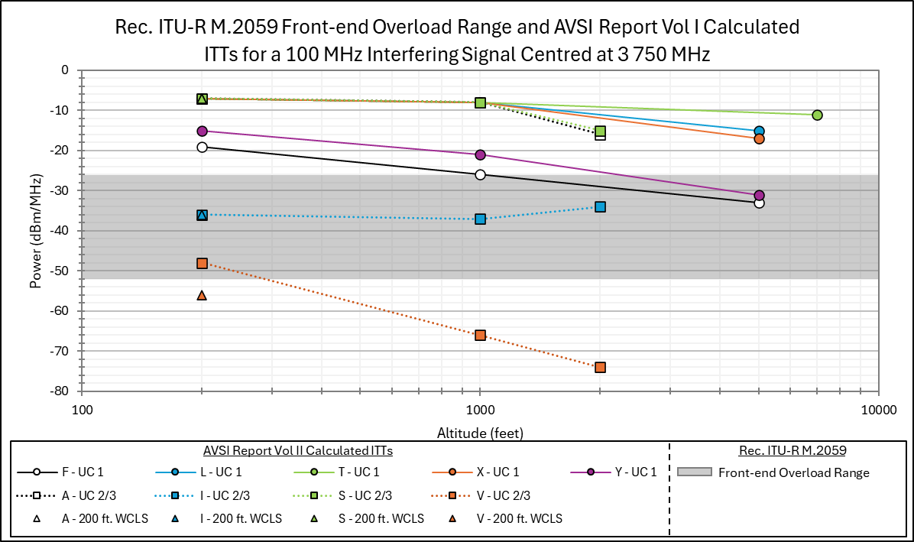

Figure A1-4
Recommendation ITU-R M.2059 Front-end Overload Range and AVSI Report Vol I Calculated ITTs
for a 100 MHz Interfering Signal Centred at 3 850 MHz
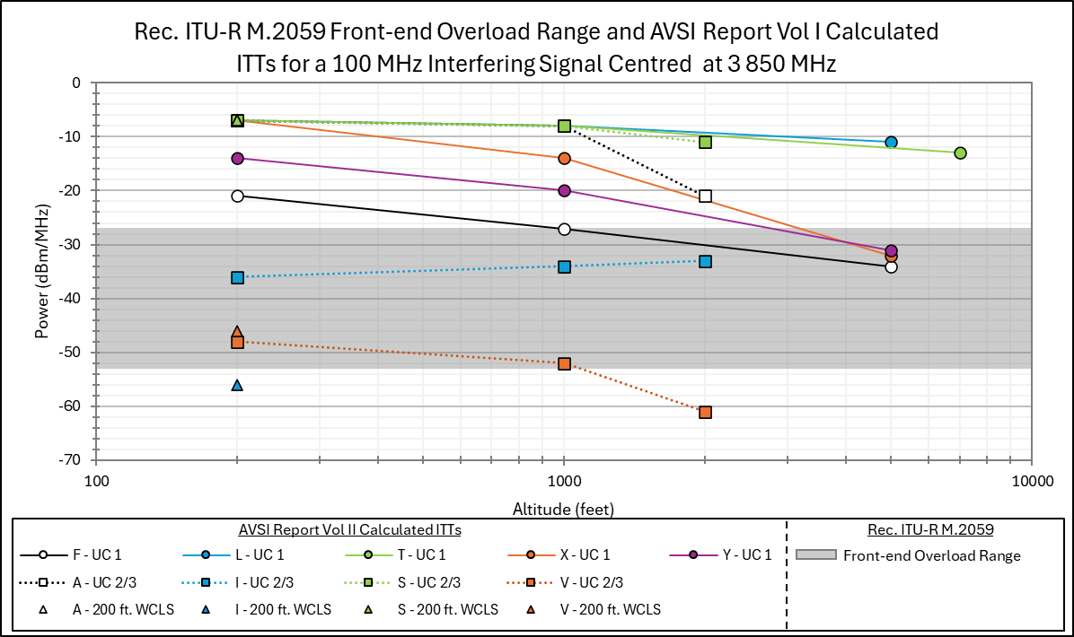
Figure A1-5
Recommendation ITU-R M.2059 Front-end Overload Range and AVSI Report Vol I Calculated ITTs
for a 100 MHz Interfering Signal Centred at 3 930 MHz
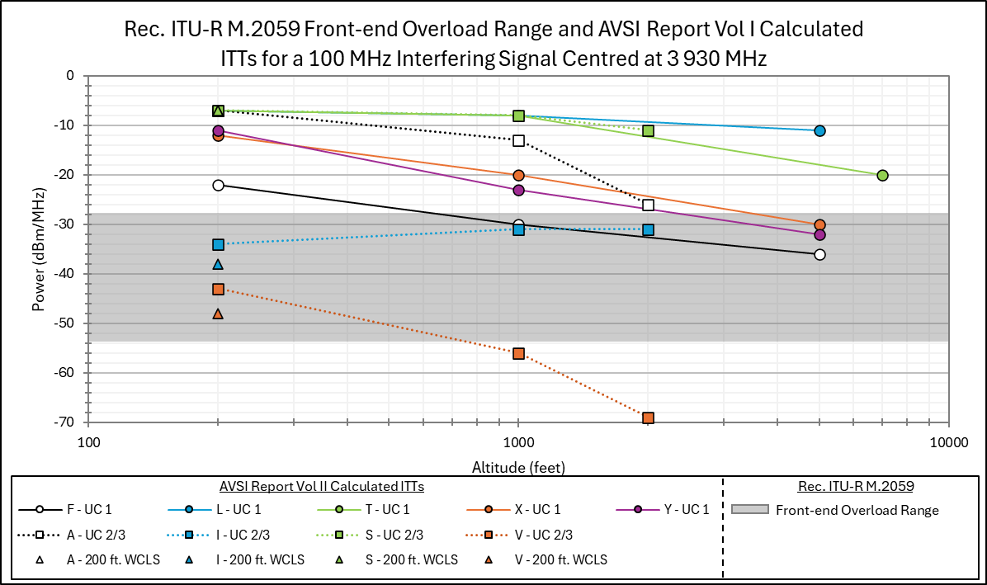
Figure A1-6
Recommendation ITU-R M.2059 Front-end Overload Range and AVSI Report Vol I BPs
for a 100 MHz Interfering Signal Centred at 3 750 MHz
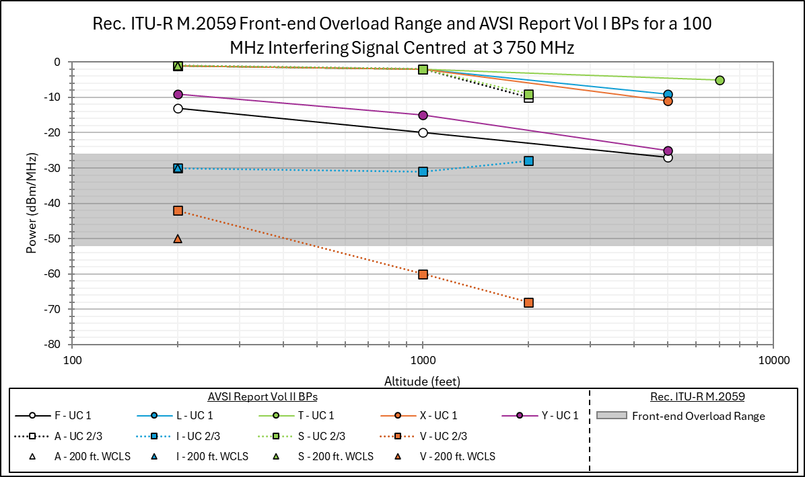
Figure A1-7
Recommendation ITU-R M.2059 Front-end Overload Range and AVSI Report Vol I BPs
for a 100 MHz Interfering Signal Centred at 3 850 MHz
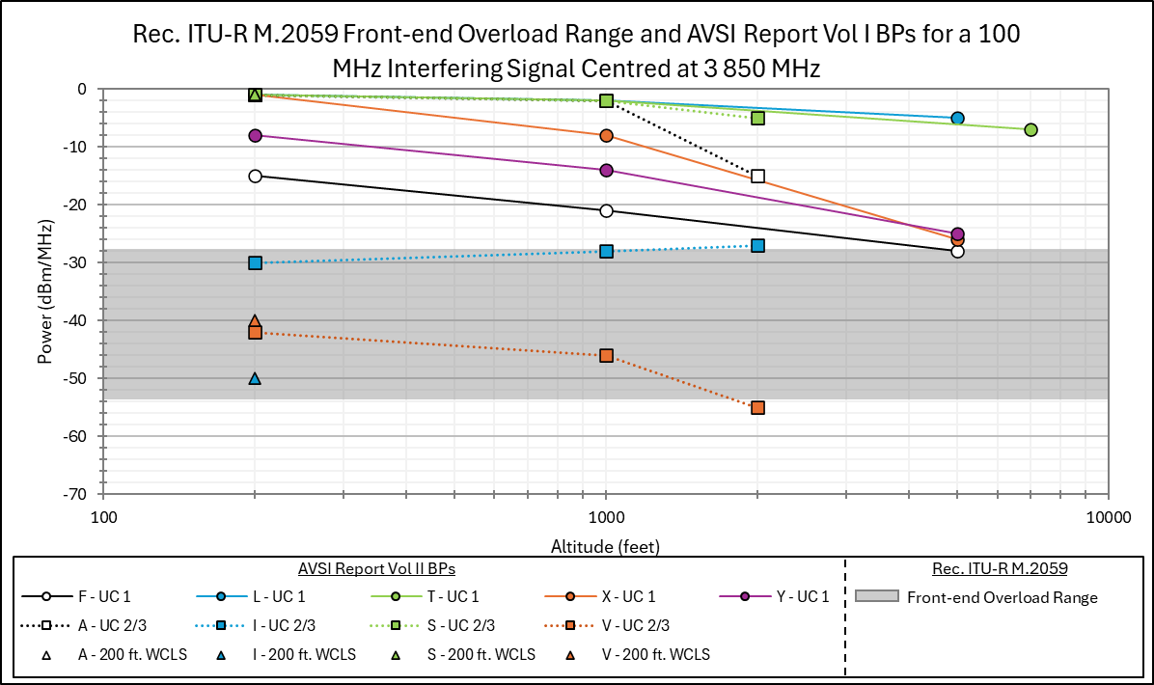
Figure A1-8
Recommendation ITU-R M.2059 Front-end Overload Range and AVSI Report Vol I BPs
for a 100 MHz Interfering Signal Centred at 3 930 MHz
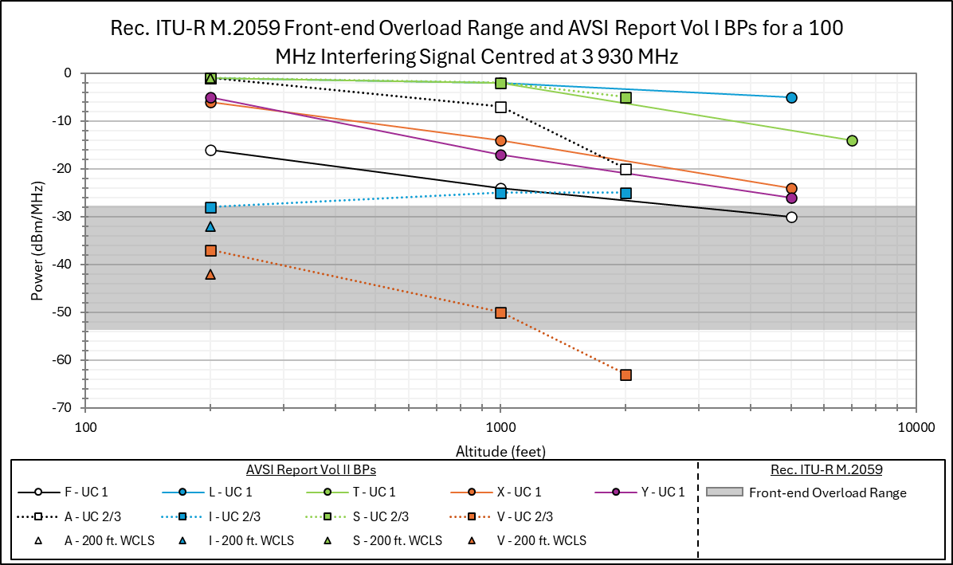

A1-4 Observations of Section A1-3 Comparisons
The AVSI Report data is not an exact match of Rec. ITU-R M.2059 RA performance. The RecommendationITU-R M.2059 RAs were meant to be representative of RAs installed on a variety of aircraft, the information from AVSI Report provides more insight into the types and performance of RAs over frequency and altitude through its categorisation of the tested altimeters in UCs.
The AVSI Report Vol I and II testing is performed on a sample of ten different RAs units reflective of nine unique altimeter models at a limited number of frequencies and simulated altitudes, which limits the conclusions that may be drawn as a result.

A1-5 Conclusions
New RA Minimum Operational Performance Standards (MOPS) are currently under development. When these MOPS are completed, new ITU documentation should be developed that provides a higher fidelity RA protection criteria model (or models) to be used in sharing and compatibility studies.
Based on the comparisons in section A1-3, applying the protection criteria thresholds in Rec. ITU-R M.2059 for altitudes ranging from ground level up to the altitude denoted as “operational altitude” will overprotect some RAs operating at altitudes less than 5000 ft. As seen by the AVSI Report measured BPs and calculated ITTs, many RAs tested show improved resilience to interference at lower altitudes relative to the minimum Rec. ITU-R M.2059 protection criteria thresholds.

ANNEX 2
This Annex provides a technical analysis of recent aviation testing of Radio Altimeter (RA) performance for various altitudes and compares test results with the parameters of Recommendation ITU-R M.2059.

A2-1 Observations on Rec. ITU-R M.2059 Parameters
If a receiver’s desired signal level is near thermal noise such that a 1 dB noise rise over thermal may impact the receiver’s performance, then this receiver is operating near the edge of its coverage range and is receiving the weakest desired signal detectable. The parameters defined for RA receivers in Rec. ITU-R M.2059 were developed for conditions in which the receiver was operating at the edge of its coverage range. An RA operating at its maximum reported height limit above terrain would resemble this operating condition, with the desired signal being near the weakest detectable level. An RA operating at a lower height above terrain receives a much stronger desired signal level than the signal available at the maximum height; in this operating condition, a 1 dB rise over thermal noise may not impact the receiver performance.
Furthermore, the Rec. ITU-R M.2059 equations defining front-end overload, receiver desense, and false altitude criteria did not include a term for self-interference from transmissions by the RA’s transceiver or from other RAs installed on the aircraft. Comparing the aviation test data at a range of heights to the parameters in Rec. ITU-R M.2059 may help identify whether additional considerations in the use of the Rec. ITU-R M.2059 parameters are warranted, due to differences in RA performance at lower heights above ground, or due to the presence of the own-aircraft interference.

A2-2 Background of AVSI Test Reports
Aviation industry test data assessing RA susceptibility to in-band signals within 4200-4400 MHz, and to signals outside of the RA band, may be beneficial to use in comparisons to the thresholds in Rec. ITU-R M.2059. One example of this test data is the aviation industry measurements performed by the Aerospace Vehicle Systems Institute (AVSI), a cooperative research environment that includes major aerospace companies and government organizations. These measurement data sets are publicly available (https://avsi.aero/afe76s2-report/).
The AVSI Volume I report provided test data collected in the presence of IMT fundamental emissions within 3700-3980 MHz, covering the C-Band allocation in the United States. The fundamental emissions test procedure, which injected strong out-of-band interferers and assessed receiver impacts, closely resembled a front-end overload test, enabling comparison to the receiver front-end overload characteristics in Rec. ITU-R M.2059.
The AVSI Volume II report provided test data collected with a wideband interferer within the 4 200-4400 MHz band. AVSI injected a 160 MHz Additive White Gaussian Noise (AWGN) signal at the RA receiver input port. This test procedure would increase the noise level at the receiver, and the observed performance impact would resemble either the receiver desensitization or the FMCW false altitude characteristics in Rec. ITU-R M.2059.
The AVSI Volume III report provided further test data of fundamental emissions and in-band emissions tests, collected by RA manufacturers. The fundamental emissions tests included a broader range of frequencies, with some manufacturers testing from 3000 to 5000 MHz. In some cases, manufacturers tested across the full range of temperatures, and tested multiple units of the same model of RA.
All the following tables, figures, and text referencing BPs use the AVSI percentile and NCD criterion while excluding the mean error criterion.

A2-3 AVSI Report Vol II and III UC 1 Measured RA Receiver Susceptibility to In-band Signals
The AVSI Report Vol II and III measured BPs of UC 1 RA susceptibility to in-band signals, for the maximum test height versus performance at 200 feet, is shown in Table A2-1. The performance at 200 ft was 14 to 40 dB better than at the maximum test height.
Table A2-1
AVSI UC 1 RA Receiver BPs in the Presence of In-band Signals at Various Altitudes

RA Model | Max Height Tested (ft) | Max Height BP (dBm/MHz) | BP at 1000 ft (dBm/MHz) | BP at 200 ft (dBm/MHz) | Delta (dB) between max height BP and 200 feet BP
F | 5000 | -101 | -79 | -67 | 34
L | 5000 | -88 | -73 (Vol II)  -75 (Vol III) | -74 (Vol II) /-75 (Vol III) | 14  13
T | 7000 | -91 | -68 (Vol II)  -65.8 (Vol III) | -62 (Vol II)  -60.8 (Vol III) | 29  30.2
X | 5000 | -98 | -78 (Vol II)  -77.2 (Vol III) | -58 | 40
Y | 5000 | -101 | -78 | -64 | 37

Figure A2-1 compares the AVSI Report Vol II and III UC 1 RA receiver BPs at 200 ft and maximum height to the Rec. ITU-R M.2059 receiver desensitization thresholds derived above in Annex 1.
Figure A2-1
AVSI Report Vol II and III UC1 In-band BPs Comparison at Tested Altitudes to
Recommendation ITU-R M.2059 Desense Thresholds
The AVSI Report Vol II and III UC1 In-band BPs at maximum height were 9 dB better than the best receiver desensitization threshold in Rec. ITU-R M.2059 and the UC1 In-band BPs at 200 ft were at least 36 dB better.

A2-4 AVSI Report Vol I and III UC 1 Measured RA Receiver Susceptibility to Out-of-band Signals
The AVSI Volume I report provided RA susceptibility measurements to out-of-band, 100 MHz wide signals centered at 3750, 3850, and 3930 MHz. The AVSI Volume III report provided RA manufacturer-provided measurements over a broader range of center frequencies from 3 000 to 5 000 MHz. These out-of-band test results can be compared against the receiver front-end overload characteristics defined by Rec. ITU-R M.2059. Since the receiver front-end overload was defined for an interferer within 4200-4400 MHz, the characteristics must be adjusted according to the frequency dependent rejection (FDR) of any filtering present in the receiver that impacts out-of-band signals. The Front-end overload thresholds can be calculated using Equations A1-3 and A1-4 contained in Annex 1. The FDR defined in Rec. ITU-R M.2059 is provided in Table A2-2.
Table A2-2
Recommendation ITU-R M.2059 Frequency Dependent Rejection and Resulting Range
of Front-end Overload Thresholds

Table A2-3 shows the lowest UC 1 BPs for the worst center frequency tested for each RA in the AVSI Volume I and III reports, along with the full range of center frequencies tested, and compares the BPs to the range of RA receiver front-end overload thresholds provided for all of the RAs in Recommendation ITU-R M.2059.
Table A2-3
AVSI Volume I and III UC 1 RA Susceptibility to Out-of-band Signals

The AVSI out-of-band susceptibility BP measurements of UC 1 RAs at low height above terrain exceeded the thresholds in M.2059 by wide margins. At maximum height, the RA performance was better than the best-performing RAs in M.2059, and more than 25 dB better than the least resilient RAs.
The Volume I and III test data for center frequencies ranging from 3750 to 3950 MHz are shown in the below figures and compared to the characteristics of the full range of RAs in Rec. ITU-R M.2059.
Figure A2-2
UC 1 RAs 3750 MHz Receiver Front-end Overload Comparison to Rec. ITU-R M.2059
Figure A2-4
UC 1 RAs 3850 MHz Receiver Front-end Overload Comparison to Rec. ITU-R M.2059
Figure A2-5
UC 1 RAs 3950 MHz Receiver Front-end Overload Comparison to Rec. ITU-R M.2059
The AVSI Report Volume III included some measurements of RA performance in the presence of out-of-band IMT signals at additional frequencies outside the RA operating band, again with 100 MHz bandwidth. Table A2-4 provides the comparison of AVSI Report BPs for receiver front-end overload across the range of frequencies tested, up to 4800 MHz, for models F and T. The other UC1 RAs (models L, X, and Y) were not tested across a broader range of frequencies in AVSI Report Vol III.
Table A2-4
UC 1 Model F and T RAs Receiver Front-end Overload BP Comparison Across Center Frequencies
from 3750 to 4750 MHz

A2-5 Conclusions
Based on AVSI testing, more up-to-date measurements of RA performance in the presence of in-band and out-of-band signals are available. The AVSI test data is informative of UC 1 RA performance at lower HAT as compared to the maximum reported height. The UC 1 RA models, at the tested altitudes and frequencies considering the percentile and NCD criterion while excluding the mean error criterion, show better tolerance of both in-band and out-of-band signals at all heights, compared to the characteristics in Rec. ITU-R M.2059. The comparison of Models F and T data below and above the RA band show similar or improved tolerance in the 4400-4800 MHz band relative to the similar centre frequency offset below the RA band.

Editor’s Note: The intent for the second draft is add a new annex describing the Altitude adjustment factor which should be supported by data in the previous annex. This would also align with the proposed RLS.

AVSI Report Vol I and II tested one unit of eight commercial RA models and two units of a ninth commercial RA model.
Data is published at https://avsi.aero/avsi-publishes-volume-iii-of-the-afe-76s2-report/
This volume also contains some compatibility analysis studies that will not be used in this document, only the radio altimeter data will be extracted
Mean Error is computed from a differential measurement, i.e., the percent change of the average reported HAT in the presence of interference from the average HAT measured without interference.
Percentiles refer to the cumulative distribution of normalized HAT values measured while the RA is exposed to interference.
This factor accounts for the discrete power step sizes used in testing, recognizing that threshold exists between the final working condition and first BP condition.
This factor accounts for equipment measurement error.
This factor accounts for two elements, one, statistical deviations in performance among the population of RAs of which the single tested model falls within, and two, statistical deviations in performance accounting for temperature impacts since the models were tested at room temperature but operate in a range of temperatures.
The receiver desensitization threshold assumed a 1 dB noise rise over thermal, and the receiver front-end overload threshold assumed a 1 dB compression point of the receiver front-end, which would reduce the dynamic range by 1 dB.
For example, the external loop loss incurred by the RA transmission of an FMCW signal at a height of 7,000 feet is 120 dB, versus a loop loss of 89 dB at 200 feet, a difference of 31 dB. RTCA DO-155, Appendix B, Figure 4.
The voluntary standard, ARINC Characteristic 707-7, April 6, 2009, states the “RF isolation between the two antennas (transmit and receive) of each system as installed should be at least 75 dB” and notes that for two and three RA installations per aircraft, “the isolation between the transmitting antenna of one system and the receiving antenna of all other systems should be 60 dB or more” (p. 11). These RA transmissions consist of in-band power and unwanted emissions which may affect the receiver front-end overload, receiver desensitization, and false altitude levels. Since these RA transmissions were included in the AVSI test setup, the test data may more reliably quantify operational RA performance than the characteristics in Recommendation ITU-R M.2059.
Recommendation ITU-R M.2059 states “Receiver front-end overload occurs when sufficient power from an interfering signal saturates the front-end of a radio altimeter receiver causing the inherent effects of non-linear behaviour” (p. 18).
The BP criterion of mean +/- 0.5% error was not used in Annex 2 because RA standards define larger tolerances of 2% to 5% height accuracy (ARINC 707, FAA TSO C87 and C87a, EASA ETSO-2C87, RTCA DO-155, and EUROCAE ED-30).
AVSI, AFE 76s2 Report Derivation of Radar Altimeter Interference Tolerance Masks Volume II: Spurious Test Results, Doc ID 76s2-REP-04, Dec. 2021, Tables 4-4 and 4-18. The BP, recorded in dBm/160 MHz in the tables, was converted to dBm/MHz by adding 22 dB (10*log(160) = 22 dB). The factors AVSI added for backoff, temperature, unit-to-unit variation, and experimental error are not included in this annex. Since the Rec. ITU-R M.2059 thresholds are derived as the beginning of impairment to receiver performance, they are analogous to the AVSI test BPs where the RA performance was beginning to exceed the AVSI-defined criteria. Adding the AVSI factors to the measured BP data is no longer a comparison of BPs. Furthermore, the AVSI BP criteria were developed to determine the onset of harmful interference, not the point at which interference becomes so severe that it drives the RA performance outside the Minimum Performance Standard (MPS) accuracy requirements.
The table presents performance of RAs installed in larger single-aisle and wide-body commercial air transport airplanes. The RAs presented were considered in the recent multi-stakeholder coexistence study conducted by CEPT culminating in ECC Report 362.
The chirp bandwidth approach is for fixed frequency interferers in the RA operating bandwidth; this analysis assumes that a wideband noise rise over thermal in the 4200-4400 MHz band has the same receiver desense impact as a fixed frequency interferer present in the chirp bandwidth (i.e., a further 3 dB reduction).
Recommendation ITU-R M.2059 frequency dependent rejection of 24 dB per octave is modest compared to modern/typical receiver bandpass filter performance.
A reported value of NB indicates no BP was observed because the highest testable power level was insufficient to induce a failure criterion as defined in the AVSI reports. NB values will also include the highest tested power level in parenthesis.
The recent multi-stakeholder coexistence study conducted by CEPT culminating in ECC Report 362, with robust aviation and wireless industry participation, relied on the publicly available AVSI data to derive the pass/fail thresholds. The report did not rely on M.2059 guidance.

