|  |  |
| --- | --- |
| **US Radiocommunication Sector**  **FACT SHEET** | |
| **Working Party:** ITU-R WP 5C | **Document No:** USWP5C33-01 |
| **Reference:** WRC-27 AI 1.10, Annex 2.1 Doc 5C/206 | **Date:** August 21, 2025 |
| **Document Title:** Working document on sharing studies under Agenda Item 1.10 | |
| **Author(s)/Contributor(s):**  Andrew Meadows  AFSMO  Thomas Shanholtz  eSimplicity for AFSMO  Victory Nguyen  eSimplicity for AFSMO | Phone: 334-467-4720  E-mail: andrew.meadows.1@us.af.mil  Phone: 304-703-3990  E-mail: thomas.shanholtz@esimplicity.com  Phone: 443-535-3942  E-mail: victory.nguyen@esimplicity.com |
| **Purpose/Objective:** The purpose of this document is to continue the sharing and compatibility studies for WRC-27 Agenda Item 1.10 in accordance with Resolution 775 (WRC-23). | |
| **Abstract:** This contribution continues the sharing studies between the FS/AMS systems and FSS GSO system in the 71-76 and 81-86 GHz range. | |
| **Fact Sheet Preparer:** Victory Nguyen | |

|  |  |
| --- | --- |
| **Radiocommunication Study Groups** |  |
|  |  |
|  |  |
| Source: Annex 2.1 Doc 5C/206  Subject: WRC-27 Agenda Item 1.10 | **Document 5C/XX** |
| **XX November 2025** |
| **English only** |
| **United States of America** | |
| **Working document on sharing studies under agenda item 1.10** | |
|  | |

**Introduction**

WRC-27 Agenda Item 1.10 considers developing power flux-density and equivalent isotropically radiated power limits for inclusion in Article 21 of the Radio Regulations for the fixed-satellite, mobile-satellite and broadcasting-satellite services to protect the fixed and mobile services in the frequency bands 71-76 GHz and 81-86 GHz, in accordance with Resolution 775 (Rev.WRC-23).

This contribution provides an update to the working document presented in Annex 2.1 of the WP 5C Chair’s Report, Document 5C/206. Particular emphasis on the studies in Sections 8.1.1.2, 8.4.2, 9.1.1, and 9.2.1.

Attachment: 1

|  |
| --- |
| ATTACHMENT  Annex 2.1 to Working Party 5C Chair’s Report |
| WORKING DOCUMENT ON SHARING STUDIES UNDER  WRC-27 AGENDA ITEM 1.10 |
|  |

Editor’s note: Sections 8 and 9 are compiled and not reviewed nor agreed.

# 1 Introduction

WRC-27 agenda item 1.10 addresses:

*1.10 to consider developing power flux density and equivalent isotropically radiated power limits for inclusion in Article* ***21*** *of the Radio Regulations for the fixed-satellite, mobile-satellite and broadcasting-satellite services to protect the fixed and mobile services in the frequency bands 71-76 GHz and 81-86 GHz, in accordance with Resolution* ***775 (Rev.WRC-23)****;*

In Resolution **775 (WRC-23)**, the World Radiocommunication Conference (Dubai, 2023),

resolves to invite the ITU Radiocommunication Sector to complete in time for the 2027 world radiocommunication conference

*the appropriate studies to determine power flux-density (pfd) and equivalent isotropically radiated power (e.i.r.p.) limits to be included in Article* ***21*** *for satellite services (fixed-satellite service (FSS), mobile-satellite service (MSS) and broadcasting-satellite service (BSS)) to protect the current and planned fixed and mobile services in the frequency bands 71-76 GHz and 81-86 GHz, …*

This document contains the result of the studies under WRC-27 agenda item 1.10, in response to Resolution **775 (Rev.WRC-23)**.

# 2 Provisions of the Radio Regulations

The extracts from Article **5** of the Radio Regulations (RR), edition 2024, is presented in Tables 1 and 2 for the frequency ranges 71-76 GHz and 81-86 GHz, respectively.

Table 1

Extract from Article 5 of Radio Regulations for 71-76 GHz band

|  |  |  |
| --- | --- | --- |
| Allocation to services | | |
| Region 1 | Region 2 | Region 3 |
| 71-74 FIXED  FIXED-SATELLITE (space-to-Earth)  MOBILE  MOBILE-SATELLITE (space-to-Earth) | | |
| 74-76 FIXED  FIXED-SATELLITE (space-to-Earth)  MOBILE  BROADCASTING  BROADCASTING-SATELLITE  Space research (space-to-Earth)  5.561 | | |

Table 2

Extract from Article 5 of Radio Regulations for 81-86 GHz band

|  |  |  |
| --- | --- | --- |
| Allocation to services | | |
| Region 1 | Region 2 | Region 3 |
| 81-84 FIXED 5.338A  FIXED-SATELLITE (Earth-to-space)  MOBILE  MOBILE-SATELLITE (Earth-to-space)  RADIO ASTRONOMY  Space research (space-to-Earth)  5.149 5.561A | | |
| 84-86 FIXED 5.338A  FIXED-SATELLITE (Earth-to-space) 5.561B  MOBILE  RADIO ASTRONOMY  5.149 | | |

Based on the information provided above, the appropriate studies could be carried out taking into account the nature of frequency bands and the service allocation in these frequency bands, to determine related pfd and e.i.r.p limits, as shown below:

– pfd limit for fixed-satellite service (space-to-Earth) to protect mobile service and fixed service in 71-76 GHz;

– pfd limit for mobile-satellite service (space-to-Earth) to protect mobile service and fixed service in 71-74 GHz;

– pfd limit for broadcasting-satellite service to protect mobile service and fixed service in 74-76 GHz;

– e.i.r.p limit for fixed-satellite service (Earth-to-space) to protect mobile service and fixed service in 81-86 GHz;

– e.i.r.p limit for mobile-satellite service (Earth-to-space) to protect mobile service and fixed service in 81-84 GHz.

# 3 Propagation conditions

Document [5C/74](https://www.itu.int/md/R23-WP5C-C-0074/en) from WPs 3J and 3M contains references to the following recommendations, and explanations:

Recommendation [ITU-R P.452](https://www.itu.int/rec/R-REC-P.452/en) is applicable for sharing studies between stations on the surface of the Earth. While the models have been tested up to 50 GHz, it is considered that it can be used for frequencies up to 100 GHz with the following caveats:

1 The free space loss component is applicable for all frequencies without limit.

2 The gaseous attenuation component, based on Recommendation [ITU-R P.676](https://www.itu.int/rec/R-REC-P.676/en), is applicable from 1 to 1 000 GHz.

3 The prediction method for diffraction loss is applicable for frequencies to at least 100 GHz although the input data required, such as terrain profiles, may not be detailed enough at the higher frequencies. However, the loss due to diffraction at these frequencies is quite large, so once a path is fully transhorizon, the only significant propagation mechanism is troposcatter.

4 While the troposcatter and anomalous propagation methods are based on measurements up to 50 GHz and have not been tested at higher frequencies, there is nothing intrinsic in the methods that would prevent their use between 50 and 86 GHz.

**Recommendation** [ITU-R P.619](http://www.itu.int/rec/R-REC-P.619/en) **is applicable for sharing studies between stations in space and stations on the Earth’s surface from of 100 MHz to 100 GHz.**

**Recommendation** [ITU-R P.2108](https://www.itu.int/rec/R-REC-P.2108/en) **– *Prediction of clutter loss from 30 MHz and 100 GHz*.**

Notwithstanding the elements received from WPs 3J and 3M, in Section V of RR Article **21**(e.g. No. **21.16**), the limit of power flux-density from space-stations relates to the power flux-density which would be obtained under assumed free-space propagation conditions.

# 4 Characteristics and protection criteria of FS stations

The following ITU-R Recommendations contain relevant technical and operational characteristics as well as protection criteria for FS systems:

– Recommendation [ITU-R F.758-8](https://www.itu.int/rec/R-REC-F.758-8-202502-I/en) contains the principles for the development of sharing criteria of digital systems in the FS. It also contains information on representative technical characteristics of digital fixed wireless systems (FWS) in the FS for use in sharing studies above about 30 MHz. For agenda item (AI) 1.10, the following table abstracted from Table 12 contains the system parameters for PP FS systems in allocated bands from 71-76 GHz and 81-86 GHz.

Table 3

Typical values for FS point-point system parameters in the frequency band 71-76 and 81-86 GHz

| Frequency range (GHz) | 71-76/81-86 | |
| --- | --- | --- |
| Reference ITU-R Recommendation | F.2006 | |
| Modulation | QPSK | 64-QAM |
| Channel spacing and receiver noise bandwidth (MHz) | 250, 500, 750, 1 000, **1 250**, 1 500, 1 750, 2 000, 2 250 | 500, 700, 1 000 |
| Tx output power range (dBW) | –10 | –20 |
| Tx output power density range (dBW/MHz)(1) | –41 | –47…-50 |
| Feeder/multiplexer loss range (dB) | 0 | 0 |
| Antenna gain range (dBi) | 54 | 44…50 |
| e.i.r.p. range (dBW) | 44 | 24…30 |
| e.i.r.p. density range (dBW/MHz)(1) | 13 | –6…3 |
| Receiver noise figure typical (dB) | 10 | 8 |
| Receiver noise power density typical (=*NRX*) (dBW/MHz) | –134 | –136 |
| Normalized Rx input level for 1 × 10–6 BER (dBW/MHz) | –120.5 | –94…-91 |
| Nominal long-term interference power density (dBW/MHz)(2) | –134 + *I*/*N* | –136 + *I*/*N* |

– Recommendation ITU-R [F.699-8](https://www.itu.int/rec/R-REC-F.699/en) provides reference radiation patterns for, and information on, point-to-point FWS antennas in the frequency range from 100 MHz to 86 GHz. This information may be used in single-entry analyses and interference assessments when information concerning the FWS antenna is not available.

– Recommendation ITU-R [F.1245-3](https://www.itu.int/rec/R-REC-F.1245/en)provides average sidelobes and related reference radiation patterns for point-to-point FWS antennas in the frequency range from 1 GHz to 86 GHz. This information may be used for aggregate coordination and interference assessment studies when information concerning the FWS antenna is not available.

*Editor’s note: More discussion is needed on how to best study the impact of antennas having radiation patterns with sidelobe levels differing significantly from those in Recommendations ITU-R F.699 and F.1245, and take into account the study and treatment of radiation patterns based on deployment of FWS antennas by memberships. Memberships are encouraged to provide further inputs on this topic to the future meetings.*

Recommendations ITU-R F.699 and ITU-R F.1245 provide reference radiation patterns to be used when information concerning the FWS antenna is not available. The radiation pattern of some deployed FWS antenna may have side lobes which fall above or below these recommendations’ reference patterns. Therefore, some sensitivity analysis may be considered, taking into account radiation patterns of antennas deployed. Attachment 4 provides some antenna patterns which could be used for sensitivity analysis.

Typical FS station parameters are provided in the following table, to facilitate the sharing study.

Considering the above ITU-R recommendations, the following parameters are selected to develop studies.

Editor’s note: it is encouraged for membership to provide their data on elevation angle at next meeting, including towards supplementing the information to preliminary draft revision of Recommendation ITU-R F.2086, which is targeted to be finalized at next WP5C meeting.

Table 4

Typical values for FS point-point system parameters in the frequency band 71-76 and 81-86 GHz

|  |  |
| --- | --- |
| System parameters | Typical Value |
| Channel spacing and receiver noise bandwidth (MHz) | 500 |
| Modulation | 64 to128-QAM |
| Feeder/multiplexer loss (dB) | 0 |
| Antenna gain (dBi) | 41.5, 45 or 51 |
| Antenna size (m) | 0.2, 0.3 or 0.6 |
| Receiver noise figure (dB) | 8 |
| Antenna height(m) | 30 |
| Antenna RPE | F.699-8 and F.1245-3 |
| Link length (km) | 0.4-3 |
| Elevation angle (degree) | [−10 to 10], [−5 to −5], [−4 to 4] |
| Nominal long-term interference power density (dBW/MHz) | –136 + *I*/*N* |

The following protection criteria used in study of WRC-27 agenda item 1.10 are:

‒ for the long-term, the *I/N* at the input of the FS receiver should not exceed –10 dB for more than 20% of the time;

‒ for the short-term, the *I/N* at the input of the FS receiver should not exceed +11 dB for more than 0.00128% of the time. The derivation methodology is in Attachment 1.

# 5 Characteristics and protection criteria of MS stations

(5C/[149](https://www.itu.int/md/meetingdoc.asp?lang=en&parent=R23-WP5C-C-0149))

Receivers operating in these bands for end points in motion have typical characteristics of other receivers in the band, with the difference being that they may be pointed above the horizon and therefore must be protected from emissions from earth-to-space links. Receivers use a target *C/N* of 15 dB, with a 7 dB noise figure. Channelization plans for 71-76 GHz and 81-86 GHz would be based on Recommendation [ITU-R F.2006](https://www.itu.int/rec/R-REC-F.2006/en), which provides different channel sizes from 250 MHz up to 5 GHz and includes a plan for 1.25 GHz segmentation. Typical operating bandwidths for the AMS are 500 to 1 000 MHz. The target thermal noise is ‒164 dBm/Hz and the target RX power is ‒92 dBW.

Antenna characteristics:

A variety of different types of antennas are used by systems in the 71-76 GHz and 81-86 GHz frequency bands. Antennas in these bands are generally of a variety of sizes (0.3 to 0.6 m) and vary between the airborne component of the link and the ground-based component of the link. The airborne antennas gain is typically in the 44-51 dBi range and will be in operation at elevations between 10 000 and 50 000 feet. The ground-based antenna gain is typically near 51 dBi. Horizontal, vertical and circular polarizations are used with circular as the preferred polarisation. Ground stations operate with a minimum elevation angle of 5 degrees and a maximum elevation angle of 45 degrees.

If antenna characteristics provided in Table 1 are sufficient, these characteristics should be used in sharing analyses. If additional characteristics are required, the first source of the data should be measured antenna characteristics. Recommendation [ITU-R F.699](https://www.itu.int/rec/R-REC-F.699/en) patterns are used for the mobile antennas given that these platforms can operate within the context of a coordinated fixed service.

Protection criteria for the aeronautical mobile service

When operating near the maximum radio line-of-sight distance separation between the transmitter and receiver, the performance of the communication link is often noise limited. An increase in receiver effective noise of 1 dB would constitute significant degradation communication range, equivalent to a reduction in communication range of approximately 10% in a free‑space propagation environment.

Such an increased effective receiver noise corresponds to an (*I* + *N*)/*N* ratio of 1.26, or an *I*/*N* ratio of about −6 dB. This represents the required protection criterion for these systems from all sources of interference.

Table 5

Representative receiver technical characteristics of the AMS systems in the frequency band 71-76 and 81-86 GHz

|  |  |  |  |  |  |
| --- | --- | --- | --- | --- | --- |
| Parameter | | Units | Airborne Receiver | Ground Receiver | Air-to-air (ATA) System Airborne |
| Tuning range | | GHz | 81-86 | 71-76 | 71-76 & 81-86 |
| RF selectivity | 3 dB | MHz | 100 | 100 | 100 |
| 20 dB | MHz | 500/750/1 000 | 500/750/1 000 | 500/750/1 000 |
| 60 dB | MHz | 5 000 | 5 000 | 5 000 |
| IF selectivity | 3 dB | MHz | 100 | 100 | 100 |
| 20 dB | MHz | 500/750/1 000 | 500/750/1 000 | 500/750/1 000 |
| 60 dB | MHz | 5 000 | 5 000 | 5 000 |
| NF | | dB | 7 | 7 | 7 |
| Sensitivity | | dBm | −75 to −80 | −80 to −90 | −75 to −80 |
| Image rejection | | dB | 20 | 20 | 20 |
| Spurious rejection | | dB | 20 | 20 | 20 |
| Antenna gain | | dBi | 51 | 51 | 51 |
| 1st sidelobe | | dBi | 5 @ 0.7° for horizontal  5 @ 1.1° for vertical | 5 @ 0.7° for horizontal  5 @ 1.1° for vertical | 5 @ 0.7° for horizontal  5 @ 1.1° for vertical |
| Polarization | |  | RHCP[1] & LHCP[2] | RHCP1 & LHCP2 | RHCP1 & LHCP2 |
| Antenna pattern/type | |  | Parabolic or phased array | Horn | Parabolic or phased array |
| Horizontal BW | | degrees | 0.5 | 0.5 | 0.5 |
| Vertical BW | | degrees | 0.9 | 0.5 | 0.9 |
| Antenna model | |  | Recommendation ITU-R F.699 | Recommendation ITU-R F.699 | Recommendation ITU-R F.699 |

# 6 Characteristics of FSS & BSS stations

Tables in Attachment 2 summarize system characteristics, sent by WP 4A in Document 5C/142, that could be used in sharing studies within the context of WRC-27 AI 1.10. Satellite systems and networks in BR IFIC (Space services) with frequency assignments in the 71-76 GHz and 81‑86 GHz bands could also be used for sharing studies.

With respect to the question on how to model multiple systems to perform aggregate interference calculations, WP 4A recommends conducting simulations with the systems listed in the Attachment 2 noting that (1) additional satellite systems and networks in BR IFIC (Space services) could be included in aggregate interference calculations and (2) multiple co-frequency GSOs can operate over the same area from different longitudes on the GSO arc.

Moreover, WP 4A notes that non‑GSO systems may implement mitigation measures among themselves. Normally, these measures, if applied, are confidential, but one possible technique to model these measures is to use avoidance angle between co-frequency beams. That is, for instance, on a given frequency, System A’s beam will need to have at least 1.5° angular separation with System B’s beam if they are serving the same area on Earth. It is not feasible to serve the same spot on the same frequency from satellites that are in close proximity of each other.

When considering aggregate interference from GSO satellites, a minimum longitude difference between satellites of 1° could be used.

Table 2 and 3 of Attachment 2, as well as BR IFIC (Space Service) contains characteristics of earth stations to be considered by WP 5C to determine appropriate e.i.r.p. limits.

Files attached to the liaison statement ([5C/142](https://www.itu.int/md/meetingdoc.asp?lang=en&parent=R23-WP5C-C-0142)) of WP 4A are placed on the SharePoint ([link](https://extranet.itu.int/rsg-meetings/sg5/wp5c/Share/WG%205C-2%20Sharing,%20compatibility%20aspects%20and%20WRCs%20issues/AI%201.10/R23-WP5C-C-0142!!MSW-E%20Attacehed%20file%20FE86C782.zip)). BR has also provided information on characteristics of FSS and MSS networks and systems in Document [5C/148](https://www.itu.int/md/meetingdoc.asp?lang=en&parent=R23-WP5C-C-0148).

Additional information provided by the BR has been provided in 5C/[148](https://www.itu.int/md/meetingdoc.asp?lang=en&parent=R23-WP5C-C-0148). Two attached Microsoft Excel documents contain information on:

– The characteristics of FSS and MSS networks and systems in the bands 71-74 GHz and 81-84 GHz as currently contained BR IFIC 3034 dated 12 November 2024;

– To cover FSS only use of the frequency bands 74-76 GHz and 84-86 GHz the characteristics of FSS and MSS networks and systems are provided for the whole frequency bands 71-76 GHz and 81-86 GHz.

These characteristics include frequency assignments using space operation classes of stations which can be considered as operating under either FSS or MSS allocations depending on the case.

# 7 Characteristics of MSS stations

Upon request of WP 4C (see Document 5C/143), BR reviewed the satellite filings to gather characteristics of MSS networks or systems in the frequency bands 71-74 GHz and 81-84 GHz and sent them directly to WP 5C. The dataset can be found in shared folder ([link](https://eur01.safelinks.protection.outlook.com/?url=https%3A%2F%2Fextranet.itu.int%2Frsg-meetings%2Fsg5%2Fwp5c%2FShare%2FForms%2FColumn%2520view.aspx%3FRootFolder%3D%252Frsg-meetings%252Fsg5%252Fwp5c%252FShare%252FWG%25205C-2%2520Sharing%252C%2520compatibility%2520aspects%2520and%2520WRCs%2520issues%26FolderCTID%3D0x0120003D12FDCA4AB21246A058EC9F73544730%26View%3D%257BD767BD77-F6D3-429A-BA07-6B1F103BD607%257D&data=05%7C02%7CNasarat.Ali%40ofcom.org.uk%7C5acfc255dc794d30b57008dd08bc1371%7C0af648de310c40688ae4f9418bae24cc%7C0%7C0%7C638676326146941601%7CUnknown%7CTWFpbGZsb3d8eyJFbXB0eU1hcGkiOnRydWUsIlYiOiIwLjAuMDAwMCIsIlAiOiJXaW4zMiIsIkFOIjoiTWFpbCIsIldUIjoyfQ%3D%3D%7C0%7C%7C%7C&sdata=iqYDdAt934iliKA%2Ba7L9h9c4iRGk4FAUyxXK9wa2qTs%3D&reserved=0)). It includes orbital parameters of satellite systems published by administration in BR IFIC (Space Services). BR has also provided information on characteristics of FSS and MSS networks and systems in Document [5C/148](https://www.itu.int/md/meetingdoc.asp?lang=en&parent=R23-WP5C-C-0148).

Attachment 3 in this working document presents 4 systems extracted from that dataset, to be used as possible examples of MSS systems for studies under this agenda item.

Editor's note: Consideration of sections 8 and 9 started at the May 2025 meeting of WP 5C and will continue at the next meeting. Attachment 5 contains Q&A on these sections. Attachment 6 contains comparison table of each study.

Followings are considerations of Section 8 and 9 at this meeting:

*{Summary of revisions at the May 2025 meeting of WP 5C*

* *5C/148 was already mentioned in the WD, Annex 2.4 to 5C/152*
* *5C/149 is introduced trough 5C/188*
* *5C/154 was noted*
* *5C/166 was incorporated in section 8.2, with other short modifications in other parts of the document*
* *5C/168 was incorporated in sections 8.4.1 and 8.5.1*
* *5C/170 was reflected in 8.1.1.1., but scenario 1 and corresponding section is proposed for deletion in 5C/166.*
* *5C/179 is incorporated in section 8.5.2*
* *5C/183 is incorporated in section 8.3*
* *5C/188 incorporated in sections 8.1.1.2, 8.4.2, and 9 + several limited editorial changes, noting section 8.1 is proposed for deletion in 5C/166}*

# 8 Protection of the fixed service

*{Editor’s note: Section 8.1 is proposed for suppression in 5C/166, but 5C/170 proposes one amendment to the Table on Parameters of the station of the fixed service, and 5C/188 proposes to add new material}*

**8.1 Methodology for the determination of power flux-density (pfd) limits**

Determination of pfd limits for possible inclusion in RR Article **21** may result in the addition of one or several entries in Table **21-4** which defines pfd limits in dB(W/m2) for angles of arrival (δ) above the horizontal plane.

To calculate this angle of arrival, and hence, the pfd limits, positions of the interfering satellite and of the victim station are necessary.

Recommendation [ITU-R F.1108-4](https://www.itu.int/rec/R-REC-F.1108/en) – *Determination of the criteria to protect fixed service receivers from the emissions of space stations operating in non-geostationary orbits in shared frequency bands* contains various methodologies to determine the criteria to protect fixed service receivers from emissions of space stations operating in non-geostationary orbits in shared frequency bands. Annex 1 of this Recommendation contains the necessary formulas to evaluate the satellite elevation and angular distance from the victim antenna main beam.

The following sections provides different study scenario to assess sharing between FS and FSS.

**8.1.1 Sharing with GSO satellites**

As the interference from GSO satellites is steady, the long-term protection criterion of Recommendation ITU-R F.758 is used.

**8.1.1.1 Scenario 1**

Station(s) of the fixed service are defined with the parameters of the following table.

Table 5

**Parameters of the station of the fixed service**

|  |  |  |
| --- | --- | --- |
| **Parameter** | **Value** | **Source** |
| Latitude (°) | 0, 25, 50, 75 |  |
| Longitude (°) | 0 |  |
| Altitude (m) | 30 |  |
| Antenna elevation (0) | 0, 2.5, 5 | Rec. ITU-R F.2086 |
| Azimut (°) | 0 to 180 |  |
| Antenna diameter (cm) | 20, 30 or 60 |  |
| Antenna diagram |  | Rec. ITU-R F.1245, EN 302 217-4 Class 3 |
| Max antenna gain |  | Rec. ITU-R F.699 |
| *I/N* (dB) long-term | ‒10 | Rec. ITU-R F.758 |
| Nominal long-term interference power density (dBW/MHz) | ‒146 | Rec. ITU-R F.758 |

*{Yellow highlight from 5C/170}*

GSO satellites are separated from 10, 4, or 1°.

Exceedance over the nominal long-term interference power density is assessed with several tentative pfd masks.

*{Editor’s note: The following figure provides an example of such assessment*

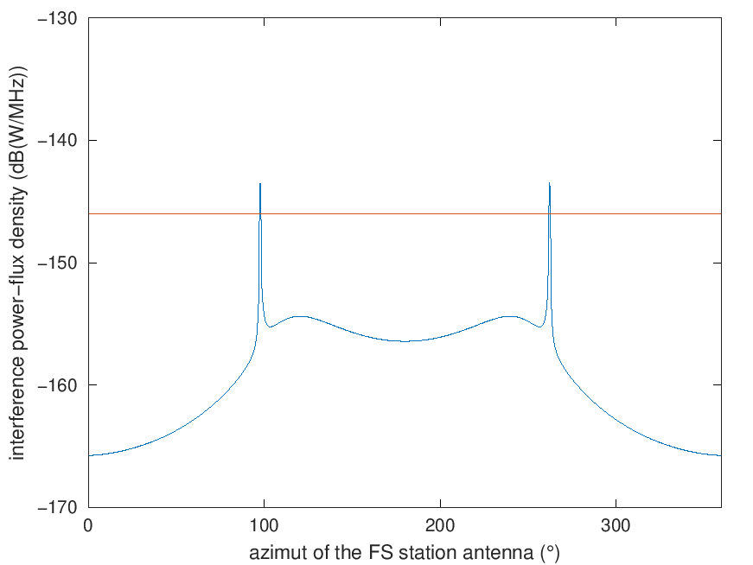}

**8.1.1.2 Scenario 2: Single Interferer (GSO Satellite, Dynamic Analysis)**

The following GSO FSS characteristics were extracted from Attachment 2 of this document which was liaised from Working Party 4A (Document 5C/142).

Table 6

**Parameters of the GSO FSS System**

| **Parameter** | **System C (Satellite)** | **System C (Earth Station)** |
| --- | --- | --- |
| Frequency (GHz) | 71-76 | 81-86 |
| Altitude (km) | 35,786 | N/A |
| Number of planes | 1 | N/A |
| Satellites per plane | 1 | N/A |
| Inclination angle (deg) | 0 | N/A |
| RAAN | N/A | N/A |
| Antenna Pattern | Appendix 7 Annex 3 Section 3  G1= ‒13 dB  Beamwidth = 0.42 deg | S.580 |
| Peak antenna gain (dBi) | 50 | 50 (D:0.6 m) |
| Input power density (dBW/Hz) | ‒77.8[3] | -77.8 |
| Minimum Elevation Angle (degrees) | 3 | 3 |
| Bandwidth (MHz) | 180 | 180 |
| Out of band emission mask | SM.1541-6 | SM.1541-6 |
| Number of co-frequency beams (N_co) | 1 | 1 |
| Max Power Flux Density on the ground  dBW/m2/MHz | -129.85 | N/A |
| Worst[4] Earth station density per 2 000 000 km2 | N/A | 25 |



The analysis was conducted assuming that the FS system was operating at locations at the following latitude/longitude: 39.6° N, and 104.6° W. For the FS system, the FS receiver antenna is pointing directly at another FS station whose location is randomized within a 0.4 to 3 km circle of the receiver.

FIGURE X

Methodology Flow Chart

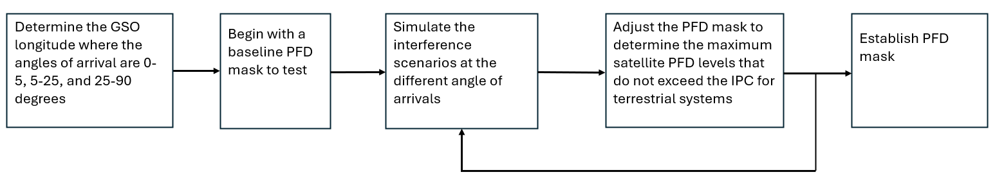

The analysis produced a cumulative distribution function (CDF) curve for the I/N levels received by the FS which was then compared to the I/N protection criteria of FS.

The following assumptions were made during the analysis:

• The location of the GSO satellite is 0° N and the longitude is randomized in a uniform distribution

• The polarization of the FSS GSO satellite and FSS ES is RHCP. The polarization of the FS is linear

• Polarization mismatch loss is 3dB.

• The elevation angle of the FS ranges from -5 to +5 degrees in a uniform distribution

Study results

The results are presented in the following plots. In the following figures, the FS receiving station I/N is plotted as a cumulative distribution function (CDF).

Two simulations were run. In the first simulation, no provision for avoiding mainbeam coupling between the FS receiver and the satellite. For the second simulation, the FS receiver antenna pointing angles were restricted such that the antenna main beam was never directed within 1.5 degrees of the satellite[5]. This resulted in two possible PFD limits for the FSS GSO satellite.

TABLE 7

**PFD Mask of GSO Satellite, No Avoidance**

|  |  |  |  |  |  |
| --- | --- | --- | --- | --- | --- |
| Frequency Band | System | Limit in dB(W/m2) for angles  of arrival (δ) above the horizontal plane | | | Reference Bandwidth |
| 0°-5° | 5°-25° | 25°-90° |
| 71-76 GHz | Fixed-satellite (geostationary-satellite orbit) | -115 | | | 1 MHz |

FIGURE X

**FS receiver I/N CDF plot, No Avoidance Angle**

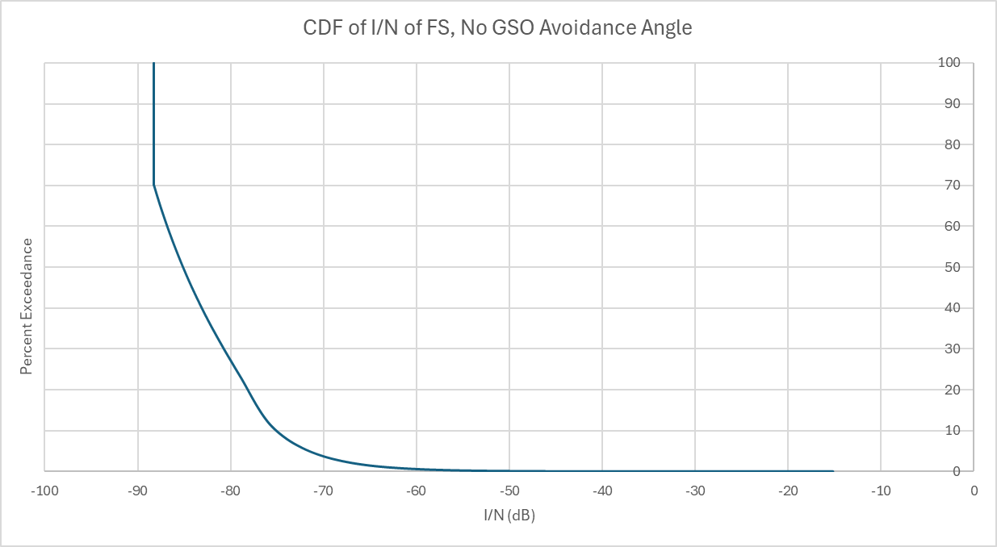

TABLE 8

**PFD Mask of GSO Satellite, 1.5° avoidance angle**

|  |  |  |  |  |  |
| --- | --- | --- | --- | --- | --- |
| Frequency Band | System | Limit in dB(W/m2) for angles  of arrival (δ) above the horizontal plane | | | Reference Bandwidth |
| 0°-5° | 5°-25° | 25°-90° |
| 71-76 GHz | Fixed-satellite (geostationary-satellite orbit) | -92 | | | 1 MHz |

Figure X

**FS receiver I/N CDF plot, 1.5° avoidance angle**

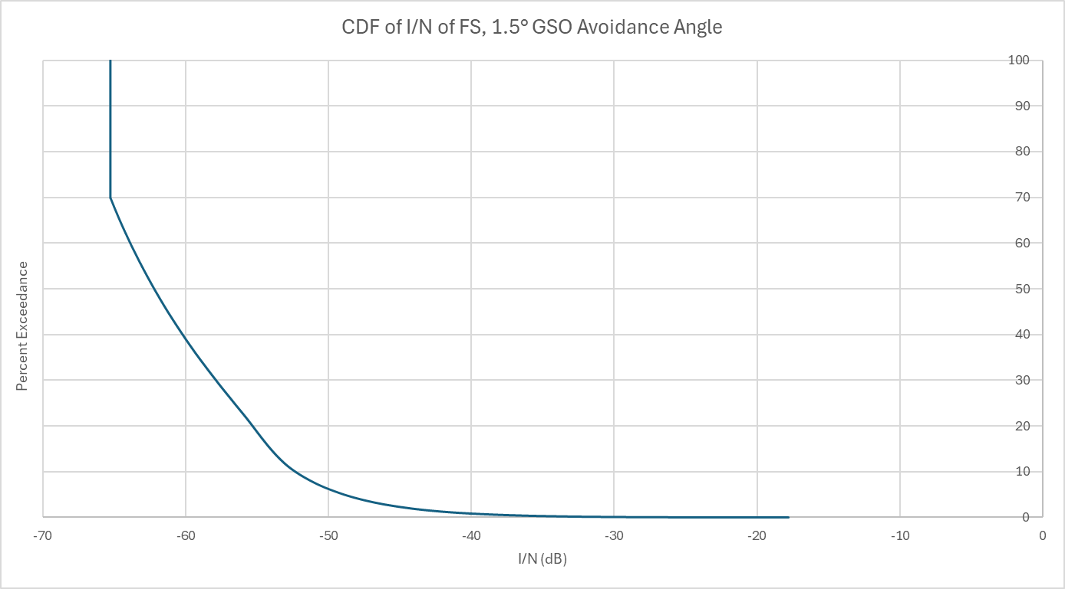

**8.1.2 Sharing with non-GSO satellites**

Recommendation ITU-R F.1108-4 – *Determination of the criteria to protect fixed service receivers from the emissions of space stations operating in non-geostationary orbits in shared frequency bands* contains equations to simulate the operation of a non-GSO satellite and thereby the statistics necessary to determine how often a satellite will be visible in any direction for a particular terrestrial station or position.

**8.1.2.1 Scenario 1**

Station(s) of the fixed service are defined with the parameters of the following table.

Table 6

**Parameters of the station of the fixed service**

|  |  |  |
| --- | --- | --- |
| **Parameter** | **Value** | **Source** |
| Latitude (°) | 0, 25, 50, 75 |  |
| Longitude (°) | 0 |  |
| Altitude (m) | 30 |  |
| Antenna elevation (0) | 0, 2.5, 5 | Rec. ITU-R F.2086 |
| Azimut (°) | 0, 60, 120, 180 |  |
| Antenna diameter (cm) | 20, 30 or 60 |  |
| Antenna diagram |  | Rec. ITU-R F.1245 |
| Max antenna gain |  | Rec. ITU-R F.699 |
| *I/N* (dB) long-term | ‒10 | Rec. ITU-R F.758 |
| Nominal long-term interference power density (dBW/MHz) | ‒146 | Rec. ITU-R F.758 |
| *I/N* (dB) short-term | [TBD] |  |
| Nominal short-term interference power density (dBW/MHz) | [TBD] |  |

Compliance with the short-term and long-term protection criteria is assessed for several tentative pfd masks.

A sensitivity analysis is provided to assess the influence of:

‒ the number of satellites in the non-GSO system (1, 10, 100, 1 000, 10 000, 100 000), or other numbers of satellites in line with the elements provided by WP 4A, and

‒ altitude of the non-GSO satellites.

**8.2 Methodology for assessment of candidate pfd masks**

**8.2.1 Existing pfd masks in RR Article 21**

RR Article **21**, and more specifically Table 21-4, provides pfd limits that shall not be exceeded by emissions from a space station, for all conditions and for all methods of modulation.

Table 5

**Extract of RR Table 21-4 in the frequency range 42-42.5 GHz**

|  |  |  |  |  |  |  |
| --- | --- | --- | --- | --- | --- | --- |
| **Frequency band** | **Service**\* | **Limit in dB(W/m2) for angles of arrival (δ) above the horizontal plane** | | | | **Reference bandwidth** |
| **0°-5°** | **5°-25°** | | **25°-90°** |
|  |  |  |  | |  |  |
| 40-40.5 GHz | Fixed-satellite  Mobile-satellite | −115 | −115 + 0.5(δ − 5) | | −105 | 1 MHz |
|  |  |  |  | |  |  |
| 42-42.5 GHz | Fixed-satellite (non-geostationary-satellite orbit)  Broadcasting-satellite  (non-geostationary-satellite orbit) | −12011, 21 | **5°-25°** | | −105 11, 21 | 1 MHz |
| −120 + 0.75(δ − 5)11, 21 | |
| 42-42.5 GHz | Fixed-satellite (geostationary-satellite orbit)  Broadcasting-satellite  (geostationary-satellite orbit) | −12721 | **5°-20°** | **20°-25°** | −10521 | 1 MHz |
| −127 + (4/3) (δ − 5)21 | −107 + 0.4 (δ − 20)21 |

The pfd is the power flux density produced on earth’s surface.

These pfd limits are defined as a function of the angle of arrival above the horizontal plane and are, therefore, purely geometrically defined. These pfd mask could be starting point for studies under this agenda item

**8.2.2 Calculation of the angle of arrival and separation angle**

The angle of arrival above the horizon can be calculated with the position of a victim station and the position of a space station.

With orbital characteristics collected by WP 5C from data provided by WP 4A ([5C/142](https://www.itu.int/md/meetingdoc.asp?lang=en&parent=R23-WP5C-C-0142)), WP 4C ([5C/143](https://www.itu.int/md/meetingdoc.asp?lang=en&parent=R23-WP5C-C-0143)) and the radiocommunication bureau ([5C/148](https://www.itu.int/md/meetingdoc.asp?lang=en&parent=R23-WP5C-C-0148)), it is possible to know the position of satellites at any given moment in time. Coordinates are then projected in a common east, north, up (ENU) reference frame, centred on the terrestrial station, in order to calculate:

‒ the angle of arrival θelev above the horizon, and

‒ the separation angle φsep, between the direction of the antenna of the terrestrial station and the direction of the space station.

This calculation makes no distinction between satellites above or below minimum elevation angle.

**8.2.3 Calculation of the power of the interfering signal**

Knowing the separation angle φsep, Recommendation ITU-R F.1245-3 can be used to calculate the antenna gain in the direction of the space station . The level of interference can then be evaluated with the effective antenna aperture *Ae*:

(dB m2) (1)

where  is the wavelength (m).

(dB W/MHz) (2)

The formula above doesn’t take into account atmospheric losses, as the pfd is given at the level of the ground in accordance with RR Article **21.16** which provides that “*The power flux-density at the Earth’s surface produced by emissions from a space station, including emissions from a reflecting satellite, for all conditions and for all methods of modulation, shall not exceed the limit given in Table* ***21-4****. The limit relates to the power flux-density which would be obtained under assumed free-space propagation conditions and applies to emissions by a space station of the service indicated where the frequency bands are shared with equal rights with the fixed or mobile service, unless otherwise stated.” Further consideration may be required regarding* atmospheric losses to assess whether these need further consideration or not.

**8.2.4 Schematic diagram**

FIGURE1

**Calculation of the power of interference**

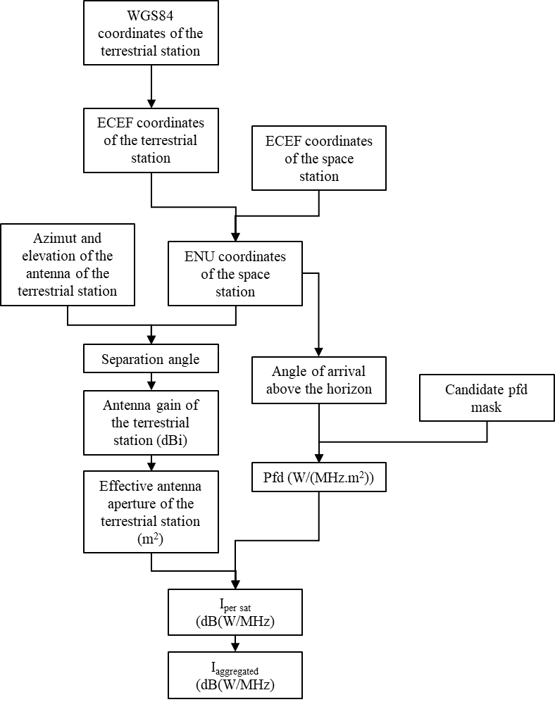

**8.2.5 Repeated calculation over time and for various hypothesis**

The above calculation can be repeated for different moments in time over a given period. The period should be long enough to take into account all possible geometries for the non-GSO system(s) under consideration and have enough data to produce stable statistics.

Due to the high antenna discrimination of 30 cm and 60 cm antenna dishes around 80 GHz, in order not to miss an event where a satellite is crossing the main beam of the terrestrial station antenna, the minimum step of calculation should be somewhere in a range between 1 and 5 seconds.

In order to compare results to low percentages of times, like 0.00128%. The dataset should be around 100/0.00128*100 ≈ 78.125×105 events, equivalent to ~30 days with steps of 0.33 s.

To minimise time taken for simulations, 3, 10 and 31 days were used.

**8.2.6 Sensitivity analysis**

In application of the methodology described above, this section provides calculation examples to investigate the influence of some parameters of the fixed service on calculation results. Therefore, these results are subject to further discussions and refinement.

**8.2.6.1 Common input data**

**8.2.6.1.1 Satellite systems under consideration**

Information on systems to be considered in studies are grouped in Annexes 2 and 3.

In this section, systems I, J, K, N and Q are used. This selection of system is arbitrary and simulation results may be updated at a later stage, to take into account developments for example, aggregation of interference from all visible satellites.

**8.2.6.1.2 Pfd masks**

In this document, pfd masks of the following table are studied as a staring point.

Table 6

**Pfd masks used in this document**

|  |  |  |  |  |  |
| --- | --- | --- | --- | --- | --- |
| **Mask** | **Limit in dB(W/m2) for angles of arrival (δ) above the horizontal plane** | | | | **Reference bandwidth** |
| Pfd mask 01 | 0°-5° | 5°-25° | | 25°-90° | 1 MHz |
| −115 | −115 + 0.5(d − 5) | | −105 |
| Pfd mask 02 | 0°-5° | 5°-20° | 20°-25° | 25°-90° | 1 MHz |
| −127 | −127 + (4/3) (δ − 5) | −107 + 0.4 (δ − 20) | −105 |
| Pfd mask 03 | 0°-5° | 5°-25° | | 25°-90° | 1 MHz |
| −120 | −120 + 0.75 (d − 5) | | −105 |

**8.2.6.2 Effect of FS station latitude**

Table 7

**Extract of RR Table 21-4 in the frequency range 42-42.5 GHz**

|  |  |  |
| --- | --- | --- |
| Parameter | Value | Unit |
| Number of victim stations | 9 | - |
| Longitude | 0 | ° |
| Latitude | 0-80 | ° |
| Azimuth | 0, 45, 90, 135, 180 | ° |
| Up tilt | 1 | ° |
| Antenna diameter | 60 | ° |
| Satellite systems | I, J, K and N | - |
| pfd mask | 01 | - |

The following figures show 9 cumulative distribution functions (CDF) corresponding to stations of the fixed service with latitudes from 0 to 80°. Other parameters are described in the above table.

Each curve represents the probability that an interference power is exceeded for more than a given percentage of time.

**8.2.6.2.1 Azimuth 0°**

*{3 days at 0.33 seconds per steps}*

FIGURE2

**CDF for 9 stations of the FS with different latitudes, azimuth 0°**

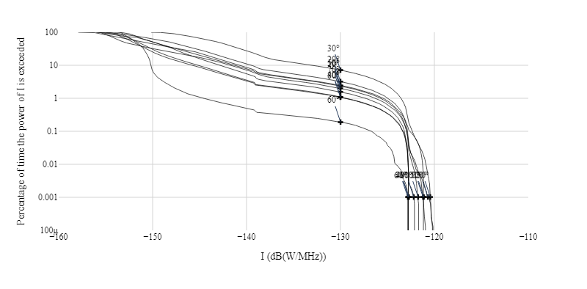

FIGURE3

**CDF for 9 stations of the FS with different latitudes, azimuth 0° (zoom short-term)**

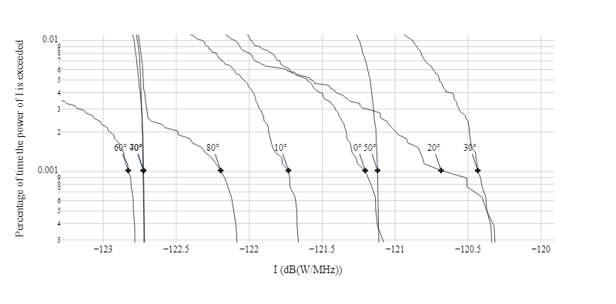

FIGURE4

**CDF for 9 stations of the FS with different latitudes, azimuth 0° (zoom long-term)**

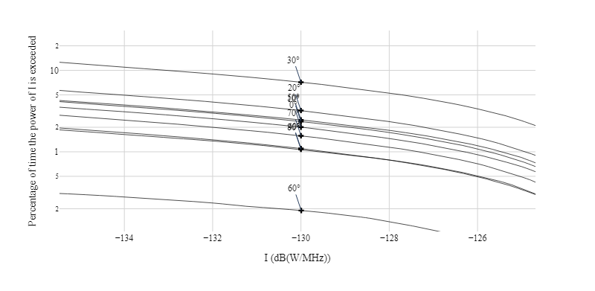

**8.2.6.2.2 Azimuth 45°**

*{3 days at 0.33 seconds per steps}*

FIGURE5

**CDF for 9 stations of the FS with different latitudes, azimuth 45°**

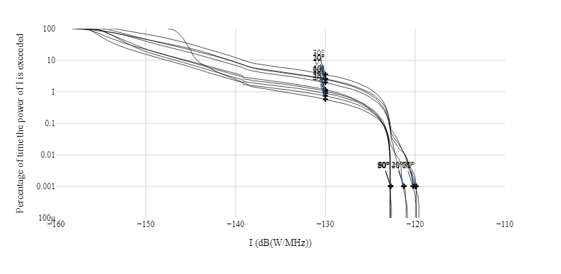

FIGURE6

**CDF for 9 stations of the FS with different latitudes, azimuth 45° (zoom short-term)**

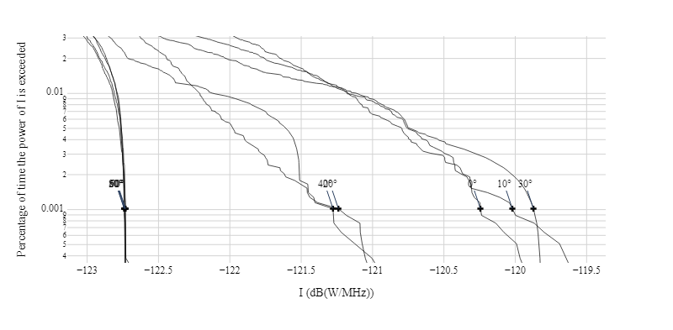

FIGURE7

**CDF for 9 stations of the FS with different latitudes, azimuth 45° (zoom long-term)**

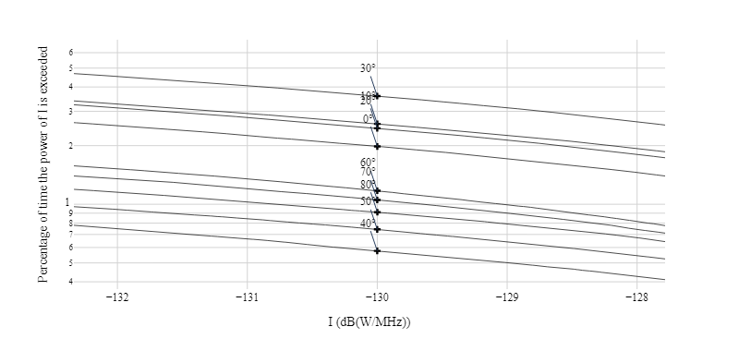

**8.2.6.2.3 Azimuth 90°**

*{3 days at 0.33 seconds per steps}*

FIGURE8

**CDF for 9 stations of the FS with different latitudes, azimuth 90°**

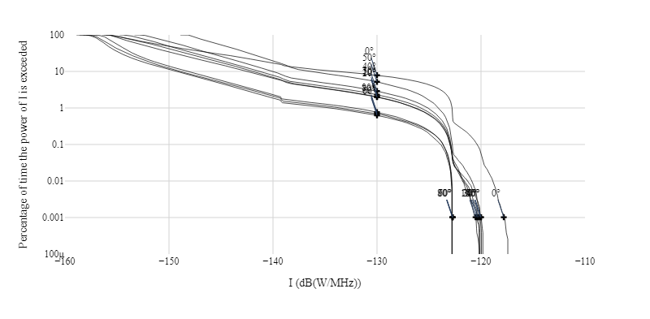

FIGURE9

**CDF for 9 stations of the FS with different latitudes, azimuth 90° (zoom short-term)**

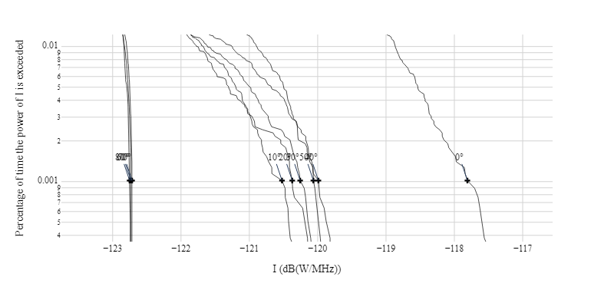

FIGURE10

**CDF for 9 stations of the FS with different latitudes, azimuth 90° (zoom long-term)**

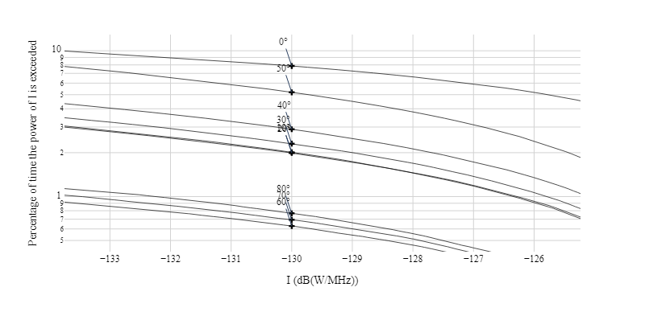

Because system I has an orbital plan in the equatorial plan, a station at latitude 0° with an antenna pointing towards East (i.e. 90° of azimuth) will receive higher levels of long-term interference.

**8.2.6.2.4 Azimuth 135°**

*{3 days at 0.33 seconds per steps}*

FIGURE11

**CDF for 9 stations of the FS with different latitudes, azimuth 135°**

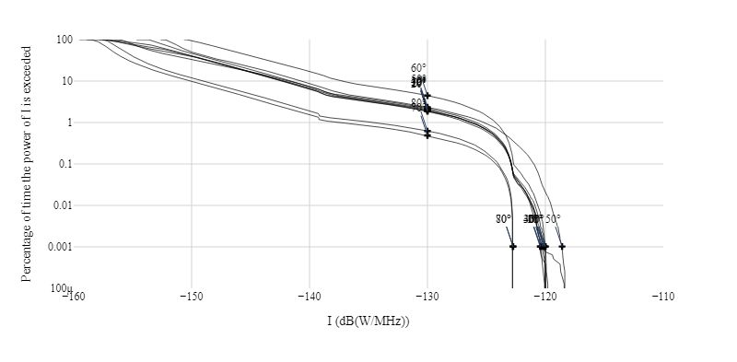

FIGURE12

**CDF for 9 stations of the FS with different latitudes, azimuth 135° (zoom short-term)**

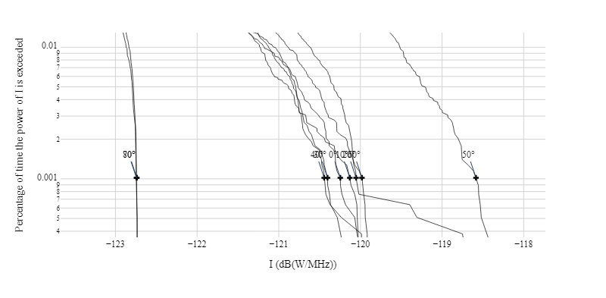

FIGURE13

**CDF for 9 stations of the FS with different latitudes, azimuth 135° (zoom long-term)**

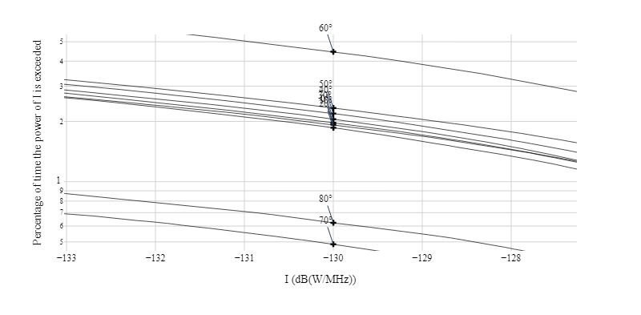

**8.2.6.2.5 Azimuth 180°**

*{3 days at 0.33 seconds per steps}*

FIGURE14

**CDF for 9 stations of the FS with different latitudes, azimuth 180°**

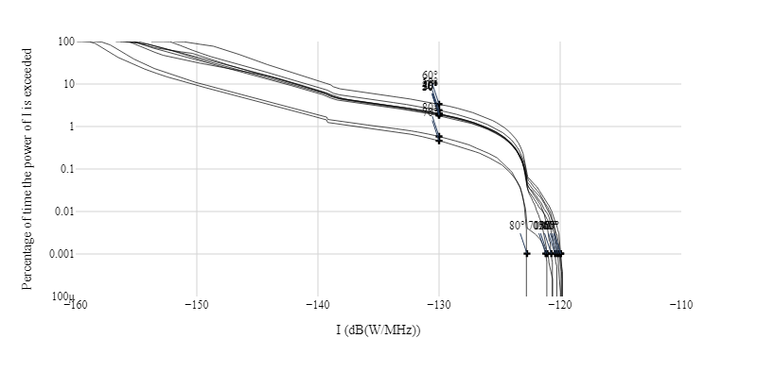

FIGURE15

**CDF for 9 stations of the FS with different latitudes, azimuth 180° (zoom short-term)**

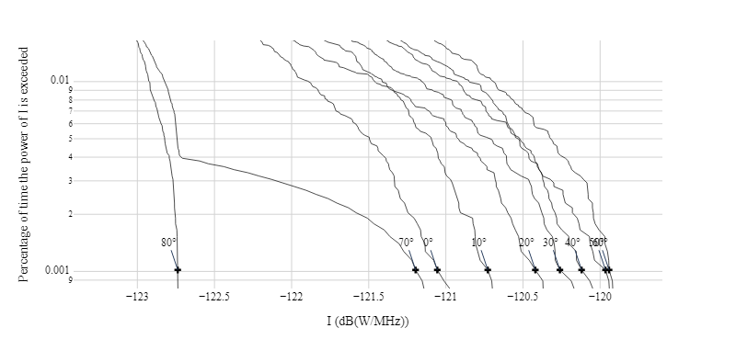

FIGURE16

**CDF for 9 stations of the FS with different latitudes, azimuth 180° (zoom long-term)**

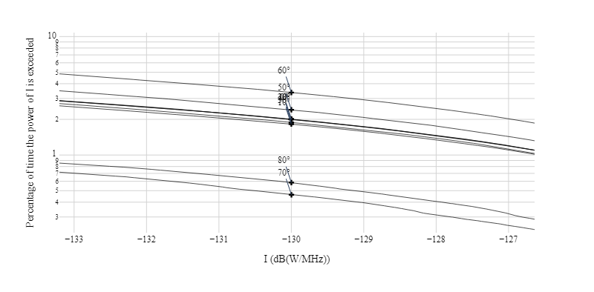

**8.2.6.2.6 Observations**

The above CDFs show that the worst latitude varies with the FS antenna azimuth, and that for a given FS antenna azimuth, the worst latitude for the short-term interference is not necessarily the same as the worst latitude for the long-term interference.

**8.2.6.3 Effect of FS antenna diameter**

Table 8

**Parameters**

|  |  |  |
| --- | --- | --- |
| **Parameter** | **Value** | **Unit** |
| Number of victim stations | 3 | - |
| Longitude | 0 | ° |
| Latitude | 48 | ° |
| Azimuth | 90 | ° |
| Up tilt | 1 | ° |
| Antenna diameter | 20, 30 or 60 | ° |
| Satellite systems | I, J, K and N | - |
| pfd mask | 01 | - |

The following figure shows 3 cumulative distribution functions (CDF) corresponding to stations of the fixed service with antennas of 30 or 60 cm diameters. These CDFs represent the percentage of time a given interference power is exceeded.

*{31 days at 0.33 seconds per steps}*

FIGURE17

**CDF for antennas of diameters 30 and 60 cm**

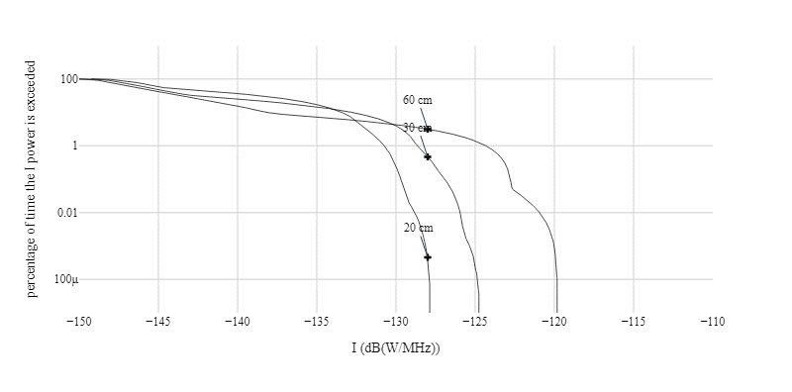

For low percentages of time (when considering the short-term protection criterion), 60 cm antennas will be more prone to interference because their maximum gain is around 6 dB higher than the maximum gain of 30 cm antennas.

For higher percentages of time, 20 and 30 cm antennas have less selectivity with higher side lobes compared to 60 cm antennas. Nonetheless, for higher numbers of satellites, the probability that a satellite crosses the main antenna beam may exceed 20%.

Therefore, when considering compliance with the long-term protection criterion, it may be useful to study antennas of various diameters: from 20 to 60 cm.

**8.2.6.4 Effect of FS up tilt**

Table 9

**Extract of RR Table 21-4 in the frequency range 42-42.5 GHz**

|  |  |  |
| --- | --- | --- |
| **Parameter** | **Value** | **Unit** |
| Number of victim stations | 6 | - |
| Longitude | 0 | ° |
| Latitude | 48 | ° |
| Azimuth | 90 | ° |
| Up tilt | 0 to 5 | ° |
| Antenna diameter | 60 | ° |
| Satellite systems | I, J, K and N | - |
| pfd mask | 02 | - |

The following figure shows 6 CDFs, giving the percentage of time a given level of interference is exceeded.

*{31 days at 0.33 seconds per steps}*

FIGURE18

**CDFs for antenna tilt in the range 0 to 5°**

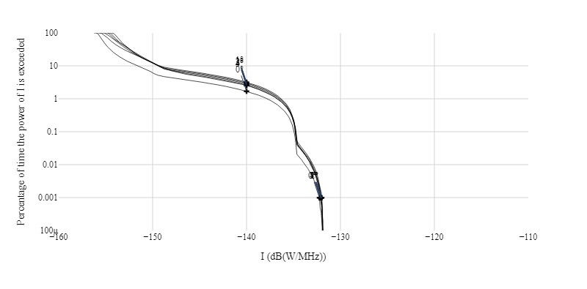

FIGURE19

**CDFs for antenna tilt in the range 0 to 5°,** zoom **long-term**

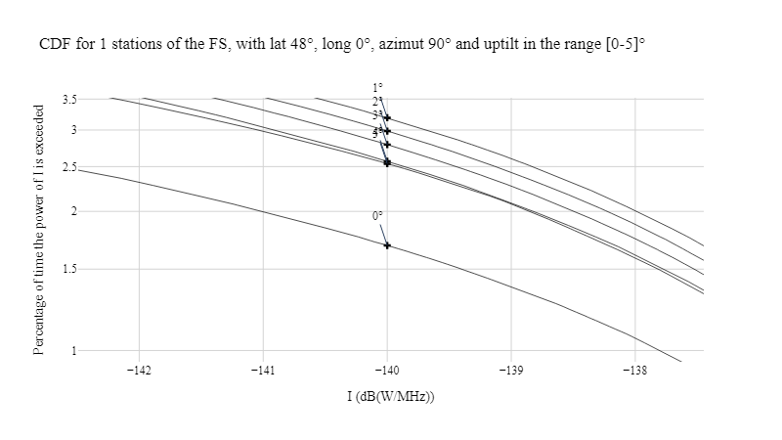

For the short-term interference assessment, even with thousands of satellites, no definitive conclusion can be drawn.

Still, 1 or 2° of up tilt may be an appropriate choice, as the main beam of the antenna would stay in the lower part of the pfd mask.

**8.2.6.5 Effect of the number of satellites**

The parameters of the following table are used in this section.

Table 10

|  |  |  |
| --- | --- | --- |
| **Parameter** | **Value** | **Unit** |
| Number of victim stations | 3 | - |
| Longitude | 0 | ° |
| Latitude | 48 | ° |
| Azimuth | 90 | ° |
| Up tilt | 2 | ° |
| Antenna diameter | 60 | cm |
| pfd mask | 01 | - |
| Satellite systems | J, K & Q | - |

**8.2.6.5.1 System J (864 satellites)**

The following CDFs represent the percentage of time a given level of interference is exceeded, for various FS antennas azimuths.

*{10 days at 0.33 seconds per steps}*

FIGURE20

**CDFs for azimuths 90, 135 and 180°**

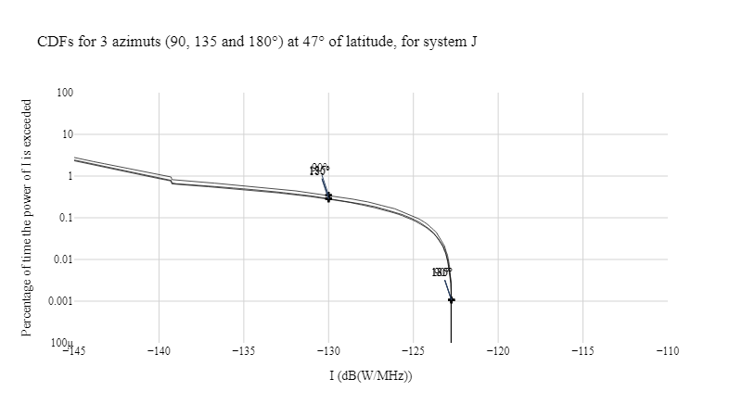

FIGURE21

**CDFs for azimuths 90, 135 and 180° (zoom long-term)**

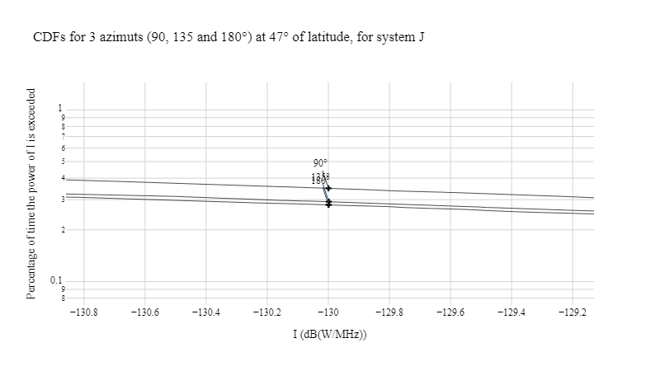

**8.2.6.5.2 System K (5 952 satellites)**

The following CDFs represent the percentage of time a given level of interference is exceeded, for various FS antennas azimuths.

*{10 days at 0.33 seconds per steps}*

FIGURE22

**CDFs for azimuths 90, 135 and 180°**

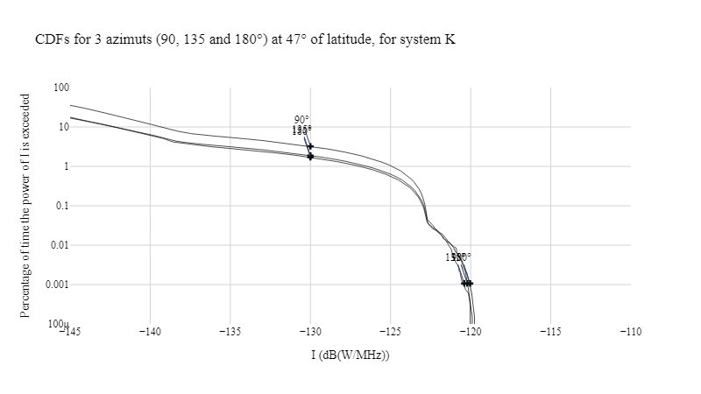

**8.2.6.5.3 System Q (67 744 satellites)**

The following CDFs represent the percentage of time a given level of interference is exceeded, for various FS antennas azimuths.

*{10 days at 0.33 seconds per steps}*

FIGURE23

**CDFs for azimuths 90, 135 and 180°**

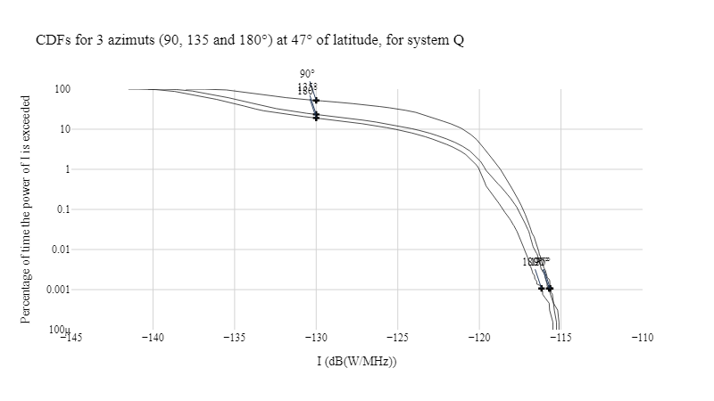

**8.2.6.5.3.1 Observations**

At a latitude of 47°, an antenna at 90° of azimuth will receive higher level of interference compared to 135 and 180° of azimuth.

The size of the system influences the long-term interference.

But its influence on the short-term interference may be further investigated.

**8.2.7 Observations**

The pfd value provided by a pfd mask in this document is independent of propagation conditions and clutter.

These preliminary study results show the influence of several parameters on the level of short-term and long-term interference, without any conclusions about the protection of FS in the 71-76 GHz

These results show that studies should consider a range of parameters for sensitivity analysis for the fixed service, including:

‒ Latitude in the range 0 to +/-80°

‒ Elevation in the range 0 to 4 or 5°

‒ Azimuths without limitations

‒ Antenna diameters: 20 to 60 cm.

*{from 5C/183, similar to 5C/166}*

**8.3 Methodology for the consideration on pfd masks**

One target of Agenda Item 1.10 is to determine power flux-density (pfd) limits to be included in RR Article **21** for downlink satellite services to protect the current and planned FS and MS in the frequency bands 71-76 GHz and 81-86 GHz.

Pfd mask is the power flux density emitted from Satellite at the surface of the receiver in victim station, regardless of transmitting power of Satellite, antenna gain of Satellite and propagation conditions.

The study uses the pfd mask in the frequency range 49.44-50.2 GHz in table 21-4 in *Radio Regulation 2024*, as shown in Fig 1, to evaluate the methodology and interference from non-GSO downlink to FS stations in AI 1.10. This contribution provides preliminary simulation results and relevant analysis under this pfd mask, and iterations will be done later and provided in future meetings to find out an appropriate pfd mask limit, to be applied for AI 1.10.

It is assumed that in the study, every Satellite works at the same time, and emits energy according to the pfd mask.

Figure 1

**Mask used in the study from *Radio Regulation 2024***

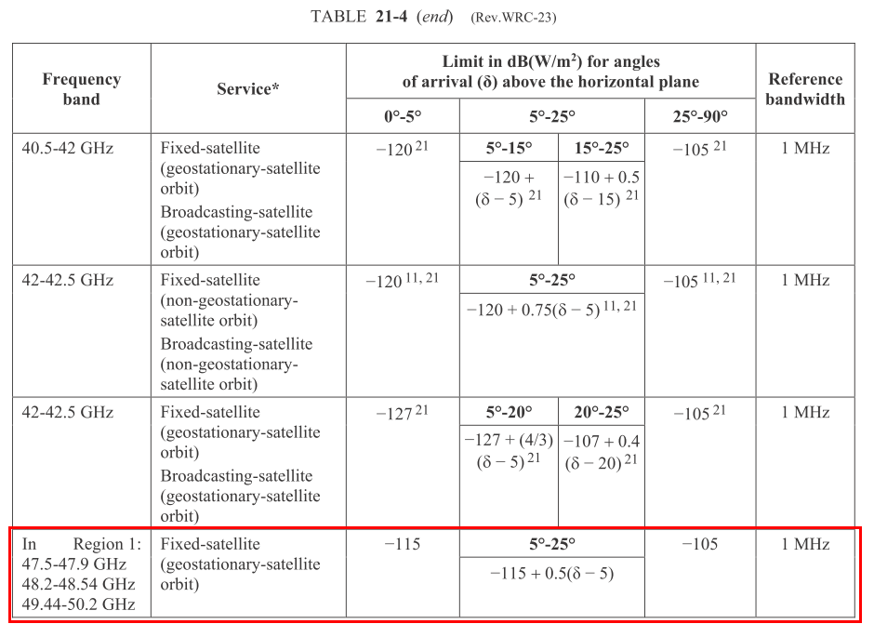

**8.3.1 Determination of interference to FS station**

The following scheme is used to determine the interference from non-GSO Satellite to FS station.

Figure 2

**Scheme to calculate interference from non-GSO Satellite to FS station**

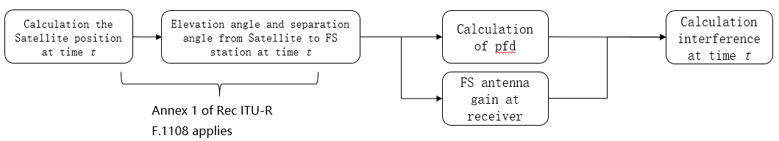

Annex 1 of Recommendation ITUR F.1108 is used to determine visibility statistics of space stations operating in circular non-GSO orbits as seen by a terrestrial station.

The elevation angle and separation angle at time *t* could be calculated according to the algorithms provided by above Annex 1 of Recommendation ITUR F.1108. The interference then could be calculated as:

(1)

Where,

is the elevation angle of Satellite of the satellite above the horizon of the terrestrial station, assuming a horizon angle of 0°;

is the angular distance from the main beam of this terrestrial station antenna to the satellite;

● is the wavelength (m).

**8.3.2 Statistic of the interference over a certain time period**

Calculations according to above scheme has been done over a certain time period, to acquire a statistic of the interference. In order to implement short-term interference over 0.00128%, calculation step of 0.33 second over 10 days has been applied to all the simulations.

**8.3.3 FS parameters and Satellite parameters used in the simulation**

The following general FS parameters listed in table 1 are used in each simulation.

Table 1

**FS parameters used in each simulation**

|  |  |
| --- | --- |
| **System parameters** | **Typical Value** |
| Channel spacing and receiver noise bandwidth (MHz) | 500 |
| Modulation | 128 QAM |
| Feeder/multiplexer loss (dB) | 0 |
| Antenna gain (dBi) | 51 |
| Antenna size (m) | 0.6 |
| Receiver noise figure (dB) | 7 |
| Antenna height(m) | 30 |
| Antenna RPE | F.1245-3 |
| Link length (km) | 3 |
| Noise floor (dBW/MHz) | -137 |

Satellite System B (3236 Satellites), L (19708 Satellites), M (27900 Satellites) and N (36 Satellites) from WP5C Working Document on AI 1.10 ([Annex 2.4 to Document 5C/152](https://www.itu.int/dms_ties/itu-r/md/23/wp5c/c/R23-WP5C-C-0152!N02.04!MSW-E.docx)) have been used in aggregated interference simulations, and Satellite systems B, L, M, N and Q (67744 Satellites) have been used separately in single satellite system simulations.

**8.3.4 Simulation results**

**8.3.4.1 Results of different latitude and azimuth**

Table 2 shows the conditions of simulation of different latitude and azimuth.

Table 2

**Conditions of simulation of different latitude and azimuth**

|  |  |
| --- | --- |
| **Condition items** | **Values** |
| Satellite systems | B,L,M,N（aggregated interference from all the system mentioned） |
| Longitude (degree) | 0 |
| Latitude (degree) | 0, 5, 15, 25, 35, 45, 55, 65, 75 |
| Azimuth (degree) | 0, 30, 60, 120, 150, 180 |
| Elevation angle (degree) | 2 |

Figures 3-11 show the simulation result of different latitude.

Figure 3

**Interference CDF at latitude of 0 degree for different azimuth**

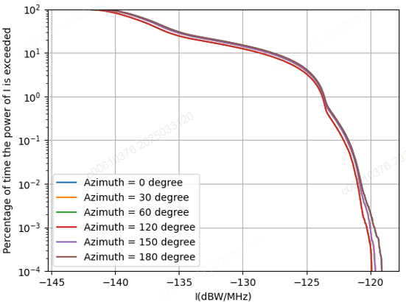

Figure 4

**Interference CDF at latitude of 5 degree for different azimuth**

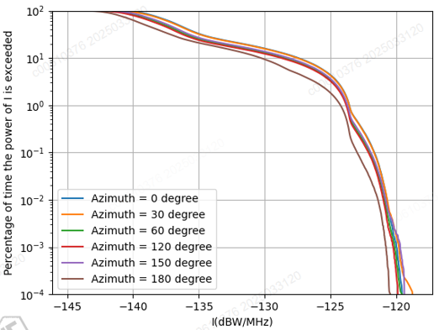

Figure 5

**Interference CDF at latitude of 15 degree for different azimuth**

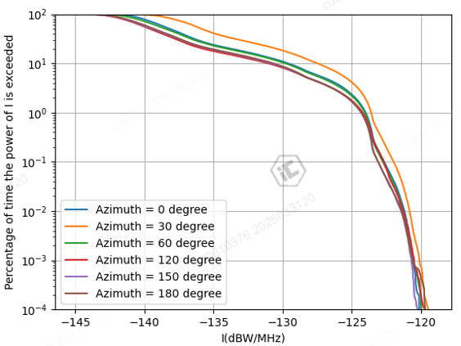

Figure 6

**Interference CDF at latitude of 25 degree for different azimuth**

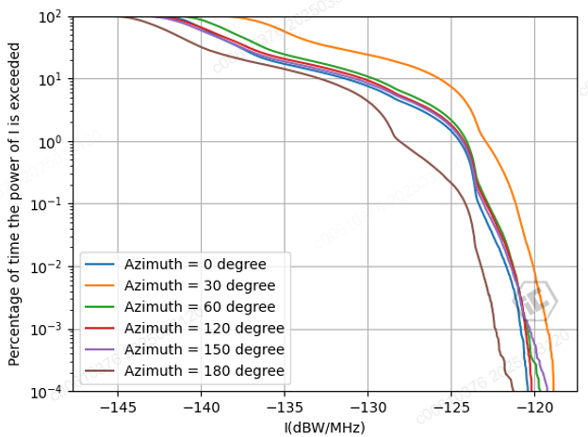

Figure 7

**Interference CDF at latitude of 35 degree for different azimuth**

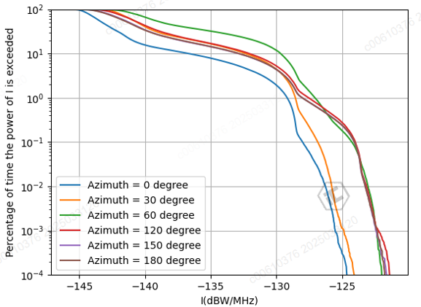

Figure 8

**Interference CDF at latitude of 45 degree for different azimuth**

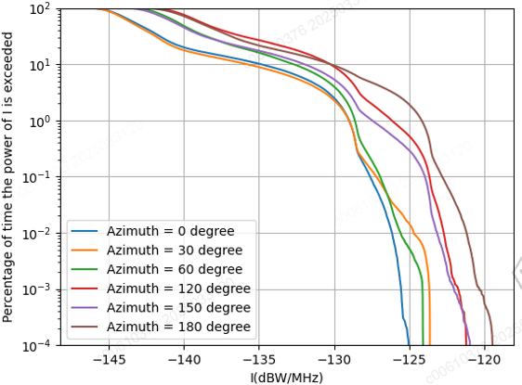

Figure 9

**Interference CDF at latitude of 55 degree for different azimuth**

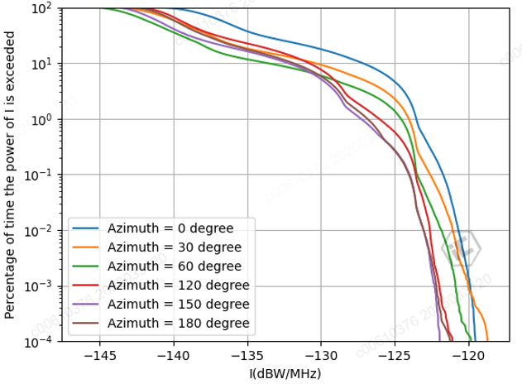

Figure 10

**Interference CDF at latitude of 65 degree for different azimuth**

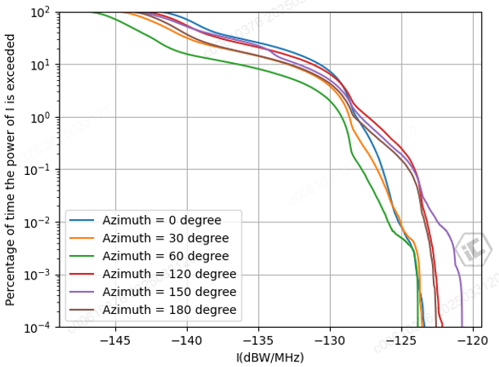

Figure 11

**Interference CDF at latitude of 75 degree for different azimuth**

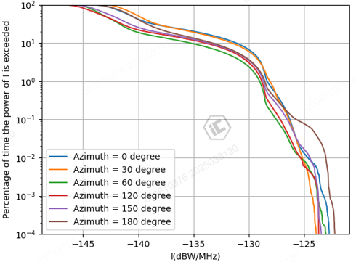

Figures 11-16 show the simulation result of different azimuth.

Figure 12

**Interference CDF at azimuth of 0 degree for different latitude**

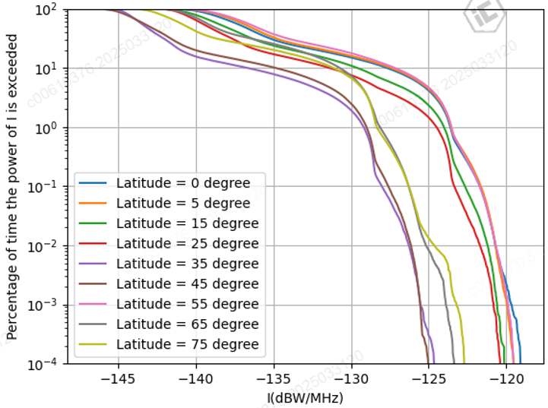

Figure 13

**Interference CDF at azimuth of 30 degree for different latitude**

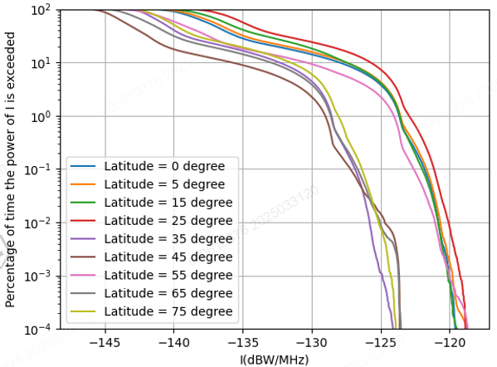

Figure 14

Interference CDF at azimuth of 60 degree for different latitude

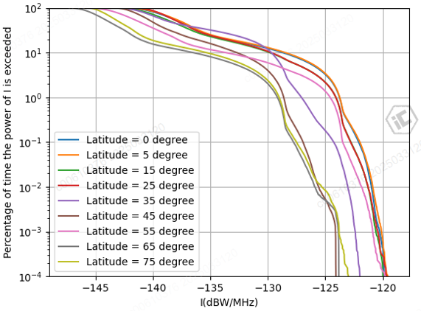

Figure 15

**Interference CDF at azimuth of 120 degree for different latitude**

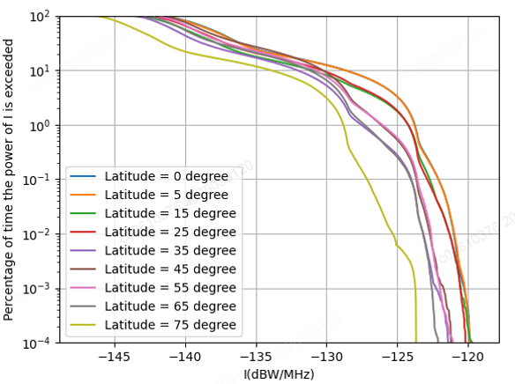

Figure 16

**Interference CDF at azimuth of 150 degree for different latitude**

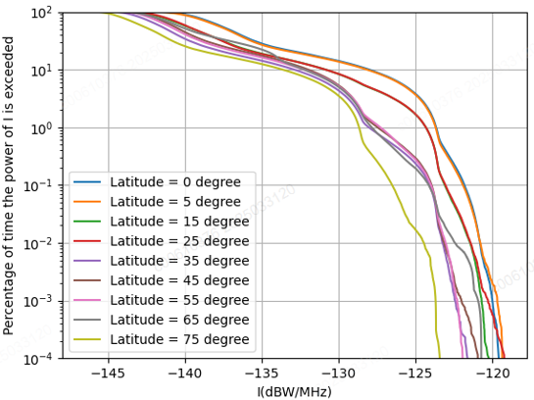

Figure 17

**Interference CDF at azimuth of 180 degree for different latitude**

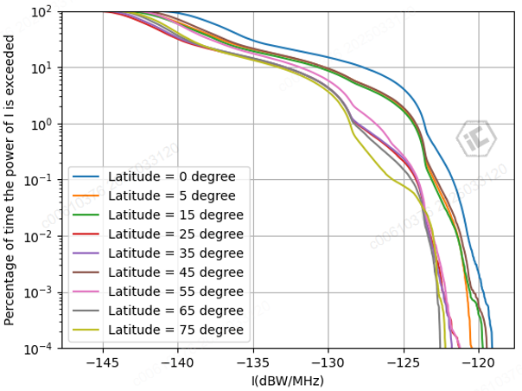

**8.3.4.2 Results of different elevation angle**

Table 3 shows the conditions of simulation of different elevation angle.

Table 2

**Conditions of simulation of different elevation angle**

|  |  |
| --- | --- |
| **Condition items** | **Values** |
| Satellite systems | B,L,M,N（aggregated interference from all the system mentioned） |
| Longitude (degree) | 116 |
| Latitude (degree) | 40 |
| Azimuth (degree) | 90 |
| Elevation angle (degree) | 0, 1, 2, 3, 4, 5, 20 |

Figures 18 show the simulation result of different elevation angle.

Figure 18

**Interference CDF at different elevation angle**

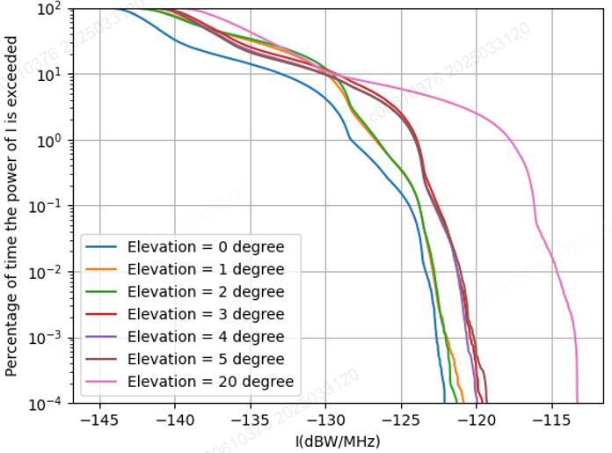

Figure 19

**Zoom in of different elevation angle at high interference level**

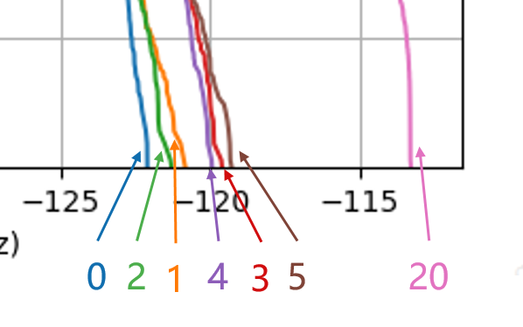

**8.3.4.3 Results of single Satellite system**

Table 4 shows the conditions of simulation of different single Satellite system.

Table 2

**Conditions of simulation of different single Satellite system**

|  |  |
| --- | --- |
| **Condition items** | **Values** |
| Satellite systems | B,L,M,N (aggregated interference from each Satellite system) |
| Longitude (degree) | 116 |
| Latitude (degree) | 40 |
| Azimuth (degree) | 0, 60, 120 |
| Elevation angle (degree) | 2 |

Figures 20-23 show the simulation result of different single Satellite system.

Figure 20

**Interference CDF for system B at different azimuth**

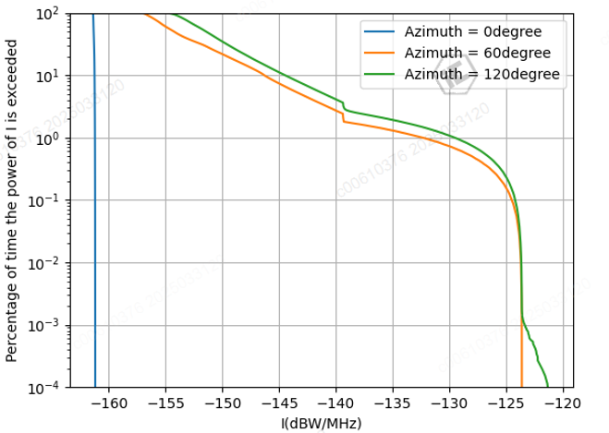

Figure 21

**Interference CDF for system L at different azimuth**

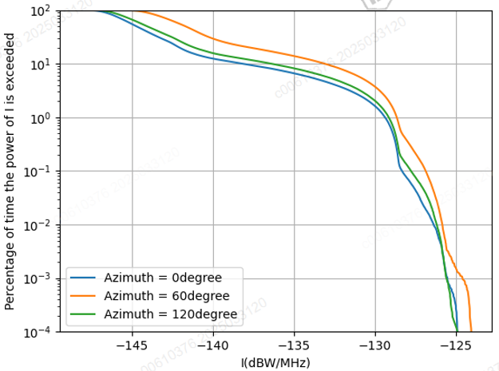

Figure 22

**Interference CDF for system M at different azimuth**

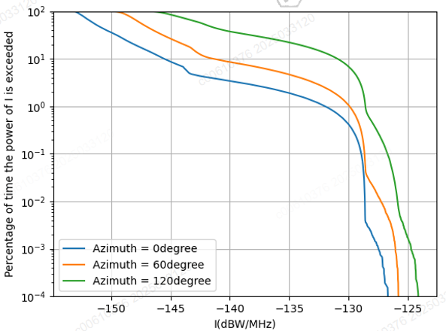

Figure 23

**Interference CDF for system N at different azimuth**

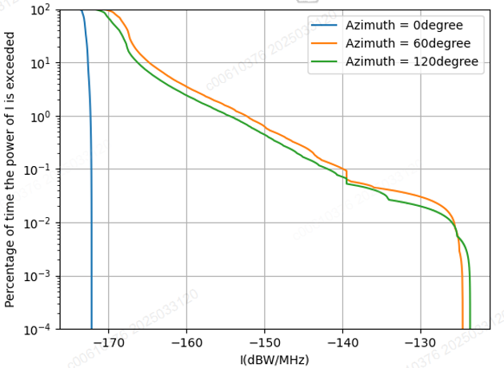

**8.3.4.4 Results of very large Satellite system**

Table 4 shows the conditions of simulation of very large Satellite system Q (67744 Satellites).

Table 2

**Conditions of simulation of very large Satellite system Q**

|  |  |
| --- | --- |
| **Condition items** | **Values** |
| Satellite systems | Q（aggregated interference from each Satellite system） |
| Longitude (degree) | 116 |
| Latitude (degree) | 40 |
| Azimuth (degree) | 0, 90, 180 |
| Elevation angle (degree) | 0, 2 |

Figures 24 show the simulation result of very large Satellite system Q.

Figure 23

**Interference CDF for system Q at different azimuth and different elevation angle**

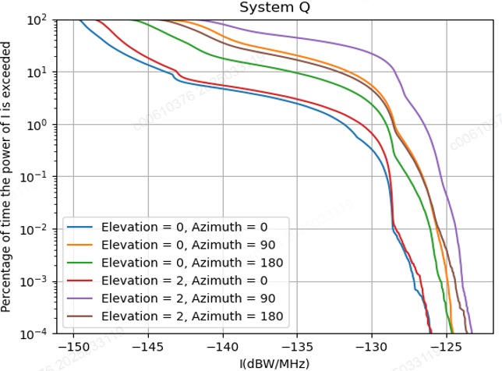

**8.3.4.5 Observation and Proposal**

It could be observed from the simulation results that,

1 Different conditions including different azimuth, different elevation angle, different latitude, etc., could have different simulation results.

2 The interference does not increase linearly with the increase of elevation angle.

3 In some cases, there is very large interference in a short time comparing to long-term interference, then the short-term protection is necessary to appropriately protect FS links.

It is suggested WP5C adopt the methodology in this contribution and take into consideration of the observations in this contribution for future study of the pfd mask.

**8.4 Methodology for the determination of equivalent isotropically radiated power (e.i.r.p.) limits**

*{next section from 5C/168}*

***8.4.1 Title TBD***

RR Article **21** contains the same e.i.r.p. mask for most frequency ranges, equal to 64 dBW/MHz for elevation angles below 0 degrees and equal to 64 + 3θ dBW/MHz for elevation angles up to 5 degrees. In order to assess the applicability of this mask for the considered frequency range the following analysis can be performed.

, (1)

where:

– basic transmission loss (based on Recommendation ITU-R P.452);

– e.i.r.p. of Earth station antenna according to the limit from RR Article **21** (64 dBW/MHz);

– antenna radiation pattern of FS station;

– FS sensitivity (from Recommendation ITU-R F.758).

The geometry of the scenario is shown in Figure 6.

Figure 6

**Geometry of the scenario**

Figure 7 shows two plots:

‒ the left plot: basic transmission loss calculated based on Recommendation ITU-R P.452, for the receive point on the level of the ground, the height of the Earth station is 0 m and 50 m;

‒ the right plot: the right side of equation (1), i.e. (minimum coupling loss)), the horizontal axis is FS off-axis angle .

The analysis doesn’t make any assumptions on FS pointing angle in respect of Earth station or tilt angle. As in order to meet FS protection criterion the basic transmission loss should be lower than the minimum coupling loss, these two graphs permit to find distance for any FS pointing to provide protection to FS station.

Figure 7

**E.i.r.p. level analysis**

**Conclusions**

Figure 7 above permits to assess the applicability of e.i.r.p. limit in the considered frequency range. For example, when FS antenna is pointing directly to the Earth station antenna () the distance will be about 250-300 km, but when FS station is pointing to the opposite direction, it will be less than 50 km.

*{Next section from 5C/188}*

**8.4.2 Sharing with GSO FSS Earth Stations**

The following GSO FSS characteristics were extracted from Attachment 2 of this document which was liaised from Working Party 4A (Document 5C/142).

Table 10

**Parameters of the GSO FSS System**

|  |  |  |
| --- | --- | --- |
| **Parameter** | **System C (Satellite)** | **System C (Earth Station)** |
| Frequency (GHz) | 71-76 | 81-86 |
| Altitude (km) | 35,786 | N/A |
| Number of planes | 1 | N/A |
| Satellites per plane | 1 | N/A |
| Inclination angle (deg) | 0 | N/A |
| RAAN | N/A | N/A |
| Antenna Pattern | Appendix 7 Annex 3 Section 3  G1= ‒13 dB  Beamwidth = 0.42 deg | S.580 |
| Peak antenna gain (dBi) | 50 | 50 (D:0.6 m) |
| Input power density (dBW/Hz) | ‒77.8[6] | -77.8 |
| Minimum Elevation Angle (degrees) | 3 | 3 |
| Bandwidth (MHz) | 180 | 180 |
| Out of band emission mask | SM.1541-6 | SM.1541-6 |
| Number of co-frequency beams (N_co) | 1 | 1 |
| Max Power Flux Density on the ground  dBW/m2/MHz | -129.85 | N/A |
| Worst[7] Earth station density per 2 000 000 km2 | N/A | 25 |

**8.4.2.1 Scenario 1: Single Interferer (GSO FSS ES, Dynamic Analysis)**

Station(s) of the fixed service are defined with the parameters of the following table.



The analysis was conducted assuming that both the FS system was operating at locations at the following latitude/longitude: 39.73° N, and 104.75° W. The location of the FS was randomized within a 40 km radius of the FSS ES that is stationed at the aforementioned location. The FS receiver antenna is pointing directly at another FS station whose location is randomized within a 0.4 to 3 km circle of the receiver.

The analysis produced a cumulative distribution function (CDF) curve for the I/N levels received by the FS which was then compared to the I/N protection criteria of FS.

The following assumptions were made during the analysis:

• The SRTM V3 (3 arc second, 90m) terrain profile data was used

• There is only 1 ES deployed at 39.73° N and 104.75° W

• The ES is pointing at the GSO satellite

• The elevation pointing angle of the ES is 5 degrees

• The EIRP of the ES is 79 dBW in accordance with RR Nos. 21.8

• The beamwidth of the FSS ES is 0.41 degrees

• The FSS ES antenna height is 10 m

• The polarization of the FSS GSO satellite and FSS ES is RHCP. The polarization of the FS is linear

• Polarization mismatch loss is 3 dB

Study results

The results are presented in the following plots. In the following figures, the FS receiving station I/N is plotted as a cumulative distribution function (CDF).

FIGURE X

**FS receiver I/N CDF plot**

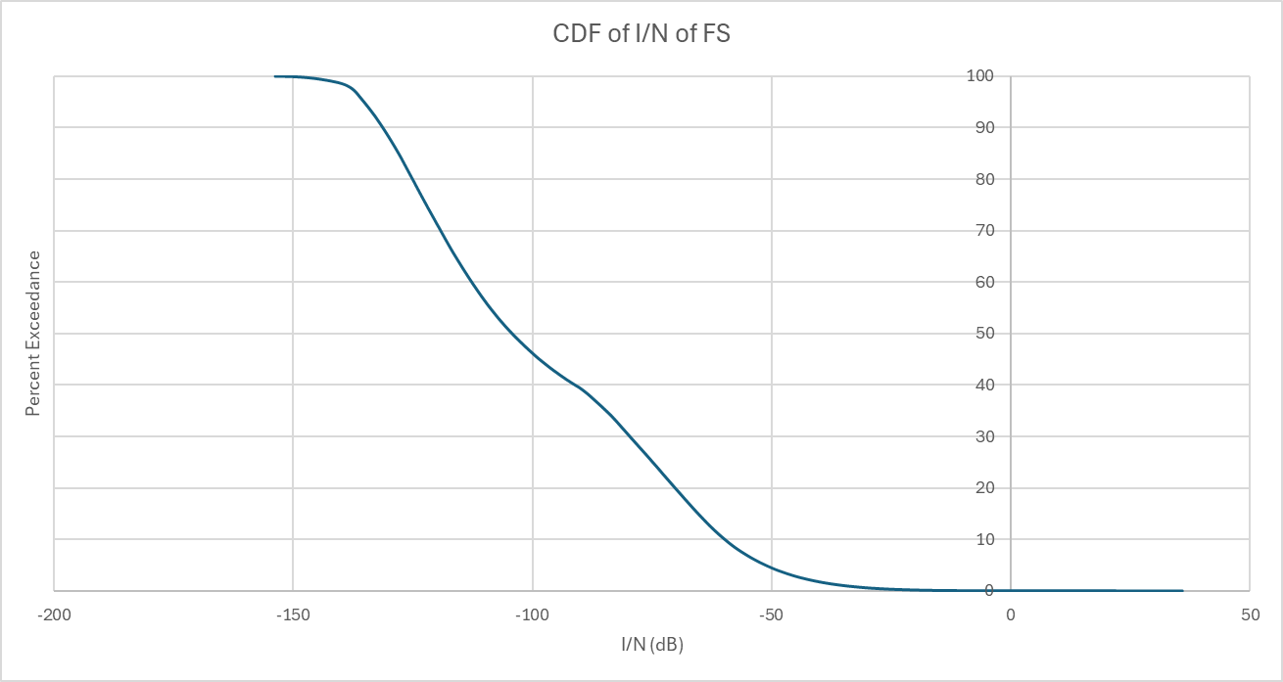

TABLE X

FS receiver I/N values

|  |  |  |
| --- | --- | --- |
|  | 20% | 0.00128% |
| FS | -70.2 dB | 10.9 dB |

**8.5 Studies**

*{Study 1 in the next section from 5C/168}*

**8.5.1 Study 1: General dependencies for determination of power flux-density (pfd) limits**

The aim of this section is to analyse interference level received by FS station.

The geometry of the analysed scenario is as follows: one FS station is located on the Earth’s surface with its directional antenna pointing horizontally. This FS station receives interference from a number of satellites located at some heights above. Since the most satellite networks are in the considered frequency range on non-GSO orbits, an assumption of random uniform distribution of satellites around the Earth is used. One snapshot of such satellite distribution when all satellites are located on the same height in the visibility of FS station is shown in Figure 1. Green dots are satellites, transparent frame sphere corresponds to its orbit height, coloured sphere is the Earth.

Figure 1

**One snapshot of satellite distribution**

Beams are not specified, but emissions from each satellite meet exactly a pfd mask (see illustration in Figure 2).

Figure 2

**Interference due to pfd caused by each transmitting satellite**

Pfd masks contained in Article **21** of the Radio Regulation have three main parts (see pfd mask 3 in Figure 3):

‒ horizontal part from 25 to 90 degrees elevation,

‒ horizontal part from 0 to 5 degrees elevation, the level is much lower than the level from 25 to 90 degrees,

‒ linear slant bending between level at 5 degrees and level at 25 degrees.

The last part may consist of two different linear slant parts in some cases.

Figure 3 shows number of satellites on each orbit height as it was provided in respect to FSS satellite systems in doc. 5C/142 (Table 1) (Attachment 3 of this document) (about 97 500 satellites in total).

Figure 3

**Number of planned FSS satellites depending on the height of the orbit**

In order to consider the more realistic number of simultaneously working satellites the calculations of *I/N* were performed for decreased number of satellites (they are all working simultaneously in the FS band). An example of such decreased satellite distribution is presented in Figure 4 (it gives about 26 satellites in the visibility of FS station).

Figure 4

**Decreased number of satellites on orbits**

Figure 5 shows CDFs of *I/N* corresponding to the decreased FSS satellite distributions. Visible satellites simultaneously transmit in the same frequency. The blue line corresponds to 39 satellites, the red line – to 22 satellites, the yellow line – to 26 satellites. Long-term protection criterion which is marked in Figure 5 as red star.

Figure 5

***I/N* CDFs with different orbit heights**

Figure 5 was calculated for pfd ‒105 dB(W/m2) in 1 MHz for all elevation angles, addition of any step to pfd mask will further decrease interference level.

*{Study 2 from 5C/179}*

**8.5.2 Study 2**

This study considers operational conditions of the FS as provided in doc 5C/166. The choice is driven by the fact that this CEPT contribution contains multiple antenna sizes, thus leading a more complete analysis than consider one single antenna size. With respect to the parameters of GSO and non-GSO systems (including minimum elevation, GSO exclusion zone, and max number of co-frequency beams at a specific location), the ones provided by 4A in their Liaison Statement to 5C were used. Additionally, the methodology considers propagation characteristics as per Doc. 5C/74 (guidance provided by WP 3J and 3M).

The statistics of the interference power against time for each power flux density (PFD) mask specified is calculated at each timestep using the method described below:

I =

is the assumed power flux density at the Earth’s surface in dB(W/m2/MHz)

is the wavelength in meters

is the atmospheric loss (i.e., gas, rain, cloud and scintillation) experienced by the link. Propagation losses should be considered based on ITU-R Recommendations ITU-R P.676, ITU-R P.618, ITU-R P.840 and referenced recommendations therein.

is the gain of the FS receiving antenna at off-axis angle degrees

Note: this equation does not consider Feeder Losses, which are normally considered. This is an extra layer of conservatism. Tonga also notes that feeder losses have been indeed considered in previous similar studies (see “Scaling Factor” from WRC-19)

The steps taken in the analysis are the following:

1) Select a group of representative GSO and non-GSO systems to use in the analysis.

2) Based on the parameters of the selected non-GSO systems, determine number of visible satellites to the FS station, , with minimum elevation of 0°.

3) Determine the pool of eligible satellites for each of the selected non-GSO systems complying with minimum elevation angle, , and minimum GSO exclusion angle, at the terrestrial ES location.

4) Select maximum number of non-GSO satellites allowed to transmit with overlapping frequencies towards the same location on the ground, using random satellite selection strategy.

5) For the remaining visible satellites, determine contribution of the sidelobes towards the same location on the ground assuming random placement of the beam from the satellite with its beam footprint.

6) Aggregate power levels received at the FS station by combining the received interference power from all satellites of the non-GSO system.

7) Aggregate power levels received at a FS station by combining the received interference power from the selected GSO and non-GSO systems.

The selected parameters of the selected GSO and there non-GSO systems are shown in Table 1. These parameters are collected from Document 5C/142 for these systems and one single assumption is made on N_co and minimum elevation for system D (as parameters were missing in the 4A doc). According to the WP4A guidance, 1.5° minimum angular separation is used among the three non-GSO systems’ beams serving the same location on Earth.

Table 1

**Parameters of the Selected GSO and non-GSO Systems (as per 4A guidance)**

|  |  |  |  |  |  |  |  |
| --- | --- | --- | --- | --- | --- | --- | --- |
| GSO/Non-GSO System | Height  (km) | Number of planes | Satellites per plane | Inclination angle (deg) | Number of co-frequency beams, | Min. Elevation Angle, | Min. GSO Exclusion angle, |
| System-B (non-GSO) | 590, 610, 630 | 28, 36, 34 | 28, 36, 34 | 33, 42, 51.9 | 32 | 20° | 1° |
| System-C (GSO) | 35786 | 1 | 1 | 0 | 1 | 3° | N/A |
| System-D (non-GSO) | 1050 | 12 | 28 | 89 | 8 (assumed) | 20° (assumed) | 1° |
| System-M (non-GSO) | 340, 345, 350, 360, 525, 530, 535, 604, 614 | 12, 18, 48, 48, 48, 30, 28, 28, 28 | 110, 110, 110, 120, 120, 120, 120, 12, 18 | 53, 46, 38, 97, 53, 43, 33, 148, 116 | 32 | 15° | 1° |

Table 2 lists the pfd masks used in the analysis for the selected GSO and non-GSO systems. All satellites that are in view of the FS station are assumed to be possibly interfering satellites for this study. The satellites transmitting towards the location of FS station are randomly selected from each set of prospective transmitting satellites.

Table 2

**Pfd masks for the Selected GSO and non-GSO systems**

|  |  |  |  |  |
| --- | --- | --- | --- | --- |
| **System** | **PFD in dB(W/m2) for angles of arrival ()**  **above the horizontal plane** | | | **Reference Bandwidth** |
| **0°-5°** | **5°-25°** | **25°-95°** |
| **Non-GSO** | -115 | -115+0.5*( - 5) | -105 | 1 MHz |
| **GSO** | -129.85 | | |

FS link characteristics has been used following WP 5C guidance as listed in Table 3. Atmospheric attenuation (i.e., gas, rain, cloud and scintillation) in accordance with Recommendation Per ITU-R P.676, ITU-R P.618, ITU-R P.840 has been considered.

Table 3

**FS Link Characteristics**

|  |  |
| --- | --- |
| **Parameters** | **Specifications** |
| Frequency (GHz) | 73.5 |
| FS Antenna maximum Receive Gain (dBi) | 41.5 (0.2 m), 51(0.6 m) |
| FS Antenna Pattern | Per Rec. ITU-R F.1245-3 |
| Latitude (degrees) | 24° N, 45° N, 60° N |
| Longitude (degrees) | 3° E |
| Elevation Angles | 4° |
| Receiver Noise Figure (dB) | 8 |

The protection criteria for FS safeguard used in this analysis are:

a Long-term: *I/N* should not exceed –10 dB for more than 20% of the time (derived from Recommendation ITU-R F.758-8)

b Short-term: *I/N* should not exceed +11 dB for more than 0.00128% of the time in any month.

**Results of study # 1**

Figure 1-12 compare aggregate I/N from the selected GSO and three non-GSO systems to

• the smallest dimension 0.2 m FS station antenna,

• pointing at four different azimuth directions (i.e., 0°, 90°, 180° and 270°),

• for maximum FS antenna elevation angle of 4°,

• at a representative frequency (i.e., 73.5 GHz).

Each figure compares three different atmospheric attenuation scenarios –

1 All atmospheric attenuations (attenuations due to rain, cloud, gas and scintillation);

2 Rain attenuation only;

3 No atmospheric attenuation (clear sky).

It is evident from the plots that with the PFD masks used in the analysis, both long-term and short-term limits are met. At the same time, the plots show the significant impact of taking into account atmospheric attenuation.

Figure 1

**Aggregate *I/N* from Selected Systems at 24°N, FS max. Receive Gain 41.5 dBi, Azimuth 0°**

Figure 2

**Aggregate *I/N* from Selected Systems at 24°N, FS max. Receive Gain 41.5 dBi, Azimuth 90°**

Figure 3

**Aggregate *I/N* from Selected Systems at 24°N, FS max. Receive Gain 41.5 dBi, Azimuth 180°**

Figure 4

**Aggregate *I/N* from Selected Systems at 24°N, FS max. Receive Gain 41.5 dBi, Azimuth 270°**

Figure 5

**Aggregate *I/N* from Selected Systems at 45°N, FS max. Receive Gain 41.5 dBi, Azimuth 0°**

Figure 6

**Aggregate *I/N* from Selected Systems at 45°N, FS max. Receive Gain 41.5 dBi, Azimuth 90°**

Figure 7

**Aggregate *I/N* from Selected Systems at 45°N, FS max. Receive Gain 41.5 dBi, Azimuth 180°**

Figure 8

**Aggregate *I/N* from Selected Systems at 45°N, FS max. Receive Gain 41.5 dBi, Azimuth 270°**

Figure 9

**Aggregate *I/N* from Selected Systems at 60°N, FS max. Receive Gain 41.5 dBi, Azimuth 0°**

Figure 10

**Aggregate *I/N* from Selected Systems at 60°N, FS max. Receive Gain 41.5 dBi, Azimuth 90°**

Figure 11

**Aggregate *I/N* from Selected Systems at 60°N, FS max. Receive Gain 41.5 dBi, Azimuth 180°**

Figure 12

**Aggregate *I/N* from Selected Systems at 60°N, FS max. Receive Gain 41.5 dBi, Azimuth 270°**

Similarly, Figure 13-24 compare aggregate *I/N* from the same selected GSO and three non-GSO systems to

• the largest dimension 0.6m FS station antenna,

• pointing at four different azimuth directions (i.e., 0°, 90°, 180° and 270°),

• for maximum FS antenna elevation angle of 4°,

• at same representative frequency (i.e., 73.5 GHz).

Again, each figure compares three different of atmospheric attenuation scenarios as mentioned above.

Figure 13

**Aggregate *I/N* from Selected Systems at 24°N, FS max. Receive Gain 51 dBi, Azimuth 0°**

Figure 14

**Aggregate *I/N* from Selected Systems at 24°N, FS max. Receive Gain 51 dBi, Azimuth 90°**

Figure 15

**Aggregate *I/N* from Selected Systems at 24°N, FS max. Receive Gain 51 dBi, Azimuth 180°**

Figure 16

**Aggregate *I/N* from Selected Systems at 24°N, FS max. Receive Gain 51 dBi, Azimuth 270°**

Figure 17

**Aggregate *I/N* from Selected Systems at 45°N, FS max. Receive Gain 51 dBi, Azimuth 0°**

Figure 18

**Aggregate *I/N* from Selected Systems at 45°N, FS max. Receive Gain 51 dBi, Azimuth 90°**

Figure 19

**Aggregate *I/N* from Selected Systems at 45°N, FS max. Receive Gain 51 dBi, Azimuth 180°**

Figure 20

**Aggregate *I/N* from Selected Systems at 45°N, FS max. Receive Gain 51 dBi, Azimuth 270°**

Figure 21

**Aggregate *I/N* from Selected Systems at 60°N, FS max. Receive Gain 51 dBi, Azimuth 0°**

Figure 22

**Aggregate *I/N* from Selected Systems at 60°N, FS max. Receive Gain 51 dBi, Azimuth 90°**

Figure 23

**Aggregate *I/N* from Selected Systems at 60°N, FS max. Receive Gain 51 dBi, Azimuth 180°**

Figure 24

**Aggregate *I/N* from Selected Systems at 60°N, FS max. Receive Gain 51 dBi, Azimuth 270°**

**9 Protection of the mobile service**

**9.1 Methodology for the determination of power flux-density (pfd) limits**

Determination of pfd limits for possible inclusion in RR Article **21** may result in the addition of one or several entries in Table **21-4** which defines pfd limits in dB(W/m2) for angles of arrival (δ) above the horizontal plane.

To calculate this angle of arrival, and hence, the pfd limits, positions of the interfering satellite and of the victim station are necessary.

Recommendation [ITU-R F.1108-4](https://www.itu.int/rec/R-REC-F.1108/en) – *Determination of the criteria to protect fixed service receivers from the emissions of space stations operating in non-geostationary orbits in shared frequency bands* contains various methodologies to determine the criteria to protect fixed service receivers from emissions of space stations operating in non-geostationary orbits in shared frequency bands. Annex 1 of this Recommendation contains the necessary formulas to evaluate the satellite elevation and angular distance from the victim antenna main beam.

The following sections provides different study scenario to assess sharing between FS and FSS.

**9.1.1 Sharing with GSO FSS Satellite**

As the interference from GSO satellites is steady, the long-term protection criterion of Recommendation ITU-R F.758 is used.

The following GSO FSS characteristics were extracted from Attachment 2 of this document which was liaised from Working Party 4A (Document 5C/142).

Table 12

**Parameters of the GSO FSS System**

|  |  |  |
| --- | --- | --- |
| **Parameter** | **System C (Satellite)** | **System C (Earth Station)** |
| Frequency (GHz) | 71-76 | 81-86 |
| Altitude (km) | 35,786 | N/A |
| Number of planes | 1 | N/A |
| Satellites per plane | 1 | N/A |
| Inclination angle (deg) | 0 | N/A |
| RAAN | N/A | N/A |
| Antenna Pattern | Appendix 7 Annex 3 Section 3  G1= ‒13 dB  Beamwidth = 0.42 deg | S.580 |
| Peak antenna gain (dBi) | 50 | 50 (D:0.6 m) |
| Input power density (dBW/Hz) | ‒77.8[8] | -77.8 |
| Minimum Elevation Angle (degrees) | 3 | 3 |
| Bandwidth (MHz) | 180 | 180 |
| Out of band emission mask | SM.1541-6 | SM.1541-6 |
| Number of co-frequency beams (N_co) | 1 | 1 |
| Max Power Flux Density on the ground  dBW/m2/MHz | -129.85 | N/A |
| Worst[9] Earth station density per 2 000 000 km2 | N/A | 25 |

**9.1.1.1 Scenario 1: Single Interferer (GSO Satellite, Dynamic Analysis)**

Station(s) of the mobile service are defined with the parameters given in Section 5.

The analysis was conducted assuming that the AMS was operating at the following latitude/longitude: 39.6° N, and 104.6° W.. For the AMS Ground receiver, the receiver is pointing at an airborne system whose location is randomized within a 9 to 94 km circle of the receiver. For the AMS Air-Air receiver, the receiver is pointing at an airborne system whose location is randomized within a 100 km of the receiver.

FIGURE X

Methodology Flow Chart



The analysis produced a cumulative distribution function (CDF) curve for the I/N levels received by the AMS which were then compared to the I/N protection criteria of AMS.

The following assumptions were made during the analysis:

• The location of the GSO satellite is 0° N and the longitude is randomized in a uniform distribution

• The AMS ground system antenna height is 10 m

• The AMS airborne system is operating at 9 km above ground

• The polarization of the FSS GSO satellite and AMS system is RHCP.

Study results

The results are presented in the following plots. In the following figures, the AMS receiving station *I/N* is plotted as a cumulative distribution function (CDF).

Two simulations were run. In the first simulation, no provision for avoiding mainbeam coupling between the FS receiver and the satellite. For the second simulation, the FS receiver antenna pointing angles were restricted such that the antenna main beam was never directed within 1.5 degrees of the satellite[10]. This resulted in two possible PFD limits for the FSS GSO satellite.

TABLE X

**PFD Mask of GSO Satellite, No Avoidance Angle**

|  |  |  |  |  |  |
| --- | --- | --- | --- | --- | --- |
| Frequency Band | System | Limit in dB(W/m2) for angles  of arrival (δ) above the horizontal plane | | | Reference Bandwidth |
| 0°-5° | 5°-25° | 25°-90° |
| 71-76 GHz | Fixed-satellite (geostationary-satellite orbit) | -115 | | | 1 MHz |

Figure X

**AMS receiver I/N CDF plot, No Avoidance Angle** 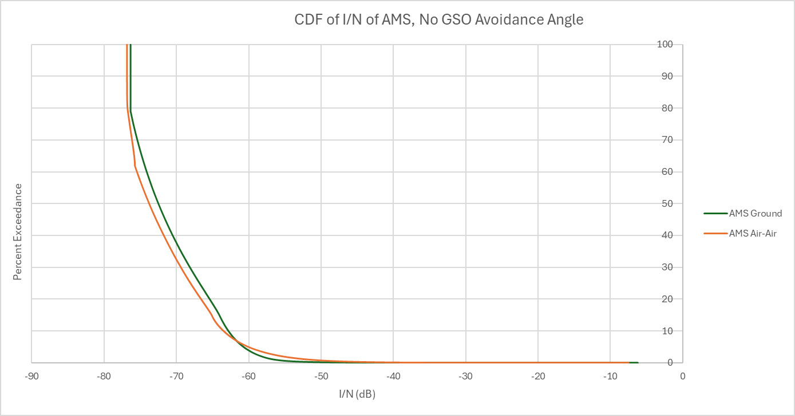

TABLE 8

**PFD Mask of GSO Satellite, 1.5° Avoidance Angle**

|  |  |  |  |  |  |
| --- | --- | --- | --- | --- | --- |
| Frequency Band | System | Limit in dB(W/m2) for angles  of arrival (δ) above the horizontal plane | | | Reference Bandwidth |
| 0°-5° | 5°-25° | 25°-90° |
| 71-76 GHz | Fixed-satellite (geostationary-satellite orbit) | -92 | | | 1 MHz |

FIGURE X

**AMS receiver I/N CDF plot, 1.5° Avoidance Angle**

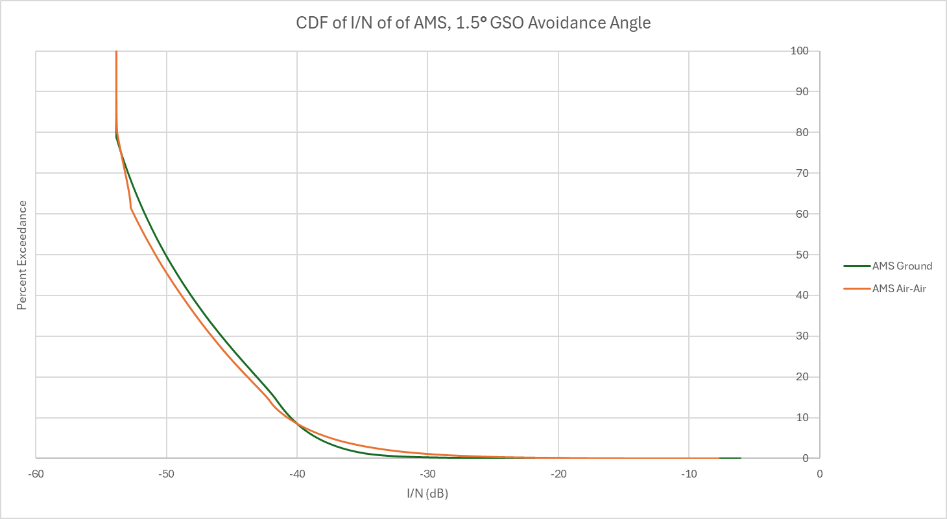

**9.2 Methodology for the determination of equivalent isotropically radiated power (e.i.r.p.) limits**

TBD

**9.2.1 Sharing with GSO FSS Earth Stations**

The following GSO FSS characteristics were extracted from Attachment 2 of this document which was liaised from Working Party 4A (Document 5C/142).

Table 13

**Parameters of the GSO FSS System**

| **Parameter** | **System C (Satellite)** | **System C (Earth Station)** |
| --- | --- | --- |
| Frequency (GHz) | 71-76 | 81-86 |
| Altitude (km) | 35,786 | N/A |
| Number of planes | 1 | N/A |
| Satellites per plane | 1 | N/A |
| Inclination angle (deg) | 0 | N/A |
| RAAN | N/A | N/A |
| Antenna Pattern | Appendix 7 Annex 3 Section 3  G1= ‒13 dB  Beamwidth = 0.42 deg | S.580 |
| Peak antenna gain (dBi) | 50 | 50 (D:0.6 m) |
| Input power density (dBW/Hz) | ‒77.8[11] | -77.8 |
| Minimum Elevation Angle (degrees) | 3 | 3 |

**9.2.1.1 Scenario 1: Single Interferer (GSO FSS ES, Dynamic Analysis)**

Station(s) of the mobile service are defined with the parameters given in Section 5.

The analysis was conducted assuming that the AMS was operating at locations at the following latitude/longitude: 39.73° N, and 104.75° W. The location of the AMS system was randomized within a 400 km radius, respectively, of the FSS ES that is stationed at the aforementioned location.

The analysis produced a cumulative distribution function (CDF) curve for the *I/N* levels received by the AMS which were then compared to the I/N protection criteria of AMS.

The following assumptions were made during the analysis:

• The SRTM V3 (3 arc second, 90m) terrain profile data was used

• There is only 1 ES deployed at 39.73° N and 104.75° W

• The ES is pointing at the GSO satellite

• The elevation pointing angle of the ES is 5 degrees

• The EIRP of the ES is 79 dBW in accordance with RR Nos. 21.8

• The beamwidth of the FSS ES is 0.41 degrees

• The AMS airborne receiver’s antenna can point at either the AMS ground or airborne transmitter

• The AMS ground system and FSS ES antenna heights are 10 m

• The AMS airborne receiver is operating at 9 km above ground

• The polarization of the FSS GSO satellite, FSS ES, and AMS system is RHCP.

Study results

The results are presented in the following plots. In the following figures, the AMS receiving station *I/N* is plotted as a cumulative distribution function (CDF).

FIGURE X

**AMS receiver I/N CDF plot**

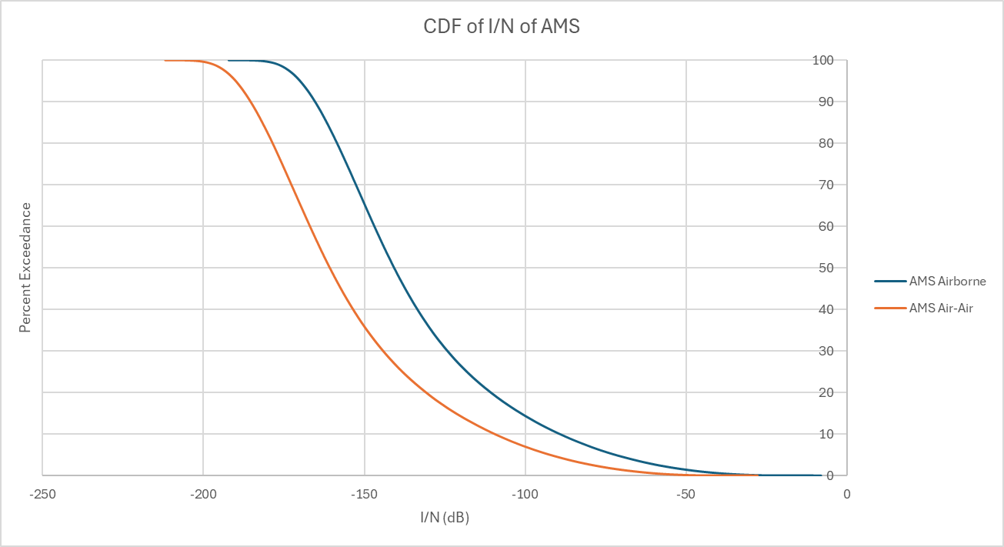

TABLE X

AMS receiver I/N maximum value

|  |  |
| --- | --- |
|  | Maximum I/N |
| AMS Airborne | -8.04 dB |
| AMS Air-Air | -27.8 dB |

# ATTACHMENT 1

Derivation of short-term protection criteria for agenda item 1.10

**1 Introduction**

The derivation of short-term protection criteria is according to Recommendations ITU-R F.1606-0 and ITU-R F.1495-2.

The methodology presented in this Attachment is based on the assumption that fading in the 71-76 GHz and 81-86 GHz (E-band) is dominated by rain and that, therefore, even if long-term interference has an effect on the performance of the link, the main way to have an outage of the FS link is to have an interference level higher than the fade margin of the link, whatever the propagation conditions may be.

On this basis, the following apportionment of the effect of interference on the degradation of the link (and on the EPOs) has been assumed:

– 20% of FS link degradation due to long-term interference;

– 80% of FS link degradation due to short-term interference.

**2 EPOs**

The allowable degradation in performance of real FWS due to interference from other services sharing the same frequency bands on a primary basis are expressed as a permissible fraction (10%) of the total EPOs and are defined in Recommendation ITU-R F.1565.

Fixed satellite systems are currently used in the E-band for the backhaul links of wireless access networks for point-to-point (P-P) applications. The service transmitted via E-band FS systems is packet service only.

The corresponding EPO values are given in Table 1, and correspond to the following assumptions:

– Access network section (Table 10 of Recommendation ITU-R F.1565-1, as shown in Fig. 1, for convenience);

– Rate from 160 to 3500 Mbit/s in Tables 10 of Recommendation ITU-R F.1565-1;

– *C*  8%.

Table 7

|  |  |  |
| --- | --- | --- |
|  | EPO (fraction of any month) based on the application of Recommendation ITU-R F.1565-1 | |
|  | Total allowable to interference | Short-term interference (80%) |
| Errored second ratio | For further study | N/A |
| Severely errored second ratio | 1.6  10–5 | 1.28  10–5 |

Figure 1

Table 10 of Recommendation ITU-R F.1565-1

Please note, EPO based on ESR is more stringent and is more appropriate to protect FS. However, consider there is no ESR value for high capacity in Table 10, EPO at E-band based on only SESR is provided in this contribution. Update of EPO at E-band should be considered if ESR value for high capacity is supplemented in the future.

**3 Short-term criteria**

**3.1 Methodology**

As explained in § 1, the main way to have an outage of the FS link, considering short-term interference, is to have an interference level higher than the fade margin of the link, whatever the propagation conditions may be. That means, the permissible I/N for short-term protection is the largest value that will not cause SES in the absence of fading.

The definition of short-term criteria is then linked to both values of fade margin (or net fade margin considering ATPC[12]1) and EPO allocated to short-term interference as defined in Table 1, considering that the fade margin is allocated to the short-term criteria.

**3.2 Fixed service fade margins**

In the E-band, since link lengths are likely to be short and AM is normally enabled to high modulation, and also BCA applications would decrease the fade margin, an FS fade margin of 10 dB was considered representative of conventional links.

As the EPO are referenced to ITU-T Recommendations G.826 definitions, it is necessary to extrapolate the fade margin corresponding to SES levels. On the basis of agreed assumptions (for detailed derivation, please refer to Recommendation ITU-R F.1606-0), the fade margin for SES is 1 dB higher than the fade margin referenced to the BER 1 ×10–6 level. Table 2 summarizes these different values of fade margins and, associated with the correspondent EPO ratios, allows to define short-term criteria for the FS.

Table 8

|  |  |  |
| --- | --- | --- |
|  | Fade margin  (dB) | EPO ratio |
| BER 1 ×10–6 | 10 |  |
| SES | 11 | 1.28 × 10–5 |

Thus, the short-term criteria proposed to be used in E-band have been defined associating the SES EPO (see Table 2) and the corresponding I/N as defined in Table 3.

Table 9

|  |  |  |
| --- | --- | --- |
|  | I/N (dB) | Percentage of time not to be exceeded (%) |
| Criterion | 11 | 0.00128 |

# ATTACHMENT 2

Proposed examples of FSS satellite systems to be considered  
for studies under WRC-27 agenda item 1.10

Table 10

Orbit configuration

| Parameter | System A[13] | System B | System C | System D | System E | System F | System G | System H | System I | System J | System K | System L | System M[14] |
| --- | --- | --- | --- | --- | --- | --- | --- | --- | --- | --- | --- | --- | --- |
| Height (km) | 525, 530, 535 | 590, 610, 630 | 35786 | 1050 | 1414 | 450 to 900 | 340 to 614 | 600, 1200 | 8 062 | 1 175 | 355, 347 | 500, 500, 600, 600, 700, 700, 800, 800, 900, 900, 1000, 1000, 1100, 1100, 1200, 1200, 1300, 1300, 1400, 1400, 8100, 8100, 8100, 8100, 8100, 8100, 8100, 8100, 12000, 12000, 12000, 12000, 12000, 12000, 12000, 12000, 16000, 16000, 16000, 16000, 16000, 16000, 16000, 16000, 20000, 20000, 20000, 20000, 20000, 20000, 20000, 20000, 23222, 23222, | 340, 345, 350, 360, 525, 530, 535, 604, 614 |
| Number of planes | 28, 28, (24,4) | 28, 36, 34 | 1 | 12 | 8 | 81 | 794 | 132 | 1, 4, 6 | 18 | 24, 24 | 36, 36, 36, 36, 34, 34, 30, 30, 28, 28, 24, 24, 24, 24, 22, 24, 20, 20, 18, 18, 1, 12, 12, 12, 12, 12, 12, 12, 1, 12, 12, 12, 12, 12, 12, 12, 1, 12, 12, 12, 12, 12, 12, 12, 1, 12, 12, 12, 12, 12, 12, 12, 1, 12 | 12, 18, 48, 48, 48, 30, 28, 28, 28 |
| Satellites per plane | 120, 120, (28,27) | 28, 36, 34 | 1 | 28 | 6 | 1 to 8 | 12 to 120 | 36 to 72 | 32, 16, 12 | 48 | 124 | 36, 36, 32, 32, 32, 32, 32, 32, 30, 30, 24, 24, 24, 24, 24, 24, 24, 24, 20, 20, 96, 10, 10, 10, 10, 10, 10, 10, 96, 10, 10, 10, 10, 10, 10, 10, 96, 10, 10, 10, 10, 10, 10, 10, 96, 10, 10, 10, 10, 10, 10, 10, 96, 9 | 110, 110, 110, 120, 120, 120, 120, 12, 18 |
| Inclination angle (deg) | 53, 43, 33 | 33, 42, 51.9 | 0 | 89 | 52 | 0 to 98.9 | 33 to 148 | 40 to 87.9 | 0, 90, 45 | 86.5 | 50, 50.2 | 50, 85, 50, 85, 50, 85, 50, 85, 50, 85, 50, 85, 50, 85, 50, 89, 50, 85, 50, 85, 0, 15, 45, 60, 65, 70, 75, 80, 0, 15, 45, 60, 65, 70, 75, 80, 0, 15, 45, 60, 65, 70, 75, 80, 0, 15, 45, 60, 65, 70, 75, 80, 0, 56 | 53, 46, 38, 97, 53, 43, 33, 148, 116 |
| RAAN | Equally spaced | Equally spaced |  | Equally spaced | Equally spaced | Equally spaced | Equally spaced | Equally spaced | Equally spaced | Equally spaced | Equally spaced | Equally spaced | Equally spaced |

Table 11

Other characteristics for systems A to C

|  |  |  |  |  |  |  |
| --- | --- | --- | --- | --- | --- | --- |
| Parameter | System A | System A | System B | System B | System C | System C |
| Frequency (GHz) | 71-76 | 81-86 | 71-76 | 81-86 | 71-76 | 81-86 |
| Peak antenna gain (dBi) | 52 | 60.9 (D: 1.85 m) | 41.9 or 48 | 53.6 (D: 1 m, 59.6 (D: 2 m, ), 64.5 (D: 3.5 m) | 50 | 50 (D:0.6 m) |
| Antenna Pattern | Rec S.1528  Recommend 1.2 for main beam  Recommend 1.4 for side lobes  (beyond 15°) | Recommendation ITU‑R S.580-6 | Rec. S.1528 Recommend 1.2 for main beam  Recommend 1.4 for side lobes (beyond 15°) | Recommendation ITU‑R S.580-6 | For satellite: Appendix 7 Annex 3 Section 3  G1= ‒13 dB  Beamwidth = 0.42 deg | For earth station: S.580 |
| Input power density (dBW/Hz) | ‒103 to ‒83.57  Max power only used while compensating for low elevation angles or rain fade attenuation | ‒93 to ‒80.8  Max power only used while compensating for low elevation angles or rain fade attenuation | ‒106.2 to ‒86.2  Max power only used while compensating for low elevation angles or rain fade attenuation | ‒97 to ‒77  Max power only used while compensating for low elevation angles or rain fade attenuation | ‒77.8[15] | ‒77.8 |
| Minimum Elevation Angle (degrees) | 15 | 15 | 20 | 20 | 3 | 3 |
| Bandwidth (MHz) | 1 250 | 1 250 | 100 | 100 | 180 | 180 |
| Out of band emission mask | SM.1541-6 | SM.1541-6 | SM.1541-6 | SM.1541-6 | SM.1541-6 | SM.1541-6 |
| Number of co-frequency beams (N_co) | 32 | 32 | 32 | 32 | 1 | 1 |
| Max Power Flux Density on the ground  dBW/m2/MHz | ‒106 | N/A | ‒104 | N/A | ‒129.85 | N/A |
| Worst[16] Earth station density per 2 000 000 km2 | N/A | 76 | N/A | 5 | N/A | 25 |

Table 12

Other characteristics for systems D to H

|  |  |  |  |  |  |  |  |  |  |  |
| --- | --- | --- | --- | --- | --- | --- | --- | --- | --- | --- |
| System | System D | | System E | | System F | | System G | | System H | |
| Frequency (GHz) | 71-76 | 81-86 | 71-76 | 81-86 | 71-76 | 81-86 | 71-76 | 81-86 | 71-76 | 81-86 |
| Peak Antenna Gain (dBi) | 34.1 | 40.9 to 61.3 | 25 to 45 | 35.4 to 72 | 59 | 30 to 70.5 | 35 to 60 | 35 to 71 | 39.4 to 55.9 | 41.9 to 68.3 |
| Antenna pattern | Rec S.1528 | Rec 580-6 | Rec S.1528 | AP8 | Rec S.1528 | Rec 580-6 | Rec S.1528 | AP8 | Rec S.1528 | AP8 |
| Beamwidth |  | 0.13 to 1.65 |  | 0.04 to 2.79 |  | 0.05 to 5.6 |  | 0.05 to 3 |  | 0.07 to 1.41 |
| Input Power Density (dBW/Hz) | −36.1 to −30.1 |  | −82.1 to −45.9 |  | −83 to −74 |  | −80 to −55 |  | −94.6 to −72.3 |  |

# ATTACHMENT 3

Proposed examples of MSS satellite systems to be considered  
for studies under WRC-27 agenda item 1.10

Table 13

Orbit configuration

| Parameter | System N | System O | System P | System Q |
| --- | --- | --- | --- | --- |
| Perigee (km) | 21000 | 3800, 3000, 1776, 1215, 6400 | 540, 21028.6, 23136.8, 25245, 25245, 27353.2, 29461.4, 30726.3, 35786.1 | 340, 345, 350, 360, 525, 528, 530, 535, 540, 550, 560, 560, 570, 604, 614 |
| Apogee (km) | 21000 | 9000, 9800, 11024, 11585, 6400 | 540, 50543.5, 48435.2, 46327, 46327.1, 44218.9, 42110.6, 40845.7, 35786.1 | 340, 345, 350, 360, 525, 528, 530, 535, 540, 550, 560, 560, 570, 604, 614 |
| Number of planes | 6 | 31, 1, 9, 9, 9 | 9, 256, 256, 256, 1, 255, 512, 512, 128, 256, 128, 128 | 96, 96, 96, 60, 56, 28, 56, 56, 72, 72, 4, 6, 36, 24, 36 |
| Satellites per plane | 6 | 7, 7, 21, 21, 21 | 23, 1, 1, 1, 1, 1, 1, 1, 1, 1, 1, 1 | 110, 110, 110, 120, 120, 120, 120, 120, 22, 22, 43, 58, 20, 12, 18 |
| Inclination angle (deg) | 55 | 63, 64, 45, 50, 52 | 98, 63, 41, 46, 46, 46, 63, 63, 38, 42, 20, 25 | 53, 46, 38, 97, 53, 43, 43, 33, 53, 53, 98, 98, 70, 148, 116 |
| RAAN | Equally spaced | Equally spaced | Equally spaced | Equally spaced |

# ATTACHMENT 4

Alternate antenna patterns for sensitivity analysis

The main studies in this working document are based on the patterns provided by Recommendations ITU-R F.699 and F.1245.

This attachment provides antenna radiation patterns of deployed fixed point-to-point antennas which diverge from those recommendations, for use in sensitivity analysis in the sharing studies for this agenda item.

**A5.1 Envelope diagram of manufacturer**

It is important to note that antenna pattern shown in Figure 1 represents the envelope of side-lobe peaks, and that for many studies in this working document it is necessary to consider a pattern representing average sidelobe level (as described in *considering c)* of Recommendation ITU-R F.1245). Therefore, noting that the pattern provided by Recommendation ITU-R F.699 is similar to the pattern provided by Recommendation ITU-R F.1245, with the pattern of Recommendation ITU‑R F.1245 being lower by a factor of 3 dB beyond a specific angle, an average sidelobe pattern for this antenna has been derived by applying a similar 3 dB difference. This difference is shown in the “average side-lobe attenuation” column of Table 1, with further details of methodology used to apply the difference described below Table 1.

FIGURE 1

Antenna pattern for model ANT2 0.6 80 HPX (49.7 dBi gain, 60 cm diameter)

Table 1

Antenna pattern for model ANT2 0.6 80 HPX (49.7 dBi gain, 60 cm diameter)

|  |  |  |
| --- | --- | --- |
| Angle (degrees) | Sidelobe Peak Attenuation (dB) | Average Sidelobe Attenuation (dB) |
| 0 | 0 | 0 |
| 0.1 | 0 | 0 |
| 0.2 | 1 | 1 |
| 0.3 | 3 | 3 |
| 0.3 | 4 | 4 |
| 0.4 | 6 | 6 |
| 0.4 | 8 | 8 |
| 0.5 | 11 | 11 |
| 0.5 | 12 | 12 |
| 1.2 | 12 | 15 |
| 1.2 | 23 | 26 |
| 4.9 | 30 | 33 |
| 5 | 35 | 38 |
| 10 | 42 | 45 |
| 20 | 50 | 53 |
| 30 | 52 | 55 |
| 50 | 52 | 55 |
| 70 | 55 | 58 |
| 85 | 68 | 71 |
| 180 | 68 | 71 |

The formulas to be applied to determine the reference radiation patterns of Recommendations ITU‑R F.699 and F.1245 depend on the ratio D/λ of the diameter and the wavelength of the antenna. With the antenna considered in this attachment being of 60 cm diameter, the ratio D/λ is 142.09 at 71 GHz. In this case, the appropriate reference patterns of the ITU-R Recommendations are provided in recommends 2.1.2 of F.699 and recommends 2.1.2 of F.1245, with the detailed formulas shown in Table 2 below. It can be see that the patterns are nearly identical, with only a constant 3 dB difference becoming applied from the angle ϕ*r ,* which is 0.61º for the antenna considered in this annex. Therefore, the average sidelobe pattern in Table 1 above is derived by taking the peak envelope pattern and applying a further constant 3 dB reduction for angles larger than 0.61º.

Table 2

Comparison of Reference Patterns from Recommendations ITU-R F.699 and F.1245

|  |  |  |  |
| --- | --- | --- | --- |
| Recommendation ITU-R F.1245 | | Recommendation ITU-R F.699 | |
| Sidelobe Gain Formula | Angle (ϕ) | Sidelobe Gain Formula | Angle (ϕ) |
| *Gmax*  −  2.5  ×  10–3 | 0º < ϕ < ϕ*m* | *Gmax*  −  2.5  ×  10–3 | 0º < ϕ < ϕ*m* |
| *G*1 | ϕ*m* ≤ ϕ < max (ϕ*m*, ϕ*r*) | *G*1 | ϕ*m* ≤ ϕ< ϕ*r* |
| 29  −  25 log ϕ | max (ϕ*m*, ϕ*r*) ≤ ϕ< 120º | 32  −  25 log ϕ | ϕ*r* ≤ ϕ< 120º |
| −23 | 120º ≤ ϕ ≤ 180º | −20 | 120º ≤ ϕ ≤ 180º |
| Note: The formulas to obtain G1, ϕm , and ϕr are all provided in the Recommendations ITU-R F.699 and F.1245. For the case of the antenna considered in this attachment with 60 cm diameter and 49.7 dBi gain, G1= 34.29 dBi, ϕm = 0.55º, and ϕr = 0.61º. | | | |

### A5.2 Measured antenna diagrams

TBD

# ATTACHMENT 5

Q&A for AI 1.10 methodology contributions

Editor’s note: this Attachment is only for information, and could be removed in later meetings.



# ATTACHMENT 6

Comparison Table of Summary of Studies on PFD Limits for Protection of FS from NGSO Satellite

Editor’s note: this Attachment is only for information, and could be removed in later meetings.



1. RHCP = Right hand Circular Polarization
2. LHCP = Left hand Circular Polarization
3. This is an average input power spectral density meaning there could be higher and lower power spectral densities employed by the System C satellite.
4. The worst density is provided in the table. To scale for larger area, the density should be considered together with a factor of 0.65 to account for the fact that the worst density isn’t feasible on a wider scale. For instance, density of 10 in 2 million km2, if scaled to 10 million km2 is: 10 × 10 000 000/2 000 000 × 0.65 = 32.5
5. According to Footnote 1 of Article 21, fixed and mobile services operating in frequency bands shared with space radiocommunication services (space-to-Earth) should avoid directing their antennas towards the geostationary-satellite orbit.
6. This is an average input power spectral density meaning there could be higher and lower power spectral densities employed by the System C satellite.
7. The worst density is provided in the table. To scale for larger area, the density should be considered together with a factor of 0.65 to account for the fact that the worst density isn’t feasible on a wider scale. For instance, density of 10 in 2 million km2, if scaled to 10 million km2 is: 10 × 10 000 000/2 000 000 × 0.65 = 32.5
8. This is an average input power spectral density meaning there could be higher and lower power spectral densities employed by the System C satellite.
9. The worst density is provided in the table. To scale for larger area, the density should be considered together with a factor of 0.65 to account for the fact that the worst density isn’t feasible on a wider scale. For instance, density of 10 in 2 million km2, if scaled to 10 million km2 is: 10 × 10 000 000/2 000 000 × 0.65 = 32.5
10. According to Footnote 1 of Article 21, fixed and mobile services operating in frequency bands shared with space radiocommunication services (space-to-Earth) should avoid directing their antennas towards the geostationary-satellite orbit.
11. This is an average input power spectral density meaning there could be higher and lower power spectral densities employed by the System C satellite.
12. 1 For an FS link using ATPC, the net fade margin  total fade margin – ATPC range.
13. Altitude 535 km, Inclination 33 deg, 24 planes with 28 satellites per plane and 4 planes with 27 satellites per plane.
14. Systems A and M are variations of the same system and as such, they shouldn’t be aggregated in studies.
15. This is an average input power spectral density meaning there could be higher and lower power spectral densities employed by the System C satellite.
16. The worst density is provided in the table. To scale for larger area, the density should be considered together with a factor of 0.65 to account for the fact that the worst density isn’t feasible on a wider scale. For instance, density of 10 in 2 million km2, if scaled to 10 million km2 is: 10 × 10 000 000/2 000 000 × 0.65 = 32.5