U.S. Radiocommunications Sector
Fact Sheet
Working Party: ITU-R WP 5C | Document No: USWP5C33-05
Ref: Document 5C/206 (Annex 2.1) | Date: 18 August 2025
Document Title: WORKING DOCUMENT ON SHARING STUDIES UNDER WRC-27 AGENDA ITEM 1.10
Author(s)/Contributors(s):  Zahid Islam  SpaceX  Joe McMichael  SpaceX  Nader Damavandi  SpaceX | Email: km.islam@spacex.com  Phone:  Email: Joseph.McMichael@spacex.com  Phone:  Email: Nader.Damavandi@spacex.com  Phone:
Purpose/Objective: Add studies and propose edits to the Working Doc on AI 1.10, i.e. 5C/206 (Annex 2.1)

Abstract: Within the context of AI 1.10, WP5C, based on studies, will determine power flux-density (pfd) and equivalent isotropically radiated power (e.i.r.p.) limits to be included in Article 21 for satellite services (fixed-satellite service (FSS), mobile-satellite service (MSS) and broadcasting-satellite service (BSS)) to protect the current and planned fixed and mobile services in the frequency bands 71-76 GHz and 81-86 GHz. The United States hereby propose edits to the main Working Document, 5C/206 (Annex 2.1), and add new studies taking into account accurate modelling of the example FSS systems considered.
Note: the second draft will contain additional studies that better model, among other things, the aggregate interference from GSO networks

Radiocommunication Study Groups | 
Received: TBD October 2025  Source: Document 5C/206 (Annex 2.1)  Subject: AI 1.10 | Document 5C/TBD-E
 | TBD October 2025
 | English only
United States of America
WORKING DOCUMENT ON SHARING STUDIES
UNDER WRC-27 AGENDA ITEM 1.10
Within the context of AI 1.10, WP5C, based on studies, will determine power flux-density (pfd) and equivalent isotropically radiated power (e.i.r.p.) limits to be included in Article 21 for satellite services (fixed-satellite service (FSS), mobile-satellite service (MSS) and broadcasting-satellite service (BSS)) to protect the current and planned fixed and mobile services in the frequency bands 71-76 GHz and 81-86 GHz. The United States hereby propose edits to the main Working Document, 5C/206 (Annex 2.1), and add new studies taking into account accurate modelling of the example FSS systems considered.
The edits are added in track changes. For simplicity, currently existing edits in Doc 5C/206 (Annex 2.1) have been accepted, so that the only edits are those from the United States and can easily be included in the Working Doc for review during the 5C meeting. Moreover, since the Working Doc is quite extensive already, for brevity the US only included sections where edits are provided.

4 Characteristics and protection criteria of FS stations
The following ITU-R Recommendations contain relevant technical and operational characteristics as well as protection criteria for FS systems:
– Recommendation ITU-R F.758-8 contains the principles for the development of sharing criteria of digital systems in the FS. It also contains information on representative technical characteristics of digital fixed wireless systems (FWS) in the FS for use in sharing studies above about 30 MHz. For agenda item (AI) 1.10, the following table abstracted from Table 12 contains the system parameters for PP FS systems in allocated bands from 71-76 GHz and 81-86 GHz.
Table 3
Typical values for FS point-point system parameters in the frequency band 71-76 and 81-86 GHz
Frequency range  (GHz) | 71-76/81-86
Reference ITU-R Recommendation | F.2006
Modulation | QPSK | 64-QAM
Channel spacing and receiver noise bandwidth (MHz) | 250, 500, 750, 1 000, 1 250, 1 500, 1 750, 2 000, 2 250 | 500, 700, 1 000
Tx output power range (dBW) | –10 | –20
Tx output power density range (dBW/MHz)⁽¹⁾ | –41 | –47…-50
Feeder/multiplexer loss range (dB) | 0 | 0
Antenna gain range (dBi) | 54 | 44…50
e.i.r.p. range (dBW) | 44 | 24…30
e.i.r.p. density range (dBW/MHz)⁽¹⁾ | 13 | –6…3
Receiver noise figure typical (dB) | 10 | 8
Receiver noise power density typical (=N_{RX}) (dBW/MHz) | –134 | –136
Normalized Rx input level for 1 × 10^{–6} BER (dBW/MHz) | –120.5 | –94…-91
Nominal long-term interference power density (dBW/MHz)⁽²⁾ | –134 + I/N | –136 + I/N

– Recommendation ITU-R F.699-8 provides reference radiation patterns for, and information on, point-to-point FWS antennas in the frequency range from 100 MHz to 86 GHz. This information may be used in single-entry analyses and interference assessments when information concerning the FWS antenna is not available.
– Recommendation ITU-R F.1245-3 provides average sidelobes and related reference radiation patterns for point-to-point FWS antennas in the frequency range from 1 GHz to 86 GHz. This information may be used for aggregate coordination and interference assessment studies when information concerning the FWS antenna is not available.
Editor’s note: More discussion is needed on how to best study the impact of antennas having radiation patterns with sidelobe levels differing significantly from those in Recommendations ITU-R F.699 and F.1245, and take into account the study and treatment of radiation patterns based on deployment of FWS antennas by memberships. Memberships are encouraged to provide further inputs on this topic to the future meetings.
Recommendations ITU-R F.699 and ITU-R F.1245 provide reference radiation patterns to be used when information concerning the FWS antenna is not available. The radiation pattern of some deployed FWS antenna may have side lobes which fall above or below these recommendations’ reference patterns. Therefore, some sensitivity analysis may be considered, taking into account radiation patterns of antennas deployed. Attachment 4 provides some antenna patterns which could be used for sensitivity analysis.
Typical FS station parameters are provided in the following table, to facilitate the sharing study.
Considering the above ITU-R recommendations, the following parameters are selected to develop studies.
Editor’s note: it is encouraged for membership to provide their data on elevation angle at next meeting, including towards supplementing the information to preliminary draft revision of Recommendation ITU-R F.2086, which is targeted to be finalized at next WP5C meeting.
Table 4
Typical values for FS point-point system parameters in the frequency band 71-76 and 81-86 GHz
System parameters | Typical Value
Channel spacing and receiver noise bandwidth (MHz) | 500
Modulation | 64 to128-QAM
Feeder/multiplexer loss (dB) | 0
Antenna gain (dBi) | 41.5, 45 or 51
Antenna size (m) | 0.2, 0.3 or 0.6
Receiver noise figure (dB) | 8
Antenna height(m) | 30
Antenna RPE | F.699-8 and F.1245-3
Link length (km) | 0.4-3
Elevation angle (degree) | −5 to −5
Nominal long-term interference power density (dBW/MHz) | –136 + I/N

The following protection criteria used in study of WRC-27 agenda item 1.10 are:
‒ for the long-term, the I/N at the input of the FS receiver should not exceed –10 dB for more than 20% of the time;
‒ for the short-term, the I/N at the input of the FS receiver should not exceed +11 dB for more than 0.00128% of the time. The derivation methodology is in Attachment 1.

…….

Sharing with GSO satellites
As the interference from GSO satellites is steady, the long-term protection criterion of Recommendation ITU-R F.758 is used.

Scenario 1
Station(s) of the fixed service are defined with the parameters of the following table.
Table 5
Parameters of the station of the fixed service
Parameter | Value | Source
Latitude (°) | 0, 25, 50, 75
Longitude (°) | 0
Altitude (m) | 30
Antenna elevation (0) | 0, 2.5, 5 | Rec. ITU-R F.2086
Azimut (°) | 0 to 180
Antenna diameter (cm) | 20, 30 or 60
Antenna diagram |  | Rec. ITU-R F.1245,  EN 302 217-4 Class 3
Max antenna gain |  | Rec. ITU-R F.699
I/N (dB) long-term | ‒10 | Rec. ITU-R F.758
Nominal long-term interference power density (dBW/MHz) | ‒146 | Rec. ITU-R F.758
{Yellow highlight from 5C/170}
GSO satellites are separated from 10, 4, or 1°.
Exceedance over the nominal long-term interference power density is assessed with several tentative pfd masks.
[Editor’s note: assumptions on GSO satellite spacing for sharing studies should be carefully considered in order to avoid overly conservative assumptions and ensure modelling of realistic scenarios]

…..

Methodology for assessment of candidate pfd masks

Existing pfd masks in RR Article 21
RR Article 21, and more specifically Table 21-4, provides pfd limits that shall not be exceeded by emissions from a space station, for all conditions and for all methods of modulation.
Table 5
Extract of RR Table 21-4 in the frequency range 42-42.5 GHz
Frequency band | Service* | Limit in dB(W/m²) for angles  of arrival (δ) above the horizontal plane |  |  |  | Reference bandwidth
 |  | 0°-5° | 5°-25° |  | 25°-90°
40-40.5 GHz | Fixed-satellite  Mobile-satellite | −115 | −115 + 0.5(δ − 5) |  | −105 | 1 MHz
42-42.5 GHz | Fixed-satellite  (non-geostationary-satellite orbit)  Broadcasting-satellite  (non-geostationary-satellite orbit) | −120 11, 21 | 5°-25° |  | −105 11, 21 | 1 MHz
 |  |  | −120 + 0.75(δ − 5) 11, 21
42-42.5 GHz | Fixed-satellite  (geostationary-satellite orbit)  Broadcasting-satellite  (geostationary-satellite orbit) | −127 21 | 5°-20° | 20°-25° | −105 21 | 1 MHz
 |  |  | −127 + (4/3)  (δ − 5) 21 | −107 + 0.4  (δ − 20) 21

The pfd is the power flux density produced on earth’s surface.
These pfd limits are defined as a function of the angle of arrival above the horizontal plane and are, therefore, purely geometrically defined. These pfd mask could be starting point for studies under this agenda item but other masks can also be considered in sharing studies.

…..

Study #XX
This study considers operational conditions of the FS as provided in doc 5C/206 (Annex 2.1) and assuming 5 degrees as maximum elevation. With respect to the parameters of GSO and non-GSO systems (including minimum elevation, GSO exclusion zone, and max number of co-frequency beams at a specific location), the analysis considered cases with different operational conditions than those communicated by 4A in order to execute studies with some margins. The various assumptions different from the 4A liaison statement are on purpose all worse than the parameters communicated by 4A. Additionally, the methodology considers scenarios with propagation characteristics as per Doc. 5C/74 (guidance provided by WP 3J and 3M), as well as scenarios in clear sky.
The statistics of the interference power against time for each power flux density (PFD) mask specified is calculated at each timestep using the method described below:
I = PFD-10log104πλ2- La +Gα
PFD is the assumed power flux density at the Earth’s surface in dB(W/m²/MHz)
λ is the wavelength in meters
La is the atmospheric loss (i.e., gas, rain, cloud and scintillation) experienced by the link. Propagation losses should be considered based on ITU-R Recommendations ITU-R P.676, ITU-R P.618, ITU-R P.840 and referenced recommendations therein.
Gα is the gain of the FS receiving antenna at off-axis angle α degrees
Note: this equation does not consider Feeder Losses, which are normally considered. This is an extra layer of conservatism. USA also notes that feeder losses have been indeed considered in previous similar studies (see “Scaling Factor” from WRC-19)
The steps taken in the analysis are the following:
1) Select a group of representative GSO and non-GSO systems to use in the analysis.
2) Based on the parameters of the selected non-GSO systems, determine number of visible satellites to the FS station, Nv, with minimum elevation of 0°.
3) Determine the pool of eligible satellites for each of the selected non-GSO systems complying with minimum elevation angle, ε, and minimum GSO exclusion angle, α at the terrestrial ES location.
4) Select maximum number of non-GSO satellites allowed to transmit with overlapping frequencies towards the same location on the ground, Nco, using random satellite selection strategy.
5) For the remaining visible Nv- Nco satellites, determine contribution of the sidelobes towards the same location on the ground assuming random placement of the beam from the satellite with its beam footprint.
6) Aggregate power levels received at the FS station by combining the received interference power from all Nv satellites of the non-GSO system.
7) Aggregate power levels received at a FS station by combining the received interference power from the selected GSO and non-GSO systems.
The selected parameters of the selected GSO and there non-GSO systems are shown in Table 1. According to the WP4A guidance, 1.5° minimum angular separation is used among the three non-GSO systems’ beams serving the same location on Earth.

Table 1
Parameters of the Selected GSO and non-GSO Systems (as per 4A guidance)
GSO/Non-GSO System | Height  (km) | Number of planes | Satellites per plane | Inclination angle (deg) | Number of co-frequency beams, Nco | Min. Elevation Angle, ε | Min. GSO Exclusion angle, α
System-B (non-GSO) | 590, 610, 630 | 28, 36, 34 | 28, 36, 34 | 33, 42, 51.9 | 32 | 20° | 1°
System-C (GSO) | 35786 | 1 | 1 | 0 | 1 | 3° | N/A
System-D (non-GSO) | 1050 | 12 | 28 | 89 | 8 (assumed) | 20° (assumed) | 1°
System-M (non-GSO) | 340, 345, 350, 360, 525, 530, 535, 604, 614 | 12, 18, 48, 48, 48, 30, 28, 28, 28 | 110, 110, 110, 120, 120, 120, 120, 12, 18 | 53, 46, 38, 97, 53, 43, 33, 148, 116 | 50  (assumed) | 10°  (assumed) | 1°

Table 2 lists the flat pfd mask used in the analysis for the selected GSO and non-GSO systems. All satellites that are in view of the FS station are assumed to be possibly interfering satellites for this study. The Nco satellites transmitting towards the location of FS station are randomly selected from each set of prospective transmitting satellites.
Table 2
Pfd masks for the Selected GSO and non-GSO systems
System | PFD in dB(W/m²) for angles of arrival (δ)  above the horizontal plane |  |  | Reference Bandwidth
 | 0°-5° | 5°-25° | 25°-90°
GSO  /Non-GSO | -105 | -105 | -105 | 1 MHz

FS link characteristics has been used following WP 5C guidance as listed in Table 3. Atmospheric attenuation (i.e., gas, rain, cloud and scintillation) in accordance with Recommendation Per ITU-R P.676, ITU-R P.618, ITU-R P.840 has been considered.
Table 3
FS Link Characteristics
Parameters | Specifications
Frequency (GHz) | 73.5
FS Antenna maximum Receive Gain (dBi) | 41.5 (0.2 m), 51(0.6 m)
FS Antenna Pattern | Per Rec. ITU-R F.1245-3
Latitude (degrees) | 24° N, 45° N, 60° N
Longitude (degrees) | 3° E
Elevation Angles | 5°
Receiver Noise Figure (dB) | 8

The protection criteria for FS safeguard used in this analysis are:
a Long-term: I/N should not exceed –10 dB for more than 20% of the time (derived from Recommendation ITU-R F.758-8)
b Short-term: I/N should not exceed +11 dB for more than 0.00128% of the time in any month.
Results of study # 1
Figure 1-12 compare aggregate I/N from the selected GSO and three non-GSO systems to
the smallest dimension 0.2 m FS station antenna,
pointing at four different azimuth directions (i.e., 0°, 90°, 180° and 270°),
for maximum FS antenna elevation angle of 4°,
at a representative frequency (i.e., 73.5 GHz).
Each figure compares three different atmospheric attenuation scenarios –
1 All atmospheric attenuations (attenuations due to rain, cloud, gas and scintillation);
2 Rain attenuation only;
3 No atmospheric attenuation (clear sky).
It is evident from the plots that with the PFD masks used in the analysis, both long-term and short-term limits are met. At the same time, the plots show the significant impact of considering atmospheric attenuation.

Figure 1
Aggregate I/N from Selected Systems at 24°N, FS max. Receive Gain 41.5 dBi, Azimuth 0°
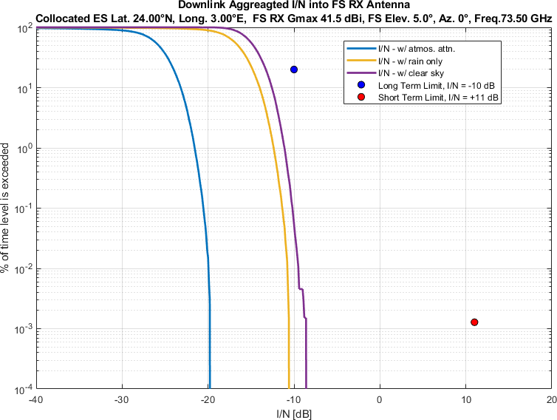
Figure 2
Aggregate I/N from Selected Systems at 24°N, FS max. Receive Gain 41.5 dBi, Azimuth 90°
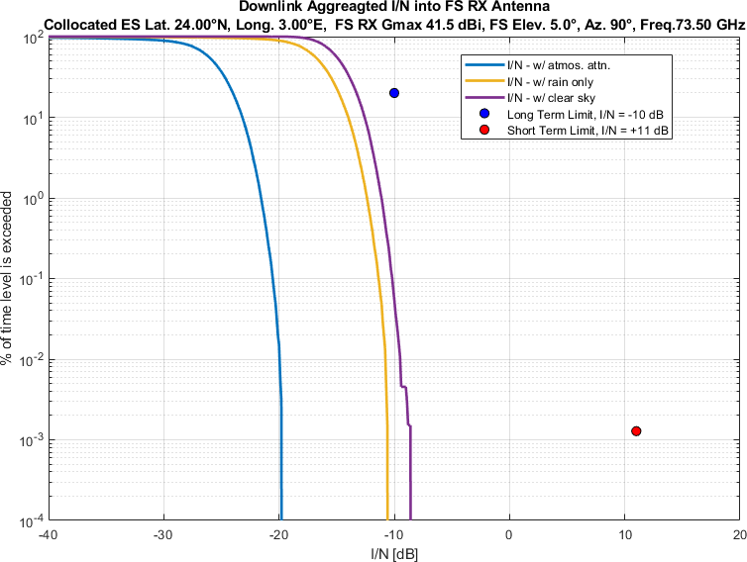
Figure 3
Aggregate I/N from Selected Systems at 24°N, FS max. Receive Gain 41.5 dBi, Azimuth 180°
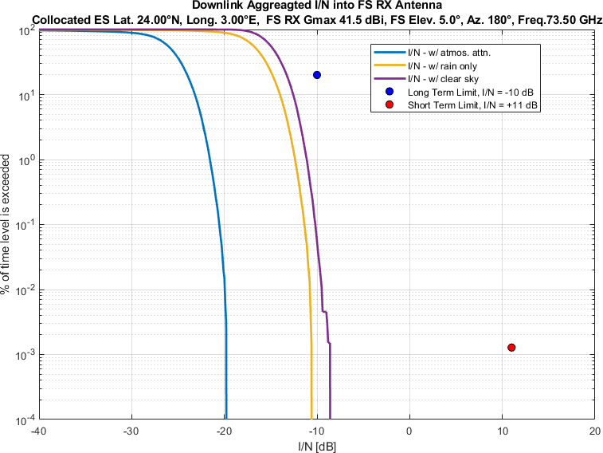
Figure 4
Aggregate I/N from Selected Systems at 24°N, FS max. Receive Gain 41.5 dBi, Azimuth 270°
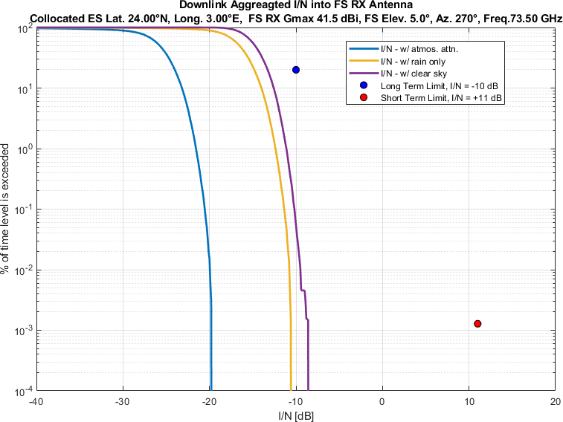

Figure 5
Aggregate I/N from Selected Systems at 45°N, FS max. Receive Gain 41.5 dBi, Azimuth 0°
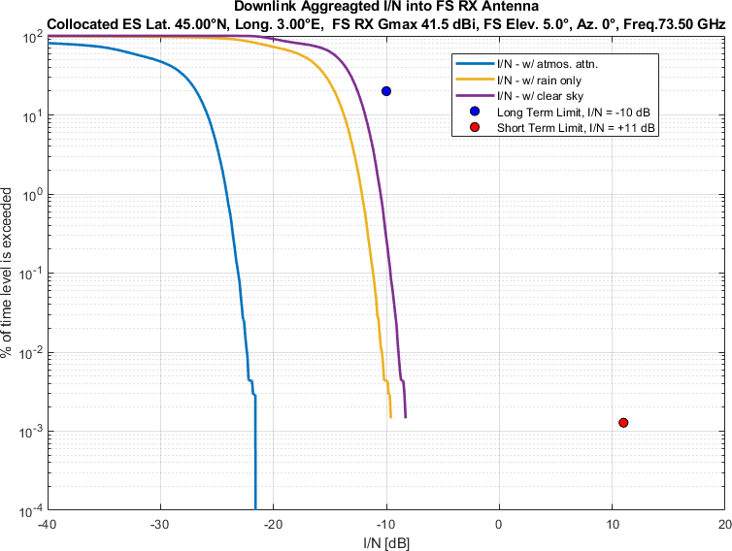
Figure 6
Aggregate I/N from Selected Systems at 45°N, FS max. Receive Gain 41.5 dBi, Azimuth 90°
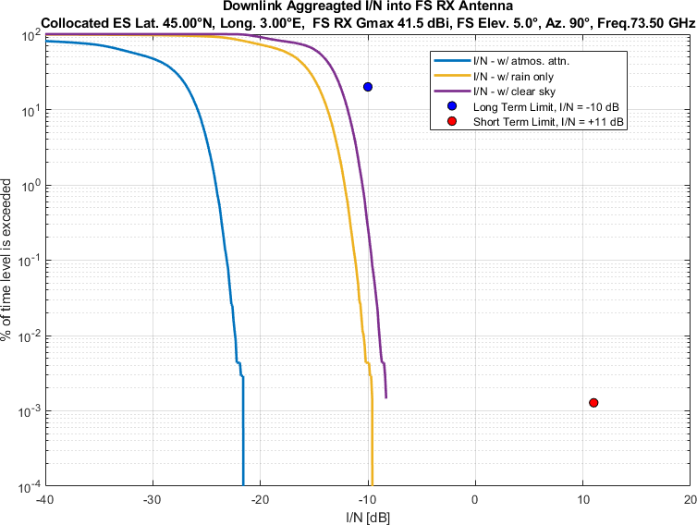
Figure 7
Aggregate I/N from Selected Systems at 45°N, FS max. Receive Gain 41.5 dBi, Azimuth 180°
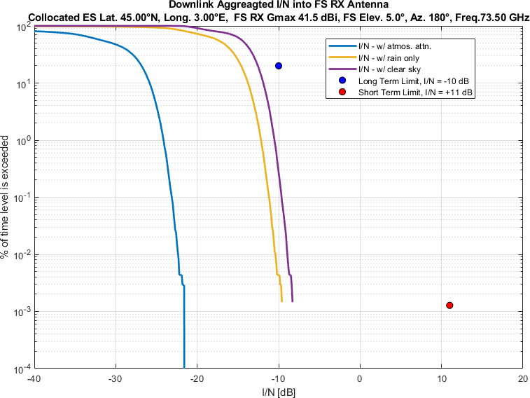
Figure 8
Aggregate I/N from Selected Systems at 45°N, FS max. Receive Gain 41.5 dBi, Azimuth 270°
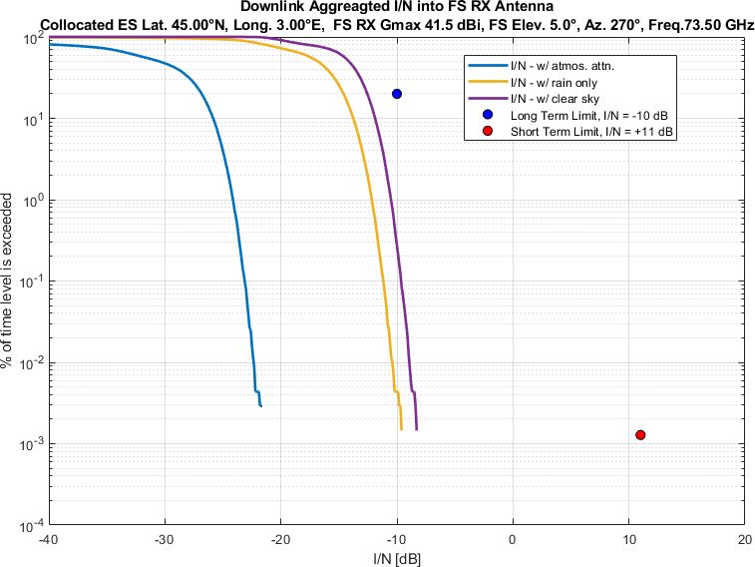

Figure 9
Aggregate I/N from Selected Systems at 60°N, FS max. Receive Gain 41.5 dBi, Azimuth 0°
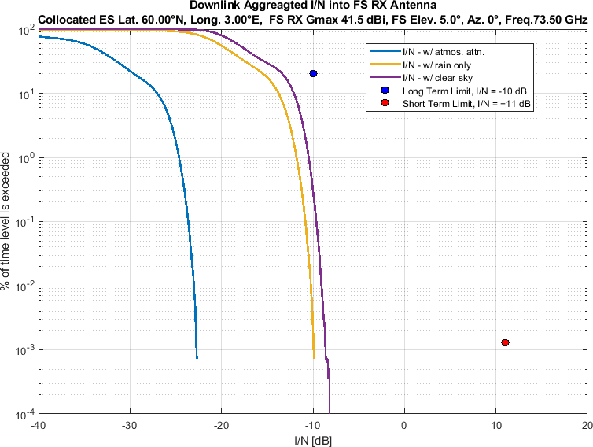
Figure 10
Aggregate I/N from Selected Systems at 60°N, FS max. Receive Gain 41.5 dBi, Azimuth 90°
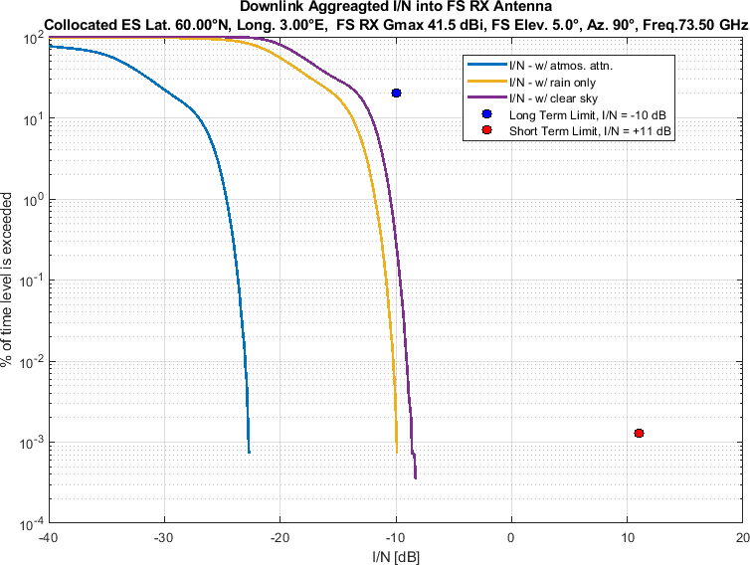
Figure 11
Aggregate I/N from Selected Systems at 60°N, FS max. Receive Gain 41.5 dBi, Azimuth 180°
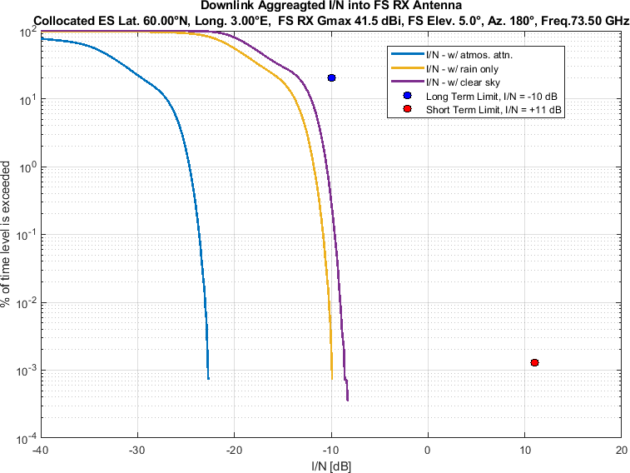
Figure 12
Aggregate I/N from Selected Systems at 60°N, FS max. Receive Gain 41.5 dBi, Azimuth 270°
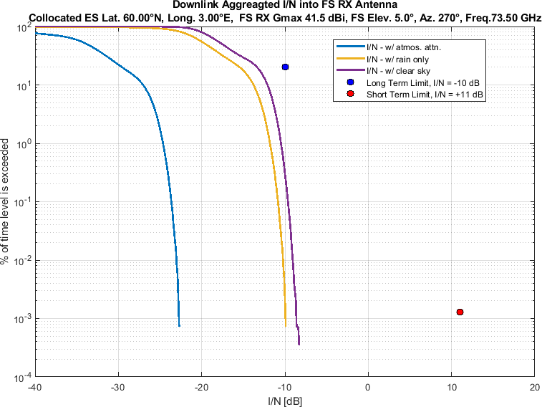

Similarly, Figure 13-24 compare aggregate I/N from the same selected GSO and three non-GSO systems to
the largest dimension 0.6m FS station antenna,
pointing at four different azimuth directions (i.e., 0°, 90°, 180° and 270°),
for maximum FS antenna elevation angle of 4°,
at same representative frequency (i.e., 73.5 GHz).
Again, each figure compares three different of atmospheric attenuation scenarios as mentioned above.

Figure 13
Aggregate I/N from Selected Systems at 24°N, FS max. Receive Gain 51 dBi, Azimuth 0°
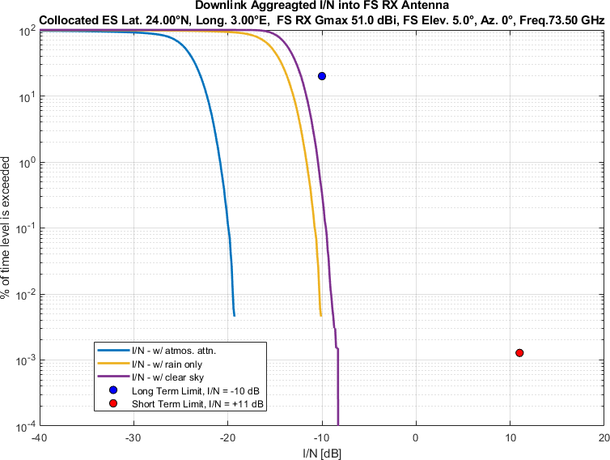
Figure 14
Aggregate I/N from Selected Systems at 24°N, FS max. Receive Gain 51 dBi, Azimuth 90°
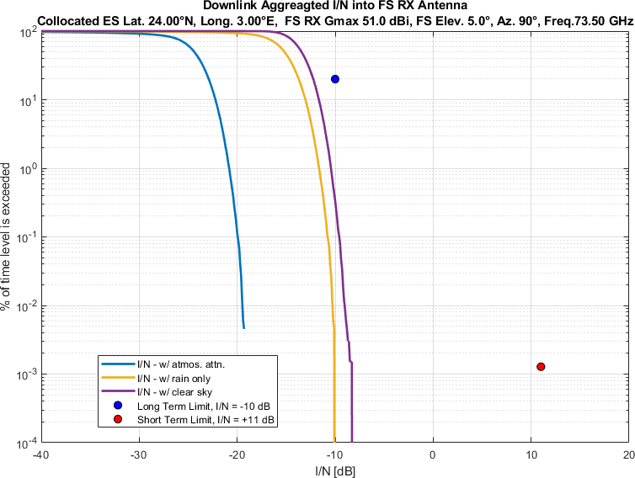
Figure 15
Aggregate I/N from Selected Systems at 24°N, FS max. Receive Gain 51 dBi, Azimuth 180°
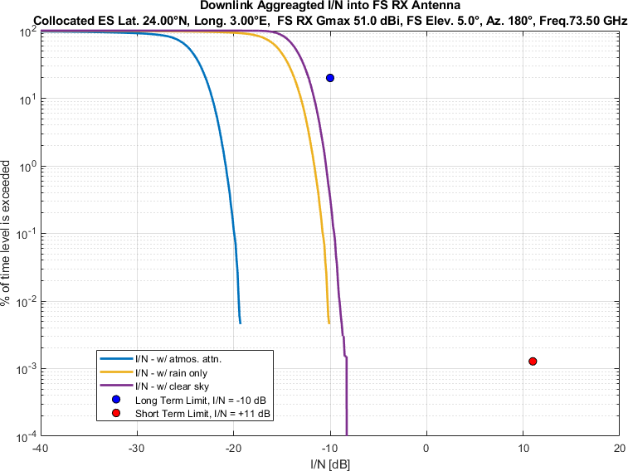
Figure 16
Aggregate I/N from Selected Systems at 24°N, FS max. Receive Gain 51 dBi, Azimuth 270°
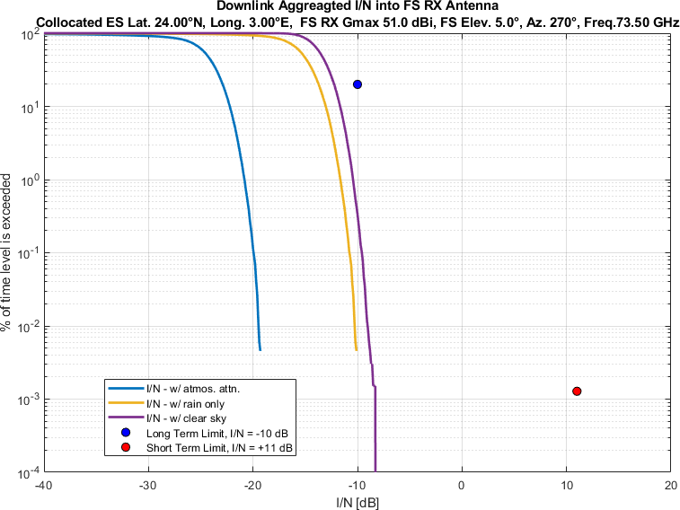

Figure 17
Aggregate I/N from Selected Systems at 45°N, FS max. Receive Gain 51 dBi, Azimuth 0°
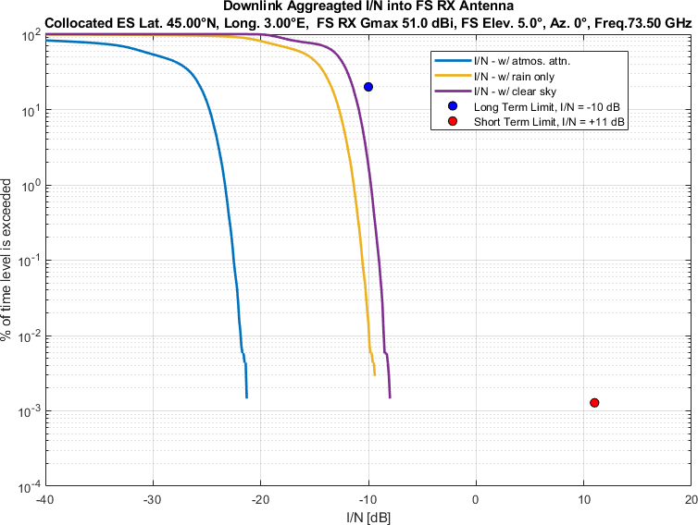
Figure 18
Aggregate I/N from Selected Systems at 45°N, FS max. Receive Gain 51 dBi, Azimuth 90°
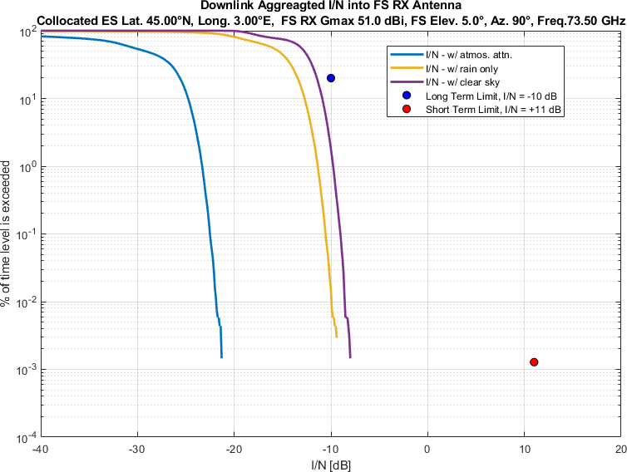
Figure 19
Aggregate I/N from Selected Systems at 45°N, FS max. Receive Gain 51 dBi, Azimuth 180°
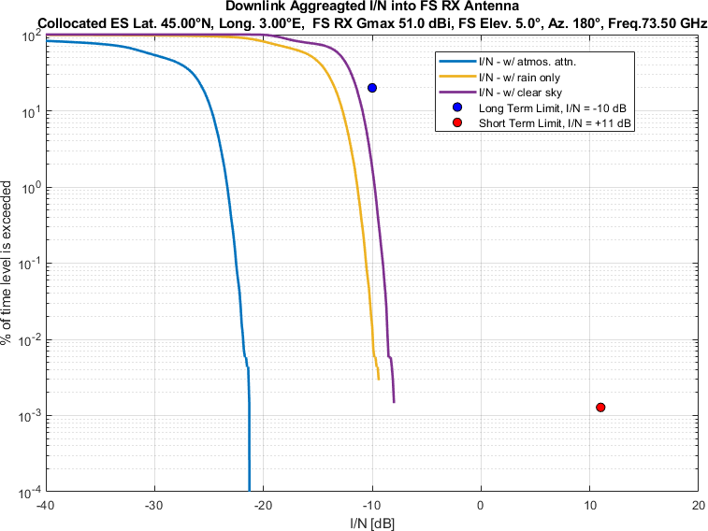
Figure 20
Aggregate I/N from Selected Systems at 45°N, FS max. Receive Gain 51 dBi, Azimuth 270°
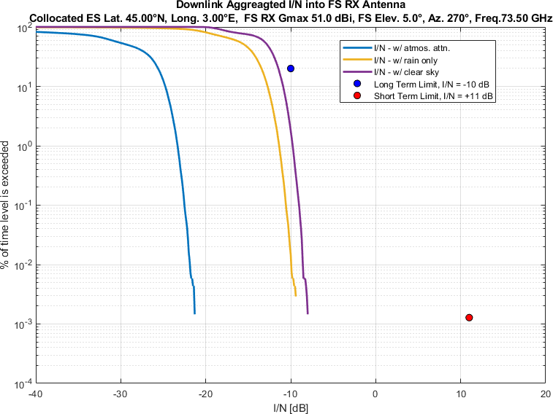

Figure 21
Aggregate I/N from Selected Systems at 60°N, FS max. Receive Gain 51 dBi, Azimuth 0°
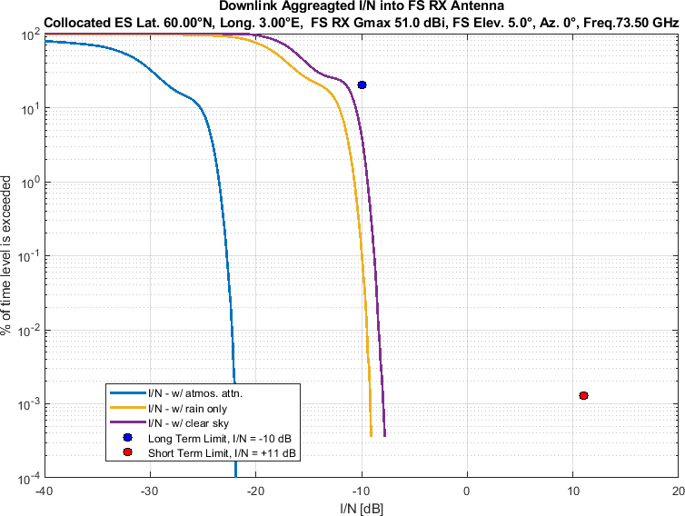
Figure 22
Aggregate I/N from Selected Systems at 60°N, FS max. Receive Gain 51 dBi, Azimuth 90°
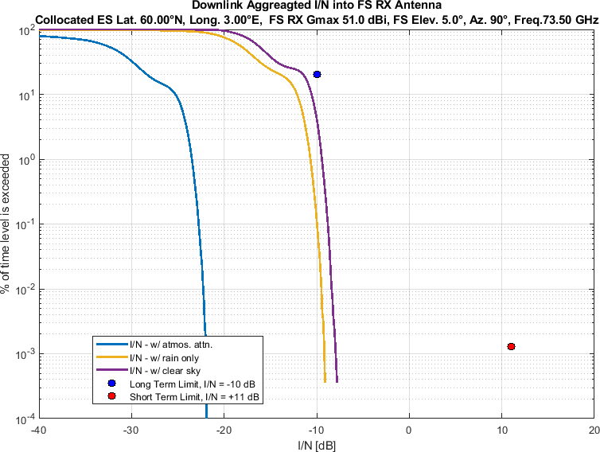
Figure 23
Aggregate I/N from Selected Systems at 60°N, FS max. Receive Gain 51 dBi, Azimuth 180°
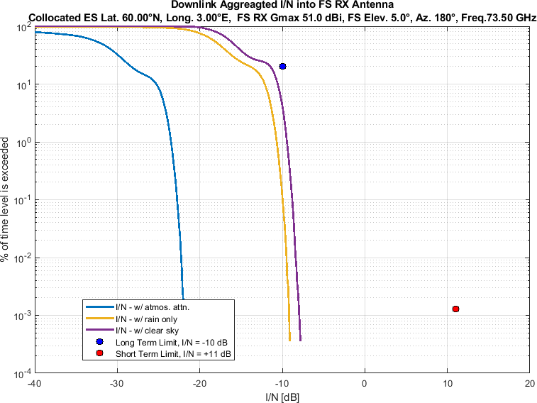
Figure 24
Aggregate I/N from Selected Systems at 60°N, FS max. Receive Gain 51 dBi, Azimuth 270°
