U.S. Radiocommunications Sector
Fact Sheet
Working Party: ITU-R WP 5B | Document No: USWP5B35-09
Ref: New | Date: 11th August 2025
Document Title: WORKING DOCUMENT TOWARDS A PRELIMINARY DRAFT NEW REPORT ITU-R M.[RNSS_AM(R)S_5GHZ_SHARING] – Sharing and compatibility study between RNSS and AM(R)S systems operating in the 5 000 to 5 150MHz Frequency Band

Author(s)/Contributors(s):  Name: Don Nellis  Org: Federal Aviation Administration  Name: Michael Neale  Org: ACES Corporation for the FAA  Name: Martin San Juan  Org: ACES Corporation for the FAA | Phone: (202) 267-9779  Email: Donald.Nellis@faa.gov  Phone: (858) 705-8978  Email: michael.neale@aces-inc.com  Phone: (202) 267-5976  Email: martin.sanjuan@aces-inc.com
Purpose/Objective: The purpose of this contribution is a sharing and compatibility study between the RNSS operating in the 5 010 – 5 030 MHz frequency band and the AM(R)S service supporting Unmanned Aircraft Systems operating in the 5 030 to 5 091 MHz frequency band. This study is aimed at finalizing the e.i.r.p. density limit that is currently provisional in RR No. 5.443C
Abstract: This initial contribution provides an outline for the study and the characteristics of the two systems.

Radiocommunication Study Groups | 
Received : XXX  Source: New  Subject: New Report  ITU-R M.[RNSS_AM(R)S_5GHZ_SHARING] | Document 5B/XXX-E
 | XXX
 | English only
United Sates of America
WORKING DOCUMENT TOWARDS A preliminary draft new RePORT Itu-r m.[RNSS_AM(R)S_5GHz_SHARING]
Sharing and compatibility study between RNSS and AM(R)S systems operating in the 5 010 to 5 091 MHz Frequency Band
Introduction
At WRC-2012 it was agreed, under No. 5.443C, that the frequency band 5 030-5 091MHz could be used by the aeronautical mobile (R) service limited to internationally standardized aeronautical systems. Industry, international standards development organizations and ICAO have been working since then to develop the technology and standards necessary to use that allocation. Consequently, it is now possible to provide characteristics and protection criteria for such systems for use in any future sharing studies within ITU-R.
Proposal
The United States of America proposes to assist in answering the above need by providing characteristics as Attachment 1 for such Control and Non-Payload Communications (CNPC) links operating in the AM(R)S allocation under No. 5443C and used in air-ground applications between Unmanned Aircraft (UA) and their Control Station (CS) where the Remote Pilot (RP) is located.
Attachment 2 provides the characteristics of the Galileo Positioning System, and the Global Positioning System, the two most widely used GNSS constellation in Region 2 of the RNSS services operating in the 5 010 – 5 030 MHz frequency band as found in ITU-R M.2031-1.
Attachment 3 provides an outline for conducting the sharing and compatibility study of the two systems detailing the various cases and the processes.

Attachments: 3

ATTACHMENT 1

UAS CNPC Characteristics

Introduction and scope

As recommended, UAS CNPC Characteristics are taken from PDNR ITU-R M.[AM(R)S_AMS(R)S_CHAR_5GHZ] - Characteristics and Protection Criteria of Terrestrial and Satellite Unmanned Aircraft System Control and Non-Payload Communications Links operating in the Aeronautical Mobile (R) Service and Aeronautical Mobile Satellite (R) Service in the band 5 030-5 091 MHz.

[Figure 1]
Example command and non-payload communications link system components

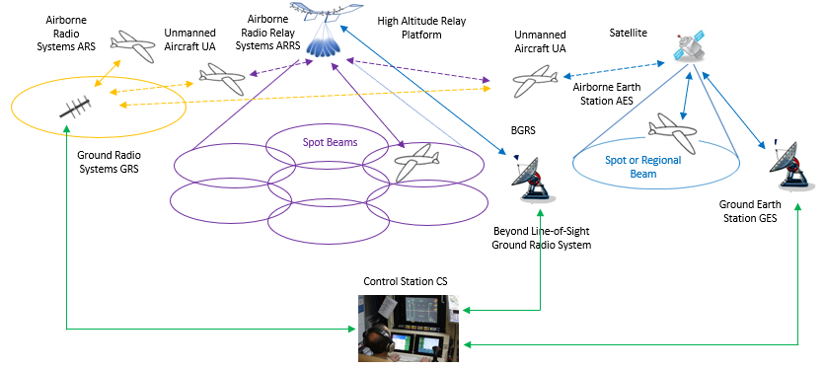

Unmanned aircraft and control station characteristics for terrestrial control
and non-payload communication link

The terrestrial component uses an airborne radio system (ARS) on the UA to communicate with a ground radio system (GRS) that connects to the UACS.
TABLE 1
Transmission and reception characteristics for the terrestrial control
and non-payload communication link System 1
Terrestrial command and non-payload communication System 1
 | Units | UA ARS | GRS
Frequency of operation | MHz | 5 030 to 5 091 | 5 030 to 5 091
Duplexing |  | Time division duplex (TDD) | TDD
Transmit/receive duration | msec | 60 Receive + 2.5 guard time  65 Transmit + 2.5 guard time | 60 Transmit + 2.5 guard time  65 Receive + 2.5 guard time
Modulation |  | GMSK or QPSK | GMSK or QPSK
Modulation symbol rates | ksps | GMSK: TBD  including error correction/detection, guard times and synchronization overhead | GSMK: TBD  including error correction/detection, guard times and synchronization overhead
Forward error correction |  | GMSK: Rate 5/8 Turbo Conv.  Code  QPSK: Rate 5/9 and Rate 1/3 TCC | GMSK: Rate 5/8 Turbo Conv. Code  QPSK: Rate 5/9 and Rate 1/3 TCC
Error detection |  | 32-bit CRC | 32-bit CRC
Baseband Input/Output Signal |  | User Data | User Data
User Data Bit Rates | kbps | GMSK: TBD  QPSK: TBD  Includes TDD duty cycle overhead | GMSK: TBD  QPSK: TBD  Includes TDD duty cycle overhead
Occupied bandwidth, C | kHz | Variable per application with a maximum of 250 | Variable per application with a maximum of 250
Antenna gain | dBi | 2 | Maximum 20
Cable loss | dB | 2 | 1
Antenna pattern |  | Constant azimuth  Constant elevation | Constant azimuth  Tailored in elevation  See Table 2
Antenna polarization |  | Vertical with aircraft flying straight and level | Vertical
Maximum antenna height | m | 22 860 (mean sea level)  Typical 6 000 | 2 to 50  Typical 10
Service range | km | 550  Typical 80 | 550  Typical 80
Transmitter conducted power | dBm | 40 | 40
Transmitter in band emission limits | dBc/  1 MHz | −66 at 2 MHz offset  See Table 3 | −66 at 2 MHz offset  See Table 3
Receiver noise figure | dB | 7 | 7
Receiver sensitivity | dBm | GMSK: TBD  QPSK: TBD | GMSK: TBD  QPSK: TBD
Receiver in band rejection – except the operating channel | dB | One channel separation: 23  Two channel separation: 43  Three channel separation: 57  2 MHz or more separation: 63 | One channel separation: 23  Two channel separation: 43  Three channel separation: 57  2 MHz or more separation: 63
Protection criteria (aggregate) I/N | dB | –6 | –6

TABLE 2
GRS elevation antenna pattern envelope is constant in azimuth for System 1 with 20 dBi antenna with
elevation 3 dB beamwidth equal to 9° and azimuth 3 dB beamwidth equal to 32°
System 1
Elevation degrees | Gain dBi
0.5 | 19.0
1.5 | 19.5
2.5 | 20.0
3.5 | 19.5
7 | 17.0
11.5 | 14.0
16 | 11.5
32 | 6.5
64 | 1.5
>75 | 0.5

Note: The GRS uses a sectorized or steerable in azimuth beam antenna, with the fixed elevation pattern given in Table 2.
[Editor’s note: All the gains indicated for the antenna pattern in Table 2.1 are positive, which is questionable.]
TABLE 3
Transmitter out of band emission limits in the 5 030-5 091 MHz frequency band for system 1
System 1
Offset from carrier frequency | dBc/kHz
Channel width ÷ 2 | −54
1.5 × channel width | −74
500 kHz | −90
2 000 kHz | −96

TABLE 4
Transmitter spurious emission limits
 | Maximum command and non-payload communication link system power spectral density in the spurious domain
 | UA ARS | GRS
System 1 | TBD | TBD

[Editor’s note: It is envisioned that the proposed Recommendation will eventually include the spurious emission characteristics of AM(R)S transmissions into adjacent allocations including those below 5 030 MHz that would be necessary for sharing studies to resolve the provisional nature of the -75 dBW/MHz protection value in RR No. 5.443C.]
TABLE 5
Terrestrial System 1 Example link budget
Link Budget Element | GRS to UA | UA to GRS
Maximum Slant Range | 80 km | 80 km
Typical UA Altitude (AGL) at Slant Range | 6,000 m | 6,000 m
GRS to UA LOS Path Elevation Angle | 3.0 deg | 3.0 deg
Transmitter Antenna Gain at Path Elevation Angle | 19.75 dBi | 2 dBi
EIRP (10W transmitter conducted power, plus Antenna Gain minus cable loss) | 58.75 dBm | 41.0 dBm
Free Space Loss at Slant Range at 5 091 MHz | 144.7 dB | 144.7 dB
Multipath Fading plus Airframe Obstruction for 99.8% Availability | 13.0 dB | 13.0 dB
Receiver Antenna Gain at Path Elevation Angle | 2 dBi | 19.75 dBi
Received Signal Level, C (including cable loss) | −98.0 dBm | −98.0 dBm
Total On Channel Interference Power Density from other CNPC Systems | −138.3 dBm/kHz | −129.0 dBm/kHz
Receiver Noise Power for 7dB Noise Figure in 500 kHz Noise Bandwidth | −140.0 dBm/kHz | −140.0 dBm/kHz
Total On Channel Interference Power Density from other non-CNPC Systems at -6dB Aggregate I/N Protection Criteria | −146.0 dBm/kHz | −146.0 dBm/kHz
Combined On Channel Interference and Noise Power Density | −135.6 dBm/kHz | −128.6dBm/kHz
ICAO 6dB Aeronautical Safety Margin added to Combined On Channel Interference and Noise Power Density, Io + No | −129.6 dBm/kHz | −122.6 dBm/kHz
Maximum Modulation Symbol Rate, Rs | 170 kHz | 170 kHz
Es/No including 3 dB implementation Loss, for required BER assuming GMSK with rate 5/8 Turbo Convolutional Code for FEC | 2.3 dB | 2.3 dB
Required Cmin/(Io + No), equals Es/No plus 10 x Log Rs | 24.6 dBm-kHz | 24.6 dBm-kHz
Available C/(Io + No) | 31.6 dBm-kHz | 24.6 dBm-kHz
Excess Link Margin @ Maximum Modulation Symbol Rate | 7.0 dB | 0.0 dB

ATTACHMENT 2

RNSS Characteristics

Introduction and scope

As recommended by WP 4C (5B/312), RNSS characteristics and protection criteria are taken from Recommendation ITU-R M.2031-1 - Characteristics and protection criteria of receiving earth stations and characteristics of transmitting space stations in the radionavigation-satellite service (space-to-Earth) operating in the band 5 010-5 030 MHz.
These characteristics and protection criteria should be used in performing analyses of radio frequency interference impact on systems and networks in the RNSS (space-to-Earth) operating in the band 5 010-5 030 MHz from the Control and Non-Payload Communications (CNPC) links operating in the AM(R)S allocation under No. 5443C.
TABLE 1-1
Service link characteristics and protection criteria for receiving earth stations
operating in the band 5 010-5 030 MHz
Parameter | Galileo | GPS
Signal frequency range (MHz)
Maximum receiver antenna gain (dBi)
RF filter 3 dB bandwidth (MHz)
Pre-correlation filter 3 dB bandwidth (MHz)
Receiver system noise temperature (K)
Tracking mode threshold power level of aggregate narrow-band interference at the passive antenna output (dBW)
Acquisition mode threshold power level of aggregate narrow-band interference at the passive antenna output (dBW)
Tracking mode threshold power density level of aggregate wideband interference at the passive antenna output (dB(W/MHz))
Acquisition mode threshold power density level of aggregate wideband interference at the passive antenna output (dB(W/MHz))
TABLE 1-2
Feeder link characteristics for receiving earth stations
operating in the band 5 010-5 030 MHz

Characteristics of receiving feeder-link earth stations
operating in the band 5 010-5 030 MHz
Parameter | GPS | QZSS
Antenna diameter (m)
Polarization
Antenna pattern
Theoretical antenna gain (dBi)
Antenna efficiency loss (dB)
Maximum receive antenna gain (dBi)
Receiver system noise temperature (K)
Minimum elevation (degrees)

Feeder downlink transmissions in the band 5 010-5 030 MHz
Parameter | GPS | QZSS
Signal frequency range (MHz) (Note 1)
Encoded bit rate (bit/s)
Signal modulation method
Polarization
Ellipticity (dB)
Transmit e.i.r.p. (dBW)
NOTE 1 – Carrier frequency of the RNSS signal of interest ± half the signal bandwidth.

[Editor’s note: Draft Liaison Statement to WP5B indicates WP4C initiating an update/revision to ITU-R M.2031-1.]

ATTACHMENT 3

Outline for conducting the sharing and compatibility study of the two systems

1 Introduction and scope
At WRC-2012 it was agreed, under No. 5.443C, that the frequency band 5 030-5 091MHz could be used by the aeronautical mobile (R) service limited to internationally standardized aeronautical systems.
No. 5.443C states that “Unwanted emissions from the aeronautical mobile (R) service in the frequency band 5030-5091 MHz shall be limited to protect RNSS system downlinks in the adjacent 5010-5030 MHz band. Until such time that an appropriate value is established in a relevant ITU-R Recommendation, the e.i.r.p. density limit of −75 dBW/MHz in the frequency band 5010-5030 MHz for any AM(R)S station unwanted emission should be used. (WRC-12)”
It is the intention of this study to investigate the e.i.r.p. density limit that needs to be applied to the emissions of UAS CNPC (whose characteristics are provided in Attachment 1) in order to protect the RNSS whose characteristics and protection criteria are provided in Attachment 2 and in so doing enable the provisional nature of the current e.i.r.p. density limit to be resolved.

1.1 RNSS and UAS CNPC Frequency Allocation
The frequency arrangement is shown below. The target systems were RNSS systems operating in the 5 010-5 030 MHz frequency band, which is adjacent to the CNPC frequency band.
Figure 1
Frequency Placement of RNSS, CNPC and AM(R)S operating in the 5 000-5 150 MHz frequency band
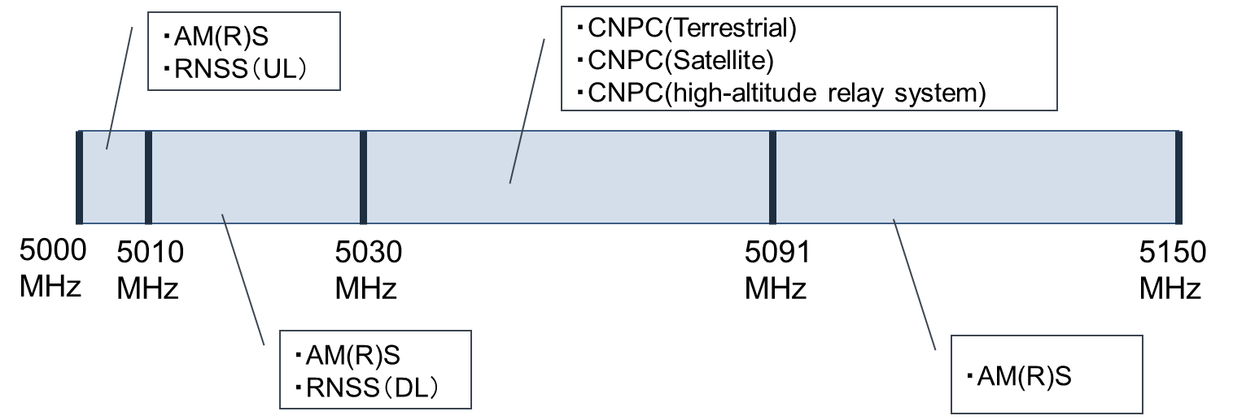

NOTE 1: Compatibility studies among UAS CNPC systems are currently being conducted mainly by aeronautical standardization bodies and are outside the scope of this shared-use study.
NOTE 2: RNSS (UL) in the 5 000-5 010 MHz frequency range is out of scope as there is sufficient frequency separation.
[Editor's Note: There is an AM(R)S system operating at 5 010-5 030 MHz and 5 091-5 150 MHz called AeroMACS. However, its operational status is still under investigation and will be addressed in a future WP 5B meeting.]

2 Terrestrial CNPC Link Compatibility studies with RNSS

Case A.1: Potential interference from GRS to mobile station RNSS users (ground and airborne)

Case A.2: Potential interference from GRS to fixed station RNSS feeder space-to-Earth link

Case A.3: Potential interference from UA to mobile station RNSS users (ground and airborne)

Case A.4: Potential interference from UA to fixed station RNSS feeder space-to-Earth link

____________

