U.S. Radiocommunications Sector
Fact Sheet
Working Party: ITU-R WP 5C | Document No: USWP5C33-05
Ref: Document 5C/206 (Annex 2.1) | Date: 2 September 2025
Document Title: WORKING DOCUMENT ON SHARING STUDIES UNDER WRC-27 AGENDA ITEM 1.10
Author(s)/Contributors(s):  Zahid Islam  SpaceX  Joe McMichael  SpaceX  Nader Damavandi  SpaceX  Jameson Dempsey  SpaceX | Email: km.islam@spacex.com  Email: Joseph.McMichael@spacex.com  Email: Nader.Damavandi@spacex.com  Email: jameson.dempsey@spacex.com
Purpose/Objective: Add studies and propose edits to the Working Doc on AI 1.10, i.e. 5C/206 (Annex 2.1)

Abstract: Within the context of AI 1.10, WP5C, based on studies, will determine power flux-density (pfd) and equivalent isotropically radiated power (e.i.r.p.) limits to be included in Article 21 for satellite services (fixed-satellite service (FSS), mobile-satellite service (MSS) and broadcasting-satellite service (BSS)) to protect the current and planned fixed and mobile services in the frequency bands 71-76 GHz and 81-86 GHz. The United States hereby propose edits to the main Working Document, 5C/206 (Annex 2.1), and add new studies taking into account accurate modelling of the example FSS systems considered.
Note: the second draft contains additional studies that better model, among other things, the aggregate interference from GSO networks

Radiocommunication Study Groups | 
Received: TBD October 2025  Source: Document 5C/206 (Annex 2.1)  Subject: AI 1.10 | Document 5C/TBD-E
 | TBD October 2025
 | English only
United States of America
WORKING DOCUMENT ON SHARING STUDIES
UNDER WRC-27 AGENDA ITEM 1.10
Within the context of AI 1.10, WP5C, based on studies, will determine power flux-density (pfd) and equivalent isotropically radiated power (e.i.r.p.) limits to be included in Article 21 for satellite services (fixed-satellite service (FSS), mobile-satellite service (MSS) and broadcasting-satellite service (BSS)) to protect the current and planned fixed and mobile services in the frequency bands 71-76 GHz and 81-86 GHz. The United States hereby propose edits to the main Working Document, 5C/206 (Annex 2.1), and add new studies taking into account accurate modelling of the example FSS systems considered.
The edits are added in track changes. For simplicity, currently existing edits in Doc 5C/206 (Annex 2.1) have been accepted, so that the only edits are those from the United States and can easily be included in the Working Doc for review during the 5C meeting. Moreover, since the Working Doc is quite extensive already, for brevity the US only included sections where edits are provided.

The updates in the second draft are highlighted in green.

4 Characteristics and protection criteria of FS stations
The following ITU-R Recommendations contain relevant technical and operational characteristics as well as protection criteria for FS systems:
– Recommendation ITU-R F.758-8 contains the principles for the development of sharing criteria of digital systems in the FS. It also contains information on representative technical characteristics of digital fixed wireless systems (FWS) in the FS for use in sharing studies above about 30 MHz. For agenda item (AI) 1.10, the following table abstracted from Table 12 contains the system parameters for PP FS systems in allocated bands from 71-76 GHz and 81-86 GHz.
Table 3
Typical values for FS point-point system parameters in the frequency band 71-76 and 81-86 GHz
Frequency range  (GHz) | 71-76/81-86
Reference ITU-R Recommendation | F.2006
Modulation | QPSK | 64-QAM
Channel spacing and receiver noise bandwidth (MHz) | 250, 500, 750, 1 000, 1 250, 1 500, 1 750, 2 000, 2 250 | 500, 700, 1 000
Tx output power range (dBW) | –10 | –20
Tx output power density range (dBW/MHz)⁽¹⁾ | –41 | –47…-50
Feeder/multiplexer loss range (dB) | 0 | 0
Antenna gain range (dBi) | 54 | 44…50
e.i.r.p. range (dBW) | 44 | 24…30
e.i.r.p. density range (dBW/MHz)⁽¹⁾ | 13 | –6…3
Receiver noise figure typical (dB) | 10 | 8
Receiver noise power density typical (=N_{RX}) (dBW/MHz) | –134 | –136
Normalized Rx input level for 1 × 10^{–6} BER (dBW/MHz) | –120.5 | –94…-91
Nominal long-term interference power density (dBW/MHz)⁽²⁾ | –134 + I/N | –136 + I/N

– Recommendation ITU-R F.699-8 provides reference radiation patterns for, and information on, point-to-point FWS antennas in the frequency range from 100 MHz to 86 GHz. This information may be used in single-entry analyses and interference assessments when information concerning the FWS antenna is not available.
– Recommendation ITU-R F.1245-3 provides average sidelobes and related reference radiation patterns for point-to-point FWS antennas in the frequency range from 1 GHz to 86 GHz. This information may be used for aggregate coordination and interference assessment studies when information concerning the FWS antenna is not available.
Editor’s note: More discussion is needed on how to best study the impact of antennas having radiation patterns with sidelobe levels differing significantly from those in Recommendations ITU-R F.699 and F.1245, and take into account the study and treatment of radiation patterns based on deployment of FWS antennas by memberships. Memberships are encouraged to provide further inputs on this topic to the future meetings.
Recommendations ITU-R F.699 and ITU-R F.1245 provide reference radiation patterns to be used when information concerning the FWS antenna is not available. The radiation pattern of some deployed FWS antenna may have side lobes which fall above or below these recommendations’ reference patterns. Therefore, some sensitivity analysis may be considered, taking into account radiation patterns of antennas deployed. Attachment 4 provides some antenna patterns which could be used for sensitivity analysis.
Typical FS station parameters are provided in the following table, to facilitate the sharing study.
Considering the above ITU-R recommendations, the following parameters are selected to develop studies.
Editor’s note: it is encouraged for membership to provide their data on elevation angle at next meeting, including towards supplementing the information to preliminary draft revision of Recommendation ITU-R F.2086, which is targeted to be finalized at next WP5C meeting.
Table 4
Typical values for FS point-point system parameters in the frequency band 71-76 and 81-86 GHz
System parameters | Typical Value
Channel spacing and receiver noise bandwidth (MHz) | 500
Modulation | 64 to128-QAM
Feeder/multiplexer loss (dB) | 0
Antenna gain (dBi) | 41.5, 45 or 51
Antenna size (m) | 0.2, 0.3 or 0.6
Receiver noise figure (dB) | 8
Antenna height(m) | 30
Antenna RPE | F.699-8 and F.1245-3
Link length (km) | 0.4-3
Elevation angle (degree) | −5 to 5
Nominal long-term interference power density (dBW/MHz) | –136 + I/N

The following protection criteria used in study of WRC-27 agenda item 1.10 are:
‒ for the long-term, the I/N at the input of the FS receiver should not exceed –10 dB for more than 20% of the time;
‒ for the short-term, the I/N at the input of the FS receiver should not exceed +11 dB for more than 0.00128% of the time. The derivation methodology is in Attachment 1.

…….

Sharing with GSO satellites
As the interference from GSO satellites is steady, the long-term protection criterion of Recommendation ITU-R F.758 is used.

Scenario 1
Station(s) of the fixed service are defined with the parameters of the following table.
Table 5
Parameters of the station of the fixed service
Parameter | Value | Source
Latitude (°) | 0, 25, 50, 75
Longitude (°) | 0
Altitude (m) | 30
Antenna elevation (0) | 0, 2.5, 5 | Rec. ITU-R F.2086
Azimut (°) | 0 to 180
Antenna diameter (cm) | 20, 30 or 60
Antenna diagram |  | Rec. ITU-R F.1245,  EN 302 217-4 Class 3
Max antenna gain |  | Rec. ITU-R F.699
I/N (dB) long-term | ‒10 | Rec. ITU-R F.758
Nominal long-term interference power density (dBW/MHz) | ‒146 | Rec. ITU-R F.758
{Yellow highlight from 5C/170}
GSO satellites are separated from 10, 4, or 1°.
Exceedance over the nominal long-term interference power density is assessed with several tentative pfd masks.
[Editor’s note: assumptions on GSO satellite spacing for sharing studies should be carefully considered in order to avoid overly conservative assumptions and ensure modelling of realistic scenarios]

…..

Methodology for assessment of candidate pfd masks

Existing pfd masks in RR Article 21
RR Article 21, and more specifically Table 21-4, provides pfd limits that shall not be exceeded by emissions from a space station, for all conditions and for all methods of modulation.
Table 5
Extract of RR Table 21-4 in the frequency range 42-42.5 GHz
Frequency band | Service* | Limit in dB(W/m²) for angles  of arrival (δ) above the horizontal plane |  |  |  | Reference bandwidth
 |  | 0°-5° | 5°-25° |  | 25°-90°
40-40.5 GHz | Fixed-satellite  Mobile-satellite | −115 | −115 + 0.5(δ − 5) |  | −105 | 1 MHz
42-42.5 GHz | Fixed-satellite  (non-geostationary-satellite orbit)  Broadcasting-satellite  (non-geostationary-satellite orbit) | −120 11, 21 | 5°-25° |  | −105 11, 21 | 1 MHz
 |  |  | −120 + 0.75(δ − 5) 11, 21
42-42.5 GHz | Fixed-satellite  (geostationary-satellite orbit)  Broadcasting-satellite  (geostationary-satellite orbit) | −127 21 | 5°-20° | 20°-25° | −105 21 | 1 MHz
 |  |  | −127 + (4/3)  (δ − 5) 21 | −107 + 0.4  (δ − 20) 21

The pfd is the power flux density produced on earth’s surface.
These pfd limits are defined as a function of the angle of arrival above the horizontal plane and are, therefore, purely geometrically defined. These pfd mask could be starting point for studies under this agenda item but other masks can also be considered in sharing studies.

…..

Study #XX
This study considers operational conditions of the FS as provided in doc 5C/206 (Annex 2.1) and assuming 5 degrees as maximum elevation. With respect to the parameters of GSO and non-GSO systems (including minimum elevation, GSO exclusion zone, and max number of co-frequency beams at a specific location), the analysis considered cases with different operational conditions than those communicated by 4A in order to execute studies with some margin/conservatism. The various assumptions different from the 4A liaison statement are on purpose all worse than the parameters communicated by 4A. Additionally, the methodology considers scenarios with propagation characteristics as per Doc. 5C/74 (guidance provided by WP 3J and 3M), as well as scenarios in clear sky.
The statistics of the interference power against time for each power flux density (PFD) mask specified is calculated at each timestep using the method described below:
I = PFD-10log104πλ2- La +Gα
PFD is the assumed power flux density at the Earth’s surface in dB(W/m²/MHz)
λ is the wavelength in meters
La is the atmospheric loss (i.e., gas, rain, cloud and scintillation) experienced by the link. Propagation losses should be considered based on ITU-R Recommendations ITU-R P.676, ITU-R P.618, ITU-R P.840 and referenced recommendations therein.
Gα is the gain of the FS receiving antenna at off-axis angle α degrees
Note: this equation does not consider Feeder Losses, which are normally considered. This is an extra layer of conservatism. USA also notes that feeder losses have been indeed considered in previous similar studies (see “Scaling Factor” from WRC-23)
The steps taken in the analysis are the following:
1) Select a group of representative GSO and non-GSO systems to use in the analysis.
2) Based on the parameters of the selected non-GSO systems, determine number of visible satellites to the FS station, Nv, with minimum elevation of 0°.
3) Determine the pool of eligible satellites for each of the selected non-GSO systems complying with minimum elevation angle, ε, and minimum GSO exclusion angle, α at the terrestrial ES location.
4) Select maximum number of non-GSO satellites allowed to transmit with overlapping frequencies towards the same location on the ground, Nco, using random satellite selection strategy.
5) For the remaining visible Nv- Nco satellites, determine contribution of the sidelobes towards the same location on the ground assuming random placement of the beam from the satellite with its beam footprint.
6) Aggregate power levels received at the FS station by combining the received interference power from all Nv satellites of the non-GSO system.
7) Aggregate power levels received at a FS station by combining the received interference power from the selected GSO and non-GSO systems. The FS station effective system noise temperature is also increased with atmospheric attenuation according to equation (69) in ITU-R P.618-14.
The selected parameters of the selected GSO and there non-GSO systems are shown in Table 1. According to the WP4A guidance, 1.5° minimum angular separation is used among the three non-GSO systems’ beams serving the same location on Earth.
Table 1
Parameters of the Selected GSO and non-GSO Systems (as per 4A guidance)
GSO/Non-GSO System | Height  (km) | Number of planes | Satellites per plane | Inclination angle (deg) | Number of co-frequency beams, Nco | Min. Elevation Angle, ε | Min. GSO Exclusion angle, α
System-B (non-GSO) | 590, 610, 630 | 28, 36, 34 | 28, 36, 34 | 33, 42, 51.9 | 32 | 20° | 1°
System-C (GSO) | 35786 | 1 | 1 | 0 | 1 | 3° | N/A
System-D (non-GSO) | 1050 | 12 | 28 | 89 | 8 (assumed) | 20° (assumed) | 1°
System-M (non-GSO) | 340, 345, 350, 360, 525, 530, 535, 604, 614 | 12, 18, 48, 48, 48, 30, 28, 28, 28 | 110, 110, 110, 120, 120, 120, 120, 12, 18 | 53, 46, 38, 97, 53, 43, 33, 148, 116 | 50  (assumed) | 10°  (assumed) | 1°

Table 2 lists the flat pfd mask used in the analysis for the selected GSO and non-GSO systems. All satellites that are in view of the FS station are assumed to be possibly interfering satellites for this study. The Nco satellites transmitting towards the location of FS station are randomly selected from each set of prospective transmitting satellites.
Table 2
Pfd masks for the Selected GSO and non-GSO systems
System | PFD in dB(W/m²) for angles of arrival (δ)  above the horizontal plane |  |  | Reference Bandwidth
 | 0°-5° | 5°-25° | 25°-90°
GSO  /Non-GSO | -105 | -105 | -105 | 1 MHz

FS link characteristics has been used following WP 5C guidance as listed in Table 3. Atmospheric attenuation (i.e., gas, rain, cloud and scintillation) in accordance with Recommendation Per ITU-R P.676, ITU-R P.618, ITU-R P.840 has been considered.
Table 3
FS Link Characteristics
Parameters | Specifications
Frequency (GHz) | 73.5
FS Antenna maximum Receive Gain (dBi) | 41.5 (0.2 m), 51(0.6 m)
FS Antenna Pattern | Per Rec. ITU-R F.1245-3
Latitude (degrees) | 24° N, 45° N, 60° N
Longitude (degrees) | 3° E
Elevation Angles | 5°
Receiver Noise Figure (dB) | 8
Antenna height(m) above mean sea level (AMSL) | 30
Above mean sea level (AMSL) (m) | 24° N, 3° E: 528 m  45° N, 3° E: 1014 m  60° N, 3° E: 0 m

Note that assuming a constant fixed elevation of 5° for the FS victim is a worst-case assumption.

The protection criteria for FS safeguard used in this analysis are:
a Long-term: I/N should not exceed –10 dB for more than 20% of the time (derived from Recommendation ITU-R F.758-8)
b Short-term: I/N should not exceed +11 dB for more than 0.00128% of the time in any month.
Results of study #XX
Figures 1-54 compare aggregate I/N from the selected GSO and three non-GSO systems to
- The smallest dimension 0.2 m FS station antenna,
- Pointing at eighteen different azimuth directions at 20° intervals
- For maximum FS antenna elevation angle of 5°,
- At a representative frequency (i.e., 73.5 GHz).
Each figure compares three different atmospheric attenuation scenarios –
- All atmospheric attenuations (attenuations due to rain, cloud, gas and scintillation) according to equation (65) in ITU-R P.618-14;
- Rain attenuation only;
- No atmospheric attenuation (clear sky).
It is evident from the plots that with the PFD masks used in the analysis, both long-term and short-term limits are met. At the same time, the plots show the significant impact of considering atmospheric attenuation.

Figure 1
Aggregate I/N from Selected Systems at 24°N, FS max. Receive Gain 41.5 dBi, Azimuth 0°
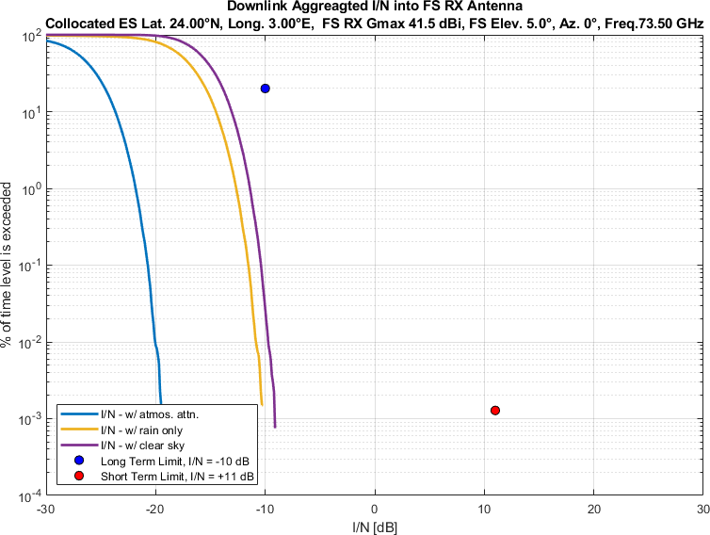
Figure 2
Aggregate I/N from Selected Systems at 24°N, FS max. Receive Gain 41.5 dBi, Azimuth 20°
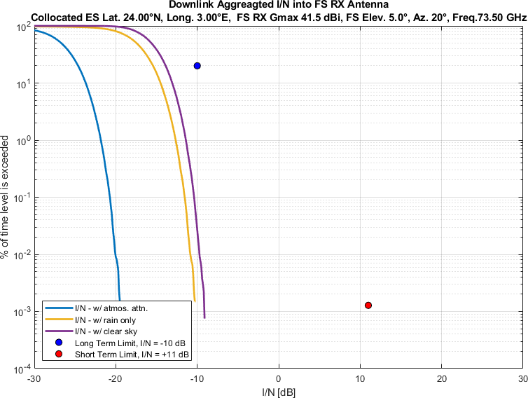
Figure 3
Aggregate I/N from Selected Systems at 24°N, FS max. Receive Gain 41.5 dBi, Azimuth 40°
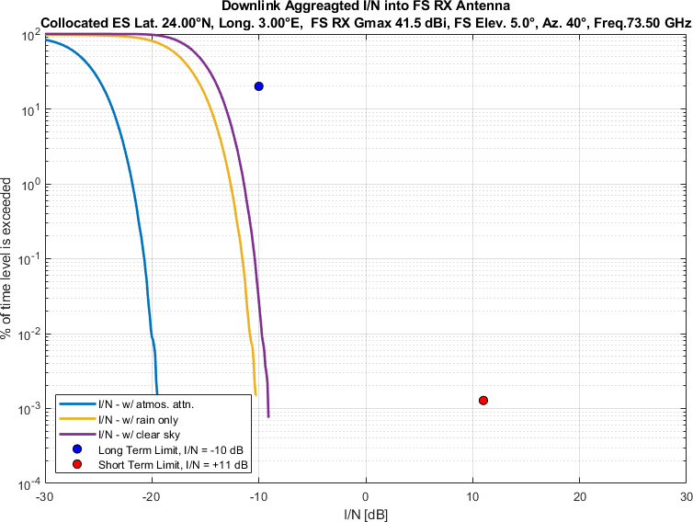
Figure 4
Aggregate I/N from Selected Systems at 24°N, FS max. Receive Gain 41.5 dBi, Azimuth 60°
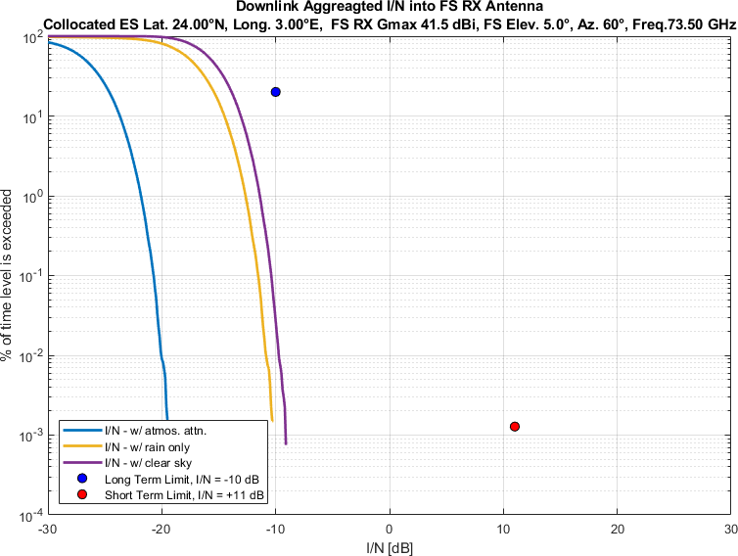
Figure 5
Aggregate I/N from Selected Systems at 24°N, FS max. Receive Gain 41.5 dBi, Azimuth 80°
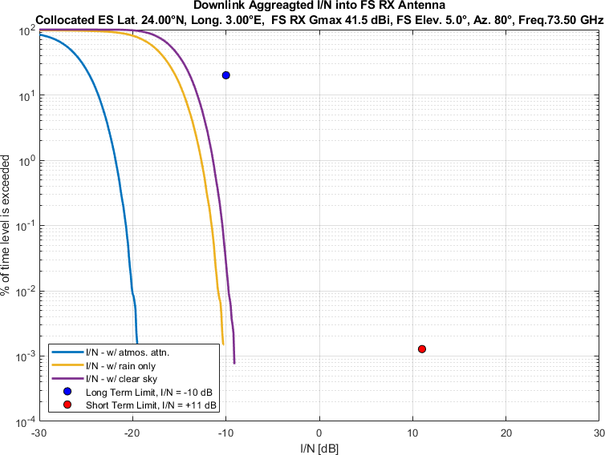
Figure 6
Aggregate I/N from Selected Systems at 24°N, FS max. Receive Gain 41.5 dBi, Azimuth 100°
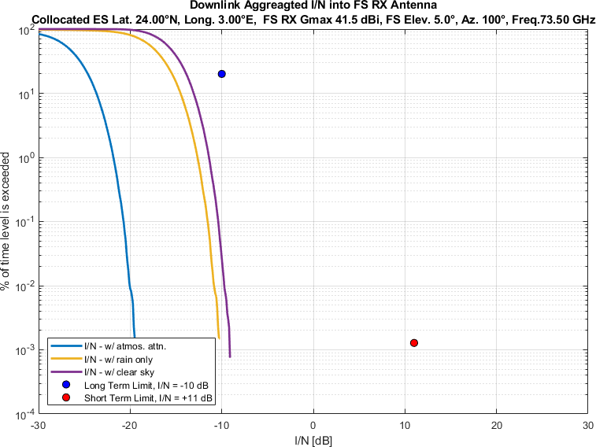
Figure 7
Aggregate I/N from Selected Systems at 24°N, FS max. Receive Gain 41.5 dBi, Azimuth 120°
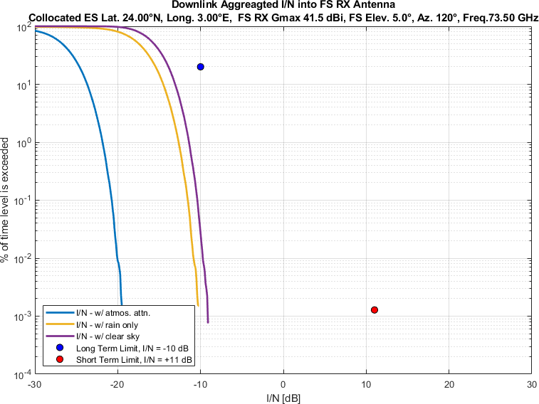
Figure 8
Aggregate I/N from Selected Systems at 24°N, FS max. Receive Gain 41.5 dBi, Azimuth 140°
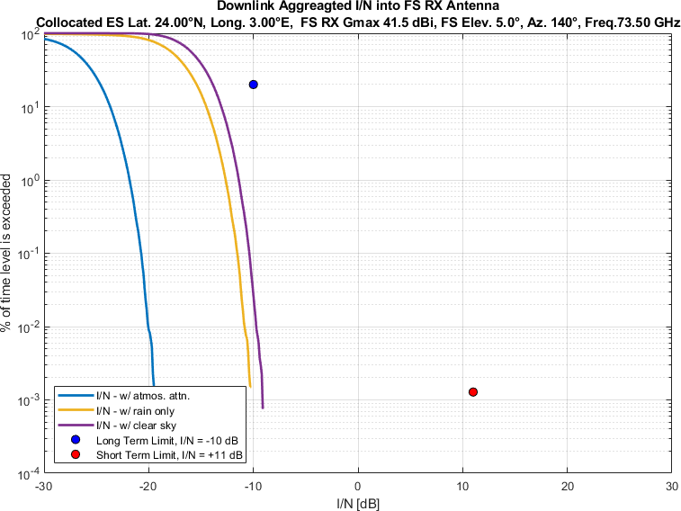
Figure 9
Aggregate I/N from Selected Systems at 24°N, FS max. Receive Gain 41.5 dBi, Azimuth 160°
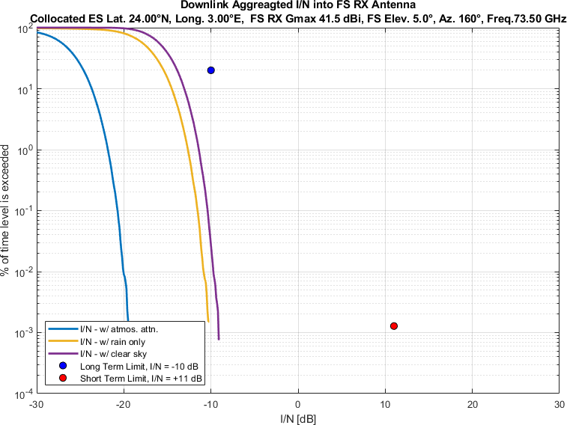
Figure 10
Aggregate I/N from Selected Systems at 24°N, FS max. Receive Gain 41.5 dBi, Azimuth 180°
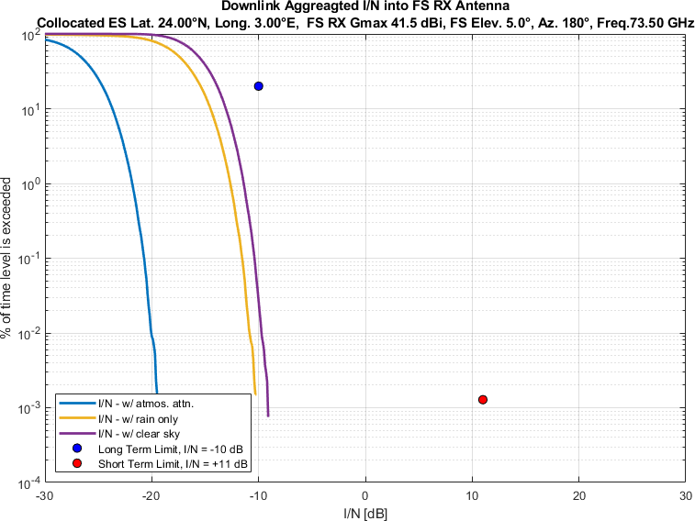
Figure 11
Aggregate I/N from Selected Systems at 24°N, FS max. Receive Gain 41.5 dBi, Azimuth 200°
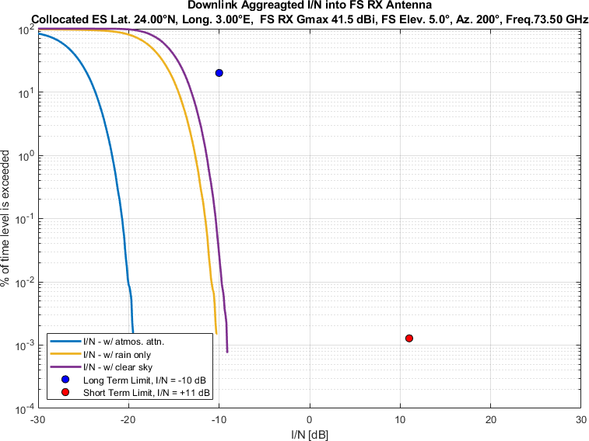
Figure 12
Aggregate I/N from Selected Systems at 24°N, FS max. Receive Gain 41.5 dBi, Azimuth 220°
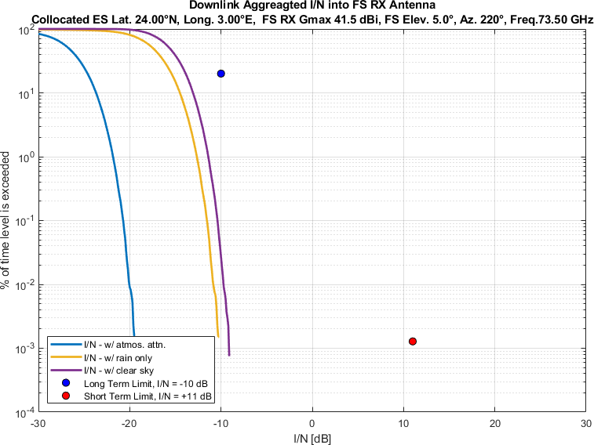
Figure 13
Aggregate I/N from Selected Systems at 24°N, FS max. Receive Gain 41.5 dBi, Azimuth 240°
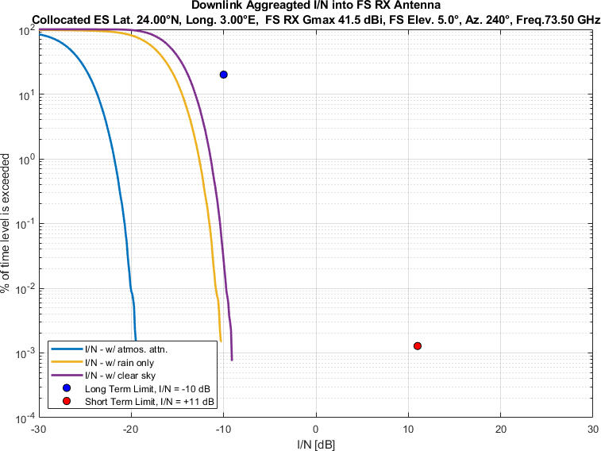
Figure 14
Aggregate I/N from Selected Systems at 24°N, FS max. Receive Gain 41.5 dBi, Azimuth 260°
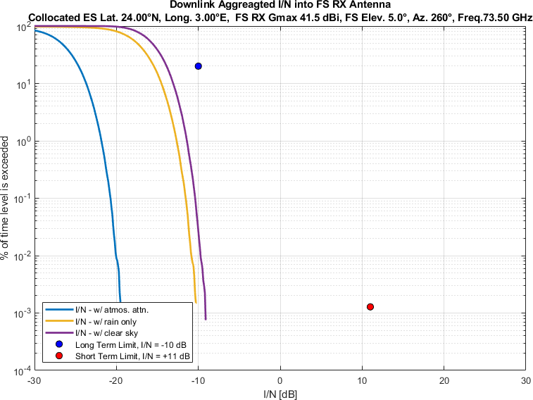
Figure 15
Aggregate I/N from Selected Systems at 24°N, FS max. Receive Gain 41.5 dBi, Azimuth 280°
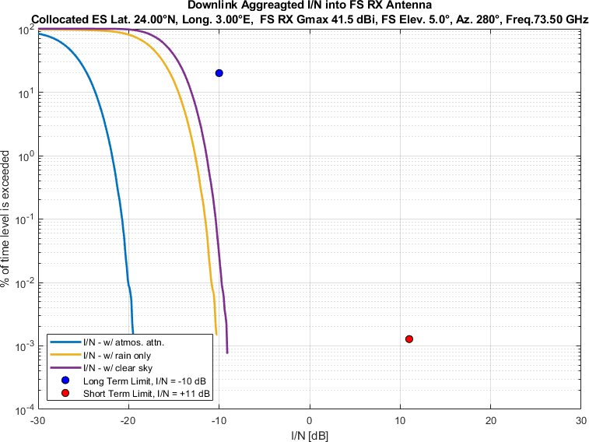
Figure 16
Aggregate I/N from Selected Systems at 24°N, FS max. Receive Gain 41.5 dBi, Azimuth 300°
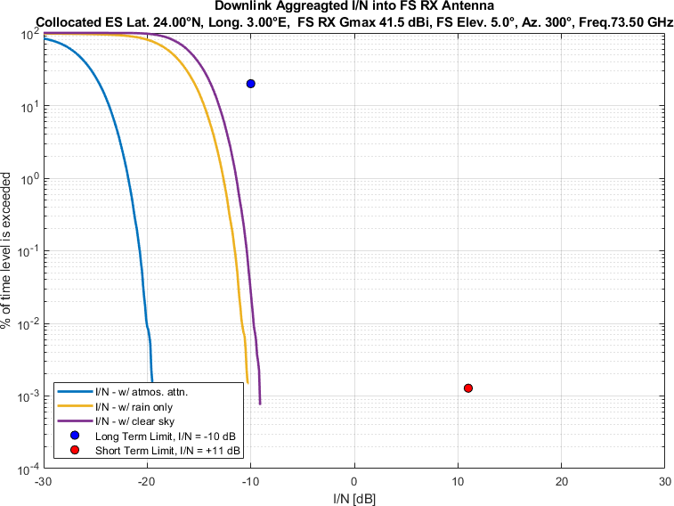
Figure 17
Aggregate I/N from Selected Systems at 24°N, FS max. Receive Gain 41.5 dBi, Azimuth 320°
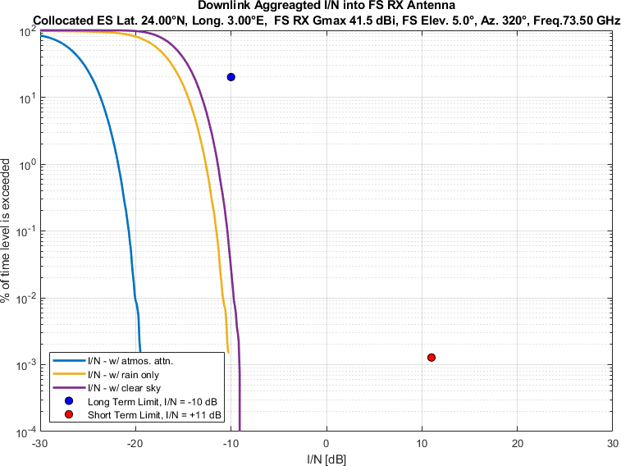
Figure 18
Aggregate I/N from Selected Systems at 24°N, FS max. Receive Gain 41.5 dBi, Azimuth 340°
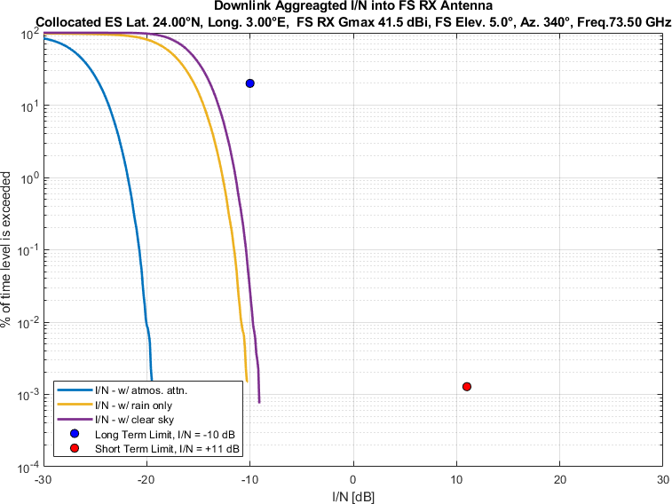
Figure 19
Aggregate I/N from Selected Systems at 45°N, FS max. Receive Gain 41.5 dBi, Azimuth 0°
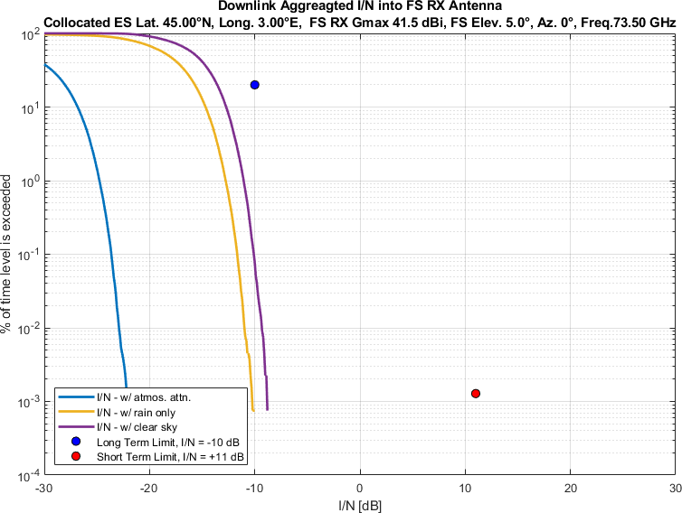
Figure 20
Aggregate I/N from Selected Systems at 45°N, FS max. Receive Gain 41.5 dBi, Azimuth 20°
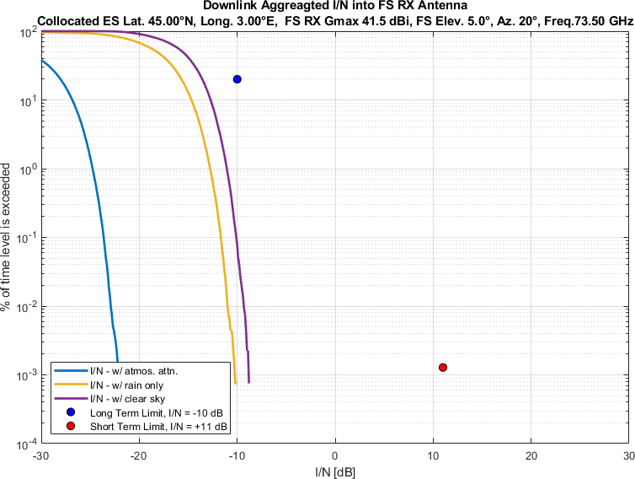
Figure 21
Aggregate I/N from Selected Systems at 45°N, FS max. Receive Gain 41.5 dBi, Azimuth 40°
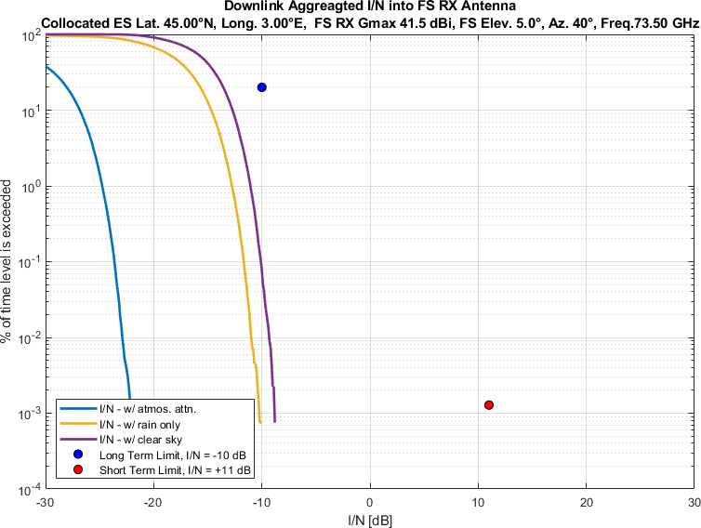
Figure 22
Aggregate I/N from Selected Systems at 45°N, FS max. Receive Gain 41.5 dBi, Azimuth 60°
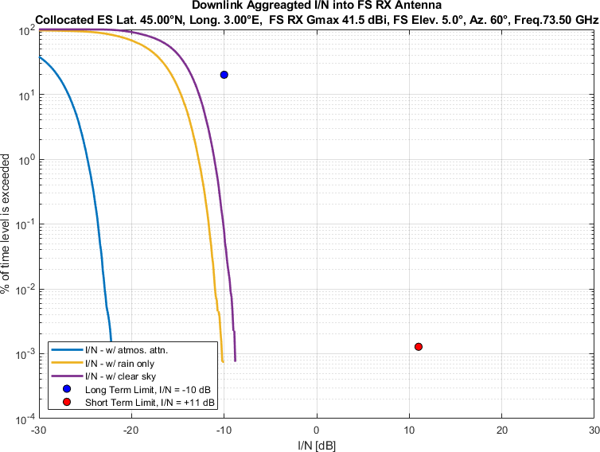
Figure 23
Aggregate I/N from Selected Systems at 45°N, FS max. Receive Gain 41.5 dBi, Azimuth 80°
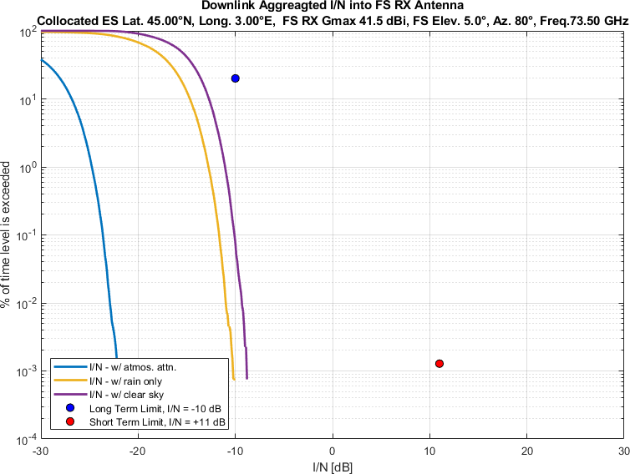
Figure 24
Aggregate I/N from Selected Systems at 45°N, FS max. Receive Gain 41.5 dBi, Azimuth 100°
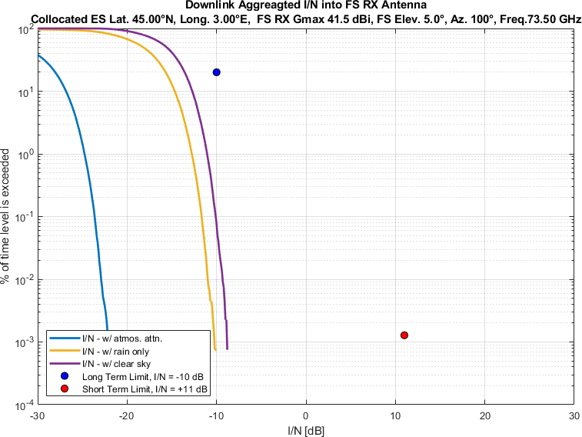
Figure 25
Aggregate I/N from Selected Systems at 45°N, FS max. Receive Gain 41.5 dBi, Azimuth 120°
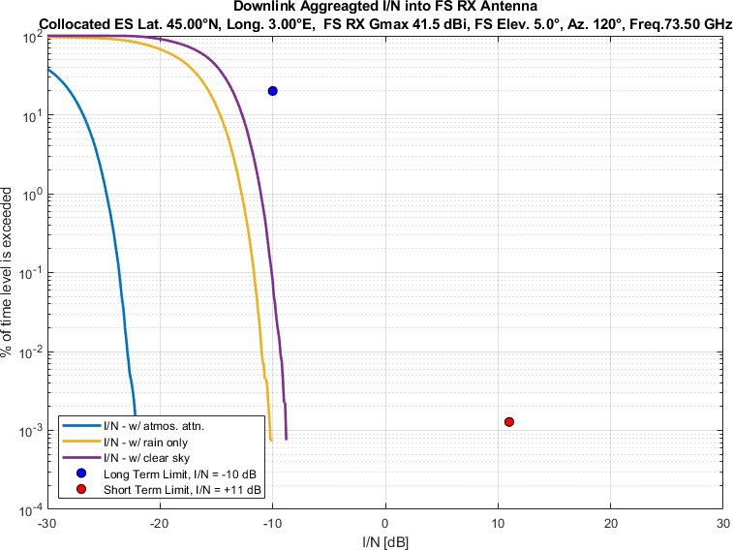
Figure 26
Aggregate I/N from Selected Systems at 45°N, FS max. Receive Gain 41.5 dBi, Azimuth 140°
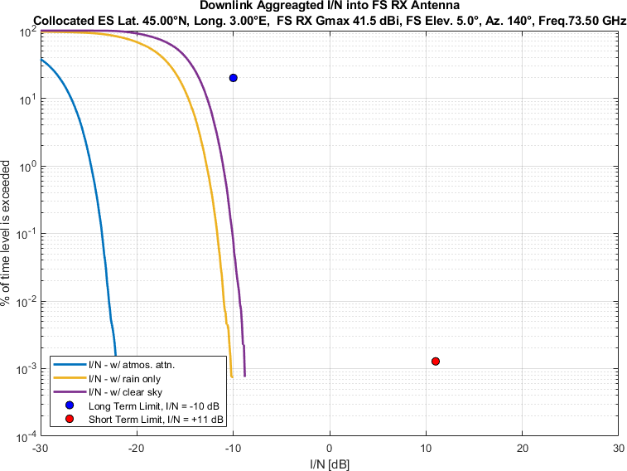
Figure 27
Aggregate I/N from Selected Systems at 45°N, FS max. Receive Gain 41.5 dBi, Azimuth 160°
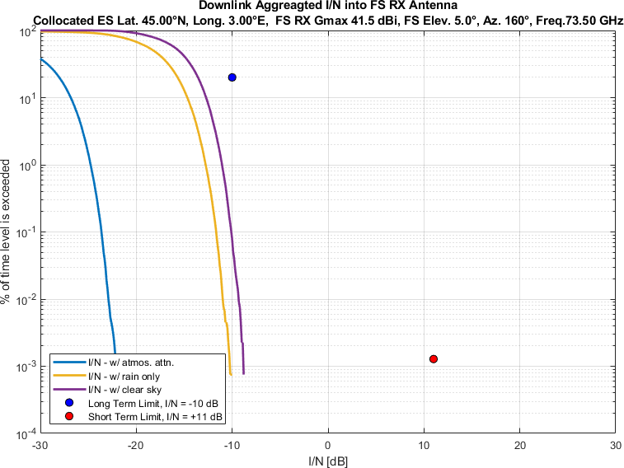
Figure 28
Aggregate I/N from Selected Systems at 45°N, FS max. Receive Gain 41.5 dBi, Azimuth 180°
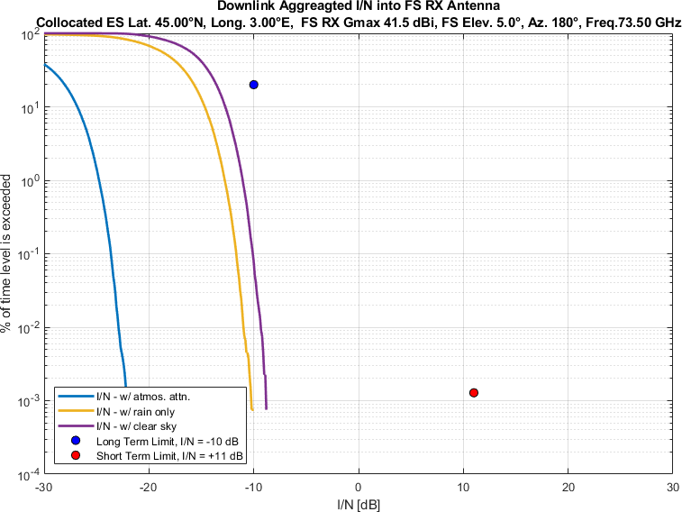
Figure 29
Aggregate I/N from Selected Systems at 45°N, FS max. Receive Gain 41.5 dBi, Azimuth 200°
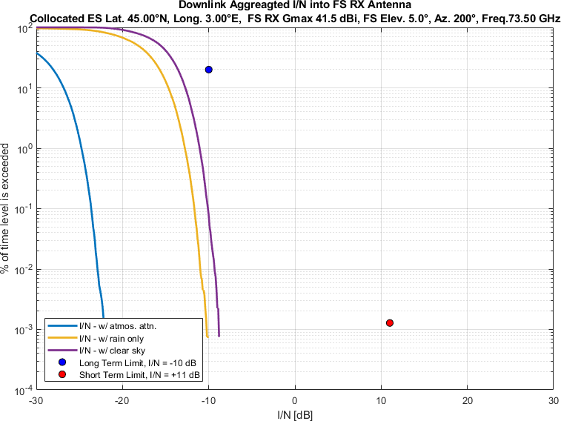
Figure 30
Aggregate I/N from Selected Systems at 45°N, FS max. Receive Gain 41.5 dBi, Azimuth 220°
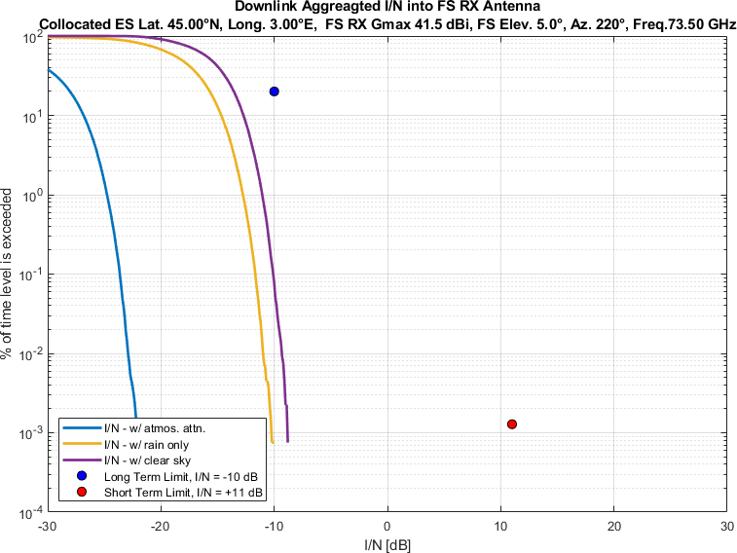
Figure 31
Aggregate I/N from Selected Systems at 45°N, FS max. Receive Gain 41.5 dBi, Azimuth 240°
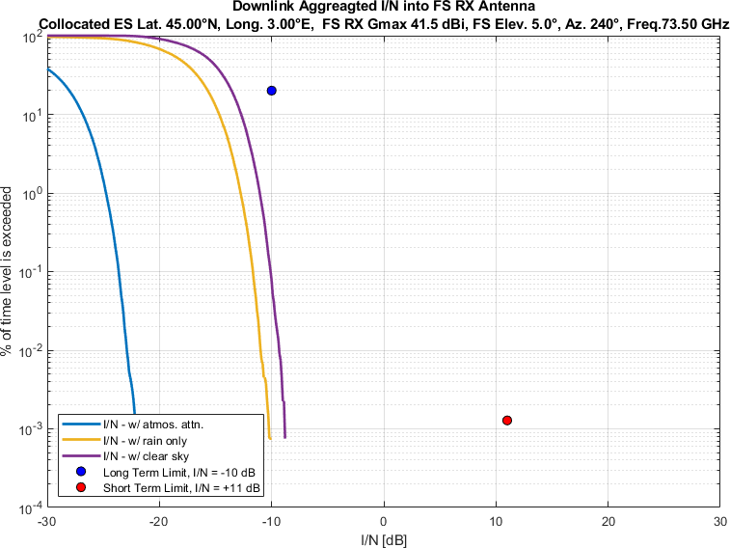
Figure 32
Aggregate I/N from Selected Systems at 45°N, FS max. Receive Gain 41.5 dBi, Azimuth 260°
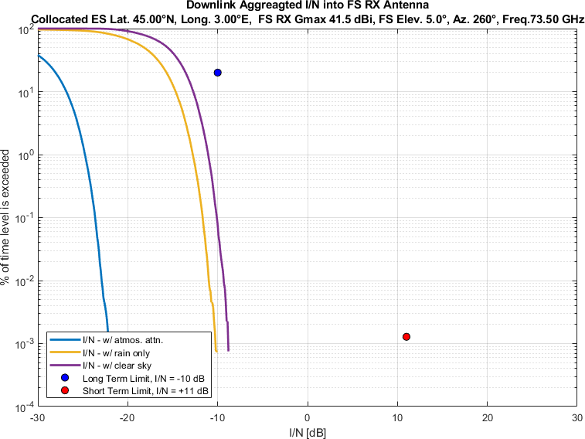
Figure 33
Aggregate I/N from Selected Systems at 45°N, FS max. Receive Gain 41.5 dBi, Azimuth 280°
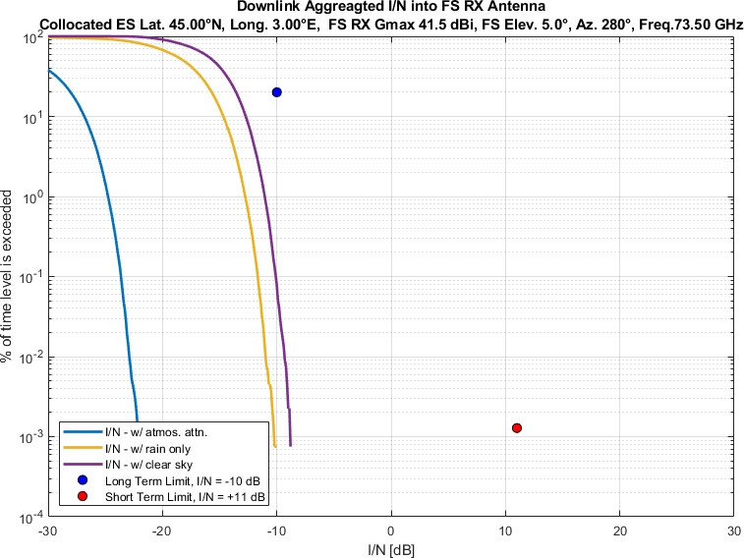
Figure 34
Aggregate I/N from Selected Systems at 45°N, FS max. Receive Gain 41.5 dBi, Azimuth 300°
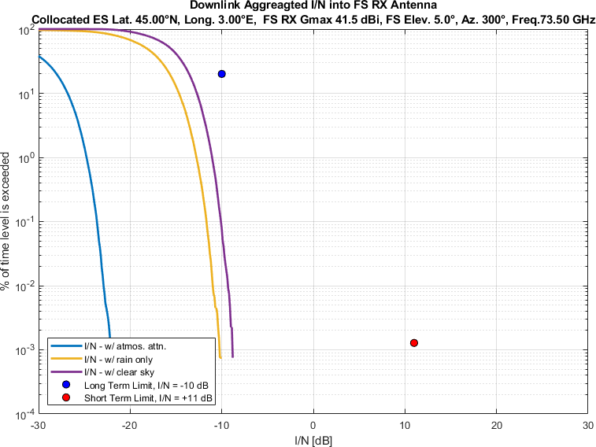
Figure 35
Aggregate I/N from Selected Systems at 45°N, FS max. Receive Gain 41.5 dBi, Azimuth 320°
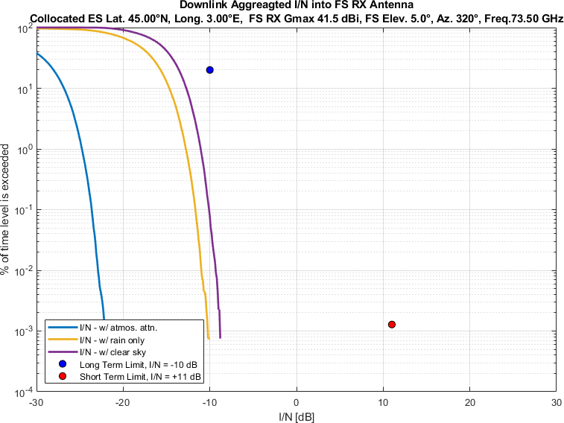
Figure 36
Aggregate I/N from Selected Systems at 45°N, FS max. Receive Gain 41.5 dBi, Azimuth 340°
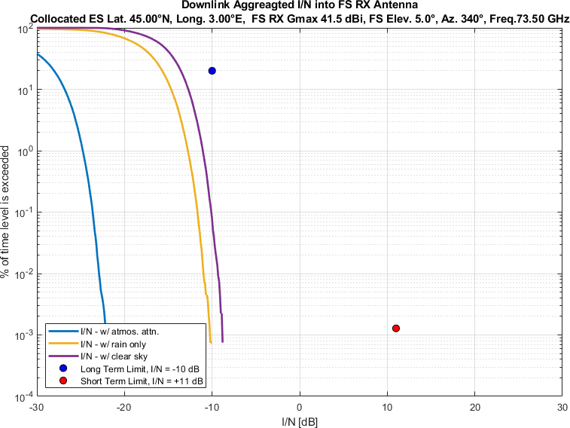
Figure 37
Aggregate I/N from Selected Systems at 60°N, FS max. Receive Gain 41.5 dBi, Azimuth 0°
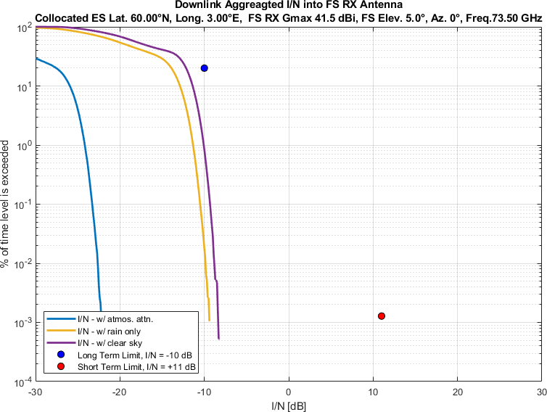
Figure 38
Aggregate I/N from Selected Systems at 60°N, FS max. Receive Gain 41.5 dBi, Azimuth 20°
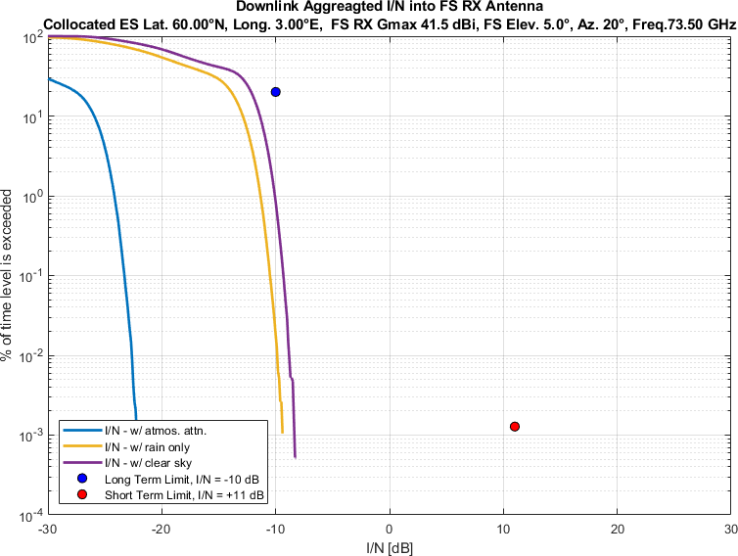
Figure 39
Aggregate I/N from Selected Systems at 60°N, FS max. Receive Gain 41.5 dBi, Azimuth 40°
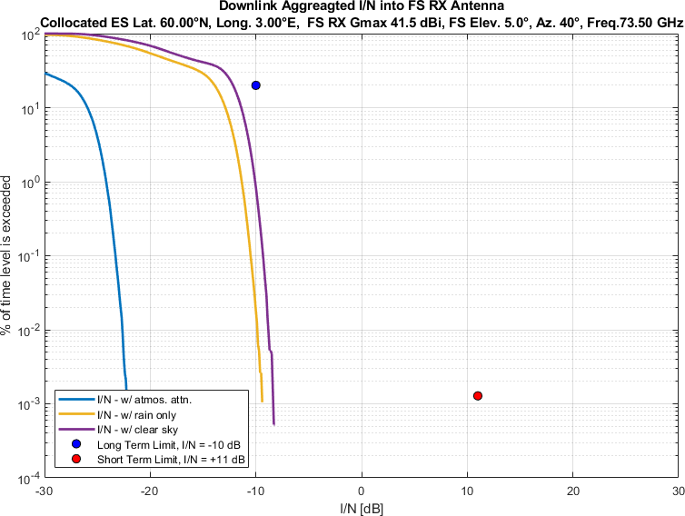
Figure 40
Aggregate I/N from Selected Systems at 60°N, FS max. Receive Gain 41.5 dBi, Azimuth 60°
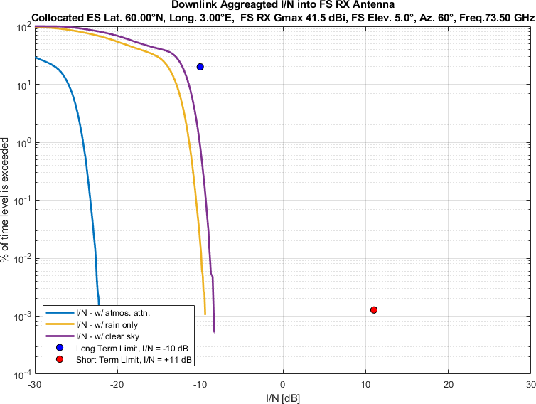
Figure 41
Aggregate I/N from Selected Systems at 60°N, FS max. Receive Gain 41.5 dBi, Azimuth 80°
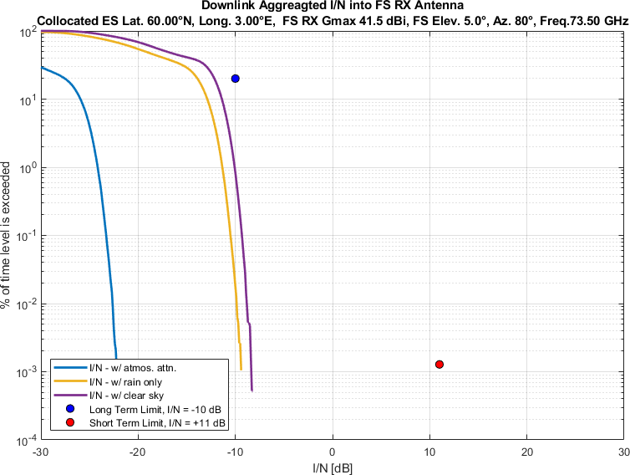
Figure 42
Aggregate I/N from Selected Systems at 60°N, FS max. Receive Gain 41.5 dBi, Azimuth 100°
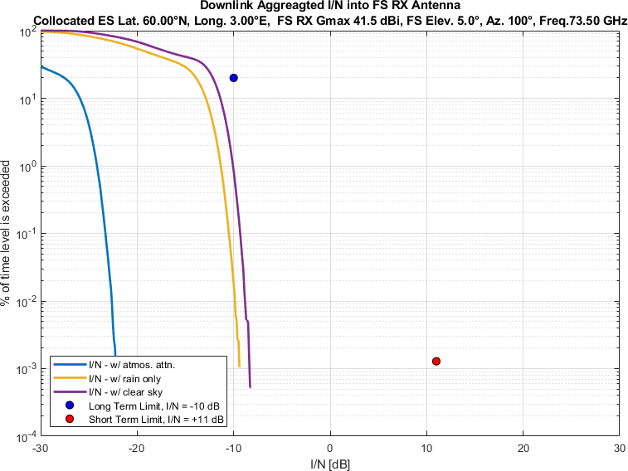
Figure 43
Aggregate I/N from Selected Systems at 60°N, FS max. Receive Gain 41.5 dBi, Azimuth 120°
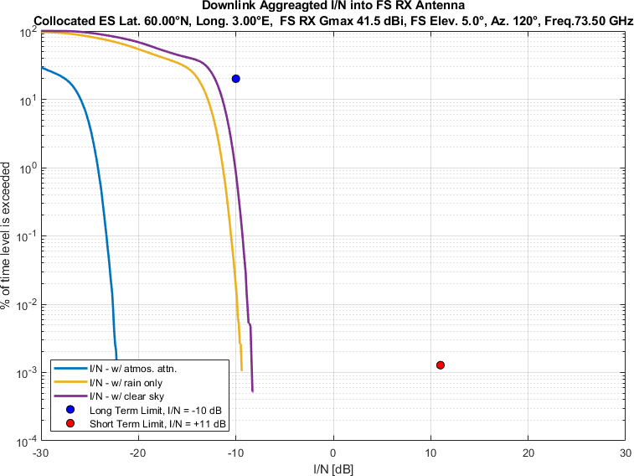Figure 44
Aggregate I/N from Selected Systems at 60° N, FS max. Receive Gain 41.5 dBi, Azimuth 140°
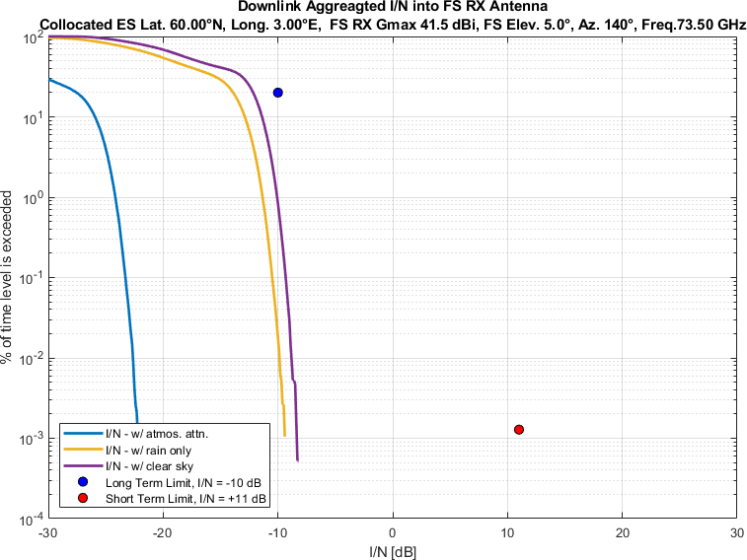
FIGURE 45
Aggregate I/N from Selected Systems at 60°N, FS max. Receive Gain 41.5 dBi, Azimuth 160°
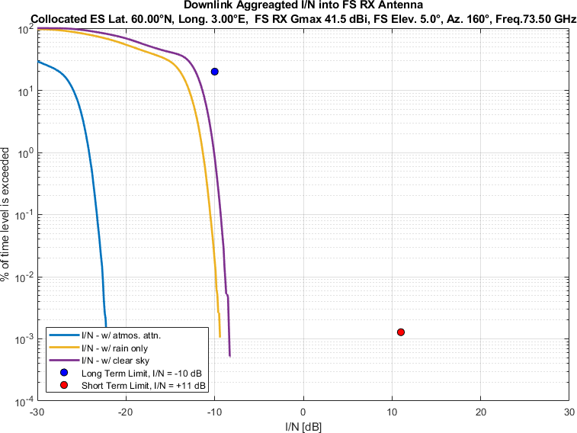
FIGURE 46
Aggregate I/N from Selected Systems at 60°N, FS max. Receive Gain 41.5 dBi, Azimuth 180°
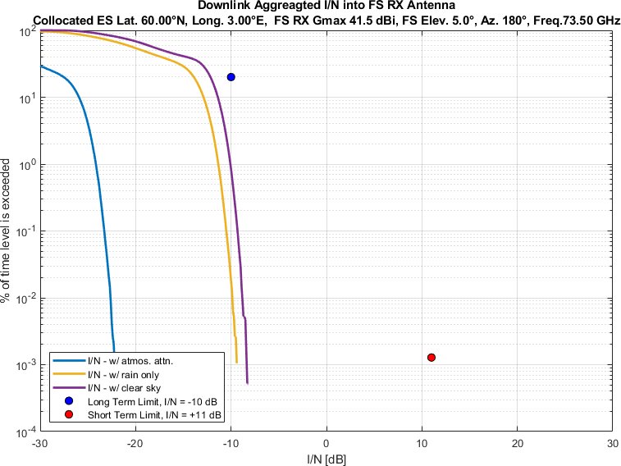
FIGURE 47
Aggregate I/N from Selected Systems at 60°N, FS max. Receive Gain 41.5 dBi, Azimuth 200°
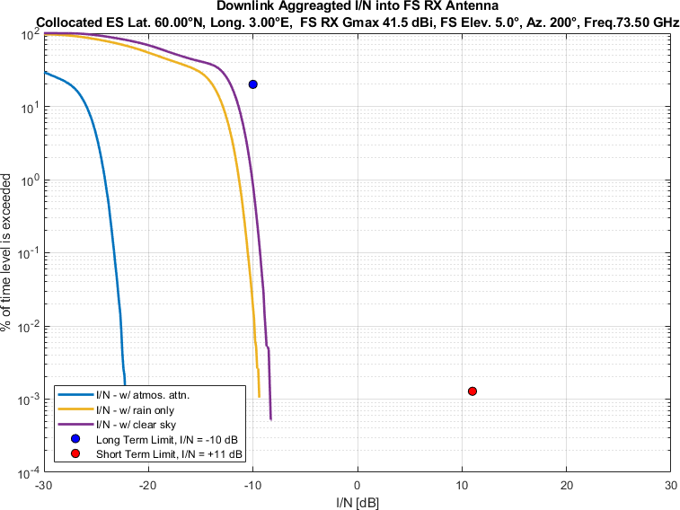
Figure 48
Aggregate I/N from Selected Systems at 60°N, FS max. Receive Gain 41.5 dBi, Azimuth 220°
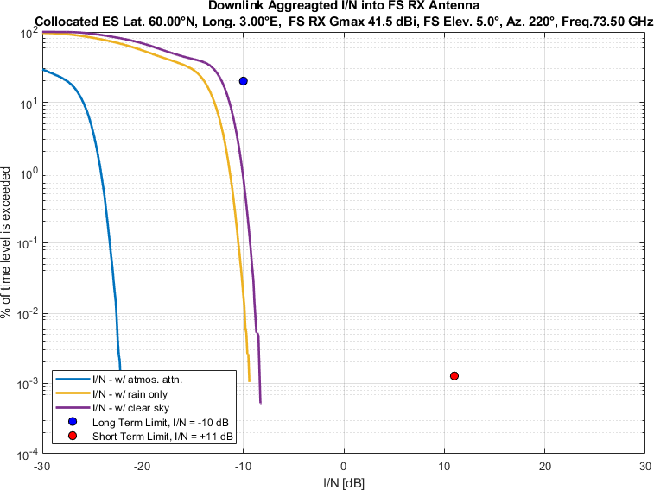
Figure 49
Aggregate I/N from Selected Systems at 60°N, FS max. Receive Gain 41.5 dBi, Azimuth 240°
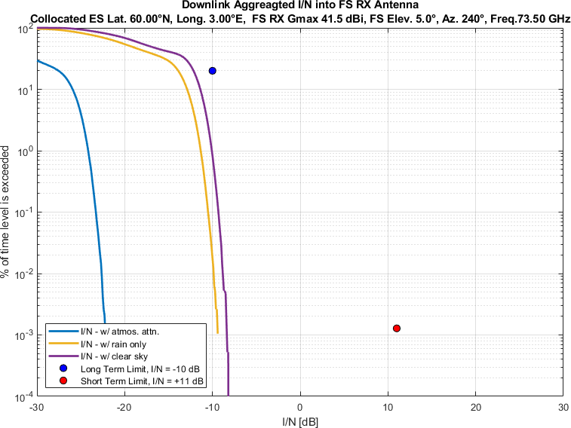
Figure 50
Aggregate I/N from Selected Systems at 60°N, FS max. Receive Gain 41.5 dBi, Azimuth 260°

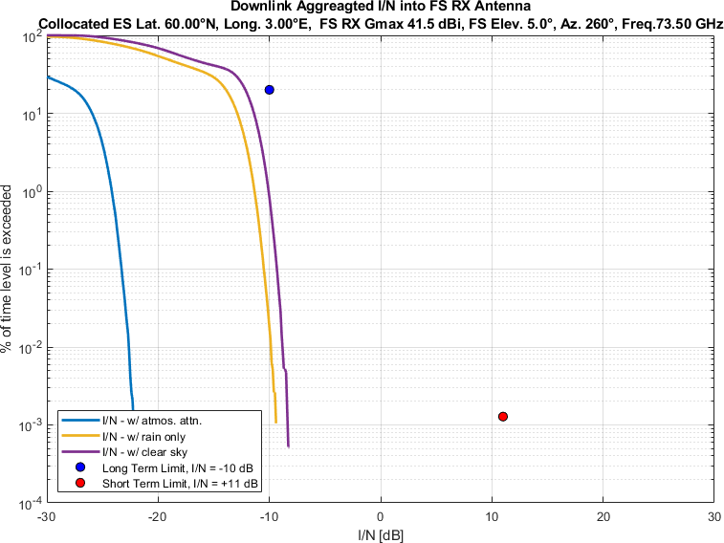
Figure 51
Aggregate I/N from Selected Systems at 60°N, FS max. Receive Gain 41.5 dBi, Azimuth 280°
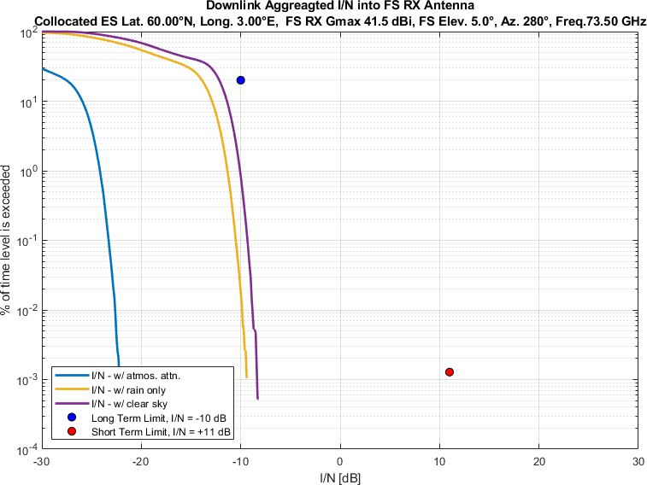
Figure 52
Aggregate I/N from Selected Systems at 60°N, FS max. Receive Gain 41.5 dBi, Azimuth 300°

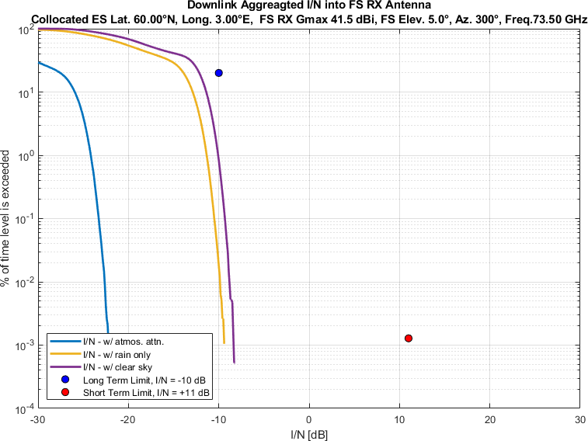
Figure 53
Aggregate I/N from Selected Systems at 60°N, FS max. Receive Gain 41.5 dBi, Azimuth 320°
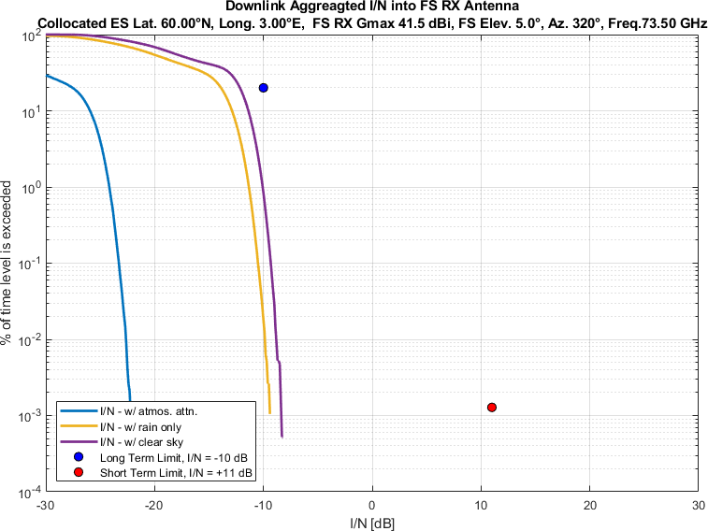
Figure 54
Aggregate I/N from Selected Systems at 60°N, FS max. Receive Gain 41.5 dBi, Azimuth 340°

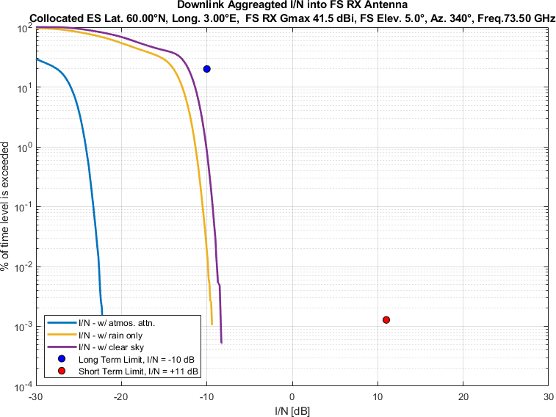

Similarly, Figures 55-108 compare aggregate I/N from the same selected GSO and three non-GSO systems to
the largest dimension 0.6m FS station antenna,
pointing at eighteen different azimuth directions at 20° intervals
for maximum FS antenna elevation angle of 5°,
at same representative frequency (i.e., 73.5 GHz).
Again, each figure compares three different of atmospheric attenuation scenarios as mentioned above.

Figure 55
Aggregate I/N from Selected Systems at 24°N, FS max. Receive Gain 51 dBi, Azimuth 0°
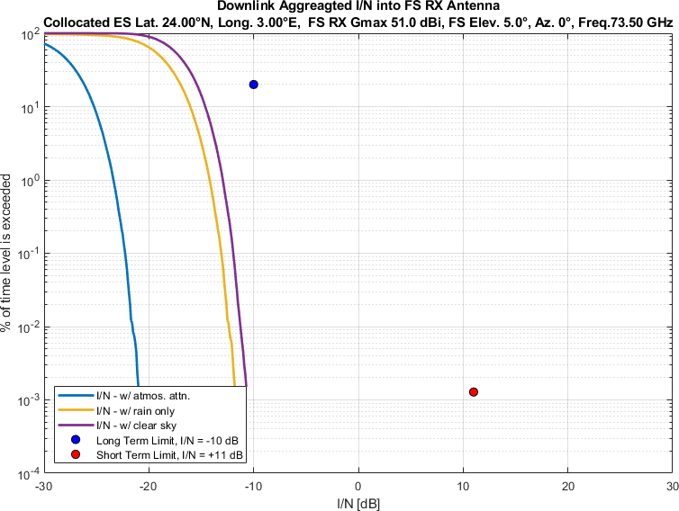
Figure 56
Aggregate I/N from Selected Systems at 24°N, FS max. Receive Gain 51 dBi, Azimuth 20°
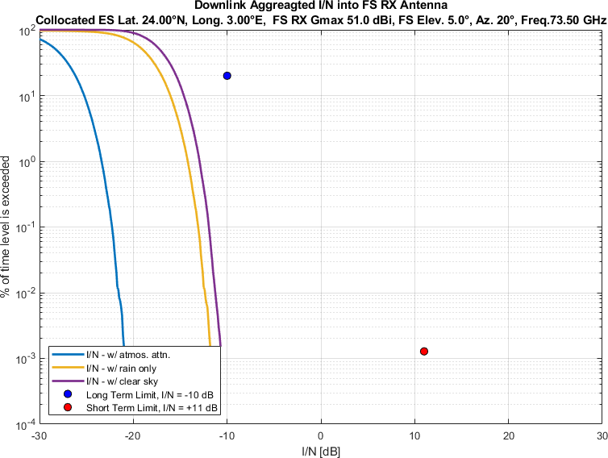
Figure 57
Aggregate I/N from Selected Systems at 24°N, FS max. Receive Gain 51 dBi, Azimuth 40°
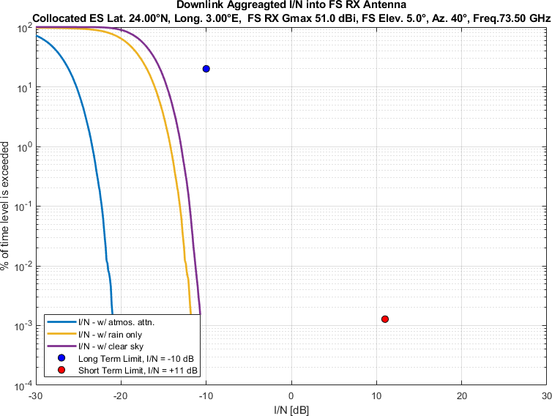
Figure 58
Aggregate I/N from Selected Systems at 24°N, FS max. Receive Gain 51 dBi, Azimuth 60°
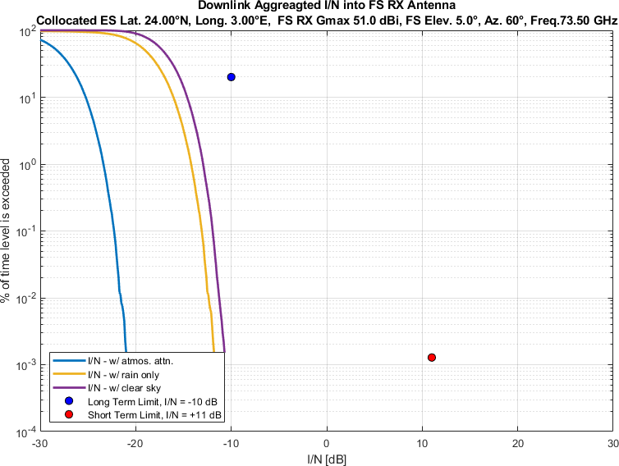
Figure 59
Aggregate I/N from Selected Systems at 24°N, FS max. Receive Gain 51 dBi, Azimuth 80°
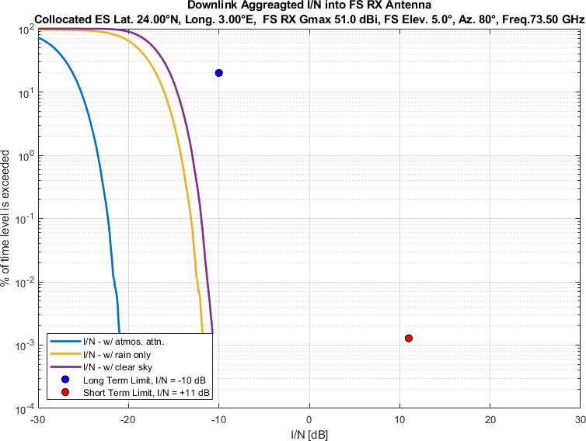
Figure 60
Aggregate I/N from Selected Systems at 24°N, FS max. Receive Gain 51 dBi, Azimuth 100°
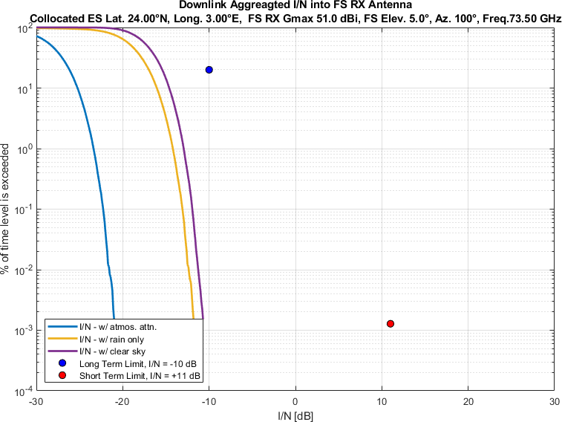
Figure 61
Aggregate I/N from Selected Systems at 24°N, FS max. Receive Gain 51 dBi, Azimuth 120°
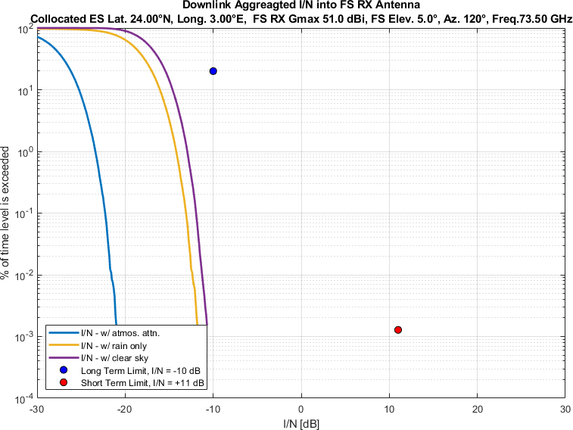
Figure 62
Aggregate I/N from Selected Systems at 24°N, FS max. Receive Gain 51 dBi, Azimuth 140°
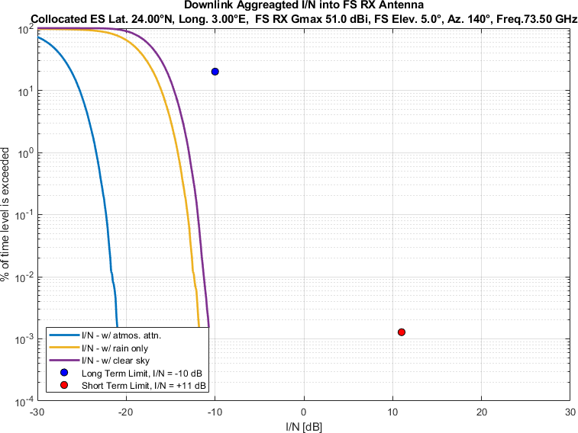
Figure 63
Aggregate I/N from Selected Systems at 24°N, FS max. Receive Gain 51 dBi, Azimuth 160°
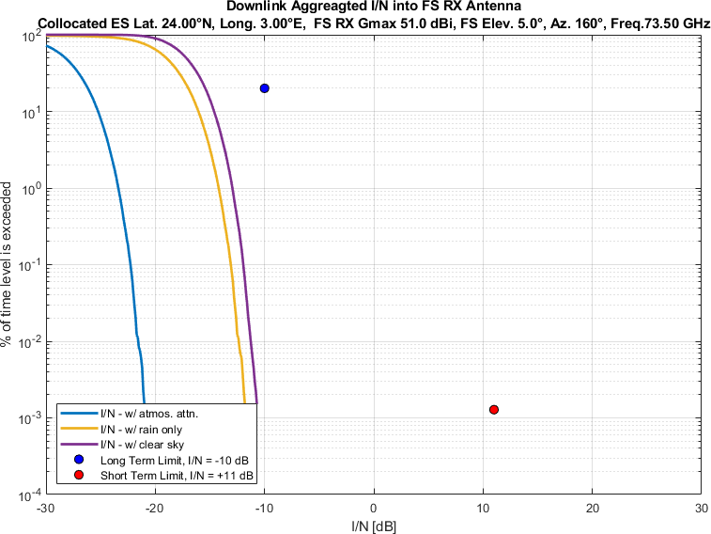
Figure 64
Aggregate I/N from Selected Systems at 24°N, FS max. Receive Gain 51 dBi, Azimuth 180°
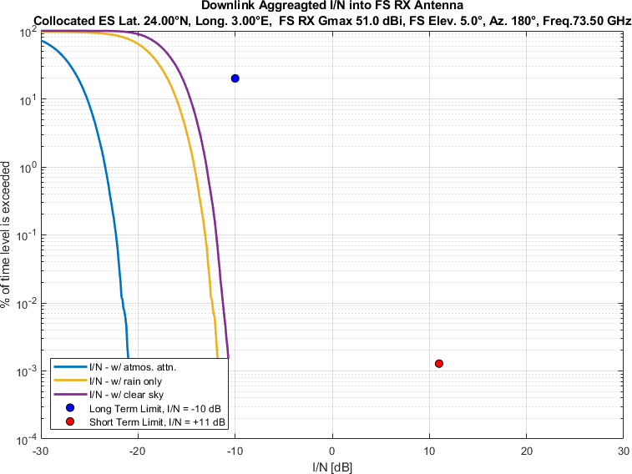
Figure 65
Aggregate I/N from Selected Systems at 24°N, FS max. Receive Gain 51 dBi, Azimuth 200°
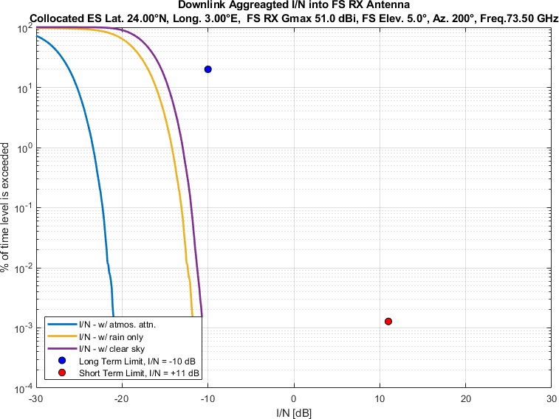
Figure 66
Aggregate I/N from Selected Systems at 24°N, FS max. Receive Gain 51 dBi, Azimuth 220°
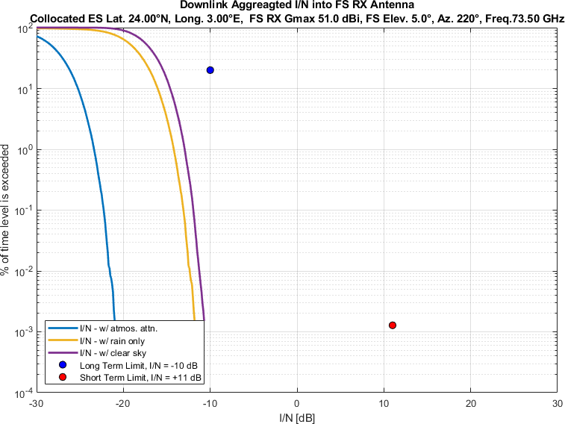
Figure 67
Aggregate I/N from Selected Systems at 24°N, FS max. Receive Gain 51 dBi, Azimuth 240°
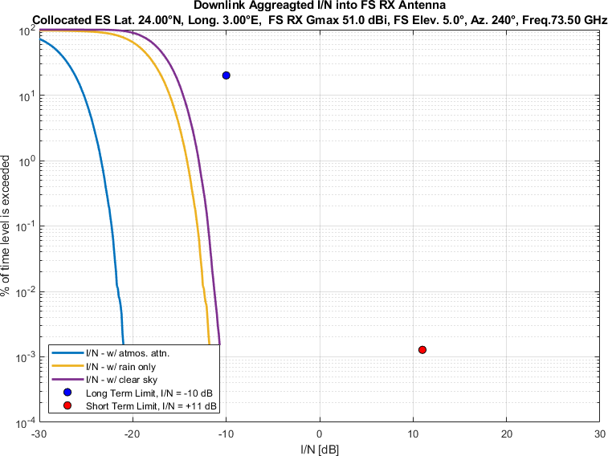
Figure 68
Aggregate I/N from Selected Systems at 24°N, FS max. Receive Gain 51 dBi, Azimuth 260°
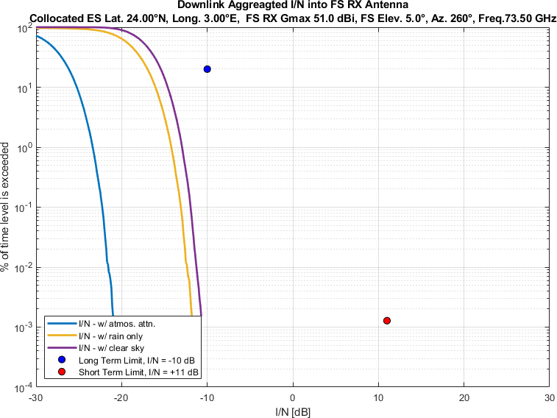
Figure 69
Aggregate I/N from Selected Systems at 24°N, FS max. Receive Gain 51 dBi, Azimuth 280°
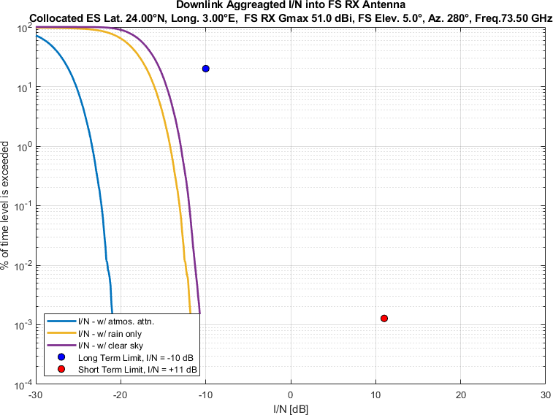
Figure 70
Aggregate I/N from Selected Systems at 24°N, FS max. Receive Gain 51 dBi, Azimuth 300°
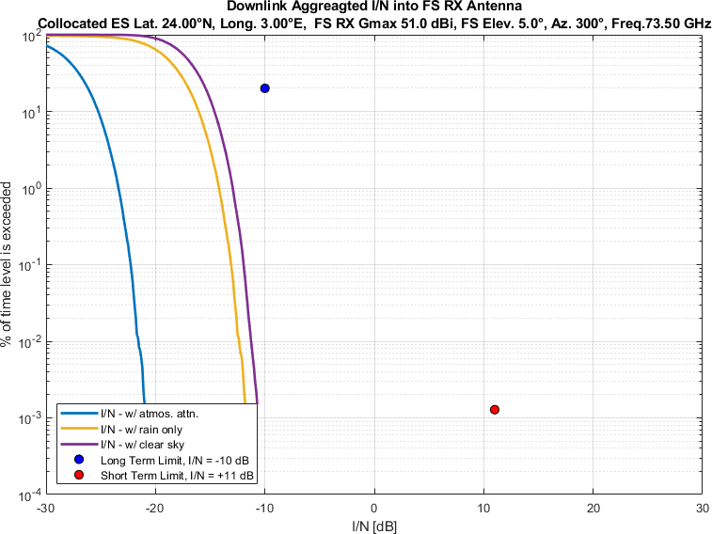
Figure 71
Aggregate I/N from Selected Systems at 24°N, FS max. Receive Gain 51 dBi, Azimuth 320°
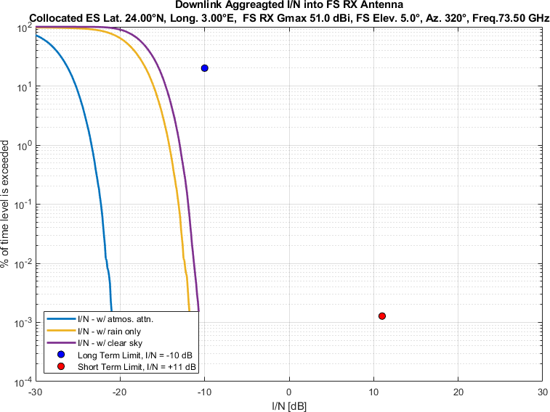
Figure 72
Aggregate I/N from Selected Systems at 24°N, FS max. Receive Gain 51 dBi, Azimuth 340°
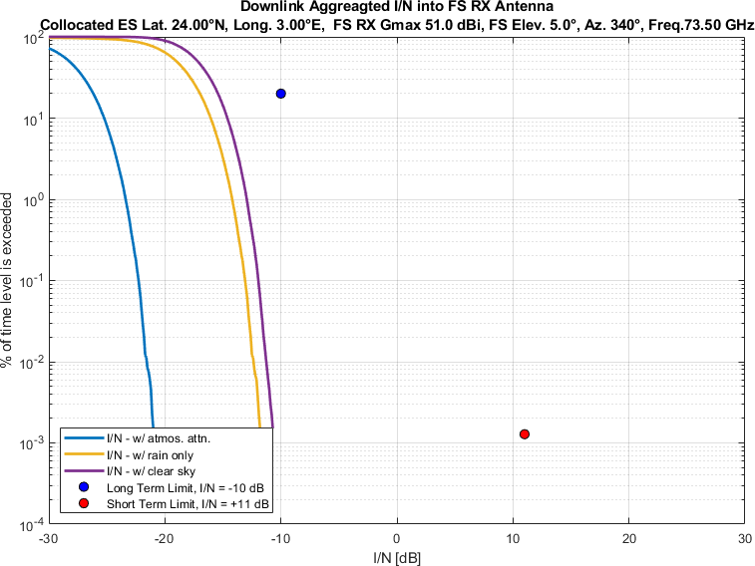
Figure 73
Aggregate I/N from Selected Systems at 45°N, FS max. Receive Gain 51 dBi, Azimuth 0°
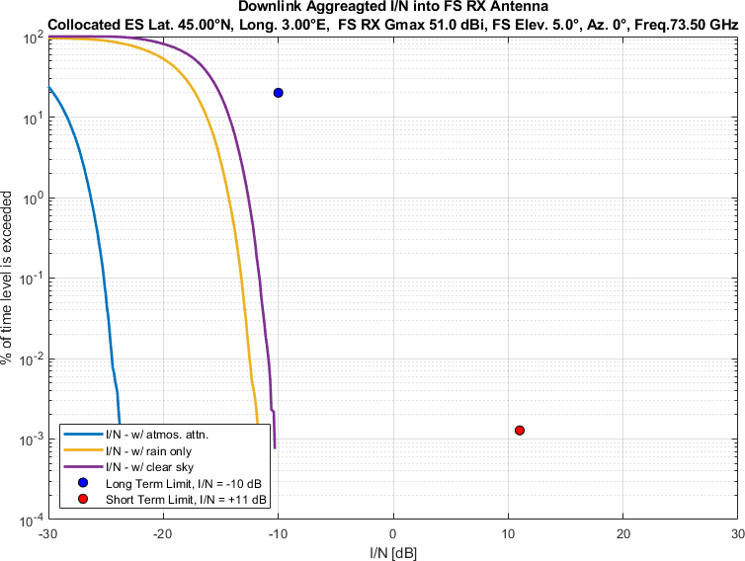
Figure 74
Aggregate I/N from Selected Systems at 45°N, FS max. Receive Gain 51 dBi, Azimuth 20°
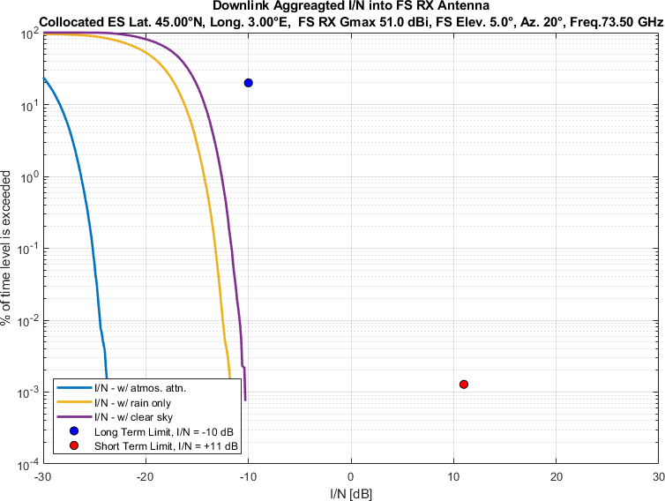
Figure 75
Aggregate I/N from Selected Systems at 45°N, FS max. Receive Gain 51 dBi, Azimuth 40°
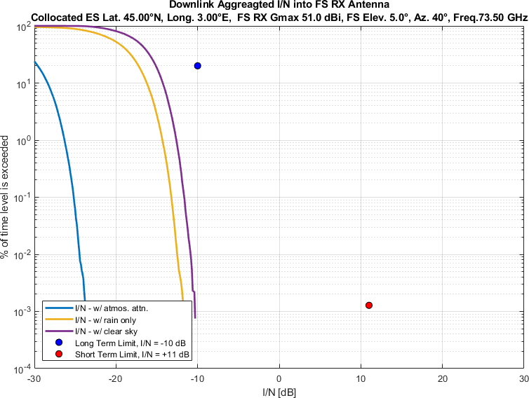
Figure 76
Aggregate I/N from Selected Systems at 45°N, FS max. Receive Gain 51 dBi, Azimuth 60°
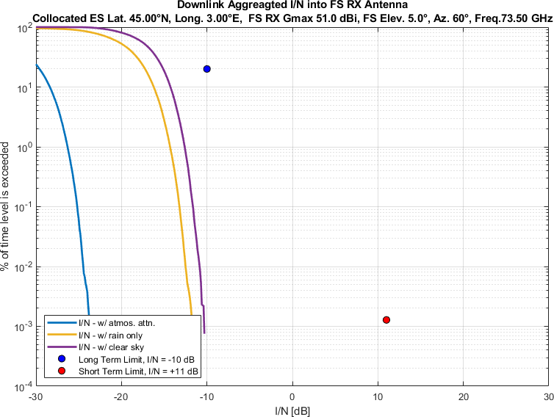
Figure 77
Aggregate I/N from Selected Systems at 45°N, FS max. Receive Gain 51 dBi, Azimuth 80°
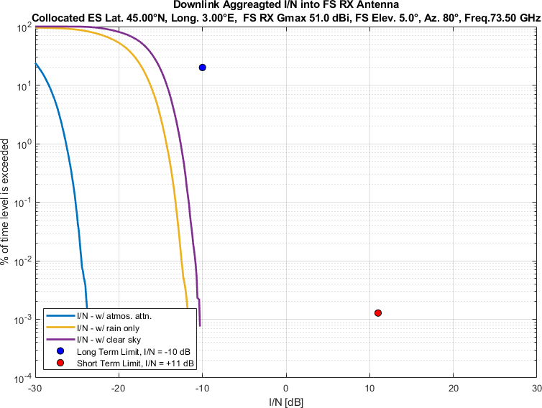
Figure 78
Aggregate I/N from Selected Systems at 45°N, FS max. Receive Gain 51 dBi, Azimuth 100°
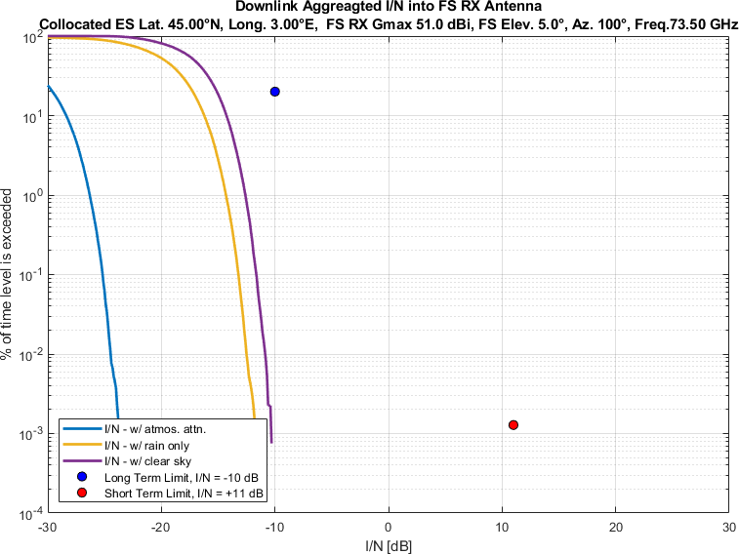
Figure 79
Aggregate I/N from Selected Systems at 45°N, FS max. Receive Gain 51 dBi, Azimuth 120°
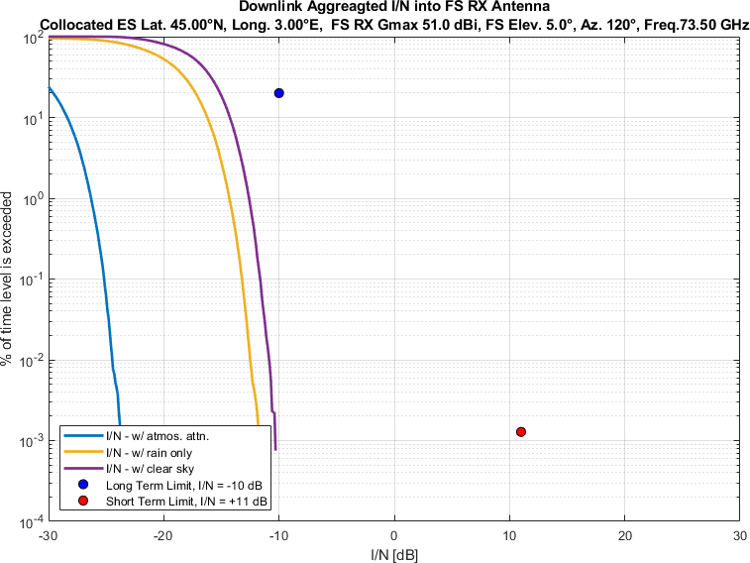
Figure 80
Aggregate I/N from Selected Systems at 45°N, FS max. Receive Gain 51 dBi, Azimuth 140°
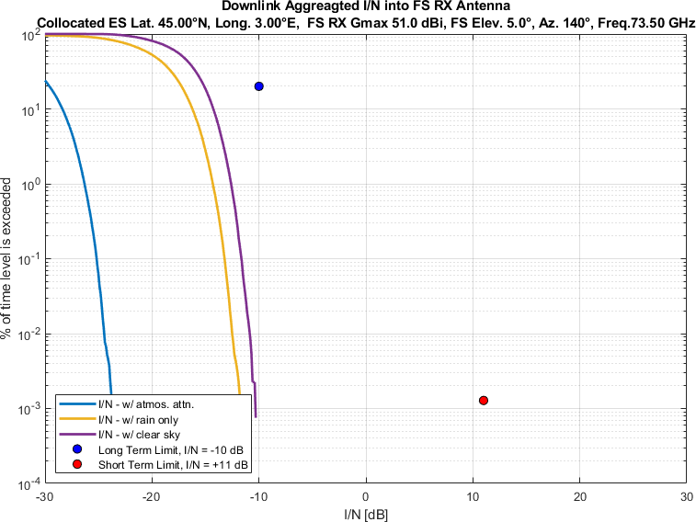
Figure 81
Aggregate I/N from Selected Systems at 45°N, FS max. Receive Gain 51 dBi, Azimuth 160°
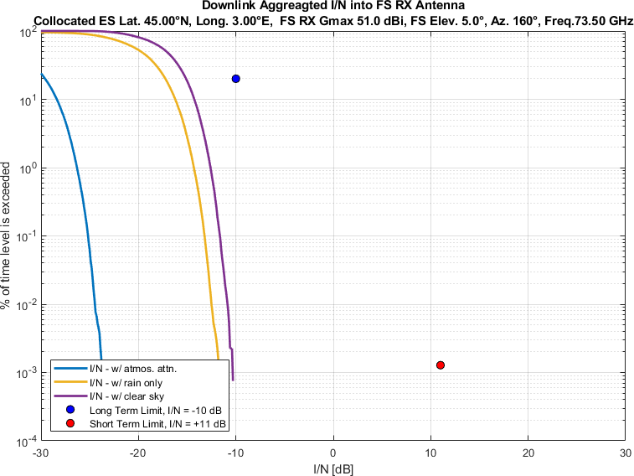
Figure 82
Aggregate I/N from Selected Systems at 45°N, FS max. Receive Gain 51 dBi, Azimuth 180°
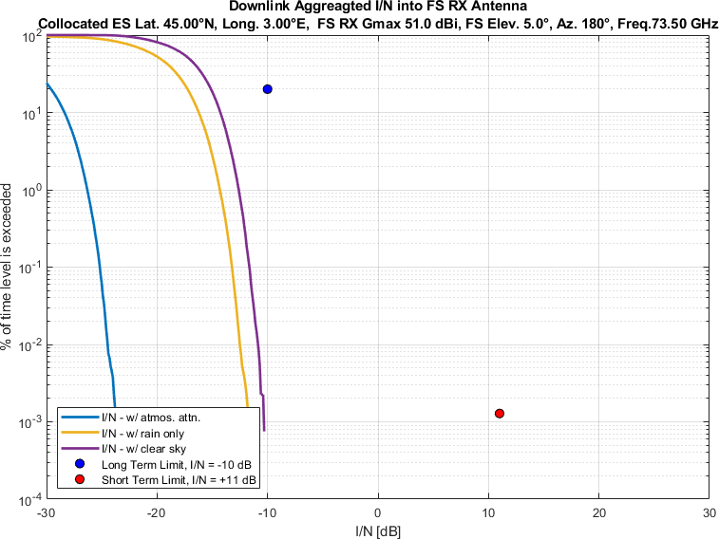
Figure 83
Aggregate I/N from Selected Systems at 45°N, FS max. Receive Gain 51 dBi, Azimuth 200°
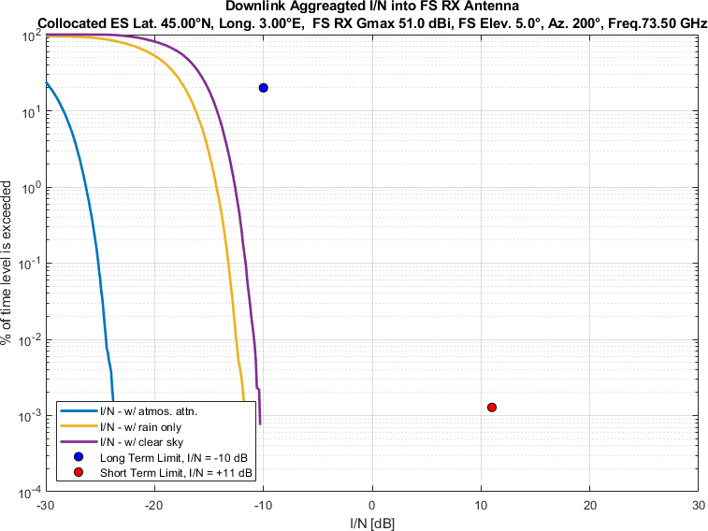
Figure 84
Aggregate I/N from Selected Systems at 45°N, FS max. Receive Gain 51 dBi, Azimuth 220°
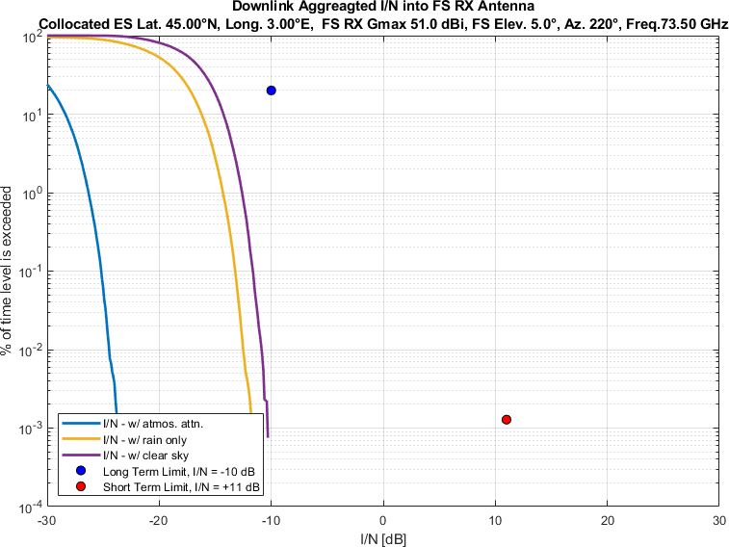
Figure 85
Aggregate I/N from Selected Systems at 45°N, FS max. Receive Gain 51 dBi, Azimuth 240°
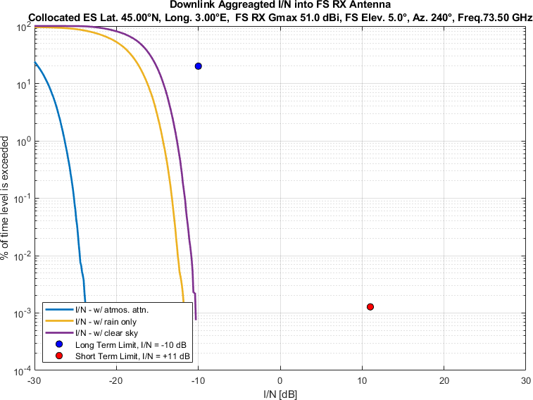
Figure 86
Aggregate I/N from Selected Systems at 45°N, FS max. Receive Gain 51 dBi, Azimuth 260°
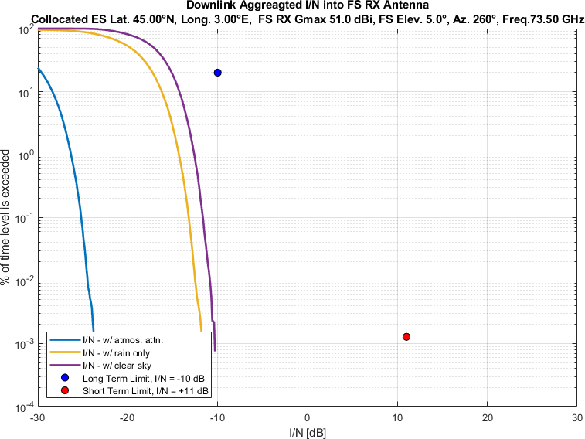
Figure 87
Aggregate I/N from Selected Systems at 45°N, FS max. Receive Gain 51 dBi, Azimuth 280°
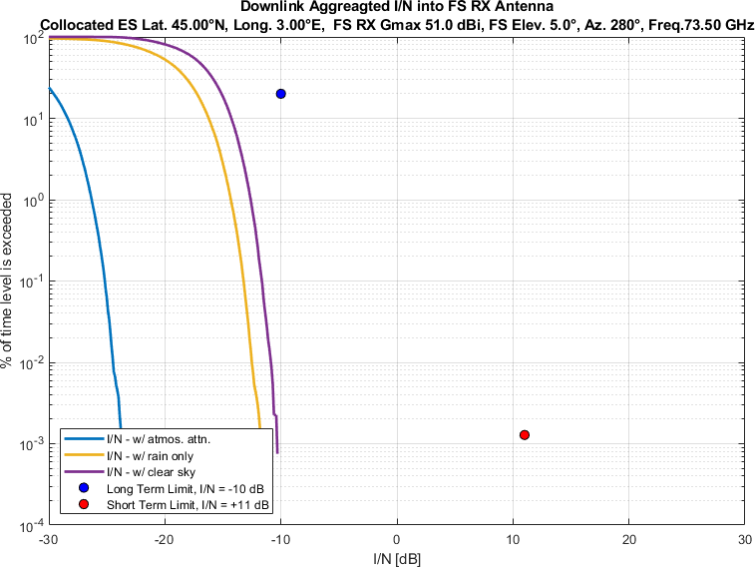
Figure 88
Aggregate I/N from Selected Systems at 45°N, FS max. Receive Gain 51 dBi, Azimuth 300°
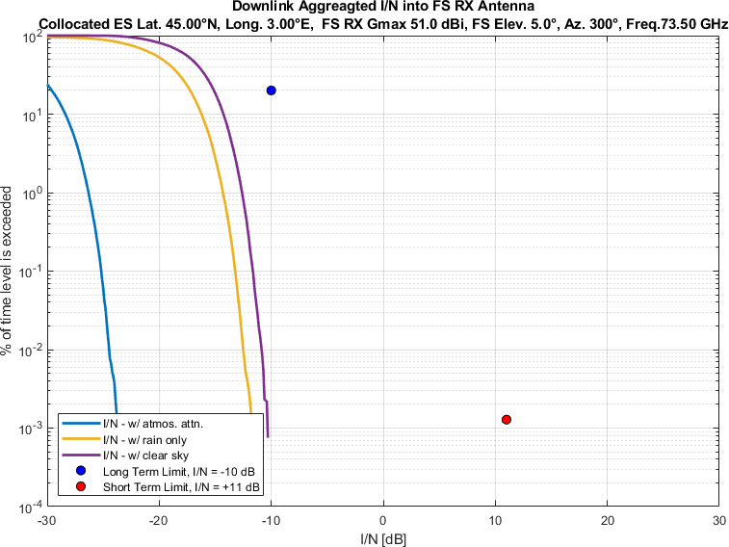
Figure 89
Aggregate I/N from Selected Systems at 45°N, FS max. Receive Gain 51 dBi, Azimuth 320°
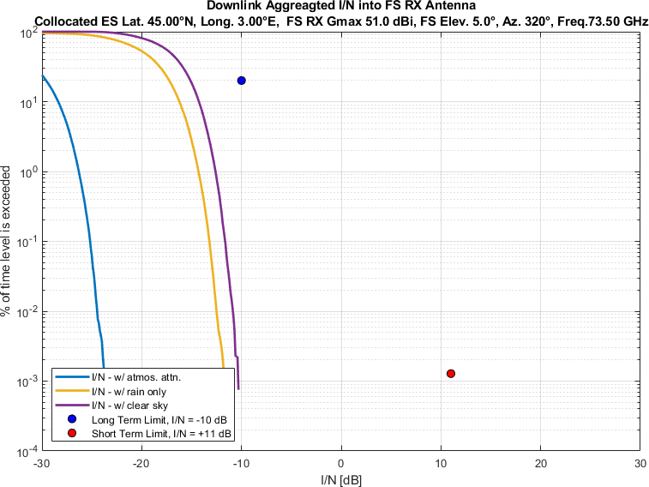
Figure 90
Aggregate I/N from Selected Systems at 45°N, FS max. Receive Gain 51 dBi, Azimuth 340°
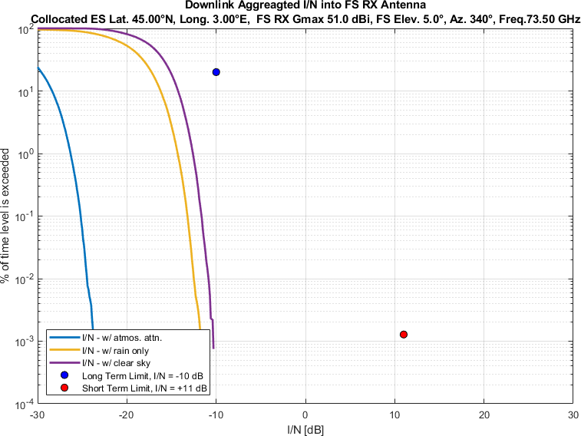
Figure 91
Aggregate I/N from Selected Systems at 60°N, FS max. Receive Gain 51 dBi, Azimuth 0°
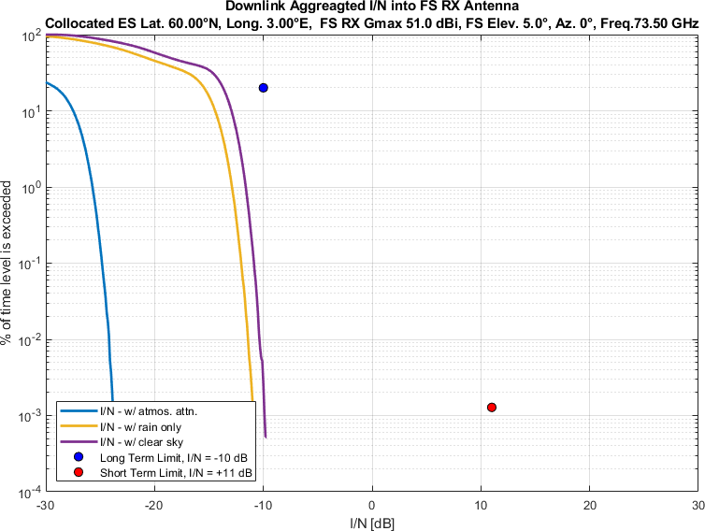
Figure 92
Aggregate I/N from Selected Systems at 60°N, FS max. Receive Gain 51 dBi, Azimuth 20°
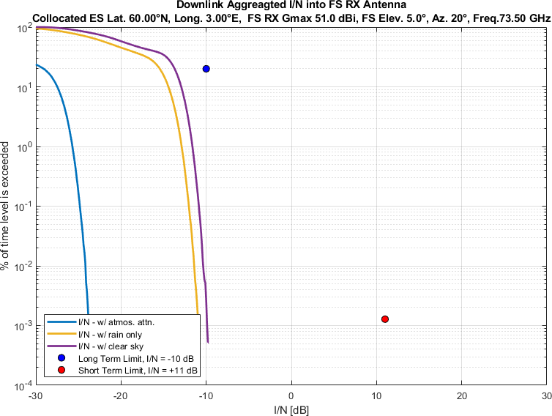
Figure 93
Aggregate I/N from Selected Systems at 60°N, FS max. Receive Gain 51 dBi, Azimuth 40°
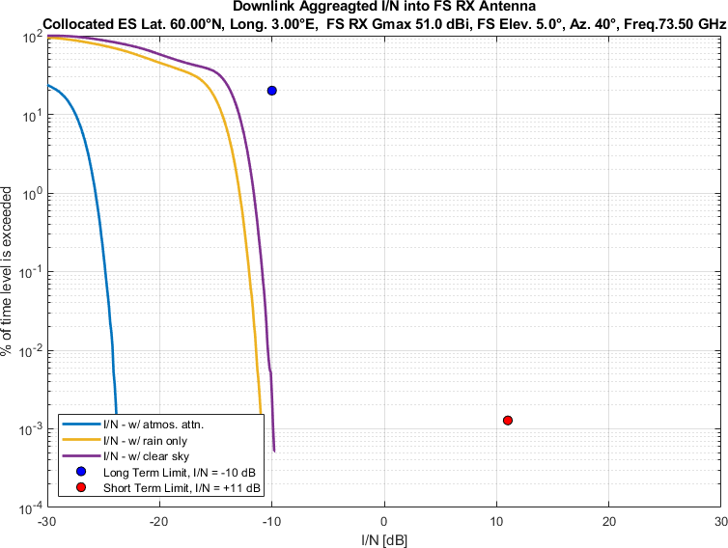
Figure 94
Aggregate I/N from Selected Systems at 60°N, FS max. Receive Gain 51 dBi, Azimuth 60°
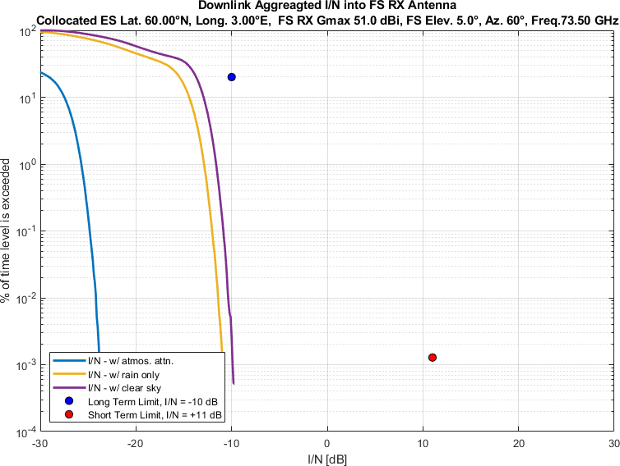
Figure 95
Aggregate I/N from Selected Systems at 60°N, FS max. Receive Gain 51 dBi, Azimuth 80°
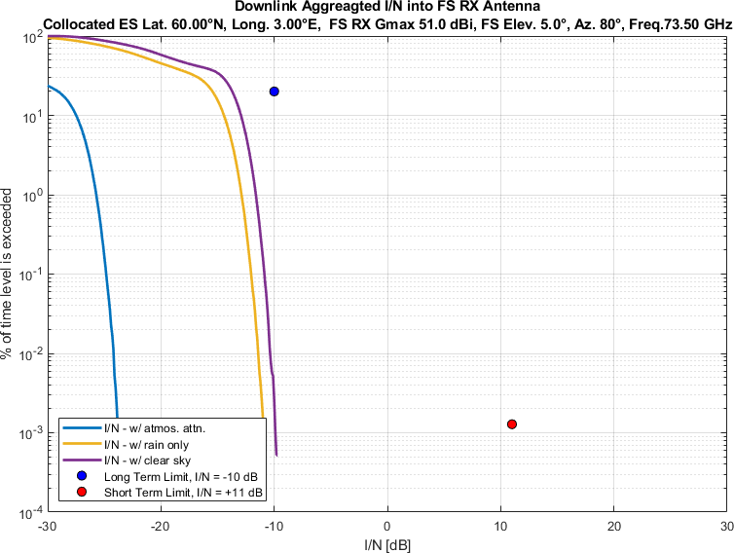
Figure 96
Aggregate I/N from Selected Systems at 60°N, FS max. Receive Gain 51 dBi, Azimuth 100°
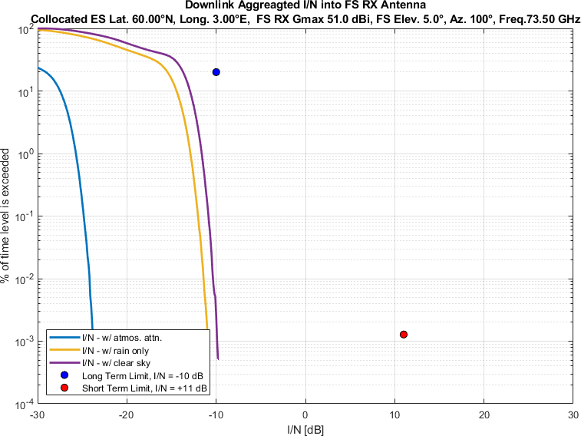
Figure 97
Aggregate I/N from Selected Systems at 60°N, FS max. Receive Gain 51 dBi, Azimuth 120°
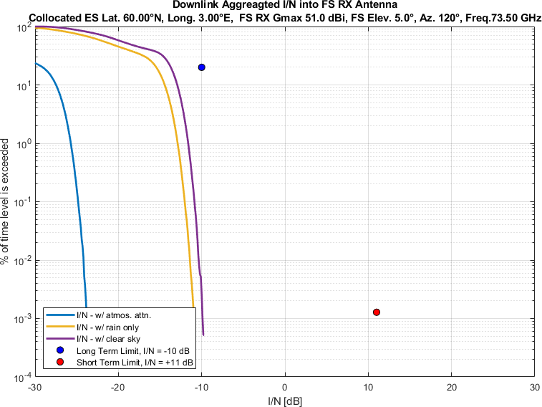
Figure 98
Aggregate I/N from Selected Systems at 60°N, FS max. Receive Gain 51 dBi, Azimuth 140°
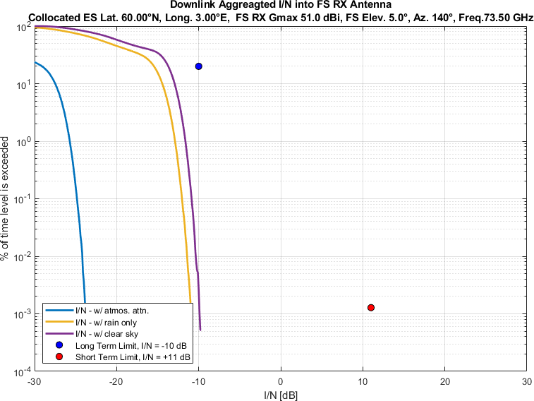
Figure 99
Aggregate I/N from Selected Systems at 60°N, FS max. Receive Gain 51 dBi, Azimuth 160°
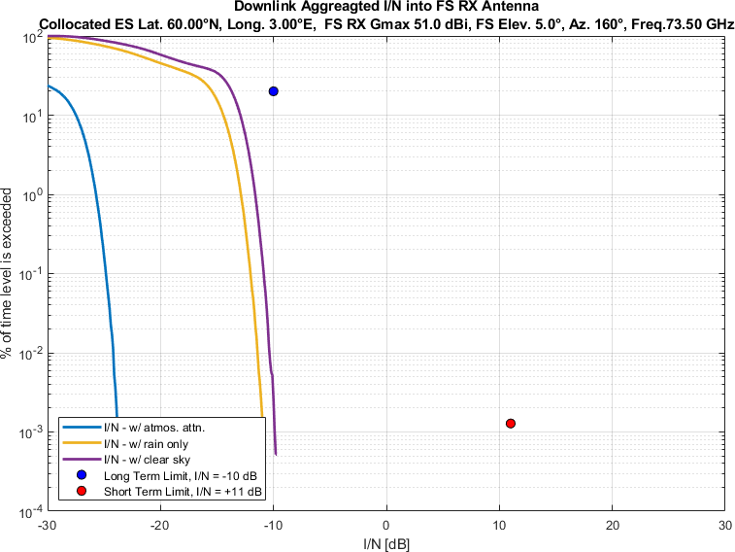
Figure 100
Aggregate I/N from Selected Systems at 60°N, FS max. Receive Gain 51 dBi, Azimuth 180°
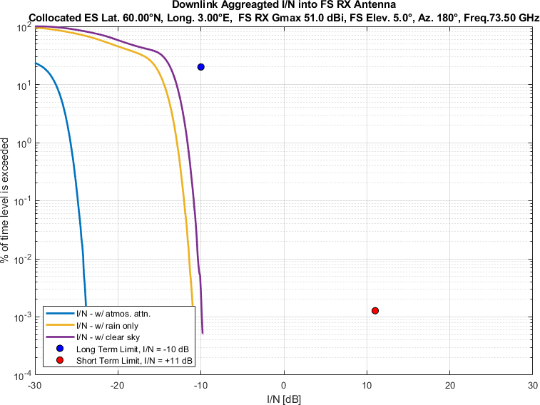
Figure 101
Aggregate I/N from Selected Systems at 60°N, FS max. Receive Gain 51 dBi, Azimuth 200°
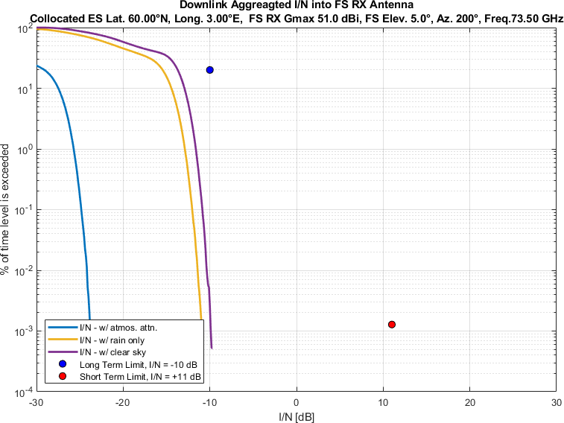
Figure 102
Aggregate I/N from Selected Systems at 60°N, FS max. Receive Gain 51 dBi, Azimuth 220°
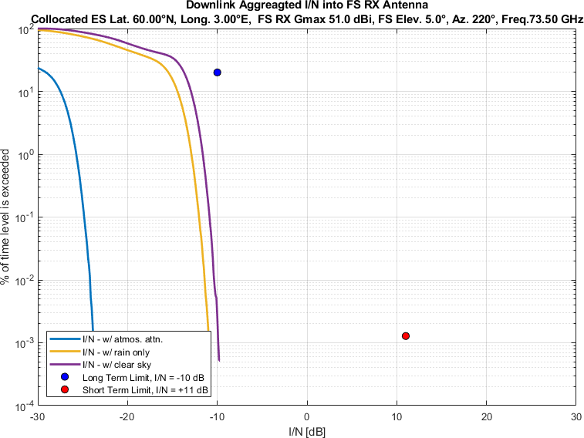
Figure 103
Aggregate I/N from Selected Systems at 60°N, FS max. Receive Gain 51 dBi, Azimuth 240°
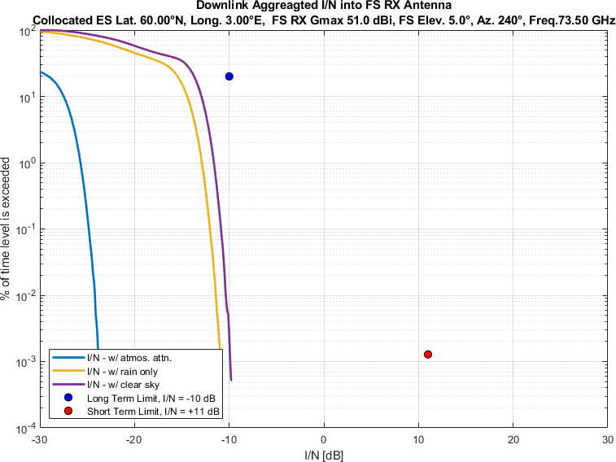
Figure 104
Aggregate I/N from Selected Systems at 60°N, FS max. Receive Gain 51 dBi, Azimuth 260°
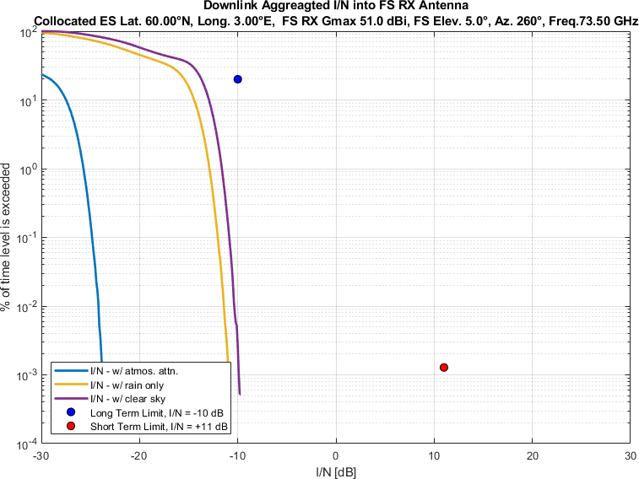
Figure 105
Aggregate I/N from Selected Systems at 60°N, FS max. Receive Gain 51 dBi, Azimuth 280°
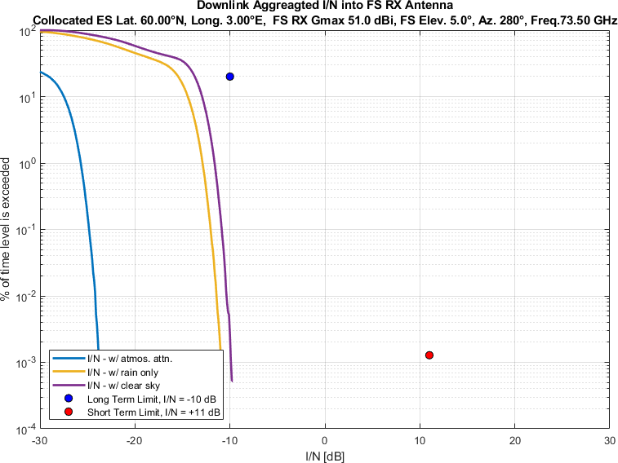
Figure 106
Aggregate I/N from Selected Systems at 60°N, FS max. Receive Gain 51 dBi, Azimuth 300°
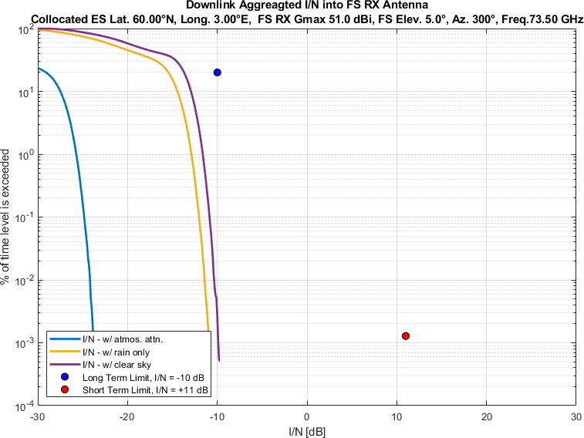
Figure 107
Aggregate I/N from Selected Systems at 60°N, FS max. Receive Gain 51 dBi, Azimuth 320°
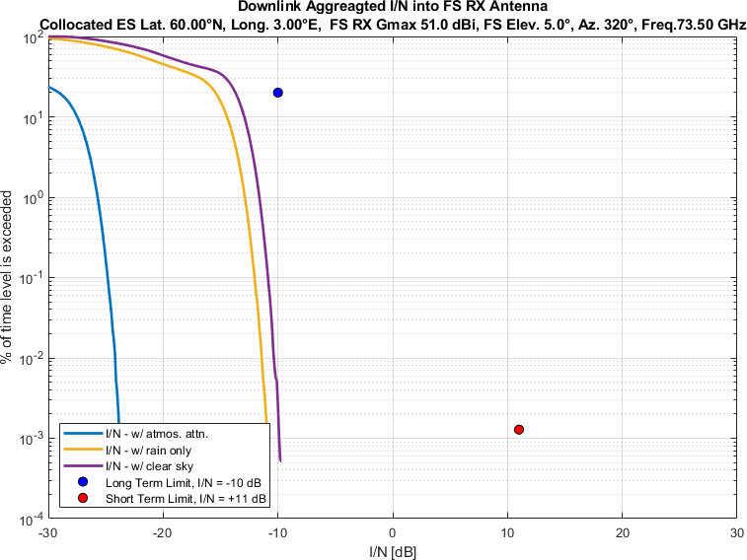
Figure 108
Aggregate I/N from Selected Systems at 60°N, FS max. Receive Gain 51 dBi, Azimuth 340°
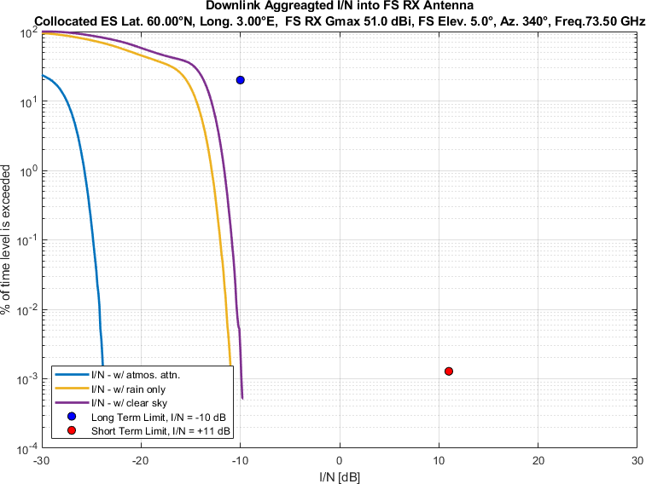

Study #XY
This study considers the same operational conditions for the FS, GSO and non-GSO systems as discussed in Study #XX above with one difference: there is now a total of 18 identical GSO systems (along with the three non-GSO systems) instead of only one. The satellites are assumed to be spaced on the GSO arc every 3° between 22.5°W to 28.5°E. The rationale for the spacing is linked to an acceptable level of interference into each other, i.e. -10.5 dB I/N, considering the selected value of max downlink PFD, i.e. -105 dBW/m2/MHz. It is clear that assuming a lower PFD, the GSOs could be spaced closer to each other.
Table 4
Parameters of the Selected GSO and non-GSO Systems (as per 4A guidance)
GSO/Non-GSO System | Height  (km) | Number of planes | Satellites per plane | Inclination angle (deg) | Number of co-frequency beams, Nco | Min. Elevation Angle, ε | Min. GSO Exclusion angle, α
System-B (non-GSO) | 590, 610, 630 | 28, 36, 34 | 28, 36, 34 | 33, 42, 51.9 | 32 | 20° | 1°
18 GSO Systems  (assumed) | 35786 | 1 | 1 | 0 | 1 | Depending on GSO longitude | N/A
System-D (non-GSO) | 1050 | 12 | 28 | 89 | 8 (assumed) | 20° (assumed) | 1°
System-M (non-GSO) | 340, 345, 350, 360, 525, 530, 535, 604, 614 | 12, 18, 48, 48, 48, 30, 28, 28, 28 | 110, 110, 110, 120, 120, 120, 120, 12, 18 | 53, 46, 38, 97, 53, 43, 33, 148, 116 | 50  (assumed) | 10°  (assumed) | 1°

Results of study # XY
Figure 1-54 compare aggregate I/N from the multiple selected GSO and three non-GSO systems to
the smallest dimension 0.2 m FS station antenna,
pointing at eighteen different azimuth directions at 20° intervals
for maximum FS antenna elevation angle of 5°,
at a representative frequency (i.e., 73.5 GHz).
Each figure compares three different atmospheric attenuation scenarios –
1 All atmospheric attenuations (attenuations due to rain, cloud, gas and scintillation) according to equation (65) in ITU-R P.618-14;
2 Rain attenuation only;
3 No atmospheric attenuation (clear sky).
It is evident from the plots that with the PFD masks used in the analysis, both long-term and short-term limits are met. At the same time, the plots show the significant impact of considering atmospheric attenuation.
Figure 1
Aggregate I/N from Selected Systems at 24°N, FS max. Receive Gain 41.5 dBi, Azimuth 0°
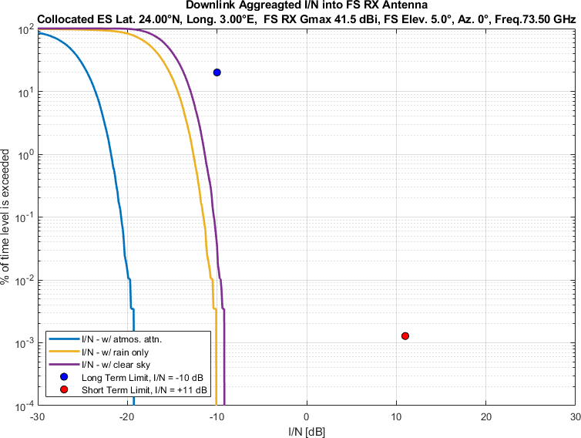
Figure 2
Aggregate I/N from Selected Systems at 24°N, FS max. Receive Gain 41.5 dBi, Azimuth 20°
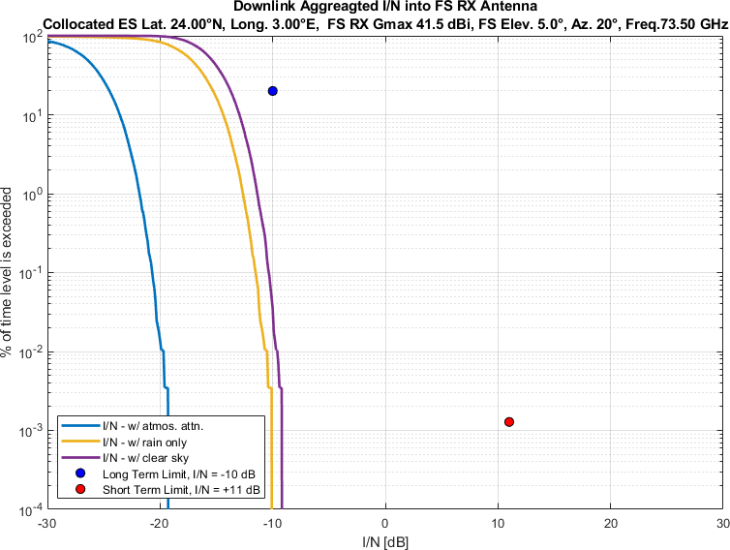
Figure 3
Aggregate I/N from Selected Systems at 24°N, FS max. Receive Gain 41.5 dBi, Azimuth 40°
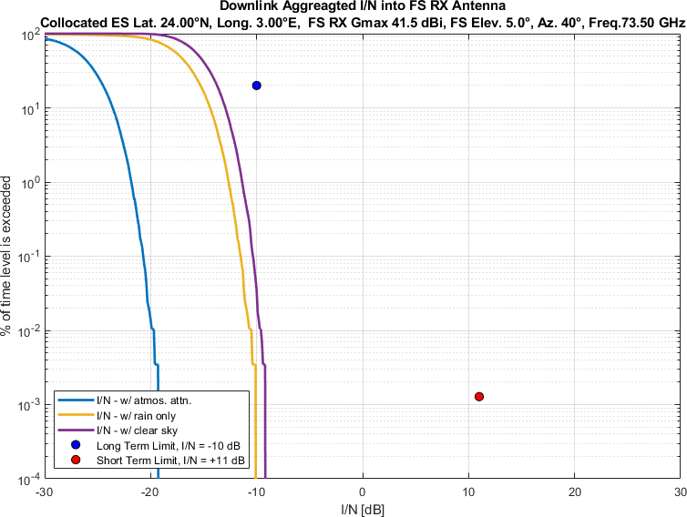
Figure 4
Aggregate I/N from Selected Systems at 24°N, FS max. Receive Gain 41.5 dBi, Azimuth 60°
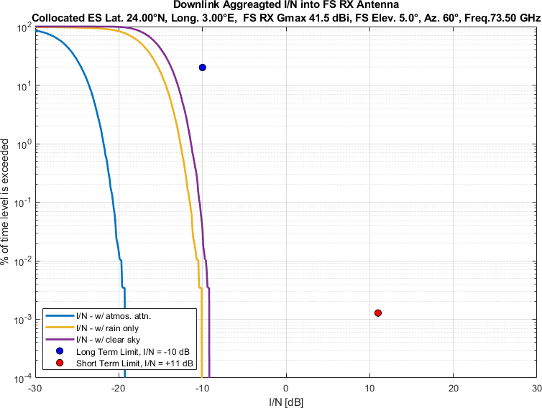
Figure 5
Aggregate I/N from Selected Systems at 24°N, FS max. Receive Gain 41.5 dBi, Azimuth 80°
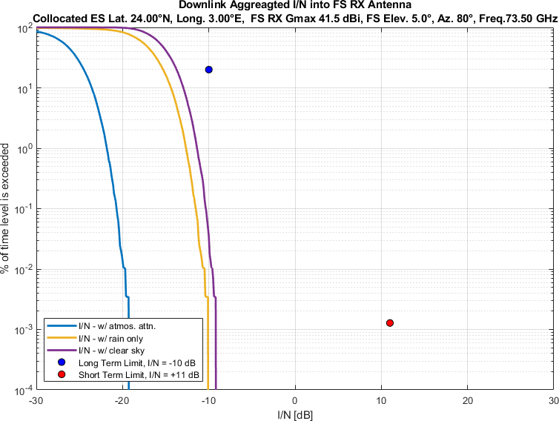
Figure 6
Aggregate I/N from Selected Systems at 24°N, FS max. Receive Gain 41.5 dBi, Azimuth 100°
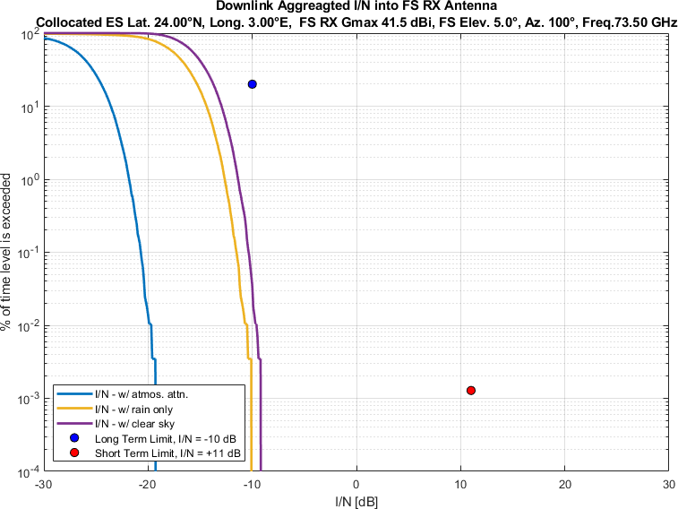
Figure 7
Aggregate I/N from Selected Systems at 24°N, FS max. Receive Gain 41.5 dBi, Azimuth 120°
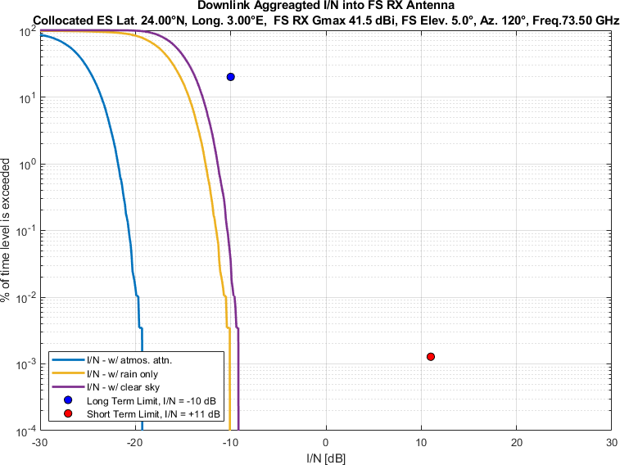
Figure 8
Aggregate I/N from Selected Systems at 24°N, FS max. Receive Gain 41.5 dBi, Azimuth 140°
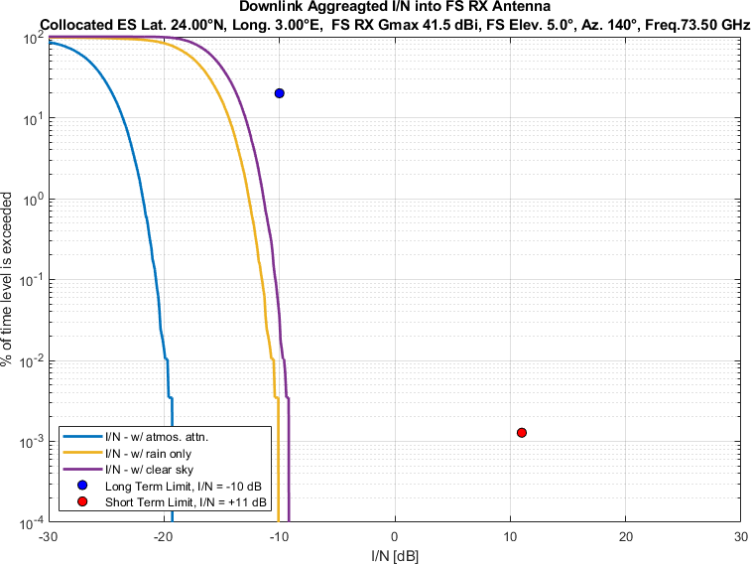
Figure 9
Aggregate I/N from Selected Systems at 24°N, FS max. Receive Gain 41.5 dBi, Azimuth 160°
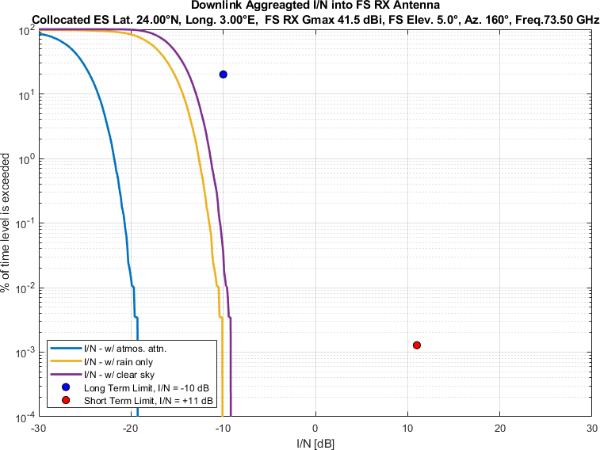
Figure 10
Aggregate I/N from Selected Systems at 24°N, FS max. Receive Gain 41.5 dBi, Azimuth 180°
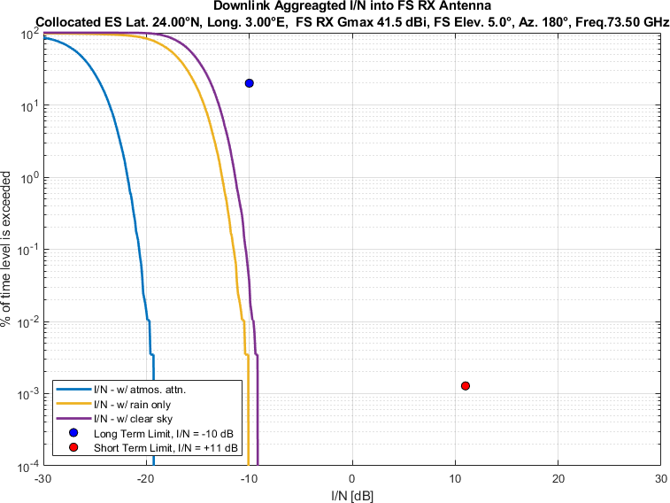
Figure 11
Aggregate I/N from Selected Systems at 24°N, FS max. Receive Gain 41.5 dBi, Azimuth 200°
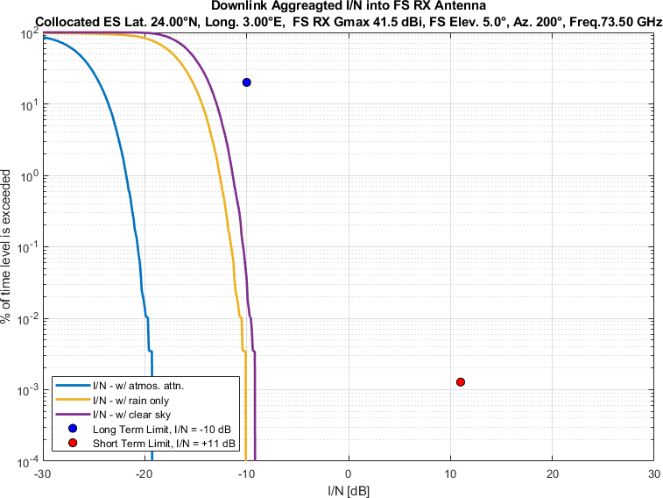
Figure 12
Aggregate I/N from Selected Systems at 24°N, FS max. Receive Gain 41.5 dBi, Azimuth 220°
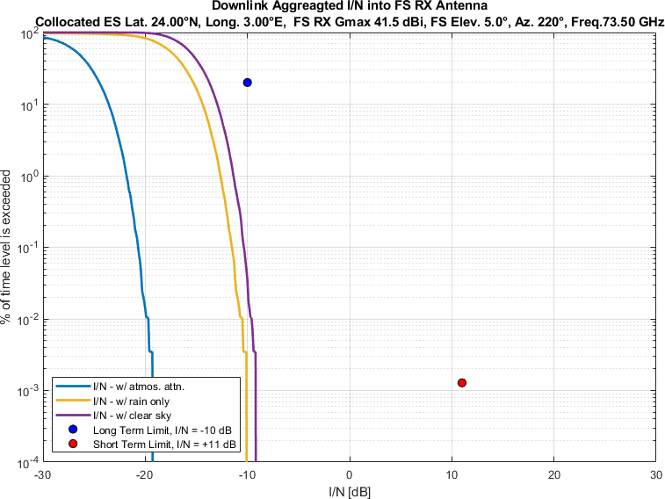
Figure 13
Aggregate I/N from Selected Systems at 24°N, FS max. Receive Gain 41.5 dBi, Azimuth 240°
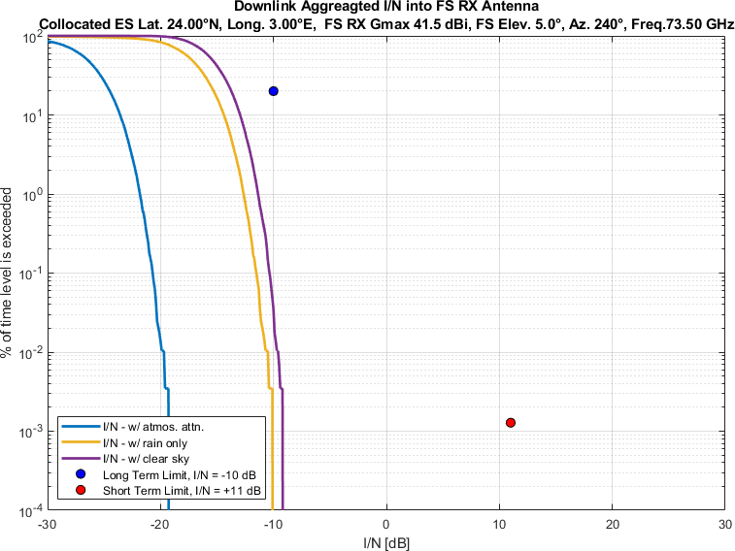
Figure 14
Aggregate I/N from Selected Systems at 24°N, FS max. Receive Gain 41.5 dBi, Azimuth 260°
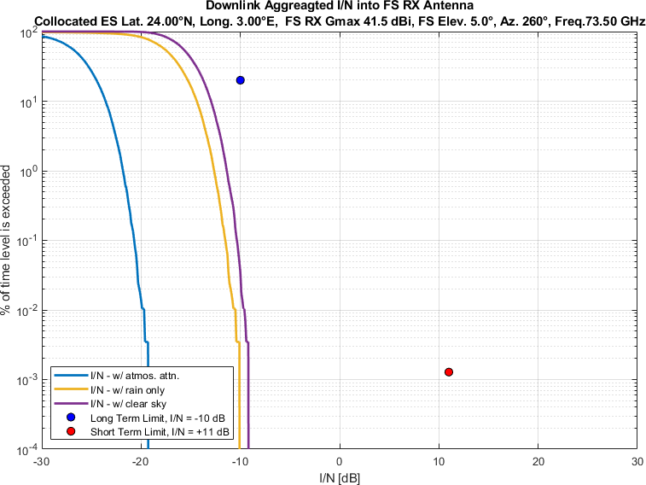
Figure 15
Aggregate I/N from Selected Systems at 24°N, FS max. Receive Gain 41.5 dBi, Azimuth 280°
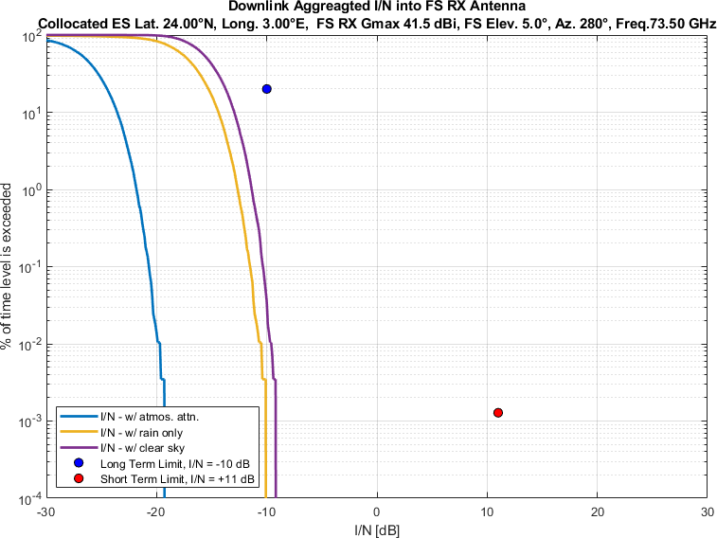
Figure 16
Aggregate I/N from Selected Systems at 24°N, FS max. Receive Gain 41.5 dBi, Azimuth 300°
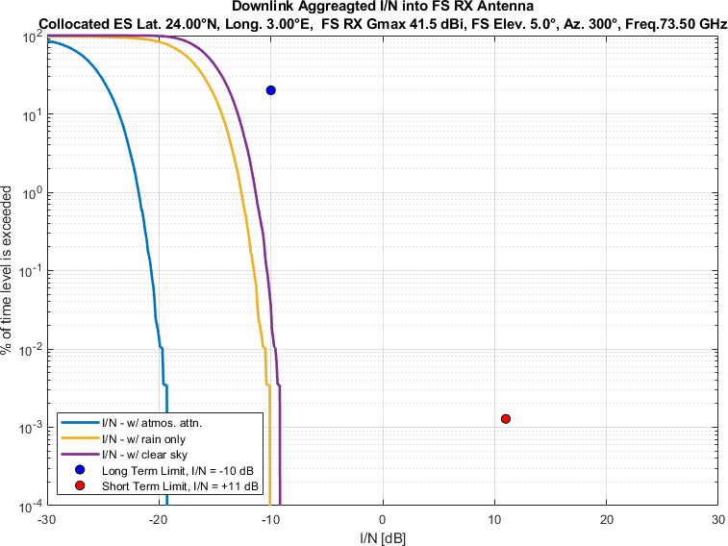
Figure 17
Aggregate I/N from Selected Systems at 24°N, FS max. Receive Gain 41.5 dBi, Azimuth 320°
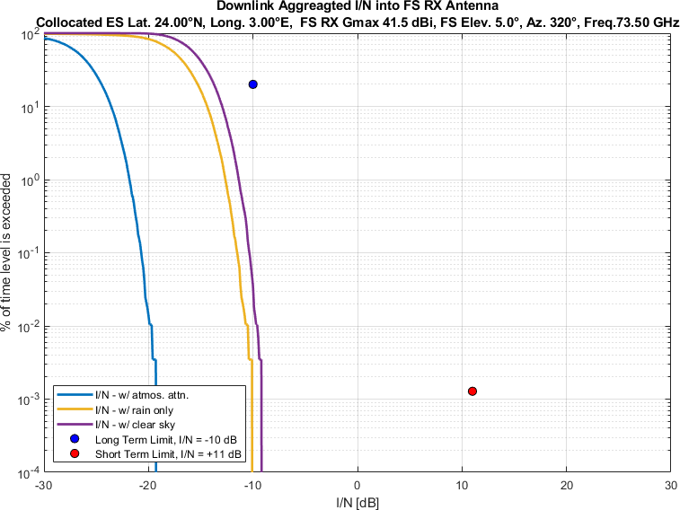
Figure 18
Aggregate I/N from Selected Systems at 24°N, FS max. Receive Gain 41.5 dBi, Azimuth 340°
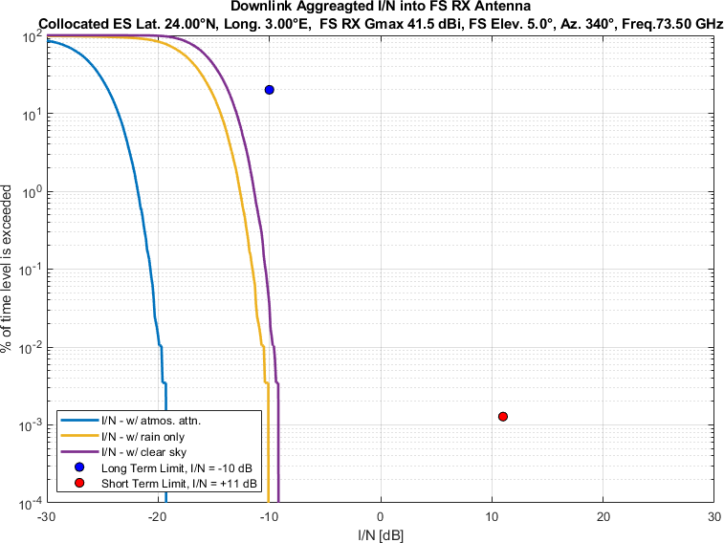
Figure 19
Aggregate I/N from Selected Systems at 45°N, FS max. Receive Gain 41.5 dBi, Azimuth 0°
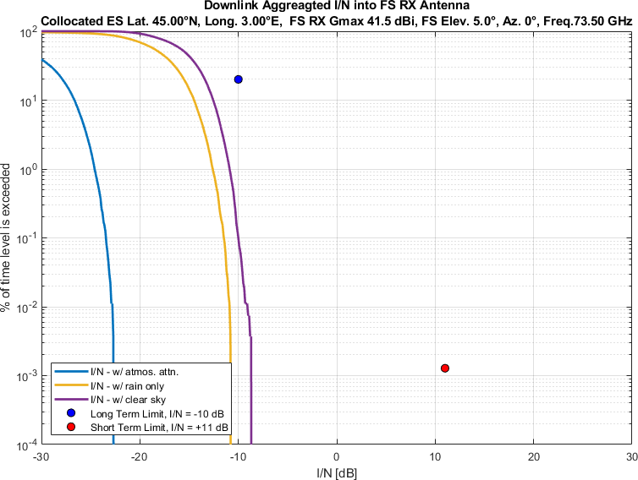
Figure 20
Aggregate I/N from Selected Systems at 45°N, FS max. Receive Gain 41.5 dBi, Azimuth 20°
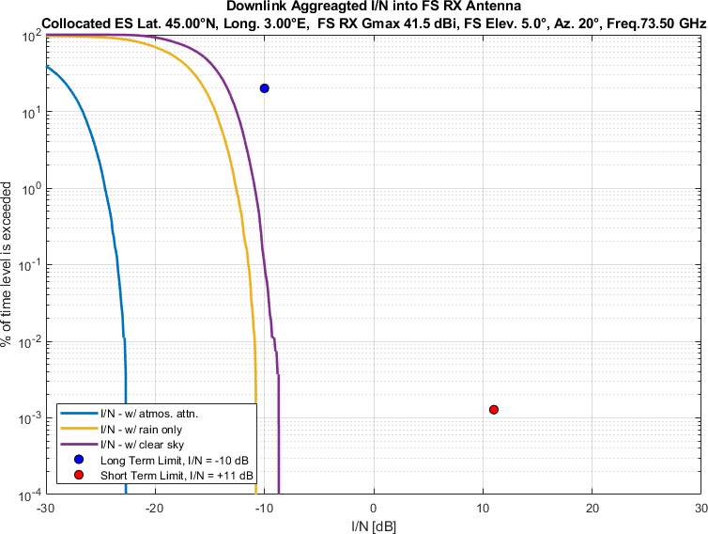
Figure 21
Aggregate I/N from Selected Systems at 45°N, FS max. Receive Gain 41.5 dBi, Azimuth 40°
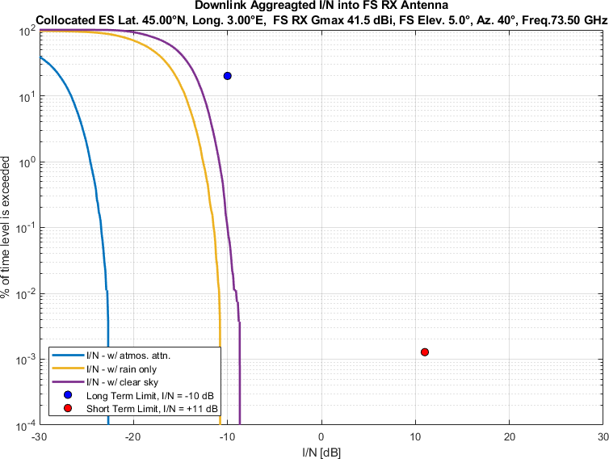
Figure 22
Aggregate I/N from Selected Systems at 45°N, FS max. Receive Gain 41.5 dBi, Azimuth 60°
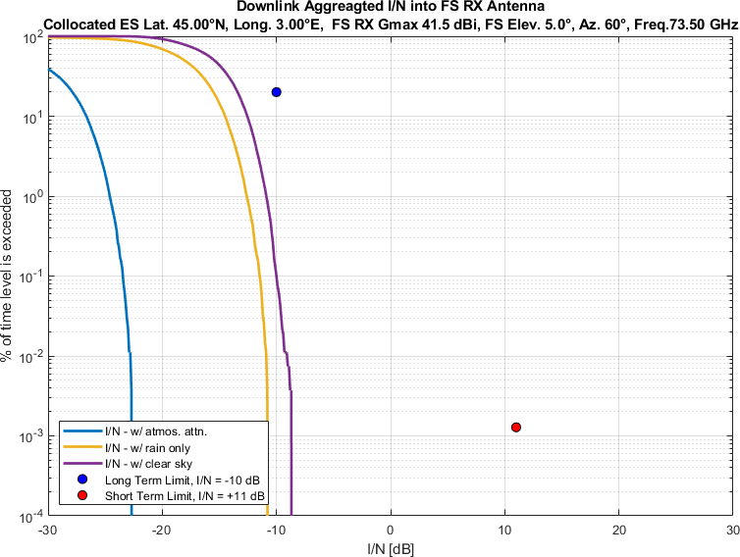
Figure 23
Aggregate I/N from Selected Systems at 45°N, FS max. Receive Gain 41.5 dBi, Azimuth 80°
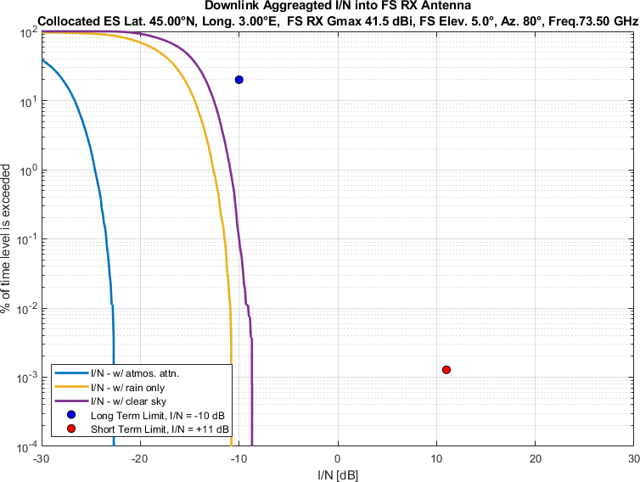
Figure 24
Aggregate I/N from Selected Systems at 45°N, FS max. Receive Gain 41.5 dBi, Azimuth 100°
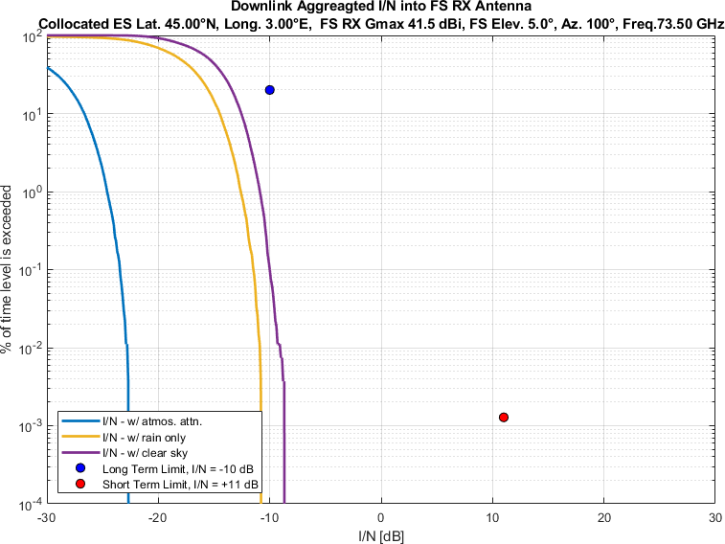
Figure 25
Aggregate I/N from Selected Systems at 45°N, FS max. Receive Gain 41.5 dBi, Azimuth 120°
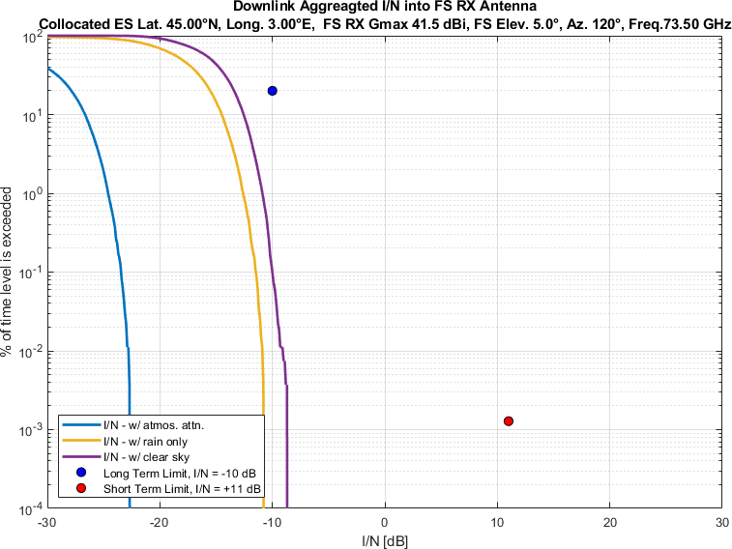
Figure 26
Aggregate I/N from Selected Systems at 45°N, FS max. Receive Gain 41.5 dBi, Azimuth 140°
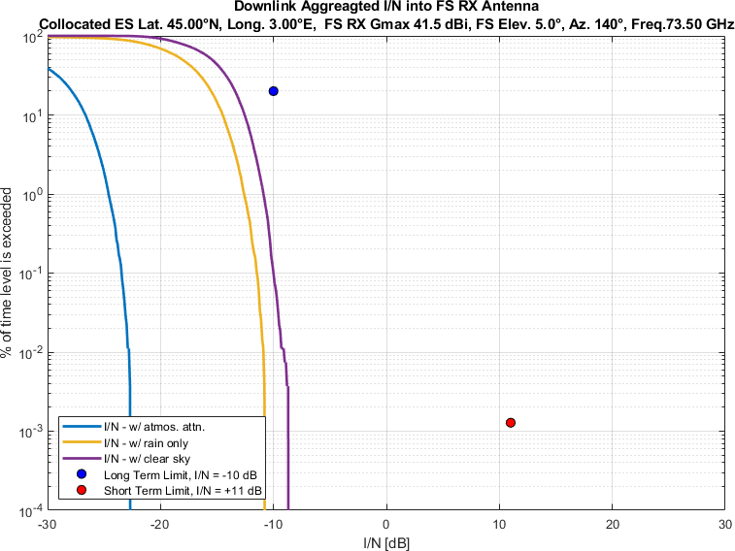
Figure 27
Aggregate I/N from Selected Systems at 45°N, FS max. Receive Gain 41.5 dBi, Azimuth 160°
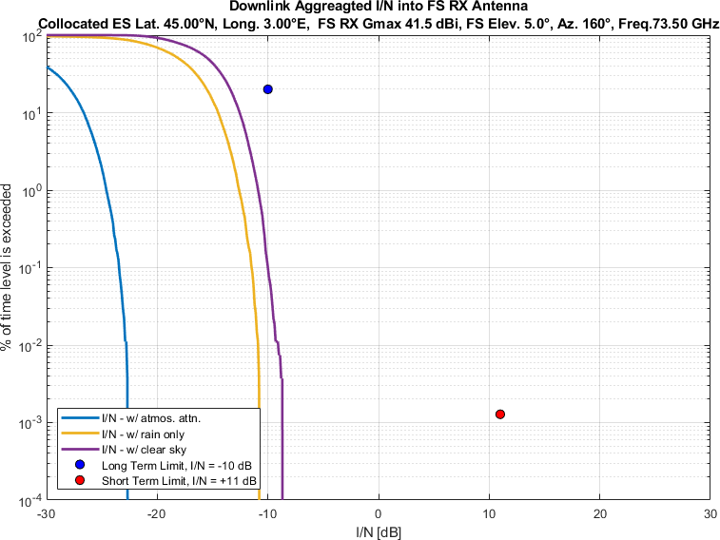
Figure 28
Aggregate I/N from Selected Systems at 45°N, FS max. Receive Gain 41.5 dBi, Azimuth 180°
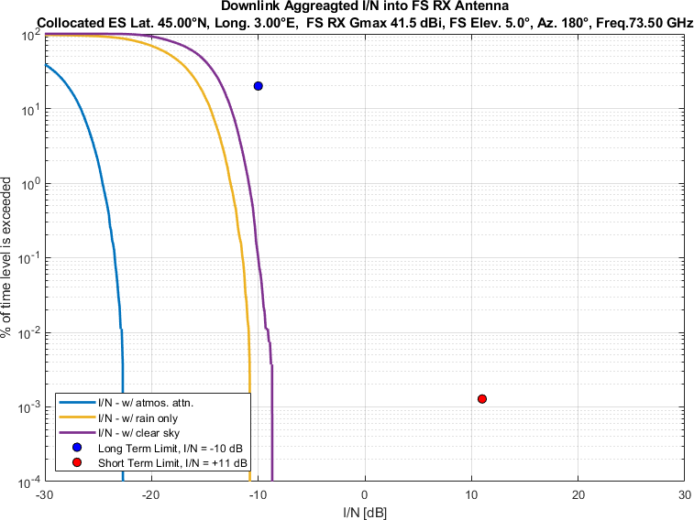
Figure 29
Aggregate I/N from Selected Systems at 45°N, FS max. Receive Gain 41.5 dBi, Azimuth 200°
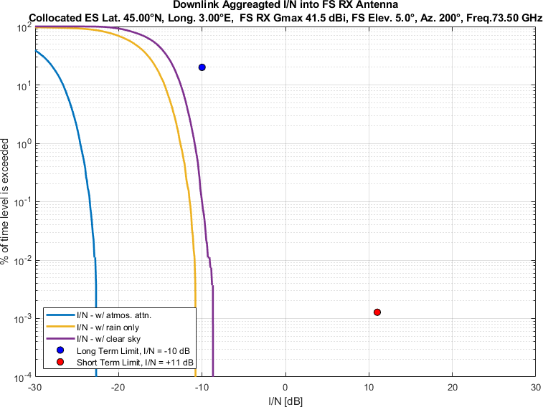
Figure 30
Aggregate I/N from Selected Systems at 45°N, FS max. Receive Gain 41.5 dBi, Azimuth 220°
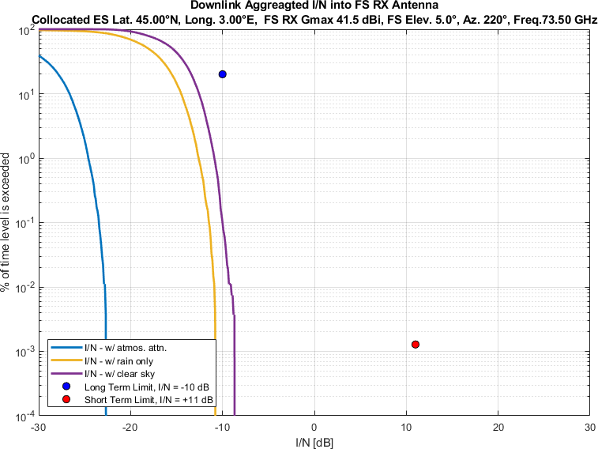
Figure 31
Aggregate I/N from Selected Systems at 45°N, FS max. Receive Gain 41.5 dBi, Azimuth 240°
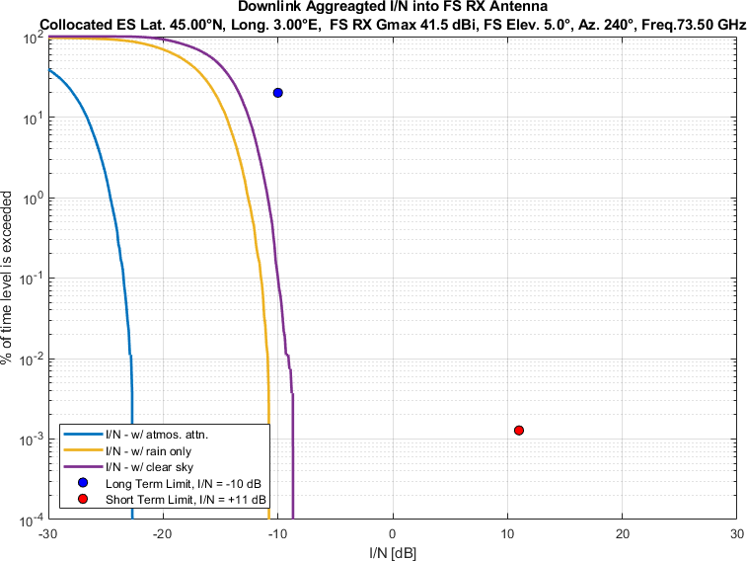
Figure 32
Aggregate I/N from Selected Systems at 45°N, FS max. Receive Gain 41.5 dBi, Azimuth 260°
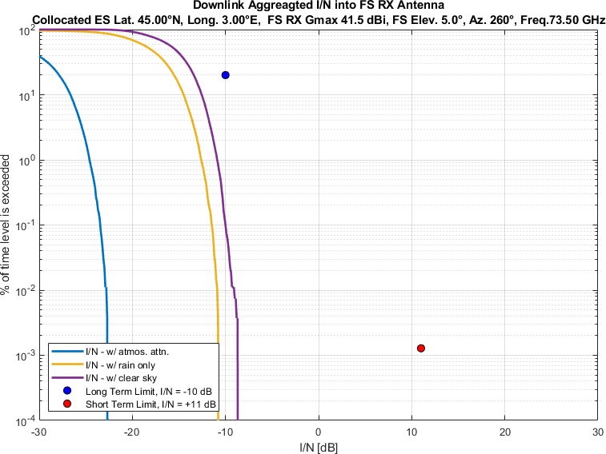
Figure 33
Aggregate I/N from Selected Systems at 45°N, FS max. Receive Gain 41.5 dBi, Azimuth 280°
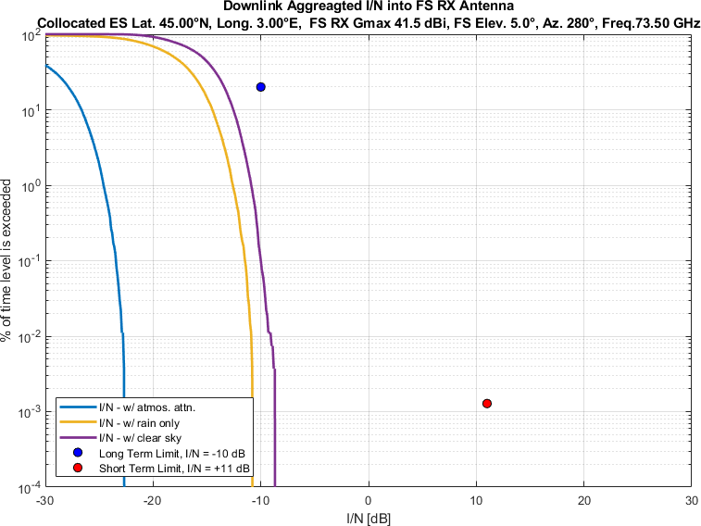
Figure 34
Aggregate I/N from Selected Systems at 45°N, FS max. Receive Gain 41.5 dBi, Azimuth 300°
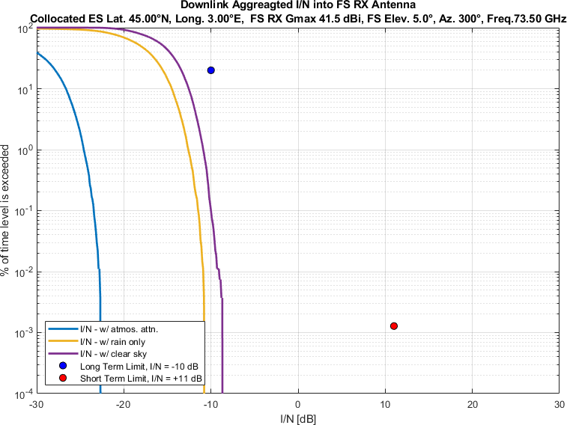
Figure 35
Aggregate I/N from Selected Systems at 45°N, FS max. Receive Gain 41.5 dBi, Azimuth 320°
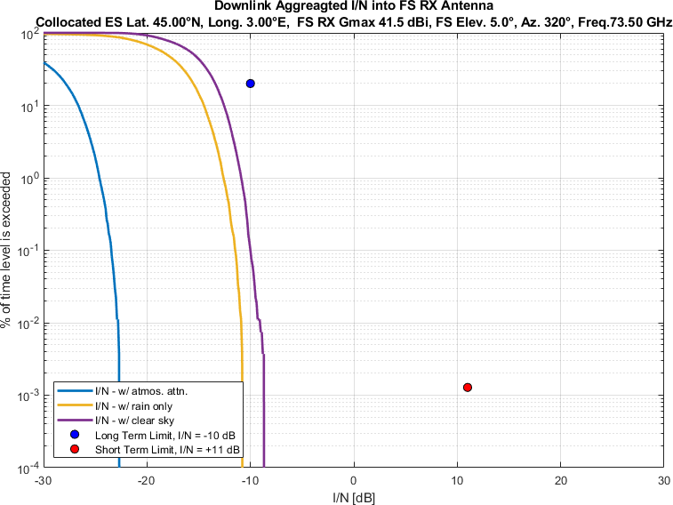
Figure 36
Aggregate I/N from Selected Systems at 45°N, FS max. Receive Gain 41.5 dBi, Azimuth 340°
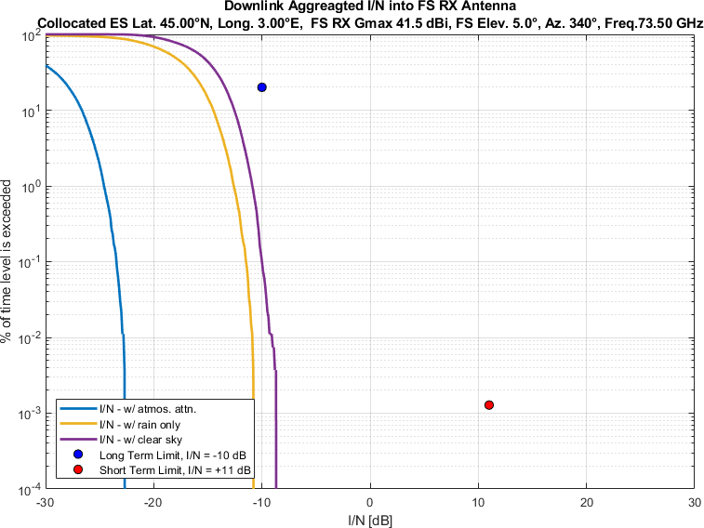
Figure 37
Aggregate I/N from Selected Systems at 60°N, FS max. Receive Gain 41.5 dBi, Azimuth 0°
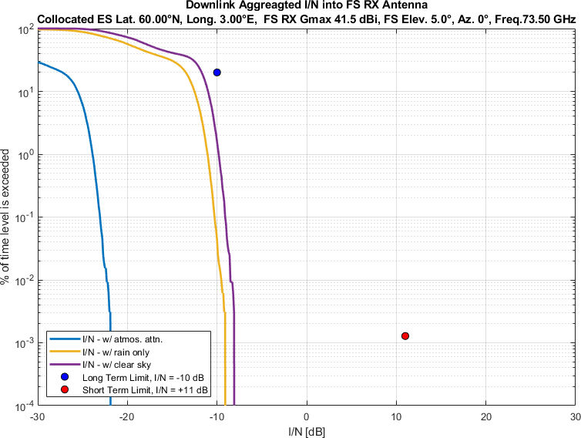
Figure 38
Aggregate I/N from Selected Systems at 60°N, FS max. Receive Gain 41.5 dBi, Azimuth 20°
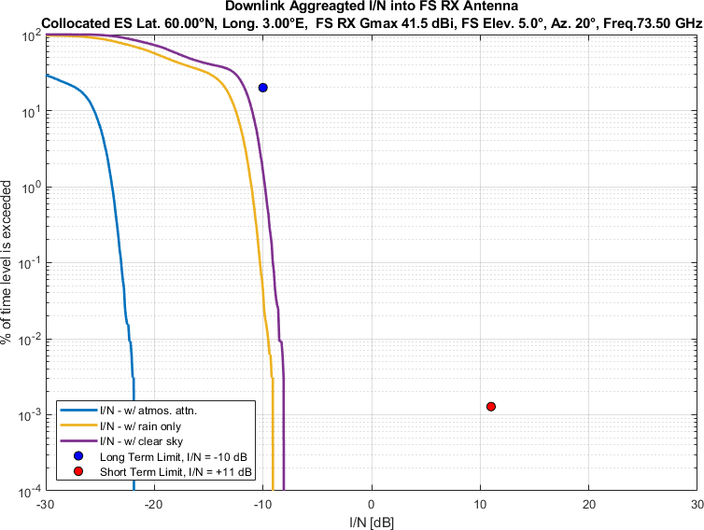
Figure 39
Aggregate I/N from Selected Systems at 60°N, FS max. Receive Gain 41.5 dBi, Azimuth 40°
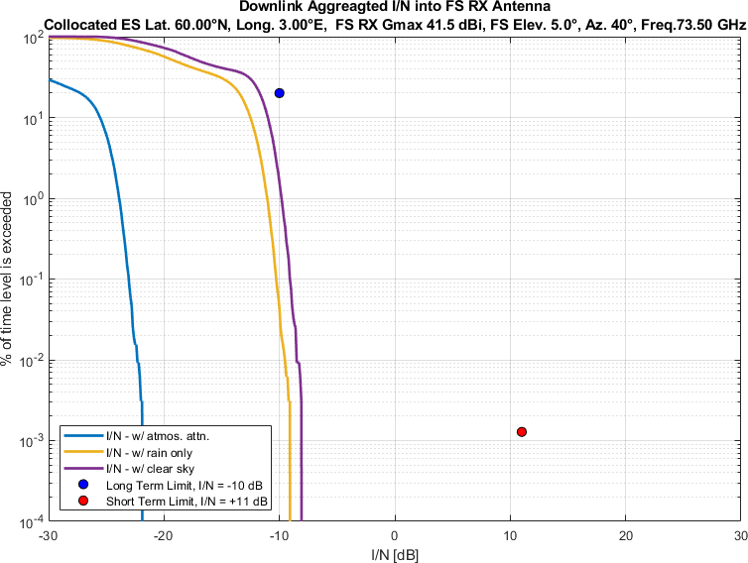
Figure 40
Aggregate I/N from Selected Systems at 60°N, FS max. Receive Gain 41.5 dBi, Azimuth 60°
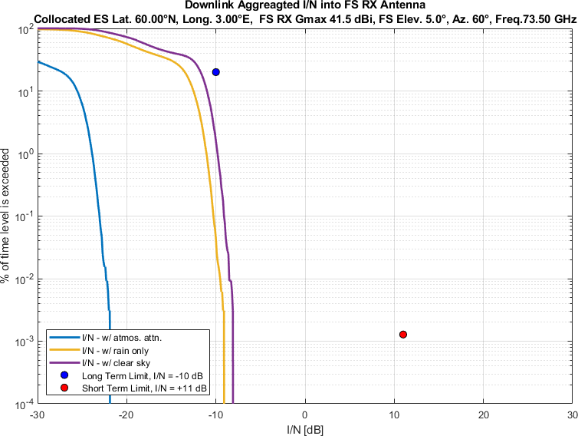
Figure 41
Aggregate I/N from Selected Systems at 60°N, FS max. Receive Gain 41.5 dBi, Azimuth 80°
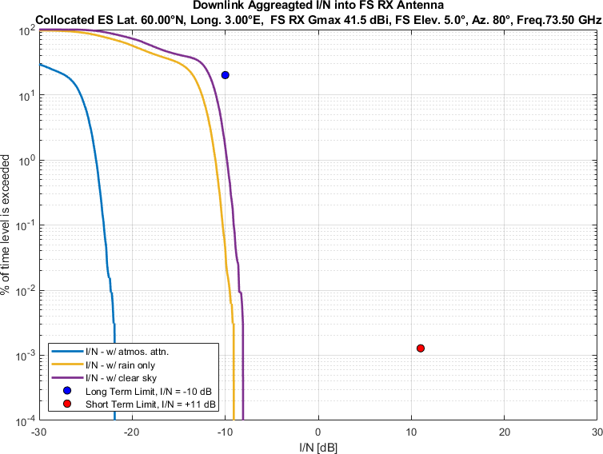
Figure 42
Aggregate I/N from Selected Systems at 60°N, FS max. Receive Gain 41.5 dBi, Azimuth 100°
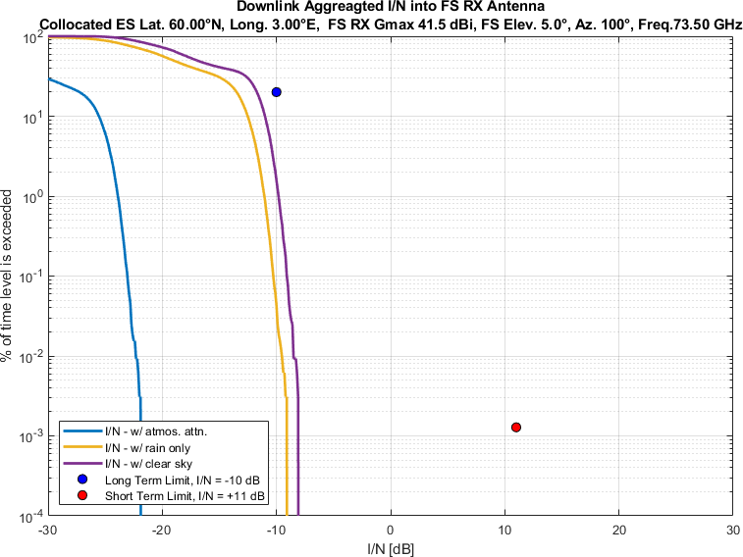
Figure 43
Aggregate I/N from Selected Systems at 60°N, FS max. Receive Gain 41.5 dBi, Azimuth 120°
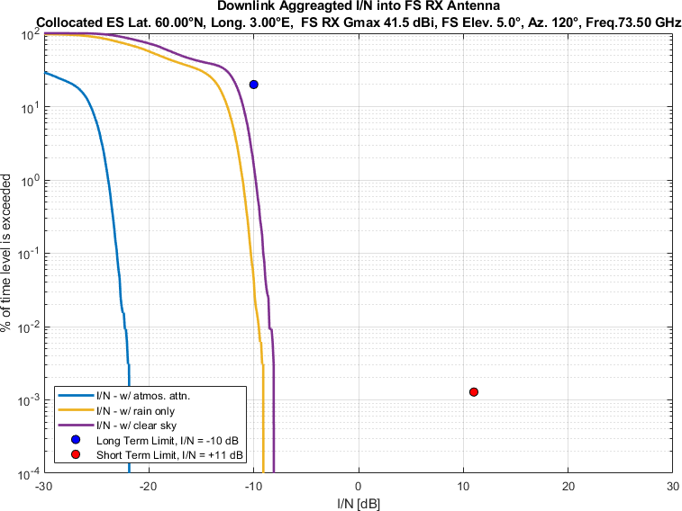
Figure 44
Aggregate I/N from Selected Systems at 60°N, FS max. Receive Gain 41.5 dBi, Azimuth 140°
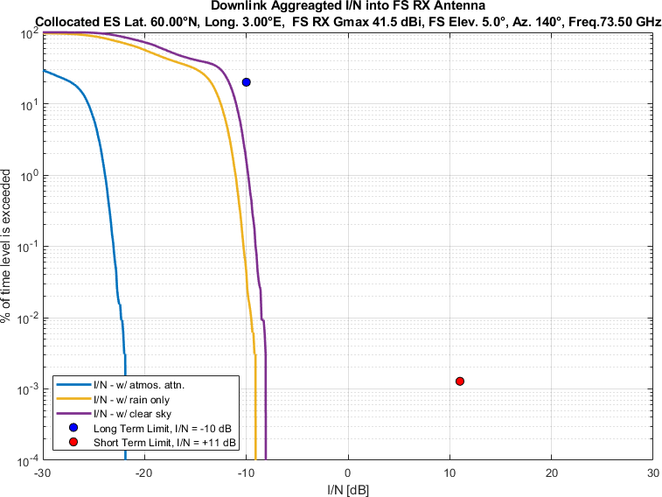
Figure 45
Aggregate I/N from Selected Systems at 60°N, FS max. Receive Gain 41.5 dBi, Azimuth 160°
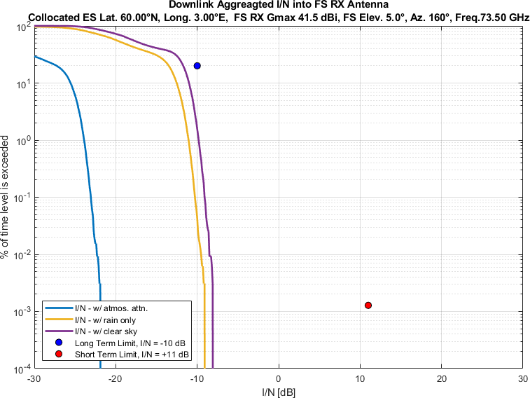
Figure 46
Aggregate I/N from Selected Systems at 60°N, FS max. Receive Gain 41.5 dBi, Azimuth 180°
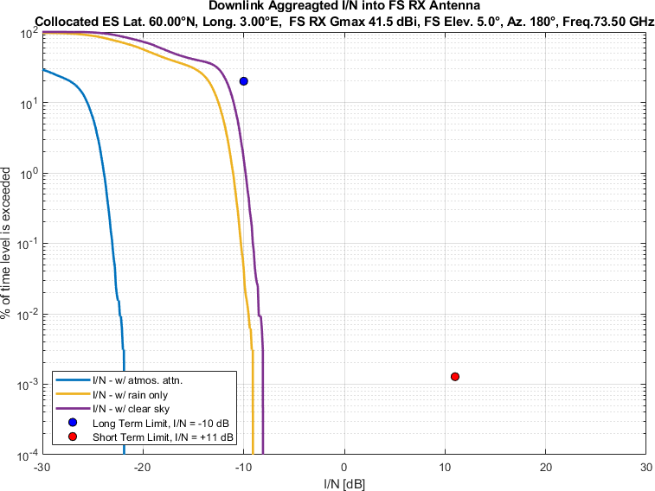
Figure 47
Aggregate I/N from Selected Systems at 60°N, FS max. Receive Gain 41.5 dBi, Azimuth 200°
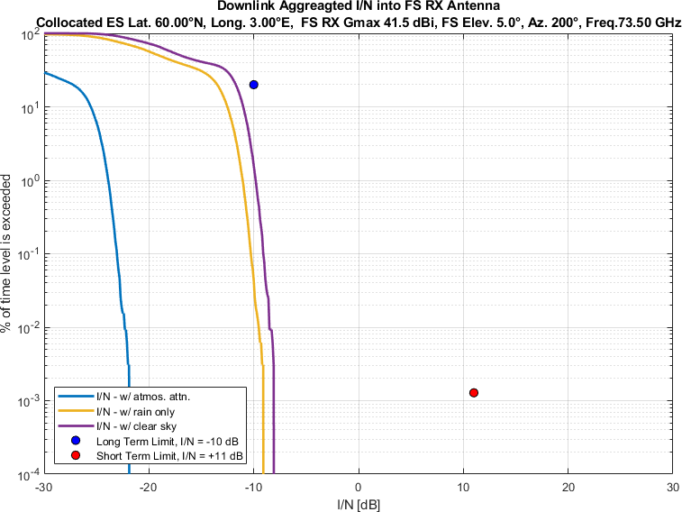
Figure 48
Aggregate I/N from Selected Systems at 60°N, FS max. Receive Gain 41.5 dBi, Azimuth 220°
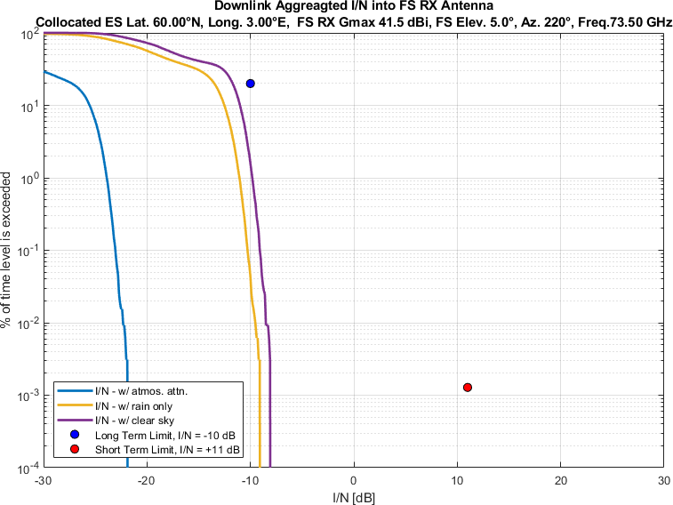
Figure 49
Aggregate I/N from Selected Systems at 60°N, FS max. Receive Gain 41.5 dBi, Azimuth 240°
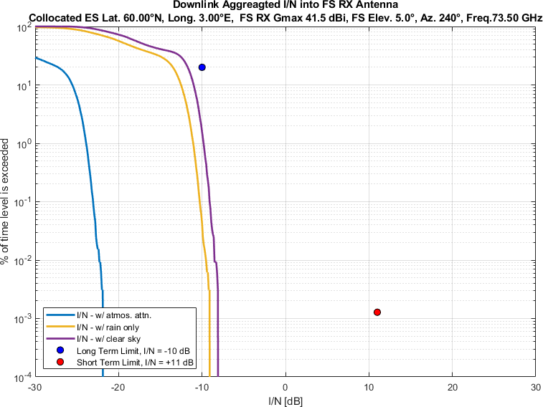
Figure 50
Aggregate I/N from Selected Systems at 60°N, FS max. Receive Gain 41.5 dBi, Azimuth 260°
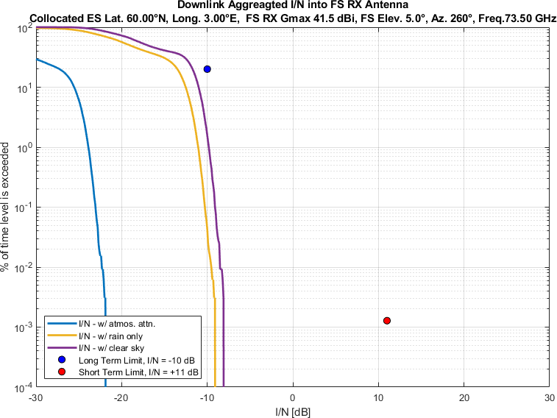
Figure 51
Aggregate I/N from Selected Systems at 60°N, FS max. Receive Gain 41.5 dBi, Azimuth 280°
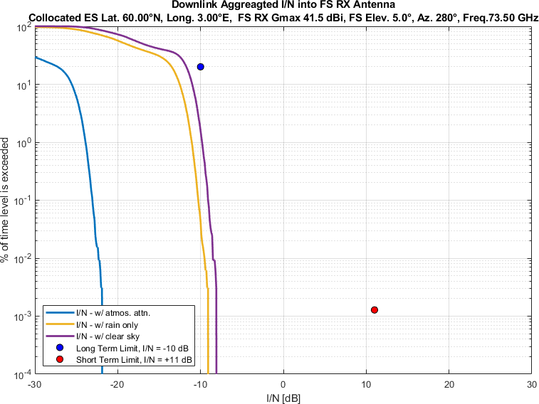
Figure 52
Aggregate I/N from Selected Systems at 60°N, FS max. Receive Gain 41.5 dBi, Azimuth 300°
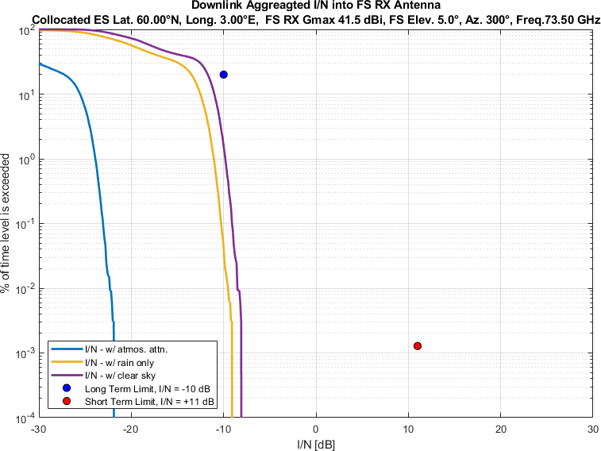
Figure 53
Aggregate I/N from Selected Systems at 60°N, FS max. Receive Gain 41.5 dBi, Azimuth 320°
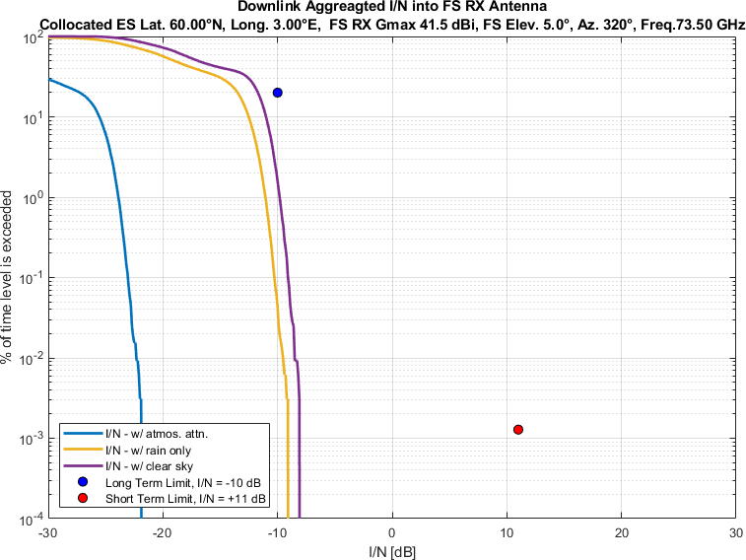
Figure 54
Aggregate I/N from Selected Systems at 60°N, FS max. Receive Gain 41.5 dBi, Azimuth 340°
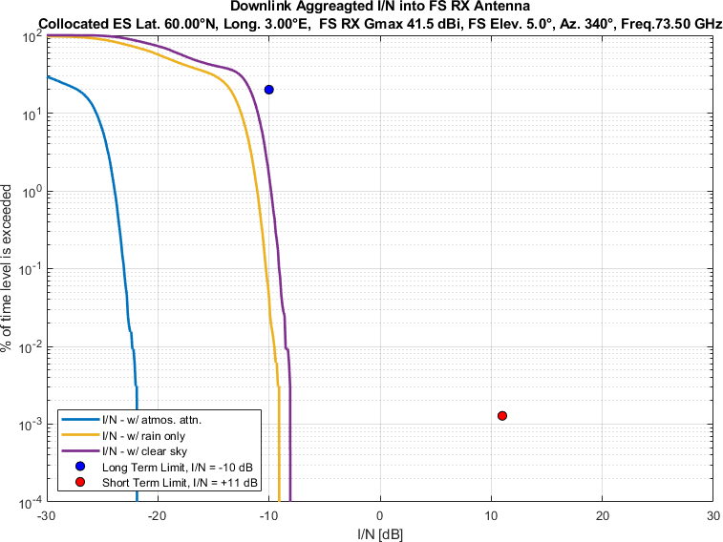

Similarly, Figure 55-108 compare aggregate I/N from the same selected GSO and three non-GSO systems to
the largest dimension 0.6m FS station antenna,
pointing at eighteen different azimuth directions at 20° intervals
for maximum FS antenna elevation angle of 5°,
at same representative frequency (i.e., 73.5 GHz).
Again, each figure compares three different of atmospheric attenuation scenarios as mentioned above.

Figure 55
Aggregate I/N from Selected Systems at 24°N, FS max. Receive Gain 51 dBi, Azimuth 0°
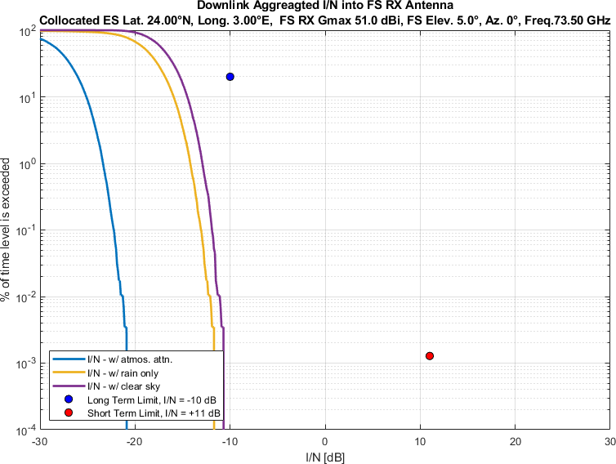
Figure 56
Aggregate I/N from Selected Systems at 24°N, FS max. Receive Gain 51 dBi, Azimuth 20°
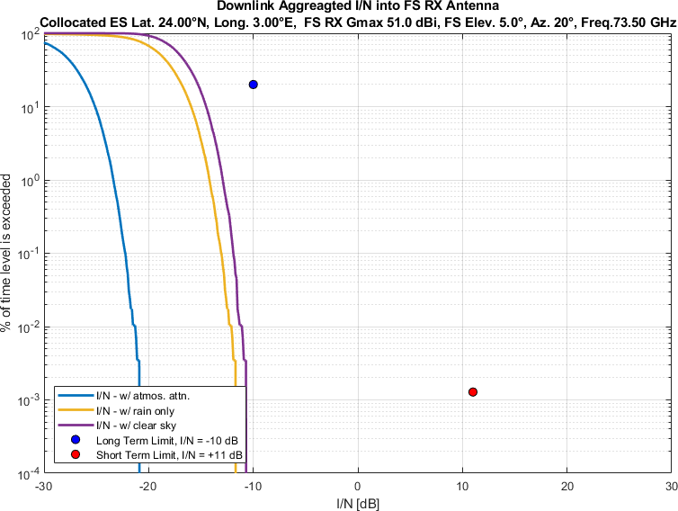
Figure 57
Aggregate I/N from Selected Systems at 24°N, FS max. Receive Gain 51 dBi, Azimuth 40°
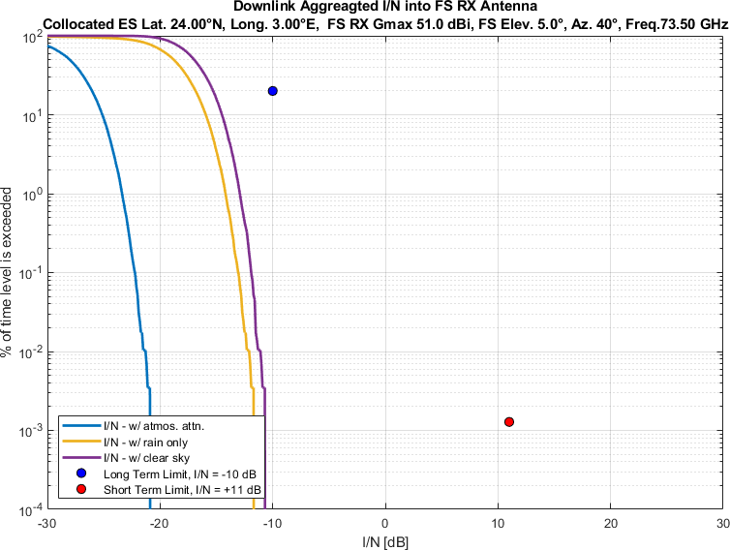
Figure 58
Aggregate I/N from Selected Systems at 24°N, FS max. Receive Gain 51 dBi, Azimuth 60°
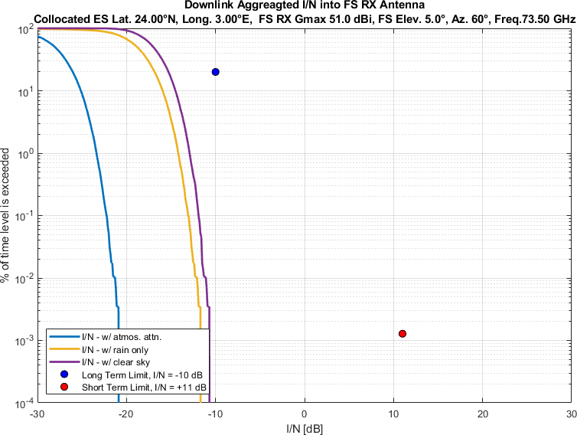
Figure 59
Aggregate I/N from Selected Systems at 24°N, FS max. Receive Gain 51 dBi, Azimuth 80°
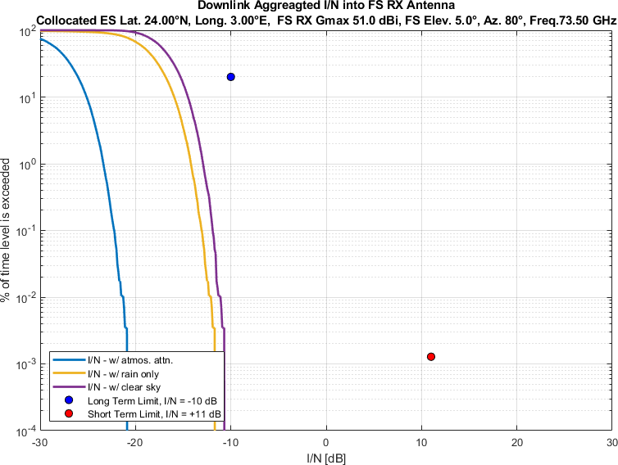
Figure 60
Aggregate I/N from Selected Systems at 24°N, FS max. Receive Gain 51 dBi, Azimuth 100°
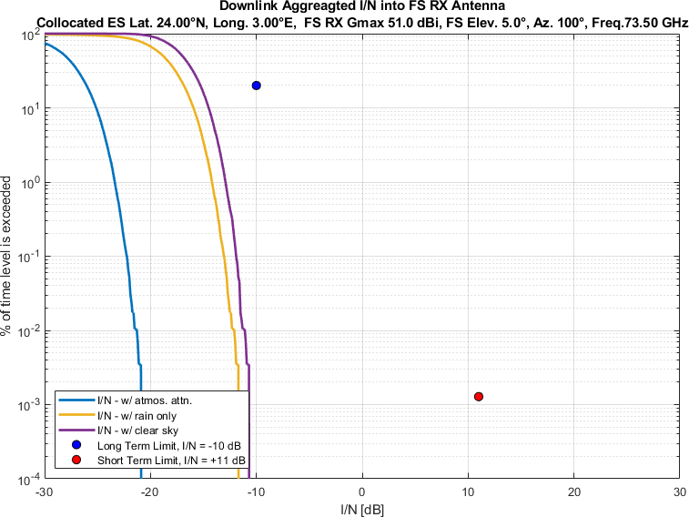
Figure 61
Aggregate I/N from Selected Systems at 24°N, FS max. Receive Gain 51 dBi, Azimuth 120°
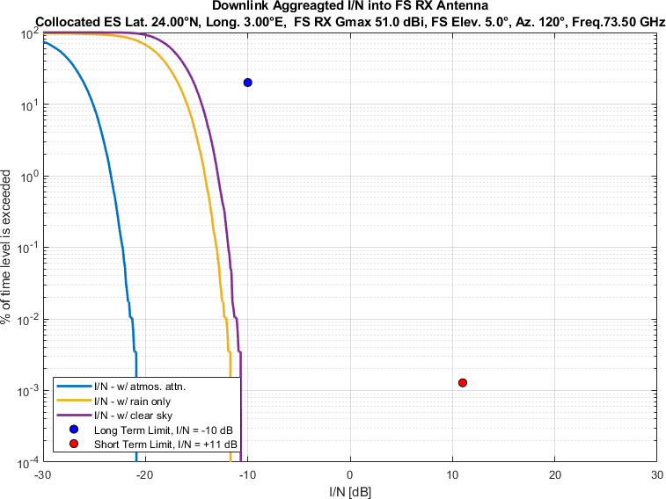
Figure 62
Aggregate I/N from Selected Systems at 24°N, FS max. Receive Gain 51 dBi, Azimuth 140°
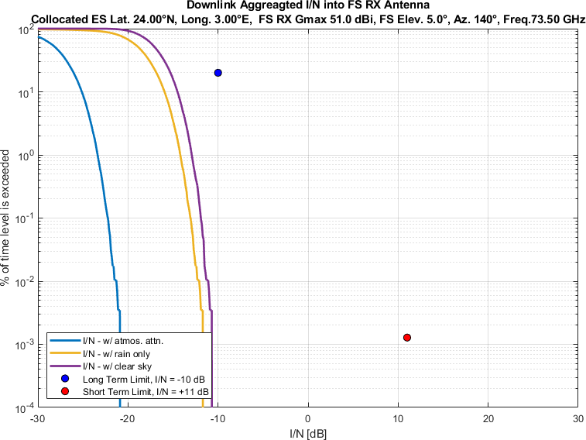
Figure 63
Aggregate I/N from Selected Systems at 24°N, FS max. Receive Gain 51 dBi, Azimuth 160°
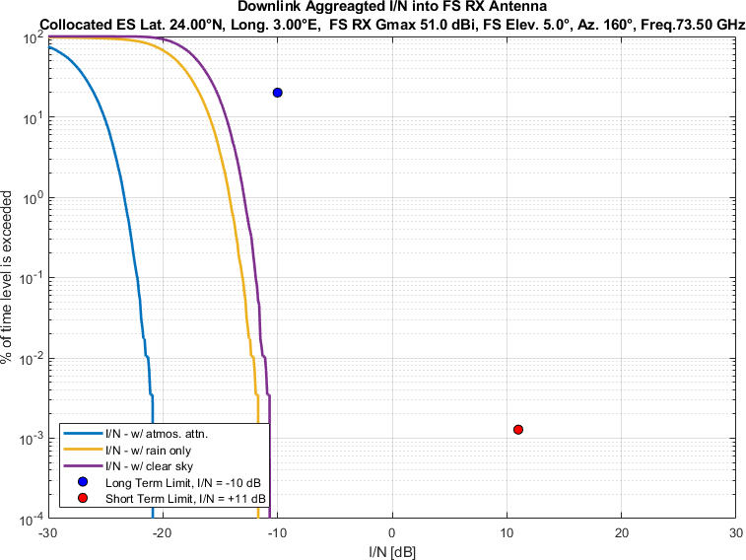
Figure 64
Aggregate I/N from Selected Systems at 24°N, FS max. Receive Gain 51 dBi, Azimuth 180°
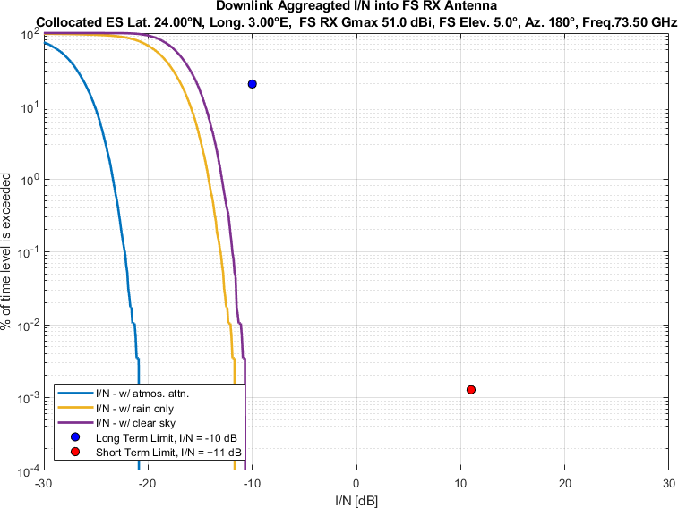
Figure 65
Aggregate I/N from Selected Systems at 24°N, FS max. Receive Gain 51 dBi, Azimuth 200°
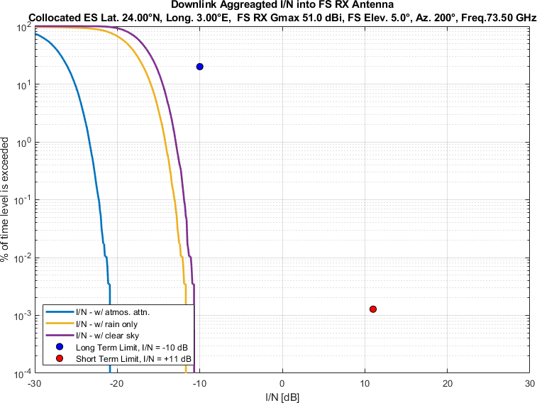
Figure 66
Aggregate I/N from Selected Systems at 24°N, FS max. Receive Gain 51 dBi, Azimuth 220°
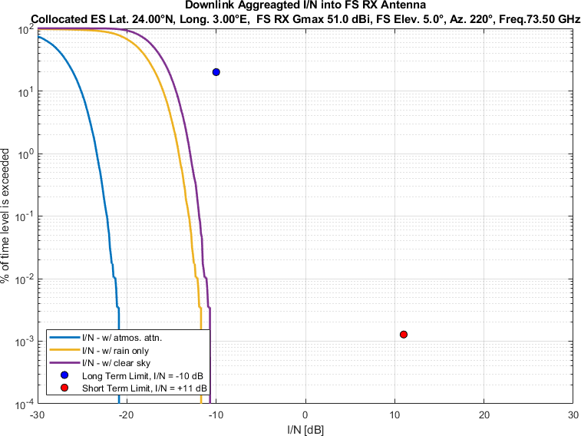
Figure 67
Aggregate I/N from Selected Systems at 24°N, FS max. Receive Gain 51 dBi, Azimuth 240°
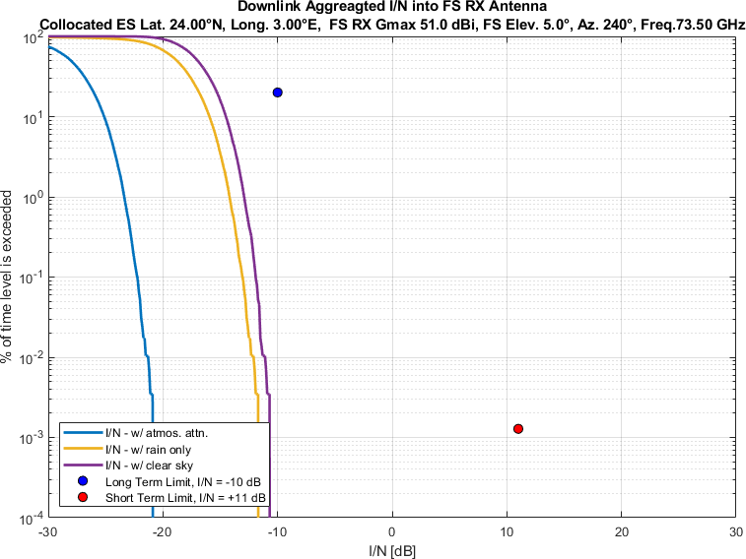
Figure 68
Aggregate I/N from Selected Systems at 24°N, FS max. Receive Gain 51 dBi, Azimuth 260°
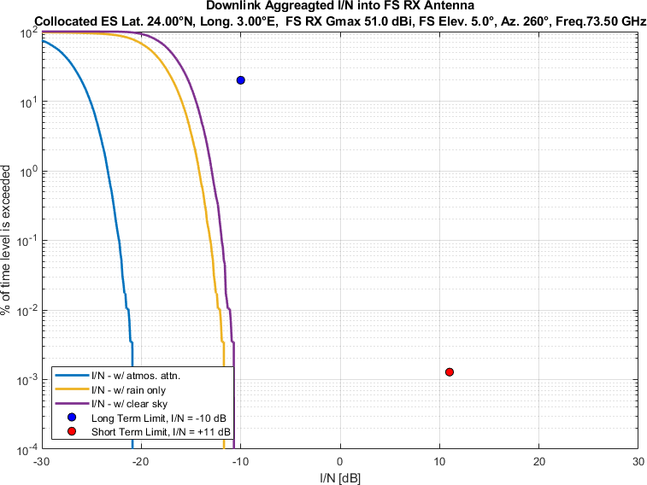
Figure 69
Aggregate I/N from Selected Systems at 24°N, FS max. Receive Gain 51 dBi, Azimuth 280°
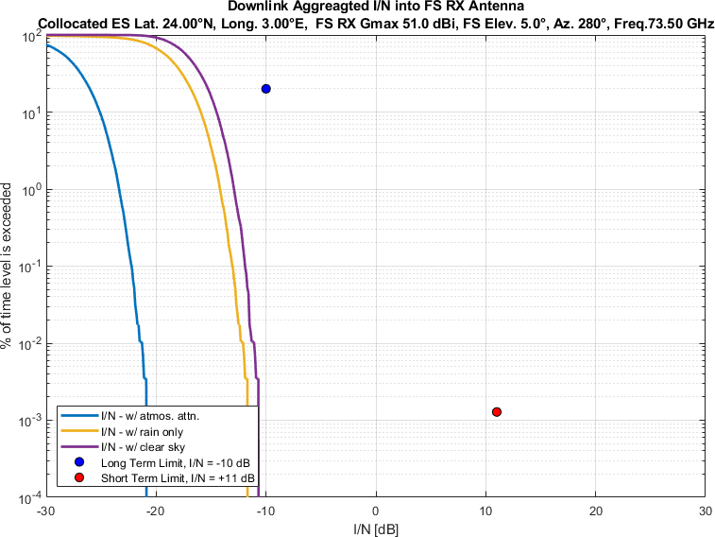
Figure 70
Aggregate I/N from Selected Systems at 24°N, FS max. Receive Gain 51 dBi, Azimuth 300°
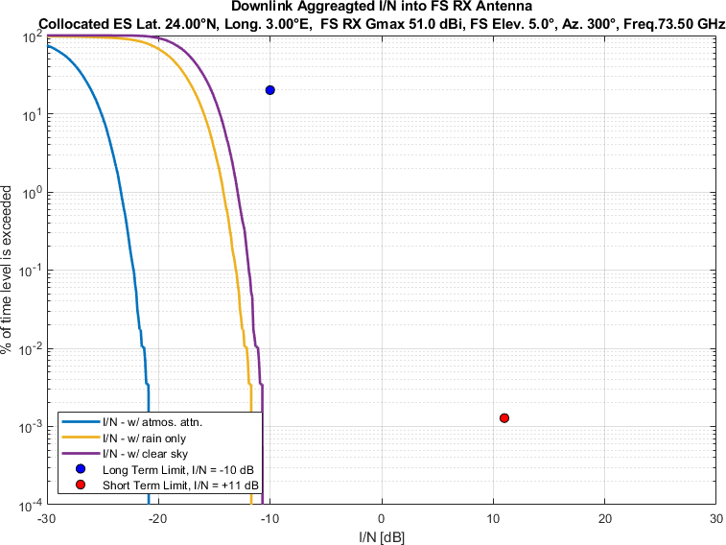
Figure 71
Aggregate I/N from Selected Systems at 24°N, FS max. Receive Gain 51 dBi, Azimuth 320°
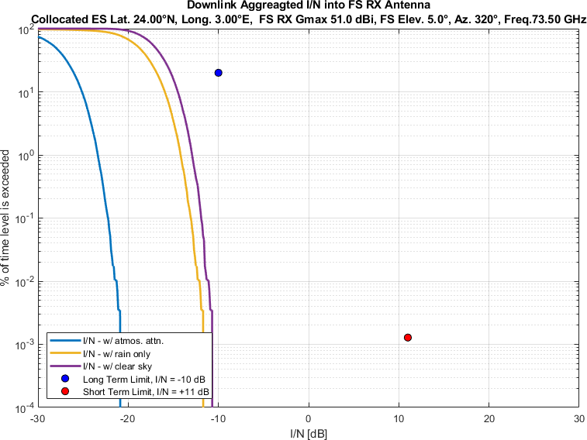
Figure 72
Aggregate I/N from Selected Systems at 24°N, FS max. Receive Gain 51 dBi, Azimuth 340°
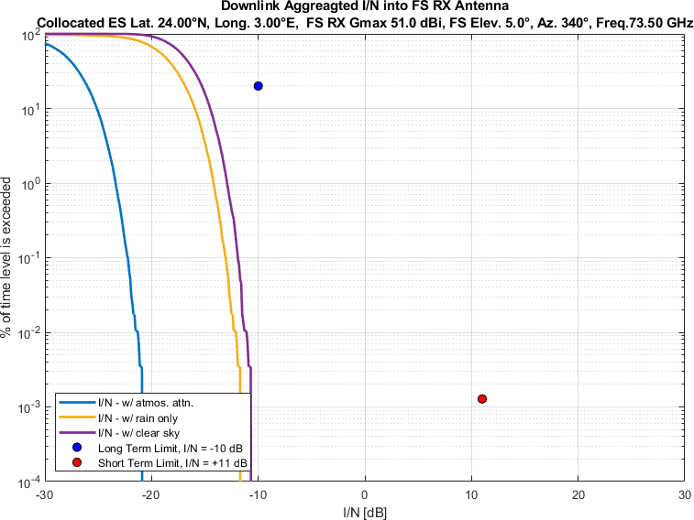
Figure 73
Aggregate I/N from Selected Systems at 45°N, FS max. Receive Gain 51 dBi, Azimuth 0°
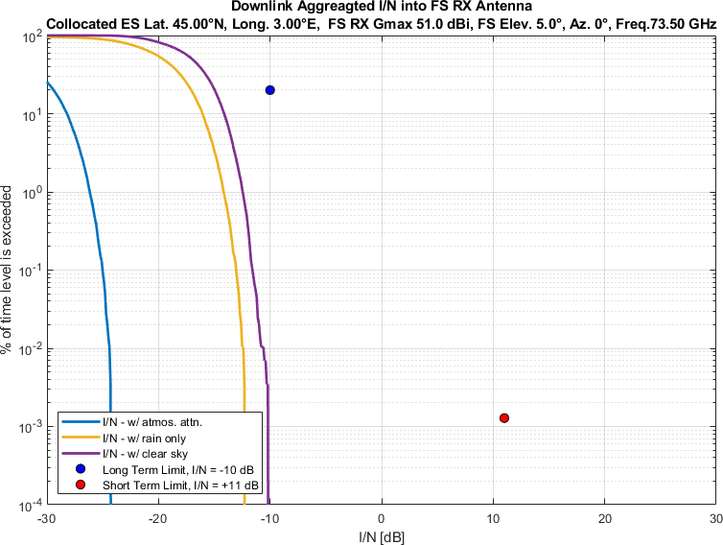
Figure 74
Aggregate I/N from Selected Systems at 45°N, FS max. Receive Gain 51 dBi, Azimuth 20°
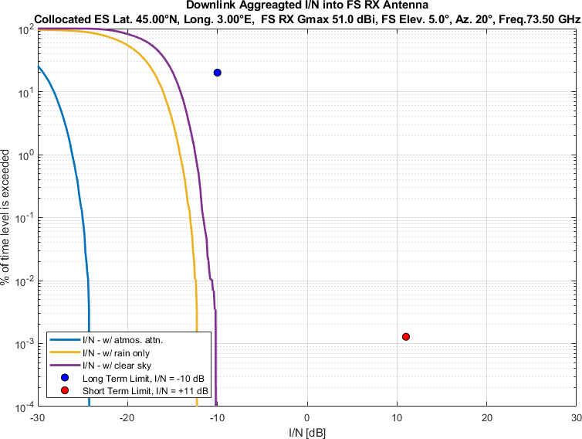
Figure 75
Aggregate I/N from Selected Systems at 45°N, FS max. Receive Gain 51 dBi, Azimuth 40°
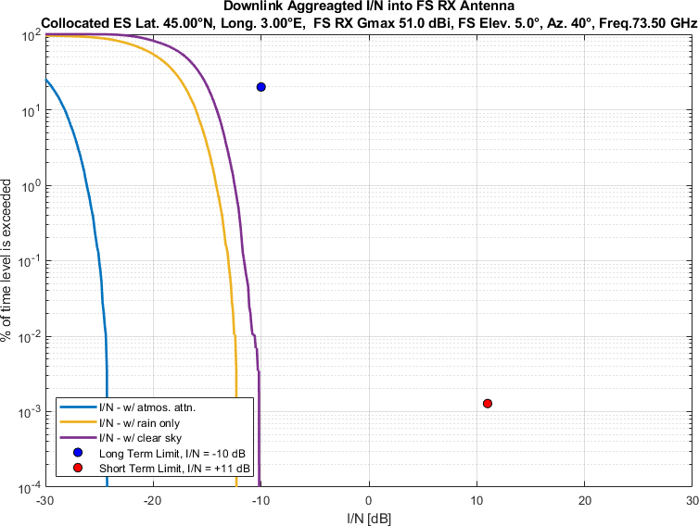
Figure 76
Aggregate I/N from Selected Systems at 45°N, FS max. Receive Gain 51 dBi, Azimuth 60°
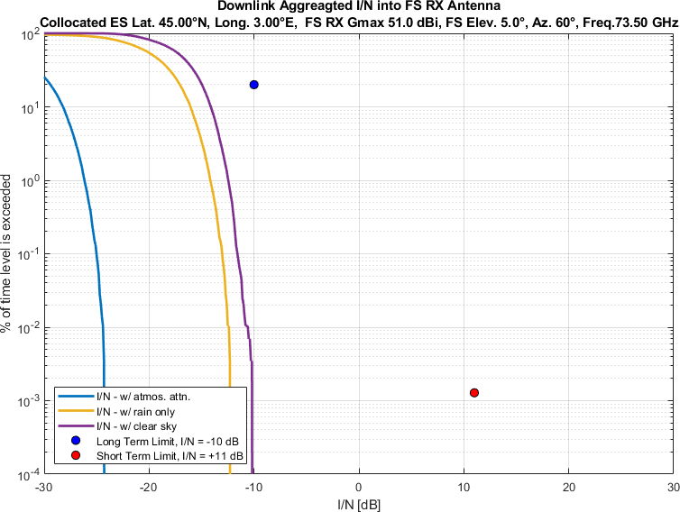
Figure 77
Aggregate I/N from Selected Systems at 45°N, FS max. Receive Gain 51 dBi, Azimuth 80°
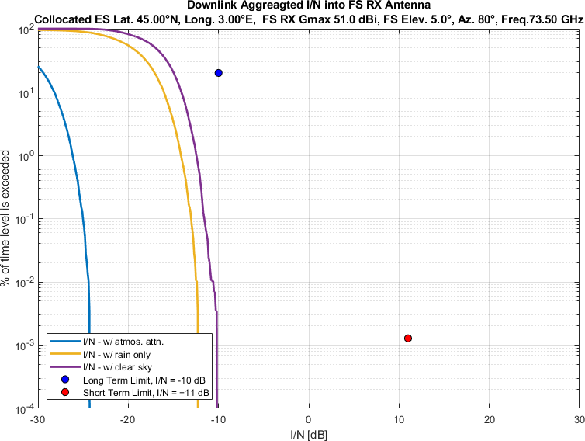
Figure 78
Aggregate I/N from Selected Systems at 45°N, FS max. Receive Gain 51 dBi, Azimuth 100°
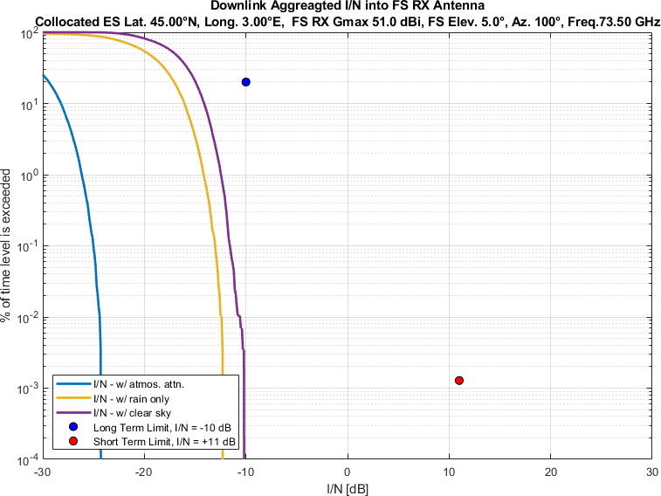
Figure 79
Aggregate I/N from Selected Systems at 45°N, FS max. Receive Gain 51 dBi, Azimuth 120°
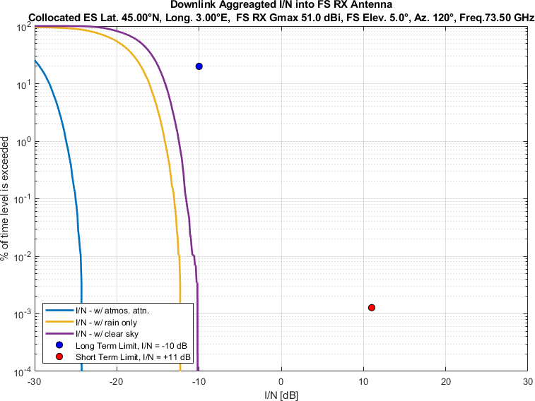
Figure 80
Aggregate I/N from Selected Systems at 45°N, FS max. Receive Gain 51 dBi, Azimuth 140°
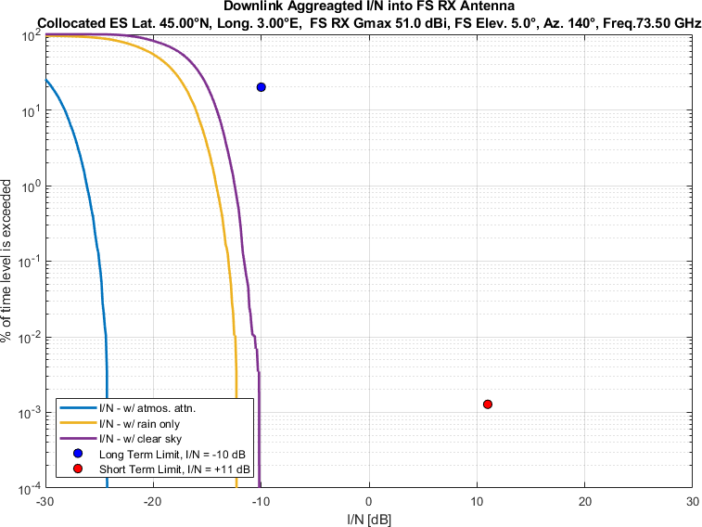
Figure 81
Aggregate I/N from Selected Systems at 45°N, FS max. Receive Gain 51 dBi, Azimuth 160°
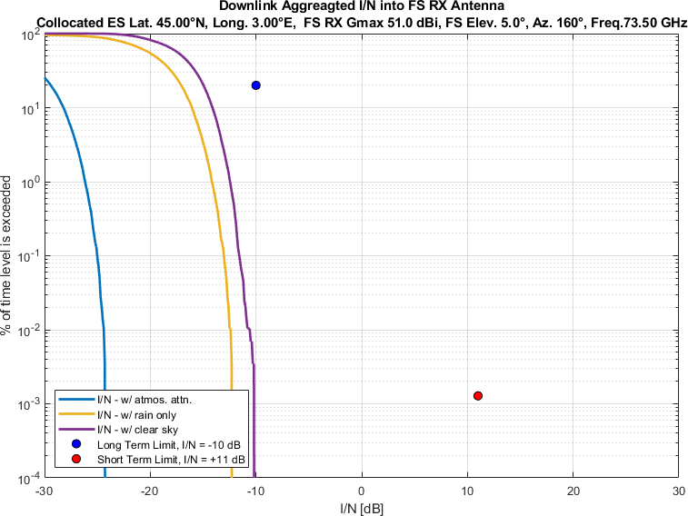
Figure 82
Aggregate I/N from Selected Systems at 45°N, FS max. Receive Gain 51 dBi, Azimuth 180°
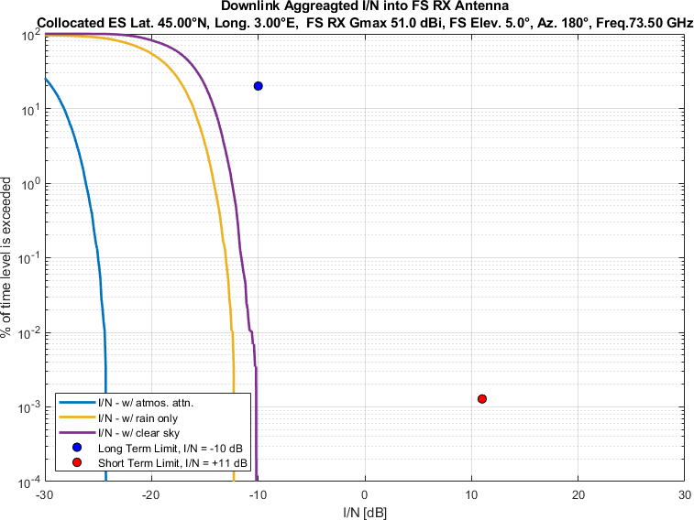
Figure 83
Aggregate I/N from Selected Systems at 45°N, FS max. Receive Gain 51 dBi, Azimuth 200°
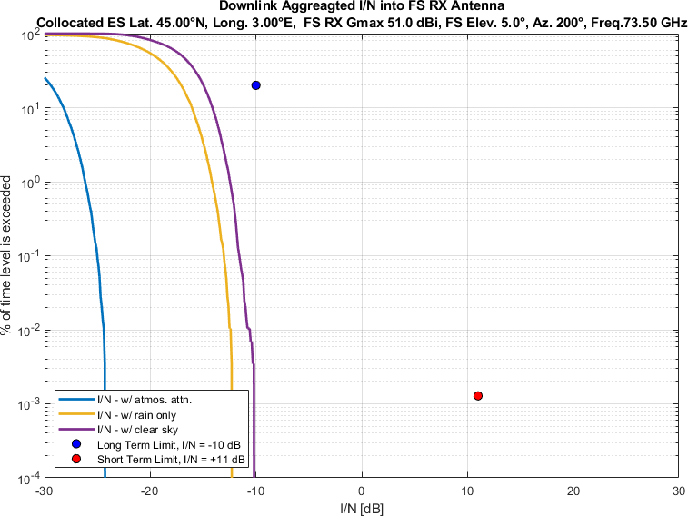
Figure 84
Aggregate I/N from Selected Systems at 45°N, FS max. Receive Gain 51 dBi, Azimuth 220°
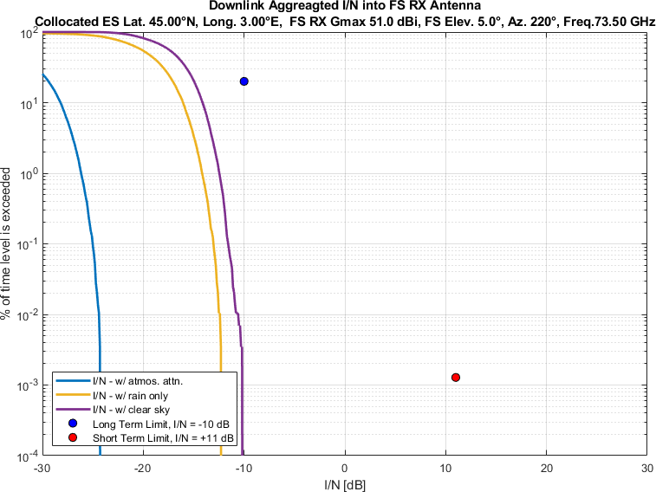
Figure 85
Aggregate I/N from Selected Systems at 45°N, FS max. Receive Gain 51 dBi, Azimuth 240°
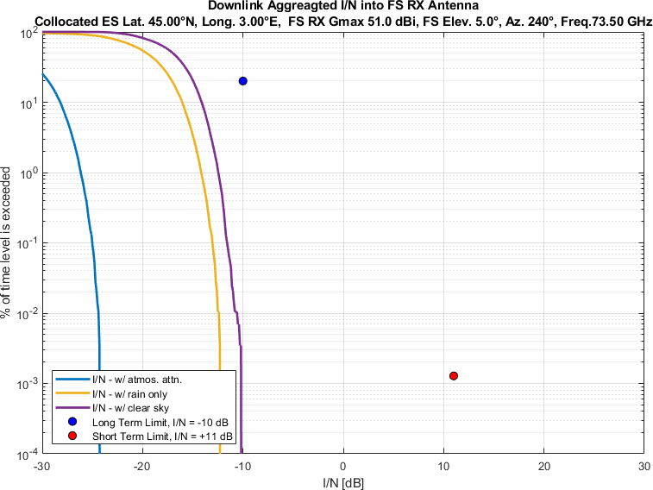
Figure 86
Aggregate I/N from Selected Systems at 45°N, FS max. Receive Gain 51 dBi, Azimuth 260°
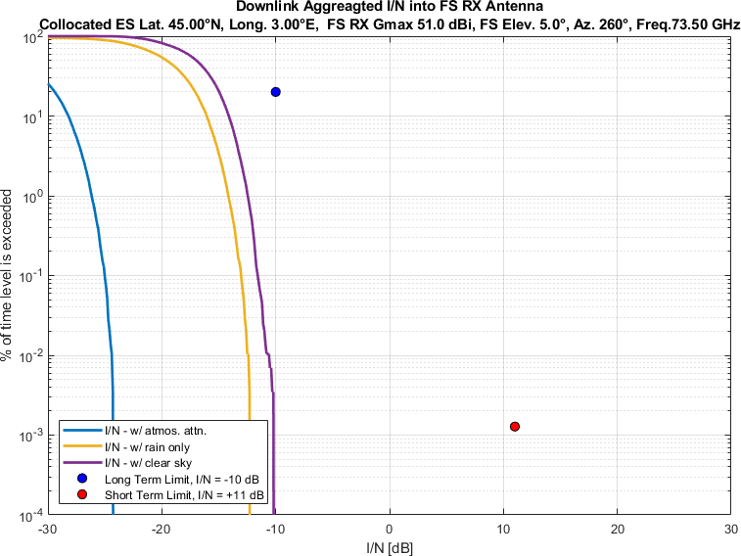
Figure 87
Aggregate I/N from Selected Systems at 45°N, FS max. Receive Gain 51 dBi, Azimuth 280°
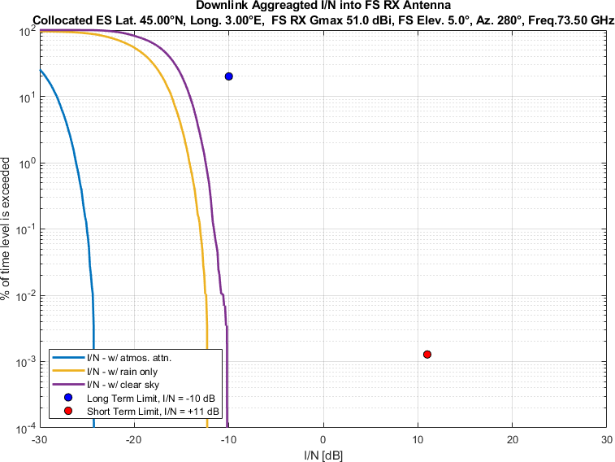
Figure 88
Aggregate I/N from Selected Systems at 45°N, FS max. Receive Gain 51 dBi, Azimuth 300°
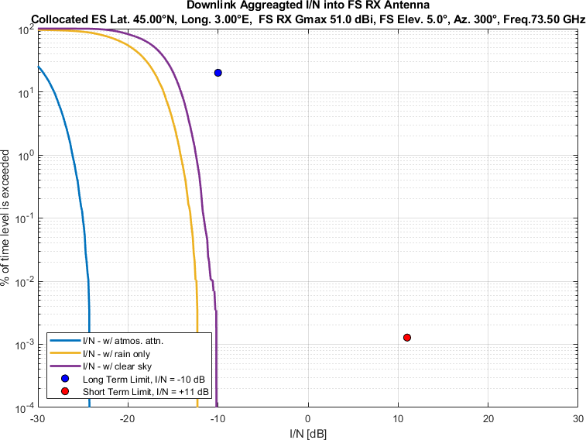
Figure 89
Aggregate I/N from Selected Systems at 45°N, FS max. Receive Gain 51 dBi, Azimuth 320°
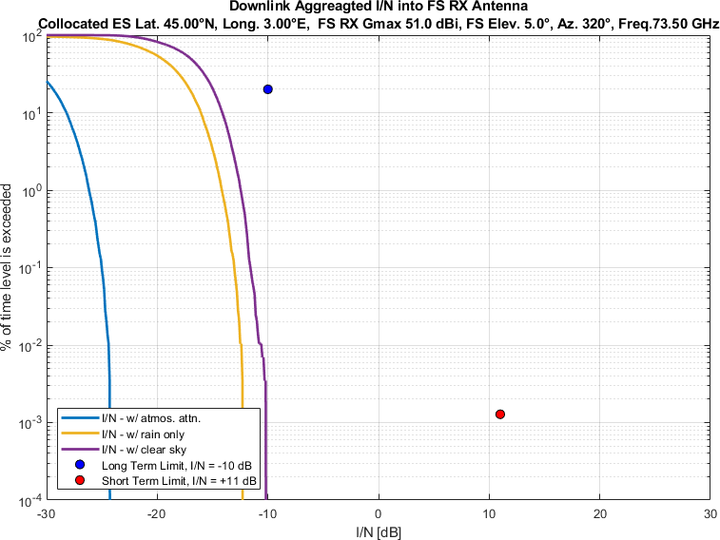
Figure 90
Aggregate I/N from Selected Systems at 45°N, FS max. Receive Gain 51 dBi, Azimuth 340°
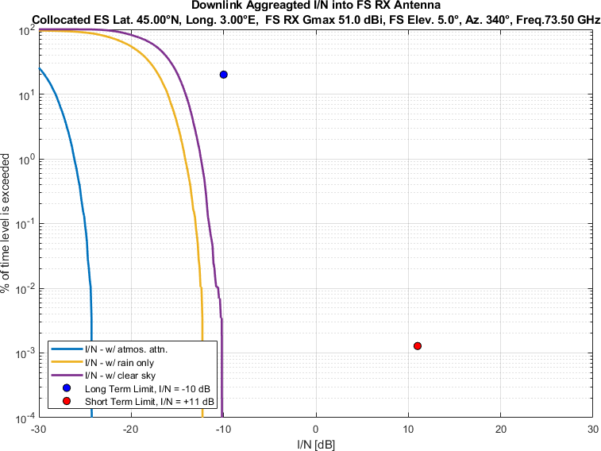
Figure 91
Aggregate I/N from Selected Systems at 60°N, FS max. Receive Gain 51 dBi, Azimuth 0°
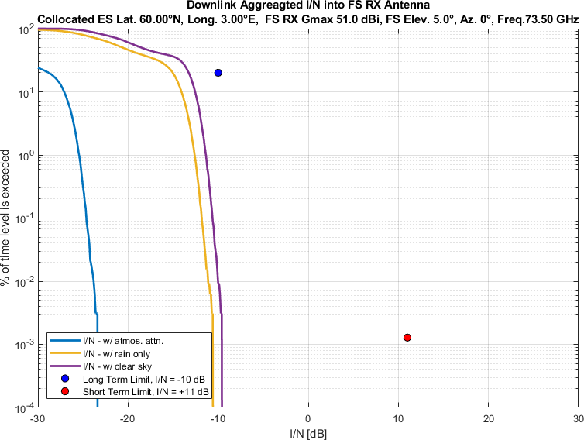
Figure 92
Aggregate I/N from Selected Systems at 60°N, FS max. Receive Gain 51 dBi, Azimuth 20°
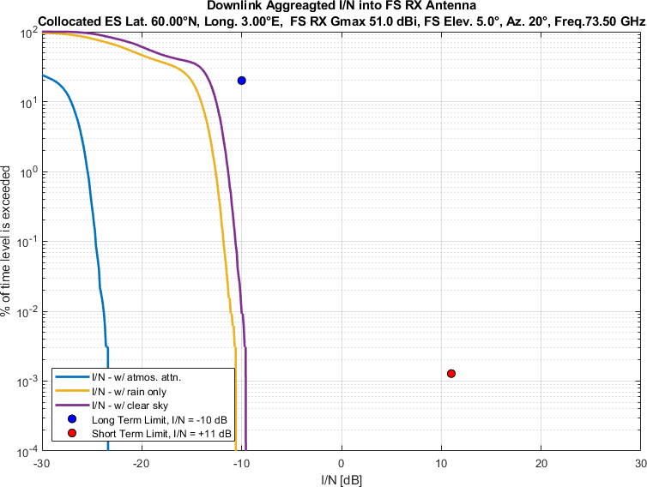
Figure 93
Aggregate I/N from Selected Systems at 60°N, FS max. Receive Gain 51 dBi, Azimuth 40°
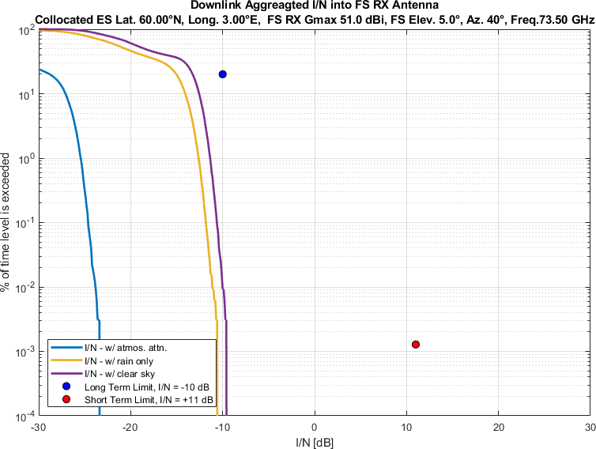
Figure 94
Aggregate I/N from Selected Systems at 60°N, FS max. Receive Gain 51 dBi, Azimuth 60°
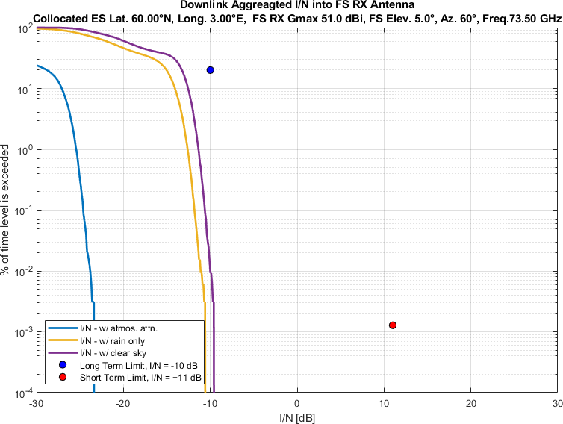
Figure 95
Aggregate I/N from Selected Systems at 60°N, FS max. Receive Gain 51 dBi, Azimuth 80°
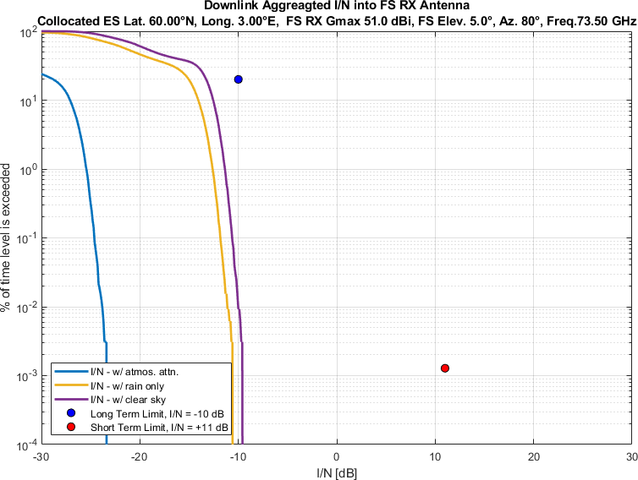
Figure 96
Aggregate I/N from Selected Systems at 60°N, FS max. Receive Gain 51 dBi, Azimuth 100°
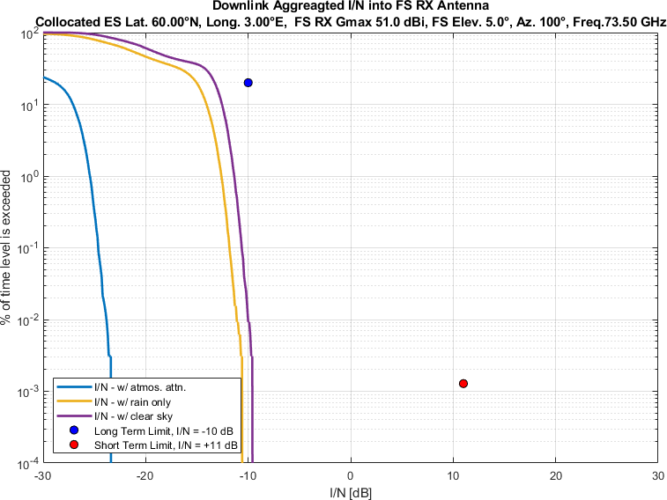
Figure 97
Aggregate I/N from Selected Systems at 60°N, FS max. Receive Gain 51 dBi, Azimuth 120°
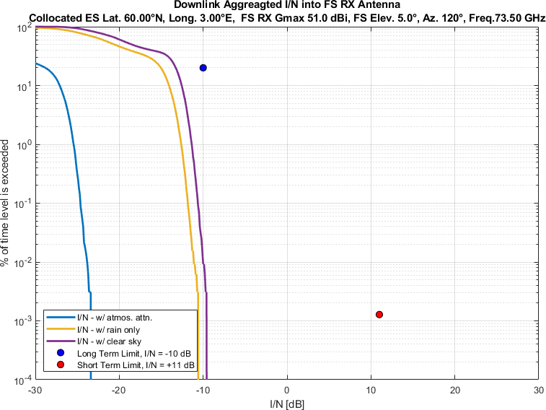
Figure 98
Aggregate I/N from Selected Systems at 60°N, FS max. Receive Gain 51 dBi, Azimuth 140°
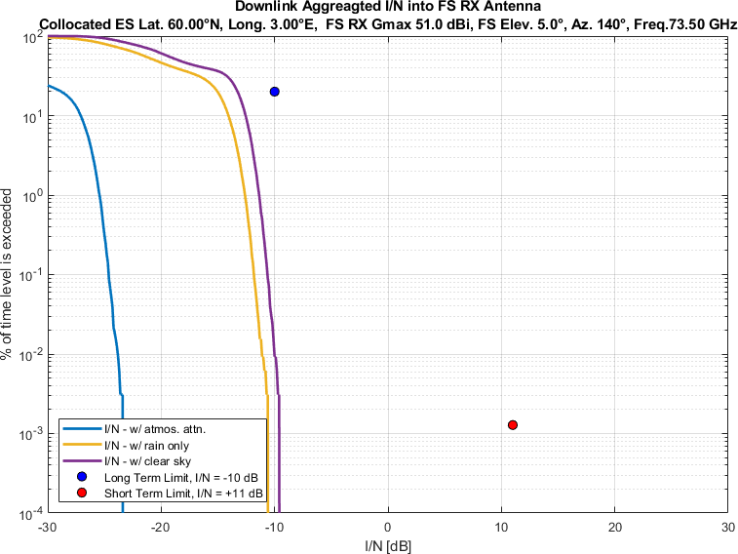
Figure 99
Aggregate I/N from Selected Systems at 60°N, FS max. Receive Gain 51 dBi, Azimuth 160°
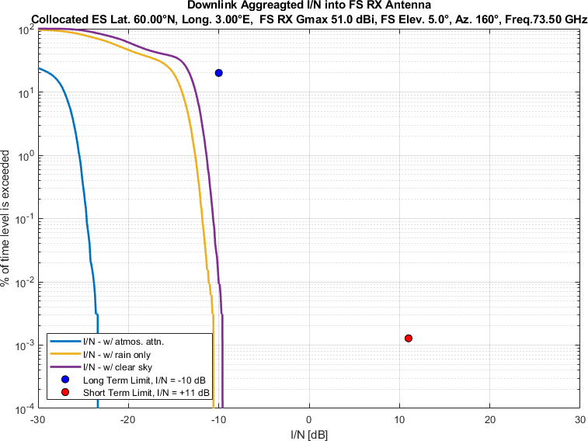
Figure 100
Aggregate I/N from Selected Systems at 60°N, FS max. Receive Gain 51 dBi, Azimuth 180°
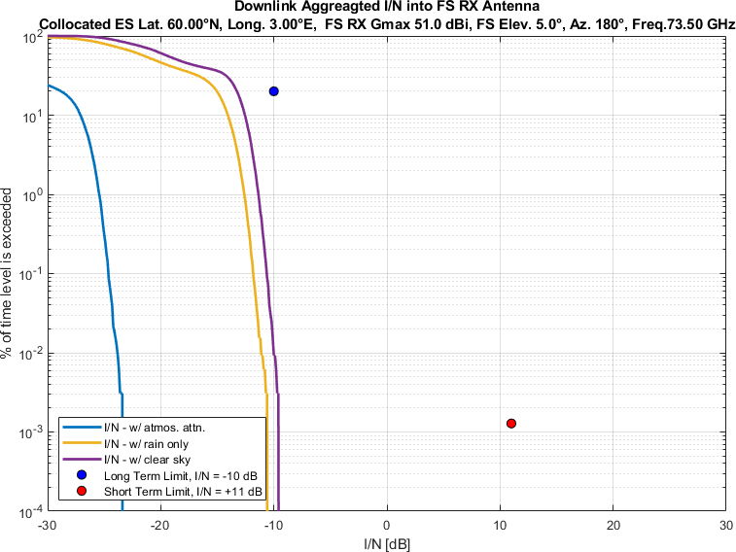
Figure 101
Aggregate I/N from Selected Systems at 60°N, FS max. Receive Gain 51 dBi, Azimuth 200°
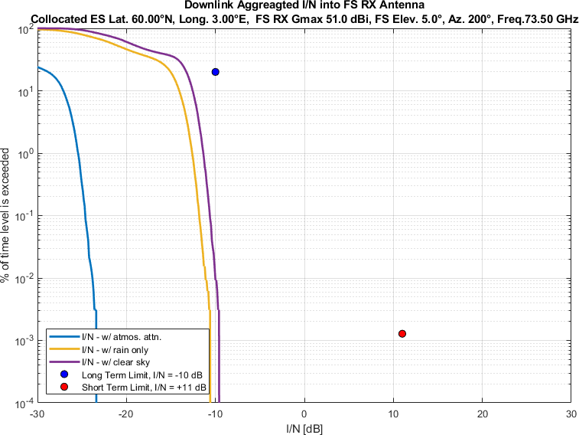
Figure 102
Aggregate I/N from Selected Systems at 60°N, FS max. Receive Gain 51 dBi, Azimuth 220°
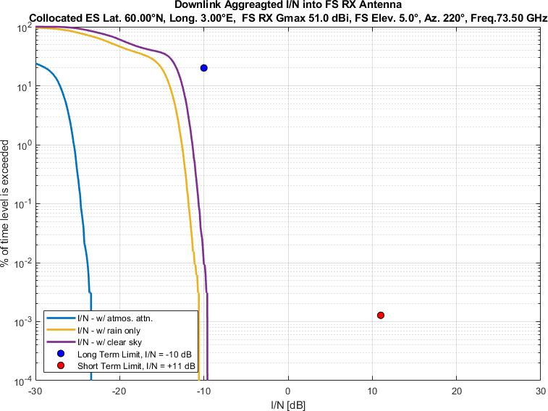
Figure 103
Aggregate I/N from Selected Systems at 60°N, FS max. Receive Gain 51 dBi, Azimuth 240°
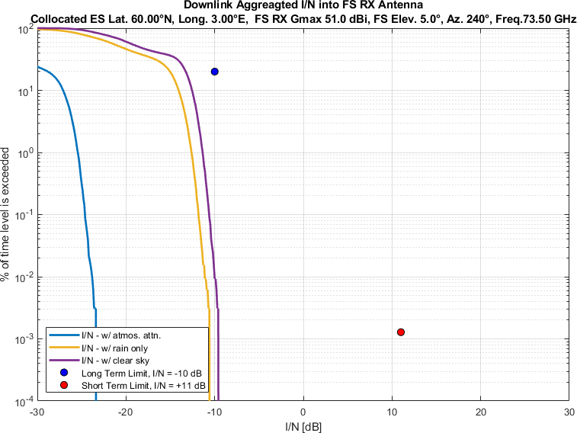
Figure 104
Aggregate I/N from Selected Systems at 60°N, FS max. Receive Gain 51 dBi, Azimuth 260°
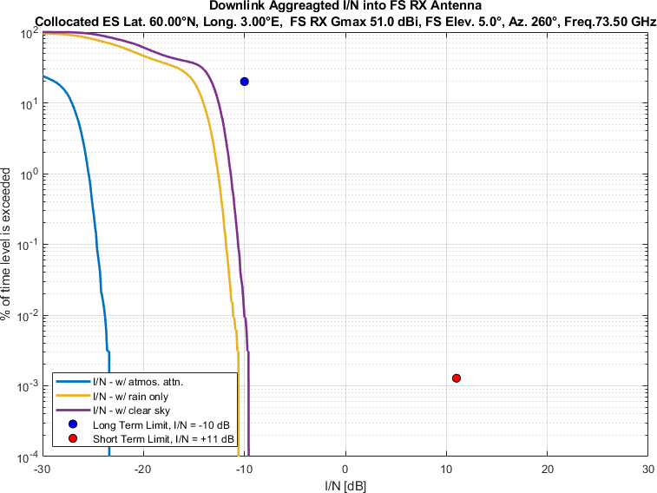
Figure 105
Aggregate I/N from Selected Systems at 60°N, FS max. Receive Gain 51 dBi, Azimuth 280°
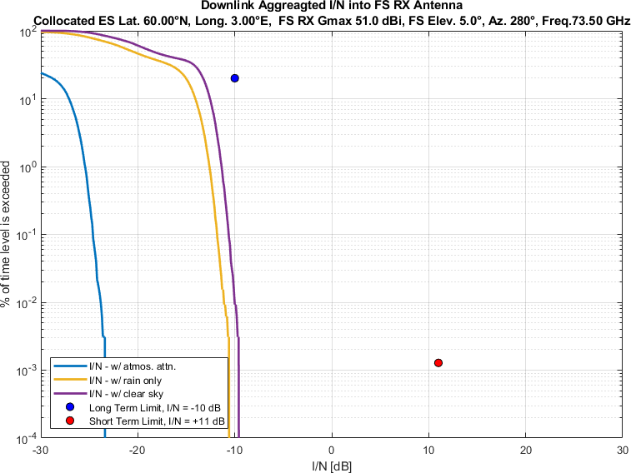
Figure 106
Aggregate I/N from Selected Systems at 60°N, FS max. Receive Gain 51 dBi, Azimuth 300°
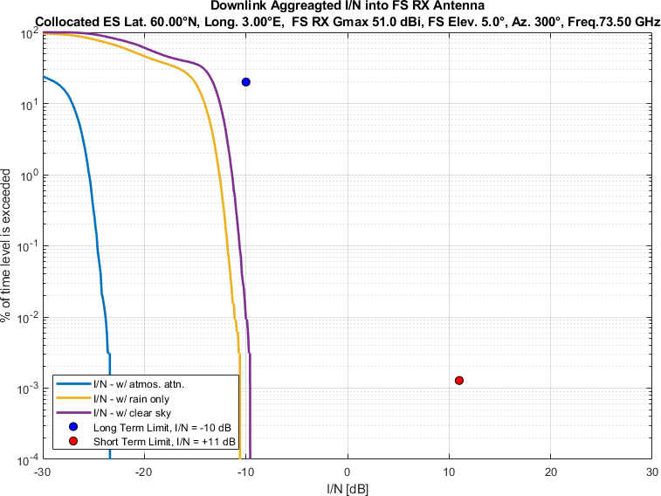
Figure 107
Aggregate I/N from Selected Systems at 60°N, FS max. Receive Gain 51 dBi, Azimuth 320°
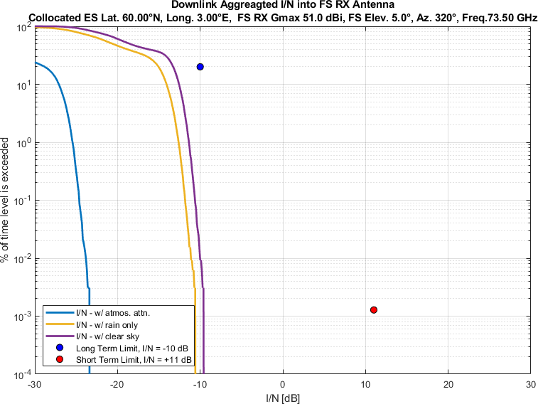
Figure 108
Aggregate I/N from Selected Systems at 60°N, FS max. Receive Gain 51 dBi, Azimuth 340°
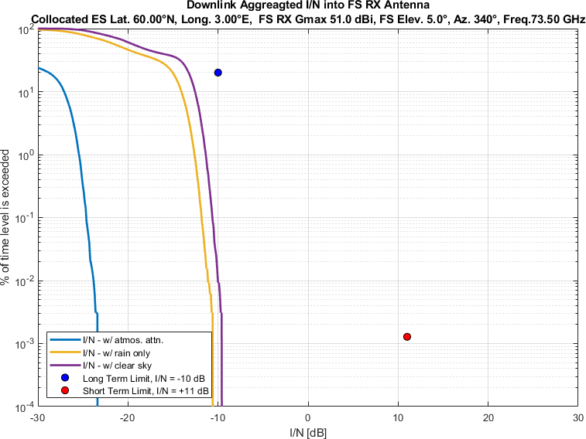

Sidelobe radiation pattern for each of the visible Nv- Nco satellites of a non-GSO system have been calculated conservatively as per Recommendation ITU-R S.1528 recommends 1.2. In some other working parties’ studies, Recommendation ITU-R S.1528 recommends 1.4 has been considered for sidelobe radiation pattern.
Note: the GSO and NGSO systems are modelled according to certain assumptions, including minimum elevation. Satellites below the minimum elevation cannot transmit to the victim site as a consequence.

