|  |  |
| --- | --- |
| **US Radiocommunication Sector**  **FACT SHEET** | |
| **Working Party:** ITU-R WP 5C | **Document No:** USWP5C33-01 |
| **Reference:** WRC-27 AI 1.10, Annex 2.1 Doc 5C/206 | **Date:** August 21, 2025 |
| **Document Title:** Working document on sharing studies under Agenda Item 1.10 | |
| **Author(s)/Contributor(s):**  Andrew Meadows  AFSMO  Thomas Shanholtz  eSimplicity for AFSMO  Victory Nguyen  eSimplicity for AFSMO | Phone: 334-467-4720  E-mail: andrew.meadows.1@us.af.mil  Phone: 304-703-3990  E-mail: thomas.shanholtz@esimplicity.com  Phone: 443-535-3942  E-mail: victory.nguyen@esimplicity.com |
| **Purpose/Objective:** The purpose of this document is to continue the sharing and compatibility studies for WRC-27 Agenda Item 1.10 in accordance with Resolution 775 (WRC-23). | |
| **Abstract:** This contribution continues the sharing studies between the FS/AMS systems and FSS GSO system in the 71-76 and 81-86 GHz range. | |
| **Fact Sheet Preparer:** Victory Nguyen | |

|  |  |
| --- | --- |
| **Radiocommunication Study Groups** |  |
|  |  |
|  |  |
| Source: Annex 2.1 Doc 5C/206  Subject: WRC-27 Agenda Item 1.10 | **Document 5C/XX** |
| **XX November 2025** |
| **English only** |
| **United States of America** | |
| **Working document on sharing studies under agenda item 1.10** | |
|  | |

**Introduction**

WRC-27 Agenda Item 1.10 considers developing power flux-density and equivalent isotropically radiated power limits for inclusion in Article 21 of the Radio Regulations for the fixed-satellite, mobile-satellite and broadcasting-satellite services to protect the fixed and mobile services in the frequency bands 71-76 GHz and 81-86 GHz, in accordance with Resolution 775 (Rev.WRC-23).

This contribution provides an update to the working document presented in Annex 2.1 of the WP 5C Chair’s Report, Document 5C/206. Particular emphasis on the studies in Sections 8.1.1.2, 8.4.2, 9.1.1, and 9.2.1. The changes from the Second Draft are highlighted in green.

Attachment: 1

|  |
| --- |
| ATTACHMENT  Annex 2.1 to Working Party 5C Chair’s Report |
| WORKING DOCUMENT ON SHARING STUDIES UNDER  WRC-27 AGENDA ITEM 1.10 |
|  |

Editor’s note: Sections 8 and 9 are compiled and not reviewed nor agreed.

# 1 Introduction

WRC-27 agenda item 1.10 addresses:

*1.10 to consider developing power flux density and equivalent isotropically radiated power limits for inclusion in Article* ***21*** *of the Radio Regulations for the fixed-satellite, mobile-satellite and broadcasting-satellite services to protect the fixed and mobile services in the frequency bands 71-76 GHz and 81-86 GHz, in accordance with Resolution* ***775 (Rev.WRC-23)****;*

In Resolution **775 (WRC-23)**, the World Radiocommunication Conference (Dubai, 2023),

resolves to invite the ITU Radiocommunication Sector to complete in time for the 2027 world radiocommunication conference

*the appropriate studies to determine power flux-density (pfd) and equivalent isotropically radiated power (e.i.r.p.) limits to be included in Article* ***21*** *for satellite services (fixed-satellite service (FSS), mobile-satellite service (MSS) and broadcasting-satellite service (BSS)) to protect the current and planned fixed and mobile services in the frequency bands 71-76 GHz and 81-86 GHz, …*

This document contains the result of the studies under WRC-27 agenda item 1.10, in response to Resolution **775 (Rev.WRC-23)**.

# 2 Provisions of the Radio Regulations

The extracts from Article **5** of the Radio Regulations (RR), edition 2024, is presented in Tables 1 and 2 for the frequency ranges 71-76 GHz and 81-86 GHz, respectively.

Table 1

Extract from Article 5 of Radio Regulations for 71-76 GHz band

|  |  |  |
| --- | --- | --- |
| Allocation to services | | |
| Region 1 | Region 2 | Region 3 |
| 71-74 FIXED  FIXED-SATELLITE (space-to-Earth)  MOBILE  MOBILE-SATELLITE (space-to-Earth) | | |
| 74-76 FIXED  FIXED-SATELLITE (space-to-Earth)  MOBILE  BROADCASTING  BROADCASTING-SATELLITE  Space research (space-to-Earth)  5.561 | | |

Table 2

Extract from Article 5 of Radio Regulations for 81-86 GHz band

|  |  |  |
| --- | --- | --- |
| Allocation to services | | |
| Region 1 | Region 2 | Region 3 |
| 81-84 FIXED 5.338A  FIXED-SATELLITE (Earth-to-space)  MOBILE  MOBILE-SATELLITE (Earth-to-space)  RADIO ASTRONOMY  Space research (space-to-Earth)  5.149 5.561A | | |
| 84-86 FIXED 5.338A  FIXED-SATELLITE (Earth-to-space) 5.561B  MOBILE  RADIO ASTRONOMY  5.149 | | |

Based on the information provided above, the appropriate studies could be carried out taking into account the nature of frequency bands and the service allocation in these frequency bands, to determine related pfd and e.i.r.p limits, as shown below:

– pfd limit for fixed-satellite service (space-to-Earth) to protect mobile service and fixed service in 71-76 GHz;

– pfd limit for mobile-satellite service (space-to-Earth) to protect mobile service and fixed service in 71-74 GHz;

– pfd limit for broadcasting-satellite service to protect mobile service and fixed service in 74-76 GHz;

– e.i.r.p limit for fixed-satellite service (Earth-to-space) to protect mobile service and fixed service in 81-86 GHz;

– e.i.r.p limit for mobile-satellite service (Earth-to-space) to protect mobile service and fixed service in 81-84 GHz.

[No changes until Section 8.1.1.2]

**8.1.1.2 Scenario 2: Single Interferer (GSO Satellite, Dynamic Analysis)**

The following GSO FSS characteristics were extracted from the liaison statement by Working Party 4A in document 5C/142. The specific system used in this study is System C.

Table 6

**Parameters of the GSO FSS System**

| **Parameter** | **System C (Satellite)** |  |
| --- | --- | --- |
| Frequency (GHz) | 71-76 |  |
| Altitude (km) | 35,786 |  |
| Number of planes | 1 |  |
| Satellites per plane | 1 |  |
| Inclination angle (deg) | 0 |  |
| RAAN | N/A |  |
|  |  |  |
|  |  |  |
|  |  | - |
|  |  |  |
|  |  |  |
|  |  |  |
| Number of co-frequency beams (N_co) | 1 |  |
|  |  |  |
|  |  |  |



The analysis was conducted assuming that the FS system was operating at locations at the following latitude/longitude: 39.6° N, and 104.6° W. For the FS system, the FS receiver antenna is pointing directly at another FS station whose location is randomized within a 0.4 to 3 km circle of the receiver.

FIGURE X

Methodology Flow Chart

The analysis produced a cumulative distribution function (CDF) curve for the I/N levels received by the FS which was then compared to the I/N protection criteria of FS.

The following assumptions were made during the analysis:

• The location of the GSO satellite is 0° N and thelongitude is randomized in a uniform distribution based on the 3 sets of angles of arrival. A final test was simulated in which the resulting angle of arrival was comprehensive of the 3 sets.

• The polarization of the FSS GSO satellite and FSS ES is RHCP. The polarization of the FS is linear

• Polarization mismatch loss is 3dB

• The elevation angle of the FS ranges from -5 to +5 degrees in a uniform distribution

Study results

The results are presented in the following plots. In the following figures, the FS receiving station I/N is plotted as a cumulative distribution function (CDF).

Two simulations were run. In the first simulation, no provision for avoiding mainbeam coupling between the FS receiver and the satellite. For the second simulation, the FS receiver antenna pointing angles were restricted such that the antenna main beam was never directed within 1.5 degrees of the satellite[1]. This resulted in two possible PFD limits for the FSS GSO satellite.

TABLE 7

**PFD Mask of GSO Satellite, No Avoidance**

|  |  |  |  |  |  |
| --- | --- | --- | --- | --- | --- |
| Frequency Band | System | Limit in dB(W/m2) for angles  of arrival (δ) above the horizontal plane | | | Reference Bandwidth |
| 0°-5° | 5°-25° | 25°-90° |
| 71-76 GHz | Fixed-satellite (geostationary-satellite orbit) | -115 | | | 1 MHz |

FIGURE X

**FS receiver I/N CDF plot, No Avoidance Angle**

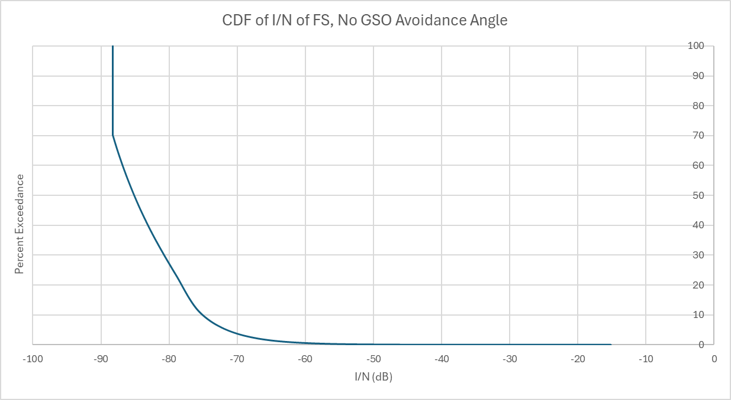

TABLE 8

**PFD Mask of GSO Satellite, 1.5° avoidance angle**

|  |  |  |  |  |  |
| --- | --- | --- | --- | --- | --- |
| Frequency Band | System | Limit in dB(W/m2) for angles  of arrival (δ) above the horizontal plane | | | Reference Bandwidth |
| 0°-5° | 5°-25° | 25°-90° |
| 71-76 GHz | Fixed-satellite (geostationary-satellite orbit) | -92 | | | 1 MHz |

Figure X

**FS receiver I/N CDF plot, 1.5° avoidance angle (TBD)**

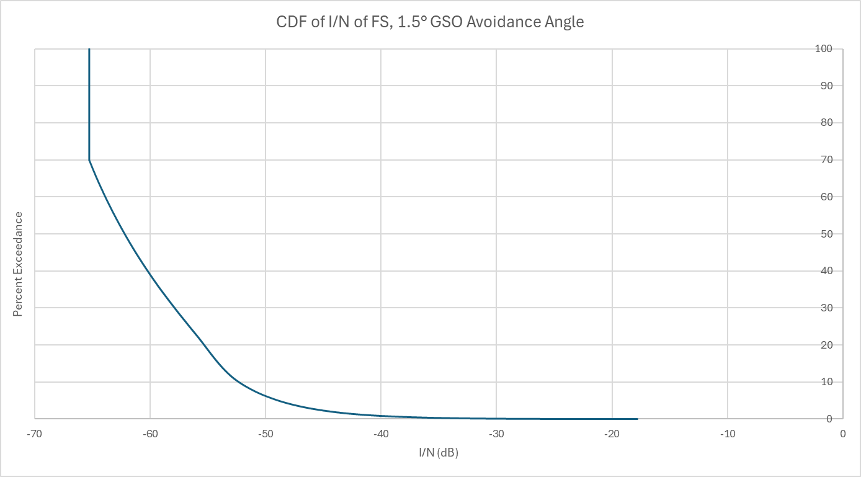

[No changes until Section Section 8.4.2]

**8.4.2 Sharing with GSO FSS Earth Stations**

The following GSO FSS characteristics were extracted from the liaison statement by Working Party 4A in document 5C/142. The specific system used in this study is System C.

Table 10

**Parameters of the GSO FSS System**

|  |  |  |
| --- | --- | --- |
| **Parameter** |  | **System C (Earth Station)** |
| Frequency (GHz) |  | 81-86 |
|  |  |  |
|  |  |  |
|  |  |  |
|  |  |  |
|  |  |  |
| Antenna Pattern |  | S.580 |
|  |  | 50 (D:0.6 m) |
|  |  |  |
|  |  |  |
|  |  |  |
|  |  |  |
|  |  |  |
|  |  |  |
|  |  |  |

**8.4.2.1 Scenario 1: Single Interferer (GSO FSS ES, Dynamic Analysis)**

Station(s) of the fixed service are defined with the parameters of the following table.



The analysis was conducted assuming that both the FS system was operating at locations at the following latitude/longitude: 39.73° N, and 104.75° W. The location of the FS was randomized with a fixed separation distance of 40 km radius of the FSS ES that is stationed at the aforementioned location. The FS receiver antenna is pointing directly at another FS station whose location is randomized within a 0.4 to 3 km circle of the receiver.

The analysis produced a cumulative distribution function (CDF) curve for the I/N levels received by the FS which was then compared to the I/N protection criteria of FS.

The following assumptions were made during the analysis:

• The SRTM V3 (3 arc second, 90m) terrain profile data was used

• A random percentage was used in the ITU-R P.452 propagation model

• There is only 1 ES deployed at 39.73° N and 104.75° W

• The ES is pointing at the GSO satellite

• The elevation pointing angle of the ES is 5 degrees

• The EIRP of the ES is 79 dBW in accordance with RR Nos. 21.8

• The beamwidth of the FSS ES is 0.41 degrees

• The FSS ES antenna height is 10 m

• The polarization of the FSS GSO satellite and FSS ES is RHCP. The polarization of the FS is linear

• Polarization mismatch loss is 3 dB.

Study results

The results are presented in the following plots. In the following figures, the FS receiving station I/N is plotted as a cumulative distribution function (CDF).

FIGURE X

**FS receiver I/N CDF plot**

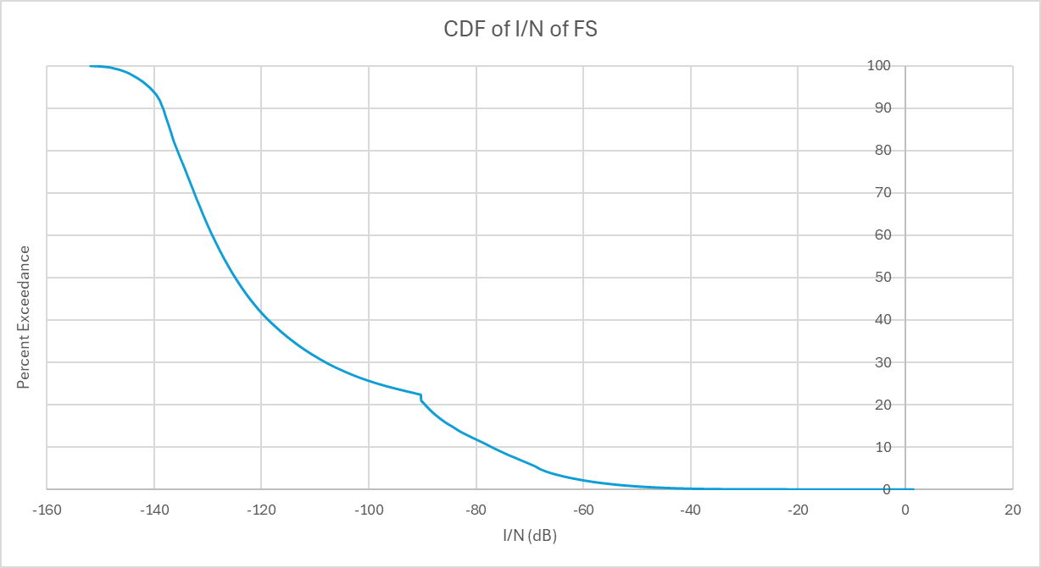

TABLE X

FS receiver I/N values

|  |  |  |
| --- | --- | --- |
|  | 20% | 0.00128% |
| FS | -89.5 dB | -13.1 dB |

[No changes to Section 9.1.1]

**9.1.1 Sharing with GSO FSS Satellite**

As the interference from GSO satellites is steady, the long-term protection criterion of Recommendation ITU-R F.758 is used.

The following GSO FSS characteristics were extracted from the liaison statement by Working Party 4A in document 5C/142. The specific system used in this study is System C.

Table 12

**Parameters of the GSO FSS System**

|  |  |  |
| --- | --- | --- |
| **Parameter** | **System C (Satellite)** |  |
| Frequency (GHz) | 71-76 |  |
| Altitude (km) | 35,786 |  |
| Number of planes | 1 |  |
| Satellites per plane | 1 |  |
| Inclination angle (deg) | 0 |  |
| RAAN | N/A |  |
|  |  |  |
|  |  |  |
|  |  |  |
|  |  |  |
|  |  |  |
|  |  |  |
| Number of co-frequency beams (N_co) | 1 |  |
|  |  |  |
|  |  |  |

**9.1.1.1 Scenario 1: Single Interferer (GSO Satellite, Dynamic Analysis)**

Station(s) of the mobile service are defined with the parameters given in Section 5.

The analysis was conducted assuming that the AMS was operating at the following latitude/longitude: 39.6° N, and 104.6° W.. For the AMS Ground receiver, the receiver is pointing at an airborne system whose location is randomized within a 9 to 94 km circle of the receiver. For the AMS Air-Air receiver, the receiver is pointing at an airborne system whose location is randomized within a 100 km of the receiver.

FIGURE X

Methodology Flow Chart

The analysis produced a cumulative distribution function (CDF) curve for the I/N levels received by the AMS which were then compared to the I/N protection criteria of AMS.

The following assumptions were made during the analysis:

• The location of the GSO satellite is 0° N and the longitude is randomized in a uniform distribution based on the 3 sets of angles of arrival. A final test was simulated in which the resulting angle of arrival was comprehensive of the 3 sets.

• The AMS ground system antenna height is 10 m

• The AMS airborne system is operating at 9 km above ground

• The polarization of the FSS GSO satellite and AMS system is RHCP.

Study results

The results are presented in the following plots. In the following figures, the AMS receiving station *I/N* is plotted as a cumulative distribution function (CDF).

Two simulations were run. In the first simulation, no provision for avoiding mainbeam coupling between the FS receiver and the satellite. For the second simulation, the FS receiver antenna pointing angles were restricted such that the antenna main beam was never directed within 1.5 degrees of the satellite[2]. This resulted in two possible PFD limits for the FSS GSO satellite.

TABLE X

**PFD Mask of GSO Satellite, No Avoidance Angle**

|  |  |  |  |  |  |
| --- | --- | --- | --- | --- | --- |
| Frequency Band | System | Limit in dB(W/m2) for angles  of arrival (δ) above the horizontal plane | | | Reference Bandwidth |
| 0°-5° | 5°-25° | 25°-90° |
| 71-76 GHz | Fixed-satellite (geostationary-satellite orbit) | -115 | | | 1 MHz |

Figure X

**AMS receiver I/N CDF plot, No Avoidance Angle** 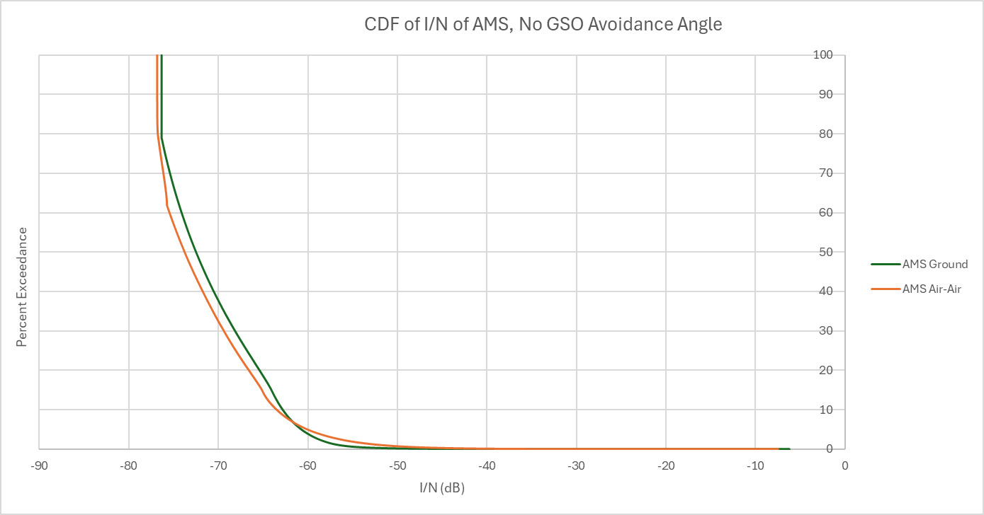

TABLE 8

**PFD Mask of GSO Satellite, 1.5° Avoidance Angle**

|  |  |  |  |  |  |
| --- | --- | --- | --- | --- | --- |
| Frequency Band | System | Limit in dB(W/m2) for angles  of arrival (δ) above the horizontal plane | | | Reference Bandwidth |
| 0°-5° | 5°-25° | 25°-90° |
| 71-76 GHz | Fixed-satellite (geostationary-satellite orbit) | -92 | | | 1 MHz |

FIGURE X

**AMS receiver I/N CDF plot, 1.5° Avoidance Angle**

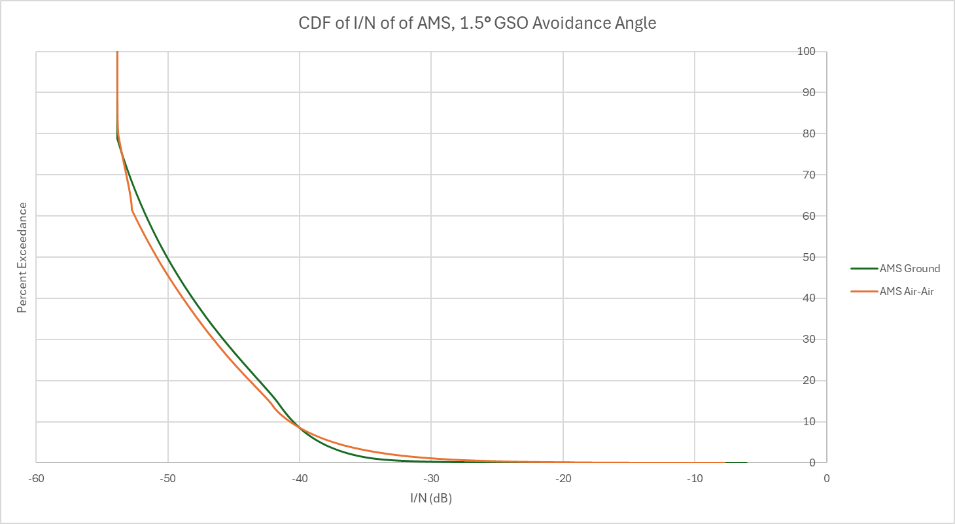

**9.2 Methodology for the determination of equivalent isotropically radiated power (e.i.r.p.) limits**

TBD

**9.2.1 Sharing with GSO FSS Earth Stations**

The following GSO FSS characteristics were extracted from the liaison statement by Working Party 4A in document 5C/142. The specific system used in this study is System C.

Table 13

**Parameters of the GSO FSS System**

| **Parameter** |  | **System C (Earth Station)** |
| --- | --- | --- |
| Frequency (GHz) |  | 81-86 |
|  |  |  |
|  |  |  |
|  |  |  |
|  |  |  |
|  |  |  |
| Antenna Pattern |  | S.580 |
| Peak antenna gain (dBi) |  | 50 (D:0.6 m) |
|  |  |  |
|  |  |  |

**9.2.1.1 Scenario 1: Single Interferer (GSO FSS ES, Dynamic Analysis)**

Station(s) of the mobile service are defined with the parameters given in Section 5.

The analysis was conducted assuming that the AMS was operating at locations at the following latitude/longitude: 39.73° N, and 104.75° W. The location of the AMS system was randomized within a 400 km radius, respectively, of the FSS ES that is stationed at the aforementioned location.

The analysis produced a cumulative distribution function (CDF) curve for the *I/N* levels received by the AMS which were then compared to the I/N protection criteria of AMS.

The following assumptions were made during the analysis:

• The SRTM V3 (3 arc second, 90m) terrain profile data was used

• A random percentage was used in the ITU-R P.452 propagation model

• There is only 1 ES deployed at 39.73° N and 104.75° W

• The ES is pointing at the GSO satellite

• The elevation pointing angle of the ES is 5 degrees

• The EIRP of the ES is 79 dBW in accordance with RR Nos. 21.8

• The beamwidth of the FSS ES is 0.41 degrees

• The AMS airborne receiver’s antenna can point at either the AMS ground or airborne transmitter

• The AMS ground system and FSS ES antenna heights are 10 m

• The AMS airborne receiver is operating at 9 km above ground

• The polarization of the FSS GSO satellite, FSS ES, and AMS system is RHCP.

Study results

The results are presented in the following plots. In the following figures, the AMS receiving station *I/N* is plotted as a cumulative distribution function (CDF).

FIGURE X

**AMS receiver I/N CDF plot**

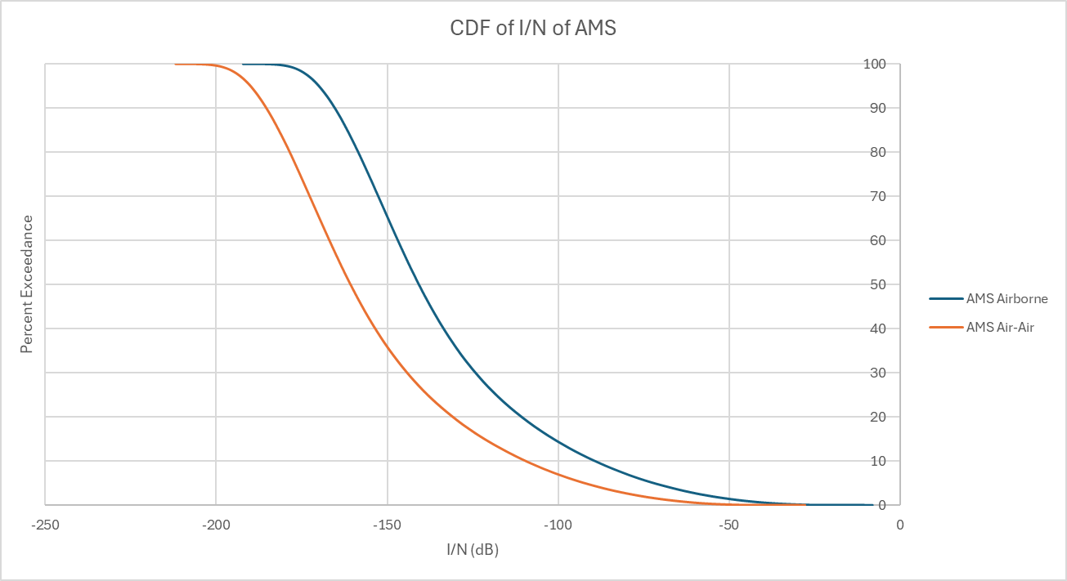

TABLE X

AMS receiver I/N maximum value

|  |  |
| --- | --- |
|  | Maximum I/N |
| AMS Airborne | -8.04 dB |
| AMS Air-Air | -27.8 dB |

1. According to Footnote 1 of Article 21, fixed and mobile services operating in frequency bands shared with space radiocommunication services (space-to-Earth) should avoid directing their antennas towards the geostationary-satellite orbit.
2. According to Footnote 1 of Article 21, fixed and mobile services operating in frequency bands shared with space radiocommunication services (space-to-Earth) should avoid directing their antennas towards the geostationary-satellite orbit.