|  |  |
| --- | --- |
| U.S. Radiocommunications Sector  Fact Sheet | |
| **Working Party:** ITU-R WP 5C | **Document No:** USWP5C33-05 |
| **Ref:**  Document 5C/206 (Annex 2.1) | **Date:** 22 September 2025 |
| Document Title: WORKING DOCUMENT ON SHARING STUDIES UNDER WRC-27 AGENDA ITEM 1.10 | |
| **Author(s)/Contributors(s):**  Zahid Islam  SpaceX  Joe McMichael  SpaceX  Nader Damavandi  SpaceX  Jameson Dempsey  SpaceX | Email: [km.islam@spacex.com](mailto:km.islam@spacex.com)  Email: [Joseph.McMichael@spacex.com](mailto:Joseph.McMichael@spacex.com)  Email: [Nader.Damavandi@spacex.com](mailto:Nader.Damavandi@spacex.com)  Email: [jameson.dempsey@spacex.com](mailto:jameson.dempsey@spacex.com) |
| **Purpose/Objective:** Add studies and propose edits to the Working Doc on AI 1.10, i.e. 5C/206 (Annex 2.1) | |
| **Abstract:** Within the context of AI 1.10, WP5C, based on studies, will determine power flux-density (pfd) and equivalent isotropically radiated power (e.i.r.p.) limits to be included in Article 21 for satellite services (fixed-satellite service (FSS), mobile-satellite service (MSS) and broadcasting-satellite service (BSS)) to protect the current and planned fixed and mobile services in the frequency bands 71-76 GHz and 81-86 GHz. The United States hereby propose edits to the main Working Document, 5C/206 (Annex 2.1), and add new studies taking into account accurate modelling of the example FSS systems considered.  Note: the second draft contains additional studies that better model, among other things, the aggregate interference from GSO networks | |

|  |  |
| --- | --- |
| **Radiocommunication Study Groups** |  |
|  |  |
|  |  |
| Received: TBD October 2025  Source: Document [5C/206](https://www.itu.int/dms_ties/itu-r/md/23/wp5c/c/R23-WP5C-C-0206!N02.01-R1!MSW-E.docx) (Annex 2.1)  Subject: AI 1.10 | **Document 5C/TBD-E** |
| **TBD October 2025** |
| **English only** |
| United States of America | |
| WORKING DOCUMENT ON SHARING STUDIES  UNDER WRC-27 AGENDA ITEM 1.10 | |
|  | |

Within the context of AI 1.10, WP5C, based on studies, will determine power flux-density (pfd) and equivalent isotropically radiated power (e.i.r.p.) limits to be included in Article 21 for satellite services (fixed-satellite service (FSS), mobile-satellite service (MSS) and broadcasting-satellite service (BSS)) to protect the current and planned fixed and mobile services in the frequency bands 71-76 GHz and 81-86 GHz. The United States hereby propose edits to the main Working Document, 5C/206 (Annex 2.1), and add new studies taking into account accurate modelling of the example FSS systems considered.

The edits are added in track changes. For simplicity, currently existing edits in Doc 5C/206 (Annex 2.1) have been accepted, so that the only edits are those from the United States and can easily be included in the Working Doc for review during the 5C meeting. Moreover, since the Working Doc is quite extensive already, for brevity the US only included sections where edits are provided.

The updates in the third draft are highlighted in green.

# 4 Characteristics and protection criteria of FS stations

The following ITU-R Recommendations contain relevant technical and operational characteristics as well as protection criteria for FS systems:

– Recommendation [ITU-R F.758-8](https://www.itu.int/rec/R-REC-F.758-8-202502-I/en) contains the principles for the development of sharing criteria of digital systems in the FS. It also contains information on representative technical characteristics of digital fixed wireless systems (FWS) in the FS for use in sharing studies above about 30 MHz. For agenda item (AI) 1.10, the following table abstracted from Table 12 contains the system parameters for PP FS systems in allocated bands from 71-76 GHz and 81-86 GHz.

Table 3

Typical values for FS point-point system parameters in the frequency band 71-76 and 81-86 GHz

| Frequency range (GHz) | 71-76/81-86 | |
| --- | --- | --- |
| Reference ITU-R Recommendation | F.2006 | |
| Modulation | QPSK | 64-QAM |
| Channel spacing and receiver noise bandwidth (MHz) | 250, 500, 750, 1 000, **1 250**, 1 500, 1 750, 2 000, 2 250 | 500, 700, 1 000 |
| Tx output power range (dBW) | –10 | –20 |
| Tx output power density range (dBW/MHz)(1) | –41 | –47…-50 |
| Feeder/multiplexer loss range (dB) | 0 | 0 |
| Antenna gain range (dBi) | 54 | 44…50 |
| e.i.r.p. range (dBW) | 44 | 24…30 |
| e.i.r.p. density range (dBW/MHz)(1) | 13 | –6…3 |
| Receiver noise figure typical (dB) | 10 | 8 |
| Receiver noise power density typical (=*NRX*) (dBW/MHz) | –134 | –136 |
| Normalized Rx input level for 1 × 10–6 BER (dBW/MHz) | –120.5 | –94…-91 |
| Nominal long-term interference power density (dBW/MHz)(2) | –134 + *I*/*N* | –136 + *I*/*N* |

– Recommendation ITU-R [F.699-8](https://www.itu.int/rec/R-REC-F.699/en) provides reference radiation patterns for, and information on, point-to-point FWS antennas in the frequency range from 100 MHz to 86 GHz. This information may be used in single-entry analyses and interference assessments when information concerning the FWS antenna is not available.

– Recommendation ITU-R [F.1245-3](https://www.itu.int/rec/R-REC-F.1245/en)provides average sidelobes and related reference radiation patterns for point-to-point FWS antennas in the frequency range from 1 GHz to 86 GHz. This information may be used for aggregate coordination and interference assessment studies when information concerning the FWS antenna is not available.

*Editor’s note: More discussion is needed on how to best study the impact of antennas having radiation patterns with sidelobe levels differing significantly from those in Recommendations ITU-R F.699 and F.1245, and take into account the study and treatment of radiation patterns based on deployment of FWS antennas by memberships. Memberships are encouraged to provide further inputs on this topic to the future meetings.*

Recommendations ITU-R F.699 and ITU-R F.1245 provide reference radiation patterns to be used when information concerning the FWS antenna is not available. The radiation pattern of some deployed FWS antenna may have side lobes which fall above or below these recommendations’ reference patterns. Therefore, some sensitivity analysis may be considered, taking into account radiation patterns of antennas deployed. Attachment 4 provides some antenna patterns which could be used for sensitivity analysis.

Typical FS station parameters are provided in the following table, to facilitate the sharing study.

Considering the above ITU-R recommendations, the following parameters are selected to develop studies.

Editor’s note: it is encouraged for membership to provide their data on elevation angle at next meeting, including towards supplementing the information to preliminary draft revision of Recommendation ITU-R F.2086, which is targeted to be finalized at next WP5C meeting.

Table 4

Typical values for FS point-point system parameters in the frequency band 71-76 and 81-86 GHz

|  |  |
| --- | --- |
| System parameters | Typical Value |
| Channel spacing and receiver noise bandwidth (MHz) | 500 |
| Modulation | 64 to128-QAM |
| Feeder/multiplexer loss (dB) | 0 |
| Antenna gain (dBi) | 41.5, 45 or 51 |
| Antenna size (m) | 0.2, 0.3 or 0.6 |
| Receiver noise figure (dB) | 8 |
| Antenna height(m) | 30 |
| Antenna RPE | F.699-8 and F.1245-3 |
| Link length (km) | 0.4-3 |
| Elevation angle (degree) | −5 to 5 |
| Nominal long-term interference power density (dBW/MHz) | –136 + *I*/*N* |

The following protection criteria used in study of WRC-27 agenda item 1.10 are:

‒ for the long-term, the *I/N* at the input of the FS receiver should not exceed –10 dB for more than 20% of the time;

‒ for the short-term, the *I/N* at the input of the FS receiver should not exceed +11 dB for more than 0.00128% of the time. The derivation methodology is in Attachment 1.

…….

### Sharing with GSO satellites

As the interference from GSO satellites is steady, the long-term protection criterion of Recommendation ITU-R F.758 is used.

#### Scenario 1

Station(s) of the fixed service are defined with the parameters of the following table.

Table 5

Parameters of the station of the fixed service

| Parameter | Value | Source |
| --- | --- | --- |
| Latitude (°) | 0, 25, 50, 75 |  |
| Longitude (°) | 0 |  |
| Altitude (m) | 30 |  |
| Antenna elevation (0) | 0, 2.5, 5 | Rec. ITU-R F.2086 |
| Azimut (°) | 0 to 180 |  |
| Antenna diameter (cm) | 20, 30 or 60 |  |
| Antenna diagram |  | Rec. ITU-R F.1245, EN 302 217-4 Class 3 |
| Max antenna gain |  | Rec. ITU-R F.699 |
| *I/N* (dB) long-term | ‒10 | Rec. ITU-R F.758 |
| Nominal long-term interference power density (dBW/MHz) | ‒146 | Rec. ITU-R F.758 |

*{Yellow highlight from 5C/170}*

GSO satellites are separated from 10, 4, or 1°.

Exceedance over the nominal long-term interference power density is assessed with several tentative pfd masks.

[Editor’s note: assumptions on GSO satellite spacing for sharing studies should be carefully considered in order to avoid overly conservative assumptions and ensure modelling of realistic scenarios]

…..

## Methodology for assessment of candidate pfd masks

### Existing pfd masks in RR Article 21

RR Article **21**, and more specifically Table 21-4, provides pfd limits that shall not be exceeded by emissions from a space station, for all conditions and for all methods of modulation.

Table 5

Extract of RR Table 21-4 in the frequency range 42-42.5 GHz

| Frequency band | Service* | Limit in dB(W/m2) for angles of arrival (δ) above the horizontal plane | | | | Reference bandwidth |
| --- | --- | --- | --- | --- | --- | --- |
| 0°-5° | 5°-25° | | 25°-90° |
| 40-40.5 GHz | Fixed-satellite  Mobile-satellite | −115 | −115 + 0.5(δ − 5) | | −105 | 1 MHz |
| 42-42.5 GHz | Fixed-satellite (non-geostationary-satellite orbit)  Broadcasting-satellite  (non-geostationary-satellite orbit) | −12011, 21 | **5°-25°** | | −105 11, 21 | 1 MHz |
| −120 + 0.75(δ − 5)11, 21 | |
| 42-42.5 GHz | Fixed-satellite (geostationary-satellite orbit)  Broadcasting-satellite  (geostationary-satellite orbit) | −12721 | **5°-20°** | **20°-25°** | −10521 | 1 MHz |
| −127 + (4/3) (δ − 5)21 | −107 + 0.4 (δ − 20)21 |

The pfd is the power flux density produced on earth’s surface.

These pfd limits are defined as a function of the angle of arrival above the horizontal plane and are, therefore, purely geometrically defined. These pfd mask could be starting point for studies under this agenda item but other masks can also be considered in sharing studies.

…..

Study #XY

This study considers operational conditions of the FS as provided in doc 5C/206 (Annex 2.1) and assuming 5 degrees as maximum elevation. With respect to the parameters of GSO and non-GSO systems (including minimum elevation, GSO exclusion zone, and max number of co-frequency beams at a specific location), the analysis considered cases with different operational conditions than those communicated by 4A to execute studies with some margin/conservatism. The various assumptions different from the 4A liaison statement are on purpose all worse than the parameters communicated by 4A. Additionally, the methodology considers scenarios with propagation characteristics as per Doc. 5C/74 (guidance provided by WP 3J and 3M), as well as scenarios in clear sky.

The statistics of the interference power against time for each power flux density (PFD) mask specified is calculated at each timestep using the method described below:

I = (eq. 1)

is the assumed power flux density at the Earth’s surface in dB(W/m2/MHz)

is the wavelength in meters

is the atmospheric loss (i.e., gas, rain, cloud and scintillation) experienced by the link. Propagation losses should be considered based on ITU-R Recommendations ITU-R P.676, ITU-R P.618, ITU-R P.840 and referenced recommendations therein.

is the gain of the FS receiving antenna at off-axis angle degrees

Note: this equation does not consider Feeder Losses, which are normally considered. This is an extra layer of conservatism. USA also notes that feeder losses have been indeed considered in previous similar studies (see “Scaling Factor” from WRC-23)

The steps taken in the analysis are the following:

1) Select a group of representative GSO and non-GSO systems to use in the analysis.

2) Based on the parameters of the selected non-GSO systems, determine number of visible satellites to the FS station, , with minimum elevation of 0°.

3) Determine the pool of eligible satellites for each of the selected non-GSO systems complying with minimum elevation angle, , and minimum GSO exclusion angle, at the terrestrial ES location.

4) Select maximum number of non-GSO satellites allowed to transmit with overlapping frequencies towards the same location on the ground, using random satellite selection strategy.

5) For the remaining visible satellites, determine contribution of the sidelobes towards[1] the same location on the ground assuming random placement of the beam from the satellite with its beam footprint.

6) Aggregate power levels received at the FS station by combining the received interference power from all satellites of the non-GSO system.

7) Aggregate power levels received at a FS station by combining the received interference power from the selected GSO and non-GSO systems. The FS station effective system noise temperature is also increased with atmospheric attenuation according to equation (69) in ITU-R P.618-14.

The selected parameters of the selected GSO and there non-GSO systems are shown in Table 1. According to the WP4A guidance, 1.5° minimum angular separation is used among the three non-GSO systems’ beams serving the same location on Earth.

**Table 1**

Parameters of the Selected GSO and non-GSO Systems (as per 4A guidance)

|  |  |  |  |  |  |  |  |
| --- | --- | --- | --- | --- | --- | --- | --- |
| GSO/Non-GSO System | Height  (km) | Number of planes | Satellites per plane | Inclination angle (deg) | Number of co-frequency beams, | Min. Elevation Angle, | Min. GSO Exclusion angle, |
| System-B (non-GSO) | 590, 610, 630 | 28, 36, 34 | 28, 36, 34 | 33, 42, 51.9 | 32 | 5°  (assumed) | 1° |
| 18 GSO Systems  (assumed) | 35786 | 1 | 1 | 0 | 1 | Depending on GSO longitude | N/A |
| System-D (non-GSO) | 1050 | 12 | 28 | 89 | 8 (assumed) | 5° (assumed) | 1° |
| System-M (non-GSO) | 340, 345, 350, 360, 525, 530, 535, 604, 614 | 12, 18, 48, 48, 48, 30, 28, 28, 28 | 110, 110, 110, 120, 120, 120, 120, 12, 18 | 53, 46, 38, 97, 53, 43, 33, 148, 116 | 50  (assumed) | 5°  (assumed) | 1° |

This study considers following different operational conditions for the GSO and non-GSO systems than those communicated by 4A to execute studies with some conservatism:

* There is a total of 18 identical GSO systems along with the three non-GSO systems. The satellites are assumed to be spaced on the GSO arc every 3° between 22.5°W to 28.5°E. The rationale for the spacing is linked to an acceptable level of interference into each other, i.e. -10.5 dB I/N, considering the selected value of max downlink PFD, i.e. -105 dBW/m2/MHz. It is clear that assuming a lower PFD, the GSOs could be spaced closer to each other.
* The minimum elevation angle for each of the three non-GSO system is assumed to be 5°. The minimum elevation angle for the non-GSO systems is lowered to define the PFD mask for lower range of angle of arrivals.
* of System-M is assumed to be 50.



Table 2 lists the pfd mask used in the Study #XY for the selected GSO and non-GSO systems. All satellites that are in view of the FS station are assumed to be possibly interfering satellites for this study. The satellites transmitting towards the location of FS station are randomly selected from each set of prospective transmitting satellites.

Table 2

Pfd masks for the Selected GSO and non-GSO systems

|  |  |  |  |  |
| --- | --- | --- | --- | --- |
| System | PFD in dB(W/m2) for angles of arrival ()  above the horizontal plane[2] | | | Reference Bandwidth |
| 0°-5° | 5°-25° | 25°-90° |
| **GSO**  **/Non-GSO** | -118 | -118+0.65() | -105 | 1 MHz |

FS link characteristics has been used following WP 5C guidance as listed in Table 3. Atmospheric attenuation (i.e., gas, rain, cloud and scintillation) in accordance with Recommendation Per ITU-R P.676, ITU-R P.618, ITU-R P.840 has been considered.

Table 3

FS Link Characteristics

|  |  |
| --- | --- |
| Parameters | Specifications |
| Frequency (GHz) | 73.5 |
| FS Antenna maximum Receive Gain (dBi) | 41.5 (0.2 m), 51(0.6 m) |
| FS Antenna Pattern | Per Rec. ITU-R F.1245-3 |
| Latitude (degrees) | 24° N, 45° N, 60° N |
| Longitude (degrees) | 3° E |
| Elevation Angles | 5° |
| Receiver Noise Figure (dB) | 8 |
| Antenna height(m) above mean sea level (AMSL) | 30 |
| Above mean sea level (AMSL) (m) | 24° N, 3° E: 528 m  45° N, 3° E: 1014 m  60° N, 3° E: 0 m |

Note that assuming a constant fixed elevation of 5° for the FS victim is a worst-case assumption.

The protection criteria for FS safeguard used in this analysis are:

a Long-term: *I/N* should not exceed –10 dB for more than 20% of the time (derived from Recommendation ITU-R F.758-8)

b Short-term: *I/N* should not exceed +11 dB for more than 0.00128% of the time in any month.

Recommendations ITU-R P.676-13 and references therein describe the attenuation by atmospheric gases. This attenuation is present even under clear sky condition. Defining new PFD limits, specially in 71-76 GHz band, without taking gaseous attenuation into account will put unnecessary constraints on the sharing of satellite services. Therefore, in Study #XY, gaseous attenuation has been considered as baseline atmospheric attenuation for in eq. (1).

WP 7C/170 proposed class 3 reference pattern of ETSI EN 302 217-4 in some parts of the sharing studies for WRC-27 agenda item 1.10. This study also includes a sensitivity analysis for the class 3 reference pattern of ETSI EN 302 217-4. The FS station is assumed to be collocated with GSO and non-GSO systems earth stations at 60° N, 3° E for the sensitivity analysis purpose. Of the three latitudes studied under Study #XY, at 60° N location the probability of GSO and non-GSO systems selecting lower elevation angle satellites increase. Hence, at this location the probability of in-line or near in-line events between the FS antenna and satellites also increase.

Results of study # XY

Figure 1-54 compare aggregate I/N from the multiple selected GSO and three non-GSO systems to

• the smallest dimension 0.2 m FS station antenna,

• pointing at eighteen different azimuth directions at 20° intervals

• for maximum FS antenna elevation angle of 5°,

• at a representative frequency (i.e., 73.5 GHz).

Each figure compares three different atmospheric attenuation scenarios –

1 All atmospheric attenuations (attenuations due to rain, cloud, gas and scintillation) according to equation (65) in ITU-R P.618-14;

2 Rain and gaseous attenuation only;

3 Gaseous attenuation only (considered as clear sky).

It is evident from the plots that with the PFD masks used in the analysis, both long-term and short-term limits are met. At the same time, the plots show the significant impact of considering atmospheric attenuation.

Figure 1

Aggregate *I/N* from Selected Systems at 24°N, FS max. Receive Gain 41.5 dBi, Azimuth 0°

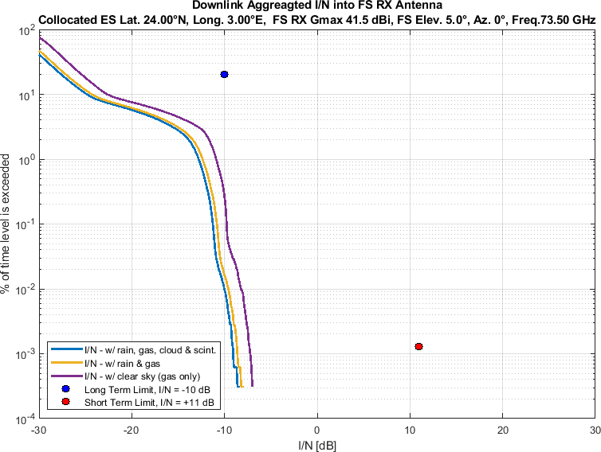

Figure 2

Aggregate *I/N* from Selected Systems at 24°N, FS max. Receive Gain 41.5 dBi, Azimuth 20°

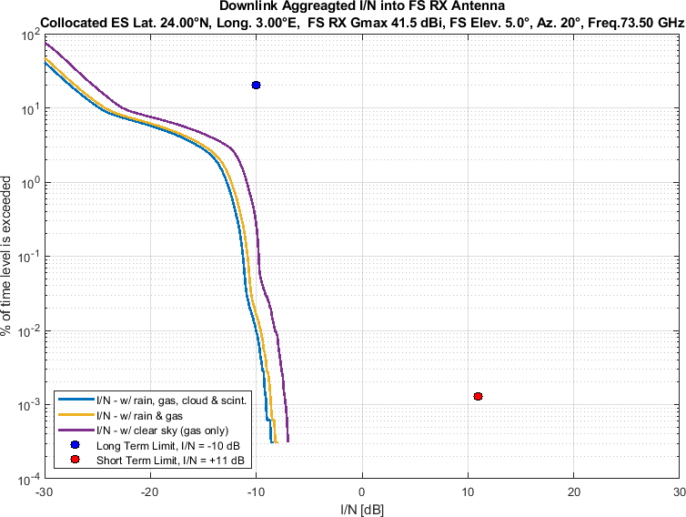

Figure 3

Aggregate *I/N* from Selected Systems at 24°N, FS max. Receive Gain 41.5 dBi, Azimuth 40°

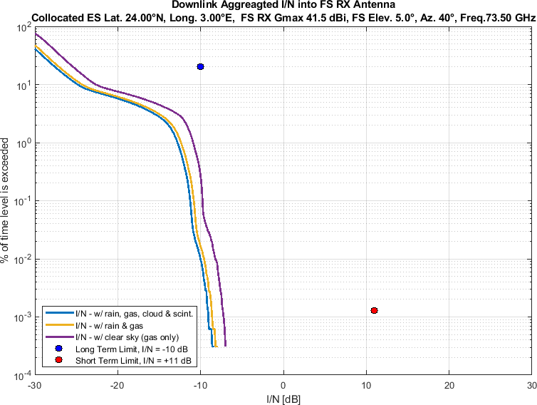

Figure 4

Aggregate *I/N* from Selected Systems at 24°N, FS max. Receive Gain 41.5 dBi, Azimuth 60°

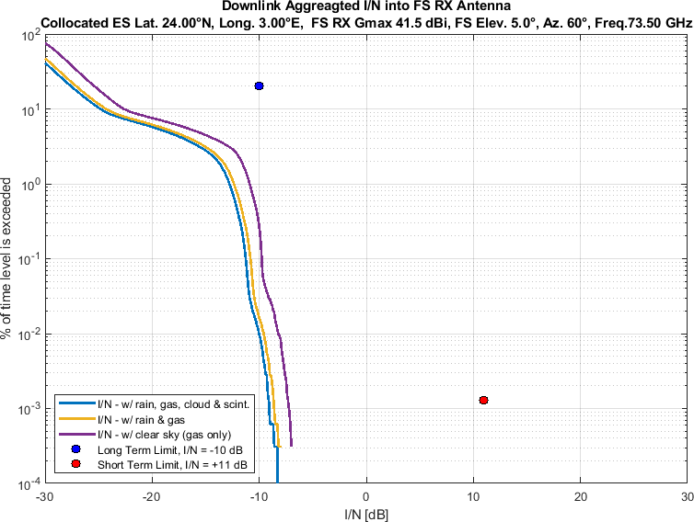

Figure 5

Aggregate *I/N* from Selected Systems at 24°N, FS max. Receive Gain 41.5 dBi, Azimuth 80°

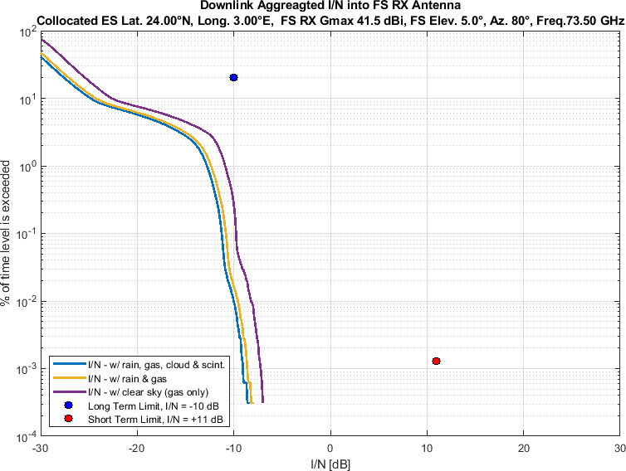

Figure 6

Aggregate *I/N* from Selected Systems at 24°N, FS max. Receive Gain 41.5 dBi, Azimuth 100°

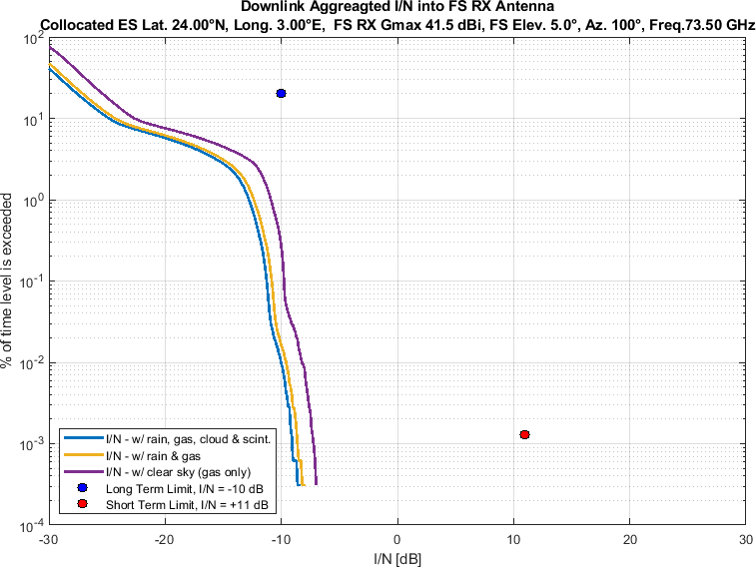

Figure 7

Aggregate *I/N* from Selected Systems at 24°N, FS max. Receive Gain 41.5 dBi, Azimuth 120°

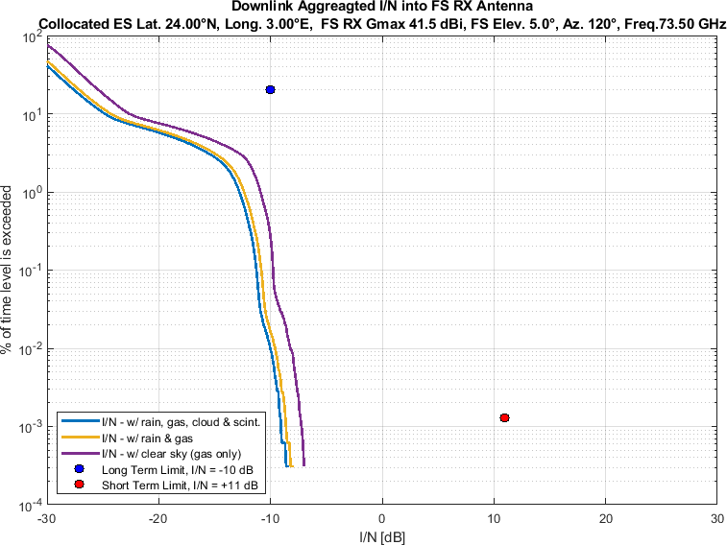

Figure 8

Aggregate *I/N* from Selected Systems at 24°N, FS max. Receive Gain 41.5 dBi, Azimuth 140°

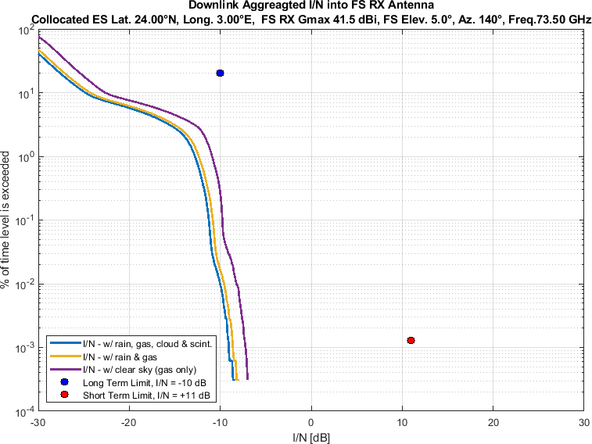

Figure 9

Aggregate *I/N* from Selected Systems at 24°N, FS max. Receive Gain 41.5 dBi, Azimuth 160°

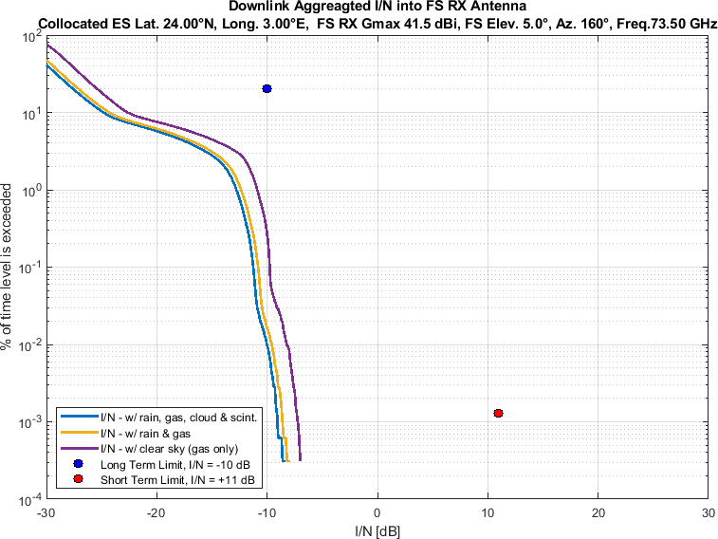

Figure 10

Aggregate *I/N* from Selected Systems at 24°N, FS max. Receive Gain 41.5 dBi, Azimuth 180°

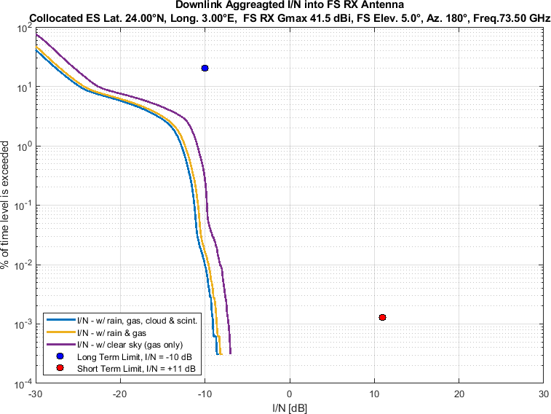

Figure 11

Aggregate *I/N* from Selected Systems at 24°N, FS max. Receive Gain 41.5 dBi, Azimuth 200°

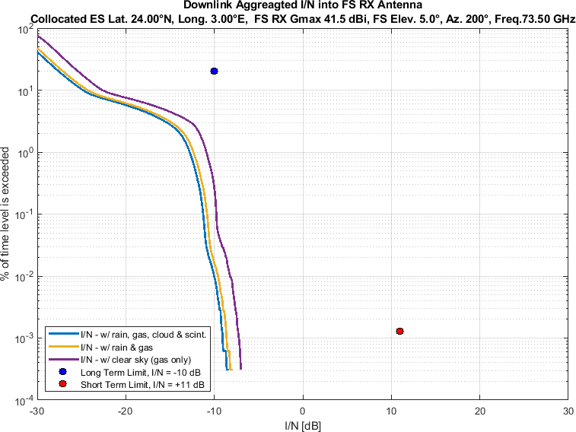

Figure 12

Aggregate *I/N* from Selected Systems at 24°N, FS max. Receive Gain 41.5 dBi, Azimuth 220°

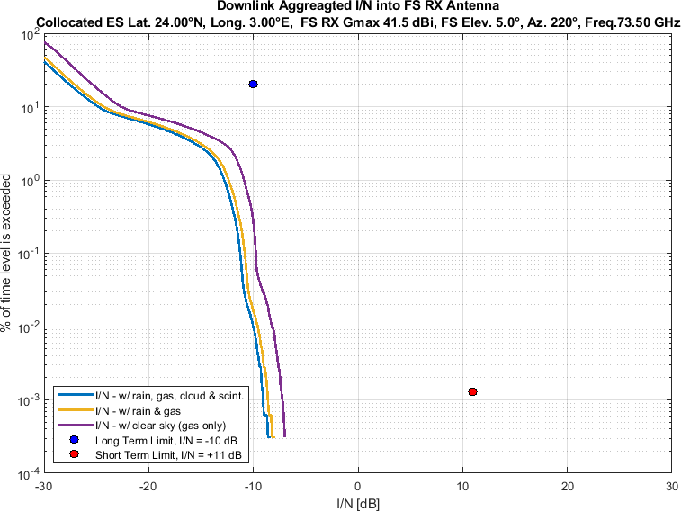

Figure 13

Aggregate *I/N* from Selected Systems at 24°N, FS max. Receive Gain 41.5 dBi, Azimuth 240°

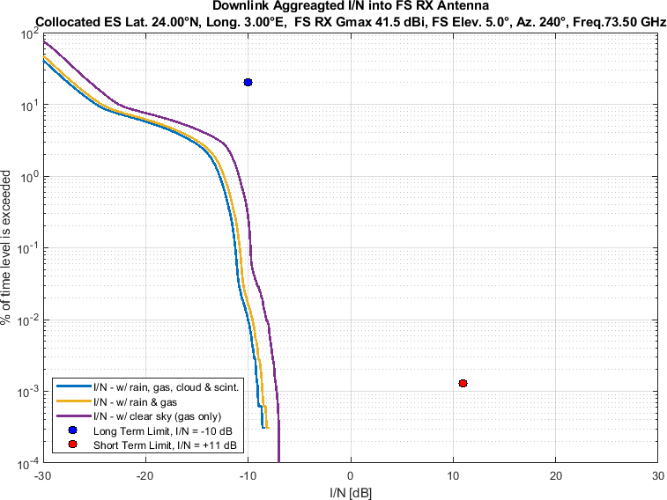

Figure 14

Aggregate *I/N* from Selected Systems at 24°N, FS max. Receive Gain 41.5 dBi, Azimuth 260°

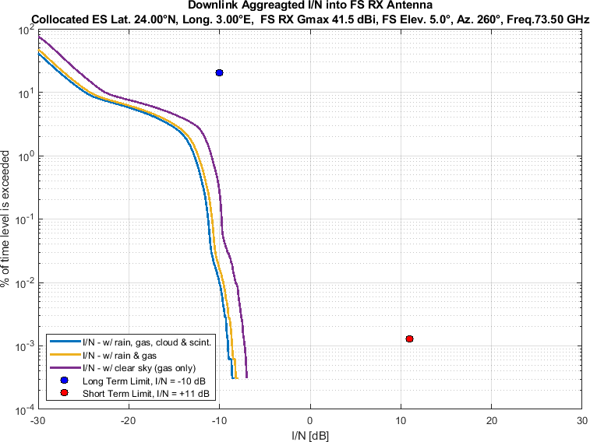

Figure 15

Aggregate *I/N* from Selected Systems at 24°N, FS max. Receive Gain 41.5 dBi, Azimuth 280°

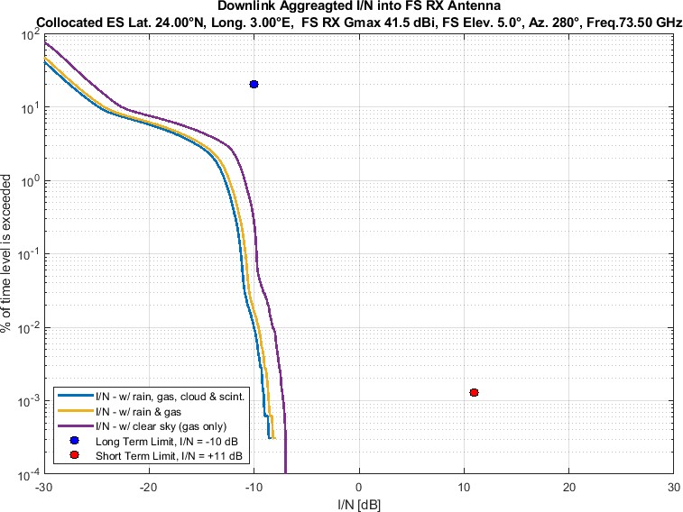

Figure 16

Aggregate *I/N* from Selected Systems at 24°N, FS max. Receive Gain 41.5 dBi, Azimuth 300°

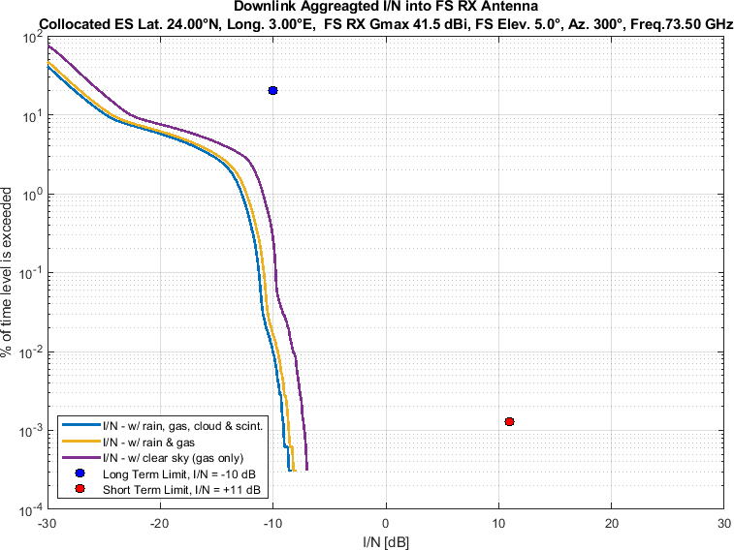

Figure 17

Aggregate *I/N* from Selected Systems at 24°N, FS max. Receive Gain 41.5 dBi, Azimuth 320°

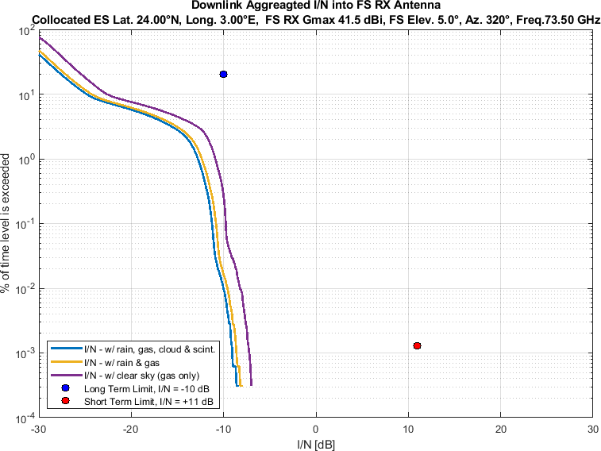

Figure 18

Aggregate *I/N* from Selected Systems at 24°N, FS max. Receive Gain 41.5 dBi, Azimuth 340°

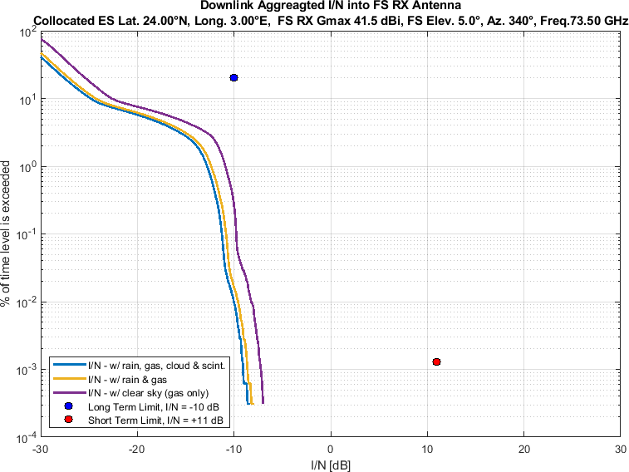

Figure 19

Aggregate *I/N* from Selected Systems at 45°N, FS max. Receive Gain 41.5 dBi, Azimuth 0°

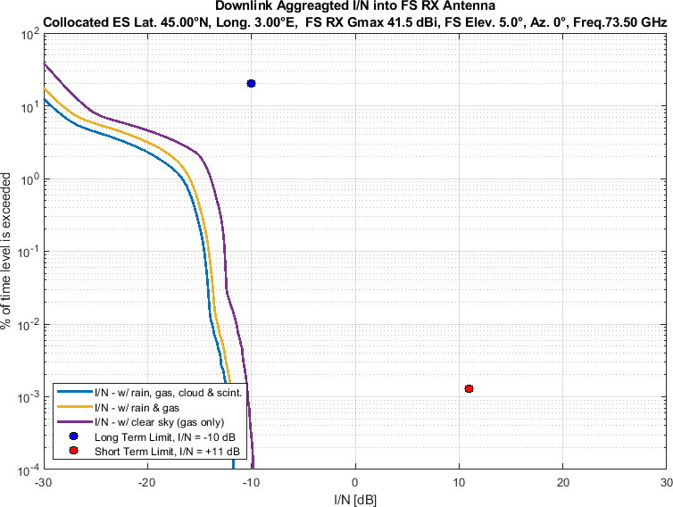

Figure 20

Aggregate *I/N* from Selected Systems at 45°N, FS max. Receive Gain 41.5 dBi, Azimuth 20°

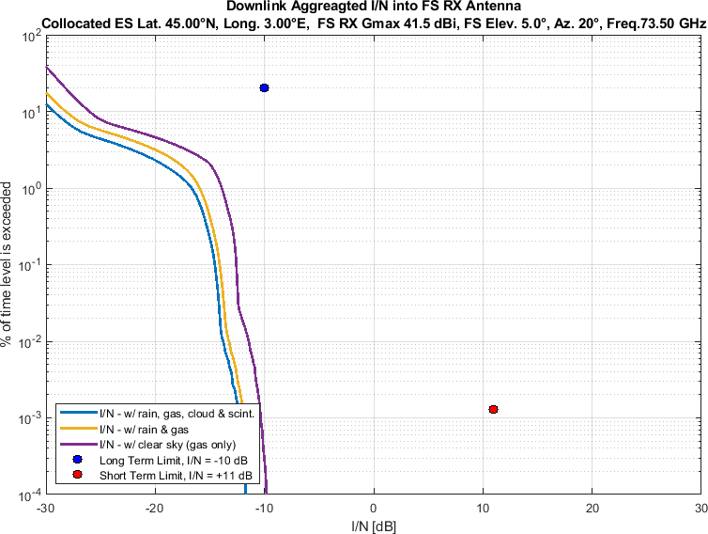

Figure 21

Aggregate *I/N* from Selected Systems at 45°N, FS max. Receive Gain 41.5 dBi, Azimuth 40°

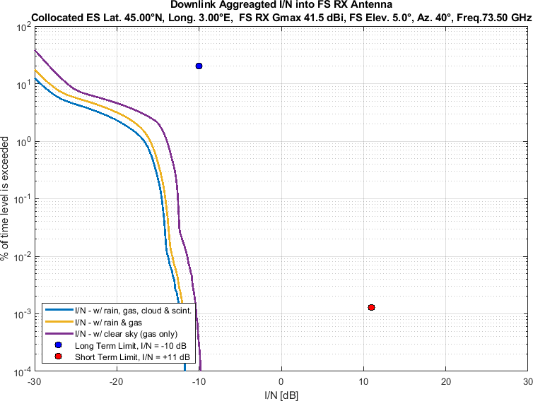

Figure 22

Aggregate *I/N* from Selected Systems at 45°N, FS max. Receive Gain 41.5 dBi, Azimuth 60°

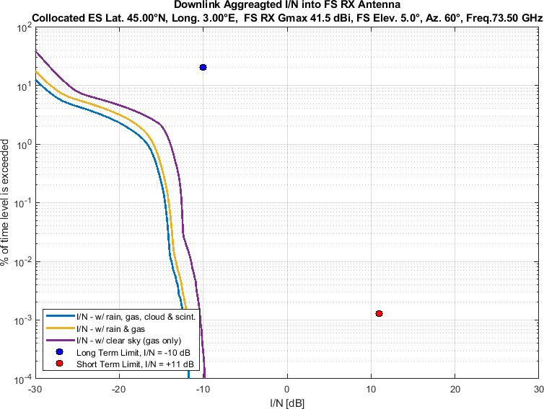

Figure 23

Aggregate *I/N* from Selected Systems at 45°N, FS max. Receive Gain 41.5 dBi, Azimuth 80°

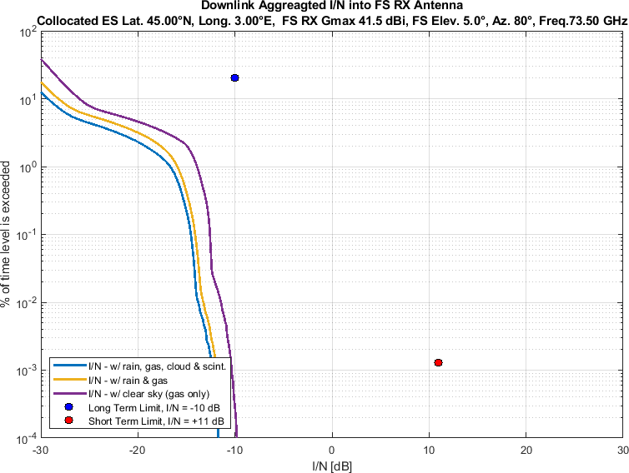

Figure 24

Aggregate *I/N* from Selected Systems at 45°N, FS max. Receive Gain 41.5 dBi, Azimuth 100°

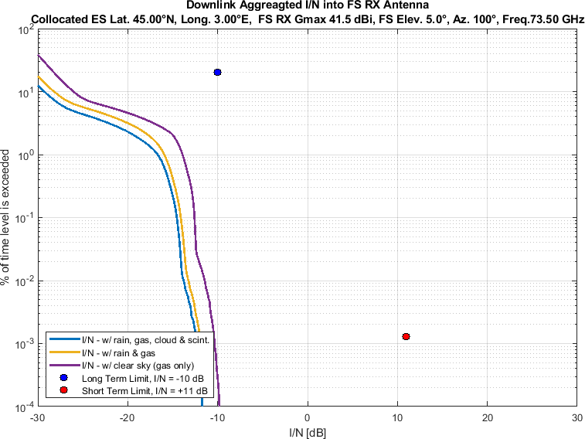

Figure 25

Aggregate *I/N* from Selected Systems at 45°N, FS max. Receive Gain 41.5 dBi, Azimuth 120°

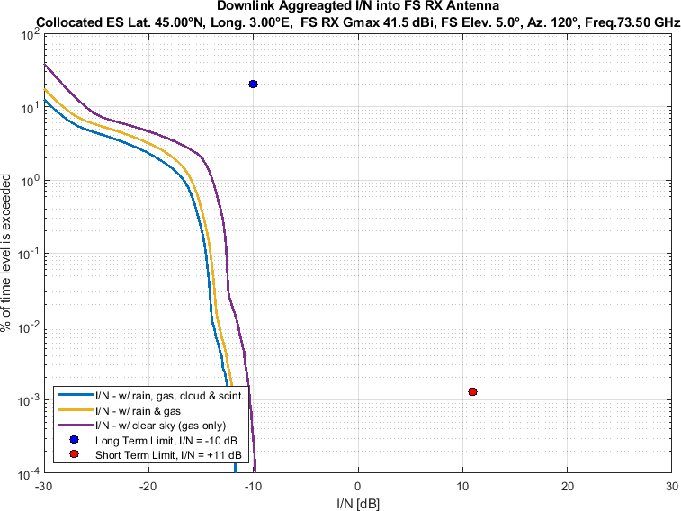

Figure 26

Aggregate *I/N* from Selected Systems at 45°N, FS max. Receive Gain 41.5 dBi, Azimuth 140°

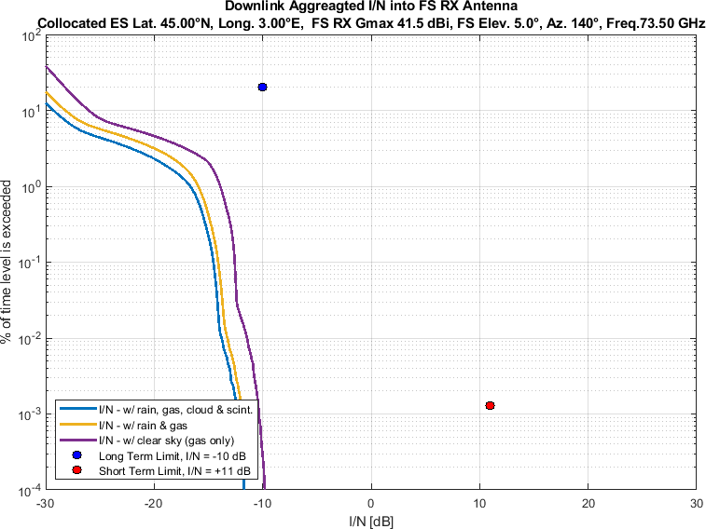

Figure 27

Aggregate *I/N* from Selected Systems at 45°N, FS max. Receive Gain 41.5 dBi, Azimuth 160°

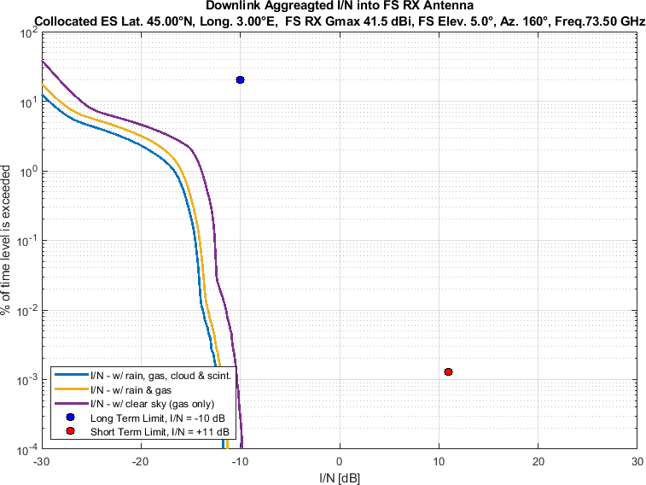

Figure 28

Aggregate *I/N* from Selected Systems at 45°N, FS max. Receive Gain 41.5 dBi, Azimuth 180°

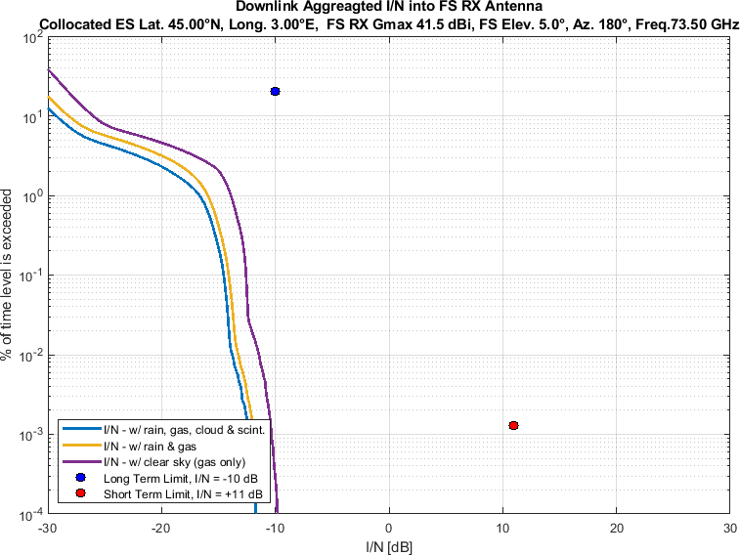

Figure 29

Aggregate *I/N* from Selected Systems at 45°N, FS max. Receive Gain 41.5 dBi, Azimuth 200°

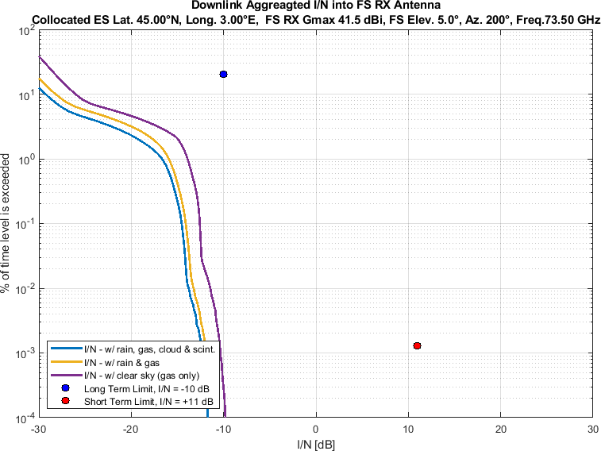

Figure 30

Aggregate *I/N* from Selected Systems at 45°N, FS max. Receive Gain 41.5 dBi, Azimuth 220°

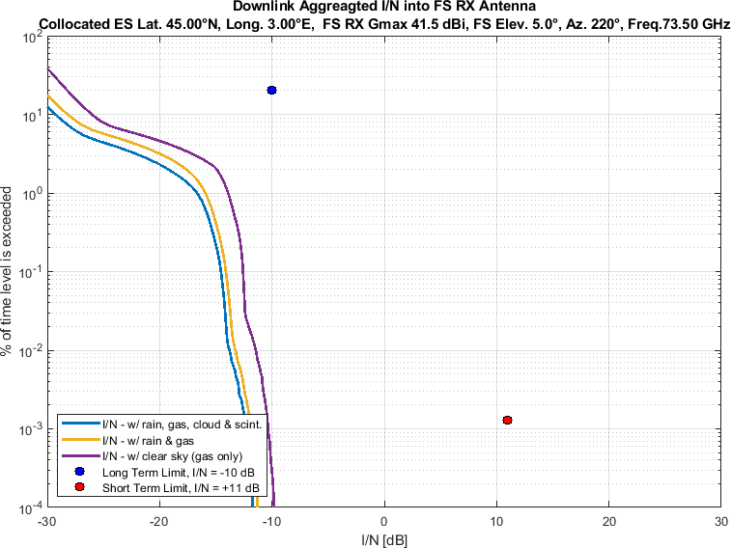

Figure 31

Aggregate *I/N* from Selected Systems at 45°N, FS max. Receive Gain 41.5 dBi, Azimuth 240°

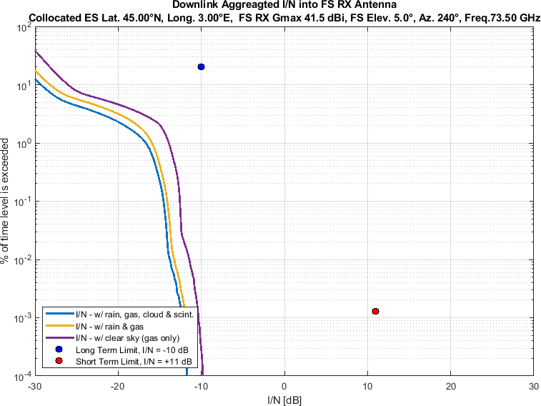

Figure 32

Aggregate *I/N* from Selected Systems at 45°N, FS max. Receive Gain 41.5 dBi, Azimuth 260°

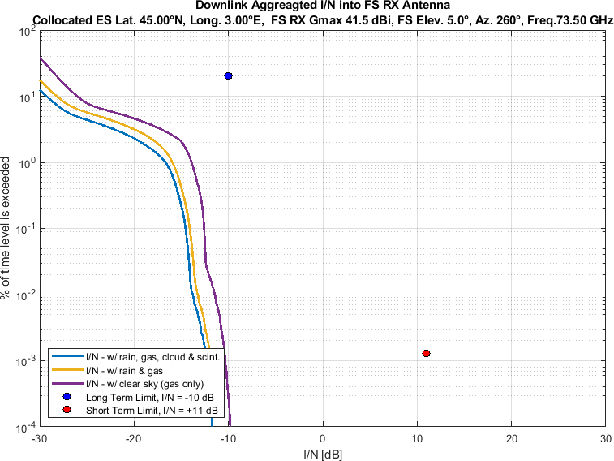

Figure 33

Aggregate *I/N* from Selected Systems at 45°N, FS max. Receive Gain 41.5 dBi, Azimuth 280°

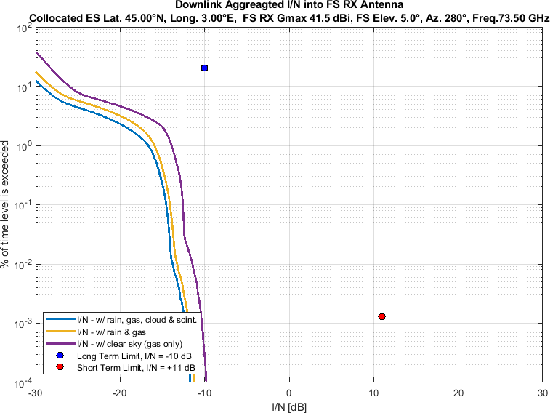

Figure 34

Aggregate *I/N* from Selected Systems at 45°N, FS max. Receive Gain 41.5 dBi, Azimuth 300°

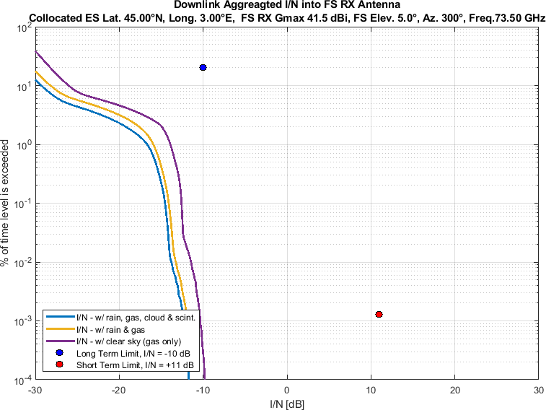

Figure 35

Aggregate *I/N* from Selected Systems at 45°N, FS max. Receive Gain 41.5 dBi, Azimuth 320°

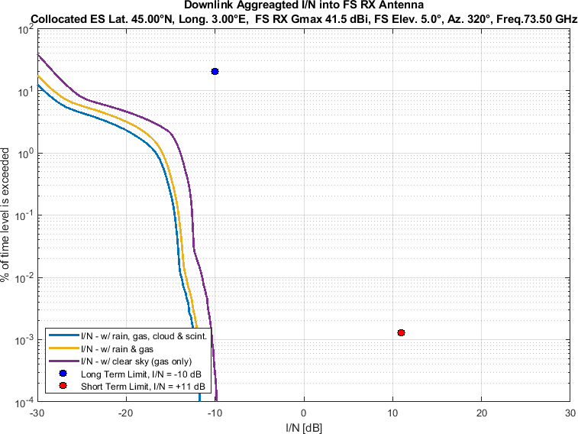

Figure 36

Aggregate *I/N* from Selected Systems at 45°N, FS max. Receive Gain 41.5 dBi, Azimuth 340°

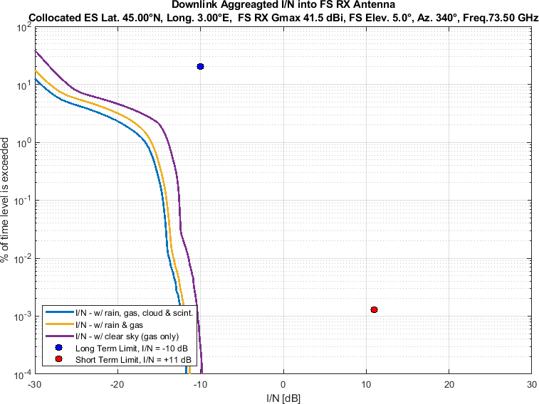

Figure 37

Aggregate *I/N* from Selected Systems at 60°N, FS max. Receive Gain 41.5 dBi, Azimuth 0°

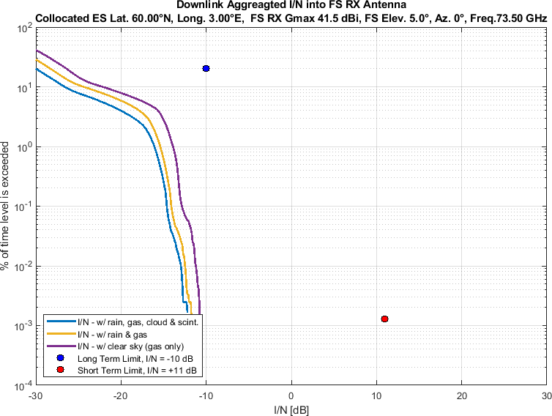

Figure 38

Aggregate *I/N* from Selected Systems at 60°N, FS max. Receive Gain 41.5 dBi, Azimuth 20°

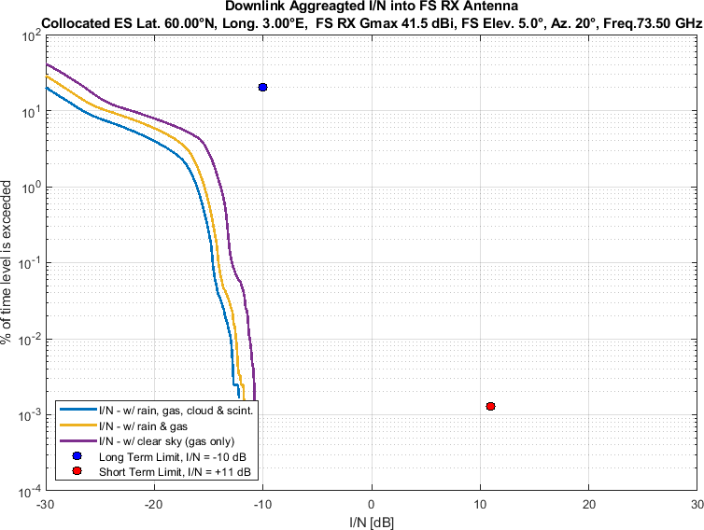

Figure 39

Aggregate *I/N* from Selected Systems at 60°N, FS max. Receive Gain 41.5 dBi, Azimuth 40°

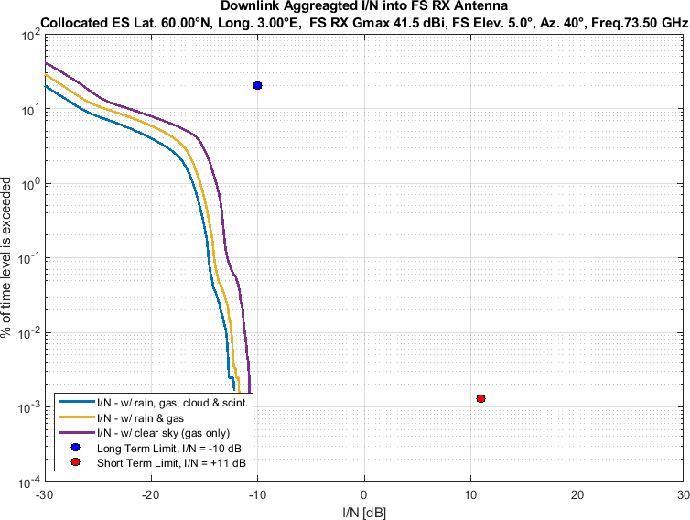

Figure 40

Aggregate *I/N* from Selected Systems at 60°N, FS max. Receive Gain 41.5 dBi, Azimuth 60°

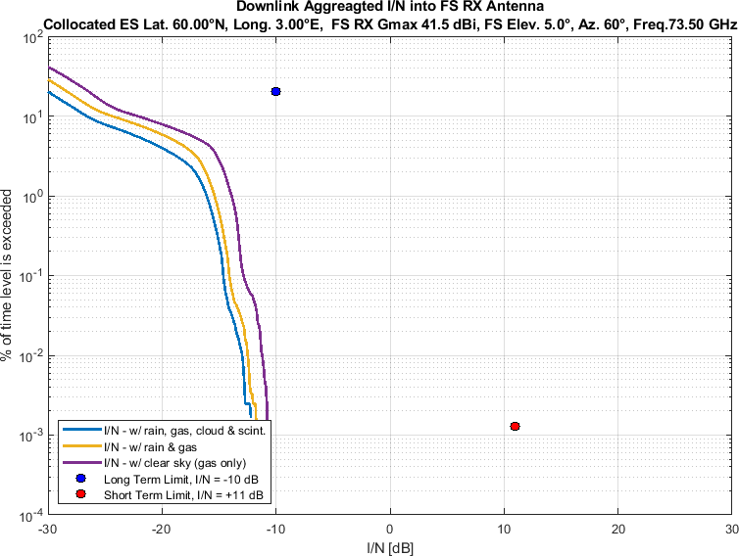

Figure 41

Aggregate *I/N* from Selected Systems at 60°N, FS max. Receive Gain 41.5 dBi, Azimuth 80°

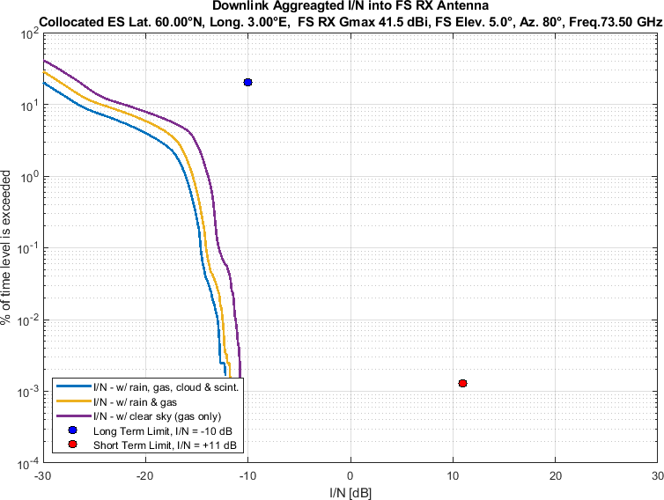

Figure 42

Aggregate *I/N* from Selected Systems at 60°N, FS max. Receive Gain 41.5 dBi, Azimuth 100°

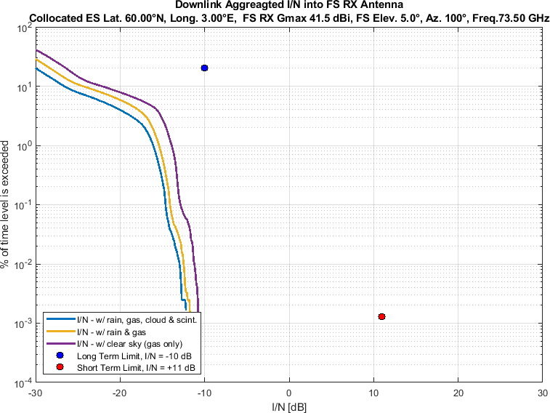

Figure 43

Aggregate *I/N* from Selected Systems at 60°N, FS max. Receive Gain 41.5 dBi, Azimuth 120°

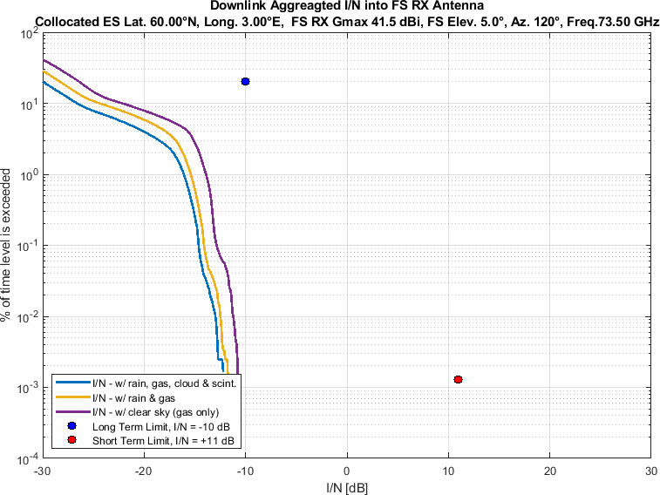

Figure 44

Aggregate *I/N* from Selected Systems at 60°N, FS max. Receive Gain 41.5 dBi, Azimuth 140°

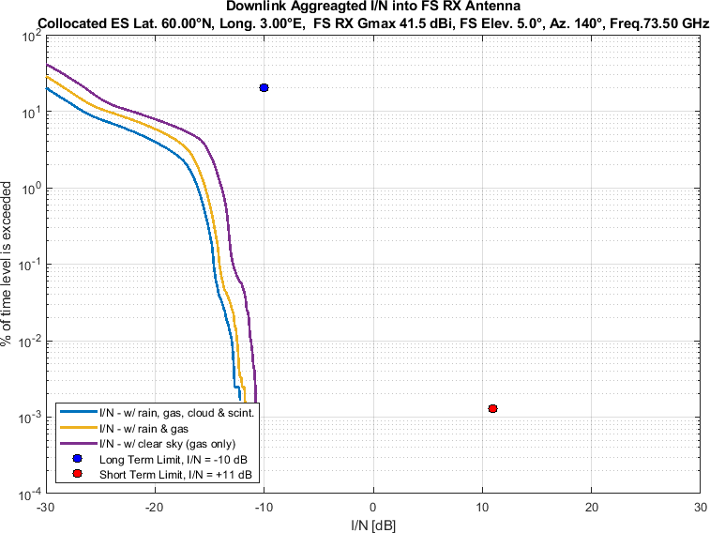

Figure 45

Aggregate *I/N* from Selected Systems at 60°N, FS max. Receive Gain 41.5 dBi, Azimuth 160°

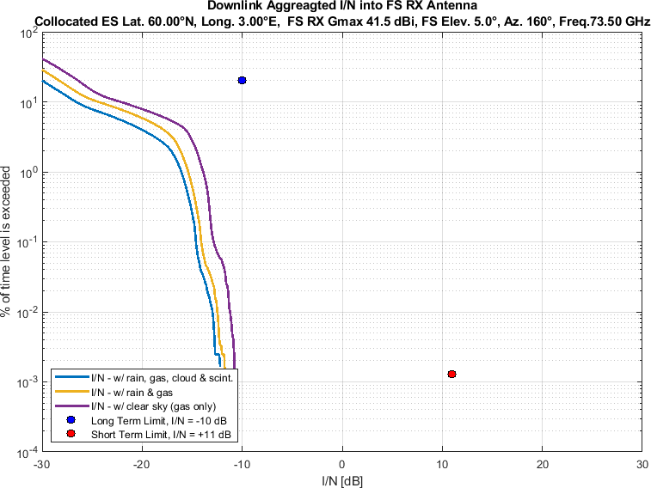

Figure 46

Aggregate *I/N* from Selected Systems at 60°N, FS max. Receive Gain 41.5 dBi, Azimuth 180°

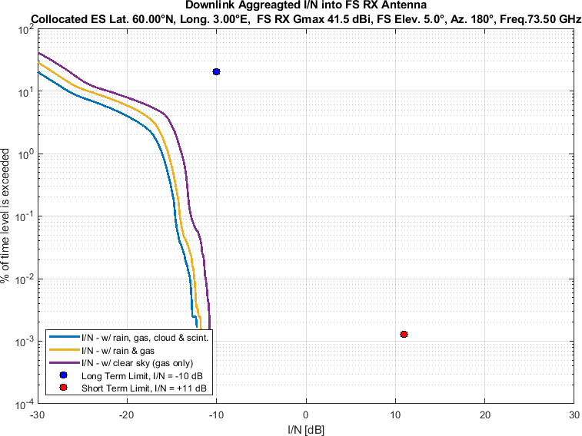

Figure 47

Aggregate *I/N* from Selected Systems at 60°N, FS max. Receive Gain 41.5 dBi, Azimuth 200°

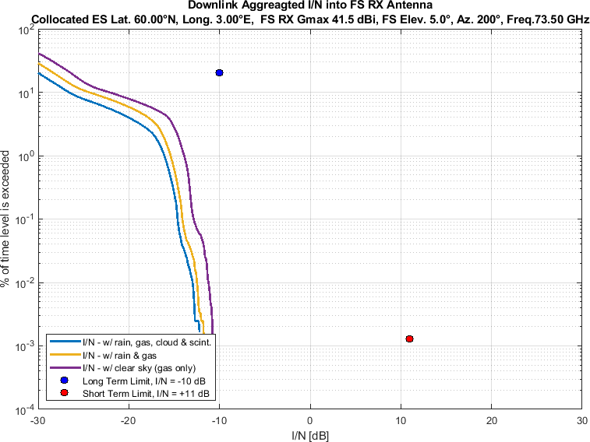

Figure 48

Aggregate *I/N* from Selected Systems at 60°N, FS max. Receive Gain 41.5 dBi, Azimuth 220°

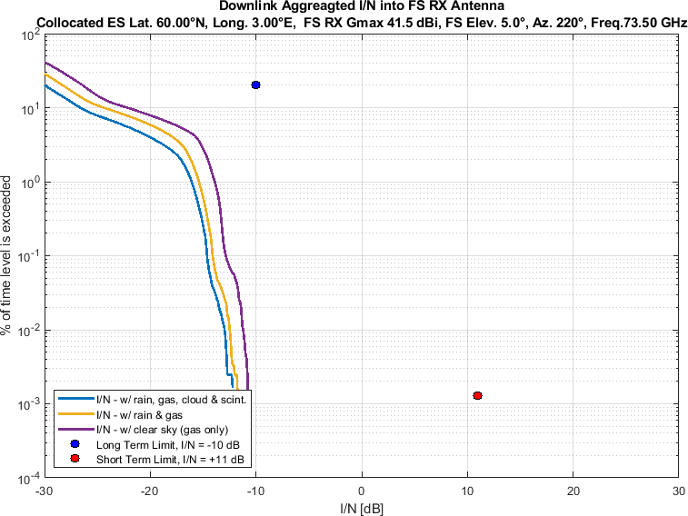

Figure 49

Aggregate *I/N* from Selected Systems at 60°N, FS max. Receive Gain 41.5 dBi, Azimuth 240°

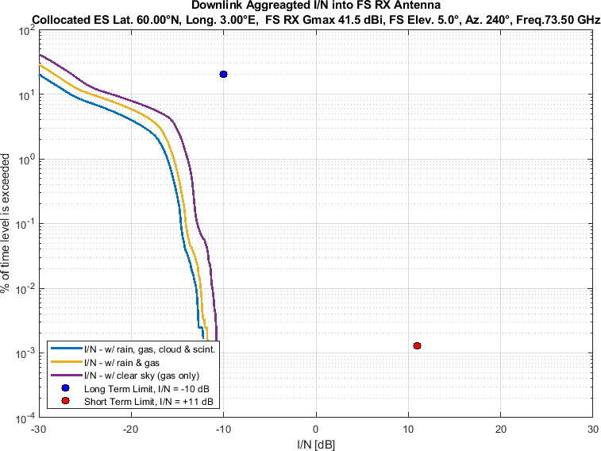

Figure 50

Aggregate *I/N* from Selected Systems at 60°N, FS max. Receive Gain 41.5 dBi, Azimuth 260°

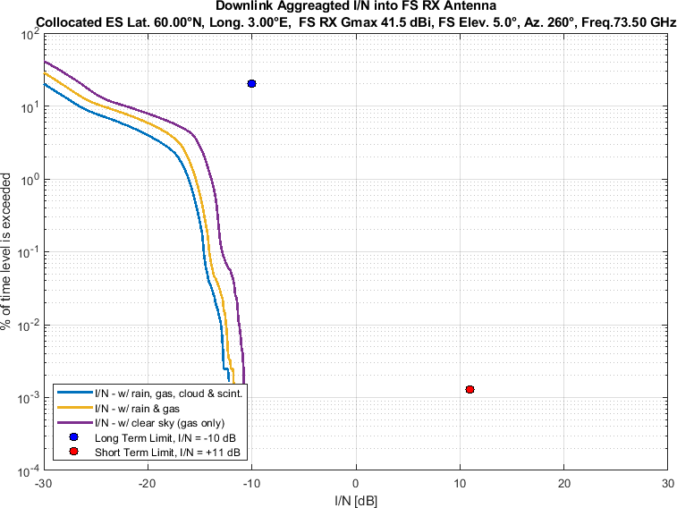

Figure 51

Aggregate *I/N* from Selected Systems at 60°N, FS max. Receive Gain 41.5 dBi, Azimuth 280°

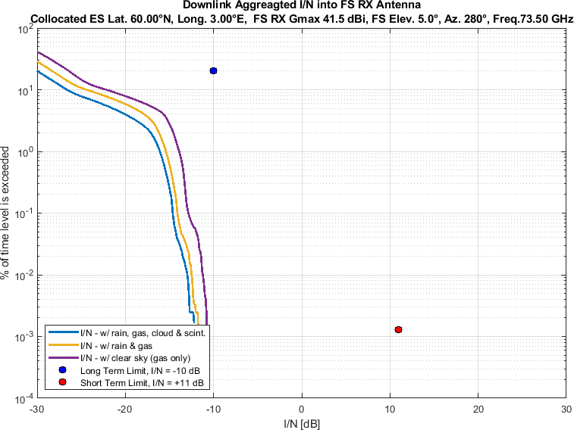

Figure 52

Aggregate *I/N* from Selected Systems at 60°N, FS max. Receive Gain 41.5 dBi, Azimuth 300°

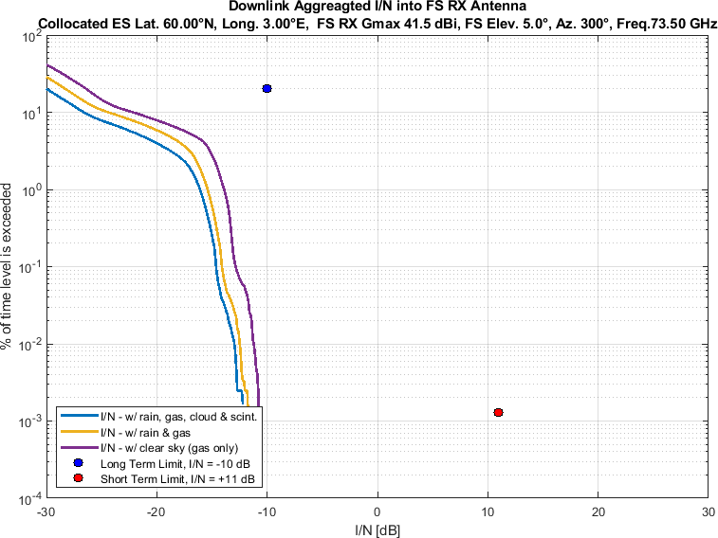

Figure 53

Aggregate *I/N* from Selected Systems at 60°N, FS max. Receive Gain 41.5 dBi, Azimuth 320°

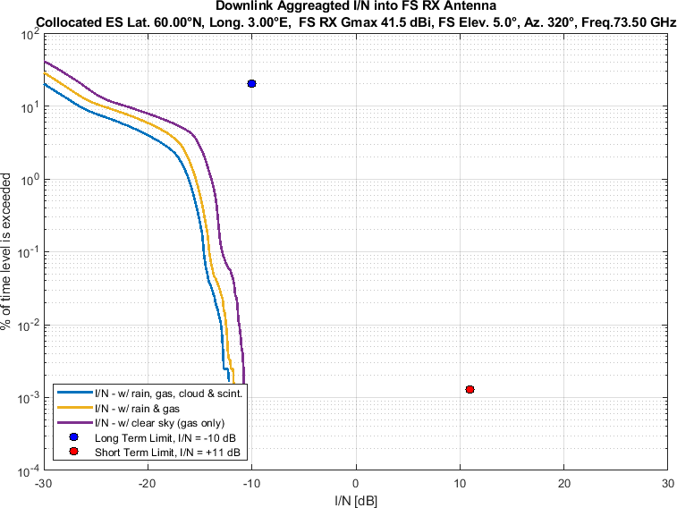

Figure 54

Aggregate *I/N* from Selected Systems at 60°N, FS max. Receive Gain 41.5 dBi, Azimuth 340°

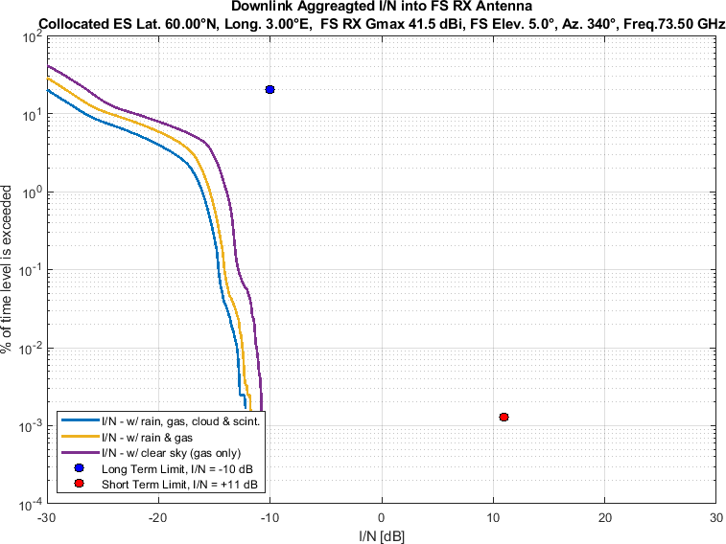

Similarly, Figure 55-108 compare aggregate *I/N* from the same selected GSO and three non-GSO systems to

• the largest dimension 0.6m FS station antenna,

• pointing at eighteen different azimuth directions at 20° intervals

• for maximum FS antenna elevation angle of 5°,

• at same representative frequency (i.e., 73.5 GHz).

Again, each figure compares three different of atmospheric attenuation scenarios as mentioned above.

Figure 55

Aggregate *I/N* from Selected Systems at 24°N, FS max. Receive Gain 51 dBi, Azimuth 0°

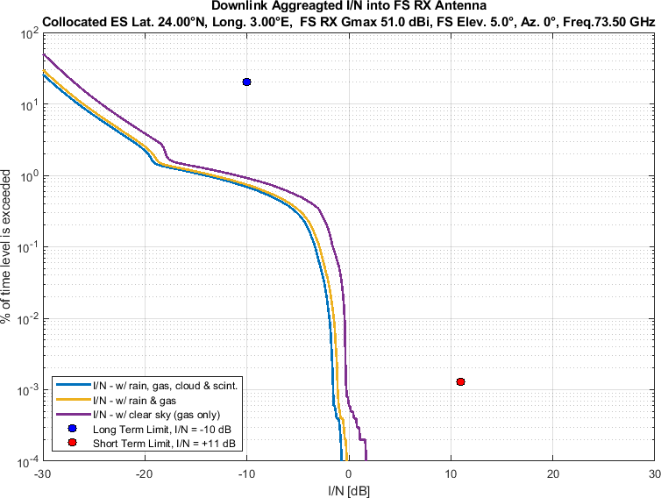

Figure 56

Aggregate *I/N* from Selected Systems at 24°N, FS max. Receive Gain 51 dBi, Azimuth 20°

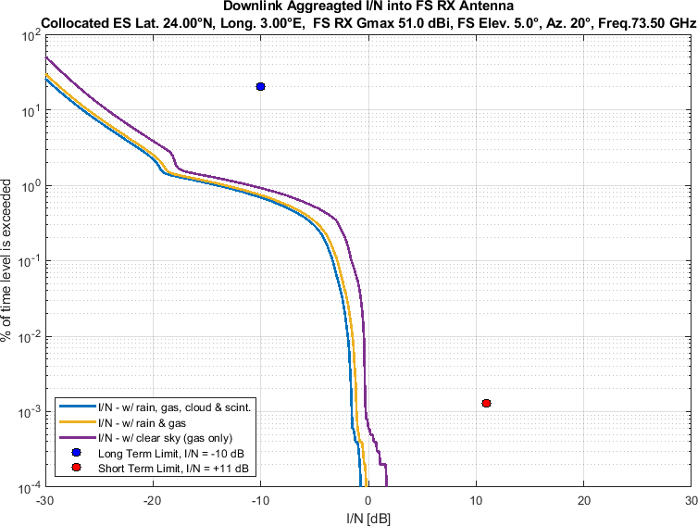

Figure 57

Aggregate *I/N* from Selected Systems at 24°N, FS max. Receive Gain 51 dBi, Azimuth 40°

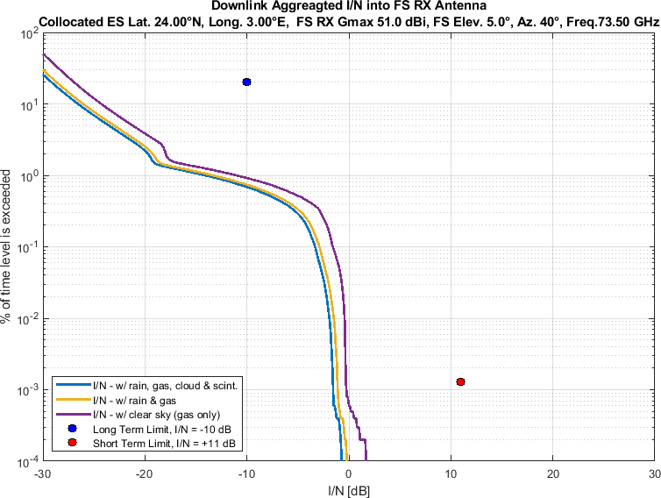

Figure 58

Aggregate *I/N* from Selected Systems at 24°N, FS max. Receive Gain 51 dBi, Azimuth 60°

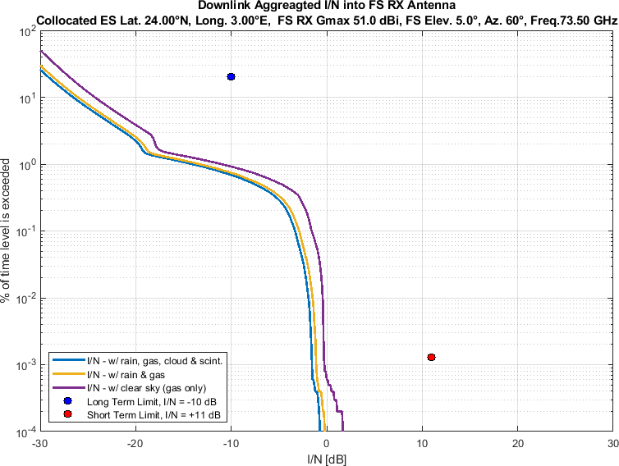

Figure 59

Aggregate *I/N* from Selected Systems at 24°N, FS max. Receive Gain 51 dBi, Azimuth 80°

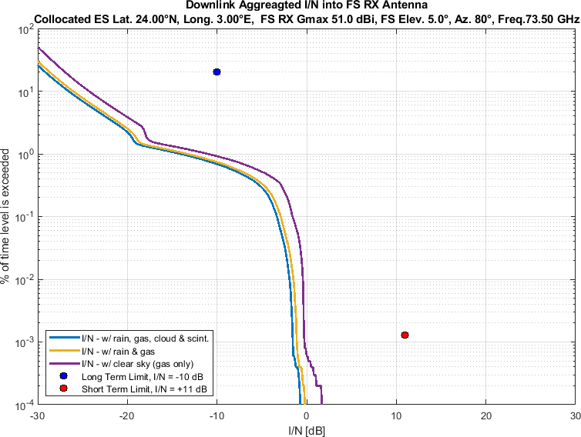

Figure 60

Aggregate *I/N* from Selected Systems at 24°N, FS max. Receive Gain 51 dBi, Azimuth 100°

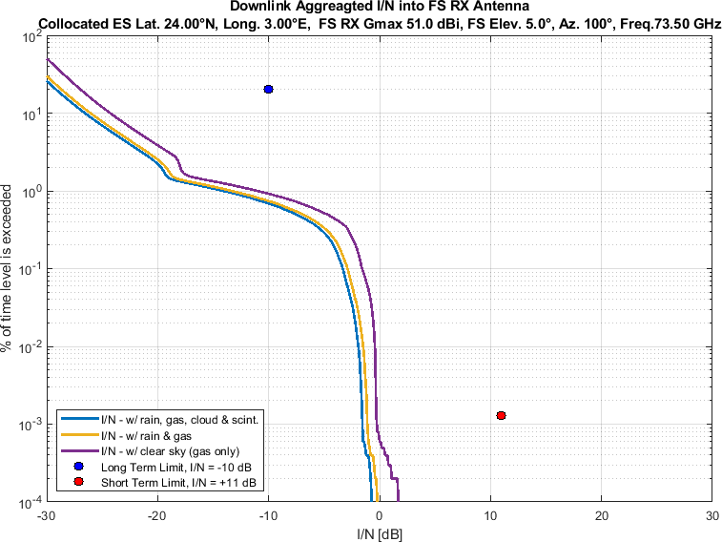

Figure 61

Aggregate *I/N* from Selected Systems at 24°N, FS max. Receive Gain 51 dBi, Azimuth 120°

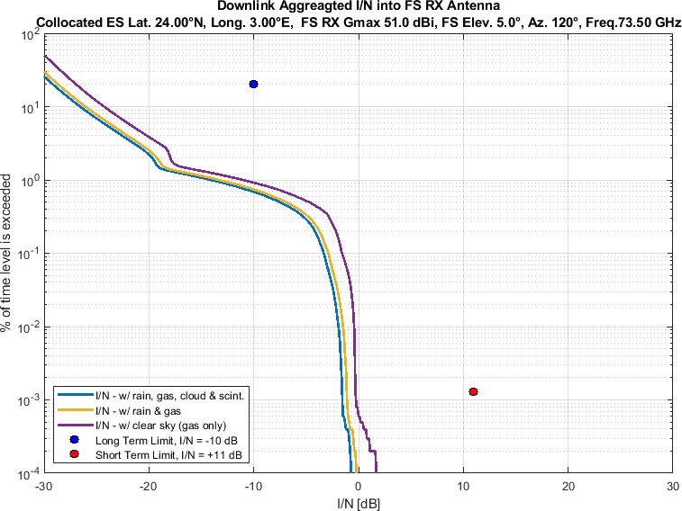

Figure 62

Aggregate *I/N* from Selected Systems at 24°N, FS max. Receive Gain 51 dBi, Azimuth 140°

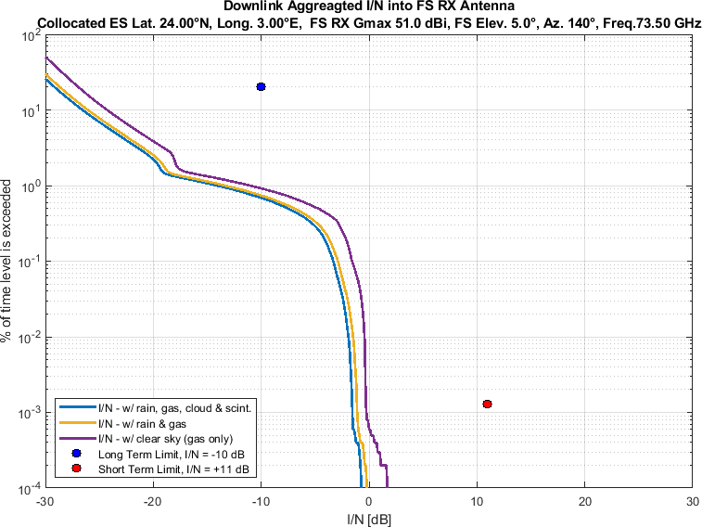

Figure 63

Aggregate *I/N* from Selected Systems at 24°N, FS max. Receive Gain 51 dBi, Azimuth 160°

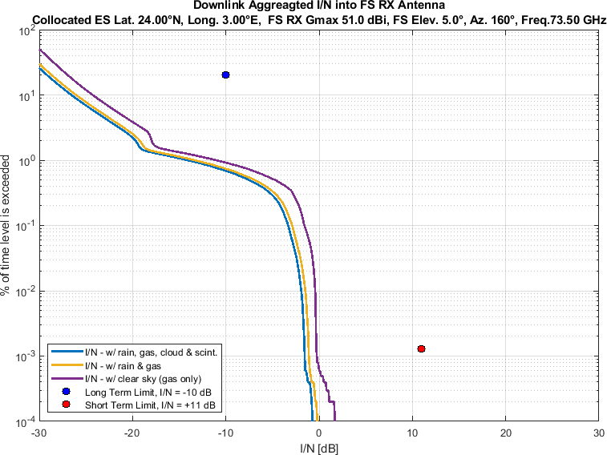

Figure 64

Aggregate *I/N* from Selected Systems at 24°N, FS max. Receive Gain 51 dBi, Azimuth 180°

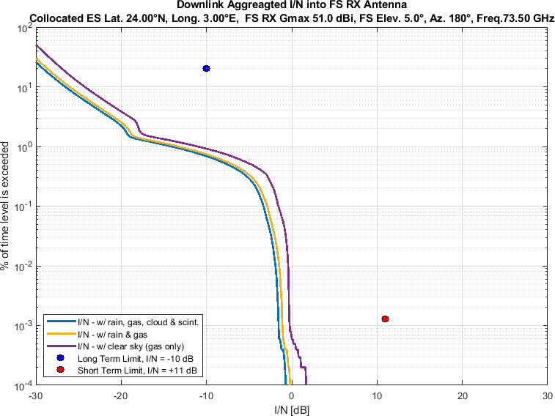

Figure 65

Aggregate *I/N* from Selected Systems at 24°N, FS max. Receive Gain 51 dBi, Azimuth 200°

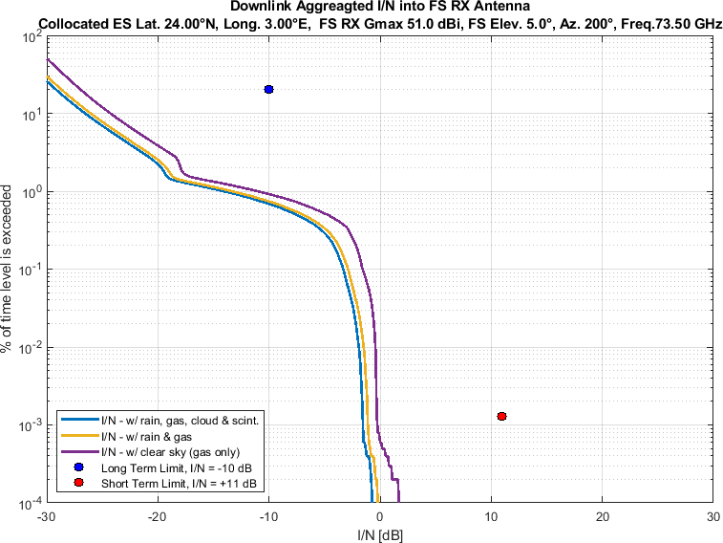

Figure 66

Aggregate *I/N* from Selected Systems at 24°N, FS max. Receive Gain 51 dBi, Azimuth 220°

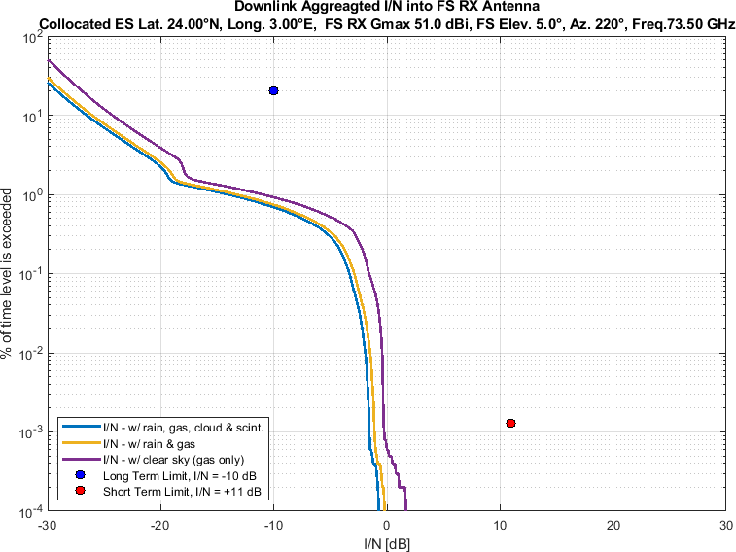

Figure 67

Aggregate *I/N* from Selected Systems at 24°N, FS max. Receive Gain 51 dBi, Azimuth 240°

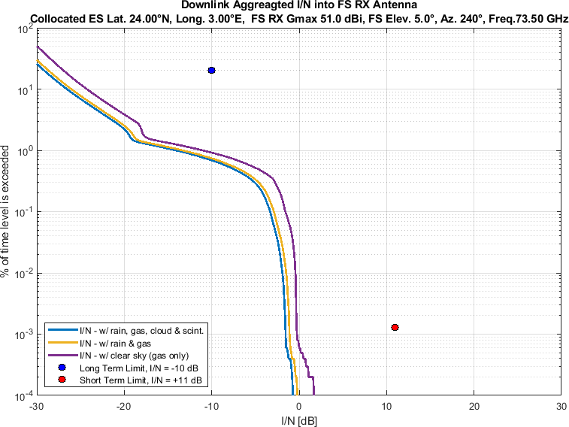

Figure 68

Aggregate *I/N* from Selected Systems at 24°N, FS max. Receive Gain 51 dBi, Azimuth 260°

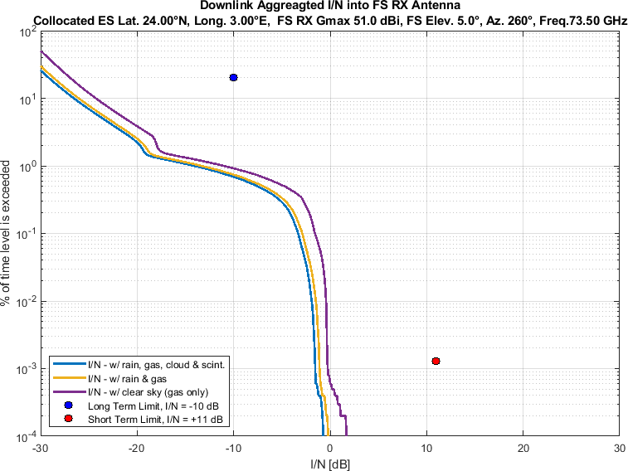

Figure 69

Aggregate *I/N* from Selected Systems at 24°N, FS max. Receive Gain 51 dBi, Azimuth 280°

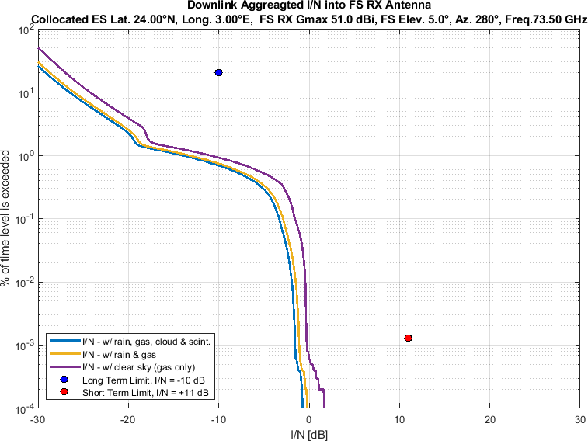

Figure 70

Aggregate *I/N* from Selected Systems at 24°N, FS max. Receive Gain 51 dBi, Azimuth 300°

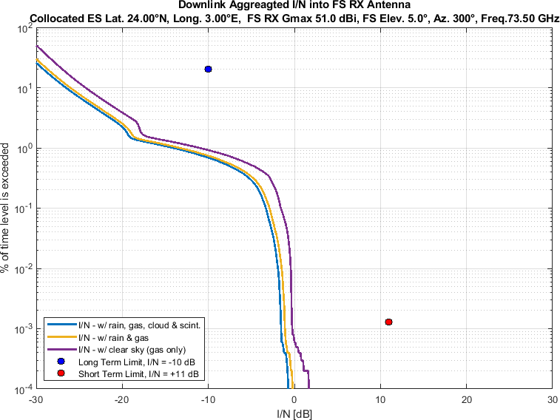

Figure 71

Aggregate *I/N* from Selected Systems at 24°N, FS max. Receive Gain 51 dBi, Azimuth 320°

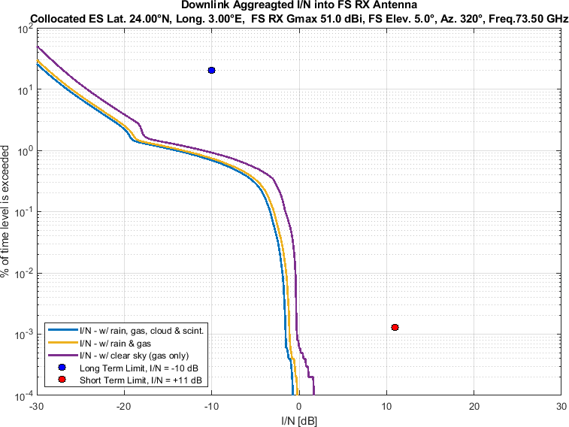

Figure 72

Aggregate *I/N* from Selected Systems at 24°N, FS max. Receive Gain 51 dBi, Azimuth 340°

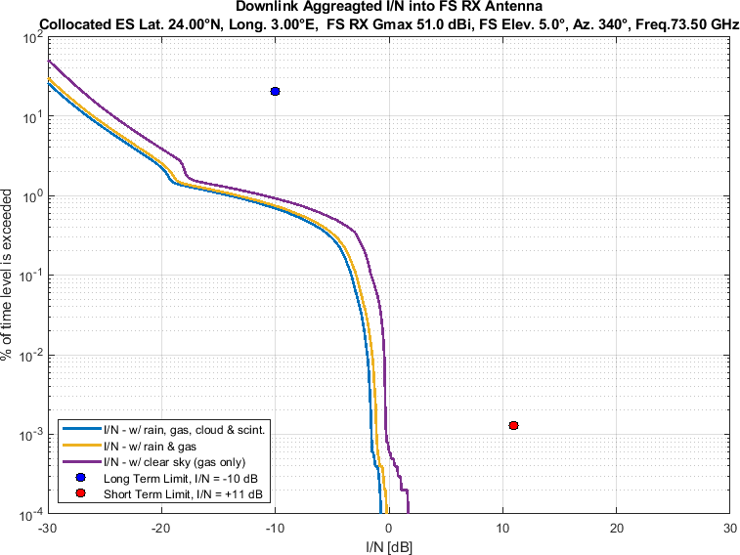

Figure 73

Aggregate *I/N* from Selected Systems at 45°N, FS max. Receive Gain 51 dBi, Azimuth 0°

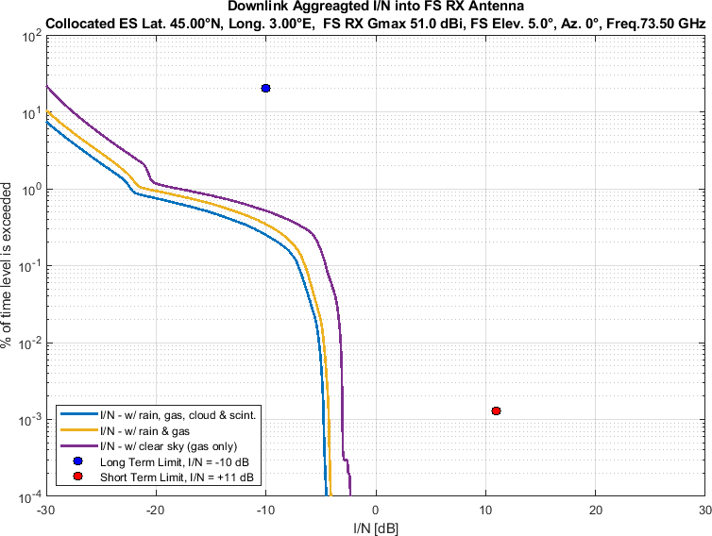

Figure 74

Aggregate *I/N* from Selected Systems at 45°N, FS max. Receive Gain 51 dBi, Azimuth 20°

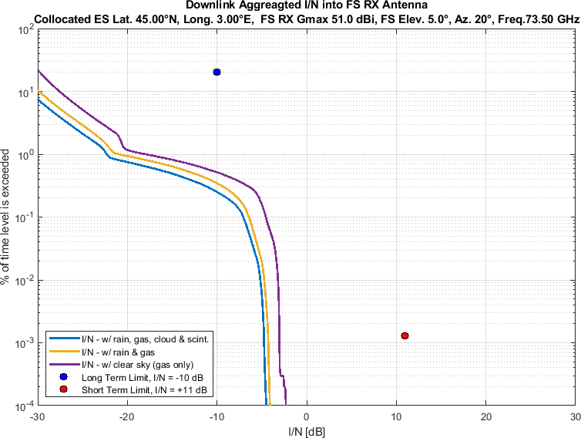

Figure 75

Aggregate *I/N* from Selected Systems at 45°N, FS max. Receive Gain 51 dBi, Azimuth 40°

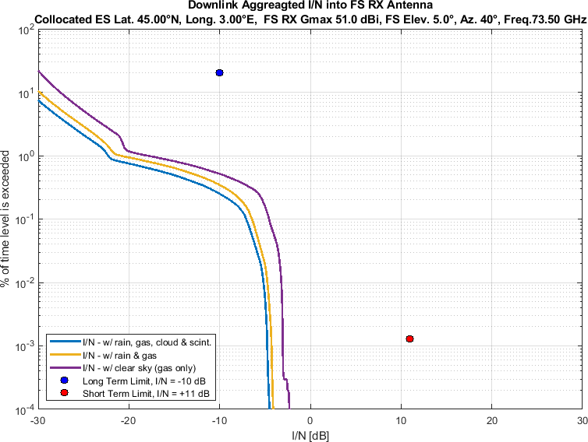

Figure 76

Aggregate *I/N* from Selected Systems at 45°N, FS max. Receive Gain 51 dBi, Azimuth 60°

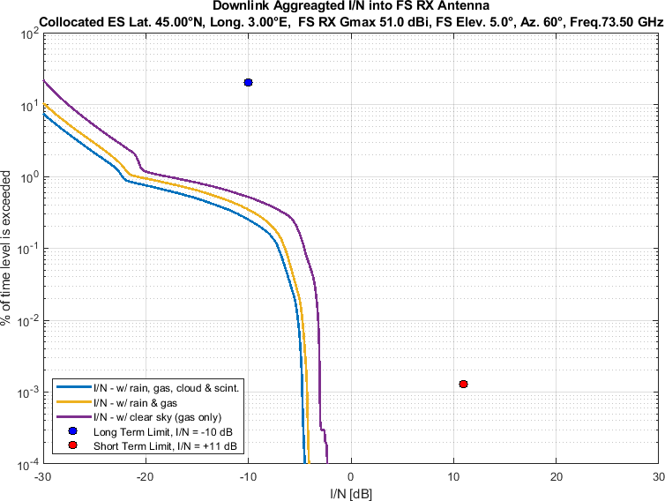

Figure 77

Aggregate *I/N* from Selected Systems at 45°N, FS max. Receive Gain 51 dBi, Azimuth 80°

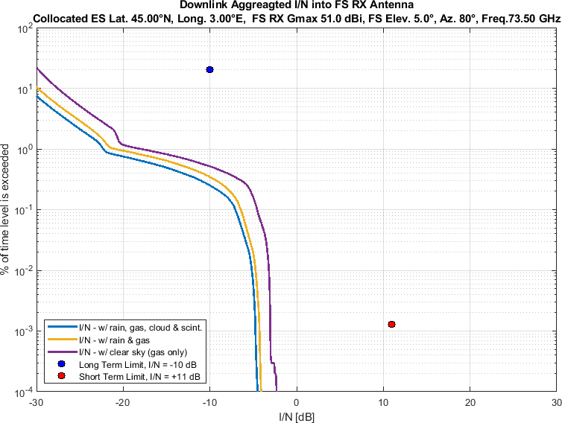

Figure 78

Aggregate *I/N* from Selected Systems at 45°N, FS max. Receive Gain 51 dBi, Azimuth 100°

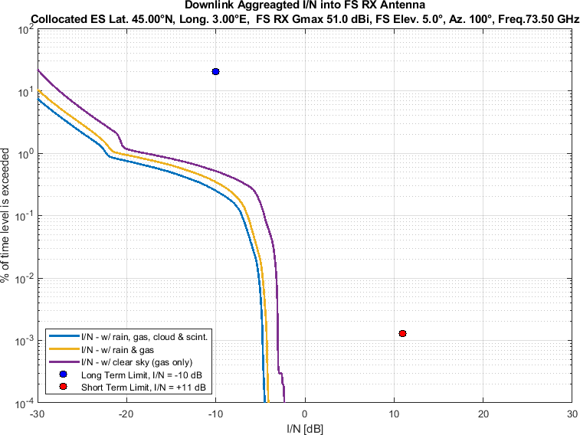

Figure 79

Aggregate *I/N* from Selected Systems at 45°N, FS max. Receive Gain 51 dBi, Azimuth 120°

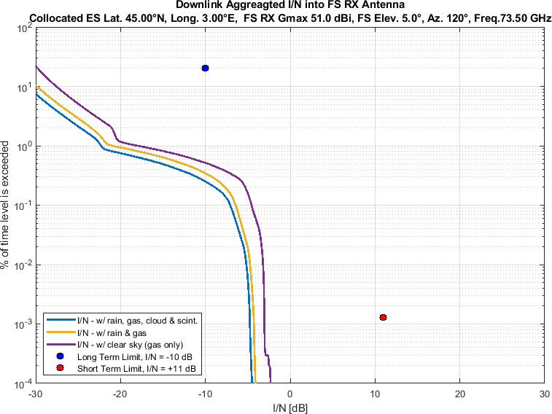

Figure 80

Aggregate *I/N* from Selected Systems at 45°N, FS max. Receive Gain 51 dBi, Azimuth 140°

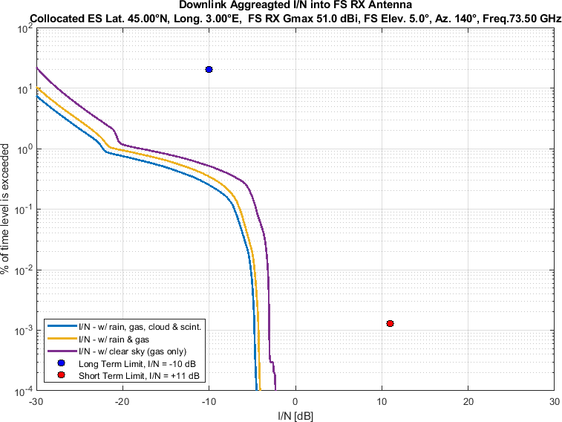

Figure 81

Aggregate *I/N* from Selected Systems at 45°N, FS max. Receive Gain 51 dBi, Azimuth 160°

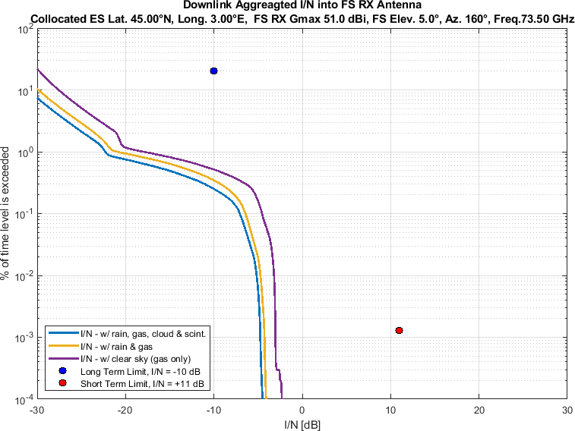

Figure 82

Aggregate *I/N* from Selected Systems at 45°N, FS max. Receive Gain 51 dBi, Azimuth 180°

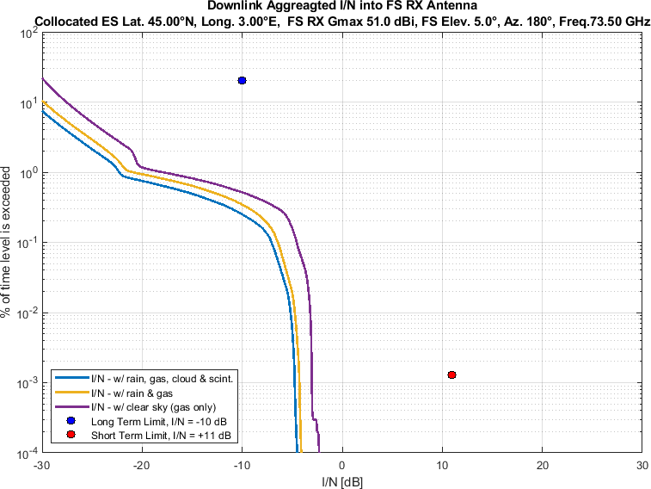

Figure 83

Aggregate *I/N* from Selected Systems at 45°N, FS max. Receive Gain 51 dBi, Azimuth 200°

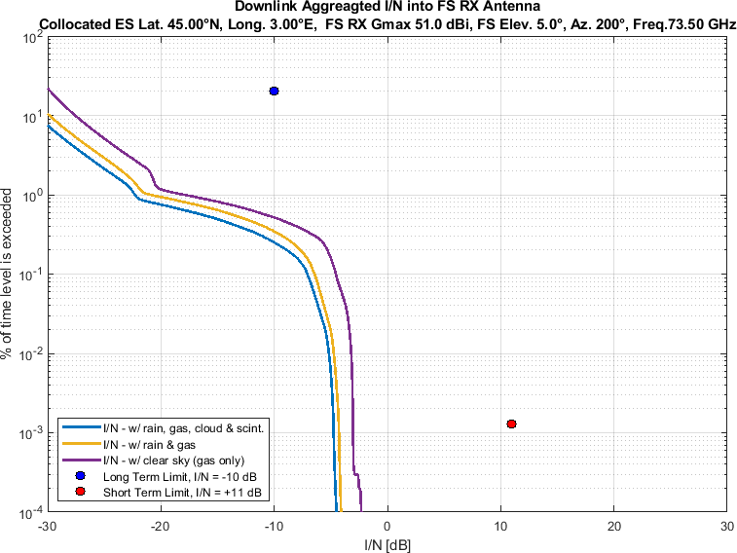

Figure 84

Aggregate *I/N* from Selected Systems at 45°N, FS max. Receive Gain 51 dBi, Azimuth 220°

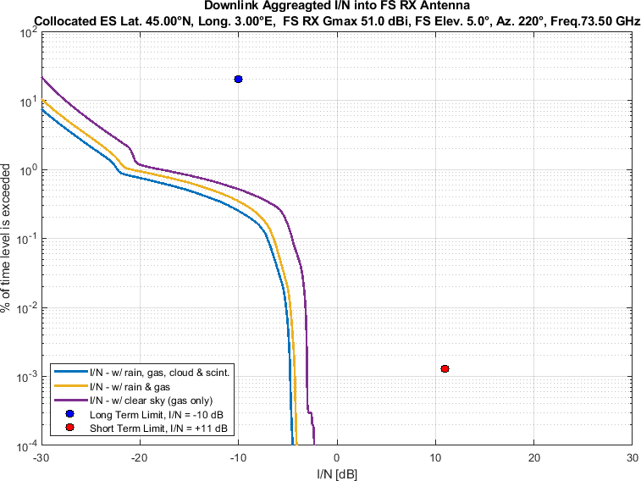

Figure 85

Aggregate *I/N* from Selected Systems at 45°N, FS max. Receive Gain 51 dBi, Azimuth 240°

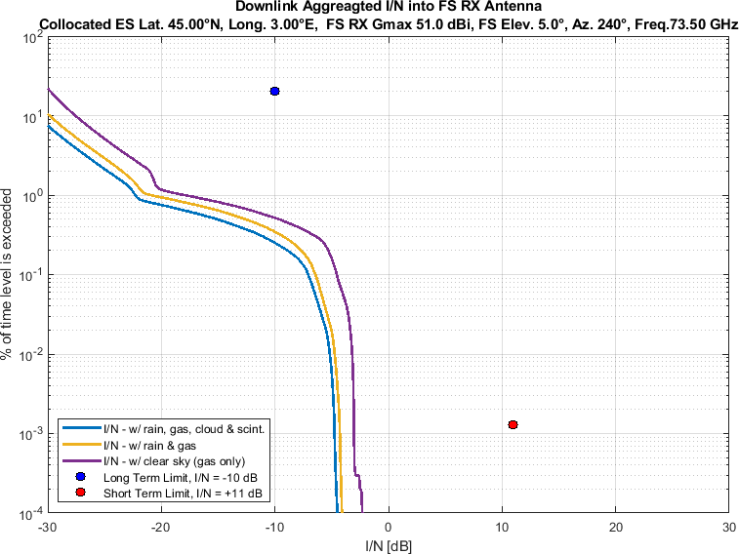

Figure 86

Aggregate *I/N* from Selected Systems at 45°N, FS max. Receive Gain 51 dBi, Azimuth 260°

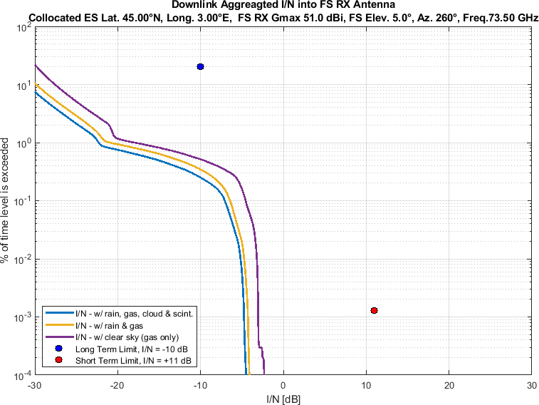

Figure 87

Aggregate *I/N* from Selected Systems at 45°N, FS max. Receive Gain 51 dBi, Azimuth 280°

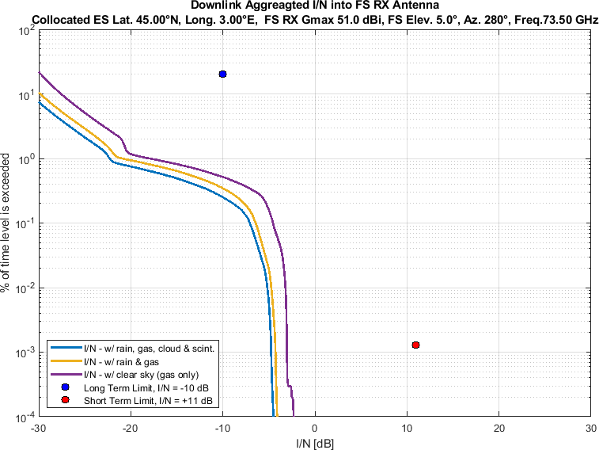

Figure 88

Aggregate *I/N* from Selected Systems at 45°N, FS max. Receive Gain 51 dBi, Azimuth 300°

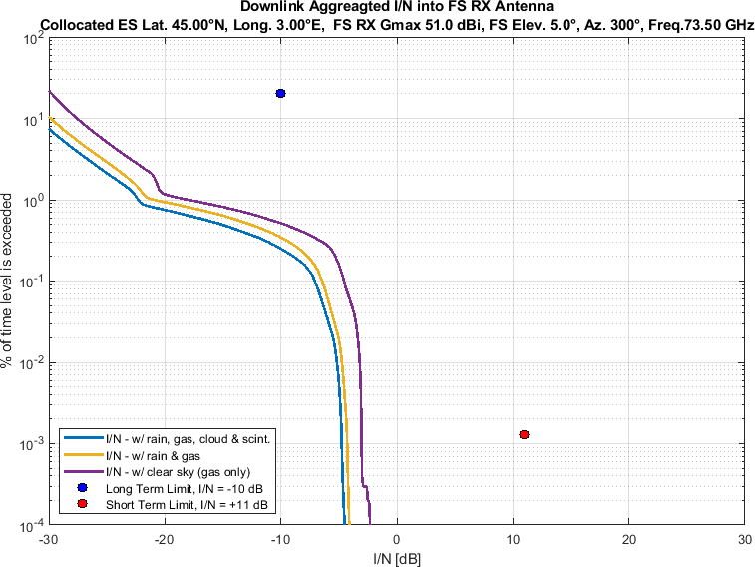

Figure 89

Aggregate *I/N* from Selected Systems at 45°N, FS max. Receive Gain 51 dBi, Azimuth 320°

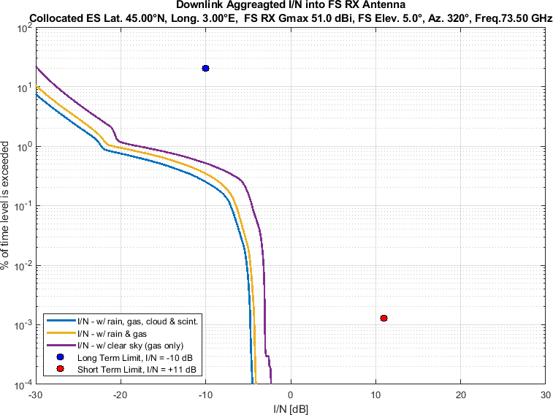

Figure 90

Aggregate *I/N* from Selected Systems at 45°N, FS max. Receive Gain 51 dBi, Azimuth 340°

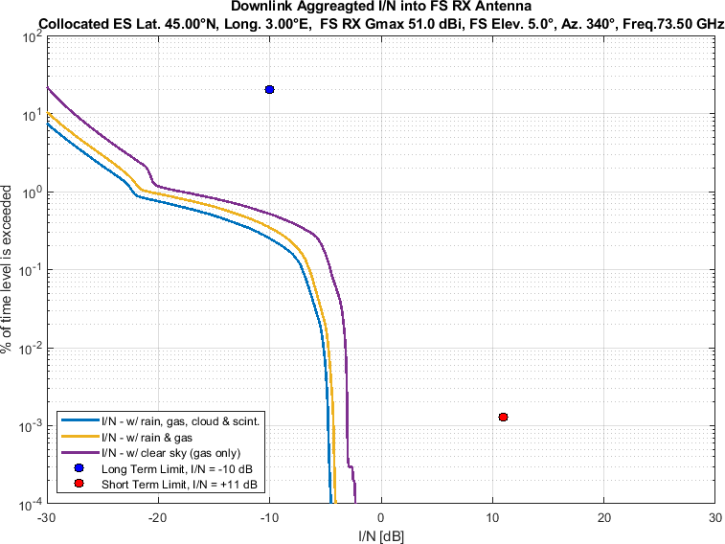

Figure 91

Aggregate *I/N* from Selected Systems at 60°N, FS max. Receive Gain 51 dBi, Azimuth 0°

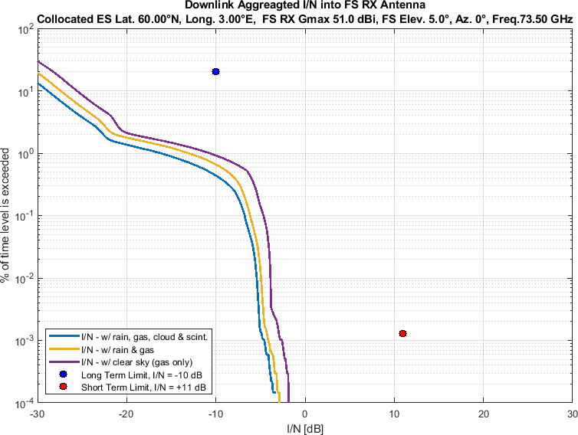

Figure 92

Aggregate *I/N* from Selected Systems at 60°N, FS max. Receive Gain 51 dBi, Azimuth 20°

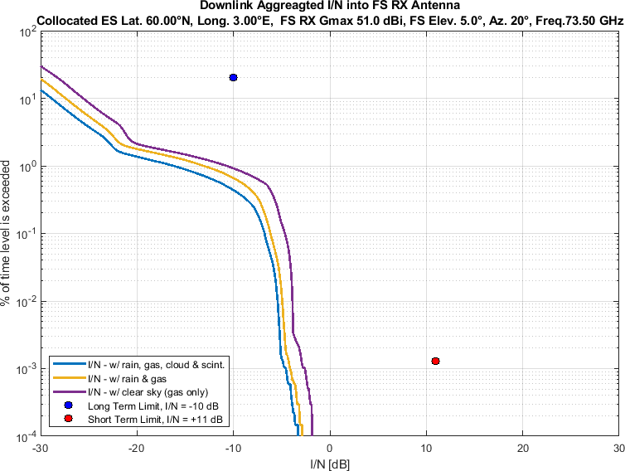

Figure 93

Aggregate *I/N* from Selected Systems at 60°N, FS max. Receive Gain 51 dBi, Azimuth 40°

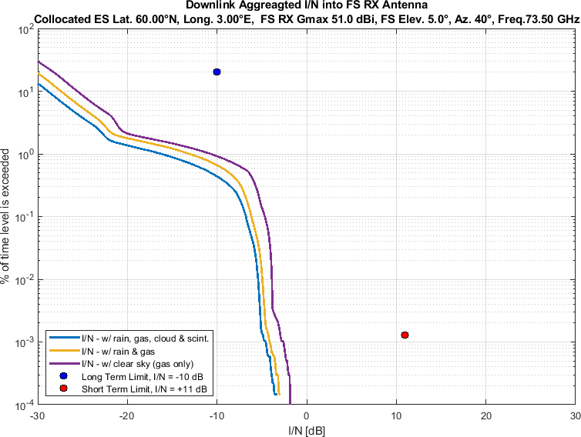

Figure 94

Aggregate *I/N* from Selected Systems at 60°N, FS max. Receive Gain 51 dBi, Azimuth 60°

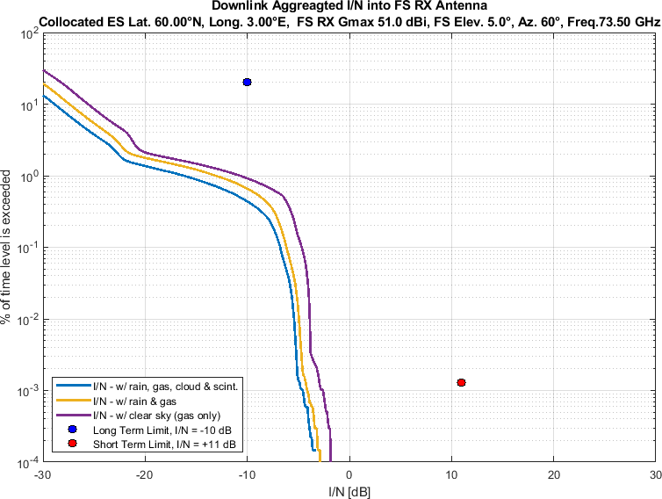

Figure 95

Aggregate *I/N* from Selected Systems at 60°N, FS max. Receive Gain 51 dBi, Azimuth 80°

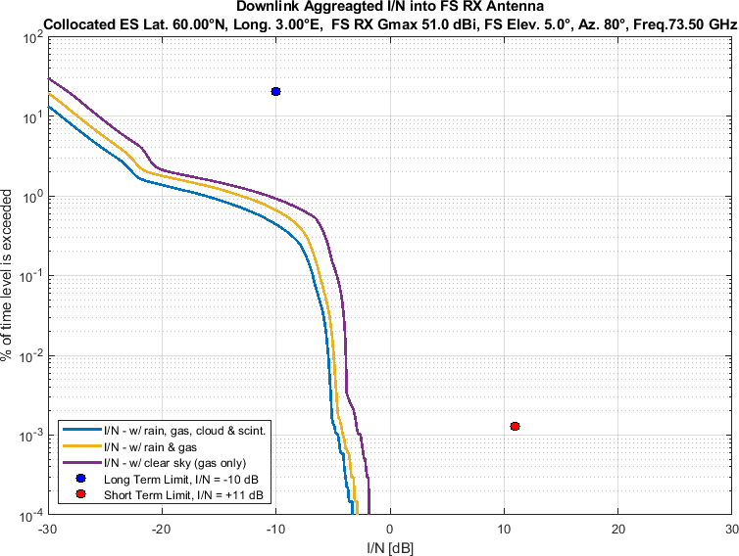

Figure 96

Aggregate *I/N* from Selected Systems at 60°N, FS max. Receive Gain 51 dBi, Azimuth 100°

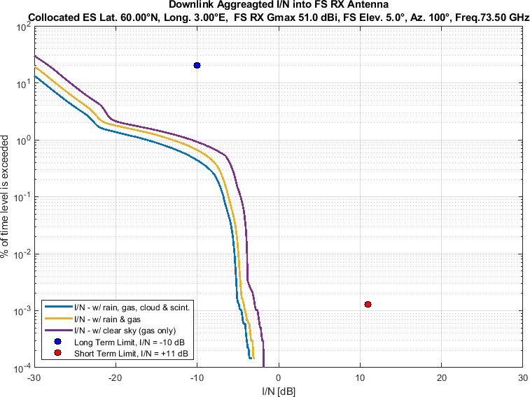

Figure 97

Aggregate *I/N* from Selected Systems at 60°N, FS max. Receive Gain 51 dBi, Azimuth 120°

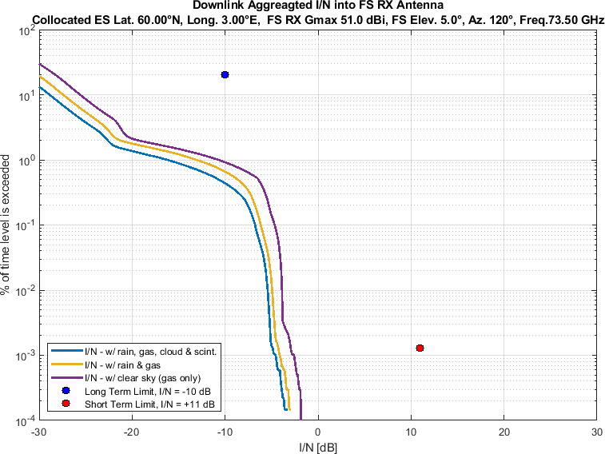

Figure 98

Aggregate *I/N* from Selected Systems at 60°N, FS max. Receive Gain 51 dBi, Azimuth 140°

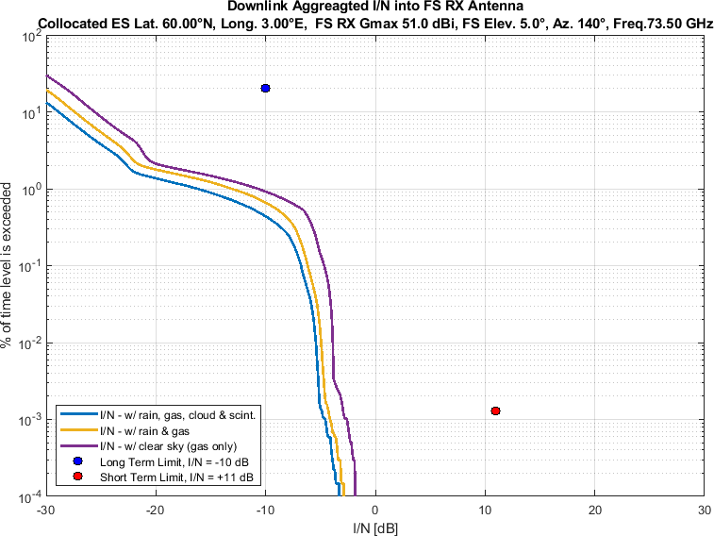

Figure 99

Aggregate *I/N* from Selected Systems at 60°N, FS max. Receive Gain 51 dBi, Azimuth 160°

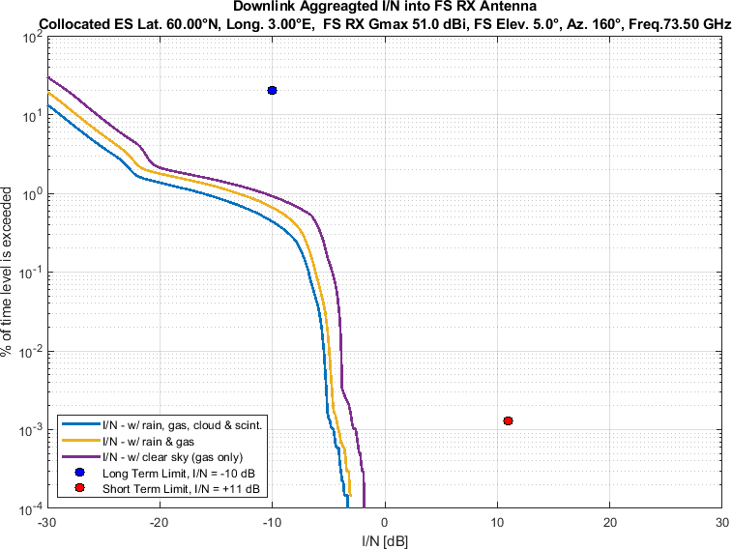

Figure 100

Aggregate *I/N* from Selected Systems at 60°N, FS max. Receive Gain 51 dBi, Azimuth 180°

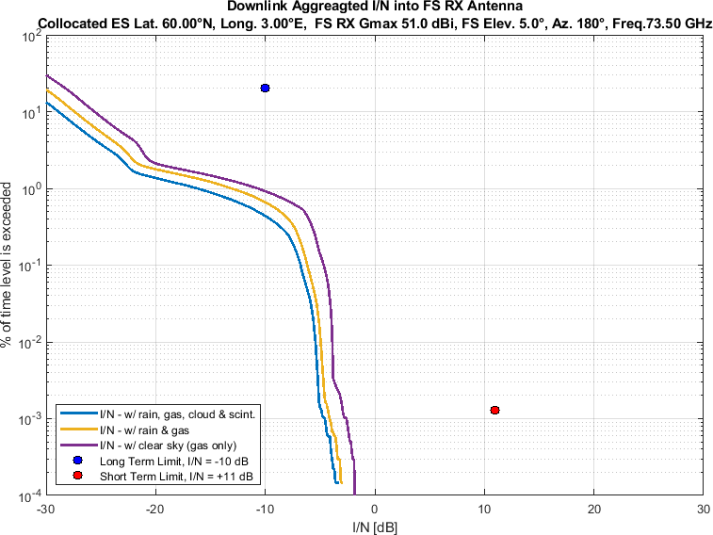

Figure 101

Aggregate *I/N* from Selected Systems at 60°N, FS max. Receive Gain 51 dBi, Azimuth 200°

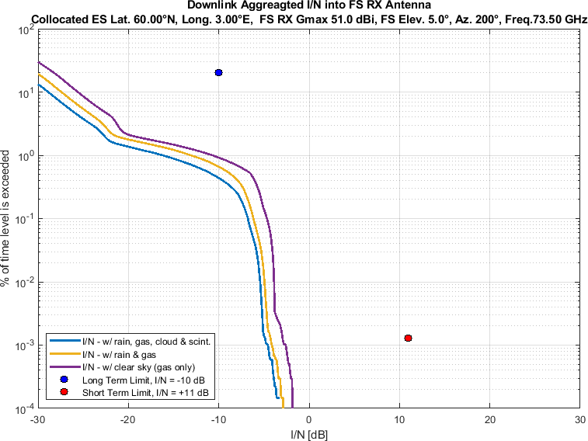

Figure 102

Aggregate *I/N* from Selected Systems at 60°N, FS max. Receive Gain 51 dBi, Azimuth 220°

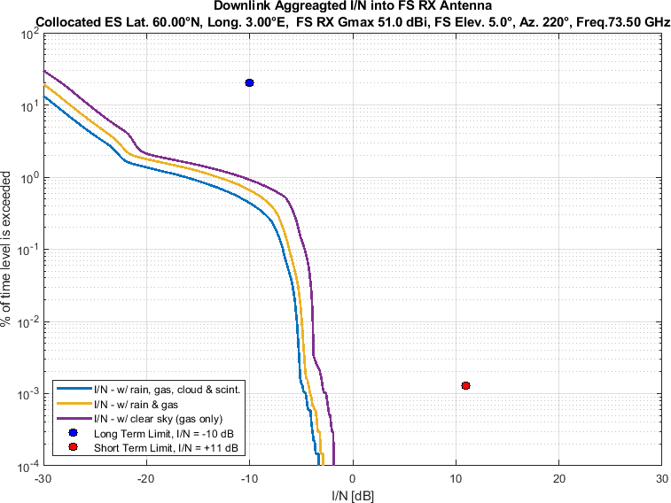

Figure 103

Aggregate *I/N* from Selected Systems at 60°N, FS max. Receive Gain 51 dBi, Azimuth 240°

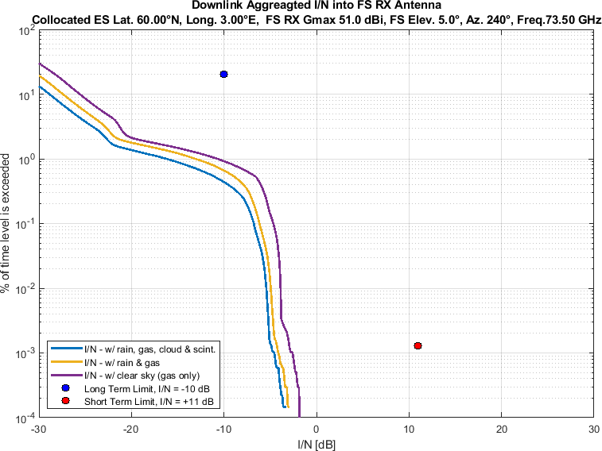

Figure 104

Aggregate *I/N* from Selected Systems at 60°N, FS max. Receive Gain 51 dBi, Azimuth 260°

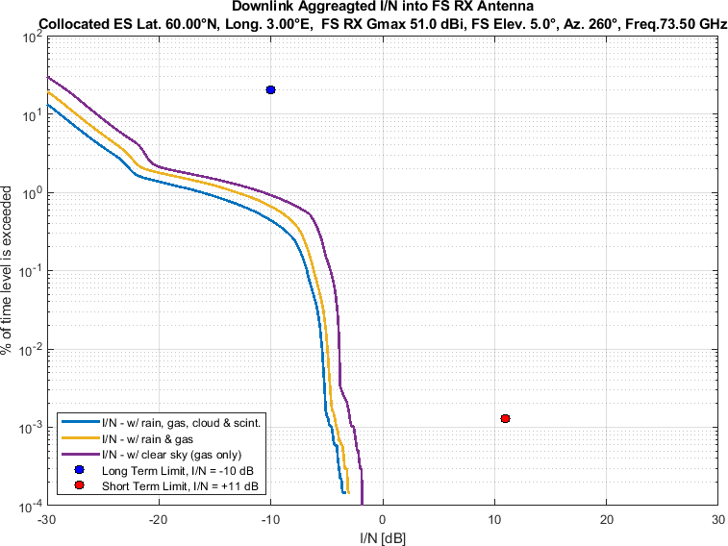

Figure 105

Aggregate *I/N* from Selected Systems at 60°N, FS max. Receive Gain 51 dBi, Azimuth 280°

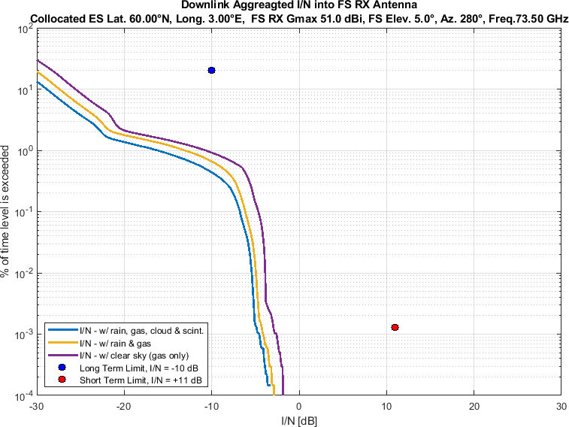

Figure 106

Aggregate *I/N* from Selected Systems at 60°N, FS max. Receive Gain 51 dBi, Azimuth 300°

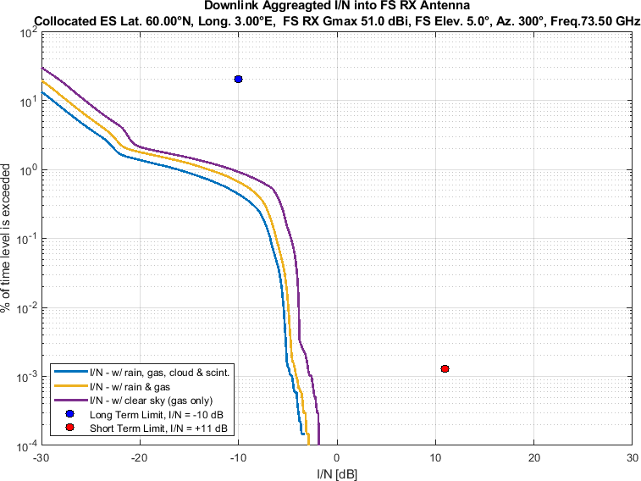

Figure 107

Aggregate *I/N* from Selected Systems at 60°N, FS max. Receive Gain 51 dBi, Azimuth 320°

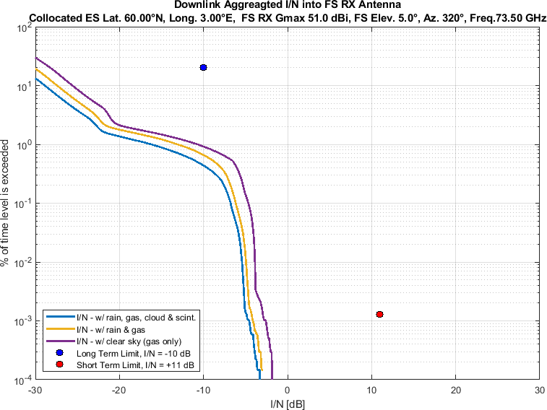

Figure 108

Aggregate *I/N* from Selected Systems at 60°N, FS max. Receive Gain 51 dBi, Azimuth 340°

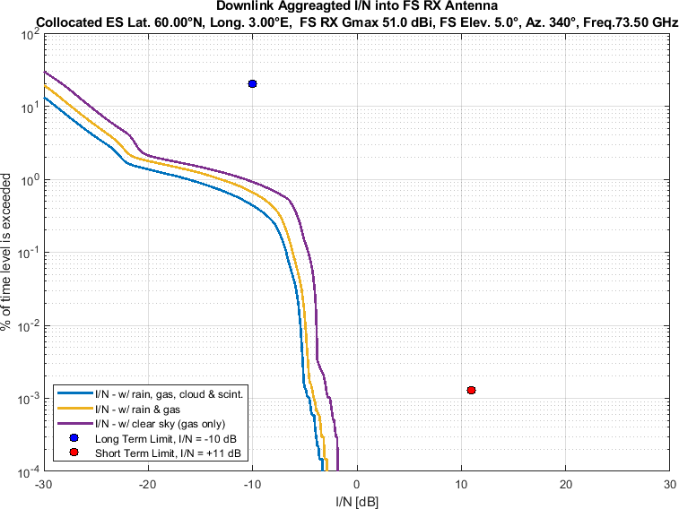

Sensitivity Analysis:

Figure 109-126 compare aggregate *I/N* from the same selected GSO and three non-GSO systems to

• the class 3 reference pattern of ETSI EN 302 217-4 as FS station antenna pattern,

• pointing at eighteen different azimuth directions at 20° intervals

• for maximum FS antenna elevation angle of 5°,

• at same representative frequency (i.e., 73.5 GHz).

Again, each figure compares three different of atmospheric attenuation scenarios as mentioned above.

Figure 109

Aggregate *I/N* from Selected Systems at 60°N, Azimuth 0°

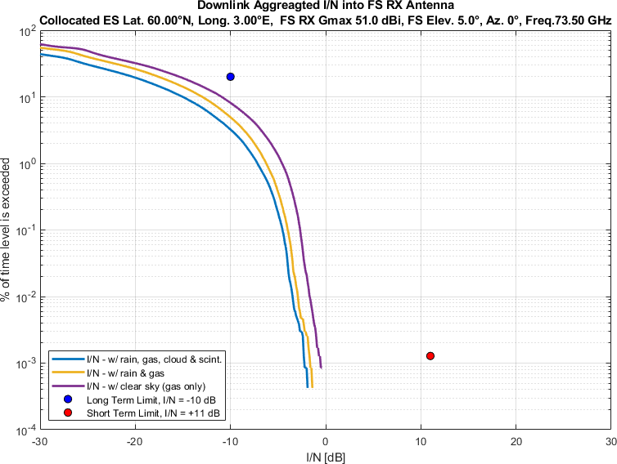

Figure 110

Aggregate *I/N* from Selected Systems at 60°N, Azimuth 20°

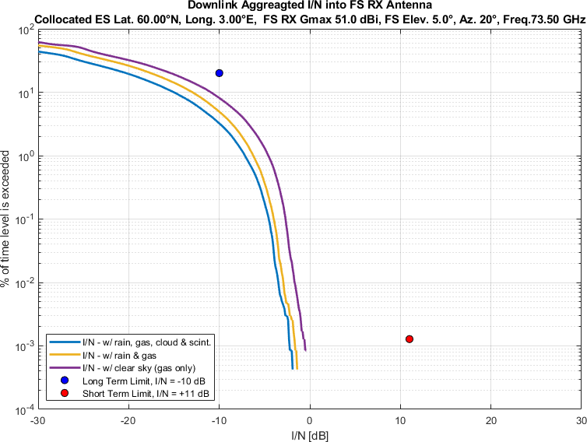

Figure 111

Aggregate *I/N* from Selected Systems at 60°N, Azimuth 40°

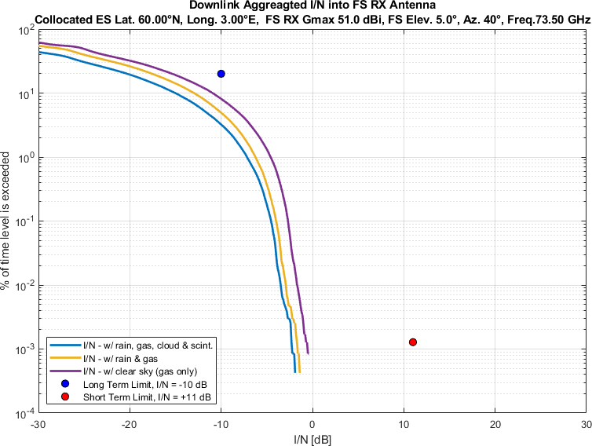

Figure 112

Aggregate *I/N* from Selected Systems at 60°N, Azimuth 60°

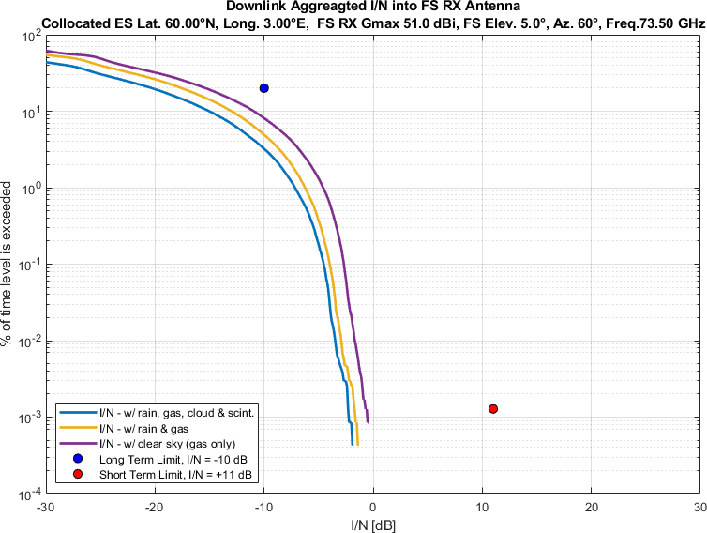

Figure 113

Aggregate *I/N* from Selected Systems at 60°N, Azimuth 80°

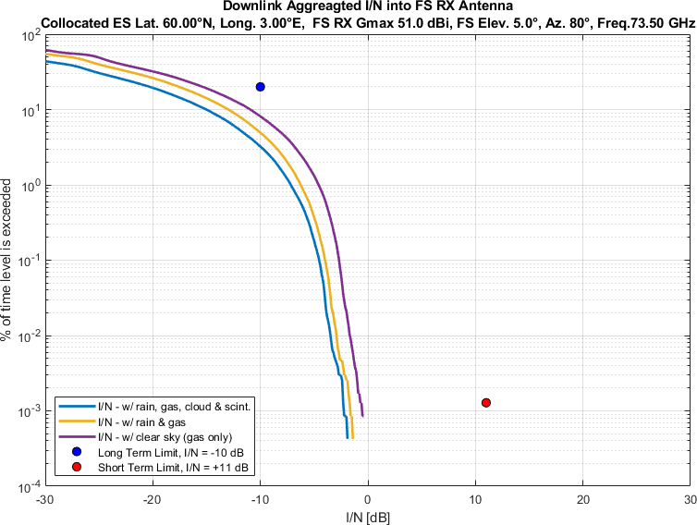

Figure 114

Aggregate *I/N* from Selected Systems at 60°N, Azimuth 100°

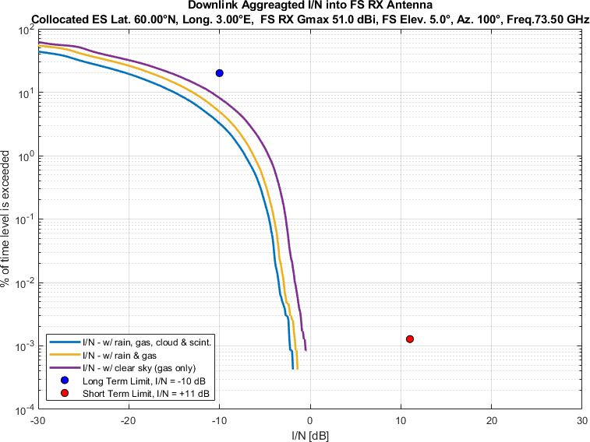

Figure 115

Aggregate *I/N* from Selected Systems at 60°N, Azimuth 120°

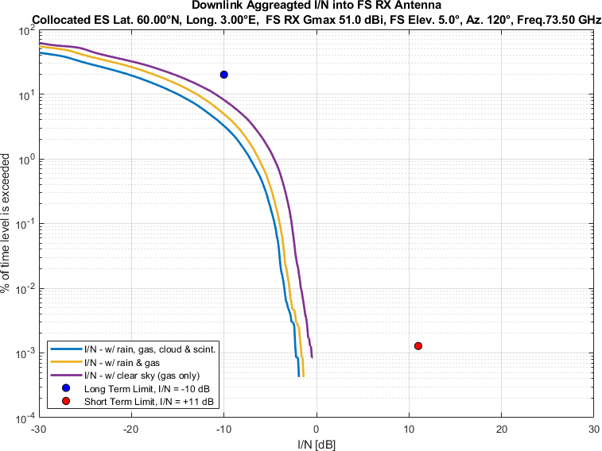

Figure 116

Aggregate *I/N* from Selected Systems at 60°N, Azimuth 140°

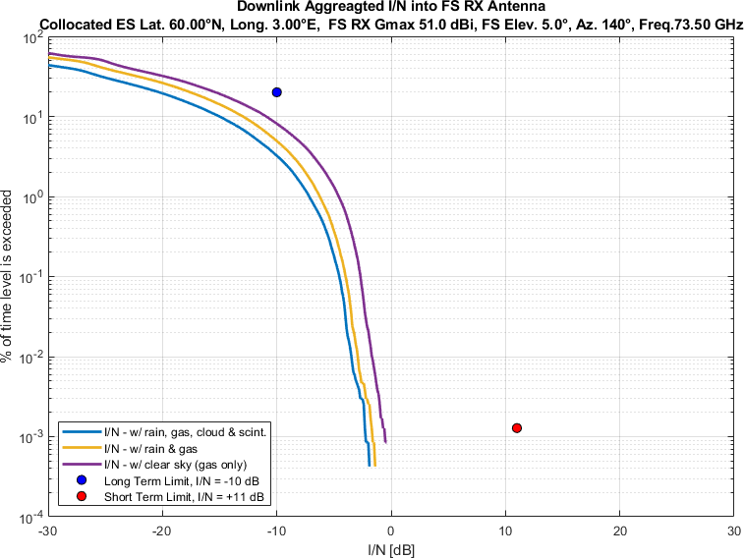

Figure 117

Aggregate *I/N* from Selected Systems at 60°N, Azimuth 160°

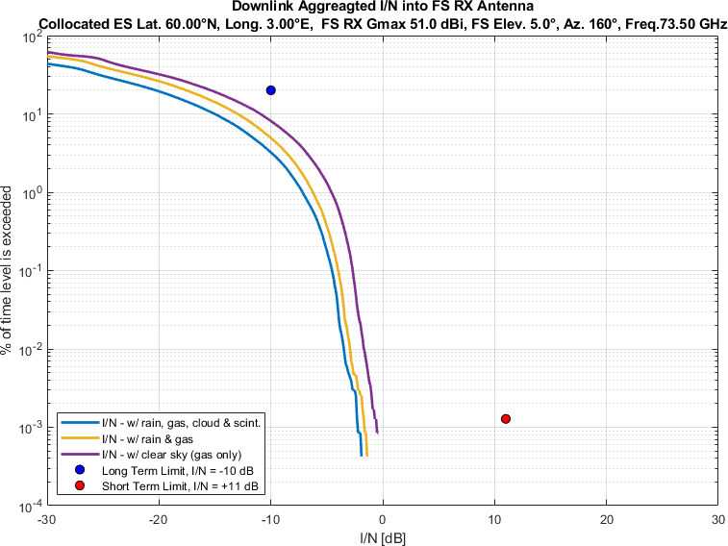

Figure 118

Aggregate *I/N* from Selected Systems at 60°N, Azimuth 180°

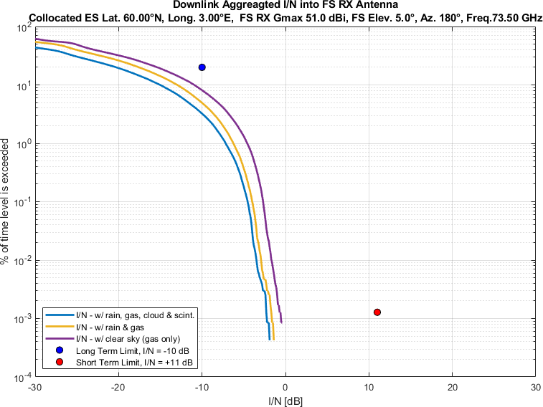

Figure 119

Aggregate *I/N* from Selected Systems at 60°N, Azimuth 200°

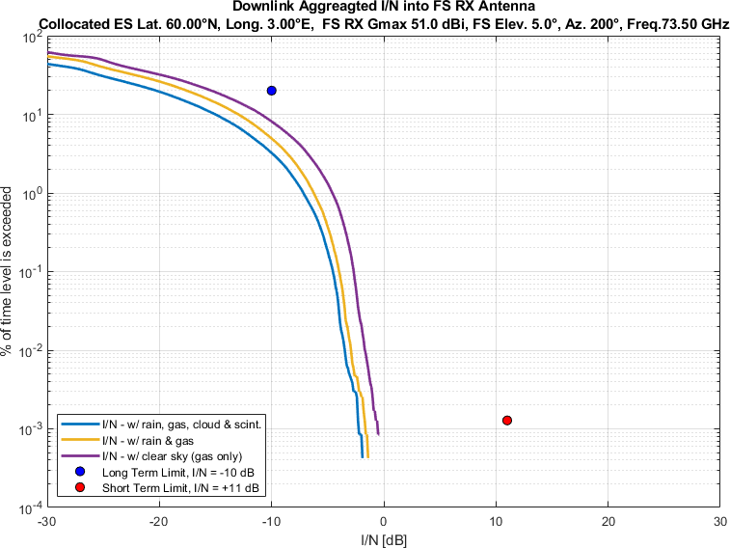

Figure 120

Aggregate *I/N* from Selected Systems at 60°N, Azimuth 220°

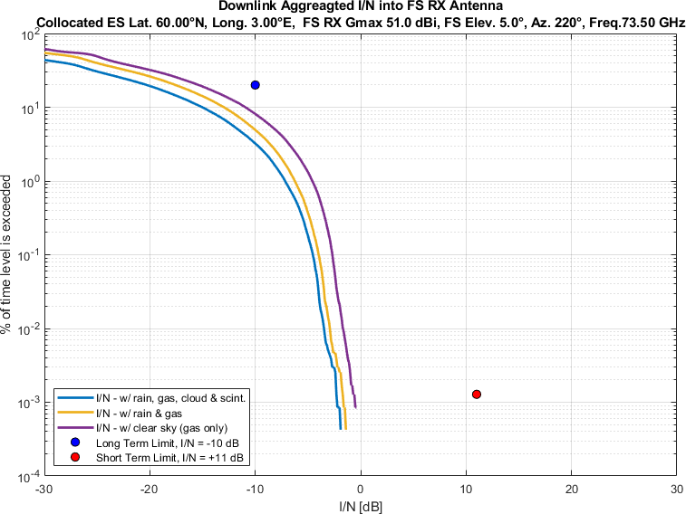

Figure 121

Aggregate *I/N* from Selected Systems at 60°N, Azimuth 240°

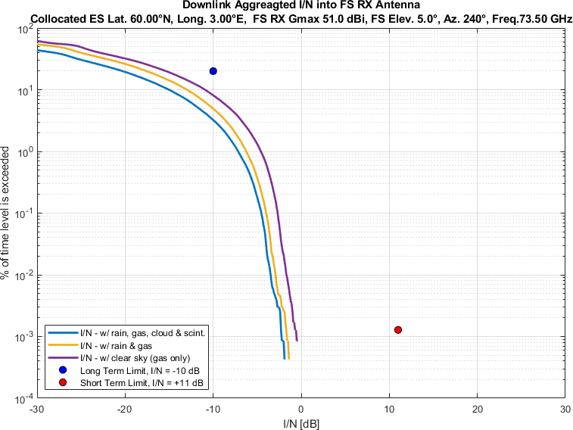

Figure 122

Aggregate *I/N* from Selected Systems at 60°N, Azimuth 260°

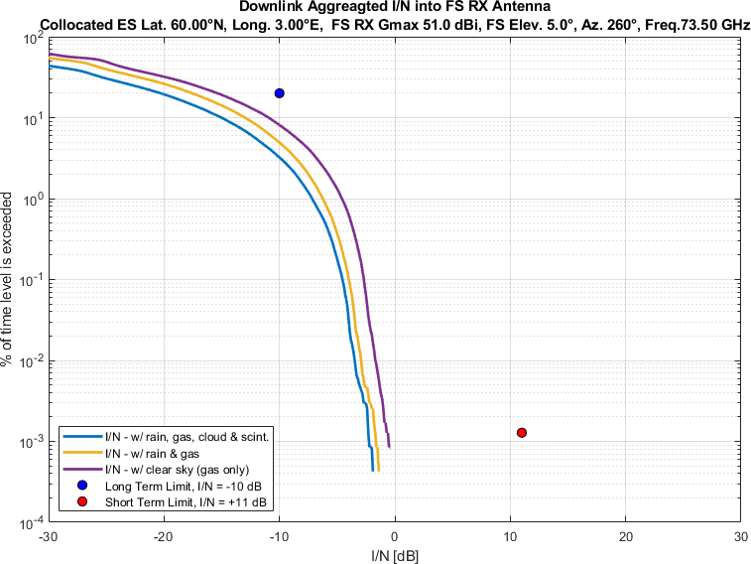

Figure 123

Aggregate *I/N* from Selected Systems at 60°N, Azimuth 280°

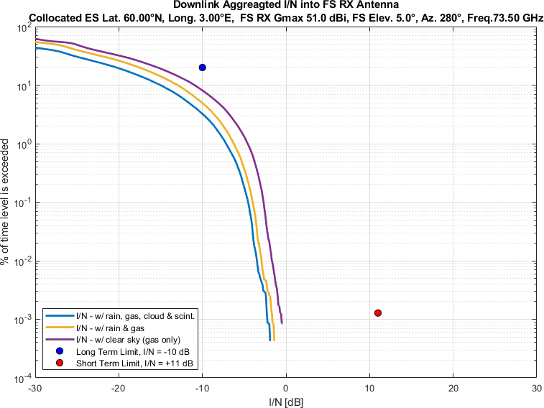

Figure 124

Aggregate *I/N* from Selected Systems at 60°N, Azimuth 300°

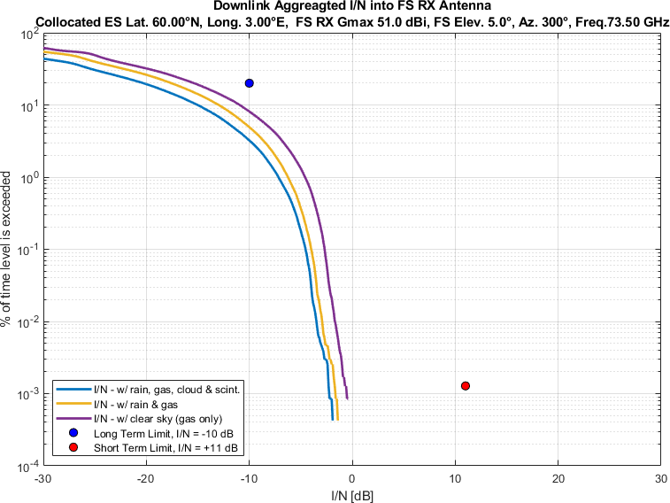

Figure 125

Aggregate *I/N* from Selected Systems at 60°N, Azimuth 320°

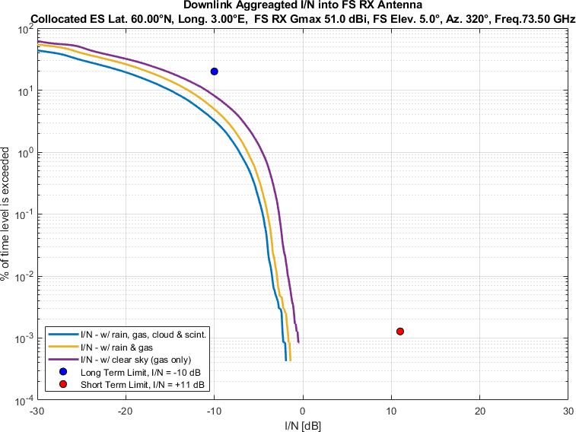

Figure 126

Aggregate *I/N* from Selected Systems at 60°N, Azimuth 340°

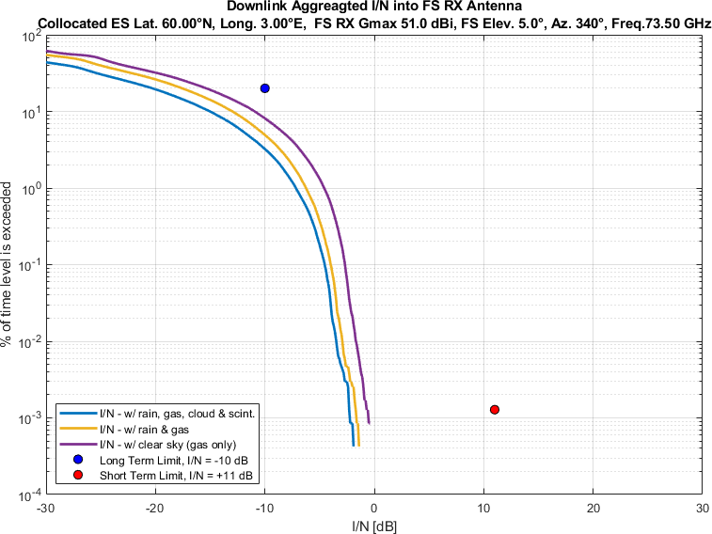

1. Sidelobe radiation pattern for each of the visible satellites of a non-GSO system have been calculated conservatively as per Recommendation ITU-R S.1528 recommends 1.2. In some other working parties’ studies, Recommendation ITU-R S.1528 recommends 1.4 has been considered for sidelobe radiation pattern.
2. Note: the GSO and NGSO systems are modelled according to certain assumptions, including minimum elevation. The Satellites below the minimum elevation cannot transmit to the victim site consequently.