U.S. Radiocommunication Sector
Fact Sheet
Working Party: ITU-R WP-5B | Document No: USWP5B-35-16
Ref: WRC-27 Agenda Item 1.8/Res. 663 (WRC-23), 5B 315/Annex 2.9 | Date: 30 Aug 2025
Document Title: WORKING DOCUMENT TOWARDS A PRELIMINARY DRAFT NEW REPORT ITU-R M.[RLS_231.5-700GHZ]
Author(s)/Contributors(s):
Ryan McDonough (NASA) | Ryan.S.McDonough@nasa.gov
Purpose/Objective: To continue development for compatibility and sharing studies performed under WRC-27 Agenda Item 1.8 in accordance with Resolution 663 (WRC-23).

Abstract: Pursuant to Resolution 663 (Rev.WRC-23), Working Party (WP) 5B is the responsible group for WRC-27 Agenda Item 1.8 request to consider possible additional spectrum allocations to the radiolocation service on a primary basis in the frequency range 231.5-275 GHz and possible new identifications for radiolocation service applications in frequency bands within the frequency range 275-700 GHz for millimetric and sub-millimetric wave imaging systems. This document will serve as a place to continue sharing and compatibility studies and their associated results for section A7 (A7.4.1.1 STUDY A) on EESS.
Fact Sheet Preparer: Ryan McDonough, NASA

Radiocommunication Study Groups | 
Received: Date 2025  Subject: WRC-27 agenda item 1.8 | Document XX/-E
Received: Date 2025  Subject: WRC-27 agenda item 1.8 | Date 2025
Received: Date 2025  Subject: WRC-27 agenda item 1.8 | Original: English
United States of America
WORKING DOCUMENT TOWARDS A PRELIMINARY DRAFT NEW REPORT ITU-R M.[RLS_231.5-700GHZ]
Studies on possible new additional allocations to the radiolocation service on a primary basis in the frequency range 231.5-275 GHz, and possible new identifications for radiolocation service applications in frequency bands within the frequency range 275-700 GHz
Pursuant to Resolution 663 (Rev.WRC-23), Working Party (WP) 5B is the responsible group for WRC-27 Agenda Item 1.8 request to consider possible additional spectrum allocations to the radiolocation service on a primary basis in the frequency range 231.5-275 GHz and possible new identifications for radiolocation service applications in frequency bands within the frequency range 275-700 GHz for millimetric and sub-millimetric wave imaging systems. This document will serve as a place to continue sharing and compatibility studies and their associated results for section A7 (A7.4.1.1 STUDY A) on EESS.

It should be noted that there are many novel vehicular short range technologies that are currently being developed and considered within several countries that may or may not be appropriate for the envisaged regulatory framework being studied under agenda item 1.8. Further discussions and shared country experiences may be useful in better understanding how these types of vehicular applications could be operated and regulated at the national and/or international levels.

Attachment: 1

Radiocommunication Study Groups
Source: 5B 315/Annex 2.9 | Annex 2.9 to  Document 5B/315-E
Source: 5B 315/Annex 2.9 | 14 May 2025
Source: 5B 315/Annex 2.9 | English only
Annex 2.9 to Working Party 5B Chair’s Report
Working document towards a preliminary draft new Report ITU-R M.[RLS_231.5-700GHz]
Frequency bands, technical characteristics, and protection criteria for sharing and compatibility studies in support of possible allocation/identification for the radiolocation service in the frequency range 231.5-700 GHz

(202X)
TABLE OF CONTENTS
1 Introduction 5
2 Provisions of the Radio Regulations 5
3 Atmospheric attenuation in the frequency bands for EESS and RAS 9
4 Characteristics of RLS systems 11
4.1 Description and operational systems characteristics of radar systems to operate
in the frequency band 231.5-450 GHz for close proximity object detection 12
4.2 Description and operational systems characteristics of vehicular radar systems
operating in the near ranges around vehicles to operate in the frequency
band 231.5-450 GHz or parts thereof 16
4.3 Description and operational systems characteristics of radar systems to operate
in the frequency range 231.5-700 GHz for security applications 23
4.4 Description and operational systems characteristics of security radar systems
to operate in the frequency band 231.5-450 GHz 29
5 Spectrum needs of RLS systems 36
5.1 Systems for close proximity object detection 36
5.2 Vehicular radar systems 36
5.3 security applications (section 4.3) 36
5.4 security applications (section 4.4) 37
6 Propagation model 37
6.1 Recommendations applicable for all sharing geometries 37
6.2 Recommendations applicable for sharing between stations
on the surface of the Earth 39
6.3 Recommendations applicable for frequencies above 200 GHz 39
7 Considerations relative to incumbent service systems 40
7.1 Summary related to fixed service systems 40
7.2 Summary related to fixed mobile service systems 40
7.3 Summary related to fixed mobile satellite service systems 40
7.4 Summary related to fixed amateur and amateur satellite service systems 40
7.5 Summary related to radionavigation service systems 41
7.6 Summary related to radionavigation satellite service systems 41
7.7 Summary related to earth exploration satellite service systems 41
7.8 Summary related to radioastronomy service systems 41
8 Conclusions 41
Annex 1 42
A1 Characteristics and technical analysis related to the fixed service systems 42
A1.1 Frequency bands 42
A1.2 Interference criteria 42
A1.3 Technical and operational characteristics 42
A1.4 Sharing and compatibility analysis 43
A1.4 Conclusions 53
Annex 2 53
A2 Characteristics and technical analysis related to the mobile service systems 53
A2.1 Frequency bands 53
A2.2 Interference criteria 54
A2.3 Technical and operational characteristics 54
A2.4 Sharing and compatibility analysis 55
A2.4 Conclusions 57
Annex 3 58
A3 Characteristics and technical analysis related to the mobile satellite service systems 58
Annex 4 58
A4 Characteristics and technical analysis related to the fixed amateur and amateur satellite service systems 58
A4.1 Frequency bands 58
A4.2 Interference criteria 58
A4.3 Technical and operational characteristics 58
A4.4 Sharing and compatibility analysis 58
Annex 5 58
A5 Characteristics and technical analysis related to radionavigation service systems 58
A5.1 Frequency bands 59
A5.2 Interference criteria 59
A5.3 Technical and operational characteristics 59
A5.4 Sharing and compatibility analysis 59
Annex 6 59
A6 Characteristics and technical analysis related to radionavigation satellite service systems 59
A6.1 Frequency bands 59
A6.2 Interference criteria 59
A6.3 Technical and operational characteristics 59
A6.4 Sharing and compatibility analysis 59
Annex 7 60
A7 Characteristics and technical analysis related to earth exploration satellite service systems 60
A7.1 Frequency bands 60
A7.2 Interference criteria 60
A7.3 Technical and operational characteristics 61
A7.4 Sharing and compatibility analysis 70
Annex 8 83
A8 Characteristics and technical analysis related to radioastronomy service systems 83
A8.1 Recommendations and Reports 84
A8.2 Representative radio astronomy sites operating in relevant frequency bands 86
A8.3 Protection criteria 90
A8.4 Graphical representations 92
A8.5 Sharing and compatibility analysis 92
Annex 9 93
A9 Common characteristics related to the RLS applications 93
A9.1 Antenna Pattern 93

Scope
TBD
Keywords
TBD
List of Abbreviations/Glossary
TBD
Related ITU-R Recommendations and Reports
TBD

1 Introduction
WRC-23 approved WRC-27 agenda item 1.8 ‘to consider possible additional spectrum allocations to the radiolocation service on a primary basis in the frequency range 231.5-275 GHz and possible new identifications for radiolocation service applications in frequency bands within the frequency range 275-700 GHz for millimetric and sub-millimetric wave imaging systems, in accordance with Resolution 663 (Rev.WRC-23)’.
Resolution 663 (Rev.WRC-23) calls to conduct the following studies:
1 the description of the technical and operational characteristics, including required protection criteria, for those receive-only and active millimetric and sub-millimetric wave RLS systems and applications in the categories listed in recognizing a);
[Editor’s Note: the result of discussion of 5B/180 should be reflected here]
2 studies on globally harmonized spectrum for the RLS, in particular for those millimetric and sub-millimetric wave RLS systems and applications above 231.5 GHz;
3 sharing and compatibility studies (in-band and adjacent bands) for active millimetric and sub-millimetric wave RLS systems and applications with other services in the frequency range 231.5-275 GHz, while ensuring protection for the current use and further development of the incumbent services allocated to this frequency range;
4 sharing and compatibility studies (in-band and adjacent bands) for RLS applications with EESS (passive), space research service (passive) and RAS applications in the frequency range 275-700 GHz, while maintaining protection for the passive service applications identified in No. 5.565;
5 sharing and compatibility studies (in-band and adjacent bands) for RLS applications with fixed service and land mobile service applications in the frequency range 275-450 GHz, as identified in No. 5.564A.
This document contains the result of the studies in response to these five bullets.

2 Provisions of the Radio Regulations
The extract from Article 5 of Radio Regulations, edition 2024, is presented in Table 1 for the frequency range 231.5-3000 GHz.
Table 1
Extract from Article 5 of Radio Regulations
Allocation to services
Region 1 | Region 2 | Region 3
231.5-232 FIXED
MOBILE
Radiolocation
232-235 FIXED
FIXED-SATELLITE (space-to-Earth)
MOBILE
Radiolocation
235-238 EARTH EXPLORATION-SATELLITE (passive) 5.563AA
FIXED
FIXED-SATELLITE (space-to-Earth)
MOBILE
SPACE RESEARCH (passive)
5.563A 5.563B
238-239.2 FIXED
FIXED-SATELLITE (space-to-Earth)
MOBILE
RADIOLOCATION
RADIONAVIGATION
RADIONAVIGATION-SATELLITE
239.2-240 EARTH EXPLORATION-SATELLITE (passive)
FIXED-SATELLITE (space-to-Earth)
RADIOLOCATION
RADIONAVIGATION
RADIONAVIGATION-SATELLITE
240-241 EARTH EXPLORATION-SATELLITE (passive)
RADIOLOCATION
241-242.2 EARTH EXPLORATION-SATELLITE (passive)
RADIO ASTRONOMY
RADIOLOCATION
Amateur
Amateur-satellite
5.149
242.2-244.2 RADIO ASTRONOMY
RADIOLOCATION
Amateur
Amateur-satellite
5.138 5.149
244.2-247.2 EARTH EXPLORATION-SATELLITE (passive)
RADIO ASTRONOMY
RADIOLOCATION
Amateur
Amateur-satellite
5.138 5.149
247.2-248 RADIO ASTRONOMY
RADIOLOCATION
Amateur
Amateur-satellite
5.149
248-250 AMATEUR
AMATEUR-SATELLITE
Radio astronomy
5.149
250-252 EARTH EXPLORATION-SATELLITE (passive)
RADIO ASTRONOMY
SPACE RESEARCH (passive)
5.340 5.563A
252-265 FIXED
MOBILE
MOBILE-SATELLITE (Earth-to-space)
RADIO ASTRONOMY
RADIONAVIGATION
RADIONAVIGATION-SATELLITE
5.149 5.554
265-275 FIXED
FIXED-SATELLITE (Earth-to-space)
MOBILE
RADIO ASTRONOMY
5.149 5.563A
275-3 000 (Not allocated) 5.564A 5.565

The allocations on the primary basis in the frequency range 231.5-275 GHz are shown schematically in Figure 1, only allocation to the radiolocation service in the frequency band 231.5-235 GHz is on the secondary basis. The identifications in the frequency range 275-700 GHz are shown in Figure 2. The use of applications of other services is not precluded in the frequency range 275-450 GHz, the frequency range 450-700 GHz can be used by active services, including fixed and mobile service applications.
FIGURE 1
Allocations in the frequency range 231.5-275 GHz
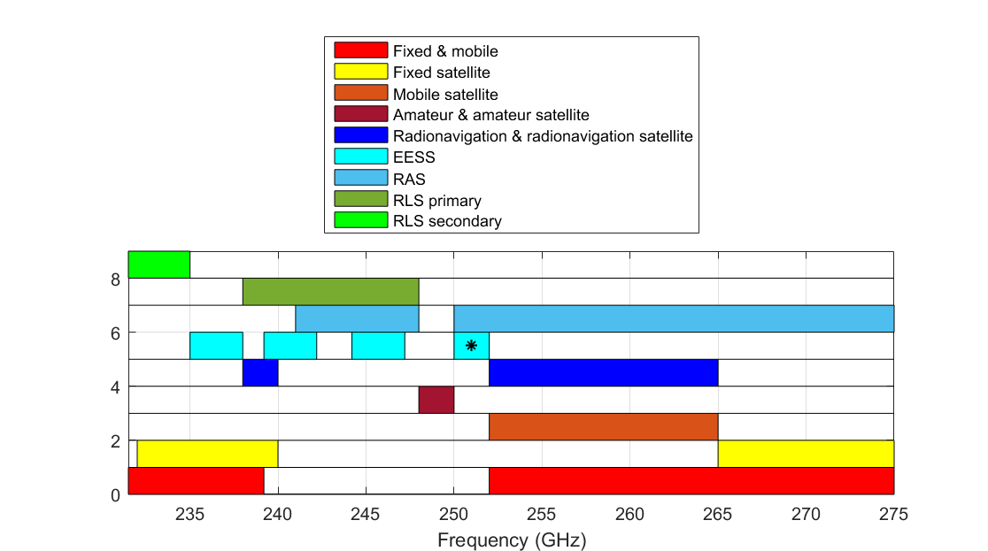
* RR 5.340 (250 – 252 GHz)
Note: No studies under WRC-23 AI 1.14 for RLS versus EESS (passive) around 240 GHz
FIGURE 2
Identifications in the frequency range 275-700 GHz
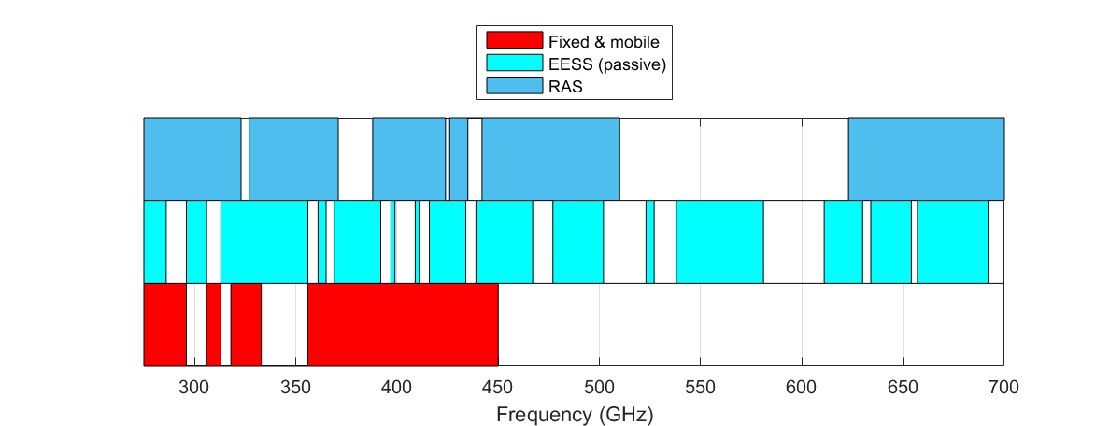
Article 1 of Radio Regulations contains the following terms and definitions in relation to radiolocation systems:
1.9 radiodetermination: The determination of the position, velocity and/or other characteristics of an object, or the obtaining of information relating to these parameters, by means of the propagation properties of radio waves.
1.11 radiolocation: Radiodetermination used for purposes other than those of radionavigation.
1.40 radiodetermination service: A radiocommunication service for the purpose of radiodetermination.
1.48 radiolocation service: A radiodetermination service for the purpose of radiolocation.
1.100 radar: A radiodetermination system based on the comparison of reference signals with radio signals reflected, or retransmitted, from the position to be determined.
1.101 primary radar: A radiodetermination system based on the comparison of reference signals with radio signals reflected from the position to be determined.
1.102 secondary radar: A radiodetermination system based on the comparison of reference signals with radio signals retransmitted from the position to be determined.
[According to these definitions, radar may work only based on the comparison of reference signals with radio signals reflected (primary radar), or retransmitted (secondary radar), from the position to be determined. The receive-only use of systems and applications aimed to detect naturally radiated power is outside of the radiolocation service as it is defined in the Radio Regulation.]

[Editor’s Note: The status of receive only systems within the RLS may need to be addressed]

3 Atmospheric attenuation in the frequency bands for EESS and RAS
The frequency range 231.5-700 GHz is characterized by important atmospheric attenuation due to dry air and water vapour. The specific attenuation and attenuation for zenith path are shown in Figures 3 and 4, respectively, for ITU-R reference atmosphere (See Recommendation ITU-R P.835).
FIGURE 3
Specific attenuation by atmospheric gases for ITU-R reference atmosphere based on
Recommendation ITU-R P.676
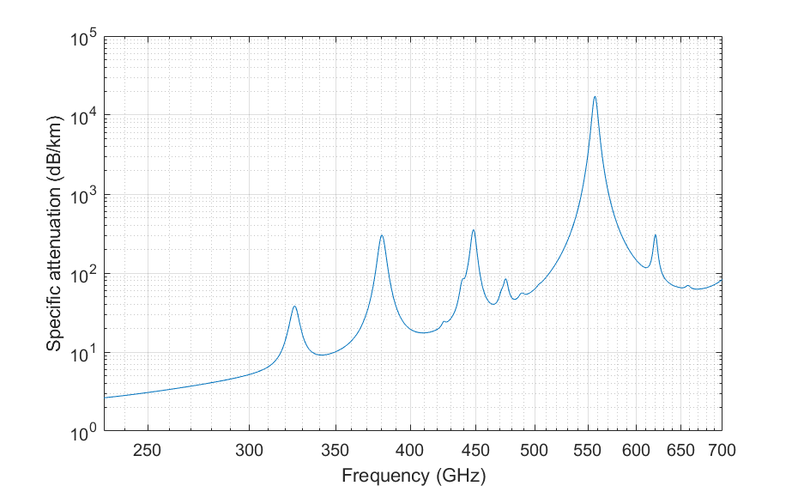
FIGURE 4
Zenith attenuation by atmospheric gases for ITU-R reference atmosphere based on
Recommendation ITU-R P.676
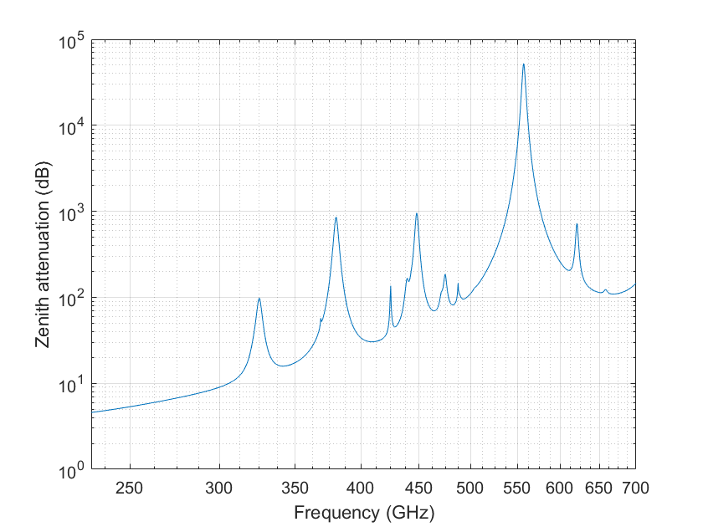
Frequency bands allocated or identified for EESS (passive) and RAS were selected in the frequency ranges corresponding to spectral lines for EESS (passive) and to the ranges between spectral lines (windows) for RAS.
General Considerations On EESS Frequency Dependent Sensitivities
The following figure demonstrates a baseline interference margin applied to the 20 proposed frequency ranges by taking into account max protection criteria (according to A7.2) and basic propagation losses: atmospheric and free-space-loss. The figure assumes a nominal EESS (passive) receiver at 800 km altitude, nadir mode, and ground reference altitude of 300 m AMSL. The margin refers to maximum EIRP (in dBW) in the relevant reference bandwidth directed back up to the orbiting sensor. Note that this scenario takes into account integrated losses through the entire atmosphere and does not take into account antenna gains of the sensor or radar systems, additional losses due to clutter, building exit losses, etc. The intention of this figure is that it should provide a rough baseline of remaining margin available to avoid exceeding protection levels for the targeted frequency ranges of study. The red shaded panels in the figure refer to RR No. 5.340 bands and the blue panels bound the frequency ranges of study.
The amateur and amateur-satellite services have a primary allocation covering the 248-250 GHz frequency band. The generic characteristics for stations of the amateur and amateur-satellite services using those bands are given in Tables 1B, 2B, 3B, 5, 6, 7 and 8 in Recommendation ITU-R M.1732-3. It should be noted that the available transmitter power for typical amateur transmitters using those bands is quite limited and is generally no more than a few milliwatts, to make up for this limitation typical maximum antenna gain of 52 dBi may be considered, where applicable, as listed in Recommendation ITU-R M.1732.
This figure demonstrates that there is a very wide range of margin values depending on the operational frequency due almost entirely to attenuation effects. It is meant to identify how much margin is available that could become closed mostly due to aggregate interference and pointing antenna alignment and its associated signal enhancements. This figure is not intended to draw conclusions about sharing and compatibility.
figure a7.4-1
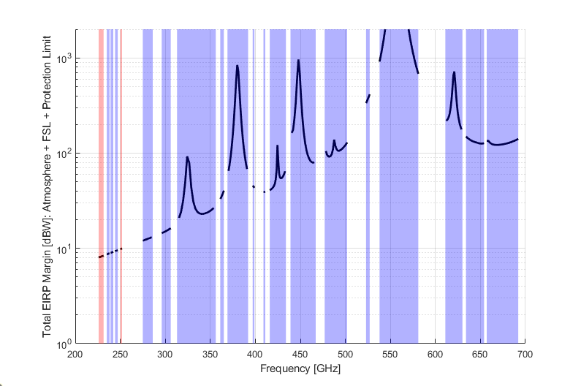
Blue above 275 GHz are RR No. 5.565 identifications
Blue between 235-275 GHz EESS(p) bands

4 Characteristics of RLS systems
[Editor’s note:
The following questions were received, and contributions are invited to address those items at the next meeting:
– More information on concept and scenario of operations will be helpful for understanding how this technology is deployed. Particularly the mobile radar systems are novel and can benefit from illustrative example.
– Area of simulation versus use of e.g. population density (a model is needed in relation with the deployment) – covered for proximity object detection (mobile/fixed), to be clarified for vehicular
– Unwanted Emissions, defined at which point? [likely TRP?]
– Regarding the use of necessary bandwidth Table 1 in 4.2 says for low speed operation, the full necessary bandwidth is used for each individual radar system Also, what are spectrum utilization mechanisms intended to accommodate high number of user elements?
Vehicular: The described vehicular radar sensors need to have access to contiguous segments of spectrum. See chapter 4.2.2.2 for further information.
– Address RLS spectrum requirement i.e. how many channel/bands is needed for this RLS application? There are at least 2 different systems. Will they all use the same spectrum or need separate one?
Vehicular: Spectrum usage depends on the usage and deployment scenarios.
Vehicular: In case of additional studies to be added the situation needs to be further examined.
– The protection of the potential RLS allocation needs to be addressed including protection criteria (I/N = −6 dB)
Vehicular: See chapter 4.2.5
- to confirm that systems operating under no protection approach (example: short range devices) are outside the scope of this agenda item
– special care would be considered on how the duty cycle and activity factor may be used in particular if expected to apply attenuation in dB that is not applicable in all cases.
]
Add Overview Table:
Type of Radar / bands of interest

4.1 Description and operational systems characteristics of radar systems to operate in the frequency band 231.5-450 GHz for close proximity object detection

4.1.1 Introduction
A description and operational system characteristics of radar systems to operate in parts of the frequency band 231.5-450 GHz is presented here.
Radiolocation Service (RLS) radar systems include three primary aspects: sensing, positioning, and localization where:
– Sensing involves the reception and processing of radio signals to gather information pertinent to a specific service. This process can utilize the geometry of the transmitter, receiver, and the environment, as typically seen in radar applications. However, some sensing tasks, like pollution monitoring, may not depend on such spatial information.
– Positioning determines the location coordinates of a connected device in a certain frame of reference using signal metrics, so it relies on sensing.
– Localization extends beyond positioning by also estimating the location coordinates of passive objects or targets in a certain frame of reference, enabling what is known as device-free localization.
The radars under considerations here are monostatic and can be mobile and/or fixed. It is used for measuring different physical parameters like presence, distance, velocity, or material properties of a target object. The obtained information is further processed and used for example to aid automation purposes. The radar application is intended for private use. They can be operational indoor and/or outdoor with a predominant usage indoor. The sensing radar does not operate all the time and its activity, i.e. when it is transmitting, is dependent on the combination of the duty cycle (in %) of the technology and the activity factor (in %) from the user or the system.
Considering pointing direction, it is assumed random pointing for any simulation time step subject to elevation mask constraints specified.
With regard to determining the active state of a single device it modelled as a random variable with probability for any given time step a fixed value according the simple product of activity factor with duty cycle. For instance, a duty cycle of 10% combined with an activity factor of 4% indicates that the probability that a single device is actively transmitting at a given time step is 0.4%.
Mobile or fixed RLS in this frequency range will contribute to object detection in close proximity by using radar-based functions with high resolution.

4.1.2 Technical characteristics of radar systems operating in the frequency range 231.5-450 GHz or parts thereof
The technical parameters of RLS radar systems operating in the frequency range 231.5-450 GHz or parts thereof are presented in Table 1. These RLS radar types will be mounted on individual mobile and /or fixed devices.
TABLE 1
RLS radar technical parameters in the frequency range between 231.5 and 450 GHz or parts thereof
Parameter | Units | Radar A  Scanning mode | Radar B  Focusing/tracking mode
Frequency band used (Note 1)  [Editor’s note: to be further assessed through the technical analysis, >100 GHz frequency range.] | GHz | 252-296  356-439 GHz | 252-296  356-439 GHz
Typical operating range | m | Up to 15 | Up to 10
Typical number of RLS radars per handheld (note 2a) | - | 2 | 2
Range resolution | cm | 10 | 1-2
Typical emission type |  | FMCW, FMCW-variants | FMCW, FMCW-variants
Max occupied bandwidth | GHz | 3 | 20
Chirp bandwidth (necessary bandwidth) | GHz | max 2.5 | max18
Typical sweep time | ms | 0.1-1 | 0.1-1
Maximum e.i.r.p. | dBm | 25 | 25
Max power density of unwanted emission | dBm/MHz | –30 | –30
Duty cycle (Note 3) | % | 10 | 10
Activity factor (Note 3) | % | 10 | 1
Receiver IF bandwidth | MHz | 15 | 100
Receiver sensitivity | dBm | –173.9 dBm/Hz + 10*log10(15 MHz) =  –102 | –94
Receiver noise figure | dB | 10 | 10
Typical antenna main beam gain | dBi | TX: 15  RX: 15 | TX: 15  RX: 15
Antenna height | m | 1.5 (mobile)  2.5 (fixed) | 1.5 (mobile)  2.5 (fixed)
Downtilt for fixed device only | deg | –25 (wall mounted)  –90 (ceiling mounted) | –25 (wall mounted)  –90 (ceiling mounted)
Antenna azimuth 3 dB beamwidth | degrees | ±3 | ±3
Antenna elevation 3 dB beamwidth | degrees | ±10 | ±10
Motion | - | Mobile (indoor/outdoor)  Or fixed indoor | Mobile (indoor/outdoor)  Or fixed indoor
Urban deployment density (Note 4) (Note 2) | devices/km² | 1 000-2 500 (mobile)  1 000-2 500 (fixed) | (Note 5)
Suburban deployment density (Note 4) (Note 2) | devices/km² | 100-250 (mobile)  100-250 (fixed) | (Note 5)
Rural deployment density (Note 4) (Note 2) | devices/km² | 10-25 (mobile)  10-25 (fixed) | (Note 5)
Antenna polarization |  | Linear | Linear
Average Antenna polarization loss | dB | 3 | 3
Average body/casing loss | dB | 3 (without body/casing shielding)  20 (full body/casing shielding) | 3 ( without body/casing shielding)  20 (full body/casing shielding)
Antenna efficiency loss | dB | 3 | 3
Indoor mobile deployment |  | 90% | 90%
Frequency reuse |  | 1 | 1
Note 1: The frequency bands listed in RR No 5.340 are excluded from the studies.

Note 2a: on the same device only one radar is ever active. It switches between them.
Note 2: These numbers of device densities (i.e. devices/km²) would represent a penetration rate from 5% to 12.5% of the population density when taking the example of a large dense urban city like Paris (e.g. 20000 inhabitants/ km²). For population density-based simulations, it is preferred to use the penetration rate of 5% to 12.5% associated to the real population density from database.
Note 3: Duty cycle (in %) is technology dependent while the activity factor (in %) is user or system dependent (with reference to 1 day).
Note 4: It is expected that the RLS use case will be distributed over 3 bands: 60 GHz, 140 GHz and above 231.5 GHz. Depending on the actual implementation requirements, a different band may be chosen (power/efficiency, integration size and bandwidth/resolution). This makes it difficult to foresee a definitive deployment number. Therefore, a range is provided.
Note 5: The number of devices is the same whether it is in scanning or focus/tracking mode, i.e. there should not be doubled counted. The scanning or focus/tracking mode are not active at the same time.

4.1.3 Antenna pattern
The equations for the antenna pattern are contained in Annex 9.1
The antenna patterns presented in in Figure 1 describes the envelope antenna pattern of the radar sensor. The function of the radar sensor is provided within the envelope antenna pattern. The patterns are theoretically designed based on the model given in the equations.
The radar sensor does not transmit over full envelope antenna pattern at any time. The radar sensor is scanning within the envelope pattern with an antenna pattern that has a smaller beamwidth. The scanning (with possible different aiming/radiation directions) is performed within the envelope antenna pattern and is used to detect and track objects. Transmission of the radar is only in the direction of a detected object, there is no transmission into the other areas of the envelope pattern. [Editors Note: More information on the instantaneous patter would be helpful for simulations]
Antenna pattern using these formulas for the sensing radar defined in Table 1 is presented in Figures 1.
Figure 1
Antenna pattern examples in transmission for close proximity object detection

4.1.4 Operational characteristics of radar systems operating in the frequency bands 231.5-450 GHz
Sensing of passive objects will be instrumental in creating digital representations of physical entities or environments. Sensing with 20 GHz of bandwidth or more enables more accurate modelling with extreme fine ranging. In this case of monostatic sensing, the transmitter and receiver are co-located.
For the implementation of the envisaged radar-based functions, one or multiple radar sensors will be mounted on the mobile/fixed device so that the coverage of the near range of the handheld is achieved. These radars switches between them and only one is ever active.
The mounting positions for the radar sensors vary to facilitate coverage of the different ranges of a handheld. The device might be stationary (fixed) or moving (mobile). There is a scanning and focusing mode. The scanning mode rate is faster to detect an object (i.e. higher activity factor) than for the focusing mode, but less bandwidth and less resolution. Once detected in the scanning mode the object may be tracked in the focus mode with higher range resolution capability (i.e. with a higher bandwidth, but lower activity factor).
The maximum necessary bandwidth indicated for the radar sensors will mainly be used in urban scenarios, where the mobile device radar(s) is(are) scanning its surrounding for objects, but by its nature it is not limited to urban only and can be used in suburban and rural at a lower deployment density.
In the indoor environment there may be obstructions, and a fixed device would have a better chance detection of an object. This may be more effective than each mobile device scanning on its own.
Since the mobile device is most likely battery operated, its transmission is sporadic, i.e. not continuous in the time domain. The need for the spectrum is dependent on the activity factor and duty cycle.

4.2 Description and operational systems characteristics of vehicular radar systems operating in the near ranges around vehicles to operate in the frequency band 231.5-450 GHz or parts thereof

4.2.1 Introduction
The present document provides an example of an application under the Radio Location Service, technical and operational characteristics and deployment information for vehicular radars operating in the near ranges around vehicles operating in the frequency band 231.5-450 GHz or parts thereof.
Vehicular radars in this frequency range will contribute to traffic-safety (the provisions of RR No. 4.10 do not apply) for vehicle passengers and road users by realizing additional radar-based functions that require a high resolution.
Considering pointing direction, it is assumed random pointing for any simulation time step subject to elevation mask constraints specified.
With regard to determining the active state of a single device it modelled as a random variable with probability for any given time step a fixed value according to the simple product of activity factor with duty cycle. For instance, a duty cycle of 10% combined with an activity factor of 4% indicates that the probability that a single device is actively transmitting at a given time step is 0.4%.

4.2.2 Technical characteristics of vehicular radars operating frequency
band 231.5-450 GHz or parts thereof
Multiple vehicular radar sensors of type X and type Y are envisioned to be installed at one vehicle.
The following subchapters provide information about the individual vehicular radar sensor types and vehicles that are equipped with a certain number of the described radar sensors.

4.2.2.1 Technical parameters for vehicular radar sensors operating in the frequency range 231.5 – 450 GHz or parts thereof
Table 1 provides the technical parameters for two types of vehicular radar sensors that will cover the near ranges of a vehicle.
TABLE 1
Technical parameters for vehicular radars in the frequency band between 231.5-450 GHz or parts thereof
Parameter | Units | Radar X  Short Range | Radar Y  Parking (support)
Frequency bands used (Note 1)  [Editor’s note: to be further assessed through the technical analysis, >100 GHz frequency range.] | GHz | 252-275 GHz  275-296 GHz  356-439 GHz | 252-275 GHz  275-296 GHz  356-439 GHz
Typical operating range | m | 25 | 10
Typical number of sensors per vehicle  (Note 2) |  | 6 | 8
Range resolution | cm | 1 | 0.3
Typical emission type |  | Digital Modulation –  SW defined | Digital Modulation –  SW defined
Max necessary bandwidth  (Note 3) | GHz | 10 | 25
Minimum occupied bandwidth  (for vehicle speeds >50km/h) | GHz | 1 | 1
Signal bandwidth | GHz | max 5 | max 12.5
Typical sweep time | ms | 10-100 | 10-100
Maximum e.i.r.p. | dBm | 65 | 55
Power spectral density | dBm/MHz | 28 | 14
Maximum transmit power to antenna | dBm | 10 | 10
Max power density of unwanted emissions  [Editors Note: Some clarifications needed on the characteristics on out-of-band and spurious emissions] | dBm/MHz | 0 | 0
Duty cycle  (Note 4) | % | Less than 50 | Less than 50
Activity factor  (Note 5) | % | Passenger cars 4,2  Truck 37.5-45.8 | Passenger cars 4,2  Truck 37.5-45.8
Receiver IF |  | software defined Radar | software defined Radar
Receiver IF bandwidth  (–3 dB) | MHz | 1 000-5 000 | 1 000-25 000
Receiver sensitivity | dBm | –105 | –100
Receiver noise figure | dB | 15 | 15
Antenna main beam gain | dBi | Typical 40, Maximal 55 | Typical 30, Maximal 45
Antenna height  Above the road | m | 0.2-2 for passenger car, typical 0.5  0.5-3.5 for Truck | 0.2-2 for passenger car  typical 0.5  0.5-3.5 for Truck
Sensor antenna (Note 6) |  | 4X4 MIMO | 4X4 MIMO
Antenna azimuth 3 dB beamwidth | degrees | +/–30° | +/–60°
Antenna elevation 3 dB beamwidth | degrees | +/–15° | +/–60°
Urban areas  (Note 7,8) | vehicles/ km2 | 453 | 453
Urban/ suburban areas  (Note 7,8) | vehicles/ km2 | 330 | 330
Highway scenario (outside urban/ suburban areas)  (Note 7,8) | vehicles/ km2 | 123 | 123
Note 1: The frequency bands listed in RR No 5.340 are excluded from the studies.
Note 2: The transmitted output signals of all radar sensors mounted on a vehicle will be arranged so that they operate in the indicated maximum necessary bandwidth.
Note 3: The maximum necessary bandwidth for the described applications depends on the intended application of the radar-based function and the speed of the vehicle. All sensors deployed at one vehicle will be synchronized in order to operate simultaneously in the indicated maximum necessary bandwidth. For each of the radar types, the required maximum necessary bandwidth must be in a contiguous spectrum segment. The indicated maximum necessary bandwidth will only be used at vehicle speeds below 50 km/h down to standstill where the full resolution of the radar sensors is needed. At vehicle speeds above 50 km/h, the necessary bandwidth will be significantly lower (approx.1 GHz).
Note 4: Duty cycle (in %) of the sensors is technology dependent, not all envisaged technologies will have a dedicated duty cycle, in some implementations this is related to the implemented signal processing and modulation.
Note 5: Activity factor (in %) is the typical operation time of a vehicle per day.
Note 6: The system is described as one antenna beam with a high gain. But since a MIMO system is actually used, this beam can be steered and the HPBWs are „envelopes“ of this scanning.
Note 7: Depending on the geographical area under consideration the number of vehicles or trucks per inhabitants varies. The timeframe for the deployment of new vehicles that are equipped with the described radar sensors will vary depending on the geographical area under consideration. The values provided here are based on Report ITU.R SM.2057-0 (Annex 6, Table 254)
Note 8: vehicles equipped with the described radar sensors are typically deployed on roads.
[Editor’s note: Table above doesn’t contain feeder / antenna efficiency loss.]

4.2.2.2 Additional information and parameters for vehicles equipped with the described radar sensors
For the implementation of the envisaged radar-based functions, multiple radar sensors will be mounted on the vehicle in order that the full coverage of the near range of the vehicle is achieved.
Depending on the required functions either only radar sensors of type X or Y or combinations of both radar types will be mounted on a vehicle. The number of sensors that are mounted on a vehicle depend on the implementation of the required functions; the maximum number of sensors is given in table 1.
The output signals of the radar sensors that are mounted on a vehicle are synchronized, so that all radar sensors will be transmitting within the indicated maximum necessary bandwidth.
Figure 1 shows the mounting positions for radar sensors type X and Y to facilitate full coverage of the near ranges of a vehicle.
FIGURE 1
Mounting positions of the radar sensors and coverage of the near ranges around the vehicle
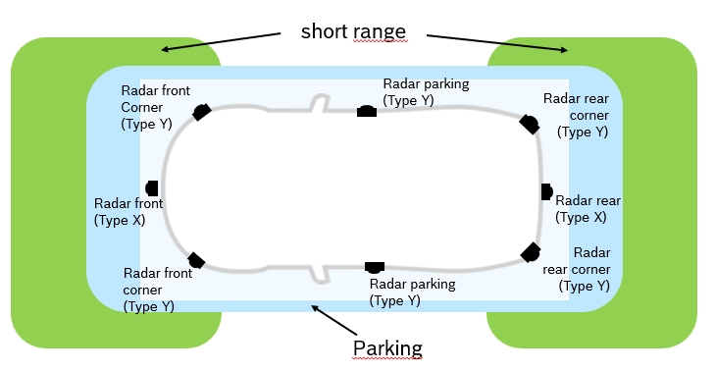
Figure 1 shows a typical deployment of radars X and Y on a vehicle. The number of radars type X and Y depends on the type of vehicle.
The maximum necessary bandwidth indicated for the radar sensors type X and Y that are mounted on a vehicle will only be used in urban scenarios, such as parking (support) and functions that cover the near range of the vehicle. The vehicle speed is below a certain threshold in these scenarios (typically 50 km/h). Outside these urban scenarios, the vehicle speed is greater than 50 km/h and the occupied bandwidth of the radar sensors is only around approximately 1 GHz.
The total required amount of spectrum for all sensors mounted at a vehicle is 35 GHz with 10 GHz for radar type X and 25 GHz for radar type Y. To implement the described vehicular radar systems, it would be beneficial to have these 35 GHz available in a contiguous block. If the requested 35 GHz is not available in a contiguous segment, the spectrum blocks for radar type X and radar type Y should be located closely together.
Interference mitigation between several radar equipped vehicles is achieved through various measures: The radar sensors have interference mitigation measures implemented in their receiver signal processing.

4.2.3 Antenna pattern
The equations for the antenna pattern are contained in Annex 9.1
The equations provide the resulting antenna radiation pattern over the scanning angles that could be used in the analysis of interference. The system is described as one antenna beam with a high gain. But since a MIMO system is actually used, this beam can be steered and the HPBWs are envelopes of this scanning.
The antenna patterns presented in Figure 1 and Figure 2 describe the envelope antenna pattern of the radar sensor. The function of the radar sensor is provided within the envelope antenna pattern. The patterns are theoretically designed based on the model given in the equations.
The radar sensor does not transmit over full envelope antenna pattern at any time. The radar sensor is scanning within the envelope pattern with an antenna pattern that has a smaller beamwidth. The scanning (with possible different aiming/radiation directions) is performed within the envelope antenna pattern and is used to detect and track objects. Transmission of the radar is only in the direction of a detected object, there is no transmission into the other areas of the envelope pattern.
[Editors Note: More information on the instantaneous patter would be helpful for simulations]
Antenna pattern using these formulas for the vehicular radars defined in Table 1 are presented in Figures 1 and 2.
Figure 1
Antenna pattern example for radar X
Figure 2
Antenna pattern example for radar Y

4.2.4 Operational characteristics of vehicular radars operating frequency band 231.5-450 GHz
The main use of described vehicular radar sensors is envisaged for urban scenarios. The sensors will be deployed in driver-assistance functions and higher-level automated vehicles where high resolutions are required. In urban scenarios with vehicle speeds between standstill and approx. 50 km/h high resolution is required to have sufficient target separation capability to detect small objects and other road users in the near ranges (up to 20 metres) around the vehicle.
The following non exhaustive gives a list of scenarios where the described sensors are intended to be used: parking, parking support, road crossings, pedestrian crossings and generally in urban traffic where vulnerable road users or small objects need to be detected.
The market deployment and the availability of vehicles that are equipped with the described radar sensors will increase over a certain timeframe. The timing for deployment and the density of vehicles that are equipped with the described radar sensors will vary depending on the geographical regions.

4.2.5 Protection criterion
In any azimuth sectors in which interference arrives, its power spectral density can simply be added to the power spectral density of the radar receiver thermal noise, to within a reasonable approximation.
If the power spectral density of the radar-receiver noise in the absence of interference is denoted by N and that of noise-like interference by I, the resulting effective noise power spectral density becomes simply I + N. An increase of about 1 dB for the automotive radars would constitute significant degradation. Such an increase corresponds to an (I + N )/N ratio of 1.26, or a protection criterion I/N of about -6 dB

4.3 Description and operational systems characteristics of radar systems to operate in the frequency range 231.5-700 GHz for security applications

4.3.1 Introduction
Primarily, most of these systems are imaging radars for body scanning. This incorporates amongst others concealed weapon and Person-Borne Improvised Explosive Device (PB-IED) detection capabilities. Due to its favourable propagation characteristics this technology can be extrapolated to numerous other applications of interest, as elaborated further in this document. In general, the range coverage of the systems extent up to a few hundred meters, depending on the application.
The low-power active RLS systems offer high resolution operational capabilities, with operational frequencies ranging from 231.5 to 700 GHz and a range resolution of 7.5 to 0.5 cm.
The findings described in this document identify the potential of RLS systems. Additionally, experimental validation has provided insight in the possible operational capabilities for security purposes.
The frequency range 0.1-1 THz is suitable for very high-resolution imaging applications due to large fractional bandwidth availability. Also, for a given integration time, the sensors in this range provide finer Doppler resolution, along with greater Doppler shifts. For a given aperture size, the antenna beamwidth is narrower, allowing for compact design for high performance operation. There are number of applications where these systems are relevant, as listed below:
High-resolution imaging for concealed weapons detection
○ Sub-THz imaging allows to penetrate through clothing whilst reflecting off of hidden objects underneath, with very high resolution. These imaging radars can be used for aiding the security sector for autonomous body scanning at reasonable stand-off distances.
Spectroscopy and imaging for Improvised Explosive Device (IED) detection
○ Similarly, spectroscopy and imaging technology can be utilized for IED detection at a safe distance. The spectral signatures provide better performance at secure distances compared to lower frequency bands, essential to alleviate threats such as identifying a suicide bomber. High explosive devices such as HMX, PETN, RDX, TNT, et cetera can be classified with higher accuracy using the sensor signatures.
Human activity monitoring in indoor/outdoor environment
○ High Doppler sensitivity at sub-THz frequencies can be used for more accurate monitoring of human activities. In conjunction with Artificial Intelligence (AI) algorithms, the radar signatures of different body part motions can be used to predict specific activities/intents that potentially pose threats.
Perimeter security of properties
○ Security of property/facilities can be enhanced by integrating the sensor capability with other sensors. Sub-THz radars will have the ability to produce detailed image of the surrounding with very high resolution. This complements other sensors such as cameras or IR sensors which are more prone to signal degradation in adverse weather conditions.
Imaging sensor for security operations in a Degraded Visual Environment (DVE)
○ A compact imaging radar can be mounted on a helicopter to act as a landing sensor for a helicopter. A technology solution for such application requires small physical size and high-resolution imaging through dust or snow.
Stand-off detection of chemical and biological agents
○ Spectroscopy and imaging can also be used for real-time, non-invasive inspection of harmful chemical and biological agents concealed by clothes, envelopes, packages et cetera. Spatial interferometric imaging provides characteristic signatures which can be used for such agent detection.
High resolution Synthetic Aperture Radar (SAR) imaging and terrain mapping for surveillance
○ Terrain mapping with RLS systems have the potential to be used for autonomous navigation, both in land and naval environments. High resolution image supplemented with Doppler information provides high fidelity target classification capabilities, which are difficult at lower bands.

4.3.2 Technical characteristics and description of active radar systems operating in frequency band 231.5 - 700 GHz
The initial description of active RLS systems operating in the frequency bands 231.5-700 GHz are presented in the following Tables.
[Editors Note: The value of the operating frequencies and densities need to be checked. Providing this information as early as possible would facilitate the studies]

TABLE 1
System 1: Imaging Radar
Parameters | Values/Description
Operating Frequency | 675 GHz
Transmit Power | ‒3 dBm (average), ‒1.55 dBm (peak)
Waveform | FMCW
Resolution/Bandwidth | 0.52 cm/28.8 GHz
Spectral Power Density | ‒16.14 dBm/GHz
Beamforming configuration | Fast scanning optics with rotating mirror  ~ 0.9° x 0.9° field of view at 25 m
Operating mode | Mechanical scanning
Typical application | Stand-off personnel screening (concealed weapons, PB-IEDs)
Key features | 25 m stand-off range  Real-time 1 Hz frame rate imaging  ~ 40 x 40 cm image per second  K-band LO with a x3 x2 x3 multiplier chain  Phase noise cancellation applied in the IF down conversion stage to improve dynamic range by ~20 dB
Purpose/foreseen result/Area of operation | Body scanning at reasonable stand-off distances of ~25 m to mitigate cognitive load and to expedite decision making process  Comparatively lower frame rate, but the advanced receiver back-end design technology can be leveraged for improving sensor sensitivity  Areas of application  ○ Airport security  ○ Entrance to critical infrastructures and facilities, E-commerce distribution centers, public landmark buildings, large scale events, prison security

TABLE 2
System 2: Imaging Radar
Parameters | Values/Description
Operating Frequency | [340 GHz]
Transmit Power | ‒6 dBm
Waveform | FMCW
Resolution/Bandwidth | 4.2 cm/3.5 GHz
Spectral Power Density | ‒11.44 dBm/GHz
Beamforming configuration | 2-axis galvanometer scanner  ~ 1.5° x 1.5° FoV at 20 m
Operating mode | Mechanical scanning
Typical application | Personnel screening (concealed weapons, PB-IEDs)
Key features | 20 m stand-off range  Up to 10 Hz frame rate imaging  ~ 50 x 50 x 100 cm at 20 m 3D image  Heterodyne architecture, with separate Schottky diode multiplier chains for transmit (x48) and local oscillator (x24) signals.  Low phase noise achieved by using Direct Digital Synthesizer (DDS) based chirp generation using a stable local oscillator (STALO) instead of voltage-controlled oscillator (VCO)
Purpose/foreseen result/Area of operation | Body scanning at reasonable stand-off distances of ~20 m to mitigate cognitive load and to expedite decision making process  High frame-rate 3D imaging capability, can be used for robust real-time body scanning operations by utilizing advanced AI based target identification algorithms  Areas of application  ○ Airport security  ○ Entrance to critical infrastructures, facilities, E-commerce distribution centers, public landmark buildings, large scale events, prison security

TABLE 3
System 3: Imaging Radars
Parameters | Values/Description
Operating Frequency | [340 GHz]
Transmit Power | 0 dBm
Waveform | FMCW
Resolution/Bandwidth | 0.5 cm/30 GHz
Spectral Power Density | ‒14.77 dBm/GHz
Beamforming configuration | Dragonian mirror focusing optics  1 x 1 m² FoV with 1 m depth of field
Operating mode | Mechanical scanning
Typical application | Personnel screening (concealed weapons, PB-IEDs)
Key features | Images a 1 x 1 x 1 m³ volume with ~1 cm³ voxel resolution  Image frame rate of 7 Hz  16 homodyne 340 GHz transceivers disposed in a linear sparse focal plane array (FPA)  Self-mixing multiplier technology, removing the need for external duplexers  Hybrid CPU/GPU architecture for processing ~15 million voxels in every 100 ms frame in the imaging volume  System performance validated by successfully detecting concealed objects of different material properties
Purpose/foreseen result/Area of operation | Body scanning at reasonable stand-off distances of ~8 m to mitigate cognitive load and to expedite decision making process  State-of-the-art radar front-end design technology can be exploited for advanced purpose-built systems, especially if can be integrated with an electronically scanning array  Areas of application  ○ Airport security  ○ Entrance to critical infrastructures, facilities, E-commerce distribution centers, public landmark buildings, large scale events, prison security

TABLE 4
System 4: Imaging Radars
Parameters | Values/Description
Operating Frequency | [340 GHz]
Transmit Power | ‒6 dBm
Waveform | FMCW
Resolution/Bandwidth | 1 cm/1.5 GHz
Spectral Power Density | ‒7.76 dBm/GHz
Beamforming configuration | 4 Tx-16 Rx MIMO array, generating 64-Tx/Rx full virtual array corresponding to an antenna size of ~128 mm  Horizontal resolution of about 14 mm at a distance of 3m  FoV of 2 m × 0.6 m
Operating mode | Mechanical scanning
Typical application | Stand-off personnel screening (concealed weapons, PB-IEDs)
Key features | Image frame rate of 4 Hz  Sparse array configuration  Tx contains a 4 × 2 × 2 frequency multiplier chain  Limited dynamic range (~44 dB), due to phase noise  System performance validated by successfully detecting concealed weapon object at ~4 m from the generated 3D MIMO images
Purpose/foreseen result/Area of operation | Body scanning at reasonable stand-off distances of ~ 5m to mitigate cognitive load and to expedite decision making process  As based on MIMO technology, advantageous for smaller physical size for a given imaging resolution. In future the technology can be explored for Joint Communication and Sensing as well  Areas of application  ○ Airport security  ○ Entrance to critical infrastructures, facilities, E-commerce distribution centers, public landmark buildings, large scale events, prison security

TABLE 5
System 5: Imaging Radars
Parameters | Values/Description
Operating Frequency | [330 GHz]
Transmit Power | +7 dBm
Waveform | FMCW
Resolution/Bandwidth | 0.5 cm/30 GHz
Spectral Power Density | ‒7.77 dBm/GHz
Beamforming configuration | Real beam imaging with lens antenna and rotating mirror  Beam width is 0.5 degrees (°)  FoV 45° x 30° (H X V)  Antenna gain 50 dBi
Operating mode | Mechanical scan
Typical application | Imaging for DVE (e.g. helicopter brownout, imaging through chain link fence)  Human activity monitoring
Key features | Human imaging at close range (~1 m)  System performance validated by successfully imaging various human activities. Also, imaging of a scene in presence of a partially obstructing object (chain link fence) is performed, demonstrating the system being able to image objects beyond the fence without problem.
Purpose/foreseen result/Area of operation | Assisting personnel/vehicle navigation in degraded visual environments  Short range real-time human activity monitoring can be useful for intent detection by incorporating AI based techniques  Areas of application  ○ helicopter landing in brown-out or white-out situations  ○ maneuvering through smoke/fog

4.4 Description and operational systems characteristics of security radar systems to operate in the frequency band 231.5-450 GHz

4.4.1 Introduction
Radars for security check or non-destructive inspection operating in this frequency range will make a significant contribution to public safety, such as counterterrorism and the security of high-risk/high-value assets or areas in the imaging and localization categories which is addressed in considering c) in Resolution 663 (Rev.WRC-23) .
Aiming to create safe and secure communities, there is a strong need to restrict the bringing of hazardous materials into public spaces. This is particularly important for long-distance trains and buildings that handle critical information or functions, where it is desirable to check the belongings or luggage of passengers and visitors for hazardous materials. Given the large number of individuals involved in these scenarios, walk-through security gates that can perform measurements without stopping the subjects are gaining attention. These gates need to conduct inspections in a short time, matching the general walking speed of passengers. Due to the nature of the application, it is assumed that access to and from the security area will be strictly controlled, and the use case is expected to be indoors.
In response to advanced factory automation and efficiency improvements, applications such as non-destructive inspection to detect scratches and impurities in production lines are highly anticipated. While non-destructive inspection using X-rays has been utilized, its application is limited due to concerns about exposure to living organisms. To enable broader use across various products, transmission-type imaging radars using high-frequency bands like terahertz waves are gaining attention, with early practical implementation being highly anticipated. This application is also expected to be operated indoors, considering the quality inspection on production lines.
Figure 1 shows Concept and scenario of operations on security radar and indoor non-destructive inspection.
FIGURE 1
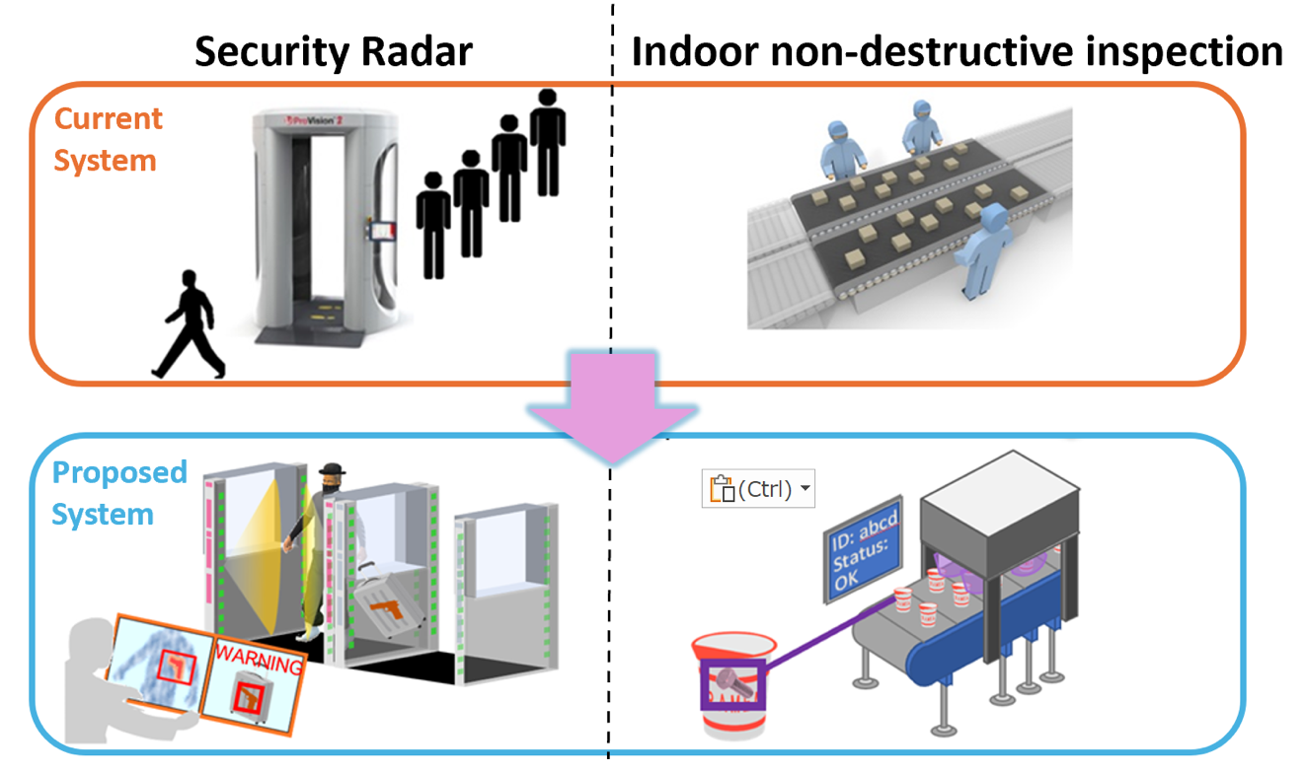
Concept and scenario of operations on security radar and indoor non-destructive inspection

4.4.2 Technical characteristics of security radar systems operating in the frequency range 231.5-450 GHz or parts thereof
The technical parameters of RLS radar systems operating in the frequency range 231.5-450 GHz or parts thereof are presented in Table 1.
TABLE 1
RLS radar technical parameters in the frequency range between 231.5 and 450 GHz or parts thereof
Parameter | Units | Radar 3  Security Radar | Radar 4  Indoor non-destructive inspection
Sub-band used (Note 1) | GHz | 252 - 296 | 252 - 296
Typical operating range | m | Up to 30 | Up to 30
Typical emission type |  | FMCW, FMCW-variants | FMCW, FMCW-variants
Max occupied bandwidth | GHz | 30 | 30
Chirp bandwidth (necessary bandwidth) | GHz | 27 | 27
Typical sweep time | μs | 0.2/GHz | 0.2/GHz
Maximum e.i.r.p. | dBm | 40 | 40
Max power density of unwanted emission | dBm/MHz | –20 | –20
Duty cycle (Note 2) | % | 2 (15.3ms/sec) | 2
Activity factor (Note 2) | % | 10 | 30
Receiver IF bandwidth | MHz | 0.2（Specifically, 167 kHz） | 0.2
Receiver sensitivity | dBm | –173.9 dBm/Hz +NF20dB+ 10*log10(0.2 MHz) =  –100.9 dBm | –100.9 dBm
Receiver noise figure | dB | 20 | 20
Antenna main beam gain | dBi | TX: 24  RX: 24 | TX: 24  RX: 24
Antenna height | m | 0.0 – 2.0 | 1.0 – 2.0
downtilt | deg | 0 (wall mounted)  ‒45 (ceiling mounted)  +45 (floor mounted) | ‒90 - 0
Antenna azimuth 3 dB beamwidth | degrees | ±3 | ±3
Antenna elevation 3 dB beamwidth | degrees | ±3 | ±3
Urban deployment density | devices/km² | 26.67 | 7.45
Suburban deployment density | devices/km² | 0.63 | 7.45
Rural deployment density | devices/km² | 0.4 | 0.46
Antenna polarization |  | Linear | Linear
Average Antenna polarization loss | dB | 3 | 3
Average body loss | dB | 0 | 0
Antenna efficiency loss | dB | 3 | 3
Indoor deployment |  | 100% | 100%
Frequency reuse |  | 1 | 1
Note 1: The frequency bands listed in RR No 5.340 are excluded from the studies.
Note 2: Duty cycle (in %) is technology dependent while the activity factor (in %) is user or system dependent (with reference to 1 day).
Note 3:

Regarding indoor deployment:
For security radar, human intervention is required when hazardous materials are detected. Additionally, since moisture on the antenna can significantly affect performance, it is difficult to envision deployment in environments without a roof where it might rain. Therefore, 100% indoor operation is assumed.
For indoor non-destructive inspection, while there may be some use cases such as at construction sites, it is unlikely to be used outdoors to detect millimeter-scale scratches while moving. Similar to security radar, moisture on the antenna can significantly affect performance, making it difficult to envision deployment in environments without a roof. Therefore, 100% indoor operation is assumed.
The basis for calculating deployment density is shown below.
The following provides an example based on Japan. Given the high density of buildings and population in Japan, it is considered that conducting studies using deployment density data based on the Japanese context would provide the necessary and sufficient conditions for ensuring sharing and compatibility with incumbent services.
Regarding security radar, potential deployment targets include train stations, airports, and important buildings.
Train stations
Regarding train stations, it is unlikely that baggage inspections would be conducted in subways, trams, or suburban areas where stations are close together and passengers can quickly disembark. Therefore, the target is limited to long-distance trains such as the Shinkansen and Maglev – magnetic levitation – railway in Japan.
However, there are only 120 Shinkansen stations, including mini-Shinkansen stations, which is a small number. Therefore, as the maximum assumed deployment density, we referred to the number of automatic ticket gates across Japan. According to statistical data from the Japanese Ministry of Land, Infrastructure, Transport and Tourism, the number of automatic ticket gates is as follows:
‒ (Private and public railways except Japan Railways Group (JR)) 2,743 stations, 17,123 gates.
‒ (JR total) 2,109 stations, 11,887 gates.
Dividing these totals by Japan's land area of 378,000 km² and rounding to the fourth decimal place, we get 0.077 gates/km². Even if four gates are installed at one location, it would be approximately 0.31 gates/km².
Airports
There are only 97 airports in Japan, which is not a significant number, so they are not considered.
Important buildings
The minimum floor area per worker stipulated by law is 4.8 square meters or more. However, in practice, the average floor area per worker in Tokyo in 2022 was 12.1 m²/person. Therefore, a floor area of 10,000 m² would accommodate approximately 826 people.
For a building of this scale, it can be assumed that some important operations are being conducted. Thus, office buildings with a floor area of 10,000 m² or more are considered important buildings where security gates are likely to be installed.
Assuming the processing capacity of a security gate is 5 seconds per person, it can handle 12 people per minute, and with 4 gates, 48 people per minute. Therefore, 800 people can be processed in about 16 minutes, which means 4 security gates per 10,000 m². The deployment density is calculated based on this assumption.
In Table 2, three major cities are categorized as Urban, Sendai City, Kyoto City, and Nagoya City are extracted as Suburban, and other regional cities are selected as Rural.
TABLE 2
Estimated deployment density of relevant security radar
Area | Total floor area of large office buildings (total floor area of 3,000 m² or more) [10,000 m²] | Total floor area of large office buildings (total floor area of 10,000 m² or more) [10,000 m²] | Regional area [km²] | deployment density [devices/km²]
Tokyo's 23 wards | 8460 | 5837.4 | 619 | 37.72
Osaka City | 2001 | 1360.68 | 223 | 24.41
Nagoya City | 803 | 497.86 | 326 | 6.11
Urban | 11264 | 7695.94 | 1168 | 26.36
Sendai City | 298 | 169.86 | 786 | 0.86
Kyoto City | 145 | 65.25 | 828 | 0.32
Fukuoka City | 528 | 295.68 | 4971 | 0.24
Suburban | 971 | 530.79 | 6585 | 0.32
Rural | 910 | 354.9 | 16385 | 0.09

Here:
‒ Total floor area of large office buildings [m²] = Total floor area of office buildings [m²] × Proportion of floor area that is 10,000 m² or more.
‒ Deployment density = (4 [units] / 10,000 [m²]) × Total floor area of large office buildings [m²] / Regional area [km²].
The results are rounded to the third decimal place.
Finally, the deployment density for train stations is uniformly set at 0.31 [devices/km²] for each region. This value is added to the deployment density for important buildings in Urban, Suburban, and Rural areas, and the results are recorded in Table 1 as the deployment density.
Next, regarding Indoor non-destructive inspection:
Based on statistical data from the Japanese Ministry of Economy, Trade and Industry, the number of production lines is estimated from the number of employees, and the number of non-destructive inspection devices is estimated accordingly. Here, it is assumed that there are approximately 30-50 employees per production line, and establishments with 30 or fewer employees are considered to have one inspection device. Additionally, since manufacturing establishments are not necessarily more concentrated in urban areas, Urban and Suburban are treated as the same.
‒ Urban/Suburban: Tokyo, Kanagawa, Aichi, and Osaka were selected as representative industrial regions of Japan.

Table 3
Estimated number of devices in urban area
Area | 29 or fewer people  (1 device) | 30-99 people  (2 devices) | 100-299 people  (4 devices) | 300 or more people (10 devices)
Tokyo | 13903 | 1189 | 232 | 76
Kanagawa | 7988 | 1264 | 465 | 194
Aichi | 14455 | 2745 | 927 | 382
Osaka | 17933 | 2367 | 529 | 142
Total | 54285 devices | 15130 devices | 8612 devices | 7940 devices
A total of 85,967 devices are distributed across the four prefectures, with a combined area of Tokyo (2,103.97 km²) + Kanagawa (2,415.86 km²) + Aichi (5,116.22 km²) + Osaka (1,901.42 km²) = a total of 11,537.47 km². The deployment density is 7.45 devices/km².
‒ Rural: Aomori, Ishikawa, Yamaguchi, and Miyazaki were selected as regions with relatively low concentrations of manufacturing industries.
Table 4
Estimated number of devices in rural area
Regions | 29 or fewer people  (1 device) | 30-99 people  (2 devices) | 100-299 people  (4 devices) | 300 or more people (10 devices)
Aomori | 1118 | 277 | 88 | 24
Ishikawa | 2562 | 451 | 146 | 46
Yamaguchi | 1450 | 345 | 139 | 59
Miyazaki | 1164 | 255 | 89 | 29
Total | 6294 devices | 2656 devices | 1848 devices | 1580 devices

A total of 12,378 devices are distributed across the four prefectures, with a combined area of Aomori (9,644.70 km²) + Ishikawa (4,186.16 km²) + Yamaguchi (6,114.13 km²) + Miyazaki (6,794.69 km²) = a total of 26,739.68 km². The deployment density is 0.46 devices/km².

4.4.3 Antenna pattern
The equations for the antenna pattern are contained in Annex 9.1Antenna pattern using these formulas for the sensing radar defined in Table 1 is presented in Figures 1 and 2.
Figure 1
Antenna pattern examples in transmission for sensing radar ( 128 × 1 elements )
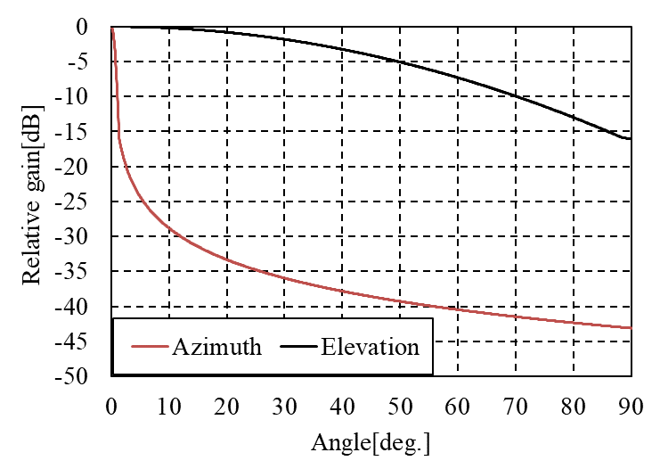
Figure 2
Antenna pattern examples in transmission for sensing radar ( 16 × 16 elements )

*Regarding Figure 2, the azimuth and elevation are consistent.

5 Spectrum needs of RLS systems

5.1 Systems for close proximity object detection
To have sufficient spectrum available for the foreseen deployment of radar sensors mounted on mobile/fixed device it would be favourable to make 40 GHz in total available for this application. If possible, this should be one spectrum segment or at least two contiguous 20 GHz channels.

5.2 Vehicular radar systems
The total required amount of spectrum for all sensors mounted at a vehicle is 35 GHz with 10 GHz for radar type X and 25 GHz for radar type Y. To implement the described vehicular radar systems, it would be beneficial to have these 35 GHz available in a contiguous block. If the requested 35 GHz is not available in a contiguous segment, the spectrum blocks for radar type X and radar type Y should be located closely together.

5.3 security applications (section 4.3)
TBD

5.4 security applications (section 4.4)
It is necessary to ensure sufficient spectrum availability for the planned deployment of radar sensors mounted on security radar systems. In this application, a resolution of less than 1 cm is required for the detection of hazardous materials. To achieve such depth resolution, a contiguous bandwidth of 30 GHz is necessary. Operation in the 252–296 GHz frequency band is envisioned for this purpose.

6 Propagation model
[Editor’s note: Working Parties 3J, 3K and 3M informed WP 5B that they intend to send an update.]
Working Parties 3J, 3K and 3M noted that WP 5B had been instructed to conduct studies taking into account the following propagation paths:
– terrestrial paths;
– Earth-to-space paths,
in the following frequency bands:
– 231.5-275 GHz;
– 275-700 GHz.
Working Parties 3J, 3K and 3M also noted that WP 5B expected the studies to include indoor, urban, suburban and rural deployment scenarios.
Working Parties 3J, 3K and 3M undertook a review of the ITU-R P-series recommendations in light of the scenarios required for WRC-27 agenda items and a working document was attached to the WP 3M Chair’s Report (Document 3M/106, Annex 1). Several areas of study were identified for further work which would be undertaken during the intersessional period.
Unless otherwise stated below, the most recently approved version of the recommendation should be used.
Information on the ITU-R P-series recommendations related to the work for WRC-27 agenda item 1.8 is provided below.

6.1 Recommendations applicable for all sharing geometries

6.1.1 ITU-R P.2108 Prediction of clutter loss
This Recommendation provides a method for calculating additional loss due to one or both of the radio terminals being embedded in local clutter (e.g., buildings, foliage) in an urban or suburban environment.
The height gain terminal correction model, section 3.1, gives the median of losses due to different terminal surrounding environments for frequencies between 30 MHz and 3 GHz. The possible propagation mechanisms include obstruction loss and reflections due to clutter objects at representative heights, scattering and reflection from the ground and smaller clutter objects. The method used in section 3.1 distinguishes between several general cases including for woodland, open areas, suburban, and urban categories. It is assumed that the dominant mechanisms are diffraction over clutter, reflection or scattering. When using this model, the basic transmission loss should be calculated to/from the height of the representative clutter height used.
In addition, two statistical models are provided in sections 3.2 and 3.3 to estimate clutter loss in urban and suburban environments as a function of probability. The statistical output of these models includes a predicted proportion of events, based on empirical data, where there is line-of-sight and therefore negligible clutter loss:
1 one model (in section 3.2) addresses terrestrial paths for frequencies between 0.5 and 67 GHz;
2 the model in section 3.3 is for an inclined path for elevation angles in the range 0 to 90 degrees and frequencies in the range 10 to 100 GHz where the terrestrial end of the path is within the clutter.
These models have been developed using measurement results as well as analytical models over the range of frequencies, particularly in urban environments.
Report ITU-R P.2402 – A method to predict the statistics of clutter loss for earth-space and aeronautical paths describes the development of a stochastic model for the inclined path in this Recommendation based on a typical cluttered terminal height of 4 to 6 metres.
There is currently no statistical clutter loss model for a rural environment.
This Recommendation should be used in addition to one of the Recommendations for the appropriate geometry. Please refer to comments in the text for each Recommendation as to when and how this should be included.
Working Parties 3J, 3K and 3M are working on updating Recommendation ITU-R P.2108-1 (section 3.3). In the interim we would encourage Working Parties of other Study Groups to wait for the conclusion of the work, the results of which will be liaised from the next WPs 3J, 3K, and 3M meetings in February 2025.

6.1.2 ITU-R P.2109 Prediction of building entry loss
This Recommendation provides a method for calculating additional loss due to one of the radio terminals being inside a building while the other is outside. Inputs to the model are frequency, probability that the loss is not exceeded, building class and elevation angle of the path at the building façade.
The current model is based on measurement data collated in Report ITU-R P.2346 in the range 80 MHz to 73 GHz and is nominally valid ‘at frequencies between about 80 MHz and 100 GHz’. Since the formulation of the present model, new data at 47 MHz and at 97, 158 and 300 GHz were submitted. Working Parties 3J, 3K and 3M anticipate that it will be possible to extend both the upper and lower frequency limits of the Recommendation, the latter to around 200 GHz, prior to July 2025. A robust extension to 700 GHz is unlikely, but it is anticipated to offer guidance for such frequencies in the same timescale. Working Parties 3J, 3K and 3M would welcome any further measurement data that may be available.
Coefficients are provided for two building types, traditional and thermally efficient; these are categorized dependent on whether thermally efficient building methods and materials are used or not.
The statistics given by the model of Recommendation ITU-R P.2109 relate to the loss exceeded at any point in any building (of the ‘traditional’ or ‘thermally efficient’ types), globally.
In most cases of practical interest, it will be necessary to combine the predicted statistics of building loss with those of local environmental clutter (e.g. other buildings) or with other spatial loss distributions. It is important that this combination takes account of the entire loss distributions, rather than, for example, just considering median or other quantile values.
The statistics of building entry loss as given by Recommendation ITU-R P.2109 are currently assumed to be independent with respect to other loss distributions and should be combined accordingly. For use in Monte Carlo models, this combination reduces to the simple process of using independent draws to sample building entry loss and, e.g. clutter loss (from Recommendation ITU-R P.2108) and combining the two by addition in decibel form.
Retrieving the overall loss, for a specific probability, is less straightforward, because the model of Recommendation ITU-R P.2109 is an empirical fit with a non-analytical form. In this case, numerical convolution should be used to derive the joint distribution.
This Recommendation should be used in addition to one of the ITU-R P-series Recommendations described below for specific geometries. Please refer to comments below as to when and how this should be included.

6.2 Recommendations applicable for sharing between stations on the surface of the Earth

6.2.1 ITU-R P.1411 – Propagation data and prediction methods for the planning of short-range outdoor radiocommunication systems and radio local area networks in the frequency range 300 MHz to 100 GHz
This Recommendation provides methods for predicting loss on outdoor short-range (typically less than 1 km) paths. The prediction includes site-specific and site-general models for line-of-sight (LOS) and non-line-of-sight (NLOS) environments, multipath models, polarization characteristics and fading conditions. The physical environments discussed in this Recommendation include urban very high rise, urban high rise, urban low-rise/suburban, residential, and rural.
The site-specific models of this recommendation require measured empirical constants to complete the calculations. Many of the prediction methods are based on measurements at specific frequencies within the range of interest. However, site-general prediction methods in the Recommendation are applicable to sharing studies using statistical methods within the frequency ranges, environments, and distances specified in the Recommendation.
It must be emphasized that the measurements and modelling in this Recommendation intrinsically include the effect of clutter over the full length of the path, so it would be inappropriate to add a calculation of clutter separately. Section 4.5.2 of the Recommendation notes the requirement to consider building entry loss separately, and this can be done by using Recommendation ITU-R P.2109 described in section 2 of the WP 3M Chair’s Report (Document 3M/106, Annex 1).
Working Party 3K is currently working to increase the frequency limit of this recommendation.

6.2.2 ITU-R P.1238 – Propagation data and prediction methods for the planning of indoor radiocommunication systems and radio local area networks in the frequency range 300 MHz to 450 GHz
This Recommendation provides prediction methods for paths contained entirely within a single building, at frequencies between 300 MHz and 450 GHz. It would be of use in interference scenarios where the dominant paths between the interfering and interfered-with systems remain inside the same building. For obvious reasons, the addition of clutter loss or building entry loss would not be appropriate in this case.

6.3 Recommendations applicable for frequencies above 200 GHz
For frequencies above 200 GHz, for unobstructed line-of-sight paths the two dominant propagation mechanisms are free-space basic transmission loss and gaseous attenuation. For frequencies above 200 GHz where obstructions along the path lead to diffraction loss, these losses are likely very high.

6.3.1 ITU-R P.525 – Calculation of free-space attenuation
Recommendation ITU-R P.525 provides methods to calculate the attenuation in free space.

6.3.2 ITU-R P.676 – Attenuation by atmospheric gases and related effects
This recommendation provides methods in its Annex 1 to calculate the slant path gaseous attenuation, phase nonlinearity, atmospheric bending, excess atmospheric path length and downwelling and upwelling noise temperatures due to oxygen and water vapour for the frequency range from 1 to 1 000 GHz for arbitrary known pressure, temperature and water vapour height profiles. Alternatively, the approximate method in Annex 2 may be used to estimate the instantaneous slant path gaseous attenuation due to oxygen and water vapour for the frequency range from 1 to 350 GHz.

7 Considerations relative to incumbent service systems
The present section provides the summary results of the technical analysis performed under this agenda item for each of the incumbent service systems.
The detailed characteristics and technical analysis are described in the following annexes:
Annex 1: Characteristics and technical analysis related to the fixed service
Annex 2: Characteristics and technical analysis related to the mobile service
Annex 3: Characteristics and technical analysis related to the mobile-satellite service
Annex 4: Characteristics and technical analysis related to the amateur and amateur satellite service systems
Annex 5: Characteristics and technical analysis related to the radionavigation service systems
Annex 6: Characteristics and technical analysis related to the radionavigation-satellite service
Annex 7: Characteristics and technical analysis related to the earth exploration satellite service systems
Annex 8: Characteristics and technical analysis related to the radioastronomy service systems
[TBD]

7.1 Summary related to fixed service systems
TBD

7.2 Summary related to fixed mobile service systems
[TBD]

7.3 Summary related to fixed mobile satellite service systems
[TBD]

7.4 Summary related to fixed amateur and amateur satellite service systems
[TBD]

7.5 Summary related to radionavigation service systems
[TBD]

7.6 Summary related to radionavigation satellite service systems
[TBD]

7.7 Summary related to earth exploration satellite service systems
[TBD]

7.8 Summary related to radioastronomy service systems
[TBD]

8 Conclusions
[TBD]
List of Annexes
Annex 1: Characteristics and technical analysis related to the fixed service
Annex 2: Characteristics and technical analysis related to the mobile service
Annex 3: Characteristics and technical analysis related to the mobile-satellite service
Annex 4: Characteristics and technical analysis related to the amateur and amateur satellite service systems
Annex 5: Characteristics and technical analysis related to the radionavigation service systems
Annex 6: Characteristics and technical analysis related to the radionavigation-satellite service
Annex 7: Characteristics and technical analysis related to the earth exploration satellite service systems
Annex 8: Characteristics and technical analysis related to the radioastronomy service systems
Annex 9: Common characteristics related to the RLS applications

Annex 1

A1 Characteristics and technical analysis related to the fixed service systems
[Editor’s note: All calculations below in this section are done based on the RLS characteristics as contained in Annex 6 to doc. 5B/216.]

A1.1 Frequency bands
According to No. 5.564A the frequency bands 275-296 GHz, 306-313 GHz, 318-333 GHz and 356-450 GHz are identified for use by administrations for the implementation of fixed service applications where no specific conditions are necessary to protect Earth exploration-satellite service (passive) applications. The frequency bands 296-306 GHz, 313-318 GHz and 333-356 GHz may only be used by fixed service applications when specific conditions to ensure the protection of Earth exploration-satellite service (passive) applications are determined.

A1.2 Interference criteria
The protection criterion is I/N –10 dB that should not be exceeded by more than 20% of the time according to Report ITU-R F.2416.

A1.3 Technical and operational characteristics
Table 1 contains technical and operational characteristics of fixed service applications from Report ITU-R F.2416.
TABLE 1
Technical and operational characteristics of the fixed service applications
Frequency band (GHz) | 275-325 | 380-445
Duplex Method | FDD/TDD | FDD/TDD
Modulation | BPSK/QPSK/8PSK/8APSK/16QAM/32QAM/64QAM  BPSK-OFDM/QPSK-OFDM/ 16QAM-OFDM/32QAM-OFDM/64QAM-OFDM | BPSK/QPSK/8PSK/8APSK/ 16QAM/32QAM, 8PSK, 8APSK  BPSK-OFDM/QPSK-OFDM/ 16QAM-OFDM/32QAM-OFDM
Channel bandwidth (GHz) | 2 to 25 (FDD)  2 to 50 (TDD) | 2 to 32.5 (FDD)  2 to 65 (TDD)
Tx output power range (dBm) | 0 to 20 | −10 to 10
Tx output power density range (dBm/GHz) | −17 to 17 | −28 to 7
Feeder/multiplexer loss range (dB) | 0 to 3 | 0 to 3
Antenna gain range (dBi) | 24 to 50 | 24 to 50
e.i.r.p. range (dBm) | 44 to 70 | 37 to 60
e.i.r.p. density range (dBm/GHz) | 30 to 67 | 19 to 57
Antenna pattern | Recommendation ITU-R F.699  (Single entry)  Recommendation ITU-R F.1245 (Aggregate) | Recommendation ITU-R F.699  (Single entry)  Recommendation ITU-R F.1245 (Aggregate)
Antenna type | Parabolic Reflector | Parabolic Reflector
Antenna height (m) | 6-25 | 10-25
Antenna elevation (degree) | ±20 (typical) | ±20 (typical)
Receiver noise figure typical (dB) | 15 | 15
Receiver noise power density typical (dBm/GHz) | −69 | −69
Normalized Rx input level for 1×10⁻⁶ BER (dBm/GHz) | −61 to −54 | −61 to −54
Link length (m) | 100 to 300 | 100 to 300
Deployment Density | See § 8.1 of Report ITU-R F.2416 | See § 8.1 of Report ITU-R F.2416

A1.4 Sharing and compatibility analysis
This study considers interference from one RLS device into one FS station. It uses Monte-Carlo method to calculate the distribution of protection distances based on FS protection criterion. The angular position of RLS station in relation to FS station is randomized (angle θ in Figure 1) as well as azimuth of the main lobe direction of RLS station (angle φ in Figure 1). For each pair of randomly generated angles the protection distance is calculated. As the propagation loss is due to free space loss and atmospheric gaseous attenuation, the variability is caused only by geometry of the interference scenario.
Figure 1
Interference scenario geometry between RLS and FS
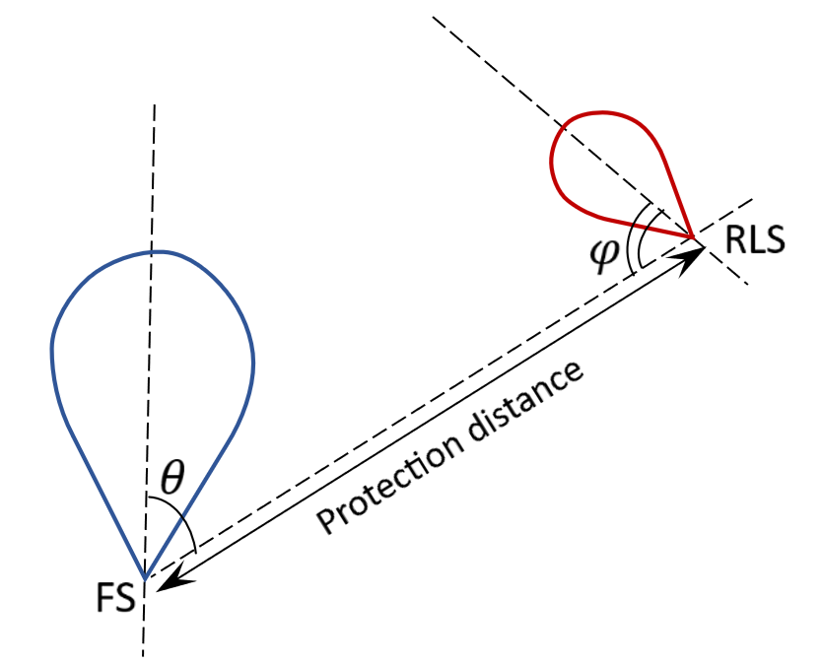
In calculations an assumption was taken that both stations are working in the same plane so elevation angle was taken as 0 degrees.
The following four outdoor RLS cases were considered:
– Case 1: Radar 1 (mobile) with RLS antenna gain 15 dBi, azimuth antenna beamwidth +/– 3 deg, e.i.r.p. 20 dBm,
– Case 2: Radar 2 (fixed) with RLS antenna gain 18 dBi, azimuth antenna beamwidth +/-2 deg, e.i.r.p. 30 dBm,
– Case 3: vehicular Radar X (short range) with RLS antenna gain 40 dBi, azimuth antenna beamwidth +/– 30 deg, e.i.r.p. 70 dBm,
– Case 4: vehicular Radar Y (parking (support) with RLS antenna gain 30 dBi, azimuth antenna beamwidth +/– 60 deg, e.i.r.p. 55 dBm,
Case 1: Radar 1 (mobile)
The CDFs of protection distances for Case 1 are shown in Figures 2, 3, 4 and 5 for frequencies 275 GHz, 325 GHz, 380 GHz, 445 GHz, respectively. The left graphs are for equal bandwidths of 2 GHz for RLS and FS, the right graphs are for FS bandwidth 50 GHz (275 GHz, 325 GHz) or 65 GHz (380 GHz, 445 GHz) and RLS bandwidth 20 GHz.
Figure 2
CDF of protection distance for Radar 1, 275 GHz
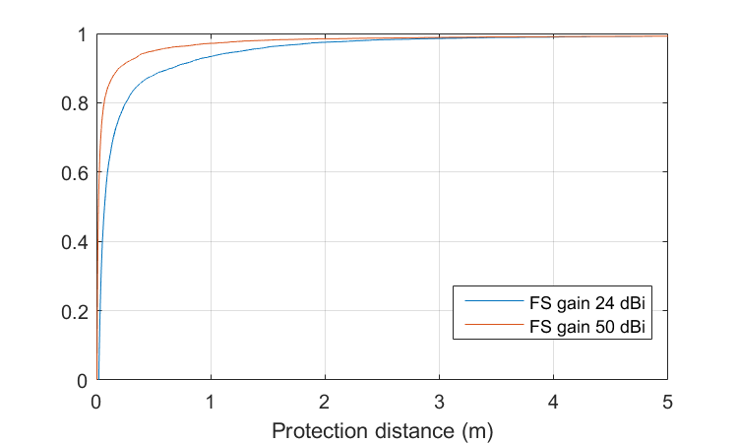 | 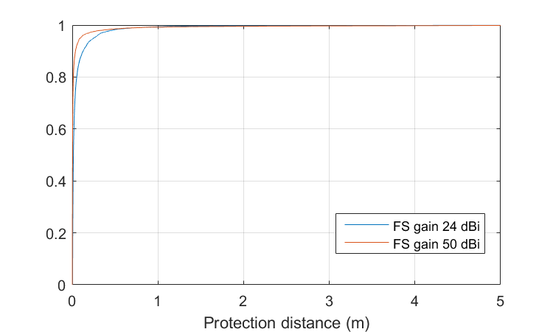
Figure 3
CDF of protection distance for Radar 1, 325 GHz
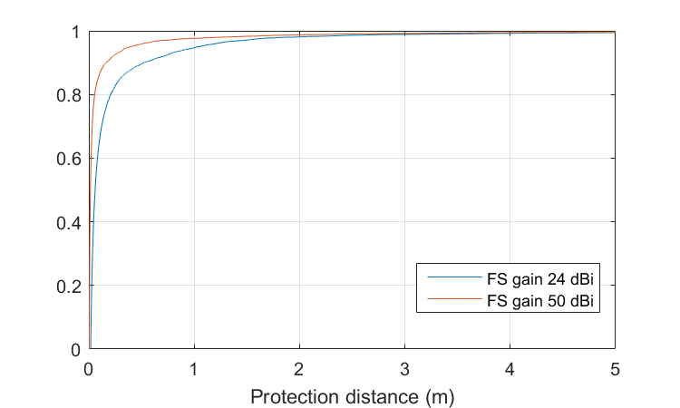 | 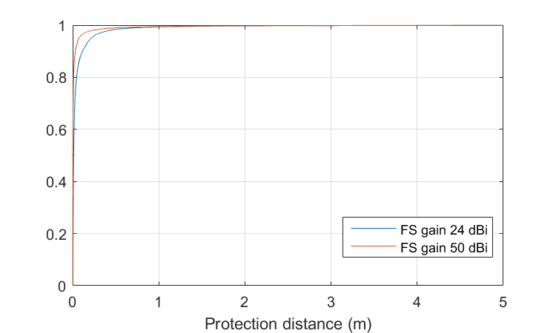
Figure 4
CDF of protection distance for Radar 1, 380 GHz
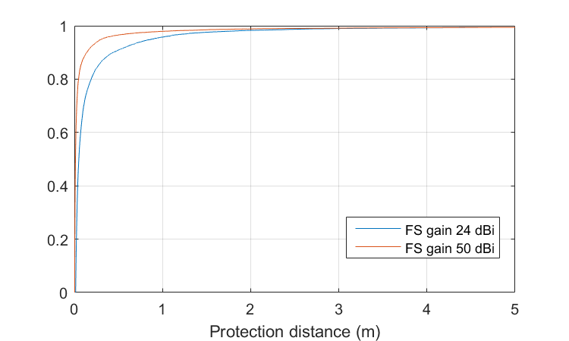 | 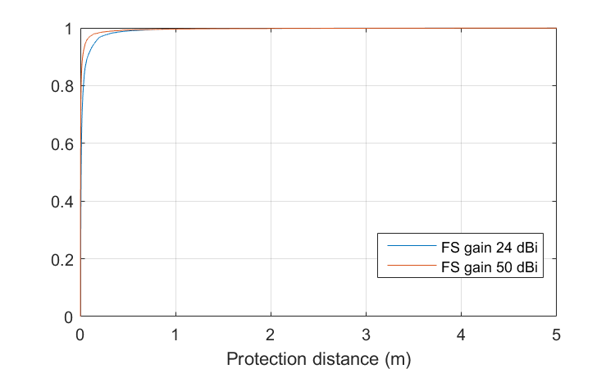
Figure 5
CDF of protection distance for Radar 1, 445 GHz
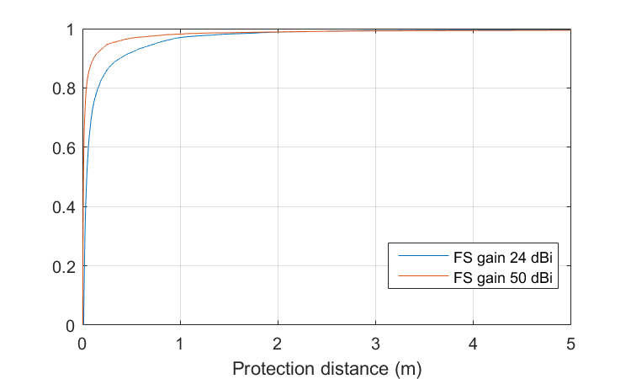 | 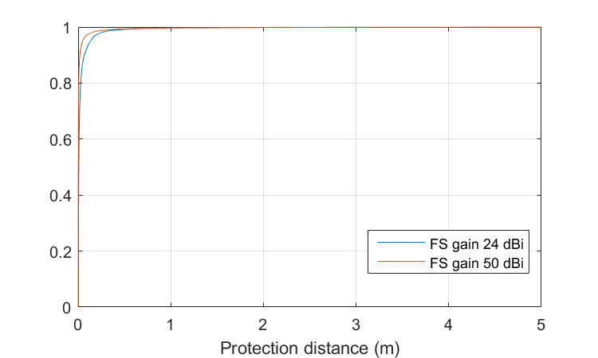
The next step is to read from Figures 2, 3, 4 and 5 the value of protection distance which corresponds to 20% of the time of the increase of interference level. These protection distances are shown in Table 2.
TABLE 2
Protection distances providing FS protection for 20% of the time for Case 1
Frequency (GHz) | FS antenna gain (dBi) | FS bandwidth (GHz) | RLS bandwidth (GHz) | Protection distance (m)
Radar 1 (mobile)
275 | 24 | 2 | 2 | 0.3
275 | 24 | 50 | 20 | 0.1
275 | 50 | 2 | 2 | 0.1
275 | 50 | 50 | 20 | 0.0
325 | 24 | 2 | 2 | 0.2
325 | 24 | 50 | 20 | 0.0
325 | 50 | 2 | 2 | 0.1
325 | 50 | 50 | 20 | 0.0
380 | 24 | 2 | 2 | 0.2
380 | 24 | 65 | 20 | 0.0
380 | 50 | 2 | 2 | 0.0
380 | 50 | 65 | 20 | 0.0
445 | 24 | 2 | 2 | 0.2
445 | 24 | 65 | 20 | 0.0
445 | 50 | 2 | 2 | 0.0
445 | 50 | 65 | 20 | 0.0

In order to verify these values Figure 6 is presented, showing the CDFs of interference to noise ratio at fixed protection distance. Left graph is for the case of equal bandwidths 2 GHz, the right graph is for the bandwidth 50 GHz for FS and 20 GHz for RLS, both for 275 GHz frequency and FS antenna gain 24 dBi. This corresponds to Figure 2 above.
Figure 6
I/N, Case 1, 275 GHz
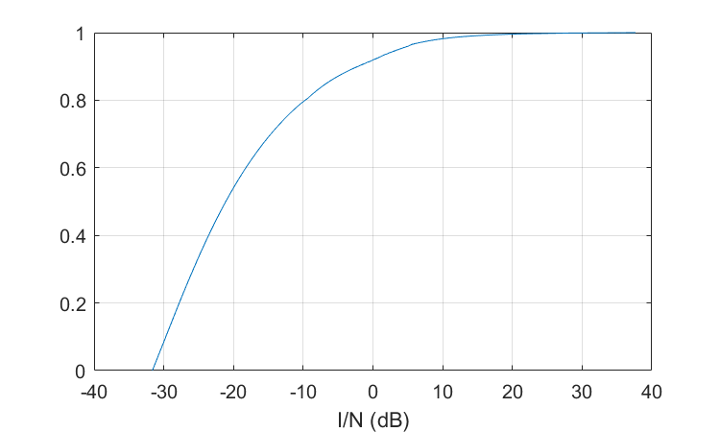 | 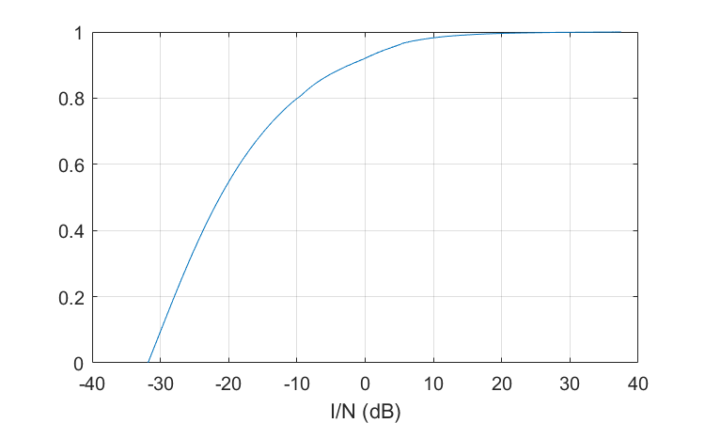
It can be seen that both graphs give I/N equal exact to FS protection criterion so the protection distances get by the methodology described above and presented in Table 2 are correctly founded.
Case 2: Radar 2 (fixed)
The CDFs of protection distances for Case 2 are shown in Figures 7, 8, 9 and 10 for frequencies 275 GHz, 325 GHz, 380 GHz, 445 GHz, respectively. The left graphs are for equal bandwidths of 2 GHz for RLS and FS, the right graphs are for FS bandwidth 50 GHz (275 GHz, 325 GHz) or 65 GHz (380 GHz, 445 GHz) and RLS bandwidth 20 GHz.
Figure 7
CDF of protection distance for Radar 2, 275 GHz
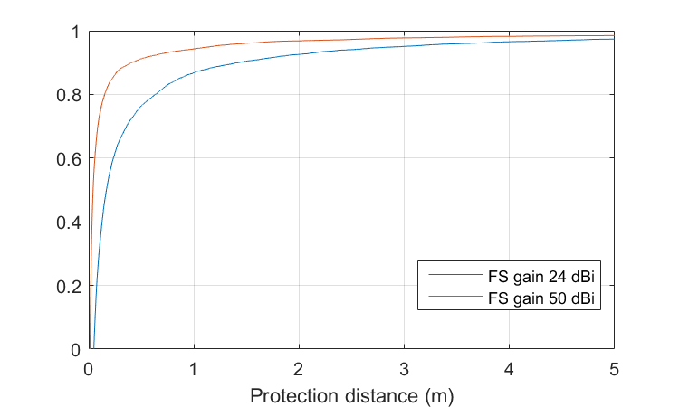 | 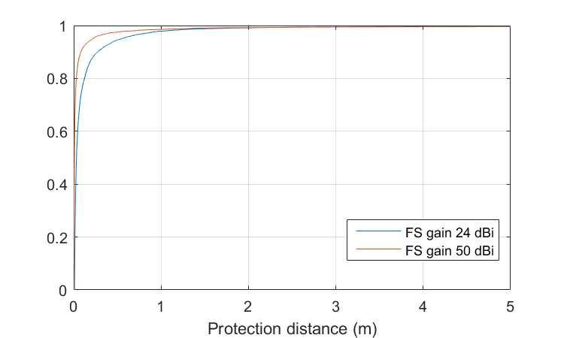
Figure 8
CDF of protection distance for Radar 2, 325 GHz
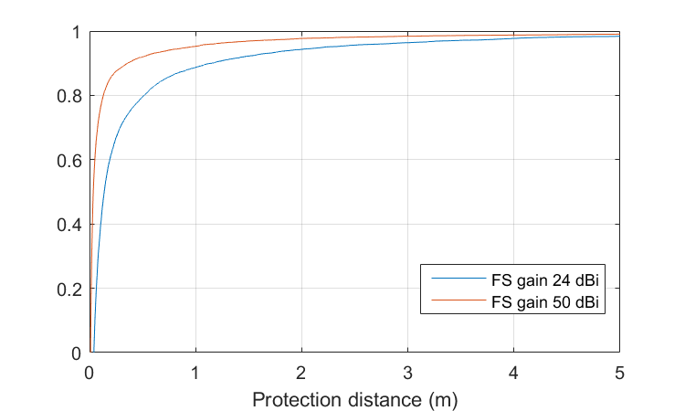 | 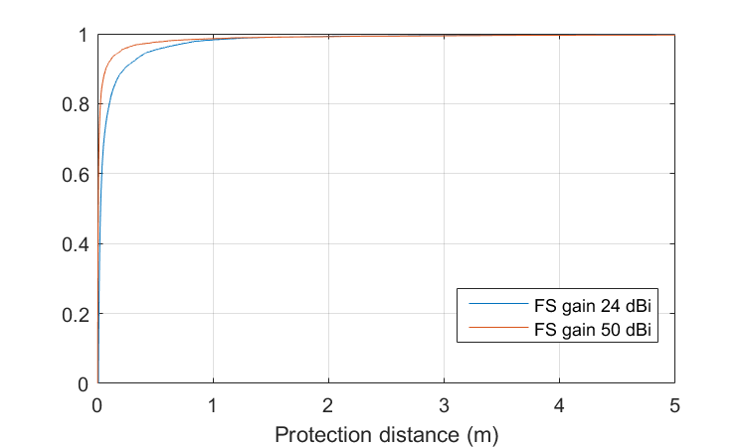
Figure 9
CDF of protection distance for Radar 2, 380 GHz
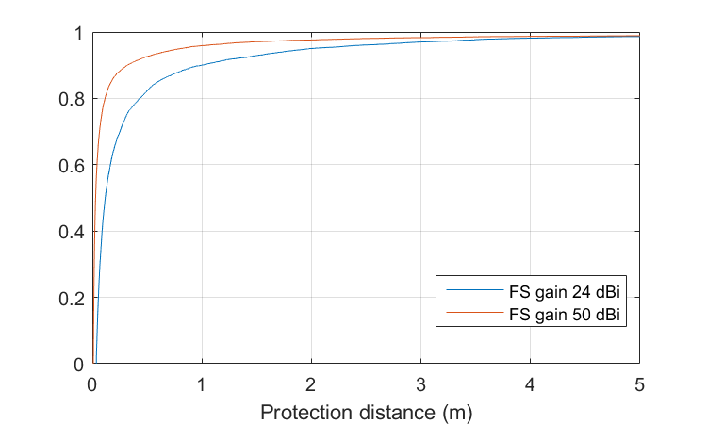 | 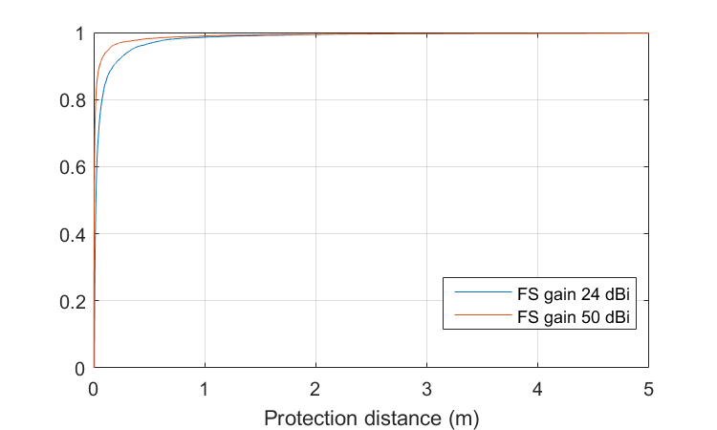
Figure 10
CDF of protection distance for Radar 2, 445 GHz
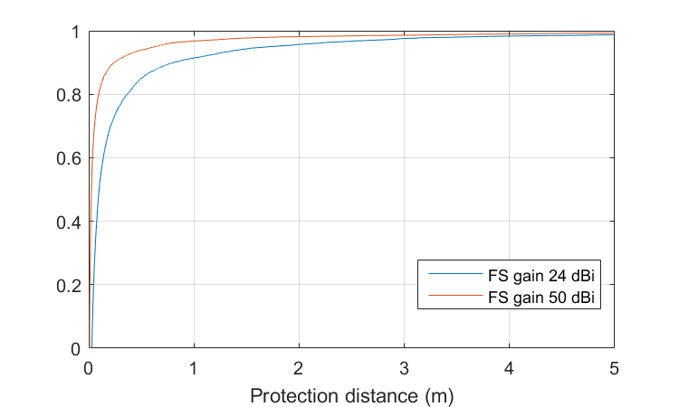 | 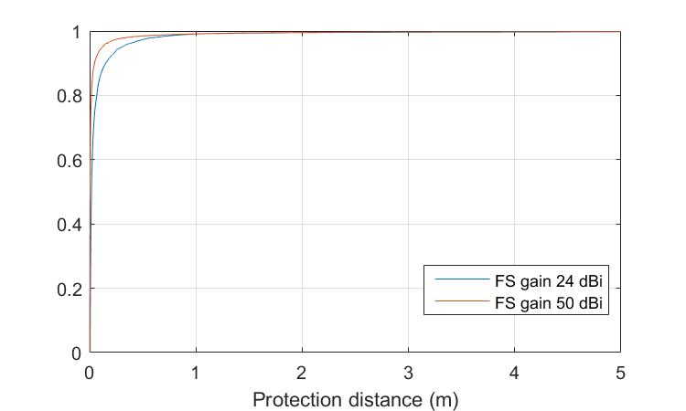
The next step is to read from Figures 7, 8, 9 and 10 the value of protection distance which corresponds to 20% of the time of the increase of the interference level. These protection distances are shown in Table 3.
TABLE 3
Protection distances providing FS protection for 20% of the time for Case 2
Frequency (GHz) | FS antenna gain (dBi) | FS bandwidth (GHz) | RLS bandwidth (GHz) | Protection distance (m)
Radar 2 (Fixed)
275 | 24 | 2 | 2 | 0.6
275 | 24 | 50 | 20 | 0.1
275 | 50 | 2 | 2 | 0.2
275 | 50 | 50 | 20 | 0.0
325 | 24 | 2 | 2 | 0.5
325 | 24 | 50 | 20 | 0.1
325 | 50 | 2 | 2 | 0.1
325 | 50 | 50 | 20 | 0.0
380 | 24 | 2 | 2 | 0.4
380 | 24 | 65 | 20 | 0.1
380 | 50 | 2 | 2 | 0.1
380 | 50 | 65 | 20 | 0.0
445 | 24 | 2 | 2 | 0.4
445 | 24 | 65 | 20 | 0.1
445 | 50 | 2 | 2 | 0.1
445 | 50 | 65 | 20 | 0.0

Case 3: vehicular Radar X (short range)
The CDFs of protection distances for Case 3 are shown in Figures 11, 12, 13 and 14 for frequencies 275 GHz, 325 GHz, 380 GHz, 445 GHz, respectively. The left graphs are for equal bandwidths of 2 GHz for RLS and FS, the right graphs are for FS bandwidth 50 GHz (275 GHz, 325 GHz) or 65 GHz (380 GHz, 445 GHz) and RLS bandwidth 5 GHz.
Figure 11
CDF of protection distance for Radar X, 275 GHz
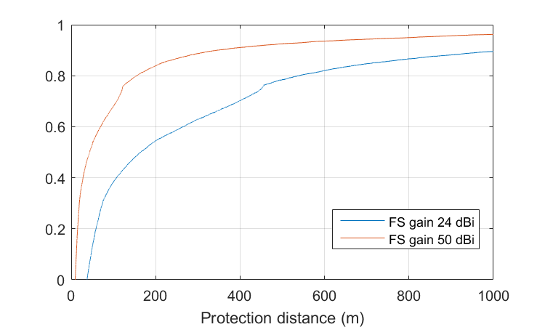 | 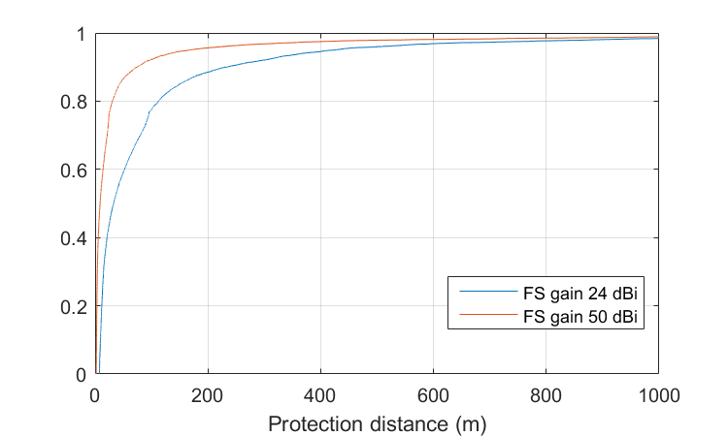
Figure 12
CDF of protection distance for Radar X, 325 GHz
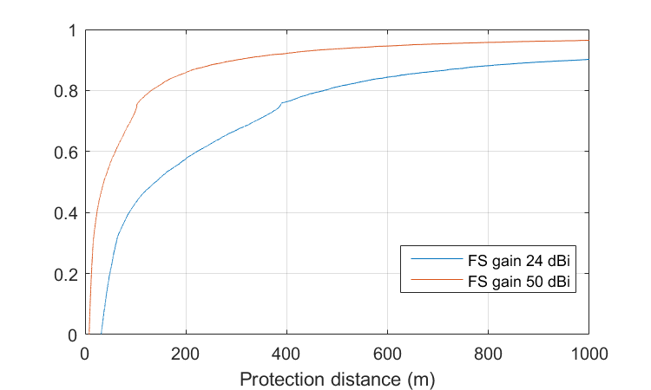 | 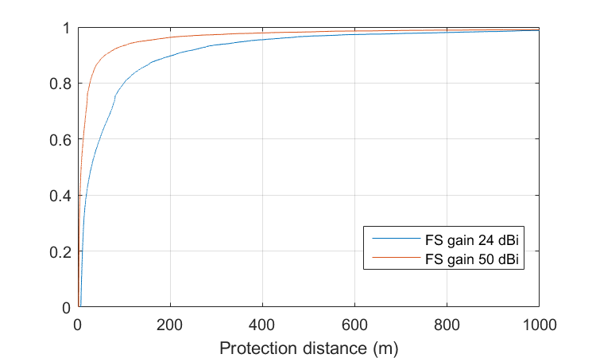
Figure 13
CDF of protection distance for Radar X, 380 GHz
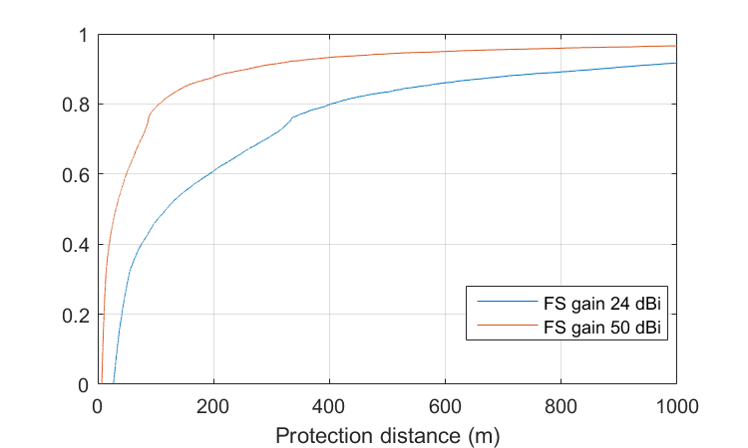 | 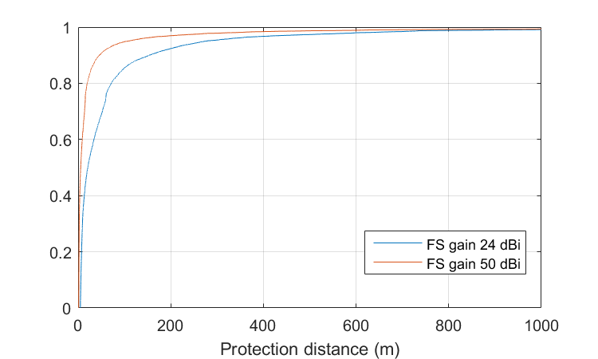
Figure 14
CDF of protection distance for Radar X, 445 GHz
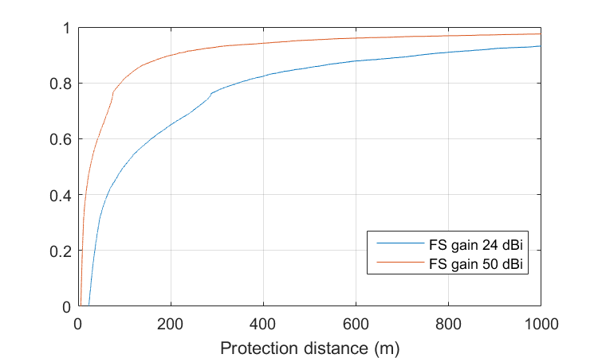 | 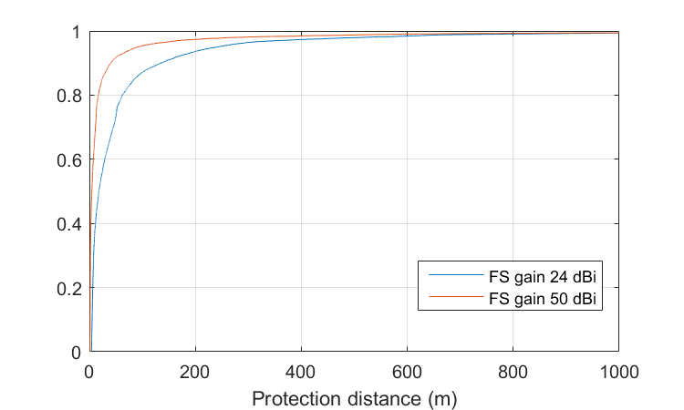
The next step is to read from Figures 11, 12, 13 and 14 the value of protection distance which corresponds to 20% of the time of the increase of the interference level. These protection distances are shown in Table 4.
TABLE 4
Protection distances providing FS protection for 20% of the time for Case 3
Frequency (GHz) | FS antenna gain (dBi) | FS bandwidth (GHz) | RLS bandwidth (GHz) | Protection distance (m)
Radar X (short range)
275 | 24 | 2 | 2 | 535
275 | 24 | 50 | 5 | 112.5
275 | 50 | 2 | 2 | 154
275 | 50 | 50 | 5 | 30.7
325 | 24 | 2 | 2 | 475
325 | 24 | 50 | 5 | 100
325 | 50 | 2 | 2 | 131.5
325 | 50 | 50 | 5 | 26.1
380 | 24 | 2 | 2 | 401
380 | 24 | 65 | 5 | 71.5
380 | 50 | 2 | 2 | 106
380 | 50 | 65 | 5 | 19.8
445 | 24 | 2 | 2 | 344
445 | 24 | 65 | 5 | 62.5
445 | 50 | 2 | 2 | 92.3
445 | 50 | 65 | 5 | 17

Case 4: vehicular Radar Y (parking (support))
The CDFs of protection distances for Case 4 are shown in Figures 15, 16, 17 and 18 for frequencies 275 GHz, 325 GHz, 380 GHz, 445 GHz, respectively. The left graphs are for equal bandwidths of 2 GHz for RLS and FS, the right graphs are for FS bandwidth 50 GHz (275 GHz, 325 GHz) or 65 GHz (380 GHz, 445 GHz) and RLS bandwidth 5 GHz.
Figure 15
CDF of protection distance for Radar Y, 275 GHz
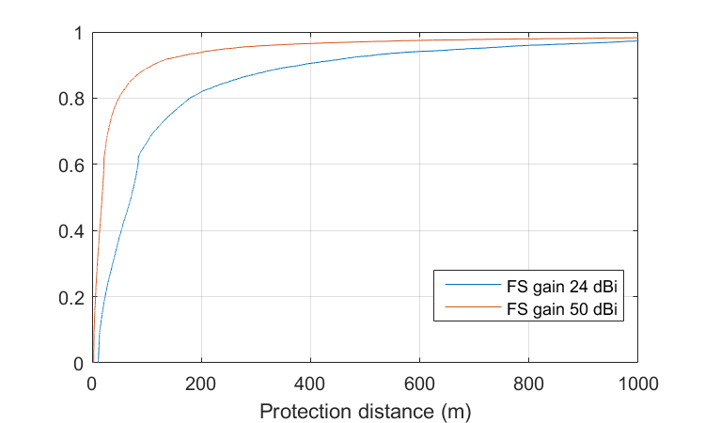 | 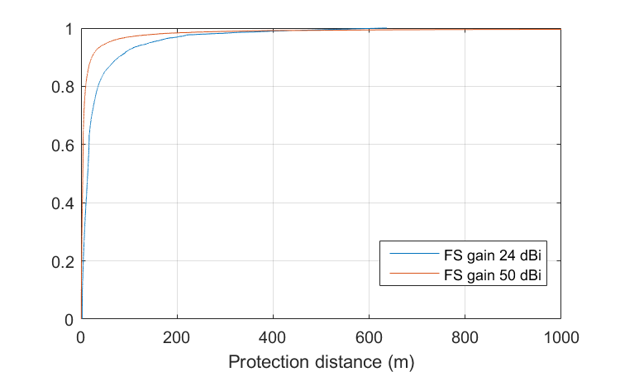
Figure 16
CDF of protection distance for Radar Y, 325 GHz
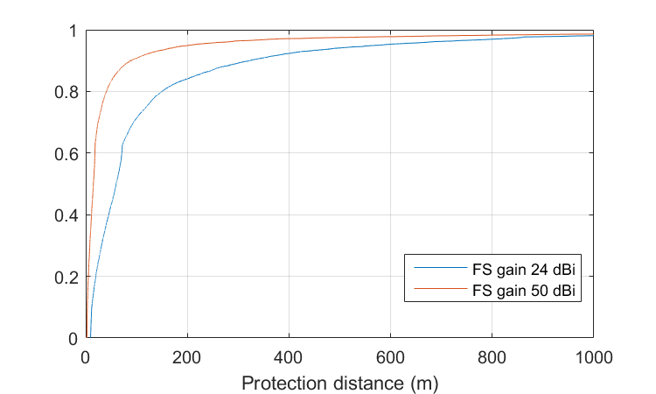 | 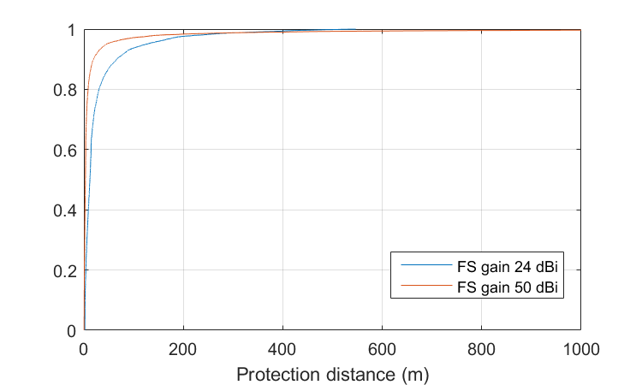
Figure 17
CDF of protection distance for Radar Y, 380 GHz
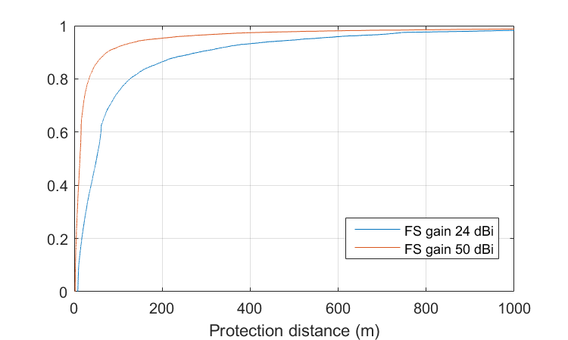 | 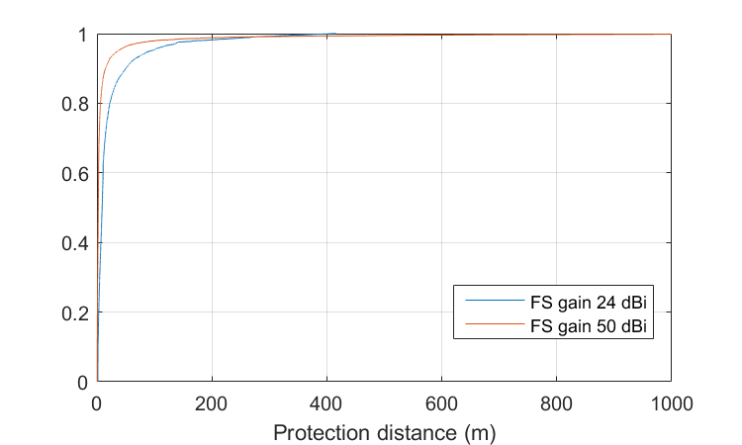
Figure 18
CDF of protection distance for Radar Y, 445 GHz
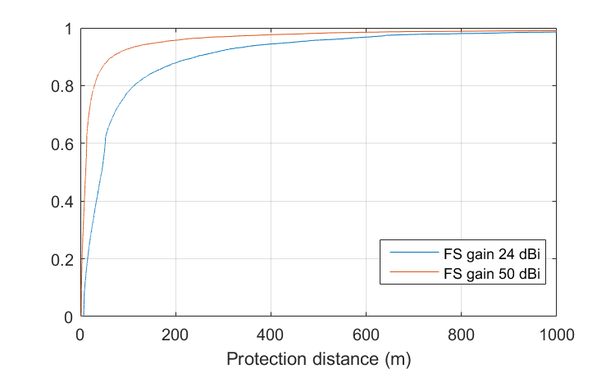 | 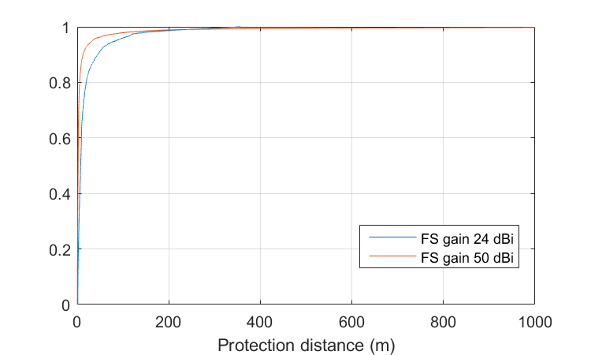
The next step is to read from Figures 15, 16, 17 and 18 the value of protection distance which corresponds to 20% of the time of the increase of the interference level. These protection distances are shown in Table 5.
TABLE 5
Protection distances providing FS protection for 20% of the time for Case 4
Frequency (GHz) | FS antenna gain (dBi) | FS bandwidth (GHz) | RLS bandwidth (GHz) | Protection distance (m)
Radar Y (parking (support))
275 | 24 | 2 | 2 | 179
275 | 24 | 50 | 15 | 35.7
275 | 50 | 2 | 2 | 49
275 | 50 | 50 | 15 | 9.8
325 | 24 | 2 | 2 | 150
325 | 24 | 50 | 15 | 30.3
325 | 50 | 2 | 2 | 40.9
325 | 50 | 50 | 5 | 8.5
380 | 24 | 2 | 2 | 127.2
380 | 24 | 65 | 5 | 22.2
380 | 50 | 2 | 2 | 33.5
380 | 50 | 65 | 5 | 6.2
445 | 24 | 2 | 2 | 113.1
445 | 24 | 65 | 5 | 19.8
445 | 50 | 2 | 2 | 29.5
445 | 50 | 65 | 5 | 5.4

A1.4 Conclusions
This study is a statistical analyse of the scenario of one RLS device in the vicinity of FS station. It shows the evident fact that wider beamwidths lead to larger protection distances, up to 535 m. These calculations consider only one vehicular radar, but according to operating scenarios there will be at least six radars on the same vehicle and protection distances will be much larger.

Annex 2

A2 Characteristics and technical analysis related to the mobile service systems
[Editor’s note: All calculations below in this section are done based on the RLS characteristics as contained in Annex 6 to doc. 5B/216.]

A2.1 Frequency bands
According to No. 5.564A the frequency bands 275-296 GHz, 306-313 GHz, 318-333 GHz and 356-450 GHz are identified for use by administrations for the implementation of land mobile service applications where no specific conditions are necessary to protect Earth exploration-satellite service (passive) applications. The frequency bands 296-306 GHz, 313-318 GHz and 333-356 GHz may only be used by land mobile service applications when specific conditions to ensure the protection of Earth exploration-satellite service (passive) applications are determined.

A2.2 Interference criteria
The protection criterion is I/N -6 dB according to Report ITU-R M.2517.

A2.3 Technical and operational characteristics
Table 1 contains technical and operational characteristics of two types of CPMS applications from Report ITU-R M.2417.
TABLE 1
Technical and operational characteristics of the land mobile service CPMS applications
Parameters | Values
Parameters | CPMS application | Enhanced CPMS application
Frequency band (GHz) | 275-325 | 275-450
Deployment density ⁽¹⁾ | 0.6 devices/km² | 0.6 devices/km²
Tx output power density (dBm/GHz) | −3.8….6.9 | −10.1…6.7
Max. e.i.r.p. density(dBm/GHz) | 26.2…...36.9 | 19.9…36.7
Duplex Method | FDD/TDD | FDD/TDD
Modulation | OOK-SC/BPSK-SC/QPSK-SC/16QAM-SC/64QAM-SC  BPSK-OFDM/QPSK-OFDM/ 16QAM-OFDM/32QAM-OFDM/64QAM-OFDM | OOK-SC/BPSK-SC/QPSK-SC/16QAM-SC/64QAM-SC/8PSK-SC/8APSK-SC  BPSK-OFDM/QPSK-OFDM/ 16QAM-OFDM/32QAM-OFDM/64QAM-OFDM
Average distance between CPMS fixed and mobile devices (m) | 0.1 | 0.1
Maximum distance between CPMS fixed and mobile devices (m) | 1 | 1
Antenna height (m) | 1…2 | -
Antenna beamwidth (degree) | 3…10 | 5…90
Antenna elevation (degree) | ±90 | ±90
Frequency reuse | 1 | 1
Antenna type | Horn | Horn
Antenna pattern | Gaussian | Gaussian
Antenna polarization | Linear | Linear
Indoor CPMS fixed device deployment (%) | 100 | 90
Feeder loss (dB) | 2 | 2
Maximum CPMS fixed/mobile device output power (dBm) | 10 | 10
Channel bandwidth (GHz) | 2.16/4.32/8.64/12.96/17.28/ 25.92/51.8 | 2.16/4.32/8.64/12.96/17.28/25.92/51.84/69.12/103.68
Maximum CPMS fixed device antenna gain (dBi) | 30 | 30
Maximum CPMS mobile device antenna gain (dBi) | 15 | 15
Maximum CPMS fixed device output power (e.i.r.p.) (dBm) | 40 | 40
Maximum CPMS mobile device output power (e.i.r.p.) (dBm) | 25 | 25
Average activity factor (%) | 0.76 | 0.2
Average CPMS fixed device power (dBm (e.i.r.p)) | 20 | 20
Receiver noise figure typical (dB) | 15 | 15

A2.4 Sharing and compatibility analysis
This study considers interference from one RLS device into one MS station. It uses Monte-Carlo method to calculate the distribution of protection distances based on FS protection criterion. The angular position of RLS station in relation to the MS station is randomized (angle θ in Figure 1) as well as azimuth of the main lobe direction of RLS station (angle φ in Figure 1). For each pair of randomly generated angles the protection distance is calculated. As the propagation loss is due to free space loss and atmospheric gaseous attenuation, the variability is caused only by geometry of the interference scenario.
Figure 1
Interference scenario geometry between RLS and MS
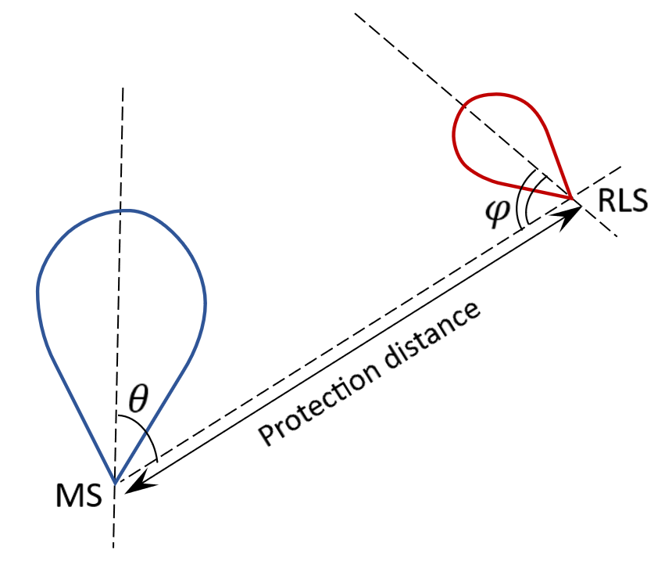
In calculations an assumption was taken that both stations are working in the same plane so elevation angle was taken as 0 degrees.
The following cases were considered:
‒ Case 1: Radar 1 (mobile) and Radar 2 (fixed) with CPMS device,
‒ Case 2: Radar 1 (mobile) and Radar 2 (fixed) with enhanced CPMS device,
‒ Case 3 : Radar X (short range) and Radar Y (parking (support) with CPMS device,
‒ Case 4 : Radar X (short range) and Radar Y (parking (support) with enhanced CPMS device.
The CDFs of protection distances for Cases 1-4 are shown in Figures 2, 3, 4 and 5 for 325 GHz frequency.
Figure 2
CDF of protection distance for Case 1
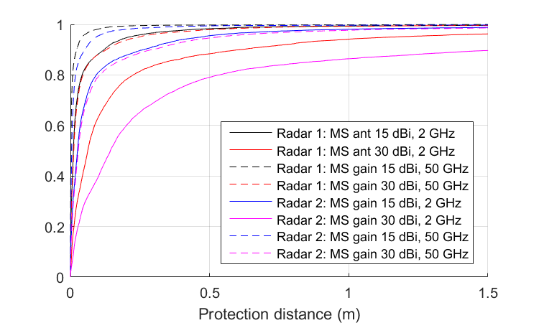
Figure 3
CDF of protection distance for Case 2
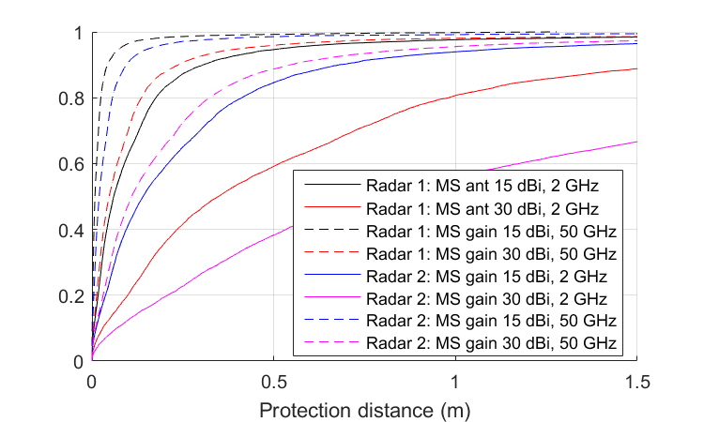
Figure 4
CDF of protection distance for Case 3
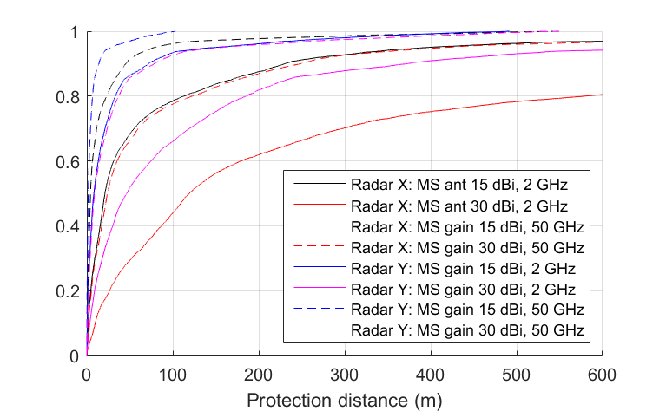
Figure 5
CDF of protection distance for Case 4
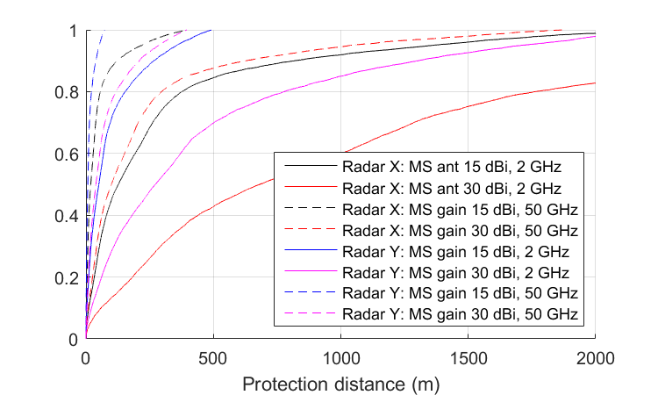

A2.4 Conclusions
This study is a statistical analyse of the scenario of one RLS device in the vicinity of MS station (CPMS device). These calculations consider only one vehicular radar, but according to operating scenarios there will be at least six radars on the same vehicle and protection distances will be much larger.

Annex 3

A3 Characteristics and technical analysis related to the mobile satellite service systems
With respect to information on technical and operational characteristics as well as protection criteria of the systems relating to WRC-27 agenda item 1.8, no input was received on this regard and there are no relevant ITU-R Reports and Recommendations.
TBD

Annex 4

A4 Characteristics and technical analysis related to the fixed amateur and amateur satellite service systems
[From 5B/218]:
The amateur and amateur-satellite services have a primary allocation covering the 248-250 GHz frequency band. The generic characteristics for stations of the amateur and amateur-satellite services using those bands are given in Tables 1B, 2B, 3B, 5, 6, 7 and 8 in Recommendation ITU-R M.1732-3. It should be noted that the available transmitter power for typical amateur transmitters using those bands is quite limited and is generally no more than a few milliwatts, to make up for this limitation typical maximum antenna gain of 52 dBi may be considered, where applicable, as listed in Recommendation ITU-R M.1732.

A4.1 Frequency bands
TBD

A4.2 Interference criteria
TBD

A4.3 Technical and operational characteristics
TBD

A4.4 Sharing and compatibility analysis
TBD

Annex 5

A5 Characteristics and technical analysis related to radionavigation service systems
With respect to information on technical and operational characteristics as well as protection criteria of the systems relating to WRC-27 agenda item 1.8, no input was received on this regard and there are no relevant ITU-R Reports and Recommendations.
TBD

A5.1 Frequency bands
TBD

A5.2 Interference criteria
TBD

A5.3 Technical and operational characteristics
TBD

A5.4 Sharing and compatibility analysis
TBD

Annex 6

A6 Characteristics and technical analysis related to radionavigation satellite service systems
With respect to information on technical and operational characteristics as well as protection criteria of the systems relating to WRC-27 agenda item 1.8, no input was received on this regard and there are no relevant ITU-R Reports and Recommendations.
TBD

A6.1 Frequency bands
TBD

A6.2 Interference criteria
TBD

A6.3 Technical and operational characteristics
TBD

A6.4 Sharing and compatibility analysis
TBD

Annex 7

A7 Characteristics and technical analysis related to earth exploration satellite service systems
[Editor’s note: All calculations below in this section are done based on the RLS characteristics as contained in Annex 6 to doc. 5B/216.]

A7.1 Frequency bands
Considering in-band and adjacent frequency bands scenarios, the following frequency bands allocated to EESS (passive) below 275 GHz need to be included in the relevant studies under this agenda item:
‒ 226-231.5 GHz: This frequency band is subject to RR No. 5.340 (all emissions are prohibited) and is adjacent to the lower edge addressed under WRC-27 agenda item 1.8. Only adjacent frequency band compatibility studies are assumed to be performed.
‒ 250-252 GHz: This frequency band is subject to RR No. 5.340 (all emissions are prohibited). Only adjacent frequency band compatibility studies are assumed to be performed.
‒ 235-238 GHz: It is noted that this frequency band is only used by limb sounding instruments.
‒ 239.2-242.2 GHz and 244.2-247.2 GHz: these two frequency bands have been allocated to EESS (passive) by WRC-23 and sharing studies with EESS (passive) should be undertaken once RLS characteristics are known.
Above 275 GHz, there is currently no frequency allocation in the RR, but RR No. 5.565 identifies several frequency bands that are relevant and are already in use by EESS (passive). When considering sharing and compatibility studies in the range 275-700 GHz, the following EESS (passive) frequency bands are to be taken into account:
‒ 275-286 GHz, 296-306 GHz, 313-356 GHz, 361-365 GHz, 369-392 GHz, 397-399 GHz, 409-411 GHz, 416-434 GHz, 439-467 GHz, 477-502 GHz, 523-527 GHz, 538-581 GHz, 611-630 GHz, 634-654 GHz, 657-692 GHz.
Finally, the band 237.9-238 GHz is also allocated to EESS (active) through RR No. 5.563B, and its use is limited to spaceborne cloud radars.

A7.2 Interference criteria
For EESS (passive), the interference criteria are given in Table 2 of Recommendation ITU-R RS.2017, as aggregate criteria for all sources of interference.
It should also be noted that this Recommendation does not yet include the protection criteria for the newly allocated bands 239.2-242.2 GHz and 244.2-247.2 GHz but interference criteria given in Report ITU-R RS.2535 should be used (i.e. the same protection criteria as specified in Recommendation ITU-R RS.2017 for the band 226-231.5 GHz).
The following Table summarises the protection criteria to be used for EESS (passive):
TABLE yy
Frequency bands  (GHz) | Reference bandwidth (MHz) | Maximum interference level  (dBW) | Percentage of area or time permissible interference level may be exceeded⁽¹⁾  (%)
226-231.5  239.2-242.2  244.2-247.2  296-306 | 200/3⁽²⁾ | −160/−194⁽²⁾ | 0.01/1⁽²⁾
313.5-355.6  361.2-365  369.2-391.2  397.2-399.2 | 200/3⁽²⁾ | −158/−194⁽²⁾ | 0.01/1⁽²⁾
416-433.46  439.1-466.3 | 200/3⁽²⁾ | −157/−194⁽²⁾ | 0.01/1⁽²⁾
523-527 | 200 | −156 | 0.01
497-502  538-581 | 200/3⁽²⁾ | −156/−194⁽²⁾ | 0.01/1⁽²⁾
634-654  656.9-692 | 200/3⁽²⁾ | −155/−194⁽²⁾ | 0.01/1⁽²⁾
235-238  250-252  275-285.4  409-411  477.75-496.75  611.7-629.7 | 3 | −194 | 1
⁽¹⁾ For a 0.01% level, the measurement area is a square on the Earth of 2 000 000 km², unless otherwise justified; for a 1% level, the measurement time is 24 h, unless otherwise justified.
⁽²⁾ First number for nadir or conical scanning modes and second number for microwave limb sounding applications
The protection criteria for EESS (active) in the band 237.9-238 GHz is given in Recommendation ITU-R RS.1166 as follows:
TABLE zz
I/N  (dB) | Data availability criteria
–10 | 99 % (systematic) | 95 % (random)

A7.3 Technical and operational characteristics

A7.3.1 EESS (passive) below 275 GHz
The 231-275 GHz frequency band is essential for the measurement of atmospheric trace gases using passive remote sensing satellite limb sounders. Specifically, at the 240 GHz part of the spectrum, data products include measurements of carbon monoxide, nitric acid in the upper and lower stratosphere, cloud ice water content (IWC), ice water path (IWP), ozone, volcanic sulfur dioxide, and improve the quality of upper tropospheric water vapor measurements.
The technical and operational characteristics of EESS (passive) systems in the range 231.5-275 GHz are given in section 6.20 of Recommendation ITU-R RS.1861, as follows:
TABLE AA
EESS (passive) sensor characteristics operating between 226 and 252 GHz
 | Sensor T1 | Sensor T2
Sensor type | Conical scan | Limb sounder
Orbit parameters
Altitude (km) | 830 | 705
Inclination (degree) | 98.7 | 98.2
Eccentricity | 0.001 | 0
Repeat period (days) | 29 | 16
Sensor antenna parameters
Number of beams | 1 | 1
Antenna size (m) | 0.255 | 1.6 (V) × 0.8 (H)
Maximum beam gain (dBi) | 52 | 67.5
Polarization | V and H | H
−3 dB beamwidth (degree) | 0.5 | 0.060 × 0.123
Instantaneous field of view (km) | 11 × 18  (155 km²) | 3.2 × 6.4
Off-nadir pointing angle (degree) | 44.7 | N/A
Incidence angle at Earth (degree) | 52.7 | N/A
Swath width (km) | 1 700 | N/A
Antenna efficiency | 0.64 | 0.69
Beam dynamics | 45 rpm (1.33 s) | Scans continuously in tangent height from the surface to ~92 km in 24.7 s, 240 scans/orbit
Sensor antenna pattern | Rec. ITU-R RS.1813 | Rec. ITU-R RS.1813 with minor mods (see NOTE)
Cold calibration ant. gain (dBi) | 47 | N/A
Cold calibration angle (degrees re. satellite track) | 130° to 135° | N/A
Cold calibration angle (degrees re. nadir direction) | 90° | N/A
Sensor receiver parameters
Sensor integration time | 2 to 3 ms | 0.166 s
Channel bandwidth | See Table CC | See Table DD
Measurement spatial resolution
Horizontal resolution (km) |  | 6.4
Vertical resolution (km) |  | 3.2
NOTE – The antenna model from Recommendation ITU-R RS.1813-1 can be adjusted to support elliptical reflectors with the following modifications:
• The maximum antenna gain be defined as: $G_{max}=10\log_{10}\left(ηπ^{2}\frac{D_{max}D_{min}}{λ^{2}}\right)$.
• The antenna diameter be defined as: $D(α)=\sqrt{D_{max}^{2}\cos^{2}\left(α\right)+ D_{min}^{2}\sin^{2}\left(α\right)}$. Therefore, the antenna diameter becomes a function of the angle (α ϵ [0°, 90°]) in the plane that is perpendicular to the antenna boresight vector and between the intended direction of emission and the antenna beam’s major axis.
• The existing functions for G(φ) and φ_{m} should be evaluated for each point in the alpha/phi space.
TABLE BB
EESS (passive) sensor characteristics operating between 226 and 252 GHz
 | Sensor T3 (MWS)
Sensor type | Nadir Scan
Orbit parameters
Altitude (km) | 830
Inclination (degree) | 98.7
Eccentricity | 0.001
Repeat period (days) | 29
Sensor antenna parameters
Number of beams | 1
Antenna size (m) | 0.35
Maximum beam gain (dBi) | 43
Polarization | QV
−3 dB beamwidth (degree) | 1.15°
Instantaneous field of view (km) | Nadir FOV: 17  (218 km²)  Outer FOV: 55 × 28  (1 225 km²)
Off-nadir pointing angle (degree) | ±49.31° cross-track
Incidence angle at Earth (degree) | 0 (nadir)  58.9
Swath width (km) | 2 220
Antenna efficiency | 0.60
Beam dynamics (s) | 2.254
Sensor antenna pattern | Rec. ITU-R RS.1813
Cold calibration ant. gain (dBi)
Cold calibration angle (degrees re. satellite track) | 90°
Cold calibration angle (degrees re. nadir direction) | 78° to 83°
Number of beams
Sensor receiver parameters
Sensor integration time (ms) | 13.7
Channel bandwidth | 2 000 MHz centred at 229 GHz
Measurement spatial resolution
Horizontal resolution | 17 km (nadir)
Vertical resolution | 17 km (nadir)

TABLE CC
Sensor T1 passive sensor characteristics for channels between 239 and 248 GHz
Centre frequency  (GHz) (see NOTE below) | Frequency range  (GHz) | Channel bandwidth  (MHz)
243.2 ± 2.5 | 239.2-242.2  244.2-247.2 | 2 × 3 000
NOTE – The T1 instrument has also multiple channels in bands above 275 GHz (three channels around 325 GHz, three channels around 448 GHz and one channel at 664 GHz).

TABLE DD
Sensor T2 passive sensor characteristics for channels between 231 and 248 GHz
Centre frequency  (GHz) | Channel bandwidth  (MHz)
231.86 | 500
232.46 | 500
233.9515 | 1 250
234.86 | 500
235.7151 | 10
235.7151 | 1 250
236.66 | 500
242.66 | 500
244.46 | 500
246.86 | 500
247.46 | 500

Unless otherwise stated, antenna patterns for EESS (passive) are provided in Recommendation ITU-R RS.1813.

A7.3.2 Characteristics of EESS (passive) sensors above 275 GHz.
The 275-700 GHz frequency band is essential for the measurement of atmospheric trace gases using passive remote sensing satellite limb sounders. Specifically, at the 640 GHz band data products include measurements of bromine monoxide, methyl chloride, methyl cyanide, methanol, chlorine monoxide, hydrogen chloride, hydroperoxyl, hypochlorous acid, volcanic sulfur dioxide, methyl cyanide, nitric acid, cloud ice water content (IWC), ice water path (IWP), nitrous oxide, ozone, and improve the quality of upper tropospheric water vapor measurements.
The technical and operational characteristics of EESS (passive) systems in the range 275-450 GHz are given in Report ITU-R RS.2431, as follows:
TABLE ee-1
Instrument | ICI | TWICE | SMM | STEAMR | GOMAS
Type of Orbit | SSO LEO | SSO LEO | SSO LEO | SSO LEO | GSO
Altitude (km) | 817 | 400 | not available | 817 | 35 684
Inclination (degrees) | 98.7 | High inclination | High inclination | 98.7 | 0
Scanning mode | Conical | Conical | Conical or cross track (Fig. ee-1) | Limb  (Fig. ee-2) | Conical
Observation Zenith Angle (OZA) (degrees) for conical scan, or  Min. pointing altitude (km), for limb scan | Conical:  53 ± 2 | Conical:  53 | not available | Limb:  6 | not available
RF Centre Frequency (GHz) | 325.15  448 | 310  380.2 | 325 | 319.5  349.6 | 380.197  424.763
RF Bandwidth  (GHz) | 3.2 – 6  2.4 – 6  (Table ee-3) | 10  7.2 | not available | 12  12 | 0.3 – 4  0.06 – 1  (Table ee-4)
Antenna type | Offset reflector, multiple feeds | Broadband multi-flare horns | not available | Reflector antenna | Filled aperture scanning
Antenna Peak Gain (dBi) | 55 | 46-48 (TBC) | not available | 70 | not available
Antenna Diameter (m) | ~ 0.5 | not available | not available | not available | 3
Antenna Beamwidth (degrees) | not available | 0.64º  0.56º | not available | See Fig. ee-2 | 0.019º  0.017º
FOV (km)  Footprint area (km²) | 16  Area ≈ 200 km²  (Table 3) | FOV: 6.5 × 9.9  Area ≈ 50 km²  FOV: 5.8 × 8.7  Area ≈ 40 km²  (Fig. 6.2-2) | not available | N/A  (See Fig. 15) | IFOV: 12  Area ≈ 110 km²  IFOV: 10  Area ≈ 75 km²

TABLE ee-2
Instrument | GEM | CAMLS | MASTER | GMS
Type of Orbit | GSO | LEO | SSO LEO | GSO
Altitude (km) | 35 684 | not available | 817 | 35 684
Inclination (degrees) | 0 | not available | 98.7 | 0
Scanning mode | Conical | Limb | Limb | wide strip and thin circle combined scan (Fig. ee-3)
Observation Zenith Angle (OZA) (degrees) for conical scan, or  Min. pointing altitude (km), for limb scan | not available | Limb:  10 | Limb:  3 | N/A
RF Centre Frequency (GHz) | 380.197  425.763 | 340 | 299.75  320.0  345.6 | 338  380.197  424.763
RF Bandwidth  (GHz) | 0.05-18 (LSB) | 16 | 11.5  9.0  6.5 | 0.03-8  0.01-1
Antenna type | Filled aperture scanning | not available | Elliptical Offset  reflector | Reflector Antenna
Antenna Peak Gain (dBi) | not available | not available | not available | 76
Antenna Diameter (m) | 2 | not available | 1 × 2 | 3
Antenna Beamwidth (degrees) | 0.029º  0.026º | not available | not available | 0.027°
FOV (km)  Footprint area (km²) | FOV: 20.5  Area ≈ 330 km²  FOV: 16.4  Area ≈ 210 km² | N/A  (See Table 13) | N/A  (See Table 17) | IFOV: 16

TABLE ee-3
Channel specifications for Remote Sensor-1 (ICI)
Channel No | Frequency f_{o}±Δf (GHz) (*) | Bandwidth (MHz) (**) | Polarization | Utilization
ICI-1 | 183.31±7.0 | 2 × 2 000 | V | Water vapour profile and snowfall
ICI-2 | 183.31±3.4 | 2 × 1 500 | V | Water vapour profile and snowfall
ICI-3 | 183.31±2.0 | 2 × 1 500 | V | Water vapour profile and snowfall
ICI-4 | 243.2±2.5 | 2 × 3 000 | V, H | Quasi-window, cloud ice retrieval, cirrus clouds
ICI-5 | 325.15±9.5 | 2 × 3 000 | V | Cloud ice effective radius
ICI-6 | 325.15±3.5 | 2 × 2 400 | V
ICI-7 | 325.15±1.5 | 2 × 1 600 | V
ICI-8 | 448±7.2 | 2 × 3 000 | V | Cloud ice water path and cirrus
ICI-9 | 448±3.0 | 2 × 2 000 | V | Cloud ice water path and cirrus
ICI-10 | 448±1.4 | 2 × 1 200 | V | Cloud ice water path and cirrus
ICI-11 | 664±4.2 | 2 × 5 000 | V, H | Quasi-window, cirrus clouds, cloud ice water path
(*) For each ICI channel, measurements are performed at both sides of the centre frequency (f_{o} + Δf and f_{o} - Δf)
(**) Total bandwidth per channel, considering both sides around the centre frequency f_{o}.

TABLE ee-4
Channel specifications for Remote Sensor-6 (GOMAS) within the 275-450 GHz range
Channel No. | Frequency  (GHz) | Bandwidth  (GHz) | Utilization
GOMAS-1 | 380.17 ± 0.3 | 0.3 | Water
GOMAS-2 | 380.17 ± 0.9 | 0.5 | Water
GOMAS-3 | 380.17 ± 1.65 | 0.7 | Water
GOMAS-4 | 380.17 ± 3 | 1 | Water
GOMAS-5 | 380.17 ± 5 | 2 | Water
GOMAS-6 | 380.17 ± 7 | 2 | Water
GOMAS-7 | 380.17 ± 17 | 4 | Water
GOMAS-8 | 424.76 ± 0.15 | 0.06 | Oxygen
GOMAS-9 | 424.76 ± 0.3 | 0.1 | Oxygen
GOMAS-10 | 424.76 ± 0.6 | 0.2 | Oxygen
GOMAS-11 | 424.76 ± 1 | 0.4 | Oxygen
GOMAS-12 | 424.76 ± 1.5 | 0.6 | Oxygen
GOMAS-13 | 424.76 ± 4 | 1 | Oxygen

FIGURE ee-1
Illustration of the SMM receiver array concept
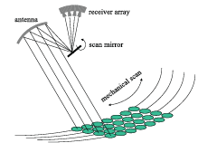

FIGURE ee-2
STEAMR limb imaging principles
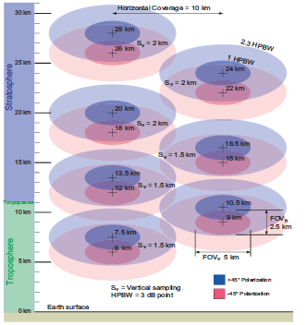
FIGURE ee-3
Typical wide strip and thin circle combined scanning configuration
Additional characteristics of EESS (passive) systems in the range 275-700 GHz are provided below:
TABLE gg
Satellite | Metop-SG-B series of 3 satellites |  |  | AWS-PFM (1 satellite) / EPS Sterna constellation (18 + 2 satellites)
Instrument | ICI |  |  | EPS Sterna Radiometer
Type of orbit | SSO |  |  | SSO
Altitude (km) | 830 |  |  | 595
Inclination (degree) | 98.7 |  |  | 97.79
Scanning geometry | Conical |  |  | Nadir (cross-track)
Centre frequency (GHz) | 1) 325.15 ± 9.5  2) 325.15 ± 3.5  3) 325.15 ± 1.5 | 1) 448 ± 7.2  2) 448 ± 3.0  3) 448 ± 1.4 | 664 ± 4.2 | 1) 325.15 ± 6.6  2) 325.15 ± 4.1  3) 325.15 ± 2.4  4) 325.15 ± 1.2
Channel bandwidth (MHz) | 1) 2 × 3 000  2) 2 × 2 400  3) 2 × 1 600 | 1) 2 × 3 000  2) 2 × 2 400  3) 2 × 1 600 | 2 × 5 000 | 1) 2 × 2 800  2) 2 × 1 800  3) 2 × 1 200  4) 2 × 800
Polarisation | H/V | H/V | H/V | QH/QV
Antenna Peak Gain (dBi) | 52 |  |  | 52
Antenna 3 dB beamwidth | 0.5 |  |  | 0.8
Footprint area / IFOV | 11 × 18 km (155 km²) |  |  | Nadir FOV: 8 km (54 km²)  Outer FOV: 16 × 35 km (433 km²)
Off-Nadir angle | 44.7° |  |  | 54.4°

TABLE hh
Satellite | future non-GSO
Instrument | ice cloud detector
Type of orbit | SSO
Altitude (km) | 836
Inclination (degree) | 98.75
Scanning geometry | Conical
Centre frequency (GHz) | 664 ± 4.2 GHz
Channel bandwidth (MHz) | 2 × 5 000
Polarisation | V/H
Antenna Peak Gain (dBi) | 54
Antenna 3 dB beamwidth | 0.4°/0.6°
Footprint area / IFOV | Nadir FOV: 18 km²
Off-Nadir angle | 53°

Unless otherwise stated, antenna patterns for EESS (passive) are provided in Recommendation ITU-R RS.1813.

A7.3.3 EESS (active) in the band 237.9-238 GHz
The characteristics of EESS (active) systems in the band 237.9-238 GHz are given in section 7.14 of Recommendation ITU-R RS.2105, as follows:
TABLE xx
Characteristics of EESS (active) missions in the 237.9-238 GHz band
Parameter | CPR-N1
Sensor type | Cloud profiling radar
Type of orbit | SSO
Altitude (km) | 705
Orbital inclination (degrees) | 98.2
Ascending node LST | 13:30
Repeat period (days) | 16
Antenna diameter (m) | 3
Antenna (Transmit and Receive) peak gain (dBi) | 78
Polarization | Linear
Azimuth scan rate (rpm) | 0
Antenna beam look angle (degrees) | 0
Antenna beam azimuth angle (degrees) | 0
Antenna elevation beamwidth (degrees) | 0.024
Antenna azimuth beamwidth (degrees) | 0.024
RF centre frequency (GHz) | 237.95
RF bandwidth (MHz) | 0.65
Transmit Pk power (W) | 80
Pulsewidth (μs) | 1.6
Pulse repetition frequency (PRF) (Hz) | 4 000
Range resolution (m) | 250
Horizontal resolution | 0.1 × 0.7 km
System noise figure (dB) | 11

A7.4 Sharing and compatibility analysis

A7.4.1 Sharing and compatibility analysis of EESS (passive)

A7.4.1.1 STUDY A

General Considerations
The study of sharing and compatibility of EESS (passive) sensors with regard to the proposed RLS radar systems is considered in several parts. This section covers general aspects and simulation methodology employed by A7.4. Section A7.4.1.1 describes reference Measurement Areas of Interest that the passive sensors and proposed radar system deployments for use in simulation studies. Section A7.4.2.1 covers scenarios involving frequency ranges below 275 GHz. This section includes allocated bands for EESS (passive) as well as RR No. 5.340 adjacency aspects. Section A7.4.2.2 covers scenarios involving frequency ranges above 275 GHz. This section includes consideration of frequency bands identified for use by EESS (passive) under RR No. 5.565.

Simulation Methodology
Assessments of the aggregate RFI expected from the RLS radar systems (operating according to section 4.1 or 4.2) into EESS (passive) operating in the certain bands are achieved by dynamic simulations. The analysis is conducted in which the orbit of the EESS (passive) spacecraft under investigation is dynamically simulated, retaining only the data points when the EESS (passive) sensor antenna boresight points within a defined Measurement Area of Interest (MAI), as defined in section A7.2. Calculations are performed to determine the potential interference from each of the current active stations into the EESS (passive) sensors under study and will consider the aggregate effect from multiple active stations. The simulation will propagate the satellite based on its orbital parameters, and the simulation step size is selected to be an irrational number to ensure that the beam dynamics of the passive sensor are maximally representative and do not exhibit statistically reductive periodic behaviour. At each simulation step, a snapshot of the interference scenario is generated where the directional vectors from each active RLS radiative source to the EESS (passive) sensor is computed along with the apparent gain of the transmit and receive antennas using their respective antenna patterns. For the RLS systems the radiation patterns are modelled by section 4.1.3 and 4.2.3 for mobile/fixed radars and vehicular radars, respectively.
The interfering signal power level, $I_{i,n}$ (W), received by a spaceborne sensor at the $n^{th}$ simulation step from the $i^{th}$ active station is calculated from:
$I_{i,n}=\frac{{ P}_{TX i,n}G_{TX i,n}{ G}_{RX i,n}}{L_{a i,n}{ L}_{FSPL i,n} }$ (A3-1)
where:
${ P}_{TX i,n}$: active station out of band transmitter power in the EESS (passive) band, accounting for frequency dependent rejection
$G_{TX i,n}$: active station antenna gain towards spaceborne sensor
$G_{RX i,n}$: spaceborne receive antenna gain towards terrestrial source
$L_{a i,n}$ : propagation losses in accordance with section 6.1
$L_{FSPL i,n}$: Free Space Path Loss (if not already included in $L_{a i,n}$).
[Editor’s note: Working Parties 3J, 3K and 3M informed WP 5B that they intend to send an update regarding propagation advice. So this aspect may be refined in the methodology for EESS.]
The aggregate interference from radiolocation systems at the $n^{th}$ simulation step,${ AggI}_{n}$ (W), is calculated by the summation of the received interference from all active stations within line of sight of EESS (passive) satellite:
${AggI}_{n}=\sum_{i}{I_{i,n}}=\sum_{i}{\frac{{P_{TX i,n} G}_{TX i,n}{ G}_{RX i,n}}{L_{a i,n}{ L}_{FSPL i,n} }}$ (A3-2)
Thus, the aggregate interference can be represented in the logarithmic domain as:
${AggI}_{n|dB}=10 {\log_{10}\left(\sum_{i}{\frac{{ P}_{TX i,n}{ G}_{TX i,n}{ G}_{RX i,n}}{L_{a i,n}{ L}_{FSPL i,n} }}\right) }_{|dB}$ (A3-3)
Using the resulting data containing received interfering power levels, a CCDF curve is generated to assess interference received by the sensor undergoing observations over the MAI.
Since the occupied bandwidth of all radar systems is significantly larger than the reference bandwidth of the EESS(p) protection, for in-band assessments, it is assumed that emissions fully cover the reference bandwidth.

Measurement Area of Interest (MAI) selection and RLS radar system deployments
MAI are chosen to represent typical EESS (passive) sensor targets that may include intersection with significant density of proposed RLS radar systems. Reference MAI will include one or more urban localities to explore the impact of deployment density categorization on the predicted interference environment. MAI A/B of figure A7.4.1.1-1 are 2 million square kilometers in area. MAI A includes the west coast of the United States of America and MAI B includes the eastern coast. MAI C in figure A7.4.1.1-1 has an area of 10 million square kilometers. All regions are commonly studied by EESS (passive) sensors.
[Editor’s Note: more MAI may be included. For instance, to examine cross border scenarios. The east coastal scenario (MAI B) mainly involves a domestic scenario for the purposes of demonstrating compatibility. A more detailed cross-border scenario such as in MAI C would be added in subsequent updates to this study.]
figure a7.4.1.1-1 Reference MAI A/B
MAI A
39.0N 118W
MAI B
37.0N 79.8W
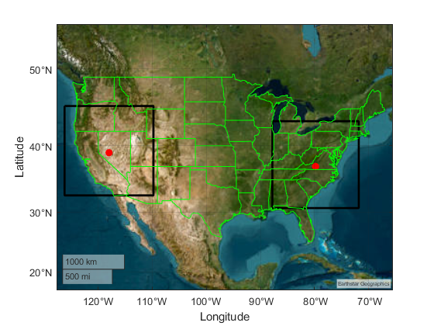
FIGURE A7.4.1.1-2 REFERENCE MAI C
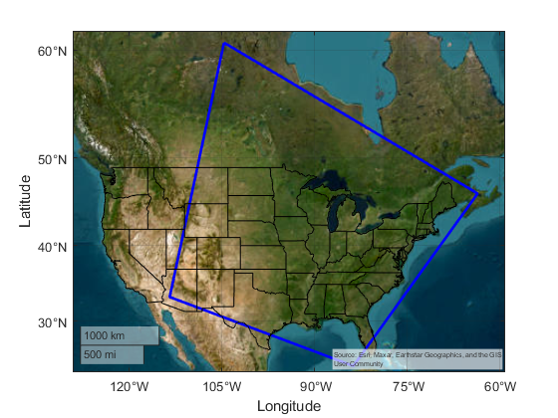

Deployment and characterization of RLS radar systems
Deployment and operational characteristics are informed by the tables and description contained in sections 4.1 and 4.2. The deployment density entries in the tables of these sections require that categories are assigned to locations inside the MAI region. Therefore, methodology is presented below describing how categories are determined.

Data sources for location based categories
All systems in these sections consider deployment density values categorized by “urban”, “suburban”, and “rural” densities as specified in sections 4.1.1 and 4.1.2 for mobile/fixed radars and vehicular radars, respectively.

Land cover-based Categorization
This is an alternative methodology to population-based categorization based on satellite imagery of ground cover that could be developed further as needed.

Gridded Population-based Categorization
The Gridded Population of the World (GPW) dataset, developed by NASA's Socioeconomic Data and Applications Center (SEDAC), offers a globally consistent and spatially explicit representation of human population distribution. Now in its fourth version (GPWv4), this dataset provides population counts and densities at a 30 arc-second (~1 km at the equator) resolution for the years 2000, 2005, 2010, 2015, and 2020. The data are derived from approximately 13.5 million national and sub-national administrative units, ensuring high-resolution mapping of population distribution. This granularity makes GPWv4 an invaluable resource for simulations requiring detailed demographic inputs, such as urban planning, disaster response, and environmental impact assessments. By integrating GPWv4 into simulation models, researchers can accurately assess human exposure to various risks, optimize resource allocation, and inform policy decisions based on precise population metrics. See: https://www.earthdata.nasa.gov/data/projects/gpw
The categorization of urban/suburban/rural is computed from the density reported by GPW-4 extrapolated to 2020, and utilizing density ranges of:
Urban >1158 persons per square km
Suburban 386 < density <= 1158 persons per square km
Rural 0 < density <= 386 persons per square km.
This set of definitions derives from U.S. Department of Health and Human Services 42 CFR Parts 403 and 408, Federal Register /Vol. 68, No. 240 /Monday, December 15, 2003 /Rules and Regulations page 69851. See: https://www.cms.gov/Regulations-and-Guidance/Regulations-and-Policies/QuarterlyProviderUpdates/downloads/cms4063ifc.pdf
figure a7.4.1-X: Population Categories MAI East
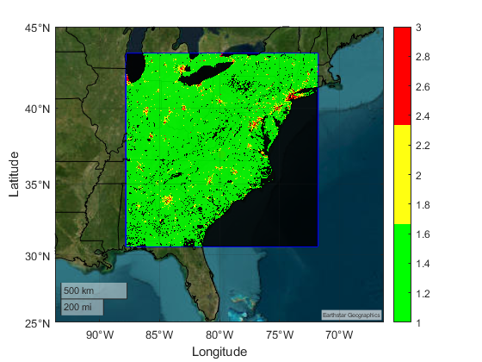
Note: State borders are drawn in black. Urban is drawn red, suburban yellow, rural green. There are also regions without data which are also drawn in black. The MAI boundary is drawn in blue.

RLS radar systems according to section 4.1 (mobile + fixed systems)

Modelling mobile radar systems
The mobile radar systems described in section 4.1 are active inside and outside buildings with mixed use.
figure a7.4.1-X mobile radar System (Radar 1)
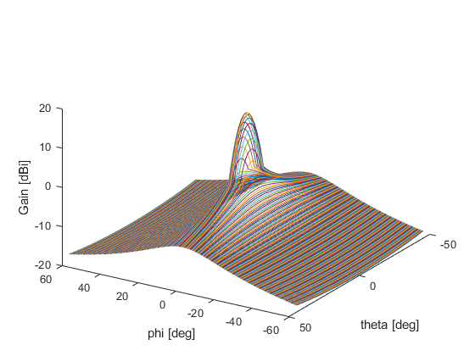
Note: This antenna pattern normalizes over all angles to average gain <=0dBi.

Modelling fixed radar systems
The fixed radar systems described in section 4.1 are active inside and outside buildings with mixed use. These systems are notable in that they have down tilt attitude.

RLS vehicular radar systems according to section 4.2 (short range + parking systems)

Modelling short range radar systems
The short-range vehicular radar systems described in section 4.2 have an added aspect associating their population on or near roadways and parking facilities. These systems are considered outdoor use with respect to estimating blocking losses from buildings, or other ground cover.
Short-distance systems were simulated as fixed positions with uniform spacing along roadways according to an inference between population category shared by the centre of the roadway combined with spatially nearby roadways to ensure that overall vehicle density (either car or truck) conforms with deployment density values in the tables of 4.2.
The source of the roadway spatial data was the North American Roads (NTAD) geospatial dataset. This source provides a digital single-line representation of major roads and highways for Canada, the United States, and Mexico. The North American Roads highway network has a number of intended uses including building national and regional-level maps where major highways and arterials are an important feature, national and regional transport corridor planning, national/regional traffic analyses including the routing of freight and passenger traffic flows within and between countries, and traffic simulations based on various disruption/diversion scenarios. The specific dataset used was published 27 October 2020. See: https://geodata.bts.gov/datasets/usdot::north-american-roads/about.
The assignment of category to roadways is complicated by the fact that some routes intersect multiple categories due to their location/length. At this time, assignment is sampled by the mean spatial location of the route. There is also a complication relating the implementation of radar deployment in adherence to the densities in the tables of 4.2. The road data include roadways with single and multi-lane routes. Moreover, the density of independent routes is highly location specific. As such, uniform spacing of vehicles on-route is selected as a simple metric for deployment. The determination of vehicle (and radar cluster) spacing is achieved by sampling 1 square kilometre area in representative land categories and adjusting the uniform spacing parameter to match the respective deployment densities per square kilometre indicated by the tables of 4.2.
Below are the representative spacing values:
Urban >1158 : 5 m,
Suburban 386 < density <= 1158 : 15 m,
Rural 0 < density <= 386 : 35 m.
For the purpose of simulation the former linear spacing between cars is used. An alternative approach is randomize allocation of systems within a spatial window and constrain deployment to roadways. So the roadways are populated with a budget of transmitters determined by the land category for the window. This procedure is repeated to cover the MAI region. The density of systems per square kilometer should be retained regardless of deployment methodology.
Time-dependent variations in spacing are expected, however, nominal values are used in simulations at this point.
figure a7.4.1-X: short-range radar (Radar X)
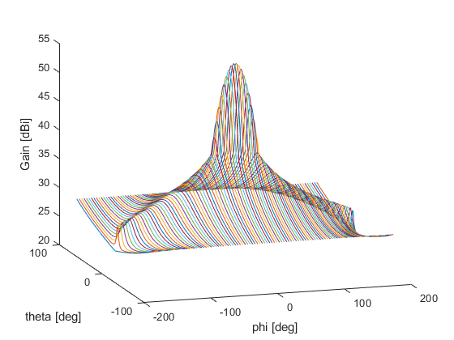
Note: This antenna pattern normalizes over all angles to average gain >0 dBi.
figure a7.4.1-X
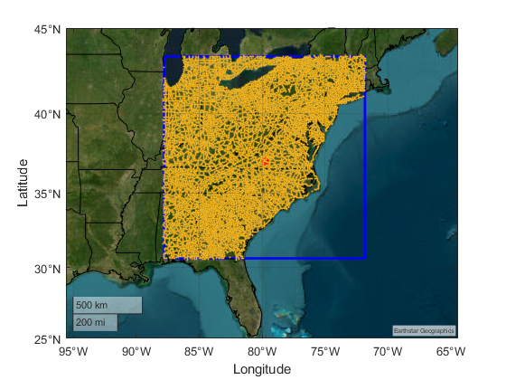
figure a7.4.1-X
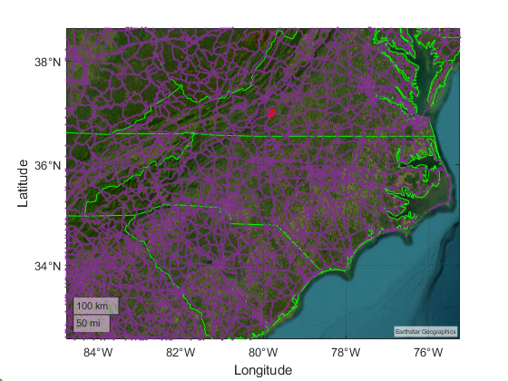
Note: All roadways are merged regardless of type (interstate, state, municipal, or local) and drawn in purple. State borders are drawn in green. The red dot is the MAI centroid.

Modelling parking radar systems
The radar systems described in section 4.2 are expected to be active in segregated regions of the roadways and building infrastructure.

Sharing and compatibility analysis EESS (passive) below 275 GHz

The following results show observed co-frequency receive power from mobile deployment at 244.6 GHz. The orbiting sensor type consists of T1 type from ITU-R RS.1861, with conical scanning mode. Figures A7.4.1-X shows local aggregation of mobile short range elements.
figure a7.4.1-X
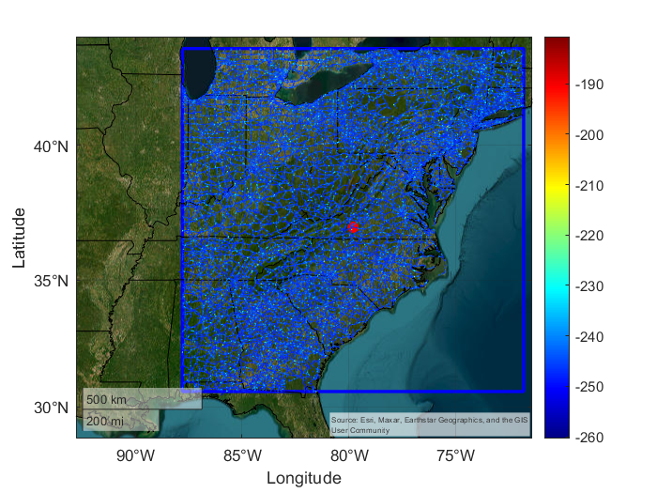
figure a7.4.1-X

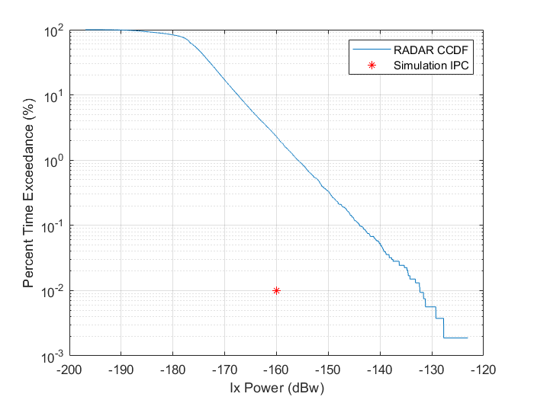
The following results show observed co-frequency receive power from fixed deployment at 244.6 GHz. The orbiting sensor type consists of T1 type from ITU-R RS.1861, with conical scanning mode. Figures A7.4.1-X shows local aggregation of scanning (Type A) and focused (Type B) elements.
figure a7.4.1-X
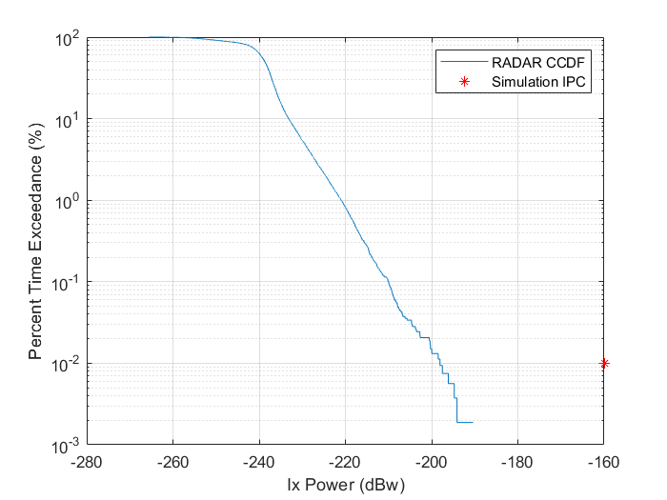

figure a7.4.1-X

TBD

Sharing and compatibility analysis EESS (passive) above 275 GHz
TBD

A7.4.1.2 STUDY B
The starting point of study B is to determine the “Maximum interference at the ground in the EESS footprint” that will have to be complied with the aggregation of all sources of interference.
Such a calculation takes into account the relevant atmospheric attenuation (from Rec. ITU-R P.676) and the following EESS (passive) parameters:
– Center frequency (GHz)
– Bandwidth (MHz)
– Orbit altitude (km)
– Nadir Angle (°)
– Protection criteria (dBW in reference bandwidth).
At current stage, calculations are only performed to address systems described in Table GG above, i.e. ICI on METOP-SG and AWS.
[Editor’s Note: Calculations for other sensors may be provided at a later stage]
These calculations consider the various measurement channels (at different frequencies) of these instruments with the corresponding free space and atmospheric attenuation (average over the bandwidth).
Table A7-1
Calculations for ICI
Table A7-2
Calculations for AWS
A more generic calculation is also provided below for an hypothetical sensor operating at 296 GHz.
Table A7-3
Calculations for Generic system at 296 GHz
As a second step, there is a need to assess the total emissions of interferers present within the EESS (passive) sensor footprint, from possible future Radiolocation service as well as other existing services (e.g. Fixed and Mobile services).
It is therefore necessary to appreciate the deployment of those various interference sources within the same geographical area.
As an example in-band, when considering the generic calculation in Table A7-3, the maximum interference at the ground in the EESS (passive) sensor footprint is 14.8 dBm/MHz.
Assuming a deployment of Fixed and Mobile service applications, as well as other Radiolocation service applications, one could propose that the portion of interference available for vehicular radars be decreased by 12 dB, hence leading to a maximum interference at the ground in the EESS (passive) sensor footprint of 2.8 dBm/MHz for such RLS applications.
Short-range vehicular radars are given for a maximum eirp of 70 dBm with a 5 GHz maximum bandwidth (see Table 1 in section 4.2.2). This could lead to a minimum eirp density of 33 dBm/MHz (to be confirmed).
This eirp density level is already above the total maximum interference acceptable, meaning that one single vehicular radar within the sensor footprint of 433 km² will exceed the EESS(passive) protection criteria to a large amount
As an example out-of-band, when considering RLS vehicular application unwanted emission levels, Table 1 in section 4.2.2 depicts a level of -30 dBm/MHz power density. As such, this level is not sufficient to perform a full compatibility analysis, since the behavior of the radar antenna in the unwanted emission domain will need to be characterized.
However, and to support the possible methodology to be used in this case, one could make the assumptions of a -30 dBm/MHz eirp density in average, to be compared with the 2.8 dBm/MHz maximum interference at the ground in the EESS (passive) sensor footprint. This would mean that a maximum of 1905 = 10^((2.8-(-30))/10) vehicular radars within 433 km² could interference EESS (passive). This represent a density of 4.4 radar per km², far from the expected deployment of such RLS applications.
This initial analysis shows that vehicular radars may not be compatible with EESS (passive) sensors in-band and adjacent band around 296 GHz. Similar conclusions may be derived in a number of channels of the ICI and AWS sensors.

A7.4.2 Sharing and compatibility analysis of EESS (active)

A.7.4.2.1 Sharing and compatibility analysis of EESS (active) in the band 237.9-238 GHz

General Considerations
TBD

Simulation Methodology
Assessments of the aggregate RFI expected from the RLS radar systems (operating according to section 4.1 or 4.1) into EESS (active) operating in the certain bands are achieved by dynamic simulations. The analysis is conducted in which the orbit of the EESS (active) spacecraft under investigation is dynamically simulated, retaining only the data points when the EESS (active) sensor antenna boresight points within the intended service area. Calculations are performed to determine the potential interference from each of the current active stations into the EESS (active) sensors under study and will consider the aggregate effect from multiple active stations. The simulation will propagate the satellite based on its orbital parameters, and the simulation step size is selected to be an irrational number to ensure that the beam dynamics of the active sensor are maximally representative and do not exhibit statistically reductive periodic behaviour. At each simulation step, a snapshot of the interference scenario is generated where the directional vectors from each active RLS radiative source to the EESS (active) sensor is computed along with the apparent gain of the transmit and receive antennas using their respective antenna patterns. For the RLS systems the radiation patterns are modelled by section 4.1.3 and 4.2.3 for mobile/fixed radars and vehicular radars, respectively.
The interfering signal power level, $I_{i,n}$ (W), received by a spaceborne sensor at the $n^{th}$ simulation step from the $i^{th}$ active station is calculated from:
$I_{i,n}=\frac{{ P}_{TX i,n}G_{TX i,n}{ G}_{RX i,n}}{L_{a i,n}{ L}_{FSPL i,n} }$ (A3-1)
where:
${ P}_{TX i,n}$: active station out of band transmitter power in the EESS (active) band, accounting for frequency dependent rejection
$G_{TX i,n}$: active station antenna gain towards spaceborne sensor
$G_{RX i,n}$: spaceborne receive antenna gain towards terrestrial source
$L_{a i,n}$ : propagation losses in accordance with section 6.1
$L_{FSPL i,n}$: Free Space Path Loss (if not already included in $L_{a i,n}$).
[Editor’s note: Working Parties 3J, 3K and 3M informed WP 5B that they intend to send an update regarding propagation advice. So this aspect may be refined in the methodology for EESS.]
The aggregate interference from radiolocation systems at the $n^{th}$ simulation step,${ AggI}_{n}$ (W), is calculated by the summation of the received interference from all active stations within line of sight of EESS (active) satellite:
${AggI}_{n}=\sum_{i}{I_{i,n}}=\sum_{i}{\frac{{P_{TX i,n} G}_{TX i,n}{ G}_{RX i,n}}{L_{a i,n}{ L}_{FSPL i,n} }}$ (A3-2)
Thus, the aggregate interference can be represented in the logarithmic domain as:
${AggI}_{n|dB}=10 {\log_{10}\left(\sum_{i}{\frac{{ P}_{TX i,n}{ G}_{TX i,n}{ G}_{RX i,n}}{L_{a i,n}{ L}_{FSPL i,n} }}\right) }_{|dB}$ (A3-3)
Using the resulting data containing received interfering power levels, a CCDF curve is generated to assess interference received by the sensor undergoing observations over the service area.
Since the occupied bandwidth of all radar systems is significantly larger than the reference bandwidth of the EESS(p) protection, for in-band assessments, it is assumed that emissions fully cover the reference bandwidth.

Deployment and characterization of RLS radar systems
The deployment and characterization of RLS radar system types will adopt those described in section A7.4.1.2.

Annex 8

A8 Characteristics and technical analysis related to radioastronomy service systems
Working Party (WP) 7D thanks WP 5B for Document 7D/60 and is pleased to provide relevant technical information pertaining to the radio astronomy service to support studies under WRC-27 agenda item 1.8 concerning possible additional spectrum allocations to the radiolocation service on a primary basis in the frequency range 231.5-275 GHz and possible new identifications for radiolocation service applications in the frequency bands within the frequency range 275-700 GHz for millimetric and sub millimetric wave imaging systems, in accordance with Resolution 663 (Rev.WRC-23).
Radio astronomy observations have been conducted for many years at frequencies above 200 GHz and, unlike the situation for active services, operating conditions are well understood. As noted in Reports ITU-R RA.2189, ITU-R RA.2512 and ITU-R SM.2450, observations above 200 GHz are conducted mostly at high altitude sites possessing exceptional atmospheric transparency, where propagation conditions of dry air and low atmospheric pressure are appropriate, which should be taken into account when performing sharing and compatibility studies with the radio astronomy service.
Radio astronomy has primary allocations in the frequency bands 200-231.5 GHz, 241-248 GHz and 250-275 GHz. Frequency bands above 275 GHz are identified for use by radio astronomy in RR No. 5.565. All emissions are prohibited in the frequency bands 200-209 GHz, 226-231.5 GHz and 250-252 GHz according to RR No. 5.340.
Working Party 7D would like to bring to the attention of WP 5B that the radio astronomy systems are listed and described in the Master International Frequency Register together with the status of allocation and conditions/remarks thereto and published in BR IFIC Space.
The spectral lines of carbon monoxide (CO) at 330.588 GHz, 345.777 GHz, 440.765 GHz, 461.041 GHz, 661.067 GHz and 691.473 GHz are of exceptional importance to radio astronomy.

A8.1 Recommendations and Reports
Recommendation ITU-R RA.314 | “Preferred frequency bands for radio astronomical measurements below 1 THz”
Recommendation ITU-R RA.517 | “Protection of the radio astronomy service from transmitters operating in adjacent bands”
Recommendation ITU-R RA.611 | “Protection of the radio astronomy service from spurious emissions”
Recommendation ITU-R RA.769 | “Protection criteria used for radio astronomical measurements”
Recommendation ITU-R RA.1031 | “Protection of the radio astronomy service in frequency bands shared with active services”
Recommendation ITU-R RA.1272 | “Protection of radio astronomy measurements above 60 GHz from ground based interference”
Recommendation ITU-R RA.1513 | “Levels of data loss to radio astronomy observations and percentage-of-time criteria resulting from degradation by interference for frequency bands allocated to the radio astronomy service on a primary basis”
Report ITU-R RA.2126 | “Techniques for mitigation of radio frequency interference in radio astronomy”
Report ITU-R RA.2131 | “Supplementary information on the detrimental threshold levels of interference to radio astronomy observations in Recommendation ITU-R RA.769”
Report ITU-R RA.2188 | “Power flux-density and e.i.r.p. levels potentially damaging to radio astronomy receivers”
Report ITU-R RA.2189 | “Sharing between the radio astronomy service and active services in the frequency range 275-3 000 GHz”  Updated versions of Tables 5 and 6 of Report ITU-R RA.2189 are given in Annex 3 here.
Report ITU-R RA.2508 | “Widely-distributed radio astronomy array systems operating above 200 GHz”
Report ITU-R RA.2512 | “Technical and operational characteristics of broadband, background-limited detectors operating in the millimetre-wave regime”  Instruments described in Report RA.2512 operating above 200 GHz are excerpted for display in Annex 2 here.
Report ITU-R SM.2450 | “Sharing and compatibility studies between land-mobile, fixed and passive services in the frequency range 275-450 GHz”  Updated and extended versions of Tables 9 and 10 (protection criteria) and 11 (sites) of Report ITU-R SM.2450 are given in Annexes 3 and 2 here, respectively.

A8.2 Representative radio astronomy sites operating in relevant frequency bands
Table 2-1 describes a representative list of radio astronomy sites currently operating heterodyne instruments above 200 GHz in the three ITU-R regions, with additional and more current information than the comparable Table 11 of Report ITU-R SM.2450.
Tables 2-2 and 2-3 describe, respectively, bolometer receivers in Chile and at the South Pole using information extracted from Report ITU-R RA.2512.
Table 2-1
Radio astronomy sites operating heterodyne instruments
ITU-R Region 1
Observatory name, place, administration | Longitude (E) Latitude (N) Elevation  (m AMSL) | Minimum elevation  (degrees) | Rx height above terrain  (m) | Uppermost operating frequency  URL  Geographical characteristics
IRAM-NOEMA 12×15 m  Plateau de Bure, France | 5.9079173°, 44.633889°  2553 | 0 | 15 | 370 GHz  https://iram-institute.org/observatories  Maximum antenna separation 1.7 km
IRAM-30 m,  Pico de Veleta, Spain | –3.392778°,  37.06611°  2850 | 0 | 31 | 370 GHz  https://iram-institute.org/observatories/

ITU-R Region 2
Observatory name, place, administration | Longitude (E) Latitude (N) Elevation  (m AMSL) | Minimum elevation  (degrees) | Rx height above terrain  (m) | Uppermost operating frequency  URL  Geographical characteristics
LMT 50 m Sierra Negra, Puebla, Mexico | –97.313333°  18.985000°  4660 | 7 | 51 | 280 GHz  http://lmtgtm.org/
APEX 12 m – Atacama Pathfinder Experiment, Chajnantor, Chile | −67.75888°  −23.00583°  4850 | 0 | 13 | 856 GHz  http://www.apex-telescope.org/ns/
FYST 6m – Fred Young Submillimeter Telescope  Chajnantor, Chile | –67.74028  –22.98583  5600 | 4 | 8 | 1.5 THz  https://www.ccatobservatory.org/
ASTE 10 m – Atacama Submillimeter Telescope Experiment,  Pampa La Bola , Chile | −67.7033°  −22.9714°  4860 | 0 | 13.6 | 940 GHz  http://aste.nao.ac.jp/index_e.html
ALMA, 54×12 m+12×7 m  Chajnantor, Chile | –67.754928°  –23.022911°  5000 | 0 | 13 | 950 GHz  https://www.almascience.org  maximum antenna separation 17 km inside a radio quiet zone of radius 35 km
NANTEN2 4 m, Pampa La Bola, Chile | –67.7031°  –22.970°  4860 | 0 | 7 | 880 GHz  https://astro.uni-koeln.de/en/observational-astrophysics/nanten2
Simons Observatory,  Chajnantor, Chile | −67.7875°  −22.95861°  5200 | 0 | 6 | 300 GHz  https://simonsobservatory.org/
ARO SMT 10 m, Mt. Graham, AZ, USA | –109.89201°  32.701303°  3200 | 7 | 11 | 375 GHz  https://aro.as.arizona.edu/
JCMT 15 m,  Mauna Kea, HI, USA | –155.47694°  19.822833°  4300 | 6 | 17 | 345 GHz  https://www.eaobservatory.org
SMA 8×6 m  Mauna Kea, HI, USA | –155.47500°  19.821667°  4300 | 0 | 8 | 420 GHz  https://lweb.cfa.harvard.edu/sma/
South Pole 10 m Telescope, NSF South Pole Research Station, USA | ……  −90°  2820 | 0 | 8 | 240 GHz  https://pole.uchicago.edu/public/Home.html  At the very South Pole

ITU-R Region 3
Observatory name, place, administration | Longitude (E) Latitude (N) Elevation  (m AMSL) | Minimum elevation  (degrees) | Rx height above terrain  (m) | Uppermost operating frequency  URL  Geographical characteristics
CCOSMA, 3m, Yangbajing, Tibet China | 90.5258°  30.1033°  4319 | 0 | 4 | 230/345 GHz  https://tinyurl.com/yjtcjfnb
Korean VLBI Network (KVN) Pyeongchang 21m radio telescopes, Republic of Korea | 128° 26′ 55.1"  37° 32′ 00.1"  557 | 5 | 15 | 275 GHz  https://kvn.kasi.re.kr
Korean VLBI Network (KVN) Yonsei 21m radio telescopes, Republic of Korea | 126° 56′ 27.4"  37° 33′ 54.9"  139 | 5 | 15 | 275 GHz  https://kvn.kasi.re.kr
SNU 6 m Radio Telescope,  Republic of Korea | 126° 57′ 19"  37° 27′ 15"  139 | 5 | 5 | 270 GHz  https://astron.snu.ac.kr/en

Table 2-2
Broadband, background-limited detectors at Parque Astronómico de Atacama, Chajnantor Chile (Report ITU-R RA.2512)
Telescope or project name,  URL | Instrument, detector count | Band centre  (GHz) | Fractional bandwidth | Antenna beamwidth  (degree) | Directivity gain  (dBi) | Instrument field of view  (degree) | Primary aperture  (m) | Unshielded aperture  (m)
JHU CLASS Cosmology large angular scale surveyor  https://sites.krieger.jhu.edu/class/ | G-band dichroic receiver  1 020 detectors | 216 | 0.17 | 0.27 | 47 | 18.9 | 0.6 | 0.35
Simons Observatory  https://simonsobservatory.org/ | POLARBEAR-2  22 764 detectors | 227  275 | 0.2  0.15 | 0.05  0.04 | 70  72 | 4.8 | 2.5 | 0.5

Table 2-3
Broadband, background-limited detectors at the South Pole Dark Sector (Report ITU-R RA.2512)
Telescope or project name  URL | Instrument, years of operation detector count | Band centre  (GHz) | Fractional bandwidth | Antenna beamwidth  (degree) | Directivity gain  (dBi) | Instrument field of view  (degree) | Primary aperture  (m) | Unshielded aperture  (m)
BICEP  https://tinyurl.com/bp4tds6z | BICEP Array  2020-current  32 724 detectors | 220  270 | 0.24  0.18 | 0.18  0.15 | 59  61 | 28 | 0.52 | 0.52
South Pole Telescope  https://pole.uchicago.edu/public/Home.html | SPT-3G  2016-current  16 260 detectors | 220 | 0.24 | 0.017 | 79 | 1.9 | 10 | 0.685

A8.3 Protection criteria
Tables 3-1 and 3-2 give protection criteria for radio astronomy observations using current values for receiver temperatures above 275 GHz. For an explanation of how the values were calculated, see Recommendation ITU-R RA.769. The entries in Tables 3-1 and 3-2 are identical to those in Tables 1 and 2 of Recommendation ITU-R RA.769 below 275 GHz and should be used in place of Tables 5-6 of Report ITU-R RA.2189 or Tables 9-10 of Report ITU-R SM.2450 at higher frequencies. Criteria from both tables should be satisfied at relevant frequencies.
Table 3-1
Threshold levels of interference detrimental to radio astronomy continuum observations
frequency  f  (MHz) | Assumed spectral line channel bandwidth  Δf  (kHz) | Minimum antenna noise temperature  T_{A}  (K) | Receiver noise temperature  T_{R}  (K) | System sensitivity⁽²⁾  (noise fluctuations) |  | Threshold interference levels⁽¹⁾ ⁽²⁾
 |  |  |  | Temperature  ΔT  (mK) | Power spectral  density  ΔP_{S}  (dB(W/Hz)) | Input power  ΔP_{H}  (dBW) | pfd  S_{H} Δf  (dB(W/m²)) | Spectral pfd  S_{H}  (dB(W/(m² ⋅ Hz)))
(1) | (2) | (3) | (4) | (5) | (6) | (7) | (8) | (9)
220 000 | 8 000 | 20 | 43 | 0.016 | –276.6 | –187.6 | –119.3 | –218.3
265 000 | 8 000 | 25 | 50 | 0.019 | –275.9 | –186.8 | –116.9 | –216.0
345 000 | 8 000 | 24 | 72 | 0.024 | –274.8 | –185.8 | –113.6 | –212.6
405 000 | 8 000 | 43 | 135 | 0.044 | –272.1 | –183.1 | –109.5 | –208.5
432 000 | 8 000 | 78 | 135 | 0.053 | –271.3 | –182.3 | –108.1 | –207.2
500 000 | 8 000 | 115 | 135 | 0.063 | –270.6 | –181.6 | –106.2 | –205.2
605 000 | 8 000 | 172 | 105 | 0.069 | –270.2 | –181.2 | –104.1 | –203.1
675 000 | 8 000 | 108 | 105 | 0.053 | –271.3 | –182.3 | –104.3 | –203.3
710 000 | 8 000 | 154 | 105 | 0.065 | –270.5 | –181.5 | –103.0 | –202.0

Table 3-2
Threshold levels of interference detrimental to radio astronomy spectral-line observations
frequency  f  (MHz) | Assumed spectral line channel bandwidth  Δf  (kHz) | Minimum antenna noise temperature  T_{A}  (K) | Receiver noise temperature  T_{R}  (K) | System sensitivity⁽²⁾  (noise fluctuations) |  | Threshold interference levels⁽¹⁾ ⁽²⁾
 |  |  |  | Temperature  ΔT  (mK) | Power spectral  density  ΔP_{S}  (dB(W/Hz)) | Input power  ΔP_{H}  (dBW) | pfd  S_{H} Δf  (dB(W/m²)) | Spectral pfd  S_{H}  (dB(W/(m² ⋅ Hz)))
(1) | (2) | (3) | (4) | (5) | (6) | (7) | (8) | (9)
220 000 | 1 000 | 20 | 43 | 1.41 | –257.1 | –207.1 | –138.8 | –198.8
265 000 | 1 000 | 25 | 50 | 1.68 | –256.4 | –206.4 | –136.4 | –196.4
345 000 | 1 000 | 23 | 72 | 2.14 | –255.3 | –205.3 | –133.1 | –193.1
405 000 | 1 000 | 43 | 135 | 3.98 | –252.6 | –202.6 | –129.0 | –189.0
432 000 | 1 000 | 78 | 135 | 4.77 | –251.8 | –201.8 | –127.7 | –187.7
500 000 | 1 000 | 115 | 135 | 5.59 | –251.1 | –201.1 | –125.7 | –185.7
605 000 | 1 000 | 172 | 105 | 6.20 | –250.7 | –200.7 | –123.6 | –183.6
675 000 | 1 000 | 108 | 105 | 4.76 | –251.8 | –201.8 | –123.8 | –183.8
710 000 | 1 000 | 154 | 105 | 5.80 | –251.0 | –201.0 | –122.5 | –182.5

A8.4 Graphical representations
Figure 4-1
Effective zenith system temperature and atmospheric transmission at ALMA
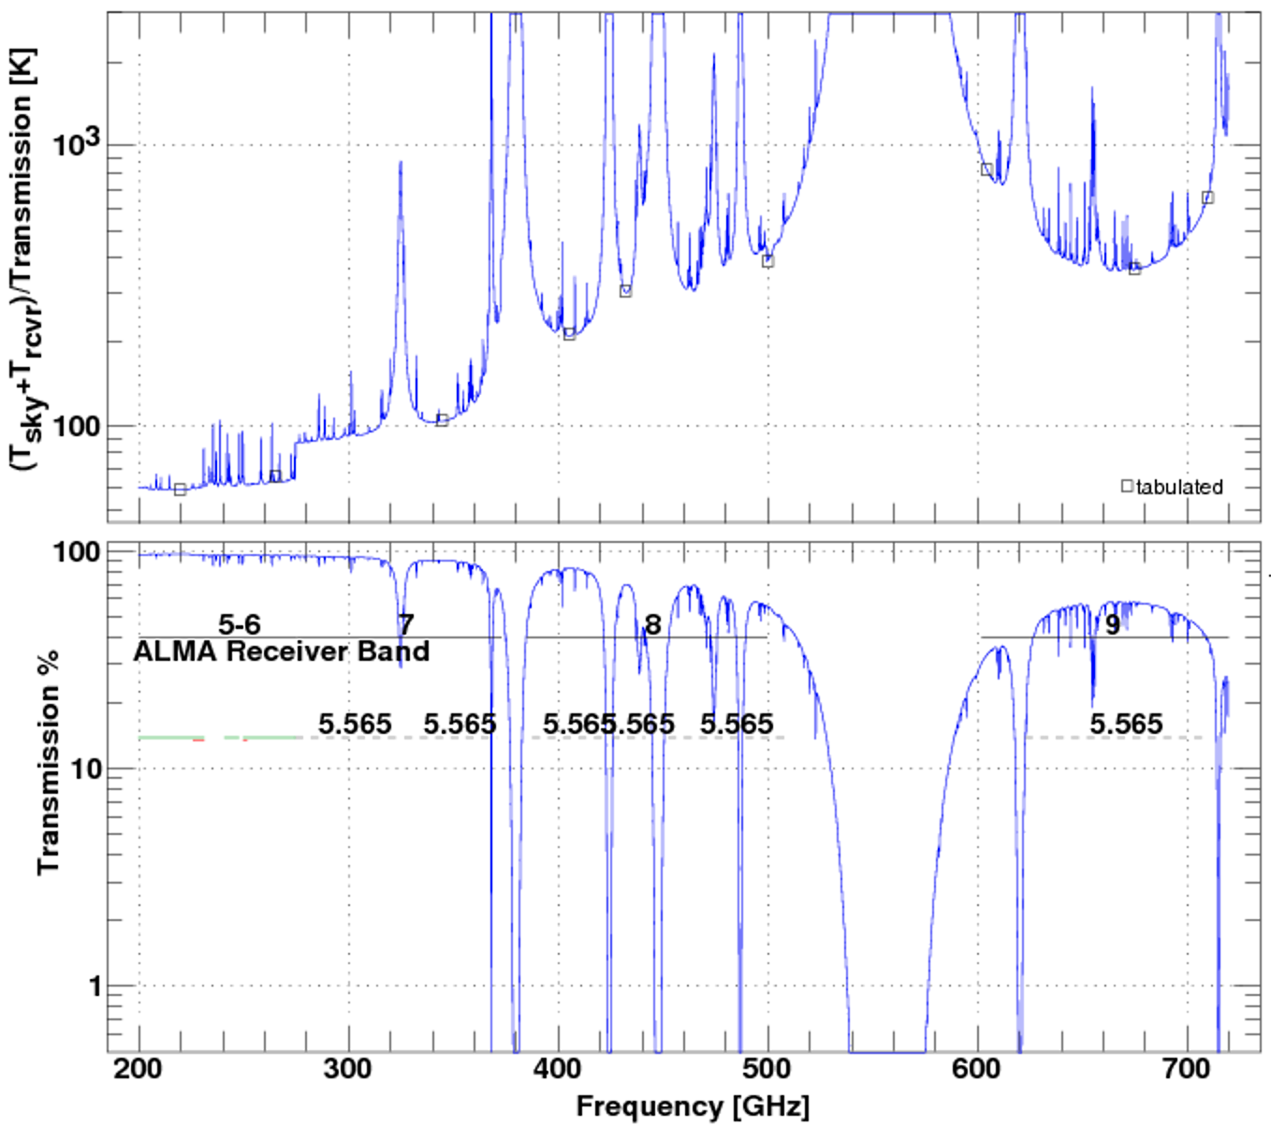
Lower plot: Atmospheric transmission at zenith as a function of frequency at ALMA. The tuning ranges of ALMA receiver bands 5-9 are shown along with the frequency bands identified in RR No. 5.565. The green horizontal lines below 275 GHz show the frequency bands allocated to radio astronomy on a primary basis and the red horizontal lines show the frequency bands subject to RR No. 5.340. Upper plot: Variation of the effective system temperature (Tsky+Trcvr)/Transmission that accounts for attenuation of the incoming signal. Values at frequencies noted in Tables 3-1 and 3-2 are marked on the plot by small open rectangles. ALMA documentation may be found at https://almascience.nrao.edu/proposing/technical-handbook.

A8.5 Sharing and compatibility analysis
TBD

Annex 9

A9 Common characteristics related to the RLS applications

A9.1 Antenna Pattern
The following equations provide the antenna radiation pattern that could be used in the analysis of interference:
$G\left(φ,θ\right)= G_{ref}\left(x\right)$
$G_{ref}\left(x\right)=G_{0}-12x²$ for $0≤x<1.152$
$G_{ref}\left(x\right)=G_{0}-15-15\log{(x)}$ for $1.152≤x$
with:
$α=arctan⁡\left(\frac{\tan{θ}}{\sin{φ}}\right)$
$Ψ_{α}=\frac{1}{\sqrt{{\left(\frac{\cos{α}}{φ_{3}}\right)}^{2}+{\left(\frac{\sin{α}}{θ_{3}}\right)}^{2}}}$
$Ψ=arccos⁡(\cos{φ}.cos{θ)}$
$x=\frac{Ψ}{Ψ_{α}}$
where:
G(ϕ,θ): gain relative to an isotropic antenna (dBi)
G₀: Maximum gain in or near the horizontal plane (dBi)
θ: Absolute value of the elevation angle relative to the angle of maximum gain (degrees)
θ₃: 3 dB beamwidth in the vertical plane (degrees)
ϕ: Azimuth angle relative to the angle of maximum gain (degrees)
ϕ₃: 3 dB beamwidth in the azimuth plane (degrees).

That is, any building of the ‘traditional’ or ‘thermally efficient’ types.

