|  |  |
| --- | --- |
| **U.S. Radiocommunications Sector**  **Fact Sheet** | |
| **Working Party:** ITU-R WP 5B | **Document No:** USWP5B35-06_R2 |
| **Ref:** Annex 2.3 to Document 5B/315 | **Date:** 08 August 2025 |
| Document Title: Annex 2.3 to Working Party 5B Chair’s Report WORKING DOCUMENT TOWARDS A PRELIMINARY DRAFT NEW REPORT ITU-R M.[RLS_AMS_ANTENNAS]  Antenna radiation patterns of radiodetermination radar and aeronautical mobile systems | |
| **Author(s)/Contributors(s):**  Eric Lee  NTIA  Raafat Nasser  ACES (for NTIA)  Tito Alvarez  FTI (for NTIA)  Ms. Emily Murphy  DHS  Mr. Richard Ontiveros  DHS  Mr. Dmitry Baraban  MITRE (for DHS) | Phone: 202-948-1188  Email: [Elee@ntia.gov](mailto:Elee@ntia.gov)    Phone : 571-277-4030  Email : [Raafar.Nasser@aces-inc.com](mailto:Raafar.Nasser@aces-inc.com)  Phone : 240-284-8657  Email : [TAlvarez@ftidc.com](mailto:TAlvarez@ftidc.com)  Phone: +1 202 751 8383  Email: [emily.murphy@hq.dhs.gov](mailto:emily.murphy@hq.dhs.gov)  Phone: +1 202 924 1036  Email:  [Richard.ontiveros@hq.dhs.gov](mailto:Richard.ontiveros@hq.dhs.gov)  Phone: +1 703 983 1783  Email:  [dmitry.baraban@associates.hq.dhs.gov](mailto:dmitry.baraban@associates.hq.dhs.gov) |
| **Purpose/Objective:** For low peak sidelobes, the cosine on a pedestal pattern produces adjacent sidelobes that are not monotonically decreasing beyond the peak sidelobe. The Taylor one parameter antenna pattern fixed this problem and provides a more familiar patterns especially for Radar systems. | |
| **Abstract****:** For low peak sidelobes, the cosine on a pedestal pattern produces adjacent sidelobes that are not monotonically decreasing beyond the peak sidelobe. The addition of the Taylor one parameter antenna pattern fixed this problem and provides a more familiar patterns especially for Radar systems. | |

|  |  |
| --- | --- |
| **Radiocommunication Study Groups** |  |
|  |  |
|  |  |
| Source: Document 5B/315 | Annex 2.3 to Document 5B/315-E |
| 14 May 2025 |
| English only |
| Annex 2.3 to Working Party 5B Chair’s Report | |
| WORKING DOCUMENT TOWARDS A PRELIMINARY DRAFT NEW REPORT ITU-R M.[RLS_AMS_ANTENNAS] | |
| Antenna radiation patterns of radiodetermination radar and aeronautical mobile systems | |

(202X)

[Editor’s note: The material included under the Scope, Section 1, Section 4, and Section 5 has been extracted from contribution 5B/258 and remains subject to further discussion at upcoming meetings.]

Scope

This Report provides the analysis of directive antenna radiation pattern models for radar and aeronautical mobile systems. The Taylor one parameter antenna model is added.

Keywords

Antenna radiation pattern, peak and average mask patterns, radar, aeronautical mobile systems.

List of Abbreviations/Glossary

TBD

Related ITU-R Recommendations and Reports

*Recommendations*

ITU-R M.1851 Mathematical models for radiodetermination radar and aeronautical mobile systems antenna patterns for use in interference analyses.

TBD

# 1 Introduction

This Report considers some directional antennas used for radar and aeronautical mobile systems except cosecant-squared elevation patterns. Two types of such antennas are analysed: antennas with circular apertures (Section 2) and antennas such as reflector antennas with non-symmetrical beam (narrow beam in one plane and wide beam in the perpendicular plane) and antenna arrays with suppressed sidelobes (Section 3). The Taylor one parameter antenna pattern is added to ensure that sidelobes adjacent to the peak sidelobe are monotonically decreasing. The question of average peak radiation patterns is considered also (Section 4).

[Editor’s Note: No changes were proposed between the Introduction section and this new section]

# 3.3 Taylor one parameter (modified sin(x)/x) line source

In radar and low-noise system design, engineers often navigate trade-offs between key antenna performance metrics. Although narrow beamwidth and strong near-sidelobe suppression are traditionally favoured, Reference 10 suggests that a more effective approach may involve modest compromises in these areas to achieve a radiation pattern where all minor lobes decay consistently and monotonically as the angle increases from the main beam.

This strategy improves clutter rejection and lowers the risk of false target detection caused by sidelobe ambiguity. When sidelobes decay smoothly and predictably, the antenna maintains tighter control over off-axis energy—an essential feature in systems with high dynamic range or low signal-to-noise ratios.

However, patterns generated using cosine and cosine2 type of excitation on a pedestal—especially at low peak sidelobe ratio levels—can produce a first sidelobe that is lower than its neighbours. This leads to non-monotonic sidelobe behaviour, which is generally undesirable in radar applications where consistent roll-off is critical for suppressing clutter and distinguishing targets accurately.

To address this issue, the Taylor one-parameter line source pattern, described in References 7 through 10, provides a more symmetric and well-behaved sidelobe structure. Its monotonic decay away from the main beam better aligns with radar system requirements, allowing for controlled sidelobe shaping without sacrificing beam integrity. Unfortunately, the original paper could not be located.

Taylor recognized that to produce a linear aperture distribution with a sidelobe envelope approximating a 1/u falloff, the uniform amplitude sin(x)/x pattern could be used as a starting point. He understood that the height of each sidelobe is controlled by the spacing between the aperture pattern factor zeros on each side of the sidelobe. Since the sin(x)/x pattern has a 1/u, the far-out zeros are spaced by integers, and the side lobe envelope decays as l/u where the variable defines the angular dependence.

Taylor’s key insight was that only the close-in zeros needed to be adjusted to suppress the near sidelobes, while the far-out zeros could remain at their integer positions. This selective modification preserves the desirable 1/u decay in the outer sidelobes while improving near-sidelobe behaviour. See Reference 8. The pattern is given by the expression below.

Eq. 3.3-1

B = Taylor one parameter value for a given Sidelobe Ratio (SLR),

is a new variable, u-space, that defines the angular dependence

d = the aperture width (m)

λ = wavelength (m),

θ = antenna pattern angle (degrees).

Where the gain in dB is given by.

Eq. 3.3-2

From reference 10 page 410, is normalized by subtracting the following value:

Eq. 3.3-2a

Where the single parameter B controls all characteristics of beamwidth, sidelobe level and efficiency. B is computed from the desired sidelobe (SLR) by iterative solution to the equation, reference 8, as:

Eq. 3.3-3

Using reference 11, chapter 20 equation 20.14.5, B can be approximated for SLR values between 13.2614 dB and 60 dB using the following expression.

Eq. 3.3-4

The antenna pattern efficiency, η, is obtained from reference 8 equation 9 by:

Eq. 3.3-5

Where is the integral of the Bessel function . This integral can be done, using Microsoft Excel, by the Excel equation:

Eq. 3.3-5a

The antenna edge taper is given in reference 7 section 3.1.6 Page 129 as:

Eq. 3.3-6

The one sided 3-dB width in u-space, , is solved iteratively as shown in reference 11 page 982 in the provided Matlab code. But since it is easier to use curve fitting to the existing data that is found in Hansen reference 5 Table 3.1 for Taylor One-Parameter Characteristics, curve fit equation is:

Eq. 3.3-7

The Taylor one-parameter line source characteristics are shown in the table below. Figure 3.3-1 shows the plot of each parameter as a function of SLR.

TABLE 3.3-1

Taylor one-parameter line source characteristics, calculated from the above equations

| Input | Eq 3.3-4 | Eq. 3.3-7 | Eq. 3.3-5 |  | Eq. 3.3-6 |
| --- | --- | --- | --- | --- | --- |
| SLR, Sidelobe Ratio (dB) | B, Taylor One-Parameter B | , one side= *(L/λ (rad) | η, Antenna Efficiency | η * (rad) | Edge Taper (dB) |
| 13.26 | 0 | 0.4429 | 1.000 | 0.443 | 0.0 |
| 15 | 0.3588 | 0.4615 | 0.993 | 0.458 | 2.5 |
| 20 | 0.7341 | 0.5119 | 0.934 | 0.478 | 9.2 |
| 25 | 1.0206 | 0.5580 | 0.863 | 0.482 | 15.3 |
| 30 | 1.2767 | 0.6002 | 0.801 | 0.481 | 21.1 |
| 35 | 1.5162 | 0.6391 | 0.750 | 0.480 | 26.8 |
| 40 | 1.7448 | 0.6752 | 0.708 | 0.478 | 32.4 |
| 45 | 1.9658 | 0.7091 | 0.673 | 0.477 | 37.9 |
| 50 | 2.1809 | 0.7411 | 0.643 | 0.477 | 43.3 |

figure 3.3-1

Taylor one-parameter line source characteristics

The one side first null angular angle location in degrees, , is obtained from reference 12 equation 4 and is written as:

Eq. 3.3-9

Reference 8 indicates that the proper placement of the pattern zeros reduces the near sidelobe levels, which have been set at locations . Assuming that the peak sidelobes angular locations is halfway between the null locations, the approximate angular locations of the pattern peak sidelobes, for each peak sidelobe number n, are found using the expression.

eq. 3.3-10

The peak sidelobe levels can be computed using the sidelobe angle from Eq. 3.3-10 and the antenna pattern equation 3.3-2 and 3.3.2a.

An estimate of the number of peak sidelobes, , to generate for a given SLR and is.

Eq. 3.3-11

The peak sidelobes pattern envelope would intersect the antenna main lobe at an angle that is approximately equal to:

Eq. 3.3-12

The average antenna sidelobe envelope is assumed, as was done for other patterns in this document, to be lower that the peak envelope by 4 dB. The average sidelobe envelope would be connected to the main lobe at a value that is 4 dB lower than the peak envelope.

A proposed front-to-back ratios as they relate to the SLR values are shown in table 3.3-2.

TABLE 3.3-2

Initial Recommendation for Front-to-Back Ratio

|  |  |
| --- | --- |
| **Peak Sidelobe Ratio (SLR) (dB)** | **Typical Front-to-Back Ratio (dB) where the envelope is a constant flat value** |
| –13 dB (uniform aperture) | ~35 dB |
| –20 dB | ~50 dB |
| –30 dB | ~60 dB |
| –40 dB | ~70 dB |
| –50 dB | ~80 dB |

The following figures show the Taylor one-parameter antenna patterns for different SLR cases.

figure 3.3-2

Taylor one parameter antenna patterns for peak SLR=14 dB

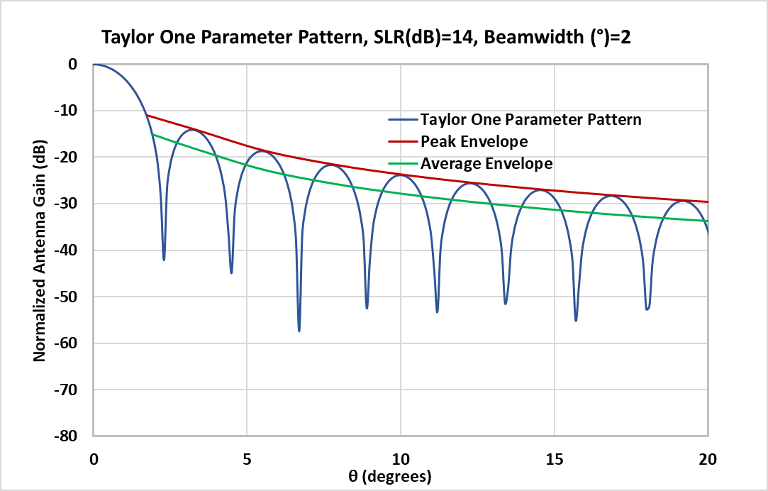

figure 3.3-3

Taylor one parameter antenna patterns for peak SLR=30 dB

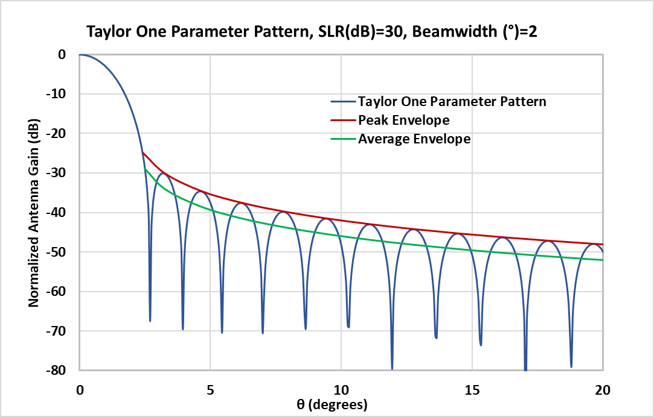

figure 3.3-4

Taylor one parameter antenna patterns for peak SLR=50 dB

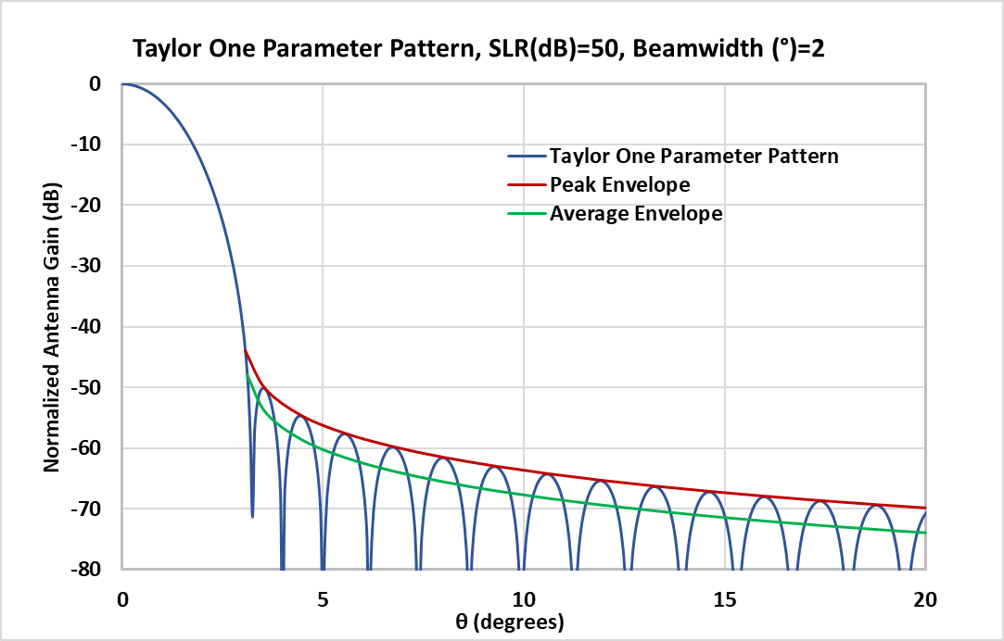

The following figures compare the Taylor one-parameter pattern with the cosine-on-pedestal and cosine-squared patterns, highlighting how their sidelobe structures differ in behaviour and decay characteristics..

figure 3.3-6

Taylor one parameter antenna patterns for peak SLR=25 dB

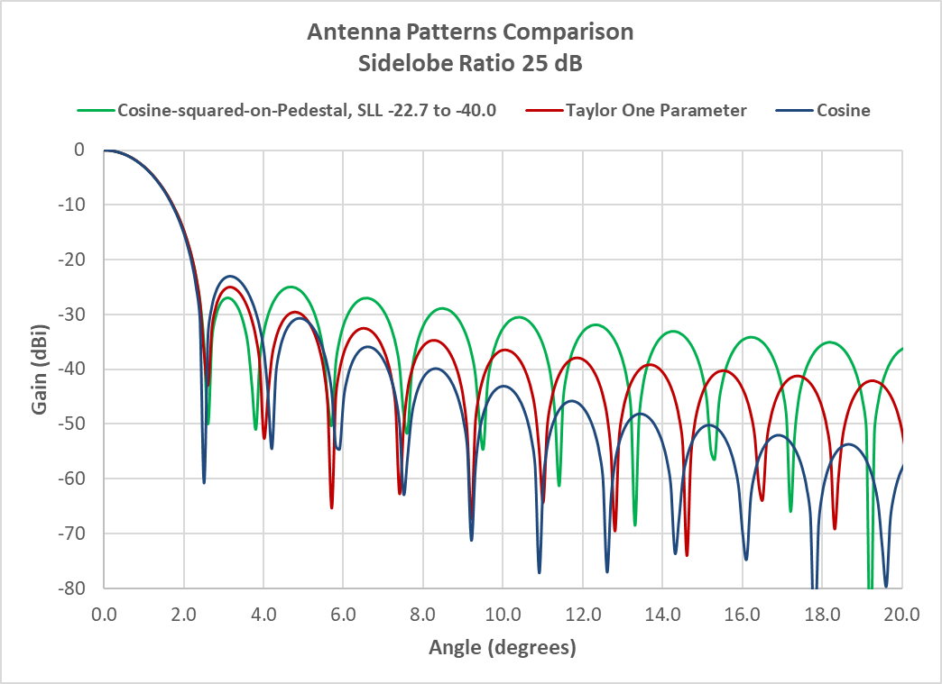

figure 3.3-7

Taylor one parameter antenna patterns for peak SLR=30 dB

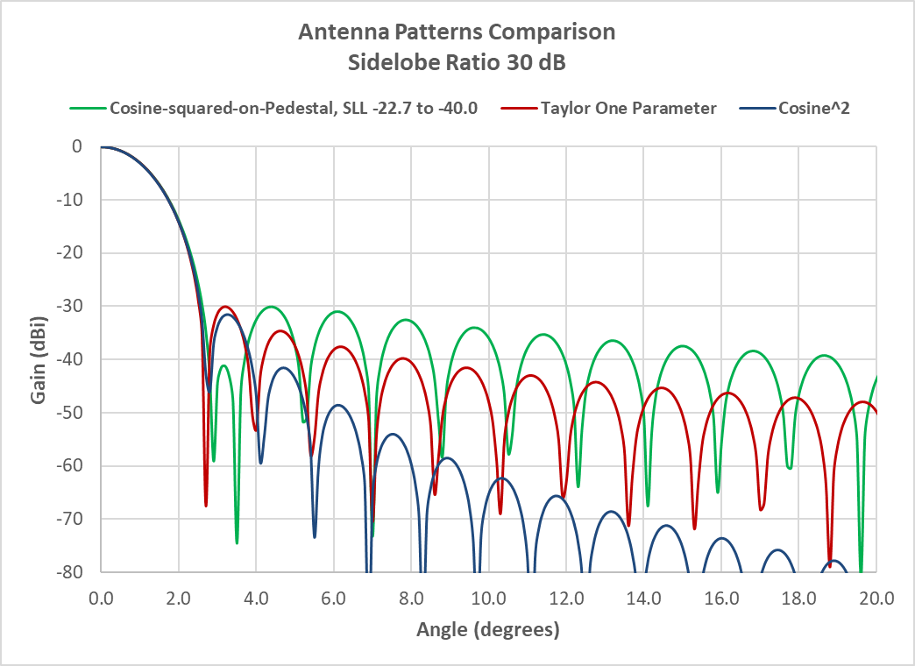

figure 3.3-8

Taylor one parameter antenna patterns for peak SLR=40 dB

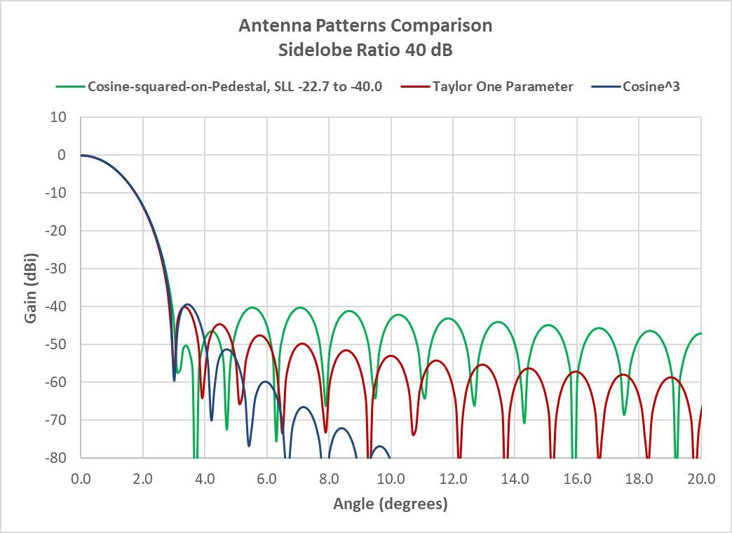

Figures 3.3-6, 3.3-7, and 3.3-8 illustrate comparative sidelobe behaviour across the Taylor one-parameter, cosine-on-pedestal, and cosine-squared antenna patterns. Pay particular attention to the first sidelobe: the cosine-on-pedestal pattern exhibits suboptimal performance for radar applications due to its relatively high and non-monotonic sidelobe structure. For systems requiring a low peak sidelobe ratio—typically below 30 dB—the Taylor one-parameter pattern is recommended for sharing studies, as it ensures adjacent sidelobes decrease monotonically, improving interference mitigation and regulatory compliance.

# [Editor’s Note: No changes in sections below this new section up to the reference section where more references are added]

References

[1] Volakis J. L., *Antenna Engineering Handbook*, 4th ed., 2007

[2] Stutzman, W. L., Thiele, G. A., *Antenna Theory and Design*, 3rd ed., 2013

[3] Skolnik, M., *Radar Handbook*, 3rd ed., 2008

[4] Balanis C. A., *Antenna Theory. Analysis and Design*, 3rd ed., 2005

[5] Hansen R.C., *Phased Array Antennas*, 2nd ed., 2009

[6] Yampolsky, A. A., Frolov, O. P., Antenny i EMS [Antennas and EMC], 1983 (in Russian)

[7] R. J. Mailloux, Phased Array Antenna Handbook, 1st ed., Artech House, 534 pp., 1994. 2nd ed., Artech House 2005.

[8] R. C. Hansen, “Array Pattern Control and Synthesis,” *Proc. IEEE*, Vol. 80, No. 1, pp. 141–151, January 1992.

[9] Taylor, T. T., “One-Parameter Family of Line Sources Producing Modified sin πu/πu Patterns”, Rep. TM 324, Hughes Aircraft Co., Culver City, CA, 1953. (note: this is the original paper, but it is not available on the internet)

[10] Balanis C. A., *Antenna Theory. Analysis and Design*, 4th ed., 2016

[11] Electromagnetic Waves and Antennas by Sophocles J. Orfanidis, Rutgers University, Copyright © 1999–2016 by Sophocles J. Orfanidis. Or <https://rutgers.app.box.com/s/rwzifofsu9slf8xy38f6uwhjd5gmn2q7> https://www.ece.rutgers.edu/orfanidis (a link to all of the author’s publications) ~~[www.ece.rutgers.edu/~orfanidi/ewa](http://www.ece.rutgers.edu/~orfanidi/ewa)~~

[12] M. Al-Husseini et al., “Independent Control of the Beamwidth and Sidelobe Level of Taylor One-parameter Arrays”, <https://lebcsr.org/wp-content/uploads/2018/01/C69.pdf>

______________