U.S. Radiocommunications Sector
Fact Sheet
Working Party: ITU-R WP 5C | Document No: USWP5C-XX
Ref: Document 5C/271 (Annex 2.4) | Date: February 18, 2026
Document Title: WORKING DOCUMENT ON SHARING STUDIES UNDER WRC-27 AGENDA ITEM 1.10
Author(s)/Contributors(s):  Zahid Islam  SpaceX  Joe McMichael  SpaceX  Nader Damavandi  SpaceX  Jameson Dempsey  SpaceX | Email: km.islam@spacex.com  Email: Joseph.McMichael@spacex.com  Email: Nader.Damavandi@spacex.com  Email: jameson.dempsey@spacex.com
Purpose/Objective: Add studies to the Working Doc on AI 1.10, i.e. 5C/271 (Annex 2.4)

Abstract: Within the context of AI 1.10, WP5C, based on studies, will determine power flux-density (pfd) and equivalent isotropically radiated power (e.i.r.p.) limits to be included in Article 21 for satellite services (fixed-satellite service (FSS), mobile-satellite service (MSS) and broadcasting-satellite service (BSS)) to protect the current and planned fixed and mobile services in the frequency bands 71-76 GHz and 81-86 GHz. The United States hereby added new studies taking into account accurate modelling of the example FSS systems considered.

Study #XY
This study considers operational conditions of the FS as provided in doc 5C/271 (Annex 2.4) and assuming 5, 7.5 and 10 degrees as maximum elevation. With respect to the parameters of GSO and non-GSO systems (including minimum elevation, GSO exclusion zone, and max number of co-frequency beams at a specific location), the analysis considered cases with different operational conditions than those communicated by 4A as described below. The various assumptions different from the 4A liaison statement are on purpose all worse than the parameters communicated by 4A. Additionally, the methodology considers scenarios with propagation characteristics as per Doc. 5C/74 (guidance provided by WP 3J and 3M), as well as scenarios in clear sky.
The statistics of the interference power against time for each power flux density (PFD) mask specified is calculated at each timestep using the method described below:

1) Collocate an FSS earth station (ES) with the terrestrial FS station.
2) Based on the parameters of the selected non-GSO systems, determine number of visible satellites to the FS station, $N_{v}$ (satellites above an elevation angle of 0°).
3) Determine the pool of eligible satellites for each of the selected non-GSO systems complying with the system-specific minimum elevation angle, $ε$, and minimum GSO exclusion angle, $α$ at the ES location.
4) Select maximum number of non-GSO satellites allowed to transmit with overlapping frequencies towards the same location on the ground, $N_{co},$ using random satellite selection strategy. Determine the contribution from the $N_{co}$ satellites to the FS station.
$I_{N_{co}}= PFD-10\log_{10}\left(\frac{4π}{λ^{2}}\right)+G\left(α\right)$ (eq. 1)
$PFD$ is the assumed power flux density at the Earth’s surface in dB(W/m²/MHz)
$λ$ is the wavelength in meters
$G\left(α\right)$ is the gain of the FS receiving antenna at off-axis angle $α$ degrees

5) For the remaining visible $N_{v}- N_{co}$ satellites (also known as non-$N_{co}$ satellites), determine contribution of the sidelobes towards the FS station assuming random placement of the beams from the satellite with its field of view.
$I_{{non-N}_{co}}= EIRP\left(θ\right)-20\log_{10}\left(\frac{4πd}{λ}\right)- L_{a} +G\left(α\right)$ (eq. 21)
$EIRP\left(θ\right)$ is the assumed effective isotropic radiated density from the non-$N_{co}$ satellite to the FS station direction in dB(W/MHz) at off-axis angle $θ$ degrees
$λ$is the wavelength in meters
$d$is the distance between the non-$N_{co}$ satellite and FS station in meters
$L_{a}$ is the atmospheric loss (gaseous attenuation) experienced by non-$N_{co}$ satellites of NGSO link when performing dynamic simulation. Such propagation loss should be considered based on ITU-R Recommendations ITU-R P.676 when applicable.
$G\left(α\right)$ is the gain of the FS receiving antenna at off-axis angle $α$ degrees

6) Aggregate power levels received at the FS station by combining the received interference power from all $N_{v}$ satellites of the GSO and non-GSO systems.
7) Aggregate power levels received at a FS station by combining the received interference power from the selected GSO and non-GSO systems. The FS station effective system noise temperature is also increased with atmospheric attenuation according to equation (69) in ITU-R P.618-14 and ITU-R P.676-13 Section 4, when atmospheric effect (gaseous attenuation) is considered in simulation.

Parameters of the Selected GSO and non-GSO Systems
The selected parameters of the selected GSO and there non-GSO systems are shown in Table 1. According to the WP4A guidance, 1.5° minimum angular separation is used among the three non-GSO systems’ beams serving the same location on Earth.
Table 1
Parameters of the Selected GSO and non-GSO Systems (as per 4A guidance)
GSO/Non-GSO System | Height  (km) | Number of planes | Satellites per plane | Inclination angle (deg) | Number of co-frequency beams, $N_{co}$ | Min. GSO Exclusion angle, $α$
System-B (non-GSO) | 590, 610, 630 | 28, 36, 34 | 28, 36, 34 | 33, 42, 51.9 | 32 | 1°
18 GSO Systems  (assumed) | 35786 | 1 | 1 | 0 | 1 | N/A
System-D (non-GSO) | 1050 | 12 | 28 | 89 | 8 (assumed) | 1°
System-L (non-GSO) | 500, 500, 600, 600, 700, 700, 800, 800, 900, 900, 1000, 1000, 1100, 1100, 1200, 1200, 1300, 1300, 1400, 1400, 8100, 8100, 8100, 8100, 8100, 8100, 8100, 8100, 12000, 12000, 12000, 12000, 12000, 12000, 12000, 12000, 16000, 16000, 16000, 16000, 16000, 16000, 16000, 16000, 20000, 20000, 20000, 20000, 20000, 20000, 20000, 20000, 23222, 23222, | 36, 36, 36, 36, 34, 34, 30, 30, 28, 28, 24, 24, 24, 24, 22, 24, 20, 20, 18, 18, 1, 12, 12, 12, 12, 12, 12, 12, 1, 12, 12, 12, 12, 12, 12, 12, 1, 12, 12, 12, 12, 12, 12, 12, 1, 12, 12, 12, 12, 12, 12, 12, 1, 12 | 36, 36, 32, 32, 32, 32, 32, 32, 30, 30, 24, 24, 24, 24, 24, 24, 24, 24, 20, 20, 96, 10, 10, 10, 10, 10, 10, 10, 96, 10, 10, 10, 10, 10, 10, 10, 96, 10, 10, 10, 10, 10, 10, 10, 96, 10, 10, 10, 10, 10, 10, 10, 96, 9 | 50, 85, 50, 85, 50, 85, 50, 85, 50, 85, 50, 85, 50, 85, 50, 89, 50, 85, 50, 85, 0, 15, 45, 60, 65, 70, 75, 80, 0, 15, 45, 60, 65, 70, 75, 80, 0, 15, 45, 60, 65, 70, 75, 80, 0, 15, 45, 60, 65, 70, 75, 80, 0, 56 | 10  (assumed) | 1°
System-M (non-GSO) | 340, 345, 350, 360, 525, 530, 535, 604, 614 | 12, 18, 48, 48, 48, 30, 28, 28, 28 | 110, 110, 110, 120, 120, 120, 120, 12, 18 | 53, 46, 38, 97, 53, 43, 33, 148, 116 | 40  (assumed) | 1°

This study considers the following operational conditions for the GSO and non-GSO systems:
- There is a total of 18 identical GSO systems along with the three non-GSO systems. The satellites are assumed to be spaced on the GSO arc every 3° between 22.5°W to 28.5°E.

- $N_{co}$ of System-M is assumed to be 40.

PFD masks
Table 2 to Table 5 lists the pfd mask used in the Study #XY for the selected GSO and non-GSO systems. All satellites that are in view of the FS station are assumed to be possibly interfering satellites for this study. The $N_{co}$ satellites transmitting towards the location of FS station are randomly selected from each set of prospective transmitting satellites.
Table 2
PFD masks for the Selected GSO systems
PFD in dB(W/m²) for angles of arrival ($δ$)  above the horizontal plane | Reference Bandwidth
0°-90° | Reference Bandwidth
-115 | 1 MHz
Table 3
PFD masks for the Selected non-GSO systems
FS maximum elevation angle | PFD in dB(W/m²) for angles of arrival ($δ$)  above the horizontal plane |  |  |  | Reference Bandwidth
FS maximum elevation angle | 0°-5° | 5°-12° | 12°-15° | 15°-90° | Reference Bandwidth
5° | -125 | -125+1.43($δ-5$) | -115+3.33($δ-12$) | -105 | 1 MHz

Table 4
PFD masks for the Selected non-GSO systems
FS maximum elevation angle | PFD in dB(W/m²) for angles of arrival ($δ$)  above the horizontal plane |  |  | Reference Bandwidth
FS maximum elevation angle | 0°-12° | 12°-15° | 15°-90° | Reference Bandwidth
7.5° | -125 | -125+6.67($δ-12$) | -105 | 1 MHz

Table 5
PFD masks for the Selected non-GSO systems
FS maximum elevation angle | PFD in dB(W/m²) for angles of arrival ($δ$)  above the horizontal plane |  |  | Reference Bandwidth
FS maximum elevation angle | 0°-5° | 5°-25° | 25°-90° | Reference Bandwidth
10° | -125 | -125+ ($δ-5$) | -105 | 1 MHz

FS Link Characteristics
FS link characteristics has been used following WP 5C guidance as listed in Table 6.
Table 6
FS Link Characteristics
Parameters | Specifications
Frequency (GHz) | 73.5
FS Antenna maximum Receive Gain (dBi) | 41.5 (0.2 m), 51(0.6 m)
FS Antenna Pattern | Rec. ITU-R F.1245-3,  EN 302 217-4 Class-3
Latitude (degrees) | 45° N
Longitude (degrees) | 3° E
Elevation Angles | 5°, 7.5°, 10°
Receiver Noise Figure (dB) | 8
Antenna height(m) above mean sea level (AMSL) | 30
Above mean sea level (AMSL) (m) | 45° N, 3° E: 1014 m

Of the two sets of satellites from a non-GSO system, $N_{co}$ and $N_{v}- N_{co}$ satellites, $N_{co}$ satellites are placing their main beam in the same location where the victim FS antenna is located. Hence it is assumed that these $N_{co}$ satellites have compensated their transmission EIRP to maintain the target PFD at the collocated FS antenna even after taking into gaseous attenuation. However, the $N_{v}- N_{co}$ satellites are adjusting their transmission EIRP for their target location which is different than the FS location. Figure below depicts the scenario. Hence, in considering contribution from these $N_{v}- N_{co}$ satellites to the FS antenna, gaseous attenuation should be considered.

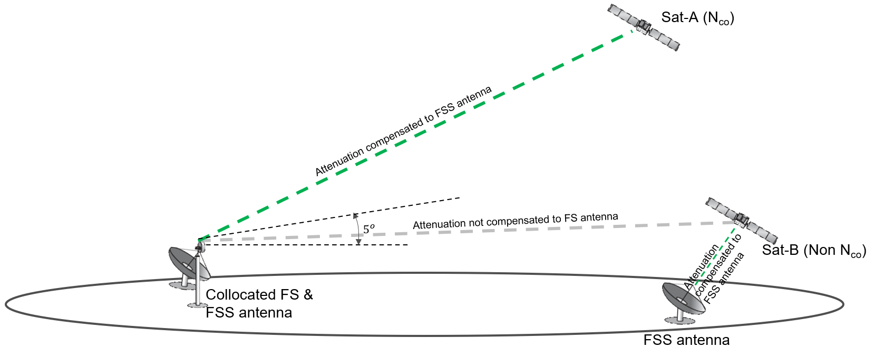

As mentioned in Recommendation ITU-R P.618, “At a given frequency the oxygen contribution to atmospheric absorption is relatively constant. However, both water vapour density, and its vertical profile are quite variable. Typically, the maximum gaseous attenuation occurs during the season of maximum rainfall”. For this reason, as a conservative approach, we exclude gaseous attenuation from water vapour component, i.e., consider dry air scenario, and take into account only attenuation due to oxygen content in the atmosphere at the test location for the $N_{v}- N_{co}$ satellites.

The protection criteria for FS safeguard used in this analysis are:
a Long-term: I/N should not exceed –10 dB for more than 20% of the time (derived from Recommendation ITU-R F.758-8)
b Short-term: I/N should not exceed +11 dB for more than 0.00128% of the time in any month.

Results of study # XY

ITU-R F.1245-3 FS station antenna pattern
Figure 1-6 shows aggregate I/N from the multiple selected GSO and four non-GSO systems for
the ITU-R F.1245-3 FS station antenna pattern,
pointing at two different azimuth directions (results can be provided with 20° intervals upon request)
for maximum FS antenna elevation angle of 5°,7.5° and 10°
at a representative frequency (i.e., 73.5 GHz).
Each figure only shows I/N for clear sky condition.
Figure 1
Aggregate I/N from Selected Systems at 45°N, Azimuth 0°
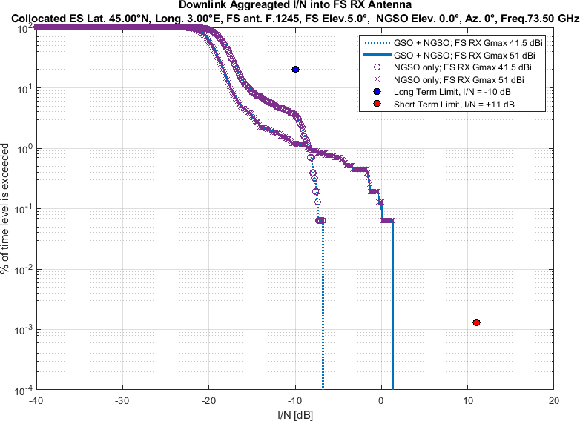
Figure 2
Aggregate I/N from Selected Systems at 45°N, Azimuth 180°
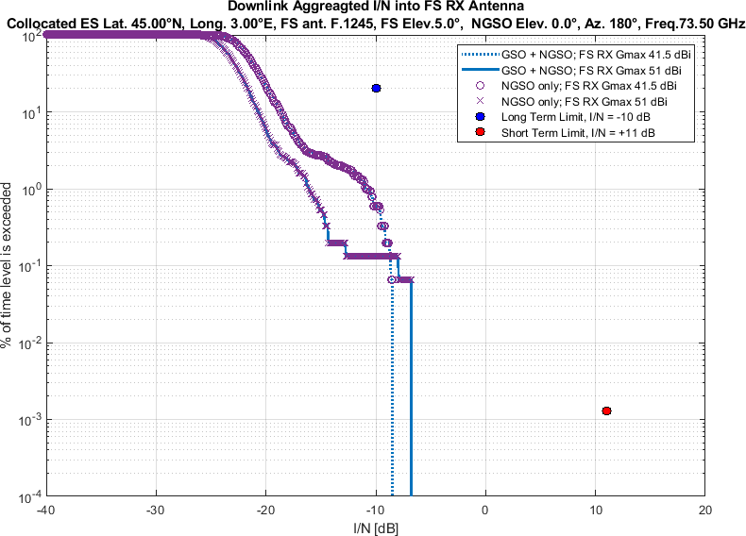
Figure 3
Aggregate I/N from Selected Systems at 45°N, Azimuth 0°
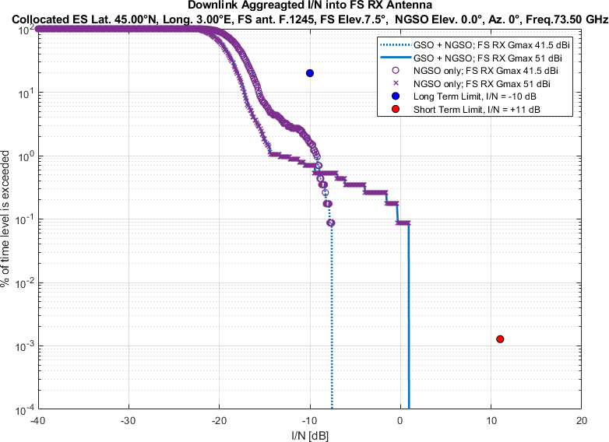
Figure 4
Aggregate I/N from Selected Systems at 45°N, Azimuth 180°
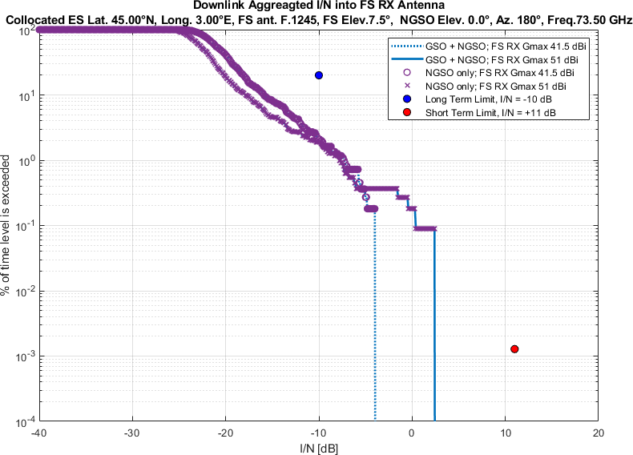

Figure 5
Aggregate I/N from Selected Systems at 45°N, Azimuth 0°
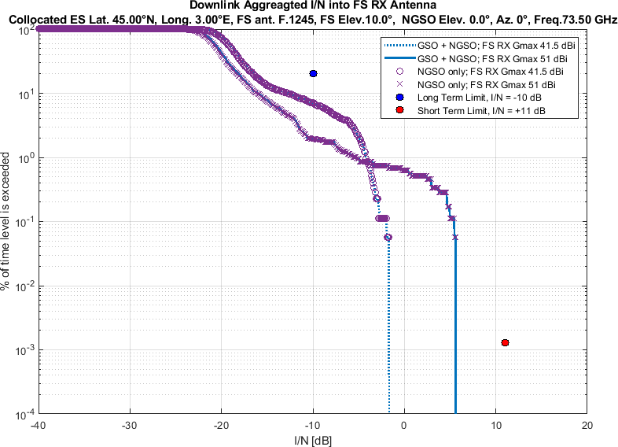
Figure 6
Aggregate I/N from Selected Systems at 45°N, Azimuth 180°
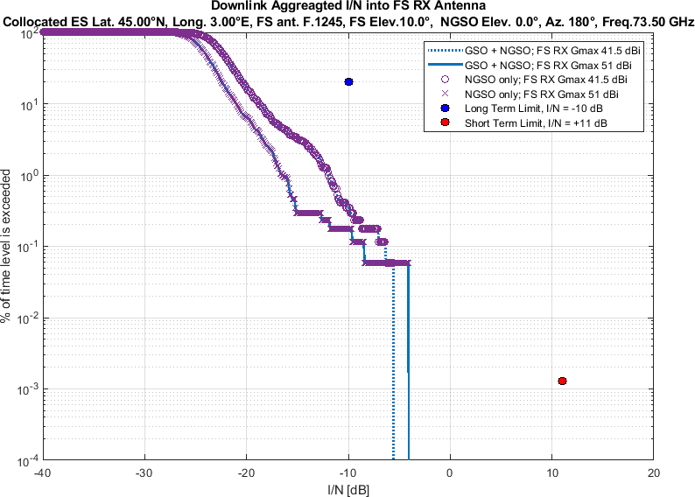

EN 302 217-4 Class-3FS station antenna pattern
Similarly, Figure 7-12 shows aggregate I/N from the same selected GSO and four non-GSO systems for
the EN 302 217-4 Class-3FS station antenna pattern,
pointing at two different azimuth directions (results can be provided with 20° intervals upon request)
for maximum FS antenna elevation angle of 5°, 7.5° and 10°
at same representative frequency (i.e., 73.5 GHz).
Each figure only shows I/N for clear sky condition.
Figure 7
Aggregate I/N from Selected Systems at 45°N, Azimuth 0°
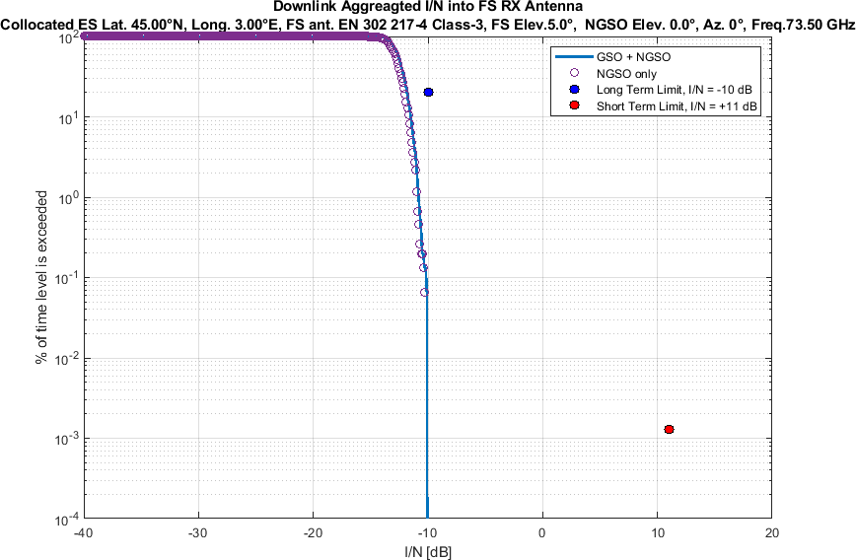
Figure 8
Aggregate I/N from Selected Systems at 45°N, Azimuth 180°
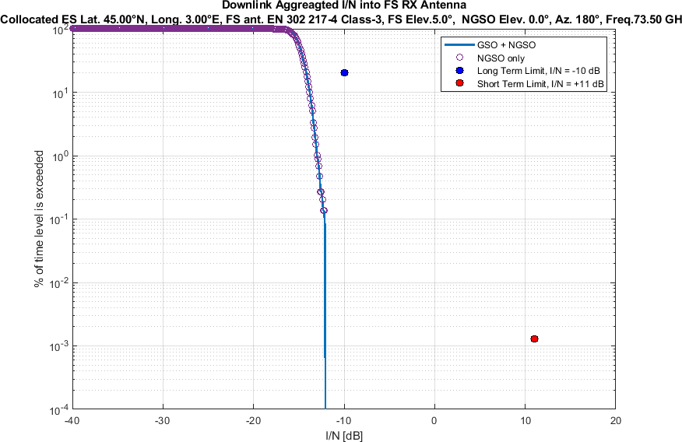
Figure 9
Aggregate I/N from Selected Systems at 45°N, Azimuth 0°
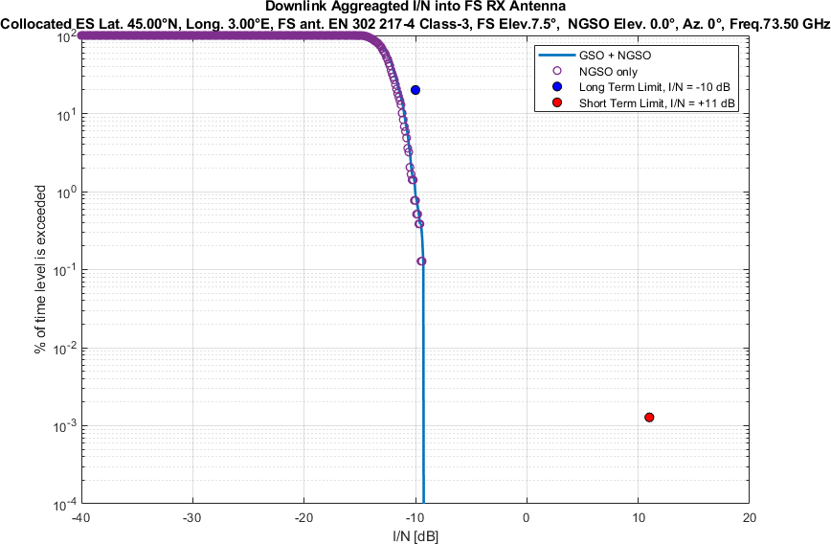
Figure 10
Aggregate I/N from Selected Systems at 45°N, Azimuth 180°
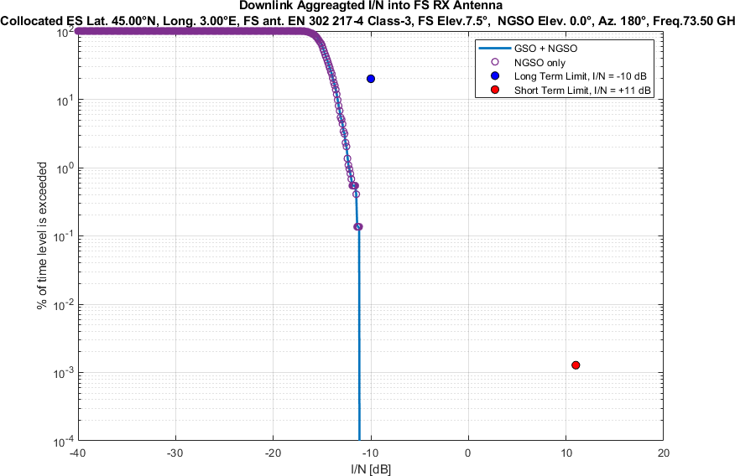

Figure 11
Aggregate I/N from Selected Systems at 45°N, Azimuth 0°
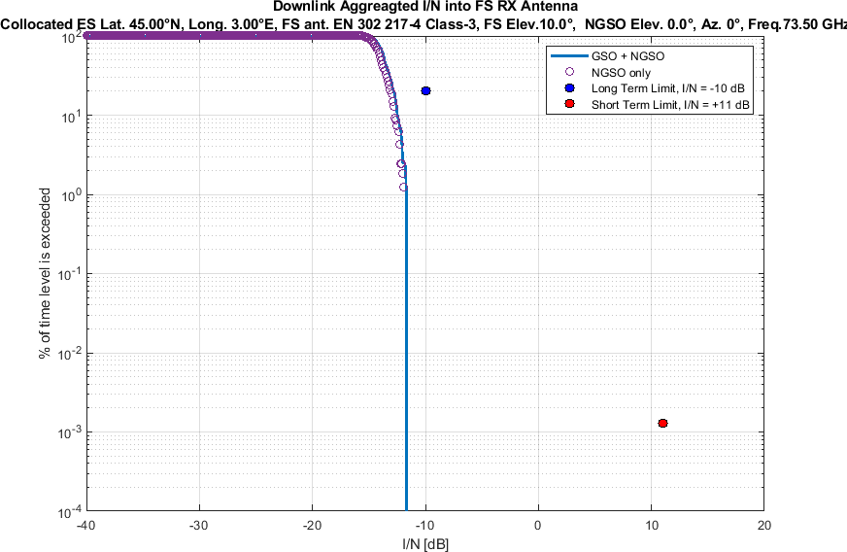
Figure 12
Aggregate I/N from Selected Systems at 45°N, Azimuth 180°
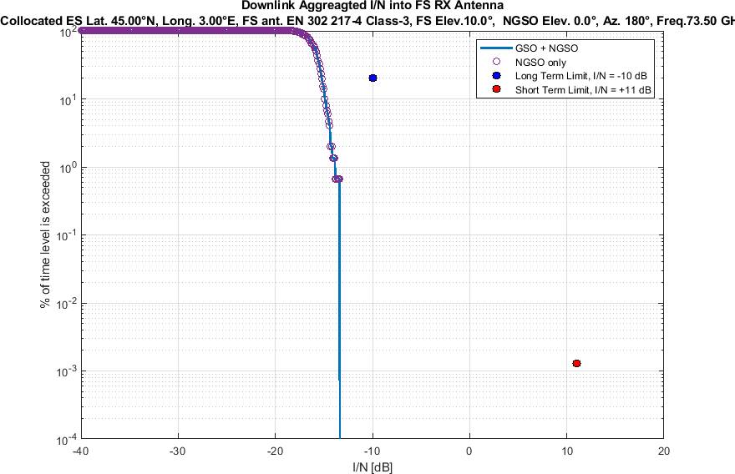

Discussion

Elevation angle

During the WP5C meeting of November 2025, the meeting agreed to consider both maximum FS victim elevation angles of 5º and 10°. This study therefore proposed PFD limits that would meet each of those two cases, plus it added a third one corresponding to a case at 7.5° FS maximum elevation angle, which would correspond to a middle-ground in between the 5° and 10° cases.

Contribution from GSO satellites in aggregate analysis

The aggregate analyses include contribution from 18 GSO satellites spaced on the GSO arc every 3°. Table 3 listed the PFD used for the GSO satellites used in the aggregate analyses. It is evident from Figure 1 to Figure 12 that for the two different FS antenna patterns, the interference contribution from the GSO satellites at test latitude is insignificant as the aggregate NGSO systems’ interference dominate the total aggregate interference. Hence, in practice, it is acceptable to decouple studies on the GSO masks from those on the NGSO ones.

Sidelobe radiation pattern for each of the visible $N_{v}- N_{co}$ satellites of a non-GSO system have been calculated conservatively as per Recommendation ITU-R S.1528 recommends 1.2. In some other working parties’ studies, Recommendation ITU-R S.1528 recommends 1.4 has been considered for sidelobe radiation pattern. The satellite antenna transmit peak gain of 48 dBi, 48 dBi, 51.1 dBi and 52 dBi have been assumed for System B, System D, System L and System M, respectively, with L_n = -20 dB.
For interference analysis, minimum elevation angle 0° have been considered for the non-GSO systems.
Study #XY is not proposing GSO PFD mask specifications; the PFD listed is only for use in aggregate analysis.

