U.S. Radiocommunications Sector
Fact Sheet
Working Party: ITU-R WP-5B | Document No: USWP5B36-XX
Ref: Annex 1.6 to Document 5B/435-E | Date: 19 February 2026
Document Title: PRELIMINARY DRAFT NEW RECOMMENDATION ITU-R M.[15.4-15.7_GHz_ARNS] - Characteristics of and protection criteria for radars operating in the aeronautical radionavigation service in the frequency band 15.4-15.7 GHz.
Author(s)/Contributors(s):  Don Nellis  Federal Aviation Administration  800 Independence Ave., S.W.  Washington, DC 20591 | Phone: (202) 267-9779  e-mail: Donald.Nellis@faa.gov
Purpose/Objective: The purpose of this contribution is to develop a new recommendation for aeronautical radionavigation systems, including unmanned aircraft systems (UAS) Detect and Avoid (DAA) radar systems, in the 15.4-15.7 GHz band. This contribution will update and/or address comments on the technical parameters of DAA radars in Table A1-1 and landing system in Table A1-2 as applicable. Due to the stability of the technical characteristics data for the airborne and ground based DAA system, this contribution proposes to upgrade the Working Document into Preliminary Draft New Recommendation. This contribution will be an update to the new report found in Annex 1.6 of Document 5B/435-E.
Abstract: This contribution is a new recommendation for UAS Detect and Avoid (DAA) systems that operate in the 15.4-15.7 GHz Aeronautical Radionavigation Service allocation. This contribution contains characteristics and protection criteria for UAS DAA radar that can be used both on airborne and ground platforms.

Radiocommunication Study Groups | 
Source: Document 5B/435 (Annex 1.6) | Document 5B/XX-E
Source: Document 5B/435 (Annex 1.6) | XX May 2026
Source: Document 5B/435 (Annex 1.6) | English only
United States of America
WORKING DOCUMENT TOWARDS A PRELIMINARY DRAFT NEW RECOMMENDATION ITU-R M.[15.4-15.7_GHZ_ARNS]
Characteristics of and protection criteria for [airborne] detect and avoid radars and aircraft landing systems operating in the aeronautical radionavigation service in the frequency band 15.4-15.7 GHz
Introduction
TBD
Proposal
TBD

______________

WORKING DOCUMENT TOWARDS A PRELIMINARY DRAFT NEW RECOMMENDATION ITU-R M.[15.4-15.7_GHZ_ARNS]
Characteristics of and protection criteria for detect and avoid radars and aircraft landing systems operating in the aeronautical radionavigation service in the frequency band 15.4-15.7 GHz
(202X)
Scope
This Recommendation specifies the characteristics and protection criteria of [airborne] detect and avoid radars and landing systems operating in the aeronautical radionavigation service (ARNS) in the frequency band 15.4-15.7 GHz.
Keywords
15.4-15.7 GHz, radar, characteristics, protection.
Abbreviations/Glossary
ARNS Aeronautical radionavigation service
DAA Detect and avoid
ESA Electronically scanned array
FMCW Frequency-modulated continuous wave
[]
RCS Radar cross-section
RR Radio Regulations
SNR Signal-to-noise power ratio
UA Unmanned aircraft
UAS Unmanned aircraft system

Related ITU Recommendations and Reports
Recommendations
ITU-R M.1372 Efficient use of the radio spectrum by radar stations in the radiodetermination service
ITU-R M.1730 Characteristics of and protection criteria for the radiolocation service in the frequency band 15.4-17.3 GHz
ITU-R S.1340 Sharing between feeder links for the mobile-satellite service and the aeronautical radionavigation service in the Earth-to-space direction in the band 15.4-15.7 GHz
Report
ITU-R M.2204 Characteristics and spectrum considerations for sense and avoid systems use on Unmanned Aircraft Systems (UAS)
The ITU Radiocommunication Assembly,
considering
a) that the technical characteristics of detect and avoid radars operating in the aeronautical radionavigation service (ARNS) are driven by the performance requirement and depend on the frequency band,
recognizing
a) that the frequency band 15.4-15.7 GHz is allocated on a primary basis to aeronautical radionavigation, and radiolocation services, and that the fixed-satellite service (Earth-to-space) is also allocated on a primary basis in the frequency band 15.43-15.63 GHz;
c) that the aeronautical radionavigation service is a safety service as specified by No. 4.10 of the Radio Regulations (RR);
d) that some interference suppression techniques between radars are contained in Recommendation ITU-R M.1372, “Efficient use of the radio spectrum by radar stations in the radiodetermination service”;
e) that RR No. 5.511A states that the fixed-satellite service (Earth-to-space) operating in the frequency band 15.43-15.63 GHz is limited to feeder links of non-geostationary systems in the mobile-satellite service and is subject to coordination under RR No. 9.11A;
f) that the limit of effective isotropically radiated power (e.i.r.p) of stations operating in the aeronautical radionavigation and fixed satellite services is provided in Recommendation ITU-R S.1340;
;
g) that the frequency band 15.4-15.7 GHz is allocated worldwide on a primary basis to the aeronautical radionavigation service;
h) that the frequency band 15.4-15.7 GHz is also allocated worldwide on a primary basis to the radiolocation service and RR No. 5.511E states that stations operating in the radiolocation service shall not cause harmful interference to, or claim protection from, stations operating in the aeronautical radionavigation service;
i) that the frequency range 15.4-15.7 GHz is also allocated on a secondary basis to the aeronautical mobile (OR) service by RR Nos. 5.511G and 5.511H,
recommends
1 that the technical and operational characteristics of the detect and avoid radars, in particular for remotely piloted aircraft, and landing systems operating in the ARNS described in the annex should be considered in studies of sharing and compatibility with systems in other services;
[2 that the criterion of interfering signal power to receiver noise power level, I/N of −6 dB should be considers to protect the detect and avoid radars and landing systems,
and that this represents the aggregate protection level if multiple interferers are present.

Annex 1
Technical and operational characteristics of detect and avoid radarsand aircraft landing systems operating in the aeronautical radionavigation service in the frequency band 15.4-15.7 GHz

A1 Introduction
This Annex presents the technical and operational characteristics of representative ARNS radars operating in the 15.4-15.7 GHz frequency band for detect and avoid (DAA) systems used for collision avoidance during all phases of flight, and for landing aids.

A1-1 Characteristics of detect and avoid radars, in particular for remotely piloted aircraft
The technical parameters are provided in Table A1-1.

TABLE A1-1
Representative technical parameters of radionavigation radar for airborne detect and avoid radars, in particular for remotely piloted aircraft
Parameter | Units | Radar 1 | Radar 2 | Radar 3 | Radar 4 | Radar 5 | Radar 6 | Radar 7 | Radar 8
Platform |  | Airborne (Note 1) | Airborne (Note 1) | Airborne (Note 1) | Airborne | Airborne | Airborne (Note 1) | Airborne | Airborne
Platform height | km | Up to 3 | Up to 3 | Up to 12 | Up to 15 | Up to 15 | Up to 3 | Up to 12 (TBC) | Up to 12 (TBC)
Radar type |  | FMCW | FMCW | Pulse-Doppler | Pulse Modulation | Pulse Modulation | FMCW | Pulse Modulation | FMCW
Operating range  [(Note 2)] | km | 2.0 | 4.5 | 9 | 5 | 10 | 13 | 13 | 5
[Maximum number of DAA systems within the same operating area] |  | [10] | [10] | [3 to 12] | [Up to 10] | [Up to 20] | [10] | [Up to 20] | [10]
Ground relative speed | km/h | 50-100 | 50-100 | Up to 195 | Up to 800 | Up to 800 | 50-100 | 500 | Up to 330
Transmitter
Frequency range | GHz | 15.4-15.7 | 15.4-15.7 | 15.4-15.7 | 15.4-15.7 | 15.4-15.7 | 15.4-15.7 | 15.4-15.7 | 15.4-15.7
Channel selection method between radars |  | Pre-programmed and channel selectable | Pre-programmed and channel selectable | SW selectable  (Note 5) | SW selectable  (Note 5) | SW selectable  (Note 5) | Pre-programmed and channel selectable | SW selectable  (Note 5) | Pre-programmed and channel selectable
Pulse width (1 meter range resolution) | μs | 239 | 239 | 0.25 to 20  (Note 6) | 1 to 20 | 1 to 20 | 239 | 1 to 5 | 58
Pulse rise and fall times | μs | 5/5 | 0.5/0.5 | 0.025/1.5 | < 0.1 | < 0.1 | 0.5/0.5 | <0.05 | −
RF emission bandwidth  −3 dB  −20 dB  −40 dB | MHz | 176  184  201 | 152  164  269 | (Band 1-MHz)  25  80  155 | 80  90  110 | 80  90  110 | 152  164  269 | 10  TBD  TBD | 176  TBD  TBD
Pulse repetition frequency | Hz | 4 000 | 4 000 | 5 000-200 000  (Note 7) | − | − | 4 000 | 20,000 – 60,000 | 17 241
Pulse repetition interval | μs | 250 | 250 | 14.30-114.03  (Note 7) | 30 to 80 | 30 to 80 | 250 | 17 – 50 | 58
Average transmitter power (conducted) during emission time [Editor’s Note: Clarify in future version what exactly is meant here. Pulse envelop power?] | W | 2 | 10 | 30 | 70 | 100 | 20 | 120 | 25
Out-of-band emission characteristics | dBc | 60 | 63 | 75  (through 3rd harmonic) | - | - | 63 | roll off 30 dB/dec | roll off 30 dB/dec
Spurious emission characteristics (conducted) | dBc | −72 | −87 | −60 | SM.329 | SM.329- | −87 | Rec ITU-R -SM.329-13  Chapter 4.2 Table 2 | Rec ITU-R -SM.329-13  Chapter 4.2 Table 2
Receiver
Receiver IF bandwidth  −3 dB  −20 dB  −60 dB | MHz | 15  32  58 | 15  32  58 | 53  70  114 | 20  40  80 | 20  40  80 | 15  32  58 | TBD | 5  TBD  TBD
Sensitivity (MDS)  (at RX input. SNR = 12 dB) | dBm | −147 | −141 | −121 | / | / | −141 | −148 | −136
Receiver noise figure | dB | 1.5 | 1.5 | 4 | 3 | 3 | 1.5 | 4 | 1.7
Antenna
Antenna type |  | AESA  (Note 9) | AESA  (Note 9) | AESA  (Note 9) | MIMO | MIMO | AESA  (Note 9) | AESA | MIMO  AESA
Antenna pattern | N.A. | TBD | N/A | N/A | See Annex 2 | See Annex 2 |  | Pencil Beam | TBD
Maximum antenna gain | dBi | 14 | 15 | 27 | 9 | 9 | 15 | 32 | 18.5
Antenna pointing | TBD | [N/A] | [N/A] | [N/A] | Front  See annex 2 | Front  See annex 2 | [N/A] | yes | Yes (Tx)
First antenna sidelobe | dBi | −17 at 50° | −15 at 50° | 25 at 8° (Vertical)  −25 at 14° (Horizontal) | see Annex 2 | see Annex 2 | −15 at 50° | −13 at 8 deg vert / 5.0 deg horz | −19 at 52°
Horizontal beamwidth | degrees | 40 | 32 | 4 | 80  (Note 10) | 80  (Note 10) | 32 | 3 (Tx) | 40 (Tx)
Vertical beamwidth | degrees | Doc 5B/186  40 | Deletes this row  28 | 2 | 80  (Note 10) | 80  (Note 10) | 28 | 6 (Tx) | 25 (Tx)
Polarization |  | Vertical | Horizontal | Horizontal | Vertical | Vertical | Horizontal | Horizontal | Horizontal
Field of Regard | degrees | (Note 11) | (Note 11) | +/−65°az  +50°/−40° el | +/−110° to +/−180° | +/−110° to +/−180° | Note 11 | +/−110° az  +/−25° el | +/−60° az  +/−45° el  (Note 11)
Horizontal Antenna scan (from boresight) | degrees | ±60 | ±60 | ±65 | Not applicable | Not applicable | ±60 | ±60 deg | ±60 deg
Vertical Antenna scan (from boresight) | degrees | ±20 | ±60 | −40, +50 | Not applicable | Not applicable | ±60 | ± 25 deg | ± 45 deg
Notes:
1 These radars can also be deployed on the ground, recognizing the need to give priority to [onboard] airborne detect and avoid radars for remotely piloted aircraft expected to be operated on a worldwide basis.
[2 These radars have similar detection range on the same aircraft, even if it flies at a different speed as long as the radar tracking software is expecting and designed for the correct aircraft speeds. What matters is radar cross section (RCS, i.e. “size”) of the target.]
3 Channel selection is purely SW-defined and can be changed on-the-fly. Some settings may allow radar to self-configure based on detected spectrum-conflict.
6 Waveform is software-defined on a CPI-by-CPI basis, and optimized for targets, and spectral environments.
7 Based on the PRI, 8,769-69,917 pulses per second for PRR are more accurate. However, these radars are dynamic/cognitive radar and the PRI/PRR can be dynamically changed based on a number of characteristics (terrain, target, etc.) hence 5,000-200,000 PRR are listed.
8
9 For Radar 1, 2, and 6: Each radar has one TX array and one RX array integrated into their design. For radar 3: High T/R ESA RF beamforming on both transmit and receive.
10 For one panel at ‒3 dB. See Annex 2 for the field of regard.
11 These radars do not have multiple panel capability. Each radar has only one TX array and one RX array integrated into their design. Field or Regard (FOR) is programmable for each individual radar. For an individual radar, FOR can be programmed as wide as ±60°. However, four of these radars can be set up orthogonally to each other to achieve a FOR of 360°.]

A1-2 Characteristics of landing system
This system is an electronic landing aid that provides flight path data to an approaching aircraft as the aircraft flies into range of the landing system. There are two separate surface transmitters, one for azimuth and one for elevation, as well as a receiver installed on the aircraft. The system utilizes a one-way transmission where the angular information is displayed on a cross-point indicator, allowing the aircraft to align itself with the runway.
The technical parameters are provided in Table A1-2.
TABLE A1-2
Technical parameters of landing system
Parameter | Units | Transmitter | Receiver
Platform |  | Land/Ship | Aircraft
Platform height | km | Land: 0.01  Ship: 0.015-0.024 | Maximum: 2
Relative to Ground speed | m/s | Land: 0  Ship: < 14 | 98
Number of aircraft per landing system |  | 1 | 1
Transmitter
Frequency tuning range | GHz | 15.4-15.7 | 15.4-15.7
Emission type |  | Pulse | Not applicable
Pulse width | μs | 0.3 | Not applicable
Pulse rise and fall times | ns | Rise Time: 25-50;  Fall Time: 25-200 | Not applicable
RF emission bandwidth at  −3 dB  −20 dB  −40 dB | MHz | 4.8  18.5  65 | Not applicable
Pulse repetition frequency | pps | 15 000 | Not applicable
Out-of-band emission characteristics | dBc | < 43 | Not applicable
Spurious emission characteristics | dBc | 65 | Not applicable
Average transmitter power | W | Peak: 2 500;  Average: 7 | Not applicable
Receiver
Receiver IF bandwidth  −3 dB  −20 dB  −60 dB | MHz | Not applicable | 12  17  24  [Editor’s note: this may not be an efficient selectivity mask: to confirm]
Sensitivity | dBm | Not applicable | −72
Receiver noise figure | dB | Not applicable | 11.5
Calculated conducted Rx noise power | dBW | Not applicable | −121.7
Image rejection | dB | Not applicable | 60
Spurious rejection | dB | Not applicable | SM.329
Antenna
Antenna type |  | Slotted waveguide | Horn
Antenna placement |  | [Ground/Surface/Ship] | Bottom of aircraft
Antenna gain | dBi | Azimuth: 32;  Elevation: 26 | 6
Antenna pattern First antenna side-lobe | N/A | TBD | TBD
Antenna pointing | N/A | TBD | TBD
Antenna azimuth beamwidth | degrees | Horizontal: 40;  Vertical: 1.3 | 70
Antenna elevation Vertical beamwidth | degrees | Horizontal: 2; Vertical: 6 | 36
Polarization |  | Vertical | Vertical
Antenna scan | degrees | Sector Scan | Fixed

Annex 2

A2-1 Antenna characteristics
Airborne detect and avoid radars Nos. 4 and 5 use antennas with MIMO (Multiple Input Multiple Output) fix panel. Therefore, these characteristics are complemented to obtain the complete radiation pattern for one panel. One panel does not allow to obtain the requested Field of Regard (FoR). The FoR of the radar refers to the area that has to be covered by the radar and is defined by the azimuth and elevation angles in regard to the platform coordinates. To obtain the requested FoR, it is necessary to use several panels. Typical FoR for DAA is ±110°, and is obtained by the use of 3 panels (each one covering 80°).
Figure
Typical Field of Regard
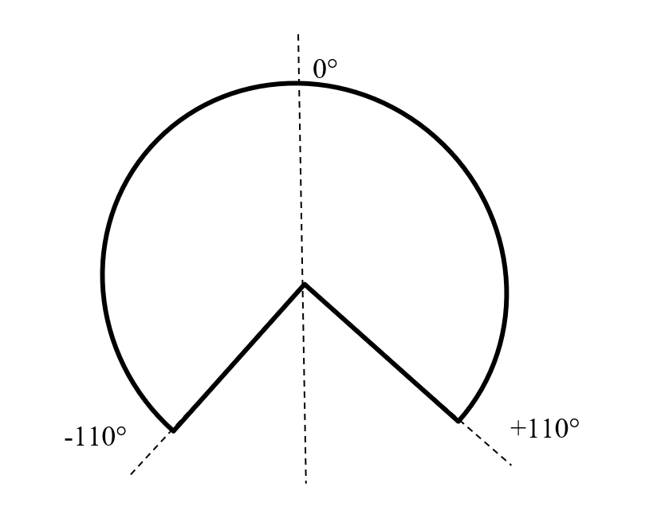
]
Single Antenna Pattern in azimuth
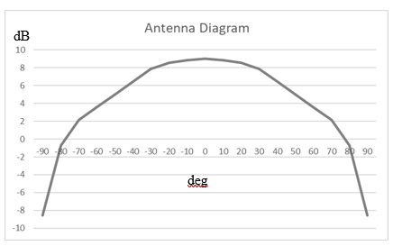
Single Antenna Pattern in elevation

This criterion does not include a safety margin.
There are two transmit antenna systems one for azimuth and one for elevation.

